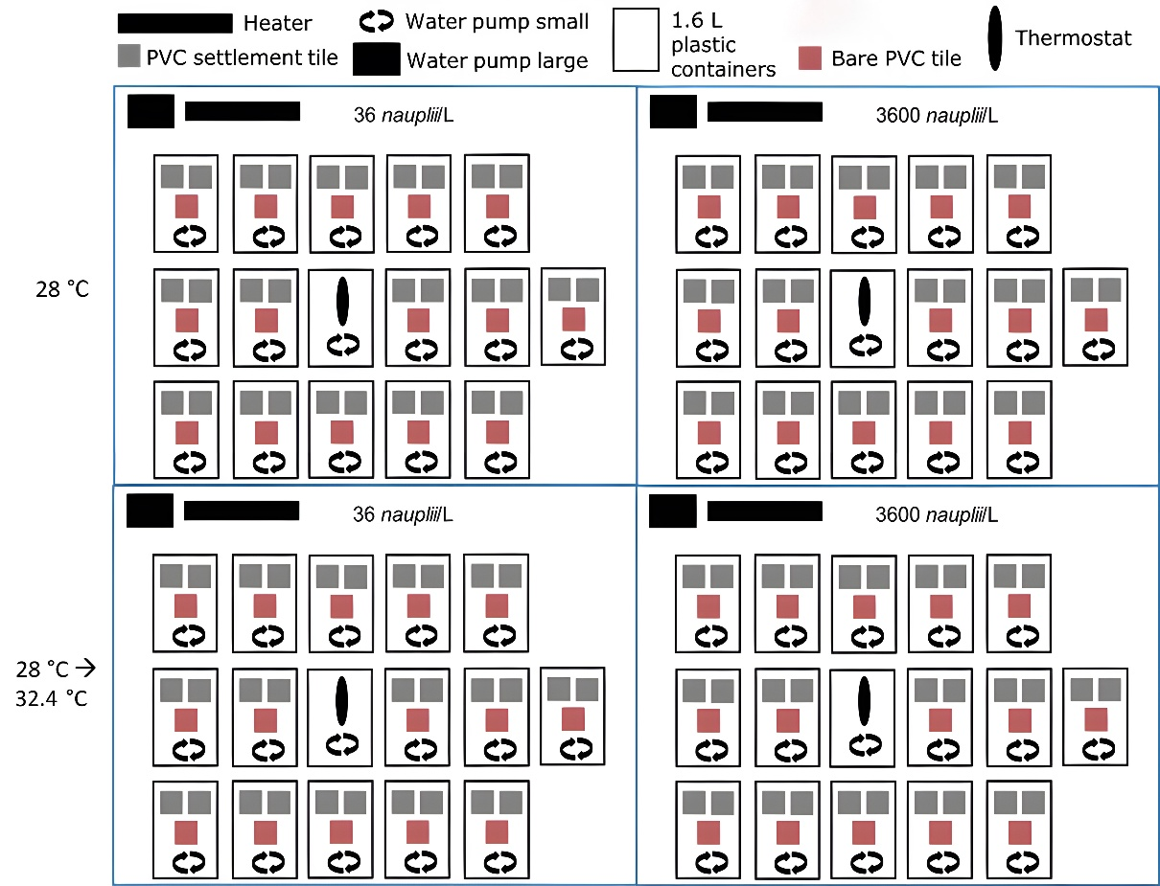

Supplementary Fig. 1 Experimental setup of 2 x 2 factorial design with F. fragum settlers exposed to either a control temperature (28°C) or a heat wave (28 °C à 32.4°C) in combination with either a low prey (36 Artemia nauplii L⁻¹) or a high prey concentration (3600 Artemia nauplii L⁻¹) over a course of 48 days. For each treatment combination, N=15 independently operating 1.6L containers were used, with two settlers in each container. Two PVC tiles with one settler per tile (grey squares) were added to each container. Out of each container, one settler was used for PSII, growth, symbiont and chl a measurements, whereas the other was used to determine prey capture rates and survival. Bare PVC tiles (red squares) were included to prevent settler tiles from moving. Blue boxes indicate separate aquaria functioning as water basins for settler containers. Thermostats with their sensor inside one container per aquarium controlled temperatures.

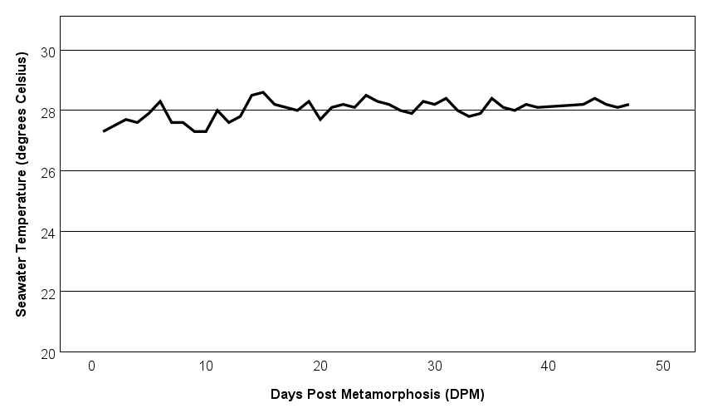

Supplementary Fig. 2 Daily temperature of the control treatments over time. Values are means (N=10, with feeding regimes averaged). Error bars are too small to visualise. Post metamorphosis was defined as the moment at which coral planula larvae have settled onto substrates and formed settlers (primary polyps).

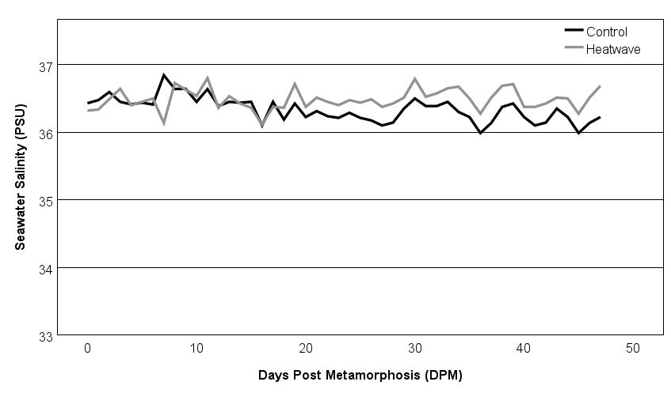
Supplementary Fig. 3 Daily salinity of the control and heatwave treatments over time. Values are means (N=10 per temperature treatment, with feeding regimes averaged). Error bars are too small to visualise. Post metamorphosis was defined as the moment at which coral planula larvae have settled onto substrates and formed settlers (primary polyps).

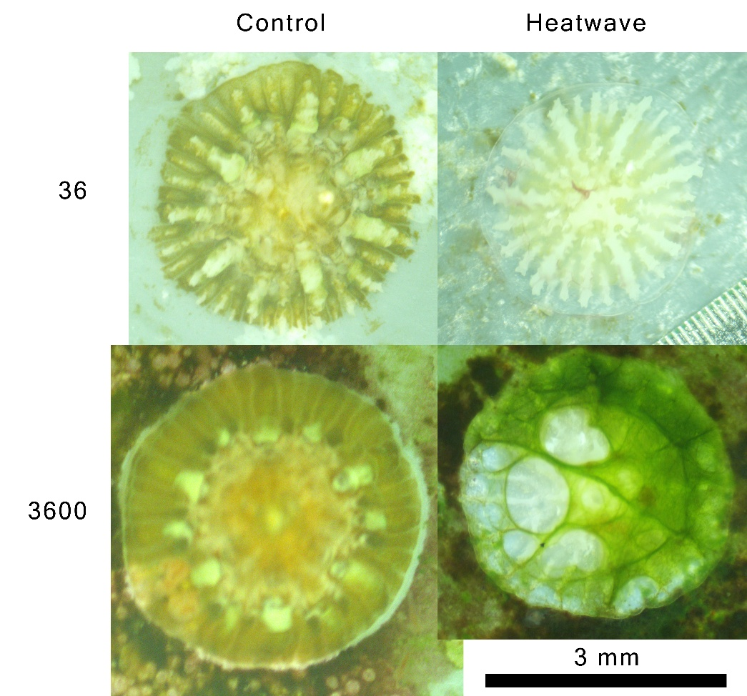

Supplementary Fig. 4 Representative photographs of settlers from each of the four treatments at 44 DPM. Notice accelerated growth of the settler at 3600 prey L⁻¹ under control temperature, and bleaching and loss of tissue in the heatwave treatments. Black scale bar is 3 mm.

Supplementary Table 1 Wilcoxon signed ranks test showing comparisons of effective PSII yield within the control and within the heat wave treatment over time, irrespective of feeding regime. Based on a Bonferroni correction, values of p<0.006 (indicated in bold) were considered significant.
Comparison (DPM) | 39 - 37 | 39 - 35 | 39 - 33 | 37 - 35 | 35 - 33
Control
Z | -4.065 | -3.587 | -3.461
Exact p (2-tailed) | <.001 | <.001 | <.001
Heatwave
Z | -3.480 | -3.883 | -3.920 | -3.942 | -1.769
Exact p (2-tailed) | <.001 | <.001 | <.001 | <.001 | .078

Supplementary Table 2 Mann-Whitney U tests showing comparisons of effective PSII yield between the control and the heat wave treatment over time, irrespective of feeding regime. Based on a Bonferroni correction, values of p<0.010 (indicated in bold) were considered significant.
Comparison (DPM) | 30 | 33 | 35 | 37 | 39
Mann-Whitney U | 357.500 | 389.500 | 278.500 | 71.500 | 30.500
Z | -.121 | -.475 | -2.203 | -4.963 | -5.219
Asymptotic p (2-tailed) | .904 | .635 | .028 | <.001 | <.001

Supplementary Table 3 Three-way mixed factorial ANOVA showing effects of time, feeding regime and temperature treatment on settler size, and follow-up simple effects contrasts indicating the effect of one factor at various levels of the other two. Data were log₁₀ transformed to conform to assumptions of normality (Shapiro-Wilk Test, p>0.05) and homogeneity of variances (Levene’s Test, p>0.05). As sphericity was violated (Mauchly’s Test, p<0.05), degrees of freedom were Greenhouse-Geisser corrected. Values of p<0.050 (indicated in bold) were considered significant, and were automatically Bonferroni-adjusted for multiple comparisons.
Source | Type III SS | df | F | p
Time | 6.590 | 1.766 | 406.003 | <.001
Feeding regime | .216 | 1 | 2.726 | .105
Temperature | .040 | 1 | .506 | .480
Time * Feeding regime | 0.122 | 1.766 | 7.543 | .001
Time * Temperature | 0.201 | 1.766 | 12.411 | <.001
Feeding * Temperature | .015 | 1 | .190 | .665
Time * Feeding regime * Temperature | 0.018 | 1.766 | 1.109 | 0.328
Simple effects contrasts of Feeding regime (Temperature averaged)
 | Time | df | F | p
 | 1 DPM | 1 | .138 | .712
 | 16 DPM | 1 | 1.407 | .241
 | 23 DPM | 1 | 1.664 | .203
 | 30 DPM | 1 | 3.314 | .074
 | 37 DPM | 1 | 7.363 | .009
Simple effects contrasts of Time (Feeding regimes averaged)
Temperature | Time | df | F | p
Control | 1 versus 16 DPM |  |  | <.001
Control | 16 versus 23 DPM |  |  | <.001
Control | 23 versus 30 DPM |  |  | <.001
Control | 30 versus 37 DPM |  |  | <.001
Heatwave | 1 versus 16 DPM |  |  | <.001
Heatwave | 16 versus 23 DPM |  |  | <.001
Heatwave | 23 versus 30 DPM |  |  | <.001
Heatwave | 30 versus 37 DPM |  |  | 1.000
Simple effects contrasts of Temperature (Feeding regimes averaged)
 | Time | df | F | p
 | 23 DPM | 1 | .344 | .560
 | 30 DPM | 1 | .069 | .794
 | 37 DPM | 1 | 5.603 | .022

Supplementary Table 4 Three-way mixed factorial ANOVA showing effects of time, feeding regime and temperature treatment on settler prey capture rates, and follow-up simple effects contrasts indicating the effect of one factor at various levels of the other two. Data were log₁₀ transformed to conform to assumptions of normality (Shapiro-Wilk Test, p>0.05) and homogeneity of variances (Levene’s Test, p>0.05). Values of p<0.050 (indicated in bold) were considered significant, and were automatically Bonferroni-adjusted for multiple comparisons.

Source | Type III SS | df | F | p
Time | .006 | 1 | .194 | .662
Feeding regime | 9.892 | 1 | 218.832 | <.001
Temperature | 2.855 | 1 | 63.170 | <.001
Feeding regime * Temperature | 1.536 | 1 | 33.982 | <.001
Time * Feeding regime | .037 | 1 | 1.289 | .262
Time * Temperature | 4.540 | 1 | 156.690 | <.001
Time * Feeding regime * Temperature | 1.177 | 1 | 40.626 | <.001
Simple effects contrasts of Feeding regime
Temperature | Time | df | F | p
Control | 5-7 DPM | 1 | 156.841 | <.001
Control | 40-42 DPM | 1 | 146.278 | <.001
Heatwave | 5-7 DPM | 1 | 107.402 | <.001
Heatwave | 40-42 DPM | 1 | 1.705 | .198
Simple effects contrasts of Time
Temperature | Feeding regime | df | F | p
Control | 36 | 1 | 13.937 | <.001
Control | 3600 | 1 | 77.428 | <.001
Heatwave | 36 | 1 | 6.486 | .014
Heatwave | 3600 | 1 | 99.856 | <.001
Simple effects contrasts of Temperature
Time | Feeding regime | df | F | p
40-42 DPM | 36 | 1 | 10.719 | .002
40-42 DPM | 3600 | 1 | 177.777 | <.001

Supplementary Table 5 Two-way factorial ANOVA showing effects of feeding regime and temperature treatment on settler areal symbiont density, and follow-up simple effects contrasts indicating the effect of one factor at various levels of the other two. Data were log₁₀ transformed to conform to assumptions of normality (Shapiro-Wilk Test, p>0.05) and homogeneity of variances (Levene’s Test, p>0.05). Values of p<0.050 (indicated in bold) were considered significant, and were automatically Bonferroni-adjusted for multiple comparisons.

Source | Type III SS | df | F | p
Feeding | .047 | 1 | 1.511 | .225
Temperature | 1.666 | 1 | 54.114 | <.001
Feeding regime * Temperature | .125 | 1 | 4.076 | .049
Simple effects contrasts of Feeding regime |  | df | F | p
Control |  | 1 | 5.393 | .024
Heatwave |  | 1 | .305 | .583
Simple effects contrasts of Temperature |  | df | F | p
36 |  | 1 | 15.681 | <.001
3600 |  | 1 | 40.255 | <.001

Supplementary Table 6 Two-way factorial ANOVA showing effects of feeding regime and temperature treatment on settler areal chlorophyll a fluorescence, and follow-up simple effects contrasts indicating the effect of one factor at various levels of the other two. Values of p<0.050 (indicated in bold) were considered significant, and were automatically Bonferroni-adjusted for multiple comparisons.

Source | Type III SS | df | F | p
Feeding regime | 941 | 1 | 6.517 | .014
Temperature | 139 | 1 | 96.418 | <.001
Feeding regime * Temperature | 970 | 1 | 6.723 | .012
Simple effects contrasts of Feeding regime |  | df | F | p
Control |  | 1 | 13.534 | <.001
Heatwave |  | 1 | .001 | .978
Simple effects contrasts of Temperature |  | df | F | p
36 |  | 1 | 28.747 | <.001
3600 |  | 1 | 70.559 | <.001

Supplementary Information 1. Excel sheet with raw data of PSII yield, growth, survival, symbiont density and chlorophyll a fluorescence.
Supplementary Information 2. SPSS Statictics sheet with raw data of PSII yield, growth, survival, symbiont density and chlorophyll a fluorescence.
Supplementary Information 3. Excel sheet with raw data of prey capture rates.
Supplementary Information 4. SPSS Statictics sheet with raw data of prey capture rates.

