Supplementary Materials
Method
Participant recruitment
Inclusion Criteria. Participants were required to (1) have a diagnosis of probable Alzheimer's disease (AD) dementia as defined by the 2011 NIA-AA core clinical criteria; (2) be between 50 and 80 years of age, with the stipulation that a diagnosis in participants under 65 be confirmed by biomarker evidence; (3) MMSE score less than 20, and (4) have demonstrated a lack of clinical improvement after at least six months of standard pharmacological therapy, ensuring the recruitment of a treatment-refractory population.
Exclusion Criteria. Individuals were excluded if they presented with (1) any contraindications to surgery, such as coagulation disorders (e.g., platelet count < 100×10⁹/L or INR > 1.4) or severe cardiopulmonary disease; (2) significant systemic illness, including severe hepatic dysfunction (ALT or AST levels > 3 times the upper limit of normal) or renal insufficiency (GFR < 30 ml/min/1.73m²); or (3) a history of intracranial hemorrhage or significant craniocerebral trauma within the last year. Further grounds for exclusion included (4) recent myocardial infarction (within 30 days), unresolved internal bleeding, or severe psychiatric conditions that would impede cooperation; and (5) current substance abuse dependencies. Finally, individuals were deemed ineligible if they (6) had a life expectancy of less than 180 days or (7) were concurrently enrolled in another interventional clinical trial.
Regional Graph Measures
We characterized the topological properties of each brain region (node) within the functional networks using a set of graph-theoretical metrics. These measures were chosen to quantify distinct aspects of nodal function, including centrality, integration, and segregation. All metrics were calculated following the established framework of Rubinov & Sporns (2010).
Degree Centrality. This index is the sum of connection weights for a given node. It provides a direct measure of a node's overall connectivity, and nodes with high DC are typically considered functional hubs.
Betweenness Centrality. Betweenness Centrality quantifies a node's importance in network-wide communication. It is defined as the fraction of all shortest paths in the network that pass through that node. High BC indicates a crucial role in connecting distinct network modules and supporting long-range communication.
Nodal Efficiency. This parameter measures a node's capacity for global information integration. It is calculated as the inverse of the average shortest path length between a node and all other nodes in the network. High nodal efficiency signifies a greater capacity for parallel information transfer with the rest of the brain.
Nodal Efficiency. This measure quantifies the communication efficiency among the direct neighbors of a node after the node itself is removed. This metric reflects the fault tolerance and processing efficiency of the local sub-network. High local efficiency suggests the node is part of a densely interconnected, and thus resilient, functional cluster.
Clustering Coefficient. This index measures the density of connections among a node's neighbors. It quantifies the extent to which the node's neighbors form a tightly connected clique. A high CC indicates that a node is part of a highly segregated neighborhood specialized for local information processing.
Participation Coefficient. This measure assesses the diversity of a node's connections across different modules. This metric distinguishes "provincial hubs," which have connections predominantly within their own module (low PC), from "connector hubs," which link multiple modules (high PC). Connector hubs are critical for integrating information across disparate functional systems.
Shortest Path Length. Measures the average shortest path length from a node to all other nodes in the network. It is another common metric for global integration, closely related to nodal efficiency but not its simple inverse. A smaller shortest path length value indicates that the node can transmit information more quickly to any other part of the network.

Table S1 | Global changes in brain network topology
Variables | Pre | Post | p value | t | Cohens d
Sigma | 1.19(0.15) | 1.17(0.19) | 0.652 | 0.45 | 0.11
Gamma | 1.20(0.16) | 1.18(0.20) | 0.655 | 0.45 | 0.11
Lambda | 1.00(0.00) | 1.00(0.00) | 0.556 | 0.60 | 0.15
CC | 0.75(0.08) | 0.74(0.08) | 0.703 | 0.39 | 0.09
SPL | 1.31(0.10) | 1.30(0.11) | 0.784 | 0.28 | 0.07
Note: Values are presented as means (standard deviations). Abbreviations: Pre, patients before left vertebral artery stenting; Post, patients after left vertebral artery stenting; CC, Clustering Coefficient; SPL, Shortest Path Length.

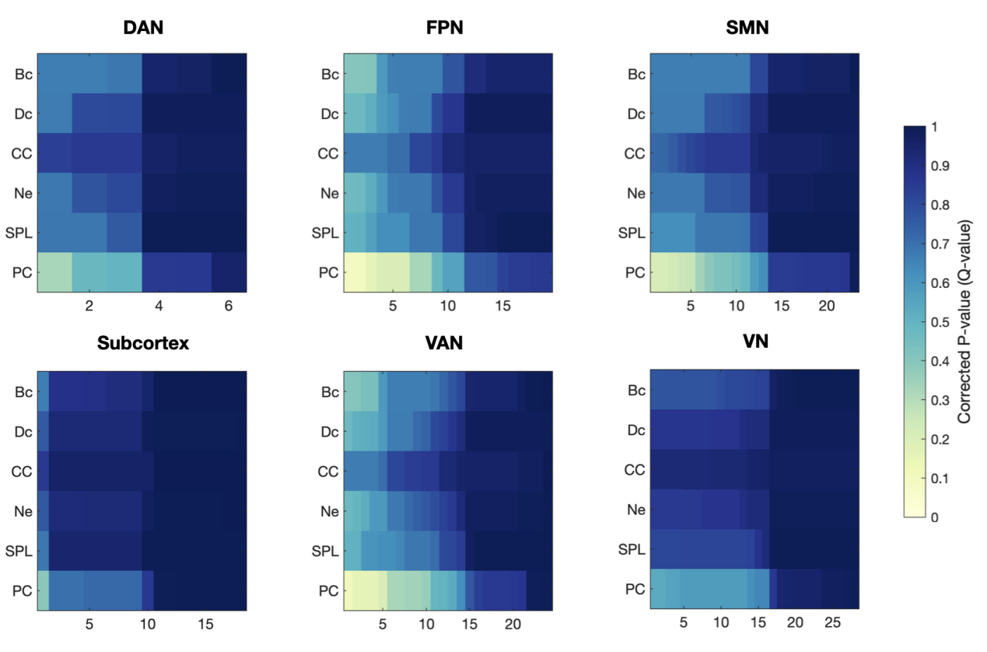
Figure S1. Q-value heatmap of functional networks other than the default network. The results indicate that, apart from the DMN, no other networks have results that pass the FDR correction. PC, Participation Coefficient; DC, Degree Centrality; Ne, Nodal Efficiency; SPL, Shortest Path Length; BC, Betweenness Centrality. CC, Clustering coefficient, DAN, dorsal attention network; DMN, default mode network; FPN, frontoparietal network; SMN, somatomotor network; VAN, ventral attention network; VN, visual network.

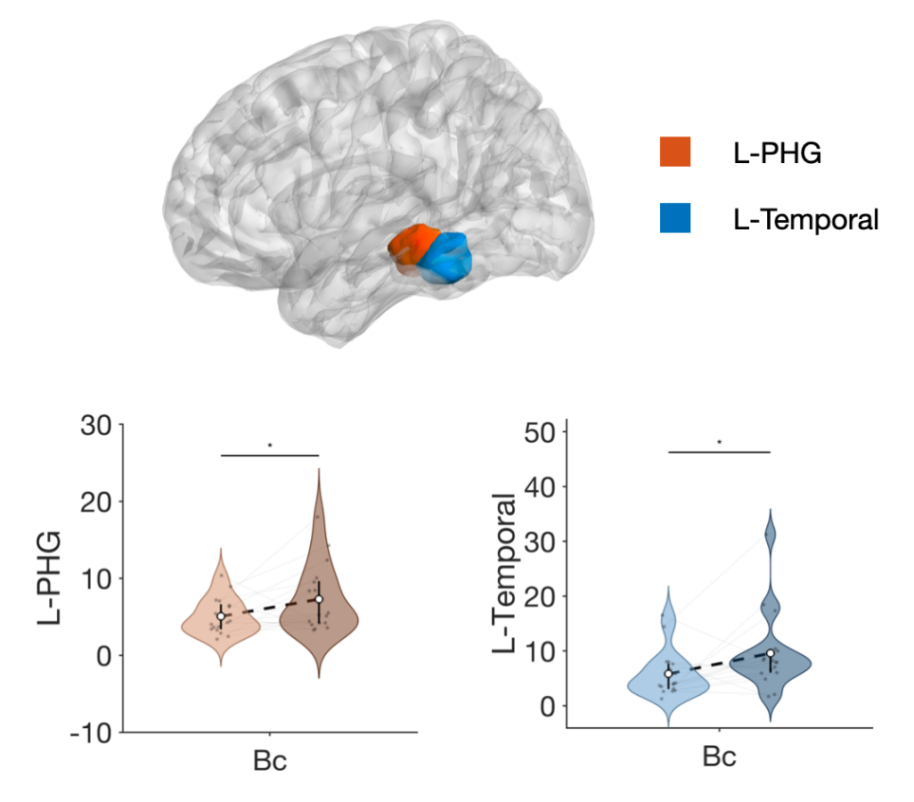
Figure S2. Changes in the betweenness centrality of DMN regions before and after dcLVA. L-PHG, Left parahippocampal gyrus, BC, betweenness centrality. In the paired violin plot, the left side represents data before treatment, and the right side represents data after treatment. The median change before and after treatment is connected by a black dashed line. Individual-level data is connected by gray lines.

