Additional file 3. Supplementary Figures
Health Indifference and the Inverse Association Between Symptom Burden and Healthcare Use: A Longitudinal Cohort Study from the Japan Society and New Tobacco/Infodemic Survey
Hikaru Oba¹*, Tomohiro Mitoma², Takahiro Tabuchi³, and Jota Maki¹
¹Medical Development Field, Center for Innovative Clinical Medicine, Okayama University Hospital, Okayama, Okayama, Japan
²Department of Obstetrics and Gynecology, Chugoku Central Hospital, Fukuyama, Hiroshima, Japan
³Division of Epidemiology, School of Public Health, Graduate School of Medicine, Tohoku University, Sendai, Miyagi, Japan
*Corresponding author:
Hikaru Oba, MD., PhD.
Medical Development Field,
Center for Innovative Clinical Medicine,
Okayama University Hospital
2-5-1, Shikata-cho, Kita-Ku, Okayama, Okayama, Japan
Email: po957sax@okayama-u.ac.jp

Supplementary Figure 1. Study Flow Diagram of Participant Selection and Attrition
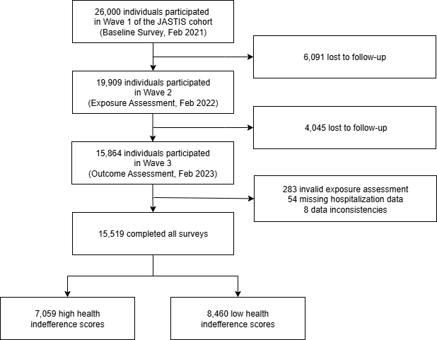
Feb, February; JASTIS, Japan Society and New Tobacco/Infodemic Survey

Supplementary Figure 2. Comparison of Multiple Imputation vs Complete Case Analysis
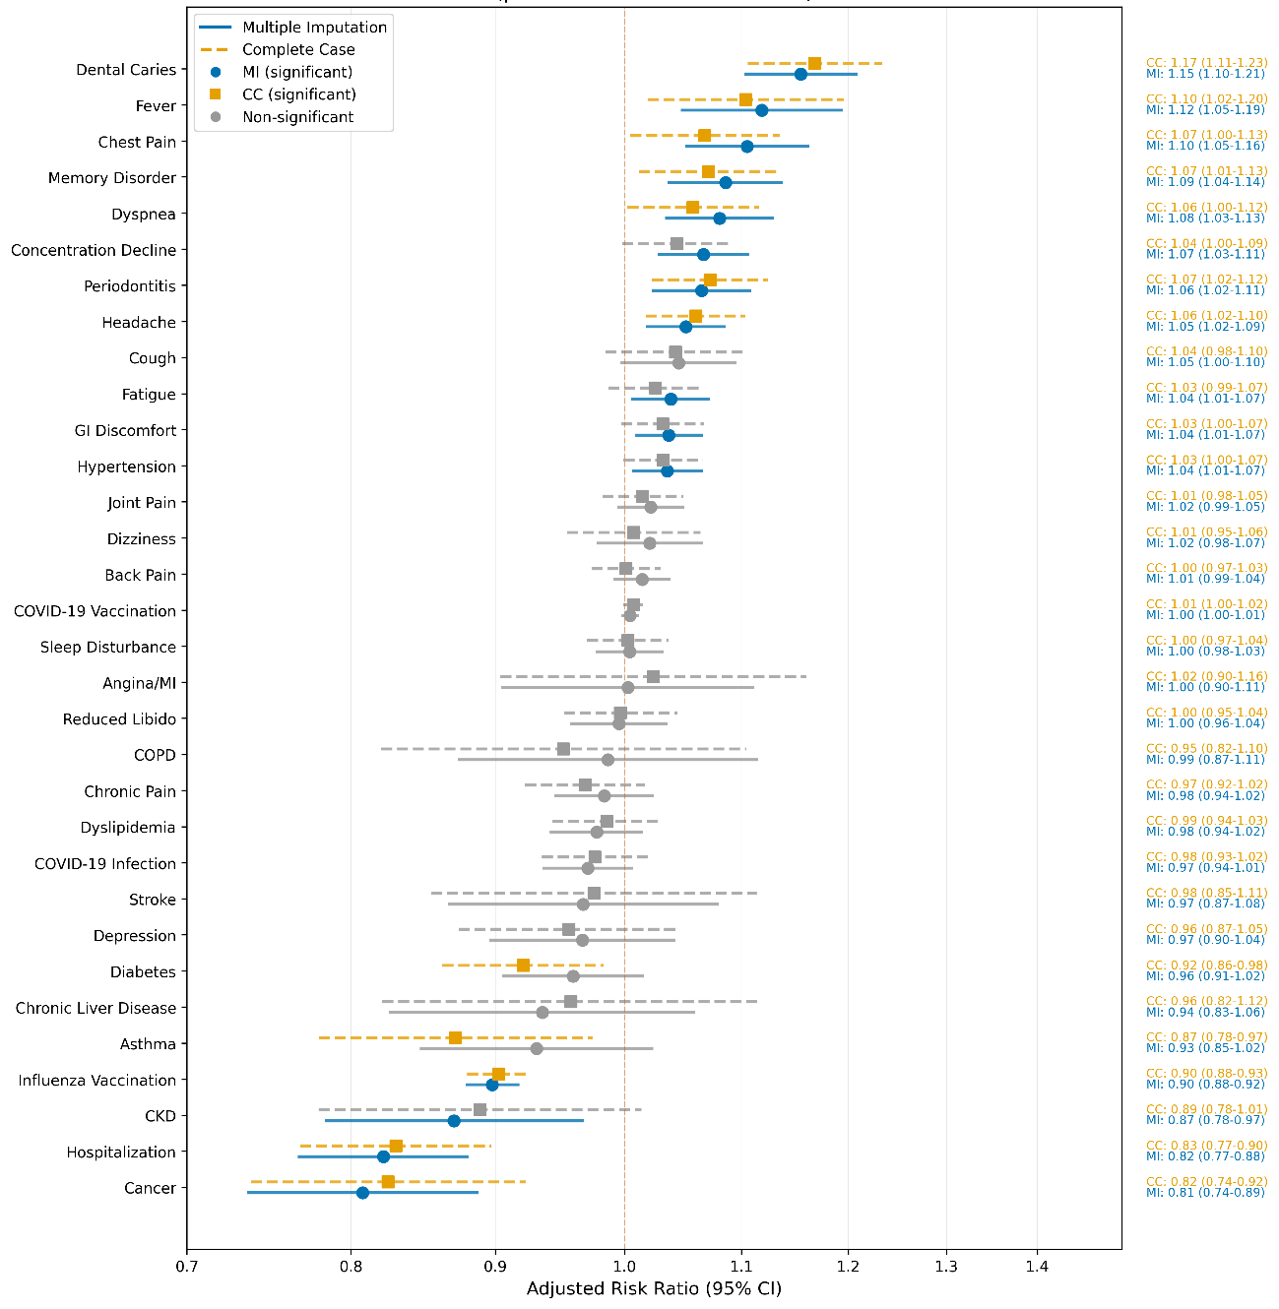
Blue solid lines with circles indicate multiple imputation results with statistical significance (P < .05). Orange dashed lines with squares indicate complete case analysis results with statistical significance (P < .05). Gray symbols indicate non-significant associations (P ≥ .05). Horizontal lines represent 95% confidence intervals. Vertical dashed line at 1.0 indicates null effect. Values on the right show point estimates (95% CI) for both MI and CC analyses. All models adjusted for baseline demographic (age, sex, education, income), social (living alone, social support), behavioral (smoking, alcohol consumption, physical activity, health checkup attendance), and health status (body mass index, self-rated health) factors. aRR, adjusted risk ratio; CC, complete case analysis; CI, confidence interval; CKD, chronic kidney disease; COPD, chronic obstructive pulmonary disease; COVID-19, coronavirus disease 2019; GI, gastrointestinal; HI, health indifference; MI, multiple imputation using chained equations; SD, standard deviation.

Supplementary Figure 3. Causal Network: Symptom Outcomes
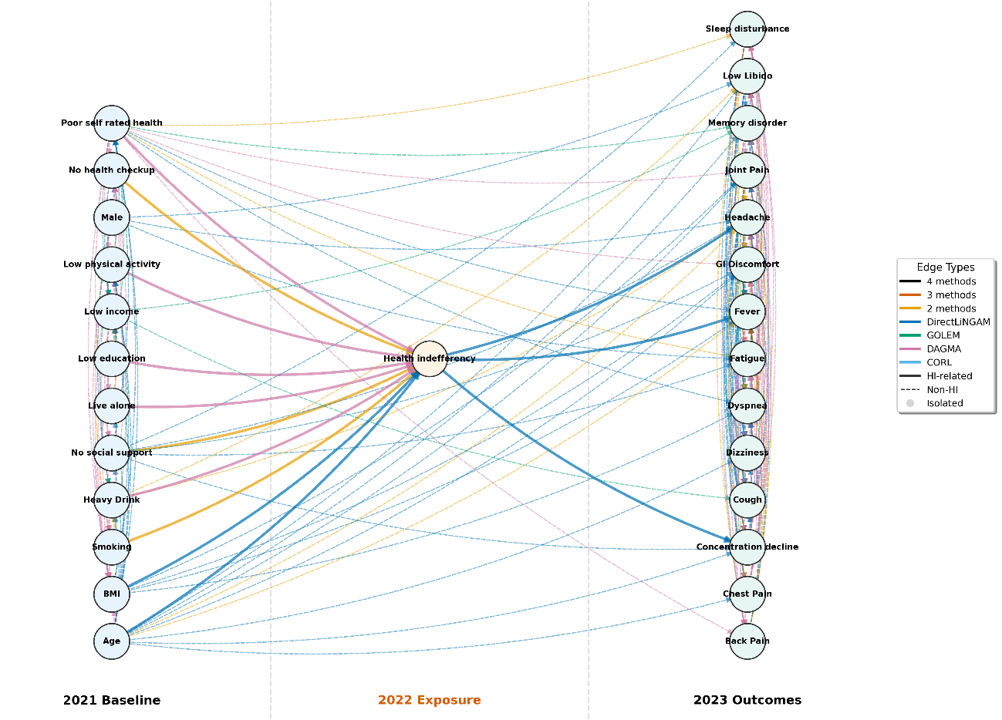
Network visualization showing 27 nodes (27 connected, 0 isolated) with 206 directed edges. Edge colors indicate consensus across four causal discovery algorithms: orange (all 4 methods), purple (3 methods), pink (2 methods), light blue (DirectLiNGAM only), light green (GOLEM only), black (DAGMA only), blue (CORL only). Solid lines represent HI-related pathways; dashed lines represent non-HI pathways. Gray circles indicate isolated nodes. BMI, body mass index; CORL, causal ordering via reinforcement learning; DAGMA, directed acyclic graphs via M-matrices and acyclicity characterization; DirectLiNGAM, direct linear non-Gaussian acyclic model; GI, gastrointestinal; GOLEM, gradient-based optimization learning for estimation of DAGs with continuous optimization; HI, health indifference

