Supplemental Material

From Qubits to Qumodes: Information Capacity of Anyonic Excitations

Satish Prajapati*, †
Department of Ceramic Technology, Government College of Engineering and Ceramic Technology
73, Abinash Chandra Banerjee Ln, Phool Bagan, Beleghata, Kolkata, West Bengal 700010

*Satish Prajapati: ORCID iD: 0009-0006-3801-1137
†Contact author: iamsatish.gcect.ac@gmail.com

This document contains:
· Supplementary Note 1: Detailed Derivation of the Partition Function
· Supplementary Note 2: Maximum Entropy and the Uniform Distribution
· Supplementary Note 3: Finite-Temperature Analysis
· Supplementary Note 4: Connection to the Holevo Bound
· Supplementary Note 5: Extended Discussion on Experimental Realization
. Supplementary Note 6: Quantum Information Application: The Anyonic Qudit
. Supplementary Note 7: Outlook on Non-Abelian Statistics
· Supplementary Figures S1–S4
· Supplementary References

- Detailed Derivation of the Partition Function

This derivation assumes the grand canonical partition function for a single state factorizes, which holds for non-interacting particles or serves as an effective description for the statistical mechanics of Haldane exclusion statistics [19]. The partition function for a single quantum state with a maximum occupancy of m particles is defined by the sum over all allowed occupation numbers:

$$Z=\sum_{n=0}^{m}{e^{-βn\left(ϵ-μ\right)}},$$

where $β=1/\left(k_{B}T\right),$ is the energy of the state, and $μ$ is the chemical potential. This is a finite geometric series. Using the identity for the sum of a geometric series,

$$\sum_{k=0}^{K}{r^{k}}=\frac{1-r^{K+1}}{1-r}, \text{for }r≠1,$$
$and setting r=e^{-β\left(ϵ-μ\right)},$ we obtain:
$$Z=\sum_{n=0}^{m}{r^{n}}=\frac{1-r^{m+1}}{1-r}=\frac{1-e^{-β\left(m+1\right)\left(ϵ-μ\right)}}{1-e^{-β\left(ϵ-μ\right)}}.$$

This is the general form used in the main text. The probability of occupancy n is given by the Boltzmann factor normalized by the partition function: $P\left(n\right)=e^{-βn\left(ϵ-μ\right)}/Z$.

- Maximum Entropy and the Uniform Distribution

The von Neumann entropy $S=-\sum_{n=0}^{m}{P\left(n\right)}\log_{2}{P}\left(n\right)$ is maximized when the probability distribution is uniform. We prove this using the method of Lagrange multipliers to maximize S under the constraint $\sum_{n=0}^{m}{P\left(n\right)}=1$.

The Lagrangian is:
$$Λ=-\sum_{n}{P\left(n\right)}\ln{P}\left(n\right)+λ\left(\sum_{n}{P\left(n\right)}-1\right),$$

where we use natural logarithm for convenience (the base of the logarithm in the entropy definition only contributes a multiplicative constant, and the maximum is found at the same distribution). Taking the derivative with respect to P(n):

$\frac{∂Λ}{∂P\left(n\right)}=-\ln{P}\left(n\right)-1+λ=0$.

This implies $\ln{P}\left(n\right)=λ-1$ for all n, meaning all P(n) are equal. From the normalization constraint, with m+1 states, we find:
$P\left(n\right)=\frac{1}{m+1} \text{for all }n$.

Substituting into the entropy formula yields the maximum capacity:

$S_{\text{max}}=-\sum_{n=0}^{m}{\frac{1}{m+1}}\log_{2}\left(\frac{1}{m+1}\right)=\log_{2}\left(m+1\right)$.

Supplementary Figure S1 shows these uniform distributions for different statistics parameters g.

- Finite-Temperature Analysis

The main text focuses on the maximum capacity at $ϵ= μ$. Here, we analyze the entropy S as a function of$β(ϵ- μ$) for different g values. The entropy is calculated from the full expression:

$S=-\sum_{n=0}^{m}{P\left(n\right)}\log_{2}{P}\left(n\right), \text{where} P\left(n\right)=\frac{e^{-βn\left(ϵ-μ\right)}}{Z}$.

Supplementary Figure S2 shows S versus $β\left(ϵ-μ\right)$ for g = 1 (fermions), g = 1/2 (semions), and g = 1/3. The entropy peaks at $ϵ=μ\left(β\left(ϵ-μ\right)=0)\right)$, reaching its maximum value of $(\log_{2}\left(m+1\right)$. The width of the peak decreases as m increases, showing that systems with higher capacity are more sensitive to detuning from the chemical potential.

- Connection to the Holevo Bound

The maximum entropy $\log_{2}\left(m+1\right)$ corresponds to the Holevo bound $χ$ [16], which defines the ultimate classical information capacity of a quantum channel. For a quantum system that can be prepared in states $ρ_{n}$with probabilities $p_{n}$, the bound is:
$$χ=S\left(\sum_{n}{p_{n}ρ_{n}}\right)-\sum_{n}{p_{n}S\left(ρ_{n}\right)},$$
where $S\left(ρ\right)$ is the von Neumann entropy.

In our case, the "states" are the different occupation numbers n. For a quantum dot in the Coulomb blockade regime, these are energy eigenstates and are therefore orthogonal and perfectly distinguishable via a charge measurement. The Holevo bound thus simplifies to the Shannon entropy of the classical source:

$$χ=-\sum_{n=0}^{m}{p_{n}}\log_{2}{p_{n}},$$

which is maximized by the uniform distribution, yielding $χ_{\text{max}}=\log_{2}\left(m+1\right).$ This confirms that our result is consistent with the fundamental limits of quantum information theory.

- Extended Discussion on Experimental Realization
The predicted conductance plateaus for the $ν= 1/3$ state $\left((g=1/3)\right)$ can be observed using quantum dot spectroscopy [18]. Key experimental considerations:

Platform: A GaAs-based two-dimensional electron gas in the fractional quantum Hall regime.
Conditions: High magnetic field ($B ≈10 T$), low temperature (T < 100 mK) [9].

Expected Signals:

· Conductance $dI/dV$: Quantized plateaus as a function of gate voltage $V_{g}$. The number of plateaus (four) is the primary signature, corresponding to the discrete occupancies n = 0, 1, 2, 3. The plateau values are set by tunneling rates and are not expected to be precisely at integer multiples of $e^{2}/h$ [6]. The key prediction is the four-periodicity.

· Shot Noise: Peaks in noise power $S_{I}$ at transitions between plateaus, providing direct signatures of the fractional charge $e^{*}/e=1/$3 tunneling [10,11]. while theoretical analyses of interferometers predict additional singular features in noise arising from anyonic tunneling processes [17].

This four-periodicity is consistent with recent experimental studies of anyonic Fabry-Pérot interferometers, which have observed oscillations with a period of 4 in the phase of the interference pattern, corresponding to the four possible occupation states of an anyon localized within the interferometer [17].

Supplementary Figure S3 shows simulated conductance and shot noise data, illustrating these expected signatures.

- Quantum Information Application: The Anyonic Qudit

The quantization of entropy to $(S_{\text{max}}=\log_{2}\left(m+1\right))$bits, as derived in Supplementary Note 2, has a direct and profound implication: the anyonic state constitutes a native qudit—a higher-dimensional generalization of a qubit. For the (g = 1/3) state $\left(m=3\right),$ this corresponds to a four-level quantum system or "ququart," capable of encoding two bits of classical information.

- Qudit Readout Principle
The projective measurement of the qudit state is performed by a direct conductance measurement. The quantized conductance $( G ∝n )$serves as the pointer variable, projecting the system onto one of the four orthogonal charge occupancy eigenstates $\left(n=0,1,2,3\right).$ A single-shot measurement of $( G )$thus yields a direct readout of the two-bit state, a significant advantage over sequential measurements often required for multi-qubit systems.

- Hardware Implementation and Resource Analysis
Supplementary Figure S4 illustrates the proposed readout circuitry and contrasts it with the conventional approach.

- Panel a (Anyonic Qudit): The readout requires a single quantum dot tuned to the $( g = 1/3 )$ state, controlled by one plunger gate $\left(V_{g}\right),$ with one pair of source (S) and drain (D) contacts, and a single analog-to-digital converter (ADC) for measurement.

- Panel b (Two Qubits): Encoding the same 4-dimensional Hilbert space with standard qubits requires two physically isolated quantum dots, two independent plunger gates $(V_{g1},V_{g2}$ ), two pairs of contacts, and two separate measurement circuits (ADC1, ADC2).

- Distinguishability and the Orthogonality of States
A valid qudit requires its computational basis states to be distinguishable. In this system, the charge occupancy states $( |n⟩$ \) are energy eigenstates (due to the large charging energy in the Coulomb blockade regime) and are therefore orthogonal $(\left(\left\langle n | n^{'}\right\rangle =δ_{nn^{'}}\right))$. A charge sensor (e.g., a quantum point contact or single-electron transistor) can distinguish between these states with high fidelity, fulfilling this requirement [20].

- Outlook towards Quantum Operations

While this work establishes the readout principle for a static anyonic qudit, performing quantum gate operations would require the controlled manipulation of superpositions of these charge states. This presents a fertile ground for future theoretical and experimental work, potentially leveraging microwave irradiation or non-adiabatic gate pulses for coherent control.

- Outlook on Non-Abelian Statistics

The theoretical framework developed here for the information capacity of quantum states governed by Haldane exclusion statistics is explicitly derived for abelian anyons. A natural and significant extension of this work involves its application to systems exhibiting non-abelian statistics, such as those predicted to exist in the $ν= 5/2$fractional quantum Hall state or in certain topological superconductors [S21, S22].

The fundamental distinction of non-abelian anyons is that their exchange operations are described by unitary transformations acting on a degenerate ground state manifold, rather than simple phase factors. The key quantity characterizing these excitations is the quantum dimension $d ≥1$, with $d > 1$ indicating non-abelian statistics. The quantum dimension quantifies the asymptotic growth of the Hilbert space with the number of particles and is directly related to the topological entanglement entropy [S23].

We posit that the maximum information capacity for a state dominated by non-abelian anyons would be fundamentally governed by this quantum dimension. We propose the following conjecture for the generalized non-abelian information capacity:
$$S_{\text{max}}^{\text{(non-ab)}}=\log_{2}{d}$$

This conjecture is motivated by several robust arguments:

- Hilbert Space Scaling: The dimension of the fusion space for $N$anyons grows as $∼d^{N}$. The associated von Neumann entropy for a uniform distribution over these states is extensive and proportional to $\log_{2}{d}$per anyon.

- Topological Entanglement Entropy: The constant sub-leading term in the entanglement entropy of a topological region is $γ=\log_{2}{d},$which represents the irreducible long-range quantum information encoded in the anyonic state [S23].

- Generalization of Abelian Case: For abelian anyons, the quantum dimension is $d=1,$ and our derived capacity $S_{\text{max}}\left(g\right)$ = $\log_{2}\left(\left\lfloor 1/g\right\rfloor +1\right)$ depends solely on the maximum occupancy. For non-abelian anyons, $d$subsumes this role, characterizing the effective number of degrees of freedom per anyon.

For instance, the Ising anyon model (a candidate for $ν=5/2$) has quantum dimension $d=\sqrt{2},$ which would imply a per-state information capacity of$0.5$bits. While this is lower than the 2-bit capacity we predict for the $ν=1/3$ state, the distinguishing feature of non-abelian anyons is the collective, topologically protected Hilbert space formed by their braiding, which is the basis for fault-tolerant topological quantum computation [S21].

A rigorous derivation of an exclusion statistics framework for non-abelian anyons, culminating in a partition function and an explicit form for $S_{\text{max}}^{\text{(non-ab)}},$ remains an open challenge. It would require a careful formulation of state counting rules within the constraints of fusion rules. Our present work provides the essential abelian limit and a clear conceptual foundation for this future endeavor. Experimentally, probing this capacity would require techniques sensitive to the quantum dimension and non-abelian braiding statistics, such as noise correlations [S24].

Supplementary Figures
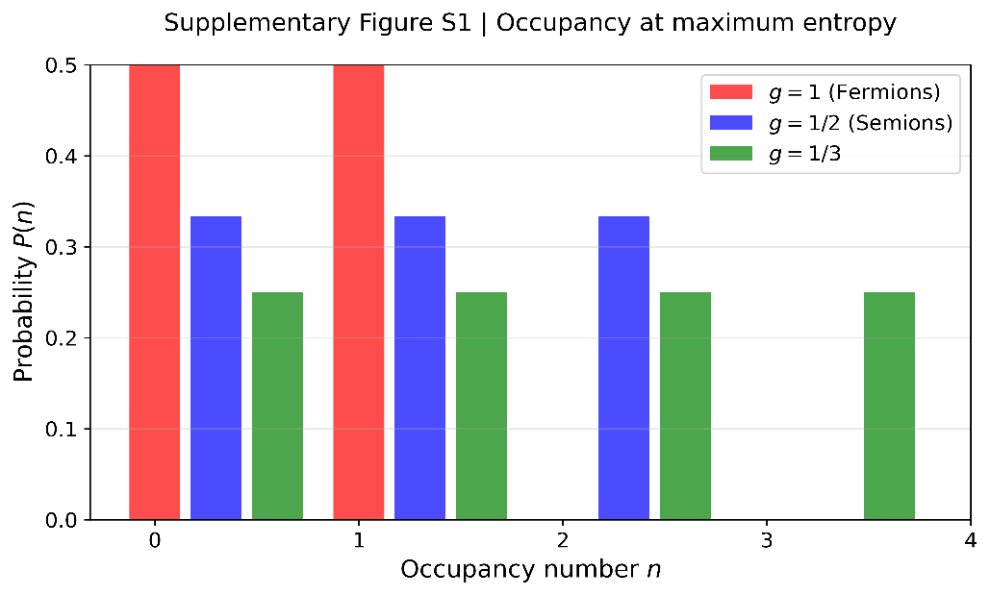

Supplementary Figure S1 | Occupancy probability distributions at maximum entropy. The probability distribution P(n) of finding n anyons in a single quantum state is shown for three different values of the exclusion statistics parameter g. At maximum entropy, which occurs when the energy level is aligned with the chemical potential $\left(ϵ=μ\right),$ all allowed occupational states are equally probable.

This results in a uniform distribution, and the corresponding maximum von Neumann entropy (information capacity) is $(S_{\text{max}}=\log_{2}\left(m+1\right),$ where $m = ⌊1/g ⌋$ is the maximum allowed occupancy. For fermions $\left(g=1,m=1\right),$ the capacity is 1 bit (qubit). For semions $\left((g=1/2,m=2)\right)$ and the $(g=1/3case \left((m=3)\right),$ the capacities are approximately 1.585 bits and 2 bits, respectively.

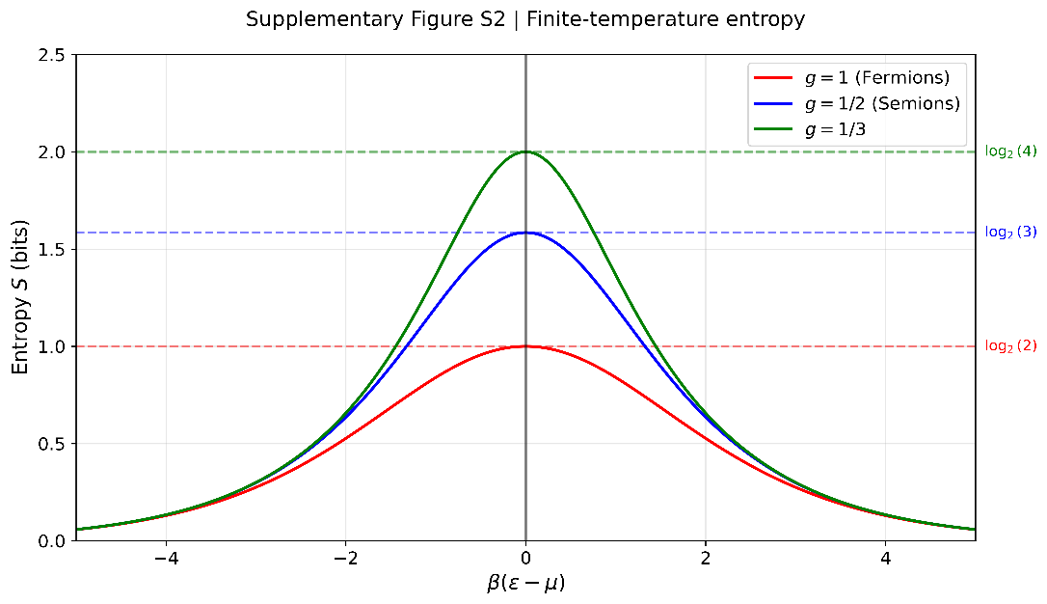

Supplementary Figure 2 | Finite-temperature dependence of the entropy. The von Neumann entropy S is plotted as a function of the detuning from the chemical potential, $β\left(ϵ-μ\right),$ for three different statistics parameters g. The entropy reaches its theoretical maximum, $S_{\text{max}}=\log_{2}\left(m+1\right)$(indicated by dashed horizontal lines), only when the energy level is precisely tuned to the chemical potential $\left(ϵ=μ)\right).$ The width of the entropy peak narrows as the maximum occupancy (m increases, indicating that systems with higher information capacity (e.g., $(g=1/3)$) require more precise energy-level tuning to achieve their full capacity.

Supplementary Figure 3 | Simulated experimental signatures for the $ν= 1/3$ state. (a) Theoretical prediction for the differential conductance $dI/dV$ through an anyon-trapping quantum dot as a function of gate voltage $V_{g}$. The four distinct plateaus correspond to the quantum dot being occupied by n = 0, 1, 2, 3 anyons (labeled), directly demonstrating the 2-bit information capacity predicted for statistics parameter g = 1/3. The conductance values are given in units of the fundamental quantum $e^{2}/9h$for charge-$e/3$ quasiparticles. (b) The corresponding predicted shot noise power $S_{I}$. Peaks in the noise spectrum occur at the transitions between conductance plateaus and provide a signature of the fractional charge $e^{*}=e/3$ tunneling through the dot.

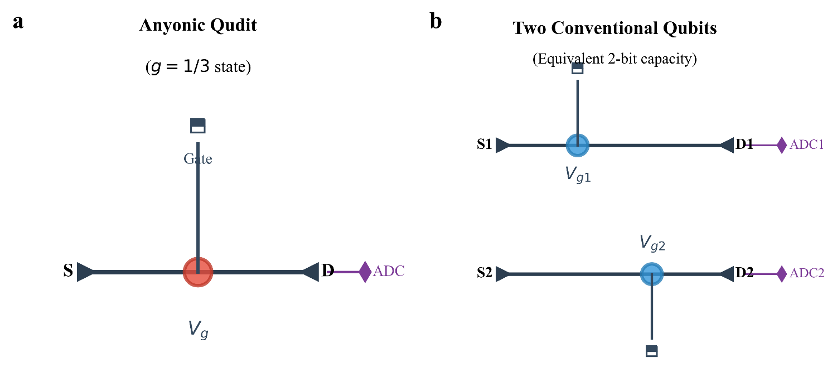

Supplementary Figure S4 | Quantum circuit implementation of an anyonic qudit. a, Measurement setup for a single anyonic qudit in the $( g = 1/3 )$ state. A single quantized conductance measurement across the source (S) and drain (D) terminals, controlled by a plunger gate $\left(V_{g}\right),$projects the state onto one of four charge occupancy $states \left((n=0,1,2,3)\right),$ encoding two bits of information. b, Equivalent setup for two conventional qubits required to span the same 4-dimensional Hilbert space, necessitating duplicate hardware.

Supplemental Material References [16–20]
[16] A. S. Holevo, IEEE Trans. Inf. Theory 44, 269 (1998).
[17] D. E. Feldman, Y. Gefen, A. Kitaev, K. T. Law, and A. Stern, arXiv:cond-mat/0612608 (2006).
[18] J. Nakamura, S. Liang, G. C. Gardner, and M. J. Manfra, Phys. Rev. X 13, 041012 (2023).
[19] Y.-S. Wu, Phys. Rev. Lett. 73, 922 (1994).
[20] M. D. LaHaye, J. Suh, P. M. Echternach, K. C. Schwab, and M. L. Roukes, Nature 459, 960 (2009).
[S 21] C. Nayak, S. H. Simon, A. Stern, M. Freedman, and S. Das Sarma, Rev. Mod. Phys. 80, 1083 (2008).

[S 22] G. Moore and N. Read, Nucl. Phys. B 360, 362 (1991).

[S23] A. Kitaev and J. Preskill, Phys. Rev. Lett. 96, 110404 (2006).

[S24] J. M. Lee, J. Y. Lee, and H.-S. Sim, Phys. Rev. Lett. 123, 016803 (2019).

