supplementary materials
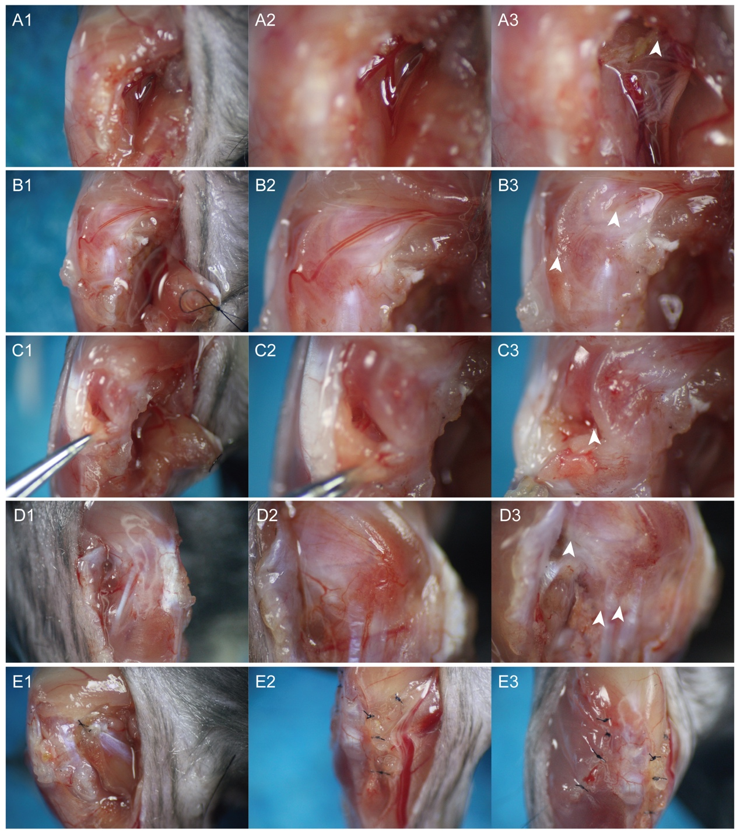
Supplementary Figure 1. Stepwise surgical procedure for establishing the JIO model.
A1–A3 Medial knee approach to expose the popliteal vessels; cauterization of the popliteal vessels (white arrow in A3).B1–B3 Medial capsulotomy to expose the medial proximal genicular vessels (MPGV); Cauterization of the MPGV (white arrow in B3).C1–C3 Retraction of Hoffa’s fat pad to expose the central genicular vessel (CGV); Cauterization of the CGV (white arrow in C3).D1–D3 Additional lateral incision to expose the lateral proximal genicular vessels (LPGV) and the lateral genicular vessels (LGV); Cauterization of the lateral epiphyseal vessels and their branches (white arrow in D3).E1–E3 Layered closure: E1, repair of the medial head of the gastrocnemius; E2, closure of the joint capsule and medial hamstrings; E3, closure of the lateral joint capsule and lateral hamstrings.

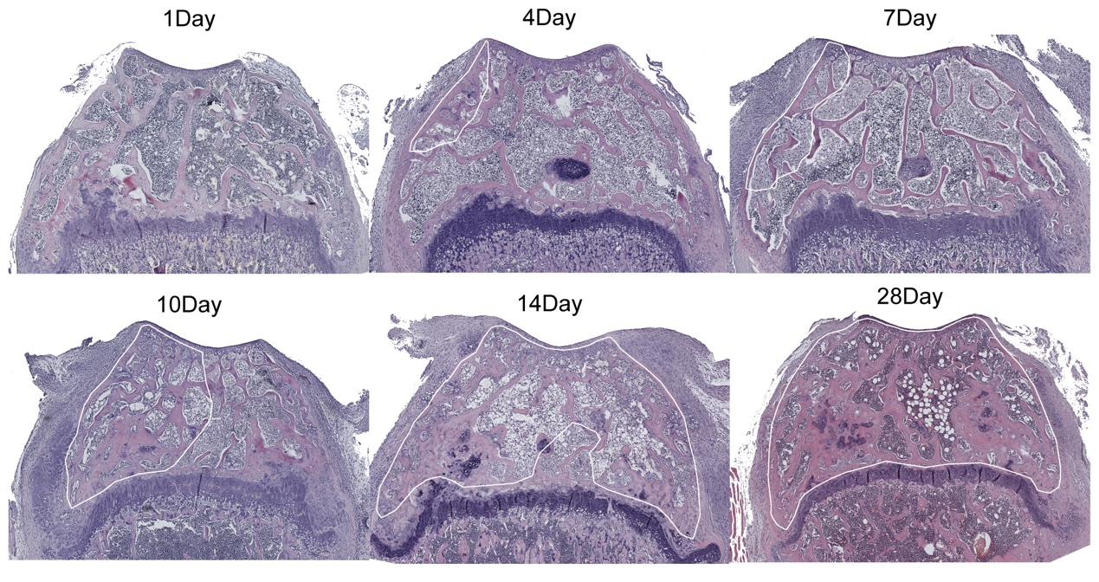
Supplementary Figure 2. Extent of epiphyseal repair at days 1–28 post-surgery (white outline delineates the repaired region).

