Supplementary Information

Portable Electrochemical Sensing Platform for Aflatoxin B1 Detection in Food Matrices
Kundan Kumar Mishra¹, Krupa M Thakkar¹, Vikram Narayanan Dhamu²,
Sriram Muthukumar², Shalini Prasad ^{1,2*}
¹Department of Bioengineering, University of Texas at Dallas, Richardson, TX 75080, USA,
²EnLiSense LLC, 1813 Audubon Pondway, Allen, TX 75013, USA.
Corresponding email: shalini.prasad@utdallas.edu

Table S1: Maximum limit of Aflatoxin B1 by food product as per EU standards [1].
Food Product | Maximum Limit (ppb)
Peanuts, dried fruit, nuts for human consumption | 2
Peanuts before being processed or peanuts added as an ingredient to a food for human consumption | 8
Nuts or dried fruit before being processed or peanuts added as an ingredient to a food for human consumption | 5
Cereals and their processed form or as an ingredient in food for human consumption | 2
Feed material from peanuts, palm-kernel, corn, copra, cottonseed, and their processed forms | 20
Feed for dairy cattle | 5
Feed for mature pigs and poultry | 20

Table S2: Comparison of the developed immunosensor with other studied label-free detection of AFB1.
Device Type/ Detection Method | Mycotoxin Detected | Sample Type | LoD | Linear Detection Range | Assay Time | Reference
Chronoamperometry | Aflatoxin | Milk | 0.01 ppb | 0.005-0.5 ppb | 15 minutes for sample preparation  Time for reading not given | [2]
Aptameric | Aflatoxin | Corn | 0.1 ng/mL | 0.01-10 ng/mL | 20 minutes for sample preparation  20 minutes for incubation and reading time | [3]
Fluorescence (Smartphone Camera) | Aflatoxin | Maize | 20 ng/mL | 20-100 ng/mL | 16 minutes sample preparation  1 minute for reading | [4]
Aptameric | Aflatoxin | Red wine and Beer | 0.4 nM | 0.4-200 nM | 13 minutes sensor preparation time  6 minutes total runtime for reading | [5]
Cyclic Voltammetry and Square Wave Voltammetry | Aflatoxin | Corn Powder | 3.5 pg/mL | 0.01-100 ng/mL | 15.5 hours for sensor and sample preparation  1.5+ hours total runtime for reading | [6]
Aptameric with Fluorescence | Aflatoxin | Corn + peanut + oatmeal + rice mixture  And  Peanut Oil + Corn Oil mixture | 0.13 ng/mL | 0.5-50 ng/mL | 41.5+ hours for sensor and sample preparation  Time for reading not given | [7]
Electrochemical Impedance Spectroscopy | Aflatoxin B1 | Corn | 0.005 ng/mL | 0.01-40.96 ng/mL | 5 minutes | This paper

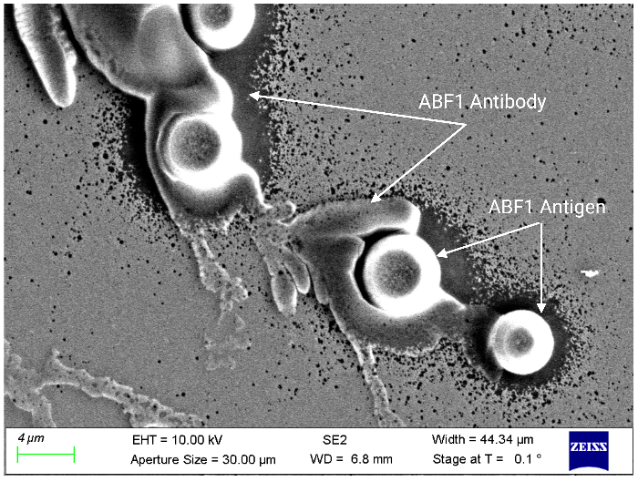
Fig. S1. SEM image showing antibody-antigen binding on the sensor surface, confirming successful AFB1 recognition.
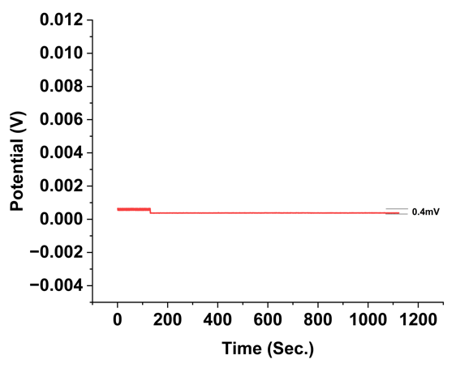
Fig S2 Show the stability performance of the prepared antibody-based sensor in overnight corn soaked matrix, measured using OCP for 1200 seconds for Aflatoxin B1

Fig. S3 Nyquist plot for Aflatoxin B1 antigens on sensor platform respectively for the 0.01 ng/mL to 40.96 ng/mL spiked dose concentrations in overnight soaked corn sample.
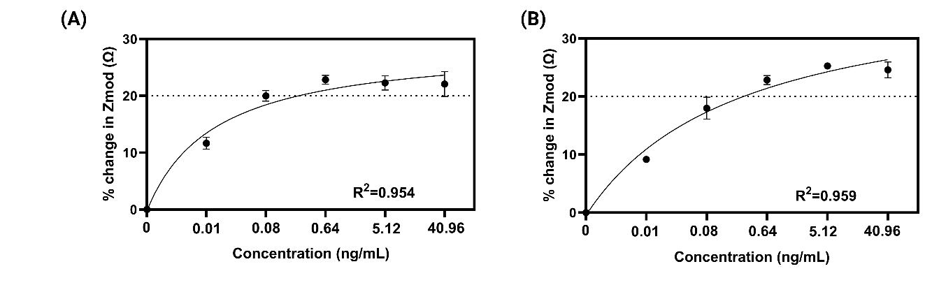
Fig S4 (A) Impedance response of the bare electrode exposed to increasing concentrations of Aflatoxin B1 (AFB1). The total percentage change in impedance remains below 25% and saturates after the second dose, indicating limited or no binding capability in the absence of surface modification. (B) Impedance response of the electrode modified only with blocking solution, showing negligible signal variation across all AFB1 concentrations. This confirms the effectiveness of the blocking layer in preventing nonspecific adsorption and further validates that the calibration signals in the functionalized sensor arise from specific antibody-antigen interactions.
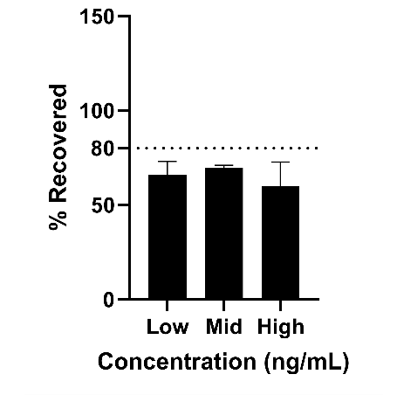
Fig. S5 The recovery graph illustrates the sensor's performance in detecting Aflatoxin M1 using the Aflatoxin B1 sensor at 400 Hz across various concentrations.

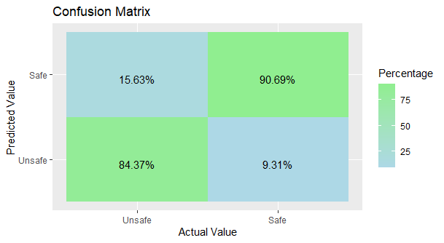
Fig. S6 The confusion matrix indicates the following values: True Positive rate of 90.69%, True Negative rate of 84.3%, False Positive rate of 15.6%, and False Negative rate of 9.3%.

References:
[1] E. Dohlman, “Mycotoxin Hazards and Regulations,” U.S Department of Agriculture, 2003. [Online]. Available: https://www.ers.usda.gov/webdocs/publications/41603/15640_aer828h_1_.pdf?v=0
[2] N. Paniel, A. Radoi, and J.-L. Marty, “Development of an Electrochemical Biosensor for the Detection of Aflatoxin M1 in Milk,” Sensors, vol. 10, no. 10, pp. 9439–9448, 2010, doi: 10.3390/s101009439.
[3] W.-B. Shim, M. J. Kim, H. Mun, and M.-G. Kim, “An aptamer-based dipstick assay for the rapid and simple detection of aflatoxin B1,” Biosens Bioelectron, vol. 62, pp. 288–294, 2014, doi: 10.1016/j.bios.2014.06.059.
[4] T. Sergeyeva et al., “Development of a smartphone-based biomimetic sensor for aflatoxin B1 detection using molecularly imprinted polymer membranes,” Talanta, vol. 201, pp. 204–210, 2019, doi: 10.1016/j.talanta.2019.04.016.
[5] L. Sun, L. Wu, and Q. Zhao, “Aptamer based surface plasmon resonance sensor for aflatoxin B1,” Microchimica Acta, vol. 184, no. 8, pp. 2605–2610, 2017, doi: 10.1007/s00604-017-2265-5.
[6] X. Zhang et al., “A novel electrochemical immunosensor for highly sensitive detection of aflatoxin B1 in corn using single-walled carbon nanotubes/chitosan,” Food Chem, vol. 192, pp. 197–202, 2016, doi: 10.1016/j.foodchem.2015.06.044.
[7] H. Tan et al., “A novel fluorescence aptasensor based on mesoporous silica nanoparticles for selective and sensitive detection of aflatoxin B1,” Anal Chim Acta, vol. 1068, pp. 87–95, 2019, doi: 10.1016/j.aca.2019.04.014.

