Supporting Information
Selenium-Doped Carbon Dots Nanozymes Block Neuronal Pyroptosis through GPX4/ROS/NLRP3/GSDMD Axis to Attenuate Ischemic Stroke
Jiaxuan Hou^{1#}, Li Yao^{2#}, Yane Li¹, Enrui Xie³, Jiawei Zhang¹, Hao Wu¹, Yuanyuan Zhu⁴, Zhichao Deng⁴, Chenxi Xu⁴, Lu Bai⁵, Mingzhen Zhang⁴, Shaoying Lu^{1∗}, Runqing Li^{5,6∗}, and Hui Cai^{1∗}

Affiliations:
- Department of Vascular Surgery, The First Affiliated Hospital of Xi’an Jiaotong University, Xi’an, Shaanxi, 710061, China
- Department of Neurology, XD Group Hospital, Xi’an, Shaanxi, 710077, China
- Department of Cardiology, The Second Affiliated Hospital of Xi’an Jiaotong University, Xi’an, Shaanxi, 710114, China
- School of Basic Medical Sciences, Xi’an Jiaotong University, Xi’an, Shaanxi, 710061, China
- Department of Radiology, The First Affiliated Hospital of Xi’an Jiaotong University, Xi’an, Shaanxi, 710061, China
- Xi’an Key Laboratory of Medical Computational Imaging, Xi’an, Shaanxi, 710061, China

∗ Authors for correspondence

Shaoying Lu (ORCID: 0000-0002-0309-5151)
Email address: robertlu@mail.xjtu.edu.cn

Runqing Li (ORCID: 0000-0003-3822-3966)
Email address: lirunqing718@xjtu.edu.cn

Hui Cai (ORCID: 0000-0001-5805-8270)
Email address: caihui@xjtufh.edu.cn

Materials and Methods
Characterization of Se-CDs, Se-CD@LP-PEG, and Se-CD@LP-GSH
Transmission electron microscopy (TEM; Thermo Fisher Scientific, USA) was utilized to observe the morphological features of the NPs. A Zetasizer Nano ZS90 (Malvern Instruments, UK) was employed to evaluate the surface charge (zeta potential) and hydrodynamic particle size. Ultraviolet–visible (UV/Vis) absorption spectra of Se-CDs were measured with a UV/Vis spectrophotometer (Thermo Fisher Scientific, USA). Functional groups present on the nanoparticle surface were identified through Fourier-transform infrared (FTIR) spectroscopy (Bruker, Germany). Surface elemental composition was investigated through X-ray photoelectron spectroscopy. (XPS; Thermo Fisher ESCALAB Xi+, USA), enabling in-depth analysis of surface functionalities and doping profiles. Additionally, electron paramagnetic resonance (EPR) measurements were carried out on a CIQTEK EPR200M spectrometer operating in continuous-wave X-band mode to probe unpaired electron species.
ROS scavenging ability evaluation
ABTS assay: The overall antioxidant capacity of the NPs was assessed by a commercially available assay kit (S0119, Beyotime, China). In brief, the NPs were added to the ABTS•⁺ working solution and stayed at ambient temperature for 3 minutes. The absorbance was then recorded at 734 nm. The radical scavenging activity was quantified using the equation: $Scavenging ablitity\left(\%\right) = \frac{A_{ABTS}-A_{Sample}}{A_{ABTS}} × 100$. Where $A_{ABTS}$ is the absorbance of the untreated ABTS•⁺ solution, and $A_{Sample}$ denotes the absorbance in the presence of NPs.
TMB assay: The ability of the NPs to neutralize •OH radicals was assessed using a TMB-based colorimetric method. A solution comprising 100 μM FeSO₄, 500 μM H₂O₂, and 3 mM TMB was mixed with different NPs concentrations and kept in darkness for 10 minutes. The absorbance of the mixture was recorded at 645 nm. The scavenging capacity was determined using the same equation applied in the ABTS•⁺ assay.
NBT assay: The ability of the NPs to neutralize O₂•⁻ radicals was acquired by the nitroblue tetrazolium (NBT) reduction assay. NPs at varying concentrations were added to a reaction mixture containing 0.05 mM NBT, 13 mM L-methionine, and 20 μM riboflavin in 25 mM PBS, followed by LED light exposure for 5 minutes to initiate the reaction. Absorbance at 560 nm was recorded, and the scavenging capacity was determined using the same equation applied in the ABTS•⁺ assay.
Glutathione peroxidase (GPx) assay: Two different commercial assay kits were used to measure GPx activity in this study. GPx Assay Kit (Yuanye Biotechnology Co., Ltd., China) was employed to assess the GPx activity of NPs. GPx could catalyze the oxidation reaction between GSH and benzoic acid chromogenic solution, resulting in the formation of a yellow anion. The concentration of this anion is acquired by measuring the absorbance at 422 nm using a microplate reader. According to the decline in GSH levels, the GPx activity can be quantitatively calculated. In addition, the Cellular GPx Assay Kit (S0056, Beyotime, China) with NADPH was employed to assess the GPx activity of NPs. In this assay, GPx catalyses the conversion of GSH into its oxidized form, glutathione disulfide (GSSG). Concurrently, Glutathione reductase restores GSH from GSSG by utilizing NADPH as an electron donor. The enzymatic activity of GPx was quantitatively determined by monitoring the decrease in optical density (OD) at 340 nm, corresponding to the consumption of NADPH. Since GPx serves as the rate-limiting enzyme in this coupled reaction system, the rate of NADPH oxidation is directly proportional to GPx activity, enabling precise evaluation of enzymatic function.
Cytotoxicity assessment
The cytotoxic effects of the NPs were measured by the CCK-8 assay (C0005, Topscience, China). bEnd.3, SH-SY5Y, and HT-22 cells were seeded at 1 × 10⁴ cells/well and cultured for 24 hours in 96-well plates. After attachment, the medium was renewed with fresh DMEM containing NPs, followed by a 24-hour incubation under standard culture conditions (37 °C, 5% CO₂). 100 μL of CCK-8 solution was then added per well, with a subsequent 2-hour incubation. The absorbance at 450 nm was determined, and relative cell viability was expressed as a fraction of the control group to quantify NP-induced cytotoxic effects
Neurological function test
Male C57BL/6 mice (8–10 weeks old) were randomly divided into experimental groups and underwent tMCAo surgery. Mice with a neurological score between 2-3 were selected for subsequent experiments, indicating moderate neurological impairment. There were five groups: Sham+Saline group; tMCAo+Saline group; tMCAo+Se-CD@LP-GSH group (2.5 mg/kg); tMCAo+Se-CD@LP-GSH group (5 mg/kg); tMCAo+Edaravone. Se-CD@LP-GSH and Edaravone [1] were dispersed in sterile Saline and administered via tail vein injection starting at 2 hours after reperfusion. According to the clinical dosage stated in the Edaravone (H20080495, Kunming Jida Pharmaceutical Co., Ltd, China) drug label (0.5 mg/kg in humans) and applying interspecies scaling based on body surface area, the starting dose for mice was determined to be 5 mg/kg. The treatment was continued every other day for a total of five days.
mNSS score: Neurological impairments were evaluated using the mNSS scale, which measures motor skills, sensory responses, balance, and reflexes. Elevated scores correspond to greater severity of deficits.^{[2]}
Cylinder Test: Mice were placed in a transparent glass cylinder, and their spontaneous wall contacts with the left, right, or both forelimbs were video-recorded over 10 minutes. The asymmetry rate was calculated as follows: Asymmetric (%) = (L-R)/(L+R+B)×100%. (L: left forelimb contact, R: right forelimb contact, B: both forelimbs contact)
Adhesive Test: This test assessed sensory function and forelimb coordination. A 3 × 3 mm² adhesive tape was applied to the plantar surface of each forepaw. The time taken to detect and remove the tape was recorded. Mice were pre-trained prior to surgery, and those unable to remove the adhesive within 60 seconds were excluded from further testing.
Morris water maze: From days 22 to 28 post-tMCAo, it was performed within a 110-cm-diameter pool filled with opaque water (made white using non-toxic titanium DiOxide). A concealed circular 11-cm-diameter platform was placed 1.5 cm under the water surface in the third quadrant. In the learning stage test from day 22 to day 28 after tMCAo, each mouse was placed into the water from the first quadrant, and the duration for the animal to locate the hidden platform was documented. Each trial lasted a maximum of 90 seconds.
We tested the learning ability at 27 days after tMCAo. On day 28, the platform was taken away. Mice were placed in the first quadrant, and their swimming trajectories were tracked for 90 seconds. patial memory retention was assessed by measuring the time the subject remained in the target quadrant.
H&E staining
After euthanasia, mouse brain tissues were collected and sliced into 6 μm sections for H&E staining. The histological alterations were then observed using a light microscope.

Hemolysis analysis
Fresh mouse blood was collected in tubes and subjected to three washes with PBS (centrifuged at 3500 rpm for 5 minutes at 4°C). The resulting red blood cells were diluted in PBS at a 1:10 ratio (packed cell volume to PBS). Solutions of Se-CD@LP-GSH (0.8 mL) at varying concentrations were combined with 0.2 mL of the RBC suspension. PBS used as the negative control, while deionized water was used as the positive control. Following a 4-hour incubation at 37°C, the samples were centrifuged, and the supernatant's absorbance was measured at 540 nm. Experiments were performed in triplicate. The hemolysis percentage was determined using the formula below:
$$Hemolysis rate \left(\%\right)=\left(\frac{{OD}_{test}-{OD}_{negative control}}{{OD}_{positive control}-{OD}_{negative control}}\right)×100\%$$

Figure S1. Characterization of Se-CDs. A) UV/Vis absorption of Se-CDs. B) Fluorescence spectra of Se-CDs. C) FTIR spectrum of Se-CDs.

Figure S2. ROS scavenging activity of Se-CDs. UV/Vis absorbance spectra of ABTS•⁺ radicals (A) and •OH (B) after incubation with Se-CDs. C) GPx-like ability of Se-CDs.

Figure S3. Characterization of Se-CDs@LP-GSH. A) DLS results of Se-CD@LP-GSH. B and C) Diameter (B) and Zeta potential (C) changes of Se-CD@LP-GSH and Se-CD@LP-PEG over different incubation times.

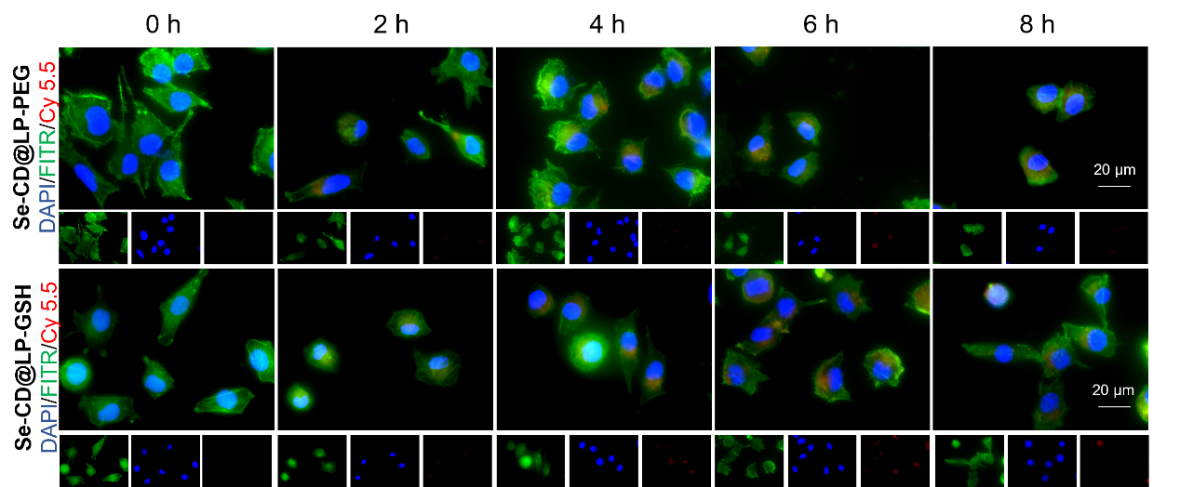
Figure S4. Fluorescence imaging of SH-SY5Y after incubation with Se-CD@LP-GSH or Se-CD@LP-PEG.

Figure S5. Cytotoxicity assessment of Se-CD@LP-GSH on HT-22 cells for 24h (A) and bEnd.3 cells for 24h (B).

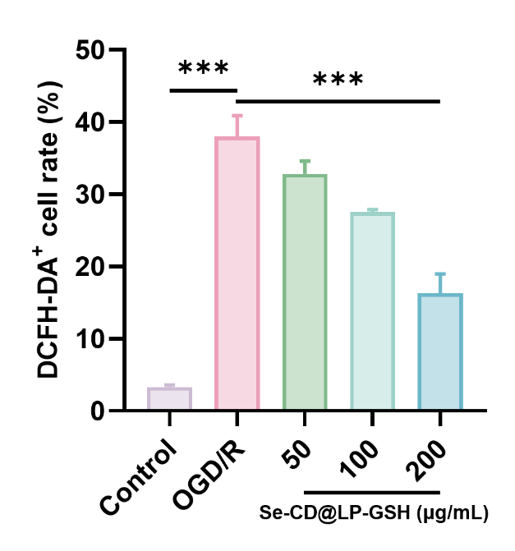
Figure S6. Statistical analysis of DCFH-DA+ cell rate of SH-SY5Y in the OGD/R model after incubation with Se-CD@LP-GSH. (n=3, ***P＜0.001)

Figure S7. Hemolysis of Se-CD@LP-GSH.

Figure S8. Biosafety analysis of Se-CDs. A) H&E staining of the major organs after treatment with Se-CD@LP-GSH. B) Blood biochemistry and complete blood panel analysis of Se-CD@LP-GSH.

Figure S9. The swimming trajectory plots of tMCAo mice treated with saline on Day 23.

Figure S10. Heatmap of differentially expressed genes between tMCAo and tMCAo+Se-CD@LP-GSH groups (fold change＞1.5 and P value＜0.05).

Table S1. The primer sequence used for qRT-PCR on mice in the study.

Gene | Primer Forward | Primer Reverse
NLRP3 | ATCAACAGGCGAGACCTCTG | GTCCTCCTGGCATACCATAGA
GPX4 | GATGGAGCCCATTCCTGAACC | CCCTGTACTTATCCAGGCAGA
IL-1β | CACTACAGGCTCCGAGATGAACAAC | TGTCGTTGCTTGGTTCTCCTTGTAC
IL-18 | CCAGACCAGACTGATAATATAC | CTTGTTCTTACAGGAGAGG

Table S2. The primary antibody used in the study.

Antibidy | Host animal | Dilution for Immunoblot | Dilution for IF | Dilution for IHC | Distributor | Cat. Num.
GSDMD | Rabbiit | 1:1000 |  |  | Abcam | Ab219800
GSDMD-N | Rabbiit | 1:1000 |  |  | Abcam | Ab215203
NLRP3 | Rabbiit | 1:1000 |  |  | Abcam | Ab215203
NLRP3 | Mouse |  | 1:200 |  | Proteintech | 66102-1-Ig
Pro-caspase1 | Rabbiit | 1:1000 |  |  | Abcam | Ab179515
Cleaved caspase1 | Rabbiit | 1:1000 |  |  | Cell signaling technology | Asp296
GPX4 | Rabbiit | 1:1000 | 1:200 |  | Abmart | T56956
β-Tubulin | Mouse | 1:10000 |  |  | Proteintech | 10091-1-AP
IL-1β | Rabbiit |  |  | 1:800 | Servicebio | GB11113-100
IL-18 | Rabbiit |  |  | 1:100 | Selleck | F2146
NeuN | Mouse |  | 1:300 |  | Proteintech | 66836-1-Ig
NeuN | Rabbit |  | 1:300 |  | Proteintech | 26975-1-AP

References

1. Hu Q, Zuo T, Deng L, Chen S, Yu W, Liu S, et al. β-Caryophyllene suppresses ferroptosis induced by cerebral ischemia reperfusion via activation of the NRF2/HO-1 signaling pathway in MCAO/R rats. Phytomedicine. 2022;102.
2. Jiang XC, Xiang JJ, Wu HH, Zhang TY, Zhang DP, Xu QH, et al. Neural Stem Cells Transfected with Reactive Oxygen Species-Responsive Polyplexes for Effective Treatment of Ischemic Stroke. Adv Mater. 2019;31(10):e1807591.

