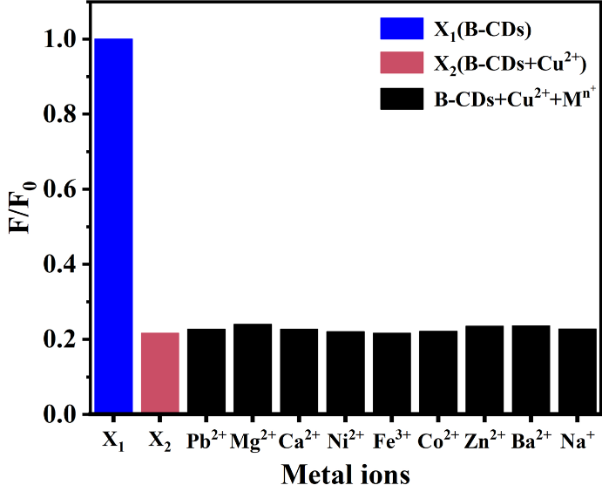
Fig.S1 Interference of other metal ions (M^{n+}) on the detection of Cu²⁺ ions by B-CDs

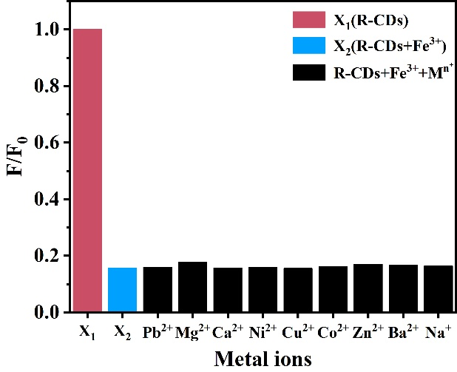
Fig.S2 Interference of other metal ions (M^{n+}) on the detection of Fe³⁺ ions by R-CDs

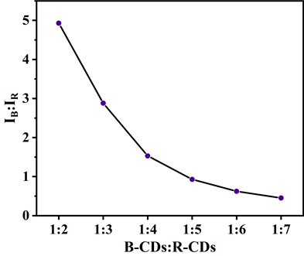
Fig.S3 Fluorescence intensity ratio of the dual emission peaks of B/R-CDs at different volume ratios of B-CDs and R-CDs

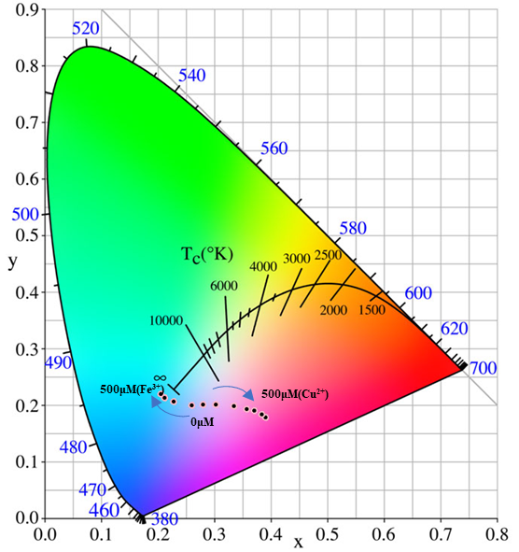
Fig.S4 CIE chromaticity diagrams of B/R-CDs in the presence of different concentrations of Cu²⁺ and Fe³⁺

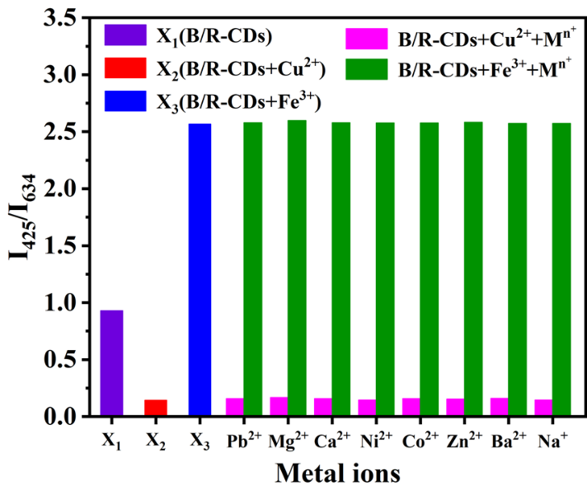
Fig.S5 Interference of other metal ions (M^{n+}) on the detection by B/R-CDs

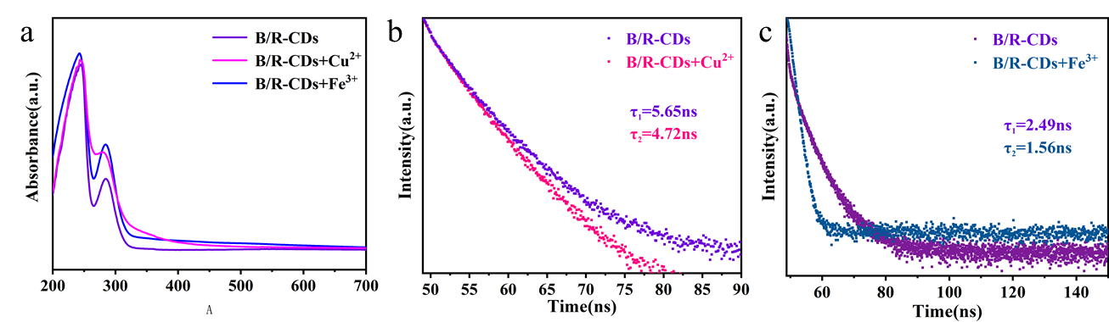
Fig.S6 PL spectra of B/R-CDs before and after adding Cu²⁺ and Fe³⁺ (a). Fluorescence lifetime decay profiles of B/R-CDs before and after adding Cu²⁺ (λ_{em} = 425 nm, b) and Fe³⁺ (λ_{em} = 634 nm, c)

