Supplemental data

Figure S1:
Nile Red (Sigma-Aldrich) which stains lipid droplets was used as a maker of quiescence. PS-1 cells were incubated with 1 mg/mL Nile Red for 30 minutes at room temperature. As shown in the figure S1, control cells have a red staining which disappears in Cd exposed cells. Together with α-SMA staining, these results confirm that Cd exposure activates human PSCs.
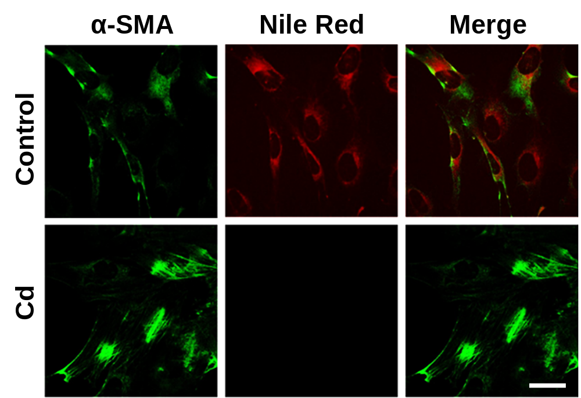
Fig. S1 Detection of α-SMA fibres (green) and lipid droplets (Nile Red) in control and Cd exposes PS-1 cells by immunofluorescence (n=3). Bar=20 µm.

Figure S2:

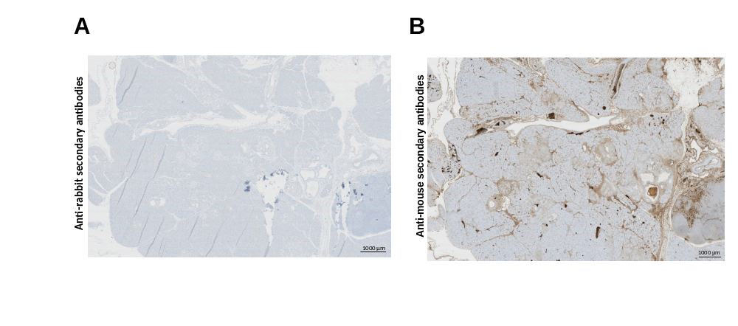
Fig. S2 Negative controls of IHC. Bar=1000µm.

