Supplementary Material

Part 1. Parameters of Diffusion Tensor Image
The parameters of diffusion tensor image were as follows: TR = 4200 ms, TE = 60 ms, flip angle = 180º, field of view = 240 × 240 mm², voxel size = 1.0 × 1.0 × 4.0 mm³, slice number = 25, slice thickness = 4 mm, directions = 30, b-value 1 = 0, and b-value 2 = 1000.
Part 2. Information of Boundary of ROIs
The BrainLab® system was used to track the SLF/AF. Two regions of interest (ROIs) were outlined on the inferior frontal lobe (ROI-1) and the posterior region of the temporal lobe (ROI-2) consecutively. The midline was inside the boundary of the two ROIs. Regarding ROI-1, the superior and inferior boundaries were the inferior frontal sulcus and the lateral fissure, respectively. The anterior and posterior boundaries were the anterior region of the triangle of the frontal lobe and the precentral sulcus, respectively. For ROI-2, the superior and inferior boundaries were the lateral fissure and the tentorium of the cerebellum, respectively. The anterior and posterior boundaries were the middle part of the temporal lobe (corresponding to a cross-point between the lateral fissure and central sulcus) and the occipitotemporal sulcus, respectively. The thresholds of fiber tracking were as follows: fiber length = 100 mm and fractional anisotropy = 0.2.
Part 3. Detailed Information of awake craniotomy
The Ojemann stimulators (bipolar interval distance = 5 mm) were applied for language cortical and subcortical mapping during AC (intensity from 1 mA to 6 mA; square wave; frequency = 60 Hz; stimulating duration = 4 s) [1]. The threshold of the stimulation current was determined when we identified sensorimotor cortices. A picture-naming task in Chinese was used to identify positive sites. If the stimulation of a site induced speech arrest, anomia, dysarthria, or speech slow, the site was noted. If two or more stimulations (the 2/3 principle) induced a positive reaction, the site was defined as a positive site. Moreover, 5-mm-diamter sterile circles were used to mark positive sites. For each tumor, the parts of the tumor showing positive sites were removed, and the rest of the tumor was saved. Engraving resection was used to preserve drainage veins.

Part 4. Distribution of preoperative epilepsy and postoperative epilepsy control
In this study, no difference in the rate of preoperative GRE occurrence between the glioma with and without oligodendroglioma (p = 0.21, Chi-square test). Moreover, there were 11, 7, 10, and 12 from type I to IV with preoperative GRE, respectively. The incidence of GRE was 64.7%, 46.7%, 55.6%, and 66.7% from type I to IV, respectively. No difference in ration of preoperative epilepsy was found among the four subtypes (p = 0.64, Fisher’s exact test).
With antiepileptic drugs in postoperation, 16 patients suffered from transient seizures, and eight patients suffered from complicated seizures. Moreover, 40 patients had history of preoperative GRE, and 87.5% of them (35/40) controlled well and arrived at Engel class I. Additionally, five patients with complicated seizures controlled unsatisfactorily, and they arrived at Engel class II. Furthermore, nine patients had postoperative seizure without history of preoperative seizure, and three of them controlled unsatisfactorily. No difference was found among the four subtypes (p = 0.31, Chi-square test).
Part 5. Supplementary Tables
Table S1. The information of biomarkers status in four sub-type groups.
 | Type I | Type II | Type III | Type IV | p value
IDH status |  |  |  |  | 0.082
Mutation | 16 | 9 | 11 | 14 | 0.082
Wild-type | 1 | 6 | 7 | 4 | 0.082
MGMT status |  |  |  |  | 0.094
Methylation | 14 | 7 | 10 | 15 | 0.094
Non-methylation | 3 | 8 | 8 | 3 | 0.094
Chromosome 1p/19q |  |  |  |  | 0.807
Co-deletion | 9 | 7 | 7 | 7 | 0.807
Non-codeletion | 8 | 8 | 11 | 11 | 0.807
*IDH = Isocitrate Dehydrogenase

Table S2. The histological distribution in each sub-group.
 | Type I | Type II | Type III | Type IV
O and AO | 9 | 7 | 7 | 7
A and AA and GBM | 8 | 8 | 11 | 11
p value | Type I | Type II | Type III | Type IV
Type I | - | 0.723 | 0.404 | 0.404
Type II | 0.723 | - | 0.652 | 0.652
Type III | 0.404 | 0.652 | - | > 0.999
Type IV | 0.404 | 0.652 | > 0.999 | -
* O = Oligodendroglioma; AO = Anaplastic oligodendroglioma; A = Astrocytoma; AA = Anaplastic astrocytoma; GBM = glioblastoma

Table S3. Extent of tumor resection and motor functional prognosis.
 | Type I |  | Type II |  |  | Type III |  | Type IV
 | Total Resection | Subtotal Resection | Total Resection | Subtotal Resection |  | Total Resection | Subtotal Resection | Total Resection | Subtotal Resection
After AC 0 days
Recovered | 9 | 4 | 5 |  | 1 | 11 | 4 | 5 | 4
Unrecovered | 1 | 3 | 6 |  | 3 | 2 | 1 | 4 | 5
p value | 0.25 |  | 0.60 |  |  | >0.99 |  | >0.99
After AC 3 days
Recovered | 6 | 5 | 4 |  | 1 | 9 | 2 | 5 | 3
Unrecovered | 4 | 2 | 7 |  | 3 | 4 | 3 | 4 | 6
p value | >0.99 |  | >0.99 |  |  | 0.33 |  | 0.64
After AC 14 days
Recovered | 9 | 6 | 6 |  | 1 | 11 | 4 | 6 | 4
Unrecovered | 1 | 1 | 5 |  | 3 | 2 | 1 | 3 | 5
p value | >0.99 |  | 0.57 |  |  | >0.99 |  | 0.64
After AC 3 months
Recovered | 9 | 7 | 7 |  | 1 | 12 | 5 | 7 | 6
Unrecovered | 1 | 0 | 4 |  | 3 | 1 | 0 | 2 | 3
p value | >0.99 |  | 0.28 |  |  | >0.99 |  | >0.99

* The Fisher’s exact test was applied to compare difference.

Table S4. Preoperative motor impairment and language functional prognosis.
 | Type I |  | Type II |  |  | Type III |  | Type IV
 | Impairment | Healthy | Impairment | Healthy |  | Impairment | Healthy | Impairment | Healthy
After AC 0 days
Recovered | 6 | 7 | 3 |  | 3 | 5 | 10 | 2 | 7
Unrecovered | 0 | 4 | 3 |  | 6 | 0 | 3 | 1 | 8
p value | 0.24 |  | 0.62 |  |  | 0.52 |  | >0.99
After AC 3 days
Recovered | 5 | 6 | 3 |  | 2 | 4 | 7 | 2 | 6
Unrecovered | 1 | 5 | 3 |  | 7 | 1 | 6 | 1 | 9
p value | 0.33 |  | 0.34 |  |  | 0.60 |  | 0.56
After AC 14 days
Recovered | 6 | 9 | 3 |  | 3 | 5 | 10 | 3 | 7
Unrecovered | 0 | 2 | 3 |  | 6 | 0 | 3 | 0 | 8
p value | 0.52 |  | 0.62 |  |  | 0.52 |  | 0.22
After AC 3 months
Recovered | 6 | 10 | 3 |  | 4 | 5 | 12 | 3 | 10
Unrecovered | 0 | 1 | 3 |  | 5 | 0 | 1 | 0 | 5
p value | >0.99 |  | >0.99 |  |  | >0.99 |  | 0.52
* The Fisher’s exact test was applied to compare difference.

Table S5. Preoperative epileptic status and language functional prognosis.
 | Type I |  | Type II |  |  | Type III |  | Type IV
 | epilepsy | non-epilepsy | epilepsy | non-epilepsy |  | epilepsy | non-epilepsy | epilepsy | non-epilepsy
After AC 0 days
Recovered | 8 | 5 | 2 |  | 4 | 10 | 5 | 6 | 3
Unrecovered | 3 | 1 | 5 |  | 4 | 0 | 3 | 6 | 3
p value | >0.99 |  | 0.61 |  |  | 0.07 |  | >0.99
After AC 3 days
Recovered | 6 | 5 | 2 |  | 3 | 8 | 4 | 5 | 3
Unrecovered | 5 | 1 | 5 |  | 5 | 2 | 4 | 7 | 3
p value | 0.33 |  | >0.99 |  |  | 0.32 |  | >0.99
After AC 14 days
Recovered | 9 | 6 | 2 |  | 4 | 10 | 7 | 8 | 4
Unrecovered | 2 | 0 | 5 |  | 4 | 0 | 1 | 4 | 2
p value | 0.51 |  | 0.61 |  |  | 0.44 |  | >0.99
After AC 3 months
Recovered | 10 | 6 | 3 |  | 5 | 10 | 8 | 9 | 6
Unrecovered | 1 | 0 | 4 |  | 3 | 0 | 0 | 3 | 0
p value | >0.99 |  | 0.62 |  |  | >0.99 |  | 0.51
* The Fisher’s exact test was applied to compare difference.

Part 6. Supplementary Figures
Figure S1. The distribution of patients based on outcomes of surgical-related language impairments.

Figure S2. Tumor invasion of the each subtype. The value in the color bar means the number of patients with gliomas in a same area.

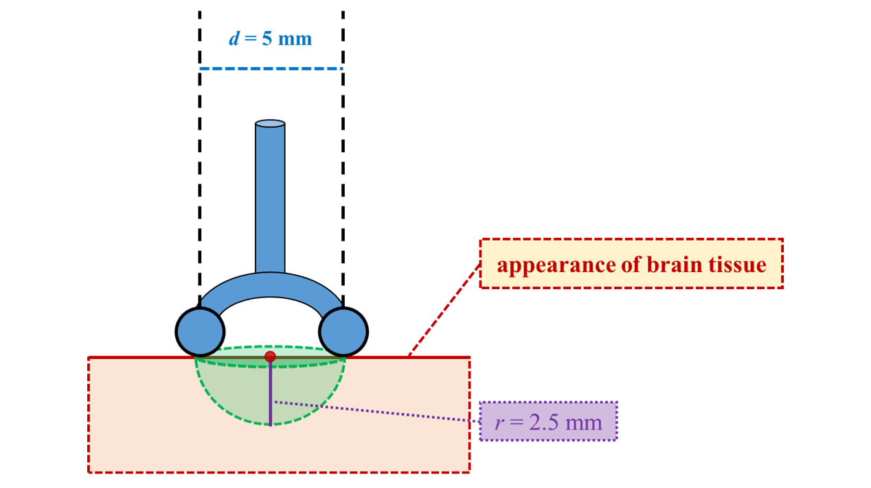
Figure S3. The efficient region of bipolar direct cortical stimulation. The green region is efficient region and the purple line represents the efficient depth.

Reference
1. Fang S, Liang J, Qian T, Wang Y, Liu X, Fan X, Li S, Wang Y, Jiang T (2017) Anatomic Location of Tumor Predicts the Accuracy of Motor Function Localization in Diffuse Lower-Grade Gliomas Involving the Hand Knob Area. AJNR Am J Neuroradiol 38: 1990-1997 doi:10.3174/ajnr.A5342

