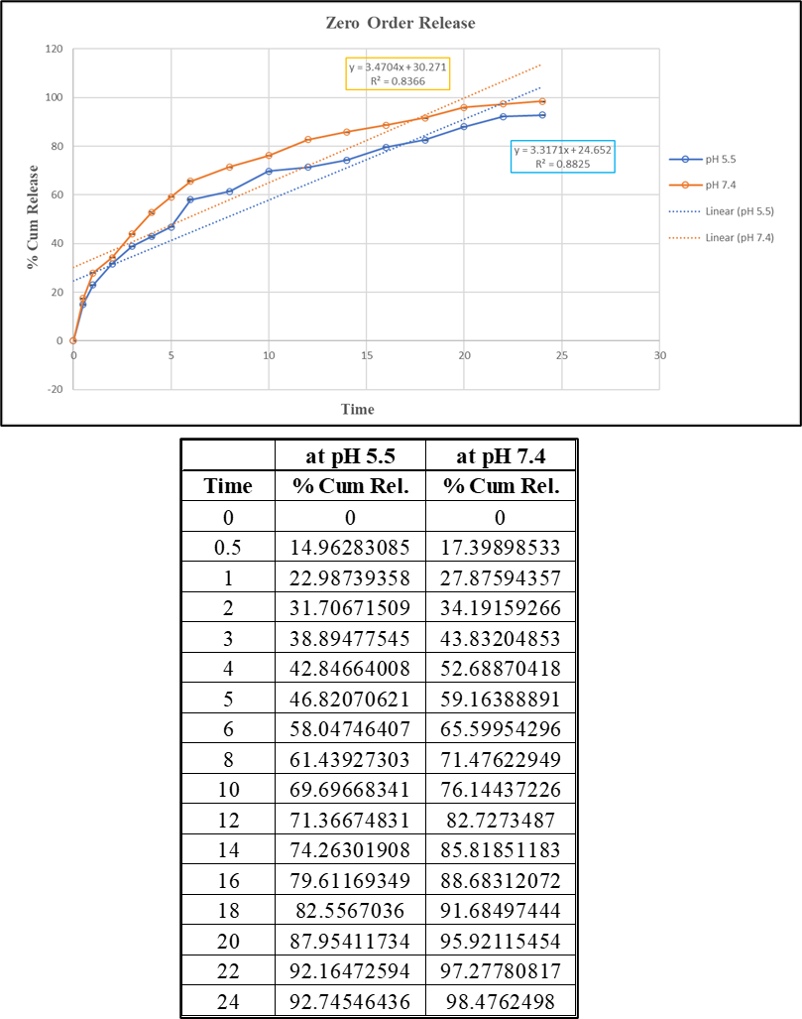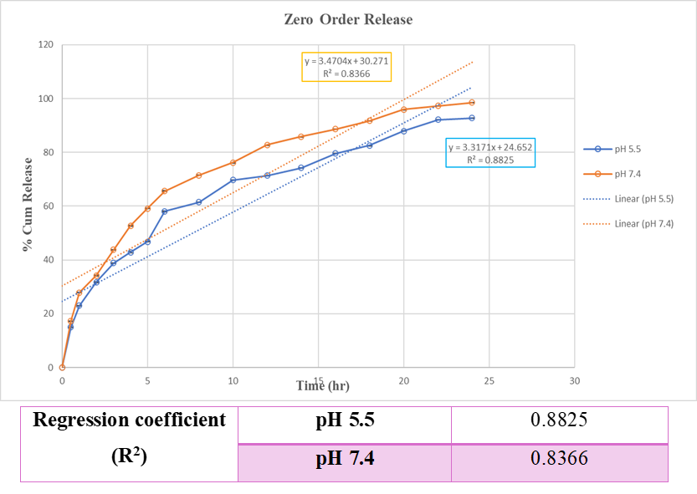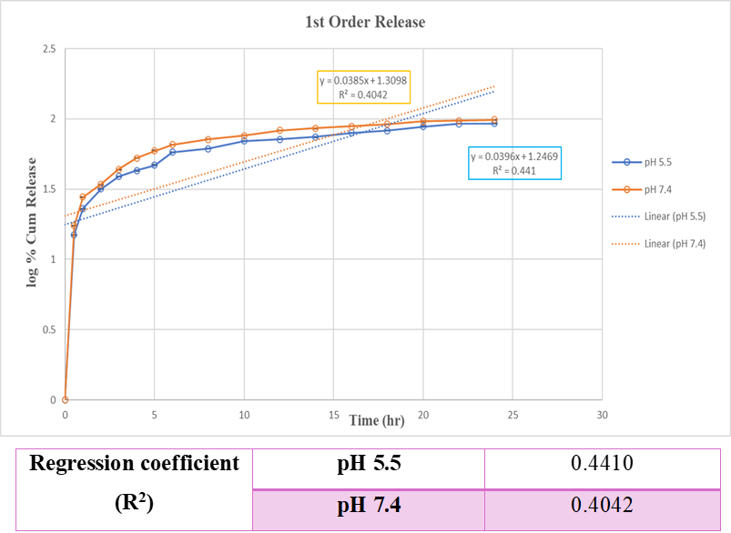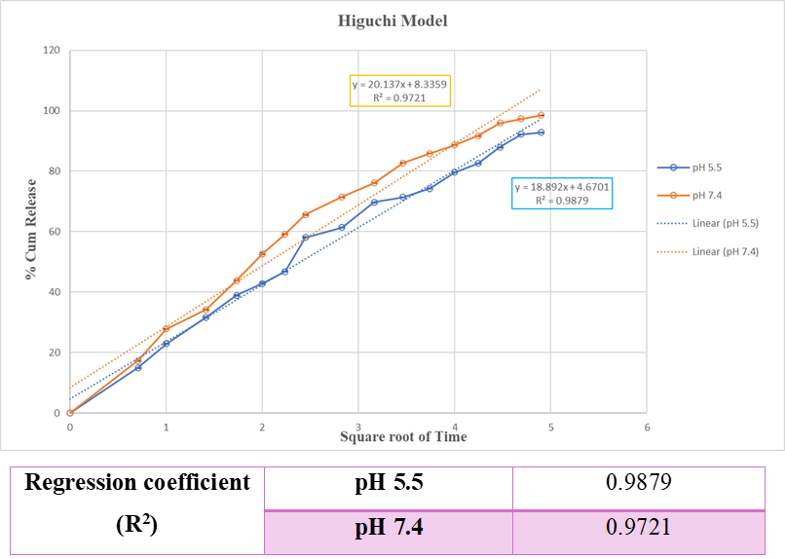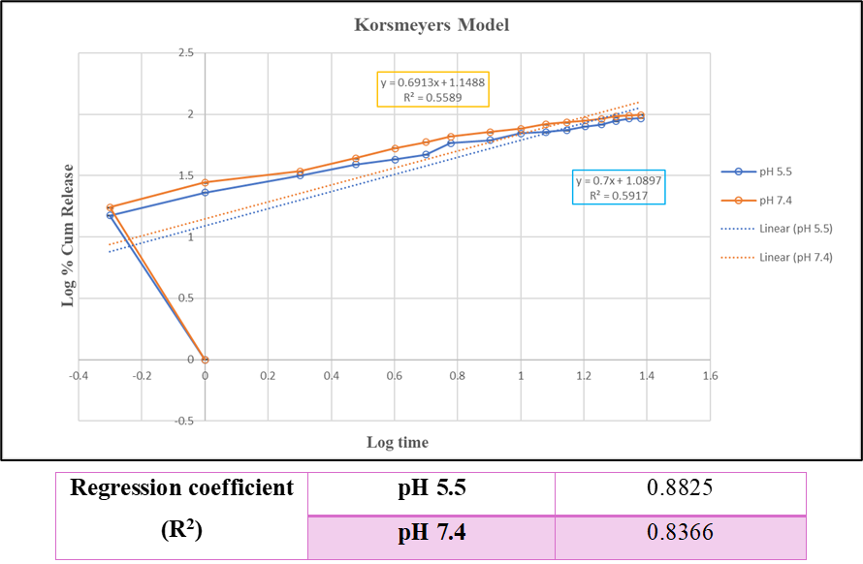
In Vitro Drug Release Using Dialysis Bag
Zero Order Release
First Order Release
Higuchi Release Model
Korsmeyer Peppas Model
Fig S1. % Cumulative release vs Time graph at pH 5.5 and pH 7.4

(A)

(B)
Fig S2. (A) Calibration plot of % cell viability v/s drug concentration (B) % Cell viability values of MCF7 cells after 24hrs.
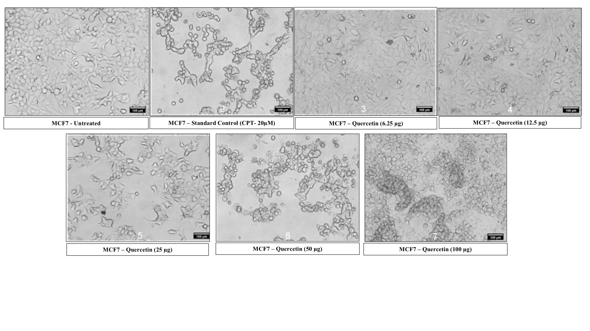
Fig S3. Morphology of MCF7 cells after 24h Quercetin treatment (20x magnification).
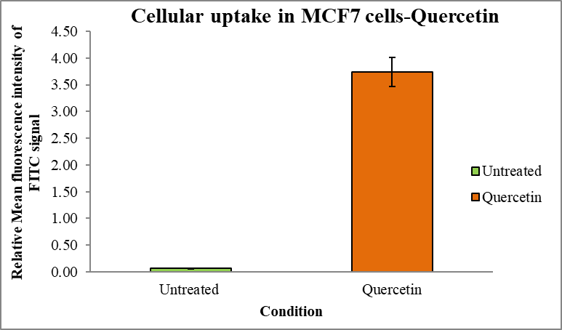
Fig S4. Cellular uptake in MCF-7 cells - Quercetin
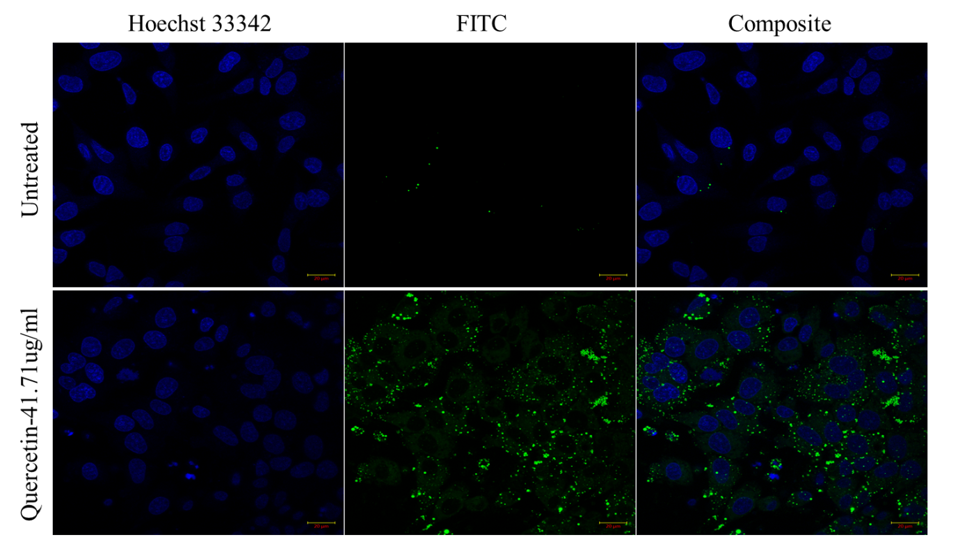
Fig S5. Overlaid Montage image represented the cellular uptake effect of Quercetin with 42µg/ml after the incubation period of 4 hour by Confocal Microscopy

