Supporting Information
Moisture-induced surface degradation mechanism of argyrodite Li₆PS₅Cl under dry-room conditions
Yoon-Seong Kim¹, Jeong-Doo Yi², Sihyeon Sung³, Dong-Hwa Seo^{1*}
¹ Department of Materials Science and Engineering, Korea Advanced Institute of Science and Technology (KAIST), 291, Daehak-ro, Yuseong-gu, Daejeon 34141, Republic of Korea
² Korea Automotive Technology Institute (KATECH), 303, Pungse-ro, Pungse-myeon, Cheonan-si, Chungcheongnam-do 31214, Republic of Korea
³ Samsung SDI, 882, Dongtanwoncheon-ro, Yeongtong-gu, Suwon-si, Gyeonggi-do 16677, Republic of Korea
*Correspondence and requests for materials should be addressed to Dong-Hwa Seo (dseo@kaist.ac.kr)

Table of contents
- Supplementary Figure 1 | Difference in ionic conductivity between the pristine and 3-day dry room exposed Li₆PS₅Cl (LPSC).
- Supplementary Figure 2 | Difference in the X-ray diffraction (XRD) pattern between the pristine and the 7-day dry room exposed LPSC.
- Supplementary Figure 3 | X-ray photoelectron spectroscopy (XPS) analysis detection for initial surfaces.
- Supplementary Table 1 | Theoretical reaction energies (E_{reaction}) of three possible reaction equations based on bulk structures.
- Supplementary Table 2 | Lattice parameters of structures used in computational simulations.
- Supplementary Figure 4 | Structural definition for atomic layers of the LPSC surface.
- Supplementary Figure 5 | S-O substitution energy (E_{sub}) values depending on the case of oxygen substitution.
- Supplementary Figure 6 | Bond elongation after the 2nd layer-substitution (LPSCO).
- Supplementary Figure 7 | Atomic definition for the oxygen and sulfur sites from the third to the fifth layers of the fully O-substituted LPSC at the first three layers (LPSCO₁₂₃).
- Supplementary Figure 8 | Relative stability of the structures, where S-O exchange occurs between the oxygen at the third atomic layer and non-bonding sulfur or the broken P–S bonding site in the layers below, compared to the LPSCO₁₂₃.
- Supplementary Figure 9 | Phase distribution of LPSC surface depending on the etching beam intensity.
- Supplementary Figure 10 | XPS depth analysis of LPSC_{5d}.
- Supplementary Figure 11 | XPS depth analysis of the 3-minute etched LPSC_{25d}.

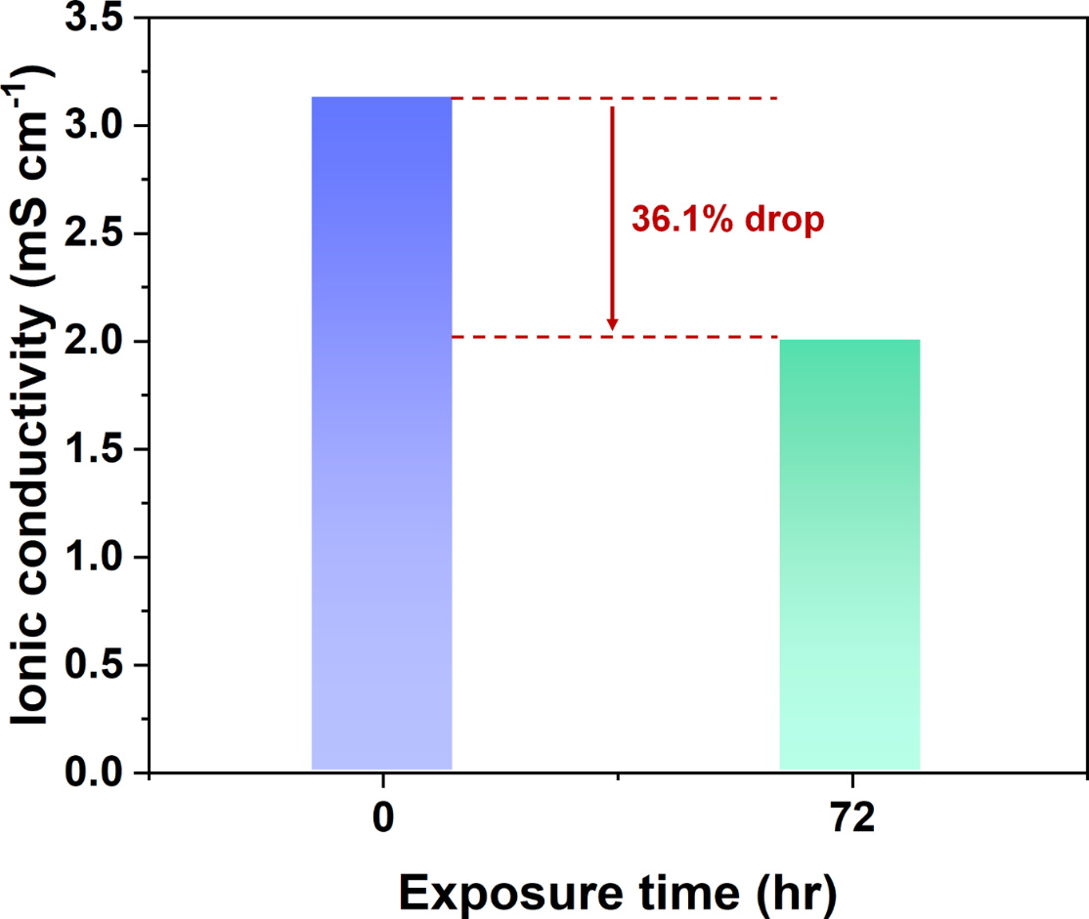
Supplementary Figure 1 | Difference in ionic conductivity between the pristine and 3-day dry room exposed Li₆PS₅Cl (LPSC).

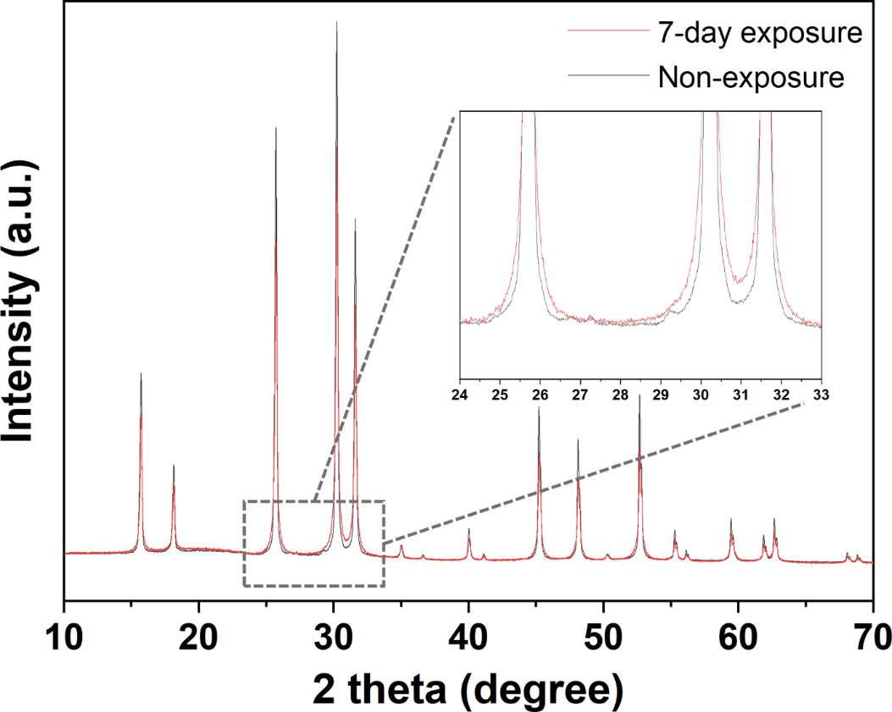
Supplementary Figure 2 | Difference in the XRD pattern between the pristine and the 7-day dry room exposed LPSC.

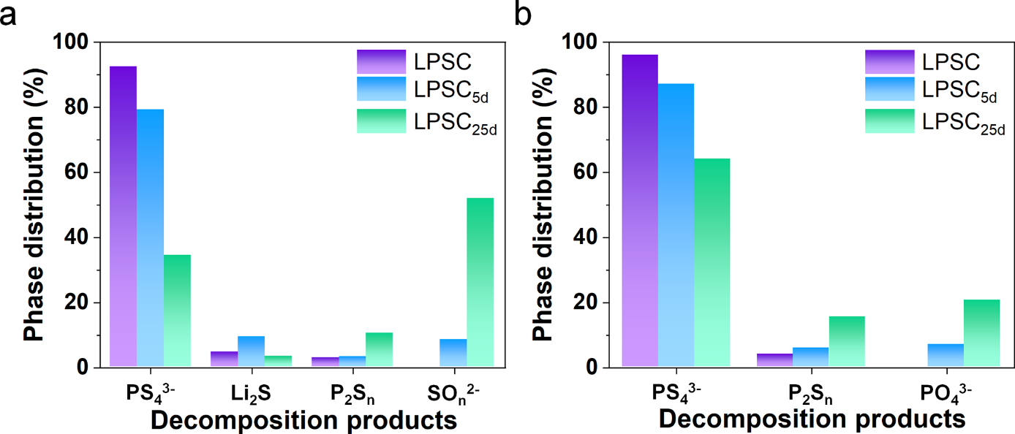
Supplementary Figure 3 | X-ray photoelectron spectroscopy (XPS) analysis detection for initial surfaces. Phase distributions of initial surfaces depending on the dry room exposure time, non-exposure (LPSC), 5-day exposure (LPSC_{5d}), and 25-day exposure (LPSC_{25d}), in a S 2p spectra and b P 2p spectra.

Reaction equations | E_{reaction}  [eV / formula unit]
(1) Li₆PS₅Cl + 6H₂O → LiCl + Li₃PO₄ + 2LiOH + 5H₂S | –6.222
(2) 2LiOH + CO₂ → Li₂CO₃ + H₂O | –1.465
(3) Li₆PS₅Cl + 4H₂O + 2O₂ → LiCl + Li₃PO₄ + Li₂SO₄ + 4H₂S | –18.991

Supplementary Table 1 | Theoretical reaction energies (E_{reaction}) of three possible reaction equations based on bulk structures.

Structure | Lattice parameters (Å)
Structure | a | b | c
LPSC-bulk | 10.255 | 10.255 | 10.255
LPSC-slab | 10.255 | 10.255 | 44.389

Supplementary Table 2 | Lattice parameters of structures used in computational simulations.

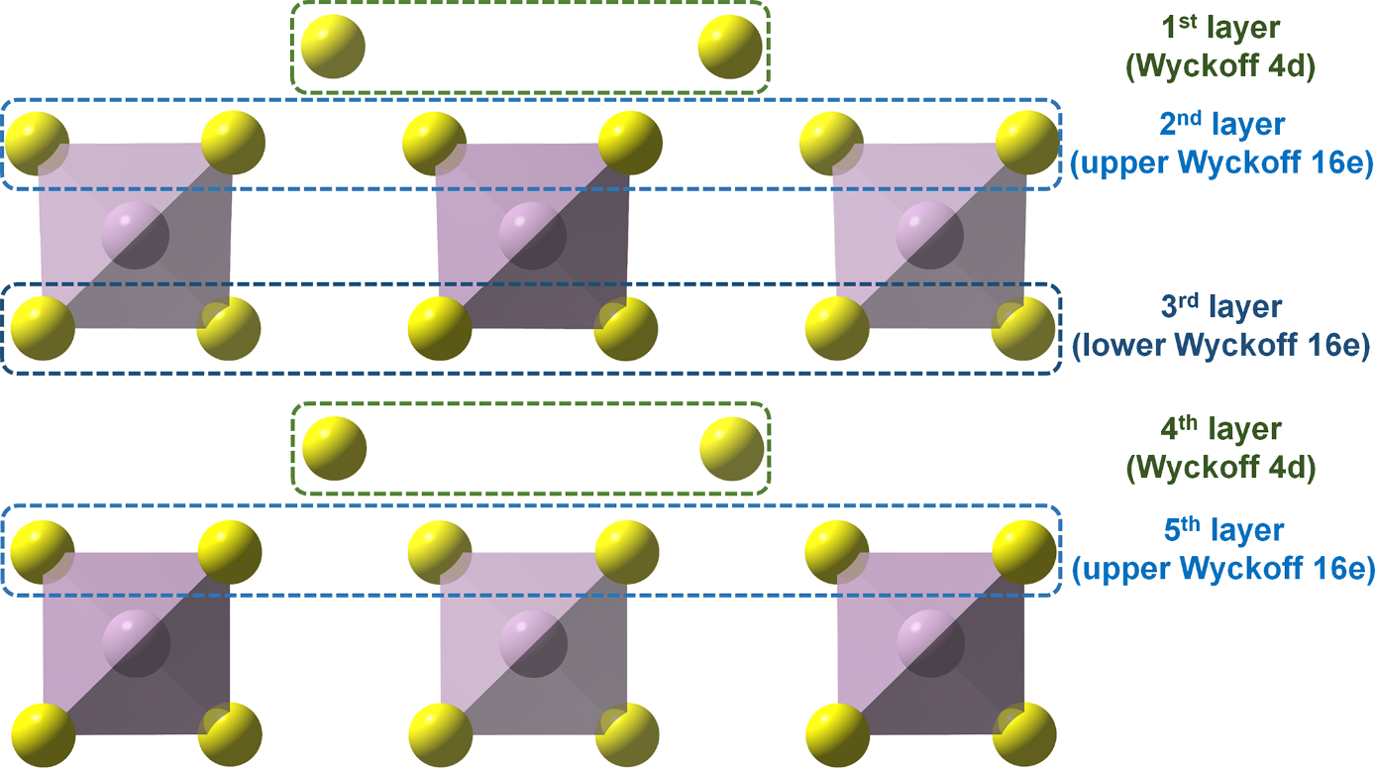
Supplementary Figure 4 | Structural definition for atomic layers of the LPSC surface.

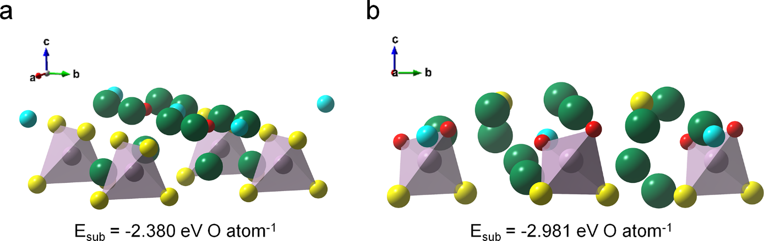
Supplementary Figure 5 | S-O substitution energy (E_{sub}) values depending on the case of oxygen substitution. E_{sub} values for a 1st layer-substituted and b 2nd layer-substituted LPSC structures.

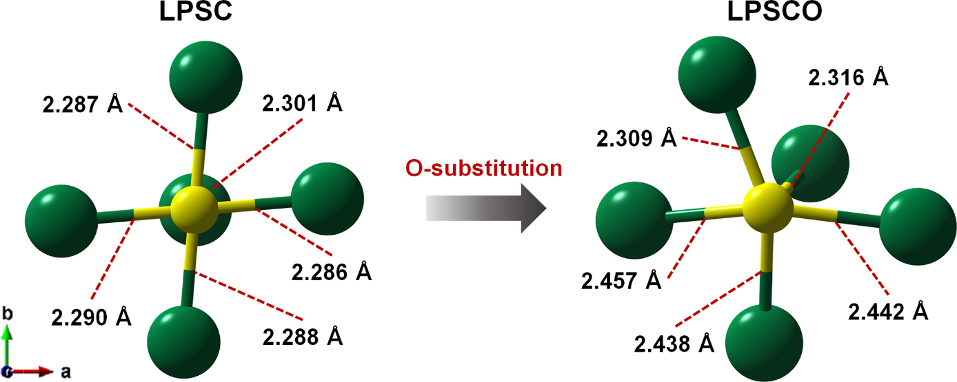
Supplementary Figure 6 | Bond elongation after the 2nd layer-substitution (LPSCO).

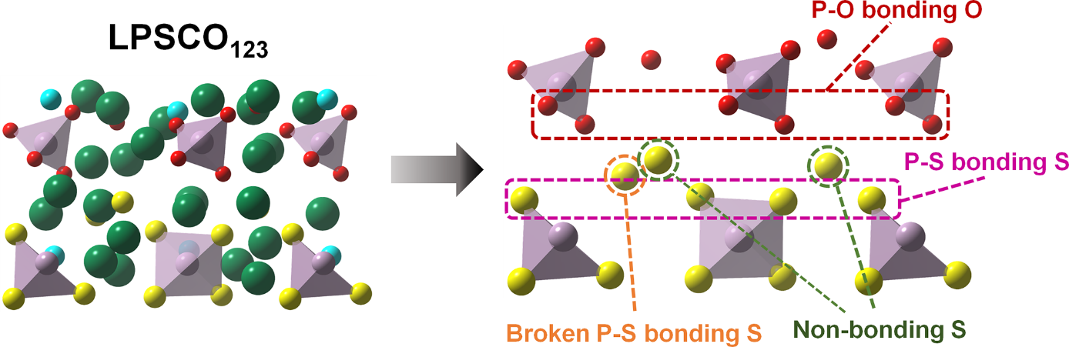
Supplementary Figure 7 | Atomic definition for the oxygen and sulfur sites from the third to the fifth layers of the fully O-substituted LPSC at the first three layers (LPSCO₁₂₃).

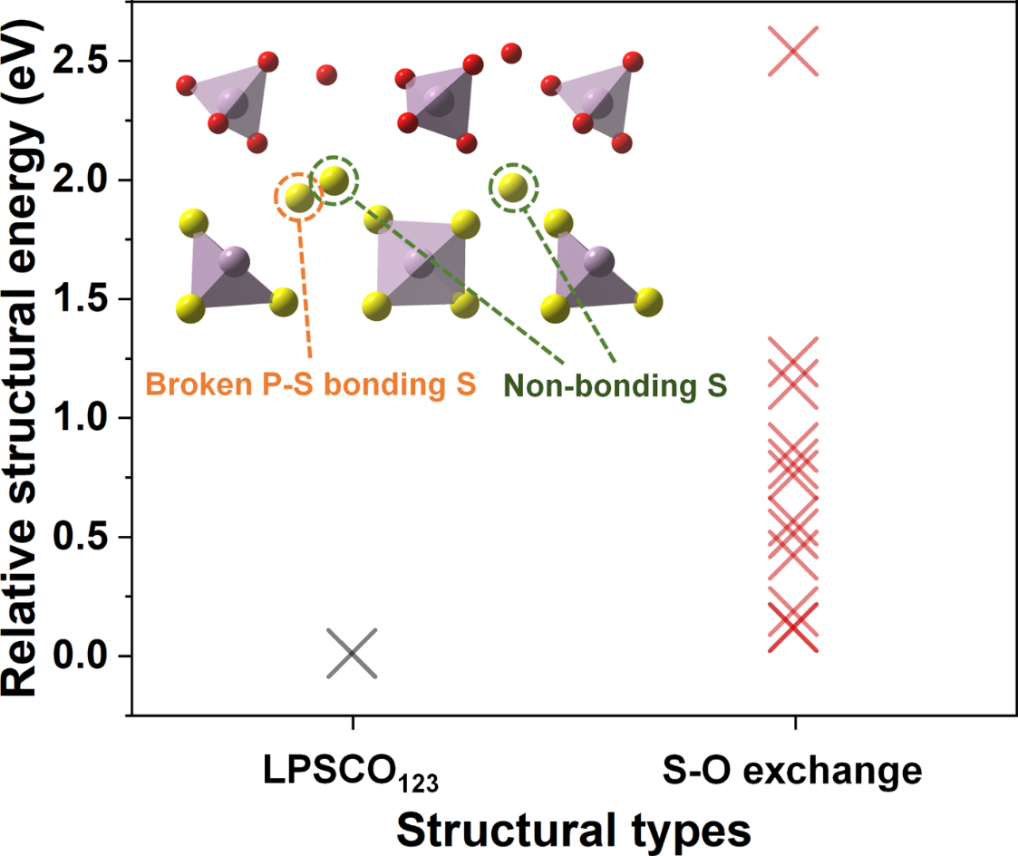
Supplementary Figure 8 | Relative stability of the structures, where S-O exchange occurs between the oxygen at the third atomic layer and the sulfur at the non-bonding site or the broken P–S bonding site in the layers below, compared to the LPSCO₁₂₃.

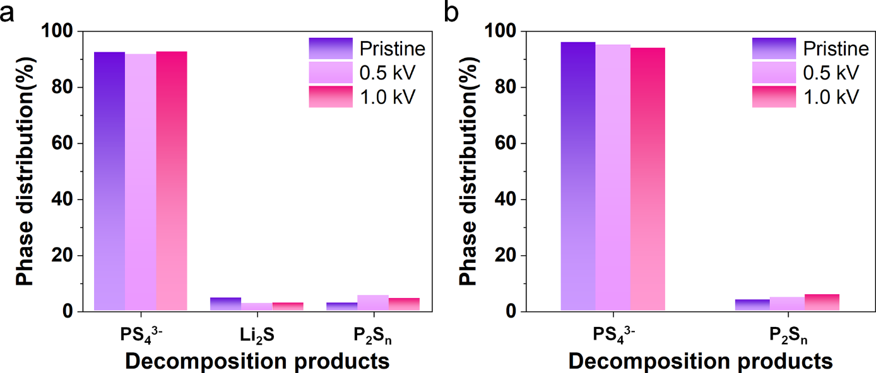
Supplementary Figure 9 | Phase distribution of LPSC surface depending on the etching beam intensity. The distribution of decomposition products depending on the beam intensity in a S 2p spectra and b P 2p spectra.

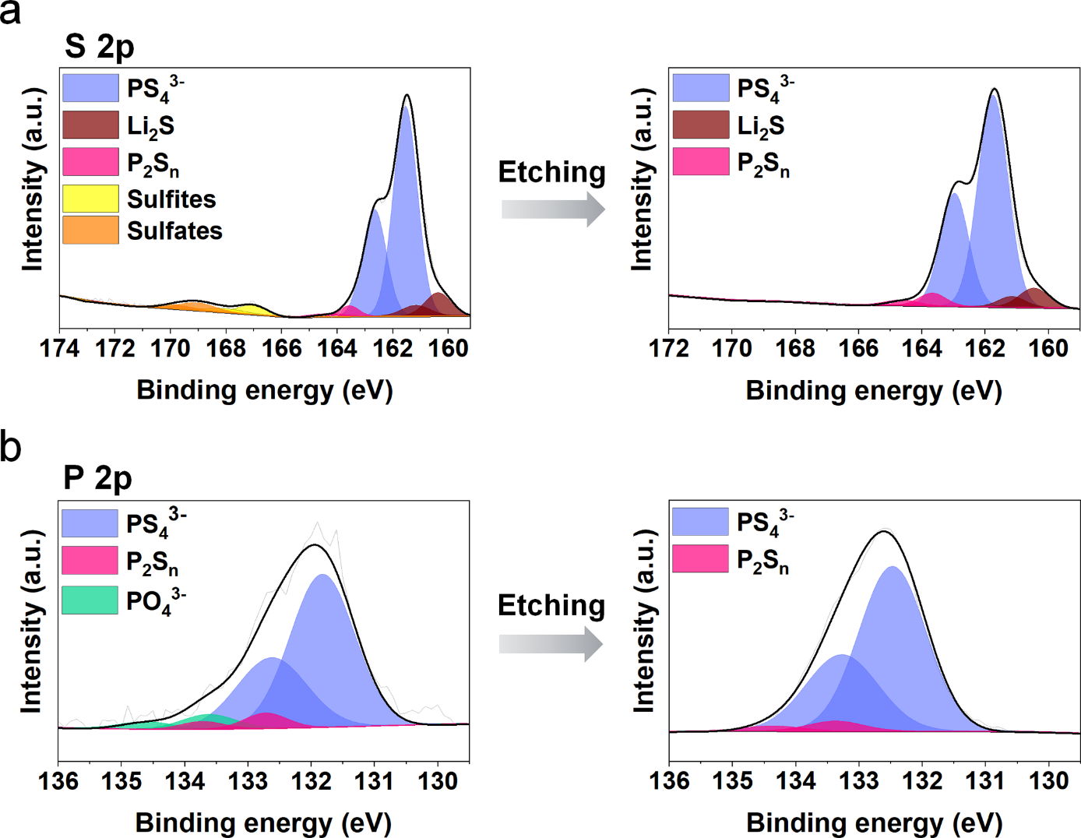
Supplementary Figure 10 | XPS depth analysis of LPSC_{5d}. The change in decomposition phase compositions of LPSC_{5d} after 3 minutes of etching with the 0.5 kV beam in a S 2p spectra and b P 2p spectra.

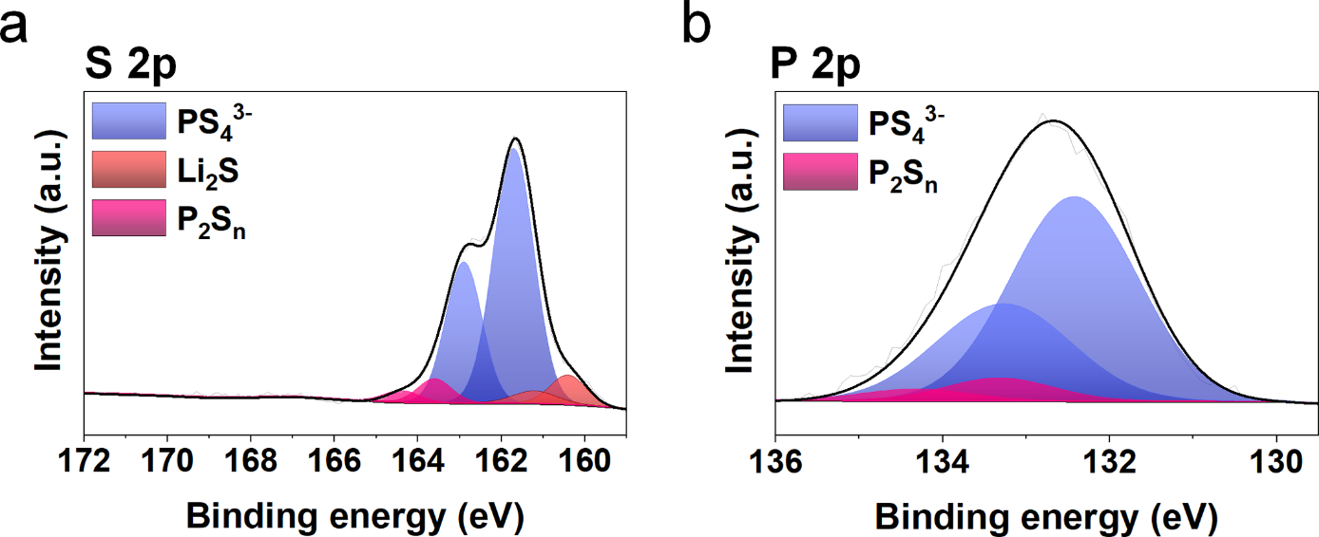
Supplementary Figure 11 | XPS depth analysis of the 3-minute etched LPSC_{25d}. The change in decomposition phase compositions of the 3-minute etched LPSC_{25d} after an additional 40 minutes of etching with the 1.0 kV beam in a S 2p spectra and b P 2p spectra.

