Supporting information

Biochar-supported Fe/Mg co-doped MoS₂ synergistically enhances PMS activation for the degradation of tetracycline hydrochloride: A study on the Fe²⁺/Fe³⁺ cycling driving mechanism and catalytic stability
Haifeng Li, ª Yu Yao, ª Peixuan Li, ª Xiqian Guo, ª Yan Zhang,* ª Jifen Wang* ª and Yi Zhang.ª
ªSchool of Resources and Environmental Engineering, Shanghai Polytechnic University, 2360 Jinhai Road, Pudong New Area, Shanghai, China.
Email:yzhang@sspu.edu.cn ; wangjifen@sspu.edu.cn

This supplementary material contains 8 pages, including 5 Texts, 1 Table, and 1 figure.

Lists of Captions:
Text S1. Chemicals and reagents.
Text S2. Experimental procedures for pollutant degradation using various catalytic systems.
Text S3. Simulate the anions found in natural water bodies.
Text S4. The concentration of TCH in the degradation experiments was evaluated using high-performance liquid chromatography-mass spectrometry.
Text S5. The concentrations of metal ions in the water were measured using an Inductively Coupled Plasma Atomic Emission Spectrometer (ICP-AES) following each treatment cycle.
Table S1. Presents the BET specific surface area and pore characteristics of BC, Fe@BC, and Fe/Mg@BC-Mo.
Fig.S1. Mass spectrometry of TC and its degradation intermediates in the Fe/Mg@BC-Mo/PMS system (a-g): TC, P1, P2, P3, P4, P5, P6, P7, P8, P9, P10, P11, P12, P13.

Text S1.Chemicals and Reagents.
Construction waste wood powder, heptahydrate ferrous sulfate (FeSO₄·7H₂O), anhydrous magnesium sulfate (MgSO₄), molybdenum disulfide (MoS₂), hydrochloric acid (HCl), sodium hydroxide (NaOH), tert-butanol (TBA), methanol (MeOH), L-histidine (L-His), para-benzoquinone (ρ-BQ), dodecylbenzenesulfonic acid sodium salt (SDBS), sodium chloride (NaCl), sodium carbonate (Na₂CO₃), sodium dihydrogen phosphate (NaH₂PO₄), and humic acid (HA) were supplied by China National Pharmaceutical Group. TCH was purchased from Aladdin Biochemical Corporation. All the above chemicals were of analytical grade, and the laboratory provided ultrapure water for use in this study.

Text S2.Experimental procedures for pollutant degradation using various catalytic systems.
Samples were collected at 0, 2, 5, 10, 20, 30, 40, and 60 minutes, with 5 mL of the reaction solution filtered through a 0.22 μm hydrophilic syringe filter to remove the catalyst. The sample solution was then mixed with methanol in a 1:1 ratio and stored in a 1.5 mL brown bottle. The initial concentration of pollutants was adjusted to 10, 20, 30, 50, and 80 mg/L to explore the effect of TCH concentration. The solution's pH was modified using 0.1 M H₂SO₄ and NaOH to investigate the effect of pH.

Text S3. Simulate the anions found in natural water bodies.
Tert-butanol (TBA), methanol (MeOH), L-histidine (L-His), and para-benzoquinone (ρ-BQ) were utilised to quench and identify the roles of the free radicals O₂^{·-}, SO₄^{·-}, ·OH, and the non-free radical ¹O₂ in this process.

Text S4. The concentration of TCH in the degradation experiments was evaluated using high-performance liquid chromatography-mass spectrometry.
High-performance liquid chromatography-mass spectrometry (HPLC, Shimadzu LCMS-8040, Japan) was employed with a C18 column, utilising a mobile phase of acetonitrile: 0.1% formic acid water (1:3) to analyse the UV absorbance at 356 nm for each time point and record the peak area.

Text S5. The concentrations of metal ions in the water were measured using an Inductively Coupled Plasma Atomic Emission Spectrometer (ICP-AES) following each treatment cycle.
The Mg ion concentration after the first and second catalytic uses was 25.37 mg/L and 24.88 mg/L, respectively, mainly due to the high presence of Ca and Mg ions in the bio-based material. Currently, there is no global unified limit for magnesium levels, but the Chinese "Living Drinking Water Hygiene Standard" (GB 5749-2022) sets a maximum total hardness of ≤ 450 mg/L (calculated as CaCO₃), with magnesium ions typically contributing to the total hardness. At the same time, the ion concentration also falls within the recommended range for health and taste of 10-50 mg/L. The concentration of Fe ions after three cycles of using the catalyst was 0.35 mg/L, 0.32 mg/L, and 0.08 mg/L, respectively, and fell below the detection limit after the fourth cycle. The ion standards aligned with the "Integrated Wastewater Discharge Standard" (GB 8978-1996), with total Fe at a level of ≤ 1.0 mg/L, close to the "Living Drinking Water Hygiene Standard" (GB 5749-2022), Fe ≤ 0.3 mg/L. After the first use, the Mo ion concentration was 1.75 mg/L and gradually decreased to 1.14 mg/L, 1.055 mg/L, and 0.766 mg/L with more cycles.

Table S1. Presents the BET specific surface area and pore characteristics of BC, Fe@BC, and Fe/Mg@BC-Mo.
sample | Specific surface area  /m²·g⁻¹ | Specific surface area of Micropores  /m²·g⁻¹ | Total pore volume  /cm³·g⁻¹ | Average pore size  /nm
BC | 124.20 | 155.64 | 0.0520 | 1.6747
Fe@BC | 223.83 | 288.54 | 0.1027 | 1.8361
Fe/Mg@BC | 340.01 | 248.5 | 0.0984 | 1.1572
Fe/Mg@BC-Mo | 205.91 | 263.26 | 0.0942 | 1.8299

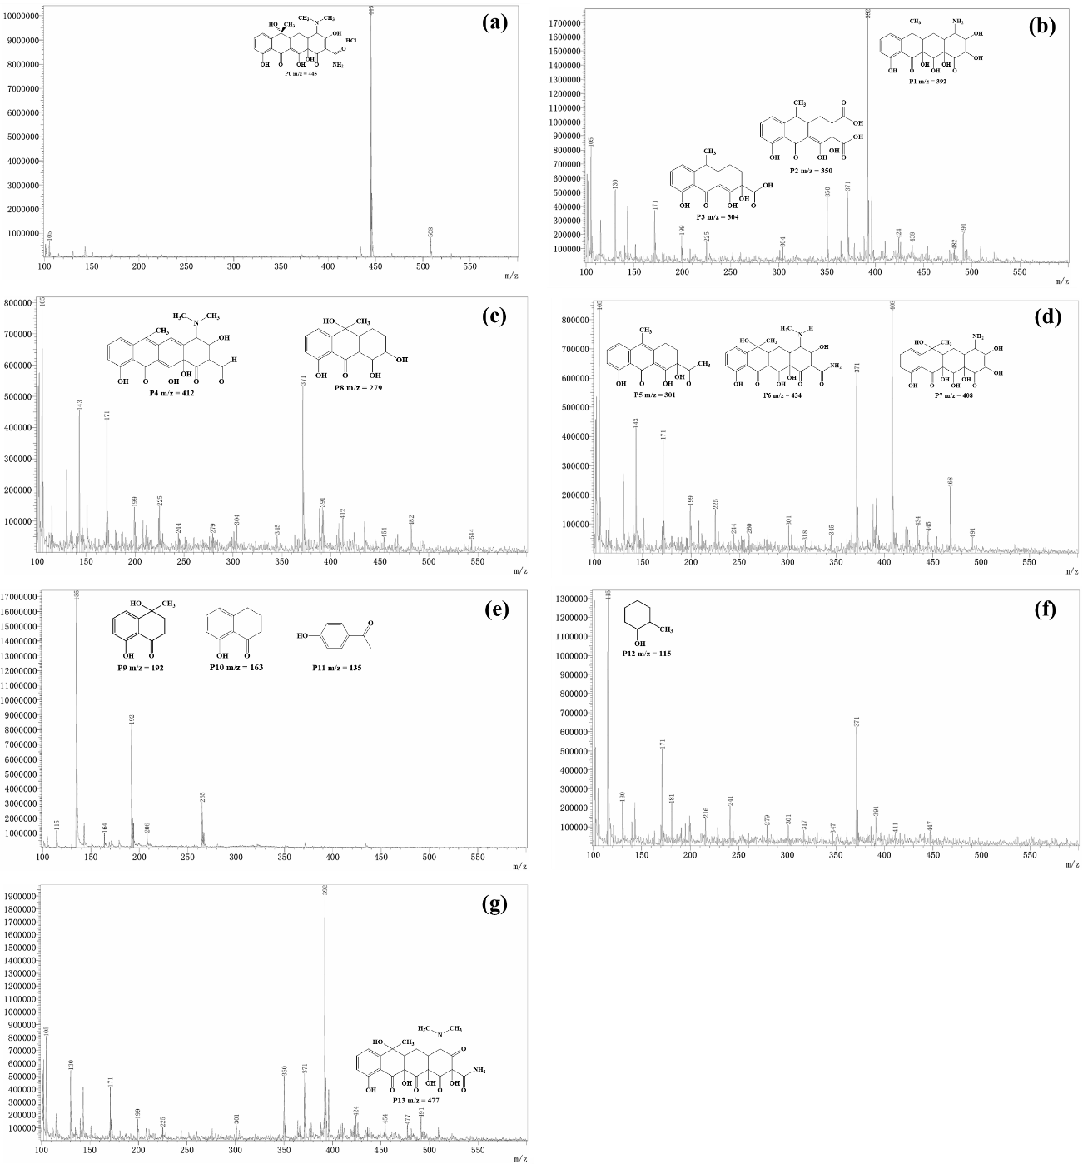
Fig.S1 Mass spectrometry of TC and its degradation intermediates in the Fe/Mg@BC-Mo/PMS system (a-g): TC, P1, P2, P3, P4, P5, P6, P7, P8, P9, P10, P11, P12, P13.

