Cannabis consumption is associated with altered steroid metabolism in young men

Mathieu Galmiche, Isabel Meister, Fanny Zufferey, Michel F. Rossier, Rita Rahban, Serge Nef, Julien Boccard, Serge Rudaz

Supporting Information

Section S1: Extended steroid profiling in the cohort of 94 male human serum samples 4
Section S2: OPLS-DA model (M1) discriminating the circulating steroid profile from cannabis users and non-users 5
Section S3: Univariate analyses of C11-oxy androgen concentrations depending on the cannabis consumption status 7
Section S4: PLS model (M2) relating the circulating steroid profile with serum THC concentrations in cannabis users 8
Section S5: PLS model (M3) relating the circulating steroid profile with serum THC-COOH concentrations in cannabis users 11
Section S6: Univariate analyses comparing androgen concentrations between occasional and chronic cannabis consumers 13
Section S7: OPLS-DA model (M4) discriminating the circulating steroid profile from chronic and occasional cannabis users 14
Section S8: Investigation of possible confounding factors in the study of the extended steroid profile in relation with cannabis usage 16
Section S9: Correlation of the steroid profile with other sex hormones 18

Figure S 1 : Histogram representing the variability of normalized peak areas measured for each detected compound in pooled QC samples 4
Figure S 2 : Partition of the detected steroid compounds building up the extended steroid profile dataset within the eight defined steroid subclasses 4
Figure S 3 : Scores plot showing the separation of samples from the “THC-positive” group and the “control” group according to the OPLS-DA model M1. 5
Figure S 4 : Loadings plot displaying the variables responsible for group separation in model M1 5
Figure S 5 : Variables Importance in Projection (VIP) characterizing the importance of each variable in the predictive component of model M1. 6
Figure S 6 : Model M1 permutation plot displaying observed R²Y and Q² versus corresponding values obtained under the null hypothesis in a permutation test with 100 permutations. 6
Figure S 7 : Beeswarm charts with univariate statistical analyses (t-tests), showing the differences in circulating C11-oxy androgen concentrations between controls and THC-positive participants 7
Figure S 8 : Observed vs. predicted values of serum THC concentrations according to the PLS model M2 8
Figure S 9 : Loadings plot showing the distribution of variables from the steroid profile (X-variables) and serum THC concentration (Y-variable) in the PLS model M2. 8
Figure S 10 : Regression coefficients representing the contribution of each X-variable from the extended steroid profile to predict the serum THC concentration (Y-variable) in the PLS model M2. 9
Figure S 11 : Variables Importance in Projection (VIP) characterizing the importance of each X-variable in the prediction of the serum THC concentration (Y) in M2. 9
Figure S 12 : Annotated loadings plot from M2 model showing that gonadal androgens (A4, T and DHT) are positively correlated with serum THC concentrations, whereas adrenal androgens (11B-OHA4, 11B-OHT, 11-KA4, 11-KT) are rather not correlated or negatively correlated with serum THC. 10
Figure S 13 : Observed vs. predicted values of serum THC-COOH levels according to the PLS model M3 11
Figure S 14 : Loadings plot showing the distribution of variables from the steroid profile (X-variables) and serum THC concentration (Y-variable) in the PLS model M3. 11
Figure S 15 : Regression coefficients representing the contribution of each X-variable from the extended steroid profile to predict the serum THC-COOH concentration (Y-variable) in the PLS model M3. 12
Figure S 16 : Variables Importance in Projection (VIP) characterizing the importance of each X-variable in the prediction of the serum THC-COOH concentration (Y) in M3. 12
Figure S 17 : Beeswarm charts with univariate statistical analyses (t-tests) showing the differences in steroid concentrations between occasional (light green) and chronic (dark green) cannabis consumers. 13
Figure S 18 : Scores plot showing the separation of samples from the occasional and the chronic consumer groups according to the OPLS-DA model M4. 14
Figure S 19 : Loadings plot displaying the variables responsible for group separation in model M4 14
Figure S 21 : Model M5 permutation plot displaying observed R²Y and Q² versus corresponding values obtained under the null hypothesis in a permutation test with 100 permutations. 15
Figure S 20 : Variables Importance in Projection (VIP) characterizing the importance of each variable in the predictive component of model M5. 15
Figure S 22 : Beeswarm chart with the corresponding univariate statistical analysis (unpaired t-test) demonstrating the absence of significant difference in Body Mass Index between the subjects of each group (THC-positive vs. control) 17
Figure S 23 : Estimation plots from univariate statistical analyses (t-tests), showing the differences in circulating levels of A) luteinizing hormone (LH) and B) follicle stimulating hormone (FSH) between controls and THC-positive participants (left pane), or occasional and chronic cannabis consumers (right pane). 18

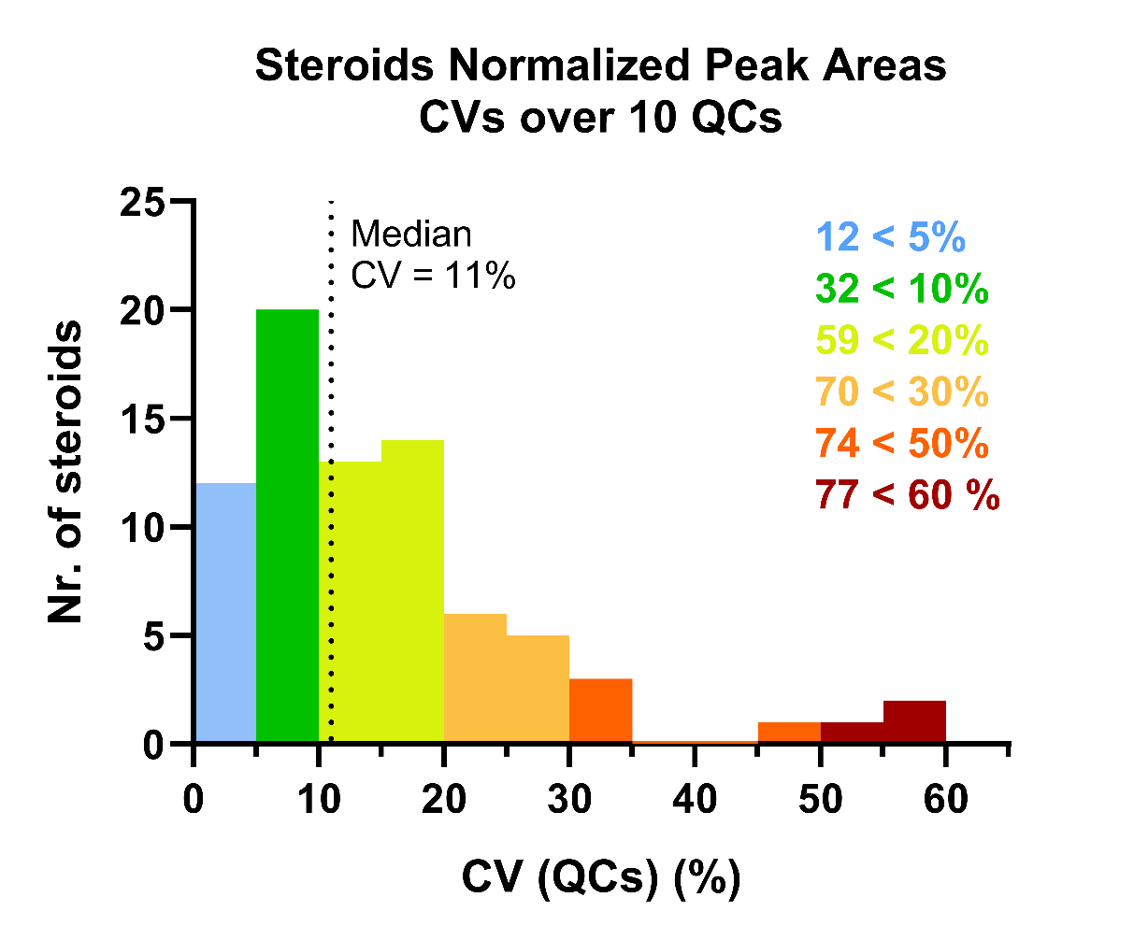
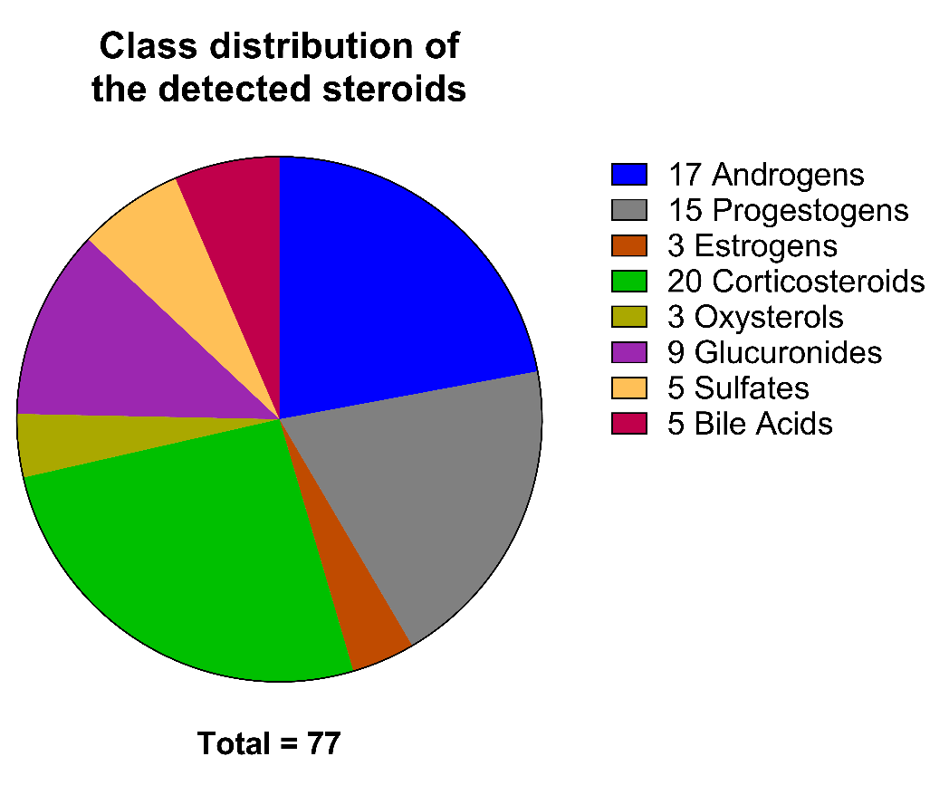
Section S1: Extended steroid profiling in the cohort of 94 male human serum samples
Figure S 1 : Histogram representing the variability of normalized peak areas measured for each detected compound in pooled QC samples
Figure S 2 : Partition of the detected steroid compounds building up the extended steroid profile dataset within the eight defined steroid subclasses

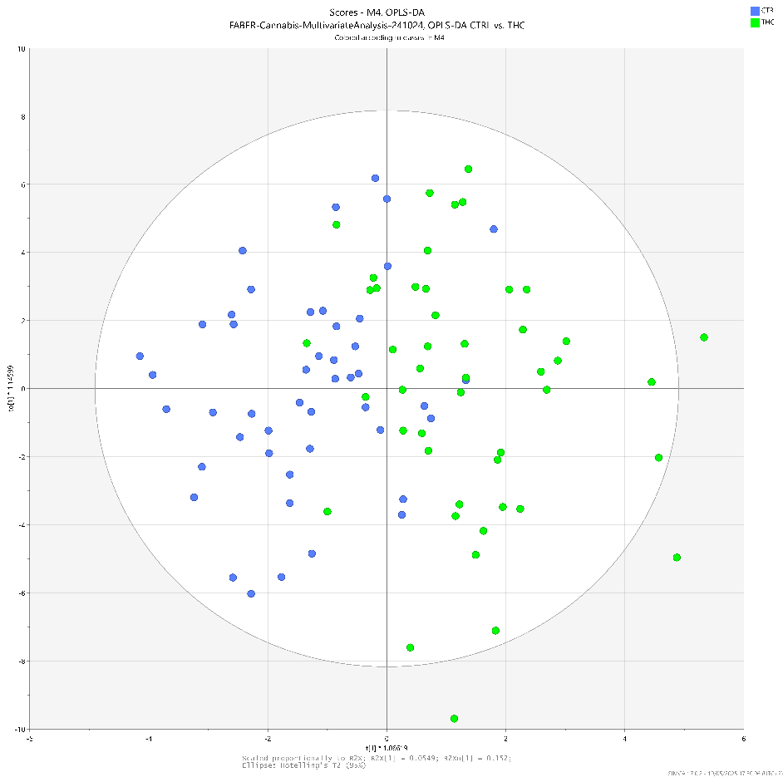
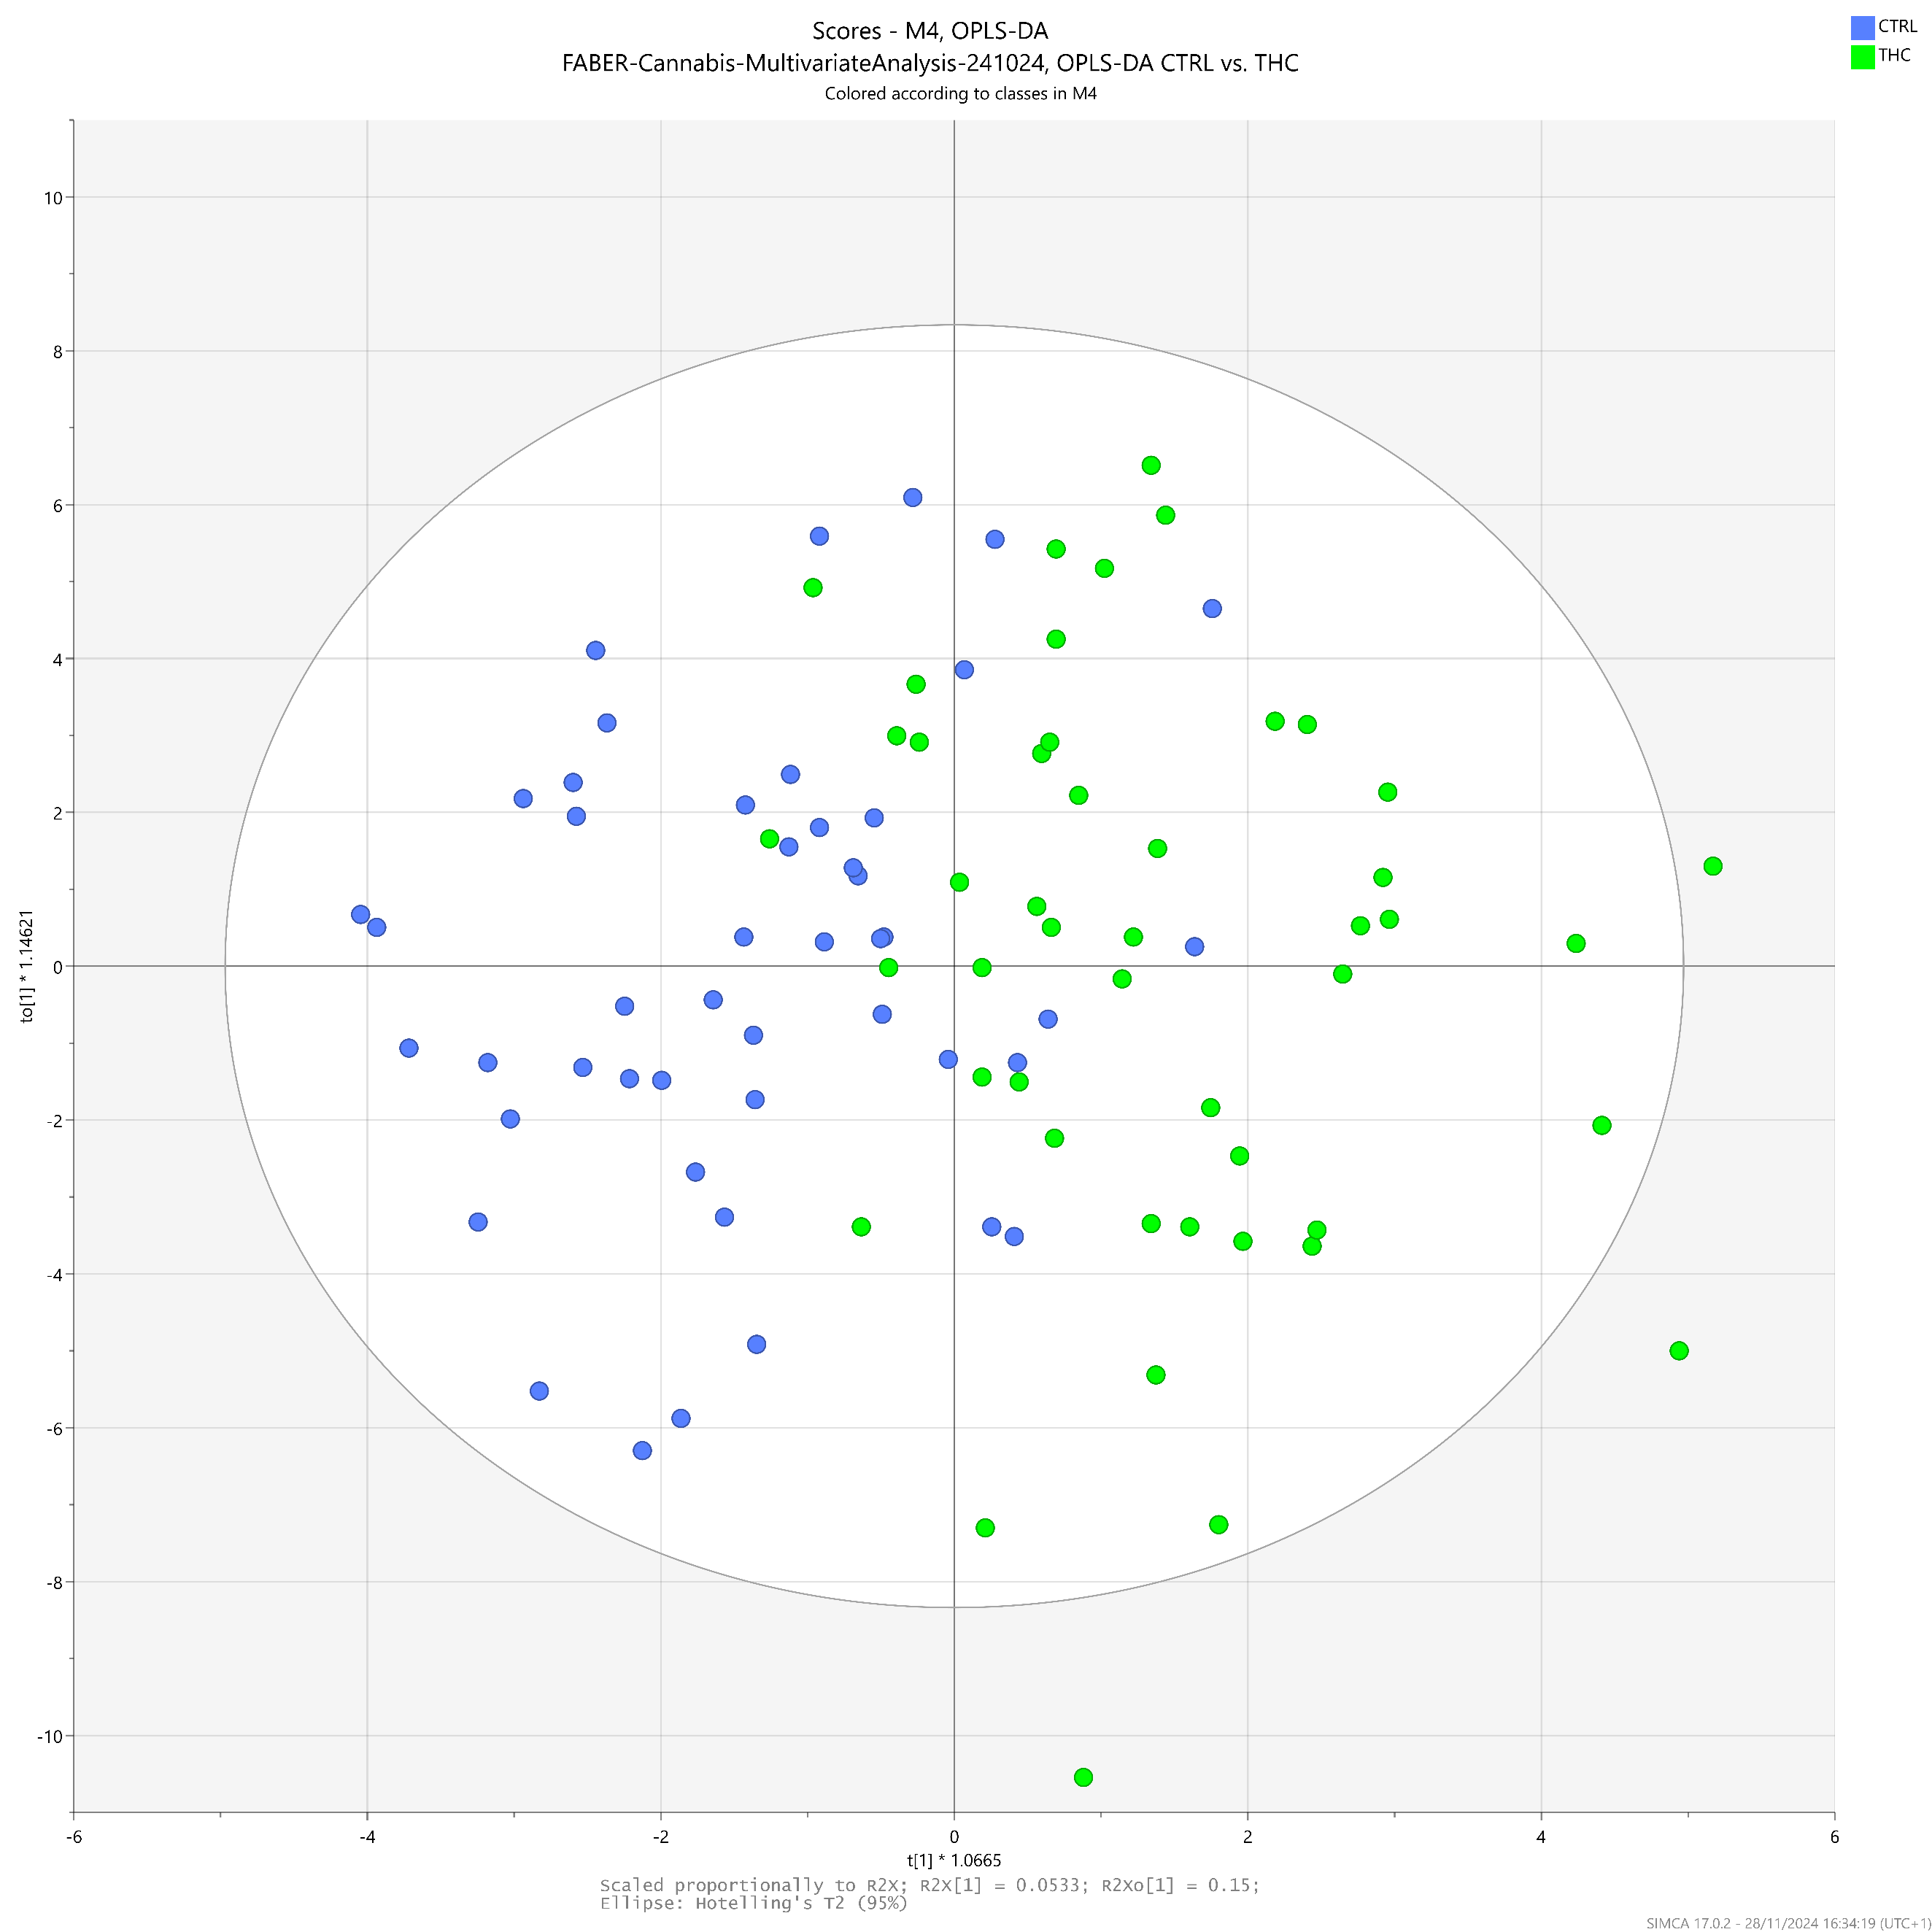
Section S2: OPLS-DA model (M1) discriminating the circulating steroid profile from cannabis users and non-users
Figure S 3 : Scores plot showing the separation of samples from the “THC-positive” group and the “control” group according to the OPLS-DA model M1.
0
-2
-4
-6
2
4
6
t _{p}

-6
-4
-2
0
2
4
6
t _{o1}

8
10
-8
-10

M1
1 predictive
& 1 orthogonal
component
R²Xp = 0.055
R²Y = 0.49
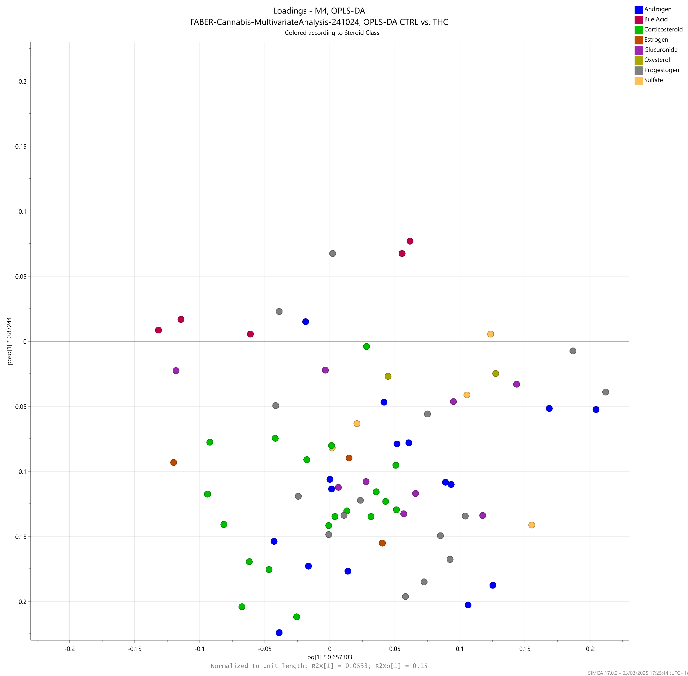
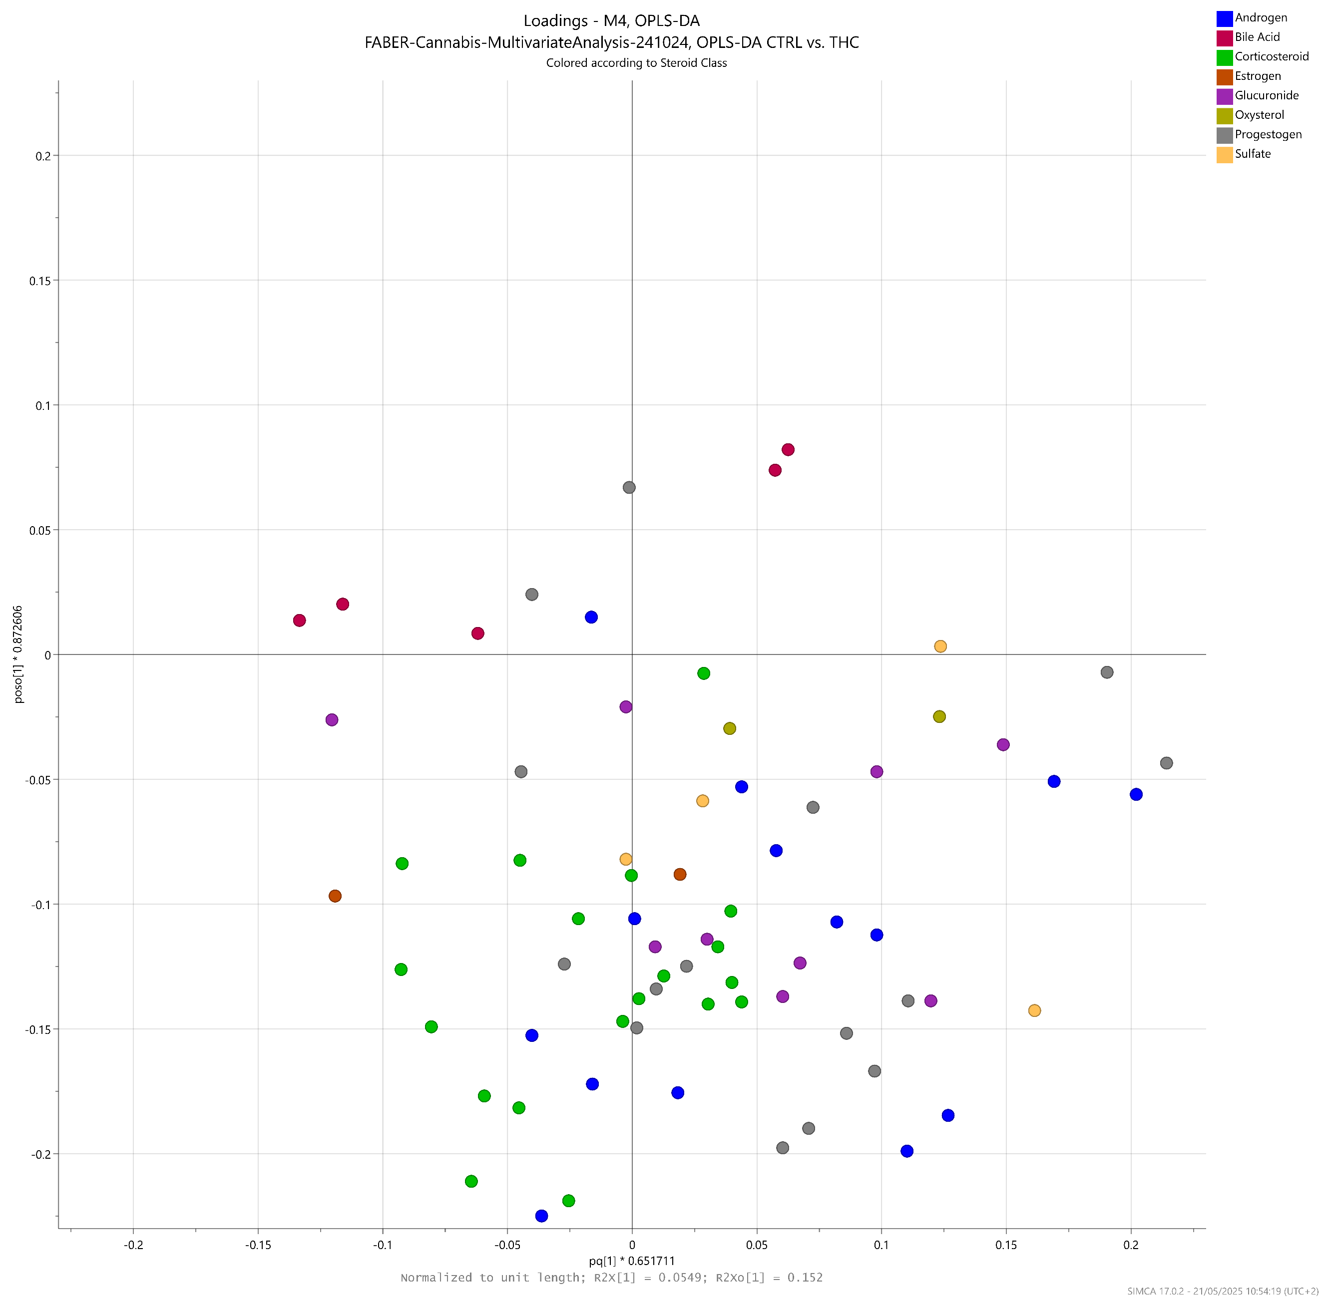
Q² = 0.19
Figure S 4 : Loadings plot displaying the variables responsible for group separation in model M1
0
0.05
0.1
0.15
0.2
-0.05
-0.1
-0.15
-0.2
p _{p}

-0.05
-0.1
-0.15
-0.2
0
0.05
0.1
0.15
0.2
p _{o1}

5B-DHP4
11B-OHP4
DHT
T

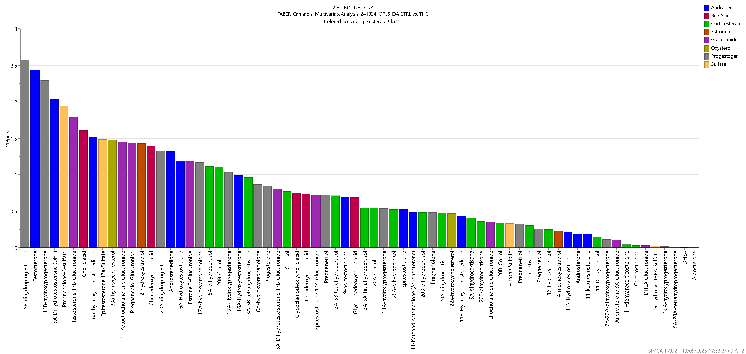
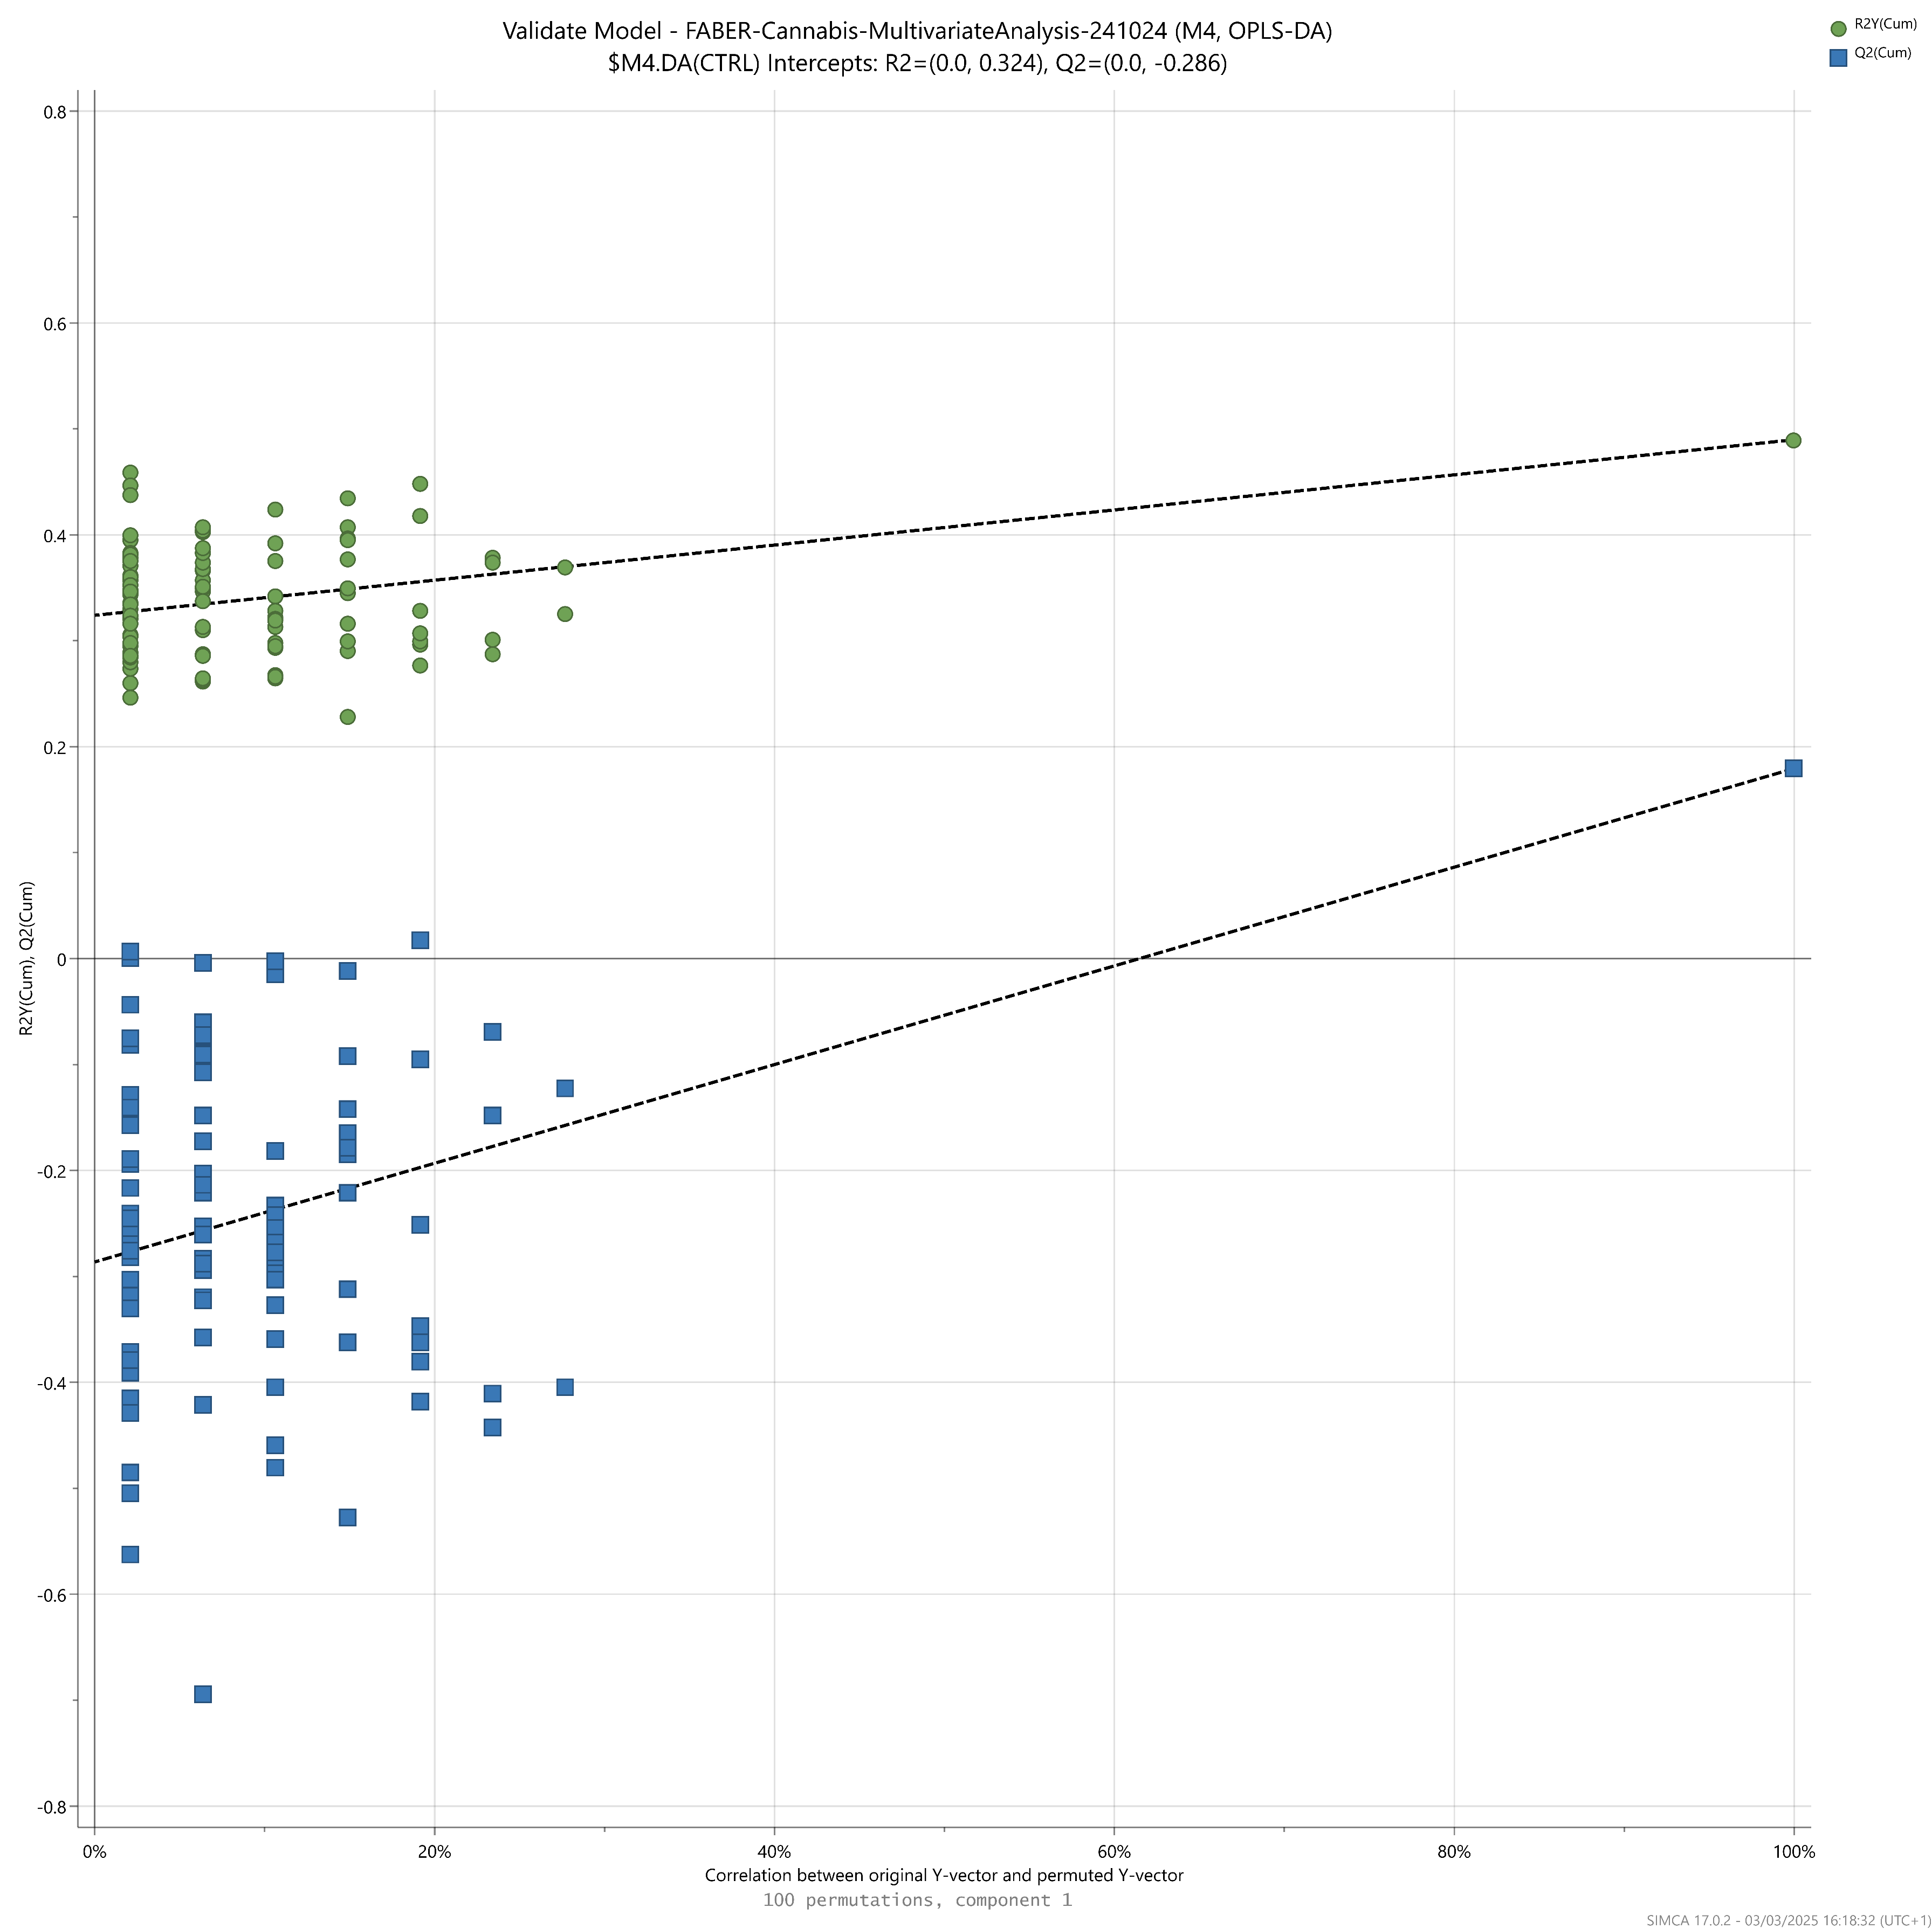
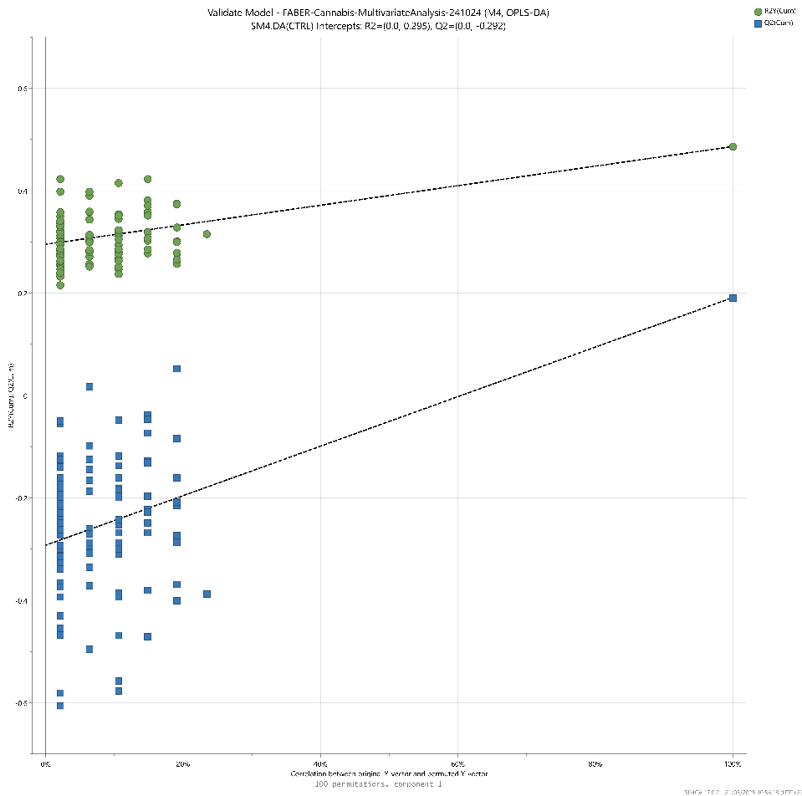
Figure S 5 : Variables Importance in Projection (VIP) characterizing the importance of each variable in the predictive component of model M1.
11B-OHP4
5B-DHP4
A4
T
DHT
11-KA4
11B-OHA4
11B-OHT
11-KT
DHEA
VIP = 1
0%
20%
Correlation between original Y-vector and permuted Y-vector
40%
60%
80%
100%
0
-0.2
-0.4
-0.6
0.6
0.4
0.2
R²Y / Q²
Figure S 6 : Model M1 permutation plot displaying observed R²Y and Q² versus corresponding values obtained under the null hypothesis in a permutation test with 100 permutations.

Section S3: Univariate analyses of C11-oxy androgen concentrations depending on the cannabis consumption status
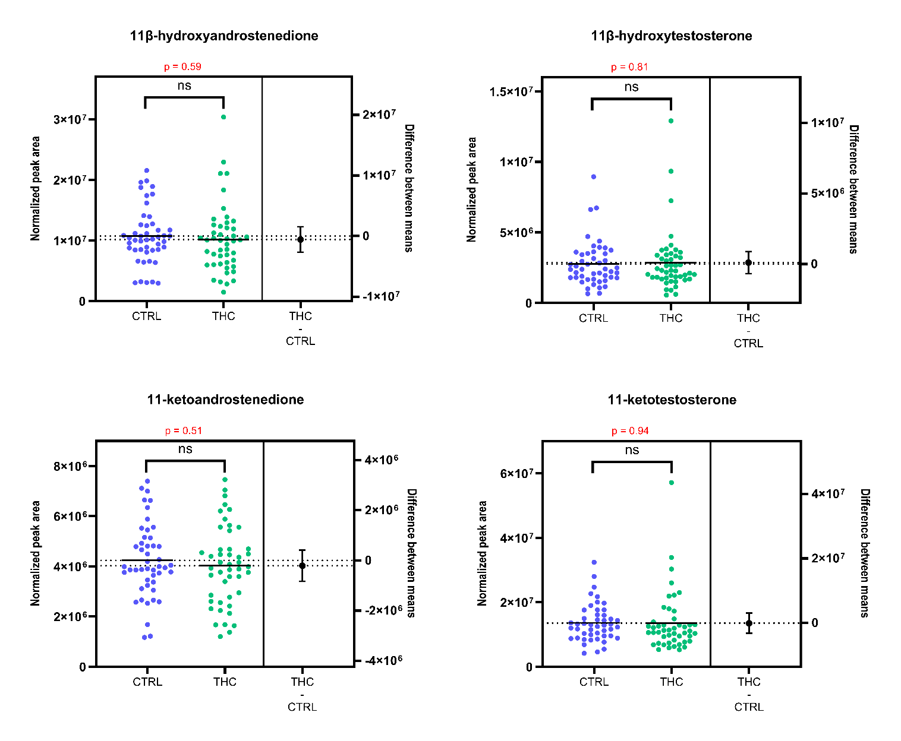
Figure S 7 : Beeswarm charts with univariate statistical analyses (t-tests), showing the differences in circulating C11-oxy androgen concentrations between controls and THC-positive participants

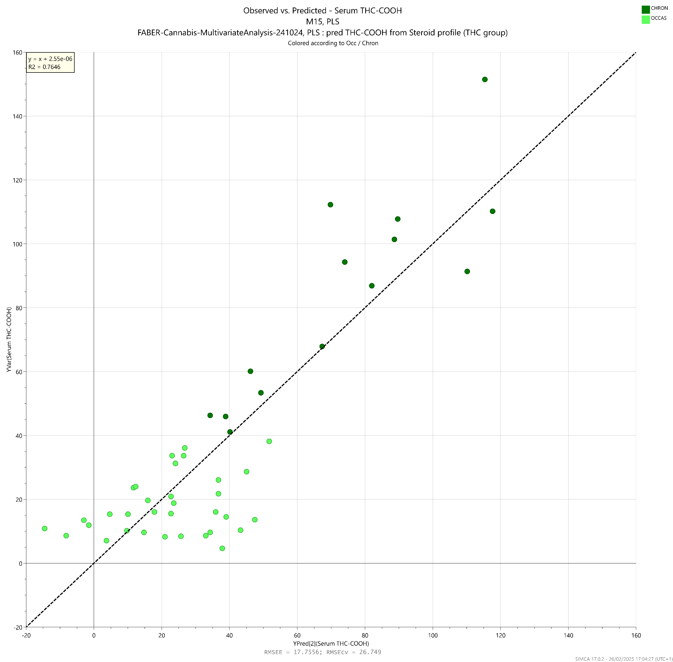
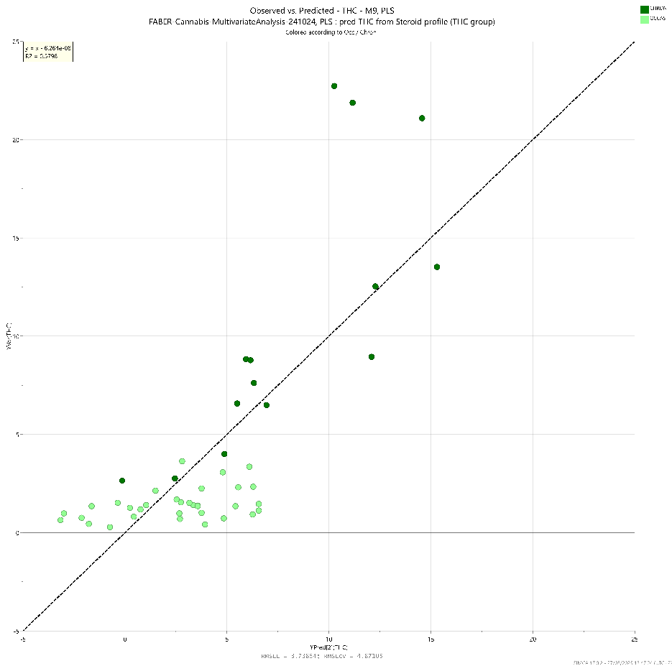
Section S4: PLS model (M2) relating the circulating steroid profile with serum THC concentrations in cannabis users
0
5
-5
10
15
20
25
[THC]_{serum}, predicted (ng/mL)
-5
0
5
10
15
20
25
[THC]_{serum}, observed (ng/mL)
Figure S 8 : Observed vs. predicted values of serum THC concentrations according to the PLS model M2
M2
2 components
R²X = 0.22
R²Y = 0.58
Q² = 0.22

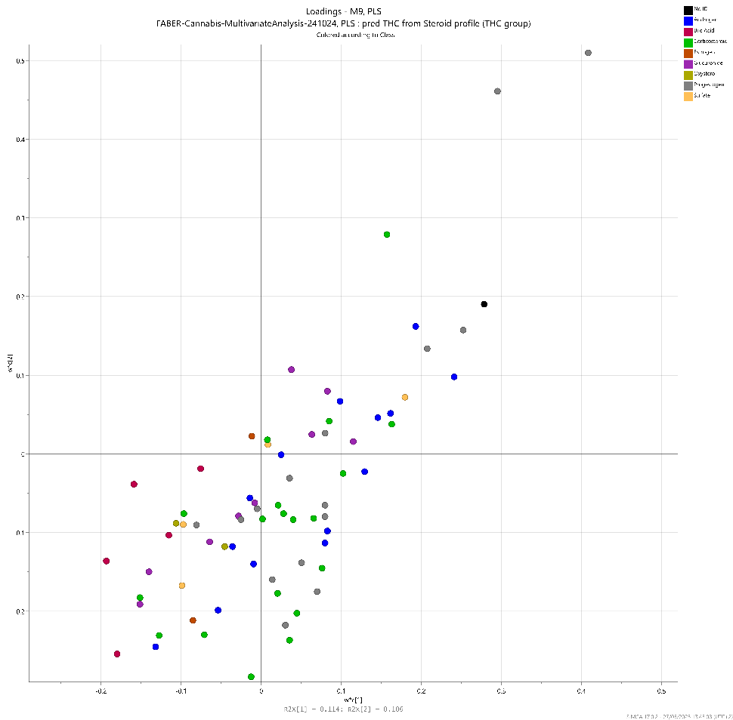
w*c ₁

-0.2
-0.1
0
0.1
0.2
0.3
0.4
0.5
-0.2
-0.1
0
0.1
0.2
0.3
0.4
0.5
w*c ₂

5B-DHP4
11B-OHP4
A4
THC
16A-OHA4
11-KA4
T
DHT
11B-OHA4
11B-OHT
11-KT
DHEA
20A-DHP4
17A-OHP5
6A-OHT
20B-Col
P5S
Figure S 9 : Loadings plot showing the distribution of variables from the steroid profile (X-variables) and serum THC concentration (Y-variable) in the PLS model M2.

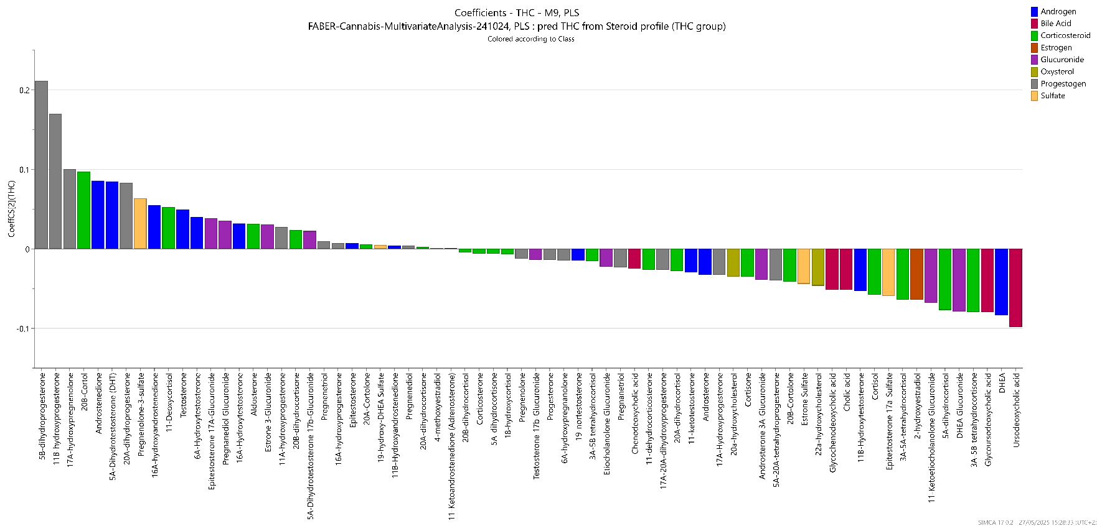
Figure S 10 : Regression coefficients representing the contribution of each X-variable from the extended steroid profile to predict the serum THC concentration (Y-variable) in the PLS model M2.
A4
11-KA4
T
DHT
11B-OHA4
11B-OHT
11-KT

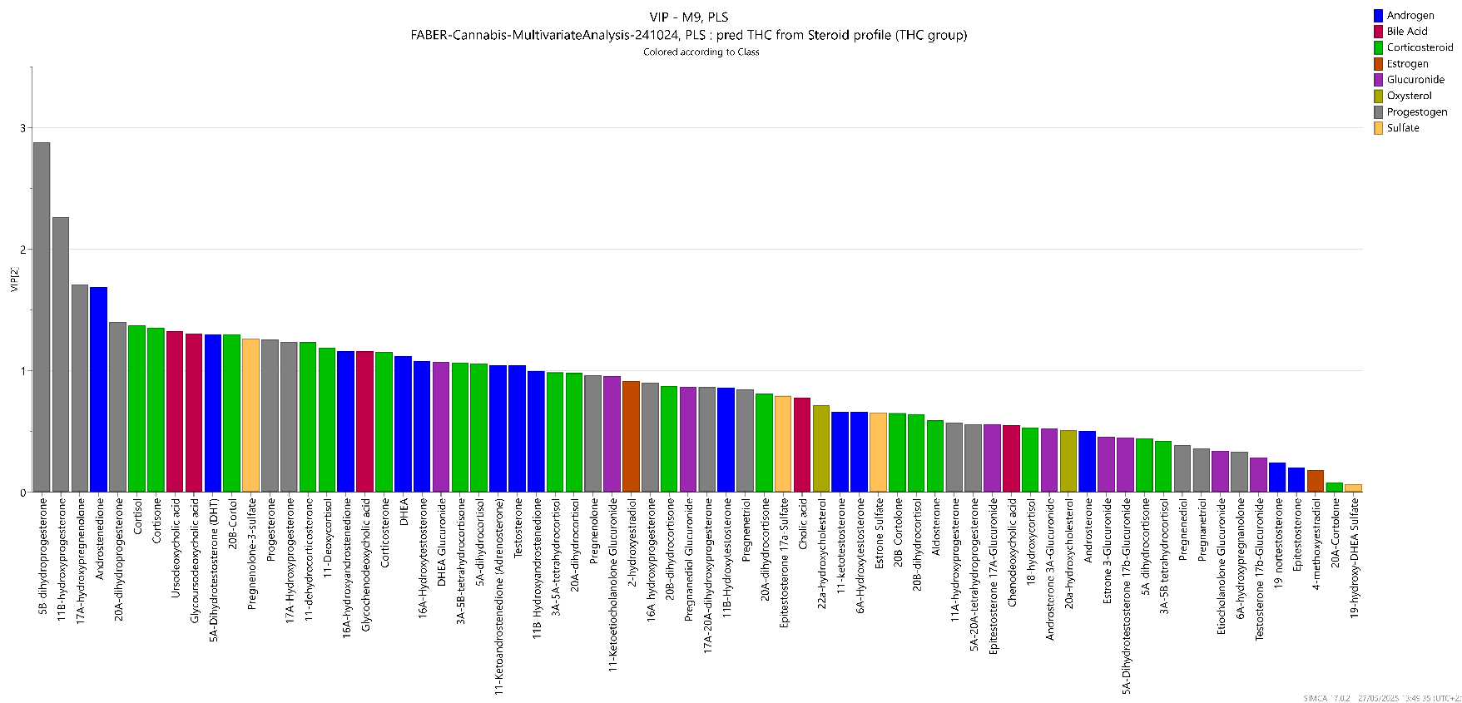
Figure S 11 : Variables Importance in Projection (VIP) characterizing the importance of each X-variable in the prediction of the serum THC concentration (Y) in M2.
VIP = 1
A4
11-KA4
T
DHT
11B-OHT
11-KT
11B-OHA4
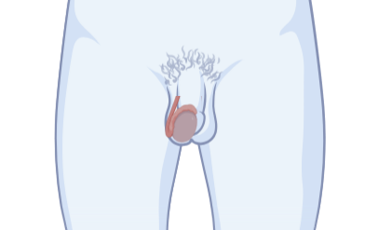
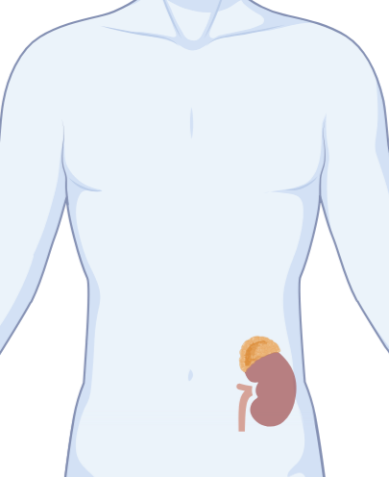
w*c ₁

-0.2
-0.1
0
0.1
0.2
0.3
0.4
0.5
-0.2
-0.1
0
0.1
0.2
0.3
0.4
0.5
w*c ₂

A4
THC
11-KA4
T
DHT
11B-OHA4
11B-OHT
11-KT
DHEA
11B-OHP4
5B-DHP4
Figure S 12 : Annotated loadings plot from M2 model showing that gonadal androgens (A4, T and DHT) are positively correlated with serum THC concentrations, whereas adrenal androgens (11B-OHA4, 11B-OHT, 11-KA4, 11-KT) are rather not correlated or negatively correlated with serum THC.

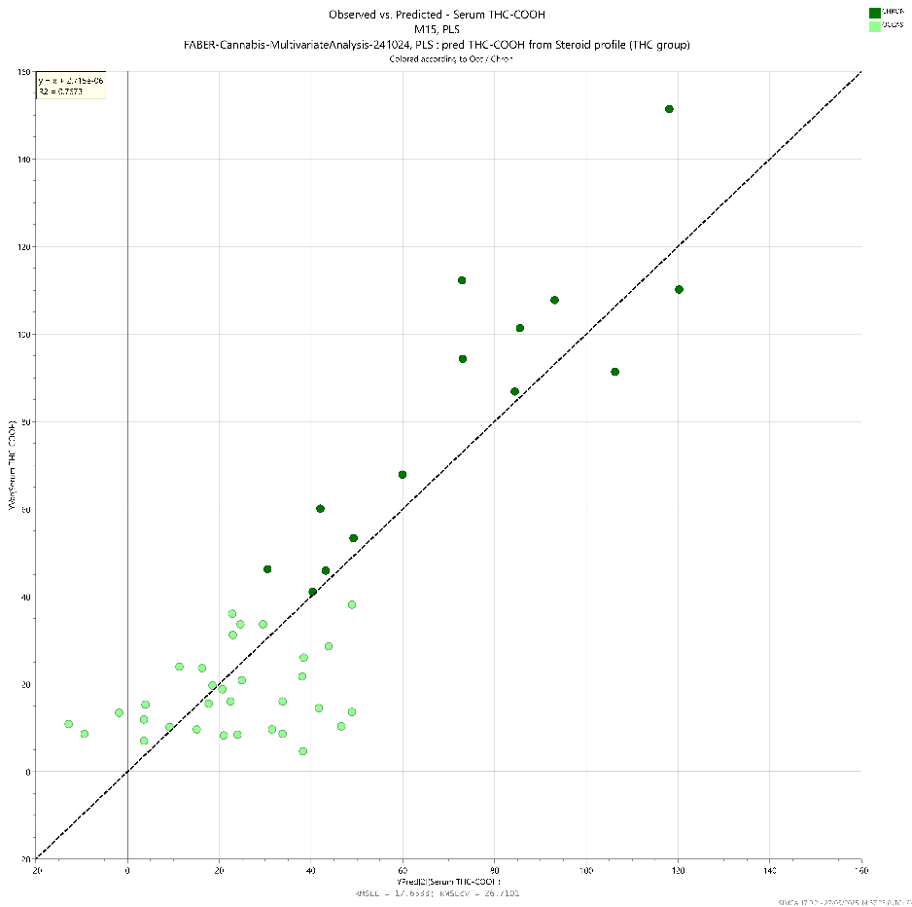
Section S5: PLS model (M3) relating the circulating steroid profile with serum THC-COOH concentrations in cannabis users
0
20
40
-20
60
80
100
120
140
160
[THC-COOH]_{serum}, predicted (ng/mL)
-20
0
20
40
60
80
100
120
140
160
[THC-COOH]_{serum}, observed (ng/mL)
Figure S 13 : Observed vs. predicted values of serum THC-COOH levels according to the PLS model M3
M3
2 components
R²X = 0.22
R²Y = 0.77
Q² = 0.45
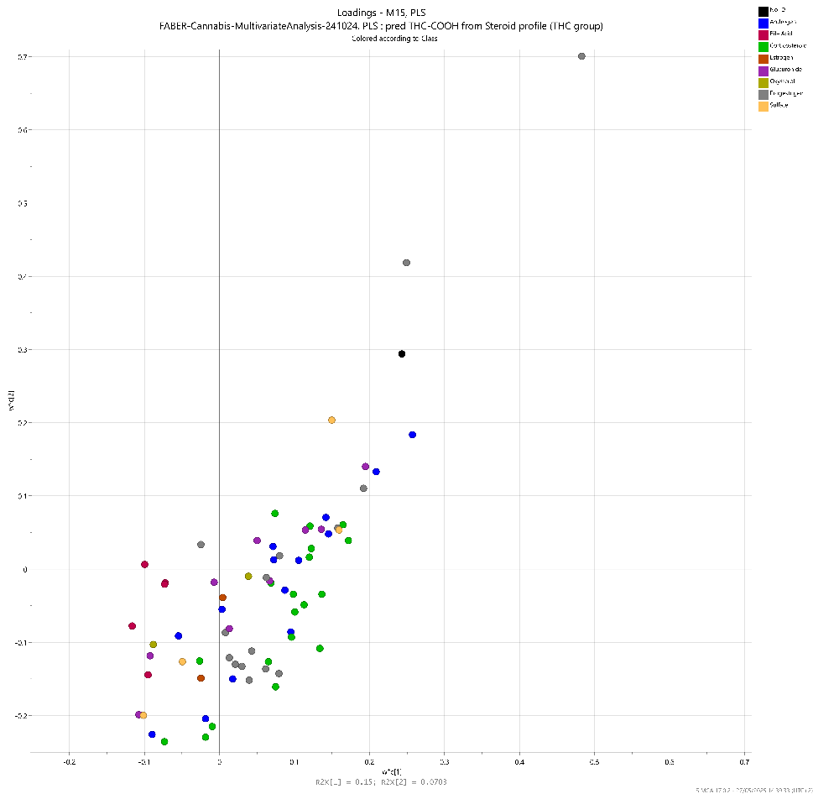
-0.2
-0.1
0
0.1
0.2
0.3
0.4
0.5
0.6
w*c ₁

0.7
-0.2
-0.1
0
0.1
0.2
0.3
0.4
0.5
0.6
w*c ₂

0.7
5B-DHP4
11B-OHP4
THC-COOH
A4
16A-OHA4
11-KA4
T
DHT
11B-OHA4
11B-OHT
11-KT
DHEA
20A-DHP4
OHDHEAS
PdiolG
Figure S 14 : Loadings plot showing the distribution of variables from the steroid profile (X-variables) and serum THC concentration (Y-variable) in the PLS model M3.
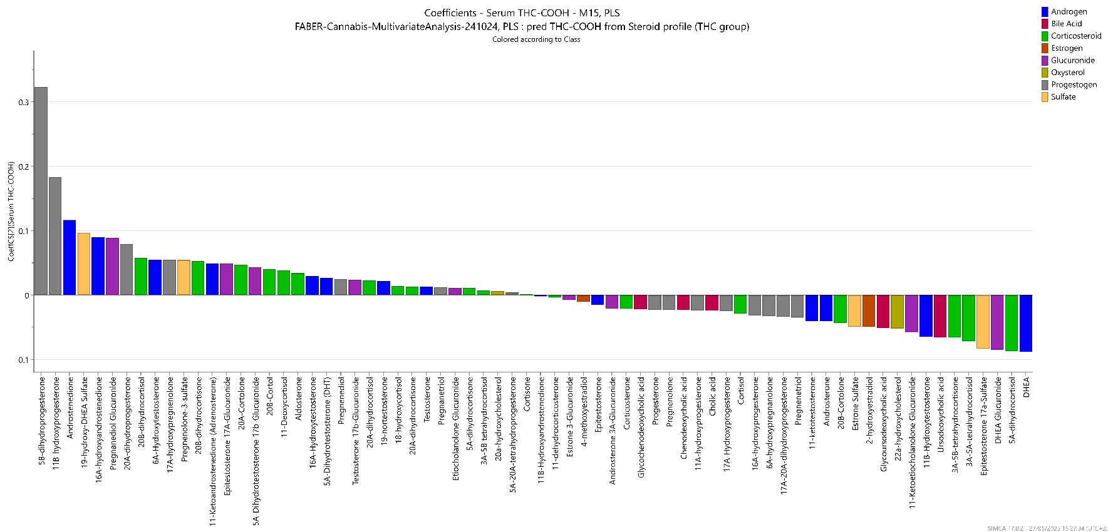
Figure S 15 : Regression coefficients representing the contribution of each X-variable from the extended steroid profile to predict the serum THC-COOH concentration (Y-variable) in the PLS model M3.
A4
11-KA4
T
DHT
11B-OHA4
11B-OHT
11-KT

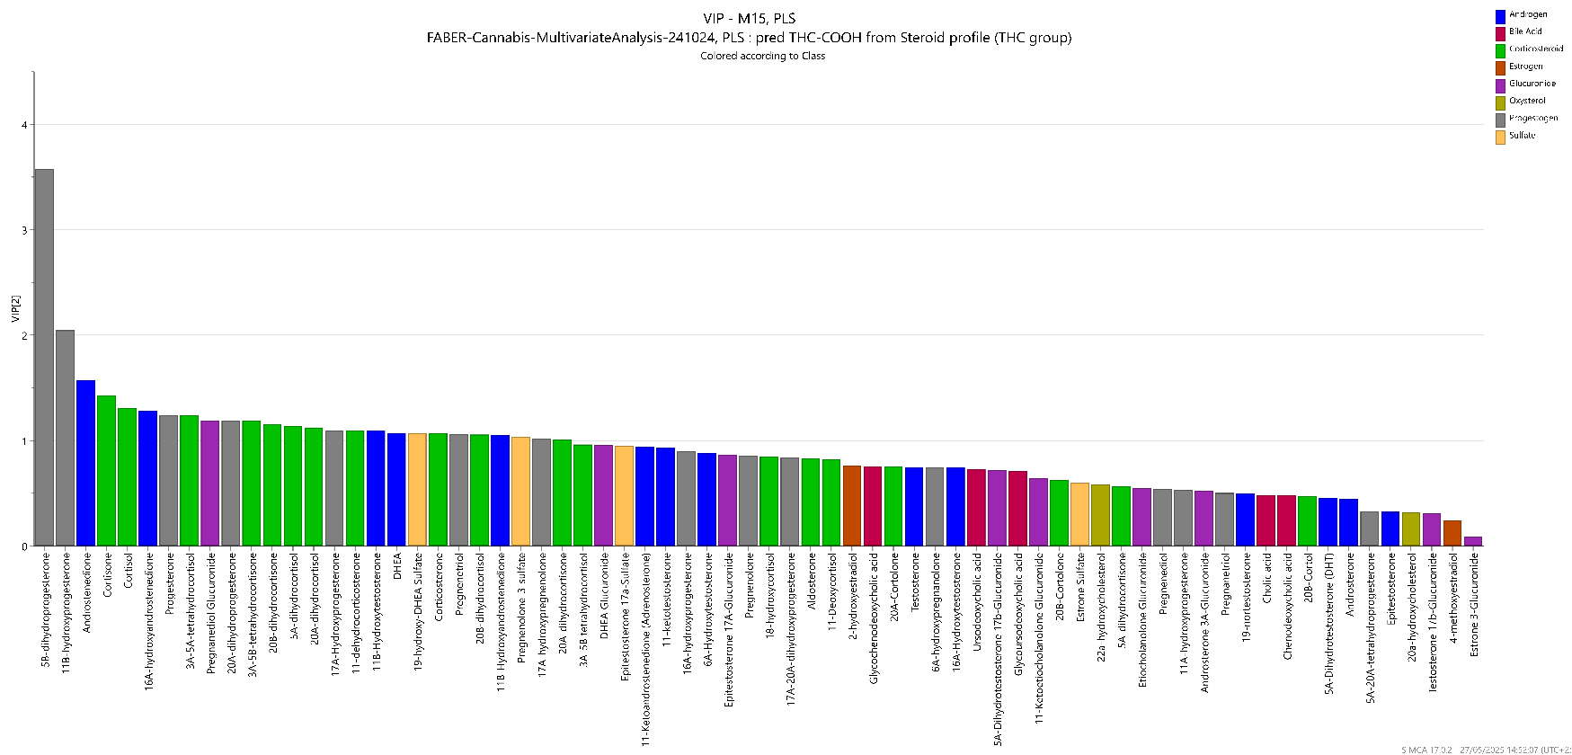
Figure S 16 : Variables Importance in Projection (VIP) characterizing the importance of each X-variable in the prediction of the serum THC-COOH concentration (Y) in M3.
VIP = 1
A4
11-KA4
11B-OHA4
11B-OHT
11-KT
T
DHT

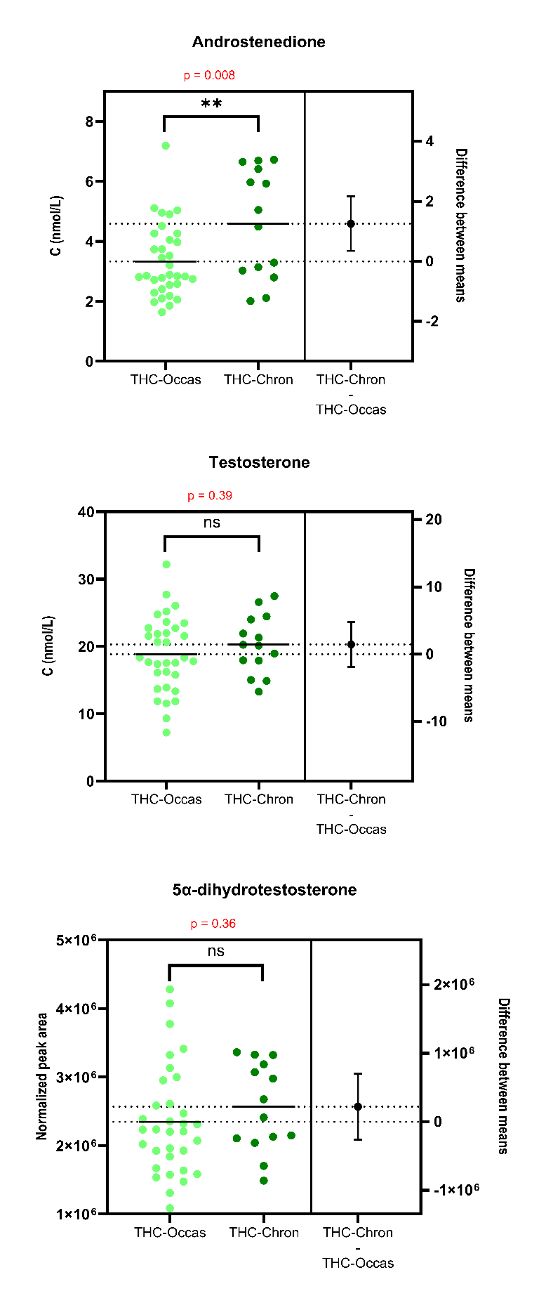
Section S6: Univariate analyses comparing androgen concentrations between occasional and chronic cannabis consumers

Figure S 17 : Beeswarm charts with univariate statistical analyses (t-tests) showing the differences in steroid concentrations between occasional (light green) and chronic (dark green) cannabis consumers.

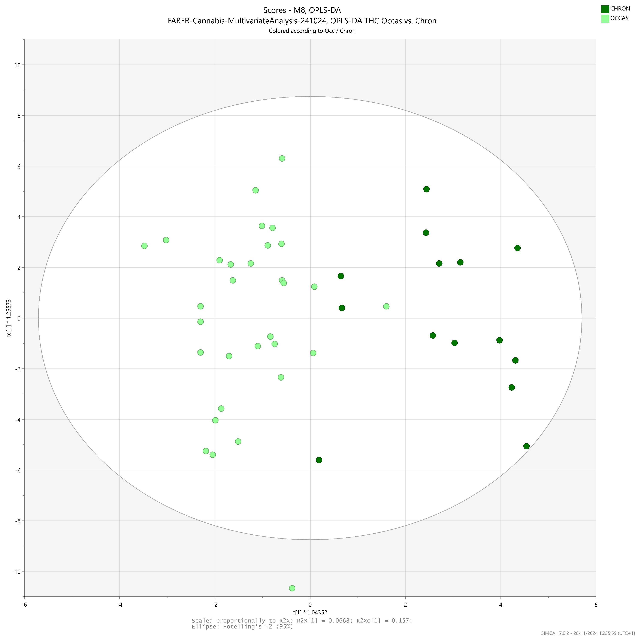
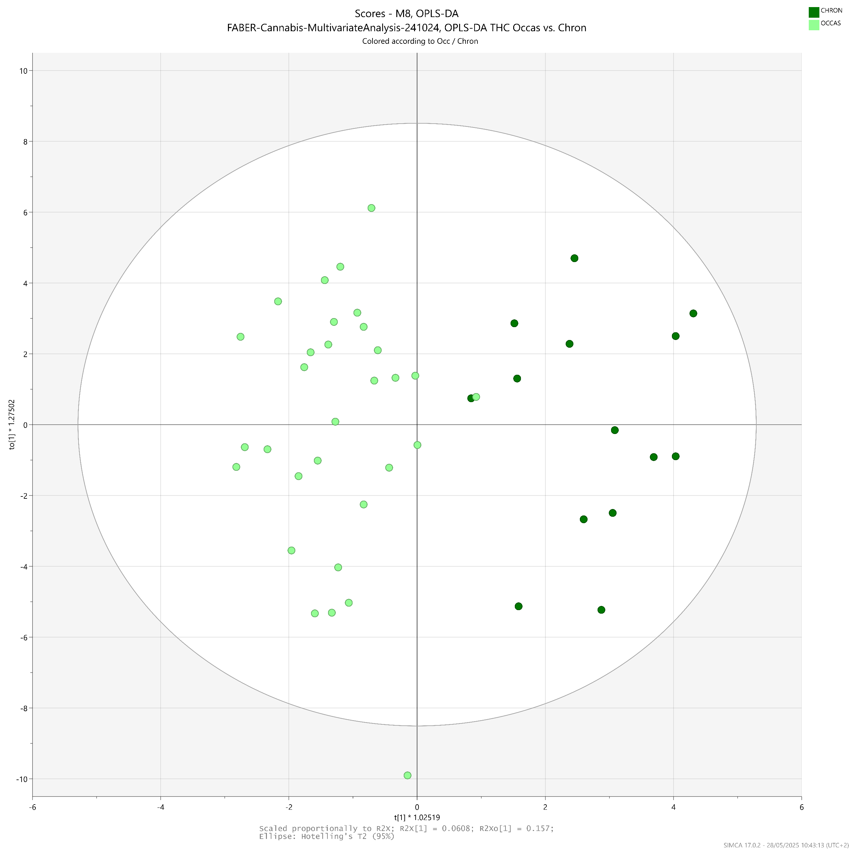
Section S7: OPLS-DA model (M4) discriminating the circulating steroid profile from chronic and occasional cannabis users
t _{p}
0
-2
-4
-6
2
4
6
-6
-4
-2
0
2
4
6
t _{o1}
8
10
-8
-10
Figure S 18 : Scores plot showing the separation of samples from the occasional and the chronic consumer groups according to the OPLS-DA model M4.
M4
1 predictive & 2 orthogonal components R²Xp = 0.061 R²Y = 0.80
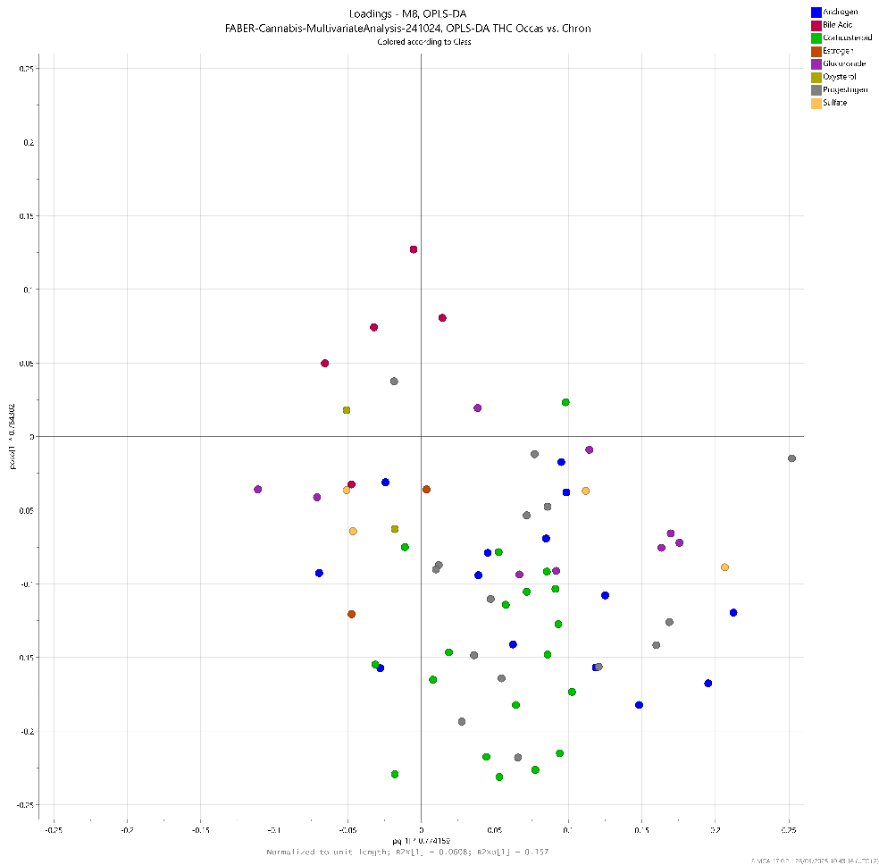
Q² = 0.36
0.25
-0.25
-0.05
-0.10
-0.15
-0.20
0
0.05
0.10
0.15
0.20
p _{o1}

p _{p}

0.25
0
0.05
0.10
0.15
0.20
-0.05
-0.10
-0.15
-0.20
-0.25
5B-DHP4
PdiolG
DHTG
P5S
16A-OHA4
20A-DHP4
A4
EpiTG
17A-OHP5
Figure S 19 : Loadings plot displaying the variables responsible for group separation in model M4

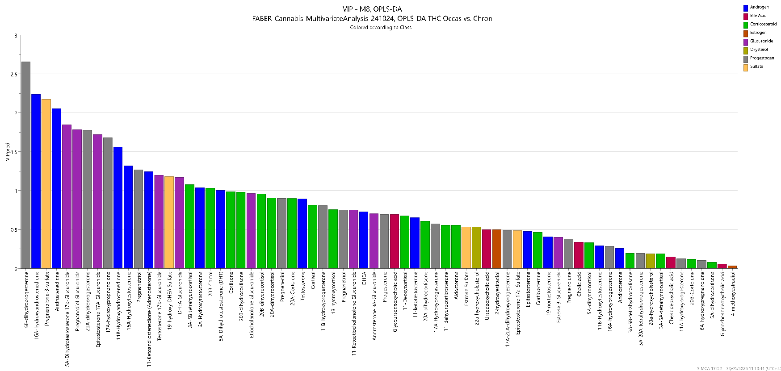
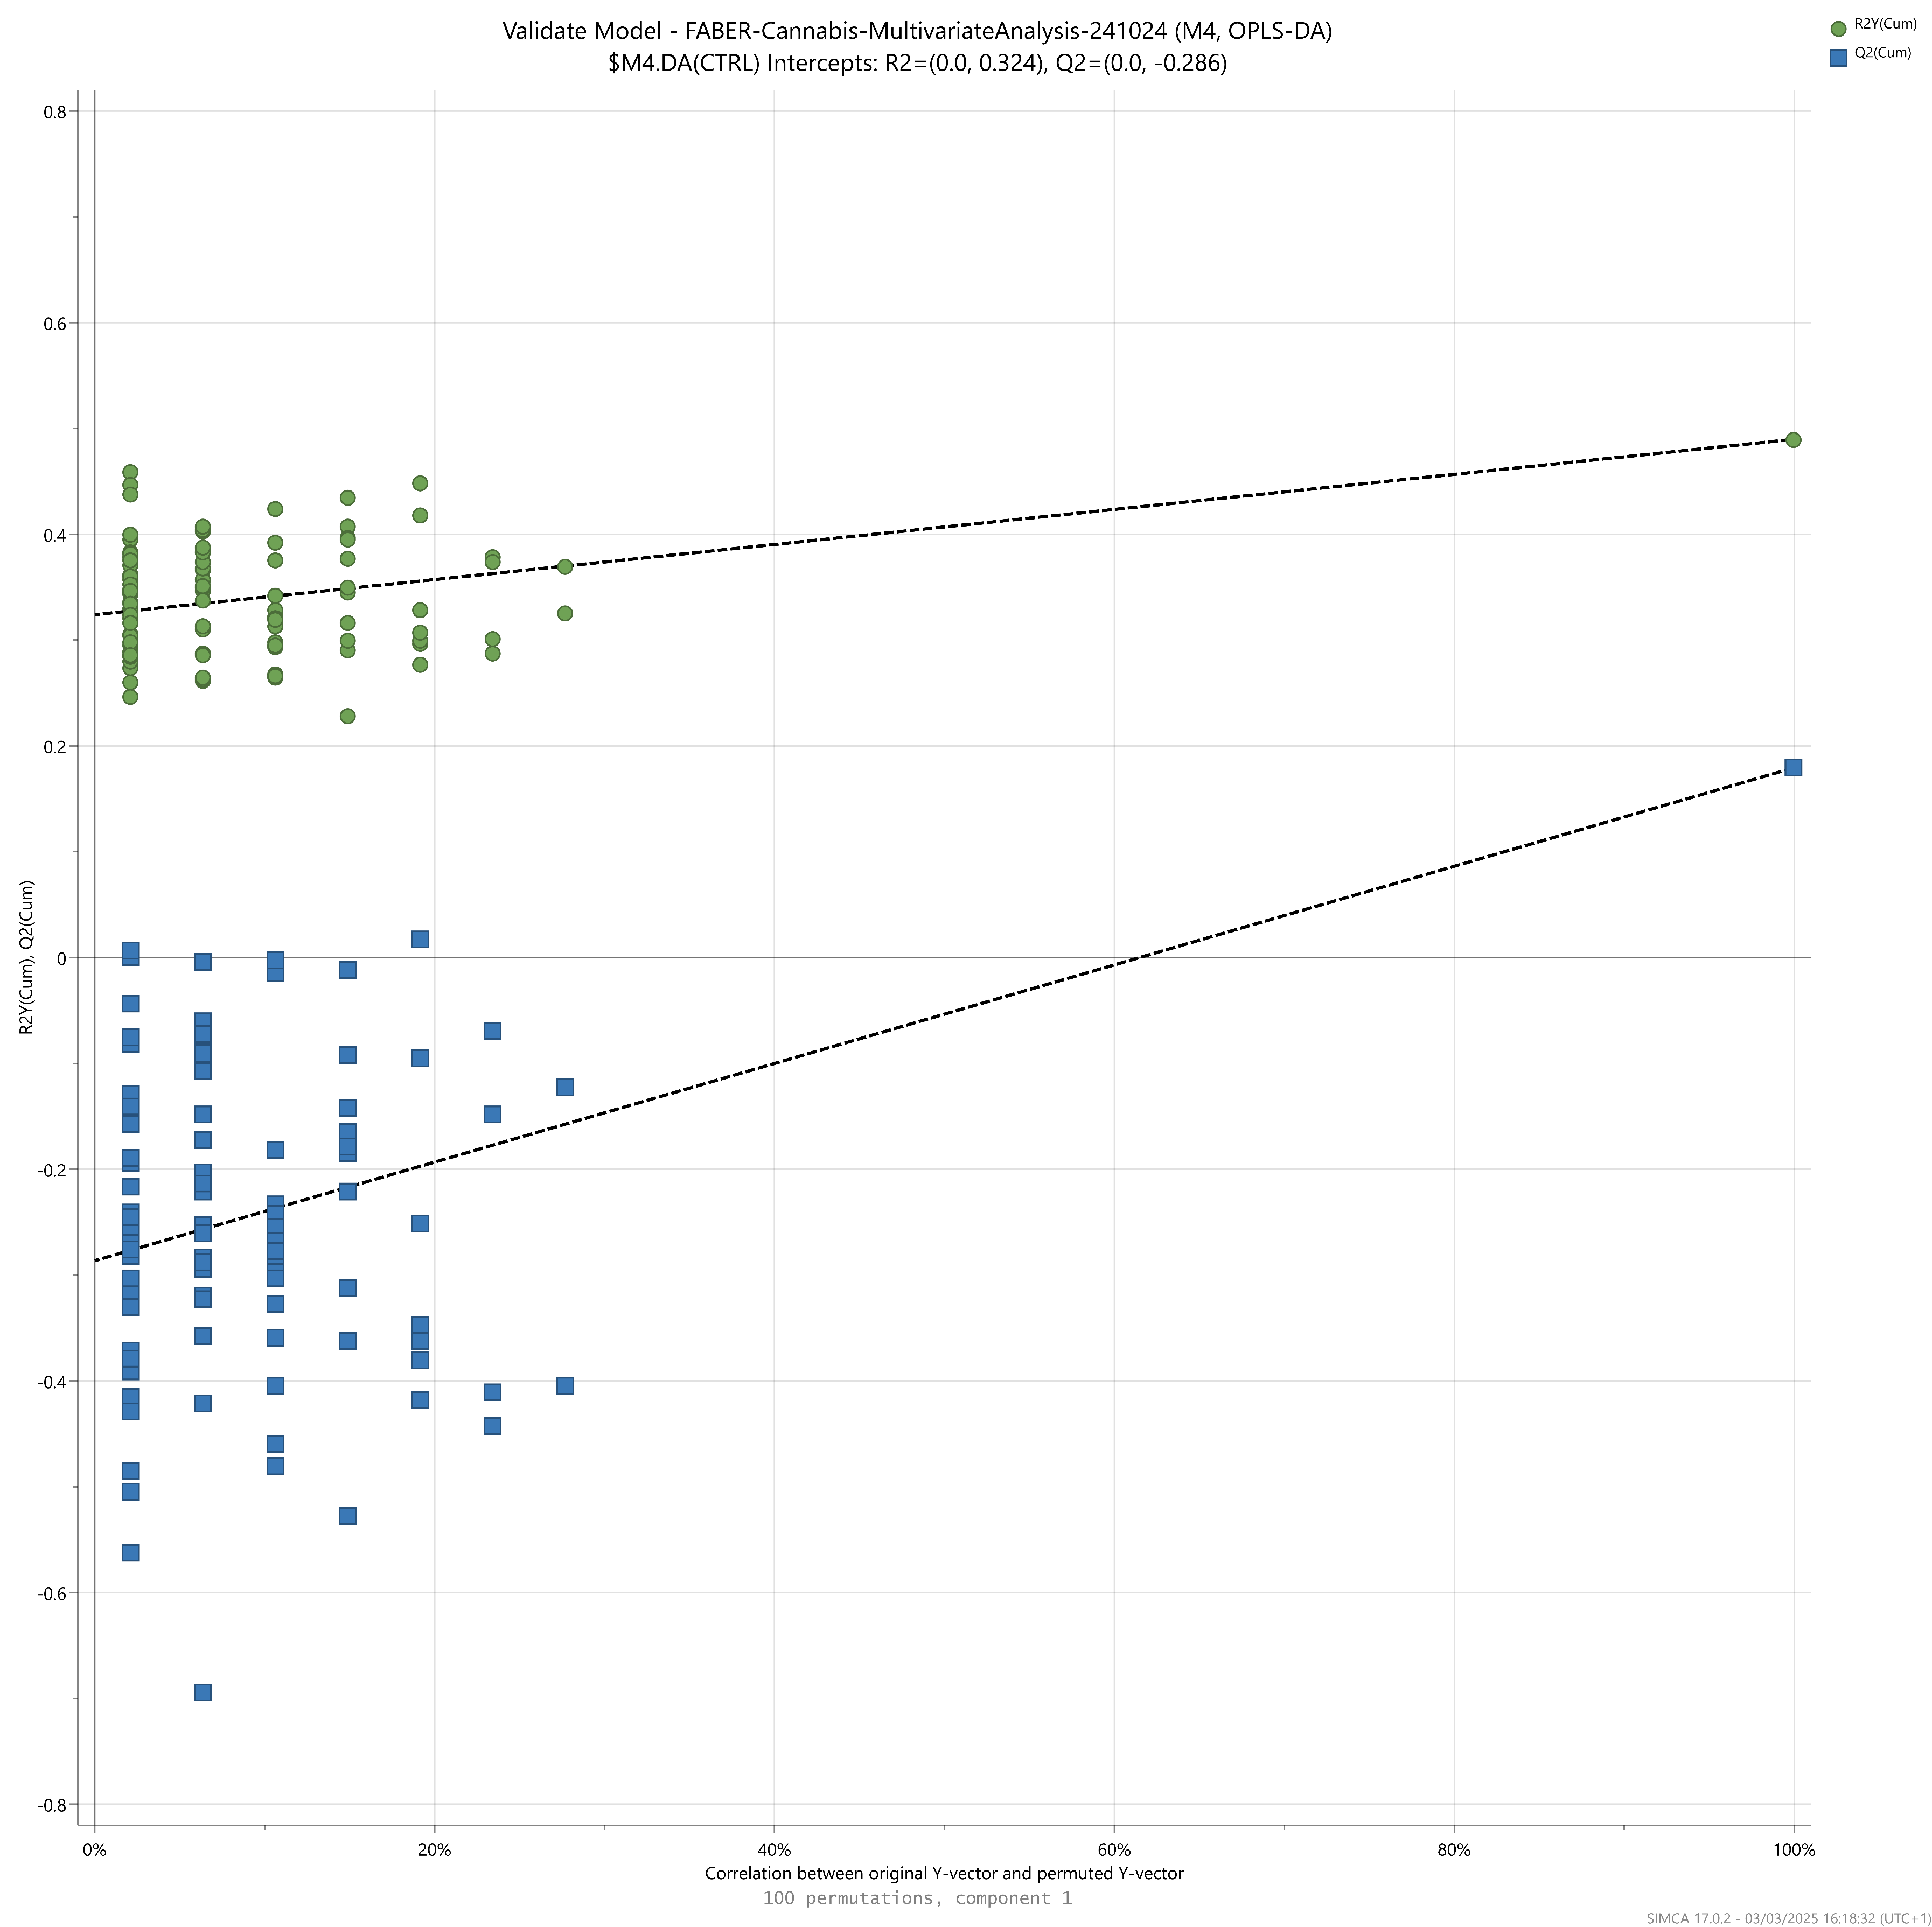
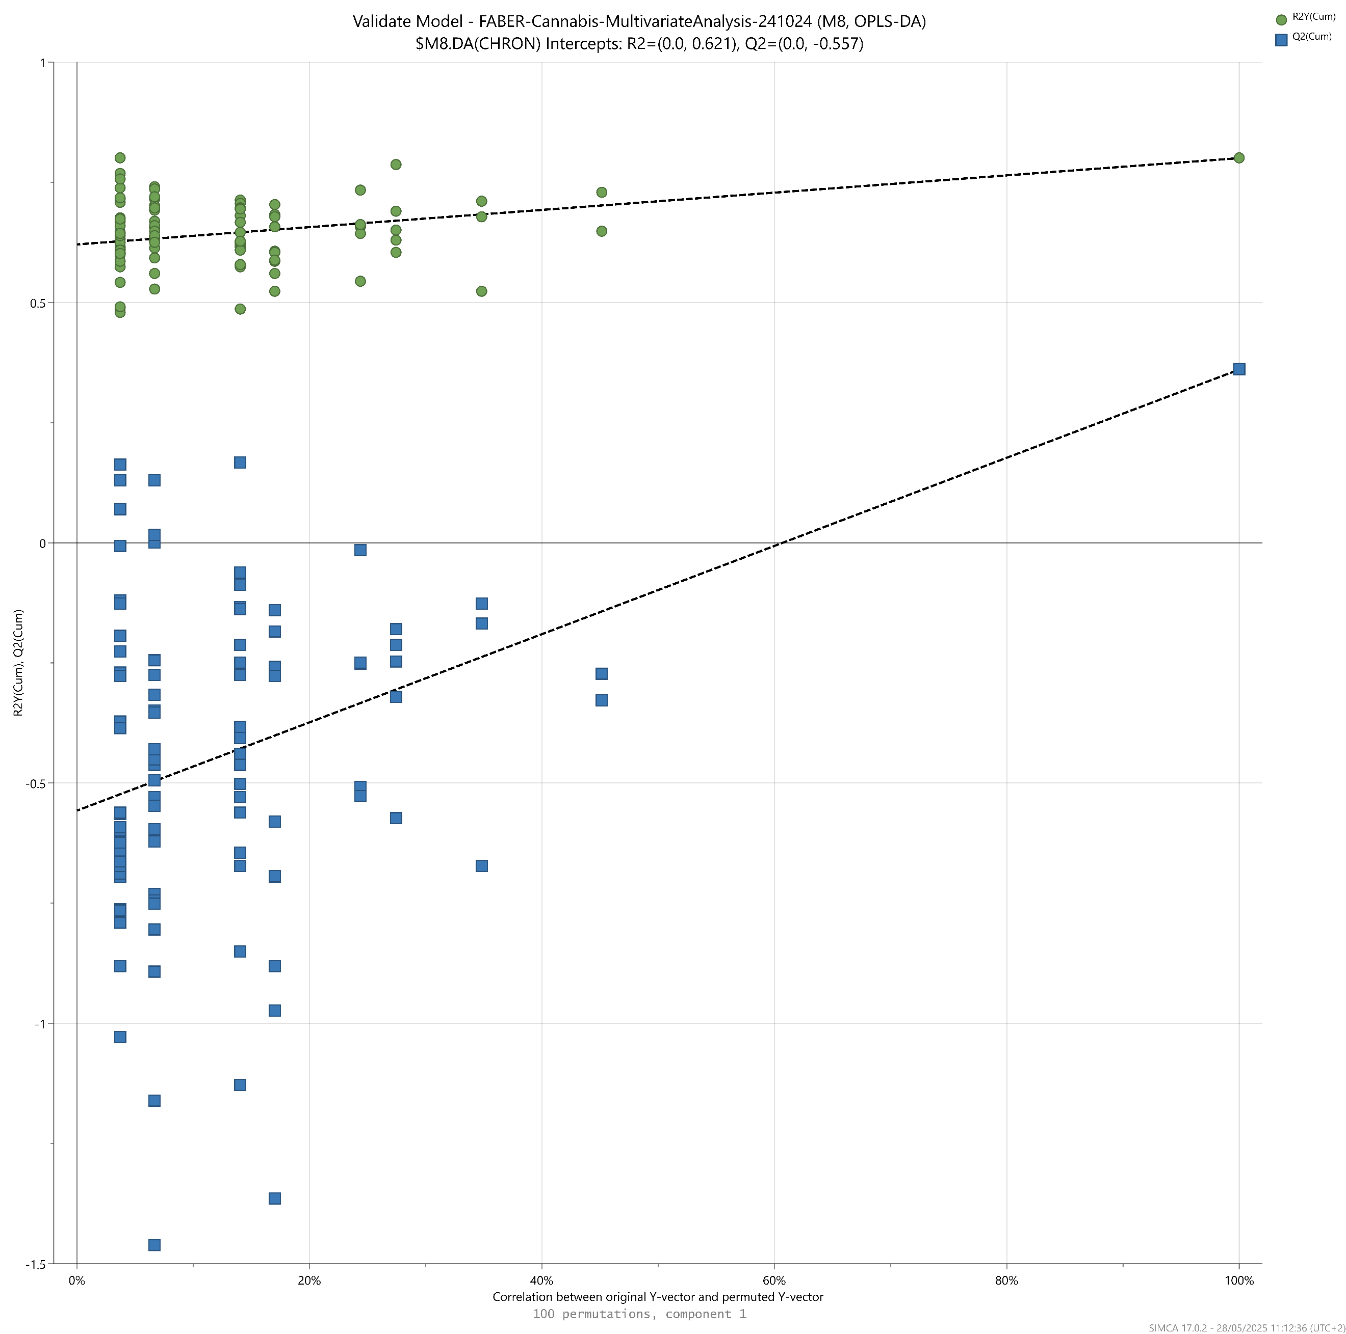
VIP = 1
Figure S 20 : Variables Importance in Projection (VIP) characterizing the importance of each variable in the predictive component of model M5.
5B-DHP4
A4
16A-OHA4
11B-OHP4
T
DHT
R²Y / Q²
0%
20%
Correlation between original Y-vector and permuted Y-vector
40%
60%
80%
100%
0
-0.5
1.0
-1.0
0.5
-1.5
Figure S 21 : Model M5 permutation plot displaying observed R²Y and Q² versus corresponding values obtained under the null hypothesis in a permutation test with 100 permutations.

Section S8: Investigation of possible confounding factors in the study of the extended steroid profile in relation with cannabis usage

In this study, two potential confounding factors were identified a priori, and could be investigated with the available data: tobacco consumption and Body Mass Index (BMI).

- Tobacco consumption
Tobacco smoking is known to be a major confounder in studies aiming at deciphering the effects of cannabis on male reproductive health (Shiels et al., 2009 ; Gundersen et al., 2015 ; Deltourbe et al., 2025). It is indeed frequent that cannabis smokers are also tobacco smokers. Gundersen et al. could not separate variations of testosterone levels that would be solely due to marijuana use from the influence of cigarette smoking (Gundersen et al., 2015).
In our cohort, there was also an important overlap between participants who declared cannabis smoking and cigarette smoking (see Table S5). Only 10 out of 47 controls smoked tobacco, and only 5 out of 47 THC-positive participants did not smoke tobacco. In total, there were 52 cigarette smokers among the 94 participants of the study.
The OPLS-DA model differentiating cigarette smokers (n = 52) from non-smokers (n = 42) displayed worse metrics than the models based on cannabis consumption (R²Y = 0.41 and Q² = -0.01 with two components). The negative value of Q², along with the permutation test that shows several Q² values obtained under the null hypothesis higher than the experimental one, suggests that in the present dataset, the prediction of cigarette smoking status based on steroid profile is unreliable. Therefore, although some discriminant variables of this tobacco-based OPLS-DA model are in common with cannabis-related models (e.g., 5B-DHP4), the effects observed on the extended steroid profile in this cohort and described in this manuscript are primarily related to the cannabis smoking status, not to the cigarette smoking status.
This was confirmed by the attempt to generate a PLS model with quantitative information on the number of cigarettes consumed daily by cigarette smokers, as they declared it. This attempt was unsuccessful, as the Q² value of the model was negative and decreasing at each additional component. Again, the steroid profile measured in this cohort was not related to the amount of tobacco smoking. As a drawback, the tobacco consumption of the participants was only evaluated from their statement and was not confirmed by any biomarker, oppositely to the cannabis consumption which was confirmed by THC and THC-COOH.

- Body Mass Index
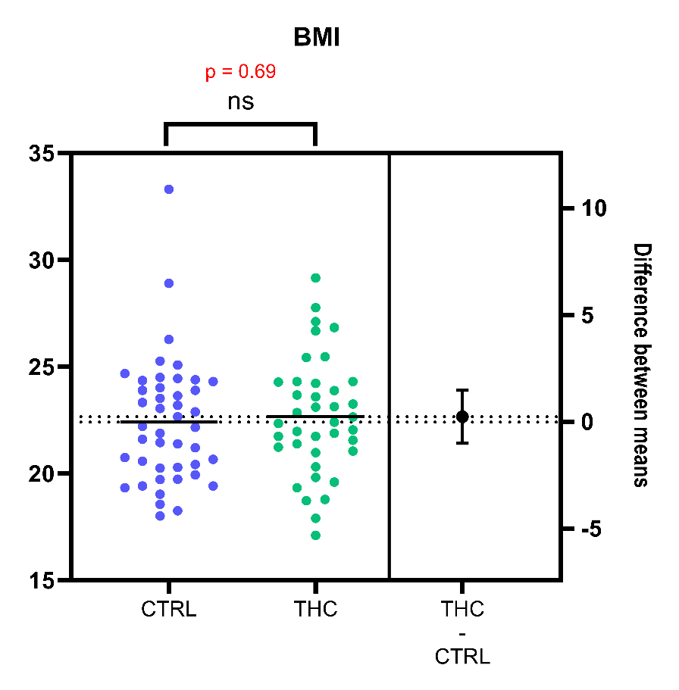
BMI is known to impact circulating steroid concentrations in males (Mezzullo et al., 2020 ; Deltourbe et al., 2025). In the present study, we ensured that the THC-positive and control groups were matched in BMI, as no significant difference in BMI was observed between the two groups (p-value = 0.69, see Figure S38). Furthermore, there was no model able to relate steroid profile as X-variable to BMI as Y-variable using PLS regression. No component at all was found to be significant in this attempt to generate a BMI-based model (Q² < 0 starting from the first component and decreasing at each additional component). Therefore, it was determined that BMI was not a significant confounding factor in the present study.
Figure S 22 : Beeswarm chart with the corresponding univariate statistical analysis (unpaired t-test) demonstrating the absence of significant difference in Body Mass Index between the subjects of each group (THC-positive vs. control)

Section S9: Correlation of the steroid profile with other sex hormones
Data on the extended steroid profile measured in participants from this cohort were combined with data on LH and FSH measured in the same samples by Zufferey et al. ²⁰. However, no robust PLS model could be established to relate these hormones secreted by the anterior pituitary to circulating steroid concentrations. Q² values were negative for both multivariate models, irrespective of the number of components involved. The dataset was even reduced to sex hormones only (androgens, progestogens, estrogens and their phase II metabolites) in an attempt to reduce the noise related to other steroid subclasses, without yielding any improvement.
LH was slightly, insignificantly increased in cannabis users compared to controls (p = 0.22) but not affected by the occasional or chronic frequency of use (p = 0.85), and the same result was obtained for FSH (p = 0.12 and p = 0.85, respectively) (see Figure S1).
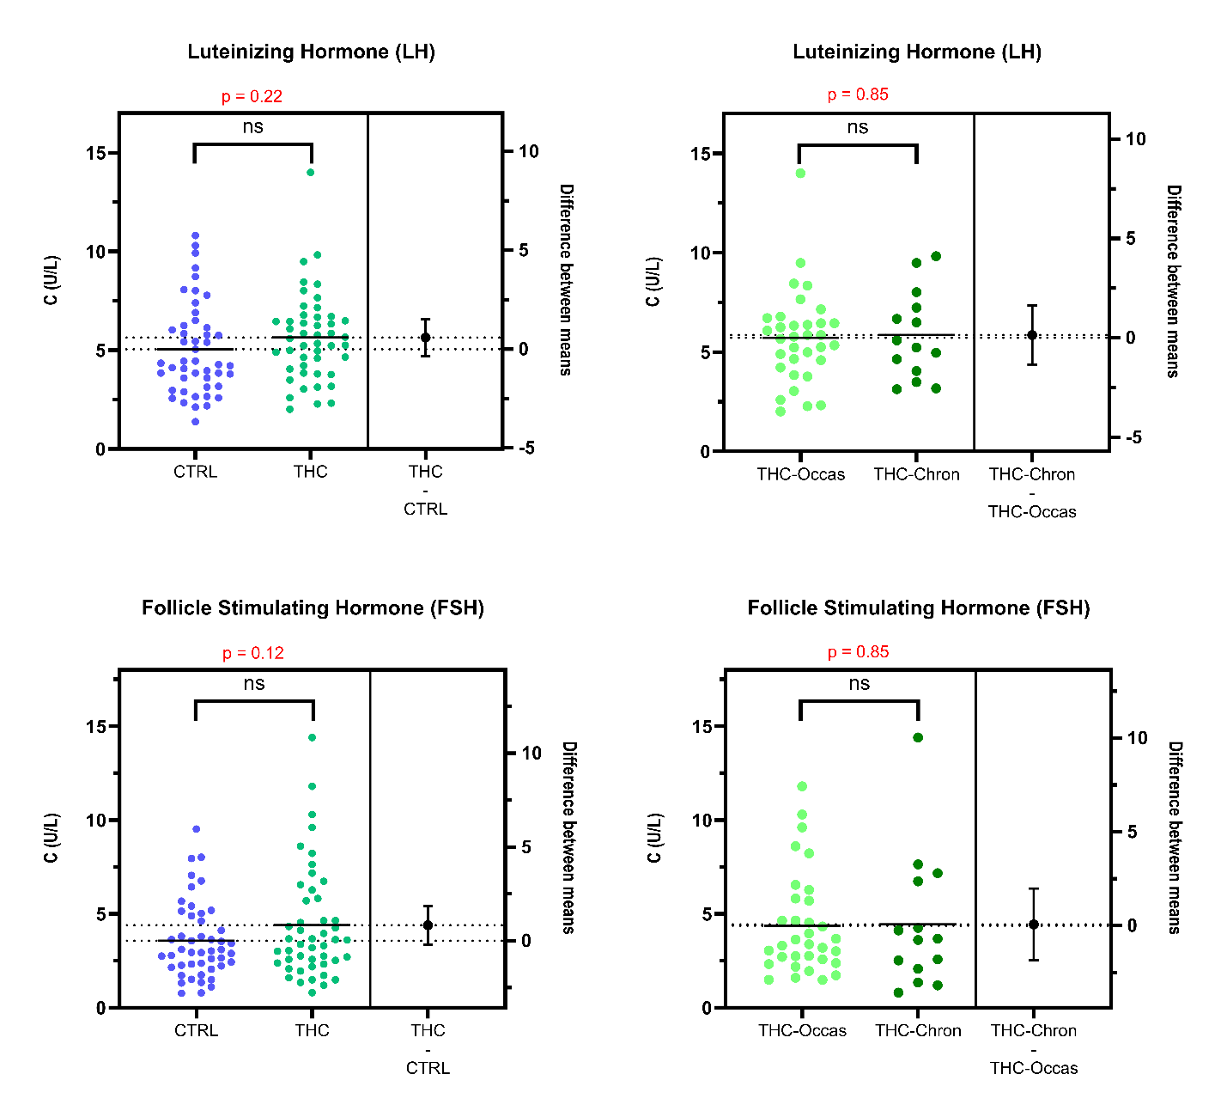
Hence, no conclusive relationship could be established between LH, FSH, cannabis consumption, and steroid hormones.
A
B
Figure S 23 : Estimation plots from univariate statistical analyses (t-tests), showing the differences in circulating levels of A) luteinizing hormone (LH) and B) follicle stimulating hormone (FSH) between controls and THC-positive participants (left pane), or occasional and chronic cannabis consumers (right pane).

