SUPPLEMENTARY FILES

Supplementary Information 1

Patient 1:
Demographics:
- Female, age range 30-40 years
Clinical History:
- Sporadic urinary tract infections (UTIs) since age 13
- Marked increase in UTI frequency over the past 10 years, temporally associated with repeated dental surgeries, jawbone inflammation, and prolonged antibiotic exposure (clindamycin, amoxicillin/clavulanic acid)
- Chronic recurrent UTIs for 6 years, with symptomatic episodes every 2–4 weeks, often recurring shortly after antibiotic cessation
- 5 antibiotic courses for UTI within the last 12 month, but 10 episodes in total
Previous Treatments:
- Canephron®, Cystinol®, cranberry-based supplements, D-mannose, methenamine hippurate, chondroitin-sulfate and hyaluronic acid instillations, immunostimulatory therapy (Strovac®, Uro-Vaxom®, Uromune®), repetitive short term antibiotics, repetitive short term antibiotics, long-term antibiotic prophylaxis, vaginal estriol, and progesterone
Current Medication:
- Canephron®, Cystinol®, cranberry supplements, D-mannose, vaginal estriol, and progesterone
Symptoms:
- Severe dysuria during acute flares; mitigated urgency with high fluid intake (3–5 L/day). Flare-ups correlate with the premenstrual phase, cold exposure, fatigue, intake of sugar, histamine-rich, or iron-rich foods
Lower Urinary Tract Function:
- Normal
Bowel Function:
- Dysbiosis history; improved post-fecal microbiota transfer
Risk Factors:
- Vaginal atrophy, intestinal dysbiosis (leaky gut), suspected immunosuppression (frequent HSV reactivations, chronic fatigue), and hormonal fluctuations
Comorbidities:
- Chronic dental infections, HSV reactivations, iron deficiency (possible Chlamydophila pneumoniae link), leaky gut syndrome
Diagnostic Workup:
- Vitals: Blood pressure (BP) 113/81 mmHg, heart rate (HR) 81 bpm, temperature (T( 37.0 °C
- Ultrasound: Normal kidneys; bladder with 40 mL post-void residual
- Uroflowmetry: Voided volume 630 mL, Qmax 42 mL/s, bell-shaped curve
- Cystoscopy: Normal
- 3-day bladder diary: Avg. micturition volume Ø 380 mL (range 50 - 760, n = 34); daytime frequency 9 - 13x, nighttime frequency 0 - 1x; avg. fluid intake Ø 2870 mL/24h; no urgency or incontinence episodes
- 7-day bowl diary: Number of bowel movements 11; stool volume (scale: 0 = none, 4 = high) avg. 2.5 (range 1–4); stool form (Bristol Stool Chart) avg. 5.5 (range 2–6); sensation of incomplete evacuation: 60%; no incontinence
- Urinalysis: pH 5.5, nitrite negative, leukocytes 2/µL, erythrocytes 3/µL, bacteria 13/µL
- Urine Culture: No bacterial growth (most recent); latest positive: E. coli cultivated from urine 2 months prior treatment (during symptomatic UTI)
- Questionnaires:
  - ACSS: Typical symptoms 4, Differential 2, Quality of life 4
  - IPSS: Symptoms 11; Quality of life 6
  - SF-36: Physical functioning 95%, Role limitations due to physical health 50%, Role limitations due to emotional problems 67%, Energy/fatigue 15%, Emotional well-being 28%, Social functioning 25%, Pain 12.5%, General health 20%, Health change 50%
Allergies:
- None

Patient 2:

Demographics:

Female, age range 60-70 years

Clinical History:

First UTIs already in childhood, recurrent UTIs since young age (24 years)

UTI episodes often associated with sexual intercourse

Starting in 2021, UTI episodes were more frequent

Status post pyelonephritis episodes

Both antibiotic and non-antibiotic therapies failed to induce long-term remission
- 4 antibiotic courses for UTI within the last 12 months
Previous Treatments:

Canephron®, Cystinol®, cranberry-based supplements, D-mannose, immunostimulatory therapy (Strovac®), repetitive short term antibiotics, vaginal estriol, traditional chinese medicine, Forskolin

Current Medication:

Ramipril, D-mannose, VitaFemin

Symptoms:

Dysuria, vaginal burning, cloudy and odorous urine, occasional incontinence
Lower Urinary Tract Function:
- Normal

Bowel Function:

Normal

Risk Factors:

None identified

Comorbidities:

Hypertension

Diagnostic Workup:

Vitals: BP 128/86 mmHg, HR 79 bpm, T 36.8 °C

Ultrasound: Normal kidneys and bladder

Uroflowmetry: Voided volume 395 mL, Qmax 32 mL/s, no residual, bell-shaped curve

Cystoscopy: Normal
- 3-day Bladder diary: Avg. micturition volume Ø 415 mL (range 170 - 750, n = 21); daytime frequency 5 - 7x, nighttime frequency 1x; avg. fluid intake Ø 3000 mL/24h; no urgency or incontinence episodes
- 7-day bowl diary: Number of bowel movements 12; stool volume (scale: 0 = none, 4 = high) avg. 2.5 (range 1–4); stool form (Bristol Stool Chart) avg. 3 (range 1–4); sensation of incomplete evacuation 65%; no incontinence.

Urinalysis: pH 6.0, nitrite negative, leukocytes 155/µL, erythrocytes 7/µL, bacteria >100,000/µL

Urine Culture: E. coli >10⁵/mL, fluoroquinolone-resistant

Questionnaires:

ACSS: Typical symptoms 3, Differential 1, Quality of life 1

IPSS: Symptoms 8; Quality of life 4

SF-36: Physical functioning 90%, Role limitations due to physical health 100%, Role limitations due to emotional problems 100%, Energy/fatigue 75%, Emotional well-being 76%, Social functioning 88%, Pain 58%, General health 75%, Health change 100%

Allergies:

Dust mites; facial flushing with penicillin and doxycycline

Patient 3:
Demographics:
- Female, age range 20-30 years
Clinical History:
- Recurrent E. coli UTIs for 5 years with increasing frequency.
- 5 antibiotic courses for UTI within the last 12 month
Previous Treatments:
- D-mannose, traditional Chinese medicine (TCM), and immunostimulatory therapy (Strovac), repetitive short term antibiotics, long-term antibiotic prophylaxis
Current Medication:
- None
Symptoms:
- Dysuria, urgency, foul-smelling/cloudy urine, occasional macroscopic hematuria
Lower Urinary Tract Function:
- Sporadic urgency symptoms
Bowel Function:
- Normal
Risk Factors:
- Incomplete bladder emptying; hypercapacity bladder volumes
Comorbidities:
- None
Diagnostic Workup:
- Vitals: BP 121/78 mmHg, HR 80 bpm, T 35.9 °C
Ultrasound: Normal kidneys; post void residual 150 mL
- Uroflowmetry: Voided volume 465 mL, Qmax 43 mL/s, residuals 150 mL (first), 45 mL (second), bell-shaped curve
- Cystoscopy: Normal
- 3-day Bladder diary: Avg. micturition volume Ø 425mL (range 140 - 1250, n = 21); daytime frequency 5 - 7x, nighttime frequency 0 - 1x; avg. fluid intake Ø 2930 mL/24h; no urgency or incontinence episodes
- 7-day bowl diary: Number of bowel movements 12; stool volume (scale: 0 = none, 4 = high) avg. 2.2 (range 1–3); stool form (Bristol Stool Chart) avg. 4.8 (range 4–6); sensation of incomplete evacuation in 92%; no incontinence
- Urinalysis: pH 7.0, nitrite positive, leukocytes 1/µL, erythrocytes 1/µL, bacteria 95,131/µL
Urine Culture: E. coli 10⁵/mL; resistant to aminopenicillins, fluoroquinolones
- Questionnaires:
  - ACSS: Typical symptoms 8, Differential 0, Quality of life 1
  - IPSS: Symptoms 6; Quality of life 1
  - SF-36: Physical functioning 100%, Role limitations due to physical health 100%, Role limitations due to emotional problems 100%, Energy/fatigue 75%, Emotional well-being 88%, Social functioning 100%, Pain 90%, General health 85%, Health change 50%
Allergies:
- None

Supplementary Information 2: Certificate of analysis for Bat001
Please see associated .pdf

Supplementary Information 3: Certificate of analysis for Bat003
Please see associated .pdf

Supplementary Table 1: Clinical strains isolated before, during, and after the experimental treatment.
Please see associated excel file and screen shot below

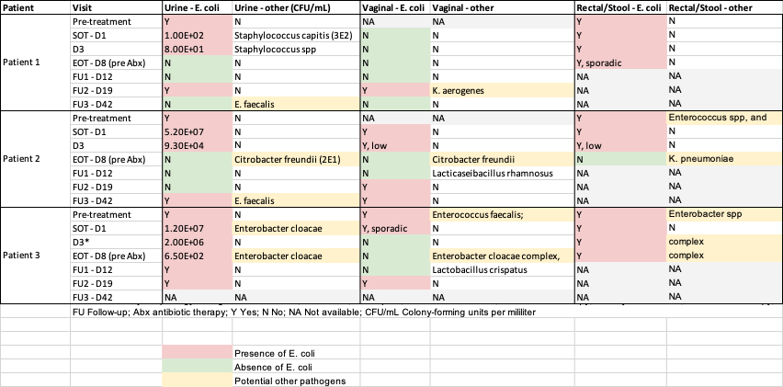

Supplementary Table 2: Antibiotic susceptibility testing (AST) results of clinical strains isolated before and after the experimental treatment.
Please see associated excel file and screen shot below

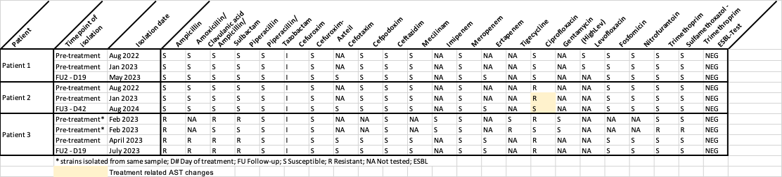

Supplementary Table 3: Phylogenetic distance matrix of clinical strains isolated before, during, and after the experimental treatment.
SOT Start-of-therapy; EOT End-of-therapy. Please see associated excel file and screen shot below

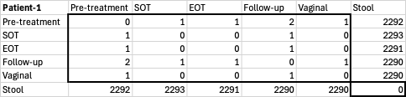

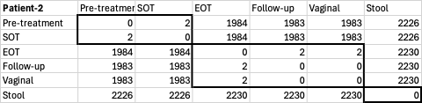

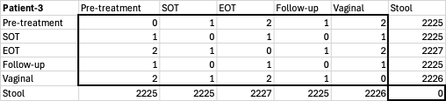

Supplementary Table 4: Virulence factor analysis of clinical strains isolated before and after the experimental treatment.
Please see associated excel file

Supplementary Figure 1: Phage susceptibility testing
A. Phage susceptibility testing in Luria broth (LB) and patient urine taken prior to treatment measured by optical density (OD600) over time, represented in growth curves and as percent growth inhibition (%) at 5h and 18h. B. Solid media assays were also performed using dilution spot assays in LB media.
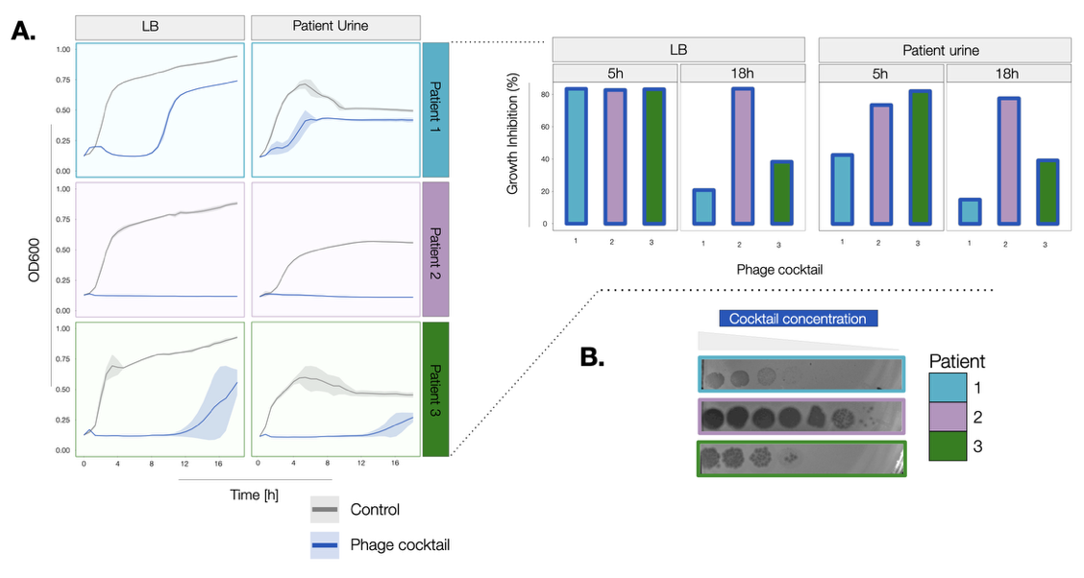

Supplementary Figure 2: Acute Cystitis Symptoms Score
Individual patient values of the Acute Cystitis Symptom Score (ACSS) before administration and at each study visit, including sum scores for the different domains.

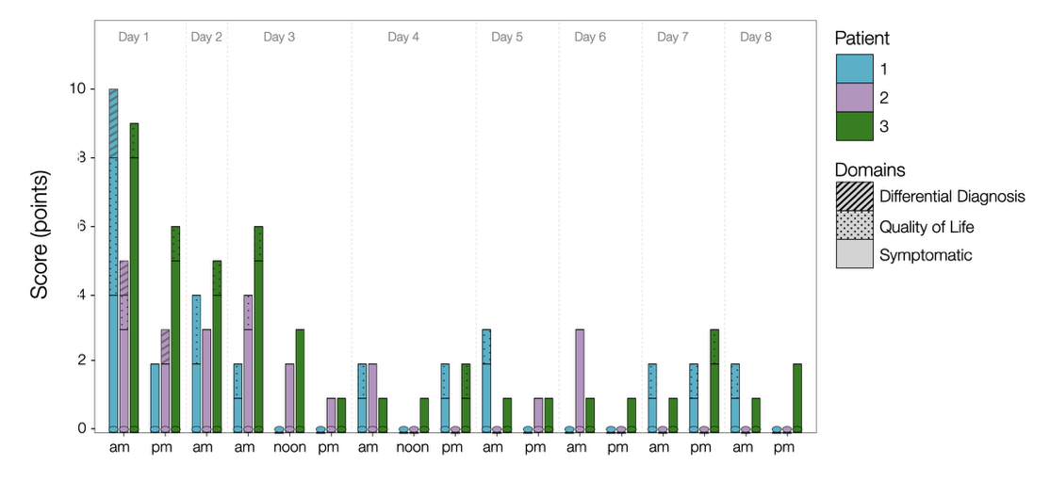
Supplementary Figure 3: Urinalysis Parameters
A. Total bacterial counts (per µL) measured by flow cytometry (Sysmex UF-5000, Kobe, Japan) before administration and at each study visit, displayed on a log10 scale. B. Total white blood cell counts (per µL) measured by flow cytometry before administration and at each study visit.

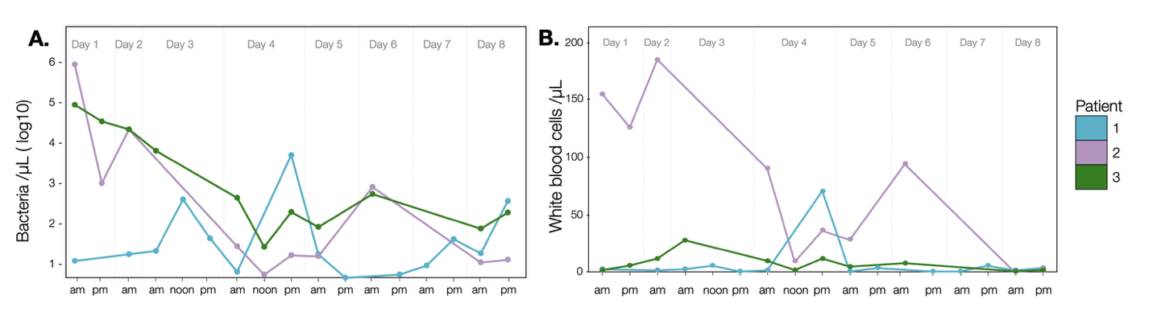
Supplementary Figure 4: Serum neutralization of phages at start and end of therapy
Serum neutralization of phages at start (SOT) versus end of treatment (EOT). Residual phage titers post exposure to patient serum measured by spot assay are shown in PFU/mL in log10 per patient (rows) and per phage (columns). Points indicate technical replicates (n=3); boxes show medians. One-sided comparisons were used to test reduction in phages longitudinally (EOT < SOT); “ns” non-significant.

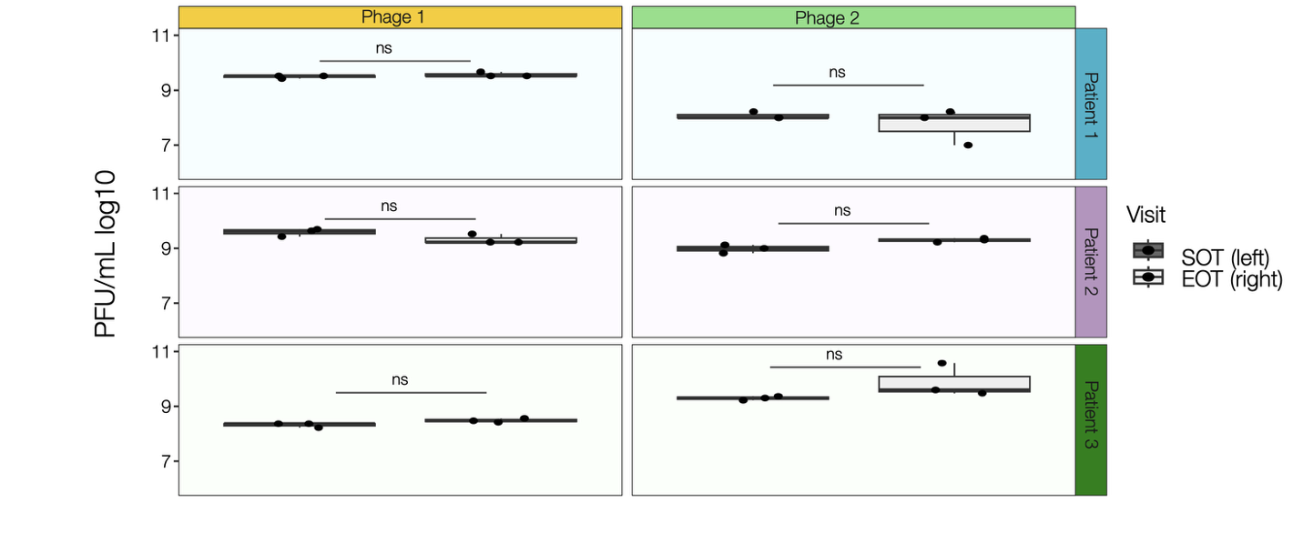

Supplementary Figure 5: Viable phage recovery in urine at first void
Phage concentrations in urine were quantified using dilution spot assays and multiplied by the total volume of voided urine. The applied dose was 2x10¹⁰ PFU and phage cocktail was retained between until next void.

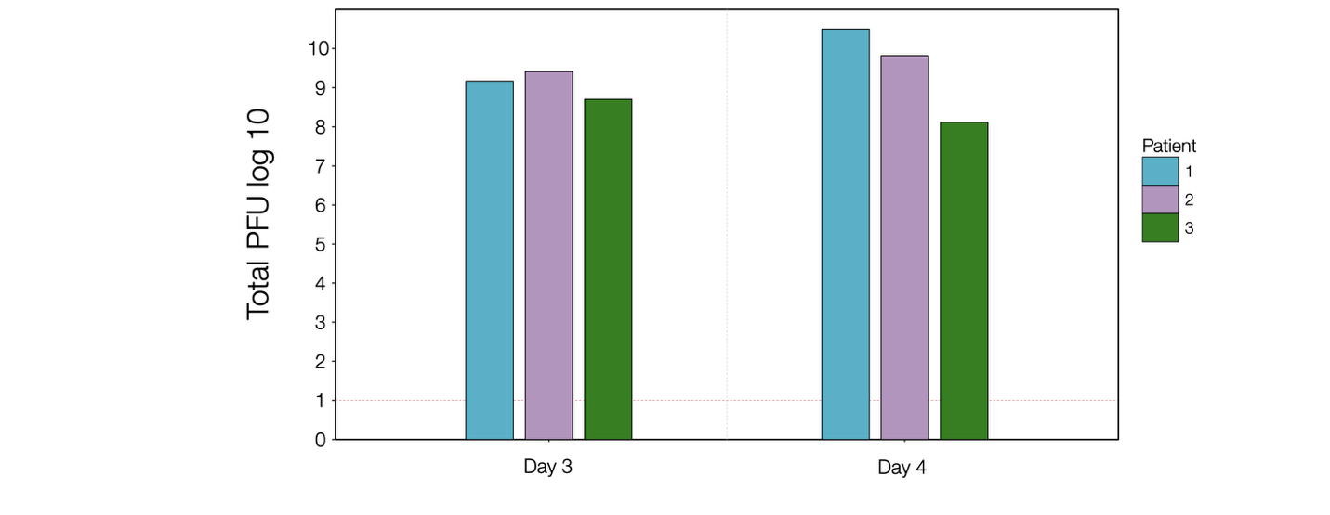
Supplementary Figure 6: Phage susceptibility testing of Patient 2 isolates during phage treatment.
Patient susceptibility of E. coli isolates from patient urine at SOT and EOT (pre-antibiotics) showing bacterial growth curves and percent inhibition at 5h and 18h to the individual phages and phage cocktail used.

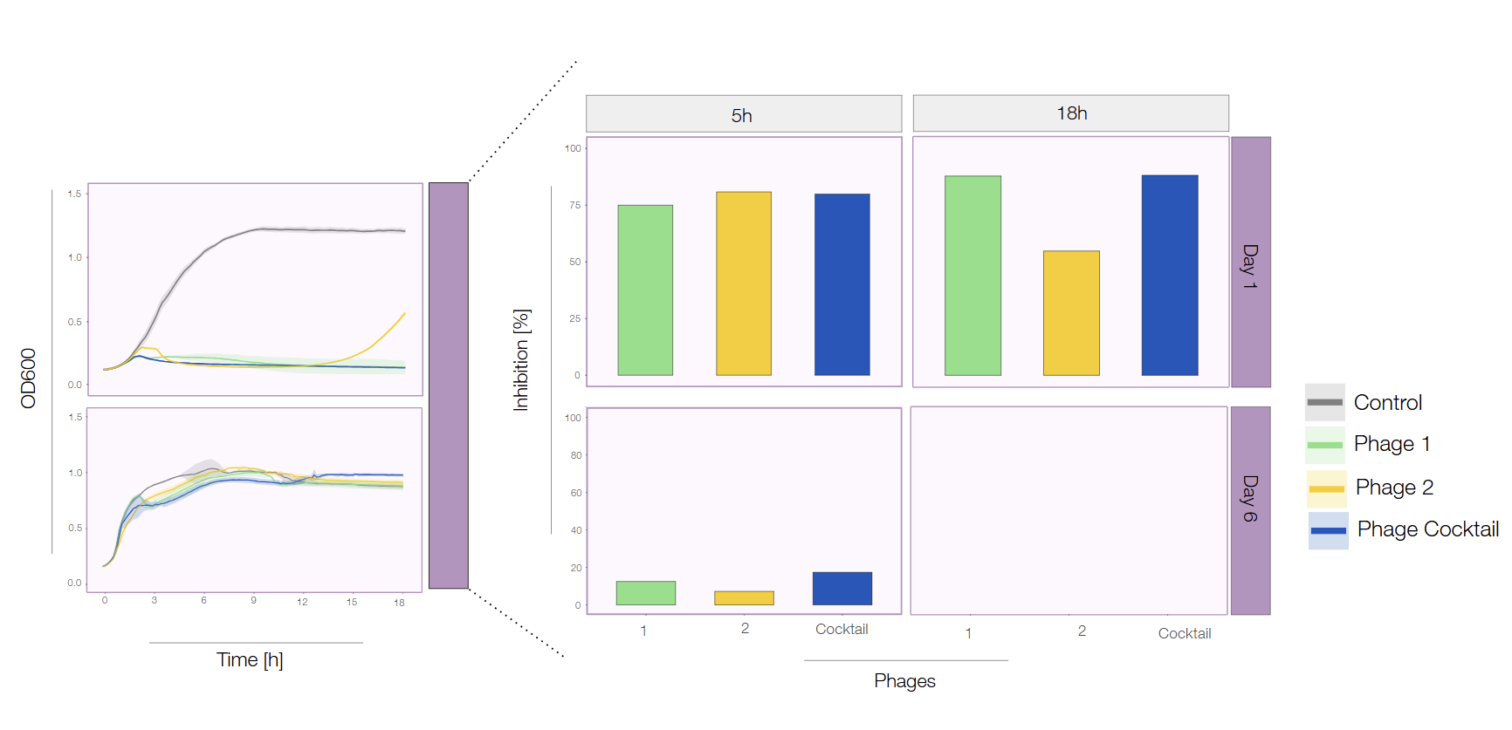

Supplementary Figure 7: Shotgun metagenomic sequencing of patient samples
A: Relative abundance of E. coli in the different body materials over time. B: Principal component analysis illustrating Bray-curtis beta diversity of stool samples. A shift towards the donor microbiota composition can be seen in the samples following FMT. Small number next to the symbols indicates day of sampling. Timing of samples: Baseline, Prior any treatment; Day 8, After phage treatment but before FMT; Day 15-19, 7 days after FMT; Day 29-43, 28-30 days after FMT in Patient (Pat.) 1 and 2.

