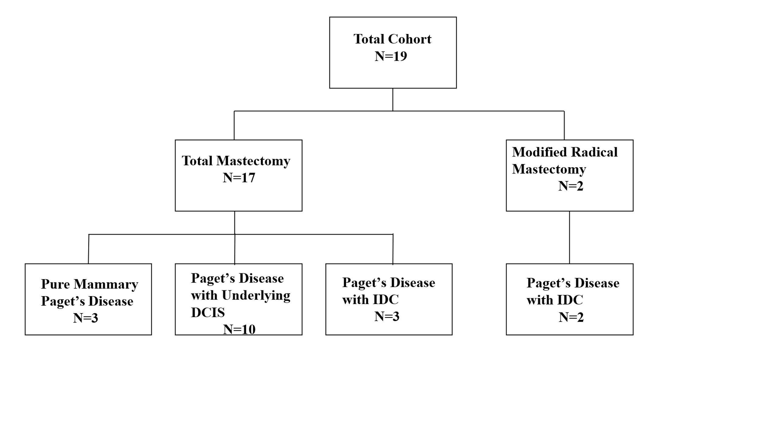
Table

Table 1. Classification of patients based on surgical procedure and final histopathology

