Supplementary Figures

Tim-4 internalizes apoptotic cells through Axl-mediated signal transduction
Byeongjin Moon^{1, §}, Jaeseon Jeon^{1, §}, Eunhye Oh¹, Jinwook Han¹, Juyeon Lee¹, Eojin Hwang¹, Chang Sup Lee², Dongtak Jeong³, Daeho Park^{1, *}
1. School of Life Sciences, Gwangju Institute of Science and Technology, Gwangju 61005, Korea
2. College of Pharmacy and Research Institute of Pharmaceutical Sciences, Gyeongsang National University, Jinju 52828, Korea
3. Department of Molecular and Life Science, College of Science and Convergence Technology, Hanyang University ERICA Campus, Ansan 15588, Korea.
§ These authors contributed equally to this work.

Running title: Axl relays signals for Tim-4-mediated efferocytosis

* Correspondence to

Daeho Park
School of Life Sciences
Gwangju Institute of Science and Technology
Gwangju 61005, Korea
Tel.: 82-62-715-2890
Fax: 82-62-715-2484

E-mail: daehopark@gist.ac.kr

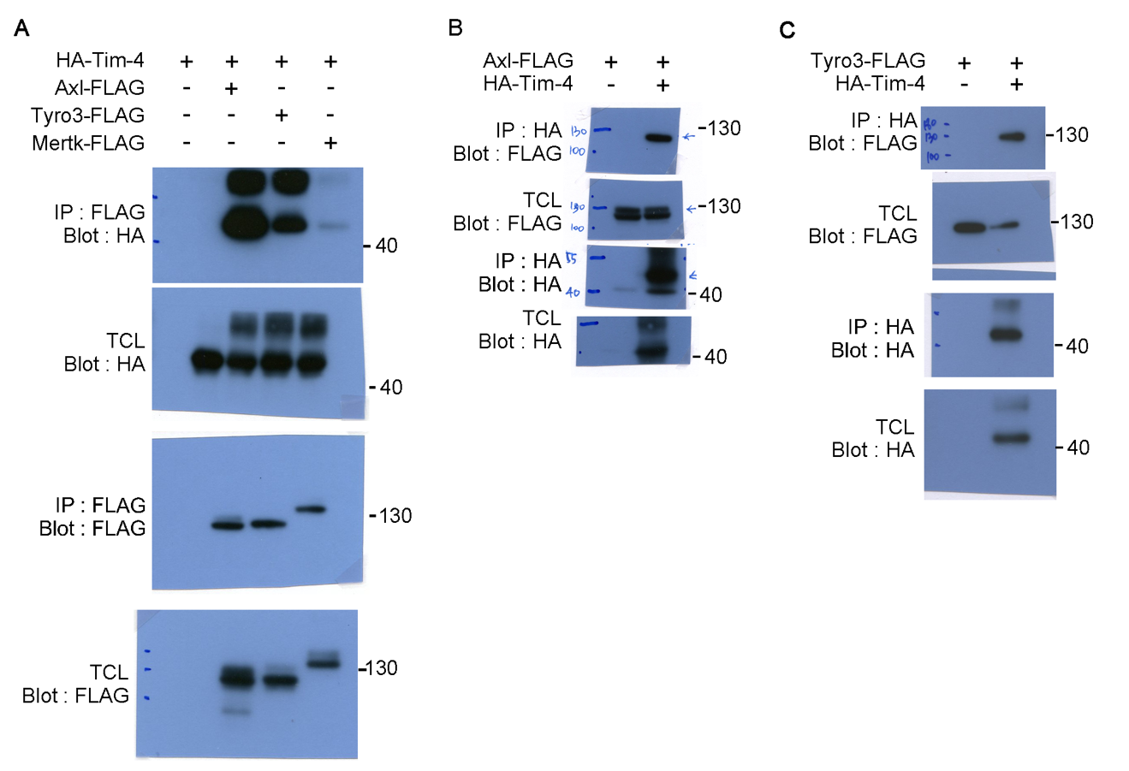

Supplementary Figure 1. Full western blots used in Fig. 1
A-B Original western blots for Fig. 1B (A), Fig. 1C (B), and Fig. 1D (C)

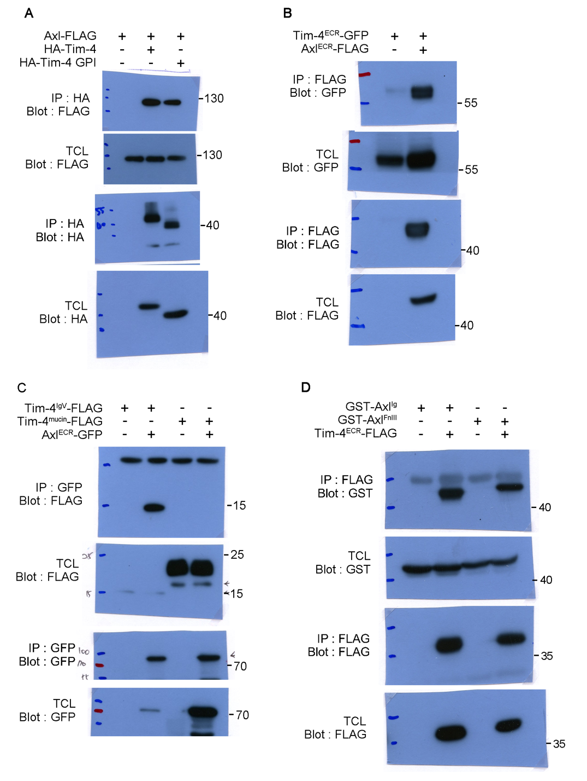

Supplementary Figure 2. Full western blots used in Fig. 2
A-D Original western blots for Fig. 2C (A), Fig. 2D (B), Fig. 2E (C), and Fig. 2F (D)

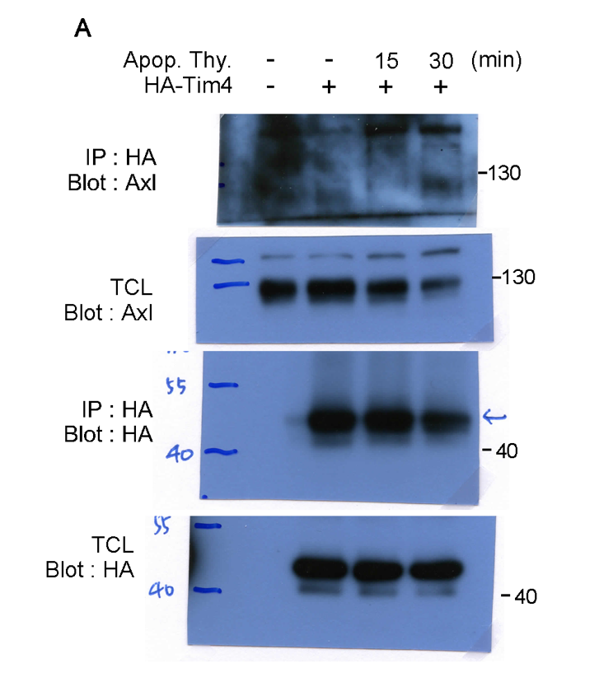

Supplementary Figure 3. Full western blots used in Fig. 3
A Original western blots for Fig. 3A

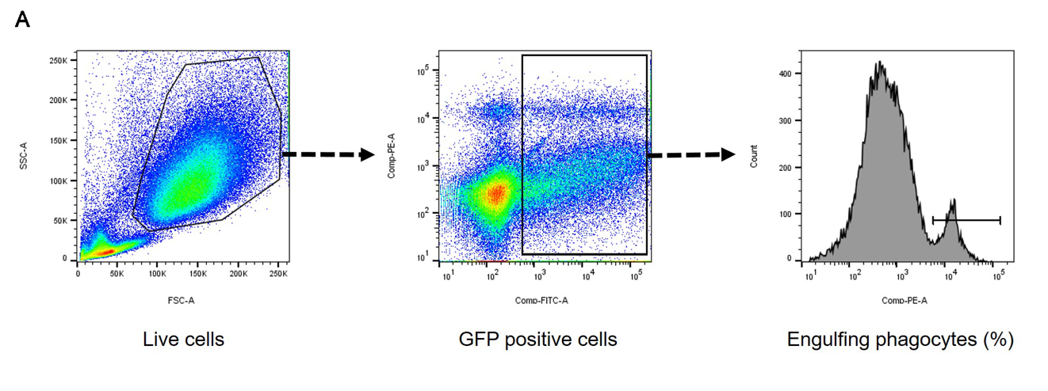

Supplementary Figure 4. Representative gating strategy for the efferocytosis assay
A To gate for engulfing phagocytes, we first gated live cells using a forward scatter (FSC) and side scatter (SSC) dot plot. We then gated the GFP-positive cells. Among these, cells that were also TMRM-positive or pHrodo-positive were considered phagocytes that ingested apoptotic cells.

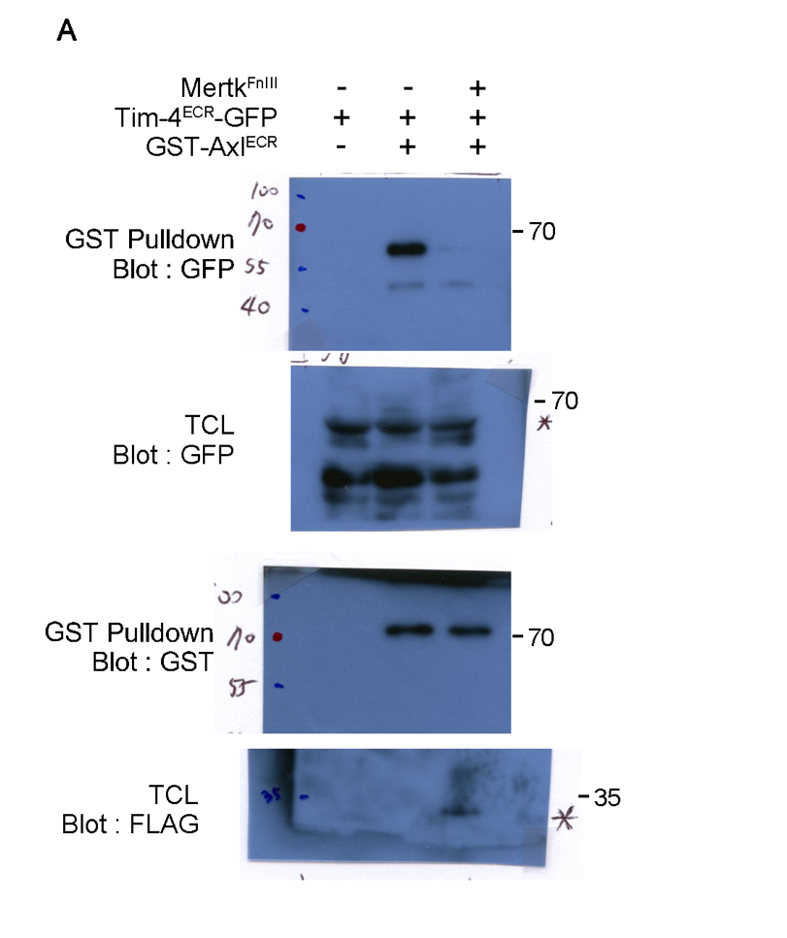

Supplementary Figure 5. Full western blots used in Fig. 4
A Original western blots for Fig. 4A

