Supplementary Figures

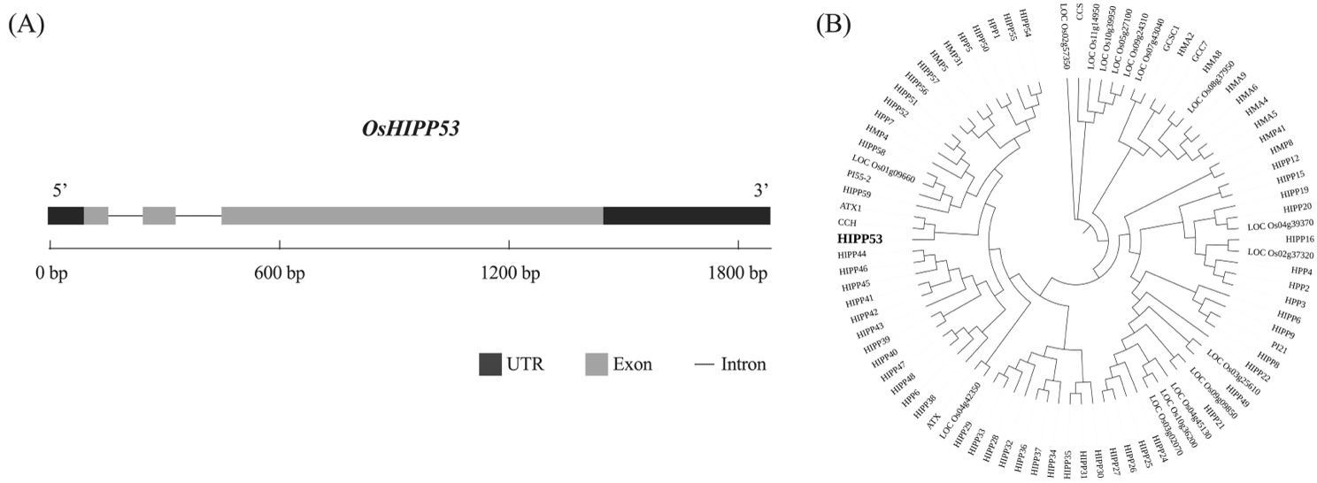
Supplementary Fig. 1 Analysis of OsHIPP53 structures. (A) Gene structure diagram of OsHIPP53. (B) Phylogenetic analysis of OsHIPP53 and its homologs in rice, and the number of the bootstrap replication is 1000.

