Supplementary data
Text S1. Measurement procedures for Se⁴⁺ and Fe²⁺.
Sample Collection: Mix the samples thoroughly in the reaction vessel, then expeditiously draw 3-4 ml of the sample solution using a 5 ml syringe and filter it through a 0.22 μm filter membrane;
Preparation of Ortho-Phenanthroline Solution: Dissolve 0.375 g of anhydrous ortho-phenanthroline in 10 mL of alcohol. Transfer the solution to a 250 ml volumetric flask, rinsing the original container thrice with ultrapure water, and then transferring the rinsate to the volumetric flask using a dropper to reach a final volume, resulting in a 0.15% ortho-phenanthroline solution;
Determination of Fe²⁺ Concentration: Combine 1 mL of the filtered sample with 1 ml of NaAc HAc buffer solution, 1 ml of 0.15% ortho-phenanthroline solution, and 7 ml of ultrapure water. After thorough mixing, allow the solution to stand for 30 minutes, then measure the absorbance at 510 nm using a UV-visible spectrophotometer;
Determination of Se⁴⁺ Concentration: Take 1 mL of the filtered sample, dilute it to 5 mL with 0.5 M HNO₃ solution, and analyze the concentration of the diluted sample using ICP-OES.
Text S2. The process of selecting and configuring a buffer system.
1) The specific configuration of the acetic acid buffer system is as follows:
Weigh 4.5g of anhydrous sodium acetate and 2.5 mL of glacial acetic acid into a 100 mL beaker. Once the sodium acetate is fully dissolved, transfer the solution to a 250 ml volumetric flask and dilute to 250 ml to create a NaAc-HAc buffer with an acetate ion concentration of 0.4 M;
2) The specific configuration of the morpholineethanesulfonic acid buffer system is as follows:
Weigh 24.4 g of 2-morpholineethanesulfonic acid (MES) and dissolve it in 200 mL of ultrapure water. Subsequently, adjust the pH to 6.5 using a 5 M NaOH solution and dilute the solution to 250 mL to create a MES buffer with a concentration of 0.5 M;
3) The specific configuration of the propanesulfonic acid buffer system is as follows:
Weigh 26.2 g of 3-(N-morpholine) propanesulfonic acid (MOPS) and dissolve it in 200 mL of ultrapure water. Adjust the pH to 7.5 using a 5M NaOH solution and adjust the volume of the ultrapure water to 250 mL to create a MOPS buffer at a concentration of 0.5 M;
4) The specific configuration of the N-2-hydroxyethylpiperazin-N'-2-ethanesulfonic acid buffer system is as follows:
Dissolve 29.8 g of N-2-hydroxyethylpiperazin-N'-2-ethanesulfonic acid (HEPES) in 200 ml of ultrapure water to create a 0.5 M HEPES buffer solution. Adjust the pH to 8.0 by adding a 5M NaOH solution, and dilute the mixture to a final volume of 250 ml with ultrapure water.
Text S3. Thermodynamic calculations for the reactions between HSeO₃²⁻ and Fe²⁺.
The reactions between HSeO₃²⁻ and Fe²⁺ can be described by the following equations:
HSeO₃ ⁻ + 4Fe²⁺ + 3H₂O = Se(0) + 2Fe₂O₃ + 7H⁺ (1)
Δ_{r}G = Δ_{r}G(0)+RT*LnK=-4.846– 39.95 pH – 5.7076 log ([HSeO₃⁻]*[Fe²⁺]⁴)
SeO₃ ²⁻ + 4Fe²⁺ + 3H₂O = Se(0) + 2Fe₂O₃ + 6H⁺ (2)
Δ_{r}G = Δ_{r}G(0)+RT*LnK= -52.566– 34.24 pH – 5.7076 log ([SeO₃²⁻]*[Fe²⁺]⁴)
Text S4. Details for potentiometric titration.
Potentiometric titration was conducted at 25°C using a Mettler Toledo automatic titrator (T70) equipped with a combined pH electrode in a nitrogen atmosphere. A total of 0.4002 g of granite powder was introduced into a polyethylene titration cup containing 40.0 mL of 0.1000 M NaClO4 solution. Subsequently, the cup was affixed to the titrator, and nitrogen was bubbled through the solution for 8 hours to reach equilibrium. pH measurements were taken using a Mettler Toledo combined glass electrode DGi115-SC, calibrated with standard buffer solutions of pH 4.00, 7.00, and 10.00 before the experiment. The suspension was titrated with CO₂-free NaOH solution (0.096 mol·L⁻¹) until reaching a pH of 3.0. Following this, the slurry was further titrated with CO2-free HClO4 solution (0.094 mol·L⁻¹) until a pH of 11.0 was achieved. Throughout the titration process, the titrator was programmed to record pH values when the drift was below 0.7 mV min⁻¹ for over 150 s after each addition of acid or base solutions.
Text S5. Determination of solution potential.
To determine the solution potential, the electrode is first removed from the potentiometer and rinsed with ultrapure water to eliminate any residual substances on its surface. Subsequently, the electrode is gently dried with filter paper. It is then slowly immersed into the solution to be tested, ensuring complete submersion without contact with the container's bottom or walls to prevent interference with the measurement. Following full immersion, the measurement begins, and data is continuously collected for 5 minutes to establish a stable reading indicative of equilibrium between the electrode and the solution. Upon completion of the measurement, the current potential value is recorded.
Concurrently, we examined the electrode potentials (depicted as dots in the Figure 4) of 0.4 mM Se⁴⁺ and 0.1 mM Fe²⁺ across various pH levels (4.8, 6.3, 6.75, 7.00, 7.25, 7.5, 8.0). These experimental results closely matched the theoretically calculated values (represented by straight lines in the Figure 4). Notably, the theoretical potentials of Fe²⁺ at different concentrations closely aligned with the measured potentials, underscoring the precision of our testing methodology.
The formula used to calculate electrode potential is as follows:
HSeO₃ ⁻ + 4e⁻ + 5H⁺ = Se(0) + 3H₂O
$$φ_{1}=φ^{θ}+\frac{0.05916}{4}lg\left[{HSeO_{3}}^{-}\right]{\left[H^{+}\right]}^{5}=0.7806-0.07395pH+0.01479*lg\left[{HSeO_{3}}^{-}\right]$$
Fe₂O₃ + 6H⁺ + 2e⁻ = 2Fe²⁺ + 3H₂O
$$φ_{2}=φ^{θ}(\frac{{Fe}_{2}O_{3}}{{Fe}^{2+}})+\frac{0.05916}{2}*lg\frac{{\left[H^{+}\right]}^{6}}{{\left[{Fe}^{2+}\right]}^{2}}=0.7284-0.1773pH-0.05916*lg{Fe}^{2+}$$
Figure S1. SEM images, the EDX spectrum, XPS, XRF and XRD results of fresh granite.
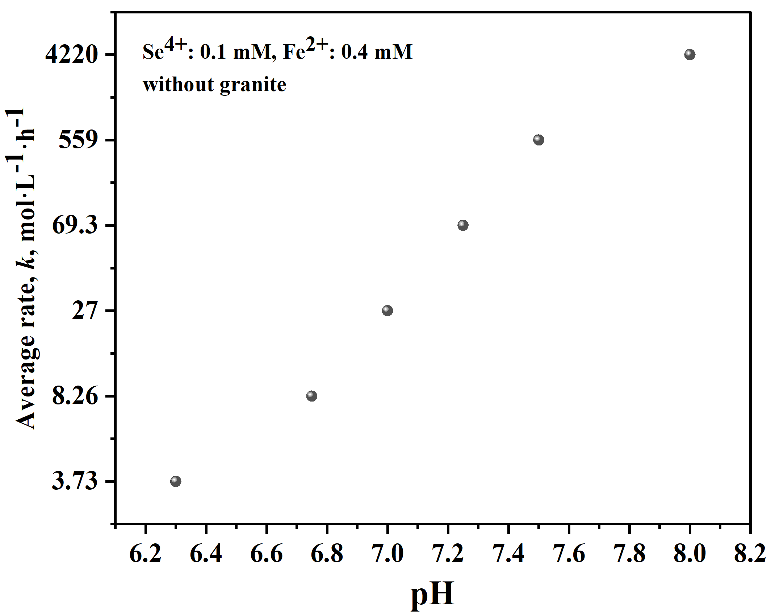
Figure S2. The connection between the average rate and pH is depicted under homogeneous conditions.
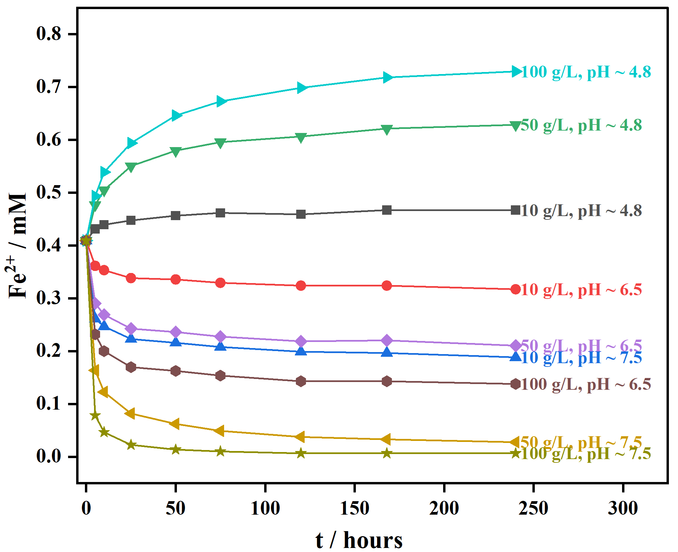
Figure S3. The adsorption kinetics of Fe²⁺ in granite.

Figure S4. The distribution of Se⁴⁺ specialty as a function of pH was investigated with an initial concentration of [Se⁴⁺] = 1×10⁻⁴ M and a pe of 4. Thermodynamic data for Se from OECD/NEA (2005) were utilized in calculations conducted using PHREEQC. Various reduction products of Se⁴⁺ were taken into account, including Se⁰, FeSe, FeSe₂, SeO₂, Fe₂(SeO₃)₃, and Fe₂(OH)₄SeO₃, alongside potential oxidation products of Fe²⁺ like Fe(OH)₃(a), Fe₃(OH)₈, Fe(OH)2, Fe(OH)_{2.7}Cl_{.3}, Ferrihydrite, Magnetite, and Hematite.
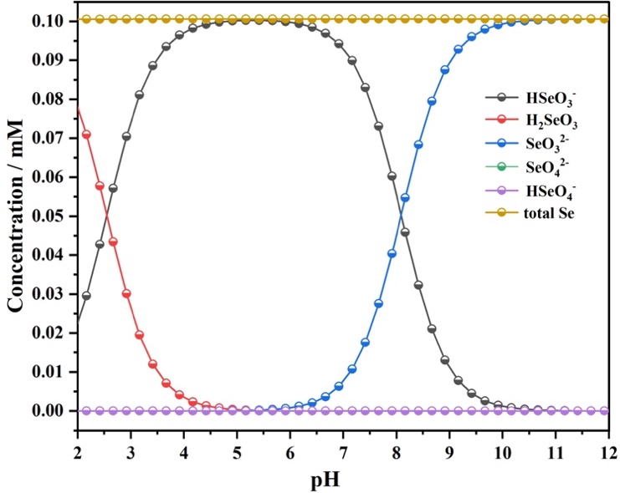
Figure S5. The distribution of Se⁴⁺ speciation as a function of pH was investigated with an initial concentration of [Se⁴⁺] = 1×10⁻⁴ M and a set pe of 4. Thermodynamic data for Se from OECD/NEA (2005) was used for calculations conducted using PHREEQC.

Table S1. Standard Gibbs free energies of formation Δ_{f}G⁰ (kJ·mol⁻¹) used for thermodynamic calculations.
Species | H₂O(l) | Fe³⁺ | Fe₂O₃ | HSeO₃⁻ | SeO₃²⁻ | Se(0)
Δ_{f}G⁰ | -237.14 [1]* | -16.28 [1]* | -742.2 [1]* | -410.11 [2]* | -362.39 [2]* | 0 [2]*
*References
- J. Chivot, 2004. Thermodynamique des produits de corrosion. Sci. Tech. Ser. ANDRA, 34–35.
- Olin, Å., et al., Chemical Thermodynamics of Selenium. 2005: Chemical Thermodynamics of Selenium.
Table S2. The Se_{3d} XPS analysis results for the solid phase in heterogeneous (granite, 70 g/L) reactions at different time intervals are presented, including binding energy (eV) and peak area.
Sample  ID | time  day(s) | Se⁴⁺ |  | Se⁰ |  | Fe³⁺ |  | Fe²⁺
Sample  ID | time  day(s) | B.E./eV | Area | B.E./eV | Area | B.E./eV | Area | B.E./eV | Area
pH~6.4 | 3 | 59.0 | 4.9 | 55.1 | 29.4 | 56.7 | 48.2 | 54.2 | 17.4
pH~6.4 | 15 | 58.5 | 12.7 | 54.8 | 29.2 | 56.5 | 41.1 | 53.8 | 17.0
pH~7.5 | 1 | - | - | 55.4 | 46.9 | 57.1 | 33.6 | 54.0 | 19.5
pH~7.5 | 15 | - | - | 55.2 | 42.6 | 56.8 | 46.7 | 53.7 | 10.8
pH~8.0 | 1 | - | - | 55.7 | 55.6 | 57.5 | 27.3 | 54.1 | 17.1
pH~8.0 | 15 | - | - | 55.5 | 50.9 | 57.1 | 44.4 | 53.5 | 4.7

