Supplementary Materials
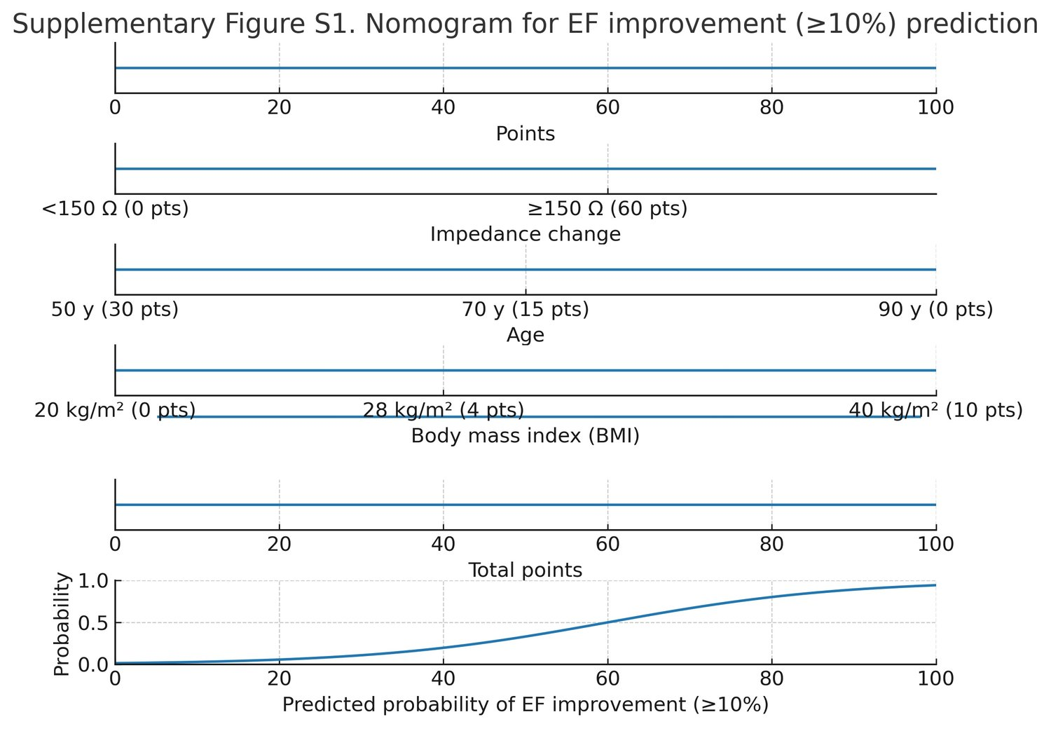

Supplementary Fig. S1. Nomogram for CRT response prediction based on multivariable logistic regression including impedance change, age, and BMI.
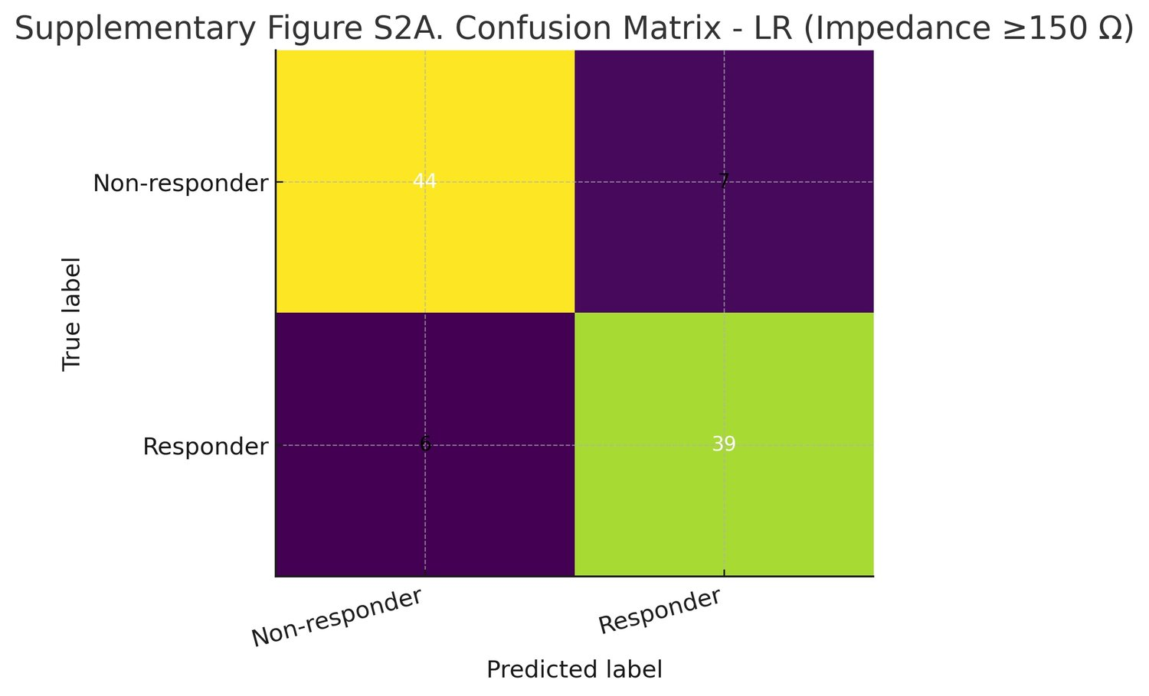
Supplementary Fig. S2A. Confusion matrix for univariate logistic regression (impedance ≥150 Ω; accuracy 86.5%).
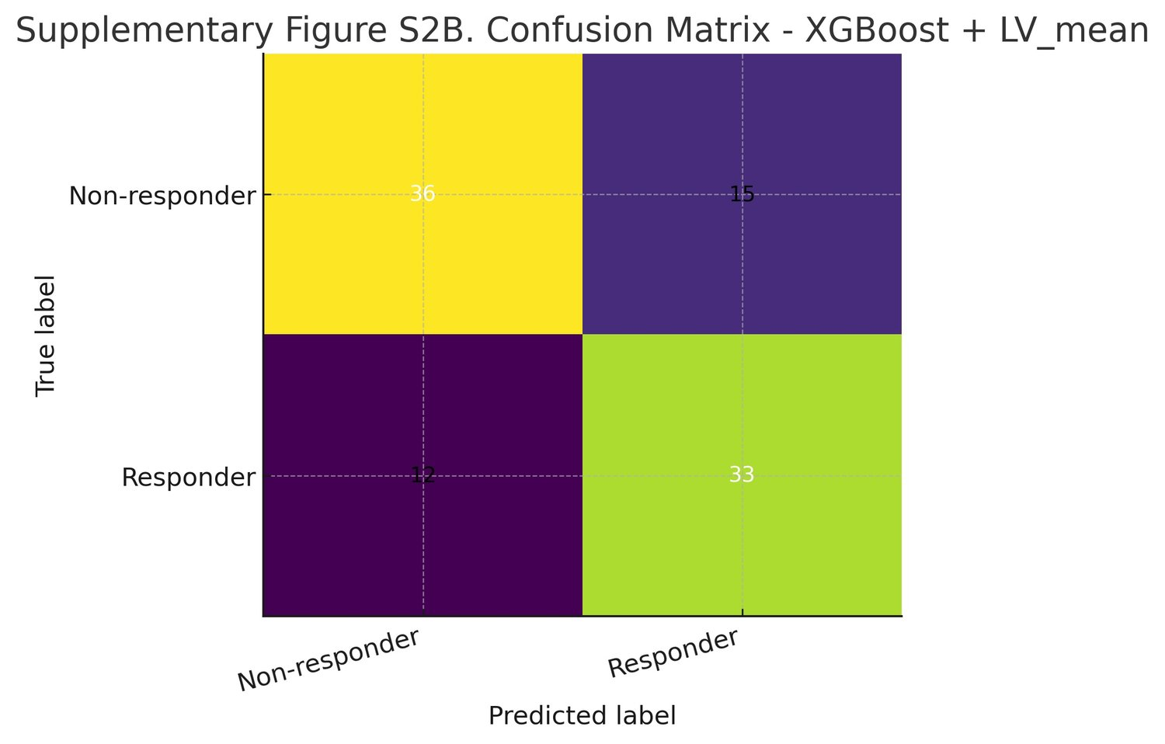

Supplementary Fig. S2B. Confusion matrix for XGBoost model with impedance, age, BMI, and LV_mean (overall accuracy ~72%).
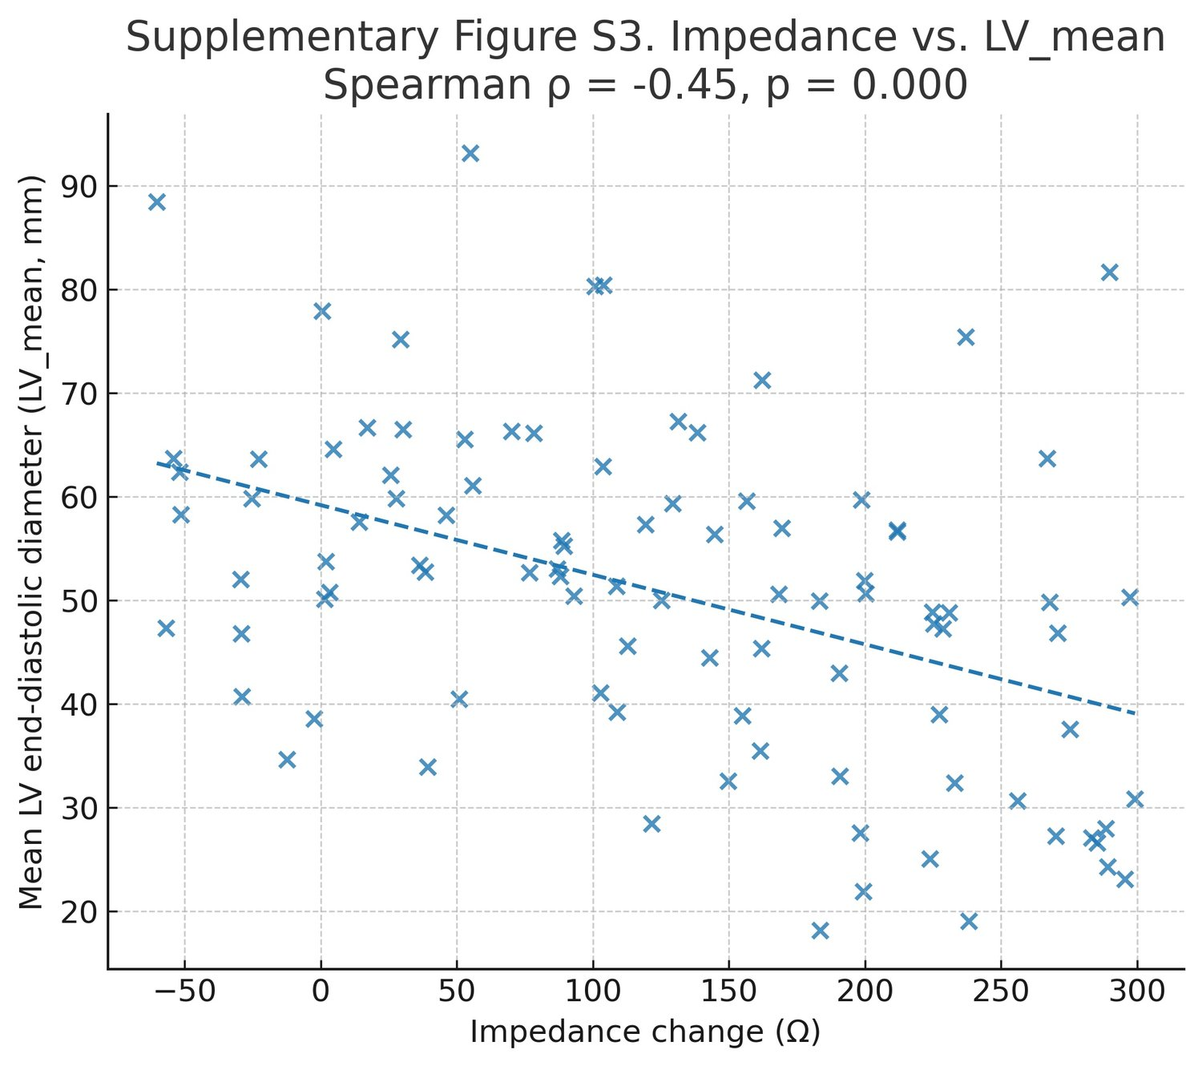

Supplementary Fig. S3. Correlation between LV impedance change and LV_mean (ρ = –0.29, p = 0.007).

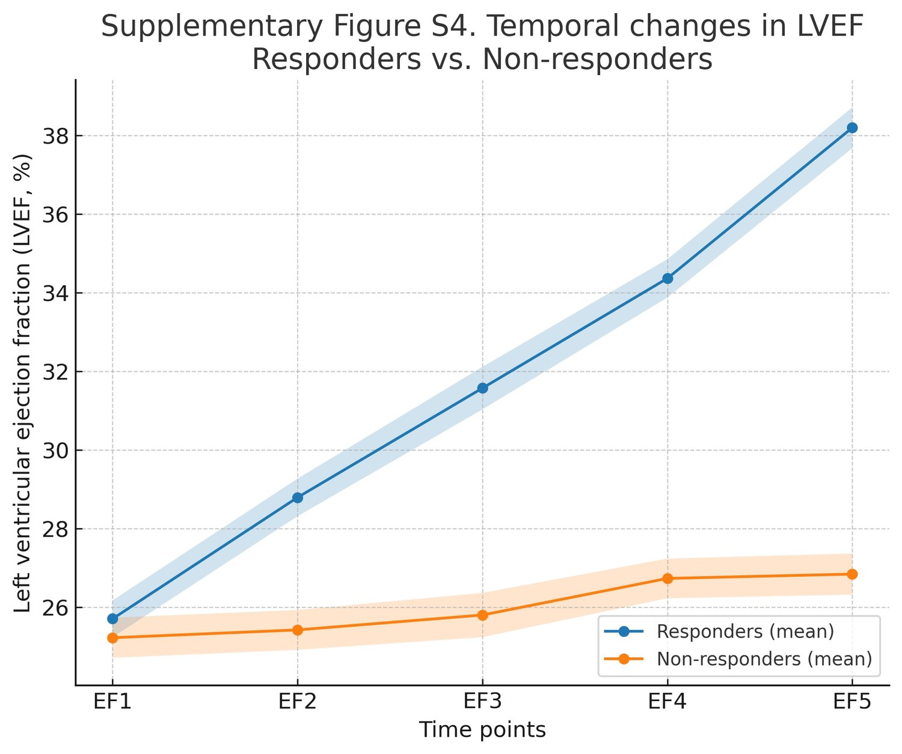

Supplementary Fig. S4. Temporal changes in LVEF during follow-up: responders vs. non-responders.

