TABLE 1: Demographic profile of the respondents.

Variable | Category | Number
Informant category | Village folks | 61
Informant category | University people | 52
Number of tribal respondents in total |  | 55
Gender | - Female
Gender | Village folks | 12
Gender | University people | 26
Gender | - Male
Gender | Village folks | 49
Gender | University people | 26
Age of the respondents | 18-30 years | 55
Age of the respondents | 31-40 years | 20
Age of the respondents | 41-60 years | 29
Age of the respondents | >60 years | 09
The main occupation of the respondents | Peasants | 37
The main occupation of the respondents | Blacksmiths | 03
The main occupation of the respondents | Shepherds | 04
The main occupation of the respondents | Shop keepers | 05
The main occupation of the respondents | Housewives | 13
The main occupation of the respondents | University employed | 07
The main occupation of the respondents | Students | 44
Monthly income | < Rs. 6000/- | 34
Monthly income | ≥ Rs. 6000/- | 79
Family structure | With children | 53
Family structure | Without children | 60
Literacy level | Illiterates | 29
Literacy level | Primary education | 08
Literacy level | Secondary education | 12
Literacy level | Graduate | 64

TABLE 2: Socioeconomic characteristics of the sample and average scores pertaining to Risk Perception (RP), Environmental Responsibility (ER), Positive Conservation Emotions (PE), Educational Conservation Campaign (ECC), Access and Benefit Sharing (ABS), and Attitude Towards Conservation (AC).
Characteristics | Percentage | Average Standardized Score
Characteristics | Percentage | RP | ER | PE | ECC | ABS | AC
Gender
Male | 66.4 | 0.140 | -0.066 | -0.059 | 0.027 | -0.023 | 0.188
Female | 33.6 | -0.071 | 0.034 | 0.030 | -0.014 | 0.012 | -0.095
Children
No children | 50.4 | -0.003 | -0.115 | 0.001 | -0.117 | -0.118 | 0.091
One or more children | 49.6 | 0.003 | 0.117 | -0.001 | 0.119 | 0.120 | -0.092
Income in Rupees
<= 6000 | 30.1 | -0.199 | -0.123 | -0.131 | -0.075 | 0.279 | -0.302
> 6000 | 69.9 | 0.086 | 0.053 | 0.056 | 0.032 | -0.120 | 0.130
Age in years
< = 25 | 42.5 | 0.389 | -0.070 | 0.028 | 0.172 | -0.454 | 0.325
> 25 | 57.5 | -0.288 | 0.052 | -0.021 | -0.127 | 0.335 | -0.240
Place of residence
University | 46.0 | 0.333 | -0.160 | -0.025 | 0.195 | -0.488 | 0.421
Village | 54.0 | -0.284 | 0.137 | 0.021 | -0.166 | 0.416 | -0.359

TABLE 3: Correlation between RP, ER, PE, ECC, ABS, and AC.
 | RP | ER | PE | ECC | ABS | AC
RP | 1.00
ER | 0.258*** | 1.00
PE | 0.379*** | 0.524*** | 1.00
ECC | 0.360*** | 0.174* | 0.190** | 1.00
ABS | -0.076 | 0.041 | 0.101 | 0.091 | 1.00
AC | 0.288*** | 0.175* | 0.084 | 0.259*** | -0.188** | 1.00
*** significant at 1 % level of significance, ** significant at 5 % level of significance, * significant at 10 % level of significance

TABLE 4: The effect of RP on positive conservation emotions (PE).
Variable | All | Place |  | Gender |  | Children |  | Income |  | Age
 |  | Village | University | Male | Female | None | having | $$≤6000$$ | $$>6000$$ | $$≤25$$ | $$>25$$
Risk perception | 0.379  (< 0.01) | 0.429  (< 0.01) | 0.423  (< 0.01) | 0.339  (< 0.01) | 0.501  (< 0.01) | 0.474  (< 0.01) | 0.299  (0.01) | 0.365  (0.04) | 0.378  (< 0.01) | 0.344  ( 0.02) | 0.476  (< 0.01)
Constant | 0.00  (> 0.99) | 0.143  (0.27) | -0.165  (0.22) | 0.054  (0.64) | -0.129  (0.34) | 0.002  (0.99) | -0.002  (0.99) | -0.058  (0.75) | 0.024  (0.81) | -0.106  (0.47) | 0.116  (0.34)
Sample  size | 113 | 61 | 52 | 75 | 38 | 57 | 56 | 34 | 79 | 48 | 65
$$R^{2}$$ | 0.143 | 0.171 | 0.156 | 0.112 | 0.257 | 0.181 | 0.112 | 0.122 | 0.148 | 0.115 | 0.188

TABLE 5: The effect of ER on PE.
Variable | All | Place |  | Gender |  | Children |  | Income |  | Age
 |  | Village | University | Male | Female | None | having | $$≤6000$$ | $$>6000$$ | $$≤25$$ | $$>25$$
Environmental  responsibility | 0.524  (< 0.01) | 0.497  (< 0.01) | 0.569  (< 0.01) | 0.528  (< 0.01) | 0.535  (< 0.01) | 0.755  (< 0.01) | 0.340  (< 0.01) | 0.449  (0.02) | 0.549  (< 0.01) | 0.500  (< 0.01) | 0.552  (< 0.01)
Constant | 0.00  (> 0.99) | -0.470  (0.70) | 0.067  (0.54) | 0.012  (0.91) | -0.023  (0.86) | 0.087  (0.41) | -0.040  (0.73) | -0.076  (0.67) | 0.027  (0.76) | 0.063  (0.60) | -0.049  (0.65)
Sample  size | 113 | 61 | 52 | 75 | 38 | 57 | 56 | 34 | 79 | 48 | 65
$$R^{2}$$ | 0.275 | 0.213 | 0.367 | 0.255 | 0.320 | 0.458 | 0.141 | 0.164 | 0.332 | 0.292 | 0.268

TABLE 6: The effect of PE on AC.
Variable | All | Place |  | Gender |  | Children |  | Income |  | Age
 |  | Village | University | Male | Female | None | having | $$≤6000$$ | $$>6000$$ | $$≤25$$ | $$>25$$
Positive emotions | 0.084  (0.38) | 0.298  (0.06) | -0.058  (0.54) | -0.037  (0.74) | 0.403  (0.02) | 0.236  (0.06) | -0.116  (0.43) | -0.066  (0.68) | 0.138  (0.24) | 0.306  (0.07) | -0.077  (0.46)
Constant | 0.00  (> 0.99) | 0.428  (< 0.01) | -0.358  (< 0.01) | -0.094  (0.41) | 0.212  (0.18) | 0.091  (0.48) | -0.092  (0.50) | -0.310  (0.08) | 0.122  (0.28) | 0.317  (0.05) | -0.242  (0.02)
Sample  size | 113 | 61 | 52 | 75 | 38 | 57 | 56 | 34 | 79 | 48 | 65
$$R^{2}$$ | 0.007 | 0.068 | 0.007 | 0.002 | 0.136 | 0.064 | 0.012 | 0.005 | 0.018 | 0.072 | 0.009

TABLE 7: Moderating effect of (ACC) on PE and AC.
Variable | All | Place |  | Gender |  | Children |  | Income |  | Age
 |  | Village | University | Male | Female | None | having | $$≤6000$$ | $$>6000$$ | $$≤25$$ | $$>25$$
PE | 0.085  (0.37) | -0.148  (0.17) | 0.271  (0.14) | -0.036  (0.75) | 0.386  (0.03) | 0.238  (0.04) | -0.131  (0.36) | -0.245  (0.16) | 0.090  (0.45) | 0.287  (0.121) | -0.118  (0.30)
ACC * PE | 0.102  (0.40) | -0.263  (0.09) | 0.063  (0.75) | 0.023  (0.80) | 0.178  (0.37) | 0.300  (0.03) | -0.461  (0.04) | -0.485  (0.03) | 0.285  (0.05) | 0.049  (0.81) | -0.139  (0.41)
Constant | -0.019  (0.84) | -0.326  (<0.01) | 0.410  (0.01) | -0.098  (0.41) | 0.174  (0.29) | 0.011  (0.93) | -0.042  (0.75) | -0.249  (0.14) | 0.069  (0.54) | 0.304  (0.07) | -0.224  (0.04)
Sample  size | 113 | 61 | 52 | 75 | 38 | 57 | 56 | 34 | 79 | 48 | 65
$$R^{2}$$ | 0.013 | 0.053 | 0.070 | 0.002 | 0.156 | 0.146 | 0.084 | 0.140 | 0.065 | 0.073 | 0.020

TABLE 8: Moderating effect of ABS on PE and AC.
Variable | All | Place |  | Gender |  | Children |  | Income |  | Age
 |  | Village | University | Male | Female | None | having | $$≤6000$$ | $$>6000$$ | $$≤25$$ | $$>25$$
PE | 0.085  (0.90) | -0.059  (0.56) | 0.220  (0.21) | -0.038  (0.74) | 0.422  (0.01) | 0.215  (0.09) | -0.107  (0.49) | -0.087  (0.59) | 0.118 (0.31) | 0.225  (0.21) | -0.069  (0.53)
ABS * PE | -0.125  (0.19) | 0.002  (0.99) | -0.171  (0.30) | -0.068  (0.57) | -0.292  (0.06) | -0.117  (0.38) | -0.035  (0.82) | 0.105  (0.49) | 0.121  (0.04) | -0.196  (0.27) | -0.027  (.81)
Constant | 0.013  (0.89) | -0.358  (< 0.01) | 0.449  (< 0.01) | -0.091  (0.43) | 0.275  (0.08) | 0.085  (0.51) | -0.084  (0.56) | -0.331  (0.07) | 0.140  (0.21) | 0.356  (0.03) | 0.241  (0.03)
Sample  size | 113 | 61 | 52 | 75 | 38 | 57 | 56 | 34 | 79 | 48 | 65
$$R^{2}$$ | 0.022 | 0.007 | 0.088 | 0.006 | 0.219 | 0.078 | 0.013 | 0.021 | 0.068 | 0.096 | 0.010

TABLE 9: Path coefficients for Path Model I and Path Model II.
Model I |  | Model II
Path | Path coefficient (p-value) | Path | Path coefficient (p-value)
RP → PE | 0.261 (< .001) | ER → AC | 0.064 (0.429)
ER → PE | 0.457 (< .001) | ECC → AC | 0.378 (< .001)
PE → AC | 0.059 (0.511) | ER:ECC → AC | 0.378 (< .001)
ECC → AC | 0.262 (0.003) | ABS → AC | -0.170 (0.032)
PE:ECC → AC | 0.085 (0.444) | ER:ABS → AC | -0.185 (.013)
ABS → AC | -0.218 (0.013) | PE → ER | 0.524 (< .001)
PE:ABS → AC | -0.125 (0.159) | RP → PE | 0.379 (< .001)
AC: Attitude Towards Conservation; RP: Risk Perception; ER: Environmental Responsibility; PE: Positive Conservation Emotions; ECC: Educational Conservation Campaign; ABS: Access and Benefit Sharing.

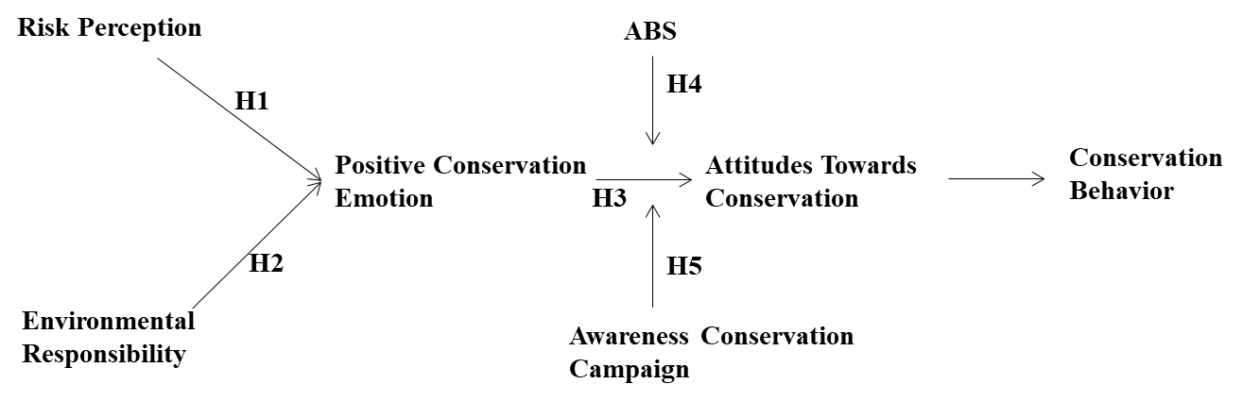

FIGURE 1 The proposed model, showing the interrelatedness among different psychometric variables (adopted from Long et al. 2025, and modified).

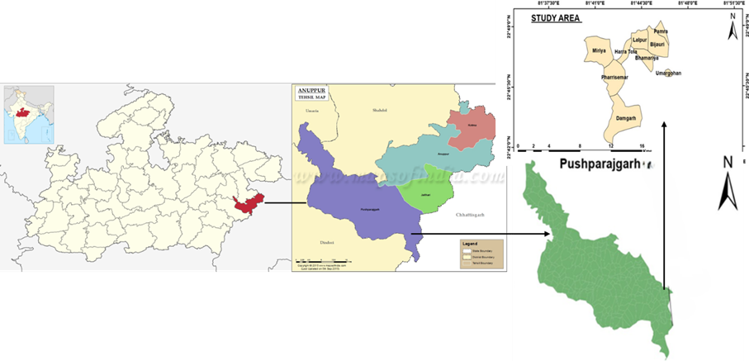
FIGURE 2 A map of the study area

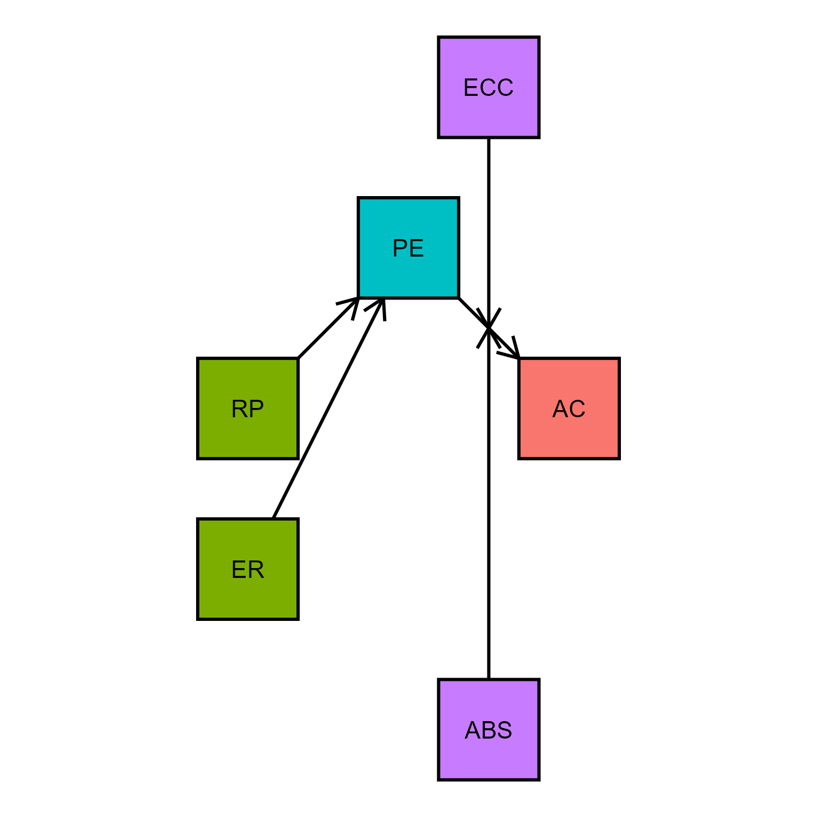  FIGURE 3 The Path Model I. | 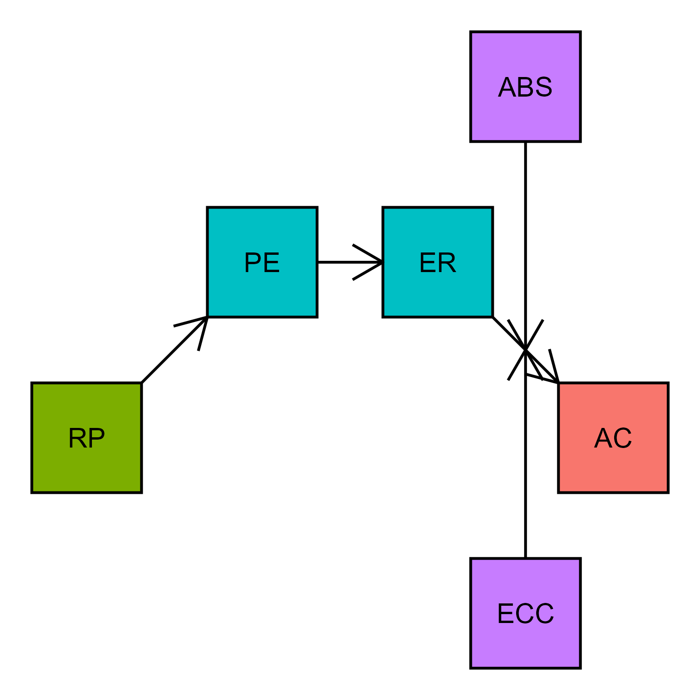  FIGURE 4: The Path Model II.

