Title: Acid tolerant bacterium Bacillus amyloliquefaciens MBNC retains biocontrol efficiency against fungal phytopathogens in low pH

Naimisha Chowdhury^{1,2}, Dibya Jyoti Hazarika^{1,2}, Gunajit Goswami¹, Unmona Sarmah¹, Shrutirupa Borah², Robin Chandra Boro², Madhumita Barooah^{1,2} *

Supplementary table S1: Effects of temperature on the antimicrobial activity of B. amyloliquefaciens MBNC against fungal phytopathogens

Antimicrobial activity
Under Heat Treatment (100°C, 1 h)
Fungal isolate | Day 3 bacterial supernatant
 | pH 7.0 | pH 4.5
Pythium myriotylum 1NC | +++ | +++
Fusarium incarnatum 3NC | ++ | ++
Fusarium redolens 6NC | +++ | +++
Fusarium verticilloides 2NC | + | +
Fusarium oxysporum 5NC | ++ | ++
Athelia rolfsii 4NC | ++ | ++

Diameter of inhibition zone: +, 1.00 to 4.00 mm; ++, 4.00 to 8.00 mm; +++, 8.00 to 12.00 mm

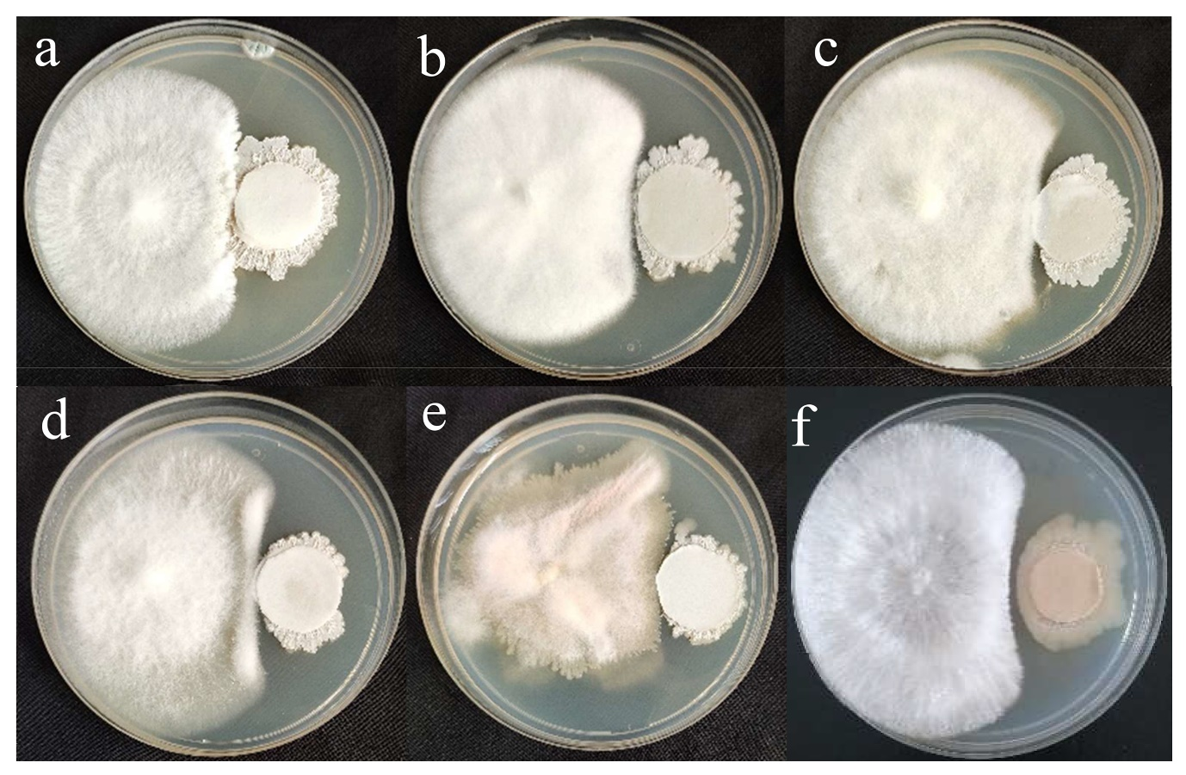
Supplementary Fig. S1: Antifungal activity of B. amyloliquefaciens MBNC against the six different fungal plant pathogens (a) Pythium myriotylum 1NC, (b) Fusarium incarnatum 3NC, (c) F. redolens 6NC (d) F. verticilloides 2NC (e) F. oxysporum 5NC and (f) Athelia rolfsii 4NC
Supplementary Fig. S2: Phytohormone, Indole-3-acetic acid (IAA) and gibberellic acid (GA) production by B. amyloliquefaciens MBNC at neutral (pH 7.0) and acid stress (pH 4.5) condition

