Supplementary

- Supplementary tables
  - Supplementary Table S1. Baseline characteristics, AI-ECG age metrics, and AF burden by atrial fibrillation subtype in the S-Patch registry
  - Supplementary Table S2. Baseline Demographics, Clinical Characteristics, AI-ECG Derived Age Metrics, and Atrial Fibrillation Burden in Participants with and without Device-detected Atrial Fibrillation in the Memo-Patch Registry
  - Supplementary Table S3. Clinical, Demographic, and AI-Derived Electrophysiological Characteristics of Participants Stratified by Device-Detected, Paroxysmal, and Persistent Atrial Fibrillation in the S-patch Registry (Subjects Exhibiting AF Rhythm)
- Supplementary figures
  - Supplementary Figure S1. Supplementary Figure S1. Real versus CycleGAN-Generated Single-Lead ECG Waveforms
  - Supplementary Figure S2. Validation of the AI-ECG Age Prediction Model Using Synthetic Single-Lead ECG Waveforms
  - Supplementary Figure S3. AI-Predicted ECG Age from CycleGAN-Generated 12-Lead ECGs versus Chronological Age
  - Supplementary Figure S4. Association of an AI-ECG Age Gap with prevalent diseases
  - Supplementary Figure S5. Adjusted association between AI-ECG age gap and prevalent atrial fibrillation
  - Supplementary Figure S6. Adjusted relationship between AI-ECG age gap and atrial-fibrillation burden
- Supplementary methods
  - Supplementary Method S1 – Detailed Description of Study Datasets
  - Supplementary Method S2: Model Architecture and Training Procedures
  - Supplementary Method S3: Validation and Clinical Evaluation of the PROPHECG-Age Single Model

Supplementary Table S1. Baseline characteristics, AI-ECG age metrics, and AF burden by atrial fibrillation subtype in the S-Patch registry
S-patch |  | None  -AF (N) |  | Device detected  -AF (DD) |  | Paroxysmal  -AF (PX) |  | Persistent  -AF (PS) | p-value | Regression  Coef. (p-value)
 | N | Mean (std)/N (%) | N | Mean (std)/N (%) | N | Mean (std)/N (%) | N | Mean (std)/N (%) | PX vs PS | N vs DD vs PX vs PS
Total Sample Count | 285 |  | 9 |  | 1024 |  | 182
AI-ECG Age
AI-ECG Age at sinus rhythm | 285 | 59.1 (9.1) | 9 | 65.8 (10.0) | 1024 | 60.4 (9.3) | 182 | 62.3 (9.4) | 0.015 | 0.834 (0.002)
AI-ECG Age Gap at sinus | 285 | -4.2 (12.8) | 9 | -0.6 (10.4) | 1024 | -1.4 (12.3) | 182 | -0.1 (12.3) | 0.175 | 1.38 (<0.001)
Demographics | 285 |  | 9 |  | 1024 |  | 182
Age |  | 63.4 (12.6) |  | 66.3 (5.6) |  | 61.8 (10.6) |  | 62.3 (10.8) | 0.568
Sex |  |  |  |  |  |  |  |  | 0.013
Male |  | 131 (46%) |  | 2 (22%) |  | 714 (70%) |  | 144 (79%)
Female |  | 154 (54%) |  | 7 (77%) |  | 310 (30%) |  | 38 (21%)
BMI | 285 | 23.6 (4.3) | 9 | 23.2 (2.7) | 1023 | 24.6 (3.9) | 182 | 25.5 (4.1) | 0.008 | 0.59 (<0.001)
Blood pressure | 285 |  | 9 |  | 1023 |  | 182
Systolic Pressure (mmHg) |  | 130.3 (16.2) |  | 131.9 (20.4) |  | 125.7 (14.9) |  | 127.7 (14.2) | 0.071 | -1.53 (<0.001)
Diastolic Pressure (mmHg) |  | 74.5 (11.9) |  | 70.0 (17.9) |  | 74.3 (11.0) |  | 74.8 (10.4) | 0.523 | 0.03 (0.928)
Comorbidities | 285 |  | 9 |  | 1023 |  | 182
Congestive HF |  | 35 (12%) |  | 0 (0%) |  | 115 (11%) |  | 44 (24%) | 0.276
Hypertension |  | 173 (61%) |  | 5 (56%) |  | 540 (53%) |  | 110 (60%) | <0.001
Dyslipidemia |  | 103 (36%) |  | 3 (33%) |  | 341 (33%) |  | 47 (26%) | 0.043
Diabetes mellitus |  | 64 (22%) |  | 1 (11%) |  | 172 (17%) |  | 35 (19%) | 0.027
Previous Stroke/TIA |  | 26 (9%) |  | 0 (0%) |  | 86 (8%) |  | 18 (10%) | 0.488
Previous myocardial infarction |  | 8 (3%) |  | 0 (0%) |  | 14 (1%) |  | 2 (1%) | 0.203
Chronic kidney disease |  | 8 (3%) |  | 0 (0%) |  | 40 (4%) |  | 4 (2%) | 0.562
CHA2DS2-VASc | 285 | 2.4 (1.2) | 9 | 2.1 (1.1) | 1023 | 1.9 (1.4) | 182 | 2.0 (1.4) | 0.119
HASBLED | 285 | 1.3 (0.9) | 9 | 1.2 (1.1) | 1023 | 1.2 (0.9) | 182 | 1.3 (0.9) | 0.115 | -0.19 (<0.001)
Smoking status | 285 |  | 9 |  | 1023 |  | 182 |  | 0.019 | -0.03 (0.252)
No |  | 241 (85%) |  | 8 (88%) |  | 810 (79%) |  | 127 (70%)
mild |  | 25 (9%) |  | 1 (11%) |  | 119 (12%) |  | 30 (16%)
Severe |  | 19 (7%) |  | 0 (0%) |  | 94 (9%) |  | 25 (14%)
Drinking status | 285 |  | 9 |  | 1023 |  | 182 |  | 0.159
No |  | 223 (78%) |  | 7 (78%) |  | 744 (73%) |  | 120 (66%)
Mild |  | 15 (5%) |  | 1 (11%) |  | 44 (4%) |  | 11 (6%)
Severe |  | 47 (16%) |  | 1 (11%) |  | 235 (23%) |  | 51 (28%)

Data are shown for participants with no AF (n = 285), device detected AF (n = 9), paroxysmal AF (n = 1,024) and persistent AF (n = 182). Continuous variables are presented as mean ± SD and categorical variables as n (%). AI-ECG age at sinus rhythm and at AF rhythm, AI-ECG age gap (predicted age – chronological age), and AF burden (%) all increase stepwise from none to paroxysmal to persistent AF. P-values compare paroxysmal versus persistent AF (Student’s t-test or χ² test), and the regression trend coefficient (with p-value) assesses the linear increase across AF subtypes (DD, PX, PS). Abbreviations: AF, atrial fibrillation; BMI, body mass index; HF, heart failure; MI, myocardial infarction; CKD, chronic kidney disease; CHA₂DS₂-VASc, Congestive heart failure, Hypertension, Age ≥75 (doubled), Diabetes, Stroke/TIA (doubled), Vascular disease, Age 65–74, Sex category; HAS-BLED, Hypertension, Abnormal renal/liver function, Stroke, Bleeding, Labile INR, Elderly, Drugs/alcohol concomitantly.

Supplementary Table S2. Baseline Demographics, Clinical Characteristics, AI-ECG Derived Age Metrics, and Atrial Fibrillation Burden in Participants with and without Device-detected Atrial Fibrillation in the Memo-Patch Registry
Memo-patch |  | None -AF |  | Device detected -AF | p-value
 | N | Mean (std)/N (%) | N | Mean (std)/N (%)
Total Sample Count | 505 |  | 24
AI-ECG Age | 505 |  | 24
AI-ECG Age at sinus rhythm |  | 58.1 (8.8) |  | 60.5 (8.8) | 0.207
AI-ECG Age Gap at sinus |  | -9.1 (11.0) |  | -9.9 (9.5) | 0.691
AF burden |  |  | 24
AF burden (%) |  | NA |  | 16.3 (27.3)
Demographics | 505 |  | 24
Age |  | 67.3 (9.7) |  | 70.5 (7.6) | 0.058
Sex |  |  |  |  | 0.229
Male |  | 142 (28%) |  | 10 (42%)
Female |  | 363 (72%) |  | 14 (58%)
BMI |  | 24.2 (3.5) |  | 23.9 (3.2) | 0.658
Blood pressure | 504 |  | 24
Systolic Pressure (mmHg) |  | 130.6 (16.5) |  | 129.2 (15.4) | 0.675
Diastolic Pressure (mmHg) |  | 73.5 (11.3) |  | 73.1 (10.1) | 0.839
Comorbidities | 504 |  | 24
Congestive HF |  | 23 (5%) |  | 2 (8%) | 0.316
Hypertension |  | 331 (66%) |  | 16 (67%) | 1.000
Diabetes mellitus |  | 139 (28%) |  | 5 (21%) | 0.624
Previous Stroke/TIA |  | 45(9%) |  | 2 (8%) | 1.000
CHA2DS2-VASc | 504 | 2.9 (1.1) | 24 | 3.0 (1.0)
Smoking status | 503 |  | 24 |  | 0.631
No |  | 424 (84%) |  | 22 (92%)
mild |  | 49 (9%) |  | 2 (8%)
Severe |  | 30 (6%) |  | 0 (0%)
Drinking status | 503 |  | 24 |  | 0.945
No |  | 416 (83%) |  | 20 (83%)
Mild |  | 55 (11%) |  | 2 (8%)
Severe |  | 32 (6%) |  | 2 (8%)

Data are shown for participants with no AF (n = 505) and device detected AF (n = 24). Data presented as mean (standard deviation, SD) or frequency (%). AF: Atrial fibrillation; AI-ECG: Artificial Intelligence-derived Electrocardiogram; BMI: Body Mass Index; CHAD2DS2-VASc: Congestive heart failure, Hypertension, Age ≥75 years, Diabetes mellitus, previous Stroke/transient ischemic attack/thromboembolism, Vascular disease, Age 65–74 years, Sex category (female). Statistical comparisons were conducted using t-tests or Fisher’s exact test as appropriate

Supplementary Table S3. Clinical, Demographic, and AI-Derived Electrophysiological Characteristics of Participants Stratified by Device-Detected, Paroxysmal, and Persistent Atrial Fibrillation in the S-patch Registry (Subjects Exhibiting AF Rhythm)
S-patch AF |  | Overall AF |  | Device detected  (DD) |  | Paroxysmal  (PX) |  | Persistent  (PS) | p-value  (t-test) | Regression  Coef. (p-value)
 | N | Mean (std)/ N (%) | N | Mean (std)/ N (%) | N | Mean (std)/ N (%) | N | Mean (std)/ N (%) | PX vs PS | DD vs PX vs PS
Total Sample Count | 233 |  | 9 |  | 180 |  | 42
AI-ECG Age | 233 |  | 9 |  | 180 |  | 42
AI-ECG Age Gap at sinus |  | -1.8 (12.2) |  | -0.6 (10.4) |  | -2.3 (11.9) |  | -0.3 (13.8) | 0.405 | 1.12 (0.533)
AI-ECG Age Gap at AF rhythm |  | 7.5 (11.5) |  | 3.0 (6.9) |  | 7.5 (11.4) |  | 8.3 (12.6) | 0.709 | 1.61 (0.342)
AF burden | 233 |  | 9 |  | 180 |  | 42
AF burden (%) |  | 37.3 (36.4) |  | 25.9 (38.7) |  | 35.8 (35.2) |  | 46.7 (40.3) | 0.113 | 10.67 (0.046)
Demographics | 233 |  | 9 |  | 180 |  | 42
Age |  | 62.5 (9.7) |  | 66.3 (5.6) |  | 62.3 (9.3) |  | 62.6 (11.8) | 0.888 | -0.67 (0.637)
Sex |  |  |  |  |  |  |  |  | 0.679
Male |  | 184 (79%) |  | 2 (22%) |  | 145 (81%) |  | 35 (83%)
Female |  | 49 (21%) |  | 7 (77%) |  | 35 (19%) |  | 7 (17%)
BMI |  | 24.7 (3.4) | 9 | 23.2 (2.7) | 179 | 24.5 (3.5) | 42 | 25.8 (3.2) | 0.022 | 1.30 (0.009)
Blood pressure | 231 |  | 9 |  | 179 |  | 42
Systolic Pressure (mmHg) |  | 125.9 (13.6) |  | 131.9 (20.4) |  | 125.0 (13.9) |  | 128.9 (9.4) | 0.032 | 1.49 (0.457)
Diastolic Pressure (mmHg) |  | 75.1 (10.8) |  | 70.0 (17.9) |  | 75.1 (10.3) |  | 76.3 (10.8) | 0.509 | 2.09 (0.189)
CHA2DS2-VASc | 231 | 1.9 (1.3) | 9 | 2.1 (1.1) | 179 | 1.8 (1.3) | 42 | 2.0 (1.6) | 0.437 | 0.09 (0.639)
HASBLED | 231 | 1.2 (0.9) | 9 | 1.2 (1.1) | 179 | 1.2 (0.8) | 42 | 1.1 (1.0) | 0.823 | -0.04 (0.771)

Data presented as mean (standard deviation, SD) or frequency (%). AF: Atrial fibrillation; DD: Device-detected AF; PX: Paroxysmal AF; PS: Persistent AF; AI-ECG: Artificial Intelligence-derived Electrocardiogram; BMI: Body Mass Index; CHA2DS2-VASc: Congestive heart failure, Hypertension, Age ≥75 years, Diabetes mellitus, previous Stroke/transient ischemic attack/thromboembolism, Vascular disease, Age 65–74 years, Sex category (female); HASBLED: Hypertension, Abnormal renal/liver function, Stroke, Bleeding history or predisposition, Labile INR, Elderly (>65 years), Drugs/alcohol concomitantly. Statistical significance determined by t-tests and regression analyses, with bold values indicating statistical significance (p<0.05). Two participants exhibiting AF rhythm without clear prior clinical diagnosis classification are excluded from the subgroup analyses, thus resulting in 231 participants described in this table.

Supplementary Figure S1. Supplementary Figure S1. Real versus CycleGAN-Generated Single-Lead ECG Waveforms
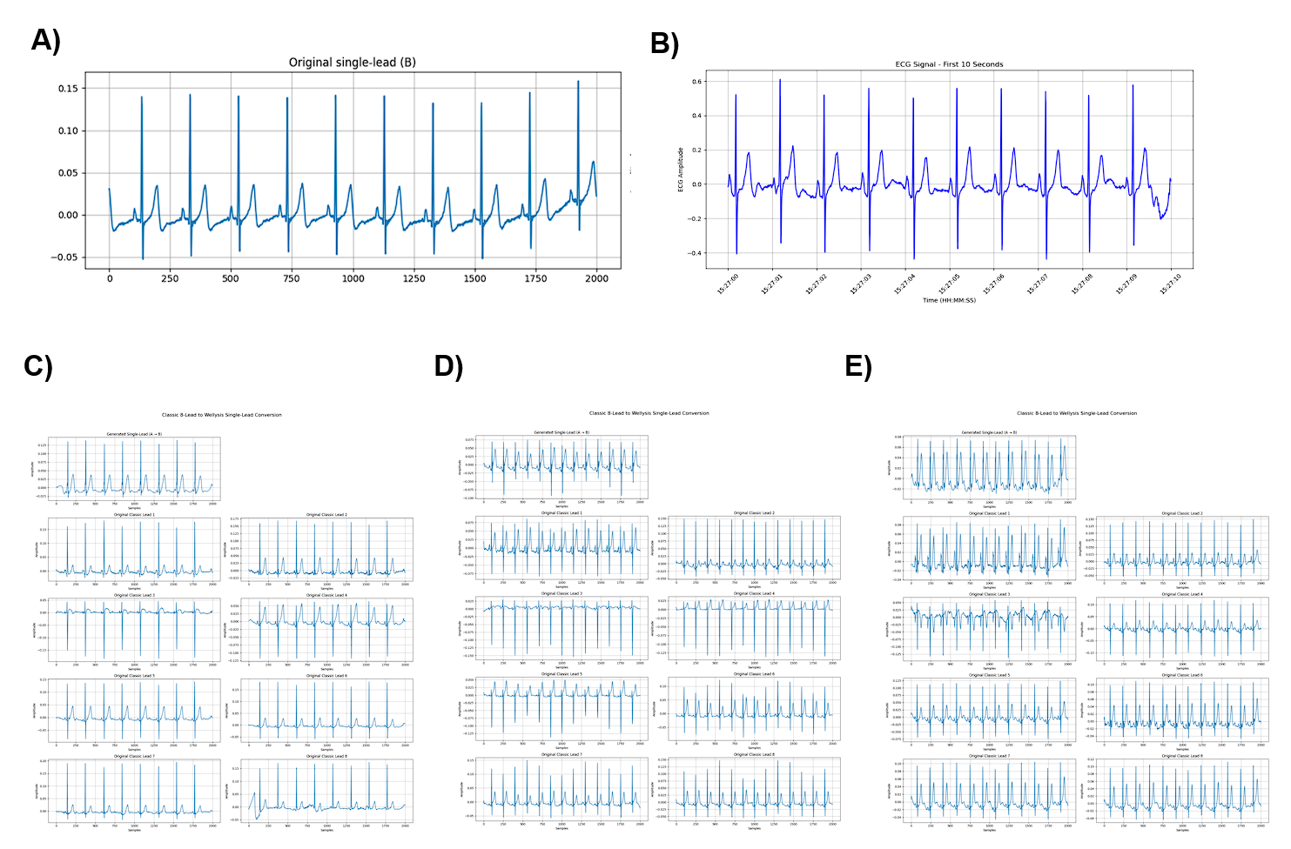
Top panels: Representative 10-second single-lead ECG snippets recorded from two wearable devices—Wellysis S-Patch (A) and HUINNO Memo-Patch (B). Bottom panels(C-E): Corresponding synthetic single-lead ECG segments generated by the Cycle-Consistent Generative Adversarial Network (CycleGAN). Each column shows multiple 10-second windows; red boxes highlight selected synthetic segments that closely recapitulate the morphology (P-wave, QRS complex, T-wave) and rhythm characteristics of the real recordings. This demonstrates the CycleGAN’s ability to produce high-fidelity single-lead ECG waveforms suitable for downstream AI-ECG age modeling.

Supplementary Figure S2. Validation of the AI-ECG Age Prediction Model Using Synthetic Single-Lead ECG Waveforms
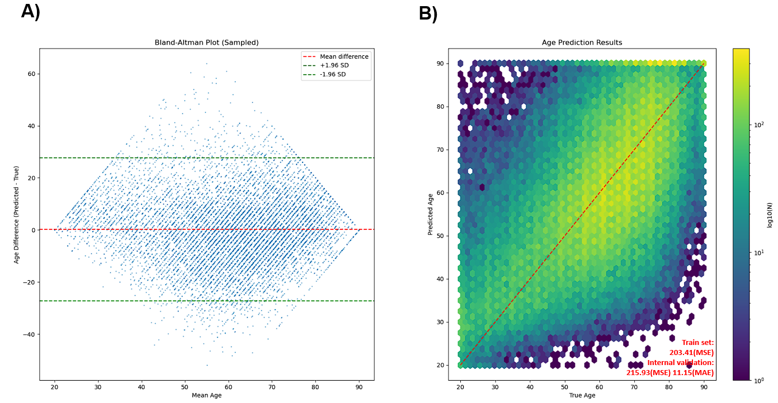
The ResNet-1D AI-ECG age model was evaluated using synthetic single-lead ECG waveforms generated via CycleGAN. Panel (A) displays a Bland–Altman plot, illustrating the agreement between predicted and actual age. The red dashed line indicates the mean difference (bias), and the green dashed lines represent the limits of agreement (±1.96 SD). Panel (B) shows a hexbin density plot of the predicted versus true age values, with the red dashed line representing perfect age prediction (y = x). The color gradient indicates the log₁₀-transformed count of data points within each hexagonal bin, highlighting areas of higher prediction density. The model achieved a mean squared error (MSE) of 203.41 in the training dataset and an MSE of 215.93 with a mean absolute error (MAE) of 11.15 years in internal validation using held-out synthetic ECG data.

Supplementary Figure S3. AI-Predicted ECG Age from CycleGAN-Generated 12-Lead ECGs versus Chronological Age

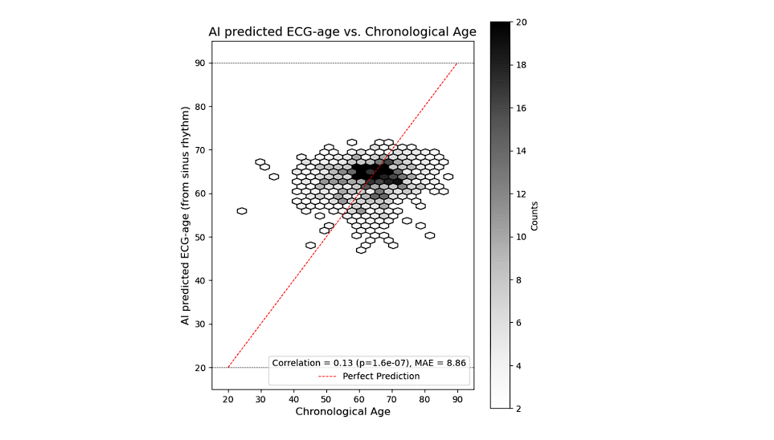
Performance evaluation of the PROPHECG-Age model when applied to 8-lead ECGs generated from single-lead ECGs using a CycleGAN model. The hexbin plot shows the relationship between AI-predicted ECG age and chronological age, with the color scale indicating density. The red dashed line represents perfect prediction. The model yields a modest correlation (r = 0.13, p = 1.6e-07) with a mean absolute error (MAE) of 8.86 years, suggesting limited but statistically significant predictive accuracy when inferring multi-lead features from single-lead inputs via CycleGAN

Supplementary Figure S4. Association of an AI-ECG Age Gap with prevalent diseases

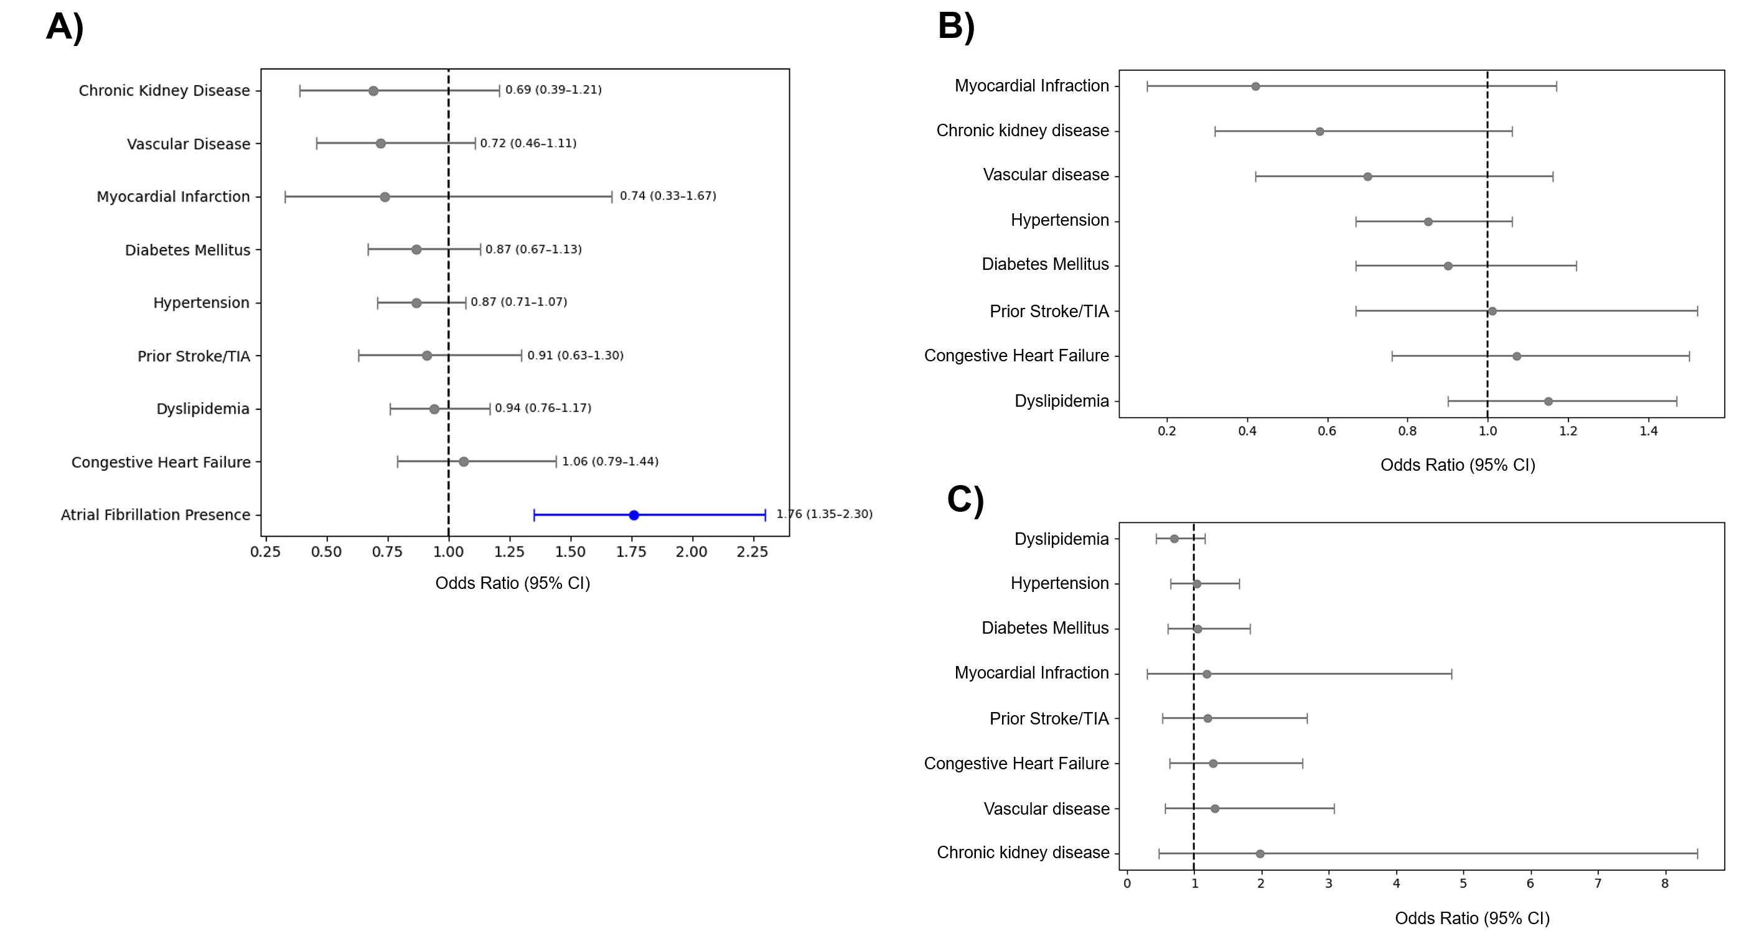
This illustrates, in a set of three forest plots, the multivariable‐adjusted association between an elevated AI-ECG age gap (> –1.8 years, the mean gap in the S-Patch registry) and a panel of prevalent comorbidities. In the full cohort of 1,500 participants (Panel A), atrial fibrillation (AF) is the only condition whose confidence interval lies entirely to the right of the null, indicating a statistically significant relationship (OR = 1.76, 95 % CI 1.35–2.30), whereas the odds ratios for chronic kidney disease, vascular disease, prior myocardial infarction, diabetes mellitus, hypertension, prior stroke/TIA, dyslipidaemia and congestive heart failure all straddle the unity line. When the analysis is stratified, neither the AF-positive subgroup (n = 1,217; Panel B) nor the AF-negative subgroup (n = 285; Panel C) shows any significant links between an elevated age gap and the same set of comorbidities, as every 95 % CI crosses the vertical reference line at OR = 1. All models adjust for the full list of comorbidities as covariates in addition to the CHA₂DS₂-VASc score, underscoring that a widened AI-ECG age gap is selectively associated with the presence of AF itself, rather than with other common cardiovascular or metabolic conditions, irrespective of AF status.

Supplementary Figure S5. Adjusted association between AI-ECG age gap and prevalent atrial fibrillation
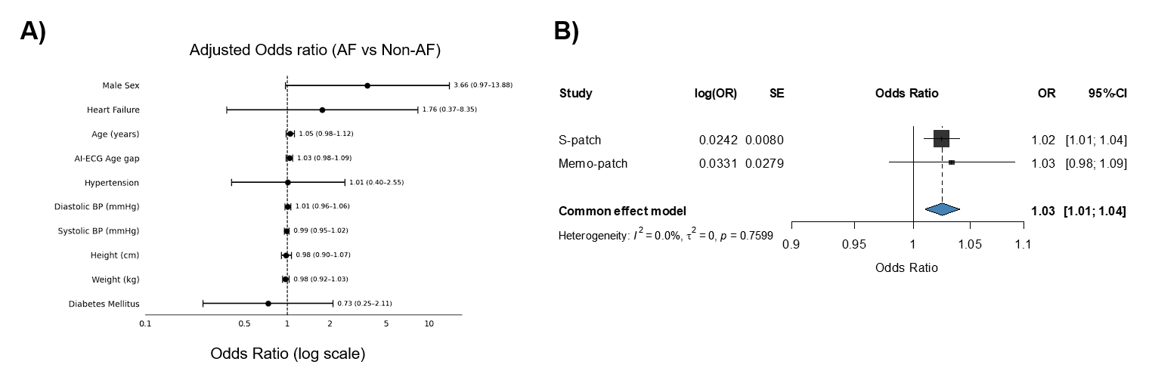

Panel A. External validation (Memo-Patch cohort, n = 529). Forest plot of multivariable odds ratios (ORs) for atrial fibrillation (AF) versus non-AF derived from a single logistic-regression model that included the AI-ECG age gap and all CHARGE-AF covariates. Horizontal bars show 95 % confidence intervals on a log scale. In this external cohort, each 1-year increase in the AI-ECG age gap was not a significant predictor of AF (adjusted OR = 1.03, 95 % CI 0.98–1.09). Panel B. Fixed-effect meta-analysis (S-Patch + Memo-Patch). Cohort-specific estimates for the AI-ECG age gap (S-Patch and Memo-Patch) are pooled using inverse-variance weighting. The combined OR is 1.03 per additional year (95 % CI 1.01–1.04), with no between-study heterogeneity (I² = 0 %, p = 0.76). Thus, while the Memo-Patch cohort alone does not reach significance, the aggregated evidence supports a modest, dose-dependent relationship between a larger AI-ECG age gap and AF prevalence.

Supplementary Figure S6. Adjusted relationship between AI-ECG age gap and atrial-fibrillation burden

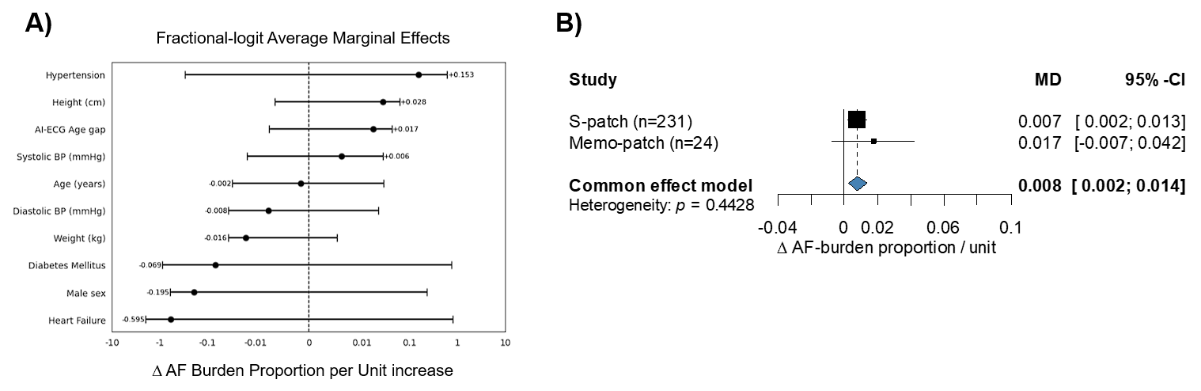

Panel A depicts average marginal effects from a fractional-logit model fitted in the external Memo-Patch cohort (n = 24 participants with ≥1 AF episode). The model related the proportion of monitoring time spent in AF to the AI-ECG age gap while adjusting for all CHARGE-AF covariates; horizontal bars represent 95 % confidence intervals on a log scale. Each additional-year increase in the age gap corresponded to a non-significant 0.017-unit rise in AF-burden proportion (≈1.7 percentage points; 95 % CI –0.007 to 0.042), whereas hypertension exerted the largest positive effect. Panel B pools the marginal effects for the age gap from the S-Patch and Memo-Patch cohorts using fixed-effect inverse-variance weighting. The combined estimate was significant—0.008-unit increase in AF-burden proportion per 1-year age-gap increment (95 % CI 0.002–0.014)—with no evidence of between-study heterogeneity (I² = 0 %, p = 0.44). Thus, although the Memo-Patch analysis alone was not significant, the meta-analysis supports a modest but consistent association between larger AI-ECG age gaps and higher AF burden.

Supplementary Method S1 – Detailed Description of Study Datasets
This study utilized three datasets comprising both retrospective and prospective sources: the Severance Hospital 12-lead ECG archive, the S-Patch registry (NCT05119725), and the Memo Patch registry (NCT05355948). Each dataset contributed uniquely to model development, training, and validation across varied clinical and temporal contexts.

Severance Hospital 12-lead ECG Archive
The Severance Hospital ECG dataset was extracted from a large institutional repository containing 3,672,020 ECGs from 837,666 individuals, collected between January 2006 and September 2021. This repository includes medical records and other health data from patients who visited or were referred to Severance Hospital, a major tertiary referral center in South Korea. For the present study, only ECGs meeting strict inclusion criteria were retained—namely, a standard 12-lead configuration, 500 Hz sampling frequency, 10-second duration, and availability of age metadata for participants aged 20 to 90 years. ECGs lacking proper waveform structure or failing to meet these parameters were excluded. Following this quality assurance process, 1,008,566 high-quality 12-lead ECGs were randomly sampled. These recordings were employed exclusively to train a deep learning model and to generate synthetic single-lead ECGs via a CycleGAN-based domain conversion framework.

S-Patch Registry
The S-Patch dataset was obtained from a prospective multicenter registry that enrolled 1,980 participants between September 2021 and August 2024 across 15 tertiary and general hospitals in South Korea. Continuous single-lead ECG monitoring was performed using the S-Patch EX device (Wellysis Corp., Seoul, Korea) for up to 72 hours per participant in ambulatory settings. For analysis, a 48-hour recording was extracted for each subject, with the recording beginning at 00:00. Only recordings confirmed to reflect a normal sinus rhythm were used for model input. The detection of atrial fibrillation (AF) through electrocardiogram (ECG) recordings was determined through a two-step process. First, an automated deep learning–based detection algorithm was utilized, and then, manual verification was conducted by trained ECG technicians. Participants who had not received a prior diagnosis but exhibited atrial fibrillation (AF) rhythm patterns on electrocardiogram (ECG) recordings were designated as "Device-Detected AF." Subjects who were not diagnosed with atrial fibrillation (AF) and who exhibited no AF recordings during monitoring were included in the study as 'Non-AF'.
Memo Patch Registry
The Memo Patch registry is comprised of data from 582 participants enrolled at 13 hospitals from September 2022 to November 2023. The monitoring device utilized was the MEMO Patch device (HUINNO Co., Ltd., Seoul, Korea), a vendor that offers uninterrupted single-lead ECG recording for a duration of up to two weeks. Prior to enrollment, a comprehensive clinical evaluation was conducted, which confirmed the absence of atrial fibrillation (AF) in all participants. However, during the period of wearing a vendor, 24 participants ultimately detected AF rhythm and were subsequently classified as AF participants. For the AF participants, external validation of the AF burden was conducted. Participants exhibiting no atrial fibrillation rhythm during the monitoring period were designated as "non-AF" participants. The assessment enabled a comprehensive temporal stability evaluation, with monitoring durations ranging from seven to fourteen days. The performance of the model was evaluated by employing all AF (atrial fibrillation) and Non-AF (non-atrial fibrillation) data.

Preprocessing Pipeline (All Single-Lead Data)
To ensure consistency and high signal fidelity across all single-lead recordings, a standardized ECG preprocessing pipeline was applied. Signals were first filtered to remove baseline wander and noise; thereafter, the recordings were segmented into 10-second epochs every 5 minutes. Only segments with a signal quality index (SQI) ≥ 0.5 were retained for downstream analysis. [1]

Supplementary Method S2: Model Architecture and Training Procedures
1. CycleGAN-Based Single-Lead ECG Generation
To enable the generation of single-lead ECG signals from conventional 12-lead recordings, an attention-guided CycleGAN architecture was implemented. [2] This architecture comprised two generator networks and two discriminator networks, enabling bi-directional domain translation between 12-lead (Domain A) and single-lead (Domain B) ECG representations.
Generators (G_AB and G_BA): Generator G_AB was responsible for translating 12-lead ECGs into synthetic single-lead outputs. Conversely, G_BA mapped single-lead signals back into 12-lead representations to enforce cycle-consistency. Both generators were based on a 1D Residual Network (ResNet-1D) architecture comprising five residual blocks with the following channel configurations: 16 → 32 → 32 → 64 → 64. Each block employed 1D convolutional layers with sine activation functions and instance normalization to promote stable gradient flow and effective temporal feature learning. A spatial attention mechanism was incorporated to enhance context-aware synthesis, focusing learning on waveform morphologies.
Discriminators (D_A and D_B): Both discriminators followed a 1D PatchGAN configuration, assessing the authenticity of signal patches rather than entire sequences to better capture local waveform fidelity. D_A evaluated the realism of generated 12-lead signals, while D_B assessed the realism of synthetic single-lead signals.
Loss Function and Optimization: The training objective combined: (1) Adversarial Loss: For both domains using label smoothing (real = 0.9, fake = 0.1) to reduce overfitting of discriminators; (2) Cycle-Consistency Loss (λ_cycle = 4.0): Ensuring that round-trip transformations (e.g., A → B → A) preserved identity; (3) Identity Loss (λ_id = 0.04): Penalizing unnecessary transformations when inputs already belonged to the target domain.
The overall loss was computed as a weighted sum of the above components and optimized end-to-end using the Nadam optimizer with an initial learning rate of 1 × 10⁻⁴, β₁ = 0.9, and a batch size of 4.
Training Data: (1) 50,000 randomly sampled 10-second 12-lead ECG segments from the Severance archive were used as input to Domain A. (2) 100,000 10-second single-lead ECGs recorded from the S-Patch registry were used as Domain B examples.

2. PROPHECG-Age Single Framework
To predict AI-ECG age directly from single-lead input, the previously validated PROPHECG-Age architecture was adapted for single-lead signals and retrained on CycleGAN-synthesized data.
Input Specification: The model accepts 10-second single-lead ECGs sampled at 200 Hz, resulting in input sequences of 2,000 time points.
Data Partitioning: From the synthesized dataset of 1,008,566 single-lead ECGs (produced from the full Severance archive via Generator G_AB), data were partitioned into training, validation, and test sets using the following ratios: training = 80%, validation = 5%, and testing = 15%, ensuring sufficient data for both model generalization and unbiased evaluation.
Network Architecture: Initial projection via a Conv1D layer (kernel size = 7, padding = ‘same’) maps the raw signal into a higher-dimensional latent space with a receptive field of ~35 ms. This is followed by five sequential residual blocks, each comprising two Conv1D layers (kernel size = 7) and identity skip connections. Feature channel dimensions progress as follows: 32 → 64 → 128 → 256 → 512. Temporal resolution is reduced via strided convolutions, yielding intermediate sequence lengths of [2000, 400, 80, 16, 4], enabling multi-scale temporal abstraction. Each convolution is followed by instance normalization and dropout (rate = 0.4) to promote generalization and prevent overfitting.
Output Layer: Feature maps from the final convolutional block are condensed using global average pooling. A final fully connected dense layer with a single output neuron generates a continuous age prediction corresponding to the model-inferred AI-ECG age.
Training Procedure: Training was performed using the Adam optimizer with an initial learning rate of 1 × 10⁻³. A ReduceLROnPlateau learning rate scheduler (factor = 0.1, patience = 7 epochs) was applied to adaptively adjust the learning rate. Early stopping was triggered after 20 epochs without validation loss improvement. A fixed random seed (42) ensured reproducibility, and model training was parallelized across eight NVIDIA GPUs with a batch size of 256. The mean squared error (MSE) loss was used as the training objective, optimized to minimize the difference between predicted and true chronological ages.
Through these architectural and training refinements, the PROPHECG-Age Single model preserved the core design philosophy of the original 12-lead version while adapting its structure and parameters to the unique characteristics of single-lead ECG inputs.
To complement the forward architecture used in the PROPHECG-Age Single model (i.e., 12-lead to single-lead generation and downstream prediction), we also explored a reverse approach. Specifically, we attempted to reconstruct 12-lead ECG representations from single-lead inputs using the CycleGAN generator G_BA, which enforces cycle-consistency by mapping from Domain B (single-lead) back to Domain A (12-lead). The reconstructed 12-lead signals were then input into the original PROPHECG-Age model previously trained on standard 12-lead ECGs [3], enabling us to indirectly estimate AI-ECG age from single-lead signals through back-projection. This alternative pipeline was evaluated by comparing prediction performance in terms of mean absolute error (MAE) and Pearson correlation with chronological age (Supplementary Figure S3). Although this backward approach was conceptually feasible, its performance was inferior to that of the directly trained PROPHECG-Age Single model, likely due to information loss during the signal reconstruction step.
Supplementary Method S3: Validation and Clinical Evaluation of the PROPHECG-Age Single Model
1. External Validation Using Wearable ECGs
Validation was performed using two wearable single-lead ECG datasets. In the S-Patch registry, 1,502 participants aged 20–90 years with valid sinus-rhythm data were included. Each participant’s 48-hour ECG was segmented into 5-minute epochs (576 per participant), and AI-ECG age was computed as the arithmetic mean of per-epoch predictions. Model performance was assessed using: (1) Mean Absolute Error (MAE): Difference between AI-ECG and chronological age; (2) Pearson’s correlation coefficient (r): Strength of linear association.
The same procedure was applied to an independent cohort of 529 participants (all aged 20–90) from the Memo Patch registry to confirm model generalizability.

2. AI-ECG Age Gap and Clinical Relevance
A. Association with AF Presence
In the S-Patch cohort, 1,500 of 1,502 participants had complete atrial fibrillation (AF) diagnostic data and were classified as either AF (n = 1,215) or non-AF (n = 285). Within the AF group, 1,024 individuals had paroxysmal AF, 182 had persistent AF, and 9 had device-detected new-onset AF. Two subjects showed AF rhythm but with no clinical diagnosis information at enroll, therefore were not either classified into either device detected AF nor paroxysmal or persistent AF. We first compared the mean AI-ECG age gap (AI-predicted age minus chronological age) between AF and non-AF groups using Welch’s t-test. To quantify the independent predictive value of the age gap, we then fitted multivariable logistic regression models in which AF status was regressed on the AI-ECG age gap, adjusting for sex and each component of the CHARGE-AF risk score (chronological age, height, weight, systolic and diastolic blood pressure, smoking status, antihypertensive treatment, diabetes mellitus, heart failure, and prior myocardial infarction). An identical analytic pipeline was applied to the external Memo-Patch cohort (n = 529; 505 non-AF, 24 device-detected AF), and cohort-specific odds ratios per 1-year increment in age gap were combined by fixed- or random-effects meta-analysis according to the observed heterogeneity.
B. Association with AF Burden
Among S-Patch participants who exhibited any AF during their 48-hour monitoring window (n = 233), AF burden was defined as the proportion of total recording time spent in AF. To ensure that AI-ECG age could be calculated from sinus-rhythm segments, we excluded individuals with continuous AF (100 % burden) and those without any AF (0 % burden), yielding an analytic sample of 233 participants. These were further characterized by AF subtype as follows: paroxysmal AF (n = 180, 77.9 %), persistent AF (n = 42, 18.2 %), device-detected new-onset AF (n = 9, 3.9 %), and unclassified AF (n = 2).
The relationship between AI-ECG age gap (AI-ECG age minus chronological age) and AF burden was first explored univariately using Pearson’s correlation coefficient. We then quantified the independent association by fitting a multivariable linear regression model with AF burden (expressed in percentage points) as the dependent variable and AI-ECG age gap as the primary predictor. This model was adjusted for sex and all components of the CHARGE-AF risk score—chronological age, height, weight, systolic and diastolic blood pressure, smoking status, antihypertensive treatment, diabetes mellitus, heart failure, and prior myocardial infarction—as per our AF presence analyses. To confirm generalizability, we applied the identical analytical pipeline to an independent Memo-Patch cohort of 24 participants with device-detected AF. Cohort-specific regression coefficients (change in AF burden percentage points per 1-year increase in age gap) were subsequently pooled via fixed- or random-effects meta-analysis, depending on inter-study heterogeneity.

References
1. Schlesinger, D.E., et al., Artificial intelligence for hemodynamic monitoring with a wearable electrocardiogram monitor. Communications Medicine, 2025. 5(1): p. 4.
2. Mohebbian, M.R., et al., Fetal ECG extraction from maternal ECG using attention-based CycleGAN. IEEE journal of biomedical and health informatics, 2021. 26(2): p. 515-526.
3. Cho, S., et al., Artificial intelligence–derived electrocardiographic aging and risk of atrial fibrillation: a multi-national study. European heart journal, 2025. 46(9): p. 839-852.

