Supplementary Information
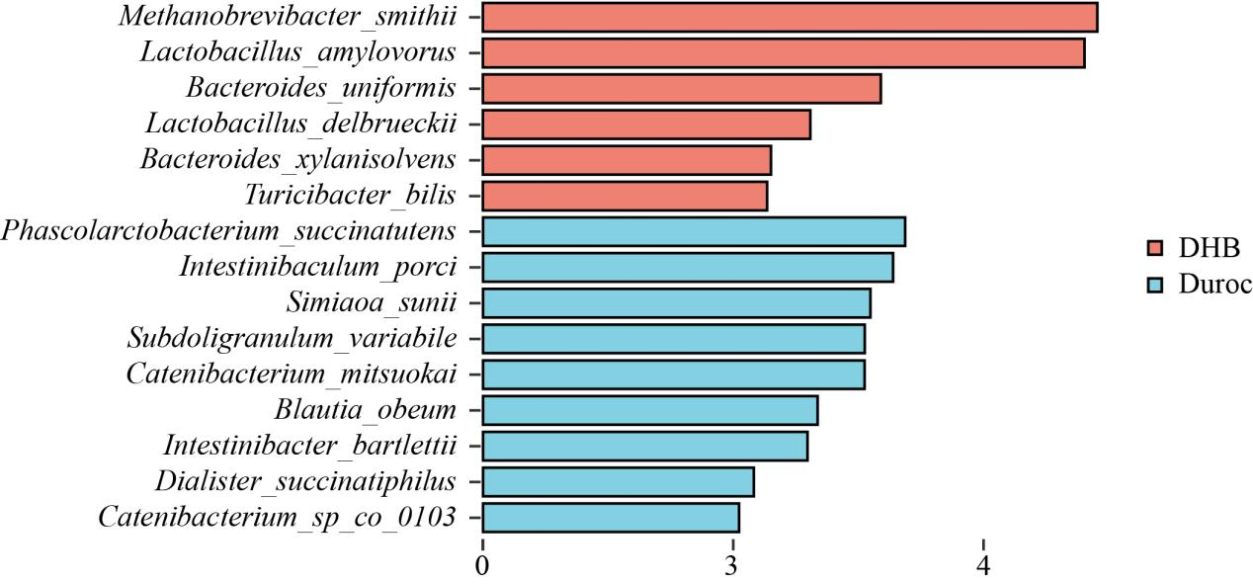
Figure S1 LEfSe analysis. DHB compare to Duroc
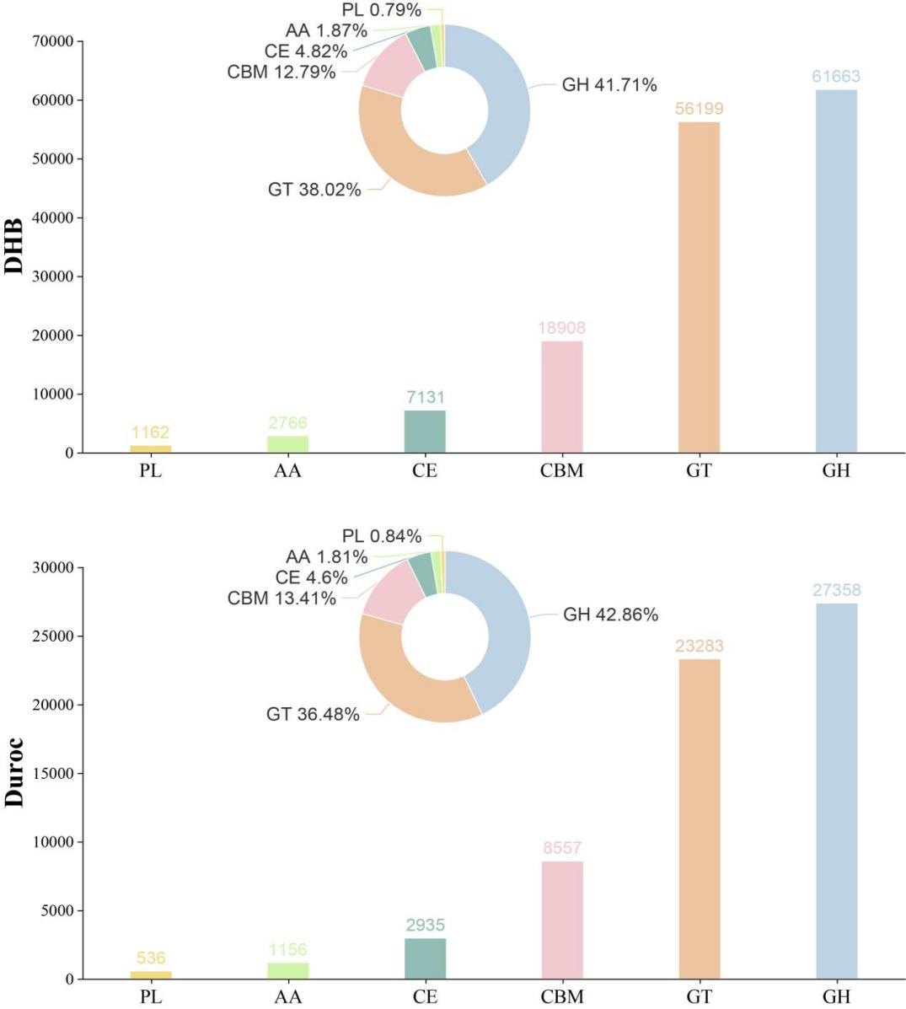
Figure S2 CAZyme families in DHB and Duroc.

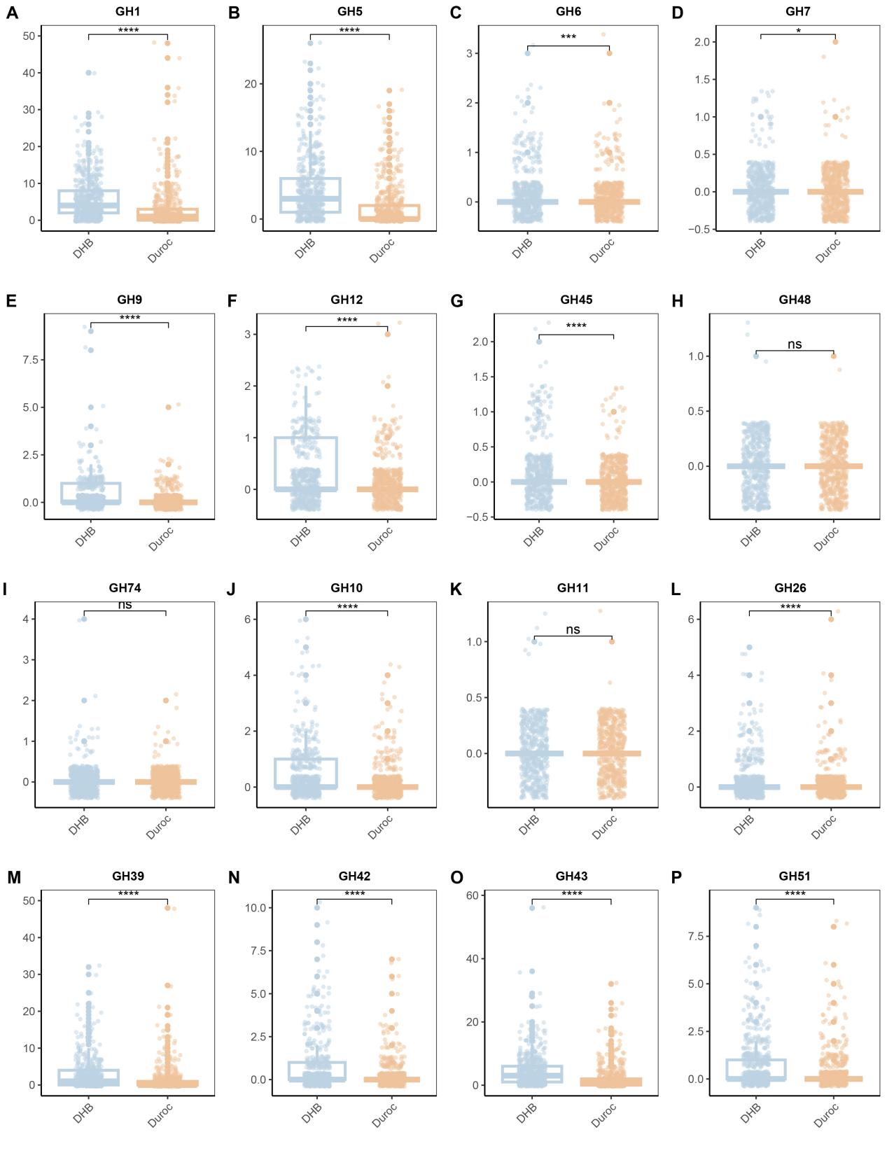
Figure S3 The number of major fiber-degrading enzyme families encoded by each MAG between DHB and Duroc. Figure A-I shows A family of cellulose degrading enzymes. J-P is a family of hemicellulose degrading enzyme

