SUPPLEMENTARY MATERIAL
Detailed clinical histories of the five patients with polymicrobial VGEI and QFA analysis
Patient 1: A 60-year-old male intravenous drug user with chronic hepatitis C was transferred to the University Hospital Zurich (USZ) due to a VGEI involving his iliac-femoral obturator bypass. He presented with a persistent, chronically exuding wound in the right groin. The collagen-coated vascular graft, originally implanted in 2006 to address an infected false aneurysm, had been occluded since 2011 despite multiple revisions. On arrival at USZ, a CT scan revealed a prosthetic-cutaneous fistula and an abscess surrounding the bypass, necessitating explantation of the graft. Cultures from the pus around the surgical site and the explanted bypass identified Staphylococcus aureus and Corynebacterium amycolatum (strain pair from patient 1). Due to good collateralization, it was not necessary to implant a new graft to ensure perfusion to the leg. The patient underwent a 20-day course of amoxicillin-clavulanic acid and was discharged without any signs of relapse or reinfection. Clinical and laboratory follow-up to date has confirmed the absence of recurrence. Supplementary Figure 2 provides a graphical depiction of the patient’s clinical course.
Patient 2: In 2021, a 72-year-old male was hospitalized for a suspected relapse of VGEI, following a two-months history of recurrent fever, chills, and abdominal pain. His medical history included graft replacement due to chronic VGEI caused by Pseudomonas aeruginosa, with a residual ingrown vascular graft. Post replacement, targeted therapy for Pseudomonas was maintained for one year. Upon admission in 2021, blood cultures identified Pseudomonas aeruginosa, Escherichia coli, and Prevotella spp., prompting treatment with piperacillin/tazobactam. The infected abdominal graft was replaced with a bovine pericardial prosthesis. Cultures from the explanted graft yielded C. glabrata and E. coli (strain pair from patient 2). The patient’s hospital course was marked by multiple complications, including mesenteric ischemia necessitating hemicolectomy. Despite aggressive treatment, the patient succumbed after a prolonged and challenging 96-day course in intensive care. Supplementary Figure 3a illustrates the patient’s clinical progression.
Patient 3: A 53-year-old male with HIV/hepatitis C-coinfection and a history of intravenous drug use was hospitalized with swelling and bleeding in his right groin. He was diagnosed with a femoral artery aneurysm and underwent xenopericardial patchplasty. Tissue and blood cultures grew Methicillin-resistant Staphylococcus aureus (MRSA), prompting treatment with vancomycin, which was later switched to daptomycin and flucloxacillin due to persistent bacteraemia. Despite antimicrobial treatment, the inguinal wound dehisced, exposing the vascular graft. Subsequent debridement identified Klebsiella aerogenes and Candida glabrata (strain pair from patient 3). The wound was managed with closure using a sartorius muscle flap. The patient was discharged after six days and prescribed a 12-week regimen of trimethoprim/sulfamethoxazole, rifampicin, and isavuconazole.
Patient 4 A 51-year-old male on hemodialysis was transferred to the hospital with elevated inflammatory markers (CRP 301 mg/L, Lc 21 G/L). Examination revealed an exposed polytetrafluoroethylene (PTFE) brachio-axillary shunt, strongly suggestive of another infectious complication following two years of treatment with clindamycin and ciprofloxacin for previous infections caused by S. aureus and Citrobacter freundii. Emergency surgery was performed to remove the exposed shunt material, and the antimicrobial treatment was switched to vancomycin and meropenem. Cultures from the graft identified Enterococcus faecalis and Corynebacterium amycolatum (strain pair from patient 4). Unfortunately, the patient developed uncontrollable gastric bleeding, resulting in death from haemorrhagic shock on the fourth day of hospitalization.
Patient 5: A 73-year-old male underwent aortic graft implantation for a newly diagnosed thoracoabdominal aortic aneurysm. Postoperatively, he experienced haemorrhagic shock due to bleeding from the common iliac vein, necessitating an emergency relaparotomy. On the 10th postoperative day, ischemic perforation of the sigmoid colon required hemicolectomy. During the procedure, a 2x5 cm peritoneal rupture was discovered, exposing the retroperitoneal vascular prosthesis indicating secondary VGEI. Cultures from abdominal and retroperitoneal swabs identified multi-resistant E. cloacae AmpC and methicillin-resistant S. epidermidis (strain pair from patient 5), prompting a change in antimicrobial therapy to daptomycin and ceftazidime/avibactam. Following discharge, the patient continued a six-month course of antimicrobial treatment, and no further infectious episodes have been reported.

Supplementary Figure 1: Individual growth curves derived from time-lapse images
Panel A
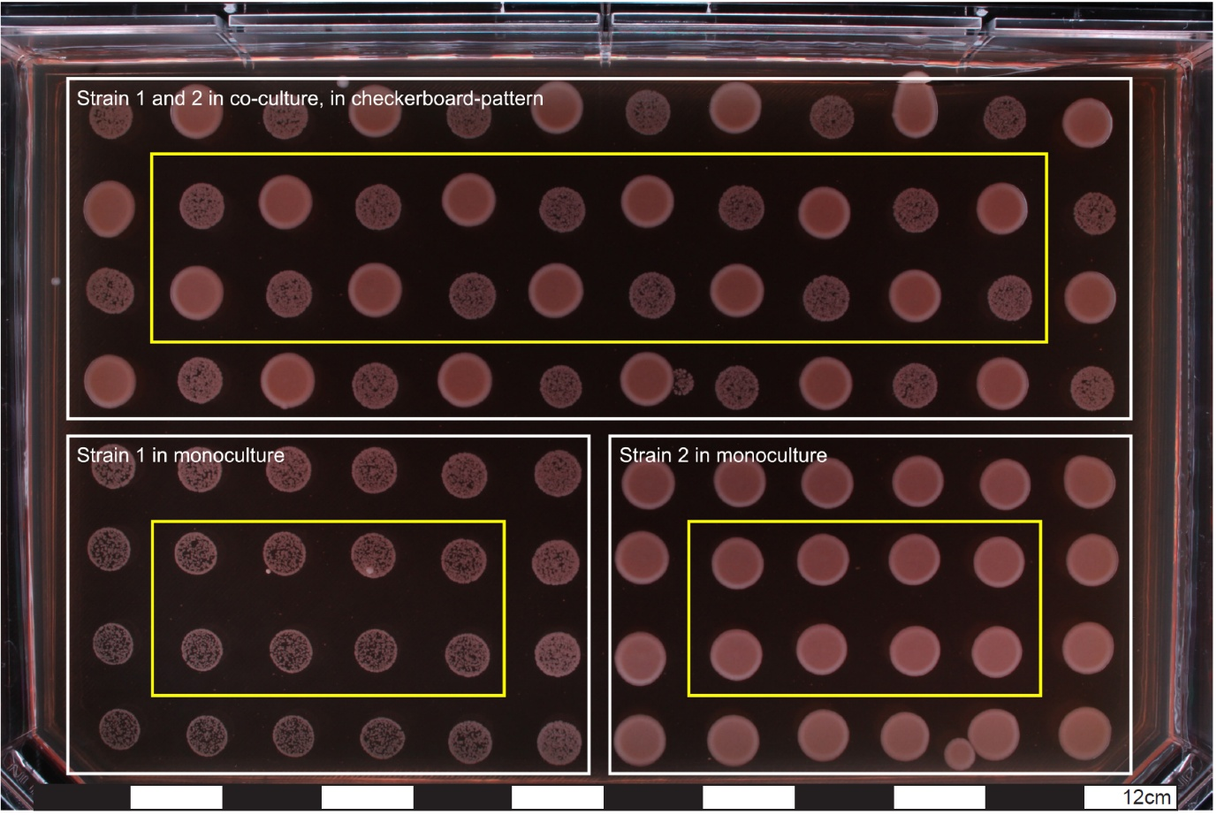
Panel B
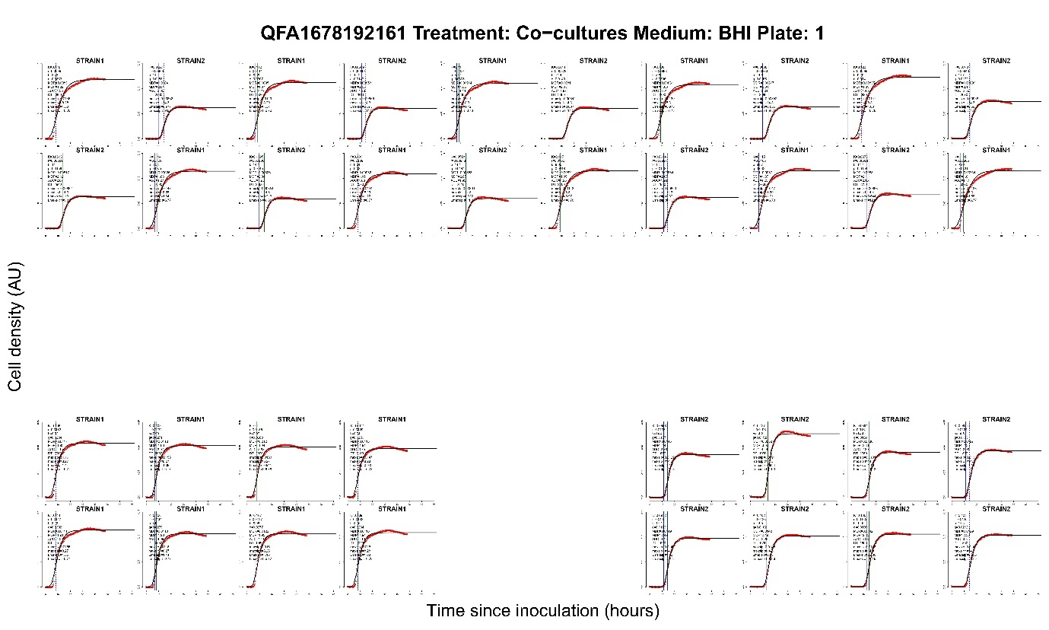

Panel A. General QFA setup. Strain-couplets were drop-plated in a predefined pattern, with strains growing in a checkerboard-pattern at the top to create a co-culture of strain 1 and 2, while at the bottom strains grew in monoculture. The analysis excluded borders of each condition, including solely the spots within the yellow frames in further analysis.
Panel B. Calculated growth curves per spot.

Supplementary Figure 2: Clinical course of a VGEI due to S. aureus and C. amycolatum (patient 1)
2: Clinical course
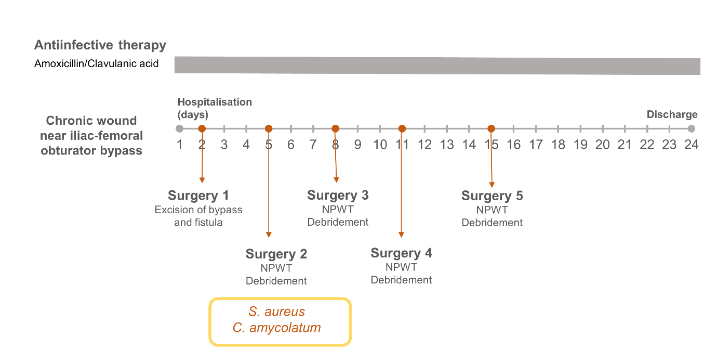

Figure legend: An overview of the clinical course, antimicrobial treatments, surgical interventions, and pathogen sampling relevant to the vascular graft/ endograft infection.
Abbreviations: NPWT, negative pressure wound therapy.

Supplementary Figure 3: Clinical course of a VGEI due to E. coli and C. glabrata (Patient 2)
3a: Clinical course
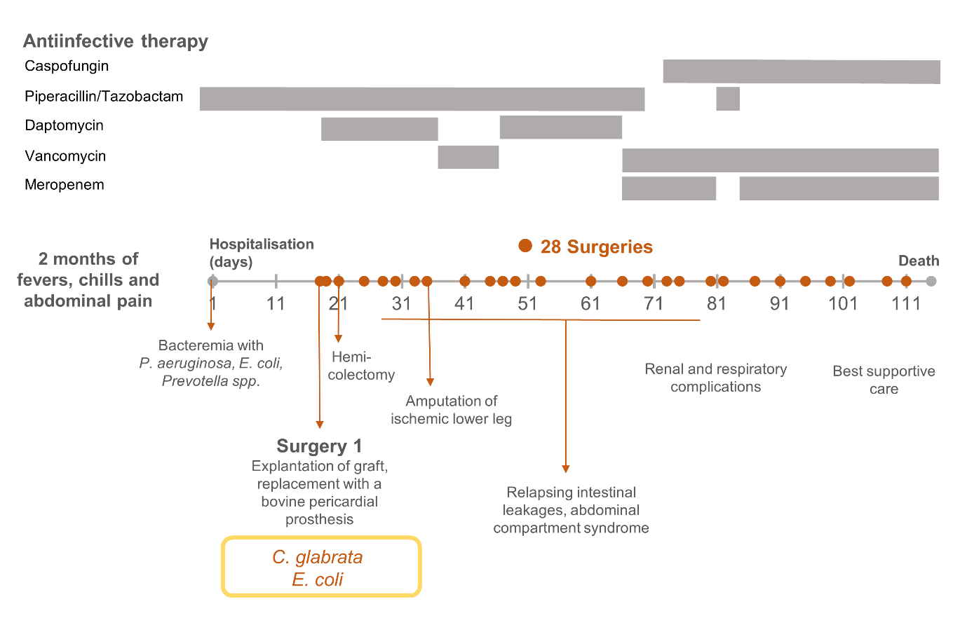

3b: QFA-setup for E. coli and C. glabrata, showing almost no growth of C. glabrata 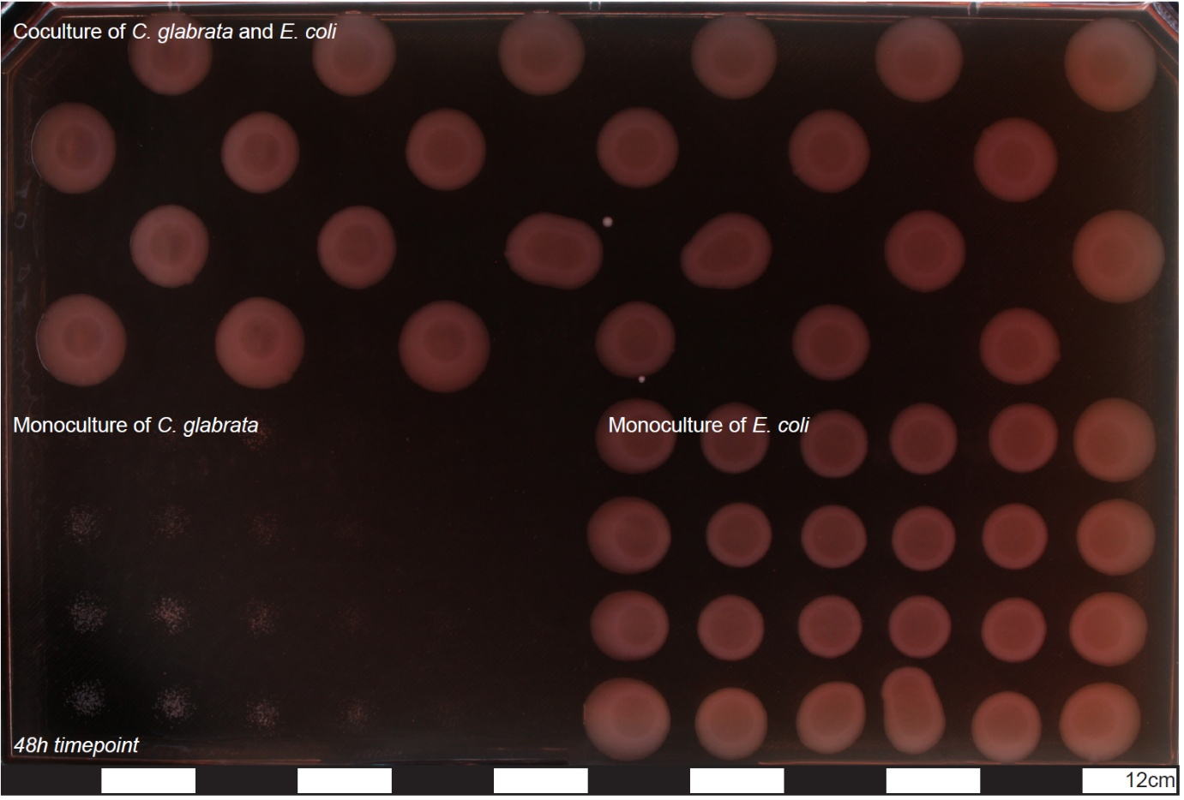
3c: Inhibition assay
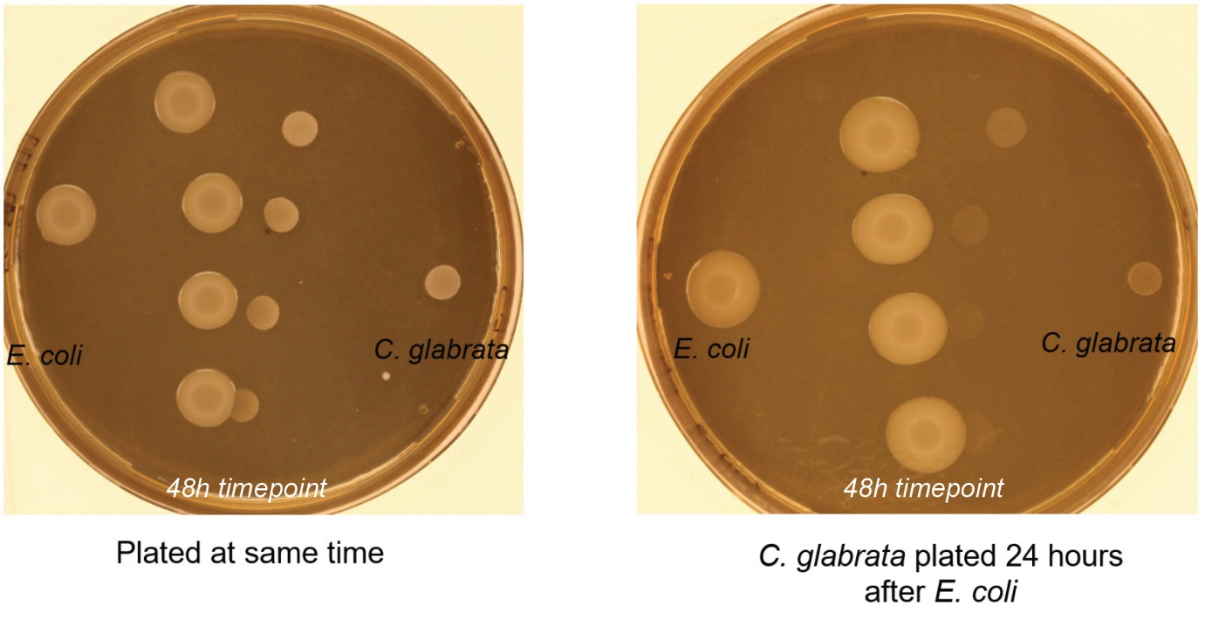
Figure legend
3a: Summary of the clinical course, antimicrobial and surgical treatments, and pathogen sampling relevant to the vascular graft/ endograft infection.
3b: QFA-setup of E. coli (gowth visible on bottom right side in monoculture and in coculture on the top half of the agar plate) and C. glabrata (minimal growth on bottom left side and no growth visible in grid). The calculation of fitness was not possible due to the lack of growth of C. glabrata in the control spots. We postulated, that E. coli managed to inhibit C. glabrata on the whole agar plate. As a result, we attempted to assess the inhibitory effect of E. coli on C. glabrata using an inhibition assay.
3c: Results of inhibition assay between E. coli and C. glabrata. C. glabrata exhibited better growth as distance from the E. coli spots increased. Since no competition was observed between the E. coli spots, this effect is likely due to the inhibitory action of E. coli on C. glabrata, rather than nutrient depletion in the agar. As shown in the image on the right, the inhibitory effect was more pronounced and covered a wider area when E. coli was plated 24h earlier. This suggests that inhibitory factors from E. coli had more time to diffuse into the agar.

