“Sport-Specific Loading Drives Ultrasound-Detected Entheseal Adaptations in Elite Athletes”

SUPPLEMENTARY DATA
1.The US scanning protocol
For optimal shoulder US assessment, the patient should sit with the elbow flexed 90°, palm up. Rotate the arm externally, fixing the elbow on the iliac crest to show the subscapularis tendon. For the supraspinatus tendon, place the patient’s arm posteriorly, placing the palm side of the hand on the superior aspect of the iliac wing.
The triceps entheses were assessed with the elbow flexed to 90°. The subjects were in a supine position with 30° semi-flexion of the knee to assess the patellar and quadriceps entheses. Then, they were brought into a prone position with their feet hanging over the examination table to assess the Achilles tendon and plantar fascia entheses.
Scoring system of elementary lesions
Table S1. Ultrasound elementary lesion definitions and scoring system used in the study.
Elementary lesion | Score 0 | Score 1 | Score 2 | Score 3
Thickening | < cut off * | thickening < 1mm | Thickening: 1mm ≤ but <2mms | thickening ≥2 mms
Hypoechogenicity | no changes | mild changes | moderate changes | severe changes
Calcifications | no changes | mild changes | moderate changes | severe changes
Enthesophytes | no changes | mild changes | moderate changes | severe changes
Erosions (max size of the erosion) | no erosion | >0 mm but <2 mm | ≥2 mm and <4 mm | ≥4 mm
Power Dopplerª | no changes | mild changes | moderate changes | severe changes
Normal values* for each entheseal thickness were defined as quadriceps tendon entheses < 6.1mm, proximal and distal patellar tendon entheses < 4 mm, Achilles tendon entheses < 5.29 mm, plantar fascia aponeurosis < 4.4 mm, triceps tendon entheses < 4.3 mm. An increase of less than 1 mm exceeding the threshold was scored as grade 1, 1mm ≤ but <2mms was scored as grade 2, and ≥2 mms was scored as grade 3) (10,11). aPower Doppler signal must be approximately < 2 mm near the bony cortex at the enthesis site.

2. The calculations of US scores

Table S2. Calculation of total inflammation and damage scores based on ultrasound findings.
İnflammation score | Thickening + Hypoechogenicity + Power Doppler scores
Cronisity score | Calcifications + Enthesophytes + Erosions scores
Total US score | İnflammation score + Cronisity score

3. The calculations of the cut off value of thickness

The cut off value of thickness increase for each enthesis area in elite athletes was calculated separately using the mean +2SD method, as calculated in previous studies (supplementary file, Table S3-4) (12).

Table S3. Cut-off values for entheseal thickness in elite athletes (mean + 2 SD method).
Grade | Cut-off value
0 | ≤Mean±2SD
1 | >Mean±2SD - ≤Mean±3SD
2 | >Mean±3SD - ≤Mean±4SD
3 | >Mean±4SD

Table S4. The cut off value of thickness for each enthesis area according to gender

 | Female |  |  |  | Male
 | Grade 0 | Grade 1 | Grade 2 | Grade 3 | Grade 0 | Grade 1 | Grade 2 | Grade 3
Quadriceps | ≤0,55012 | ≤0,60678 | ≤0,66344 | >0,66344 | ≤0,64014 | ≤0,71166 | ≤0,78318 | >0,78318
Proximal Patella | ≤0,49022 | ≤0,55453 | ≤0,61884 | >0,61884 | ≤0,52696 | ≤0,58219 | ≤0,63742 | >0,63742
Distal Patella | ≤0,44836 | ≤0,49984 | ≤0,55132 | >0,55132 | ≤0,45042 | ≤0,49738 | ≤0,54434 | >0,54434
Achilles | ≤0,40128 | ≤0,44802 | ≤0,49476 | >0,49476 | ≤0,42040 | ≤0,46460 | ≤0,50880 | >0,50880
Plantar Facia | ≤0,38058 | ≤0,42687 | ≤0,47316 | >0,47316 | ≤0,41212 | ≤0,46168 | ≤0,51124 | >0,51124
Triceps | ≤0,36760 | ≤0,41860 | ≤0,46960 | >0,46960 | ≤0,38078 | ≤0,41907 | ≤0,45736 | >0,45736
Medial epicondil | ≤0,27838 | ≤0,31047 | ≤0,34256 | >0,34256 | ≤0,32500 | ≤0,36915 | ≤0,41330 | >0,41330
Lateral Epicondil | ≤0,45738 | ≤0,51467 | ≤0,57196 | >0,57196 | ≤0,44846 | ≤0,49139 | ≤0,53432 | >0,53432
Subscapularis | ≤0,52604 | ≤0,60556 | ≤0,68508 | >0,68508 | ≤0,52608 | ≤0,59507 | ≤0,66406 | >0,66406
Supraspinatus | ≤0,60142 | ≤0,68053 | ≤0,75964 | >0,75964 | ≤0,64852 | ≤0,73193 | ≤0,81534 | >0,81534

Table S5: The differences for the inflammation and damage scores for the upper extremity entheses, based on the sports categories.
 | Group A  (Upper extremity dominant) | Group B  (Upper extremity non-dominant) | Sedentary Group | p
 |  |  |  | All Groups | Group A vs Group B | Group A vs Sedentary | Group B vs Sedentary
Upper Extremity Inflammation score, median (IQR) | 1 (0-3) | 0.5 (0-3) | 0 (0-1.5) | 0.013 | 1.000 | 0.010 | 0.587
Upper Extremity Damage score, median (IQR) | 0 (0-3) | 0.5 (0-0.5) | 0 (0-0) | <0.001 | 0.129 | <0.001 | 1.000

Table S6: Linear Regression Analysis of Upper Extremity Inflammation and Damage Scores

Upper Extremity Inflammation score
 | Univariate analysis |  | Multivariate analysis
 | B (95 %CI) | p | B (95 %CI) | p
Age | 0.089 (0.027 – 0.151) | 0.005 | 0.117 (0.056 – 0.178) | <0.001
Gender, Male | 1.150 (-0.171 – 2.471) | 0.087 | 0.940 (-0.295 – 2.174) | 0.133
Body Mass İndex | 0.204 (-0.071 – 0.480) | 0.143 | 0.144 (-0.113 – 0.401) | 0.267
Total athletic time | 0.069 (-0.034 – 0.171) | 0.184 | - | -
Weekly training time | 0.031 (-0.009 – 0.071) | 0.132 | 0.055 (0.017 – 0.094) | 0.005
Upper extremity dominancy in sports | 0.518 (-1.148 – 2.184) | 0.537 | - | -
Upper Extremity Damage score
 | Univariate analysis |  | Multivariate analysis
 | B (95 %CI) | p | B (95 %CI) | p
Age | 0.219 (0.153 – 0.284) | <0.001 | 0.215 (0.145 – 0.286) | <0.001
Gender, Male | -0.333 (-2.066 – 1.399) | 0.702 | - | -
Body Mass İndex | 0.243 (-0.112 – 0.597) | 0.177 | 0.163 (-0.120 – 0.445) | 0.254
Total athletic time | 0.229 (0.108 – 0.350) | <0.001 | - | -
Weekly training time | -0.009 (-0.062 – 0.043) | 0.725 | - | -
Upper extremity dominancy in sports | 1.929 (-0.166 – 4.023) | 0.071 | 0.001 (-1.795 – 1.797) | 0.999

Table S7: The differences for the inflammation and damage scores for the lower extremity entheses, based on the sports categories.
 | Group C  (Lower extremity dominant) | Group D  (Lower extremity non-dominant) | Sedentary Group | p
 |  |  |  | All Groups | Group C vs Group D | Group C vs Sedentary | Group D vs Sedentary
Lower Extremity Inflammation score, median (IQR) | 2 (1-4) | 0.5 (0-2.75) | 0 (0-1) | <0.001 | 0.137 | <0.001 | 0.179
Lower Extremity Damage score, median (IQR) | 4 (1-7.25) | 2 (1-5.75) | 2 (0-4.5) | 0.055 | N/A | N/A | N/A

Table S8: Linear Regression Analysis of Lower Extremity Inflammation and Damage Scores
Lower Extremity Inflammation score
 | Univariate analysis |  | Multivariate analysis
 | B (95 %CI) | p | B (95 %CI) | p
Age | -0.002 (-0.077 – 0.074) | 0.968 | - | -
Gender, Male | 1.658 (0.239 – 3.077) | 0.023 | 0.706 (-0.671 – 2.084) | 0.311
Body Mass İndex | 0.505 (0.291 – 0.718) | <0.001 | 0.449 (0.223 – 0.676) | <0.001
Total athletic time | 0.011 (-0.104 – 0.127) | 0.847 | - | -
Weekly training time | -0.026 (-0.074 – 0.022) | 0.281 | - | -
Lower extremity dominant | 1.611 (-0.063 – 3.284) | 0.059 | 1.396 (-0.111 – 2.903) | 0.069
Lower Extremity Damage score
 | Univariate analysis |  | Multivariate analysis
 | B (95 %CI) | p | B (95 %CI) | p
Age | 0.170 (0.097 – 0.243) | <0.001 | 0.173 (0.098 – 0.249) | <0.001
Gender, Male | 0.133 (-1.442 – 1.709) | 0.867 | - | -
Body Mass İndex | 0.235 (-0.018 – 0.488) | 0.069 | 0.248 (0.020 – 0.476) | 0.033
Total athletic time | 0.228 (0.113 – 0.342) | <0.001 | - | -
Weekly training time | -0.022 (-0.074 – 0.030) | 0.411 | - | -
Lower extremity dominant | 1.230(-0.590 – 3.051) | 0.183 | -0.118 (-1.826 – 1.590) | 0.891

4. Normal Enthesis Areas in The Upper Extremity

Figure S1. Figure S1. Normal enthesis areas of the upper extremity:
(a) triceps tendon enthesis, (b) lateral epicondyle enthesis, (c) medial epicondyle enthesis, (d) subscapularis enthesis, (e) supraspinatus enthesis.
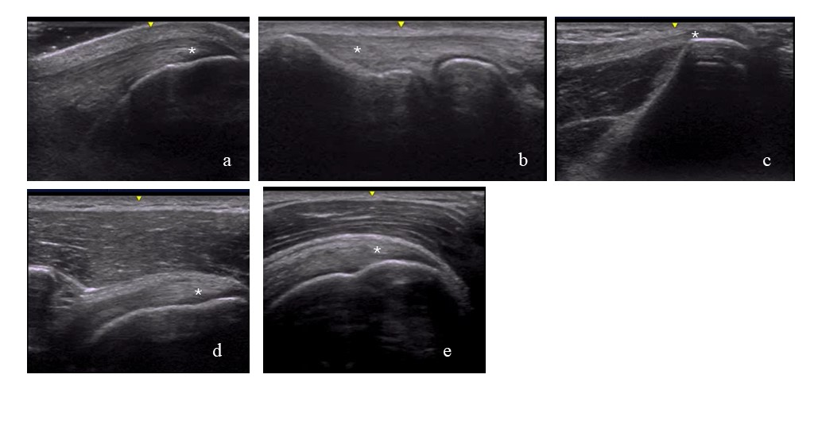

Figure S2. Normal enthesis areas of the lower extremity:
(f) quadriceps tendon enthesis, (g) proximal patellar tendon enthesis, (h) distal patellar tendon enthesis, (i) Achilles tendon enthesis, (j) plantar fascia enthesis.
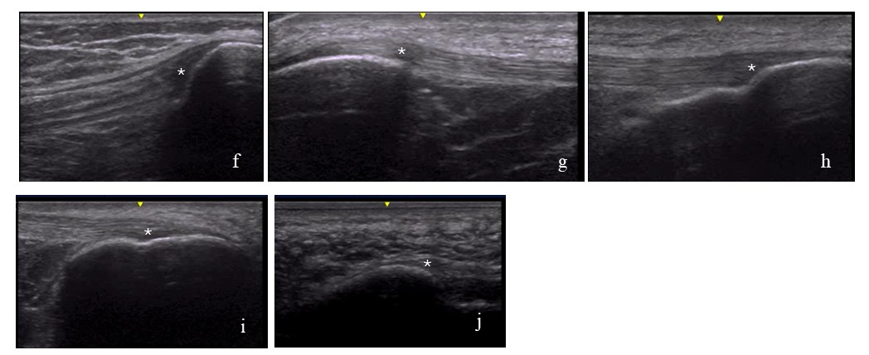

5. Distribution of elementary lesions in the enthesis areas according to sports branches

Figure S3. Distribution of elementary lesions in shoulder enthesis areas according to sports branches

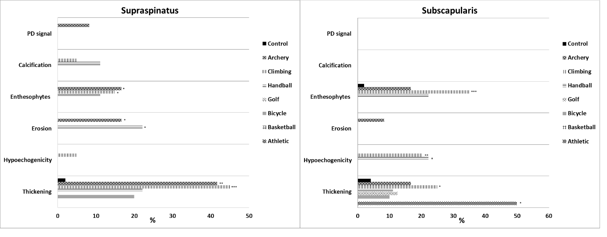

Figure S4. Distribution of elementary lesions in elbow enthesis areas according to sports branches

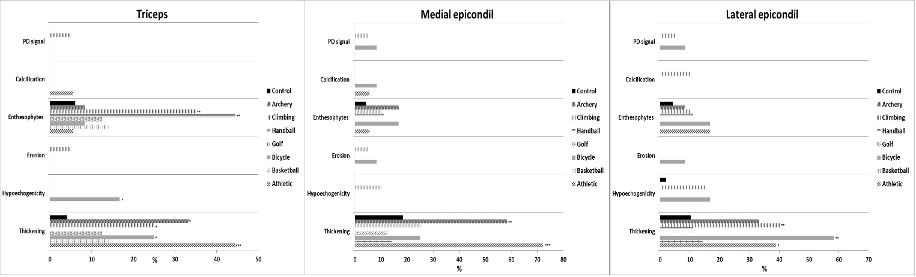

Figure S5. Distribution of elementary lesions in knee enthesis areas according to sports branches

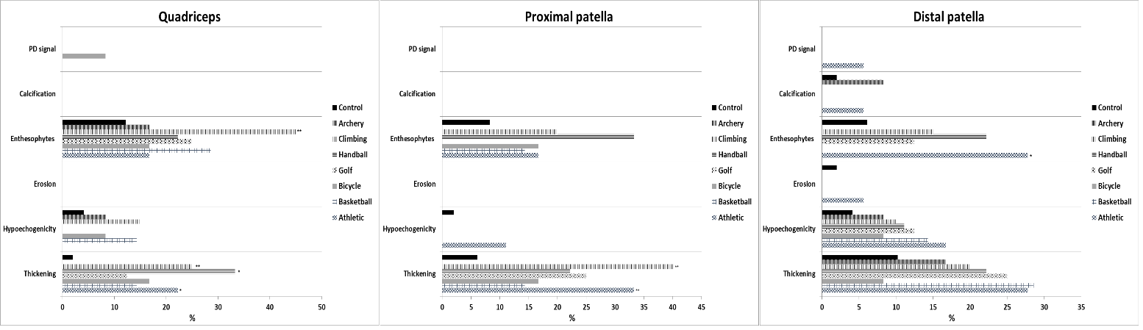

Figure S6. Distribution of elementary lesions in heel enthesis areas according to sports branches

