Appendix A CGHR-10 Codes
Table A1 CGHR-10 codes for adults (12-69 years).
Adult CGHR-10 Code | ICD-10 Range
Acute respiratory infections | H65-H68, H70-H71, J00-J22, J32, J36, J85-J86, P23
Tuberculosis | A15-A16, B90, J65
Diarrhoeal | A00-A09
Unspecified infections | A17-A33, A35-A99, B00-B17, B19-B49, B55-B89, B91-B99, C46, D64, D84, G00-G09, H10, H60, I30, I32-I33, K02, K04-K05, K61, K65, K67, K81, L00-L04, L08, M00-M01, M60, M86, N10, N30,  N34, N41, N49, N61, N70-N74, P35-P39, R50, R75, ZZ21
Malaria | B50-B54
Maternal conditions | A34, F53, O00-O08, O10-O16, O20-O99
Nutritional deficiencies | D50-D53, E00-E02, E40-E46, E50-E64, X53-X54
Chronic respiratory | J30-J31, J33-J35, J37-J64, J66-J84, J90-J99, R04-R06, R84, R91
Cancers | C00-C26, C30-C45, C47-C58, C60-C97, D00-D48, D91, N60, N62-N64, N87, R59
Ischemic heart | I20-I25, R55
Stroke | G45-G46, G81-G83, I60-I69
Diabetes mellitus | E10-E14
Other cardiovascular | I00-I03, I05-I15, I26-I28, I31, I34-I52, I70-I99, R00-R01, R03, ZZ23
Liver and alcohol related | B18, F10, K70-K77, R16-R18, X45, Y15, Y90-91
Other noncommunicable | D55-D63, D65-D83, D86, D89, E03-E07, E15-E35, E65-E68, E70E90, F00-F09, F11-F52, F54-F99, G10-G37, G40-G41, G43-G44, G50-G80, G84-G99, H00-H06, H11-H59, H61-H62, H69, H72-H95, K00-K01, K03, K06-K14, K20-K31, K35-K38, K40-K60, K62-K64, K66, K78-K80, K82-K93, L05, L10-L99, M02-M54, M61-M85, M87-M99, N00-N08, N11-N29, N31-N33, N35-N40, N42-N48, N50N59, N75-N86, N88-N99, Q00-Q99, R10-R15, R19-R23, R26-R27, R29-R49, R56, R63, R70-R74, R76-R77, R80-R82, R85-R87, R90, ZZ25
Road and transport injuries | V01-V99, Y85
Suicide | X60-X84
Other injuries | S00-S99, T00-T99, W00-W99, X00-X44, X46-X52, X55-X59, X85-X99, Y00-Y14, Y16-Y84, Y86, Y89, Y92-Y98, ZZ27
Ill-defined | R02, R07-R09, R25, R51-R54, R57-R58, R60-R62, R64-R69, R78-R79, R83, R89, R92-R94, R96, R98-R99

Table A2 CGHR-10 codes for children and neonates.
Child CGHR-10 Code (28 days to 11 years) | ICD-10 Range
Pneumonia | A37, H65-H68, H70-H71, J00-J22, J32, J36, J85-J86, P23, U04
Diarrhoeal | A00-A09
Malaria | B50-B54
Other infections | A15-A28, A30-A36, A38-A44, A46, A48-A71, A74-A75, A77-A99, B00B09, B15-B27, B30, B33-B49, B55-B60, B64-B83, B85-B92, B94-B97, B99, G00-G09, H10, H60, I30, I32-I33, I39-I41, J65, K02, K04-K05, K61, K65, K67, K81, L00-L04, L08, M00-M01, M60, M86, N10, N30, N34, N41, N49, N61, N70-N74, P35-P39, R50, R75, U00, Y95, ZZ11
Congenital anomalies | P01, P05, P07, P21, Q00-Q99
Epilepsy, leukaemia, and other noncommunicable | C00-C97, D01-D48, D55-D89, E03-E35, E65-E90, F00-F02, F73, G10G99, H00-H06, H11-H59, H61-H62, H69, H72-H95, I00-I28, I31, I34-I38, I42-I99, J30-J31, J33-J35, J37-J47, J60, J64, J66-J70, J80-J82, J84, J90-J99, K00-K01, K03, K06-K60, K62-K63, K70-K80, K82-K93, L05, L10-L99, M02-M54, M61-M85, M87-M99, N00-N08, N11-N29, N31N33, N35-N40, N42-N48, N50-N51, N60, N62-N64, N75-N99, P04, P08, P27, P51, P53-P60, P70-P72, P74-P76, P78, P80-P83, P92-P94, R00-R01, R03-R06, R11-R23, R26-R27, R29-R49, R55-R56, R59, R63, R70-R74, R76-R77, R80-R82, R84-R87, R90-R91, ZZ12-ZZ13, ZZ15
Injuries | S00-S99, T00-T98, V01-V99, W00-W99, X00-X52, X57-X99, Y00-Y91, Y97-Y98
Nutritional deficiencies | D50-D53, E00-E02, E40-E46, E50-E56, E59-E61, E63-E64, X53-X54
Other | D00, F03-F72, F74-F99, P00, P02-P03, P10-P15, P20, P22, P24-P26, P28-P29, P50, P52, P61, P77, P90-P91
Ill-defined | P96, R02, R07, R09-R10, R25, R51-R54, R57-R58, R60-R62, R64, R68-R69, R78-R79, R83, R89, R92-R99
Neonate CGHR-10 Code (<28 days)
Prematurity & low birthweight | D64, O60, P01, P05, P07, P22, P25-P28, P52, P61, P77, P80, P92, R04
Neonatal infections | A00-A09, A20-A28, A32-A35, A37-A44, A46, A48-A49, A68A70, A74-A75, A77-A79, A81-A90, B54, B95-B96, G00-G09, H10, H60, H65-H68, H70-H71, I30, I32-I33, I39-I41, J00-J22, J32, J36, J85-J86, K65, K67, K81, L00-L04, L08, M00-M01, M60, M86, N10, N30, N34, N41, N49, N61, O85, P23, P35,P39, P58-P59, P63, U04
Birth asphyxia and birth trauma | G40, P00, P02-P03, P10-P15, P20-P21, P24, P29, P50-P51, P90-P91, R06, W79, Z37
Stillbirth | P95
Congenital anomalies | C76, Q00-Q99
Other | A15-A19, A30-A31, A36, A50-A67, A71, A80, A91-A99, B00-B09, B15-B27, B30, B33-B53, B55-B60, B64-B83, B85-B92, B94, B97, B99, C00-C75, C77-C97, D00-D48, D50-D53, D55-D63, D65-D89, E00-E35, E40-E46, E50-E56, E59-E61, E63-E90, F00-F99, G10-G39, G41-G99, H00-H06, H11-H59, H61-H62, H69, H72-H95, I00-I28, I31, I34-I38, I42-I99, J30, J31, J33-J35, J37-J47, J60, J64-J70, J80-J82, J84, J90J99, K00-K63, K70-K80, K82-K93, L05, L10-L99, M02-M54, M61-M85, M87-M99, N00-N08, N11-N29, N31-N33, N35N40, N42-N48, N50-N51, N60, N62-N64, N70-N99, P04, P08, P53-P57, P60,P70-P72, P74-P76, P78, P81-P83, P93-P94, R00-R01, R03-R05, R11-R23, R26-R27, R29-R36, R39-R50, R55-R56, R59, R63, R70-R77, R80-R82, R84-R87, R90-R91, S00-S99, T00-T98, U00, V01-V99, W00-W78, W80-W99, X00-X54, X57-X99, Y00-Y91, Y95, Y97-Y98
Ill-defined | P96, R02, R07, R09-R10, R25, R51-R54, R57-R58, R60-R62, R64, R68-R69, R78-R79, R83, R89, R92-R99

Appendix B Details on Methods
This section provides additional details on the methods described in Section 2. An overview of the methods used in this study is seen in Figure B1 as a five-step process. Section B.1 provides details on the preprocessed data used for modelling. Section B.2 describes the data and parameter inputs and outputs for each model, while Section B.3 details the evaluation of model outputs at the individual and population level across different CODs, age groups, and ages.

B.1 CGHR-10 Physician-Agreed Records
Initially, 11,920 records were collected from dual-coded EVA in the HEAL-SL study. Physicians were able to assign CODs for 11,820 of the 11,920 records, where 100 of these records could not be assigned a COD due to missing or inadequate information (e.g. low quality narrative, data loss). The 11,820 physician coded records were further filtered for records where both physicians agreed on the assigned codes (records that were not reconciled or adjudicated) resulting in 6942 physician agreed records (based on comparisons using CMEA-10 codes, see Additional File 1). The 6942 records were converted into CGHR-10 codes (see Appendix A) that generalized ICD-10 codes into 19, 10, and 7 categories for the adult (12 to 69 years), child (28 days to 11 years), and neonatal (under 28 days) age groups. After conversion, a final total of 6939 physician agreed records (3826 adult, 2636 child, and 477 neonatal) were used for modelling and performance evaluation, where three records were removed as their ICD-10 codes did not have a matching CGHR-10 code.
The 6,939 physician agreed records were collected using VA from the HEAL-SL study between 2019-2022, where deaths were collected using nationwide representative sampling units across Sierra Leone (Figure B2). The distribution of the study data are shown by CGHR-10 causes of death in Table B4. All age groups had relatively evenly distributed female and male records (44-55% of 6939 records each). Across CODs, there were noticeably more female records for cancers (65%), and maternal conditions (100%), while more male records for chronic respiratory diseases (61%), other noncommunicable diseases (61%), other injuries (77%), road and transport injuries (71%), and tuberculosis (68%). Most records were coded by physicians as malaria for adults (20%) and children (52%), and stillbirth (36%) and neonatal infections (21%) for neonates. Suicide, congenital anomalies, nutritional deficiencies, and other had low sample sizes for each age group (<1% of total records for each age group). Table B5 shows the distribution of the study data by age. Across ages, there were more male records for 50-59 years (60-62%), while all other records had between 49-59% female and male records. Most records were in the 65-69 years age range for adults (15%), 1-5 years for children (62%), and 0-6 days for neonates (83%).
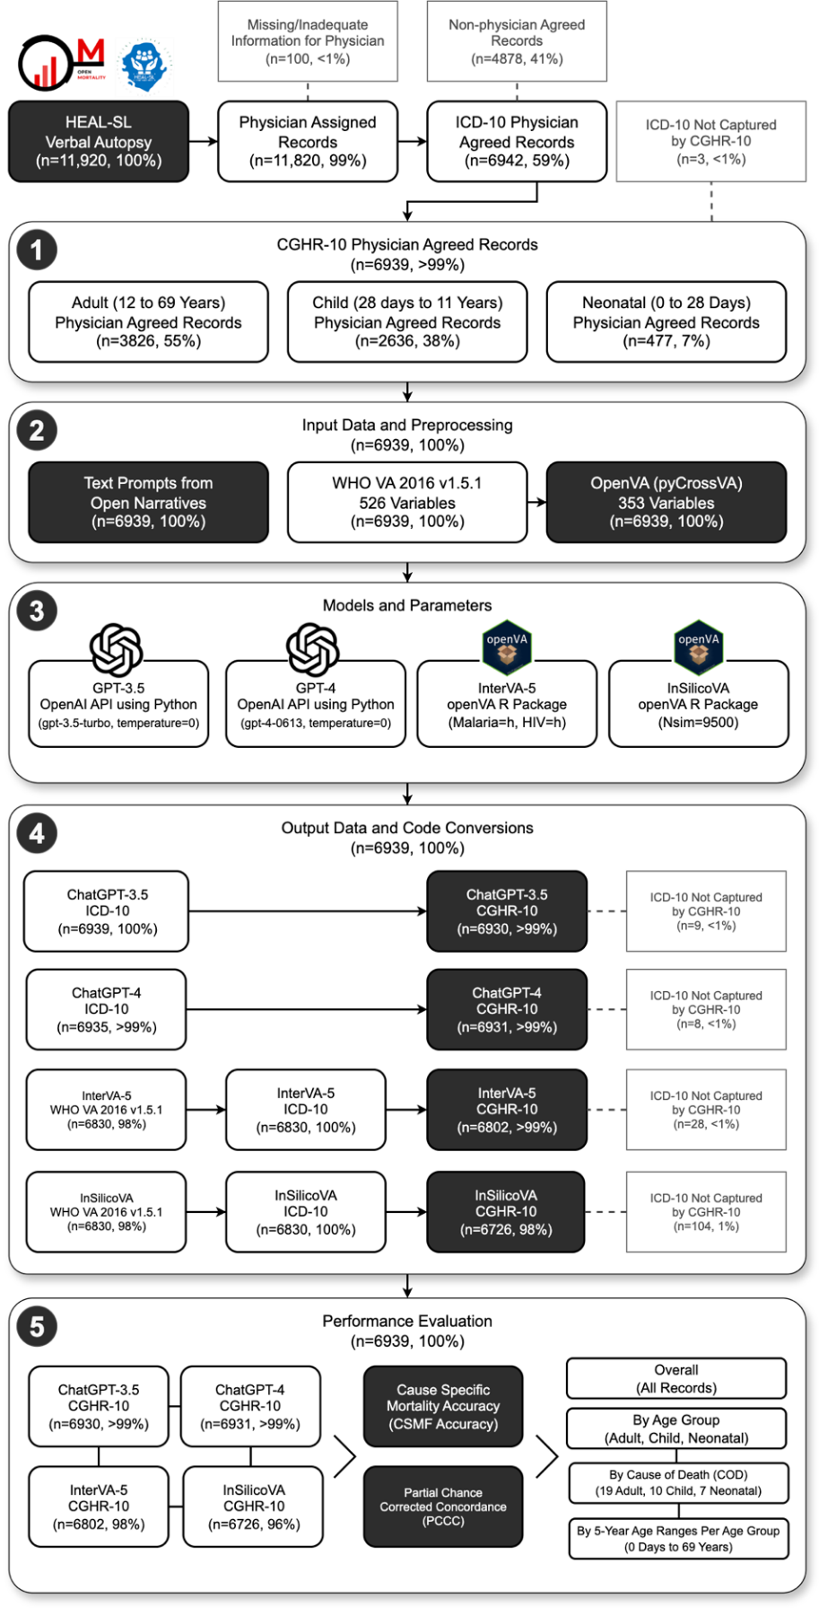
Fig. B1 Detailed flow diagram for verbal autopsy coding comparison of 6939 sample deaths in Sierra Leone. This supplements the diagram in Figure 1, providing additional details on removed records, model specifications, and sub-processes.
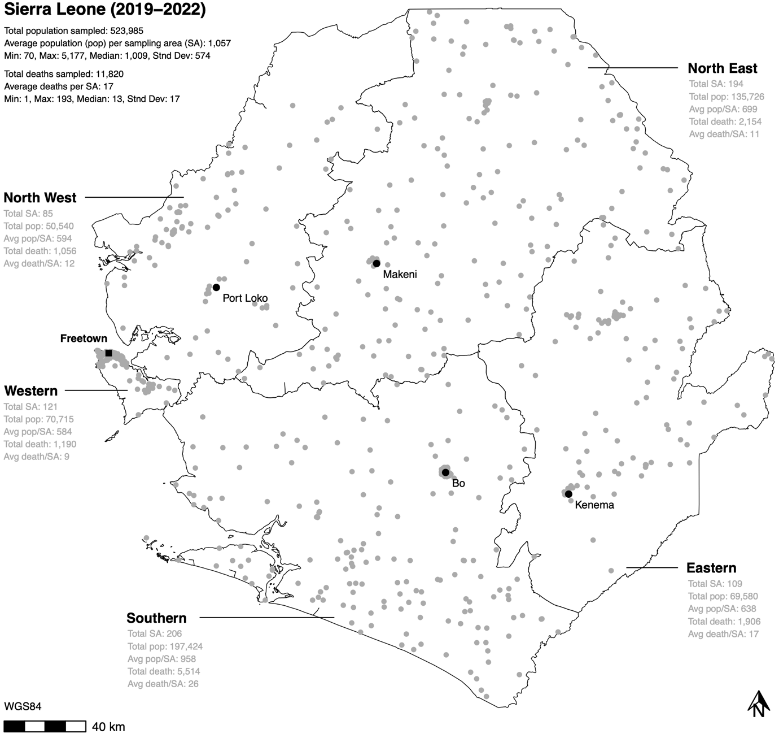
Fig. B2 Healthy Sierra Leone (HEAL-SL) verbal autopsy data sampling areas for Sierra Leone from 2019-2022. The boundaries represent Sierra Leone provinces. Each grey point represents the centroid of sampling areas. Pop=population, SA=sampling area.

B.2 Modelling Details
Each model (GPT-3.5, GPT-4, InSilicoVA, and InterVA-5) required pre-processing of the 6939 records into input data, and standardization of output COD codes from models for performance evaluation as not all models produced comparable codes across outputs. Although each model can assign multiple CODs per record, only the first generated COD response from GPT-3.5 and GPT-4, and the most probable COD from InterVA-5 and InSilicoVA were used for evaluation. Section B.2.1 describes the input data and parameters for each model, while Section B.2.3 details the outputs from running each model.

Table B4 Study data by cause of death.
Age Group | CGHR-10 Cause of Death (COD) | Female | Male | Total
Adult, 18 CODs  (n=3826, 55.1%)  Adult Female  (n=1681, 43.9%)  Adult Male  (n=2145, 56.1%) | Acute Respiratory Infections  Cancers  Chronic Respiratory Diseases  Diabetes Mellitus  Diarrhoeal Diseases  Ill-Defined  Ischemic Heart Disease  Liver And Alcohol Related Diseases  Malaria  Maternal Conditions  Other Cardiovascular Diseases  Other Noncommunicable Diseases  Other Injuries  Road And Transport Injuries  Stroke  Suicide  Tuberculosis | 48 (45.7%)  32 (65.3%)  29 (38.7%)  14 (51.9%)  102 (49.8%)  56 (47.9%)  89 (53%)  58 (45.3%)  372 (46.6%)  130 (100%)  59 (55.1%)  160 (38.6%)  83 (23.2%)  73 (29.1%)  147 (44.4%)  N/A  54 (31.6%) | 57 (54.3%)  17 (34.7%)  46 (61.3%)  13 (48.1%)  103 (50.2%)  61 (52.1%)  79 (47%)  70 (54.7%)  427 (53.4%)  N/A  48 (44.9%)  254 (61.4%)  274 (76.8%)  178 (70.9%)  184 (55.6%)  3 (100%)  117 (68.4%) | 105 (2.7%)  49 (1.3%)  75 (2%)  27 (0.7%)  205 (5.4%)  117 (3.1%)  168 (4.4%)  128 (3.3%)  799 (20.9%)  130 (3.4%)  107 (2.8%)  414 (10.8%)  357 (9.3%)  251 (6.6%)  331 (8.7%)  3 (0.1%)  171 (4.5%)
Child, 9 CODs  (n=2636, 38%)  Child Female  (n=1290, 48.9%)  Child Male  (n=1346, 51.1%) | Congenital Anomalies  Diarrhoeal Diseases  Epilepsy, Leukaemia, & Other Non-communicable  Ill-Defined  Injuries  Malaria  Nutritional Deficiencies  Other infections  Pneumonia | 1 (100%)  79 (45.1%)  61 (53.5%)  34 (48.6%)  51 (37.8%)  680 (49.2%)  7 (63.6%)  338 (50.7%)  39 (48.1%) | N/A  96 (54.9%)  53 (46.5%)  36 (51.4%)  84 (62.2%)  702 (50.8%)  4 (36.4%)  329 (49.3%)  42 (51.9%) | 1 (0%)  175 (6.6%)  114 (4.3%)  70 (2.7%)  135 (5.1%)  1382 (52.4%)  11 (0.4%)  667 (25.3%)  81 (3.1%)
Neonate, 7 CODs  (n=477, 6.9%)  Neonate Female  (n=227, 47.6%)  Neonate Male  (n=250, 52.4%) | Birth Asphyxia and Birth Trauma  Congenital Anomalies  Ill-Defined  Neonatal Infections  Other  Prematurity And Low Birthweight  Stillbirth | 38 (36.9%)  2 (100%)  11 (47.8%)  49 (49.5%)  2 (40%)  39 (53.4%)  86 (50%) | 65 (63.1%) N/A  12 (52.2%)  50 (50.5%)  3 (60%)  34 (46.6%)  86 (50%) | 103 (21.6%)  2 (0.4%)  23 (4.8%)  99 (20.8%)  5 (1%)  73 (15.3%)  172 (36.1%)

B.2.1 Input Data and Preprocessing
For GPT-3.5 and GPT-4, 6939 text prompts were generated for each physician agreed record as input to instruct the models to assign CODs based on the open narratives. Two types of text prompts were used: user prompts and system prompts. System prompts contained textual instructions to assign the role of a physician ICD-10 coder with expertise in Sierra Leone. The following system prompt was used:
You are a physician with expertise in determining underlying causes of death in Sierra Leone by assigning the most probable ICD−10 code for each death using verbal autopsy narratives. Return only the ICD−10 code without description. E. g. A00. If there are multiple ICD−10 codes, show one code per line.
User prompts contained textual instructions to perform coding of VA records based on the age, sex, and narrative of the deceased. The following template was used to generate user prompts for each record, where <age> and <sex> from the questionnaire, and <narrative> from the narratives, were replaced with values from the data:
Determine the underlying cause of death and provide the most probable ICD−10 code for a verbal autopsy narrative of a <age> years old <sex> death in Sierra Leone: <narrative>
For InterVA-5 and InSilicoVA, the standardized questionnaire data from the HEAL-SL EVA were first converted into 2016 World Health Organization (WHO) VA questionnaire revision 1.5.1 Open Data Kit (ODK) format [79, 80] consisting of 526 variables [81], followed by further conversion into OpenVA format [41] consisting of 353 variables [82] using the pyCrossVA version 0.97 Python package [83]. The 6939 records were all converted into OpenVA formatted records for InterVA-5 and InSilicoVA.
Table B5 Study data by age range.
Age Group | Age Range | Female | Male | Total
Adult (n=3826, 55.1%)  Adult Female (n=1681, 43.9%)  Adult Male (n=2145, 56.1%) | 12-14 Years  15-19 Years  20-24 Years  25-29 Years  30-34 Years  35-39 Years  40-44 Years  45-49 Years  50-54 Years  55-59 Years  60-64 Years  65-69 Years | 51 (37.8%)  115 (42.8%)  146 (53.1%)  159 (45.2%)  174 (50.9%)  153 (45.4%)  134 (42%)  148 (47%)  134 (39.6%)  96 (37.6%)  128 (40.8%)  243 (42.3%) | 84 (62.2%)  154 (57.2%)  129 (46.9%)  193 (54.8%)  168 (49.1%)  184 (54.6%)  185 (58%)  167 (53%)  204 (60.4%)  159 (62.4%)  186 (59.2%)  332 (57.7%) | 135 (3.5%)  269 (7%)  275 (7.2%)  352 (9.2%)  342 (8.9%)  337 (8.8%)  319 (8.3%)  315 (8.2%)  338 (8.8%)  255 (6.7%)  314 (8.2%)  575 (15%)
Child (n=2636, 38%)  Child Female (n=1290, 48.9%)  Child Male (n=1346, 51.1%) | 1-5 Months  6-11 Months  1-5 Years  6-11 Years | 146 (47.4%)  160 (50.8%)  822 (50.3%)  162 (42.6%) | 162 (52.6%)  155 (49.2%)  811 (49.7%)  218 (57.4%) | 308 (11.7%)  315 (11.9%)  1633 (61.9%)  380 (14.4%)
Neonate (n=477, 6.9%)  Neonate Female (n=227, 47.6%)  Neonate Male (n=250, 52.4%) | 0-6 Days  7-27 Days | 184 (46.6%)  43 (52.4%) | 211 (53.4%)  39 (47.6%) | 395 (82.8%)  82 (17.2%)

B.2.2 Models and Parameters
The GPT-3.5 and GPT-4 Application Programming Interface (API) was accessed using Python version 3.11.4 and used to assign CODs for each record. GPT-3.5 used the gpt-3.5-turbo model, while GPT-4 used the gpt-4-0613 model. The parameter temperature for GPT-3.5 and GPT-4, representing the sampling temperature ranging from 0 to 2 (default of 1), was set to 0 to produce more deterministic outputs [84]. Higher values closer to 2 may produce less deterministic outputs, while lower values closer to 0 produce more deterministic outputs. The openVA R package was used to run InterVA-5 and InSilicoVA models to assign CODs for each record in R version 4.3.1. The openVA package version 1.1.1 used dependent packages InterVA5 version 1.1.3 and InSilicoVA version 1.4.0. The Nsim (number of iterations to run) parameter [85] for InSilicoVA was set to 9500, while the HIV (level of prevalence of human immunodeficiency virus) and Malaria (level of prevalence of Malaria) parameters [86] for InterVA-5 were both set to h (high) reflecting HIV and Malaria disease assumptions in Sierra Leone [87, 88]. Note that the default value of Nsim=10000 for InSilicoVA ran until 9500 iterations before it stopped due to errors, thus Nsim=9500 was used and ran successfully.

B.2.3 Output Data and Code Conversion
Of the 6939 input records, GPT-3.5, GPT-4, InterVA-5, and InSilicoVA were able to assign CODs for 6939 (100%), 6935 (>99%), 6830 (98%), 6830 (98%) records respectively. All 6830 (100%) InterVA-5 and InSilicoVA records with WHO VA 2016 v1.5 output codes [53] were converted into ICD-10 codes respectively. After all model outputs were converted to ICD-10 codes, they were further converted to CGHR-10 codes. The 6939 GPT-3.5 and 6935 GPT-4 output records with ICD-10 codes were converted into 6930 (>99%) and 6931 (>99) records with CGHR-10 codes, where <1% (9 and 8) records did not have matching CGHR-10 codes respectively. The 6830 InterVA-5 and InSilicoVA records with ICD-10 codes were converted into 6802 (>99%) and 6726 (98%) records with CGHR-10 codes respectively, where 28 (<1%) and 104 (1%) of records could not be converted into CGHR-10 codes.

B.3 Performance Evaluation Details
The performance of GPT-3.5, GPT-4, InSilicoVA, and InterVA-5 models were evaluated with metrics at the population and individual-level by comparing their CGHR-10 COD outputs for 6939 records to physician COD assignments. Section B.3.1 describes CSMF accuracy in detail for evaluating models on the population level, Section B.3.2 describes PCCC for evaluating models on the individual-level. Records that were assigned a COD by physicians, but not by a model were considered an incorrect COD assignment by the model. CSMF accuracy and PCCC were calculated for each model overall and by three age groups (adult, child, and neonatal), then further into age and COD for each age group.

B.3.1 Cause Specific Mortality Fraction (CSMF) Accuracy
CSMF accuracy measures the performance of models at the population level, comparing distributions of CODs between the physicians and the models [54]. To calculate CSMF accuracy, $\text{CSM}{\text{F}}_{\text{j}}$ was calculated as is the fraction of physician or model records for cause j, given by dividing the number of records for cause j with the total number of records as seen in Equation B1. Then, the CSMFMaximumError, representing the worst possible model, is calculated using Equation B2. Finally, the CSMF accuracy is given by Equation B3, where k is the number of causes, j is a cause, $CSMF_{j}^{true}$ is the true physician CSMF for cause j, and $CSMF_{j}^{pred}$ is the prediction model CSMF for cause j. CSMF accuracy ranges from 0 to 1, where 1 means that the model completely matched the physician COD distribution and 0 means that it did not match the distribution.
 | $$\text{CSM}{\text{F}}_{\text{j}}=\frac{\text{Record}{\text{s}}_{\text{j}}}{\text{Records}}$$ | (B1)

 | $$CSMFMaximumError = 2(1 - Min(CSMF_{j}^{true})$$ | (B2)

 | $$CSMFAccuracy=1-\frac{\sum_{j=1}^{k}{\left|CSMF_{j}^{true}-CSMF_{j}^{pred}\right|}}{CSMFMaximumError}$$ | (B3)

B.3.2 Partial Chance Corrected Concordance (PCCC)
PCCC measures the performance of models at the individual-level, comparing COD assignments between the physicians and models on a record by record basis, correcting for COD assignments made purely by chance [54]. PCCC is given by Equation B5, where k is the number of top COD assignments from the model to consider, N is number of causes, and C is fraction of records where the physician COD assignment is one of the top COD assignments from the model. For this study, k was set to 1, making C equivalent to the fraction of true positives TP or records, where the physician COD assignment is equal to the model COD assignment as shown in Equation B4. Higher PCCC values closer to 1 indicate that model COD assignments are similar to physician COD assignments, while values closer to 0 indicate that they are not similar to physicians.
 | $$C=\frac{TP}{Records}$$ | (B4)

 | $$PCCC\left(k\right)=\frac{C-\frac{k}{N}}{1-\frac{k}{N}}$$ | (B5)
Appendix C Experiment on Repeated Runs of GPT-3.5
A short experiment was conducted to test the consistency of GPT-3.5 outputs repeated on the same record. 100 records, sampled randomly with approximately equal proportions across age groups, CODs, and survey rounds 1 and 2, were used to test repeated runs of GPT-3.5. Each record from the 100 records was rerun 10 times through GPT3.5, resulting in ten COD outputs per record. The ICD-10 codes were then converted to CGHR-10 codes and tested for consistency, where completely inconsistent results had different ICD-10 or CGHR-10 codes for each of the 10 reruns (1 times+), and completely consistent results had the same ICD-10 or CGHR-10 code for all 10 reruns (10 times), on the same record.
The results are shown in Table C6. For all 100 records, GPT-3.5 assigns the same ICD-10 and CGHR-10 code for the same record 5+ times out of 10. For 66 and 79 records, GPT-3.5 assigns the same ICD-10 and CGHR-10 code respectively for each record. This number increases to 94 (from 66) and 96 (from 79) when reducing the number of times out of 10 that GPT-3.5 assigns the same ICD-10 and CGHR-10 code respectively. Thus, GPT-3.5 does not always produce the same outputs when repeated on the same record (10 times out of 10), even when the temperature is set to 0, but does so for more than half the records. For most records (more than 90%), GPT-3.5 will produce the same outputs for the same record 7+ times of 10.
Table C6 Records with same GPT-3.5 outputs based on 10 repeated reruns of 100 records
Times with Same GPT-3.5 Outputs | ICD-10 Records | CGHR-10 Records
1 times+ (inconsistent) | 100 | 100
2 times+ | 100 | 100
3 times+ | 100 | 100
4 times+ | 100 | 100
5 times+ | 100 | 100
6 times+ | 94 | 96
7 times+ | 92 | 94
8 times+ | 86 | 91
9 times+ | 79 | 86
10 times (consistent) | 66 | 79

