Table 1. Data on host squirrels and two parasitic fleas recovered from Obihiro City between 2017 and 2020.
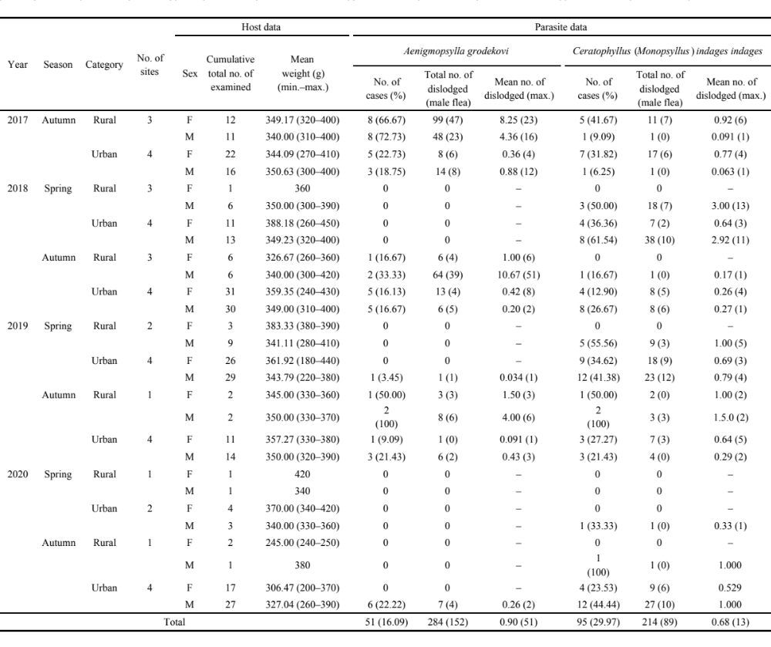
Table 2. Estimated coefficient and significance values from the optimal model based on GLMM fittings. A coefficient value for flea species represents the estimated effect size of Ceratophyllus (Monopsyllus) indages indages on Aenigmopsylla grodekovi. Significant coefficients are shown in bold.
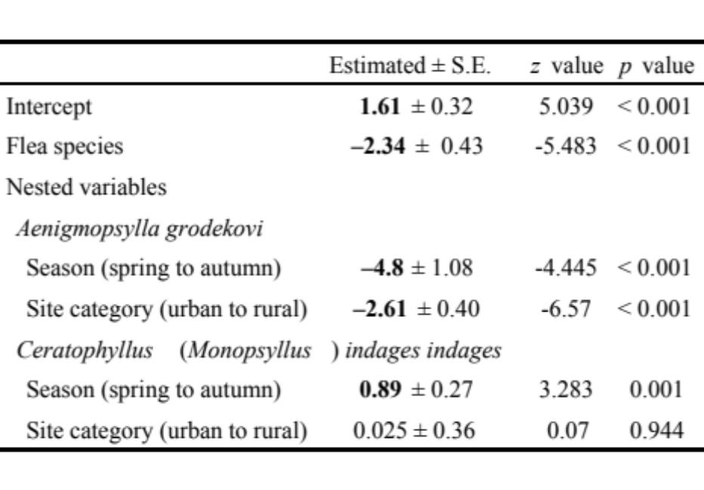

Table 3. Summary of discrepancies found in dislodged flea abundance and their potential causes.
