Divergent C2 Functionalization of N-Heteroarenes via Nonclassical Rearomatization: Retro-hetero-ene Reactions versus Sigmatropic Rearrangements
Lei Huang‡, Huilong Zhu‡, Nan Wu‡, Du Luo, Yunsheng Xue, Zhou Xu*
[a] L. Huang, Dr. H. L. Zhu, Dr. N. Wu, D. Lu, Dr. Y. S. Xue, Prof. Dr. Z. Xu
The National Medical Products Administration (NMPA) Key Laboratory for Research and Evaluation of Narcotic and Psychotropic Drugs, School of Pharmacy, Xuzhou Medical University
†These authors contribute equally to this work.
E-mail: xuzhou@xzhmu.edu.cn
Tongshan Road 209, Xuzhou221004, Jiangsu, China

Table of contents

1. General informations. 3
2. Optimization table for one-pot synthesis of 4H-pyrrolo[3,2,1-ij]quinolines. 3
3. Experimental procedures 3
4. Mechanistic investigation for figure 5 7
5. Mechanism investigations for figure 6 9
6. Computational studies 10
7. Characterization data 10
8. NMR spectra 40
9. Single crystal X-ray diffraction 207
10. Reference 208

1. General informations.
Except for the preparation of some starting materials, all reactions were conducted under an argon atmosphere. Thin-layer chromatography (TLC) was performed using UV absorbance at 254 nm. Column chromatography separation was carried out using 300 – 400 mesh silica gel. NMR spectra were recorded on a JEOL ECZ400 spectrometer at 400 MHz for ¹H NMR, 101 MHz for ¹³C NMR, and 376 MHz for ¹⁹F NMR. Proton and carbon chemical shifts are reported relative to the solvent used as an internal reference (CDCl₃: δH = 7.26 ppm; δC = 77.16 ppm; DMSO-d₆: δH = 2.50 ppm; δC = 39.52 ppm). All coupling constants (J values) were reported in Hertz (Hz). Multiplicities are reported as follows: singlet (s), doublet (d), doublet of doublets (dd), doublet of triplets(dt), doublet of quartets (dq), triplet (t), triplet of doublets (td), triplet of triplets (tt), quartet (q), pentet (p), doublet of doublets of doublets (ddd), and multiplet (m). High-resolution mass spectra (HRMS) were recorded using ESI-TOF. Tetrahydrofuran purchased from commercial sources was distilled over sodium/benzophenone and stored over sodium filaments. Unless otherwise noted, other solvents and commercially available reagents were used without further purification or analysis.

2. Optimization table for one-pot synthesis of 4H-pyrrolo[3,2,1-ij]quinolines.^{a,b}
[a] Reaction conditions: To a flask, 1a (0.210 mmol, 1.05 equiv.), Tf₂NH (0.205 mmol, 1.03 equiv.), and anhydrous HFIP (0.2 mL) were added and stirred for 5 min. Then, 2a (0.2 mmol) and PPh₃AuNTf₂ (2.5 mol%) were added, and the mixture was stirred at room temperature for 4 h. The reaction mixture was concentrated, redissolved in anhydrous THF (0.6 mL), and cooled to -78 °C under an argon atmosphere. A solution of 4a (0.4 mmol, 2.0 equiv, 1.0 M in THF) was added dropwise over 1 min at −78 °C, followed by the addition of 1 mL of saturated ammonium chloride solution.
[b] Yields were determined by ¹H NMR analysis using benzo[d][1,3]dioxole as an internal standard for quantification.
[c] Value in parentheses is isolated yield.

3. Experimental procedures
All starting materials, including heterocyclic nitrogen oxides, alkynes, N-alkenoxypyridinium salts, and Grignard reagents, were synthesized in accordance with established literature protocols.

General procedure 1

Synthesis of ortho-substituted N-heteroarenes (GP1)
To a flame-dried flask, pre-made N-alkenoxypyridine salt 1 (0.2 mmol) was added. The flask was refilled with argon twice, followed by the addition of anhydrous THF (0.4 mL) through a syringe. The reaction flask was then placed in a cryogenic reactor and cooled to -78 °C, and Grignard reagent 2 (0.4 mmol, 2.0 equiv.) was added dropwise over 2 min at -78 °C. After that, the flask was removed from the cryogenic reactor and allowed to warm to ambient temperature. Saturated ammonium chloride solution (1 mL) was then added to the flask at room temperature. The mixture was extracted with CH₂Cl₂, dried over Na₂SO₄, and evaporated under reduced pressure. The crude material was purified by flash chromatography on a silica gel column to afford the target products 3 and 4.

General procedure 2

One-pot synthesis of ortho-substituted N-heteroarenes (GP2)
To a flame-dried flask, N-oxide (0.21 mmol, 1.05 equiv.), Tf₂NH (0.2 mmol, 1.0 equiv.), and HFIP (0.2 mL) were added, and the mixture was stirred for 5 min at room temperature. To this mixture, methyl hex-5-ynoate (0.2 mmol) and PPh₃AuNTf₂ (2.5 mol%) were added, and the mixture was diluted with HFIP (0.1 mL) under an argon atmosphere. The flask was sealed, and the mixture was stirred at room temperature for 4 h. After completion, the solvent was replaced with anhydrous THF (0.6 mL). The reaction flask was then placed in a cryogenic reactor and cooled to -78 °C, and Grignard reagent 2 (0.4 mmol, 2.0 equiv.) was added dropwise over 2 min at -78 °C. After that, the flask was removed from the cryogenic reactor and allowed to warm to ambient temperature, followed by the addition of saturated ammonium chloride solution (1 mL) at room temperature. The mixture was then extracted with CH₂Cl₂, dried over Na₂SO₄, and evaporated under reduced pressure. The crude material was purified by flash chromatography on a silica gel column to afford the target products 3 and 4.

General procedure 3

One-pot synthesis of 4H-pyrrolo[3,2,1-ij]quinolines (GP3)
To a flame-dried flask was charged with N-oxide (0.21 mmol, 1.05 equiv.), Tf₂NH (0.205 mmol, 1.03 equiv.), and HFIP (0.2 mL), and the mixture was stirred for 5 min. To this mixture were added alkyne (0.2 mmol) and PPh₃AuNTf₂ (2.5 mol%), and the mixture was diluted with HFIP (0.1 mL) under an argon atmosphere. The flask was sealed, and the mixture was stirred at room temperature for 4 h. After completion, the solvent was replaced with anhydrous THF (0.6 mL). The reaction flask was placed in a cryogenic reactor and cooled to -78 °C, and Grignard reagent (0.4 mmol, 2.0 equiv.) was added dropwise over 1 min at -78 °C, followed by stirring for another 1 min. The reaction was then quenched by the addition of 1 mL of saturated ammonium chloride solution. The mixture was then extracted with CH₂Cl₂, dried over Na₂SO₄, and evaporated under reduced pressure. The crude material was purified by flash chromatography on a silica gel column to afford the target product 5.

Gram Scale Synthesis of 3a
To a flame-dried flask, pyridine 1-oxide (10.05 mmol, 1.01 equiv.), Tf₂NH (10 mmol, 1.0 equiv.), and HFIP (10 mL) were added, and the mixture was stirred for 15 min at room temperature. To this mixture, methyl hex-5-ynoate (10 mmol) and PPh₃AuNTf₂ (2.5 mol%) were added, and the mixture was diluted with HFIP (2 mL) under an argon atmosphere. The flask was sealed, and the mixture was stirred at room temperature for 8 h. After completion, the solvent was replaced with anhydrous THF (12 mL). The reaction flask was placed in a cryogenic reactor and cooled to -78 °C, and Phenylmagnesium bromide (20 mmol, 2.0 equiv.) was added dropwise over 20 min at -78 °C, followed by stirring for another 2 min. After that, the flask was removed from the cryogenic reactor and allowed to warm to ambient temperature. Then, 10 mL of saturated ammonium chloride solution was poured into the flask at room temperature. The mixture was then extracted with CH₂Cl₂, dried over Na₂SO₄, and evaporated under reduced pressure. The crude material was purified by flash chromatography on a silica gel column to afford the target products 3a and 4a.

Gram Scale Synthesis of 5aad
To a flame-dried flask, 6-methoxyquinoline 1-oxide (6.05 mmol, 1.01 equiv.), Tf₂NH (6 mmol, 1.0 equiv.), and HFIP (6 mL) were added, and the mixture was stirred for 15 min at room temperature. To this mixture, hex-5-ynenitrile (6 mmol) and PPh₃AuNTf₂ (2.5 mol%) were added, and the mixture was diluted with HFIP (1 mL) under an argon atmosphere. The flask was sealed, and the mixture was stirred at room temperature for 4 h. After completion, the solvent was replaced with anhydrous THF (12 mL). The reaction flask was placed in a cryogenic reactor and cooled to -78 °C. 4-fluorophenylmagnesium bromide (12 mmol, 2.0 equiv.) was added dropwise over 15 min at -78 °C, followed by stirring for another 1 min. Then, 10 mL of saturated ammonium chloride solution was poured into the flask. The mixture was then extracted with CH₂Cl₂, dried over Na₂SO₄, and evaporated under reduced pressure. The crude material was purified by flash chromatography on a silica gel column to afford the target product 5aah.

Synthesis of product 6
To a flame-dried screw-capped tube under ambient atmosphere, O-(mesitylsulfonyl)hydroxylamine (MSH, 0.28 mmol, 2.8 equiv.), compound 3a (0.2 mmol), oven-dried 4Å molecular sieves (80 mg), and anhydrous CH₂Cl₂ (0.5 mL) were added. The mixture was stirred for 1 h in a preheated oil bath at 40 °C. The reaction was cooled down to 25 °C. Allyl carbonochloridate (42 µL, 0.4 mmol, 2.0 equiv.) and Triethylamine (NEt₃, 84 µL, 0.6 mmol, 3.0 equiv.) were added sequentially. The mixture was stirred and irradiated in a well-ventilated photochemical reactor at 365 nm for 16 h. After completion, the mixture was extracted with CH₂Cl₂, dried over Na₂SO₄, and evaporated under reduced pressure. The crude material was purified by flash chromatography on a silica gel column to afford the target product 6.

Synthesis of products 7 - 12
To a flame-dried flask, pyridine 1-oxide-d₅ (0.21 mmol, 1.05 equiv.), Tf₂NH (0.2 mmol, 1.0 equiv.), and HFIP (0.2 mL) were added, and the mixture was stirred for 5 min at room temperature. To this mixture, alkyne (0.2 mmol) and PPh₃AuNTf₂ (2.5 mol%) were added, and the mixture was diluted with HFIP (0.1 mL) under an argon atmosphere. The flask was sealed, and the mixture was stirred at room temperature for 4 h. After completion, the solvent was replaced with anhydrous THF (0.6 mL). The reaction flask was then placed in a cryogenic reactor and cooled to -78 °C, and Phenylmagnesium bromide 2 (0.4 mmol, 2.0 equiv.) was added dropwise over 2 min at -78 °C. After that, the reaction was quenched with 1 mL of saturated ammonium chloride solution at -78 °C. The mixture was then extracted with CH₂Cl₂, dried over Na₂SO₄, and evaporated under reduced pressure. The crude material was purified by flash chromatography on a silica gel column to afford the target products 3a-D and 7-12.

Synthesis of product 13
To a vial equipped with a stir bar, 5aah (0.2 mmol) and dimethyl sulfoxide (2 mL) were added. The mixture was stirred for 5 min. Then, hydrogen peroxide (0.012 mmol, 0.06 equiv, 30% in water) and potassium carbonate (0.3 mmol, 1.5 equiv.) were added to the vial at 0 °C. The mixture was stirred for another 12 h at room temperature. After completion, the mixture was extracted with CH₂Cl₂, dried over Na₂SO₄, and evaporated under reduced pressure. The crude material was purified by flash chromatography on a silica gel column to afford the target product 13.

Synthesis of product 14
To a vial equipped with a stir bar, 5aah (0.2 mmol), N-bromosuccinimide (0.3 mmol, 1.5 equiv.), dimethyl sulfoxide (2 mL) and water (0.2 mL) were added sequentially. The mixture was stirred in air for 10 min. After that, the mixture was extracted with CH₂Cl₂, dried on Na₂SO_{4,} and evaporated under pressure reduction. The crude material was purified by flash chromatography on a silica gel column to afford the target product 14.

Synthesis of product 15
To a vial equipped with a stir bar, 5aah (0.2 mmol), ammonium thiocyanate (0.4 mmol, 2.0 equiv.), ammonium persulfate (0.4 mmol, 2.0 equiv.), ferric chloride (0.04 mmol, 0.2 equiv.), and acetonitrile (2 mL) were added sequentially. The mixture was stirred for 8 h at room temperature. Then, the mixture was extracted with CH₂Cl₂, dried over Na₂SO₄, and evaporated under reduced pressure. The crude material was purified by flash chromatography on a silica gel column to afford the target product 15.

4. Mechanistic investigation for figure 5

Experiment (A): Deuterium Labeling Experiments
To a flame-dried flask, the pre-made N-alkenoxypyridine salt (either 1a-D or 1a, 0.2 mmol) was added. The flask was then purged with argon (two cycles), followed by the addition of anhydrous THF (0.4 mL) via syringe. The reaction flask was placed in a cryogenic reactor and cooled to -78 °C. Phenylmagnesium bromide (0.4 mmol, 2.0 equiv.) was added dropwise over 2 min at -78 °C. After that, the flask was removed from the cryogenic reactor and allowed to warm to room temperature. Then, either H₂O or D₂O was added to the flask at room temperature. The mixture was then extracted with CH₂Cl₂, dried over Na₂SO₄, and evaporated under reduced pressure. The crude material was purified by flash chromatography on a silica gel column to afford the target products 3a-D, 4a-D, 3a and 4a.

Experiment (B): Quenching Reaction at -78 °C
To a flame-dried flask, pre-made N-alkenoxypyridine salt 1a (0.2 mmol) was added. The flask was then refilled with argon twice, followed by the addition of anhydrous THF (0.4 mL) through a syringe. The reaction flask was placed in a cryogenic reactor and cooled to -78 °C, and Phenylmagnesium bromide (0.4 mmol, 2.0 equiv.) was added dropwise over 2 min at -78 °C. After that, 1 mL of saturated ammonium chloride solution was added to the flask at -78 °C. The mixture was then extracted with CH₂Cl₂, dried over Na₂SO₄, and evaporated under reduced pressure. The crude material was purified by flash chromatography on a silica gel column to afford the target products 3a and 4a.
Experiment (C): Kinetic isotope Effect (KIE) Experiment
To a flame-dried flask, pre-made N-alkenoxypyridine salts 1a (0.2 mmol) and 1a-D (0.2 mmol) were added. The flask was then refilled with argon twice, followed by the addition of anhydrous THF (0.8 mL) through a syringe. The reaction flask was placed in a cryogenic reactor and cooled to -78 °C, and Phenylmagnesium bromide (0.2 mmol,1.0 equiv.) was added dropwise over 2 min at -78 °C. After that, 1 mL of saturated ammonium chloride solution was added to the flask at -78 °C. The mixture was then extracted with CH₂Cl₂, dried over Na₂SO₄, and evaporated under reduced pressure. The crude material was purified by flash chromatography on a silica gel column to afford the target products 3a and 3a-D.

Experiment (D): Control Experiment
To a flame-dried flask, pre-made substrate (0.2 mmol, 1.0 equiv.) was added. The flask was then refilled with argon twice, followed by the addition of anhydrous THF (0.4 mL) through a syringe. The reaction flask was placed in a cryogenic reactor and cooled to -78 °C, and phenylmagnesium bromide (0.4 mmol, 2.0 equiv.) was added dropwise over 2 min at -78 °C. After that, the flask was removed from the cryogenic reactor and allowed to warm to ambient temperature, followed by the addition of saturated ammonium chloride solution (1 mL) at room temperature. The mixture was then extracted with CH₂Cl₂, dried over Na₂SO₄, and evaporated under reduced pressure. The crude material was purified by flash chromatography on a silica gel column to afford the ring-open product.

5. Mechanism investigations for figure 6

Control experiments (A)
To a flame-dried flask, compound 3a'' (0.2 mmol) and anhydrous THF (0.6 mL) were added, and the mixture was stirred and cooled to -78 °C. Phenylmagnesium bromide (0.4 mmol, 2.0 equiv.) was added dropwise over 1 min at -78 °C, followed by stirring for another 1 min. Then, 1 mL of saturated ammonium chloride solution was added to the flask. The crude material was finally purified by flash chromatography to afford the target product 5a.

Control experiments (B)
To a flame-dried flask, 8-methoxyquinoline 1-oxide (0.21 mmol, 1.05 equiv.), Tf₂NH (0.205 mmol, 1.03 equiv.), and HFIP (0.2 mL) were added, and the mixture was stirred for 5 min at room temperature. To this mixture, compound 2a (0.2 mmol) and PPh₃AuNTf₂ (2.5 mol%) were added, and the mixture was diluted with HFIP (0.1 mL) under an argon atmosphere. The flask was sealed, and the mixture was stirred at room temperature for 4 h. After completion, the solvent was replaced with anhydrous THF (0.6 mL) and cooled to -78 °C. Phenylmagnesium bromide (0.4 mmol, 2.0 equiv.) was added dropwise over 1 min at -78 °C. Then, 1 mL of saturated ammonium chloride solution was added to the flask. The crude material was finally purified by flash chromatography to afford the target product 22.

Control experiments (C)
To a flame-dried flask, 1a (0.21 mmol, 1.05 equiv.), Tf₂NH (0.205 mmol, 1.03 equiv.), and HFIP (0.2 mL) were added, and the mixture was stirred for 5 min at room temperature. To this mixture, 3,3-dimethylbut-1-yne (0.2 mmol) and PPh₃AuNTf₂ (2.5 mol%) were added, and the mixture was diluted with HFIP (0.1 mL) under an argon atmosphere. The flask was sealed, and the mixture was stirred at room temperature for 4 h. After completion, the solvent was replaced with anhydrous THF (0.6 mL) and cooled to -78 °C. Phenylmagnesium bromide (0.4 mmol, 2.0 equiv.) was added dropwise over 1 min at -78 °C. Then, 1 mL of saturated ammonium chloride solution was added to the flask. The crude material was finally purified by flash chromatography to afford the target products 5aai and 23.

Control experiments (D)
To a flame-dried flask, compound 3a'' (0.2 mmol) and anhydrous THF (0.6 mL) were added. The mixture was stirred and cooled to -78 °C. [1,1'-biphenyl]-4-ylmagnesium bromide (0.4 mmol, 2.0 equiv.) was added dropwise over 1 min at -78 °C, followed by stirring for another 1 min. Then, 1 mL of saturated ammonium chloride solution was added to the flask. The crude material was finally purified by flash chromatography to afford the target products 5ah and 24.

6. Computational studies
All calculations^{[18]} were carried out using density functional theory (DFT) in Gaussian 09 package. Geometrical optimization of the studied species were performed using M06-2X functional with 6-31G(d,p) basis set in the gas phase. Vibrational frequency calculation was performed at the same level of theory to confirm the stationary points as real minima (NIMAG = 0) or transition state (TS) (NIMAG = 1). Based on the optimized geometries, the energies were further improved by M06-2X/6-311++G(d,p) single-point calculations considering the solvent effect. Intrinsic reaction coordinate (IRC) analysis was performed to ensure that TS properly connects reactant and product. SMD solvation model was used to take into account the solvent effect. 3D representations of the optimized structures were prepared using CYLView.

7. Characterization data
1-((6-methoxy-6-oxohex-1-en-2-yl)oxy)pyridin-1-ium bis((trifluoromethyl)sulfonyl)amide (1a)
Prepared according to literature.^{[2]} Yellow viscous liquid (924.4 mg, 92%, 2 mmol scale); ¹H NMR (400 MHz, Chloroform-d) δ 8.96 (d, J = 5.9 Hz, 2H), 8.72 – 8.66 (m, 1H), 8.33 – 8.27 (m, 2H), 4.56 (d, J = 5.6 Hz, 1H), 3.75 (d, J = 5.6 Hz, 1H), 3.67 (s, 3H), 2.51 – 2.42 (dt, J = 13.2, 7.1 Hz, 4H), 2.05 – 1.95 (m, 2H). ¹³C NMR (101 MHz, Chloroform-d) δ 173.7, 165.0, 147.0, 142.3, 130.5, 119.9 (q, J_{C-F} = 321.2 Hz), 89.8, 51.9, 32.8, 30.7, 21.5. ¹⁹F NMR (376 MHz, Chloroform-d) δ -80.3. HRMS(ESI⁺) m/z calcd. for [C₁₂H₁₆NO₃]⁺[M-NTf₂⁻]⁺: 222.1126, found: 222.1125.
1-((6-methoxy-6-oxohex-1-en-2-yl)oxy)pyridin-1-ium-2,3,4,5,6-d₅ bis((trifluoromethyl)sulfonyl)amide (1a-D)
Prepared according to literature.^{[2]} Yellow viscous liquid (912.3 mg, 90%, 2 mmol scale); ¹H NMR (400 MHz, Chloroform-d) δ 4.53 (d, J = 5.5 Hz, 1H), 3.71 (d, J = 5.6 Hz, 1H), 3.64 (s, 3H), 2.44 (dt, J = 13.8, 7.2 Hz, 4H), 1.96 (p, J = 7.2 Hz, 2H). ¹³C NMR (101 MHz, Chloroform-d) δ 173.7, 165.0, 146.5 (t, J_{C-D} = 26.2 Hz), 141.9 (t, J_{C-D} = 30.2 Hz), 129.1 (t, J_{C-D} = 27.0 Hz), 123.0 (d, J_{C-F} = 321.2 Hz), 89.7, 51.8, 32.8, 30.6, 21.5. ¹⁹F NMR (376 MHz, Chloroform-d) δ -80.3. HRMS(ESI⁺) m/z calcd. for [C₁₂H₁₁D₅NO₃]⁺[M-NTf₂⁻]⁺: 227.1439, found: 227.1443.
1-((6-methoxy-6-oxohex-1-en-2-yl)oxy)-4-phenylpyridin-1-ium bis((trifluoromethyl)sulfonyl)amide (1y)
Prepared according to literature.^{[2]} Yellow viscous liquid (1041.7 mg, 90%, 2 mmol scale); ¹H NMR (400 MHz, Chloroform-d) δ 8.90 (d, J = 7.2 Hz, 2H), 8.41 (d, J = 7.2 Hz, 2H), 7.89 (dd, J = 8.1, 1.5 Hz, 2H), 7.67 – 7.57 (m, 3H), 4.55 (d, J = 5.5 Hz, 1H), 3.85 (d, J = 5.4 Hz, 1H), 3.67 (s, 3H), 2.52 – 2.43 (m, 4H), 2.00 (p, J = 7.2 Hz, 2H). ¹³C NMR (101 MHz, Chloroform-d) δ 173.7, 164.8, 158.3, 141.9, 133.5, 132.9, 130.3, 128.5, 126.6, 120.0 (q, J_{C-F} = 321.5 Hz), 89.8, 51.9, 32.8, 30.8, 21.6. ¹⁹F NMR (376 MHz, Chloroform-d) δ -80.1.HRMS(ESI⁺) m/z calcd. for [C₁₈H₂₀NO₃]⁺[M-NTf₂⁻]⁺: 298.1438, found: 298.1438.
1-((6-methoxy-6-oxohex-1-en-2-yl)oxy)-4-(methoxycarbonyl)pyridin-1-ium bis((trifluoromethyl)sulfonyl)amide (1z)
Prepared according to literature.^{[2]} Yellow viscous liquid (898.6 mg, 81%, 2 mmol scale); ¹H NMR (400 MHz, Chloroform-d) δ 9.14 (d, J = 7.0 Hz, 2H), 8.68 (d, J = 7.0 Hz, 2H), 4.60 (d, J = 5.7 Hz, 1H), 4.06 (s, 3H), 3.88 (d, J = 5.7 Hz, 1H), 3.65 (s, 3H), 2.45 (dt, J = 17.0, 7.2 Hz, 4H), 1.98 (q, J = 7.1 Hz, 2H). ¹³C NMR (101 MHz, Chloroform-d) δ 173.7, 165.1, 161.2, 145.7, 143.6, 130.0, 119.8 (q, J_{C-F} = 321.3 Hz), 90.8, 54.5, 51.8, 32.7, 30.6, 21.4. ¹⁹F NMR (376 MHz, Chloroform-d) δ -80.4. HRMS(ESI⁺) m/z calcd. for [C₁₄H₁₈NO₅]⁺[M-NTf₂⁻]⁺: 280.1179, found: 280.1179.
4-chloro-1-((6-methoxy-6-oxohex-1-en-2-yl)oxy)pyridin-1-ium bis((trifluoromethyl)sulfonyl)amide (1aa)
Prepared according to literature.^{[2]} Yellow viscous liquid (859.5 mg, 80%, 2 mmol scale); ¹H NMR (400 MHz, Chloroform-d) δ 8.95 (d, J = 6.8 Hz, 2H), 8.19 (d, J = 6.8 Hz, 2H), 4.57 (d, J = 5.6 Hz, 1H), 3.85 (d, J = 5.6 Hz, 1H), 3.66 (s, 3H), 2.49 – 2.40 (m, 4H), 2.02 – 1.92 (m, 2H). ¹³C NMR (101 MHz, Chloroform-d) δ 173.8, 164.9, 155.8, 143.2, 130.7, 119.8 (q, J_{C-F} = 321.2 Hz), 90.3, 51.9, 32.8, 30.7, 21.4. ¹⁹F NMR (376 MHz, Chloroform-d) δ -80.3. HRMS(ESI⁺) m/z calcd. for [C₁₂H₁₅ClNO₃]⁺[M-NTf₂⁻]⁺: 256.0735, found: 256.0735.
4-bromo-1-((6-methoxy-6-oxohex-1-en-2-yl)oxy)pyridin-1-ium bis((trifluoromethyl)sulfonyl)amide (1ab)
Prepared according to literature.^{[2]} Brown viscous liquid (906.5 mg, 78%, 2 mmol scale); ¹H NMR (400 MHz, Chloroform-d) δ 8.78 (d, J = 7.0 Hz, 2H), 8.32 (d, J = 7.0 Hz, 2H), 4.52 (d, J = 5.4 Hz, 1H), 3.80 (d, J = 5.5 Hz, 1H), 3.60 (s, 3H), 2.39 (dt, J = 11.4, 7.1 Hz, 4H), 1.91 (m, 2H). ¹³C NMR (101 MHz, Chloroform-d) δ 173.5, 164.7, 145.0, 142.5, 133.8, 119.7 (q, J_{C-F} = 321.2 Hz), 90.0, 51.7, 32.6, 30.4, 21.3. ¹⁹F NMR (376 MHz, Methanol-d₄) δ -80.5. HRMS(ESI⁺) m/z calcd. for [C₁₂H₁₅BrNO₃]⁺[M-NTf₂⁻]⁺: 300.0230, found: 300.0237.
4-methoxy-1-((6-methoxy-6-oxohex-1-en-2-yl)oxy)pyridin-1-ium bis((trifluoromethyl)sulfonyl)amide (1ac)
Prepared according to literature.^{[2]} Yellow viscous liquid (968.2 mg, 91%, 2 mmol scale); ¹H NMR (400 MHz, Chloroform-d) δ 8.63 (d, J = 7.8 Hz, 2H), 7.57 (d, J = 7.8 Hz, 2H), 4.47 (d, J = 5.4 Hz, 1H), 4.19 (s, 3H), 3.75 (d, J = 5.4 Hz, 1H), 3.66 (s, 3H), 2.43 (t, J = 7.0 Hz, 5H), 1.96 (p, J = 7.1 Hz, 2H). ¹³C NMR (101 MHz, Chloroform-d) δ 173.7, 171.8, 164.4, 143.2, 119.9 (q, J_{C-F} = 321.3 Hz), 114.9, 88.8, 59.0, 51.8, 32.8, 30.7, 21.6. ¹⁹F NMR (376 MHz, Chloroform-d) δ -80.2. HRMS(ESI⁺) m/z calcd. for [C₁₃H₁₈NO₄]⁺[M-NTf₂⁻]⁺: 252.1230, found: 252.1236.
1-((6-methoxy-6-oxohex-1-en-2-yl)oxy)-4-phenoxypyridin-1-ium bis((trifluoromethyl)sulfonyl)amide (1ad)
Prepared according to literature.^{[2]} Yellow viscous liquid (1047.1 mg, 88%, 2 mmol scale); ¹H NMR (400 MHz, Chloroform-d) δ 8.69 (d, J = 7.8 Hz, 2H), 7.53 (t, J = 8.0 Hz, 2H), 7.46 – 7.38 (m, 3H), 7.22 – 7.18 (m, 2H), 4.49 (d, J = 5.4 Hz, 1H), 3.83 (d, J = 5.4 Hz, 1H), 3.64 (s, 3H), 2.41 (td, J = 7.2, 2.0 Hz, 4H), 1.95 (p, J = 7.1 Hz, 2H). ¹³C NMR (101 MHz, Chloroform-d) δ 173.7, 170.7, 164.4, 151.9, 144.0, 131.4, 128.2, 120.6, 119.9 (q, J_{C-F} = 321.4 Hz), 116.0, 89.2, 51.8, 32.8, 30.6, 21.5. ¹⁹F NMR (376 MHz, Chloroform-d) δ -80.3. HRMS(ESI⁺) m/z calcd. for [C₁₈H₂₀NO₄]⁺[M-NTf₂⁻]⁺: 314.1387, found: 314.1393.
1-((6-methoxy-6-oxohex-1-en-2-yl)oxy)-4-methylpyridin-1-ium bis((trifluoromethyl)sulfonyl)amide (1ae)
Prepared according to literature.^{[2]} Yellow viscous liquid (919.6 mg, 89%, 2 mmol scale); ¹H NMR (400 MHz, Chloroform-d) δ 8.73 (d, J = 6.9 Hz, 2H), 8.04 (d, J = 7.0 Hz, 2H), 4.52 (d, J = 5.5 Hz, 1H), 3.77 (d, J = 5.5 Hz, 1H), 3.67 (s, 3H), 2.77 (s, 3H), 2.45 (q, J = 7.2 Hz, 4H), 1.99 (p, J = 7.2 Hz, 2H). ¹³C NMR (101 MHz, Chloroform-d) δ 173.8, 164.7, 161.8, 140.9, 130.7, 119.9 (q, J_{C-F} = 321.2 Hz), 89.6, 51.9, 32.8, 30.8, 22.6, 21.6. ¹⁹F NMR (376 MHz, Chloroform-d) δ -78.8. HRMS(ESI⁺) m/z calcd. for [C₁₃H₁₈NO₃]⁺[M-NTf₂⁻]⁺: 236.1281, found: 236.1289.
1-((6-methoxy-6-oxohex-1-en-2-yl)oxy)-3-methylpyridin-1-ium bis((trifluoromethyl)sulfonyl)amide (1af)
Prepared according to literature.^{[2]} Yellow viscous liquid (928.9 mg, 90%, 2 mmol scale); ¹H NMR (400 MHz, Chloroform-d) δ 8.72 (d, J = 5.1 Hz, 2H), 8.43 (d, J = 8.0 Hz, 1H), 8.13 – 8.03 (m, 1H), 4.50 (d, J = 5.5 Hz, 1H), 3.73 (d, J = 5.4 Hz, 1H), 3.63 (s, 3H), 2.63 (s, 3H), 2.46 – 2.36 (m, 4H), 1.97 – 1.89(m, 2H). ¹³C NMR (101 MHz, Chloroform-d) δ 173.6, 164.7, 147.6, 141.1, 139.2, 129.3, 119.8 (q, J_{C-F} = 321.3 Hz), 89.7, 51.7, 32.7, 30.5, 21.5, 18.5. ¹⁹F NMR (376 MHz, Chloroform-d) δ -80.4. HRMS(ESI⁺) m/z calcd. for [C₁₃H₁₈NO₃]⁺[M-NTf₂⁻]⁺: 236.1281, found: 236.1284.
1-((6-methoxy-6-oxohex-1-en-2-yl)oxy)-2-phenylpyridin-1-ium bis((trifluoromethyl)sulfonyl)amide (1ag)
Prepared according to literature.^{[2]} Yellow viscous liquid (959.7 mg, 83%, 2 mmol scale); ¹H NMR (400 MHz, Chloroform-d) δ 8.92 (dd, J = 7.1, 1.3 Hz, 1H), 8.69 (td, J = 7.9, 1.2 Hz, 1H), 8.21 – 8.10 (m, 2H), 7.73 – 7.67 (m, 2H), 7.67 – 7.52 (m, 3H), 4.29 (d, J = 5.6 Hz, 1H), 3.62 (s, 3H), 3.53 (d, J = 5.6 Hz, 1H), 2.18 (t, J = 7.4 Hz, 2H), 2.07 (t, J = 7.2 Hz, 2H), 1.62 (p, J = 7.3 Hz, 2H). ¹³C NMR (101 MHz, Chloroform-d) δ 173.2, 163.3, 153.5, 147.3, 142.9, 132.9, 131.6, 129.7, 129.5, 128.6, 127.3, 119.9 (q, J_{C-F} = 321.4 Hz), 88.9, 51.7, 32.3, 30.4, 21.3. ¹⁹F NMR (376 MHz, Chloroform-d) δ -80.2. HRMS(ESI⁺) m/z calcd. for [C₁₈H₂₀NO₃]⁺[M-NTf₂⁻]⁺: 298.1438, found: 298.1440.
1-((6-methoxy-6-oxohex-1-en-2-yl)oxy)-2-methylpyridin-1-ium bis((trifluoromethyl)sulfonyl)amide (1ah)
Prepared according to literature.^{[2]} Yellow viscous liquid (900.2 mg, 87%, 2 mmol scale); ¹H NMR (400 MHz, Chloroform-d) δ 8.76 (d, J = 6.6 Hz, 1H), 8.48 (t, J = 8.5 Hz, 1H), 8.10 (d, J = 9.3 Hz, 1H), 8.02 (t, J = 7.9 Hz, 1H), 4.48 (d, J = 5.6 Hz, 1H), 3.64 (s, 3H), 3.54 (d, J = 5.6 Hz, 1H), 2.76 (s, 3H), 2.44 (dt, J = 19.4, 7.3 Hz, 4H), 1.97 (p, J = 7.2 Hz, 2H). ¹³C NMR (101 MHz, Chloroform-d) δ 173.4, 162.9, 153.9, 146.5, 142.1, 131.6, 127.9, 119.8 (q, J_{C-F} = 321.4 Hz), 88.4, 51.8, 32.8, 30.4, 21.7, 17.2. ¹⁹F NMR (376 MHz, Chloroform-d) δ -80.5. HRMS(ESI⁺) m/z calcd. for [C₁₃H₁₈NO₃]⁺[M-NTf₂⁻]⁺: 236.1281, found: 236.1285.
2-methoxy-1-((6-methoxy-6-oxohex-1-en-2-yl)oxy)pyridin-1-ium bis((trifluoromethyl)sulfonyl)amide (1ai)
Prepared according to literature.^{[2]} Yellow viscous liquid (905.0 mg, 85%, 2 mmol scale); ¹H NMR (400 MHz, Chloroform-d) δ 8.54 (ddd, J = 9.1, 7.5, 1.8 Hz, 1H), 8.43 (dd, J = 6.8, 1.7 Hz, 1H), 7.84 (dd, J = 9.0, 1.4 Hz, 1H), 7.66 – 7.59 (m, 1H), 4.42 (d, J = 5.5 Hz, 1H), 4.37 (s, 3H), 3.71 – 3.66 (m, 4H), 2.44 (dt, J = 9.0, 7.3 Hz, 4H), 1.98 (p, J = 7.4 Hz, 2H). ¹³C NMR (101 MHz, Chloroform-d) δ 173.6, 162.7, 158.3, 149.1, 140.0, 119.93, 119.89 (q, J_{C-F} = 321.3 Hz), 113.9, 87.9, 60.6, 51.9, 32.7, 30.6, 21.8. ¹⁹F NMR (376 MHz, Chloroform-d) δ -78.8. HRMS(ESI⁺) m/z calcd. for [C₁₃H₁₈NO₄]⁺[M-NTf₂⁻]⁺: 252.1230, found: 252.1234.
1-((6-methoxy-6-oxohex-1-en-2-yl)oxy)-2-(thiophen-2-yl)pyridin-1-ium bis((trifluoromethyl)sulfonyl)
amide (1aj)
Prepared according to literature.^{[2]} Yellow viscous liquid (817.6 mg, 70%, 2 mmol scale); ¹H NMR (400 MHz, Chloroform-d) δ 8.75 (d, J = 6.7 Hz, 1H), 8.53 (d, J = 4.8 Hz, 2H), 8.16 (dd, J = 4.1, 1.1 Hz, 1H), 7.96 – 7.90 (m, 2H), 7.32 (dd, J = 5.0, 4.1 Hz, 1H), 4.45 (d, J = 5.7 Hz, 1H), 3.67 (d, J = 5.7 Hz, 1H), 3.65 (s, 3H), 2.52 (t, J = 7.6 Hz, 2H), 2.41 (t, J = 7.1 Hz, 2H), 1.97 (p, J = 7.2 Hz, 2H). ¹³C NMR (101 MHz, Chloroform-d) δ 173.5, 163.2, 147.1, 145.8, 142.0, 137.2, 136.6, 129.4, 128.5, 126.5, 126.4, 119.9 (q, J_{C-F} = 321.3 Hz), 89.5, 51.8, 32.8, 30.8, 21.4. ¹⁹F NMR (376 MHz, Chloroform-d) δ -80.2. HRMS(ESI⁺) m/z calcd. for [C₁₆H₁₈NO₃S]⁺[M-NTf₂⁻]⁺: 304.1002, found: 304.1006.
2-((6-methoxy-6-oxohex-1-en-2-yl)oxy)isoquinolin-2-ium bis((trifluoromethyl)sulfonyl)amide (1ak)
Prepared according to literature.^{[2]} Yellow viscous liquid (1104.5 mg, 98%, 2 mmol scale); ¹H NMR (400 MHz, Chloroform-d) δ 9.92 (s, 1H), 8.65 – 8.51 (m, 3H), 8.34 – 8.23 (m, 2H), 8.13 – 8.06 (m, 1H), 4.55 (d, J = 5.4 Hz, 1H), 3.73 (d, J = 5.3 Hz, 1H), 3.68 (s, 3H), 2.50 (dt, J = 19.6, 7.2 Hz, 4H), 2.04 (p, J = 7.2 Hz, 2H). ¹³C NMR (101 MHz, Chloroform-d) δ 173.8, 165.0, 146.0, 138.7, 137.6, 132.8, 132.3, 131.3, 128.7, 128.1, 127.9, 119.9 (q, J_{C-F} = 321.3 Hz), 89.6, 51.8, 32.9, 30.7, 21.6. ¹⁹F NMR (376 MHz, Chloroform-d) δ -80.3. HRMS(ESI⁺) m/z calcd. for [C₁₆H₁₈NO₃]⁺[M-NTf₂⁻]⁺: 272.1281, found: 272.1280.
1-((4-phenylbut-1-en-2-yl)oxy)quinolin-1-ium bis((trifluoromethyl)sulfonyl)amide (3a'')
Prepared according to literature. Brown solid (109.2 mg, 98%, 0.2 mmol scale); ¹H NMR (400 MHz, Chloroform-d) δ 9.19 (d, J = 7.2 Hz, 2H), 8.40 (d, J = 8.2 Hz, 1H), 8.23–8.18 (m, 1H), 8.17–8.11 (m, 1H), 8.02 (t, J = 7.7 Hz, 1H), 7.84 –7.80 (m, 1H), 7.39–7.27 (m, 5H), 4.48 (d, J = 5.6 Hz, 1H), 3.52 (d, J = 5.6 Hz, 1H), 3.09 (t, J = 7.6 Hz, 2H), 2.94 (t, J = 7.6 Hz, 2H). ¹³C NMR (101 MHz, Chloroform-d) δ 164.3, 148.5, 145.1, 139.6, 137.9, 136.3, 131.8, 131.2, 130.7, 128.9, 128.7, 126.8, 122.6, 119.7 (q, J_{C-F} = 287.4 Hz), 116.2, 89.1, 33.0, 32.5. ¹⁹F NMR (376 MHz, Chloroform-d) δ -80.2. HRMS(ESI⁺) m/z calcd. for [C₁₉H₁₈NO]⁺[M-NTf₂⁻]⁺: 276.1383, found: 276.1383.
2-phenylpyridine (3a)
Prepared according to GP1. Colorless liquid (27.1 mg, 87%, 0.2 mmol scale); ¹H NMR (400 MHz, Chloroform-d) δ 8.70 (dt, J = 4.8, 1.5 Hz, 1H), 8.03 – 7.96 (m, 2H), 7.80 – 7.70 (m, 2H), 7.52 – 7.46 (m, 2H), 7.45 – 7.39 (m, 1H), 7.24 (ddd, J = 6.7, 4.8, 2.0 Hz, 1H). ¹³C NMR (101 MHz, Chloroform-d) δ 157.6, 149.8, 139.5, 136.9, 129.1, 128.9, 127.1, 122.2, 120.7. HRMS(ESI⁺) m/z calcd. for C₁₁H₉N⁺ [M+H]⁺: 156.0808, found: 156.0807.
methyl 5-oxo-6-(6-phenylpyridin-3-yl)hexanoate (3a')
Prepared according to GP1, quenched at -78 °C. White solid (23.8 mg, 4%, 2 mmol scale); ¹H NMR (400 MHz, Chloroform-d) δ 8.51 (d, J = 1.8 Hz, 1H), 8.03 – 7.89 (m, 2H), 7.70 (d, J = 8.1 Hz, 1H), 7.60 (dd, J = 8.1, 2.2 Hz, 1H), 7.51 – 7.39 (m, 3H), 3.74 (s, 2H), 3.64 (s, 3H), 2.61 (t, J = 7.2 Hz, 2H), 2.33 (t, J = 7.2 Hz, 2H), 1.92 (p, J = 7.2 Hz, 2H). ¹³C NMR (101 MHz, Chloroform-d) δ 206.5, 173.6, 156.5, 150.4, 139.1, 137.9, 129.1, 128.9, 128.2, 127.0, 120.5, 51.7, 46.5, 41.3, 32.9, 18.9. HRMS(ESI⁺) m/z calcd. for C₁₈H₁₉NO₃⁺ [M+H]⁺: 298.1438, found: 298.1436.
2-phenylpyridine-3,4,5,6-d₄ (3a-D)
Prepared according to GP1. Colorless liquid (27.8 mg, 87%, 0.2 mmol scale); ¹H NMR (400 MHz, Chloroform-d) δ 6.55 – 6.48 (m, 2H), 6.04 – 5.97 (m, 2H), 5.97 – 5.91 (m, 1H). ¹³C NMR (101 MHz, Chloroform-d) δ 157.6, 149.6 (t, J_{C-D} = 27.1 Hz), 139.5, 136.1 (t, J_{C-D} = 24.7 Hz), 129.1, 128.9, 127.0, 121.9 (t, J_{C-D} = 25.3 Hz), 120.4 (t, J_{C-D} = 27.1 Hz). HRMS(ESI⁺) m/z calcd. for C₁₁H₅D₄N⁺ [M+H]⁺: 160.1059, found: 160.1057.
2-(p-tolyl)pyridine (3b)
Prepared according to GP1. Pale-yellow liquid (29.5 mg, 87%, 0.2 mmol scale); ¹H NMR (400 MHz, Chloroform-d) δ 8.68 (dt, J = 4.8, 1.2 Hz, 1H), 7.90 (d, J = 8.2 Hz, 2H), 7.75 – 7.67 (d, J = 6.3 Hz, 2H), 7.29 (d, J = 8.3 Hz, 2H), 7.22 – 7.15 (m, 1H). ¹³C NMR (101 MHz, Chloroform-d) δ 157.6, 149.7, 139.1, 136.82, 136.76, 129.6, 126.9, 121.9, 120.4, 21.4. HRMS(ESI⁺) m/z calcd. for C₁₂H₁₁N⁺ [M+H]⁺: 170.0964, found: 170.0970.
2-([1,1'-biphenyl]-4-yl)pyridine (3c)
Prepared according to GP1. White solid (39.4 mg, 85%, 0.2 mmol scale); ¹H NMR (400 MHz, Chloroform-d) δ 8.73 (d, J = 5.7 Hz, 1H), 8.09 (d, J = 8.6 Hz, 2H), 7.81 – 7.70 (m, 4H), 7.67 (d, J = 8.4 Hz, 2H), 7.47 (t, J = 7.5 Hz, 2H), 7.38 (t, J = 7.4 Hz, 1H), 7.26 – 7.22 (m, 1H). ¹³C NMR (101 MHz, Chloroform-d) δ 157.2, 149.8, 141.9, 140.7, 138.4, 136.9, 129.0, 127.7, 127.6, 127.4, 127.2, 122.3, 120.6. HRMS(ESI⁺) m/z calcd. for C₁₇H₁₃N⁺ [M+H]⁺: 232.1121, found: 232.1119.
2-(4-(trifluoromethyl)phenyl)pyridine (3d)
Prepared according to GP1. White solid (32.2 mg, 72%, 0.2 mmol scale); ¹H NMR (400 MHz, Chloroform-d) δ 8.73 (dt, J = 4.9, 1.4 Hz, 1H), 8.11 (d, J = 8.2 Hz, 2H), 7.83 – 7.69 (m, 4H), 7.30 (ddd, J = 6.8, 4.8, 1.6 Hz, 1H). ¹³C NMR (101 MHz, Chloroform-d) δ 156.0, 150.1, 142.8, 137.2, 130.9 (q, J_{C-F} = 32.4 Hz), 127.3, 125.8 (q, J_{C-F} = 3.6 Hz), 124.3 (q, J_{C-F} = 273.3 Hz), 123.1, 121.0. ¹⁹F NMR (376 MHz, Chloroform-d) δ -63.9. HRMS(ESI⁺) m/z calcd. for C₁₂H₈F₃N⁺ [M+H]⁺: 224.0682, found: 224.0681.
2-(4-(trimethylsilyl)phenyl)pyridine (3e)
Prepared according to GP1. Colorless liquid (35.4 mg, 78%, 0.2 mmol scale); ¹H NMR (400 MHz, Chloroform-d) δ 8.70 (d, J = 4.7 Hz, 1H), 7.97 (d, J = 8.1 Hz, 2H), 7.77 – 7.73 (m, 2H), 7.64 (d, J = 8.2 Hz, 2H), 7.25 – 7.21 (m, 1H), 0.31 (s, 9H). ¹³C NMR (101 MHz, Chloroform-d) δ 157.6, 149.8, 141.6, 139.8, 136.9, 133.9, 126.3, 122.3, 120.7, -1.0. HRMS(ESI⁺) m/z calcd. for C₁₄H₁₇NSi⁺ [M+H]⁺: 228.1203, found: 228.1201.
2-(4-methoxyphenyl)pyridine (3f)
Prepared according to GP1. Colorless liquid (32.3 mg, 87%, 0.2 mmol scale); ¹H NMR (400 MHz, Chloroform-d) δ 8.65 (d, J = 4.1 Hz, 1H), 7.95 (d, J = 8.9 Hz, 2H), 7.75 – 7.63 (m, 2H), 7.20 – 7.13 (m, 1H), 7.00 (d, J = 8.9 Hz, 2H), 3.87 (s, 3H). ¹³C NMR (101 MHz, Chloroform-d) δ 159.1, 155.8, 148.2, 135.3, 130.7, 126.8, 120.1, 118.5, 112.8, 54.0. HRMS(ESI⁺) m/z calcd. for C₁₂H₁₁NO⁺ [M+H]⁺: 186.0913, found: 186.0916.
2-(4-fluorophenyl)pyridine (3g)
Prepared according to GP1. White solid (29.7 mg, 86%, 0.2 mmol scale); ¹H NMR (400 MHz, Chloroform-d) δ 8.68 (ddd, J = 4.8, 1.7, 1.0 Hz, 1H), 8.03 – 7.93 (m, 2H), 7.78 – 7.71 (m, 1H), 7.68 (dt, J = 8.0, 1.1 Hz, 1H), 7.22 (ddd, J = 7.3, 4.8, 1.2 Hz, 1H), 7.18 – 7.12 (m, 2H). ¹³C NMR (101 MHz, Chloroform-d) δ 162.2 (d, J_{C-F} = 248.3 Hz), 155.1, 148.4, 135.5, 134.2, 127.4 (d, J_{C-F} = 8.3 Hz), 120.7, 118.9, 114.3 (J_{C-F}, J = 21.6 Hz). ¹⁹F NMR (376 MHz, Chloroform-d) δ -114.5. HRMS(ESI⁺) m/z calcd. for C₁₁H₈FN⁺ [M+H]⁺: 174.0714, found:174.0715.
2-(4-chlorophenyl)pyridine (3h)
Prepared according to GP1. White solid (31.1 mg, 82%, 0.2 mmol scale); ¹H NMR (400 MHz, Chloroform-d) δ 8.69 (d, J = 4.8 Hz, 1H), 7.96 – 7.91 (m, 2H), 7.75 (td, J = 7.6, 1.7 Hz, 1H), 7.70 (d, J = 8.0 Hz, 1H), 7.47 – 7.42 (m, 2H), 7.26 – 7.22 (m, 1H). ¹³C NMR (101 MHz, Chloroform-d) δ 156.4, 149.9, 137.9, 137.0, 135.3, 129.1, 128.3, 122.5, 120.5. HRMS(ESI⁺) m/z calcd. for C₁₁H₈ClN⁺ [M+H]⁺: 190.0418, found: 190.0419.
2-(4-bromophenyl)pyridine (3i)
Prepared according to GP1. White solid (34.2 mg, 73%, 0.2 mmol scale); ¹H NMR (400 MHz, Chloroform-d) δ 8.68 (d, J = 3.8 Hz, 1H), 7.87 (d, J = 8.3 Hz, 2H), 7.71 (dd, J = 18.5, 6.0 Hz, 2H), 7.59 (d, J = 8.2 Hz, 2H), 7.24 (d, J = 5.0 Hz, 1H). ¹³C NMR (101 MHz, Chloroform-d) δ 156.4, 149.9, 138.4, 137.0, 132.0, 128.6, 123.6, 122.6, 120.4. HRMS(ESI⁺) m/z calcd. for C₁₁H₈BrN⁺ [M+H]⁺: 233.9913, found: 233.9906.
2-(3-methoxyphenyl)pyridine (3j)
Prepared according to GP1. Pale-yellow liquid (31.9 mg, 86%, 0.2 mmol scale); ¹H NMR (400 MHz, Chloroform-d) δ 8.69 (dt, J = 4.8, 1.4 Hz, 1H), 7.80 – 7.67 (m, 2H), 7.62 – 7.57 (m, 1H), 7.54 (ddd, J = 7.7, 1.5, 0.9 Hz, 1H), 7.38 (t, J = 7.9 Hz, 1H), 7.23 (ddd, J = 6.7, 4.8, 2.0 Hz, 1H), 7.02 – 6.91 (m, 1H), 3.90 (s, 3H). ¹³C NMR (101 MHz, Chloroform-d) δ 160.2, 157.4, 149.7, 141.0, 136.9, 129.9, 122.4, 120.8, 119.4, 115.2, 112.1, 55.5. HRMS(ESI⁺) m/z calcd. for C₁₂H₁₁NO⁺ [M+H]⁺: 186.0913, found: 186.0911.
2-(3-chlorophenyl)pyridine (3k)
Prepared according to GP1. Colorless liquid (30.8 mg, 86%, 0.2 mmol scale); ¹H NMR (400 MHz, Chloroform-d) δ 8.70 (d, J = 4.8 Hz, 1H), 8.01 (t, J = 1.9 Hz, 1H), 7.89 – 7.83 (m, 1H), 7.76 (td, J = 7.7, 1.8 Hz, 1H), 7.72 – 7.69 (m, 1H), 7.43 – 7.37 (m, 2H), 7.29 – 7.21 (m, 1H). ¹³C NMR (101 MHz, Chloroform-d) δ 156.1, 149.9, 141.3, 137.0, 135.0, 130.1, 129.1, 127.2, 125.1, 122.8, 120.7. HRMS(ESI⁺) m/z calcd. for C₁₁H₈ClN⁺ [M+H]⁺: 190.0418, found: 190.0418.
2-(2-methoxyphenyl)pyridine (3l)
Prepared according to GP1. Pale-yellow liquid (22.3 mg, 60%, 0.2 mmol scale); ¹H NMR (400 MHz, Chloroform-d) δ 8.70 (d, J = 4.9 Hz, 1H), 7.81 (d, J = 8.0 Hz, 2H), 7.76 (dd, J = 7.6, 1.8 Hz, 1H), 7.70 (td, J = 7.7, 1.9 Hz, 1H), 7.40 – 7.35 (m, 1H), 7.20 (ddd, J = 7.4, 4.9, 1.2 Hz, 1H), 7.08 (td, J = 7.5, 1.0 Hz, 1H), 7.01 (d, J = 8.3 Hz, 1H), 3.86 (s, 3H). ¹³C NMR (101 MHz, Chloroform-d) δ 157.1, 156.3, 149.6, 135.7, 131.3, 130.1, 129.3, 125.3, 121.8, 121.2, 111.5, 55.6. HRMS(ESI⁺) m/z calcd. for C₁₂H₁₁NO⁺ [M+H]⁺: 186.0913, found: 186.0911.
2-(naphthalen-2-yl)pyridine (3m)
Prepared according to GP1. White solid (32.1 mg, 78%, 0.2 mmol scale); ¹H NMR (400 MHz, Chloroform-d) δ 8.76 (d, J = 5.5 Hz, 1H), 8.49 (s, 1H), 8.14 (dd, J = 8.6, 1.8 Hz, 1H), 7.95 (d, J = 7.8 Hz, 2H), 7.88 (t, J = 5.0 Hz, 2H), 7.80 (t, J = 7.7 Hz, 1H), 7.51 (dd, J = 6.2, 3.2 Hz, 2H), 7.30 – 7.26 (m, 1H). ¹³C NMR (101 MHz, Chloroform-d) δ 157.5, 149.9, 137.0, 136.8, 133.8, 133.6, 128.9, 128.6, 127.8, 126.7, 126.49, 126.45, 124.7, 122.3, 121.0. HRMS(ESI⁺) m/z calcd. for C₁₅H₁₁N⁺ [M+H]⁺: 206.0964, found: 206.0965.
2-(benzo[d][1,3]dioxol-5-yl)pyridine (3n)
Prepared according to GP1. Colorless oil (35.1 mg, 88%, 0.2 mmol scale); ¹H NMR (400 MHz, Chloroform-d) δ 8.64 (d, J = 3.8 Hz, 1H), 7.71 (td, J = 7.7, 1.8 Hz, 1H), 7.63 (d, J = 8.0 Hz, 1H), 7.55 – 7.47 (m, 2H), 7.18 (ddd, J = 7.4, 4.8, 1.2 Hz, 1H), 6.94 – 6.85 (m, 1H), 6.02 (s, 2H). ¹³C NMR (101 MHz, Chloroform-d) δ 157.0, 149.6, 148.6, 148.4, 136.9, 134.0, 121.8, 121.0, 120.1, 108.6, 107.5, 101.4. HRMS(ESI⁺) m/z calcd. for C₁₂H₉NO₂⁺ [M+H]⁺: 200.0706, found: 200.0706.
2-(thiophen-2-yl)pyridine (3o)
Prepared according to GP1. Pale-yellow liquid (22.8 mg, 71%, 0.2 mmol scale); ¹H NMR (400 MHz, Chloroform-d) δ 8.57 (d, J = 4.9 Hz, 1H), 7.71 – 7.62 (d, J = 8.1 Hz, 2H), 7.58 (d, J = 3.6 Hz, 1H), 7.39 (dd, J = 5.1, 1.1 Hz, 1H), 7.17 – 7.08 (m, 2H). ¹³C NMR (101 MHz, Chloroform-d) δ 152.8, 149.7, 145.0, 136.8, 128.2, 127.7, 124.7, 122.0, 118.9. HRMS(ESI⁺) m/z calcd. for C₉H₇NS⁺ [M+H]⁺: 162.0372, found: 162.0372.
2-(benzo[b]thiophen-2-yl)pyridine (3p)
Prepared according to GP1. White solid (23.8 mg, 56%, 0.2 mmol scale); ¹H NMR (400 MHz, Chloroform-d) δ 8.64 (d, J = 4.9 Hz, 1H), 7.92 – 7.78 (m, 4H), 7.74 (td, J = 7.7, 1.7 Hz, 1H), 7.39 – 7.31 (m, 2H), 7.25 – 7.18 (m, 1H). ¹³C NMR (101 MHz, Chloroform-d) δ 152.7, 149.8, 144.9, 140.8, 140.6, 136.8, 125.2, 124.6, 124.2, 122.74, 122.72, 121.2, 119.7. HRMS(ESI⁺) m/z calcd. for C₁₃H₉NS⁺ [M+H]⁺: 212.0258, found: 212.0250
2-(dibenzo[b,d]furan-2-yl)pyridine (3q)
Prepared according to GP1. White solid (36.2 mg, 74%, 0.2 mmol scale); ¹H NMR (400 MHz, Chloroform-d) δ 8.66 (d, J = 5.7 Hz, 1H), 8.32 (dd, J = 1.8, 0.6 Hz, 1H), 8.18 (dq, J = 8.6, 1.0 Hz, 1H), 7.99 (ddd, J = 7.7, 1.4, 0.7 Hz, 1H), 7.92 (dd, J = 8.2, 1.2 Hz, 1H), 7.82 (dd, J = 8.4, 1.8 Hz, 1H), 7.75 – 7.68 (m, 3H), 7.63 (dt, J = 8.3, 0.8 Hz, 1H), 7.57 (ddd, J = 8.3, 6.8, 1.2 Hz, 1H), 7.50 (ddd, J = 8.4, 7.3, 1.3 Hz, 1H), 7.37 (td, J = 7.5, 0.9 Hz, 1H). ¹³C NMR (101 MHz, Chloroform-d) δ 160.8, 156.9, 156.5, 142.4, 137.2, 134.6, 130.2, 129.4, 127.8, 127.6, 127.5, 127.2, 127.1, 124.7, 124.3, 123.1, 122.5, 121.1, 120.1, 112.0, 111.6. HRMS(ESI⁺) m/z calcd. for C₁₇H₁₁NO⁺ [M+H]⁺: 246.0913, found: 246.0911.
2-(phenylethynyl)pyridine (3r)
Prepared according to GP1. Colorless oil (16.9 mg, 47%, 0.2 mmol scale); ¹H NMR (400 MHz, Chloroform-d) δ 8.62 (d, J = 5.4 Hz, 1H), 7.68 (td, J = 7.7, 1.8 Hz, 1H), 7.63 – 7.58 (m, 2H), 7.53 (d, J = 7.8 Hz, 1H), 7.39 – 7.32 (m, 3H), 7.24 (ddd, J = 7.6, 4.9, 1.2 Hz, 1H). ¹³C NMR (101 MHz, Chloroform-d) δ 150.2, 143.6, 136.3, 132.2, 129.1, 128.5, 127.3, 122.9, 122.4, 89.4, 88.7. HRMS(ESI⁺) m/z calcd. for C₁₃H₉N⁺ [M+H]⁺: 180.0808, found: 180.0809.
2-benzylpyridine (3s)
Prepared according to GP1. Pale yellow liquid (14.1 mg, 42%, 0.2 mmol scale); ¹H NMR (400 MHz, Chloroform-d) δ 8.55 (d, J = 4.1 Hz, 1H), 7.58 (td, J = 7.7, 1.8 Hz, 1H), 7.34 – 7.27(m, 4H), 7.25 – 7.19 (m, 1H), 7.14 – 7.09 (m, 2H), 4.16 (s, 2H). ¹³C NMR (101 MHz, Chloroform-d) δ 161.1, 149.5, 139.6, 136.7, 129.3, 128.7, 126.5, 123.3, 121.4, 44.9. HRMS(ESI⁺) m/z calcd. for C₁₂H₁₁N⁺ [M+H]⁺: 170.0964, found: 170.0970
2-(2-(1,3-dioxan-2-yl)ethyl)pyridine (3t)
Prepared according to GP1. Colorless liquid (23.0 mg, 60%, 0.2 mmol scale); ¹H NMR (400 MHz, Chloroform-d) δ 8.52 (d, J = 4.7 Hz, 1H), 7.58 (td, J = 7.7, 1.8 Hz, 1H), 7.15 (d, J = 7.8 Hz, 1H), 7.10 (dd, J = 7.4, 5.0 Hz, 1H), 4.55 (t, J = 5.2 Hz, 1H), 4.11 (dd, J = 11.2, 4.4 Hz, 2H), 3.75 (td, J = 12.4, 2.5 Hz, 2H), 2.91 (t, J = 7.8 Hz, 2H), 2.15 – 2.01 (m, 3H), 1.39 – 1.27 (m, 1H). ¹³C NMR (101 MHz, Chloroform-d) δ 161.6, 149.3, 136.5, 123.0, 121.2, 101.6, 67.0, 34.9, 32.6, 26.0. HRMS(ESI⁺) m/z calcd. for C₁₁H₁₅NO₂⁺ [M+H]⁺: 194.1176, found: 194.1174.
2-cyclohexylpyridine (3u)
Prepared according to GP1. Colorless liquid (13.3 mg, 41%, 0.2 mmol scale); ¹H NMR (400 MHz, Chloroform-d) δ 8.51 (d, J = 4.1 Hz, 1H), 7.58 (td, J = 7.7, 1.8 Hz, 1H), 7.13 (d, J = 7.9 Hz, 1H), 7.09 – 7.05 (m, 1H), 2.68 (tt, J = 11.9, 3.4 Hz, 1H), 1.98 – 1.90 (m, 2H), 1.89 – 1.80 (m, 2H), 1.77 – 1.70 (m, 1H), 1.58–1.34 (m, 4H), 1.33 – 1.20 (m, 1H). ¹³C NMR (101 MHz, Chloroform-d) δ 166.6, 149.2, 136.5, 121.1, 46.7, 33.1, 26.7, 26.2.HRMS(ESI⁺) m/z calcd. for C₁₁H₁₅N⁺ [M+H]⁺: 162.1277, found: 162.1272.
2-butylpyridine (3v)
Prepared according to GP1. Colorless liquid (11.4 mg, 42%, 0.2 mmol scale); ¹H NMR (400 MHz, Chloroform-d) δ 8.52 (d, J = 4.9 Hz, 1H), 7.58 (td, J = 7.7, 1.8 Hz, 1H), 7.14 (d, J = 7.8 Hz, 1H), 7.09 (dd, J = 7.4, 5.0 Hz, 1H), 2.78 (t, 2H), 1.75 – 1.66 (m, 2H), 1.38 (dt, J = 14.7, 7.4 Hz, 2H), 0.94 (t, J = 7.4 Hz, 3H). ¹³C NMR (101 MHz, Chloroform-d) δ 162.7, 149.3, 136.4, 122.8, 121.0, 38.3, 32.2, 22.6, 14.1. HRMS(ESI⁺) m/z calcd. for C₉H₁₃N⁺ [M+H]⁺: 136.1121, found: 136.1121.
2-octylpyridine (3w)
Prepared according to GP1. Colorless liquid (20.2 mg, 53%, 0.2 mmol scale); ¹H NMR (400 MHz, Chloroform-d) δ 8.52 (ddd, J = 4.9, 1.9, 0.9 Hz, 1H), 7.58 (td, J = 7.6, 1.9 Hz, 1H), 7.14 (dt, J = 7.8, 1.1 Hz, 1H), 7.09 (ddd, J = 7.5, 4.9, 1.2 Hz, 1H), 2.78 (t, J = 7.7 Hz, 2H), 1.77 – 1.68 (m, 2H), 1.39 – 1.22 (m, 10H), 0.87 (t, J = 6.8 Hz, 3H). ¹³C NMR (101 MHz, Chloroform-d) δ 162.7, 149.3, 136.4, 122.9, 121.0, 38.6, 32.0, 30.1, 29.60, 29.56, 29.4, 22.8, 14.3. HRMS(ESI⁺) m/z calcd. for C₁₃H₂₁N⁺ [M+H]⁺: 192.1747, found: 192.1748.
2-phenethylpyridine (3x)
Prepared according to GP1. Colorless liquid (21.4 mg, 58%, 0.2 mmol scale); ¹H NMR (400 MHz, Chloroform-d) δ 8.57 (ddd, J = 5.0, 1.9, 1.0 Hz, 1H), 7.56 (td, J = 7.6, 1.8 Hz, 1H), 7.33 – 7.23 (m, 2H), 7.30 – 7.16 (m, 3H), 7.14 – 7.05 (m, 2H), 3.20 – 2.97 (m, 4H). ¹³C NMR (101 MHz, Chloroform-d) δ 161.4, 149.5, 141.7, 136.4, 128.6, 128.5, 126.1, 123.1, 121.3, 40.4, 36.2. HRMS(ESI⁺) m/z calcd. for C₁₃H₁₃N⁺ [M+H]⁺: 184.1121, found: 184.1117.
2,4-diphenylpyridine (3y)
Prepared according to GP1. White solid (43.1 mg, 93%, 0.2 mmol scale); ¹H NMR (400 MHz, Chloroform-d) δ 8.75 (d, J = 5.1 Hz, 1H), 8.06 (d, J = 7.4 Hz, 2H), 7.94 (s, 1H), 7.73 – 7.67 (m, 2H), 7.55 – 7.67 (m, 5H), 7.48 – 7.44 (m, 2H). ¹³C NMR (101 MHz, Chloroform-d) δ 156.8, 148.8, 148.1, 138.2, 137.2, 127.84, 127.77, 127.5, 125.80, 125.78, 119.0, 117.6. HRMS(ESI⁺) m/z calcd. for C₁₇H₁₃N⁺ [M+H]⁺: 232.1122, found: 232.1122.
methyl 2-phenylisonicotinate (3z)
Prepared according to GP1. Colorless liquid (36.5 mg, 86%, 0.2 mmol scale); ¹H NMR (400 MHz, Chloroform-d) δ 8.84 (d, J = 5.0 Hz, 1H), 8.33 – 8.28 (m, 1H), 8.06 (dd, J = 7.2, 1.7 Hz, 2H), 7.77 (ddd, J = 5.0, 1.5, 0.8 Hz, 1H), 7.55 – 7.42 (m, 3H), 3.99 (s, 3H). ¹³C NMR (101 MHz, Chloroform-d) δ 166.0, 158.6, 150.6, 138.6, 138.3, 129.6, 129.0, 127.2, 121.3, 119.9, 115.5, 52.9. HRMS(ESI⁺) m/z calcd. for C₁₃H₁₁NO₂⁺ [M+H]⁺: 214.0863, found: 214.0864.
4-chloro-2-phenylpyridine (3aa)
Prepared according to GP1. White solid (30.1 mg, 79%, 0.2 mmol scale); ¹H NMR (400 MHz, Chloroform-d) δ 8.56 (d, J = 5.3 Hz, 1H), 7.97 (d, J = 8.2 Hz, 2H), 7.71 (s, 1H), 7.51 – 7.39 (m, 3H), 7.21 (dd, J = 5.3, 1.8 Hz, 1H). ¹³C NMR (101 MHz, Chloroform-d) δ 159.2, 150.6, 144.9, 138.3, 129.7, 129.0, 127.1, 122.4, 121.0. HRMS(ESI⁺) m/z calcd. for C₁₁H₈ClN⁺ [M+H]⁺: 190.0418, found: 190.0419.
4-bromo-2-phenylpyridine (3ab)
Prepared according to GP1. Colorless oil (37.4 mg, 80%, 0.2 mmol scale); ¹H NMR (400 MHz, Chloroform-d) δ 8.50 (d, J = 5.2 Hz, 1H), 7.97 (d, J = 7.2 Hz, 2H), 7.90 (s, 1H), 7.52 – 7.42 (m, 3H), 7.39 (dt, J = 5.2, 1.2 Hz, 1H). ¹³C NMR (101 MHz, Chloroform-d) δ 159.03, 150.48, 138.18, 133.59, 129.73, 128.99, 127.13, 125.37, 124.03. HRMS(ESI⁺) m/z calcd. for C₁₁H₈BrN⁺ [M+H]⁺: 233.9913, found: 233.9909.
4-methoxy-2-phenylpyridine (3ac)
Prepared according to GP1. Pale-yellow liquid (30.5 mg, 82%, 0.2 mmol scale); ¹H NMR (400 MHz, Chloroform-d) δ 8.52 (d, J = 5.7 Hz, 1H), 7.96 (dd, J = 8.3, 1.3 Hz, 3H), 7.50 – 7.39 (m, 3H), 7.23 (d, J = 2.4 Hz, 1H), 6.78 (dd, J = 5.7, 2.4 Hz, 1H), 3.91 (s, 3H). ¹³C NMR (101 MHz, Chloroform-d) δ 166.5, 159.4, 151.0, 139.6, 129.2, 128.8, 127.1, 108.3, 107.0, 55.3. HRMS(ESI⁺) m/z calcd. for C₁₂H₁₁NO⁺ [M+H]⁺: 186.0913, found: 186.0912.
4-phenoxy-2-phenylpyridine (3ad)
Prepared according to GP1. Pale-yellow liquid (43.9 mg, 89%, 0.2 mmol scale); ¹H NMR (400 MHz, Chloroform-d) δ 8.54 (d, J = 5.6, 0.5 Hz, 1H), 7.94 – 7.89 (m, 2H), 7.48 – 7.41 (m, 5H), 7.30 – 7.24 (m, 2H), 7.16 – 7.12 (m, 2H), 6.78 (dd, J = 5.6, 2.4 Hz, 1H). ¹³C NMR (101 MHz, Chloroform-d) δ 165.7, 159.8, 154.4, 151.3, 139.2, 130.4, 129.3, 128.9, 127.1, 125.5, 120.9, 110.8, 109.3. HRMS(ESI⁺) m/z calcd. for C₁₇H₁₃NO⁺ [M+H]⁺: 248.1070, found: 248.1071.
4-methyl-2-phenylpyridine (3ae)
Prepared according to GP1. White liquid (29.8 mg, 88%, 0.2 mmol scale); ¹H NMR (400 MHz, Chloroform-d) δ 8.55 (d, J = 5.0 Hz, 1H), 7.97 (dd, J = 8.3, 1.3 Hz, 2H), 7.55 (s, 1H), 7.50 – 7.44 (m, 2H), 7.43 – 7.38 (m, 1H), 7.06 (d, J = 5.0 Hz, 1H), 2.42 (s, 3H). ¹³C NMR (101 MHz, Chloroform-d) δ 156.1, 148.1, 146.6, 138.2, 127.6, 127.4, 125.7, 121.9, 120.3, 20.0. HRMS(ESI⁺) m/z calcd. for C₁₂H₁₁N⁺ [M+H]⁺: 170.0964, found: 170.0966.
3-methyl-2-phenylpyridine (3af)
Prepared according to GP1. White liquid (12.1 mg, 36%, 0.2 mmol scale); ¹H NMR (400 MHz, Chloroform-d) δ 8.53 (d, J = 4.3 Hz, 1H), 7.59 (d, J = 7.6 Hz, 1H), 7.53 (d, J = 8.6 Hz, 2H), 7.45 (t, J = 7.3 Hz, 2H), 7.40 (d, J = 7.2 Hz, 1H), 7.18 (dd, J = 7.7, 4.8 Hz, 1H), 2.36 (s, 3H). ¹³C NMR (101 MHz, Chloroform-d) δ 158.8, 147.1, 140.7, 138.7, 131.0, 129.1, 128.3, 128.1, 122.2, 20.2. HRMS(ESI⁺) m/z calcd. for C₁₂H₁₁N⁺ [M+H]⁺: 170.0964, found: 170.0961.
5-methyl-2-phenylpyridine (3af’)
Prepared according to GP1. White liquid (11.2 mg, 33%, 0.2 mmol scale); ¹H NMR (400 MHz, Chloroform-d) δ 8.53 (s, 1H), 7.96 (dd, J = 8.3, 1.2 Hz, 2H), 7.63 (d, J = 8.0 Hz, 1H), 7.56 (dd, J = 8.3, 2.0 Hz, 1H), 7.48 – 7.43 (m, 2H), 7.42 – 7.36 (m, 1H), 2.37 (s, 3H). ¹³C NMR (101 MHz, Chloroform-d) δ 154.9, 150.2, 139.5, 137.5, 131.8, 128.9, 128.8, 126.9, 120.2, 18.3. HRMS(ESI⁺) m/z calcd. for C₁₂H₁₁N⁺ [M+H]⁺: 170.0964, found: 170.0968.
2,6-diphenylpyridine (3ag)
Prepared according to GP1. White solid (26.5 mg, 57%, 0.2 mmol scale); ¹H NMR (400 MHz, Chloroform-d) δ 8.17 (dd, J = 8.3, 1.3 Hz, 4H), 7.82 (dd, J = 8.4, 7.2 Hz, 1H), 7.72 – 7.68 (m, 2H), 7.54 – 7.48 (m, 4H), 7.47 – 7.41 (m, 2H). ¹³C NMR (101 MHz, Chloroform-d) δ 157.0, 139.6, 137.6, 129.1, 128.8, 127.1, 118.8. HRMS(ESI⁺) m/z calcd. for C₁₇H₁₃N⁺ [M+H]⁺: 232.1121, found: 232.1122.
2-methyl-6-phenylpyridine (3ah)
Prepared according to GP1. White liquid (20.7 mg, 61%, 0.2 mmol scale); ¹H NMR (400 MHz, Chloroform-d) δ 7.98 (d, J = 7.4 Hz, 2H), 7.64 (t, J = 7.7 Hz, 1H), 7.55 – 7.43 (m, 3H), 7.40 (t, J = 7.9 Hz, 1H), 7.10 (d, J = 7.6 Hz, 1H), 2.63 (s, 3H). ¹³C NMR (101 MHz, Chloroform-d) δ 158.5, 157.1, 139.9, 137.0, 128.8, 127.2, 121.7, 117.8, 24.9. HRMS(ESI⁺) m/z calcd. for C₁₂H₁₁N⁺ [M+H]⁺: 170.0964, found: 170.0968.
2-methoxy-6-phenylpyridine (3ai)
Prepared according to GP1. Pale-yellow liquid (22.1 mg, 60%, 0.2 mmol scale); 1H NMR (400 MHz, Chloroform-d) δ 8.08 (dd, J = 8.3, 1.3 Hz, 2H), 7.68 – 7.58 (m, 1H), 7.51 – 7.45 (m, 2H), 7.41 (t, J = 6.6 Hz, 1H), 7.36 (dd, J = 7.4, 0.7 Hz, 1H), 6.71 (dd, J = 8.2, 0.7 Hz, 1H), 4.07 (s, 3H). 13C NMR (101 MHz, Chloroform-d) δ 163.9, 154.8, 139.3, 139.2, 129.0, 128.7, 126.8, 112.9, 109.4, 53.3. HRMS(ESI⁺) m/z calcd. for C₁₂H₁₁NO⁺ [M+H]⁺: 186.0913, found: 186.0911.
2-phenyl-6-(thiophen-2-yl)pyridine (3aj)
Prepared according to GP1. Yellow solid (22.6 mg, 48%, 0.2 mmol scale); ¹H NMR (400 MHz, Chloroform-d) δ 8.19 – 8.11 (m, 2H), 7.74 (t, J = 7.8 Hz, 1H), 7.66 (dd, J = 3.7, 1.1 Hz, 1H), 7.62 (d, J = 8.5 Hz, 1H), 7.59 (d, J = 7.8 Hz, 1H), 7.52 (t, J = 7.6 Hz, 2H), 7.47 – 7.41 (m, 2H), 7.14 (dd, J = 5.0, 3.7 Hz, 1H). ¹³C NMR (101 MHz, Chloroform-d) δ 156.8, 152.4, 145.6, 139.1, 137.5, 129.2, 128.8, 128.1, 127.7, 127.0, 124.6, 118.4, 117.1. HRMS(ESI⁺) m/z calcd. for C₁₅H₁₁NS⁺ [M+H]⁺: 238.0685, found: 238.0682.
1-phenylisoquinoline (3ak)
Prepared according to GP2. White solid (23.9 mg, 58%, 0.2 mmol scale); ¹H NMR (400 MHz, Chloroform-d) δ 8.62 (d, J = 5.7 Hz, 1H), 8.11 (d, J = 5.2 Hz, 1H), 7.89 (d, J = 8.2 Hz, 1H), 7.74 – 7.64 (m, 4H), 7.58 – 7.46 (m, 4H). ¹³C NMR (101 MHz, Chloroform-d) δ 160.9, 142.4, 139.7, 137.0, 130.2, 130.1, 128.7, 128.5, 127.7, 127.3, 127.1, 126.8, 120.1. HRMS(ESI⁺) m/z calcd. for C₁₅H₁₁N⁺ [M+H]⁺: 206.0964, found: 206.0965.
8-methyl-2-phenylquinoline (3al)
Prepared according to GP2. Pale-yellow solid (40.2 mg, 92%, 0.2 mmol scale); ¹H NMR (400 MHz, Chloroform-d) δ 8.27 (dd, J = 8.4, 1.3 Hz, 2H), 8.19 (d, J = 8.6 Hz, 1H), 7.91 (d, J = 8.6 Hz, 1H), 7.69– 7.65 (d, J = 8.2 Hz, 1H), 7.60 – 7.51 (m, 3H), 7.49 – 7.39 (m, 2H), 2.91 (s, 3H). ¹³C NMR (101 MHz, Chloroform-d) δ 155.7, 147.3, 140.0, 137.8, 137.1, 129.8, 129.4, 128.9, 127.6, 127.2, 126.2, 125.5, 118.4, 18.1. HRMS(ESI⁺) m/z calcd. for C₁₆H₁₃N⁺ [M+H]⁺: 220.1121, found: 220.1127.
8-methoxy-2-phenylquinoline (3am)
Prepared according to GP2. Pale-yellow oil (41.6 mg, 88%, 0.2 mmol scale); ¹H NMR (400 MHz, Chloroform-d) δ 8.19 (d, J = 8.3 Hz, 3H), 7.90 (d, J = 8.6 Hz, 1H), 7.51 (t, J = 7.4 Hz, 2H), 7.47 – 7.38 (m, 3H), 7.07 (dd, J = 7.4, 1.3 Hz, 1H), 4.10 (s, 3H). ¹³C NMR (101 MHz, Chloroform-d) δ 156.4, 155.7, 140.2, 139.8, 136.9, 129.3, 128.9, 128.4, 127.8, 126.6, 119.6, 119.5, 108.2, 56.2. HRMS(ESI⁺) m/z calcd. for C₁₆H₁₃NO⁺ [M+Na]⁺: 258.0889, found: 258.0893.
7-chloro-8-methyl-2-phenylquinoline (3an)
Prepared according to GP2. White solid (35.5 mg, 70%, 0.2 mmol scale); ¹H NMR (400 MHz, Chloroform-d) δ 8.29 – 8.23 (m, 2H), 8.15 (d, J = 8.6 Hz, 1H), 7.89 (d, J = 8.6 Hz, 1H), 7.62 – 7.44 (m, 5H), 2.98 (s, 3H). ¹³C NMR (101 MHz, Chloroform-d) δ 156.4, 147.6, 139.5, 137.1, 135.4, 135.1, 129.7, 129.0, 127.7, 127.6, 125.8, 125.7, 118.3, 14.6. HRMS(ESI⁺) m/z calcd. for C₁₆H₁₂ClN⁺ [M+H]⁺: 254.0731, found: 254.0733.
4-bromo-8-methoxy-2-phenylquinoline (3ao)
Prepared according to GP2. White solid (32.1 mg, 51%, 0.2 mmol scale); ¹H NMR (400 MHz, Chloroform-d) δ 8.21 (s, 1H), 8.16 (dd, J = 7.5, 2.0 Hz, 2H), 7.77 (d, J = 9.2 Hz, 1H), 7.57 – 7.43 (m, 4H), 7.12 (d, J = 7.6 Hz, 1H), 4.11 (s, 3H). ¹³C NMR (101 MHz, Chloroform-d) δ 156.1, 155.8, 140.8, 138.7, 134.7, 129.8, 129.0, 127.9, 127.8, 127.7, 123.7, 118.5, 109.0, 56.5. HRMS(ESI⁺) m/z calcd. for C₁₆H₁₂BrNO⁺ [M+Na]⁺: 335.9994, found: 335.9997.
2-phenethyl-4-phenylpyridine (3aq)
Prepared according to GP1. Colorless oil (32.8 mg, 63%, 0.2 mmol scale); ¹H NMR (400 MHz, Chloroform-d) δ 8.56 (d, J = 5.2 Hz, 1H), 7.55 – 7.49 (m, 2H), 7.45 – 7.33 (m, 3H), 7.29 (dd, J = 5.3, 1.8 Hz, 1H), 7.25 – 7.12 (m, 6H), 3.25 – 2.92 (m, 4H). ¹³C NMR (101 MHz, Chloroform-d) δ 161.8, 149.8, 148.9, 141.7, 138.6, 129.2, 129.1, 128.7, 128.5, 127.2, 126.1, 121.2, 119.5, 40.5, 36.3. HRMS(ESI⁺) m/z calcd. for C₁₉H₁₇N⁺ [M+H]⁺: 260.1434, found: 260.1434.
2-butyl-4-phenylpyridine (3ar)
Prepared according to GP1. Colorless oil (33.0 mg, 78%, 0.2 mmol scale); ¹H NMR (400 MHz, Chloroform-d) δ 8.57 (d, J = 5.1 Hz, 1H), 7.61 – 7.65 (m, 2H), 7.51 – 7.39 (m, 3H), 7.36 (s, 1H), 7.32 (dd, J = 5.2, 1.7 Hz, 1H), 2.85 (t, J = 7.7 Hz, 2H), 1.83 – 1.71 (m, 2H), 1.37 – 1.47 (m, 2H), 0.96 (t, J = 7.4 Hz, 3H). ¹³C NMR (101 MHz, Chloroform-d) δ 163.1, 149.7, 148.8, 138.7, 129.2, 129.0, 127.2, 120.8, 119.2, 38.4, 32.3, 22.7, 14.1. HRMS(ESI⁺) m/z calcd. for C₁₅H₁₇N⁺ [M+H]⁺: 212.1434, found: 212.1430.
2-benzyl-4-phenylpyridine (3as)
Prepared according to GP1. Colorless oil (34.4 mg, 70%, 0.2 mmol scale); ¹H NMR (400 MHz, Chloroform-d) δ 8.60 (d, J = 6.0 Hz, 1H), 7.58 (dd, J = 8.1, 1.5 Hz, 2H), 7.49 – 7.40 (m, 3H), 7.37 – 7.33 (m, 2H), 7.32 (d, J = 4.4 Hz, 4H), 7.26 – 7.20 (m, 1H), 4.23 (s, 2H). ¹³C NMR (101 MHz, Chloroform-d) δ 161.6, 149.9, 149.2, 139.6, 138.5, 129.24, 129.16, 129.1, 128.8, 127.2, 126.6, 121.2, 119.6, 44.9. HRMS(ESI⁺) m/z calcd. for C₁₈H₁₅N⁺ [M+H]⁺: 246.1277, found: 246.1276.
(E)-4-phenyl-2-(prop-1-en-1-yl)pyridine (3at)
Prepared according to GP1. Colorless oil (20.1 mg, 51%, 0.2 mmol scale); ¹H NMR (400 MHz, Chloroform-d) δ 8.65 (d, J = 5.2 Hz, 1H), 7.64 (dd, J = 7.3, 1.6 Hz, 2H), 7.55 – 7.39 (m, 4H), 7.33 (dd, J = 5.2, 1.7 Hz, 1H), 6.56 (dd, J = 11.8, 1.8 Hz, 1H), 6.06 (dq, J = 11.8, 7.3 Hz, 1H), 2.14 (dd, J = 7.3, 1.8 Hz, 3H). ¹³C NMR (101 MHz, Chloroform-d) δ 157.4, 149.8, 148.6, 138.7, 131.7, 129.7, 129.2, 129.1, 127.2, 122.1, 119.4, 15.3. HRMS(ESI⁺) m/z calcd. for C₁₄H₁₃N⁺ [M+H]⁺: 196.1121, found: 196.1119.
4-phenyl-2-vinylpyridine (3au)
Prepared according to GP1. Colorless oil (27.1 mg, 75%, 0.2 mmol scale); ¹H NMR (400 MHz, Chloroform-d) δ 8.62 (d, J = 5.2 Hz, 1H), 7.65 (d, J = 6.8 Hz, 2H), 7.57 – 7.42 (m, 4H), 7.38 (dd, J = 5.1, 1.6 Hz, 1H), 6.89 (dd, J = 17.5, 10.8 Hz, 1H), 6.28 (d, J = 17.5 Hz, 1H), 5.53 (d, J = 10.8 Hz, 1H). ¹³C NMR (101 MHz, Chloroform-d) δ 156.3, 150.0, 149.3, 138.4, 137.0, 129.3, 129.2, 127.2, 120.7, 119.6, 118.7. HRMS(ESI⁺) m/z calcd. for C₁₃H₁₁N⁺ [M+H]⁺: 182.0964, found: 182.0963.
4-phenyl-2-(prop-1-yn-1-yl)pyridine (3av)
Prepared according to GP1. Colorless oil (16.3 mg, 42%, 0.2 mmol scale); ¹H NMR (400 MHz, Chloroform-d) δ 8.57 (dd, J = 5.2, 0.9 Hz, 1H), 7.64 – 7.59 (m, 3H), 7.51 – 7.44 (m, 3H), 7.41 (dd, J = 5.2, 1.8 Hz, 1H), 2.11 (s, 3H). ¹³C NMR (101 MHz, Chloroform-d) δ 150.2, 148.9, 144.3, 137.7, 129.4, 129.3, 127.1, 124.8, 120.5, 87.2, 79.7, 4.5. HRMS(ESI⁺) m/z calcd. for C₁₄H₁₁N⁺ [M+H]⁺: 194.0964, found: 194.0960.
methyl 2-(4-vinylphenyl)isonicotinate (3aw)
Prepared according to GP1. White solid (35.7 mg, 75%, 0.2 mmol scale); ¹H NMR (400 MHz, Chloroform-d) δ 8.82 (d, J = 5.0 Hz, 1H), 8.30 (s, 1H), 8.04 (d, J = 8.3 Hz, 2H), 7.76 (dd, J = 5.0, 1.2 Hz, 1H), 7.53 (d, J = 8.3 Hz, 2H), 6.77 (dd, J = 17.6, 10.9 Hz, 1H), 5.85 (d, J = 17.6 Hz, 1H), 5.33 (d, J = 10.9 Hz, 1H), 3.99 (s, 3H). ¹³C NMR (101 MHz, Chloroform-d) δ 165.9, 158.1, 150.6, 138.8, 138.3, 137.9, 136.4, 127.3, 126.9, 121.2, 119.7, 115.0, 52.9. HRMS(ESI⁺) m/z calcd. for C₁₅H₁₃NO₂⁺ [M+H]⁺: 240.1019, found: 240.1020.
2-(4-chlorophenyl)-4-methoxypyridine (3ax)
Prepared according to GP1. Yellow oil (36.1 mg, 82%, 0.2 mmol scale); ¹H NMR (400 MHz, Chloroform-d) δ 8.50 (d, J = 5.7 Hz, 1H), 7.90 (d, J = 8.7 Hz, 2H), 7.43 (d, J = 8.7 Hz, 2H), 7.19 (d, J = 2.3 Hz, 1H), 6.78 (dd, J = 5.7, 2.4 Hz, 1H), 3.91 (s, 3H). ¹³C NMR (101 MHz, Chloroform-d) δ 166.6, 158.1, 151.1, 137.9, 135.3, 129.0, 128.4, 108.4, 107.0, 55.4. HRMS(ESI⁺) m/z calcd. for C₁₂H₁₀ClNO⁺ [M+H]⁺: 220.0524, found: 220.0524.
2-(4-chlorophenyl)-4-phenoxypyridine (3ay)
Prepared according to GP1. Yellow oil (45.7 mg, 81%, 0.2 mmol scale); ¹H NMR (400 MHz, Chloroform-d) δ 8.52 (d, J = 5.6 Hz, 1H), 7.89 – 7.83 (m, 2H), 7.48 – 7.38 (m, 4H), 7.30 – 7.25 (m, 2H), 7.16 – 7.11 (m, 2H), 6.78 (dd, J = 5.6, 2.3 Hz, 1H). ¹³C NMR (101 MHz, Chloroform-d) δ 165.8, 158.5, 154.3, 151.4, 137.6, 135.5, 130.4, 129.0, 128.3, 125.6, 120.9, 111.0, 109.1. HRMS(ESI⁺) m/z calcd. for C₁₇H₁₂ClNO⁺ [M+H]⁺: 282.0680, found: 282.0678.
4-bromo-2-(4-chlorophenyl)pyridine (3az)
Prepared according to GP1. White solid (45.0 mg, 84%, 0.2 mmol scale); ¹H NMR (400 MHz, Chloroform-d) δ 8.49 (d, J = 5.3 Hz, 1H), 7.92 (d, J = 8.6 Hz, 2H), 7.87 (d, J = 1.7 Hz, 1H), 7.45 (d, J = 8.6 Hz, 2H), 7.41 (dd, J = 5.3, 1.8 Hz, 1H). ¹³C NMR (101 MHz, Chloroform-d) δ 157.8, 150.6, 136.6, 136.0, 133.8, 129.2, 128.4, 125.7, 123.8. HRMS(ESI⁺) m/z calcd. for C₁₁H₇BrClN⁺ [M+H]⁺: 267.9523, found: 267.9514.
4-bromo-2-(4-fluorophenyl)pyridine (3aaa)
Prepared according to GP1. White solid (38.4 mg, 76%, 0.2 mmol scale); ¹H NMR (400 MHz, Chloroform-d) δ 8.47 (d, J = 5.3 Hz, 1H), 7.95 (dd, J = 8.8, 5.4 Hz, 2H), 7.84 (s, 1H), 7.38 (dd, J = 5.3, 1.7 Hz, 1H), 7.15 (t, J = 8.7 Hz, 2H). ¹³C NMR (101 MHz, Chloroform-d) δ 164.0 (d, J_{C-F} = 249.6 Hz), 157.9, 150.5, 134.3, 133.7, 129.0 (d, J_{C-F} = 8.4 Hz), 125.3, 123.7, 116.0 (d, J_{C-F} = 21.7 Hz). ¹⁹F NMR (376 MHz, Chloroform-d) δ -113.2. HRMS(ESI⁺) m/z calcd. for C₁₁H₇BrFN⁺ [M+H]⁺: 251.9819, found: 251.9820.
4-bromo-2-(4-fluorophenyl)pyridine (3aab)
Prepared according to GP1. White solid (42.1 mg, 80%, 0.2 mmol scale); ¹H NMR (400 MHz, Chloroform-d) δ 8.45 (d, J = 5.2 Hz, 1H), 7.97 – 7.90 (m, 2H), 7.83 (d, J = 1.7 Hz, 1H), 7.33 (dd, J = 5.2, 1.7 Hz, 1H), 7.03 – 6.95 (m, 2H), 3.87 (s, 3H). ¹³C NMR (101 MHz, Chloroform-d) δ 161.1, 158.7, 150.4, 133.5, 130.7, 128.5, 124.7, 123.2, 114.4, 55.5. HRMS(ESI⁺) m/z calcd. for C₁₂H₁₀BrNO⁺ [M+H]⁺: 264.0019, found: 264.0014.
1-(4-fluorophenyl)isoquinoline (3aac)
Prepared according to GP2. White solid (25.9 mg, 58%, 0.2 mmol scale); ¹H NMR (400 MHz, Chloroform-d) δ 8.63 (d, J = 5.7 Hz, 1H), 8.10 (d, J = 8.5 Hz, 1H), 7.92 (d, J = 8.2 Hz, 1H), 7.77 – 7.67 (m, 4H), 7.59 (t, J = 7.7 Hz, 1H), 7.31 – 7.19 (m, 2H). ¹³C NMR (101 MHz, Chloroform-d) δ 163.2 (d, J_{C-F} = 248.1 Hz), 159.8, 142.3, 137.0, 135.7, 131.9, 130.3, 127.5 (d, J_{C-F} = 7.2 Hz), 127.2, 126.8, 120.2, 115.5 (d, J_{C-F} = 21.6 Hz). ¹⁹F NMR (376 MHz, Chloroform-d) δ -114.5. HRMS(ESI⁺) m/z calcd. for C₁₅H₁₀FN⁺ [M+H]⁺: 224.0870, found: 224.0868.

1-(4-(trimethylsilyl)phenyl)isoquinoline (3aad)
Prepared according to GP2. White solid (33.4 mg, 60%, 0.2 mmol scale); ¹H NMR (400 MHz, Chloroform-d) δ 8.61 (d, J = 5.8 Hz, 1H), 8.14 (dq, J = 8.6, 1.0 Hz, 1H), 7.89 (dd, J = 8.2, 1.1 Hz, 1H), 7.73 – 7.67 (m, 5H), 7.65 (dd, J = 5.8, 1.1 Hz, 1H), 7.56 – 7.51 (m, 1H), 0.34 (s, 9H). ¹³C NMR (101 MHz, Chloroform-d) δ 160.9, 142.4, 141.1, 140.0, 137.0, 133.5, 130.1, 129.3, 127.8, 127.3, 127.1, 126.8, 120.0, -1.0. HRMS(ESI⁺) m/z calcd. for C₁₈H₁₉NSi⁺ [M+H]⁺: 278.1360, found: 278.1362.

2-phenethyl-4-phenyl-4H-pyrrolo[3,2,1-ij]quinoline (5a)
Prepared according to GP3. White solid (54.1 mg, 81%, 0.2 mmol scale); ¹H NMR (400 MHz, Chloroform-d) δ 7.38 (d, J = 8.0 Hz, 1H), 7.29 – 7.19 (m, 5H), 7.18 – 7.12 (m, 1H), 6.97 (dd, J = 15.2, 8.0 Hz, 5H), 6.81 (d, J = 7.0 Hz, 1H), 6.50 (dd, J = 9.8, 1.8 Hz, 1H), 6.27 (s, 1H), 6.00 (d, J = 4.1 Hz, 1H), 5.73 (dd, J = 9.8, 4.2 Hz, 1H), 2.85 – 2.76 (m, 1H), 2.72 – 2.61 (m, 2H), 2.61 – 2.50 (m, 1H). ¹³C NMR (101 MHz, Chloroform-d) δ 143.5, 141.3, 140.4, 133.7, 129.2, 128.5, 128.4, 128.0, 127.4, 126.2, 125.9, 124.8, 121.5, 120.22, 120.15, 118.0, 117.0, 100.5, 59.8, 35.1, 28.6. HRMS(ESI⁺) m/z calcd. for C₂₅H₂₁N⁺ [M+H]⁺: 336.1747, found: 336.1746.
4-(4-phenyl-4H-pyrrolo[3,2,1-ij]quinolin-2-yl)butanenitrile (5b)
Prepared according to GP3. White solid (47.8mg, 80%, 0.2 mmol scale); ¹H NMR (400 MHz, Chloroform-d) δ 7.38 (d, J = 8.0 Hz, 1H), 7.31 – 7.21 (m, 3H), 7.03 (dd, J = 7.8, 1.5 Hz, 2H), 7.00 – 6.94 (m, 1H), 6.84 (d, J = 7.0 Hz, 1H), 6.58 – 6.49 (m, 1H), 6.23 (s, 1H), 6.14 (dd, J = 4.0, 1.5 Hz, 1H), 5.78 (dd, J = 9.8, 4.2 Hz, 1H), 2.57 (dt, J = 15.2, 7.4 Hz, 1H), 2.38 (dt, J = 15.3, 7.4 Hz, 1H), 2.30 – 2.19 (m, 1H), 2.20–2.09 (m, 1H), 1.82 – 1.60 (m, 2H). ¹³C NMR (101 MHz, Chloroform-d) δ 143.2, 138.0, 133.8, 129.3, 128.2, 127.3 125.9, 124.6, 121.6, 120.4, 120.3, 119.4, 118.1, 117.4, 100.9, 59.9, 25.4, 24.1, 16.4. HRMS(ESI⁺) m/z calcd. for C₂₁H₁₈N₂⁺ [M+H]⁺: 299.1543, found: 299.1543.
methyl 4-(4-phenyl-4H-pyrrolo[3,2,1-ij]quinolin-2-yl)butanoate (5c)
Prepared according to GP3. White oil (28.9 mg, 43%, 0.2 mmol scale); ¹H NMR (400 MHz, Chloroform-d) δ 7.37 (d, J = 8.0 Hz, 1H), 7.29 – 7.19 (m, 3H), 7.00 (d, J = 7.4 Hz, 2H), 6.98 – 6.92 (m, 1H), 6.81 (d, J = 7.0 Hz, 1H), 6.52 (dd, J = 9.8, 1.7 Hz, 1H), 6.23 (s, 1H), 6.15 (d, J = 5.3 Hz, 1H), 5.78 (dd, J = 9.8, 4.2 Hz, 1H), 2.48 – 2.38 (m, 1H), 2.32 – 2.16 (m, 3H), 1.93 – 1.70 (m, 2H). ¹³C NMR (101 MHz, Chloroform-d) δ 173.8, 143.4, 139.8, 133.8, 129.2, 128.0, 127.3, 125.8, 124.8, 121.6, 120.2, 118.0, 117.1, 100.2, 59.8, 51.6, 33.3, 26.0, 23.4. HRMS(ESI⁺) m/z calcd. for C₂₂H₂₁NO₂⁺ [M+Na]⁺: 354.1465, found: 354.1466.
4-phenyl-2-(prop-1-en-2-yl)-4H-pyrrolo[3,2,1-ij]quinoline (5d)
Prepared according to GP3. White oil (25.5 mg, 47%, 0.2 mmol scale); ¹H NMR (400 MHz, Chloroform-d) δ 7.45 (d, J = 8.0 Hz, 1H), 7.29 – 7.17 (m, 3H), 7.02 (t, J = 7.2 Hz, 1H), 6.92 – 6.85 (m, 3H), 6.60 – 6.55 (m, 1H), 6.51 (s, 1H), 6.48 – 6.42 (m, 1H), 5.88 (dd, J = 9.8, 4.6 Hz, 1H), 5.14 (s, 1H), 5.04 (s, 1H), 1.86 (s, 3H). ¹³C NMR (101 MHz, Chloroform-d) δ 143.5, 141.2, 136.2, 135.0, 128.9, 127.8, 127.7, 125.6, 124.7, 121.5, 120.7, 120.6, 118.9, 118.0, 114.7, 103.2, 60.3, 23.5. HRMS(ESI⁺) m/z calcd. for C₂₀H₁₇N⁺ [M+H]⁺: 272.1434, found: 272.1433.
3-(4-phenyl-4H-pyrrolo[3,2,1-ij]quinolin-2-yl)propyl 4-methylbenzenesulfonate (5e)
Prepared according to GP3. Pale-Yellow oil (61.8 mg, 70%, 0.2 mmol scale); ¹H NMR (400 MHz, Chloroform-d) δ 7.69 (d, J = 8.3 Hz, 2H), 7.31 (d, J = 7.9 Hz, 1H), 7.28 – 7.19 (m, 5H), 7.00 – 6.91 (m, 3H), 6.80 (d, J = 7.0 Hz, 1H), 6.51 (dd, J = 9.8, 1.8 Hz, 1H), 6.08 – 6.02 (m, 2H), 5.75 (dd, J = 9.8, 4.2 Hz, 1H), 3.99 – 3.83 (m, 2H), 2.50 – 2.41 (m, 1H), 2.39 (s, 3H), 2.28 – 2.18 (m, 1H), 1.83 – 1.64 (m, 2H). ¹³C NMR (101 MHz, Chloroform-d) δ 144.9, 143.2, 138.7, 133.7, 133.0, 129.9, 129.2, 128.1, 127.9, 127.3, 125.9, 124.7, 121.6, 120.2, 120.1, 118.0, 117.2, 100.5, 69.4, 59.8, 27.5, 22.5, 21.7. HRMS(ESI⁺) m/z calcd. for C₂₇H₂₅NO₃S⁺ [M+Na]⁺: 466.1447, found: 466.1453.
2-(3-chloropropyl)-4-phenyl-4H-pyrrolo[3,2,1-ij]quinoline (5f)
Prepared according to GP3. White solid (50.4 mg, 82%, 0.2 mmol scale); ¹H NMR (400 MHz, Chloroform-d) δ 7.38 (d, J = 8.0 Hz, 1H), 7.32 – 7.21 (m, 3H), 7.04 (d, J = 8.1 Hz, 2H), 7.00 – 6.93 (m, 1H), 6.83 (d, J = 7.0 Hz, 1H), 6.54 (dd, J = 9.8, 1.7 Hz, 1H), 6.25 (s, 1H), 6.17 (dd, J = 4.0, 1.3 Hz, 1H), 5.80 (dd, J = 9.8, 4.2 Hz, 1H), 3.53 – 3.35 (m, 2H), 2.60 (dt, J = 15.2, 7.4 Hz, 1H), 2.40 (dt, J = 15.2, 7.3 Hz, 1H), 1.99 – 1.80 (m, 2H). ¹³C NMR (101 MHz, Chloroform-d) δ 143.4, 139.2, 133.8, 129.3, 128.1, 127.4, 125.9, 124.8, 121.7, 120.3, 120.2, 118.1, 117.2, 100.6, 59.9, 44.3, 31.2, 23.8. HRMS(ESI⁺) m/z calcd. for C₂₀H₁₈ClN⁺ [M+H]⁺: 308.1201, found: 308.1200.
2,4-diphenyl-4H-pyrrolo[3,2,1-ij]quinoline (5g)
Prepared according to GP3. White solid (31.4 mg, 51%, 0.2 mmol scale); ¹H NMR (400 MHz, Chloroform-d) δ 7.47 (d, J = 7.9 Hz, 1H), 7.28 – 7.21 (m, 5H), 7.06 – 6.98 (m, 4H), 6.92 (d, J = 7.0 Hz, 1H), 6.68 – 6.61 (m, 3H), 6.49 (s, 1H), 6.34 (d, J = 5.8 Hz, 1H), 5.85 (dd, J = 9.8, 4.5 Hz, 1H). ¹³C NMR (101 MHz, Chloroform-d) δ 142.8, 140.9, 134.8, 133.1, 128.7, 128.5, 128.3, 127.8, 127.6, 127.5, 125.9, 125.2, 121.9, 120.8, 120.7, 118.9, 117.9, 103.4, 59.8. HRMS(ESI⁺) m/z calcd. for C₂₃H₁₇N⁺ [M+H]⁺: 308.1434, found: 308.1434.
4-phenyl-2-(4-(trifluoromethyl)phenyl)-4H-pyrrolo[3,2,1-ij]quinoline (5h)
Prepared according to GP3. White solid (30.4 mg, 41%, 0.2 mmol scale); ¹H NMR (400 MHz, Chloroform-d) δ 7.55 – 7.47 (m, 3H), 7.35 (d, J = 8.0 Hz, 2H), 7.11 – 7.01 (m, 4H), 6.97 (d, J = 7.0 Hz, 1H), 6.69 – 6.63 (m, 3H), 6.57 (s, 1H), 6.34 (dd, J = 4.4, 1.4 Hz, 1H), 5.87 (dd, J = 9.8, 4.5 Hz, 1H). ¹³C NMR (101 MHz, Chloroform-d) δ 142.5, 139.1, 136.8, 135.1, 129.7 (q, J_{C-F} = 32.5 Hz), 128.8, 128.7, 127.9, 127.4, 125.8, 125.3 (q, J_{C-F} = 3.5 Hz), 125.0, 121.9, 124.2 (q, J_{C-F} = 273.3 Hz), 121.1, 119.0, 118.5, 104.5, 60.1. ¹⁹F NMR (376 MHz, Chloroform-d) δ -64.1. HRMS(ESI⁺) m/z calcd. for C₂₄H₁₆F₃N⁺ [M+H]⁺: 376.1308, found: 376.1310.
2-(methoxymethyl)-4-phenyl-4H-pyrrolo[3,2,1-ij]quinoline (5i)
Prepared according to GP3. White solid (22.6 mg, 41%, 0.2 mmol scale); ¹H NMR (400 MHz, Chloroform-d) δ 7.40 (d, J = 7.9 Hz, 1H), 7.32 – 7.21 (m, 3H), 7.13 – 7.08 (m, 2H), 6.99 – 6.94 (m, 1H), 6.86 (d, J = 7.0 Hz, 1H), 6.53 (dd, J = 9.9, 1.9 Hz, 1H), 6.40 (s, 1H), 6.35 (dd, J = 4.0, 1.7 Hz, 2H), 5.77 (dd, J = 9.8, 4.1 Hz, 1H), 4.08 (d, J = 6.5 Hz, 2H), 3.20 (s, 3H). ¹³C NMR (101 MHz, Chloroform-d) δ 143.1, 135.6, 134.7, 129.1, 128.1, 127.9, 126.4, 124.0, 121.3, 120.9, 120.4, 118.4, 118.0, 104.0, 66.9, 60.2, 57.5. HRMS(ESI⁺) m/z calcd. for C₁₉H₁₇NO⁺ [M+H]⁺: 276.1383, found: 276.1382.
2-(phenoxymethyl)-4-phenyl-4H-pyrrolo[3,2,1-ij]quinoline (5j)
Prepared according to aforementioned method. White solid (32.3 mg, 48%, 0.2 mmol scale); ¹H NMR (400 MHz, Chloroform-d) δ 7.41 (d, J = 7.6 Hz, 1H), 7.17 – 7.27 (m, 5H), 7.04 (dd, J = 6.7, 2.7 Hz, 2H), 6.96 (dt, J = 14.4, 6.7 Hz, 2H), 6.88 (d, J = 7.0 Hz, 1H), 6.84 – 6.77 (m, 2H), 6.55 (dd, J = 10.6, 2.6 Hz, 1H), 6.50 (s, 1H), 6.38 (s, 1H), 5.76 (dd, J = 9.8, 3.9 Hz, 1H), 4.77 (d, J = 13.3 Hz, 1H), 4.53 (d, J = 11.9 Hz, 1H). ¹³C NMR (101 MHz, Chloroform-d) δ 158.4, 142.6, 134.7, 134.3, 129.6, 129.1, 128.2 127.8, 126.5, 124.0, 121.4, 121.2, 121.1, 120.5, 118.4, 118.2, 114.8, 104.2, 62.8, 60.4. HRMS(ESI⁺) m/z calcd. for C₂₄H₁₉NO⁺ [M+H]⁺: 338.1539, found: 338.1543.
4-phenyl-2-(2-(phenylsulfonyl)ethyl)-4H-pyrrolo[3,2,1-ij]quinoline (5k)
Prepared according to GP3. White solid (51.1 mg, 64%, 0.2 mmol scale); ¹H NMR (400 MHz, Chloroform-d) δ 7.75 (dd, J = 8.3, 1.2 Hz, 2H), 7.65 – 7.60 (m, 1H), 7.50 (t, J = 7.8 Hz, 2H), 7.33 (d, J = 7.9 Hz, 1H), 7.27 – 7.22 (m, 3H), 7.00 – 6.92 (m, 3H), 6.84 (d, J = 7.0 Hz, 1H), 6.53 (dd, J = 9.8, 1.8 Hz, 1H), 6.15 (s, 1H), 6.07 (dd, J = 4.0, 1.6 Hz, 1H), 5.76 (dd, J = 9.8, 4.1 Hz, 1H), 3.23 – 3.15 (m, 1H), 2.98 – 2.80 (m, 2H), 2.69 – 2.60 (m, 1H). ¹³C NMR (101 MHz, Chloroform-d) δ 142.9, 138.7, 135.6, 133.9, 133.8, 129.44, 129.38, 128.3, 128.2, 127.2, 126.0, 124.5, 121.6, 120.6, 120.4, 118.1, 117.7, 101.2, 59.9, 55.2, 20.6. HRMS(ESI⁺) m/z calcd. for C₂₅H₂₁NO₂S⁺ [M+Na]⁺: 422.1185, found: 422.1183.
4-phenyl-2-propyl-4H-pyrrolo[3,2,1-ij]quinoline (5l)
Prepared according to GP3. White oil (46.0 mg, 84%, 0.2 mmol scale); ¹H NMR (400 MHz, Chloroform-d) δ 7.38 (d, J = 8.0 Hz, 1H), 7.31 – 7.21 (m, 3H), 7.06 – 7.00 (m, 2H), 6.99 – 6.93 (m, 1H), 6.81 (d, J = 7.0 Hz, 1H), 6.54 (dd, J = 9.8, 1.7 Hz, 1H), 6.23 (s, 1H), 6.17 (d, J = 2.6 Hz, 1H), 5.80 (dd, J = 9.8, 4.2 Hz, 1H), 2.41 – 2.30 (m, 1H), 2.25 – 2.16 (m, 1H), 1.65 – 1.42 (m, 2H), 0.85 (t, J = 7.4 Hz, 3H). ¹³C NMR (101 MHz, Chloroform-d) δ 143.6, 141.3, 133.8, 129.2, 127.9, 127.4, 125.9, 124.9, 121.7, 120.1, 120.0, 118.0, 116.9, 100.0, 59.8, 28.8, 21.5, 14.0. HRMS(ESI⁺) m/z calcd. for C₂₀H₁₉N⁺ [M+H]⁺: 274.1590, found: 274.1588.
2-(3-(4-phenyl-4H-pyrrolo[3,2,1-ij]quinolin-2-yl)propyl)isoindoline-1,3-dione (5m)
Prepared according to GP3. White solid (60.1 mg, 72%, 0.2 mmol scale); ¹H NMR (400 MHz, Chloroform-d) δ 7.82 – 7.76 (m, 2H), 7.69 – 7.64 (m, 2H), 7.35 (d, J = 7.9 Hz, 1H), 7.21 – 7.10 (m, 3H), 7.00 (d, J = 6.6 Hz, 2H), 6.96 – 6.90 (m, 1H), 6.79 (d, J = 7.0 Hz, 1H), 6.52 (dd, J = 9.8, 1.7 Hz, 1H), 6.28 (s, 1H), 6.16 (d, J = 2.5 Hz, 1H), 5.78 (dd, J = 9.8, 4.1 Hz, 1H), 3.67 (t, J = 7.0 Hz, 2H), 2.49 – 2.39 (m, 1H), 2.34 – 2.25 (m, 1H), 2.08 – 1.95 (m, 1H), 1.91 – 1.78 (m, 1H). ¹³C NMR (101 MHz, Chloroform-d) δ 168.4, 143.2, 139.5, 133.9, 133.7, 132.0, 129.1, 127.9, 127.3, 125.9, 124.7, 123.2, 121.5, 120.2, 120.1, 117.9, 117.0, 100.2, 59.8, 37.6, 26.8, 24.4. HRMS(ESI⁺) m/z calcd. for C₂₈H₂₂N₂O₂⁺ [M+Na]⁺: 441.1573, found: 441.1575.
4-(4-phenyl-4H-pyrrolo[3,2,1-ij]quinolin-2-yl)butyl thiophene-2-carboxylate (5n)
Prepared according to GP3. White oil (66.2 mg, 80%, 0.2 mmol scale); ¹H NMR (400 MHz, Chloroform-d) δ 7.74 (dd, J = 3.7, 1.3 Hz, 1H), 7.50 (dd, J = 5.0, 1.2 Hz, 1H), 7.35 (d, J = 8.0 Hz, 1H), 7.27 – 7.17 (m, 3H), 7.06 (dd, J = 5.0, 3.8 Hz, 1H), 6.99 (dd, J = 8.0, 1.3 Hz, 2H), 6.94 (dd, J = 8.0, 7.1 Hz, 1H), 6.79 (d, J = 7.0 Hz, 1H), 6.51 (dd, J = 9.8, 1.8 Hz, 1H), 6.23 (s, 1H), 6.13 (dd, J = 4.0, 1.6 Hz, 1H), 5.76 (dd, J = 9.8, 4.2 Hz, 1H), 4.15 (t, J = 6.1 Hz, 2H), 2.47 – 2.40 (m, 1H), 2.32 – 2.23 (m, 1H), 1.69 – 1.59 (m, 3H), 1.59 – 1.46 (m, 1H). ¹³C NMR (101 MHz, Chloroform-d) δ 162.3, 143.4, 140.5, 134.0, 133.8, 133.5, 132.4, 129.2, 128.0, 127.9, 127.3, 125.9, 124.8, 121.6, 120.2, 118.0, 117.0, 100.2, 64.9, 59.9, 28.3, 26.3, 24.7. HRMS(ESI⁺) m/z calcd. for C₂₆H₂₃NO₂S⁺ [M+Na]⁺: 436.1342, found: 436.1349.
7-bromo-2-phenethyl-4-phenyl-4H-pyrrolo[3,2,1-ij]quinoline (5o)
Prepared according to GP3. White solid (53.7 mg, 65%, 0.2 mmol scale); ¹H NMR (400 MHz, Chloroform-d) δ 7.27 – 7.17 (m, 6H), 7.17 – 7.13 (m, 1H), 7.07 (d, J = 8.4 Hz, 1H), 6.98 – 6.91 (m, 4H), 6.67 (dd, J = 9.9, 1.8 Hz, 1H), 6.20 (s, 1H), 5.86 (dd, J = 4.2, 1.6 Hz, 1H), 5.77 (dd, J = 9.9, 4.3 Hz, 1H), 2.80 – 2.70 (m, 1H), 2.68 – 2.47 (m, 3H). ¹³C NMR (101 MHz, Chloroform-d) δ 142.8, 141.1, 140.9, 134.4, 129.3, 128.9, 128.5, 128.4, 128.2, 126.2, 125.9, 124.1, 123.8, 121.2, 120.0, 117.7, 112.0, 100.7, 59.6, 34.9, 28.5. HRMS(ESI⁺) m/z calcd. for C₂₅H₂₀BrN⁺ [M+H]⁺: 414.0852, found: 414.0848.
5-bromo-2-phenethyl-4-phenyl-4H-pyrrolo[3,2,1-ij]quinoline (5p)
Prepared according to GP3. White solid (34.2 mg, 40%, 0.2 mmol scale); ¹H NMR (400 MHz, Chloroform-d) δ 7.48 (d, J = 7.9 Hz, 1H), 7.37 – 7.32 (m, 3H), 7.32 – 7.29 (m, 2H), 7.28 – 7.24 (d, J = 7.1 Hz, 1H), 7.17 – 7.12 (m, 2H), 7.06 (q, J = 7.9 Hz, 4H), 6.92 (d, J = 7.1 Hz, 1H), 6.31 (s, 1H), 6.06 (s, 1H), 2.88 – 2.60 (m, 4H). ¹³C NMR (101 MHz, Chloroform-d) δ 141.1, 140.6, 132.3, 128.9, 128.8, 128.6, 128.5, 127.2, 126.3, 126.0, 124.8, 121.4, 120.9, 120.4, 117.5, 117.2, 101.4, 65.7, 35.1, 28.5. HRMS(ESI⁺) m/z calcd. for C₂₅H₂₀BrN ⁺ [M+H]⁺: 414.0852, found: 414.0852.
6-bromo-2-phenethyl-4-phenyl-4H-pyrrolo[3,2,1-ij]quinoline (5q)
Prepared according to GP3. White solid (49.3 mg, 60%, 0.2 mmol scale); ¹H NMR (400 MHz, Chloroform-d) δ 7.47 (d, J = 7.8 Hz, 1H), 7.36 – 2.78 (m, 3H), 7.28 – 7.26 (m, 1H), 7.25 – 7.23 (m, 1H), 7.23 – 7.16 (m, 1H), 7.12 (d, J = 6.9 Hz, 1H), 7.07 (d, J = 7.7 Hz, 1H), 7.05 – 6.98 (m, 4H), 6.31 (s, 1H), 6.13 (d, J = 4.5 Hz, 1H), 6.03 (d, J = 4.5 Hz, 1H), 2.88 – 2.77 (m, 1H), 2.76 – 2.54 (m, 3H). ¹³C NMR (101 MHz, Chloroform-d) δ 142.3, 141.1, 140.5, 133.7, 129.4, 128.54, 128.47, 128.4, 127.7, 126.3, 125.9, 124.9, 121.7, 120.2, 118.0, 117.6, 117.5, 101.1, 61.7, 35.1, 28.6. HRMS(ESI⁺) m/z calcd. for C₂₅H₂₀BrN ⁺ [M+H]⁺: 414.0852, found: 414.0850.
8-bromo-2-phenethyl-4-phenyl-4H-pyrrolo[3,2,1-ij]quinoline (5r)
Prepared according to GP3. White solid (62.5 mg, 76%, 0.2 mmol scale); ¹H NMR (400 MHz, Chloroform-d) δ 7.51 (s, 1H), 7.32 – 7.27 (m, 3H), 7.25 – 7.21 (m, 2H), 7.20 – 7.15 (m, 1H), 6.99 (d, J = 7.8 Hz, 4H), 6.93 (s, 1H), 6.45 (d, J = 9.8 Hz, 1H), 6.21 (s, 1H), 5.96 (d, J = 4.0 Hz, 1H), 5.81 (dd, J = 9.8, 4.2 Hz, 1H), 2.83 – 2.76 (m, 1H), 2.72 – 2.54 (m, 3H). ¹³C NMR (101 MHz, Chloroform-d) δ 142.9, 141.6, 141.1, 132.2, 129.4, 128.8, 128.5, 128.4, 128.3, 126.3, 125.9, 122.4, 120.5, 119.7, 119.4, 113.2, 100.2, 59.8, 35.0, 28.6. HRMS(ESI⁺) m/z calcd. for C₂₅H₂₀BrN ⁺ [M+H]⁺: 414.0852, found: 414.0852.
9-bromo-2-phenethyl-4-phenyl-4H-pyrrolo[3,2,1-ij]quinoline (5s)
Prepared according to GP3. White solid (39.6 mg, 48%, 0.2 mmol scale); ¹H NMR (400 MHz, Chloroform-d) δ 7.31 – 7.21 (m, 5H), 7.19 – 7.15 (m, 1H), 7.14 – 7.10 (m, 1H), 7.03 – 6.95 (m, 4H), 6.68 (d, J = 7.6 Hz, 1H), 6.48 (dd, J = 9.8, 1.7 Hz, 1H), 6.33 (s, 1H), 5.93 (dd, J = 4.1, 1.5 Hz, 1H), 5.76 (dd, J = 9.8, 4.2 Hz, 1H), 2.89 – 2.77 (m, 1H), 2.73 – 2.52 (m, 3H). ¹³C NMR (101 MHz, Chloroform-d) δ 142.9, 141.4, 141.1, 133.7, 129.3, 128.6, 128.4, 128.2, 127.6, 126.3, 125.9, 125.8, 122.9, 120.9, 118.0, 117.3, 113.5, 100.7, 59.9, 35.1, 28.7. HRMS(ESI⁺) m/z calcd. for C₂₅H₂₀BrN ⁺ [M+H]⁺: 414.0852, found: 414.0844.
9-methyl-2-phenethyl-4-phenyl-4H-pyrrolo[3,2,1-ij]quinoline (5t)
Prepared according to GP3. White oil (51.2 mg, 73%, 0.2 mmol scale); ¹H NMR (400 MHz, Chloroform-d) δ 7.30 – 7.11 (m, 6H), 7.05 – 6.96 (m, 4H), 6.79 – 6.74 (m, 2H), 6.50 (dd, J = 9.8, 1.8 Hz, 1H), 6.31 (s, 1H), 5.98 (dd, J = 4.0, 1.3 Hz, 1H), 5.68 (dd, J = 9.8, 4.2 Hz, 1H), 2.90 – 2.76 (m, 1H), 2.74 – 2.55 (m, 3H), 2.51 (s, 3H). ¹³C NMR (101 MHz, Chloroform-d) δ 143.6, 141.4, 139.9, 133.3, 130.2, 129.2, 128.5, 128.4, 127.9, 126.2, 126.1, 125.9, 124.9, 121.5, 120.1, 117.3, 116.0, 99.1, 59.8, 35.3, 28.7, 19.0. HRMS(ESI⁺) m/z calcd. for C₂₆H₂₃N ⁺ [M+H]⁺: 350.1903, found: 350.1894.
7-methyl-2-phenethyl-4-phenyl-4H-pyrrolo[3,2,1-ij]quinoline (5u)
Prepared according to GP3. White oil (48.1 mg, 70%, 0.2 mmol scale); ¹H NMR (400 MHz, Chloroform-d) δ 7.33 – 7.27 (m, 4H), 7.25 (d, J = 7.5 Hz, 2H), 7.20 (d, J = 7.2 Hz, 1H), 7.03 (d, J = 7.6 Hz, 4H), 6.84 (d, J = 8.1 Hz, 1H), 6.75 – 6.69 (m, 1H), 6.25 (s, 1H), 6.03 (d, J = 4.1 Hz, 1H), 5.80 (dd, J = 10.0, 4.3 Hz, 1H), 2.89 – 2.79 (m, 1H), 2.76 – 2.53 (m, 3H), 2.42 (s, 3H). ¹³C NMR (101 MHz, Chloroform-d) δ 143.8, 141.4, 139.8, 134.1, 129.2, 128.46, 128.45, 128.0, 126.7, 126.1, 125.8, 125.3, 123.2, 122.7, 119.9, 119.0, 115.9, 100.3, 59.4, 35.2, 28.6, 17.1. HRMS(ESI⁺) m/z calcd. for C₂₆H₂₃N ⁺ [M+H]⁺: 350.1903, found: 350.1902.
8-methoxy-2-phenethyl-4-phenyl-4H-pyrrolo[3,2,1-ij]quinoline (5v)
Prepared according to GP3. White oil (58.3 mg, 80%, 0.2 mmol scale); ¹H NMR (400 MHz, Chloroform-d) δ 7.33 – 7.20 (m, 5H), 7.19 – 7.15 (m, 1H), 7.03 – 6.93 (m, 4H), 6.88 (d, J = 2.1 Hz, 1H), 6.54 (d, J = 2.0 Hz, 1H), 6.48 (dd, J = 9.8, 1.7 Hz, 1H), 6.21 (s, 1H), 5.99 (d, J = 3.0 Hz, 1H), 5.81 (dd, J = 9.7, 4.2 Hz, 1H), 3.84 (s, 3H), 2.86 – 2.74 (m, 1H), 2.73 – 2.51 (m, 3H). ¹³C NMR (101 MHz, Chloroform-d) δ 155.1, 143.3, 141.4, 140.5, 129.3, 129.1, 128.51, 128.49, 128.45, 128.1, 126.2, 125.9, 124.7, 121.3, 118.5, 107.5, 102.1, 100.1, 59.8, 56.2, 35.2, 28.7. HRMS(ESI⁺) m/z calcd. for C₂₆H₂₃NO ⁺ [M+H]⁺: 366.1852, found: 366.1854.
methyl 2-phenethyl-4-phenyl-4H-pyrrolo[3,2,1-ij]quinoline-8-carboxylate (5w)
Prepared according to GP3. White oil (29.3 mg, 37%, 0.2 mmol scale); ¹H NMR (400 MHz, Chloroform-d) δ 8.20 (s, 1H), 7.55 (s, 1H), 7.32 – 7.13 (m, 6H), 7.02 – 6.95 (m, 4H), 6.54 (dd, J = 9.8, 1.8 Hz, 1H), 6.34 (s, 1H), 5.97 (dd, J = 4.0, 1.5 Hz, 1H), 5.79 (dd, J = 9.8, 4.1 Hz, 1H), 3.90 (s, 3H), 2.84 – 2.73 (m, 1H), 2.72 – 2.53 (m, 3H). ¹³C NMR (101 MHz, Chloroform-d) δ 168.4, 142.8, 142.0, 141.0, 136.2, 129.3, 128.5, 128.4, 128.3, 128.2, 126.2, 125.9, 124.3, 123.6, 122.3, 121.1, 118.2, 117.6, 101.9, 59.9, 51.9, 34.9, 28.5. HRMS(ESI⁺) m/z calcd. for C₂₇H₂₃NO₂ ⁺ [M+Na]⁺: 416.1621, found: 416.1620.
8-chloro-2-phenethyl-4-phenyl-4H-pyrrolo[3,2,1-ij]quinoline (5x)
Prepared according to GP3. White solid (48.0mg, 65%, 0.2 mmol scale); ¹H NMR (400 MHz, Chloroform-d) δ 7.35 (d, J = 1.5 Hz, 1H), 7.33 – 7.20 (m, 5H), 7.21 – 7.15 (m, 1H), 6.99 (d, J = 7.5 Hz, 4H), 6.81 (d, J = 1.4 Hz, 1H), 6.45 (dd, J = 9.8, 1.5 Hz, 1H), 6.21 (s, 1H), 5.96 (d, J = 3.9 Hz, 1H), 5.81 (dd, J = 9.8, 4.2 Hz, 1H), 2.83 – 2.75 (m, 1H), 2.72 – 2.53 (m, 3H). ¹³C NMR (101 MHz, Chloroform-d) δ 142.9, 141.7, 141.1, 132.0, 129.4, 128.8, 128.5, 128.4, 128.3, 126.3, 125.9, 125.7, 125.6, 120.6, 119.4, 119.0, 117.2, 100.2, 59.8, 35.0, 28.6. HRMS(ESI⁺) m/z calcd. for C₂₅H₂₀ClN ⁺ [M+H]⁺: 370.1357, found: 370.1353.
9-chloro-2-phenethyl-4-phenyl-4H-pyrrolo[3,2,1-ij]quinoline (5y)
Prepared according to GP3. White solid (52.6 mg, 71%, 0.2 mmol scale); ¹H NMR (400 MHz, Chloroform-d) δ 7.34 – 7.15 (m, 6H), 7.04 – 6.98 (m, 4H), 6.96 (d, J = 7.6 Hz, 1H), 6.74 (d, J = 7.5 Hz, 1H), 6.50 (dd, J = 9.8, 1.8 Hz, 1H), 6.39 (s, 1H), 5.96 (dd, J = 4.2, 1.6 Hz, 1H), 5.76 (dd, J = 9.8, 4.2 Hz, 1H), 2.89 – 2.79 (m, 1H), 2.75 – 2.54 (m, 3H). ¹³C NMR (101 MHz, Chloroform-d) δ 143.0, 141.3, 141.1, 134.2, 129.4, 128.6, 128.4, 128.3, 127.5, 126.3, 125.9, 125.1, 123.8, 120.9, 119.8, 117.7, 116.9, 99.2, 59.8, 35.1, 28.7. HRMS(ESI⁺) m/z calcd. for C₂₅H₂₀ClN ⁺ [M+H]⁺: 370.1357, found: 370.1360.
8-iodo-2-phenethyl-4-phenyl-4H-pyrrolo[3,2,1-ij]quinoline (5z)
Prepared according to GP3. White solid (61.9 mg, 67%, 0.2 mmol scale); ¹H NMR (400 MHz, Chloroform-d) δ 7.72 (s, 1H), 7.34 – 7.25 (m, 3H), 7.23 (d, J = 7.8 Hz, 2H), 7.20 – 7.14 (m, 1H), 7.10 (s, 1H), 6.98 (d, J = 7.6 Hz, 4H), 6.44 (dd, J = 9.8, 1.7 Hz, 1H), 6.19 (s, 1H), 5.97 – 5.93 (m, 1H), 5.78 (dd, J = 9.8, 4.2 Hz, 1H), 2.83 – 2.52 (m, 4H). ¹³C NMR (101 MHz, Chloroform-d) δ 142.9, 141.3, 141.1, 132.6, 129.4, 128.8, 128.6, 128.5, 128.4, 128.3, 127.2, 126.3, 125.9, 125.1, 120.3, 120.0, 99.9, 83.4, 59.7, 35.0, 28.5. HRMS(ESI⁺) m/z calcd. for C₂₅H₂₀IN ⁺ [M+H]⁺: 462.0713, found: 462.0715.
6,9-dichloro-2-phenethyl-4-phenyl-4H-pyrrolo[3,2,1-ij]quinoline (5aa)
Prepared according to GP3. White solid (40.4 mg, 50%, 0.2 mmol scale); ¹H NMR (400 MHz, Chloroform-d) δ 7.34 – 7.28 (m, 3H), 7.28 – 7.21 (m, 2H), 7.21 – 7.16 (m, 1H), 7.10 – 7.01 (m, 2H), 7.01 – 6.94 (m, 4H), 6.40 (s, 1H), 5.96 (d, J = 4.5 Hz, 1H), 5.86 (d, J = 4.5 Hz, 1H), 2.88 – 2.77 (m, 1H), 2.74 – 2.52 (m, 3H). ¹³C NMR (101 MHz, Chloroform-d) δ 141.9, 141.4, 140.9, 134.3, 129.5, 128.7, 128.6, 128.4, 126.74, 126.70, 126.4, 125.9, 123.9, 123.6, 119.8, 116.5, 115.6, 99.9, 61.0, 35.0, 28.6. HRMS(ESI⁺) m/z calcd. for C₂₅H₁₉Cl₂N ⁺ [M+H]⁺: 404.0967, found: 404.0970.
6-chloro-8-fluoro-2-phenethyl-4-phenyl-4H-pyrrolo[3,2,1-ij]quinoline (5ab)
Prepared according to GP3. White solid (31.6 mg, 41%, 0.2 mmol scale); ¹H NMR (400 MHz, Chloroform-d) δ 7.32 – 7.25 (m, 3H), 7.25 – 7.19 (m, 2H), 7.25 – 7.19 (m, 1H), 7.19 – 7.14 (m, 1H), 7.00 – 6.90 (m, 5H), 6.24 (s, 1H), 5.95 (d, J = 4.5 Hz, 1H), 5.91 (d, J = 4.5 Hz, 1H), 2.87 – 2.72 (m, 1H), 2.70 – 2.48 (m, 3H). ¹³C NMR (101 MHz,
Chloroform-d) δ 158.6 (d, J_{C-F} = 233.6 Hz), 141.9 (d, J_{C-F} = 8.6 Hz), 140.9, 129.5, 128.60, 128.55, 128.4, 126.4, 126.3, 125.9, 125.3, 124.7 (d, J_{C-F} = 10.4 Hz), 117.3 (d, J_{C-F} = 10.7 Hz), 106.2 (d, J_{C-F} = 24.6 Hz), 104.4 (d, J_{C-F} = 29.5 Hz), 101.3 (d, J_{C-F} = 4.4 Hz), 60.8, 34.9, 28.6. ¹⁹F NMR (376 MHz, Chloroform-d) δ -125.5. HRMS(ESI⁺) m/z calcd. for C₂₅H₁₉ClFN ⁺ [M+H]⁺: 388.1263, found: 388.1266.
9-bromo-6-chloro-2-phenethyl-4-phenyl-4H-pyrrolo[3,2,1-ij]quinoline (5ac)
Prepared according to GP3. White solid (36.9 mg, 41%, 0.2 mmol scale); ¹H NMR (400 MHz, Chloroform-d) δ 7.34 – 7.27 (m, 3H), 7.25 – 7.17 (m, 4H), 7.03 – 6.94 (m, 5H), 6.35 (s, 1H), 5.94 (d, J = 4.5 Hz, 1H), 5.88 (d, J = 4.5 Hz, 1H), 2.87 – 2.76 (m, 1H), 2.74 – 2.50 (m, 3H). ¹³C NMR (101 MHz, Chloroform-d) δ 141.8, 141.4, 140.9, 133.8, 129.5, 128.7, 128.6, 128.4, 126.8, 126.4, 125.9, 125.7, 124.0, 122.9, 116.8, 116.1, 115.3, 101.4, 61.0, 35.0, 28.7. HRMS(ESI⁺) m/z calcd. for C₂₅H₁₉BrClN ⁺ [M+H]⁺: 448.0462, found: 448.0452.
6-chloro-2-phenethyl-4-phenyl-9-(trifluoromethyl)-4H-pyrrolo[3,2,1-ij]quinoline (5ad)
Prepared according to GP3. White solid (48.2 mg, 55%, 0.2 mmol scale); ¹H NMR (400 MHz, Chloroform-d) δ 7.31 – 7.39 (m, 4H), 7.29 – 7.18 (m, 4H), 7.02 – 6.97 (m, 4H), 6.52 (s, 1H), 6.03 – 5.95 (m, 2H), 2.90 – 2.78 (m, 1H), 2.76 – 2.53 (m, 3H). ¹³C NMR (101 MHz, Chloroform-d) δ 142.5, 141.6, 140.9, 134.2, 129.6, 128.8, 128.6, 128.4, 126.5, 126.4, 126.1, 126.0, 125.0 (q, J_{C-F} = 273.3 Hz),122.2 (q, J_{C-F} = 32.5 Hz), 119.8, 118.0 (q, J_{C-F} = 4.7 Hz), 114.9, 100.4, 60.8, 35.0, 28.8. ¹⁹F NMR (376 MHz, Chloroform-d) δ -63.2. HRMS(ESI⁺) m/z calcd. for C₂₆H₁₉ClF₃N ⁺ [M+H]⁺: 438.1231, found: 438.1232.
5-phenethyl-7-phenyl-7H-pyrrolo[3,2,1-de]phenanthridine (5ae)
Prepared according to GP3. White solid (54.0 mg, 70%, 0.2 mmol scale); ¹H NMR (400 MHz, Chloroform-d) δ 7.92 (d, J = 7.5 Hz, 1H), 7.55 (d, J = 7.3 Hz, 1H), 7.49 (d, J = 7.9 Hz, 1H), 7.24 (t, J = 7.3 Hz, 3H), 7.20 – 7.16 (m, 2H), 7.16 – 7.09 (m, 5H), 7.08 – 7.03 (m, 2H), 6.93 (dd, J = 7.4, 2.0 Hz, 2H), 6.38 (s, 1H), 6.34 (s, 1H), 2.91 – 2.81 (m, 2H), 2.76 – 2.66 (m, 2H). ¹³C NMR (101 MHz, Chloroform-d) δ 144.7, 141.3, 140.7, 134.9, 134.0, 129.1, 128.7, 128.6, 128.52, 128.47, 127.9, 127.83, 127.79, 126.3, 126.2, 125.7, 122.8, 120.5, 119.9, 117.7, 113.2, 101.2, 61.4, 35.1, 28.6. HRMS(ESI⁺) m/z calcd. for C₂₉H₂₃N ⁺ [M+H]⁺: 386.1903, found: 386.1900.
4-(4-methoxyphenyl)-2-phenethyl-4H-pyrrolo[3,2,1-ij]quinoline (5af)
Prepared according to GP3. White oil (58.5 mg, 80%, 0.2 mmol scale); ¹H NMR (400 MHz, Chloroform-d) δ 7.38 (d, J = 8.0 Hz, 1H), 7.23 (d, J = 7.5 Hz, 2H), 7.18 (d, J = 7.2 Hz, 1H), 7.04 (d, J = 7.1 Hz, 2H), 6.98 – 6.92 (m, 3H), 6.81 (t, J = 7.4 Hz, 3H), 6.52 (dd, J = 9.8, 1.5 Hz, 1H), 6.26 (s, 1H), 5.99 (d, J = 3.9 Hz, 1H), 5.74 (dd, J = 9.8, 4.2 Hz, 1H), 3.75 (s, 3H), 2.89 – 2.78 (m, 1H), 2.77 – 2.58 (m, 3H). ¹³C NMR (101 MHz, Chloroform-d) δ 159.3, 141.4, 140.5, 135.9, 133.6, 128.49, 128.46, 127.7, 127.1, 126.2, 124.8, 121.2, 120.1, 120.1, 118.1, 116.9, 114.5, 100.4, 59.2, 55.4, 35.1, 28.6. HRMS(ESI⁺) m/z calcd. for C₂₆H₂₃NO ⁺ [M+H]⁺: 366.1852, found: 366.1858.
4-(2-methoxyphenyl)-2-phenethyl-4H-pyrrolo[3,2,1-ij]quinoline (5ag)
Prepared according to GP3. White oil (53.9 mg, 74%, 0.2 mmol scale); ¹H NMR (400 MHz, Chloroform-d) δ 7.40 (d, J = 7.7 Hz, 1H), 7.25 – 7.15 (m, 4H), 7.04 (d, J = 6.9 Hz, 2H), 7.00 – 6.95 (m, 1H), 6.89 (d, J = 8.2 Hz, 1H), 6.83 – 6.77 (m, 2H), 6.61 (d, J = 4.1 Hz, 1H), 6.55 (dd, J = 9.8, 1.7 Hz, 1H), 6.50 (d, J = 7.6 Hz, 1H), 6.30 (s, 1H), 5.92 (dd, J = 9.8, 4.3 Hz, 1H), 3.87 (s, 3H), 2.93 – 2.83 (m, 1H), 2.77 – 2.55 (m, 3H). ¹³C NMR (101 MHz, Chloroform-d) δ 141.6, 140.3, 134.0, 131.8, 128.9, 128.4, 127.6, 126.5, 126.1, 121.8, 121.7, 120.1, 120.0, 118.4, 116.7, 110.4, 100.1, 77.5, 76.8, 55.5, 52.8, 28.3. HRMS(ESI⁺) m/z calcd. for C₂₆H₂₃NO ⁺ [M+H]⁺: 366.1852, found: 366.1852.
4-([1,1'-biphenyl]-4-yl)-2-phenethyl-4H-pyrrolo[3,2,1-ij]quinoline (5ah)
Prepared according to GP3. White solid (57.7 mg, 70%, 0.2 mmol scale); ¹H NMR (400 MHz, Chloroform-d) δ 7.56 – 7.52 (m, 4H), 7.46 – 7.40 (m, 3H), 7.37 – 7.32 (m, 1H), 7.26 – 7.22 (m, 2H), 7.19 (d, J = 7.3 Hz, 1H), 7.10 (d, J = 8.2 Hz, 2H), 7.04 (d, J = 7.1 Hz, 2H), 7.02 – 6.97 (m, 1H), 6.86 (d, J = 7.0 Hz, 1H), 6.57 (dd, J = 9.9, 1.7 Hz, 1H), 6.32 (s, 1H), 6.09 (d, J = 4.0 Hz, 1H), 5.81 (dd, J = 9.8, 4.2 Hz, 1H), 2.92 – 2.83 (m, 1H), 2.81 – 2.62 (m, 3H). ¹³C NMR (101 MHz, Chloroform-d) δ 142.5, 141.3, 141.0, 140.7, 140.5, 133.7, 128.9, 128.51, 128.46, 128.0, 127.6, 127.24, 127.19, 126.3, 126.2, 124.9, 121.7, 120.3, 120.2, 118.1, 117.1, 100.6, 59.5, 35.2, 28.7. HRMS(ESI⁺) m/z calcd. for C₃₁H₂₅N ⁺ [M+H]⁺: 412.2060, found: 412.2055.
4-(4-fluorophenyl)-2-phenethyl-4H-pyrrolo[3,2,1-ij]quinoline (5ai)
Prepared according to GP3. White solid (55.2 mg, 78%, 0.2 mmol scale); ¹H NMR (400 MHz, Chloroform-d) δ 7.40 (d, J = 8.0 Hz, 1H), 7.25 – 7.21 (m, 2H), 7.21 – 7.15 (m, 1H), 7.02 (d, J = 6.7 Hz, 2H), 7.00 – 6.90 (m, 5H), 6.83 (d, J = 7.0 Hz, 1H), 6.52 (dd, J = 9.8, 1.7 Hz, 1H), 6.29 (s, 1H), 5.98 (d, J = 4.1 Hz, 1H), 5.70 (dd, J = 9.8, 4.2 Hz, 1H), 2.96 – 2.51 (m, 4H). ¹³C NMR (101 MHz, Chloroform-d) δ 162.4 (d, J_{C-F} = 246.6 Hz), 141.2, 140.3, 139.44 (d, J_{C-F} = 3.0 Hz), 133.6, 128.5, 128.4, 127.5 (d, J_{C-F} = 8.2 Hz), 127.1, 126.2, 124.9, 121.7, 120.3 (d, J_{C-F} = 8.9 Hz), 117.9, 117.2, 116.2, 116.0, 100.7, 59.0, 35.0, 28.6. ¹⁹F NMR (376 MHz, Chloroform-d) δ -113.9. HRMS(ESI⁺) m/z calcd. for C₂₅H₂₀FN ⁺ [M+H]⁺: 354.1653, found: 354.1651.
4-(4-chlorophenyl)-2-phenethyl-4H-pyrrolo[3,2,1-ij]quinoline (5aj)
Prepared according to GP3. White solid (52.3 mg, 71%, 0.2 mmol scale); ¹H NMR (400 MHz, Chloroform-d) δ 7.46 (d, J = 7.9 Hz, 1H), 7.35 – 7.20 (m, 5H), 7.08 (d, J = 7.0 Hz, 2H), 7.06 – 7.02 (m, 1H), 6.96 (d, J = 8.4 Hz, 2H), 6.89 (d, J = 7.0 Hz, 1H), 6.58 (dd, J = 9.8, 1.7 Hz, 1H), 6.36 (s, 1H), 6.02 (dd, J = 4.1, 1.4 Hz, 1H), 5.75 (dd, J = 9.8, 4.2 Hz, 1H), 2.97 – 2.87 (m, 1H), 2.87 – 2.69 (m, 2H), 2.69 – 2.59 (m, 1H). ¹³C NMR (101 MHz, Chloroform-d) δ 142.0, 141.2, 140.2, 133.8, 133.6, 129.4, 128.5, 128.4, 127.2, 126.8, 126.3, 124.9, 121.9, 120.4, 120.3, 117.8, 117.3, 100.7, 59.0, 35.0, 28.6. HRMS(ESI⁺) m/z calcd. for C₂₅H₂₀ClN ⁺ [M+H]⁺: 370.1357, found: 370.1355.
4-(3-methoxyphenyl)-2-phenethyl-4H-pyrrolo[3,2,1-ij]quinoline (5ak)
Prepared according to GP3. White oil (54.6 mg, 75%, 0.2 mmol scale); ¹H NMR (400 MHz, Chloroform-d) δ 7.38 (d, J = 7.9 Hz, 1H), 7.25 – 7.15 (m, 4H), 7.03 (d, J = 7.0 Hz, 2H), 6.99 – 6.93 (m, 1H), 6.84 – 6.76 (m, 2H), 6.61 (d, J = 7.7 Hz, 1H), 6.58 – 6.50 (m, 2H), 6.28 (s, 1H), 6.01 (dd, J = 4.0, 1.4 Hz, 1H), 5.76 (dd, J = 9.8, 4.2 Hz, 1H), 3.70 (s, 3H), 2.89 – 2.78 (m, 1H), 2.76 – 2.60 (m, 3H). ¹³C NMR (101 MHz, Chloroform-d) δ 160.4, 145.2, 141.4, 140.5, 133.7, 130.4, 128.49, 128.47, 127.2, 126.2, 124.9, 121.7, 120.2, 120.1, 118.3, 118.0, 117.0, 113.1, 111.7, 100.5, 59.8, 55.3, 35.2, 28.6. HRMS(ESI⁺) m/z calcd. for C₂₆H₂₃NO ⁺ [M+H]⁺: 366.1852, found: 366.1842.
4-(3-chlorophenyl)-2-phenethyl-4H-pyrrolo[3,2,1-ij]quinoline (5al)
Prepared according to GP3. White solid (54.5 mg, 74%, 0.2 mmol scale); ¹H NMR (400 MHz, Chloroform-d) δ 7.39 (d, J = 7.9 Hz, 1H), 7.25 – 7.15 (m, 5H), 7.02 (d, J = 6.9 Hz, 3H), 7.00 – 6.93 (m, 1H), 6.88 – 6.80 (m, 2H), 6.54 (dd, J = 9.8, 1.8 Hz, 1H), 6.29 (s, 1H), 5.98 (dd, J = 4.1, 1.7 Hz, 1H), 5.70 (dd, J = 9.8, 4.2 Hz, 1H), 2.89 – 2.79 (m, 1H), 2.77 – 2.54 (m, 3H). ¹³C NMR (101 MHz, Chloroform-d) δ 145.4, 141.2, 140.2, 135.2, 133.6, 130.6, 128.6, 128.5, 128.3, 126.5, 126.3, 126.0, 124.9, 124.1, 122.2, 120.5, 120.3, 117.8, 117.3, 100.9, 59.3, 35.2, 28.6. HRMS(ESI⁺) m/z calcd. for C₂₅H₂₀ClN ⁺ [M+H]⁺: 370.1357, found: 370.1353.
3-(2-phenethyl-4H-pyrrolo[3,2,1-ij]quinolin-4-yl)benzonitrile (5am)
Prepared according to GP3. White solid (53.8 mg, 76%, 0.2 mmol scale); ¹H NMR (400 MHz, Chloroform-d) δ 7.54 (dt, J = 7.7, 1.3 Hz, 1H), 7.43 (d, J = 7.9 Hz, 1H), 7.38 (t, J = 7.8 Hz, 1H), 7.29 – 7.22 (m, 3H), 7.22 – 7.15 (m, 2H), 7.06 – 6.97 (m, 3H), 6.86 (d, J = 7.0 Hz, 1H), 6.57 (dd, J = 9.8, 1.7 Hz, 1H), 6.34 (s, 1H), 5.99 (dd, J = 4.2, 1.5 Hz, 1H), 5.69 (dd, J = 9.7, 4.3 Hz, 1H), 2.92 – 2.74 (m, 2H), 2.70 – 2.51 (m, 2H). ¹³C NMR (101 MHz, Chloroform-d) δ 144.9, 141.0, 139.8, 133.5, 131.7, 130.2, 129.2, 128.6, 128.4, 126.4, 125.7, 125.0, 122.7, 120.6, 120.5, 118.5, 117.7, 117.6, 113.4, 101.3, 58.9, 35.0, 28.6. HRMS(ESI⁺) m/z calcd. for C₂₆H₂₀N₂ ⁺ [M+H]⁺: 361.1699, found: 361.1695.
4-(naphthalen-2-yl)-2-phenethyl-4H-pyrrolo[3,2,1-ij]quinoline (5an)
Prepared according to GP3. White solid (52.5 mg, 68%, 0.2 mmol scale); ¹H NMR (400 MHz, Chloroform-d) δ 7.84 – 7.75 (m, 3H), 7.53 – 7.45 (m, 3H), 7.44 (d, J = 8.0 Hz, 1H), 7.19 – 6.98 (m, 4H), 7.05 – 6.98 (m, 1H), 6.94 – 6.89 (m, 2H), 6.87 (d, J = 7.0 Hz, 1H), 6.58 (dd, J = 9.8, 1.7 Hz, 1H), 6.31 (s, 1H), 6.23 (dd, J = 4.0, 1.4 Hz, 1H), 5.83 (dd, J = 9.8, 4.2 Hz, 1H), 2.88 – 2.78 (m, 1H), 2.76 – 2.58 (m, 3H). ¹³C NMR (101 MHz, Chloroform-d) δ 141.2, 140.64, 140.58, 133.8, 133.5, 133.7, 129.5, 128.44, 128.40, 128.2, 127.9, 127.2, 126.6, 126.3, 126.1, 124.9, 124.2, 124.1, 121.9, 120.3, 120.2, 118.1, 117.1, 100.6, 60.1, 35.1, 28.6. HRMS(ESI⁺) m/z calcd. for C₂₉H₂₃N ⁺ [M+H]⁺: 386.1903, found: 386.1902.
2-phenethyl-4-(thiophen-2-yl)-4H-pyrrolo[3,2,1-ij]quinoline (5ao)
Prepared according to GP3. White oil (48.9 mg, 72%, 0.2 mmol scale); ¹H NMR (400 MHz, Chloroform-d) δ 7.37 (d, J = 8.0 Hz, 1H), 7.27 – 7.21 (m, 2H), 7.21 – 7.12 (m, 2H), 7.07 (d, J = 8.0 Hz, 2H), 6.98 – 6.92 (m, 1H), 6.89 – 6.80 (m, 2H), 6.79 – 6.73 (m, 1H), 6.55 (dd, J = 9.7, 1.5 Hz, 1H), 6.26 (s, 2H), 5.78 (dd, J = 9.0, 4.9 Hz, 1H), 2.93 – 2.71 (m, 4H). ¹³C NMR (101 MHz, Chloroform-d) δ 147.2, 141.4, 140.6, 133.0, 128.53, 128.48, 126.9, 126.6, 126.2, 125.6, 125.1, 123.8, 122.0, 120.4, 120.3, 117.6, 117.3, 100.9, 54.8, 35.2, 28.6. HRMS(ESI⁺) m/z calcd. for C₂₃H₁₉NS ⁺ [M+H]⁺: 342.1311, found: 342.1312.
4-(benzo[b]thiophen-3-yl)-2-phenethyl-4H-pyrrolo[3,2,1-ij]quinoline (5ap)
Prepared according to GP3. White solid (50.2 mg, 64%, 0.2 mmol scale); ¹H NMR (400 MHz, Chloroform-d) δ 7.87 (d, J = 8.0 Hz, 1H), 7.48 – 7.41 (m, 2H), 7.35 (t, J = 7.1 Hz, 1H), 7.31 – 7.25 (m, 1H), 7.24 – 7.15 (m, 3H), 7.06 – 7.00 (m, 1H), 6.95 (d, J = 7.9 Hz, 3H), 6.89 (d, J = 7.0 Hz, 1H), 6.62 (dd, J = 9.8, 1.8 Hz, 1H), 6.48 (dd, J = 4.0, 1.6 Hz, 1H), 6.30 (s, 1H), 5.86 (dd, J = 9.7, 4.1 Hz, 1H), 2.87–– 2.75 (m, 1H), 2.75 – 2.62 (m, 3H). ¹³C NMR (101 MHz, Chloroform-d) δ 141.21, 141.16, 140.6, 137.9, 136.3, 133.6, 128.5, 128.4, 126.2, 125.4, 125.1, 124.8, 124.7, 123.4, 123.2, 122.9, 121.8, 120.5, 120.3, 117.9, 117.3, 100.7, 55.1, 35.2, 28.6. HRMS(ESI⁺) m/z calcd. for C₂₇H₂₁NS ⁺ [M+H]⁺: 392.1467, found: 392.1468.
4-(1-methyl-1H-indol-5-yl)-2-phenethyl-4H-pyrrolo[3,2,1-ij]quinoline (5aq)
Prepared according to GP3. White solid (40.5 mg, 52%, 0.2 mmol scale); ¹H NMR (400 MHz, Chloroform-d) δ 7.42 (d, J = 8.0 Hz, 1H), 7.35 (d, J = 1.2 Hz, 1H), 7.25 – 7.13 (m, 4H), 7.05 (d, J = 3.1 Hz, 1H), 7.01 – 6.96 (m, 3H), 6.93 (dd, J = 8.5, 1.6 Hz, 1H), 6.86 (d, J = 7.0 Hz, 1H), 6.53 (dd, J = 9.8, 1.7 Hz, 1H), 6.43 (d, J = 3.0 Hz, 1H), 6.28 (s, 1H), 6.18 (dd, J = 3.9, 1.3 Hz, 1H), 5.85 (dd, J = 9.8, 4.1 Hz, 1H), 3.76 (s, 3H), 2.88 – 2.57 (m, 4H). ¹³C NMR (101 MHz, Chloroform-d) δ 141.5, 140.8, 136.5, 134.9, 133.7, 129.7, 128.8, 128.53, 128.50, 128.4, 126.0, 124.9, 120.7, 120.0, 118.3, 118.2, 116.8, 110.1, 101.3, 100.3, 60.3, 35.2, 33.0, 28.7. HRMS(ESI⁺) m/z calcd. for C₂₈H₂₄N₂ ⁺ [M+H]⁺: 389.2012, found: 389.2010.
4-methyl-2-phenethyl-4H-pyrrolo[3,2,1-ij]quinoline (5ar)
Prepared according to GP3. White oil (47.1 mg, 86%, 0.2 mmol scale); ¹H NMR (400 MHz, Chloroform-d) δ 7.32 (dd, J = 14.4, 7.4 Hz, 3H), 7.28 – 7.19 (m, 3H), 6.92 (t, J = 7.5 Hz, 1H), 6.77 (d, J = 7.0 Hz, 1H), 6.55 (dd, J = 9.9, 1.3 Hz, 1H), 6.30 (s, 1H), 5.74 (dd, J = 9.8, 4.3 Hz, 1H), 5.11 (p, J = 6.2 Hz, 1H), 3.16 – 2.95 (m, 4H), 1.40 (d, J = 7.1 Hz, 3H). ¹³C NMR (101 MHz, Chloroform-d) δ 141.5, 139.9, 133.0, 128.7, 128.5, 128.1, 126.4, 125.1, 122.9, 112.0, 119.9, 118.5, 116.6, 99.9, 50.7, 35.3, 28.9, 24.7. HRMS(ESI⁺) m/z calcd. for C₂₀H₁₉N ⁺ [M+H]⁺: 274.1590, found: 274.1591.
4-ethyl-2-phenethyl-4H-pyrrolo[3,2,1-ij]quinoline (5as)
Prepared according to GP3. White oil (40.1 mg, 70%, 0.2 mmol scale); ¹H NMR (400 MHz, Chloroform-d) δ 7.37 (t, J = 7.3 Hz, 3H), 7.33 – 7.27 (m, 3H), 6.96 (dd, J = 7.9, 7.1 Hz, 1H), 6.81 (d, J = 7.0 Hz, 1H), 6.71 (dd, J = 9.9, 1.4 Hz, 1H), 6.36 (s, 1H), 5.76 (dd, J = 9.9, 4.4 Hz, 1H), 5.23 – 5.17 (m, 1H), 3.22 – 2.98 (m, 4H), 2.06 – 1.94 (m, 1H), 1.74 – 1.61 (m, 1H), 0.74 (t, J = 7.5 Hz, 3H). ¹³C NMR (101 MHz, Chloroform-d) δ 141.6, 139.9, 134.2, 128.7, 128.5, 126.4, 126.0, 124.7, 119.9, 118.8, 116.6, 100.0, 55.5, 35.4, 30.7, 29.0, 7.4. HRMS(ESI⁺) m/z calcd. for C₂₁H₂₁N ⁺ [M+H]⁺: 288.1747, found: 288.1750.
4-isobutyl-2-phenethyl-4H-pyrrolo[3,2,1-ij]quinoline (5at)
Prepared according to GP3. White oil (37.9 mg, 60%, 0.2 mmol scale); ¹H NMR (400 MHz, Chloroform-d) δ 7.32 – 7.24 (m, 3H), 7.23 – 7.17 (m, 3H), 6.92 – 6.84 (m, 1H), 6.73 (d, J = 7.0 Hz, 1H), 6.61 – 6.55 (m, 1H), 6.27 (s, 1H), 5.82 (dd, J = 9.9, 4.5 Hz, 1H), 5.06 – 4.97 (m, 1H), 3.11 – 2.91 (m, 4H), 1.82 – 1.71 (m, 2H), 1.50 – 1.39 (m, 1H), 0.93 (d, J = 6.5 Hz, 3H), 0.68 (d, J = 6.4 Hz, 3H). ¹³C NMR (101 MHz, Chloroform-d) δ 141.5, 139.8, 133.7, 128.7, 128.5, 126.6, 126.4, 125.1, 123.9, 119.93, 119.90, 118.7, 116.6, 100.2, 53.4, 48.1, 35.6, 28.9, 23.8, 22.4. HRMS(ESI⁺) m/z calcd. for C₂₃H₂₅N ⁺ [M+H]⁺: 316.2060, found: 316.2060.
4-butyl-2-phenethyl-4H-pyrrolo[3,2,1-ij]quinoline (5au)
Prepared according to GP3. White oil (47.1 mg, 75%, 0.2 mmol scale); ¹H NMR (400 MHz, Chloroform-d) δ 7.31 – 7.24 (m, 3H), 7.22 – 7.16 (m, 3H), 6.90 – 6.83 (m, 1H), 6.72 (d, J = 7.0 Hz, 1H), 6.59 (dd, J = 9.9, 1.4 Hz, 1H), 6.27 (s, 1H), 5.68 (dd, J = 9.9, 4.4 Hz, 1H), 5.20 – 4.91 (m, 1H), 3.11 – 2.89 (m, 4H), 1.92 – 1.82 (m, 1H), 1.59 – 1.49 (m, 1H), 1.33 – 1.22 (m, 1H), 1.21 – 1.10 (m, 2H), 0.95 – 0.83 (m, 1H), 0.76 (t, J = 7.3 Hz, 3H). ¹³C NMR (101 MHz, Chloroform-d) δ 141.5, 139.8, 134.0, 128.6, 128.5, 126.5, 126.3, 124.8, 124.3, 119.9, 118.8, 116.6, 100.0, 54.8, 37.8, 35.4, 29.0, 25.1, 22.7, 14.1. HRMS(ESI⁺) m/z calcd. for C₂₃H₂₅N ⁺ [M+H]⁺: 316.2060, found: 316.2056.
2-phenethyl-4-(4-(trimethyl-l4-sulfaneyl)but-3-yn-1-yl)-4H-pyrrolo[3,2,1-ij]quinoline (5av)
Prepared according to GP3. White solid (50.6 mg, 65%, 0.2 mmol scale); ¹H NMR (400 MHz, Chloroform-d) δ 7.34 – 7.28 (m, 3H), 7.27 – 7.19 (m, 3H), 6.90 (dd, J = 7.9, 7.1 Hz, 1H), 6.76 (d, J = 7.0 Hz, 1H), 6.66 (dd, J = 9.9, 1.3 Hz, 1H), 6.30 (s, 1H), 5.74 (dd, J = 9.9, 4.5 Hz, 1H), 5.26 – 5.20 (m, 1H), 3.15 – 2.95 (m, 4H), 2.36 – 2.24 (m, 1H), 2.13 – 2.04 (m, 1H), 1.90 – 1.78 (m, 2H), 0.09 (s, 9H). ¹³C NMR (101 MHz, Chloroform-d) δ 141.4, 139.8, 134.0, 128.7, 128.6, 126.4, 125.2, 125.0, 120.2, 120.1, 118.4, 117.0, 106.1, 100.5, 85.3, 53.6, 36.9, 35.4, 28.9, 14.3, 0.2. HRMS(ESI⁺) m/z calcd. for C₂₆H₂₉NSi ⁺ [M+H]⁺: 384.2142, found: 384.2140.
2-phenethyl-4-((tetrahydro-2H-pyran-4-yl)methyl)-4H-pyrrolo[3,2,1-ij]quinoline (5aw)
Prepared according to GP3. White oil (40.0 mg, 56%, 0.2 mmol scale); ¹H NMR (400 MHz, Chloroform-d) δ 7.31 – 7.25 (m, 3H), 7.23 – 7.15 (m, 3H), 6.88 (t, J = 7.5 Hz, 1H), 6.74 (d, J = 7.0 Hz, 1H), 6.60 (d, J = 10.7 Hz, 1H), 6.27 (s, 1H), 5.80 – 5.73 (q, J = 4.5 Hz, 1H), 5.12 – 5.03 (m, 1H), 3.88 (dd, J = 11.5, 3.4 Hz, 1H), 3.77 – 3.69 (m, 1H), 3.29 (t, J = 11.8 Hz, 1H), 3.21 – 3.12 (m, 1H), 3.11 – 2.89 (m, 4H), 1.88 – 1.76 (m, 1H), 1.74 – 1.60 (m, 2H), 1.54 – 1.45 (m, 1H), 1.35 – 1.20 (m, 1H), 1.16 – 0.98 (m, 2H).; ¹³C NMR (101 MHz, Chloroform-d) δ 141.3, 139.7, 133.7, 128.7, 128.5, 126.4, 126.1, 125.0, 124.4, 120.1, 120.0, 118.5, 116.8, 100.3, 68.0, 67.9, 52.7, 45.8, 35.4, 33.7, 33.2, 30.5, 29.0. HRMS(ESI⁺) m/z calcd. for C₂₅H₂₇NO ⁺ [M+H]⁺: 358.2165, found: 358.2159.
4-(2-(1,3-dioxan-2-yl)ethyl)-2-phenethyl-4H-pyrrolo[3,2,1-ij]quinoline (5ax)
Prepared according to GP3. White oil (39.3 mg, 53%, 0.2 mmol scale); ¹H NMR (400 MHz, Chloroform-d) δ 7.32 (d, J = 7.4 Hz, 3H), 7.29 – 7.22 (m, 3H), 6.97 – 6.84 (m, 1H), 6.75 (d, J = 7.0 Hz, 1H), 6.66 (dd, J = 9.9, 1.3 Hz, 1H), 6.31 (s, 1H), 5.73 (dd, J = 9.9, 4.4 Hz, 1H), 5.28 – 5.22 (m, 1H), 4.29 (t, J = 4.8 Hz, 1H), 4.05 – 3.95 (m, 2H), 3.78 – 3.52 (m, 2H), 3.20 – 2.94 (m, 4H), 2.16 – 1.88 (m, 2H), 1.82 – 1.60 (m, 2H), 1.35 – 1.19 (m, 3H). ¹³C NMR (101 MHz, Chloroform-d) δ 141.6, 139.9, 133.9, 128.6, 128.5, 126.3, 125.8, 124.9, 124.8, 119.9, 118.6, 116.8, 101.7, 100.1, 66.9, 54.1, 35.4, 31.8, 28.9, 28.7, 25.8. HRMS(ESI⁺) m/z calcd. for C₂₅H₂₇NO₂ ⁺ [M+H]⁺: 374.2115, found: 374.2106.
4-octyl-2-phenethyl-4H-pyrrolo[3,2,1-ij]quinoline (5ay)
Prepared according to GP3. White oil (53.0 mg, 71%, 0.2 mmol scale); ¹H NMR (400 MHz, Chloroform-d) δ 7.36 – 7.28 (m, 3H), 7.27 – 7.22 (m, 3H), 6.94 – 6.86 (m, 1H), 6.75 (d, J = 7.0 Hz, 1H), 6.63 (dd, J = 9.9, 1.4 Hz, 1H), 6.30 (s, 1H), 5.74 (dd, J = 9.9, 4.4 Hz, 1H), 5.18 – 5.10 (m, 1H), 3.18 – 2.93 (m, 4H), 1.96 – 1.85 (m, 1H), 1.64 – 1.54 (m, 1H), 1.36 – 1.29 (m, 1H), 1.27 – 1.10 (m, 11H), 1.01 – 0.90 (m, 1H), 0.84 (t, J = 7.0 Hz, 3H). ¹³C NMR (101 MHz, Chloroform-d) δ 141.6, 139.9, 134.0, 128.7, 128.5, 126.5, 126.4, 124.8, 124.3, 119.9, 118.8, 116.6, 100.0, 54.8, 38.2, 35.4, 31.9, 29.6, 29.5, 29.3, 29.0, 23.1, 22.8, 14.2. HRMS(ESI⁺) m/z calcd. for C₂₇H₃₃N ⁺ [M+H]⁺: 372.2686, found: 372.2677.
2,4-diphenethyl-4H-pyrrolo[3,2,1-ij]quinoline (5az)
Prepared according to GP3. White oil (43.0 mg, 59%, 0.2 mmol scale); ¹H NMR (400 MHz, Chloroform-d) δ 7.44 (d, J = 7.9 Hz, 1H), 7.41 – 7.36 (m, 2H), 7.32 – 7.26 (m, 5H), 7.25 – 7.19 (m, 1H), 7.12 (d, J = 7.1 Hz, 2H), 7.06–6.99 (m, 1H), 6.88 (d, J = 7.0 Hz, 1H), 6.79 (dd, J = 9.9, 1.3 Hz, 1H), 6.41 (s, 1H), 5.88 (dd, J = 9.9, 4.4 Hz, 1H), 5.29 – 5.20 (m, 1H), 3.22 – 2.97 (m, 4H), 2.79 – 2.69 (m, 1H), 2.38 – 2.26 (m, 2H), 2.04 – 1.92 (m, 1H). ¹³C NMR (101 MHz, Chloroform-d) δ 141.5, 141.2, 139.8, 134.1, 128.6, 128.5, 128.4, 126.3, 126.0, 125.8, 124.87, 124.85, 120.1, 120.0, 118.6, 116.8, 100.3, 54.12, 39.8, 35.4, 29.4, 28.9. HRMS(ESI⁺) m/z calcd. for C₂₇H₂₅N ⁺ [M+H]⁺: 364.2060, found: 364.2052.
4-cyclopropyl-2-phenethyl-4H-pyrrolo[3,2,1-ij]quinoline (5aaa)
Prepared according to GP3. White oil (48.6 mg, 81%, 0.2 mmol scale); ¹H NMR (400 MHz, Chloroform-d) δ 7.32 (dd, J = 17.4, 7.6 Hz, 3H), 7.26 – 7.18 (m, 3H), 6.96 – 6.88 (m, 1H), 6.77 (d, J = 7.0 Hz, 1H), 6.61 (d, J = 11.2 Hz, 1H), 6.32 (s, 1H), 5.69 (dd, J = 9.9, 4.5 Hz, 1H), 4.84 – 4.75 (m, 1H), 3.28 – 3.15 (m, 1H), 3.15 – 3.00 (m, 3H), 1.22 – 1.11 (m, 1H), 0.62 – 0.52 (m, 1H), 0.52 – 0.36 (m, 2H), 0.33 – 0.25 (m, 1H). ¹³C NMR (101 MHz, Chloroform-d) δ 141.6, 140.7, 133.5, 128.6, 128.5, 126.3, 125.0, 124.7, 124.0, 119.9, 118.5, 116.7, 100.1, 56.9, 35.1, 29.3, 18.7, 5.3, 1.2. HRMS(ESI⁺) m/z calcd. for C₂₂H₂₁N ⁺ [M+H]⁺: 300.1747, found: 300.1740.
2-phenethyl-4-(phenylethynyl)-4H-pyrrolo[3,2,1-ij]quinoline (5aab)
Prepared according to GP3. Brown solid (38.9 mg, 54%, 0.2 mmol scale); ¹H NMR (400 MHz, Chloroform-d) δ 7.36 – 7.30 (m, 3H), 7.27 – 7.17 (m, 8H), 6.95 – 6.89 (m, 1H), 6.80 (d, J = 7.0 Hz, 1H), 6.64 (dd, J = 9.7, 1.9 Hz, 1H), 6.28 (s, 1H), 6.04 (dd, J = 3.9, 1.7 Hz, 1H), 5.81 (dd, J = 9.7, 4.1 Hz, 1H), 3.36 – 3.24 (m, 1H), 3.21 – 3.01 (m, 3H). ¹³C NMR (101 MHz, Chloroform-d) δ 141.5, 140.5, 132.7, 131.8, 128.8, 128.60, 128.57, 128.4, 126.3, 125.1, 124.0, 122.4, 122.3, 120.6, 120.3, 117.4, 117.2, 100.5, 86.6, 85.0, 46.6, 35.01, 28.6. HRMS(ESI⁺) m/z calcd. for C₂₇H₂₁N ⁺ [M+H]⁺: 360.1747, found: 360.1753.
2-phenethyl-4-(4-phenylbut-1-yn-1-yl)-4H-pyrrolo[3,2,1-ij]quinoline (5aac)
Prepared according to GP3. White solid (53.2 mg, 69%, 0.2 mmol scale); ¹H NMR (400 MHz, Chloroform-d) δ 7.34 – 7.24 (m, 3H), 7.22 – 7.12 (m, 6H), 7.09 – 7.03 (m, 2H), 6.92 – 6.87 (m, 1H), 6.76 (d, J = 7.0 Hz, 1H), 6.56 (dd, J = 9.6, 1.8 Hz, 1H), 6.24 (s, 1H), 5.75 – 5.71 (m, 1H), 5.68 (dd, J = 9.6, 4.1 Hz, 1H), 3.19 – 2.94 (m, 4H), 2.70 (t, J = 7.5 Hz, 2H), 2.41 (td, J = 7.5, 1.9 Hz, 2H). ¹³C NMR (101 MHz, Chloroform-d) δ 141.6, 140.49, 140.45, 132.7, 128.60, 128.56, 128.53, 128.48, 126.4, 126.3, 125.1, 123.4, 123.1, 120.4, 120.2, 117.3, 117.3, 100.2, 85.2, 78.9, 46.1, 35.0, 34.8, 28.5, 21.0. HRMS(ESI⁺) m/z calcd. for C₂₉H₂₅N ⁺ [M+H]⁺: 388.2060, found: 388.2059.
4-(cyclohex-1-en-1-ylethynyl)-2-phenethyl-4H-pyrrolo[3,2,1-ij]quinoline (5aad)
Prepared according to GP3. White solid (52.7 mg, 73%, 0.2 mmol scale); ¹H NMR (400 MHz, Chloroform-d) δ 7.34 – 7.23 (m, 5H), 7.23 – 7.17 (m, 1H), 6.92 – 6.87 (m, 1H), 6.77 (d, J = 7.0 Hz, 1H), 6.58 (dd, J = 9.7, 1.9 Hz, 1H), 6.25 (s, 1H), 6.03 (dt, J = 3.8, 2.0 Hz, 1H), 5.95 (dd, J = 3.8, 1.7 Hz, 1H), 5.74 (dd, J = 9.7, 4.0 Hz, 1H), 3.31 – 3.21 (m, 1H), 3.17 – 3.00 (m, 3H), 2.05 – 1.96 (m, 4H), 1.60 – 1.46 (m, 4H). ¹³C NMR (101 MHz, Chloroform-d) δ 141.6, 140.5, 136.1, 132.7, 128.6, 126.2, 125.0, 123.6, 122.9, 120.4, 120.1, 120.0, 117.3, 117.2, 100.3, 86.8, 84.0, 46.6, 35.1, 29.1, 28.6, 25.7, 22.3, 21.5. HRMS(ESI⁺) m/z calcd. for C₂₇H₂₅N ⁺ [M+H]⁺: 364.2060, found: 364.2066.
2-phenethyl-4-(prop-1-yn-1-yl)-4H-pyrrolo[3,2,1-ij]quinoline (5aae)
Prepared according to GP3. White oil (36.4 mg, 61%, 0.2 mmol scale); ¹H NMR (400 MHz, Chloroform-d) δ 7.44 – 7.27 (m, 6H), 7.03 – 6.96 (m, 1H), 6.86 (d, J = 7.0 Hz, 1H), 6.66 (dd, J = 9.4, 1.5 Hz, 1H), 6.35 (s, 1H), 5.87 – 5.78 (m, 2H), 3.39 – 3.27 (m, 1H), 3.26 – 3.08 (m, 3H), 1.85 (d, J = 2.1 Hz, 3H). ¹³C NMR (101 MHz, Chloroform-d) δ 141.6, 140.4, 132.7, 128.6, 128.5, 126.3, 125.0, 123.4, 123.2, 120.4, 120.2, 117.2, 100.2, 81.5, 77.3, 46.1, 35.1, 28.5, 3.7. HRMS(ESI⁺) m/z calcd. for C₂₂H₁₉N ⁺ [M+H]⁺: 298.1590, found: 298.1591.
4-(2-methylprop-1-en-1-yl)-2-phenethyl-4H-pyrrolo[3,2,1-ij]quinoline (5aaf)
Prepared according to GP3. White oil (38.2 mg, 61%, 0.2 mmol scale); ¹H NMR (400 MHz, Chloroform-d) δ 7.33 (dd, J = 13.1, 7.8 Hz, 3H), 7.25 – 7.19 (m, 3H), 6.93 (t, J = 7.9 Hz, 1H), 6.77 (d, J = 7.0 Hz, 1H), 6.55 (dd, J = 9.8, 1.7 Hz, 1H), 6.27 (s, 1H), 5.77 (dd, J = 8.8, 4.1 Hz, 1H), 5.59 (dd, J = 9.8, 4.2 Hz, 1H), 5.29 (d, J = 11.0 Hz, 1H), 3.07 – 2.89 (m, 4H), 1.78 (s, 3H), 1.73 (s, 3H). ¹³C NMR (101 MHz, Chloroform-d) δ 141.6, 140.5, 133.1, 131.8, 128.6, 128.4, 126.2, 125.7, 125.6, 125.0, 122.5, 119.93, 119.90, 118.2, 116.5, 99.7, 54.0, 35.4, 28.4, 25.6, 18.2. HRMS(ESI⁺) m/z calcd. for C₂₃H₂₃N ⁺ [M+H]⁺: 314.1903, found: 314.1897.
2-phenethyl-4-vinyl-4H-pyrrolo[3,2,1-ij]quinoline (5aag)
Prepared according to GP3. White oil (28.3 mg, 50%, 0.2 mmol scale); ¹H NMR (400 MHz, Chloroform-d) δ 7.34 – 7.25 (m, 3H), 7.24 – 7.14 (m, 3H), 6.94 – 6.86 (m, 1H), 6.75 (d, J = 7.0 Hz, 1H), 6.54 (dd, J = 9.8, 1.6 Hz, 1H), 6.26 (s, 1H), 5.86 (ddd, J = 17.0, 10.1, 7.0 Hz, 1H), 5.64 (dd, J = 9.8, 4.3 Hz, 1H), 5.53 – 5.44 (m, 1H), 5.03 (d, J = 10.1 Hz, 1H), 4.93 (d, J = 17.1 Hz, 1H), 3.06 – 2.96 (m, 3H), 2.97 – 2.87 (m, 1H). ¹³C NMR (101 MHz, Chloroform-d) δ 141.6, 140.8, 137.9, 133.2, 128.6, 128.5, 126.3, 125.3, 125.0, 123.4, 120.12, 120.10, 118.2, 116.9, 114.8, 100.0, 58.3, 35.1, 28.7. HRMS(ESI⁺) m/z calcd. for C₂₁H₁₉N ⁺ [M+H]⁺: 286.1590, found: 286.1593.
4-(4-(4-fluorophenyl)-8-methoxy-4H-pyrrolo[3,2,1-ij]quinolin-2-yl)butanenitrile (5aah)
Prepared according to aforementioned method. White solid (1481.0 mg, 71%, 6 mmol scale); ¹H NMR (400 MHz, Chloroform-d) δ 7.05 – 6.96 (m, 4H), 6.88 (d, J = 2.1 Hz, 1H), 6.60–6.56 (m, 1H), 6.52 (dd, J = 9.8, 1.8 Hz, 1H), 6.19 (s, 1H), 6.15 – 6.12 (m, 1H), 5.83 (dd, J = 9.8, 4.2 Hz, 1H), 3.85 (s, 3H), 2.63 – 2.54 (m, 1H), 2.46 – 2.17 (m, 3H), 1.88 – 1.69 (m, 2H). ¹³C NMR (101 MHz, Chloroform-d) δ 162.5 (d, J_{C-F} = 247.2 Hz), 155.3, 139.0 (d, J_{C-F} = 3.1 Hz), 138.1, 129.0, 128.2, 127.6 (d, J_{C-F} = 8.2 Hz), 124.6, 121.4, 119.3, 118.5, 116.3 (d, J_{C-F} = 21.7 Hz), 108.6, 102.1, 100.7, 59.1, 56.2, 25.5, 24.2, 16.5. ¹⁹F NMR (376 MHz, Chloroform-d) δ -115.1. HRMS(ESI⁺) m/z calcd. for C₂₂H₁₉FN₂O ⁺ [M+Na]⁺: 369.1374, found: 369.1376.
2-(tert-butyl)-4-phenyl-4H-pyrrolo[3,2,1-ij]quinoline (5aai)
Prepared according to GP3. White oil (17.8 mg, 31%, 0.2 mmol scale); ¹H NMR (400 MHz, Chloroform-d) δ 7.45 (d, J = 7.9 Hz, 1H), 7.27 – 7.18 (m, 3H), 7.01 (t, J = 7.5 Hz, 1H), 6.84 (d, J = 7.1 Hz, 1H), 6.74 (d, J = 7.8 Hz, 2H), 6.52 (d, J = 9.6 Hz, 1H), 6.46 (s, 1H), 6.36 (d, J = 5.1 Hz, 1H), 5.99 (dd, J = 9.6, 5.2 Hz, 1H), 1.22 (s, 9H). ¹³C NMR (101 MHz, Chloroform-d) δ 150.2, 145.5, 135.9, 129.2, 127.7, 127.6, 124.6, 124.3, 121.4, 120.2, 120.1, 119.1, 117.4, 101.2, 60.9, 33.0, 31.1. HRMS(ESI⁺) m/z calcd. for C₂₁H₂₁N ⁺ [M+H]⁺: 288.1747, found: 288.1748.
allyl 3-phenyl-1H-1,2-diazepine-1-carboxylate (6)
Prepared according to literature.^{[15]} Yellow oil (14.8 mg, 29%, 0.2 mmol scale); ¹H NMR (400 MHz, Chloroform-d) δ 7.77 – 7.71 (m, 2H), 7.49 – 7.37 (m, 3H), 6.85 (d, J = 11.4 Hz, 1H), 6.76 (dd, J = 11.4, 5.1 Hz, 1H), 6.45 (d, J = 7.1 Hz, 1H), 6.09 – 5.98 (m, 1H), 5.88 – 5.82 (m, 1H), 5.47 – 5.36 (m, 1H), 5.32 – 5.23 (m, 1H), 4.79 (dt, J = 5.6, 1.4 Hz, 2H). ¹³C NMR (101 MHz, Chloroform-d) δ 168.0, 139.6, 135.4, 135.1, 132.3, 131.3, 130.8, 128.6, 128.5, 120.3, 118.4, 67.2. HRMS(ESI⁺) m/z calcd. for C₁₅H₁₄N₂O₂⁺ [M+H]⁺: 255.1128, found: 255.1130.
2,6-dibromo-4-(2-ethylbenzofuran-3-carbonyl)phenyl 5-oxohexanoate-6-d (7)
Prepared according to aforementioned method. Yellow oil (53.8 mg, 50%, >98%D, 0.2 mmol scale); ¹H NMR (400 MHz, Chloroform-d) δ 8.02 (s, 2H), 7.50 (d, J = 8.1 Hz, 1H), 7.40 (d, J = 8.3 Hz, 1H), 7.32 (t, J = 8.3 Hz, 1H), 7.28 – 7.22 (m, 1H), 2.91 (q, J = 7.5 Hz, 2H), 2.76 (t, J = 7.2 Hz, 2H), 2.67 (t, J = 7.1 Hz, 2H), 2.16 (t, J = 2.1 Hz, 2H), 2.10 (p, J = 7.1 Hz, 2H), 1.37 (d, J = 7.5 Hz, 3H).¹³C NMR (101 MHz, Chloroform-d) δ 207.8, 188.0, 169.2, 167.5, 153.9, 149.6, 139.1, 133.2, 126.4, 125.0, 124.2, 121.2, 118.3, 115.4, 111.3, 42.3, 32.9, 30.0 (t, J_{C-D} = 19.7 Hz), 22.2, 18.9, 12.3. HRMS(ESI⁺) m/z calcd. for C₂₃H₁₉DBr₂O₅⁺ [M+Na]⁺: 557.9632, found: 557.9601.
4-oxopentyl-5-d 2-(1-(4-chlorobenzoyl)-5-methoxy-2-methyl-1H-indol-3-yl)acetate (8)
Prepared according to aforementioned method. Yellow oil (55.1 mg, 62%, >98%D, 0.2 mmol scale); ¹H NMR (400 MHz, Chloroform-d) δ 7.66 (d, J = 8.4 Hz, 2H), 7.47 (d, J = 8.4 Hz, 2H), 6.96 (d, J = 2.5 Hz, 1H), 6.88 (d, J = 9.0 Hz, 1H), 6.67 (dd, J = 9.0, 2.5 Hz, 1H), 4.10 (t, J = 6.4 Hz, 2H), 3.83 (s, 3H), 3.65 (s, 2H), 2.43 – 2.36 (m, 5H), 2.05 (t, J = 2.1 Hz, 2H), 1.88 (p, J = 6.8 Hz, 2H). ¹³C NMR (101 MHz, Chloroform-d) δ 207.7, 170.9, 168.4, 156.2, 139.4, 136.1, 134.0, 131.3, 131.0, 130.7, 129.3, 115.1, 112.7, 111.7, 101.5, 64.3, 55.8 39.8, 30.5, 29.6 (t, J_{C-D} = 19.8Hz), 22.8, 13.5. HRMS(ESI⁺) m/z calcd. for C₂₄H₂₃DClNO₅⁺ [M+Na]⁺: 465.1298, found: 465.1299.
(8R,9S,13S,14S)-13-methyl-17-oxo-7,8,9,11,12,13,14,15,16,17-decahydro-6H-cyclopenta[a]phenanthren-3-yl 5-oxohexanoate-6-d (9)
Prepared according to aforementioned method. White sold (42.0 mg, 55%, >95%D, 0.2 mmol scale); ¹H NMR (400 MHz, Chloroform-d) δ 7.28 (d, J = 8.5 Hz, 1H), 6.84 (dd, J = 8.4, 2.5 Hz, 1H), 6.80 (d, J = 2.4 Hz, 1H), 2.94 – 2.87 (m, 2H), 2.62 – 2.56 (m, 4H), 2.51 (dd, J = 18.8, 8.6 Hz, 1H), 2.45 – 2.37 (m, 1H), 2.34 – 2.24 (m, 1H), 2.20 – 1.92 (m, 8H), 1.69 – 1.61 (m, 1H), 1.48 (m, 5H), 0.91 (s, 3H). ¹³C NMR (101 MHz, Chloroform-d) δ 221.2, 208.2, 172.2, 148.6, 138.2, 137.5, 126.6, 121.7, 118.9, 50.5, 48.1, 44.3, 42.5, 38.1, 36.0, 33.4, 31.7, 29.9 (t, J_{C-D} = 19.5 Hz), 29.5, 26.5, 25.9, 21.7, 18.9, 14.0. HRMS(ESI⁺) m/z calcd. for C₂₄H₂₉DO₄⁺ [M+Na]⁺: 406.2099, found: 406.2100.
4-oxopentyl-5-d 2-(11-oxo-6,11-dihydrodibenzo[b,e]oxepin-2-yl)acetate (10)
Prepared according to aforementioned method. Colorless oil (39.6 mg, 56%, >98%D, 0.2 mmol scale); ¹H NMR (400 MHz, Chloroform-d) δ 8.11 (d, J = 2.4 Hz, 1H), 7.88 (dd, J = 7.7, 1.2 Hz, 1H), 7.56 (td, J = 7.5, 1.4 Hz, 1H), 7.47 (td, J = 7.6, 1.2 Hz, 1H), 7.42 (dd, J = 8.4, 2.4 Hz, 1H), 7.37 (d, J = 7.4 Hz, 1H), 7.03 (d, J = 8.4 Hz, 1H), 5.19 (s, 2H), 4.11 (t, J = 6.3 Hz, 2H), 3.63 (s, 2H), 2.49 (t, J = 7.2 Hz, 2H), 2.12(t, J = 2.2 Hz 2H), 1.91 (p, J = 6.7 Hz, 2H). ¹³C NMR (101 MHz, Chloroform-d) δ 207.9, 191.0, 171.5, 160.6, 140.5, 136.5, 135.7, 133.0, 132.5, 129.6, 129.4, 128.0, 127.9, 125.3, 121.2, 73.8, 64.2, 40.4, 39.9, 29.1 (t, J_{C-D} = 19.6 Hz), 22.8. HRMS(ESI⁺) m/z calcd. for C₂₁H₁₉DO₅⁺ [M+Na]⁺: 376.1266, found: 376.1269.
4-oxopentyl-5-d 2-(4-(4-chlorobenzoyl)phenoxy)-2-methylpropanoate (11)
Prepared according to aforementioned method. Colorless oil (52.3 mg, 65%, >98%D, 0.2 mmol scale); ¹H NMR (400 MHz, Chloroform-d) δ 7.73 (d, J = 8.8 Hz, 2H), 7.69 (d, J = 8.4 Hz, 2H), 7.44 (d, J = 8.4 Hz, 2H), 6.85 (d, J = 8.8 Hz, 2H), 4.15 (t, J = 6.3 Hz, 2H), 2.29 (t, J = 7.2 Hz, 2H), 2.01 (t, J = 2.2 Hz, 2H), 1.85 (p, J = 6.7 Hz, 2H), 1.67 (s, 6H). ¹³C NMR (101 MHz, Chloroform-d) δ 207.4, 194.3, 173.8, 159.8, 138.6, 136.4, 132.2, 131.3, 130.5, 128.7, 117.2, 79.5, 65.0, 39.5, 29.8 (t, J_{C-D} = 19.6 Hz), 25.6, 22.6. HRMS(ESI⁺) m/z calcd. for C₂₂H₂₂DClO₅⁺ [M+Na]⁺: 426.1189, found: 426.1189.
4-oxopentyl-5-d 2-(4-(2,2-dichlorocyclopropyl)phenoxy)-2-methylpropanoate (12)
Prepared according to aforementioned method. Colorless oil (53.0 mg, 71%, >98%D, 0.2 mmol scale); ¹H NMR (400 MHz, Chloroform-d) δ 7.11 (d, J = 8.5 Hz, 2H), 6.78 (d, J = 8.7 Hz, 2H), 4.14 (t, J = 6.3 Hz, 2H), 2.81 (dd, J = 10.6, 8.4 Hz, 1H), 2.29 (t, J = 7.2 Hz, 2H), 2.02 (t, J = 2.2 Hz, 2H), 1.94 (dd, J = 10.7, 7.4 Hz, 1H), 1.85 (p, J = 6.7 Hz, 2H), 1.77 (dd, J = 8.2, 7.5 Hz, 1H), 1.60 (s, 6H). ¹³C NMR (101 MHz, Chloroform-d) δ 207.7, 174.3, 155.2, 129.8, 128.1, 118.2, 79.2, 64.7, 61.0, 39.6, 34.9, 29.8 (t, J_{C-D} = 19.9 Hz), 26.0, 25.5, 22.5. HRMS(ESI⁺) m/z calcd. for C₁₈H₂₁DCl₂O₄⁺ [M+Na]⁺: 396.0850, found: 396.0850.
4-(4-(4-fluorophenyl)-8-methoxy-4H-pyrrolo[3,2,1-ij]quinolin-2-yl)butanamide (13)
Prepared according to aforementioned method. White solid (69.4 mg, 95%, 0.2 mmol scale); ¹H NMR (400 MHz, DMSO-d₆) δ 7.23 (s, 1H), 7.14 (t, J = 8.5 Hz, 2H), 7.04 – 6.96 (m, 2H), 6.84 (s, 1H), 6.74 (s, 1H), 6.58 – 6.50 (m, 2H), 6.34 (d, J = 4.2 Hz, 1H), 6.15 (s, 1H), 5.95 (dd, J = 9.7, 4.3 Hz, 1H), 3.74 (s, 3H), 2.44 – 2.34 (m, 1H), 2.23 – 2.12 (m, 1H), 2.00 (t, J = 6.9 Hz, 2H), 1.80 – 1.54 (m, 2H). ¹³C NMR (101 MHz, DMSO-d₆) δ 173.8, 161.5 (d, J_{C-F} = 243.6 Hz), 154.5, 140.6, 139.4 (d, J_{C-F} = 2.7 Hz), 129.1, 128.3, 127.6 (d, J_{C-F} = 8.3 Hz), 124.3, 120.6, 118.1, 115.8 (d, J_{C-F} = 21.6 Hz), 106.7, 101.8, 99.7, 57.4, 55.5, 34.4, 25.6, 23.8. ¹⁹F NMR (376 MHz, DMSO-d₆) δ -114.5. HRMS(ESI⁺) m/z calcd. for C₂₂H₂₁FN₂O₂ ⁺ [M+Na]⁺: 387.1479, found: 387.1479.
4-(1-bromo-4-(4-fluorophenyl)-8-methoxy-4H-pyrrolo[3,2,1-ij]quinolin-2-yl)butanenitrile (14)
Prepared according to aforementioned method. White solid (52.1 mg, 62%, 0.2 mmol scale); ¹H NMR (400 MHz, Chloroform-d) δ 7.10–6.98 (m, 4H), 6.77 (d, J = 2.1 Hz, 1H), 6.61 (d, J = 2.1 Hz, 1H), 6.52 (dd, J = 9.9, 1.8 Hz, 1H), 6.13 (dd, J = 4.1, 1.6 Hz, 1H), 5.84 (dd, J = 9.9, 4.2 Hz, 1H), 3.87 (s, 3H), 2.71 – 2.51 (m, 2H), 2.31 – 2.20 (m, 2H), 1.85 – 1.72 (m, 1H), 1.39 – 1.25 (m, 1H). ¹³C NMR (101 MHz, Chloroform-d) δ 162.7 (d, J_{C-F} = 247.9 Hz), 155.9, 138.5 (d, J_{C-F} = 3.1 Hz), 134.7, 128.6, 127.9 (d, J_{C-F} = 8.2 Hz), 127.6, 124.0, 121.0, 119.3, 118.9, 116.5 (d, J_{C-F} = 21.7 Hz), 109.7, 99.7, 91.8, 59.3, 56.1, 24.4, 24.1, 16.8. ¹⁹F NMR (376 MHz, Chloroform-d) δ -114.3. HRMS(ESI⁺) m/z calcd. for C₂₂H₁₈BrFN₂O ⁺ [M+Na]⁺: 447.0479, found: 447.0471.
4-(4-(4-fluorophenyl)-8-methoxy-1-thiocyanato-4H-pyrrolo[3,2,1-ij]quinolin-2-yl)butanenitrile (15)
Prepared according to aforementioned method. White solid (54.8 mg, 68%, 0.2 mmol scale); ¹H NMR (400 MHz, Chloroform-d) δ 7.15 – 7.08 (m, 2H), 7.07 – 7.01 (m, 2H), 6.97 (d, J = 2.0 Hz, 1H), 6.68 (d, J = 2.0 Hz, 1H), 6.56 (dd, J = 9.9, 1.6 Hz, 1H), 6.16 (d, J = 2.6 Hz, 1H), 5.87 (dd, J = 9.9, 4.1 Hz, 1H), 3.91 (s, 3H), 2.90 – 2.68 (m, 2H), 2.39 – 2.25 (m, 2H), 1.91 – 1.78 (m, 1H), 1.43 – 1.28 (m, 1H). ¹³C NMR (101 MHz, Chloroform-d) δ 162.8 (d, J_{C-F} = 248.6 Hz), 156.9, 143.6, 137.7 (d, J_{C-F} = 3.1 Hz), 128.4, 128.0 (d, J_{C-F} = 8.3 Hz), 127.8, 125.9, 120.9, 119.3, 119.0, 116.7 (d, J_{C-F} = 21.8 Hz), 111.6, 110.4, 99.5, 90.6, 59.6, 56.1, 24.4, 17.1. ¹⁹F NMR (376 MHz, Chloroform-d) δ -113.7. HRMS(ESI⁺) m/z calcd. for C₂₃H₁₈FN₃OS ⁺ [M+Na]⁺: 426.1047 found: 426.1055.
3-(4-phenyl-4H-pyrrolo[3,2,1-ij]quinolin-1-yl)propyl 2-(4-(4-chlorobenzoyl)phenoxy)-2-methyl
propanoate (16)
Prepared according to GP3. White oil (96.2 mg, 82%, 0.2 mmol scale); ¹H NMR (400 MHz, Chloroform-d) δ 7.71 (d, J = 8.7 Hz, 2H), 7.61 (d, J = 8.4 Hz, 2H), 7.37 – 7.34 (m, 3H), 7.25 – 7.17 (m, 3H), 6.99 – 6.92 (m, 3H), 6.84 – 6.78 (m, 3H), 6.50 (dd, J = 9.8, 1.7 Hz, 1H), 6.15 (s, 1H), 6.02 (d, J = 4.0 Hz, 1H), 5.74 (dd, J = 9.8, 4.2 Hz, 1H), 4.18 – 3.99 (m, 2H), 2.39 – 2.27 (m, 1H), 2.22 – 2.12 (m, 1H), 1.85 – 1.56 (m, 3H), 1.62 (d, J = 3.7 Hz, 6H). ¹³C NMR (101 MHz, Chloroform-d) δ 192.6, 172.1, 158.1, 141.6, 137.5, 136.8, 134.7, 132.1, 130.5, 129.5, 128.8, 127.6, 127.0, 126.4, 125.6, 124.1, 123.0, 119.9, 118.6, 118.5, 116.3, 115.5, 98.6, 77.8, 63.3, 58.1, 25.3, 24.0, 23.7, 21.4. HRMS(ESI⁺) m/z calcd. for C₃₇H₃₂ClNO₄ ⁺ [M+Na]⁺: 612.1912, found: 612.1913.
3-(4-phenyl-4H-pyrrolo[3,2,1-ij]quinolin-2-yl)propyl 2-(11-oxo-6,11-dihydrodibenzo[b,e]oxepin-2-yl)
acetate (17)
Prepared according to GP3. White oil (46.7 mg, 43%, 0.2 mmol scale); ¹H NMR (400 MHz, Chloroform-d) δ 8.11 (d, J = 2.2 Hz, 1H), 7.87 (d, J = 7.7 Hz, 1H), 7.55 (t, J = 7.9 Hz, 1H), 7.45 (t, J = 7.5 Hz, 1H), 7.40 – 7.34 (m, 3H), 7.30 – 7.27 (m, 1H), 7.27 – 7.22 (m, 2H), 7.04 – 6.99 (m, 3H), 6.96 (t, J = 7.5 Hz, 1H), 6.82 (d, J = 7.0 Hz, 1H), 6.53 (dd, J = 9.8, 1.6 Hz, 1H), 6.21 (s, 1H), 6.16 – 6.11 (m, 1H), 5.78 (dd, J = 9.8, 4.2 Hz, 1H), 5.17 (s, 2H), 4.10 – 3.96 (m, 2H), 3.56 (s, 2H), 2.51 – 2.41 (m, 1H), 2.34 – 2.23 (m, 1H), 1.91 – 1.69 (m, 2H). ¹³C NMR (101 MHz, Chloroform-d) δ 191.0, 171.4, 160.6, 143.4, 140.6, 139.6, 136.5, 135.7, 133.8, 132.9, 132.6, 129.6, 129.4, 129.3, 128.1, 128.0, 127.3, 125.9, 125.3, 124.8, 121.6, 121.2, 120.2, 118.0, 117.1, 100.3, 73.8, 64.3, 59.8, 40.3, 27.2, 23.2. HRMS(ESI⁺) m/z calcd. for C₃₆H₂₉NO₄ ⁺ [M+Na]⁺: 562.1989, found: 562.1987.
3-(4-phenyl-4H-pyrrolo[3,2,1-ij]quinolin-1-yl)propyl 2-(4-(2,2-dichlorocyclopropyl)phenoxy)-2-methyl
propanoate (18)
Prepared according to GP3. White oil (74.7 mg, 67%, 0.2 mmol scale); ¹H NMR (400 MHz, Chloroform-d) δ 7.36 (d, J = 8.0 Hz, 1H), 7.28 – 7.18 (m, 3H), 7.05 (dd, J = 8.7, 3.0 Hz, 2H), 7.00 – 6.93 (m, 3H), 6.81 (d, J = 7.0 Hz, 1H), 6.76 (d, J = 8.5 Hz, 2H), 6.54 – 6.50 (m, 1H), 6.16 (s, 1H), 6.02 (dd, J = 9.3, 4.0 Hz, 1H), 5.75 (dd, J = 9.8, 4.2 Hz, 1H), 4.17 – 4.08 (m, 1H), 4.06 – 3.98 (m, 1H), 2.79 – 2.70 (m, 1H), 2.39 – 2.28 (m, 1H), 2.23 – 2.13 (m, 1H), 1.91 – 1.64 (m, 4H), 1.55 (s, 3H), 1.54 (s, 3H). ¹³C NMR (101 MHz, Chloroform-d) δ 174.2, 155.1, 143.28, 143.26, 139.4, 133.8, 129.8, 129.2, 128.23, 128.21, 128.0, 127.3, 125.9, 124.7, 121.6, 120.2, 118.51, 118.45, 118.0, 117.1, 100.3, 100.2, 79.2, 64.6, 61.00, 60.98, 59.7, 34.9, 27.1, 27.0, 25.89, 25.85, 25.8, 25.3, 25.1, 23.1. HRMS(ESI⁺) m/z calcd. for C₃₃H₃₁Cl₂NO₃ ⁺ [M+Na]⁺: 582.1573, found: 582.1575.
2,6-dibromo-4-(2-ethylbenzofuran-3-carbonyl)phenyl 4-(4-phenyl-4H-pyrrolo[3,2,1-ij]quinolin-2-yl)
butanoate (19)
Prepared according to GP3. White solid (79.6 mg, 55%, 0.2 mmol scale); ¹H NMR (400 MHz, Chloroform-d) δ 8.02 (s, 2H), 7.51 (d, J = 8.1 Hz, 1H), 7.41 (d, J = 7.8 Hz, 2H), 7.35 – 7.21 (m, 6H), 7.05 (d, J = 6.7 Hz, 2H), 7.02 – 6.96 (m, 1H), 6.85 (d, J = 7.0 Hz, 1H), 6.55 (dd, J = 9.8, 1.7 Hz, 1H), 6.33 (s, 1H), 6.20 (d, J = 4.0 Hz, 1H), 5.81 (dd, J = 9.8, 4.2 Hz, 1H), 2.92 (q, J = 7.5 Hz, 2H), 2.73 – 2.57 (m, 3H), 2.49 – 2.39(m, 1H), 2.11 – 1.92 (m, 2H), 1.37 (t, J = 7.5 Hz, 3H). ¹³C NMR (101 MHz, Chloroform-d) δ 187.9, 169.2, 167.5, 153.8, 149.6, 143.4, 139.4, 139.0, 133.9, 133.1, 129.3, 128.1, 127.4, 126.4, 125.9, 124.9, 124.8, 124.1, 121.6, 121.1, 120.3, 120.2, 118.3, 118.1, 117.2, 115.3, 111.3, 100.7, 59.8, 33.1, 26.0, 23.3, 22.2, 12.3. HRMS(ESI⁺) m/z calcd. for C₃₈H₂₉Br₂NO₄ ⁺ [M+Na]⁺: 744.0356, found: 744.0350.
(5aR,8aR,9R)-8-oxo-9-(3,4,5-trimethoxyphenyl)-5,5a,6,8,8a,9-hexahydrofuro[3',4':6,7]naphtho[2,3-d][1,3]dioxol-5-yl 4-(4-phenyl-4H-pyrrolo[3,2,1-ij]quinolin-2-yl)butanoate (20)
Prepared according to GP3. White solid (90.3 mg, 63%, 0.2 mmol scale); ¹H NMR (400 MHz, Chloroform-d) δ 7.35 (t, J = 7.9 Hz, 1H), 7.28 – 7.16 (m, 3H), 7.03 – 6.98 (m, 2H), 6.98 – 6.91 (m, 1H), 6.81 (d, J = 7.0 Hz, 1H), 6.67 (d, J = 11.2 Hz, 1H), 6.54 – 6.50 (m, 2H), 6.36 (d, J = 6.3 Hz, 2H), 6.23 (s, 1H), 6.15 (t, J = 4.2 Hz, 1H), 5.96 (s, 2H), 5.81 – 5.74 (m, 2H), 4.56 (d, J = 4.1 Hz, 1H), 4.23 – 4.05 (m, 2H), 3.79 (d, J = 4.8 Hz, 3H), 3.73 (s, 3H), 3.70 (s, 3H), 2.83 (dd, J = 14.6, 4.4 Hz, 1H), 2.76 – 2.64 (m, 1H), 2.54 – 2.41 (m, 1H), 2.40 – 2.35 (m, 3H), 1.92 – 1.78 (m, 2H). ¹³C NMR (101 MHz, Chloroform-d) δ 173.72, 173.66, 173.6, 152.7, 148.2, 147.6, 143.3, 139.23, 139.18, 137.17, 137.1, 134.93, 134.89, 133.8, 132.3, 129.2, 128.32, 128.30, 128.0, 127.3, 125.8, 124.6, 121.5, 120.3, 120.1, 118.0, 117.2, 109.8, 108.11, 108.06, 107.0, 101.7, 100.6, 100.5, 73.64, 73.59, 71.4, 60.8, 59.79, 59.78, 56.2, 56.1, 45.6, 45.5, 43.7, 38.7, 33.4, 26.0, 25.9, 23.2, 23.1. HRMS(ESI⁺) m/z calcd. for C₄₃H₃₉NO₉ ⁺ [M+Na]⁺: 736.2517, found: 736.2518.
3-(4-phenyl-4H-pyrrolo[3,2,1-ij]quinolin-2-yl)propyl2-(1-(4-chlorobenzoyl)-5-methoxy-2-methyl-1H-indol-3-yl)acetate (21)
Prepared according to GP3. White oil (95.0 mg, 76%, 0.2 mmol scale); ¹H NMR (400 MHz, Chloroform-d) δ 7.59 (d, J = 8.5 Hz, 2H), 7.36 (dd, J = 15.2, 8.2 Hz, 3H), 7.27 – 7.18 (m, 4H), 6.98 – 6.92 (m, 4H), 6.87 (d, J = 9.0 Hz, 1H), 6.81 (d, J = 7.0 Hz, 1H), 6.68 (dd, J = 9.0, 2.5 Hz, 1H), 6.52 (dd, J = 9.8, 1.7 Hz, 1H), 6.13 (s, 1H), 5.98 (d, J = 5.5 Hz, 1H), 5.75 (dd, J = 9.8, 4.2 Hz, 1H), 4.10 – 3.95 (m, 2H), 3.79 (s, 3H), 3.60 (s, 2H), 2.42 – 2.30 (m, 4H), 2.25 – 2.15 (m, 1H), 1.88 – 1.66 (m, 2H). ¹³C NMR (101 MHz, Chloroform-d) δ 169.2, 166.8, 154.6, 141.7, 137.8, 134.4, 132.3, 132.2, 129.6, 129.3, 129.1, 127.62, 127.59, 126.4, 125.7, 124.2, 123.1, 120.0, 118.63, 118.58, 116.4, 115.5, 113.5, 111.1, 110.1, 99.9, 98.6, 62.6, 58.1, 54.2, 28.9, 25.5, 21.4, 11.9. HRMS(ESI⁺) m/z calcd. for C₃₉H₃₃ClN₂O₄ ⁺ [M+Na]⁺: 651.2021, found: 651.2018.
1-(8-methoxy-2-phenyl-2,8-dihydroquinolin-8-yl)-4-phenylbutan-2-one (22)
Prepared according to aforementioned method. Yellow oil (39.5 mg, 52%, 0.2 mmol scale); ¹H NMR (400 MHz, Chloroform-d) δ 7.33 – 7.20 (m, 8H), 7.05 (d, J = 7.2 Hz, 2H), 6.83 – 6.73 (m, 2H), 6.69 (dd, J = 7.2, 1.6 Hz, 1H), 6.49 (d, J = 10.4 Hz, 1H), 5.93 (dd, J = 9.5, 5.6 Hz, 1H), 4.76 – 4.72 (m, 1H), 4.26 (d, J = 17.8 Hz, 1H), 3.90 (d, J = 17.8 Hz, 1H), 3.68 (s, 3H), 2.96 – 2.80 (m, 3H), 2.68 – 2.59 (m, 1H). ¹³C NMR (101 MHz, Chloroform-d) δ 210.2, 149.6, 143.6, 141.3, 133.2, 128.7, 128.5, 127.4, 126.3, 126.1, 126.0, 124.6, 120.6, 120.5, 112.6, 65.5, 64.9, 55.8, 40.9, 29.6. HRMS(ESI⁺) m/z calcd. for C₂₆H₂₅NO₂ ⁺ [M+H]⁺: 384.1958 found: 384.1964.
3,3-dimethyl-1-(2-phenylquinolin-8-yl)butan-2-one (23)
Prepared according to aforementioned method. White solid (16.2 mg, 27%, 0.2 mmol scale); ¹H NMR (400 MHz, Chloroform-d) δ 8.19 (d, J = 8.6 Hz, 1H), 8.13 (dd, J = 8.2, 1.4 Hz, 2H), 7.86 (d, J = 8.6 Hz, 1H), 7.74 (dd, J = 8.2, 1.2 Hz, 1H), 7.56 (d, J = 5.9 Hz, 1H), 7.39 – 7.27 (m, 4H), 4.61 (s, 2H), 1.34 (s, 9H). ¹³C NMR (101 MHz, Chloroform-d) δ 213.8, 156.2, 146.6, 140.0, 137.2, 134.8, 131.2, 129.3, 128.7, 127.7, 127.4, 126.8, 126.1, 118.8, 44.8, 39.3, 27.1. HRMS(ESI⁺) m/z calcd. for C₂₁H₂₁NO ⁺ [M+H]⁺: 304.1696 found: 304.1698.

8. NMR spectra
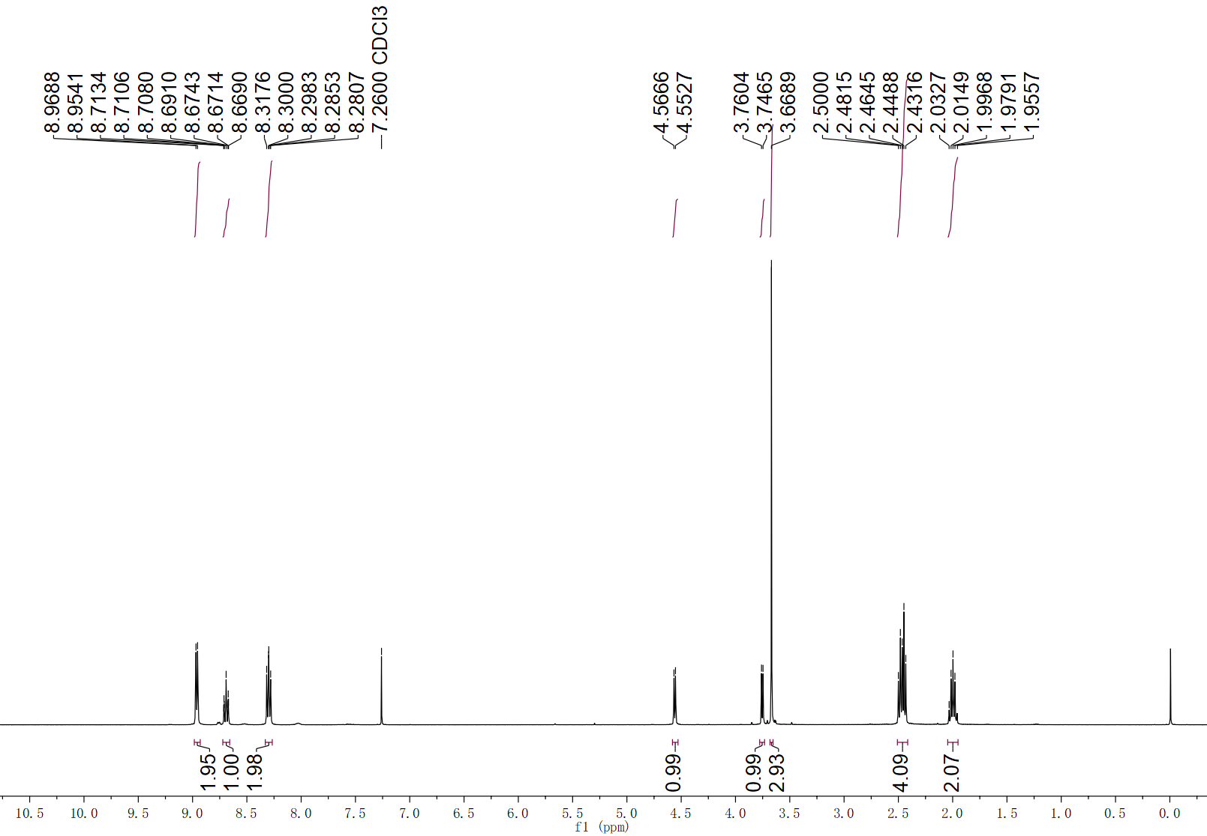
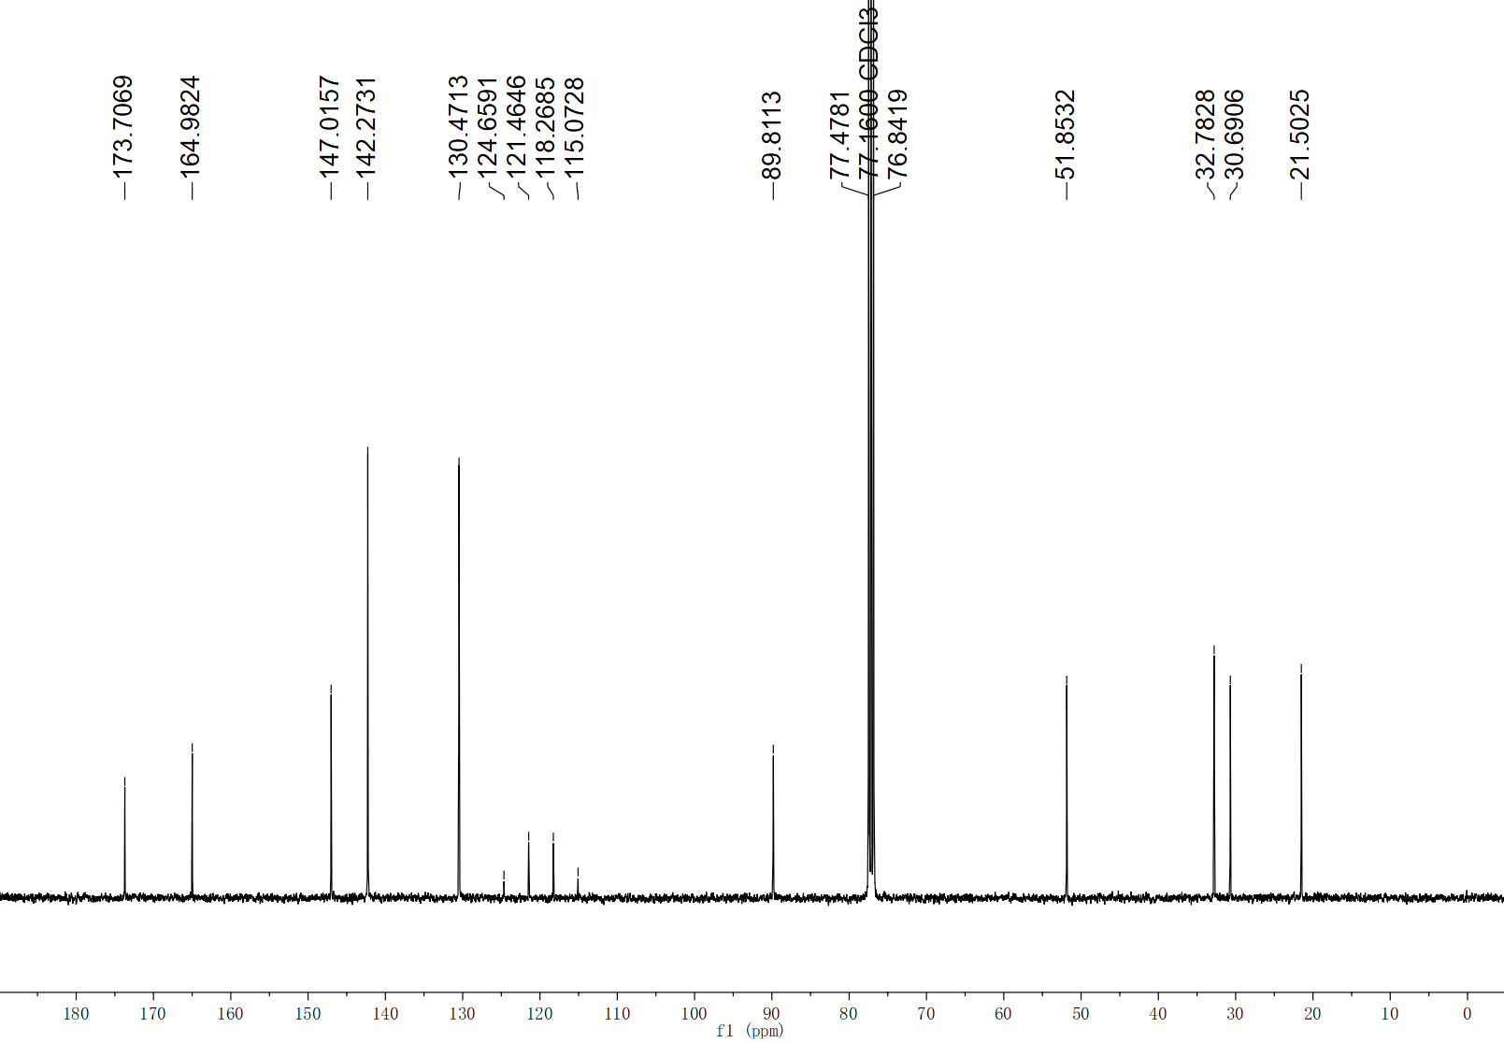
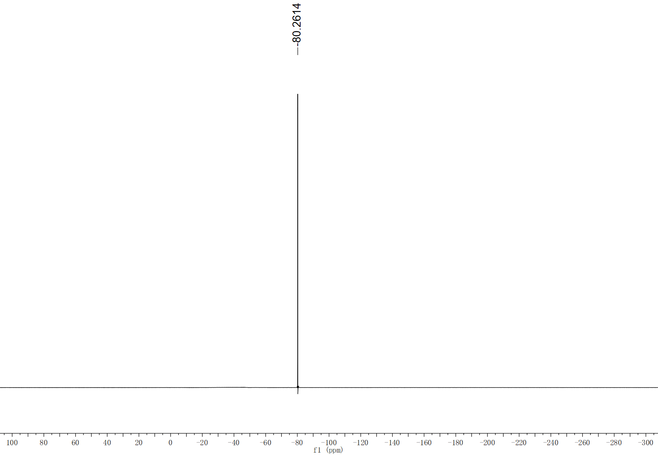
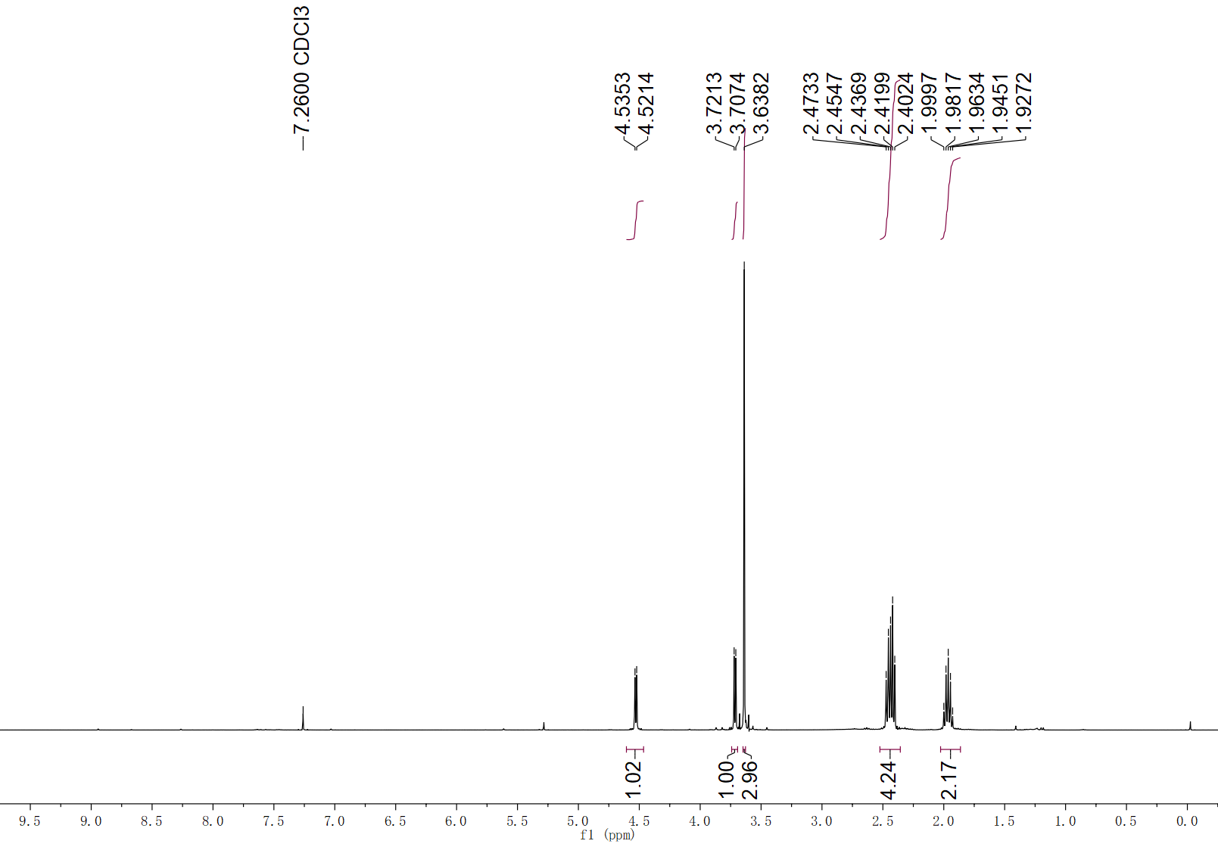
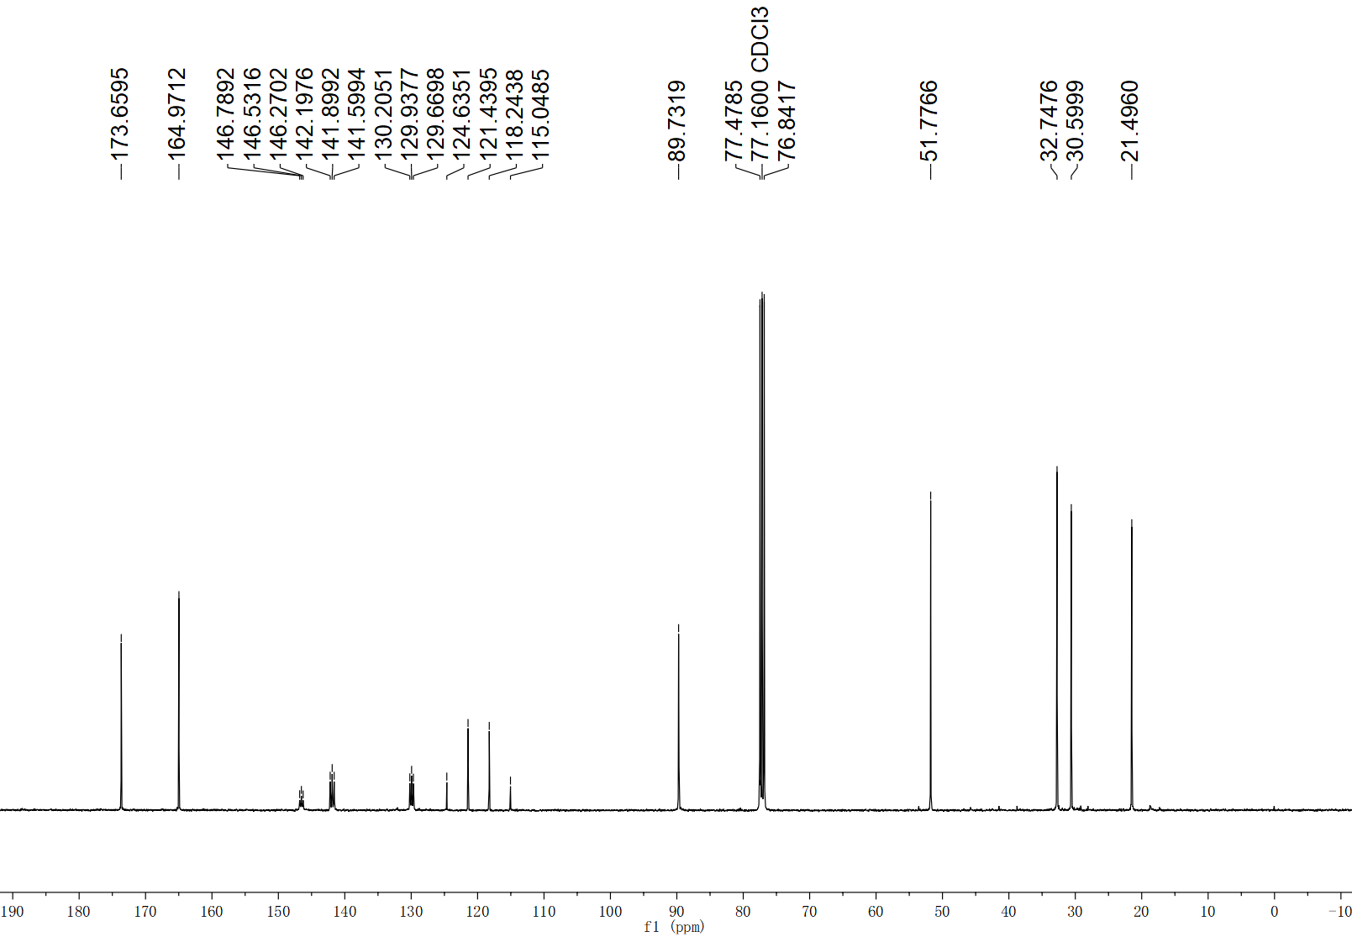
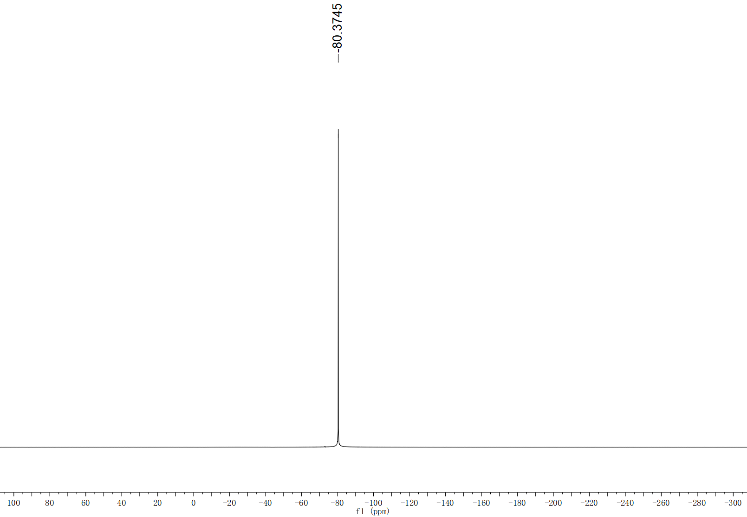

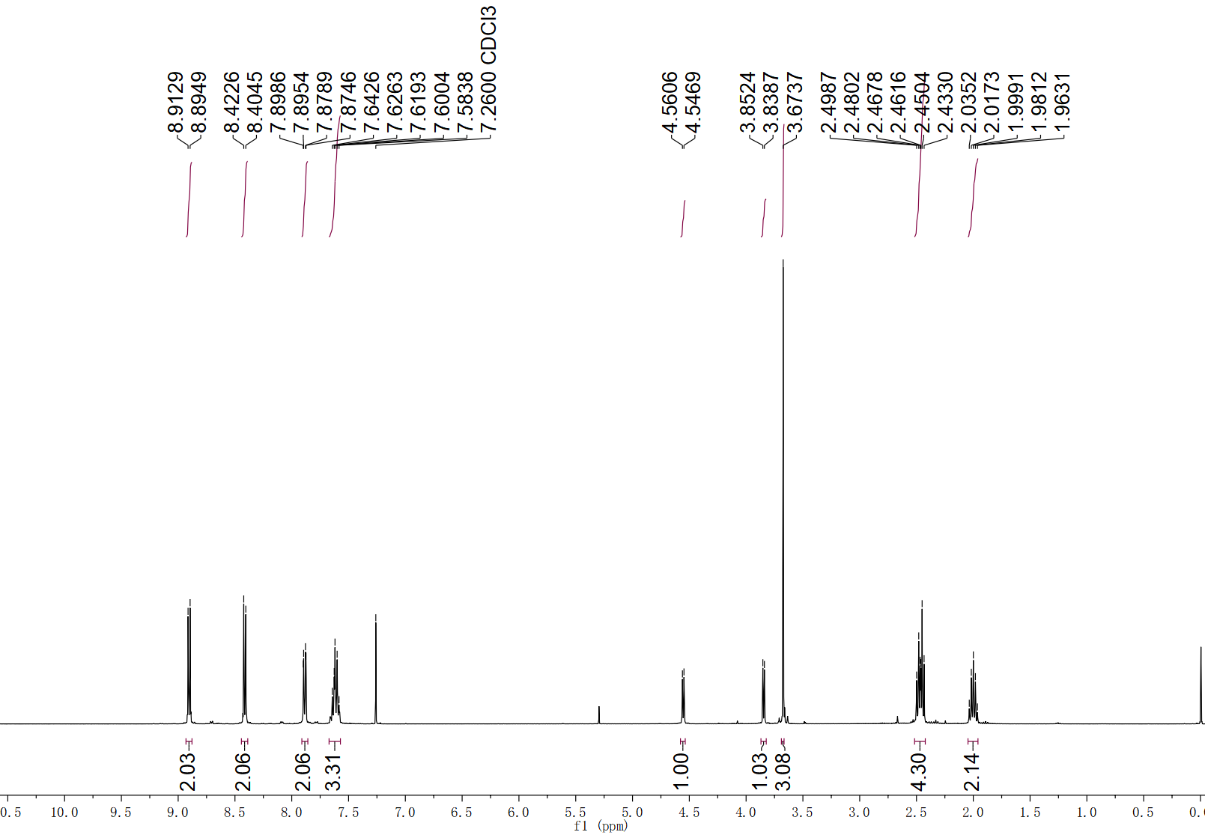
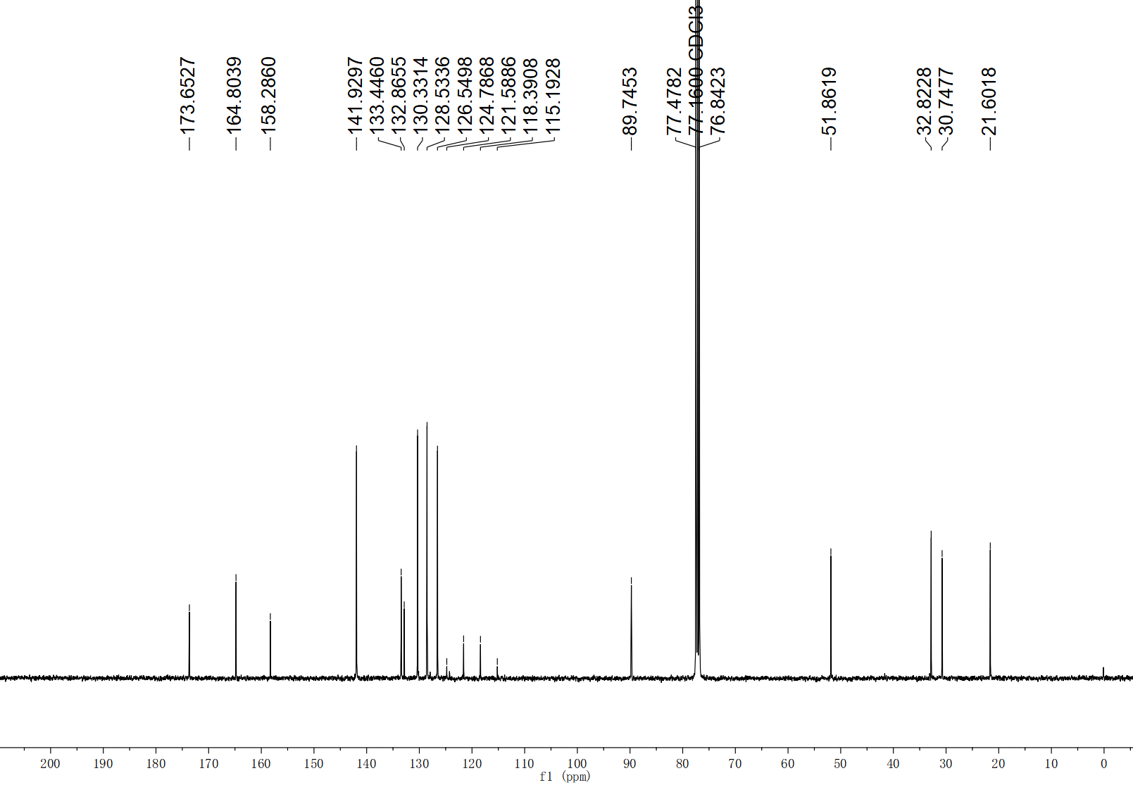
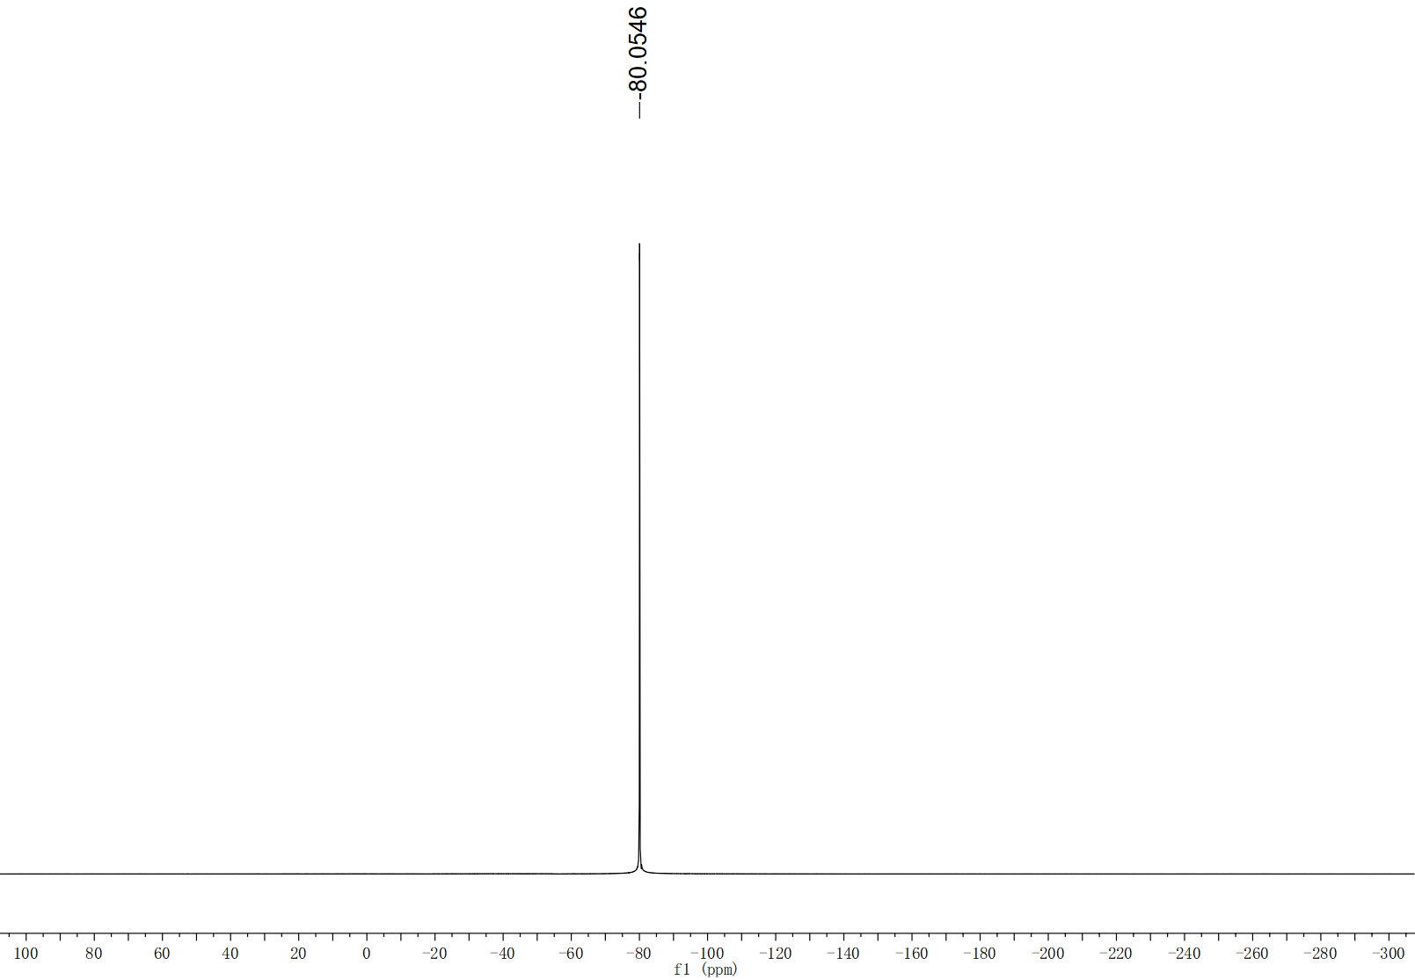

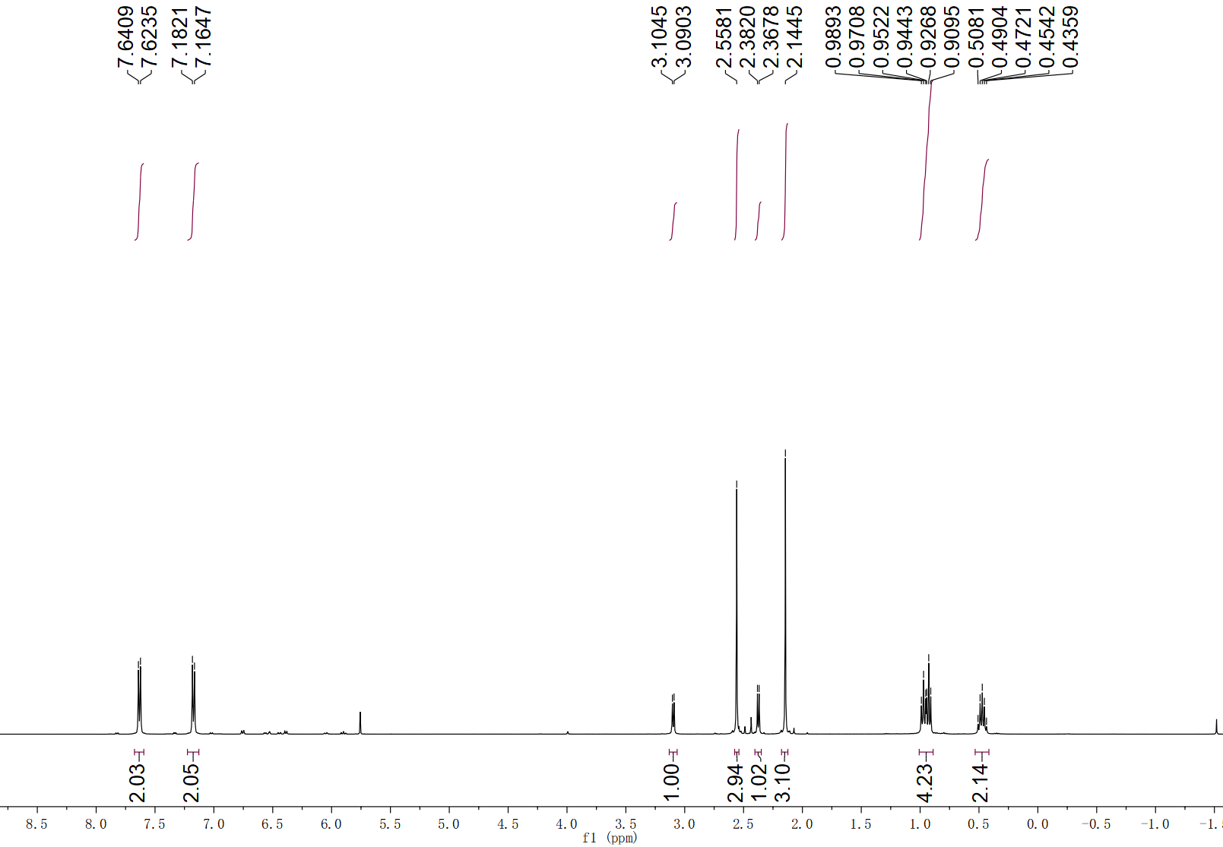
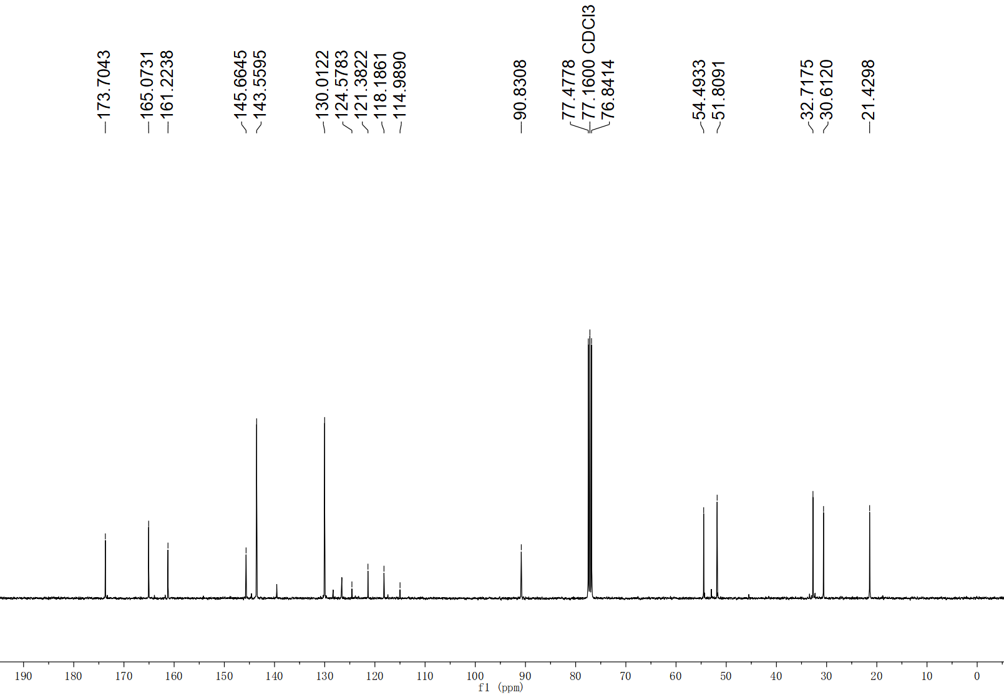
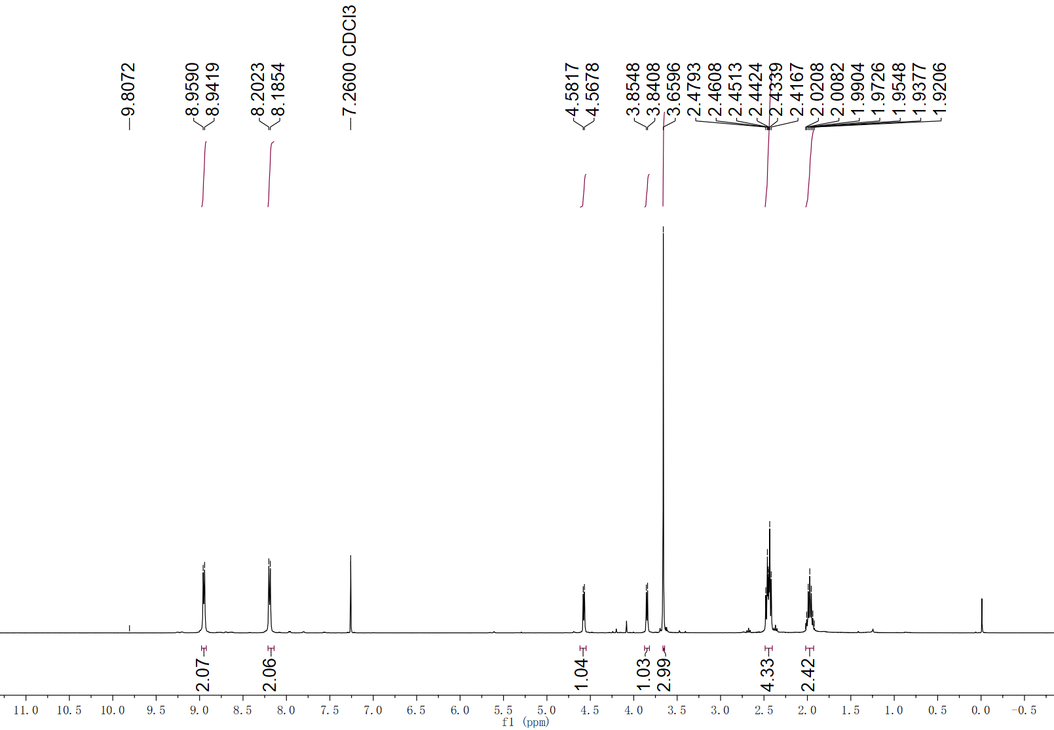
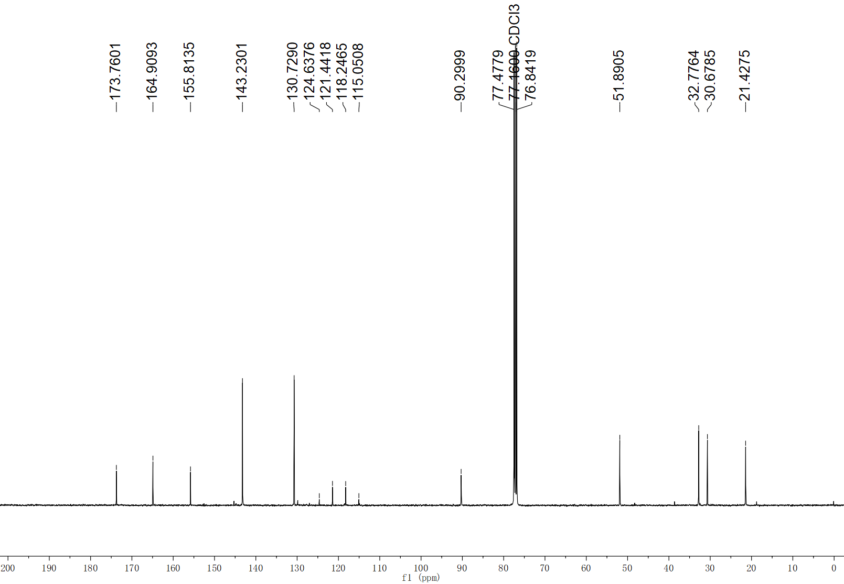
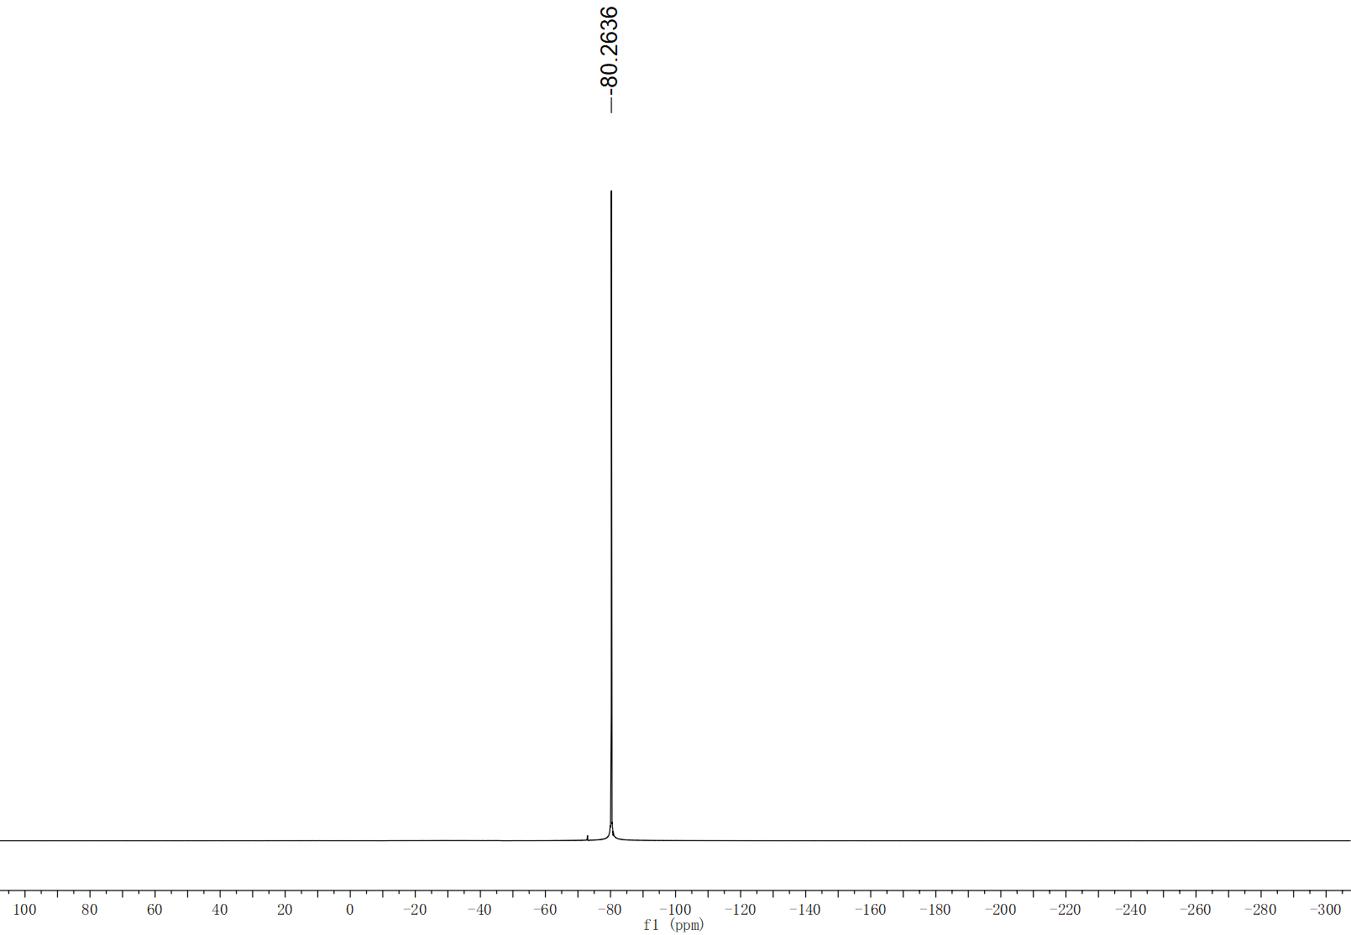
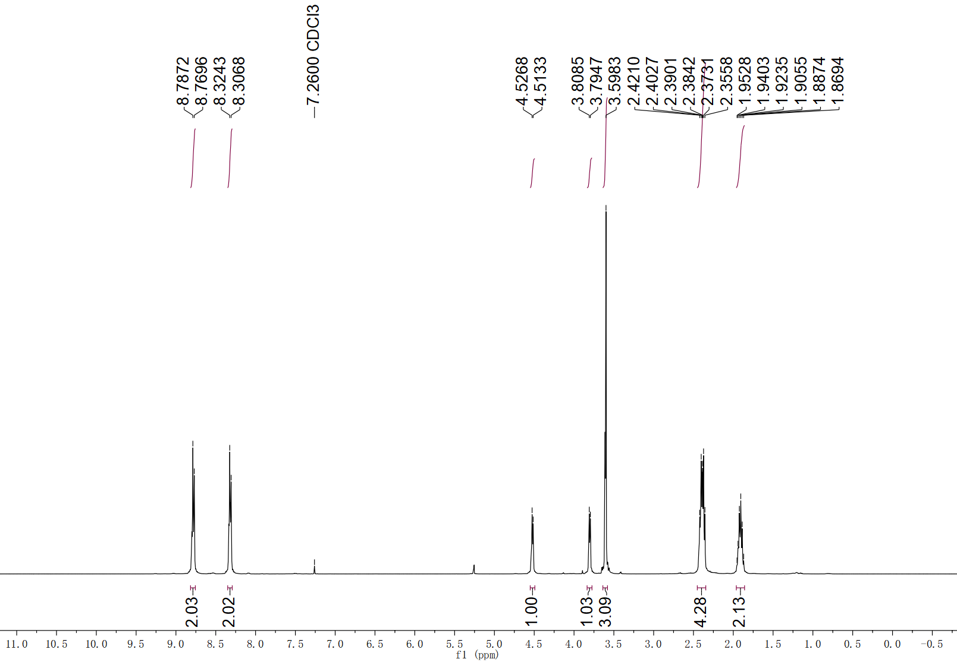
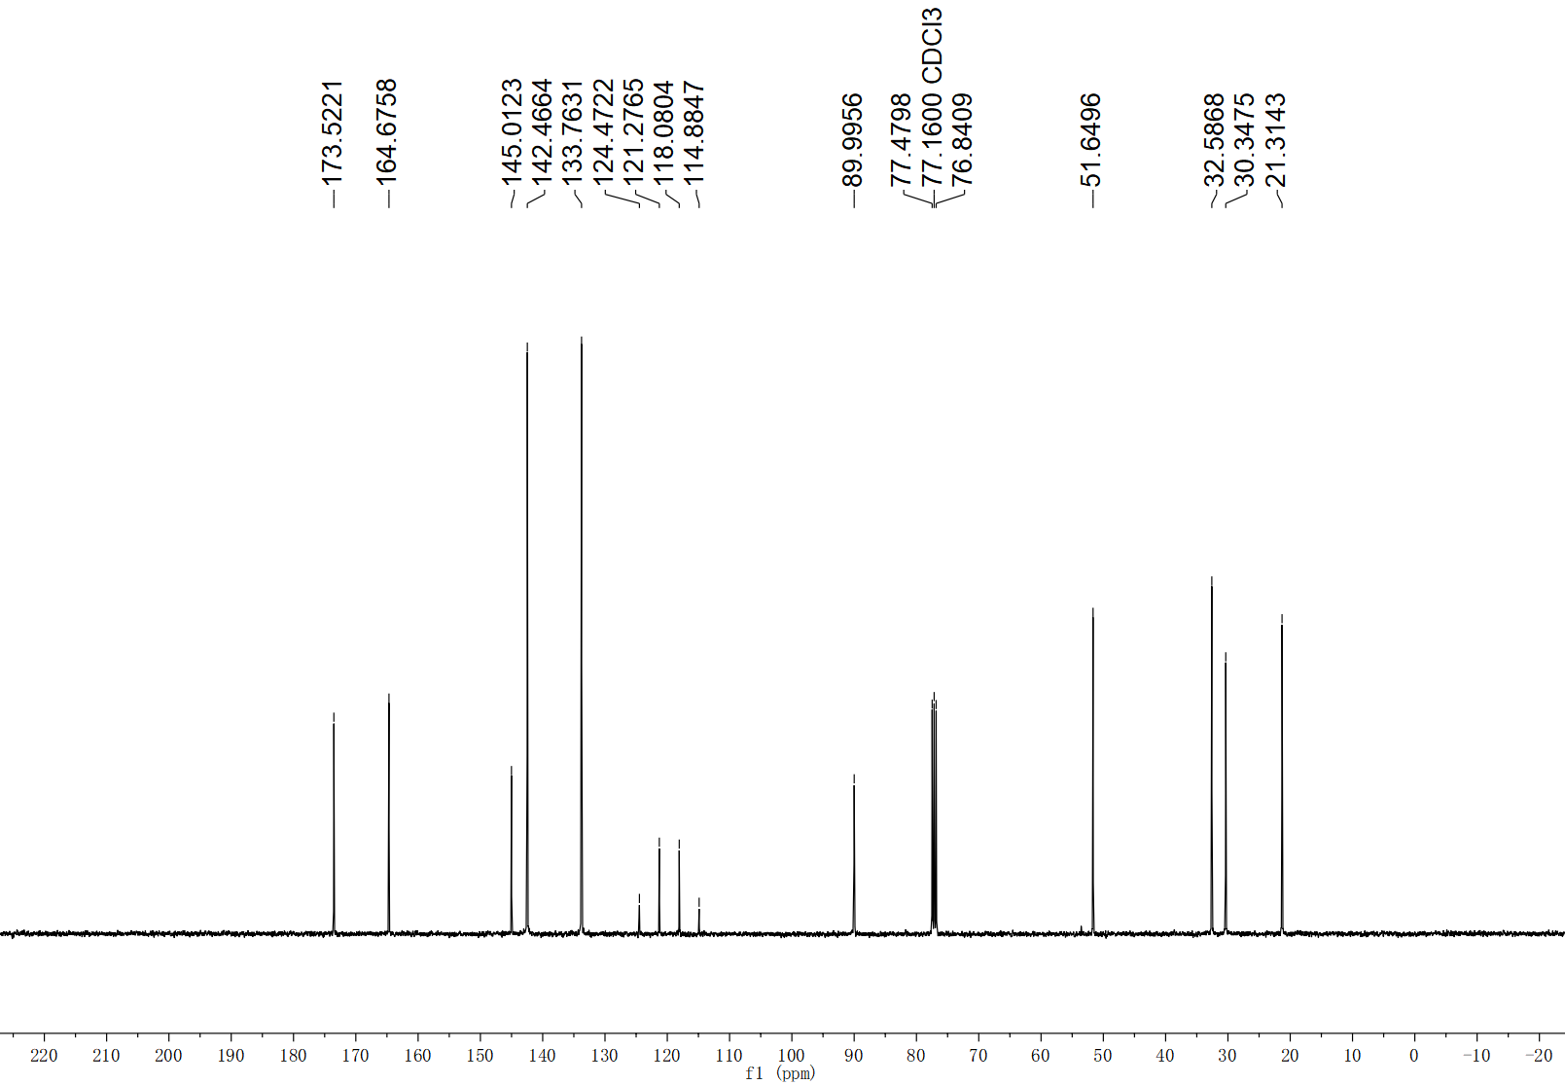
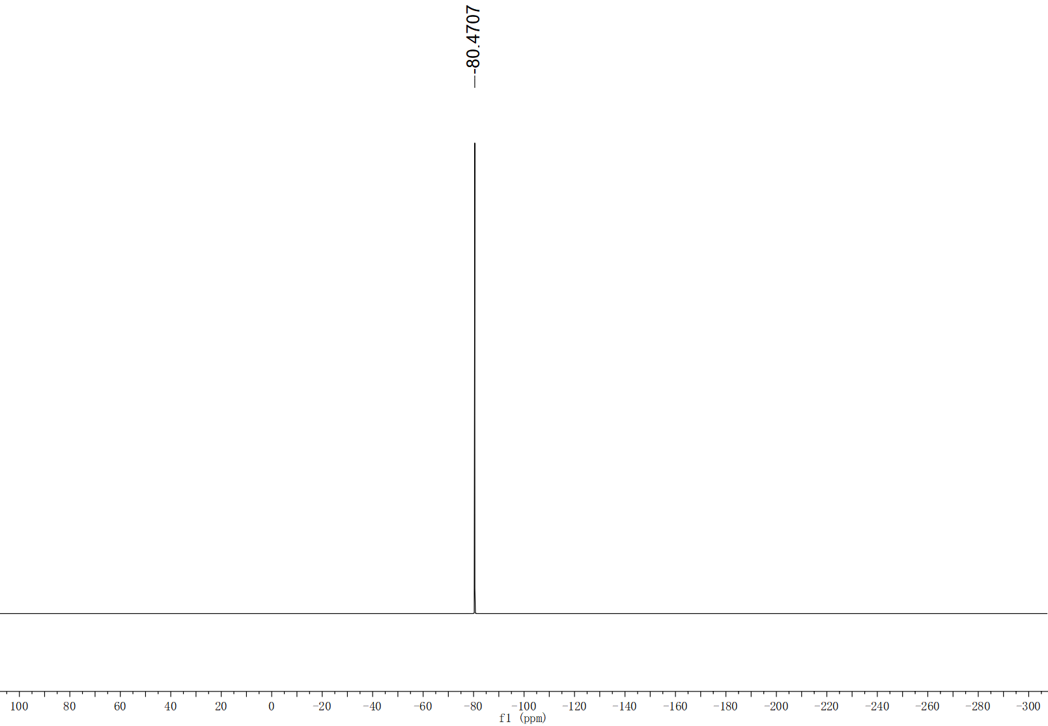
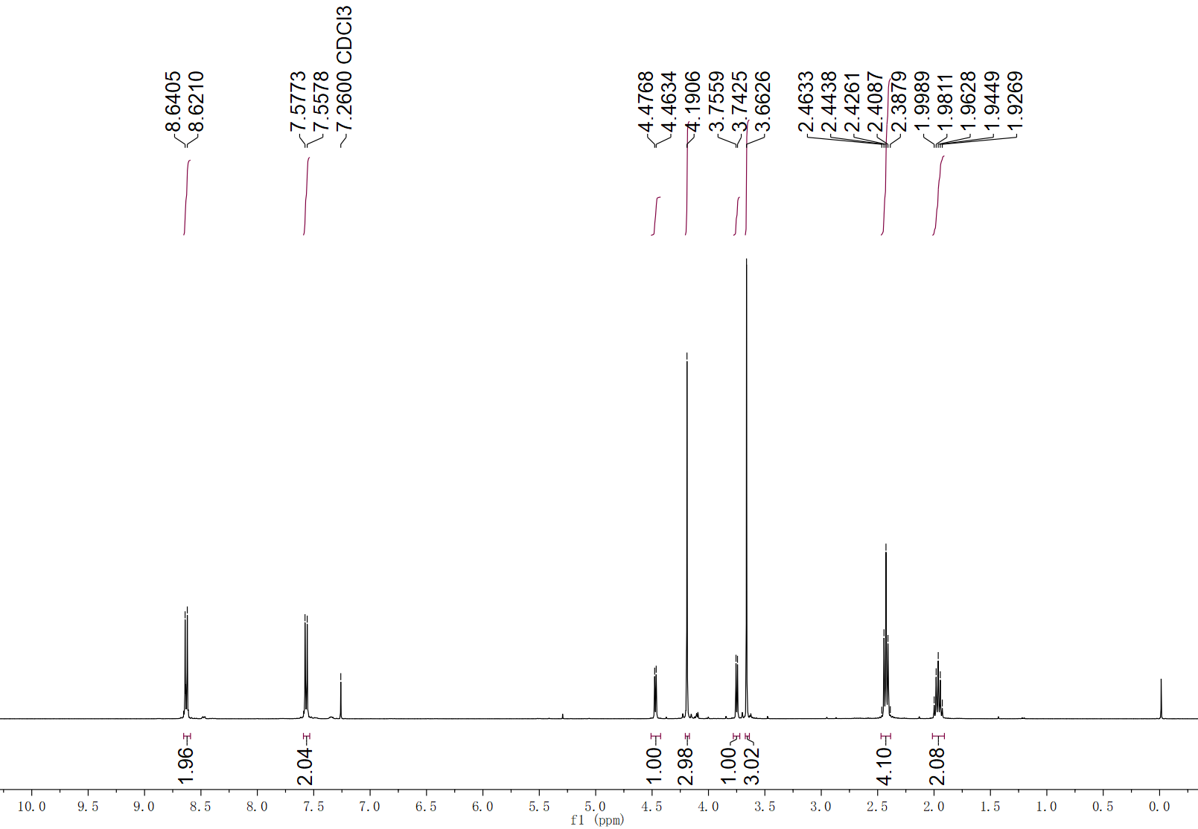
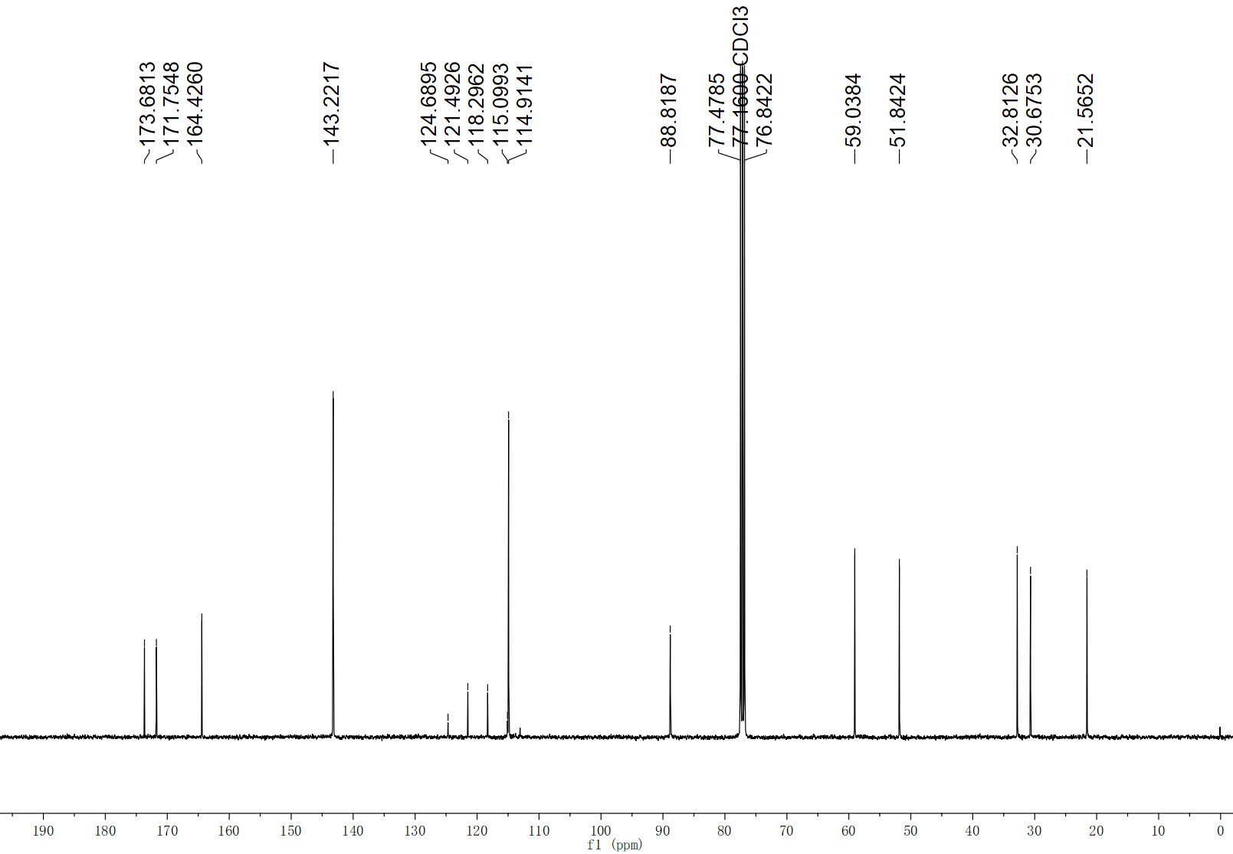
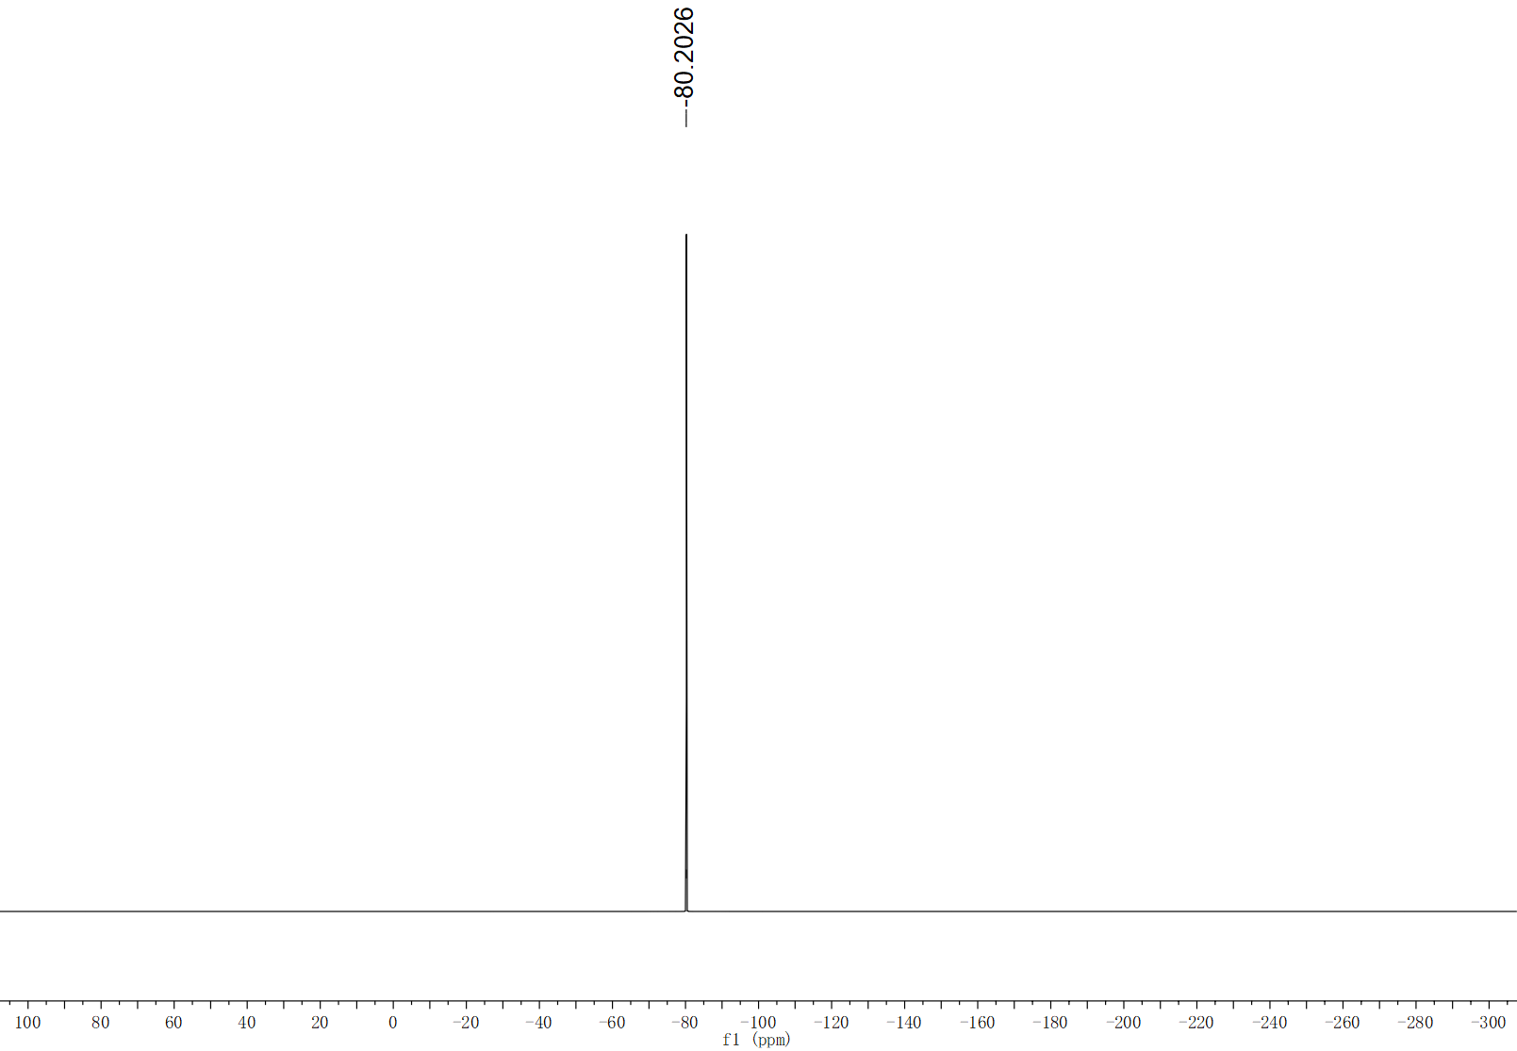
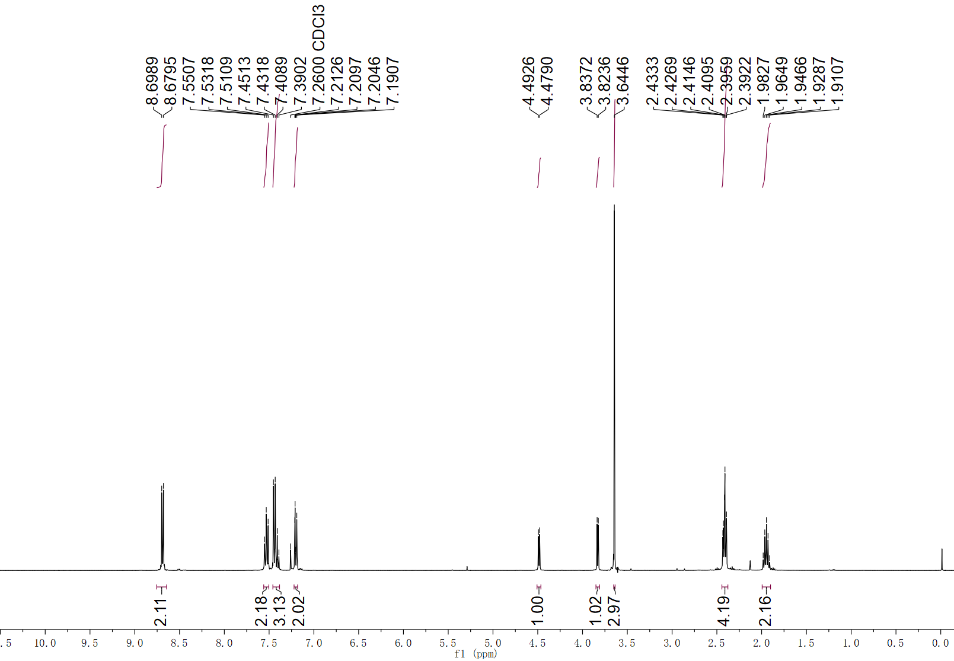
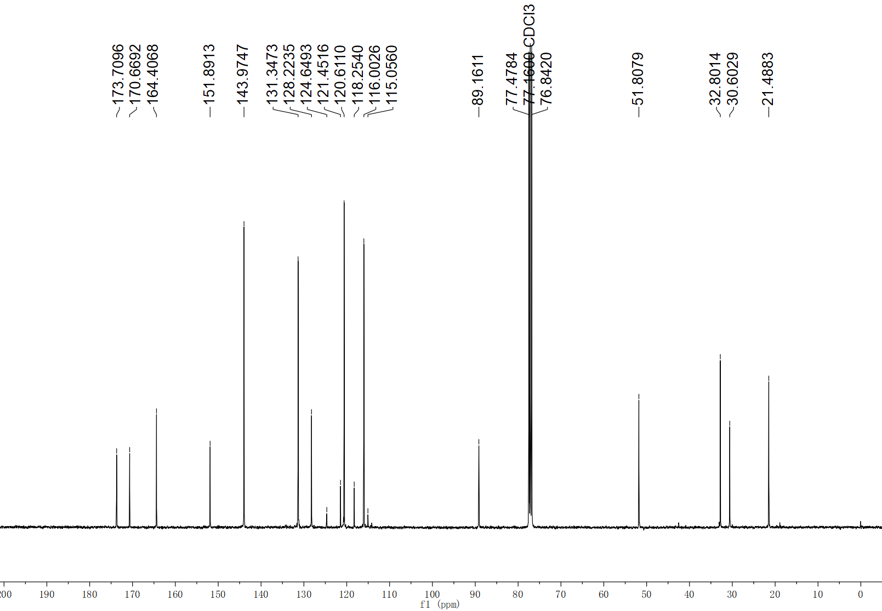
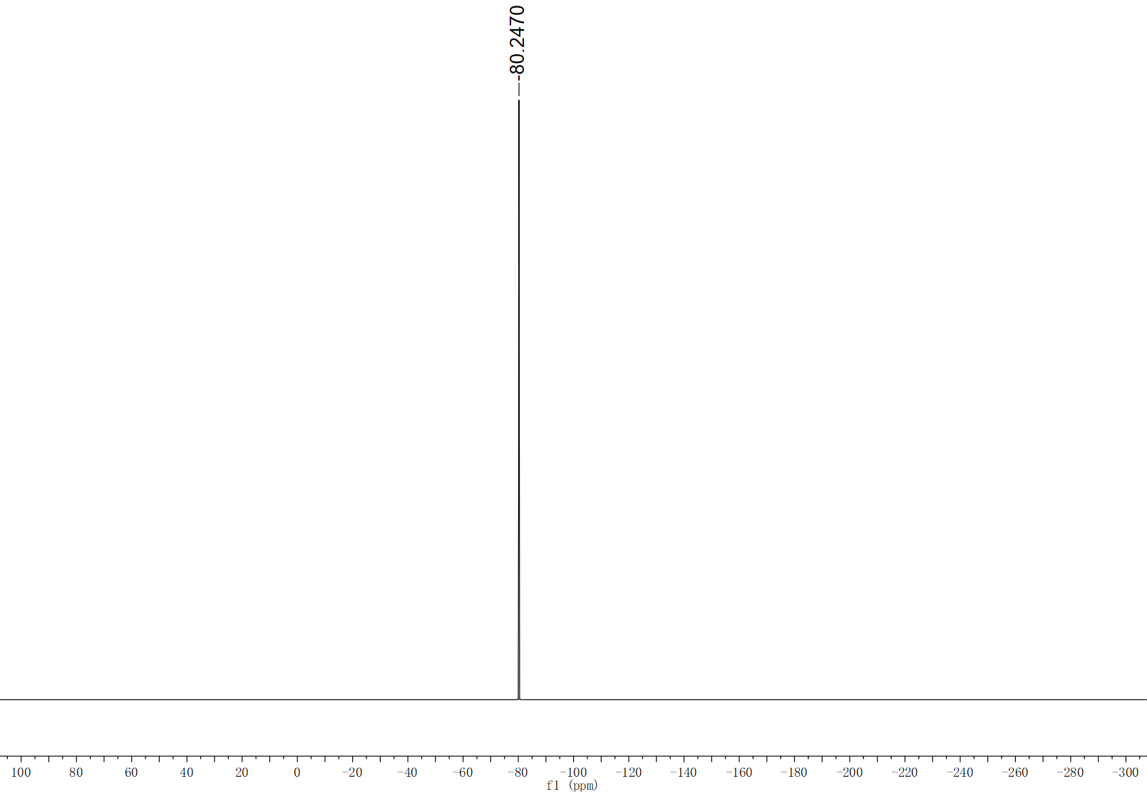
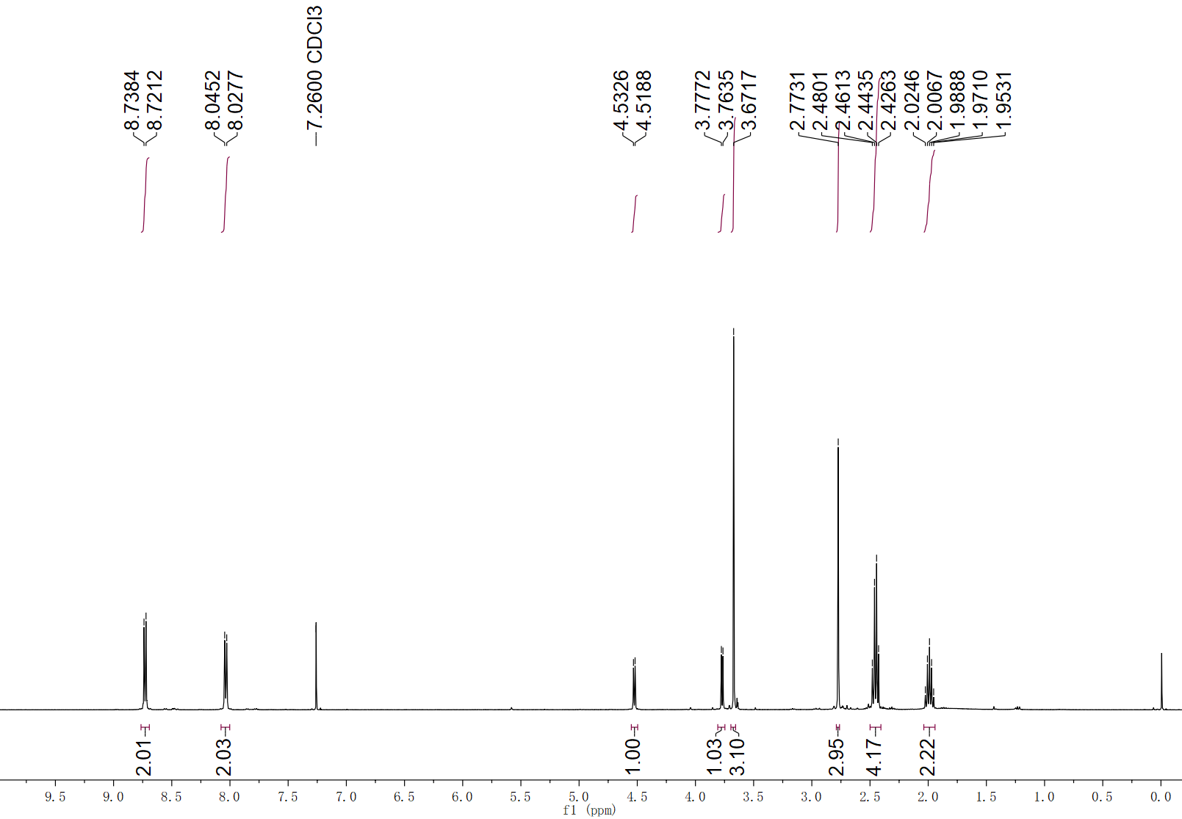
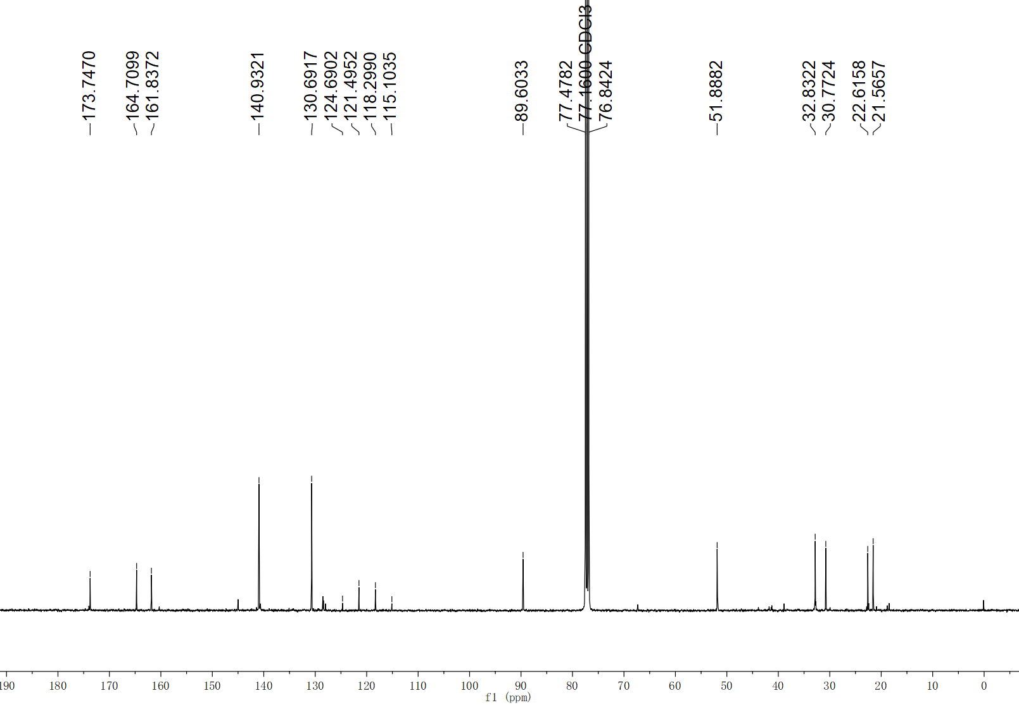
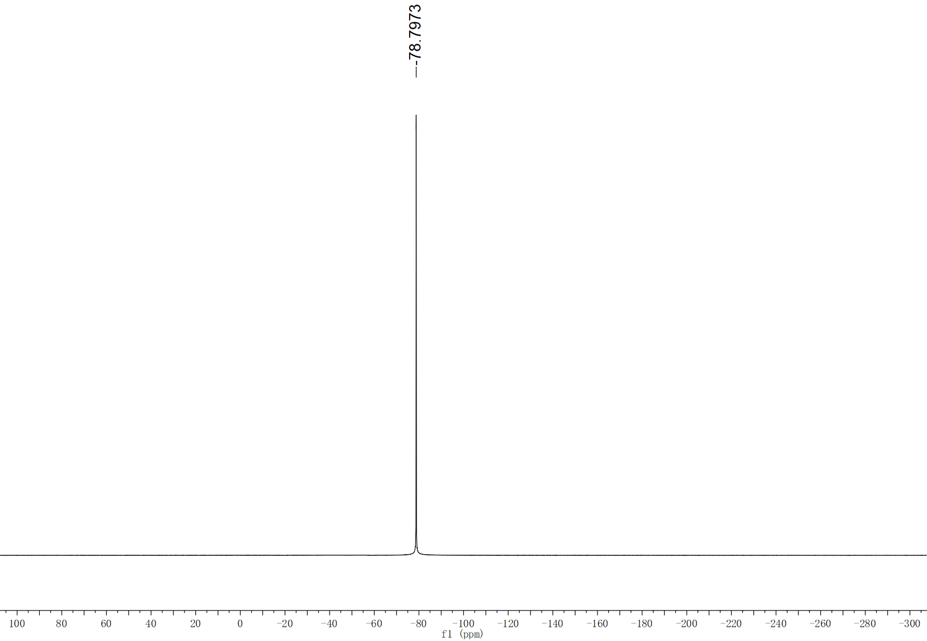
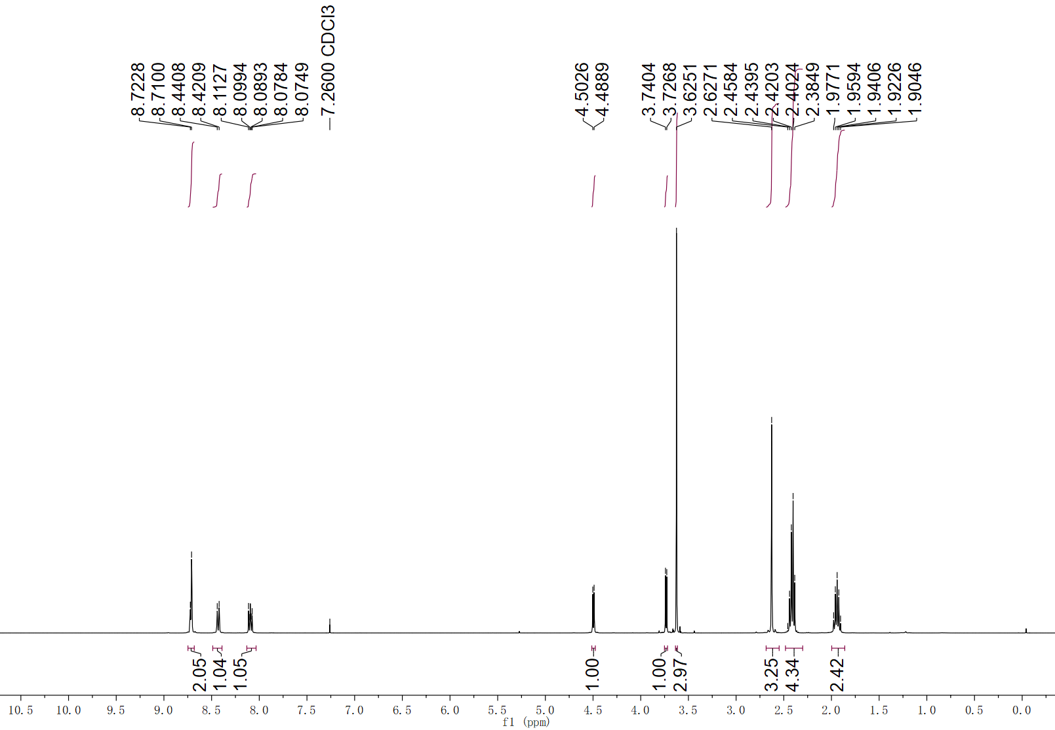
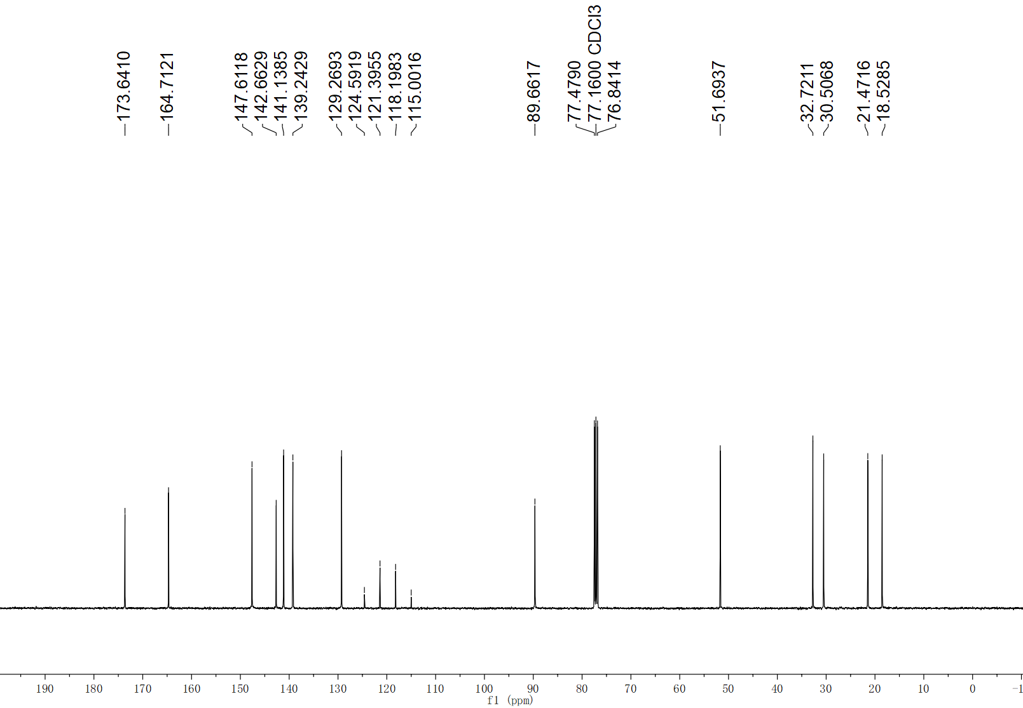
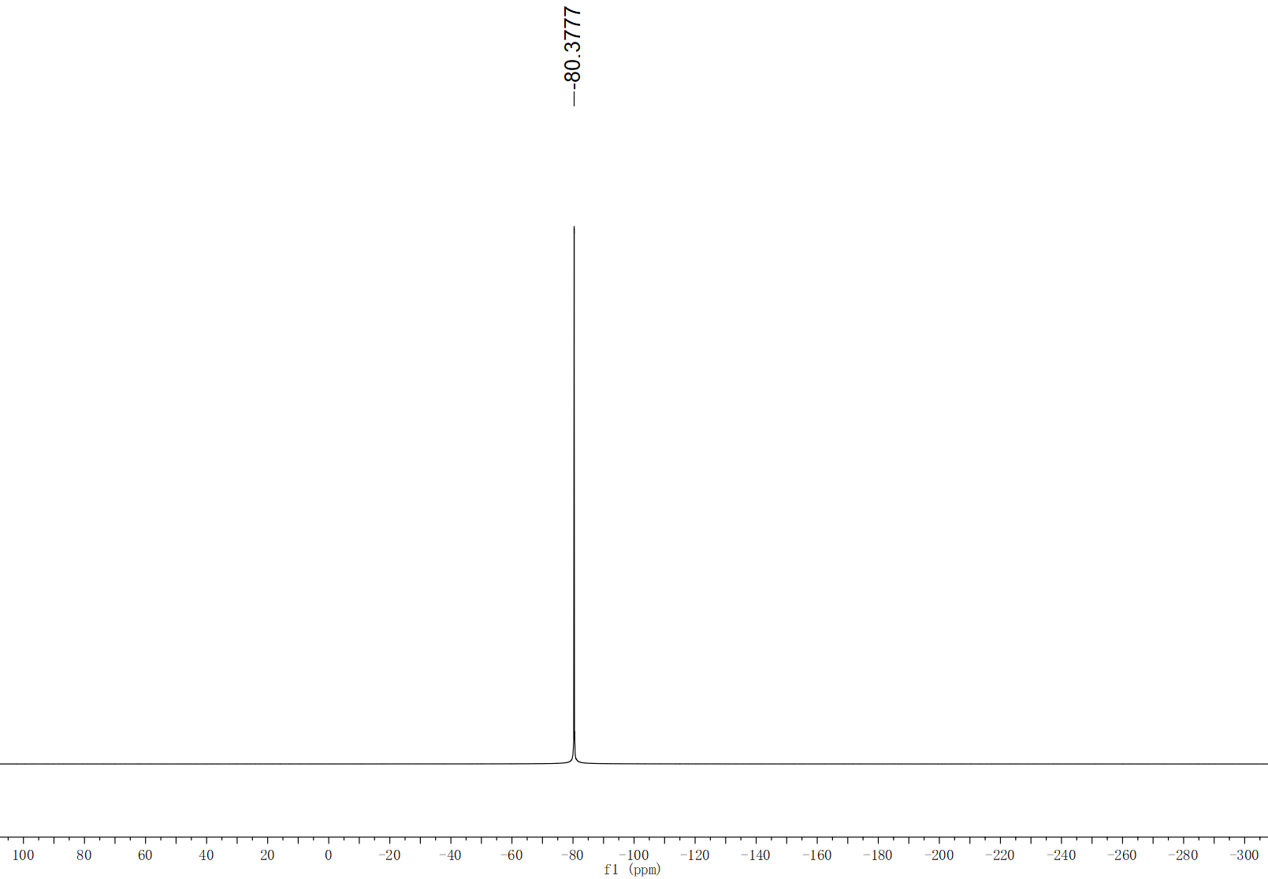
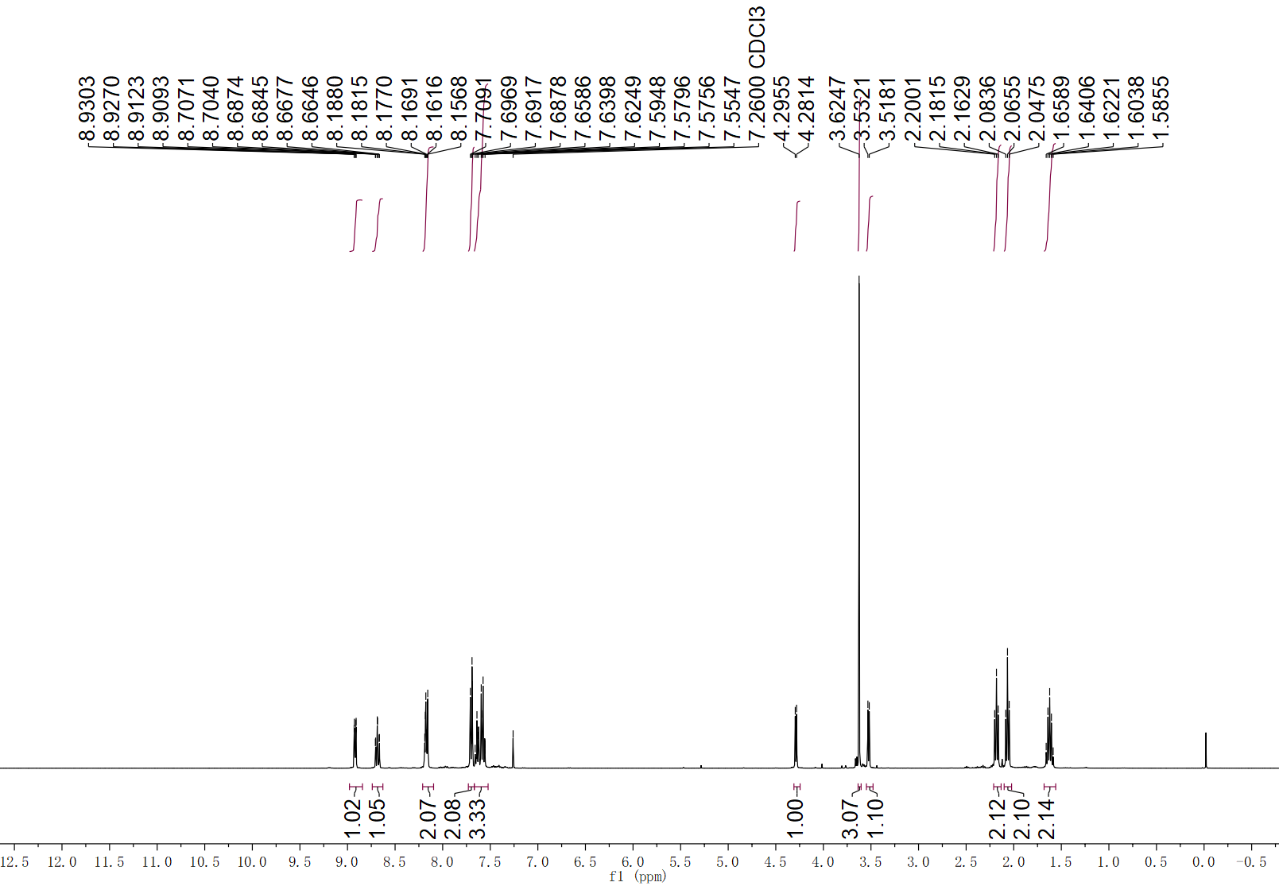
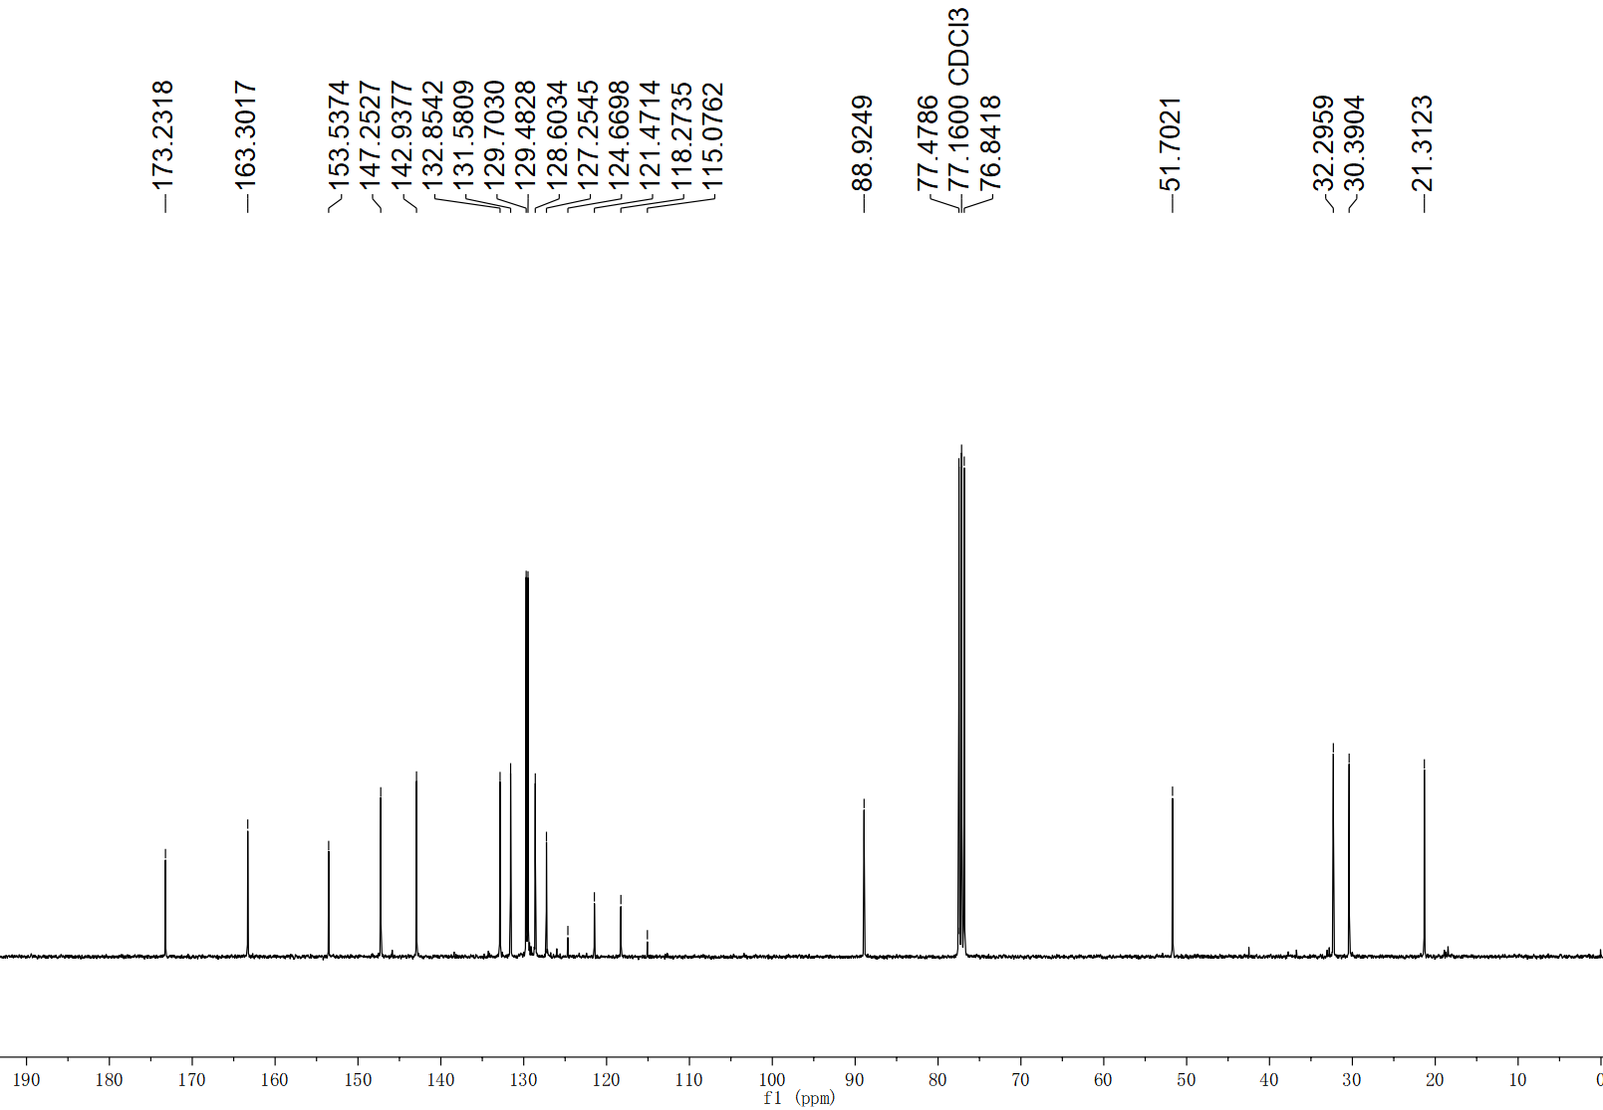
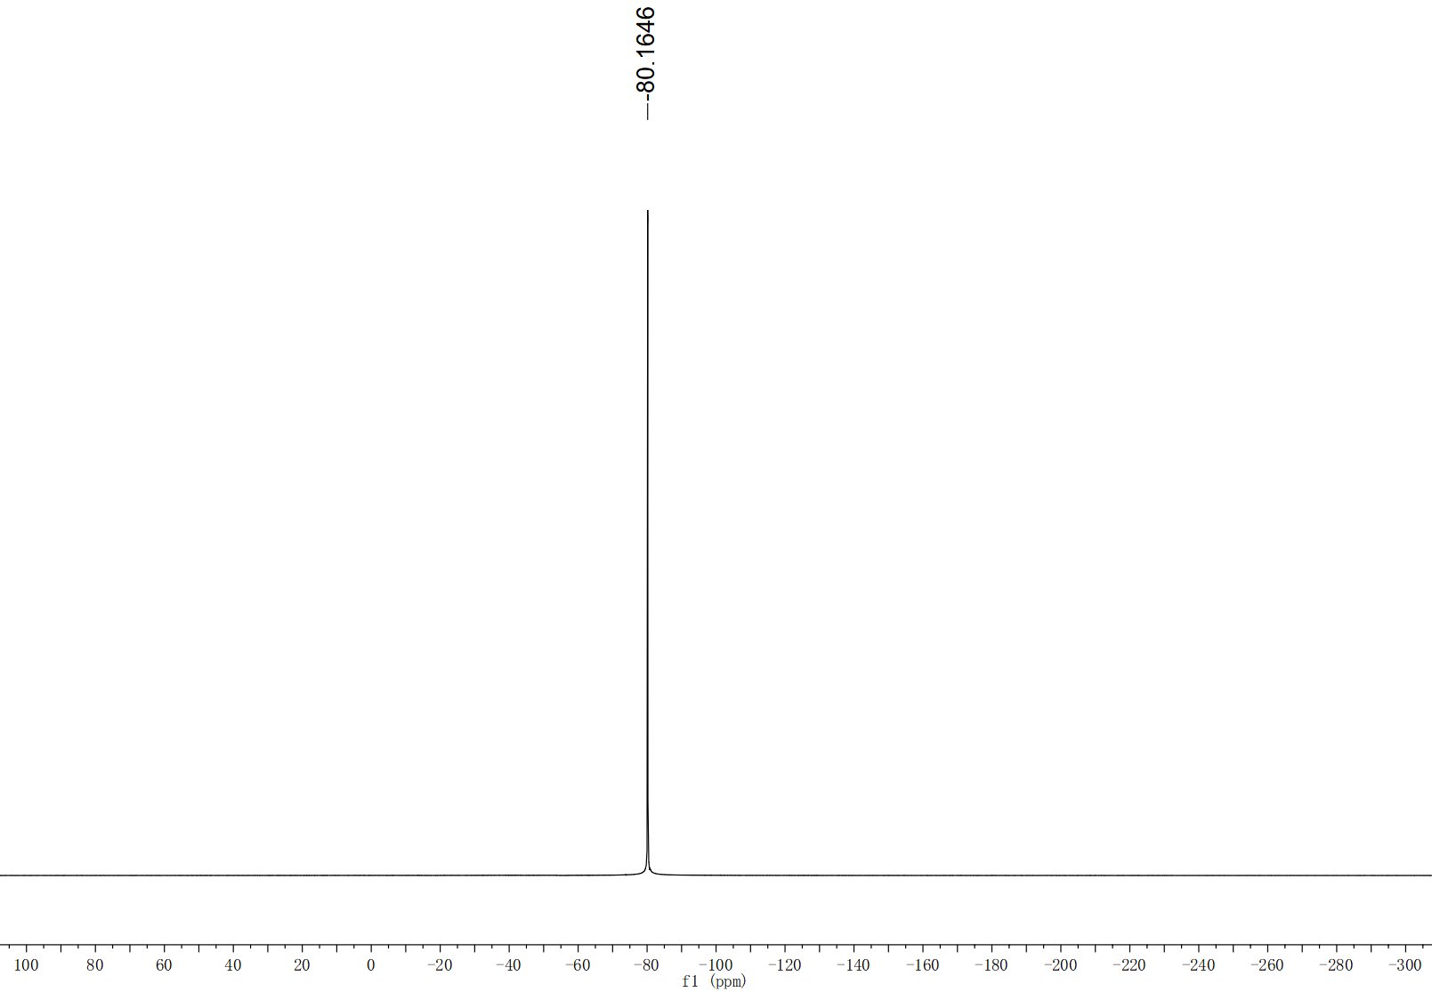
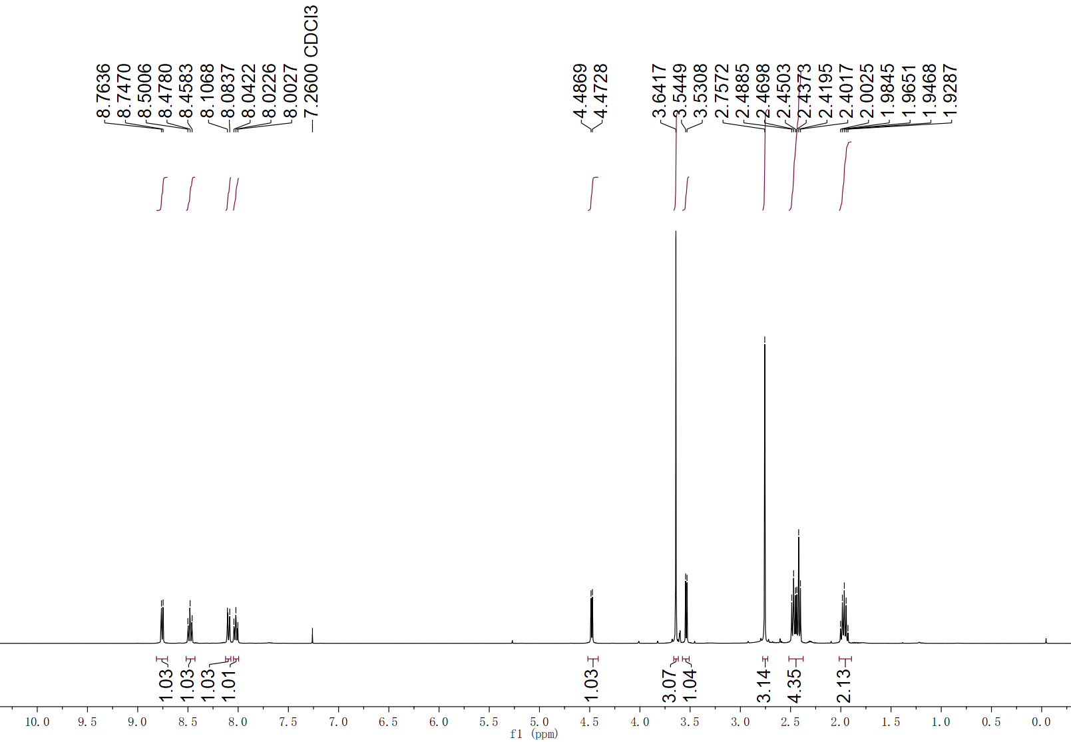
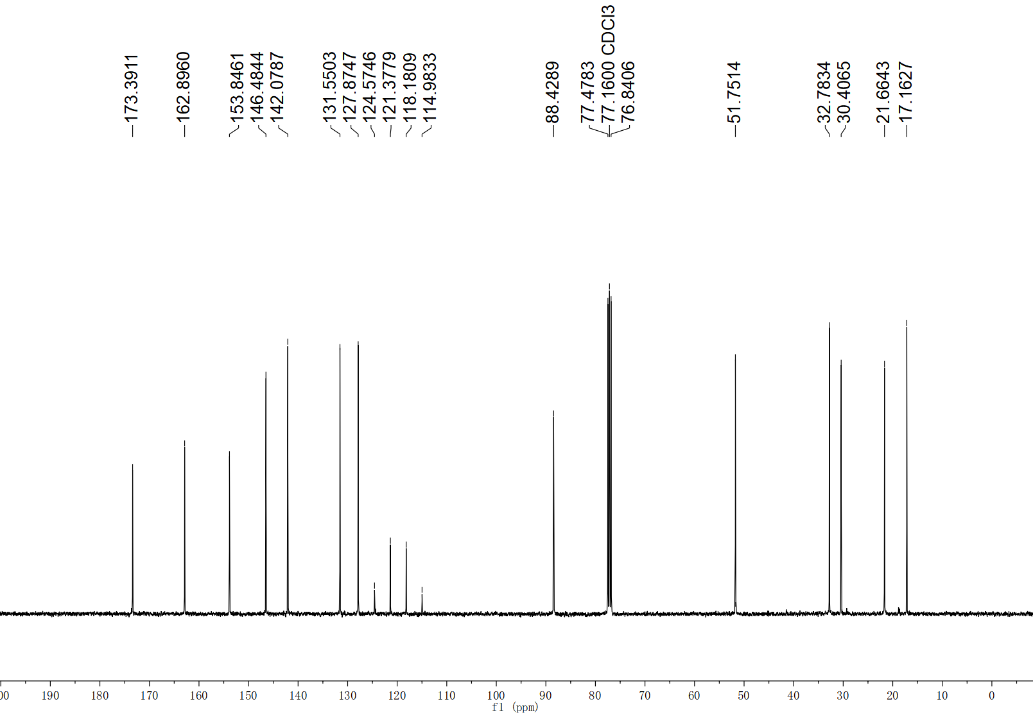
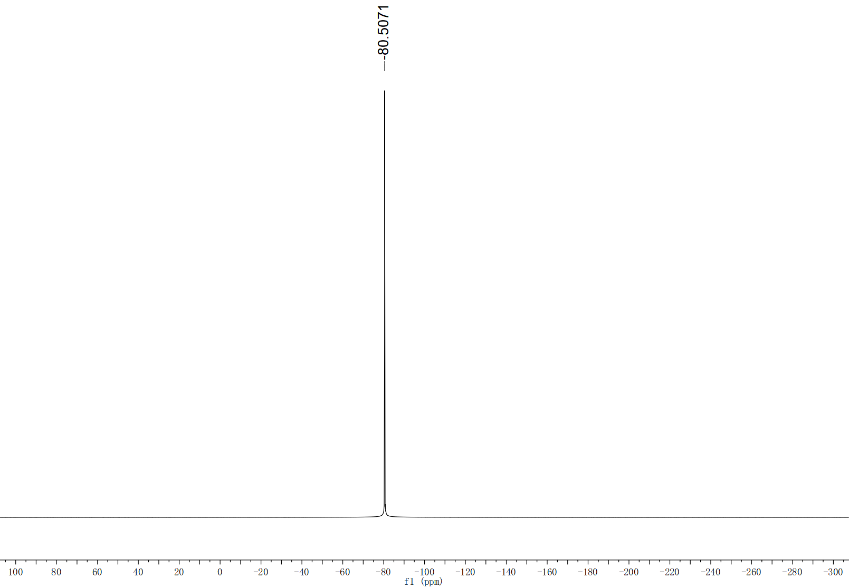
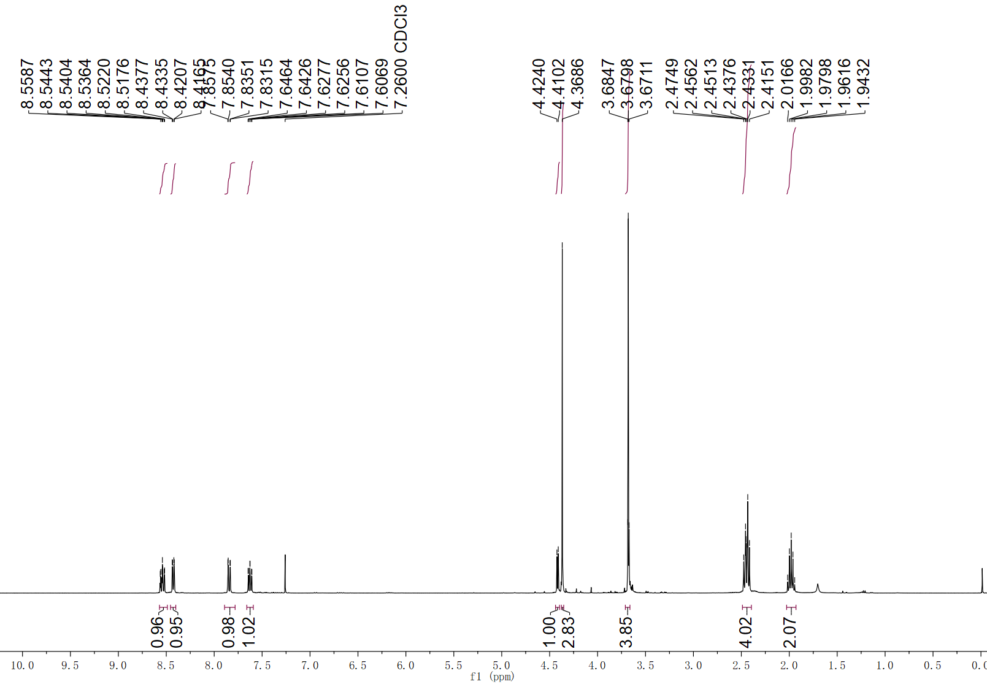
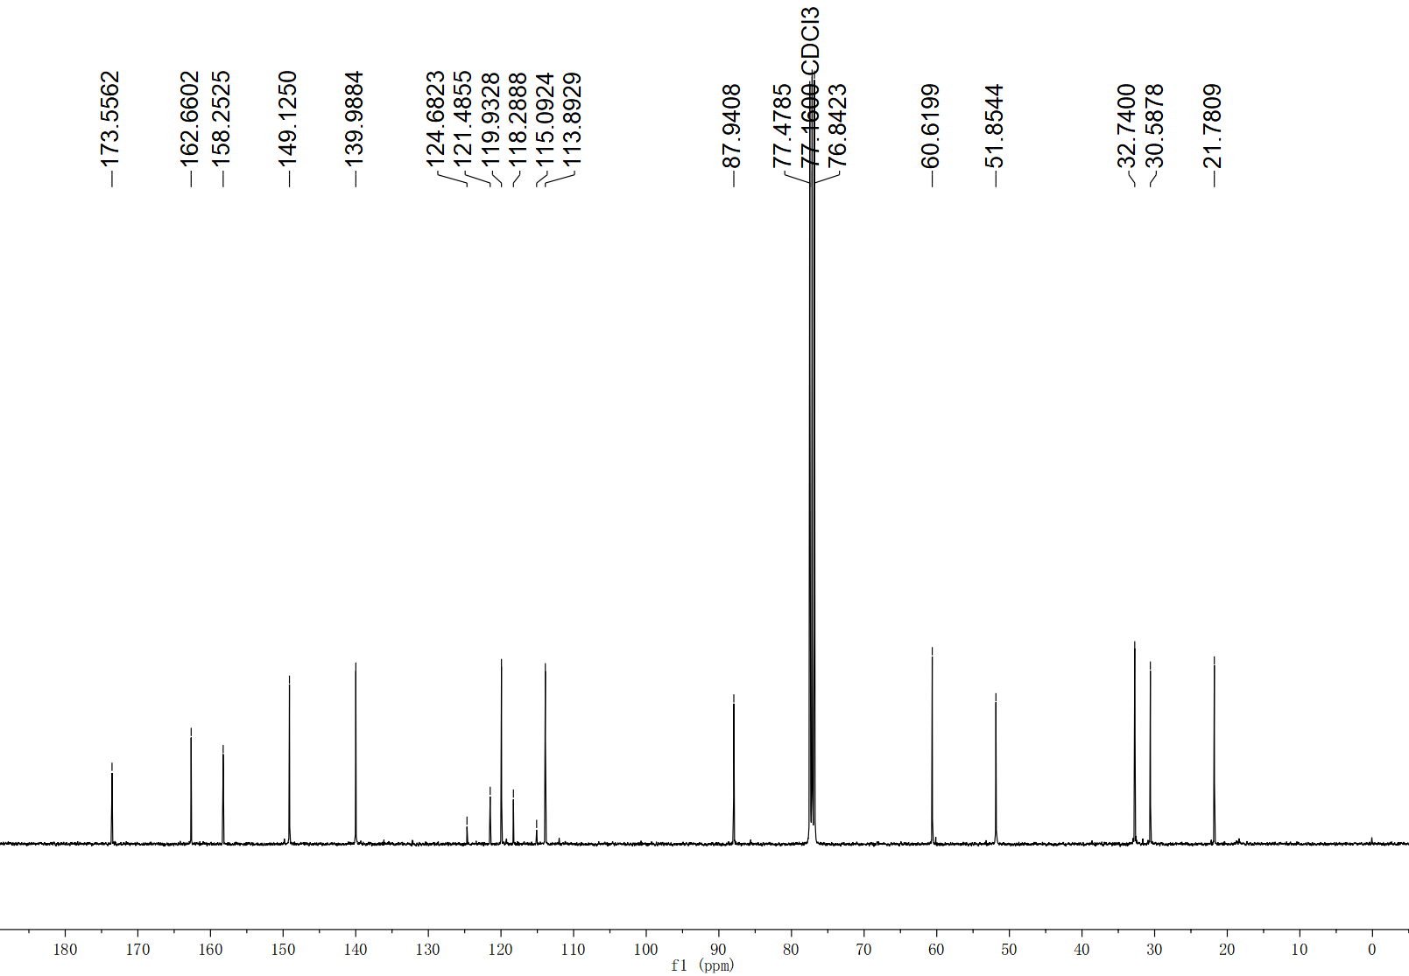

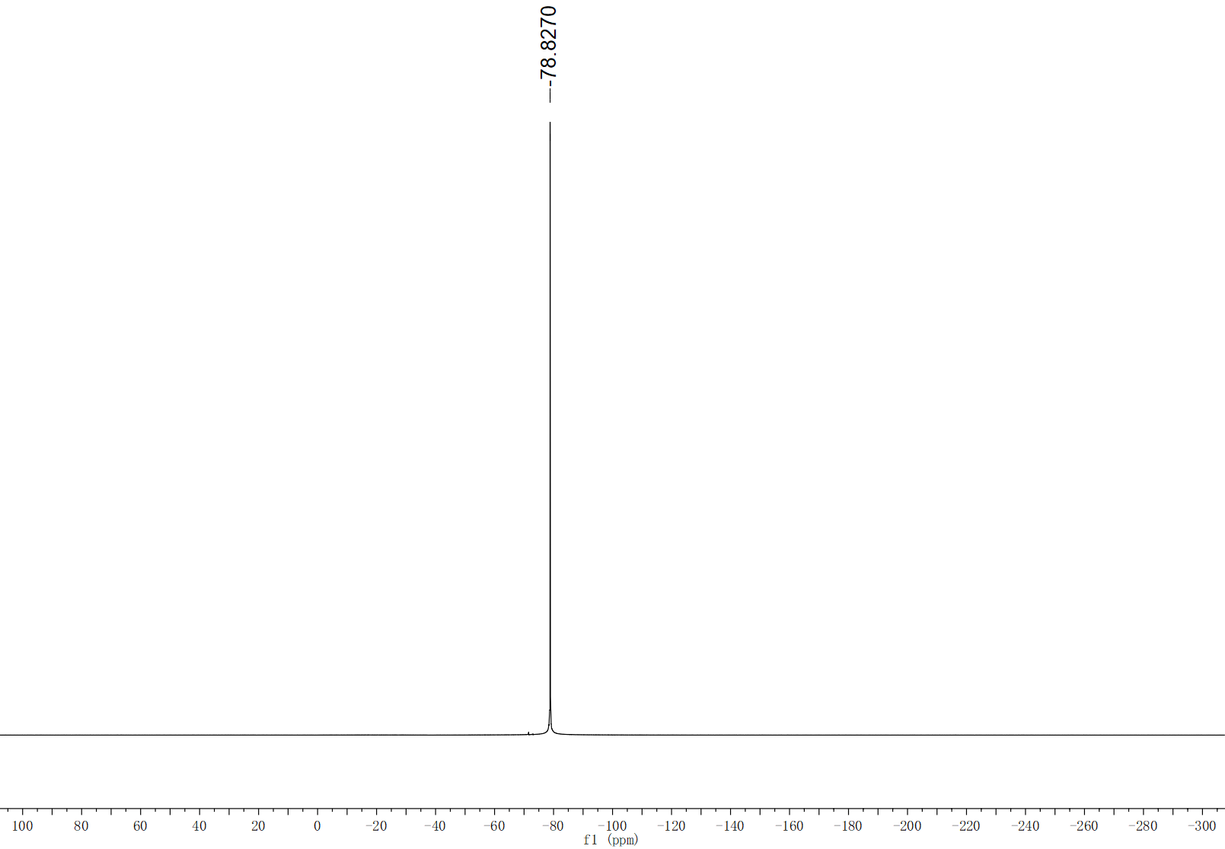
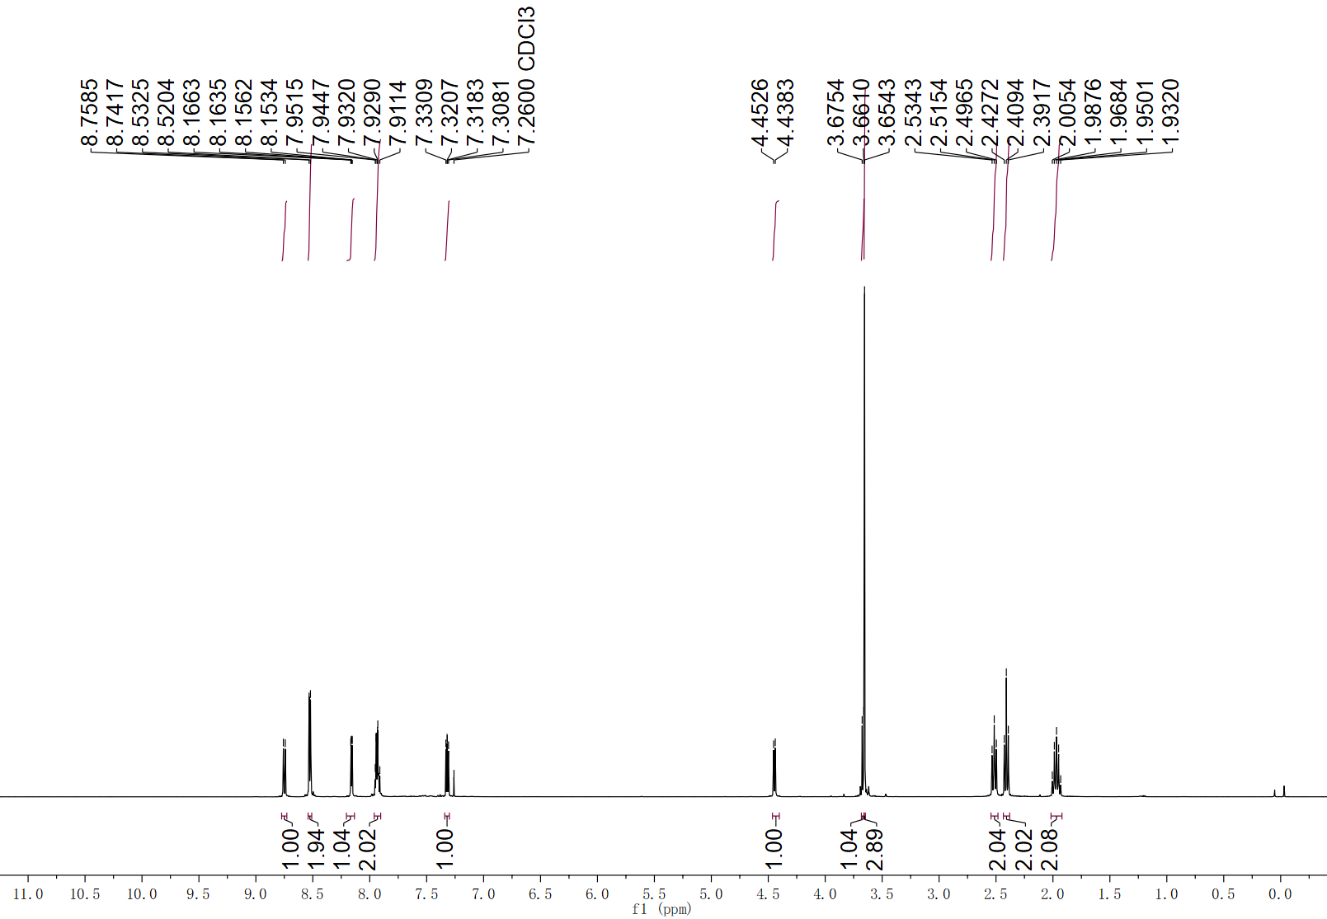
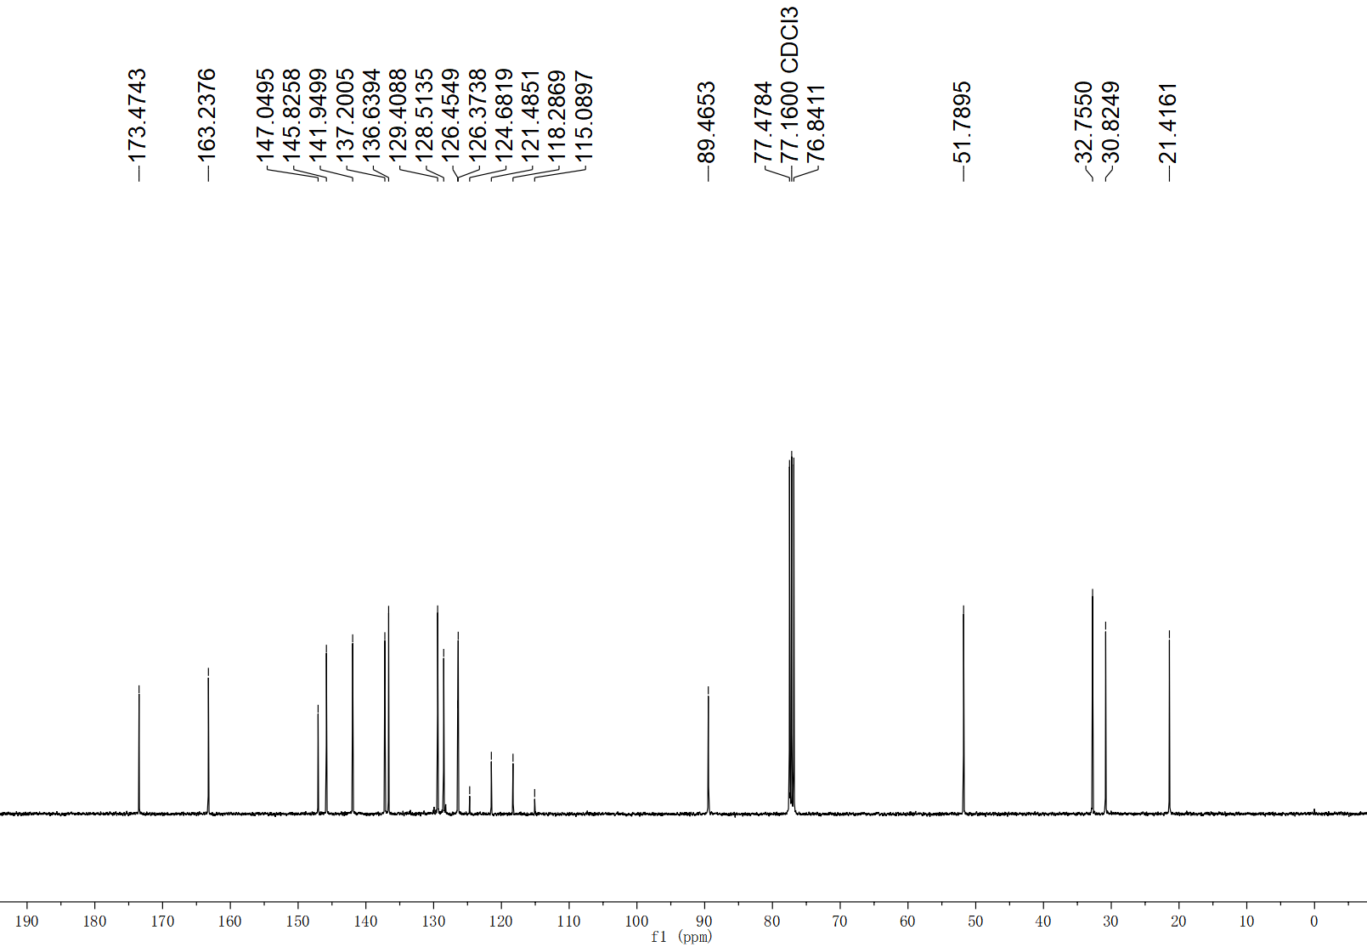
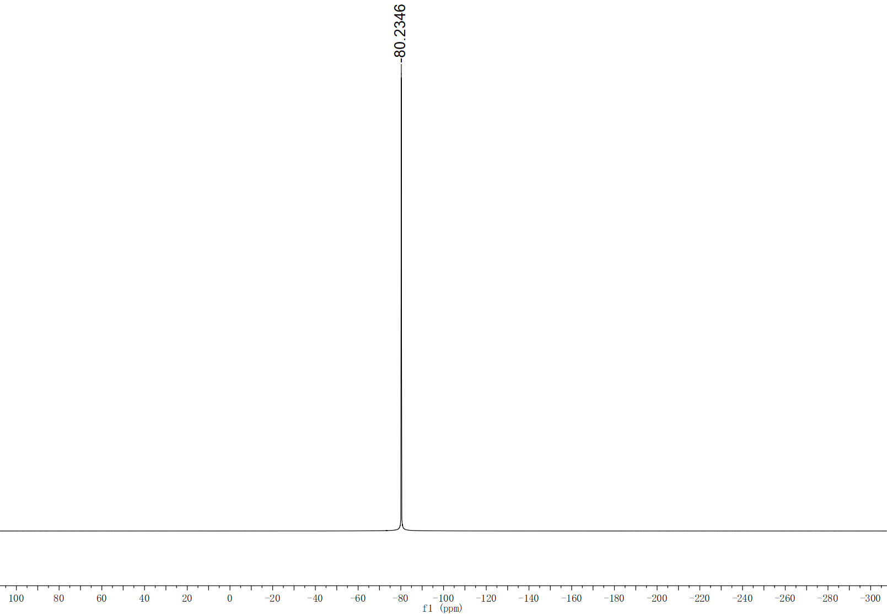
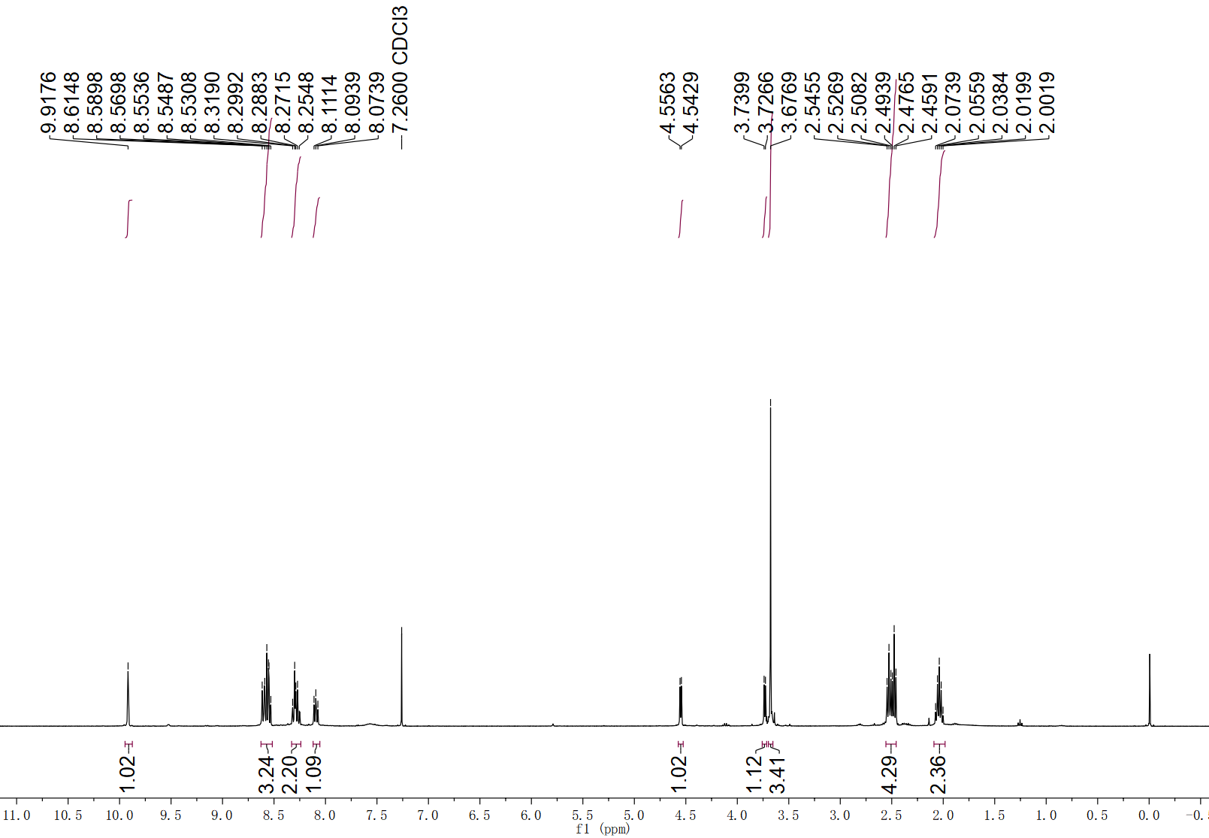
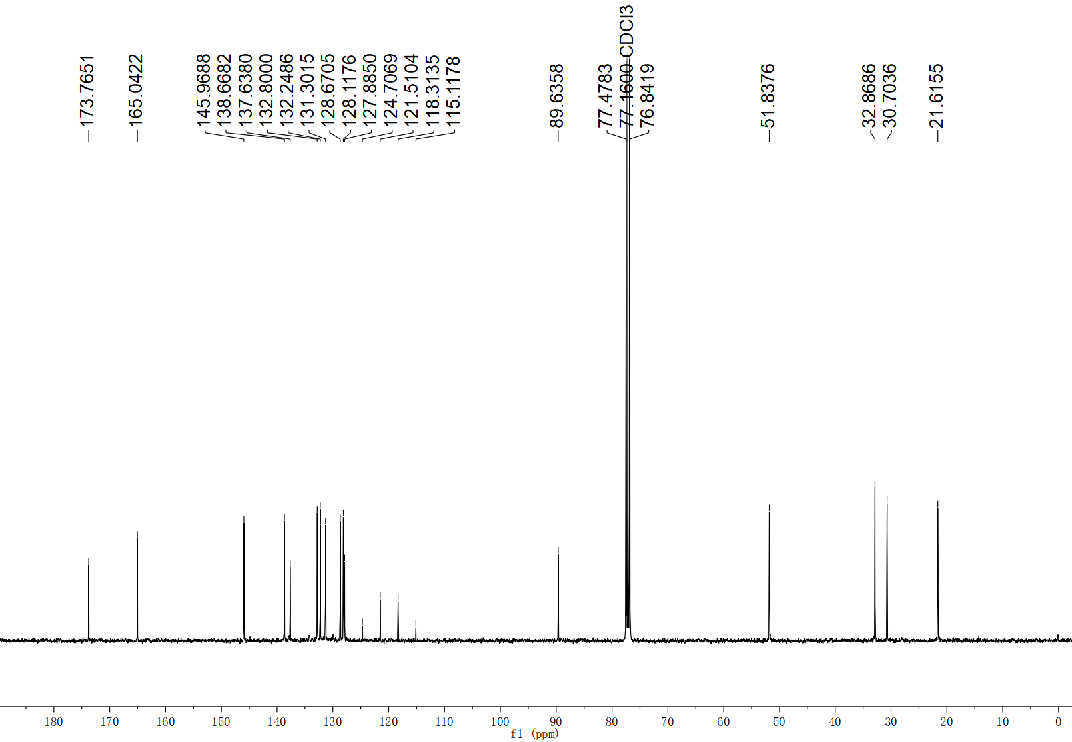
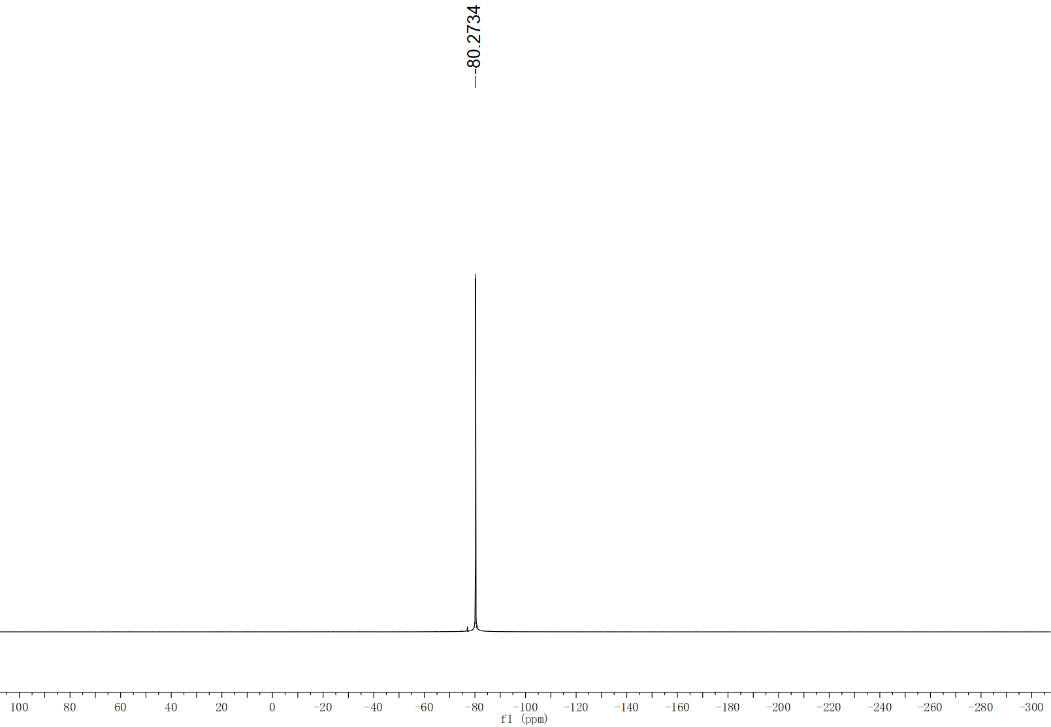
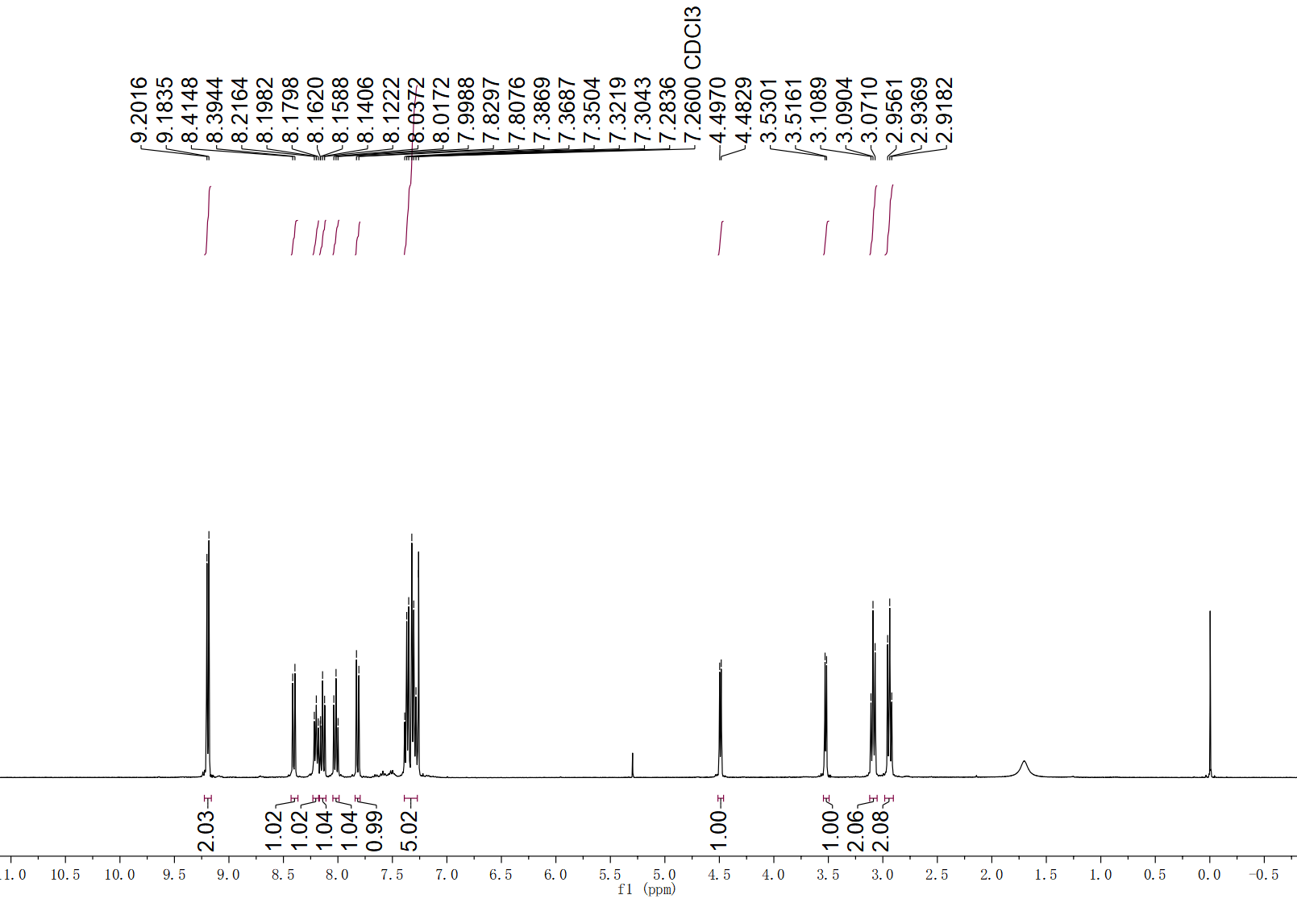
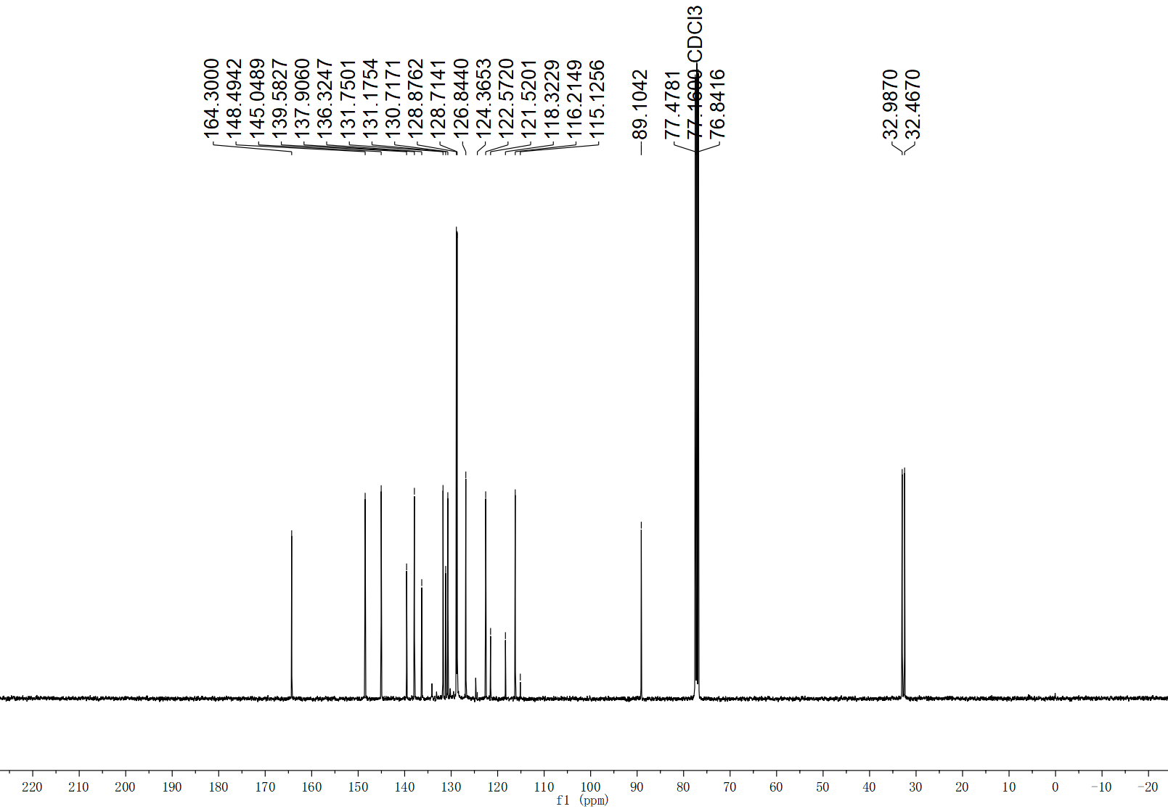
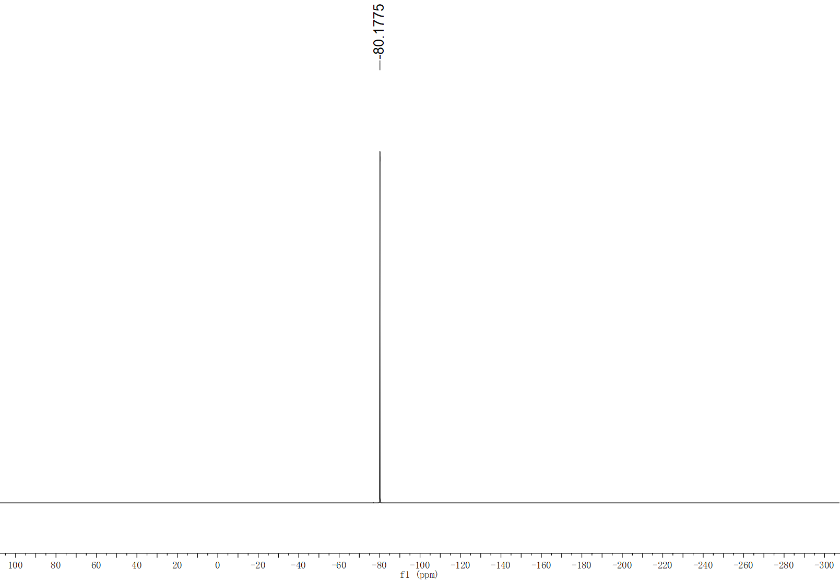
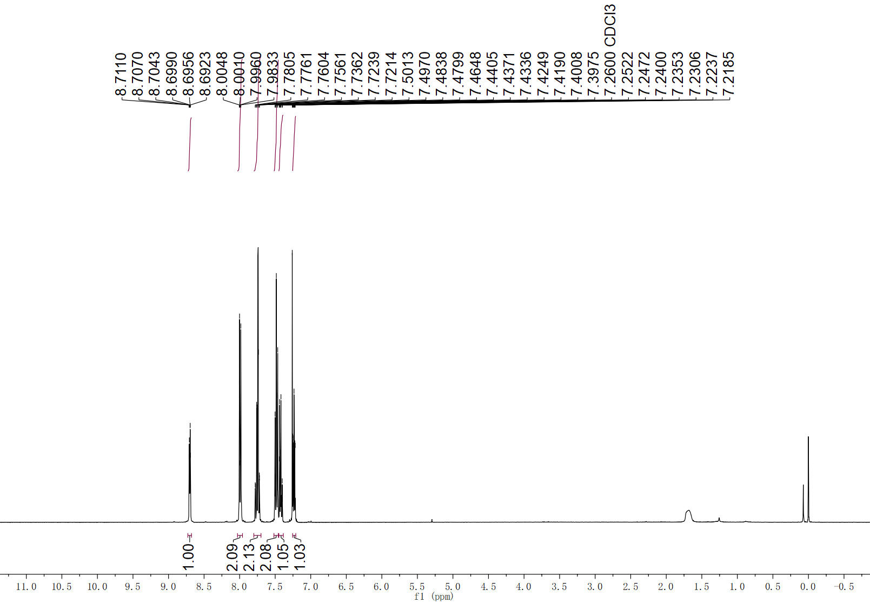
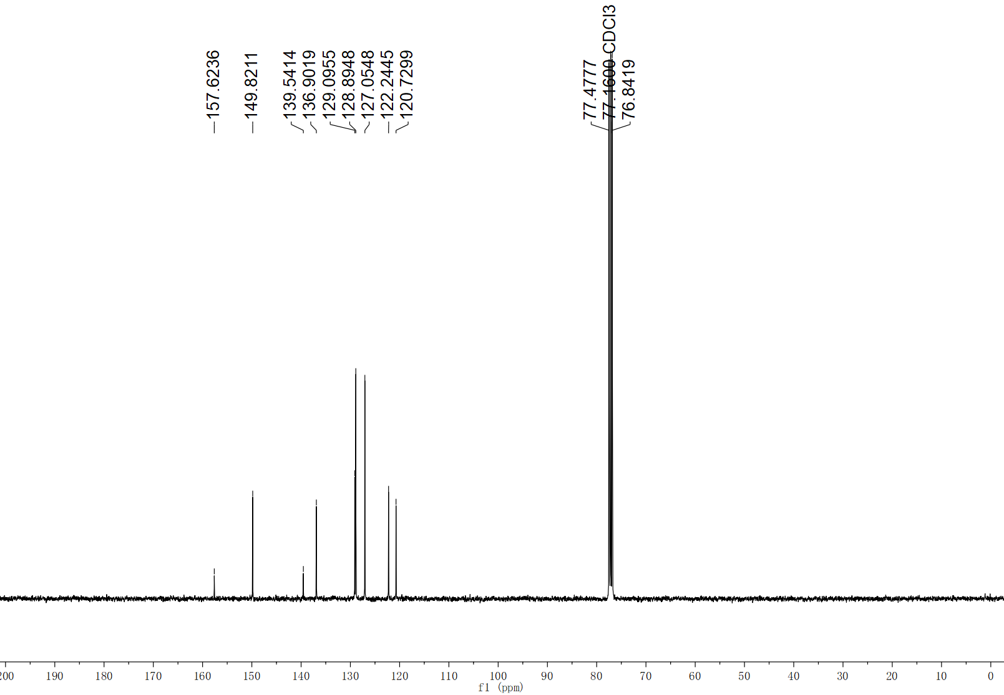

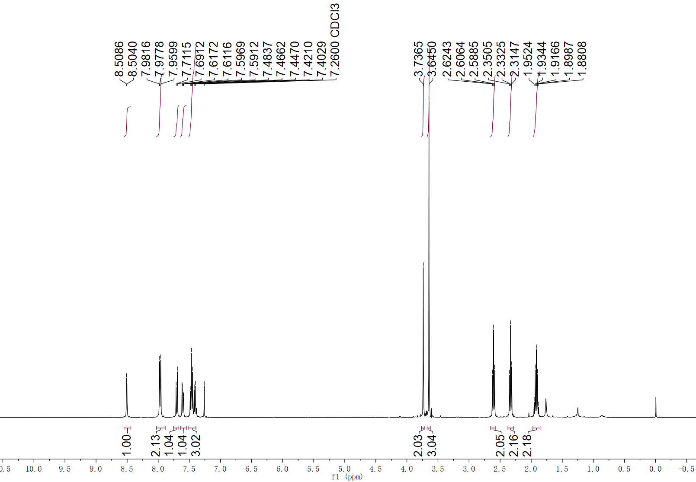
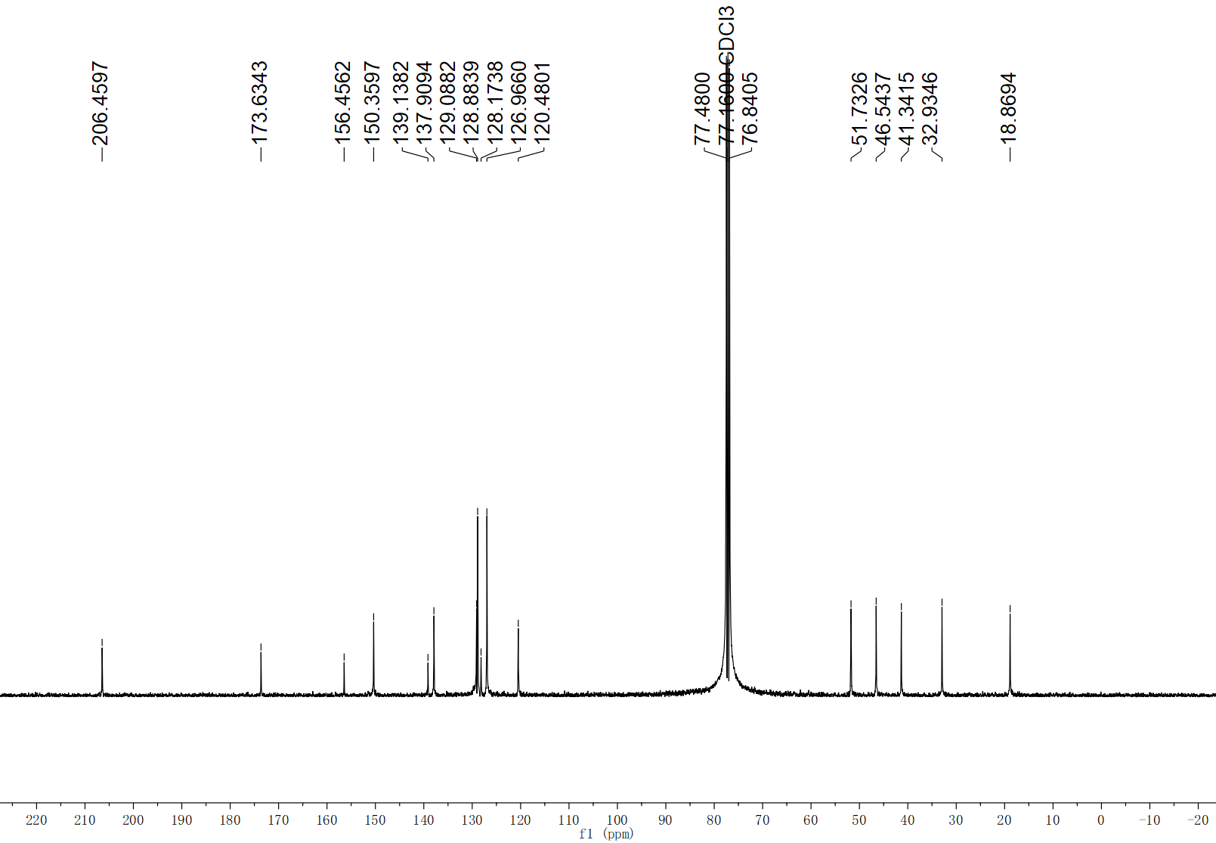

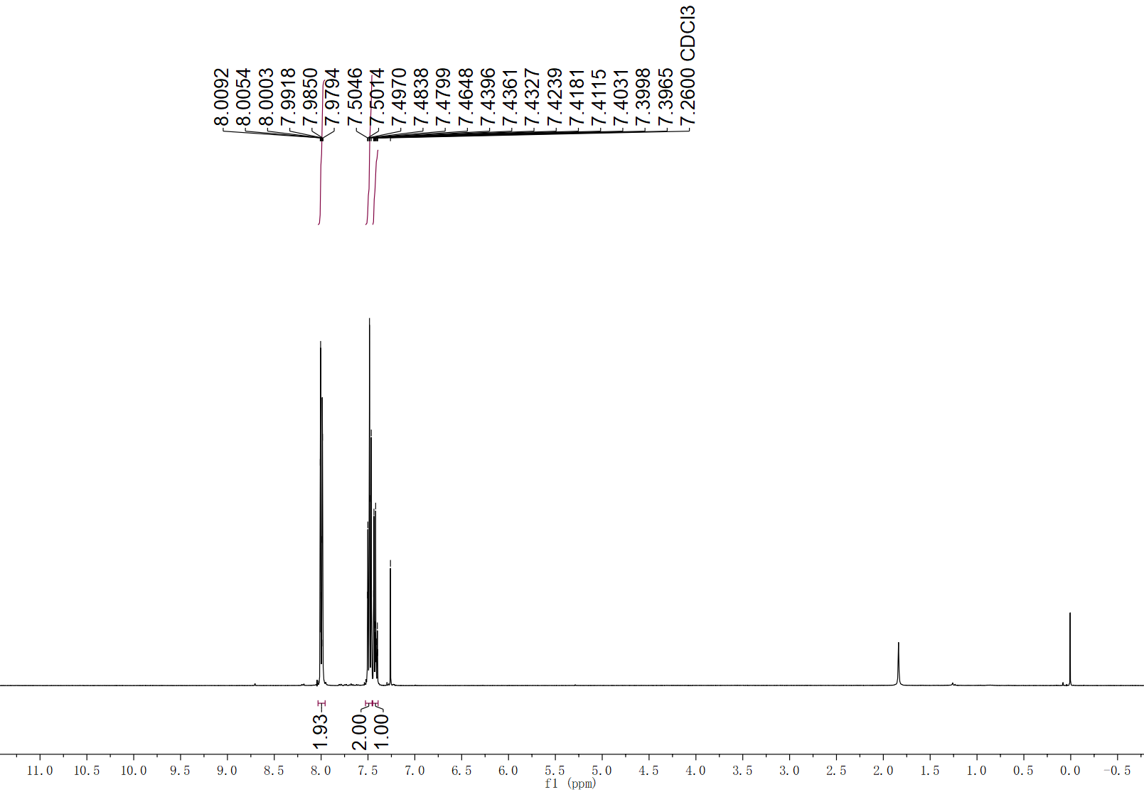
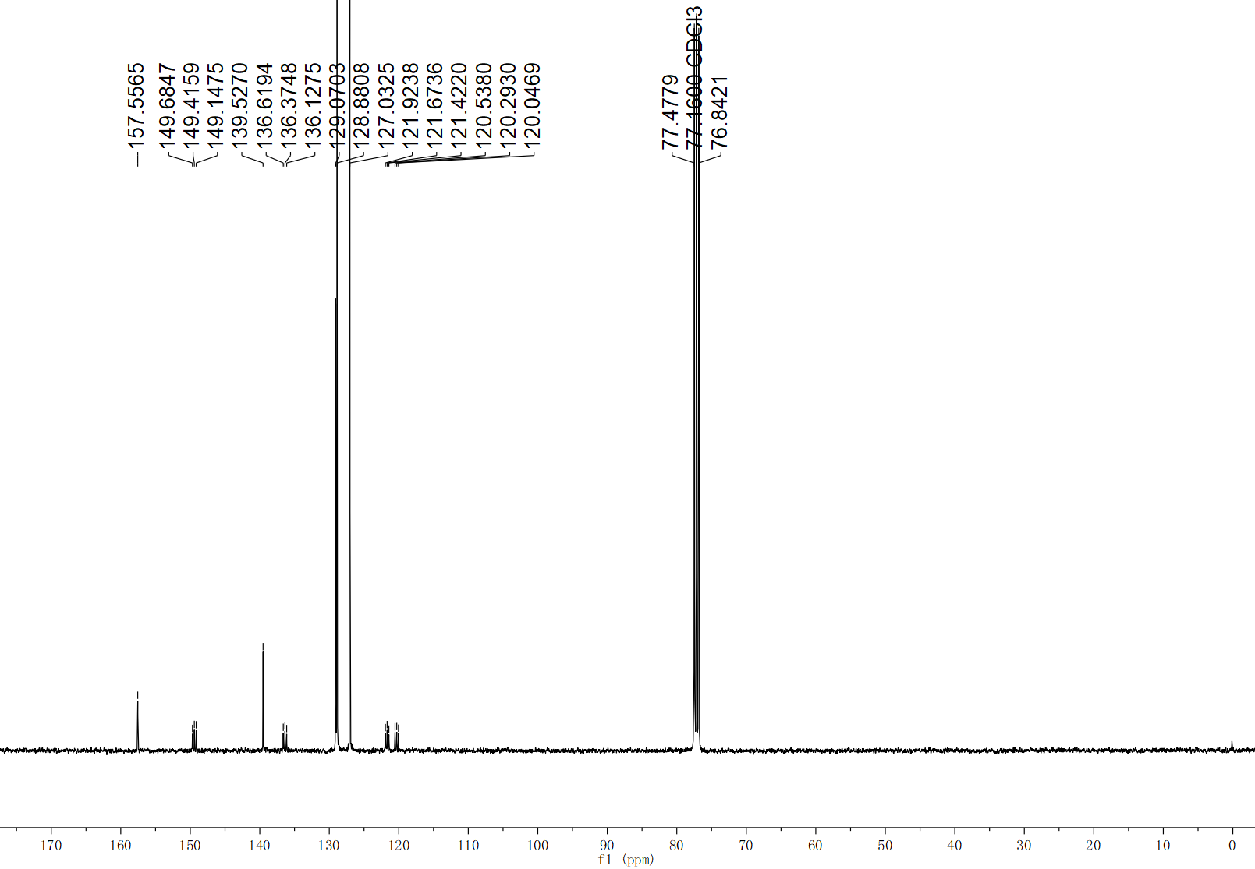
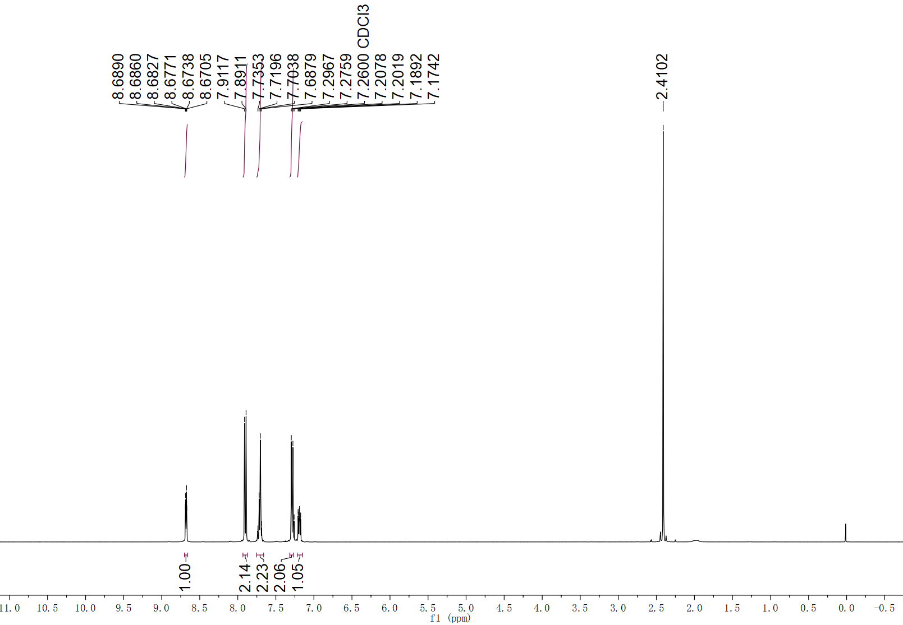
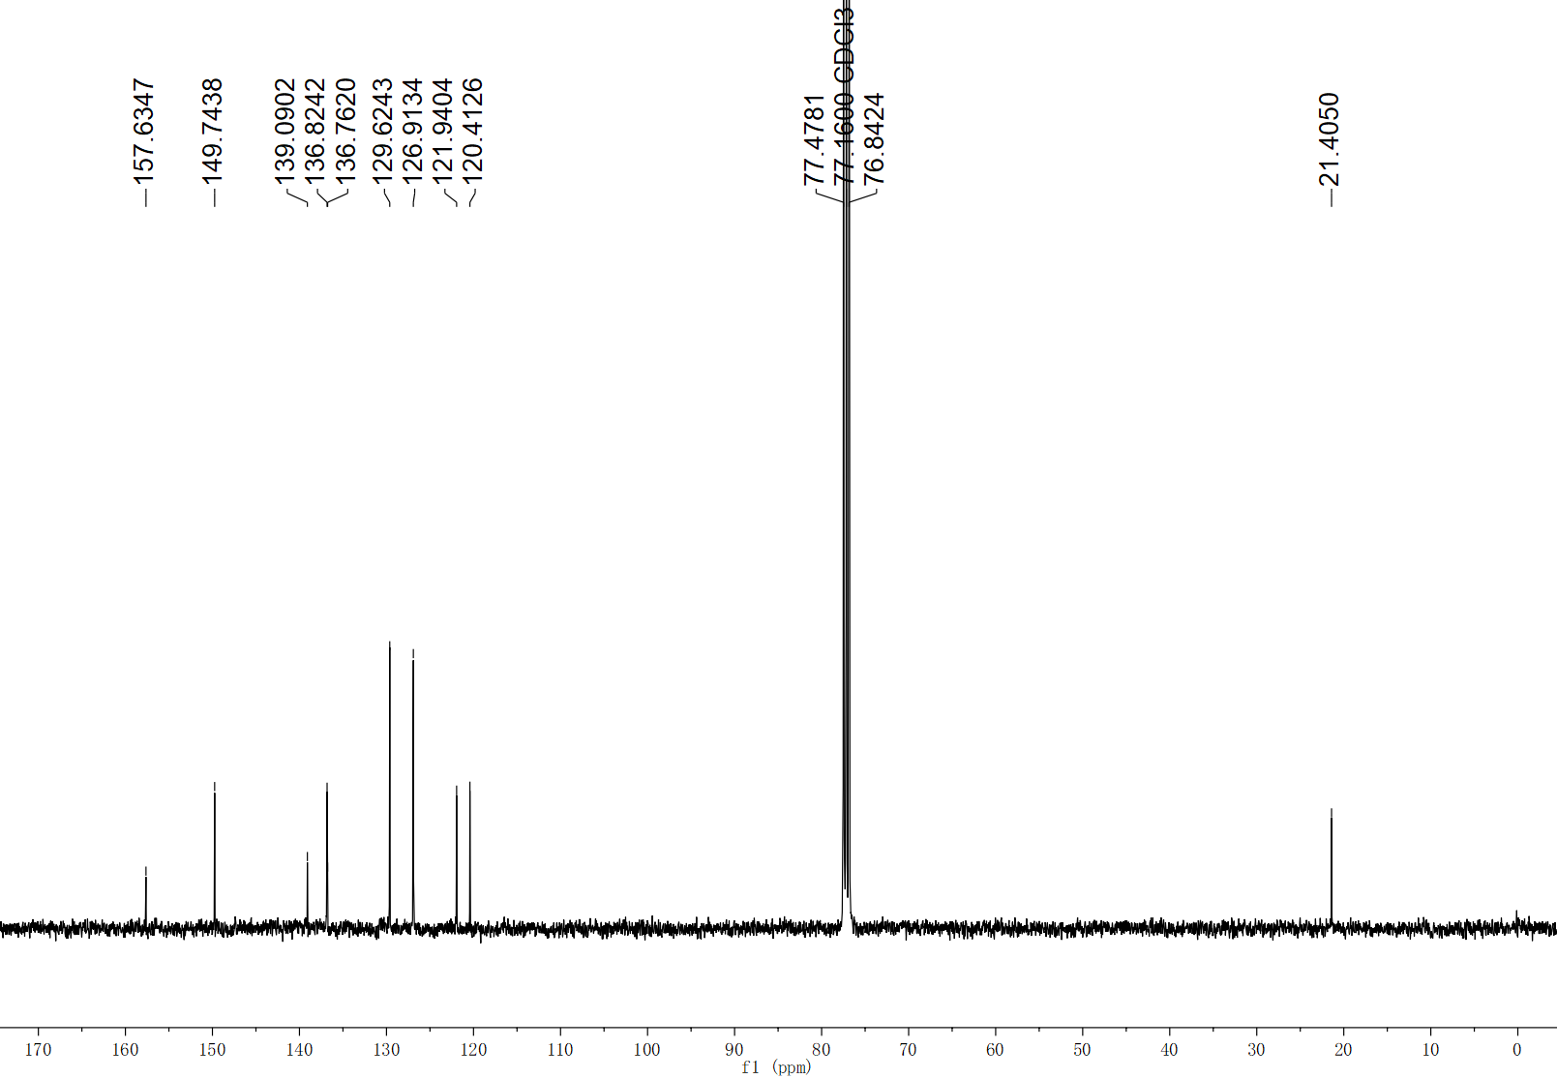
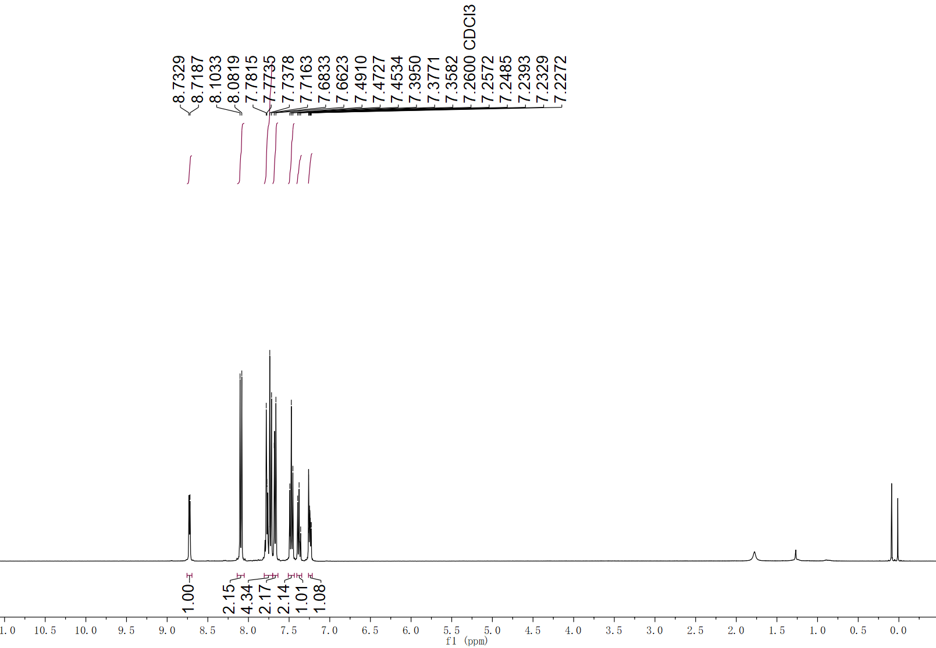
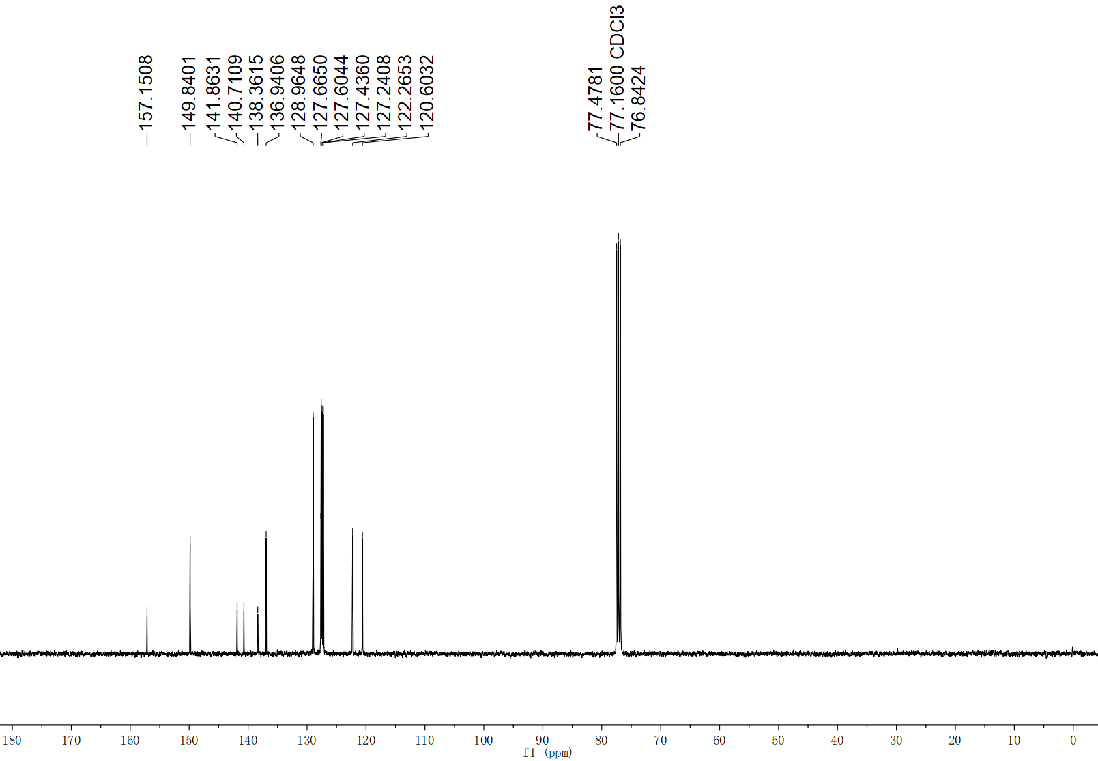
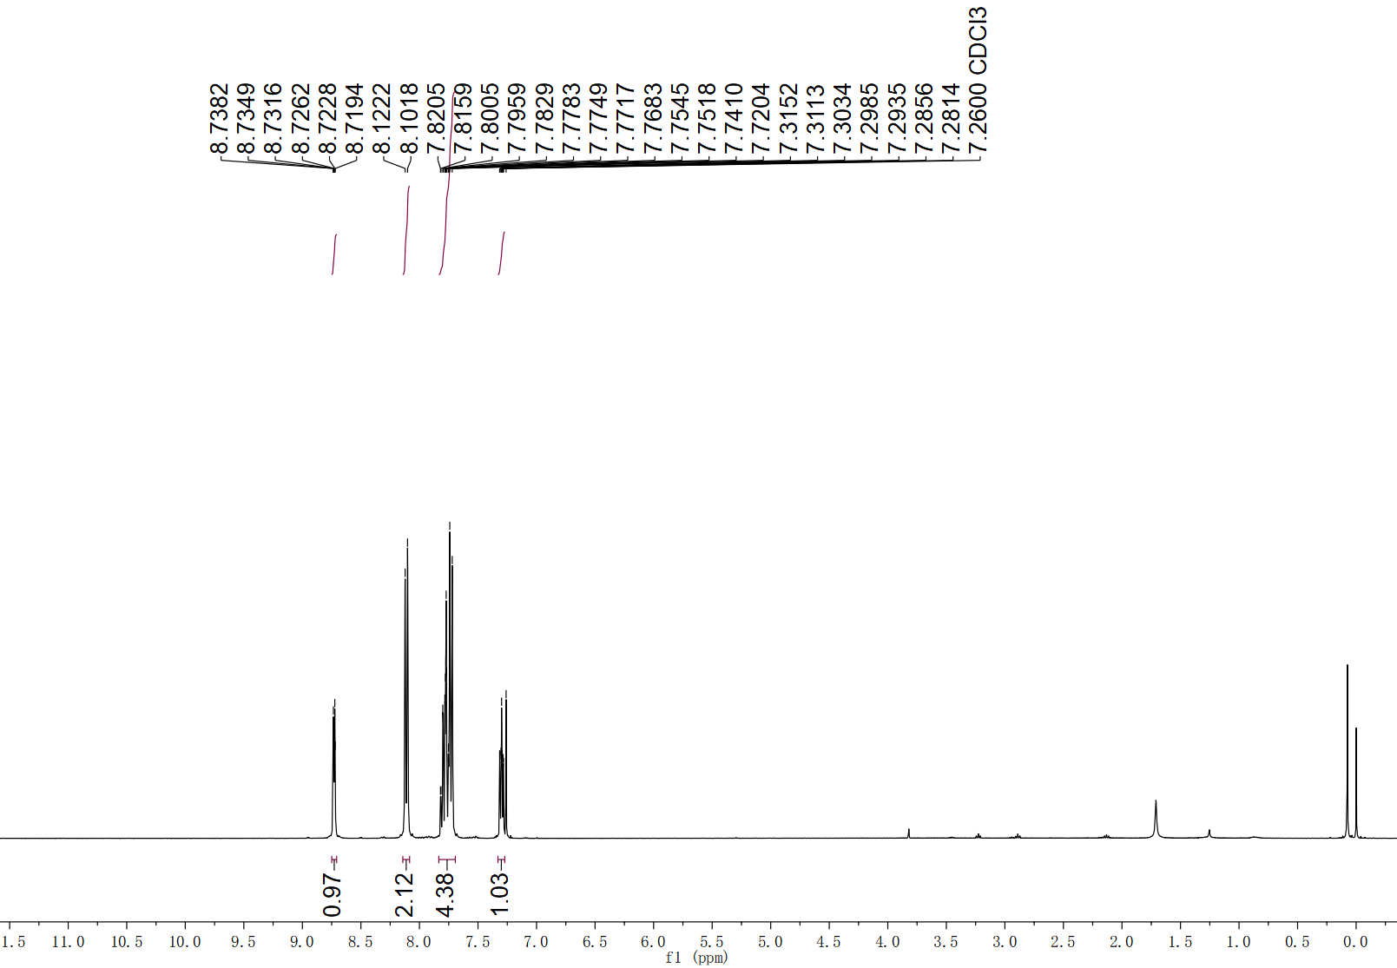
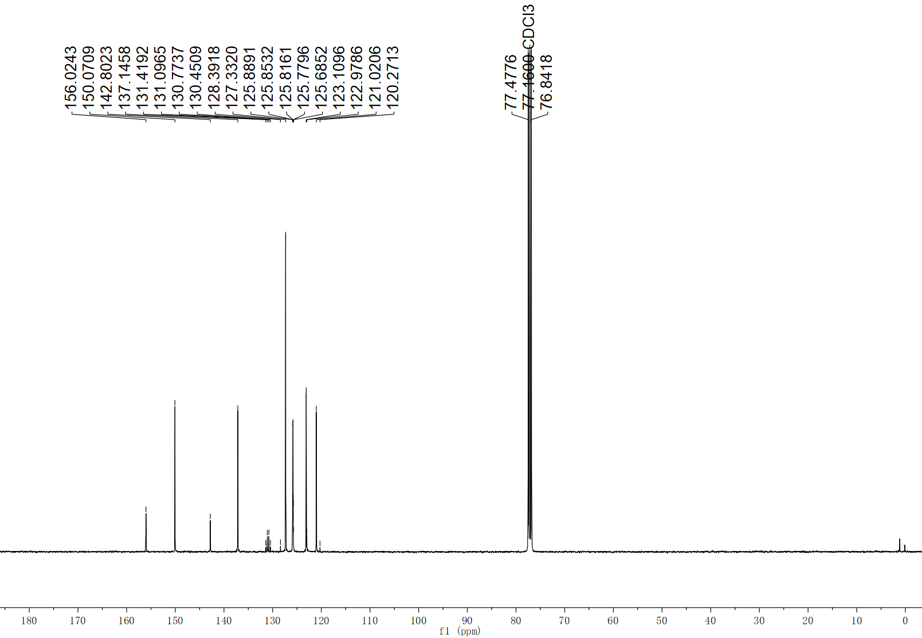
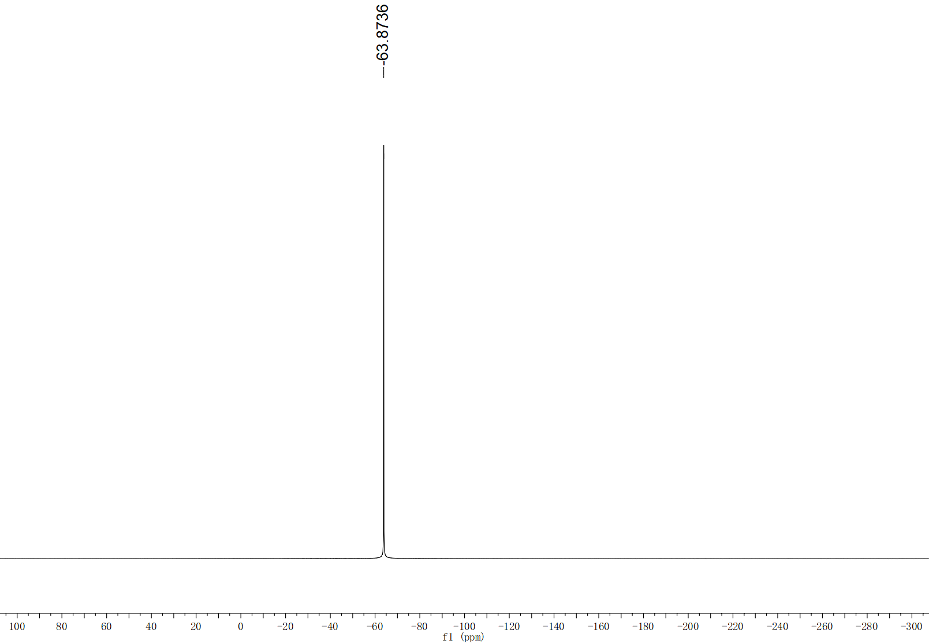
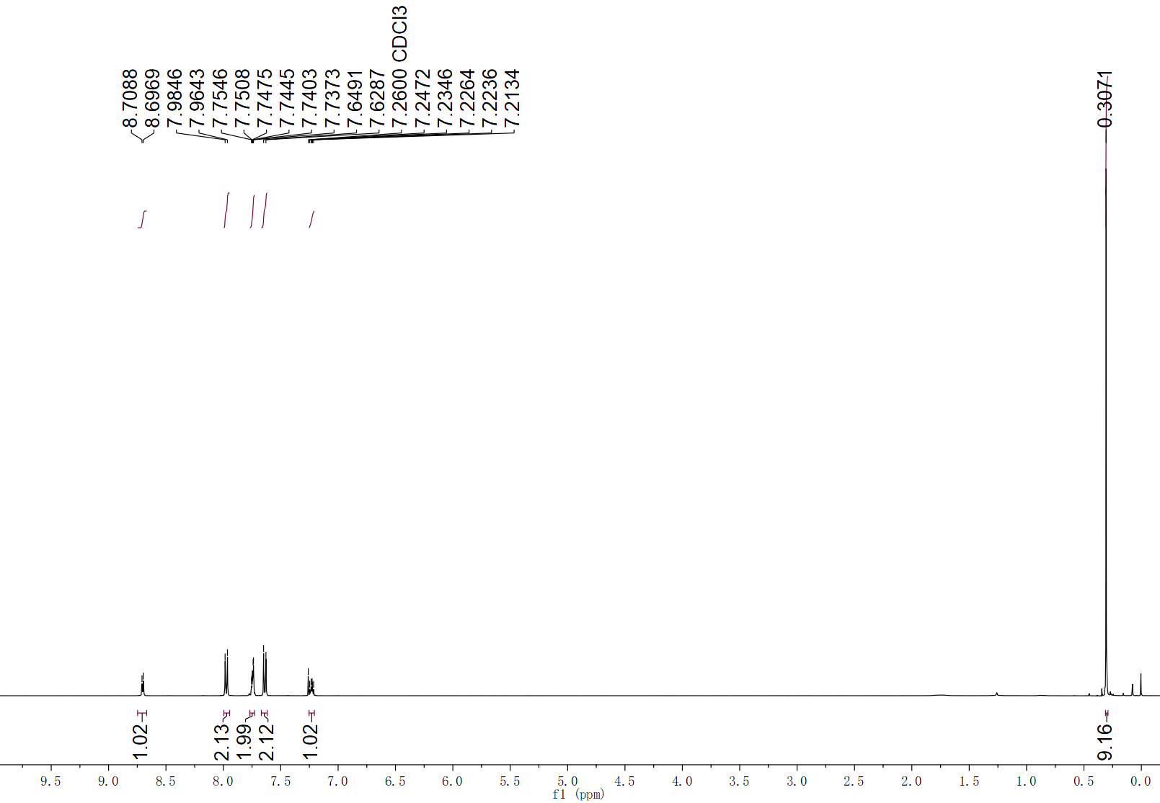
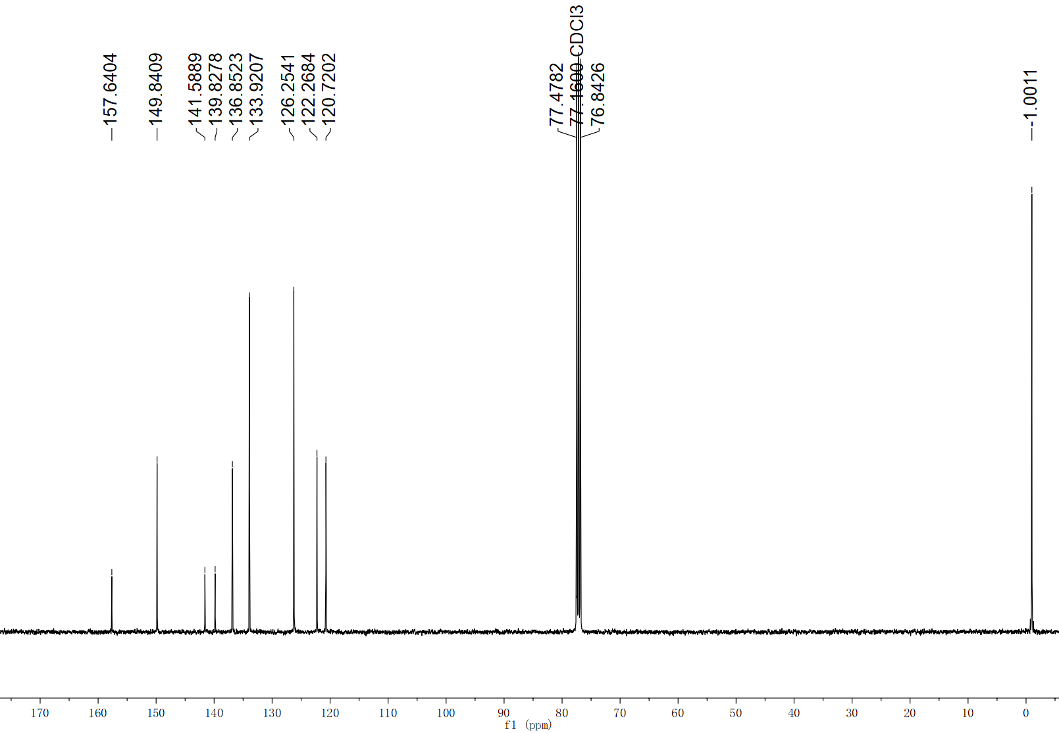
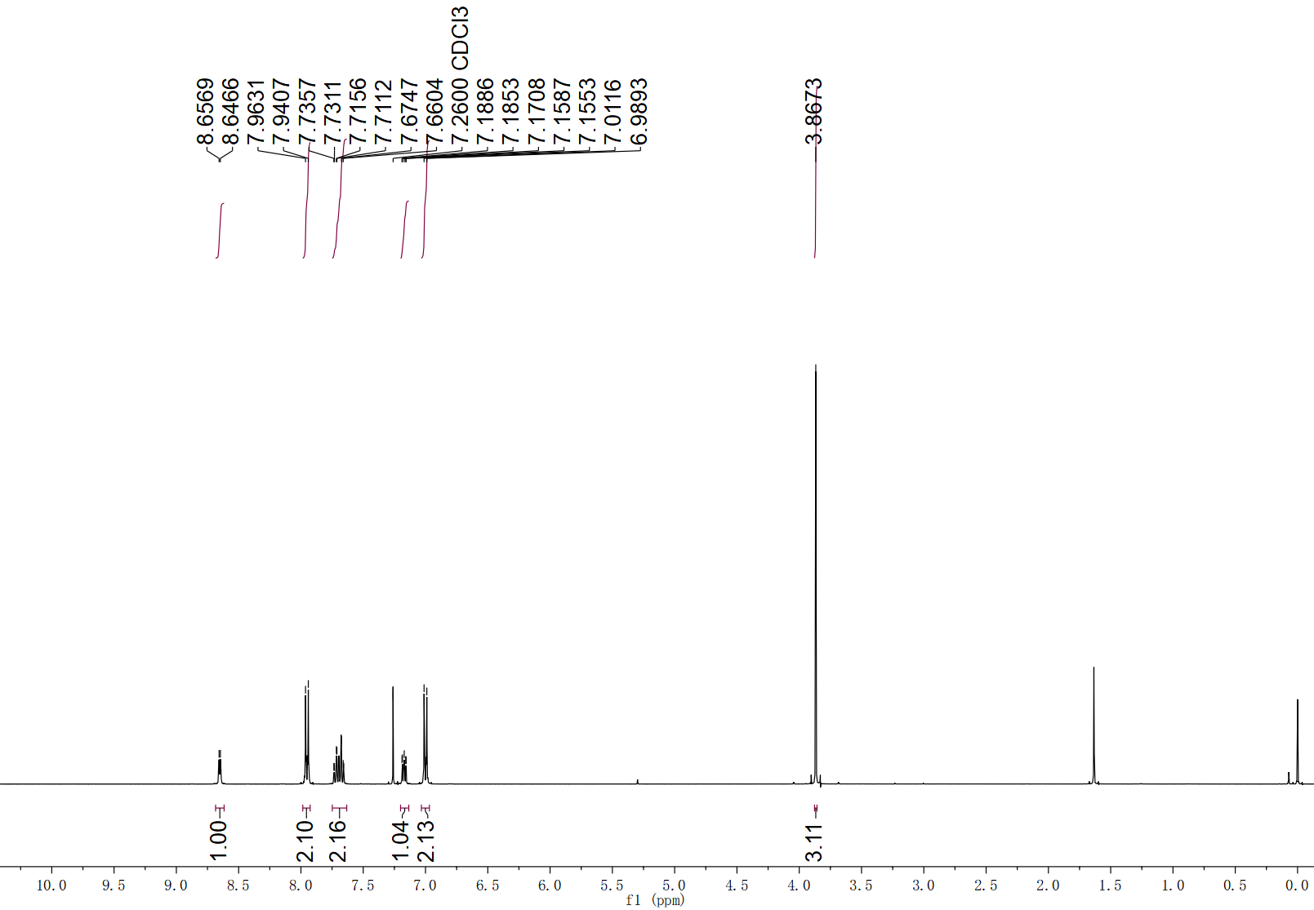
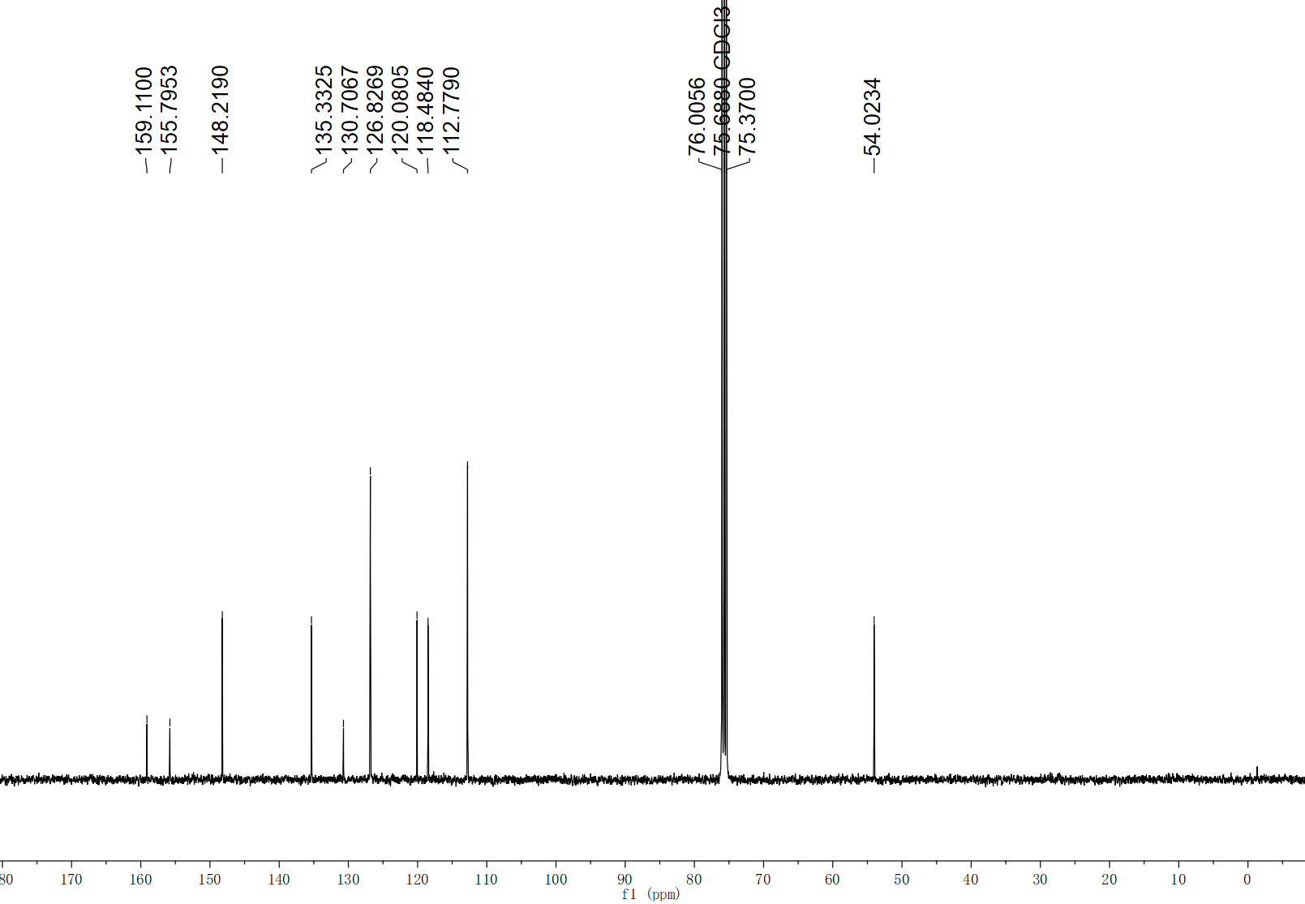
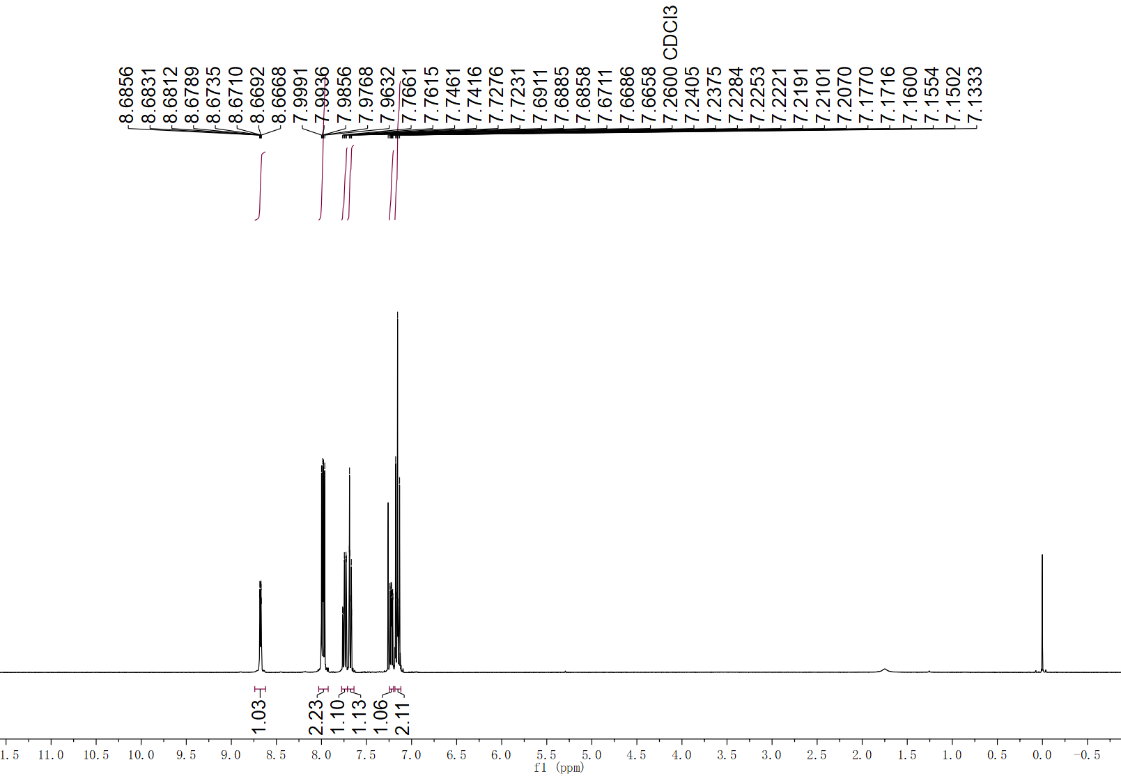
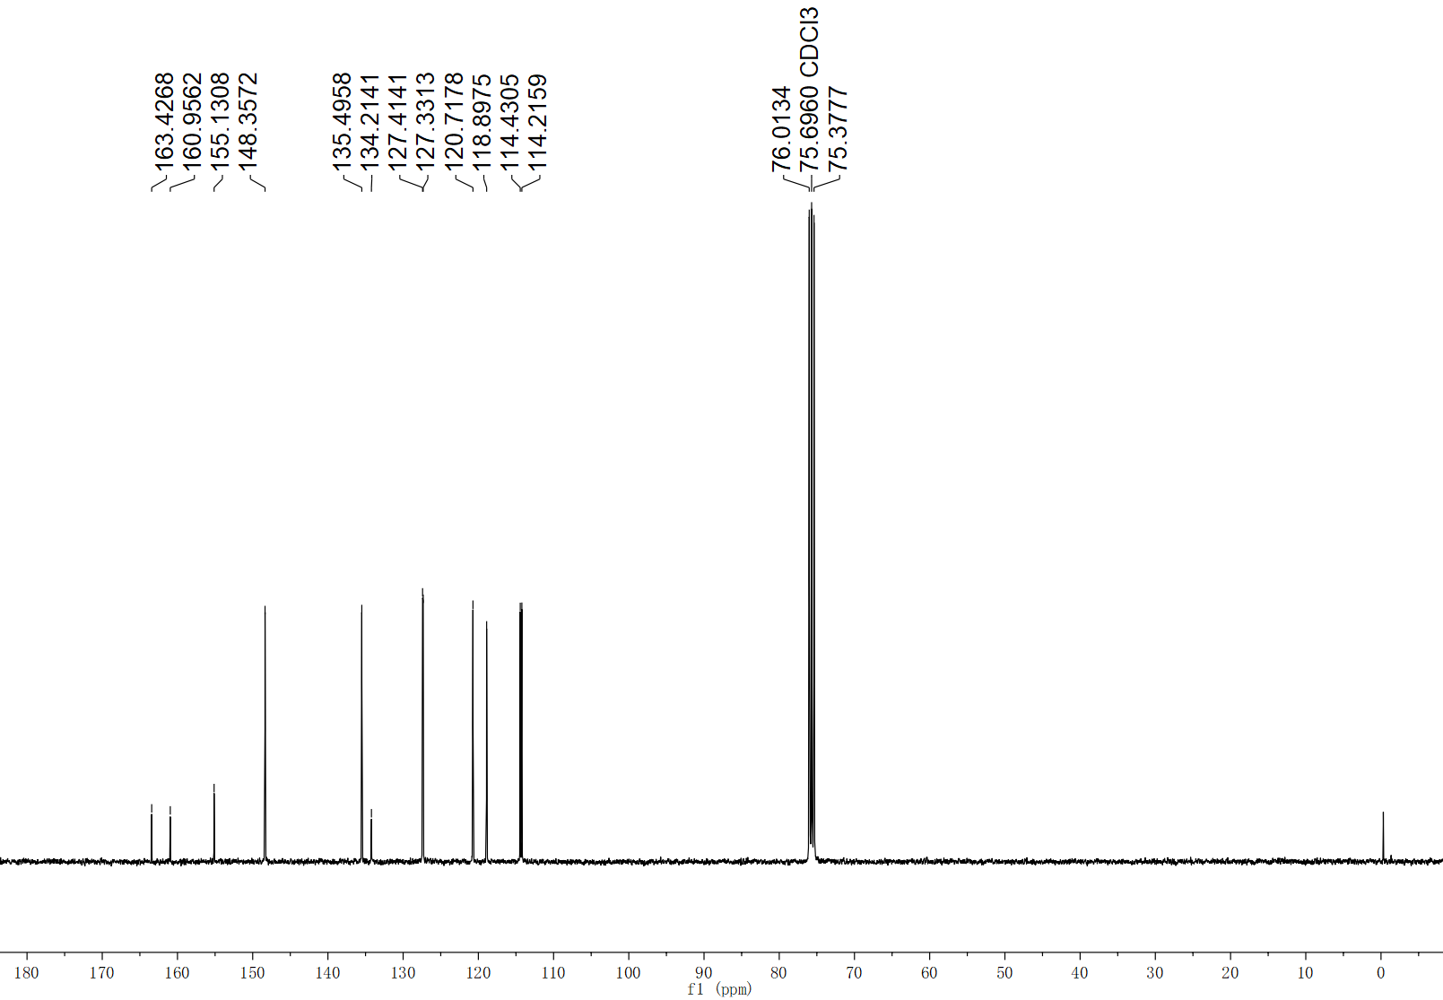
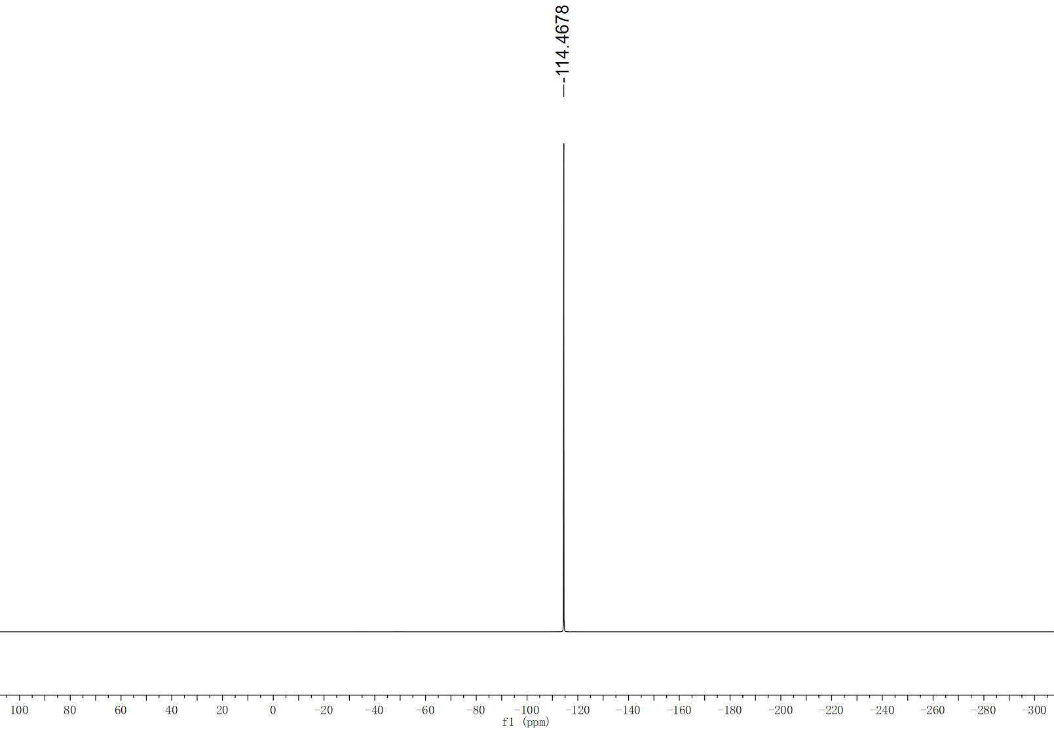
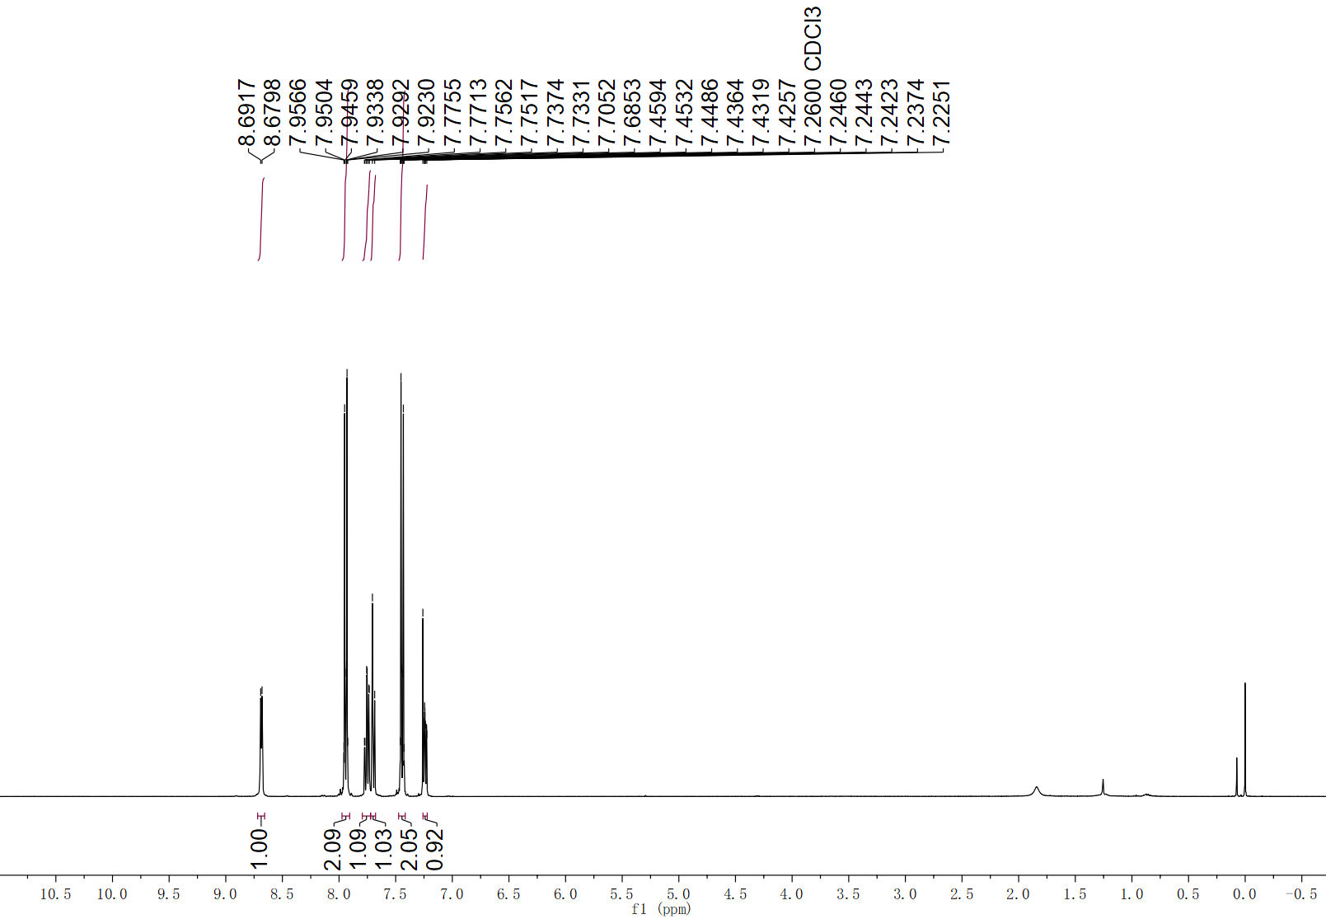
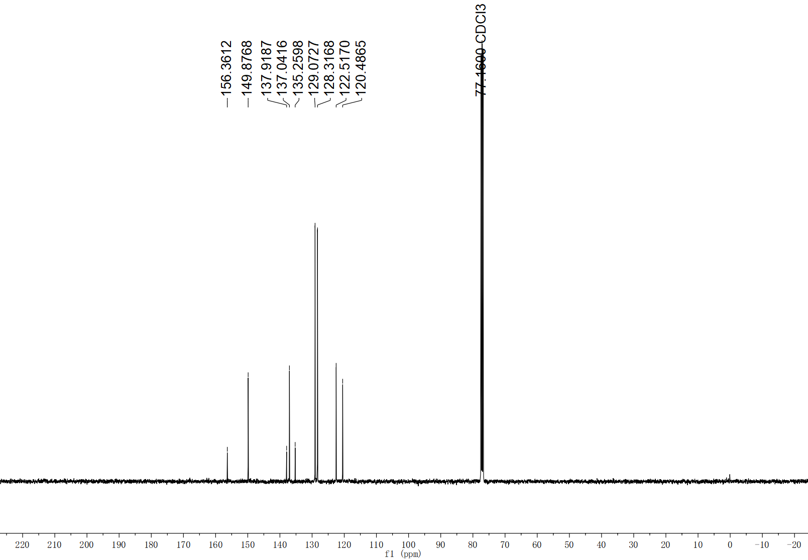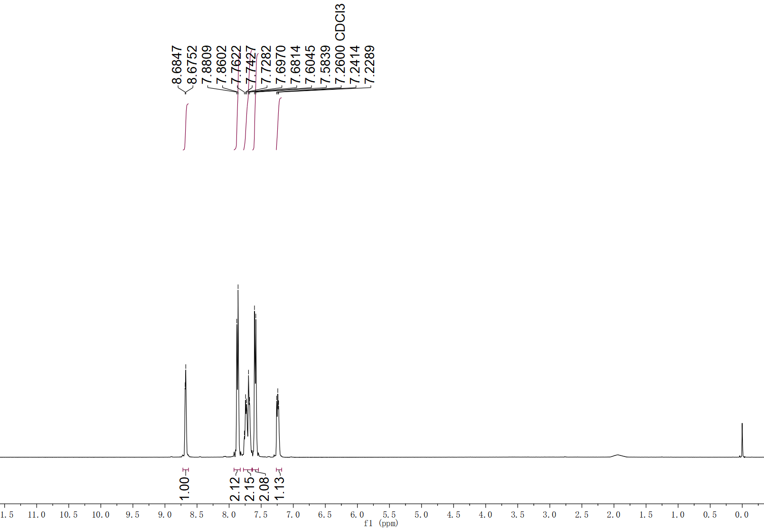
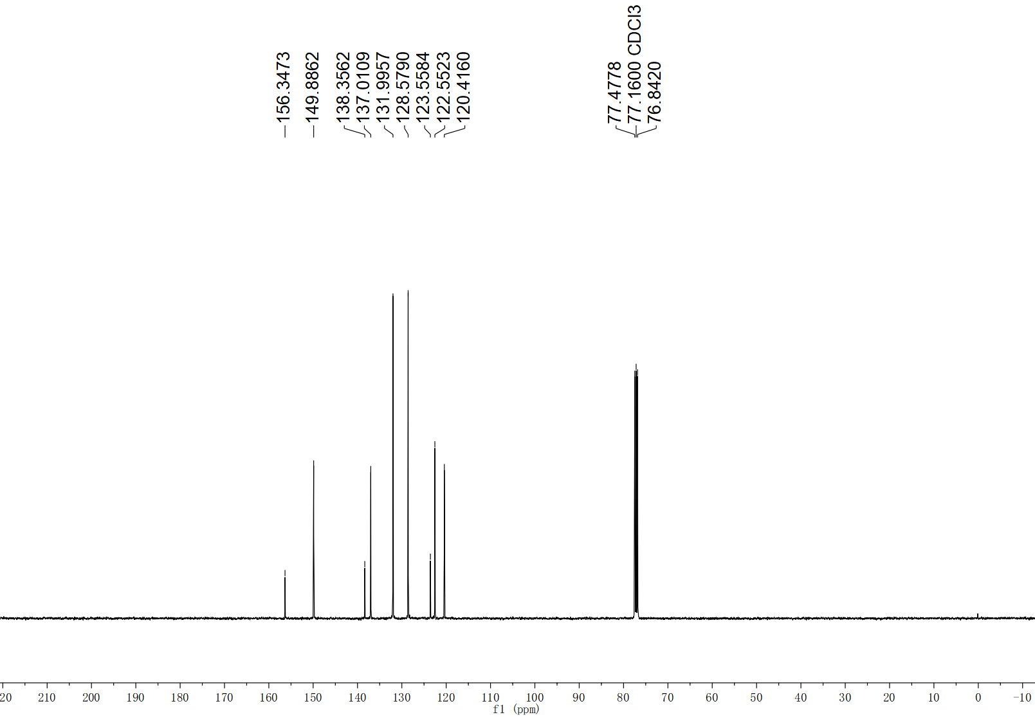
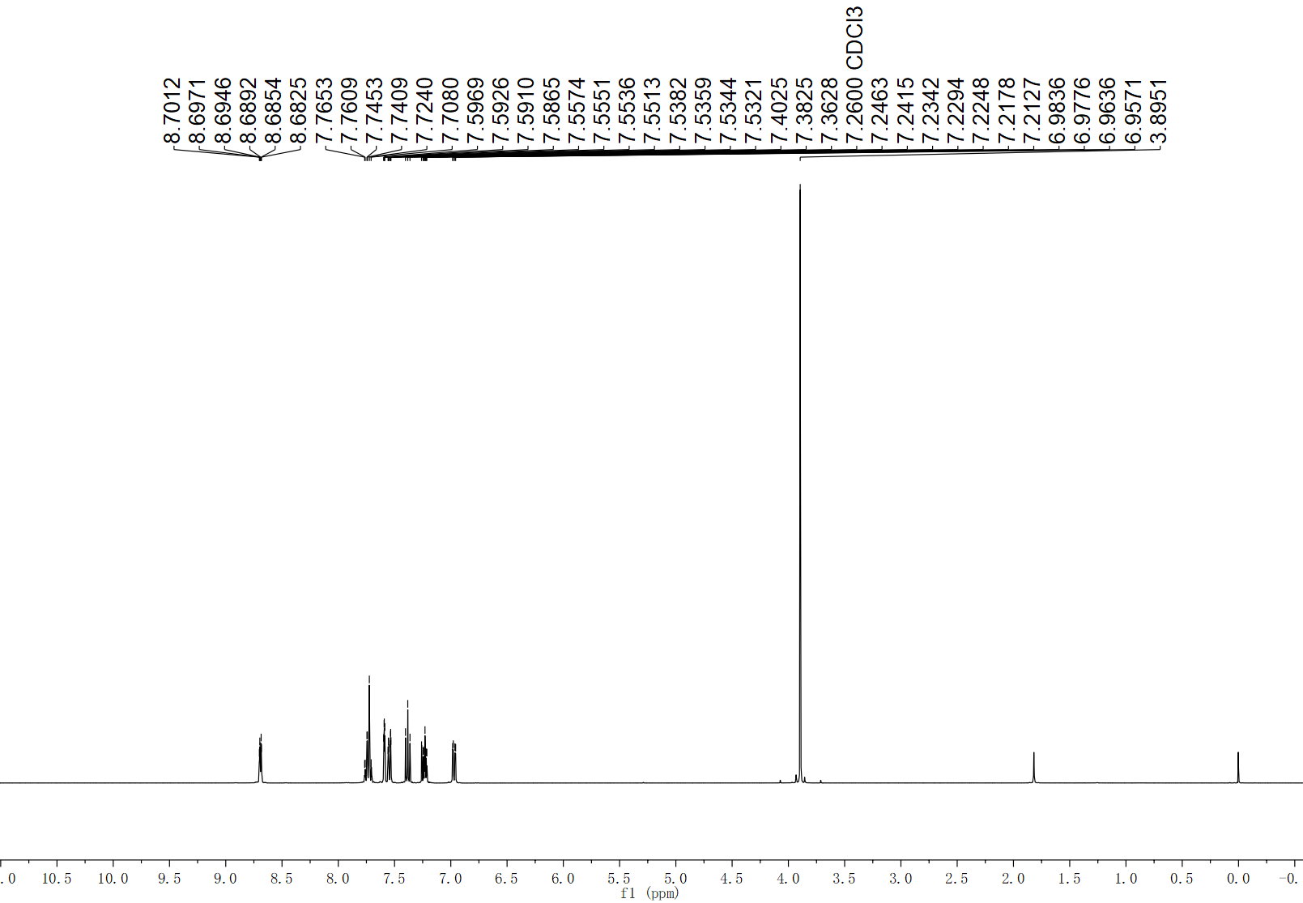
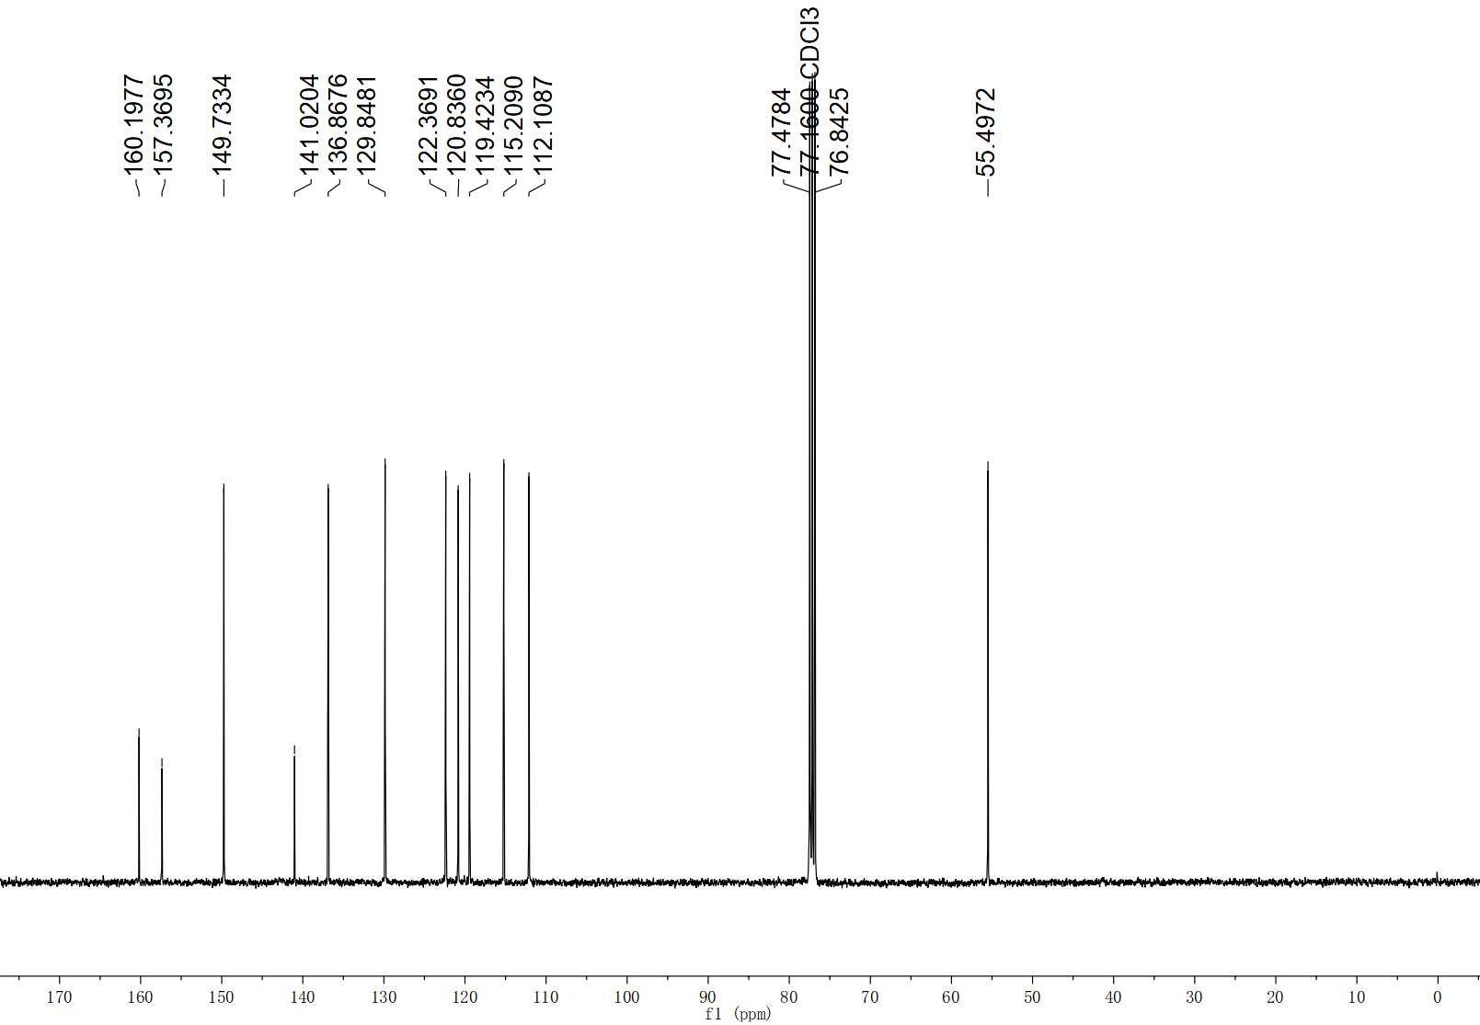
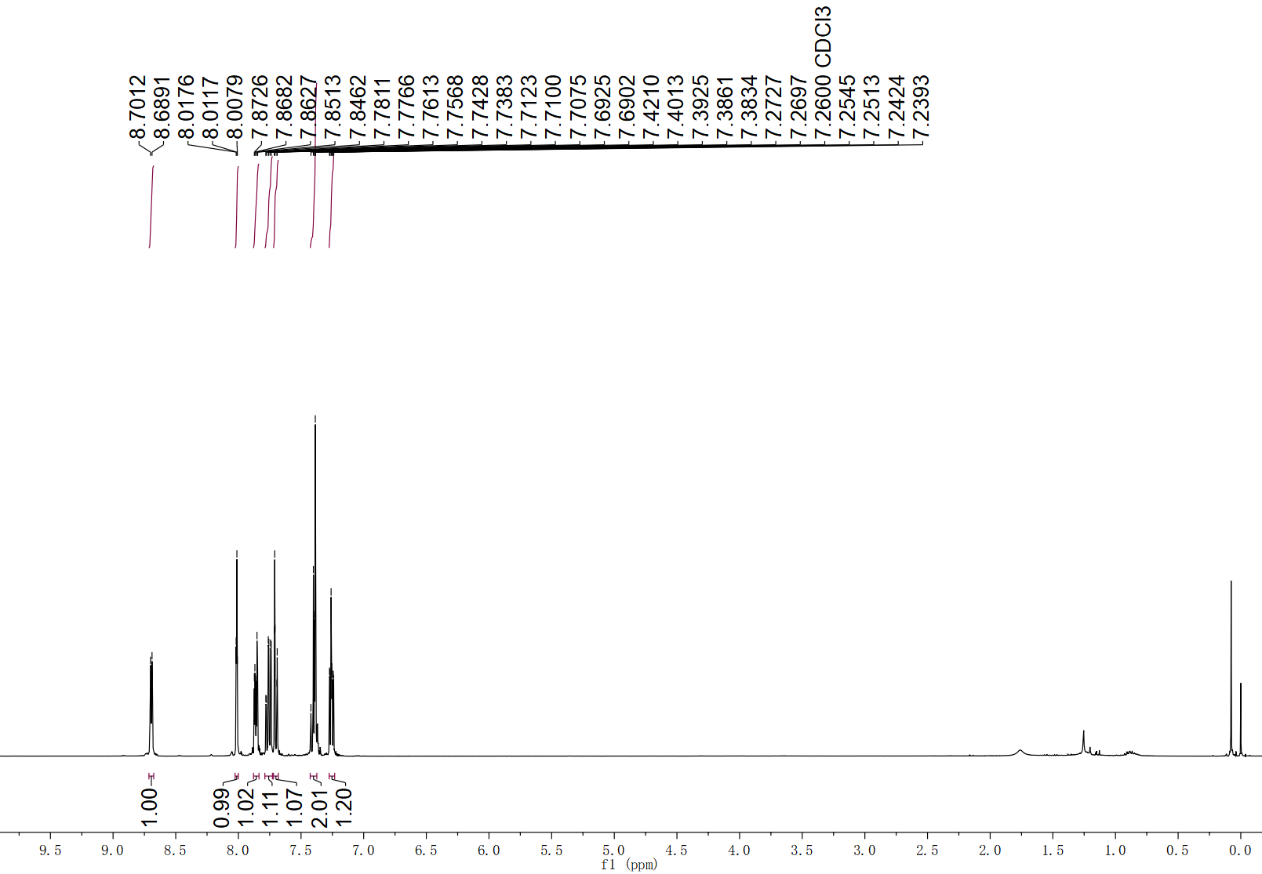
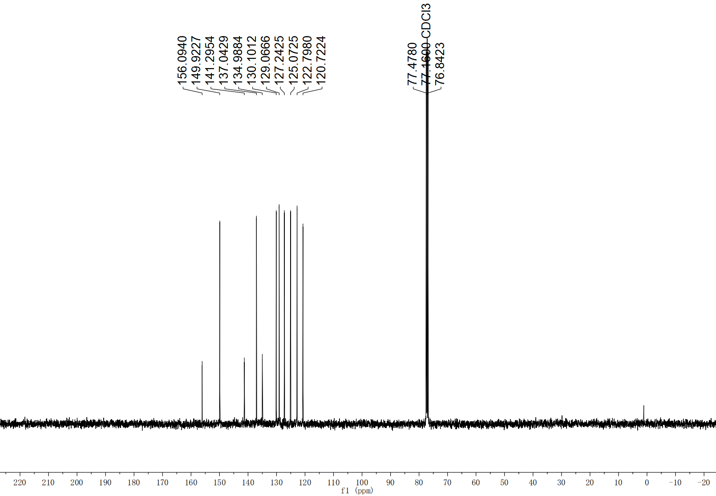
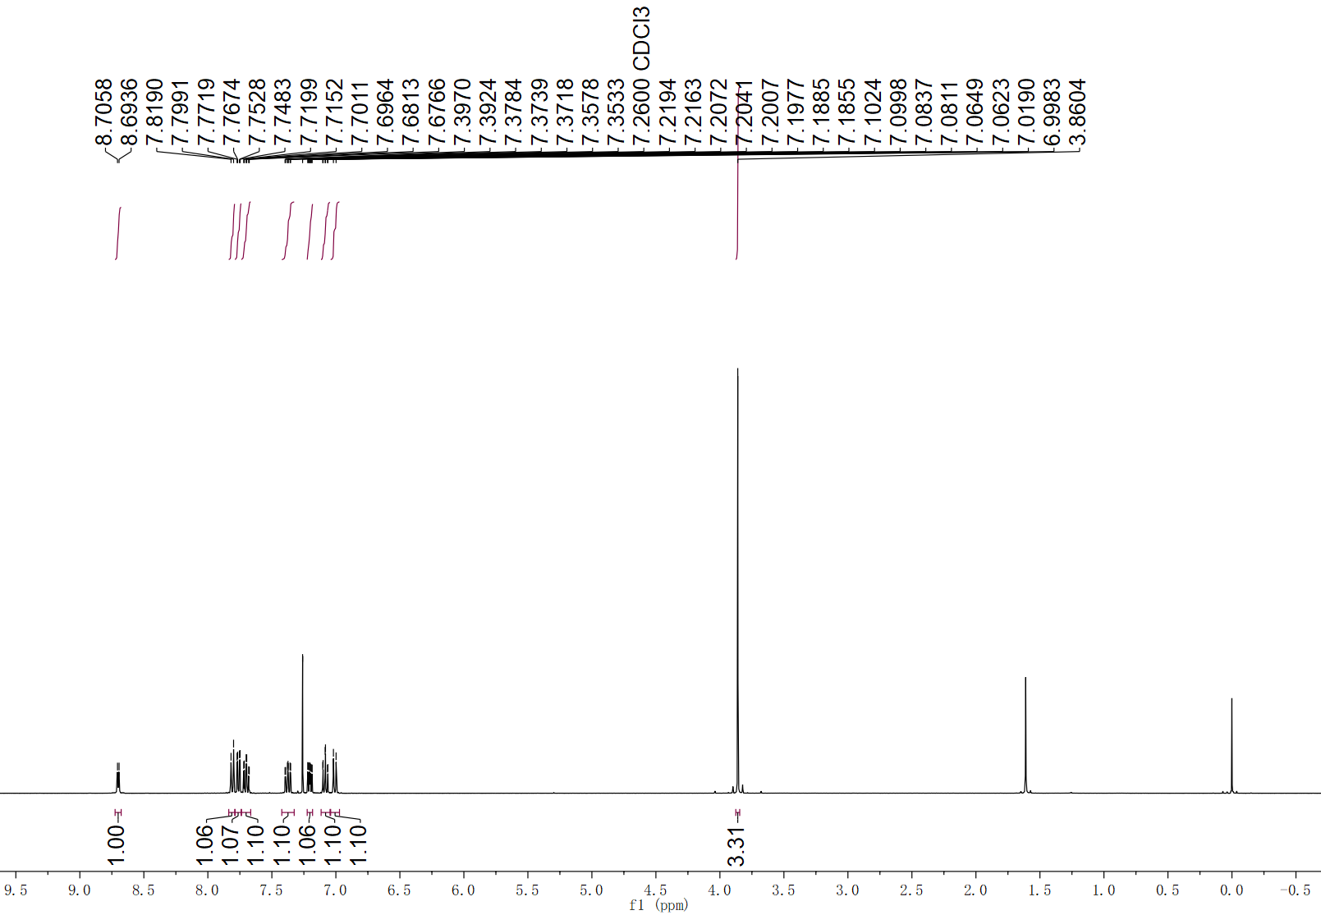
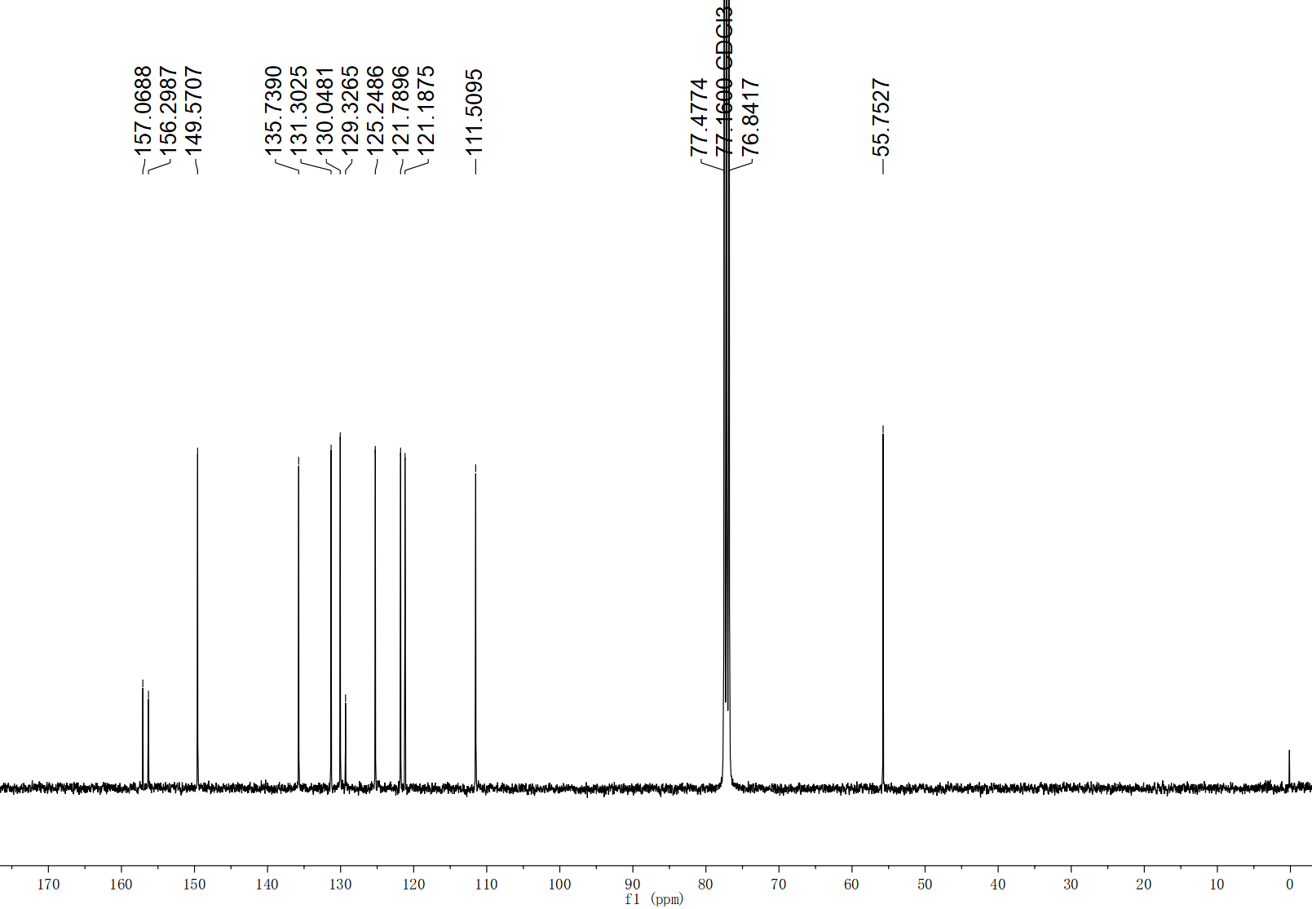
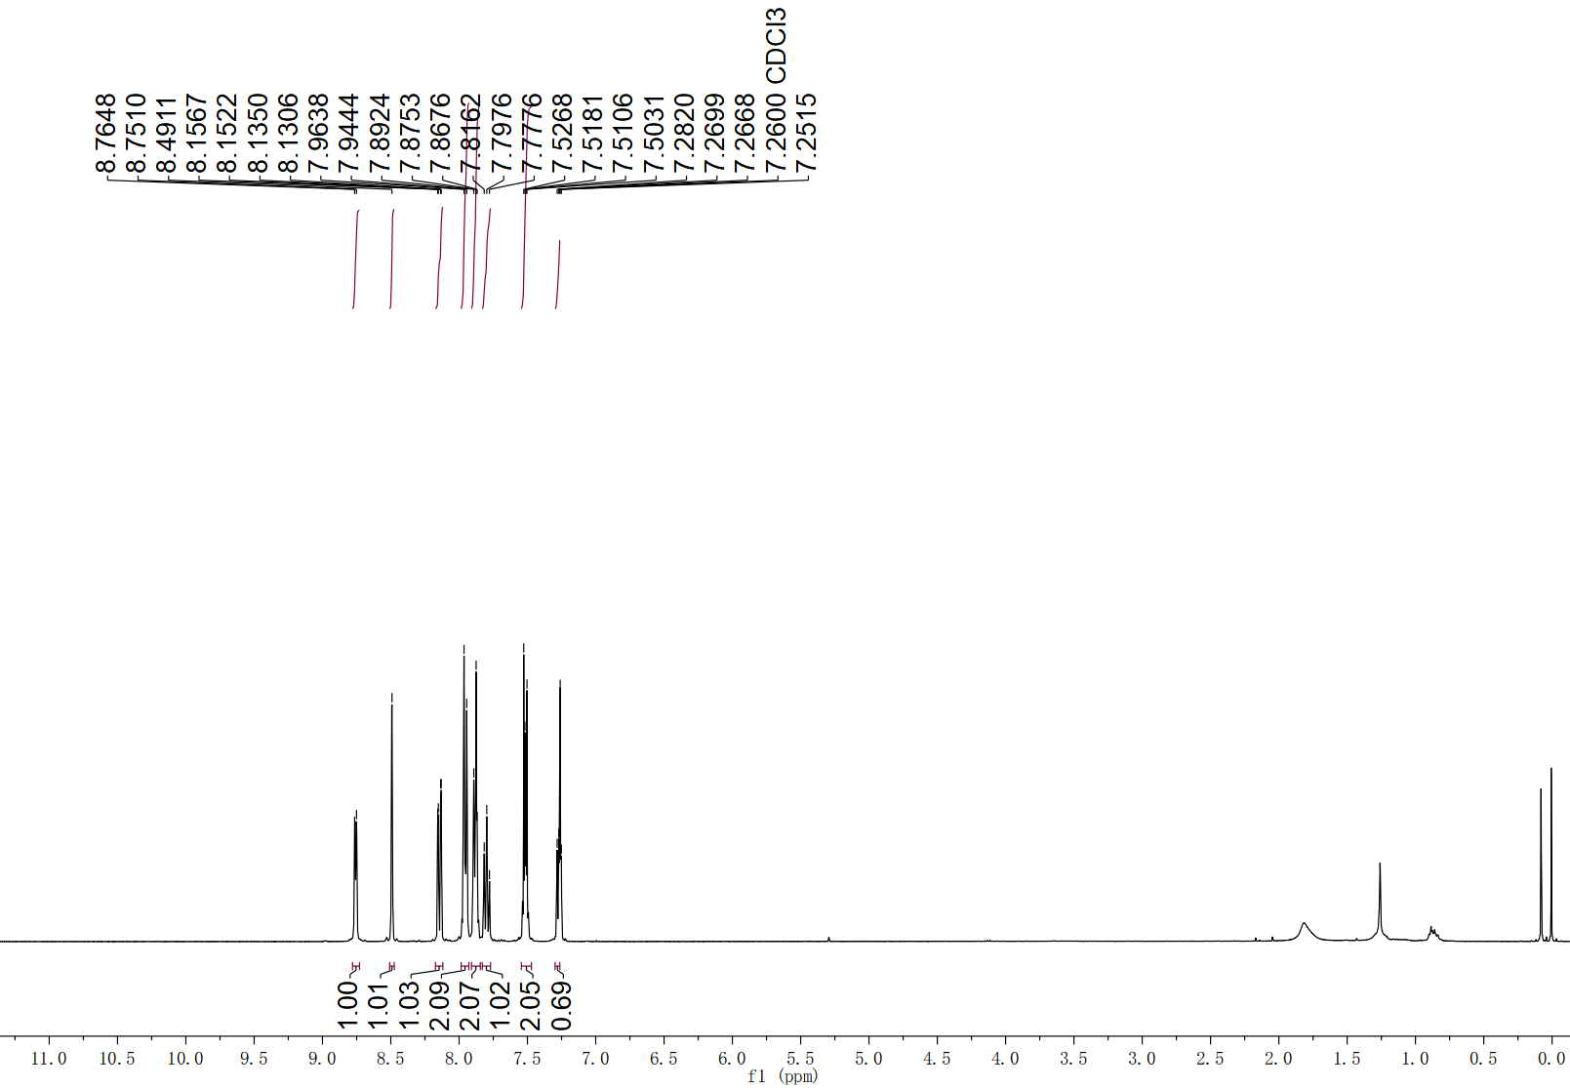
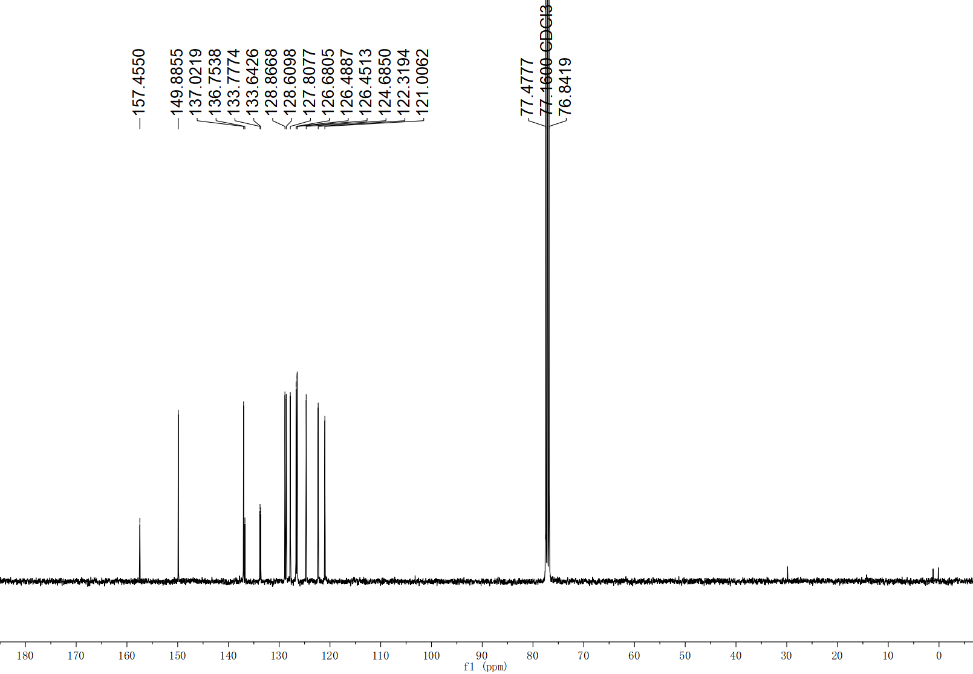
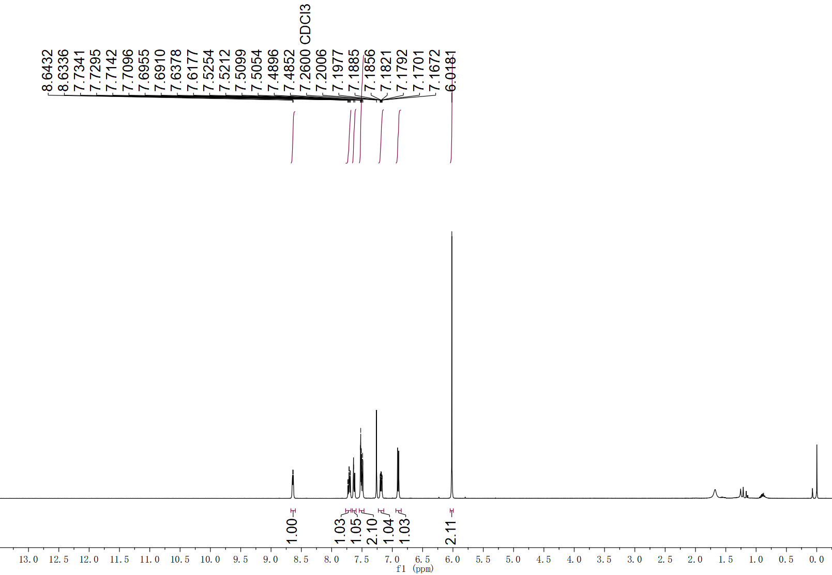
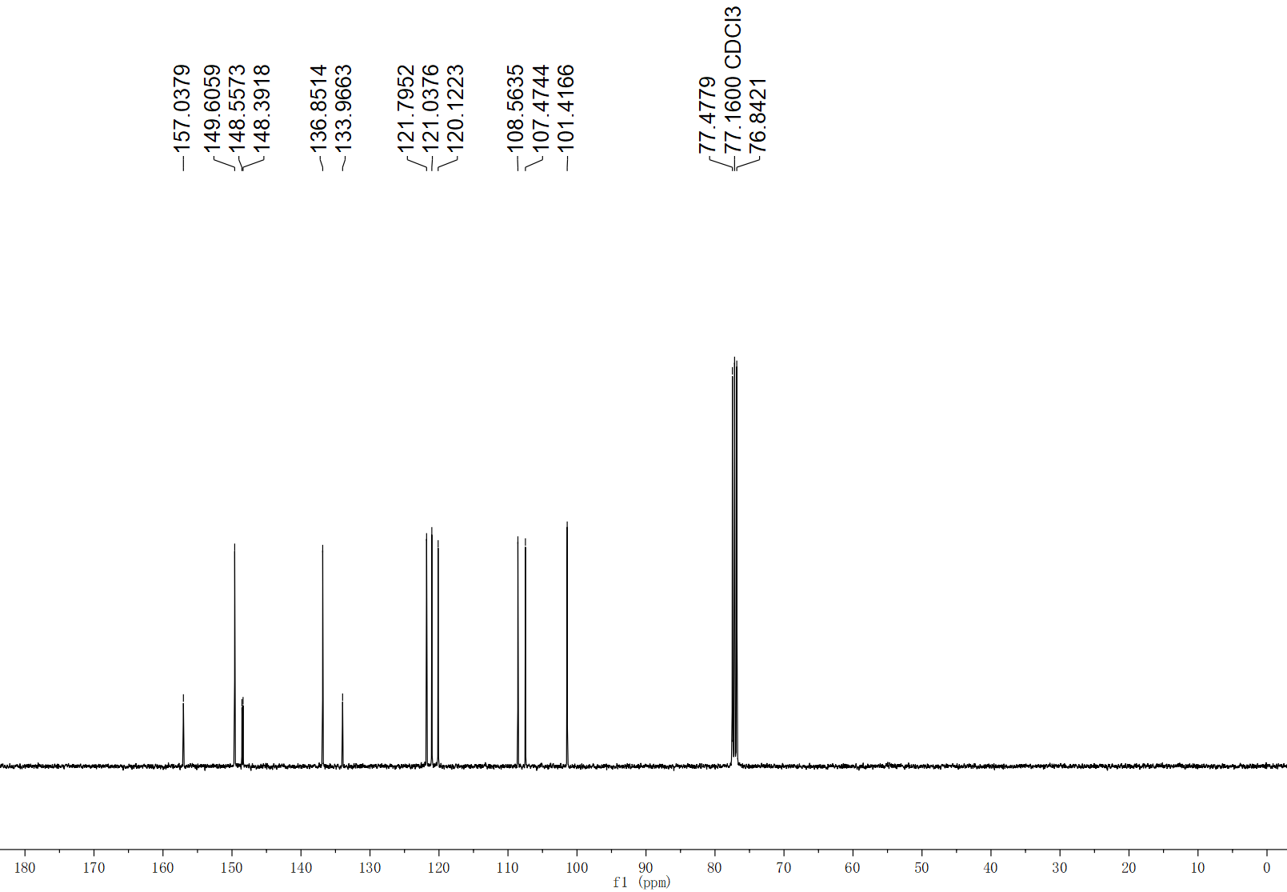
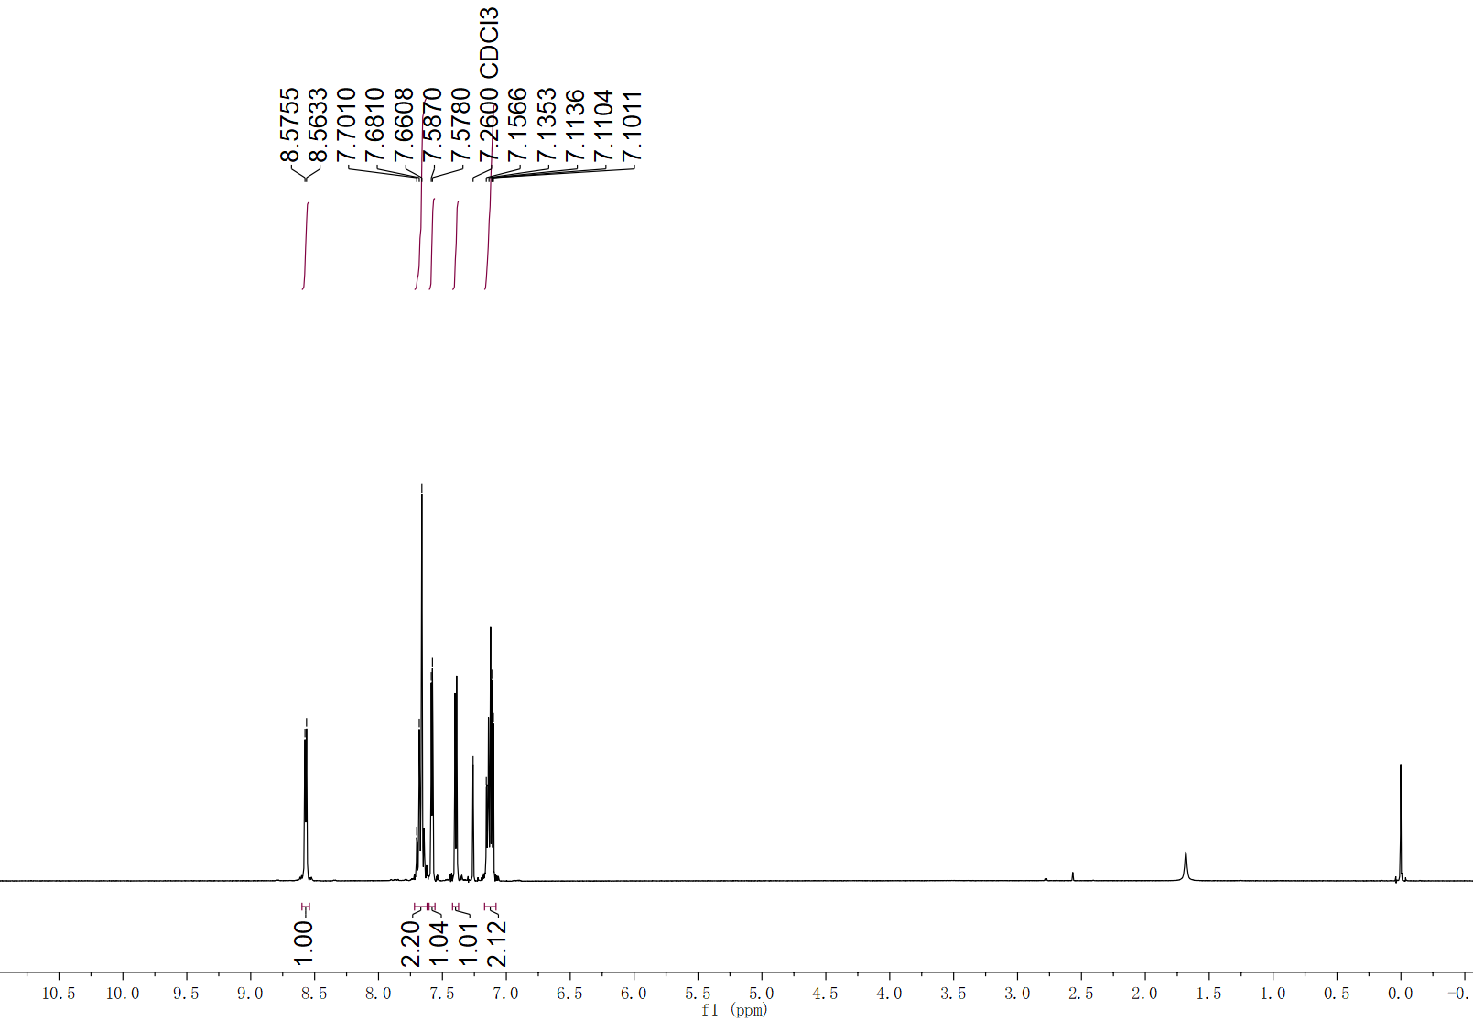
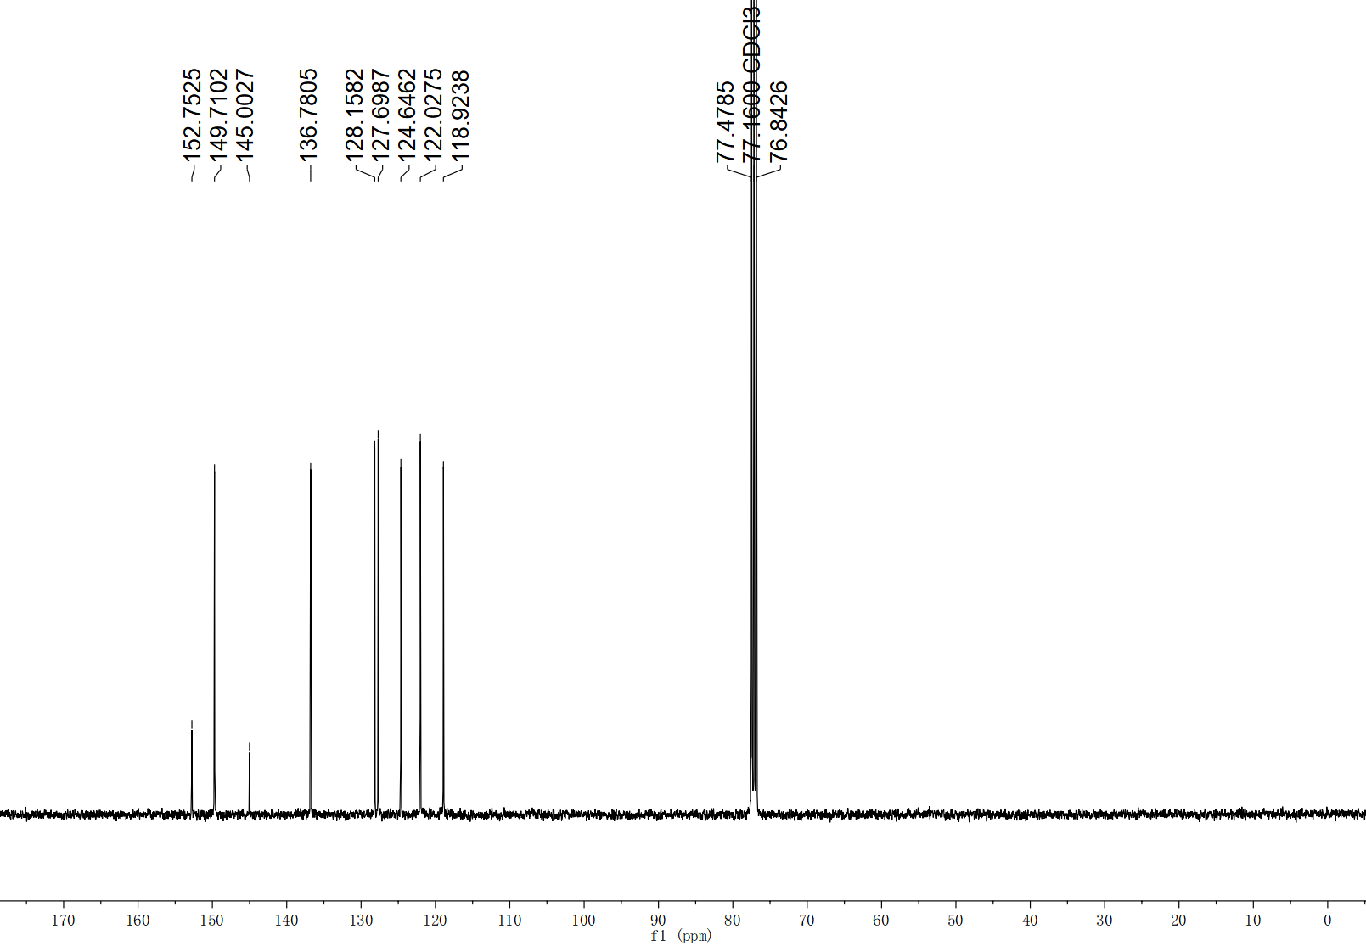
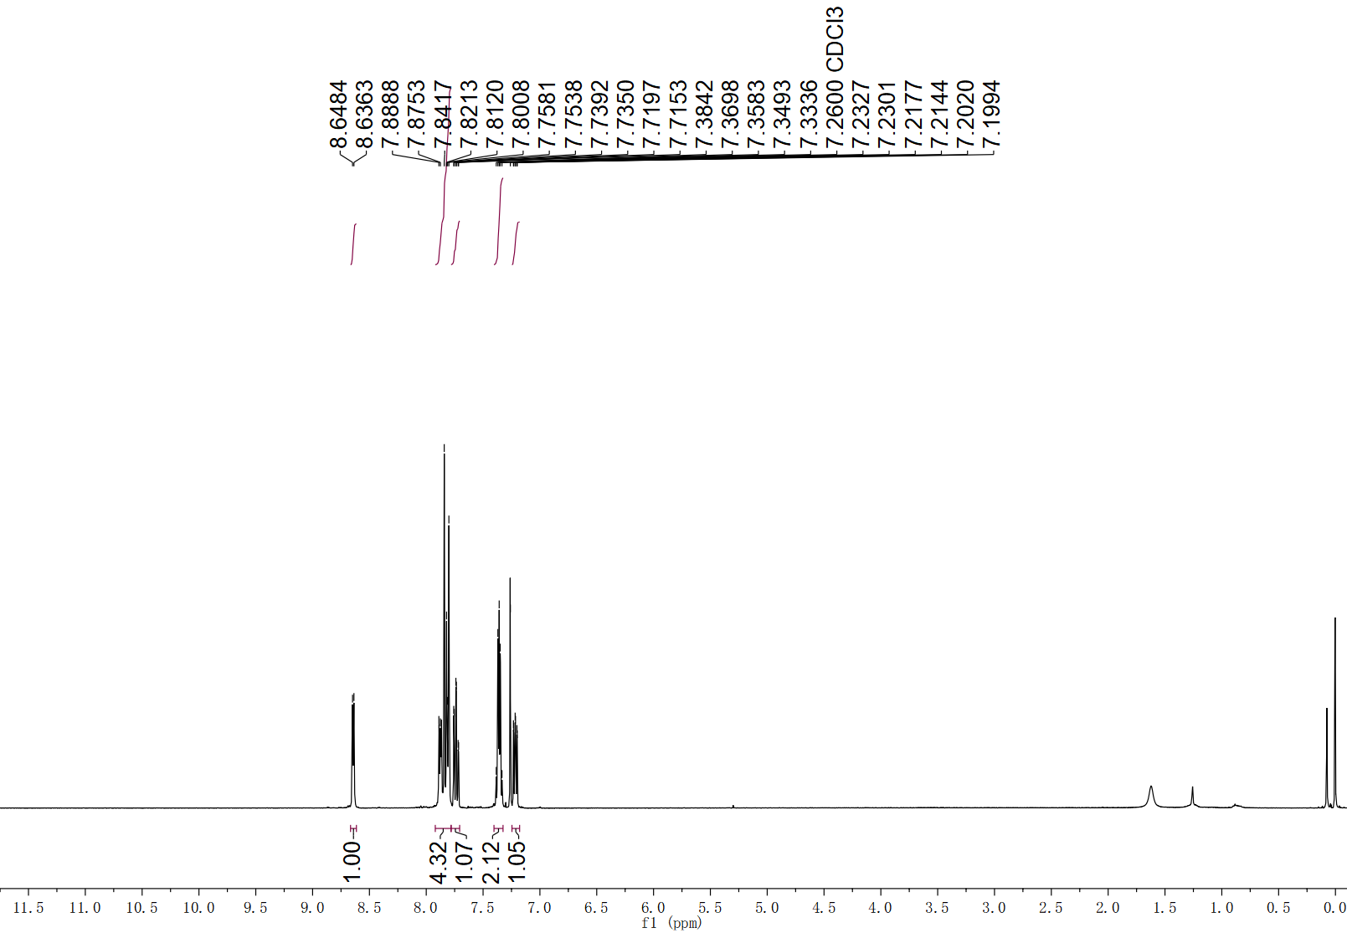
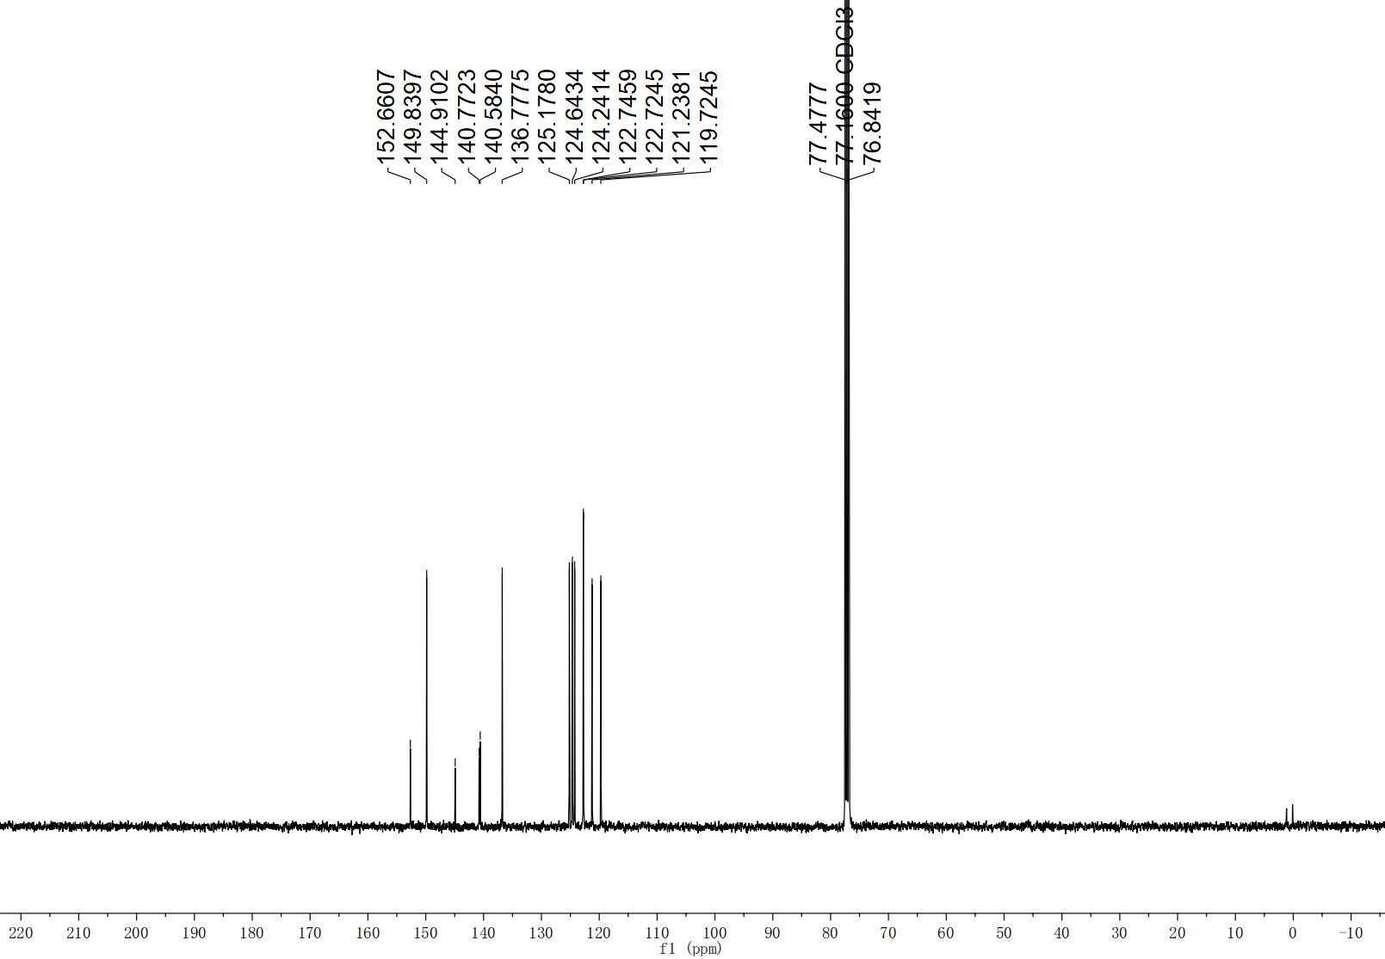
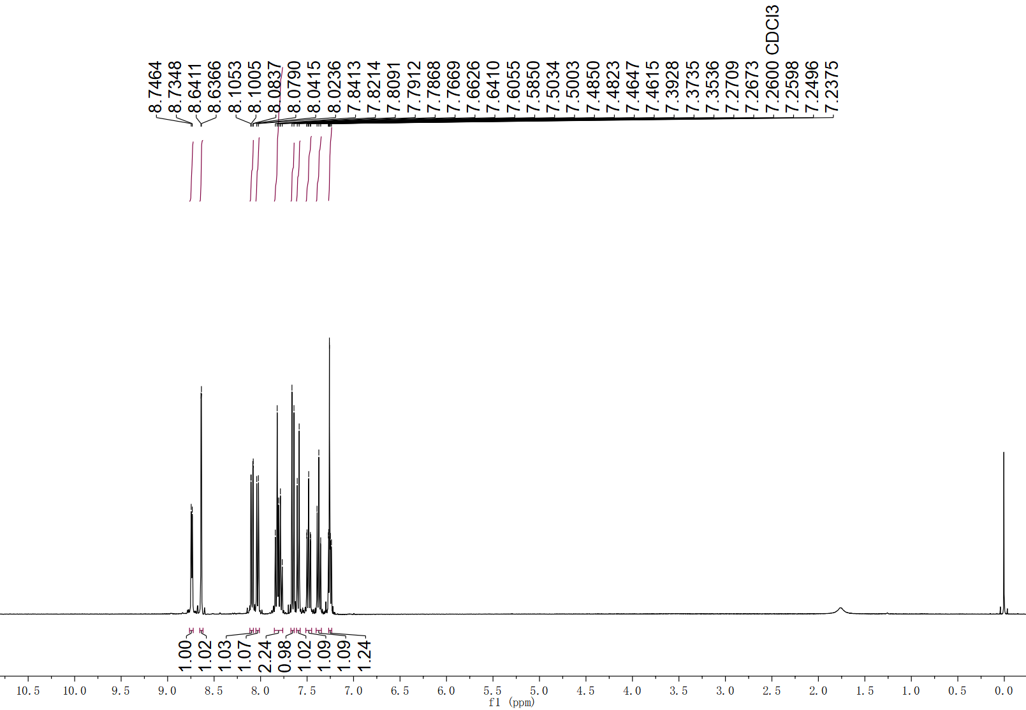
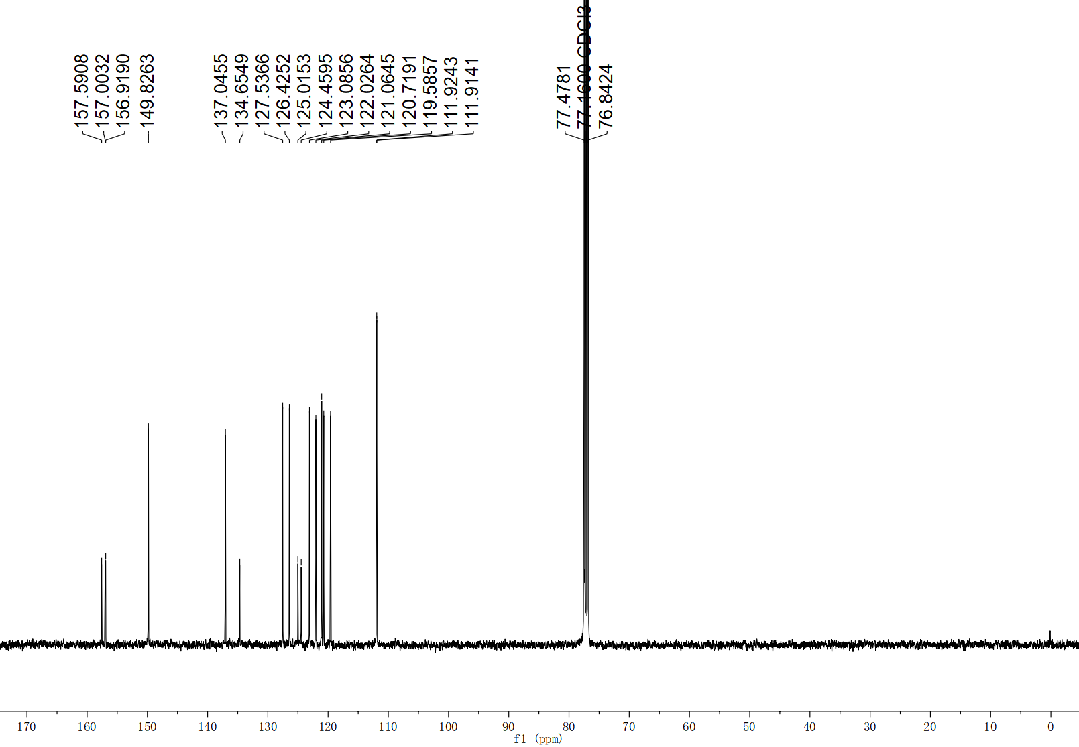
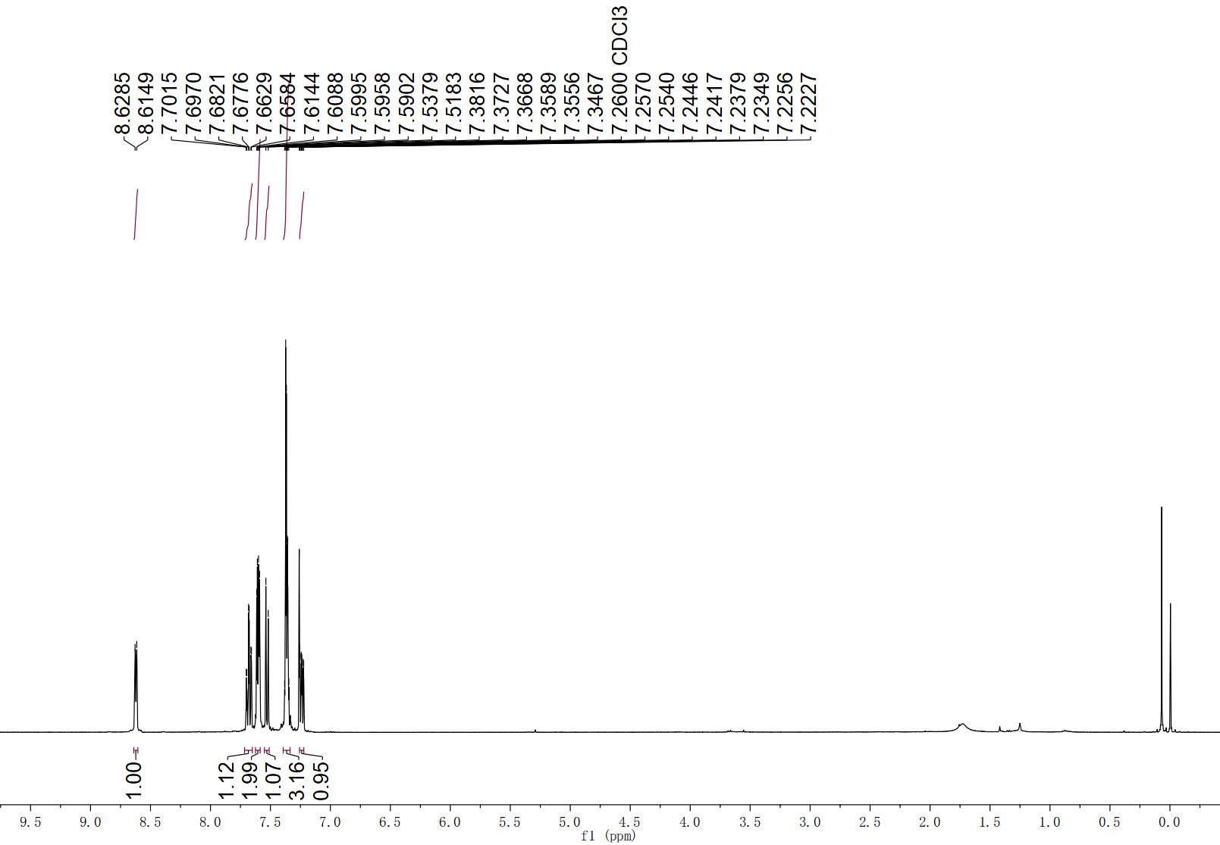
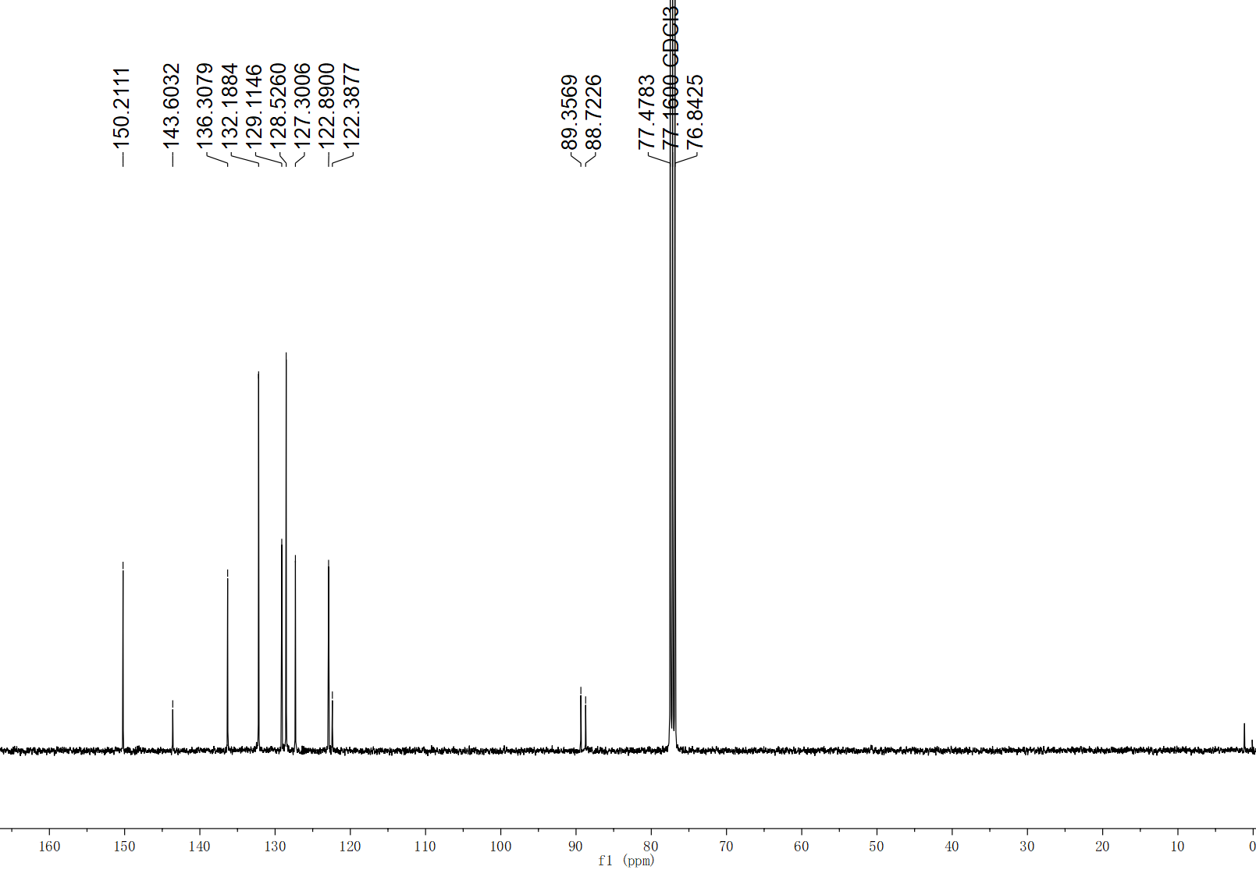
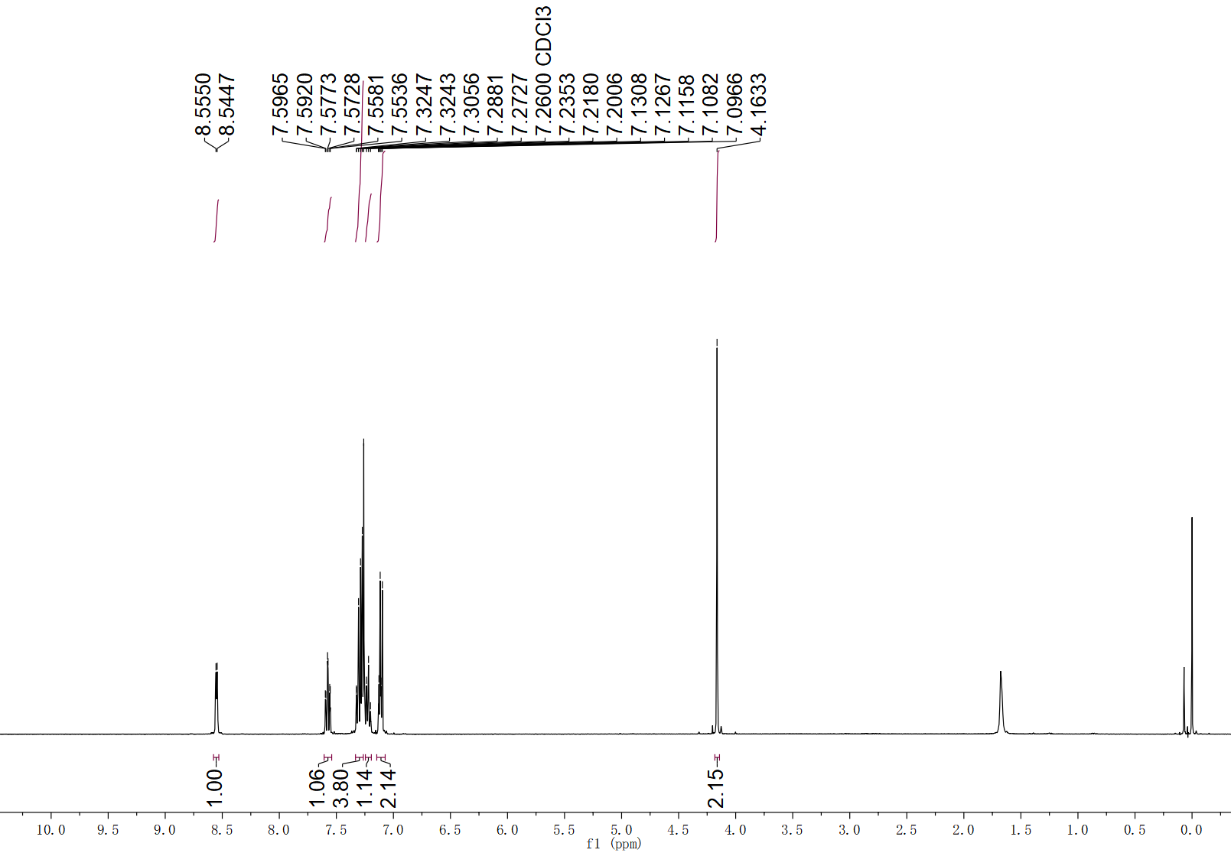
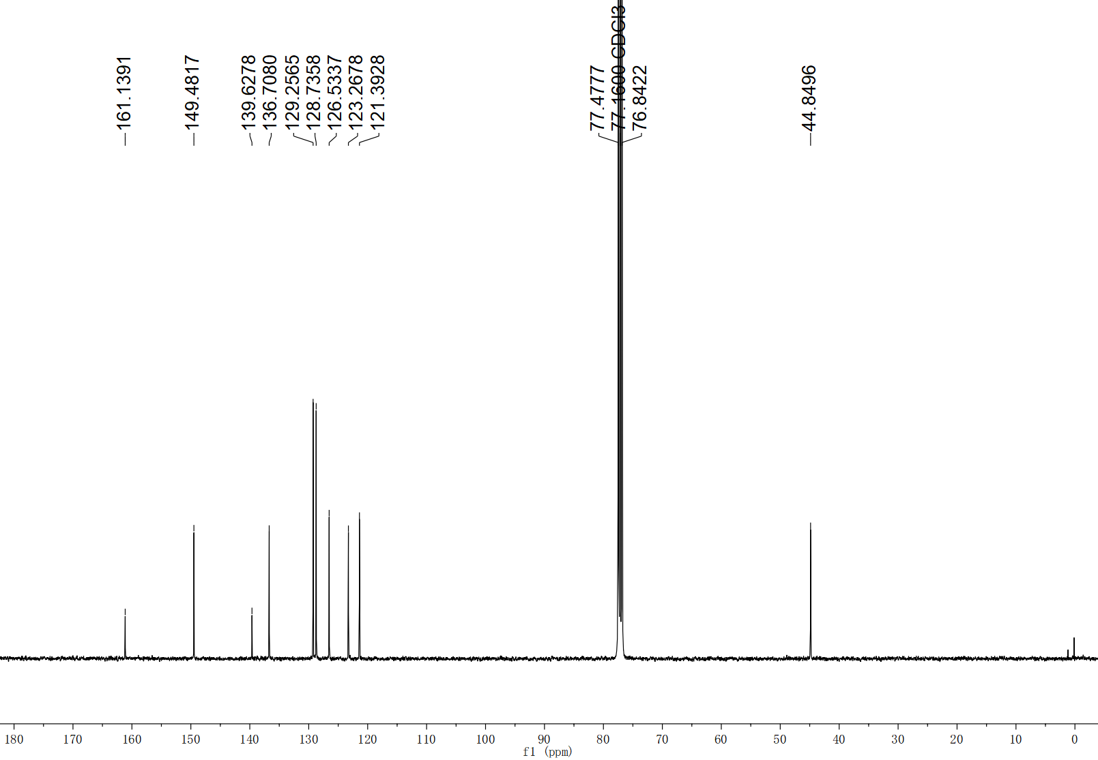
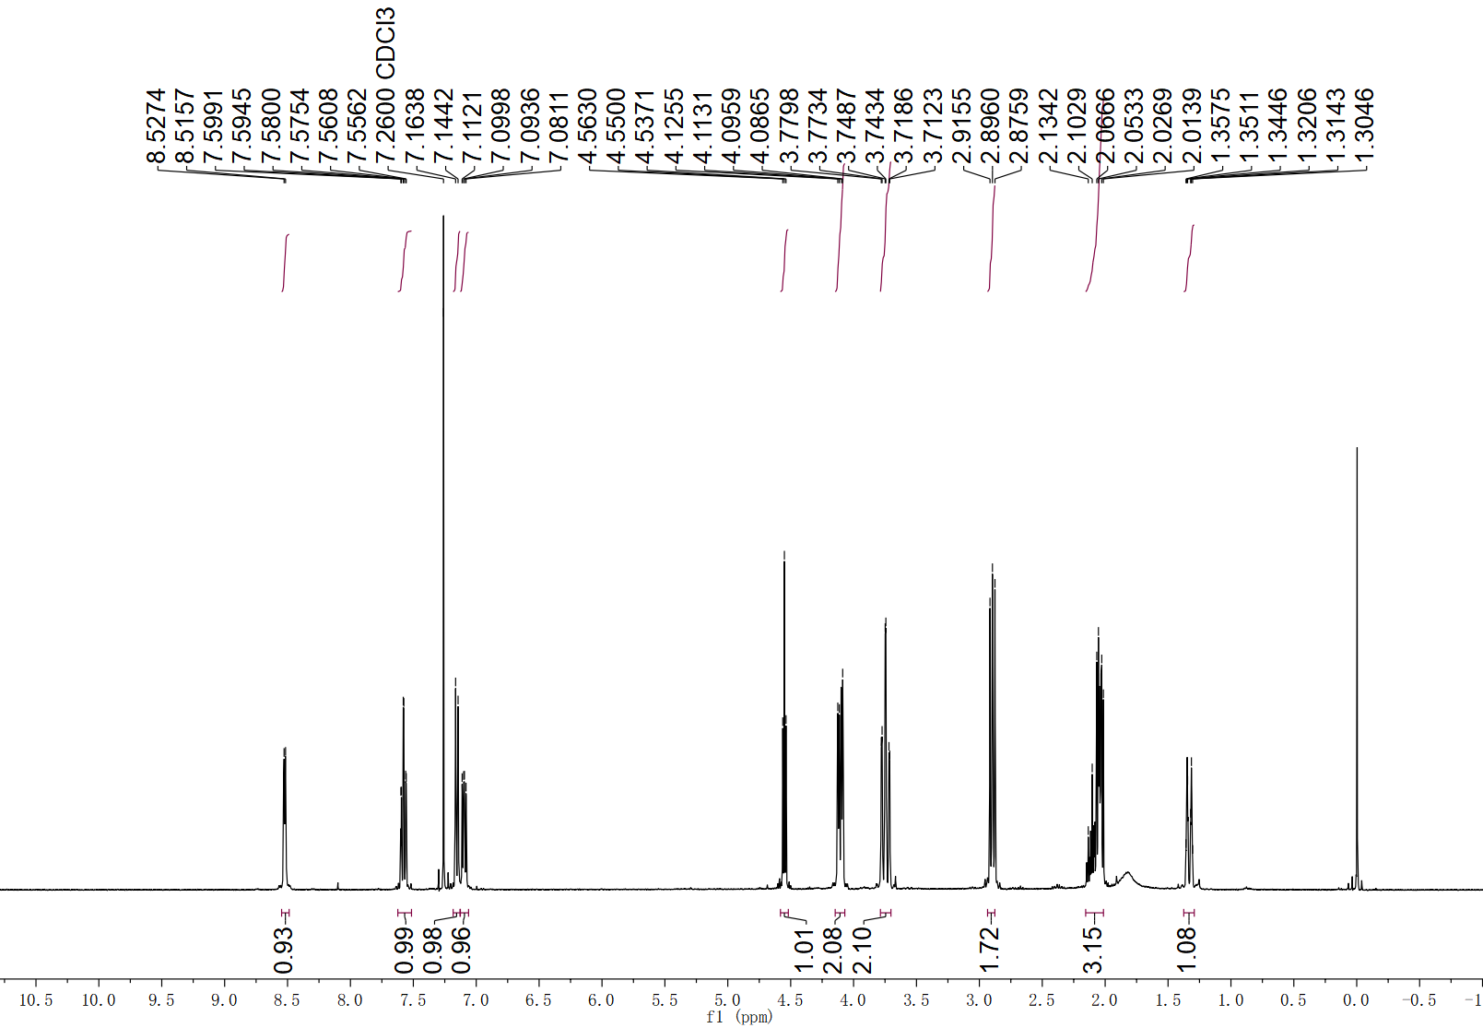
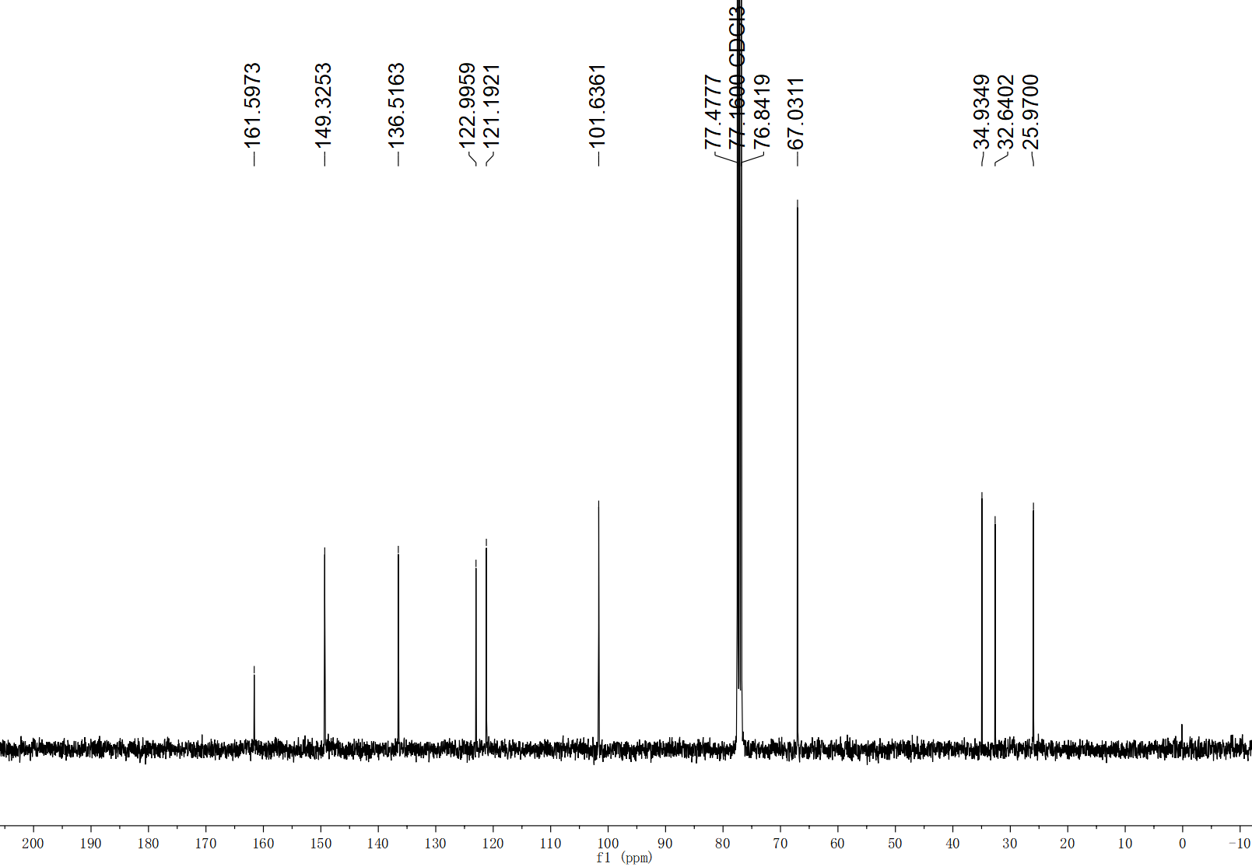
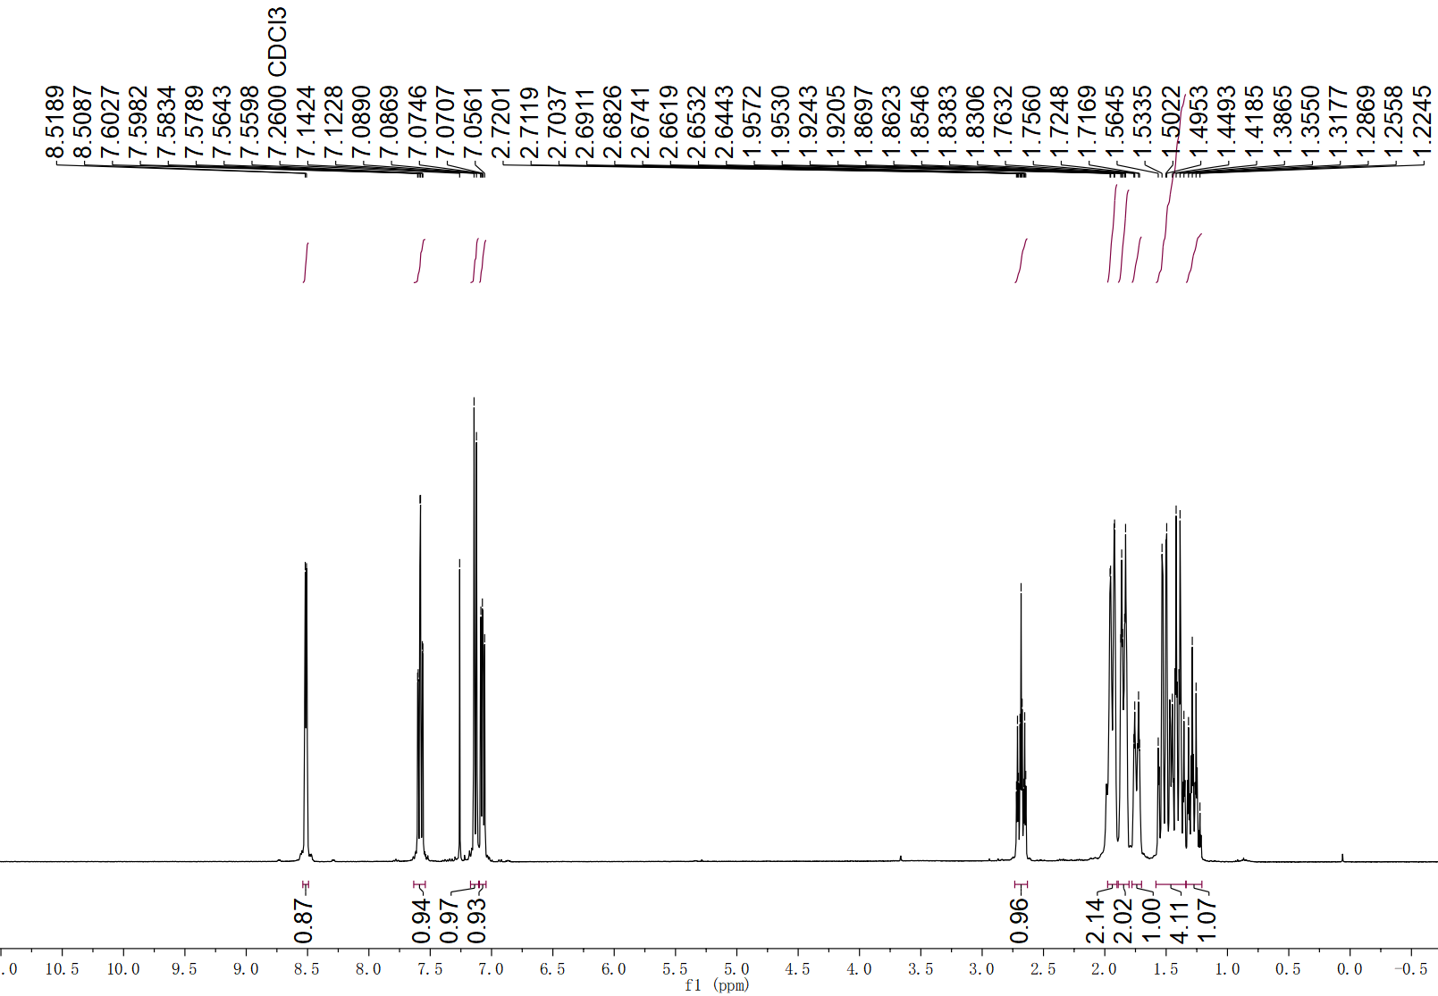
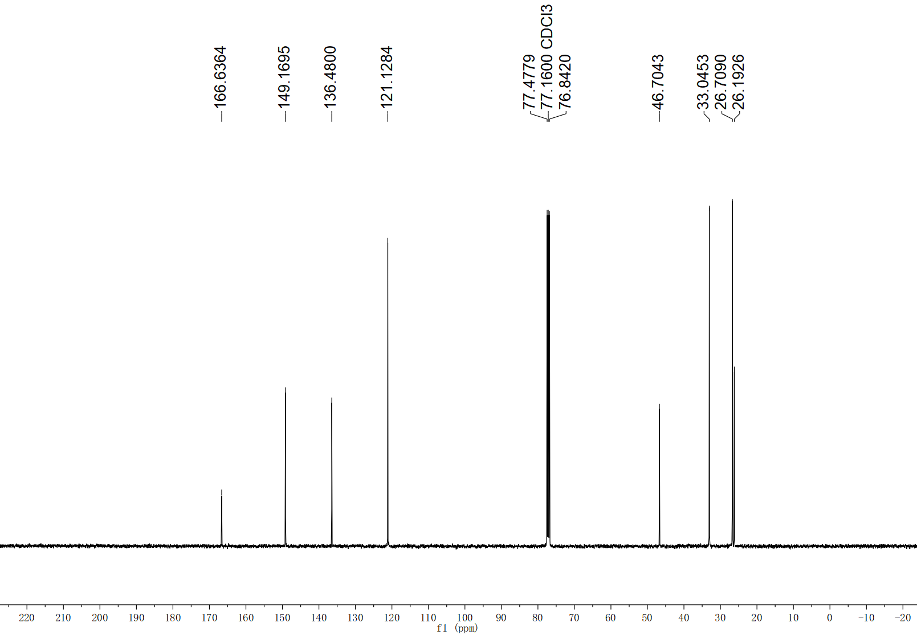
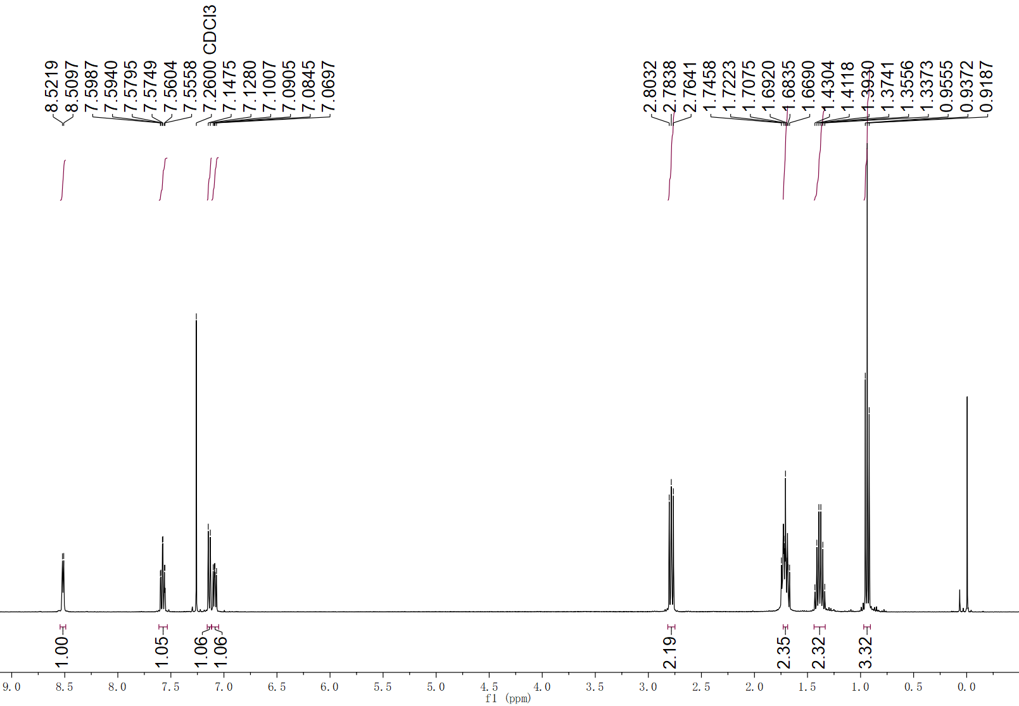
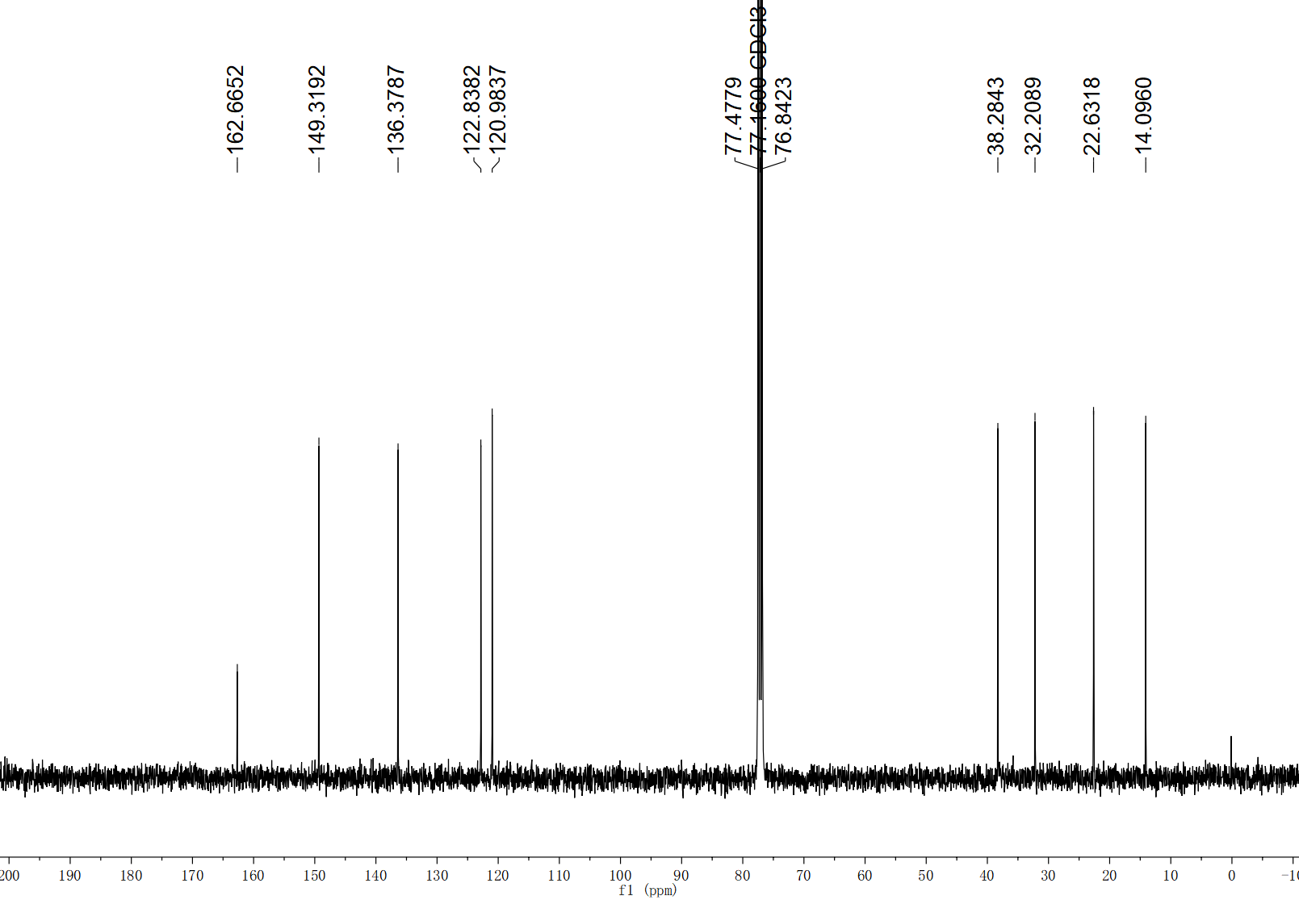
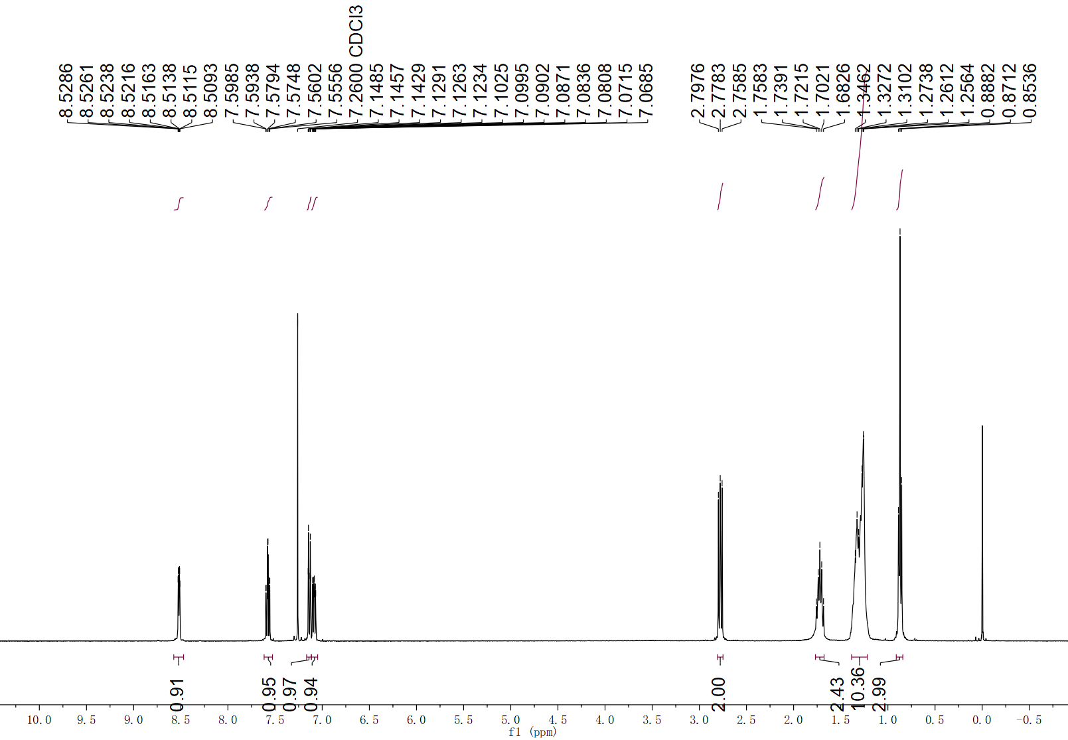
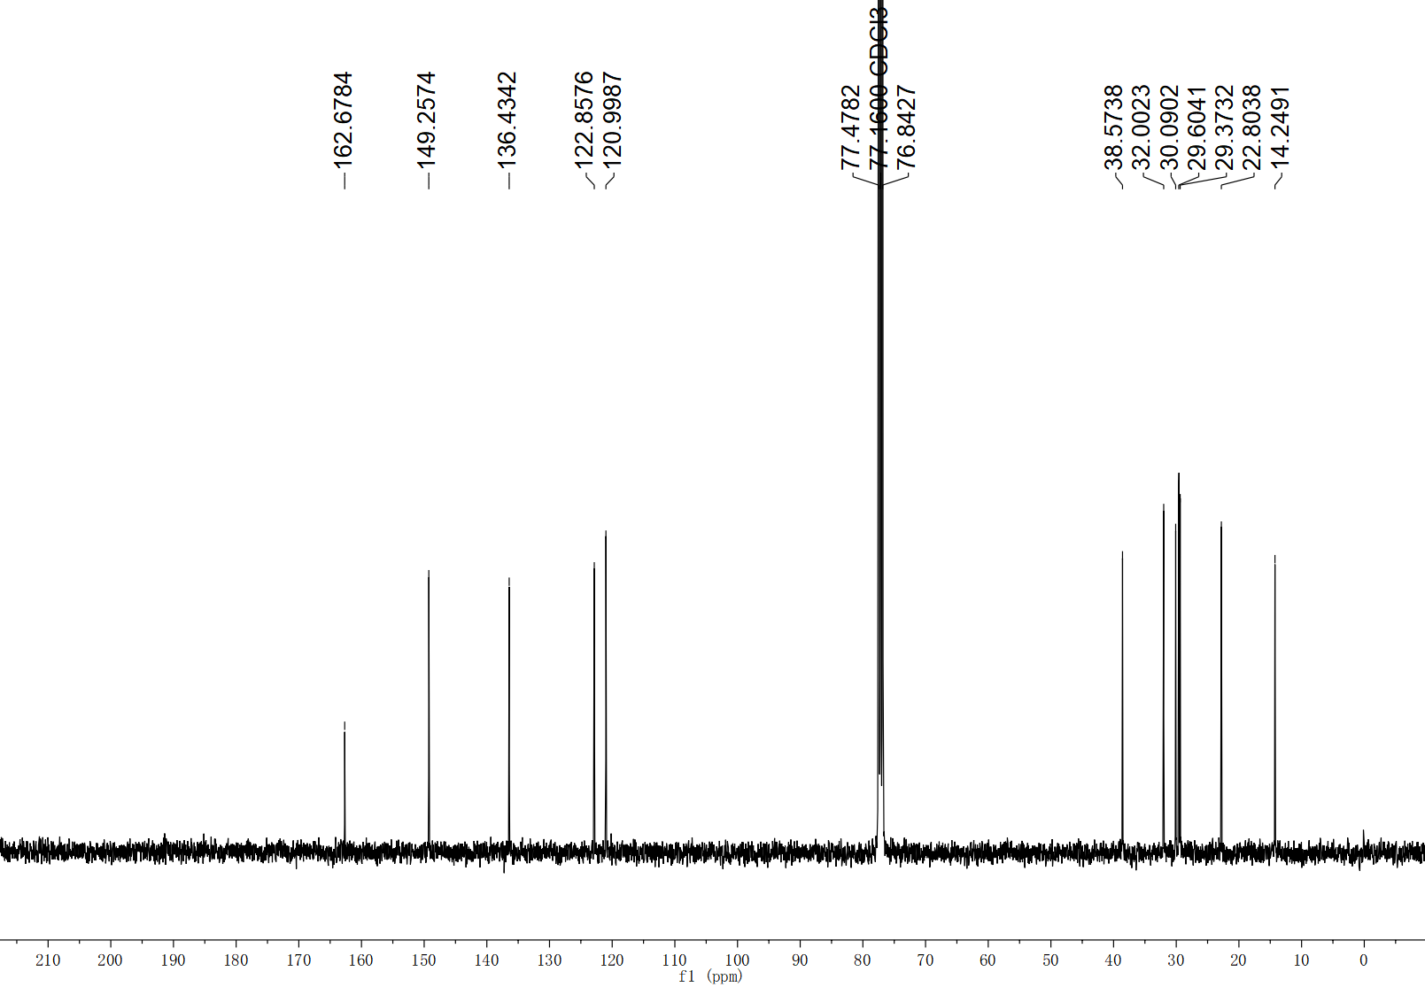
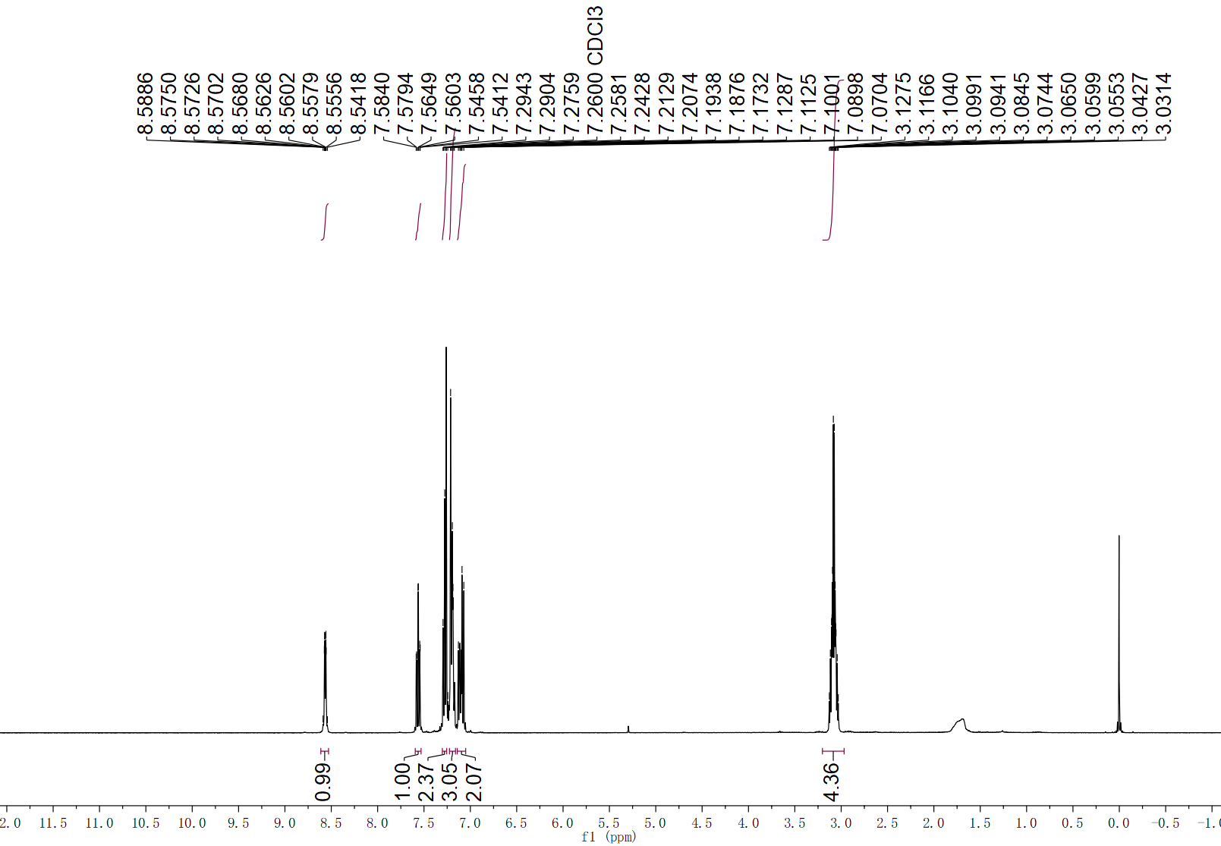
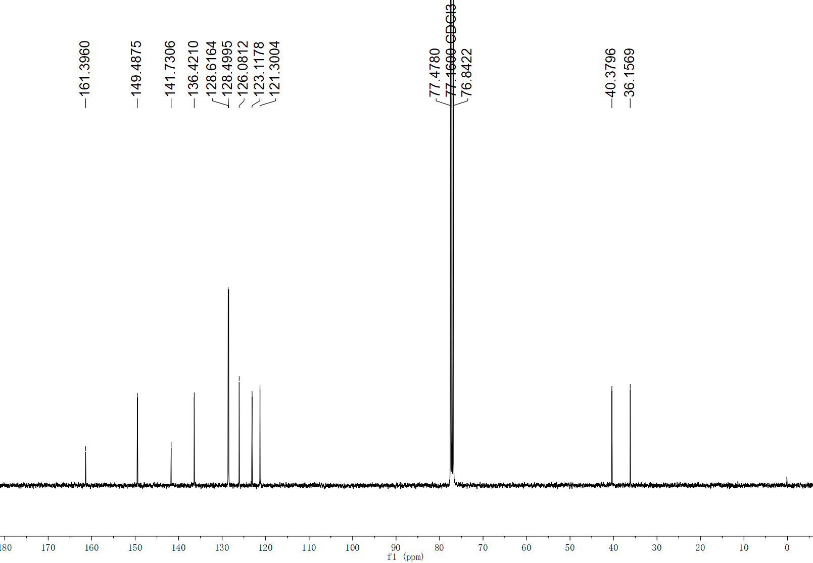
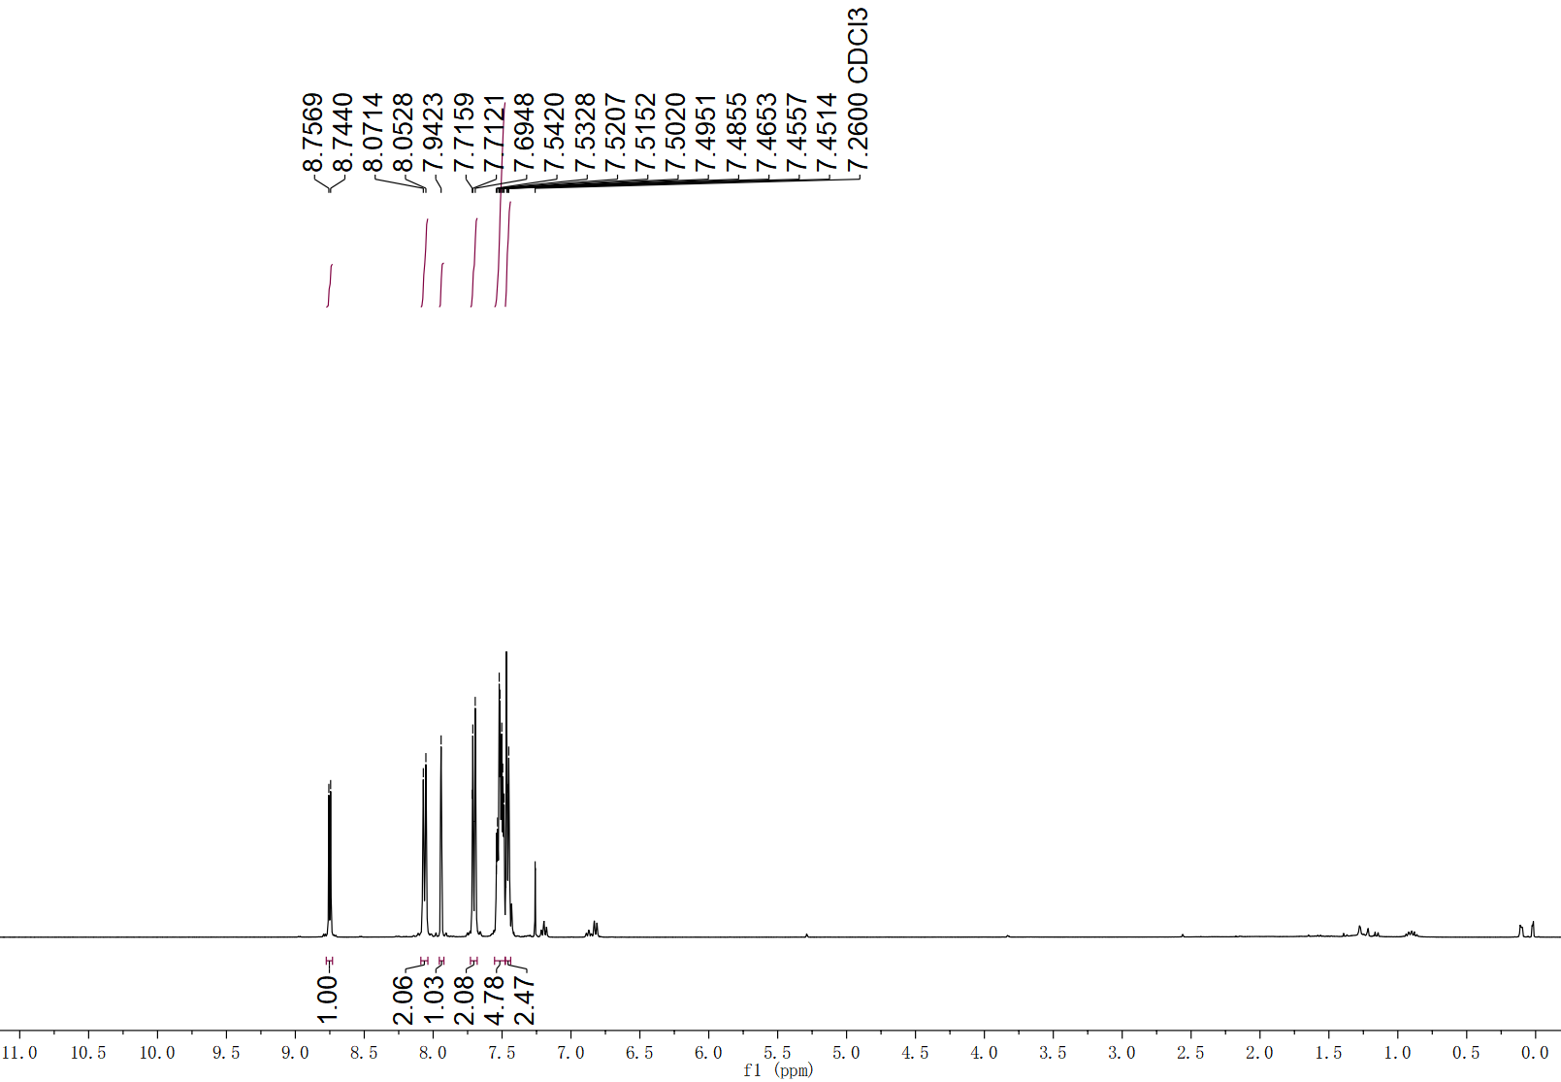
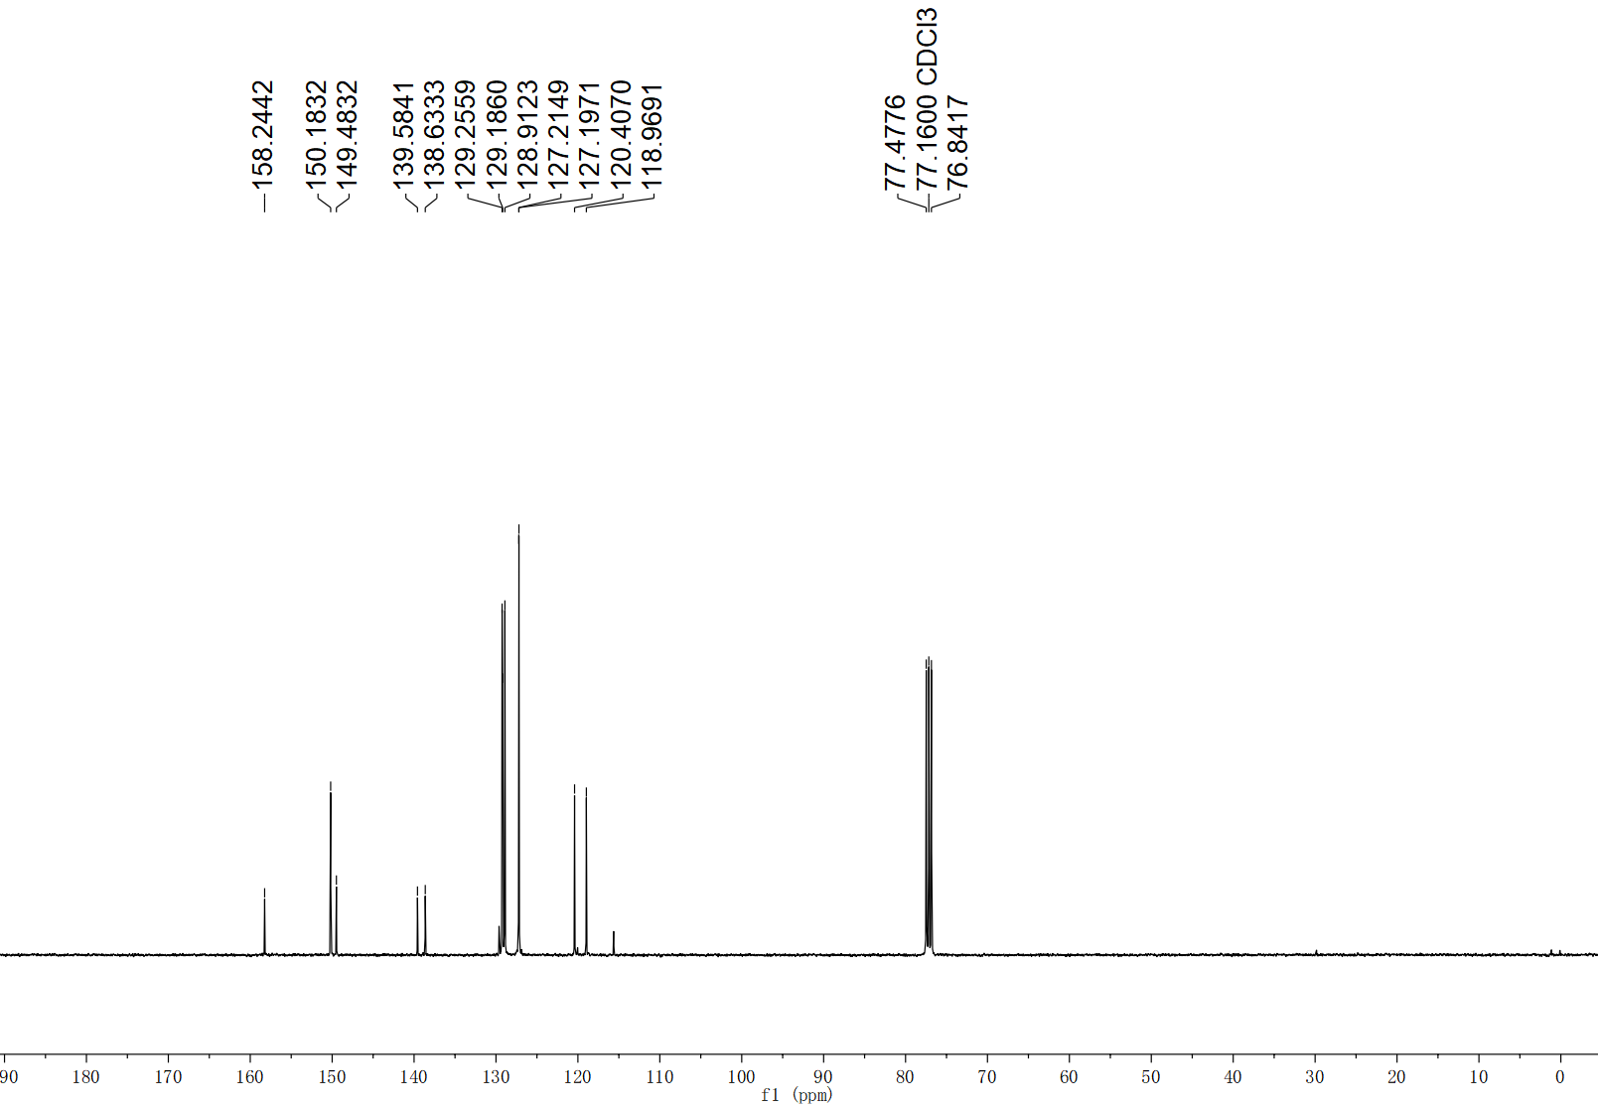
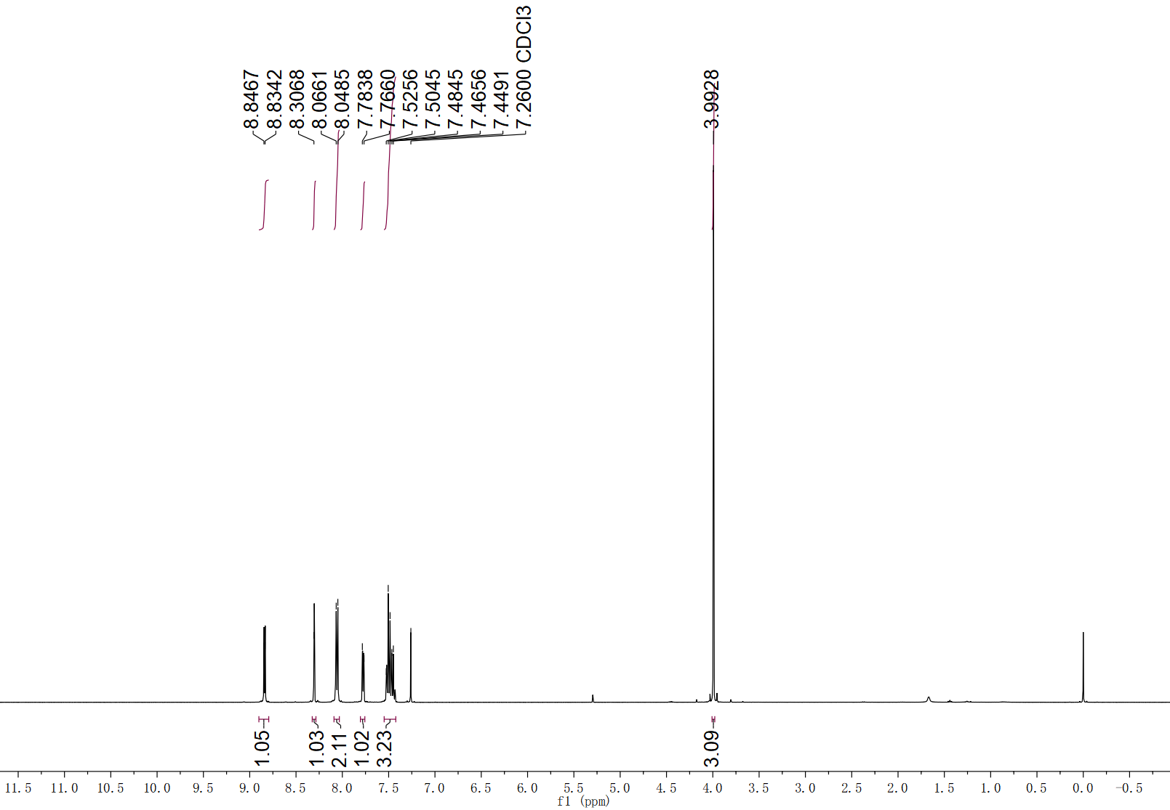
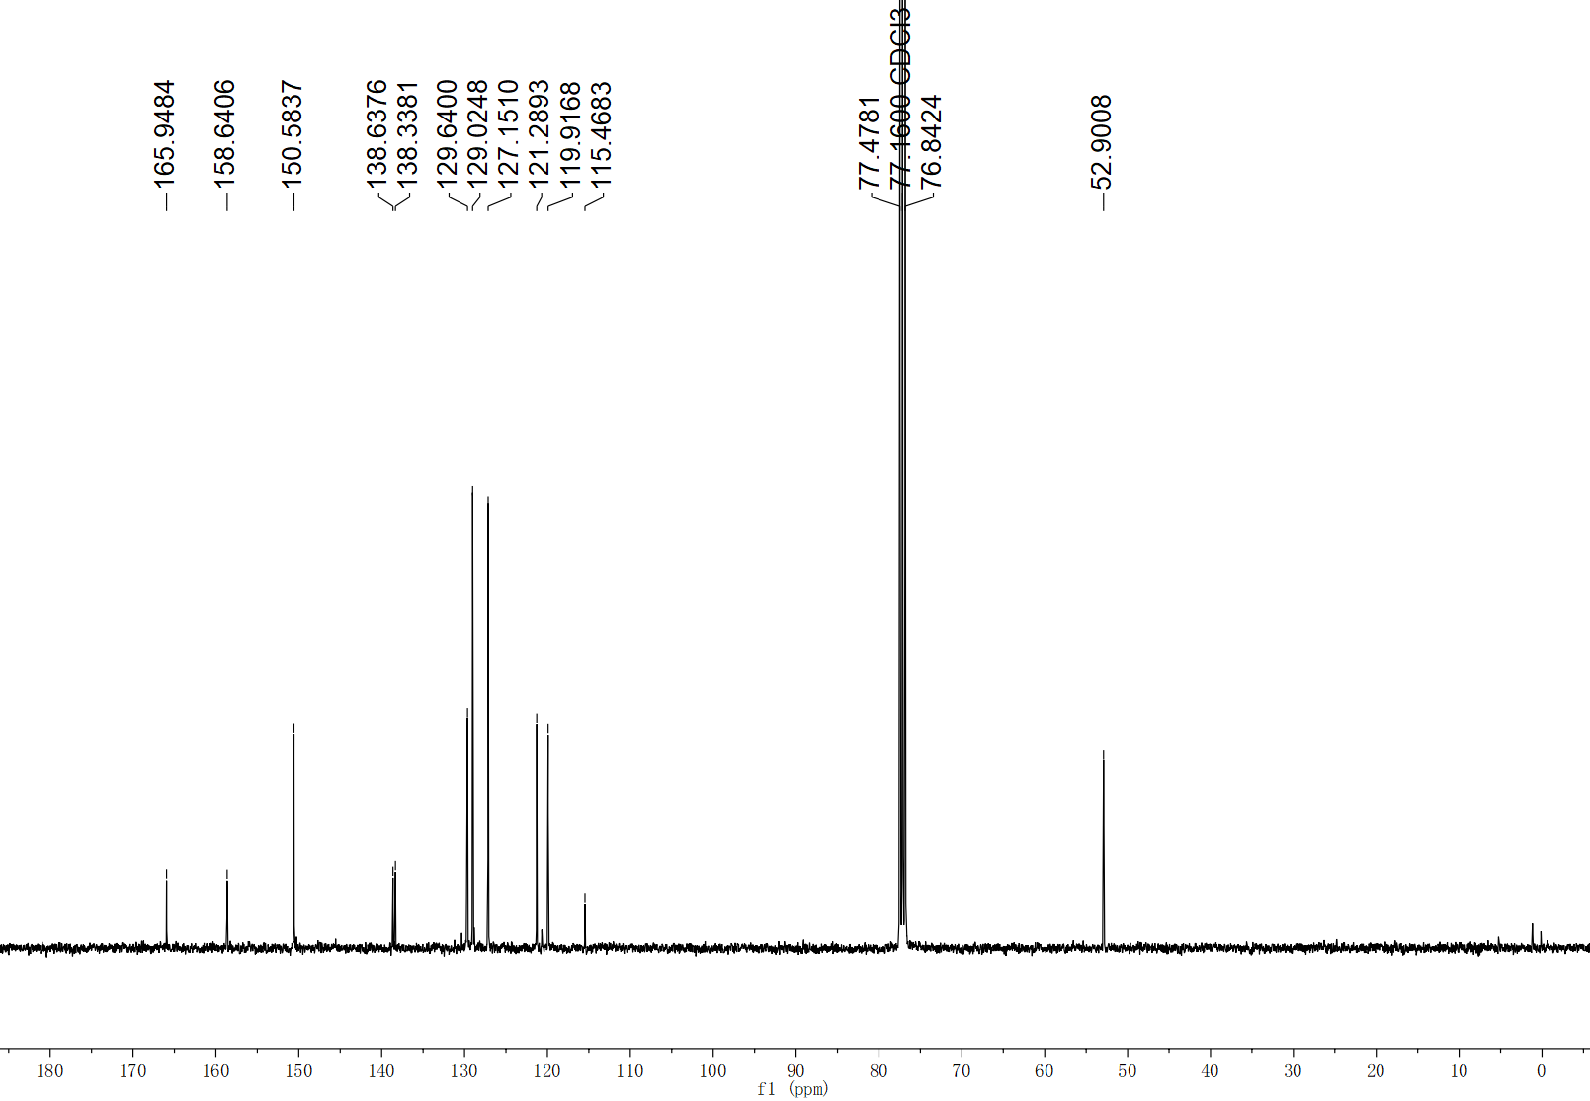
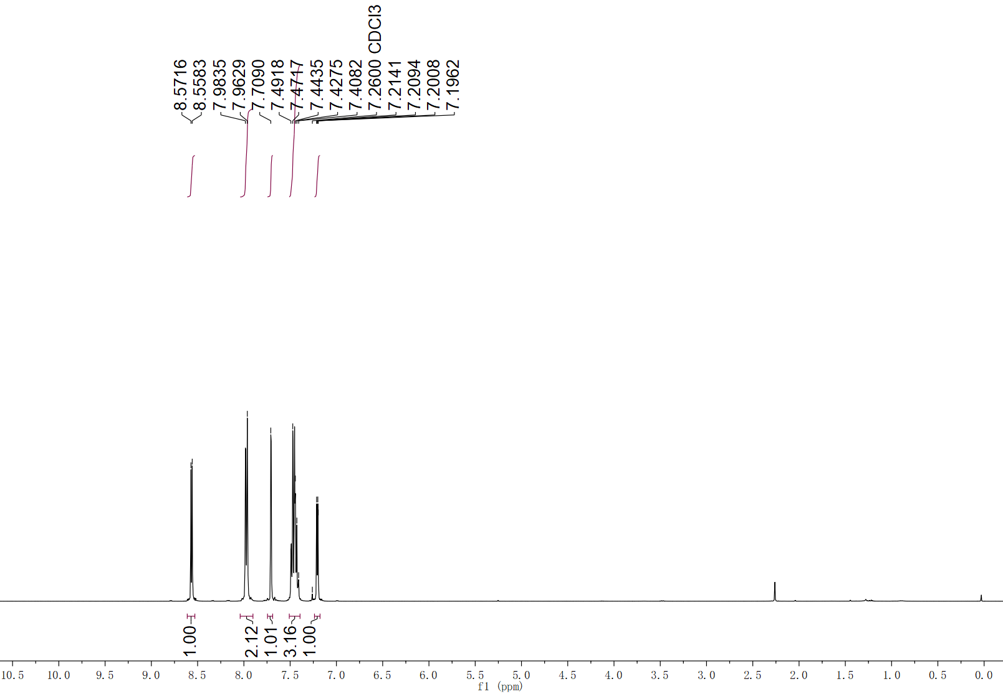
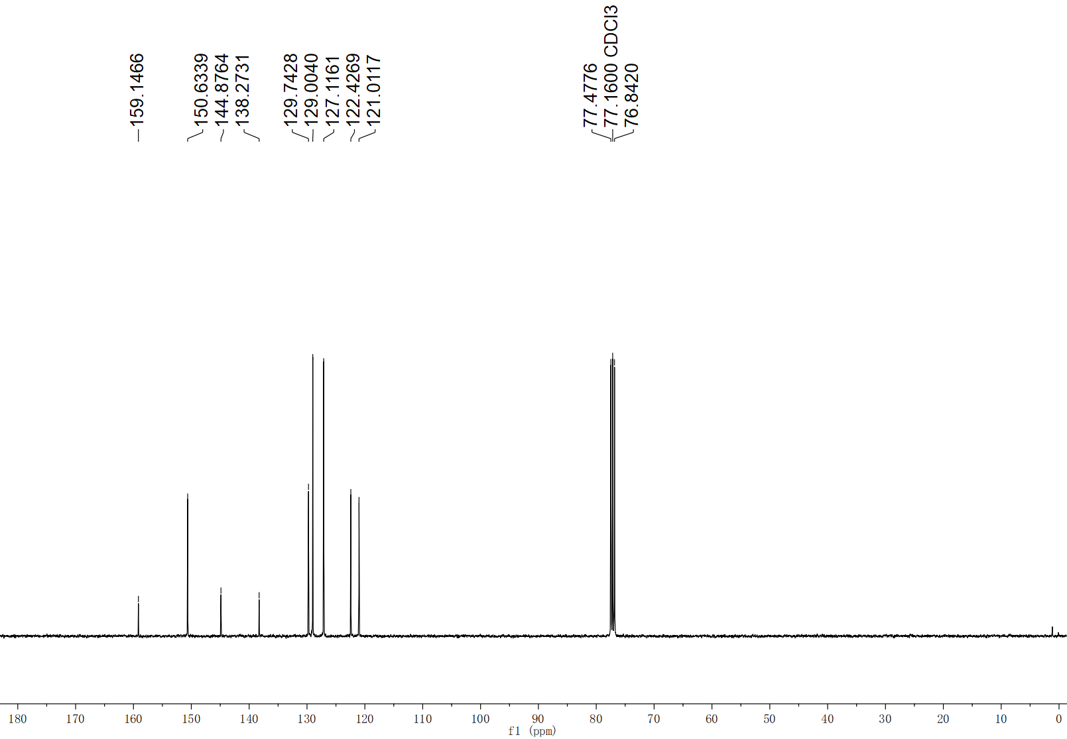
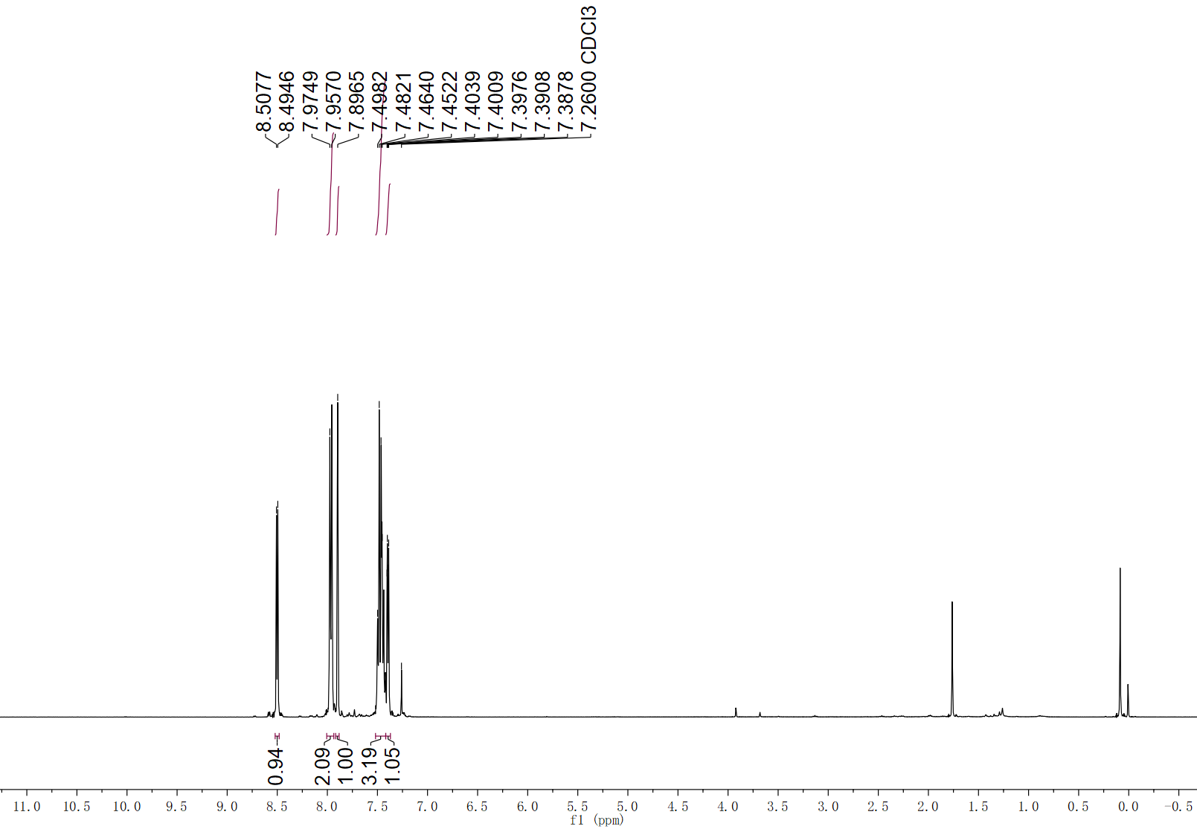
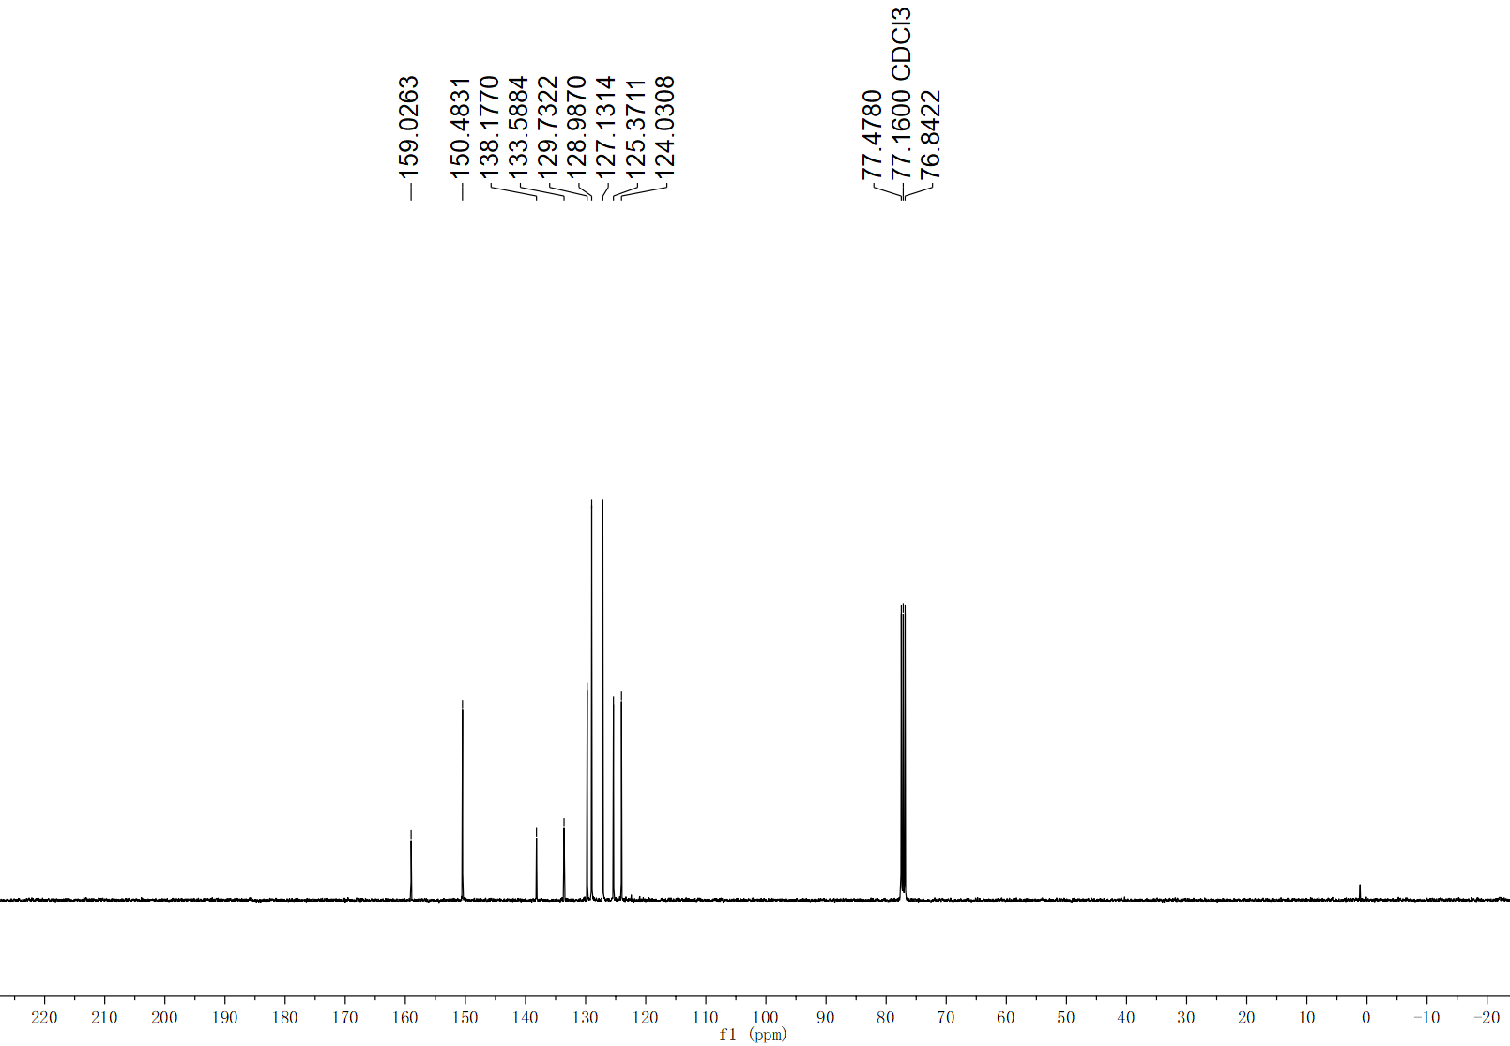
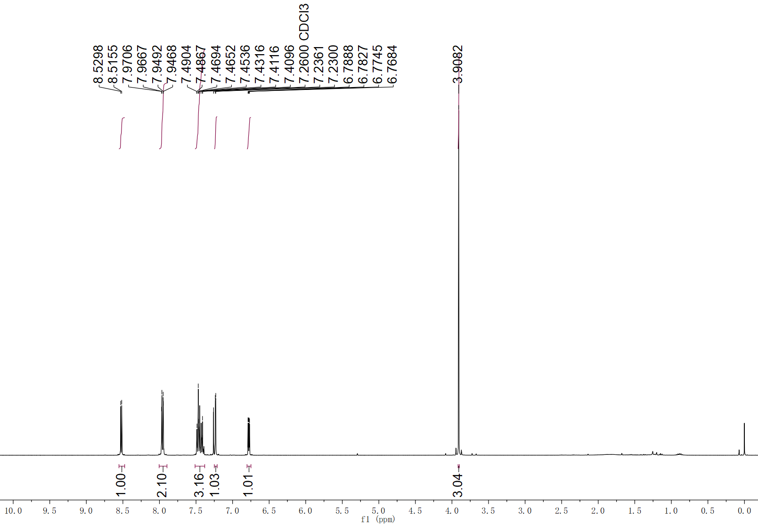
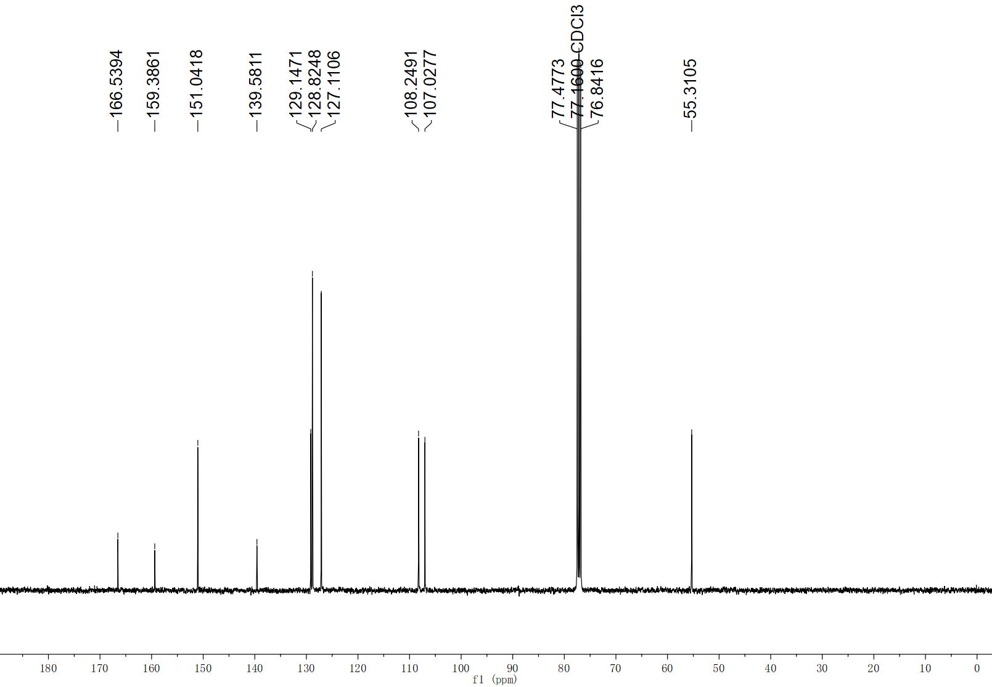
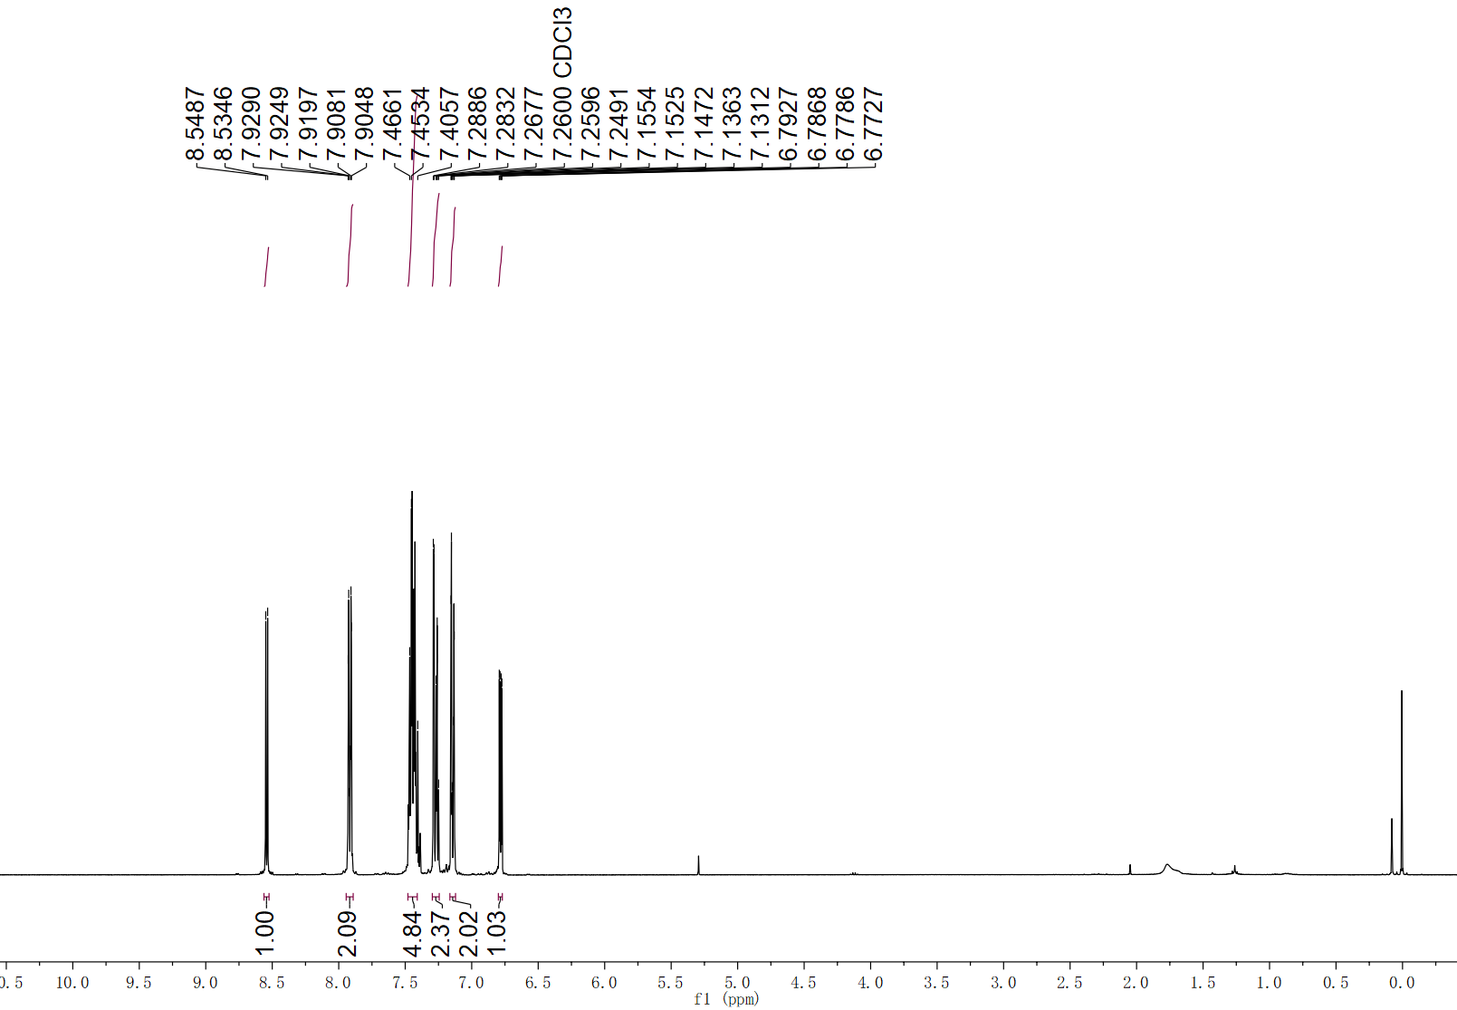
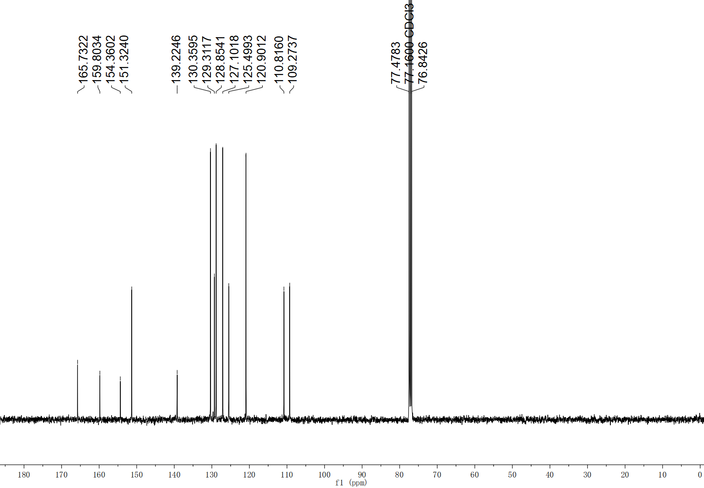
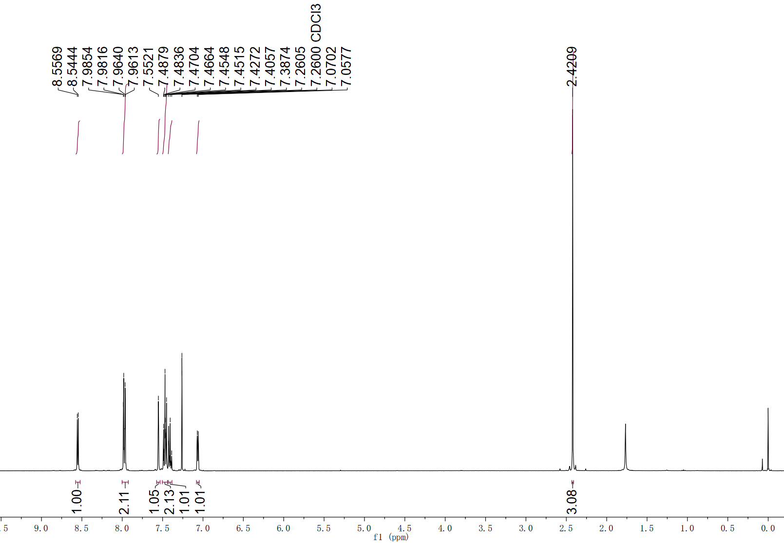
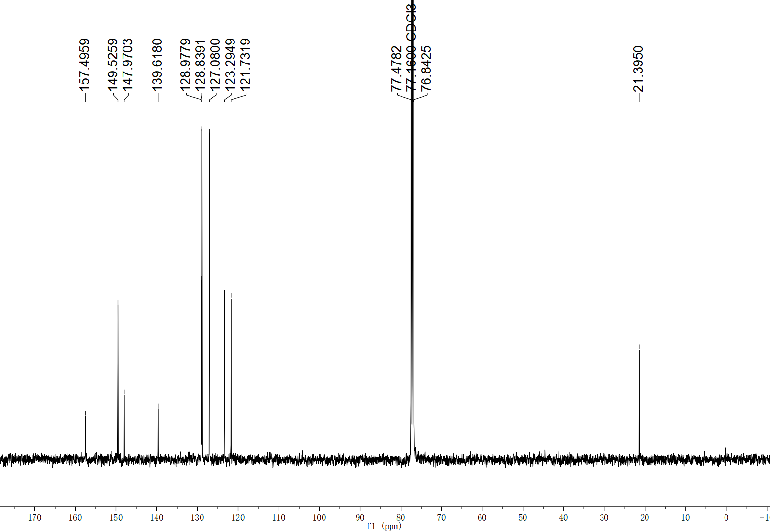
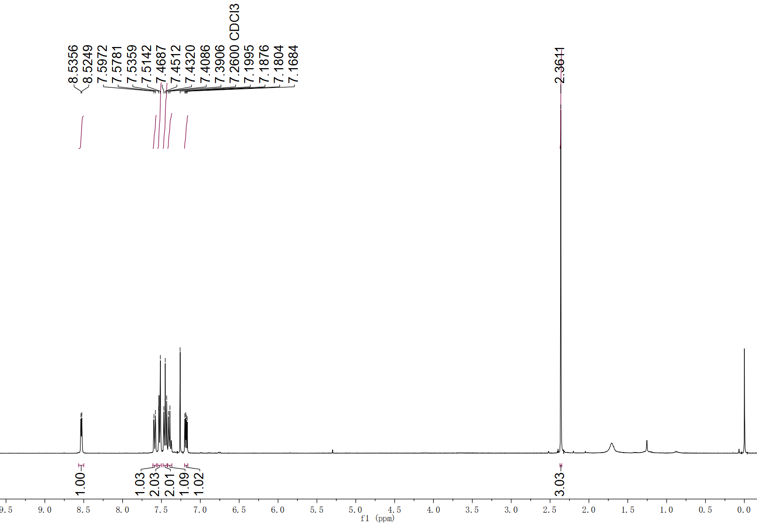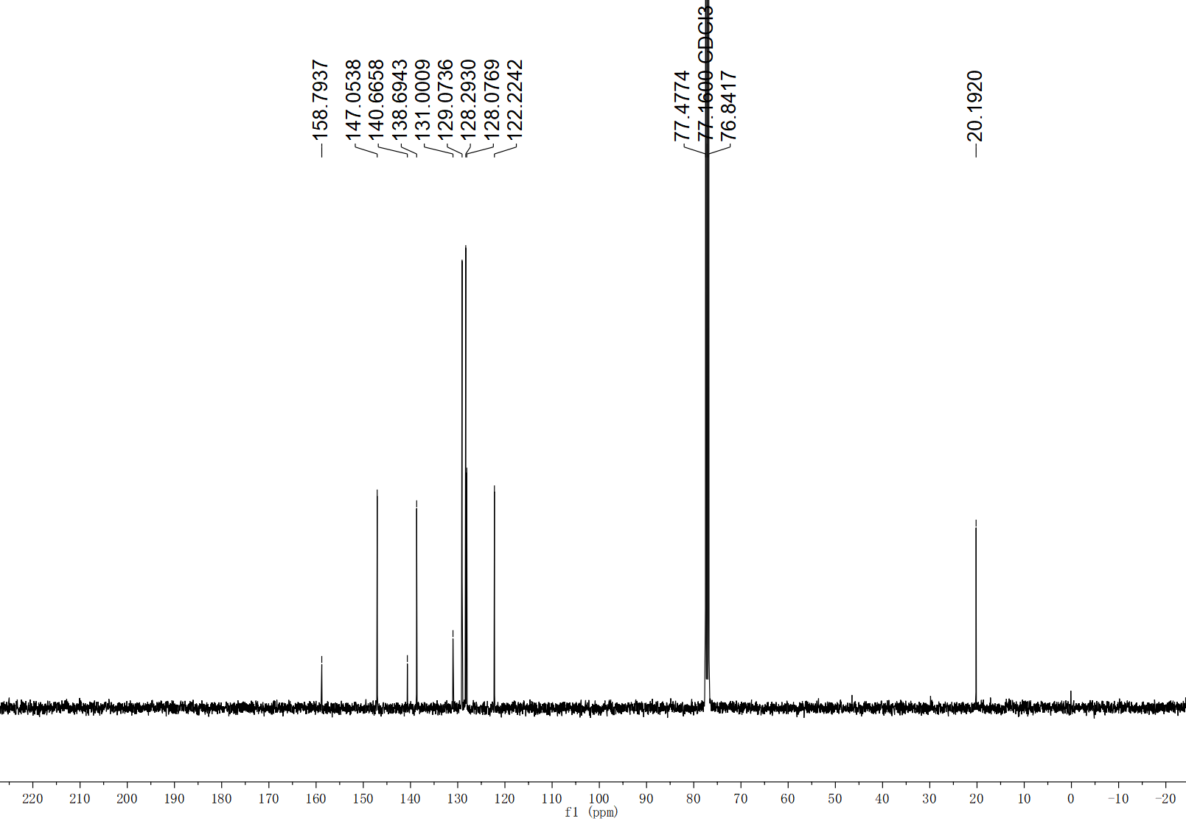
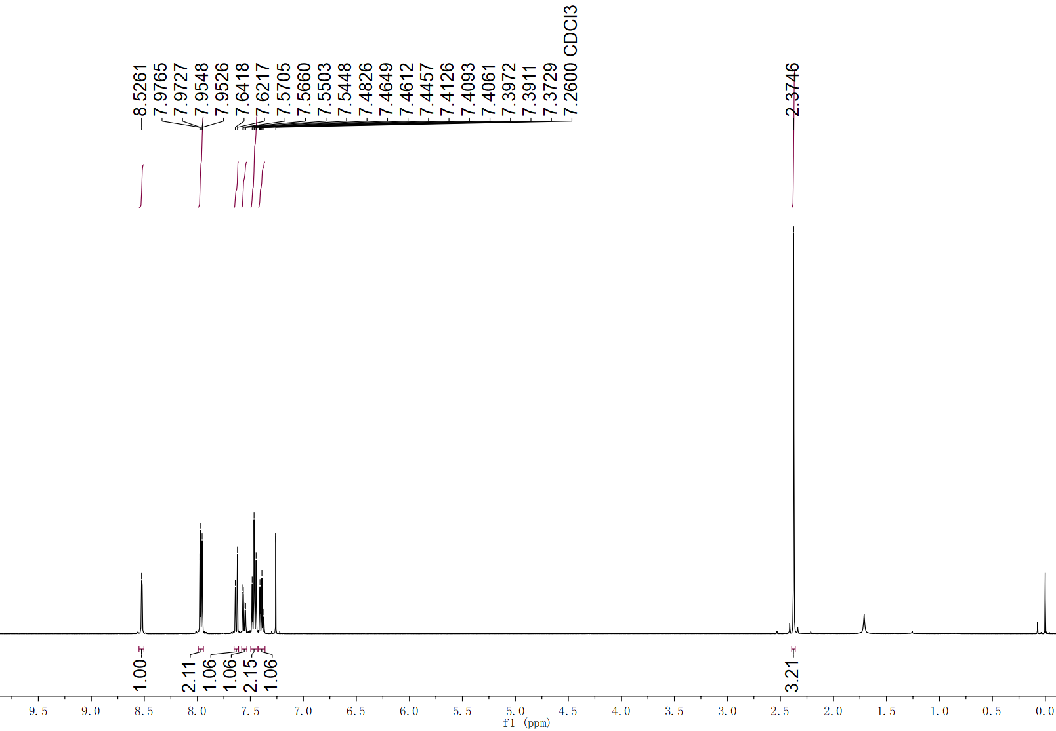
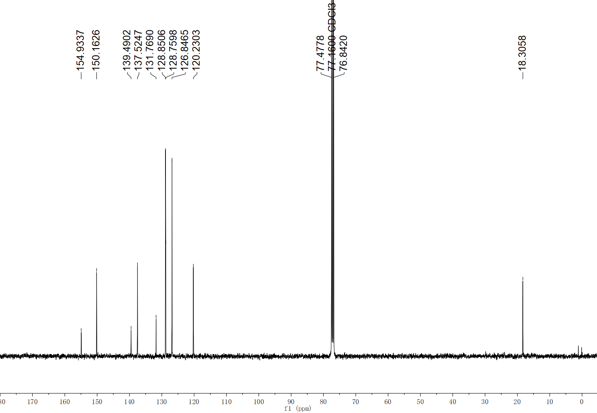
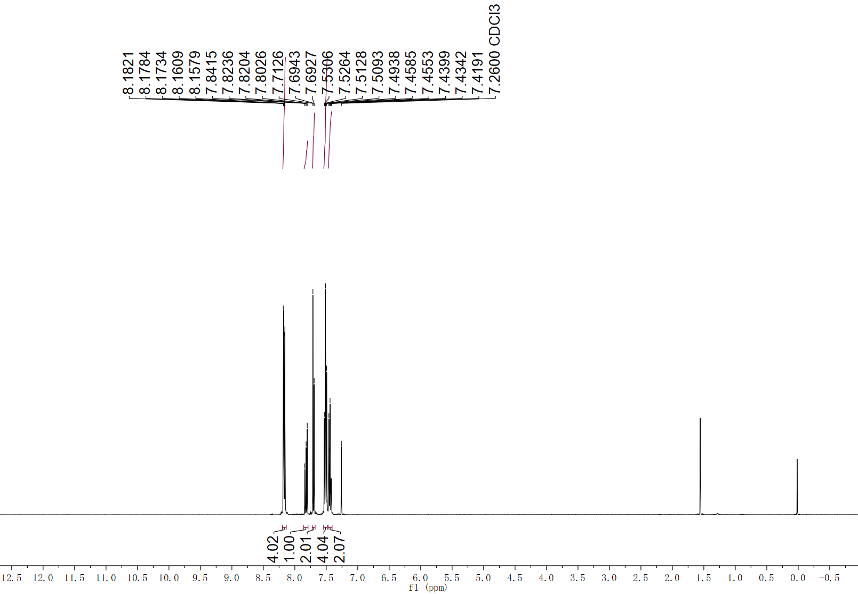
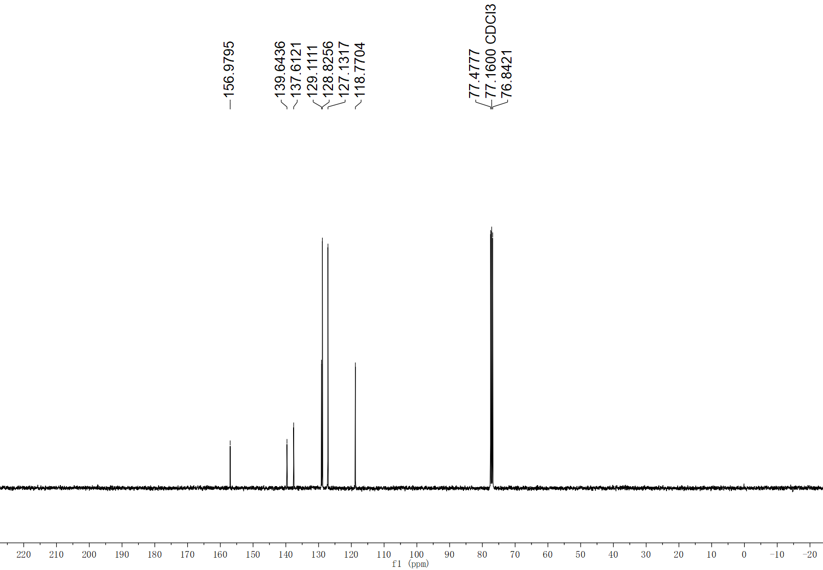
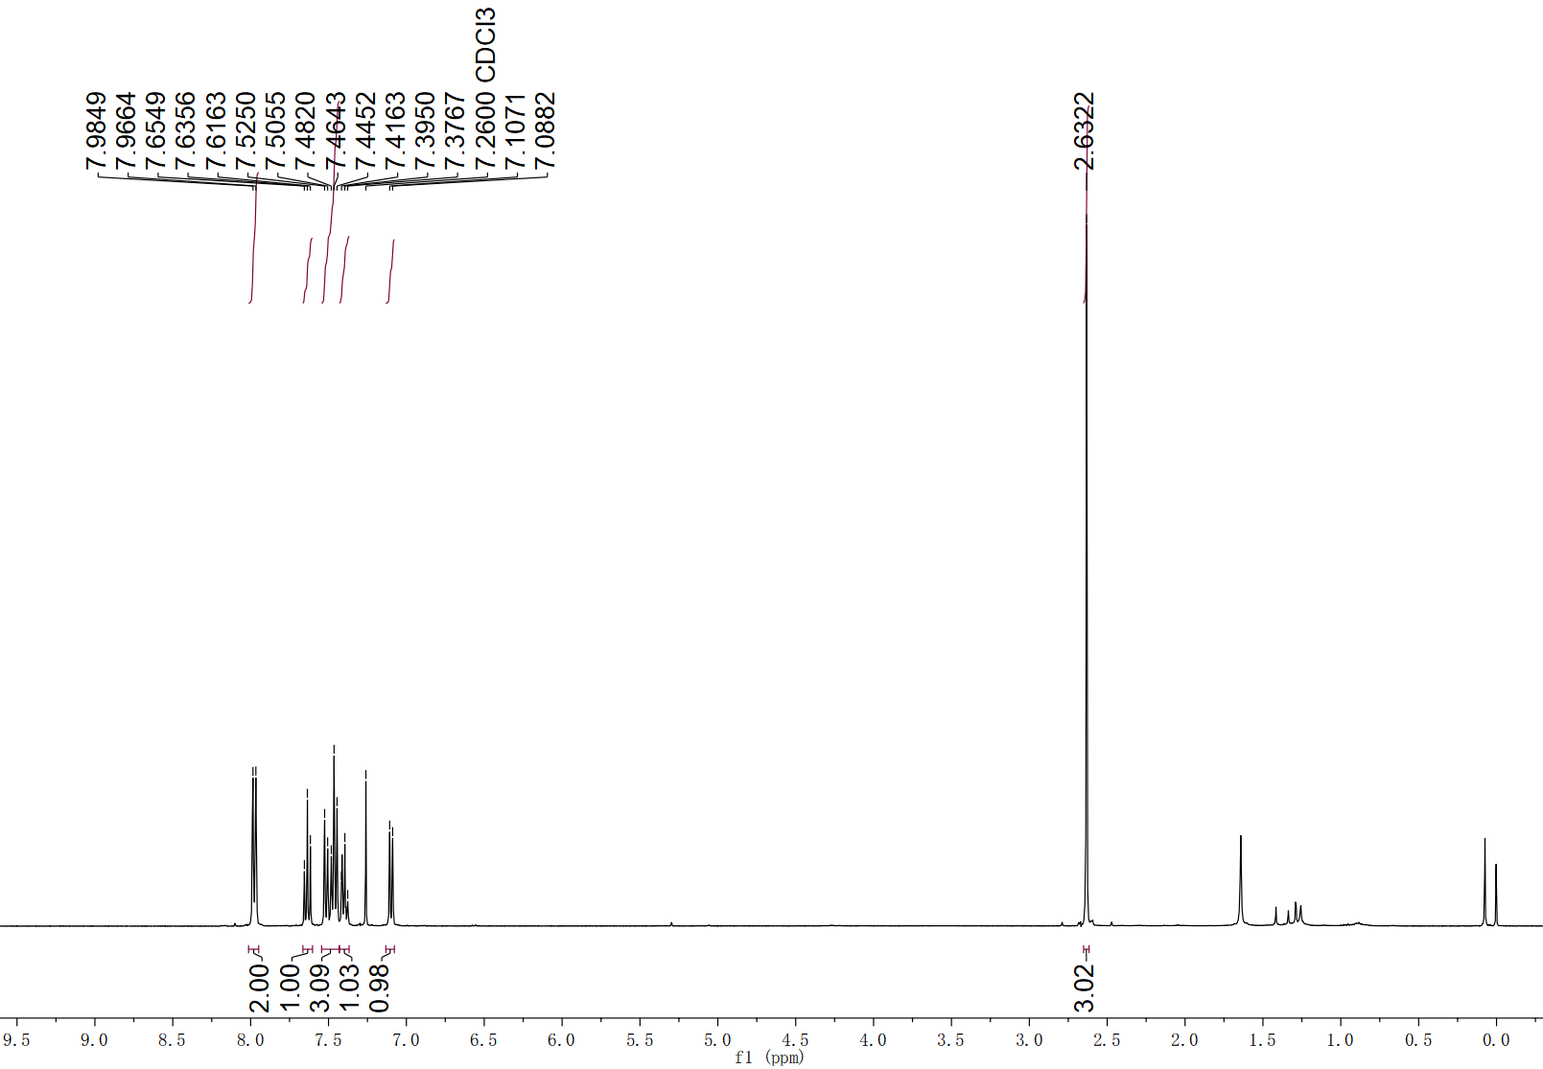
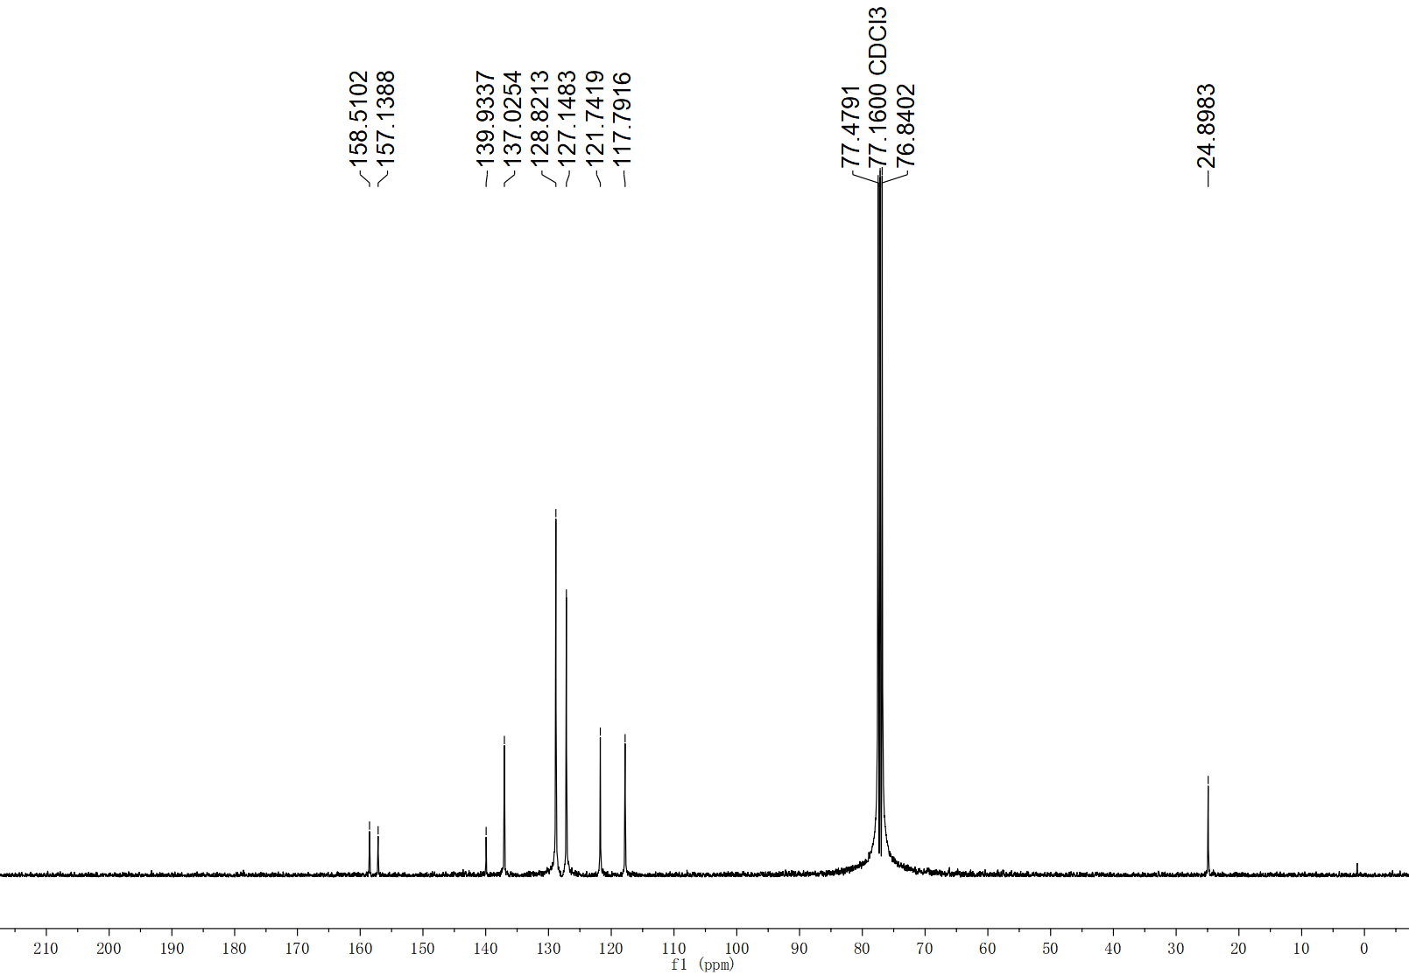
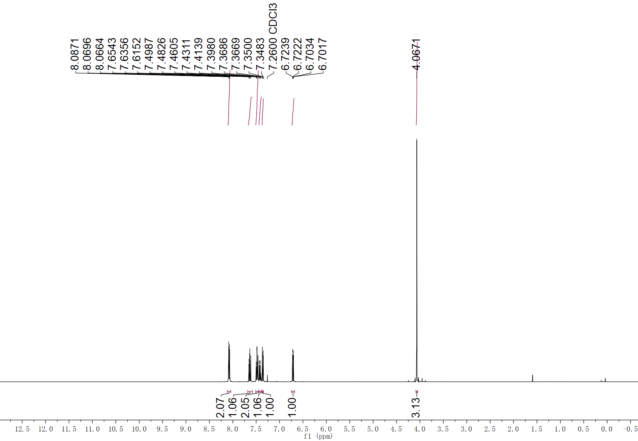
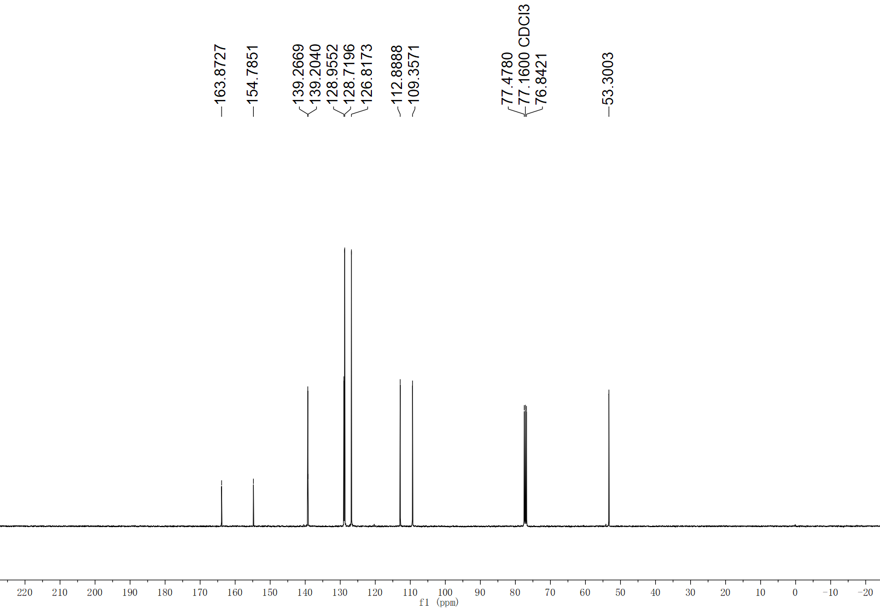
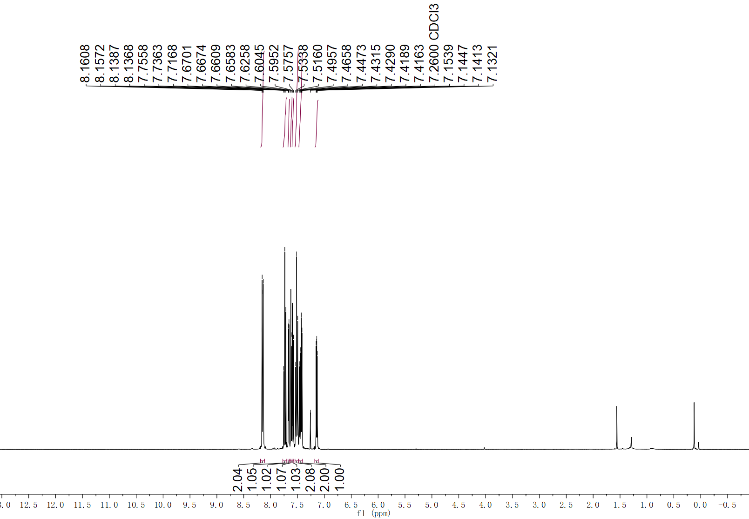
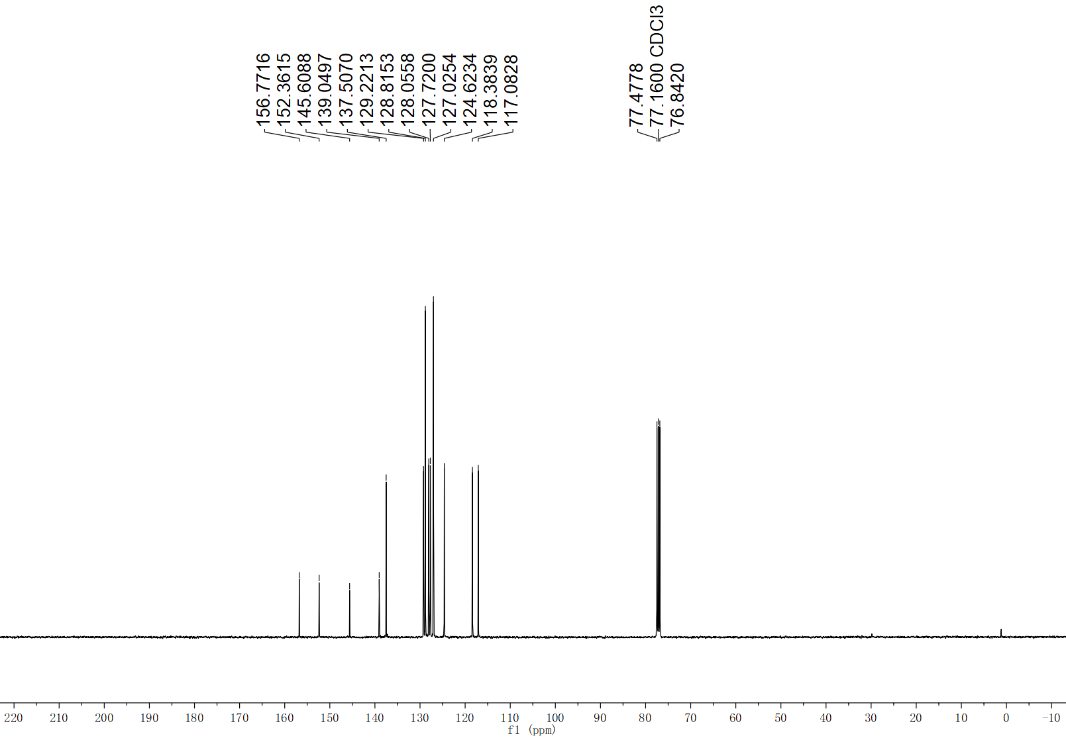
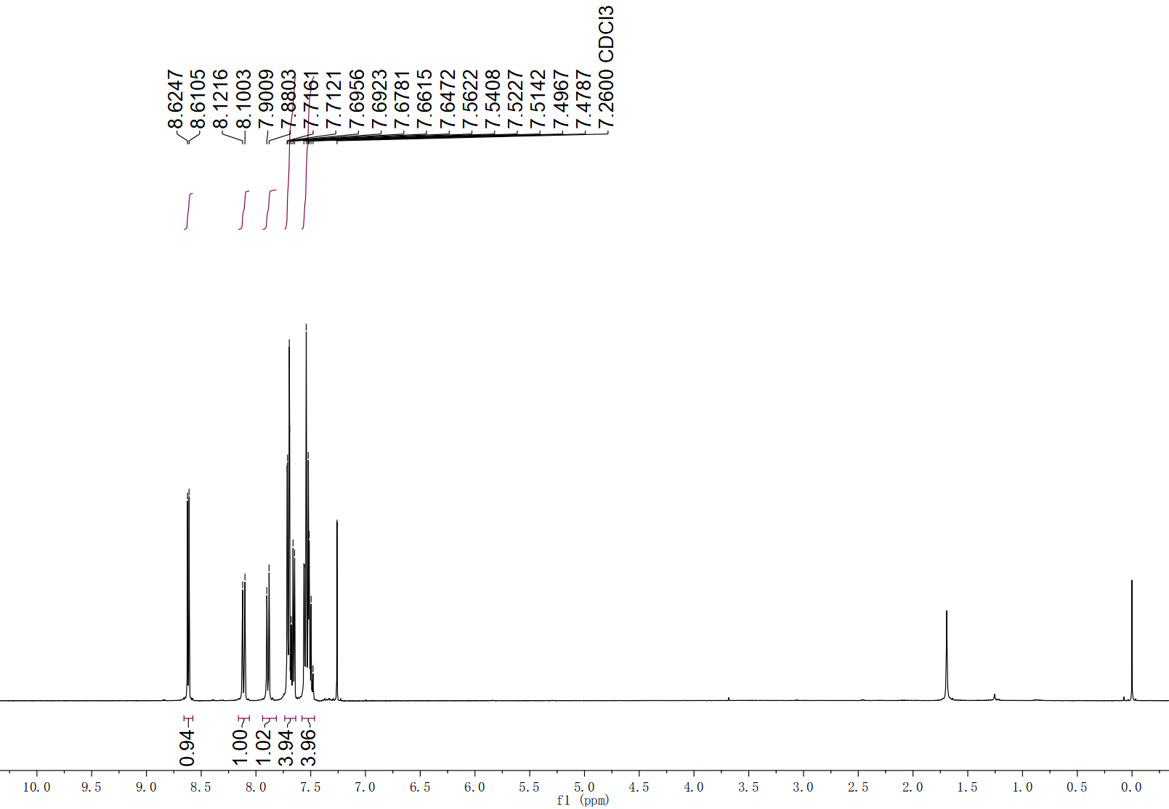
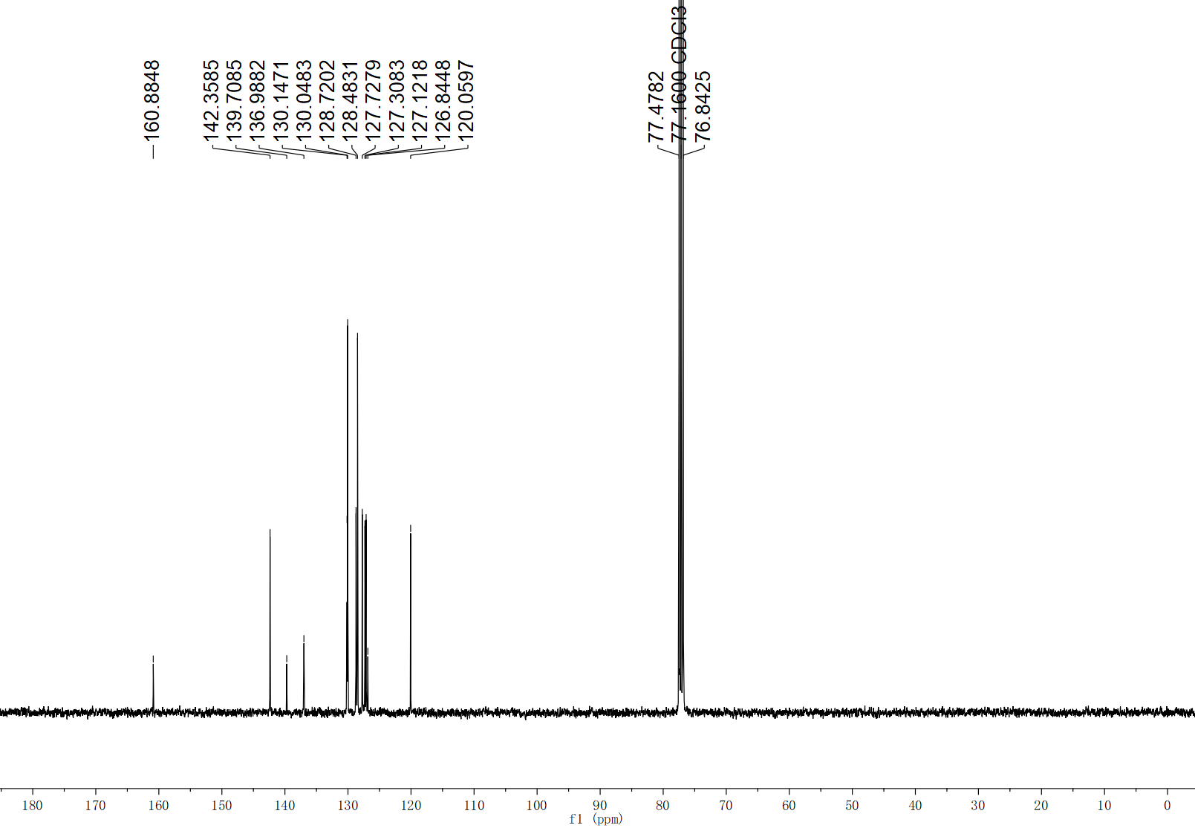
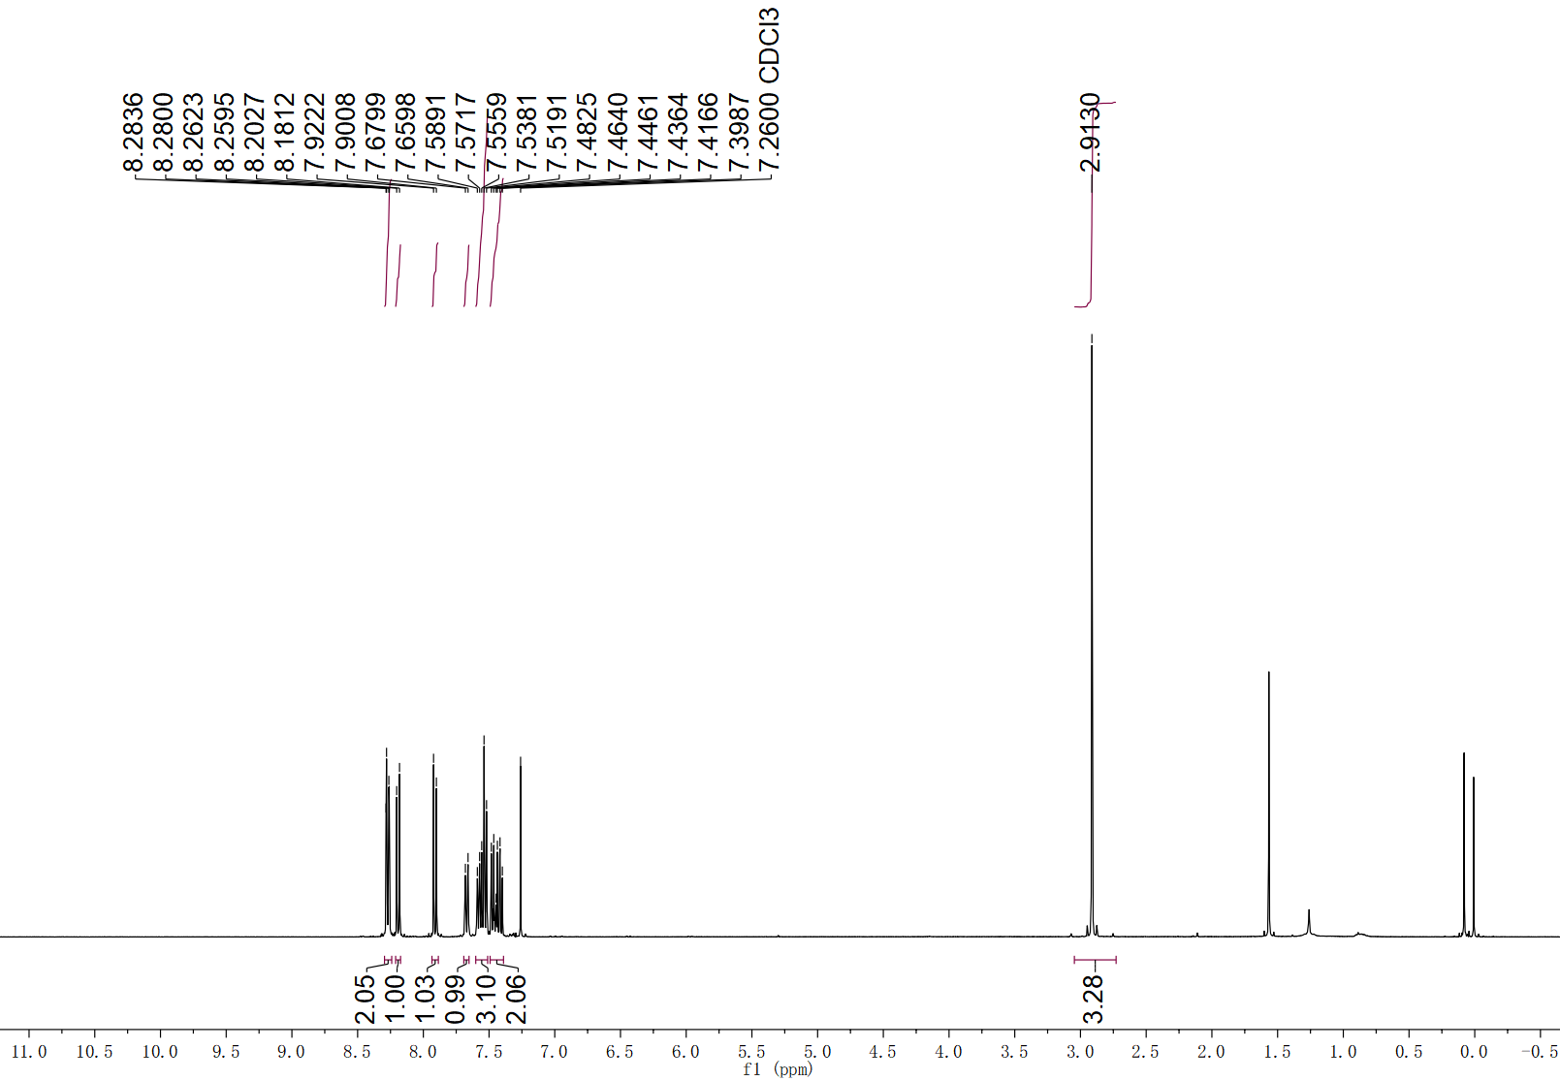
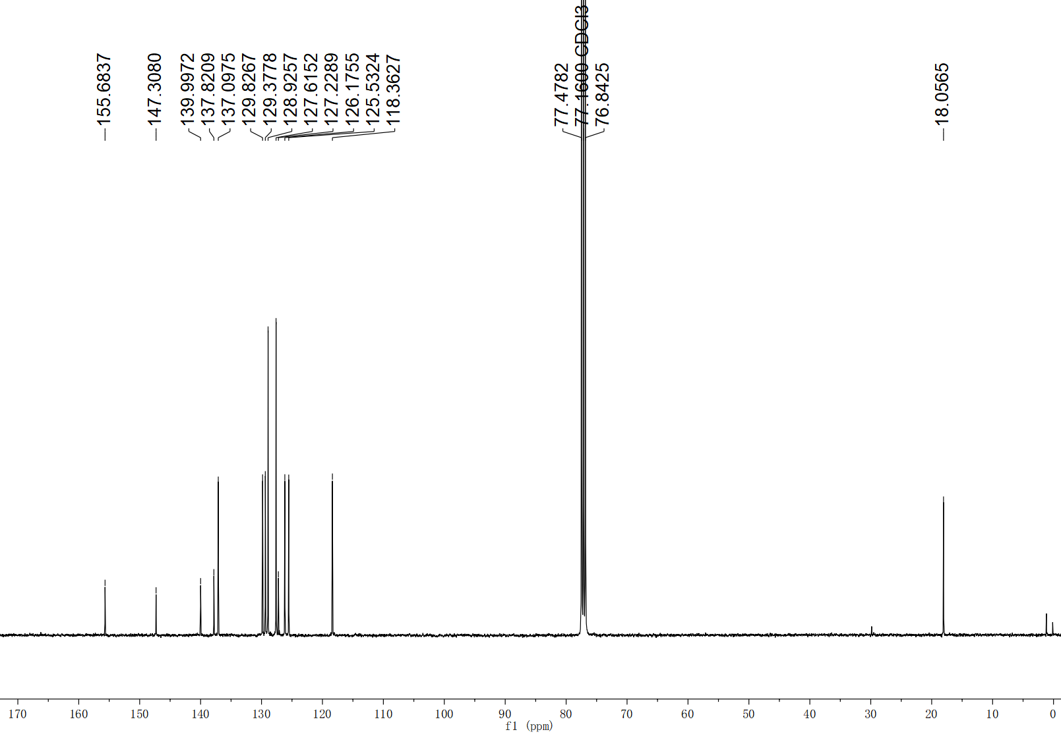
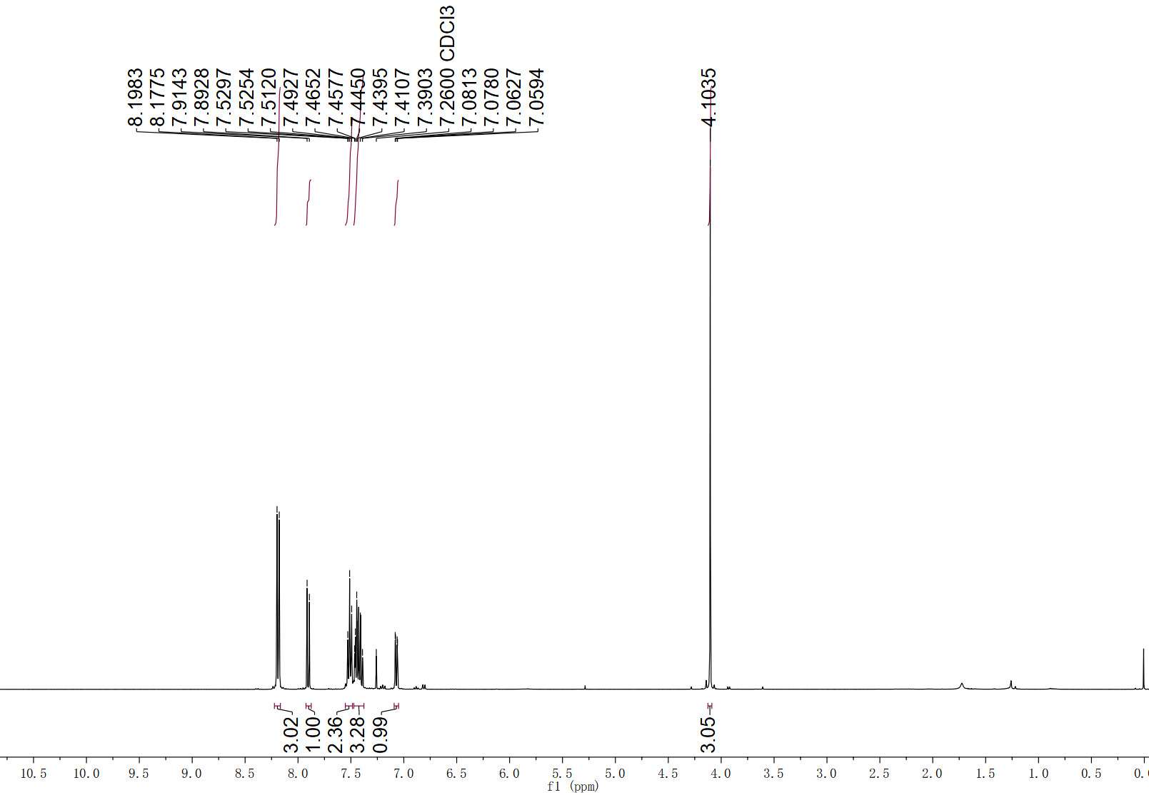
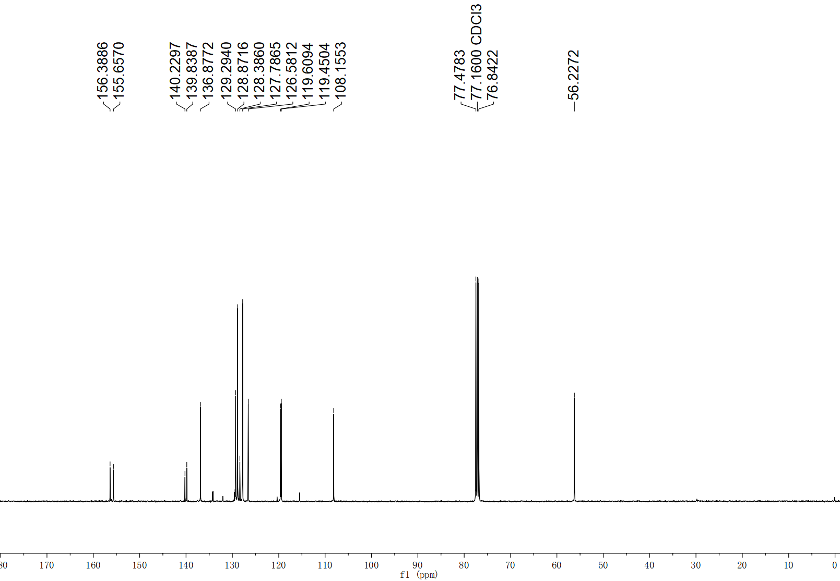
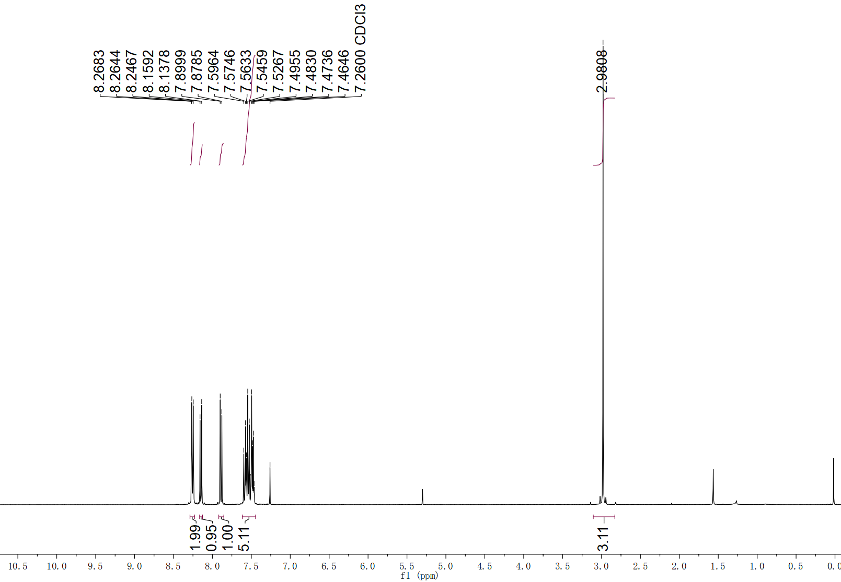
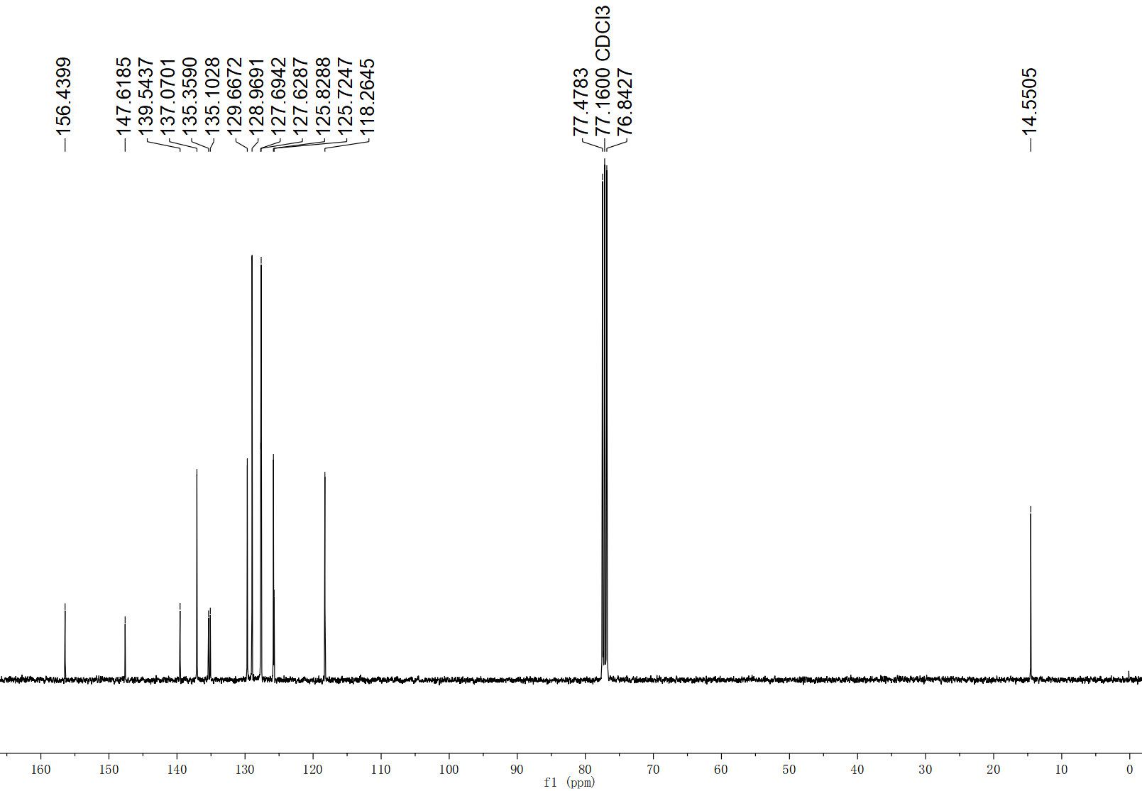
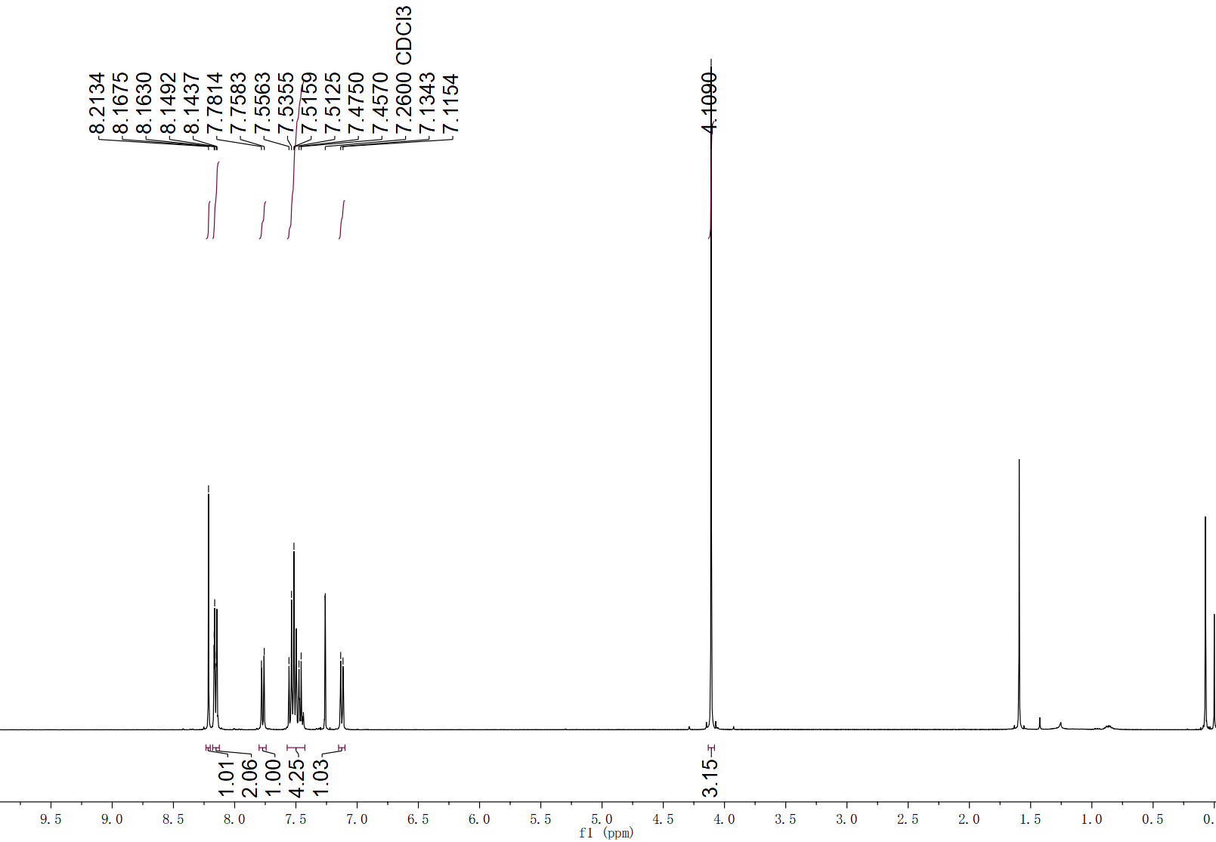
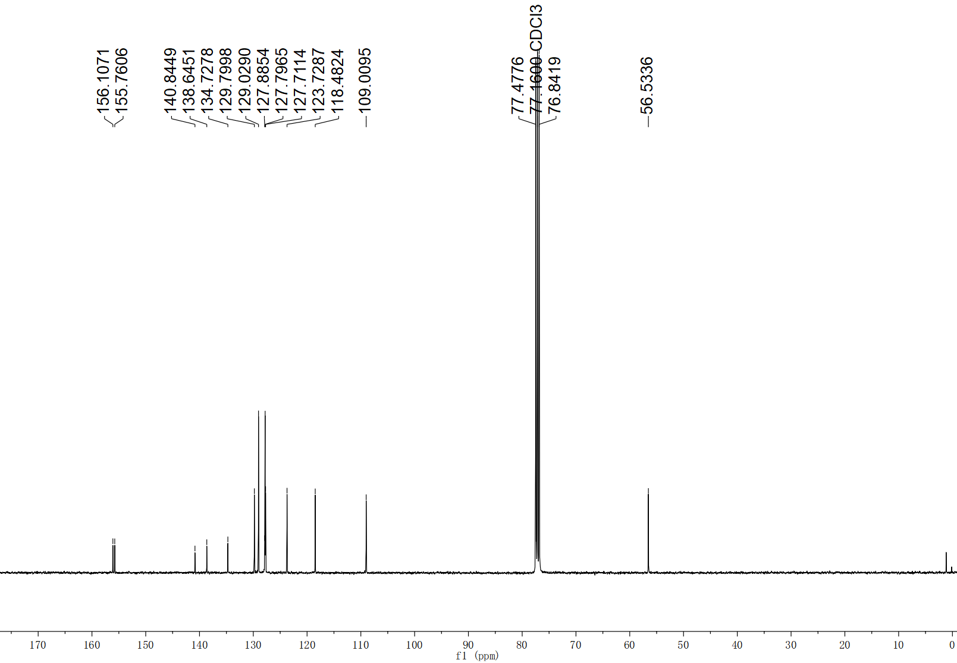
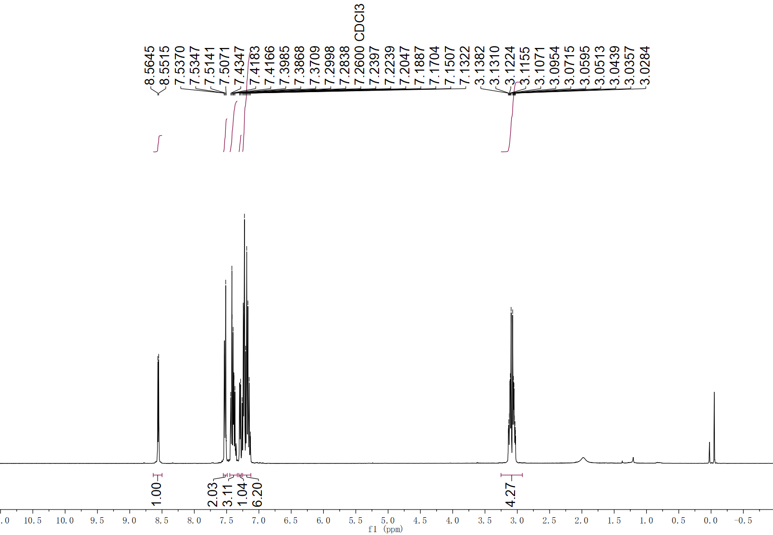
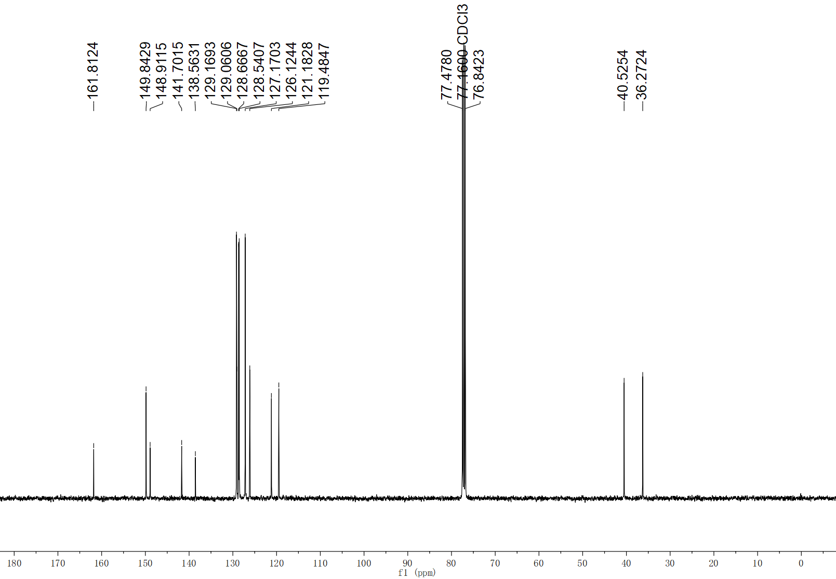
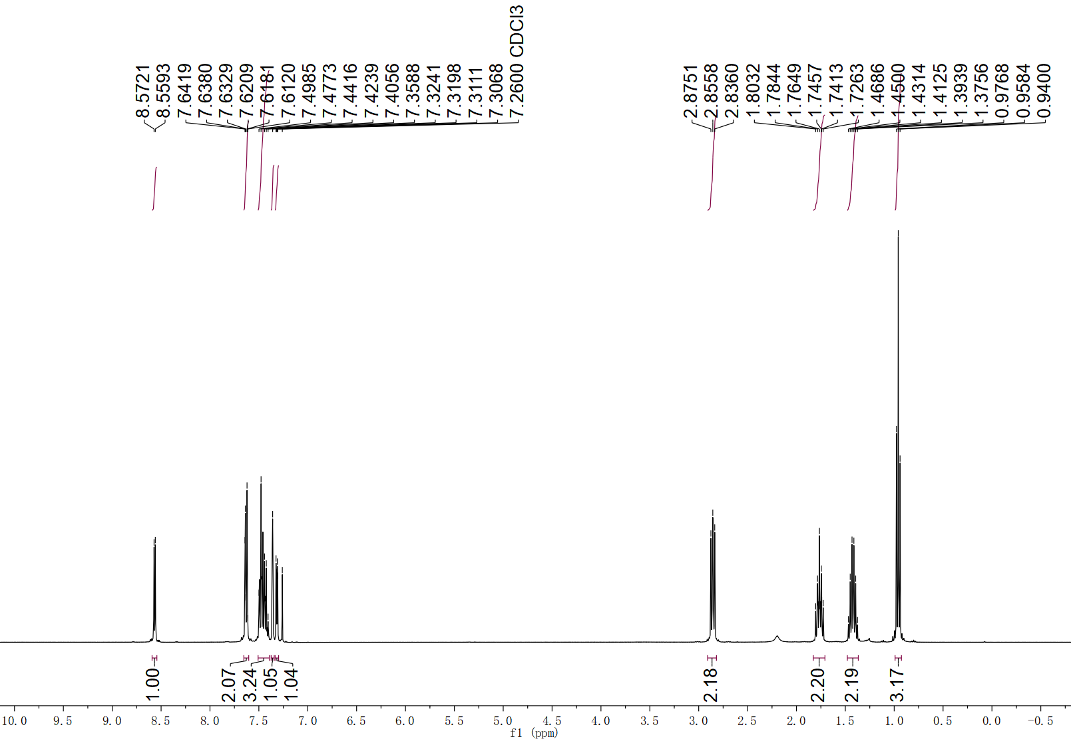
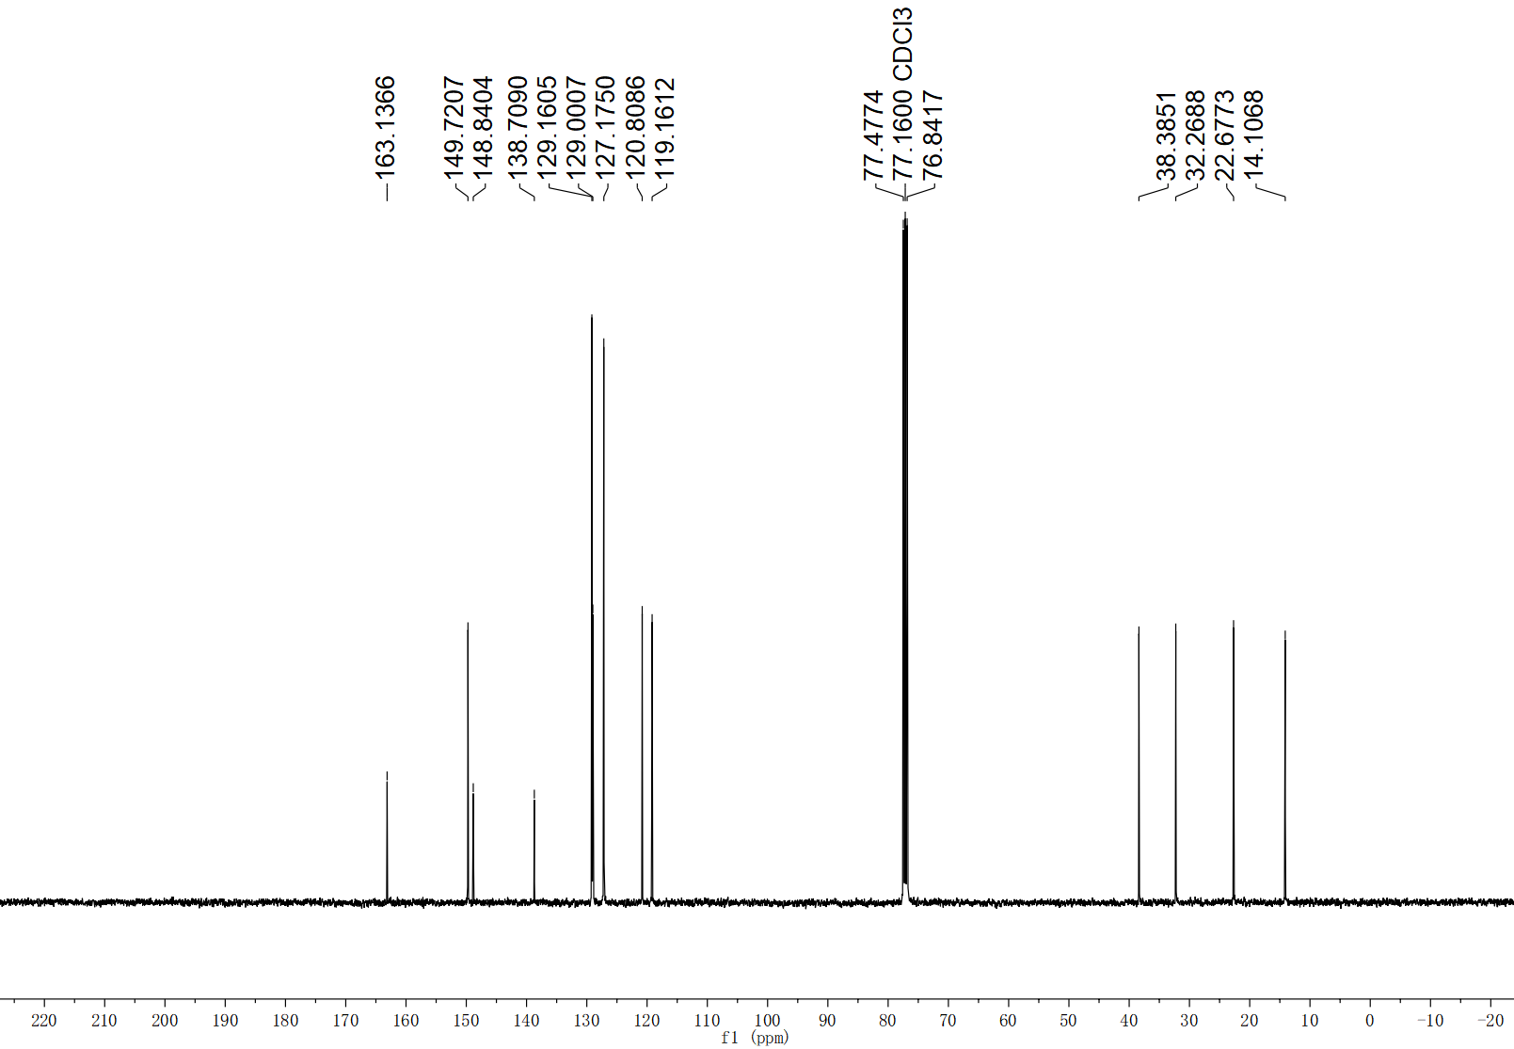
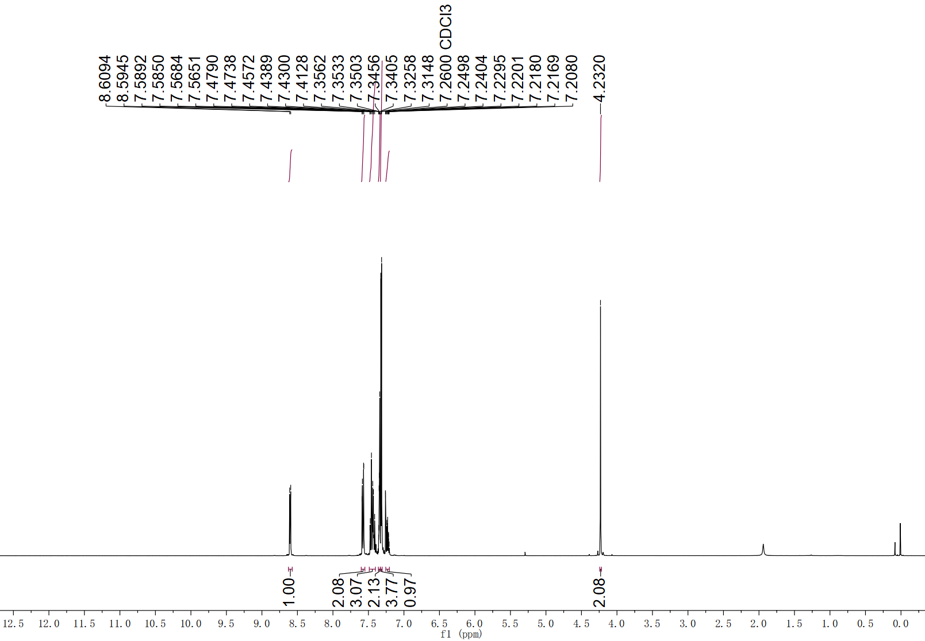
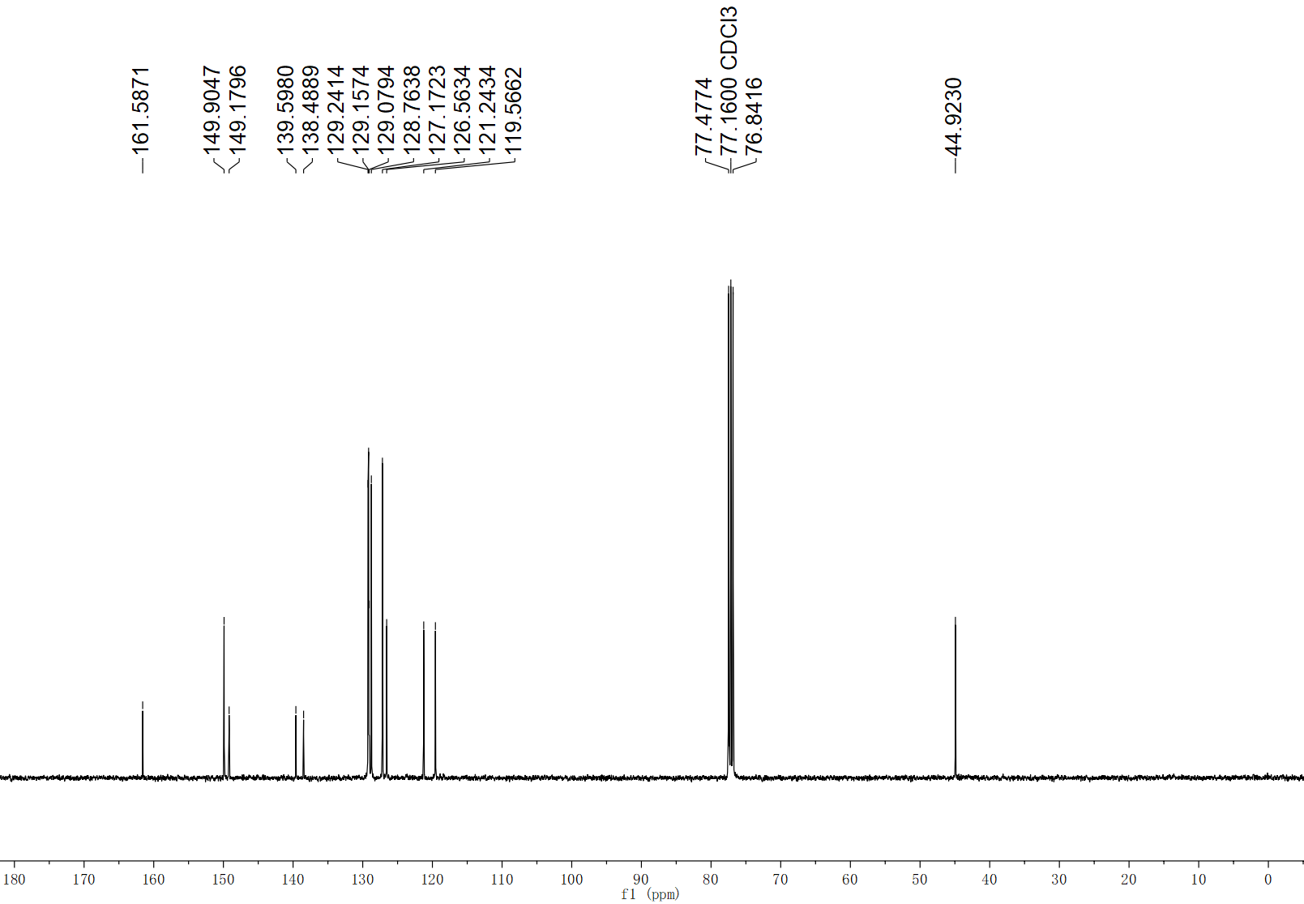
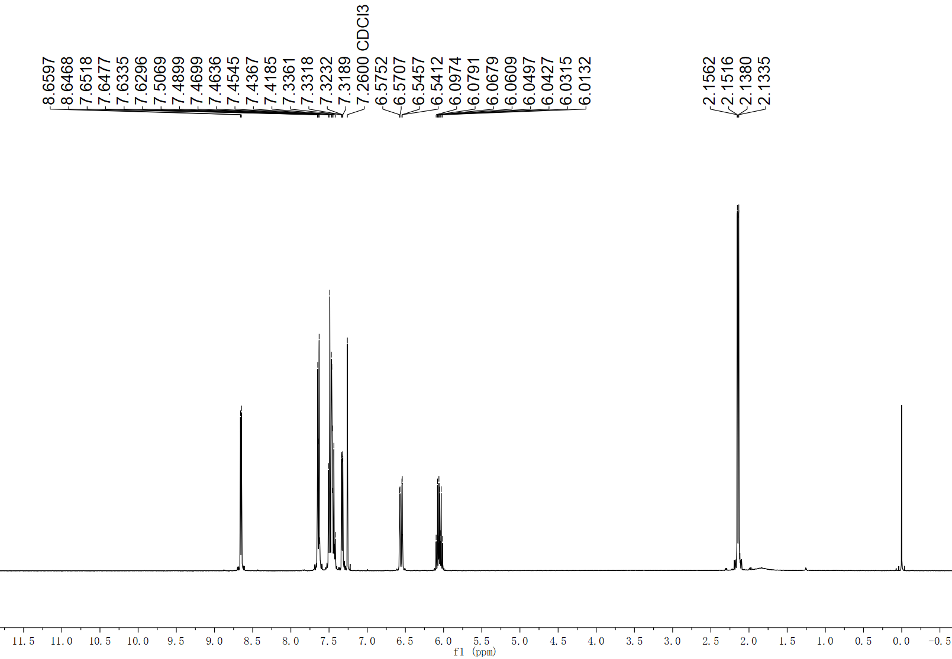
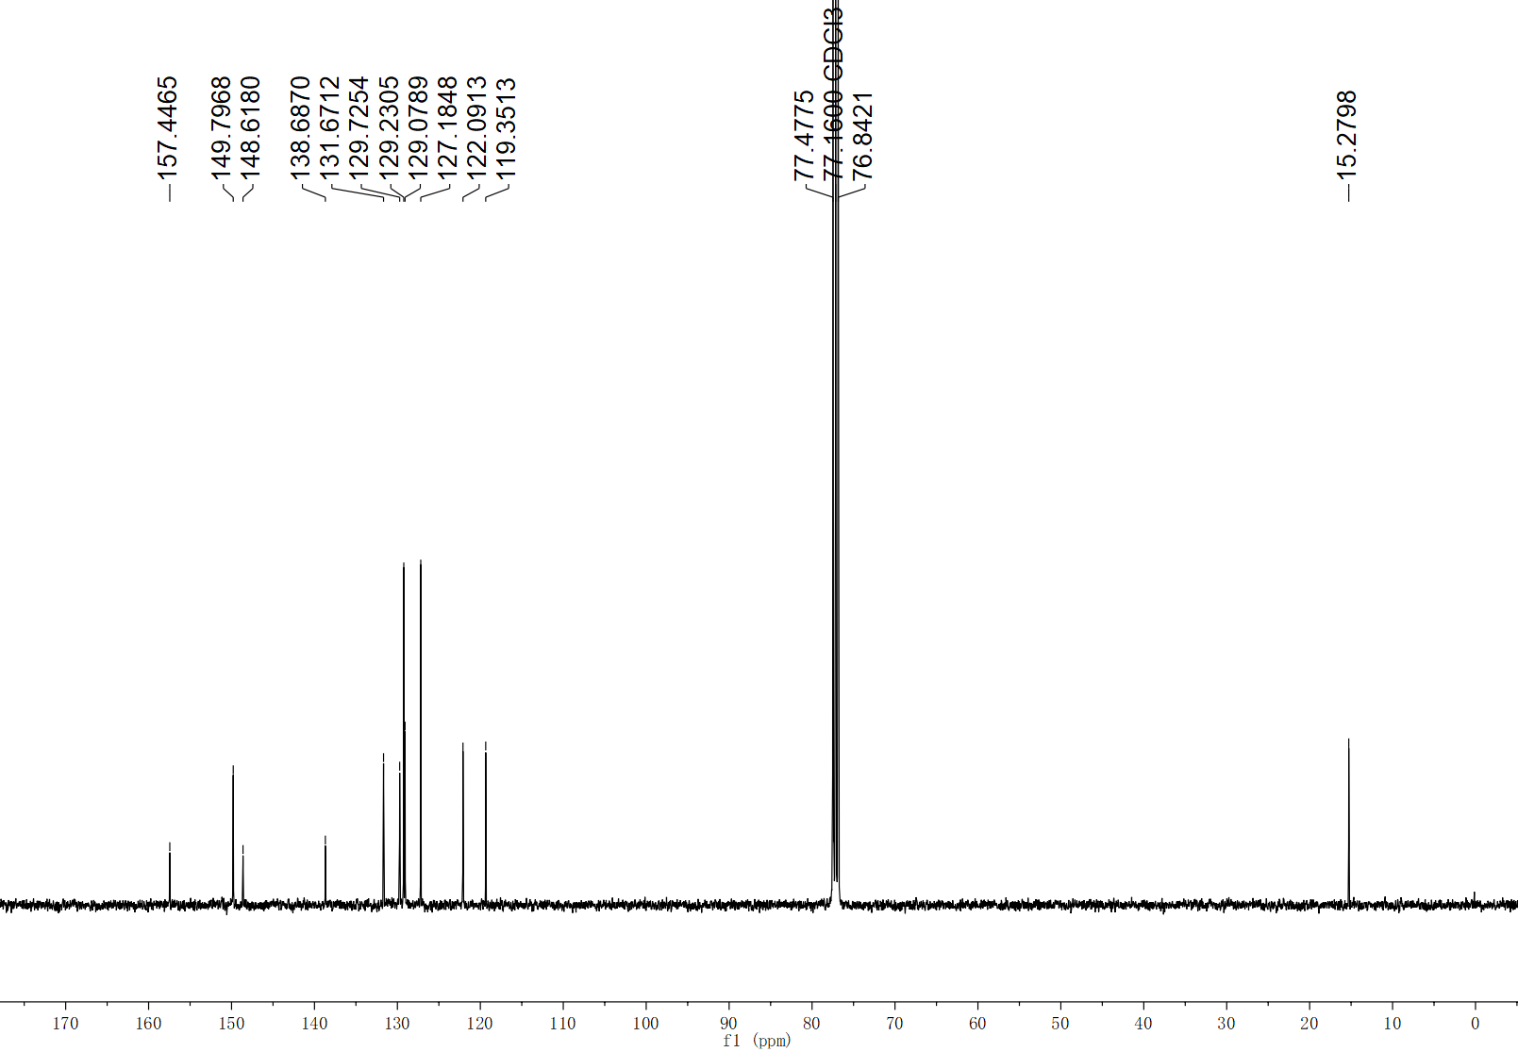
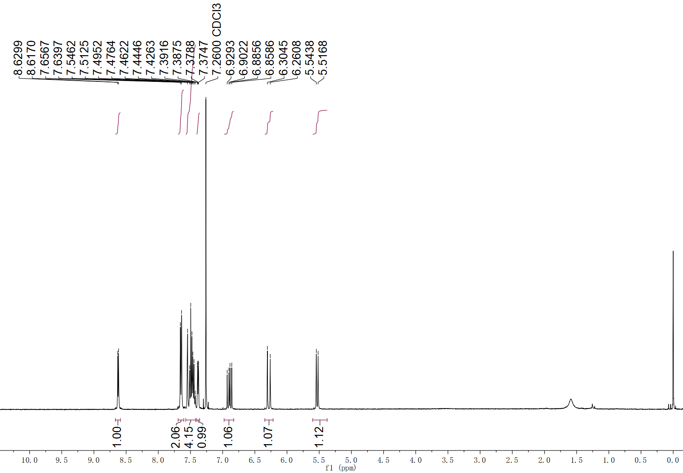
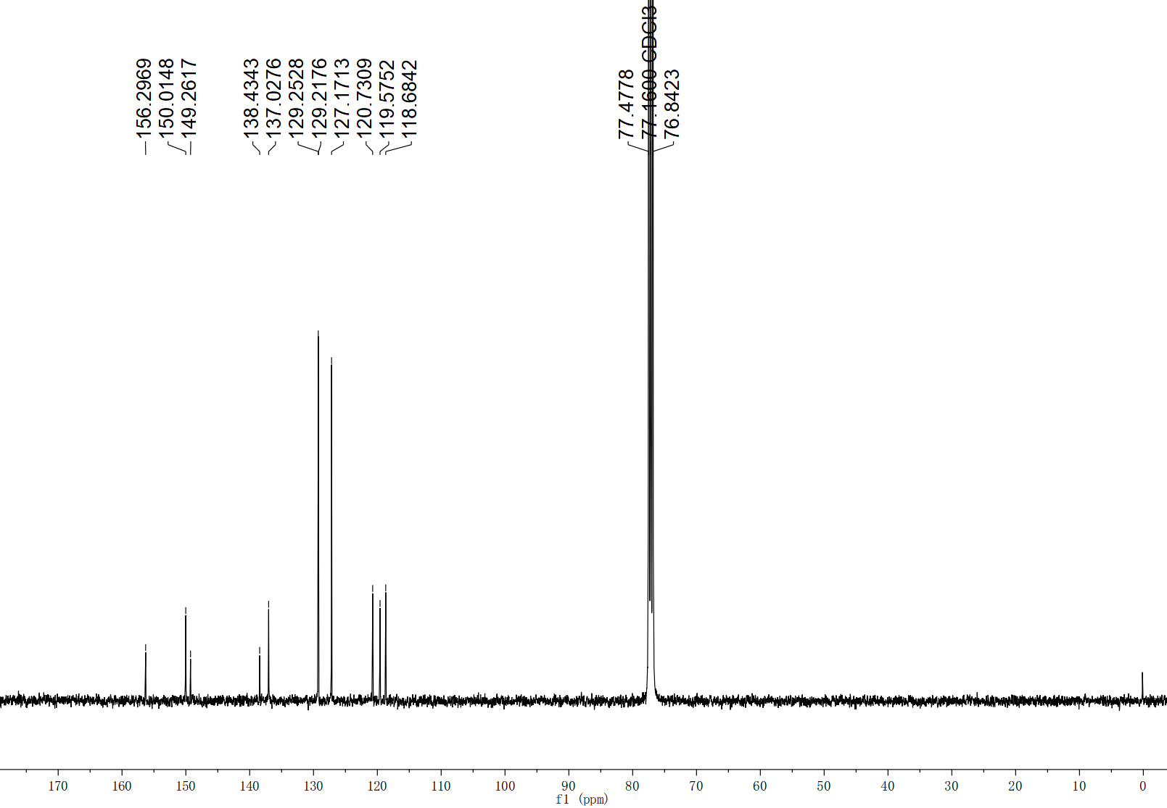
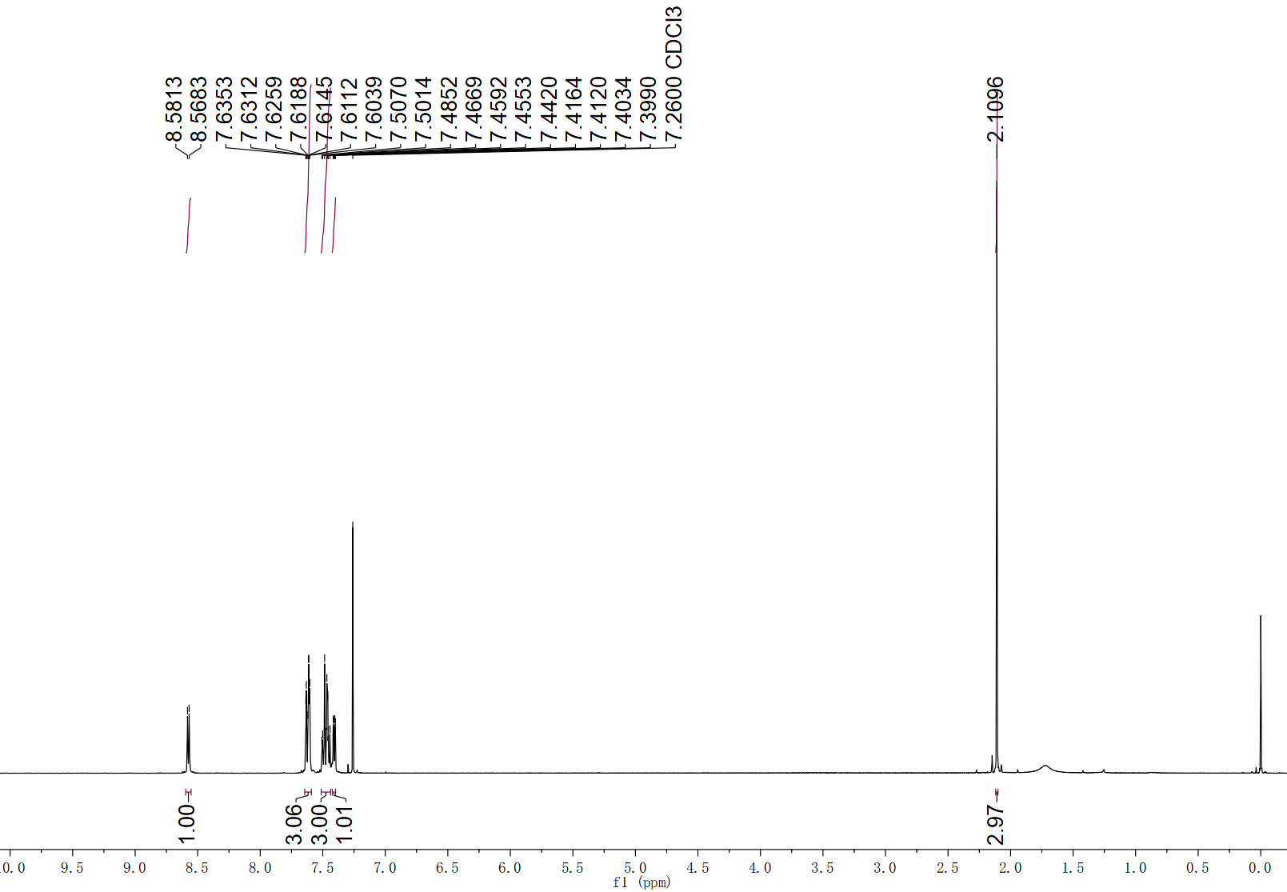
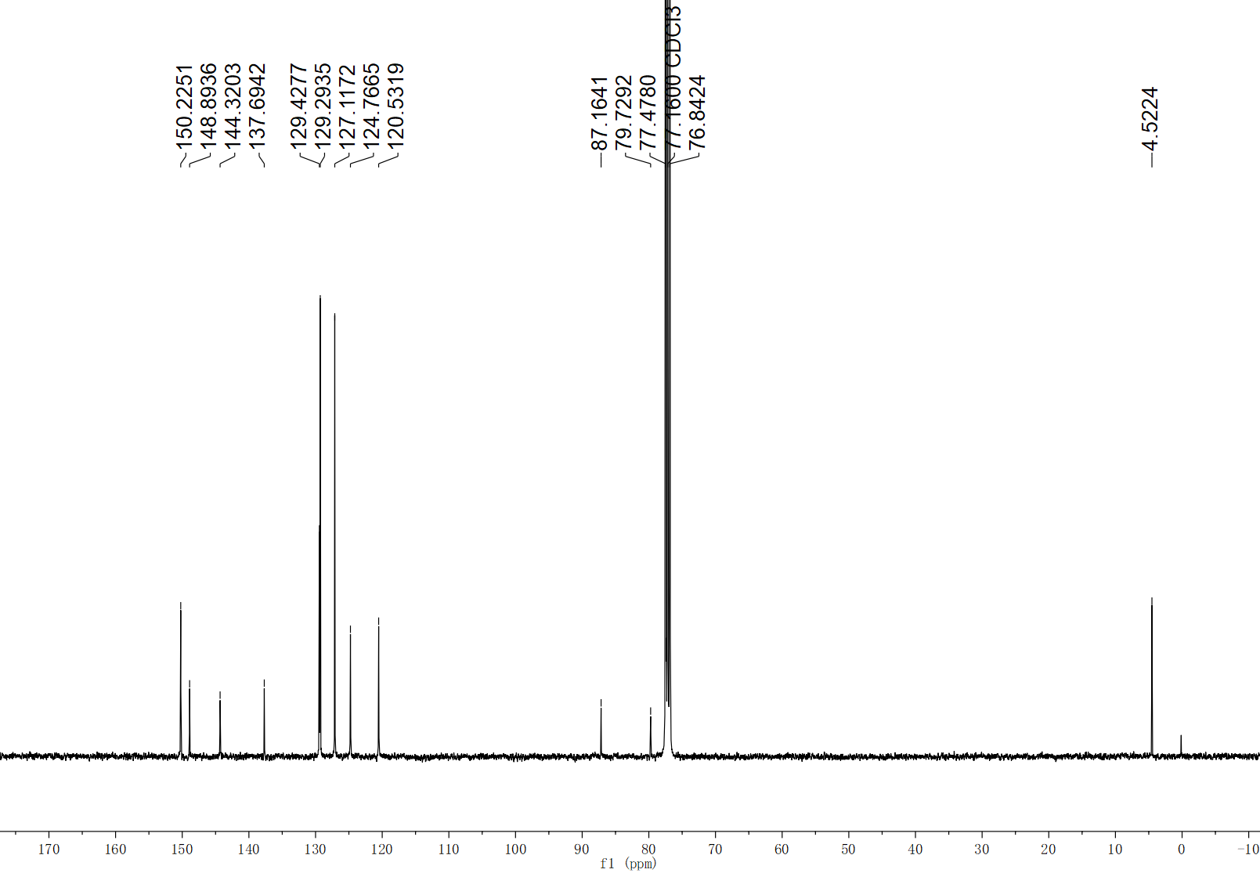
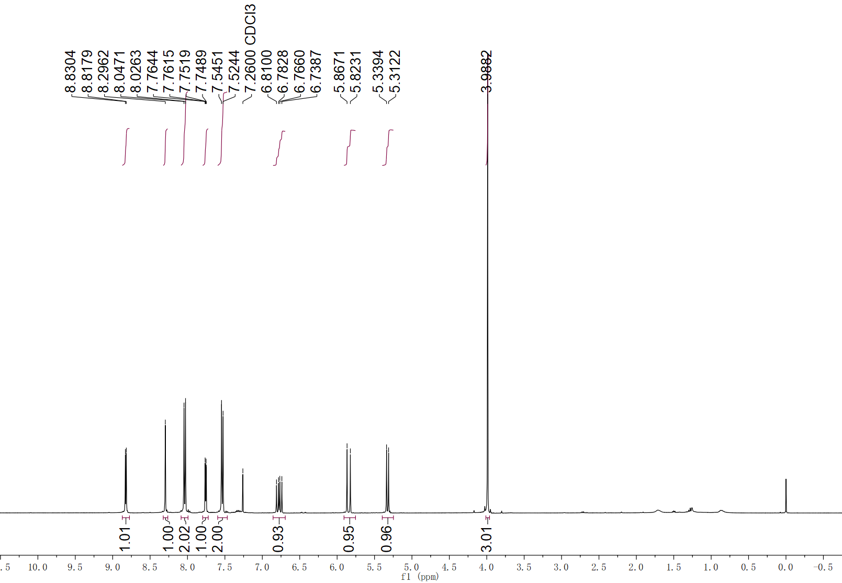

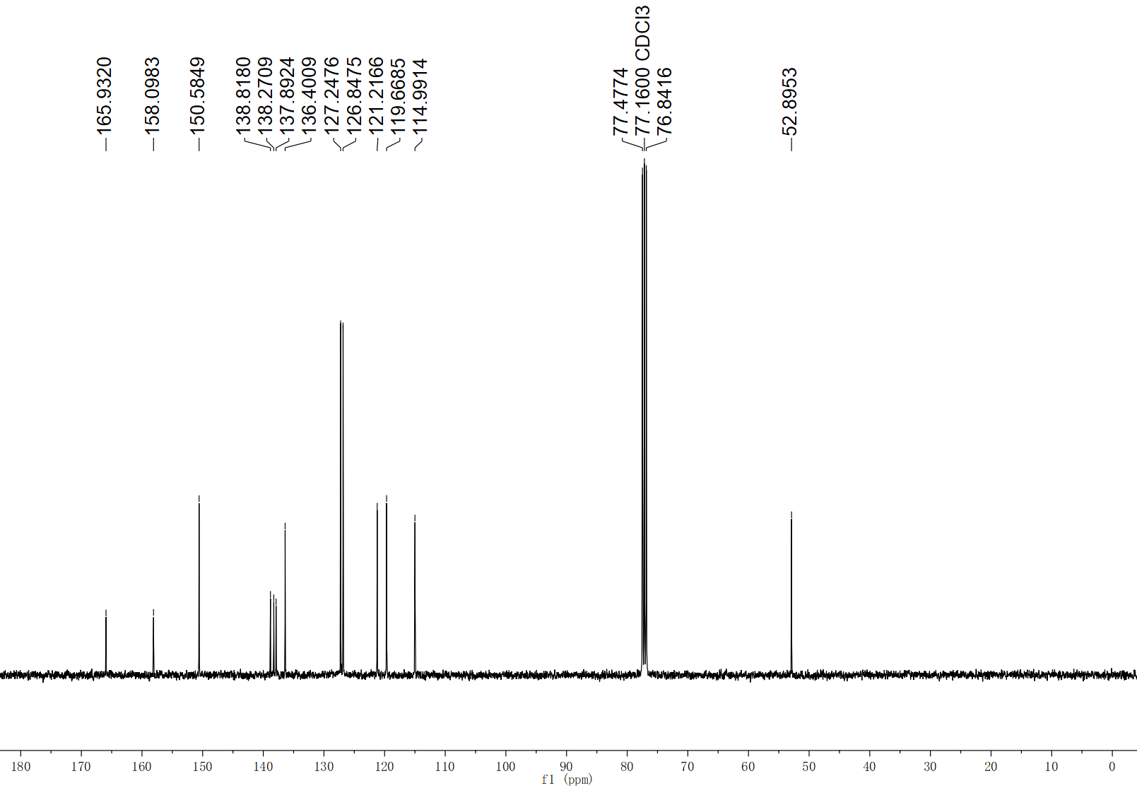

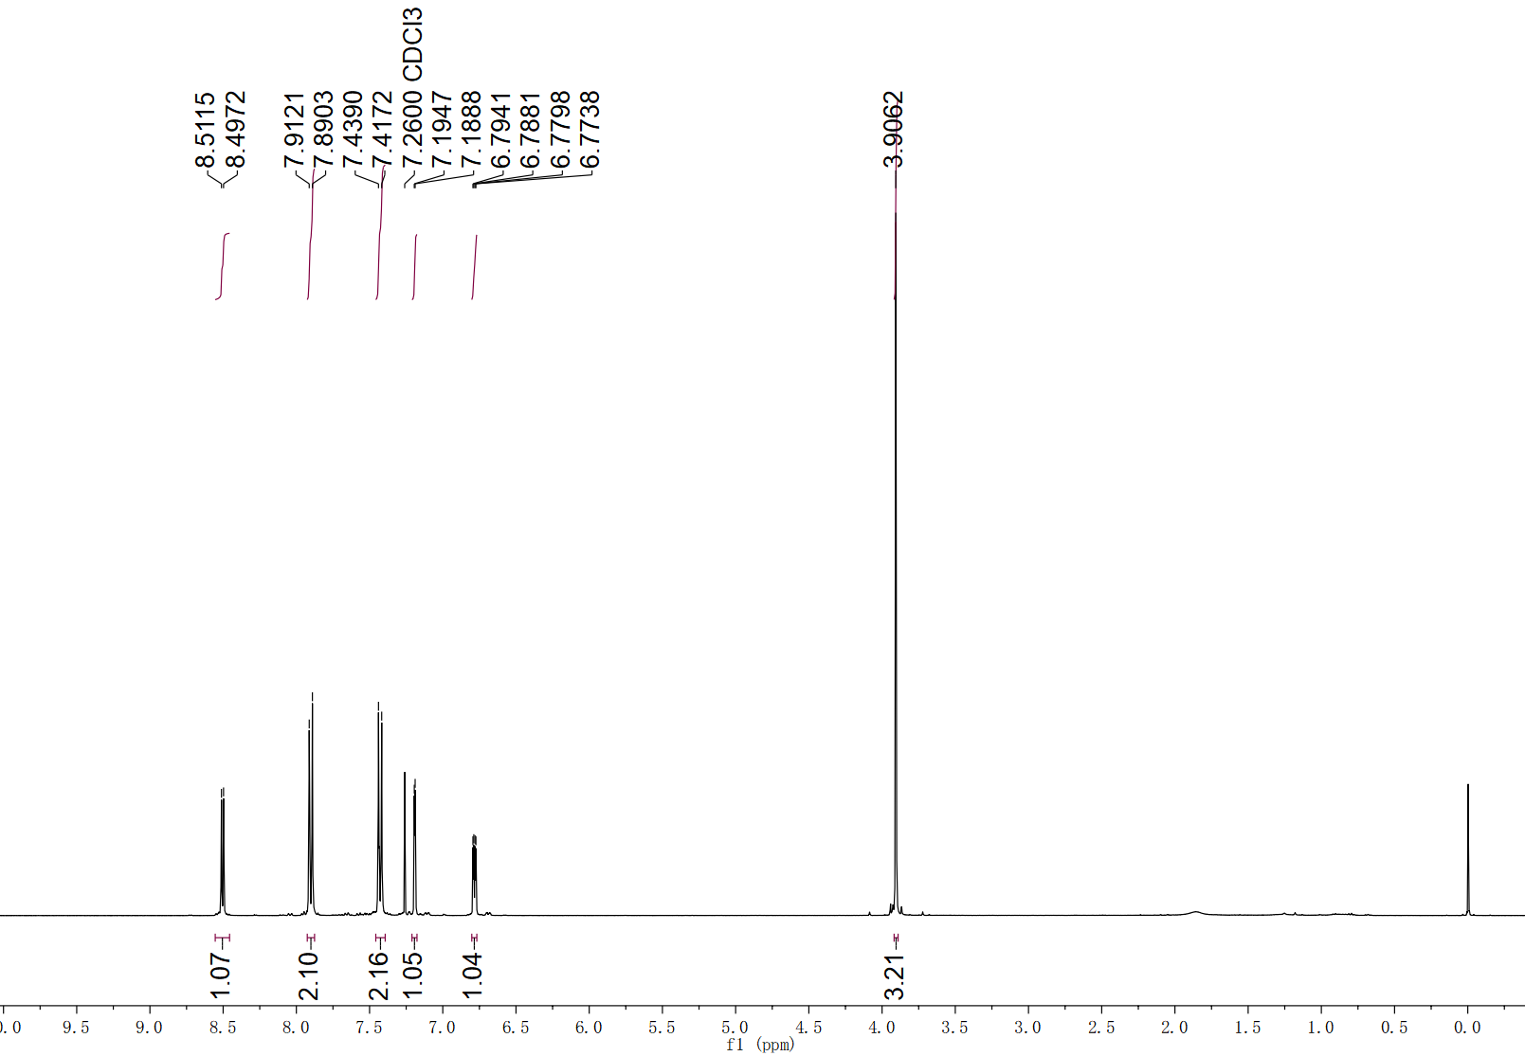
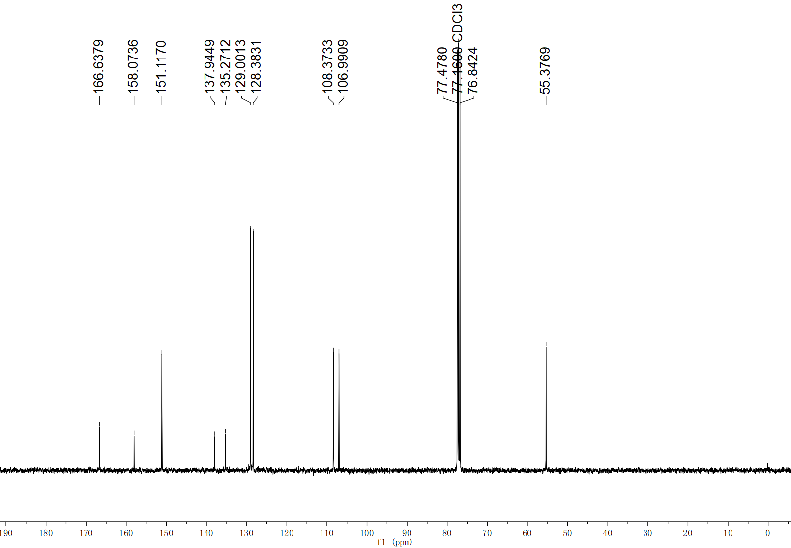
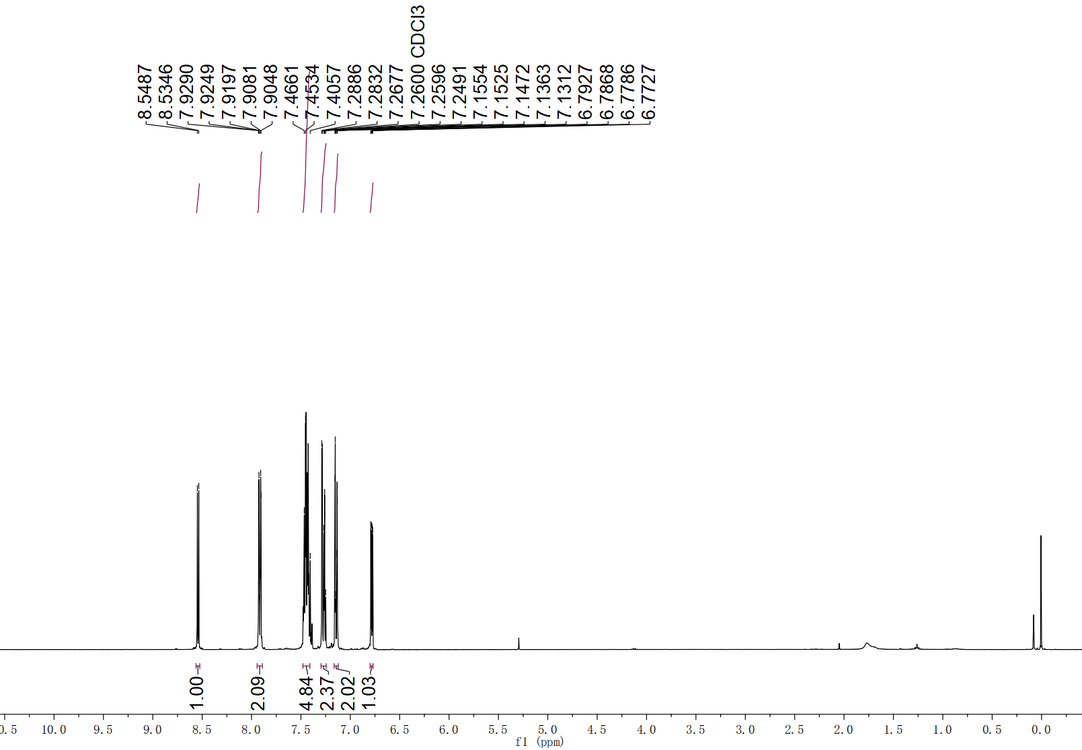
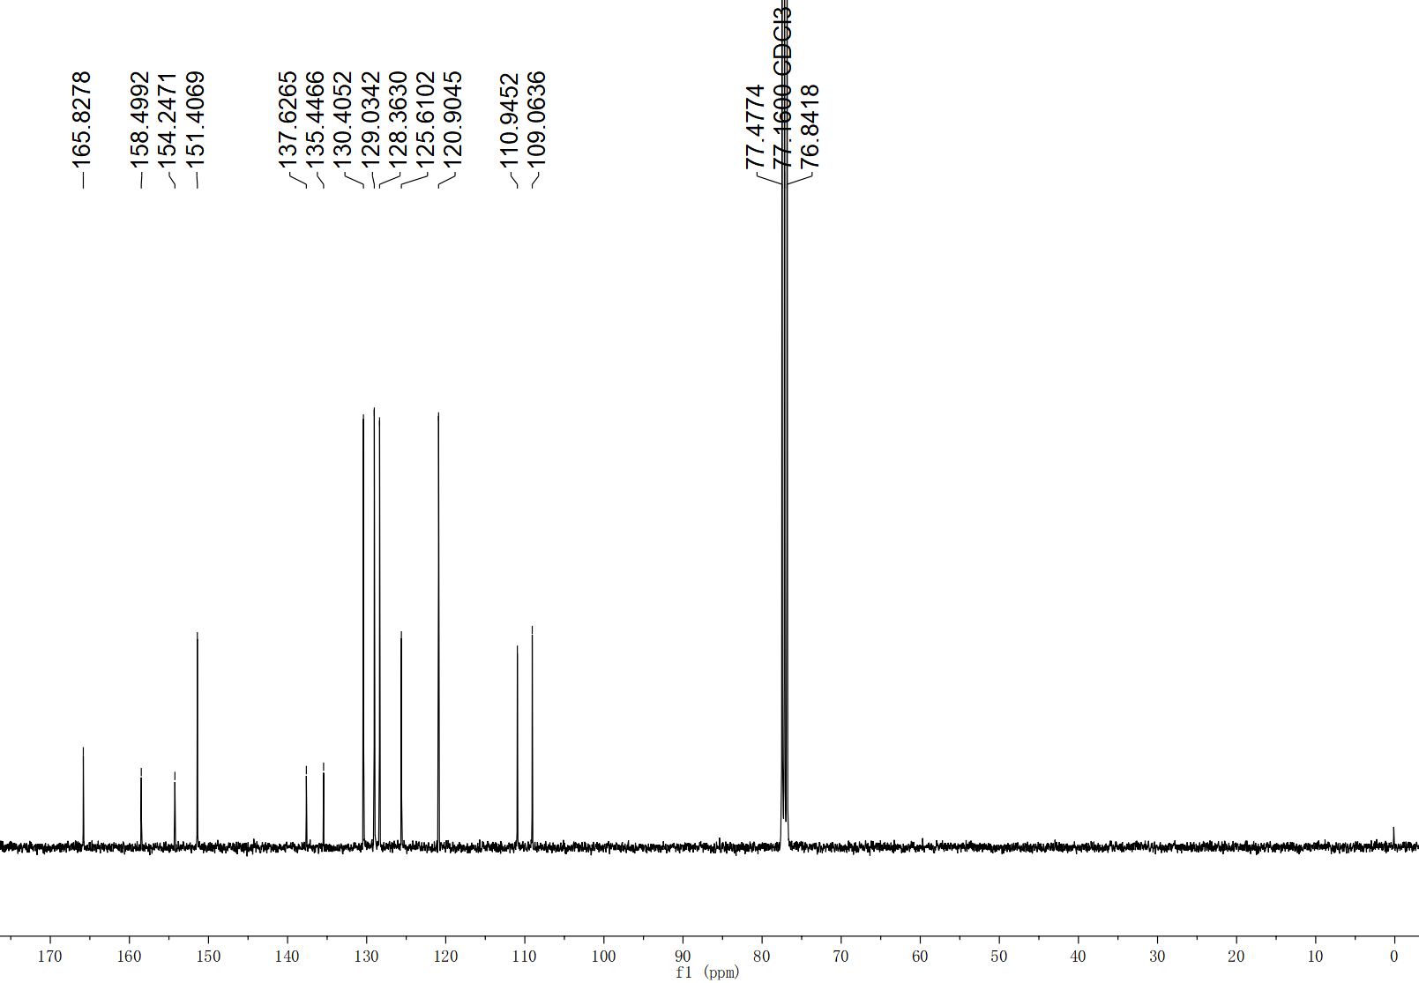
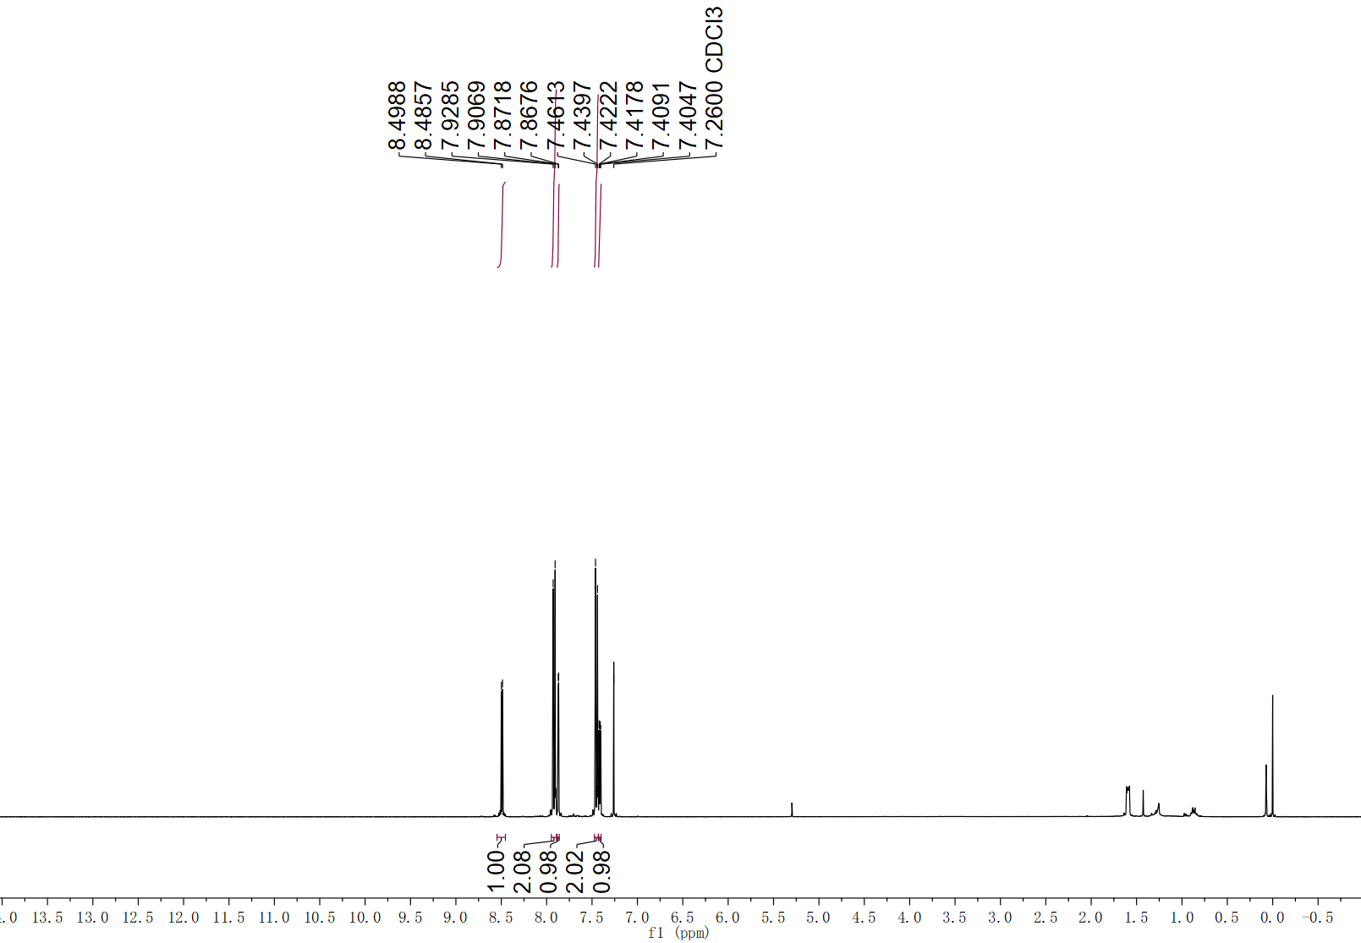
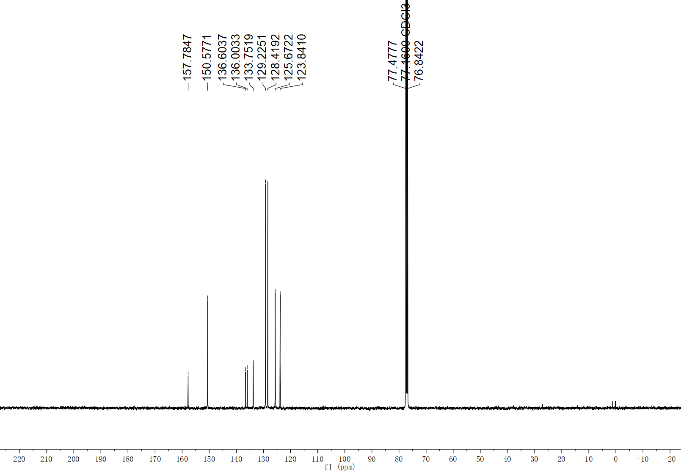
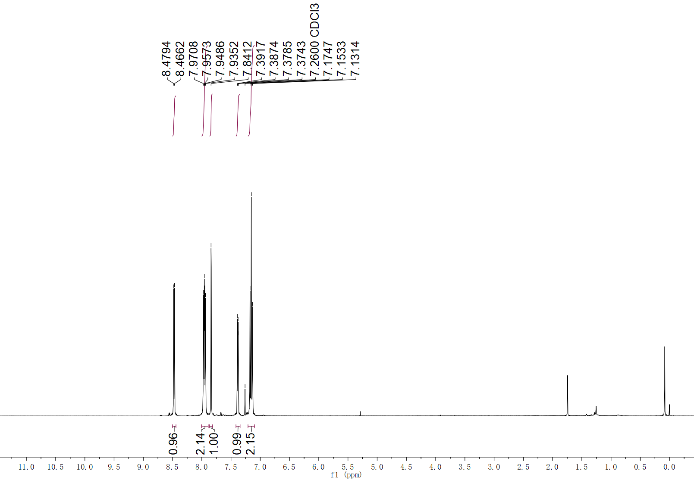
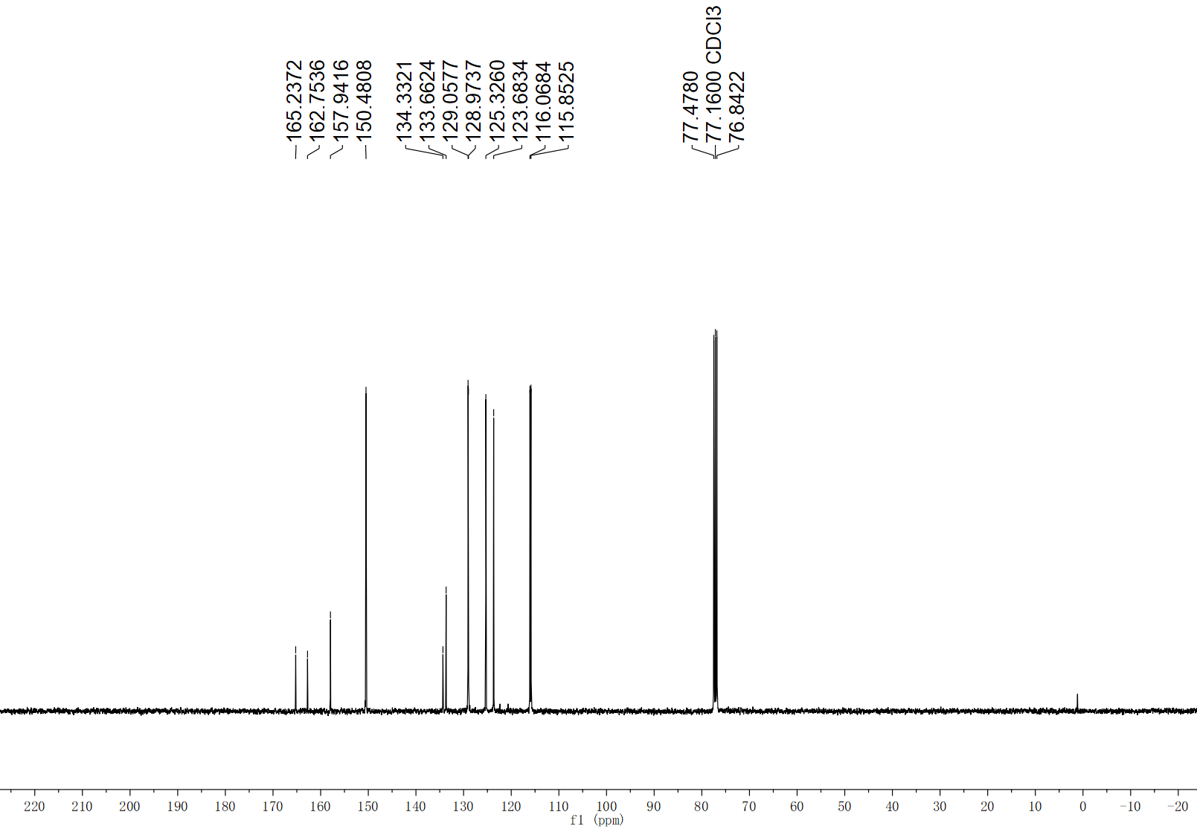
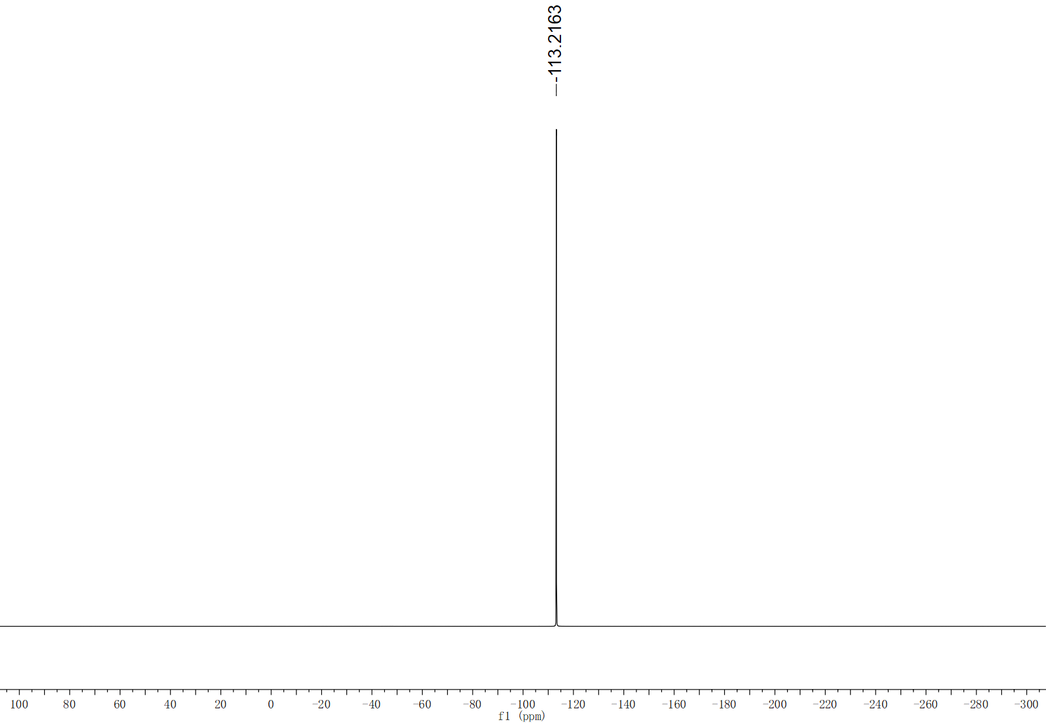
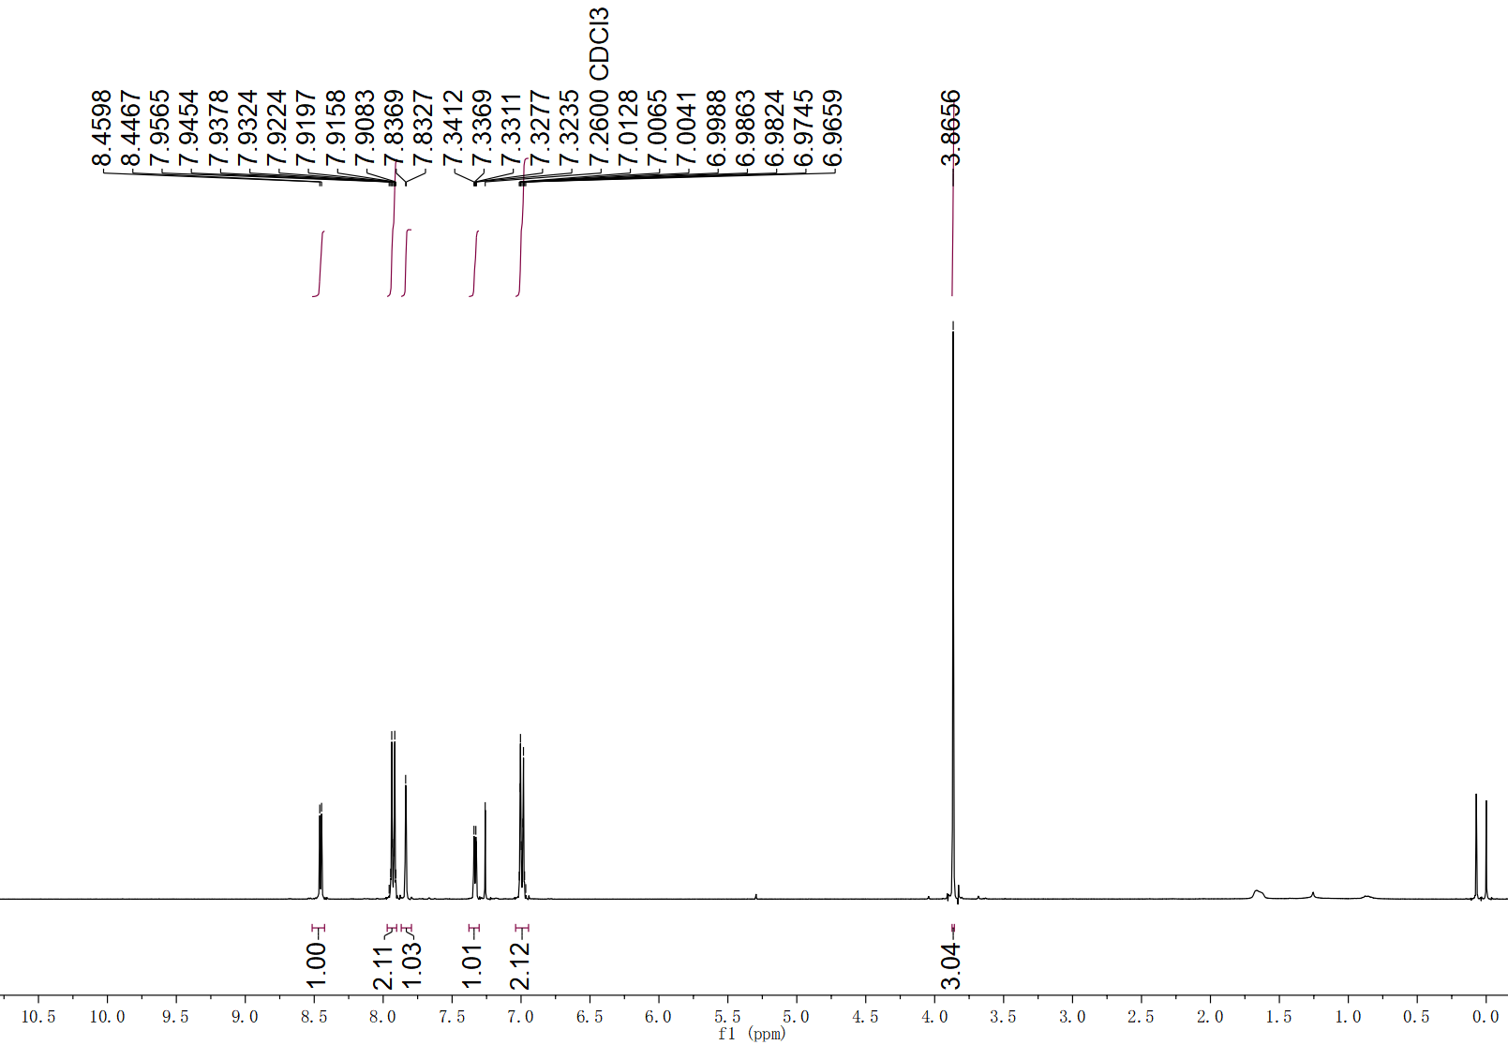
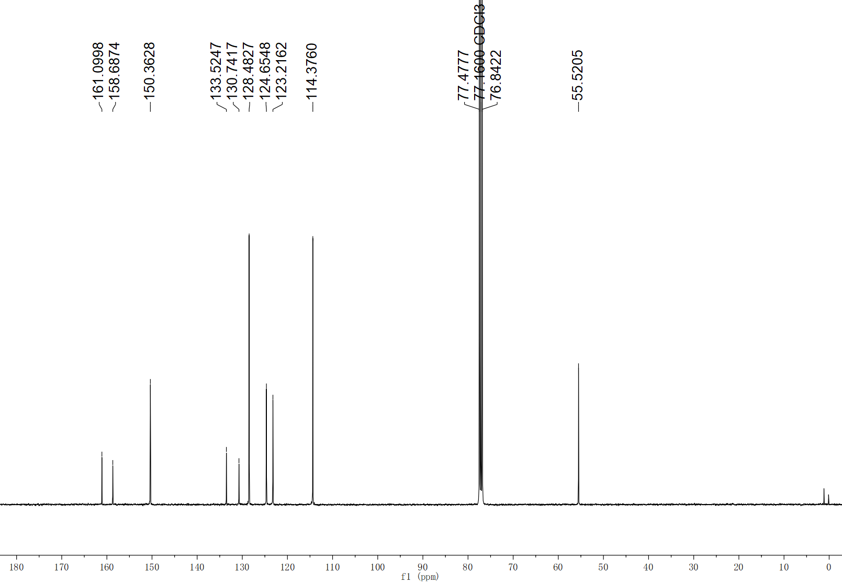
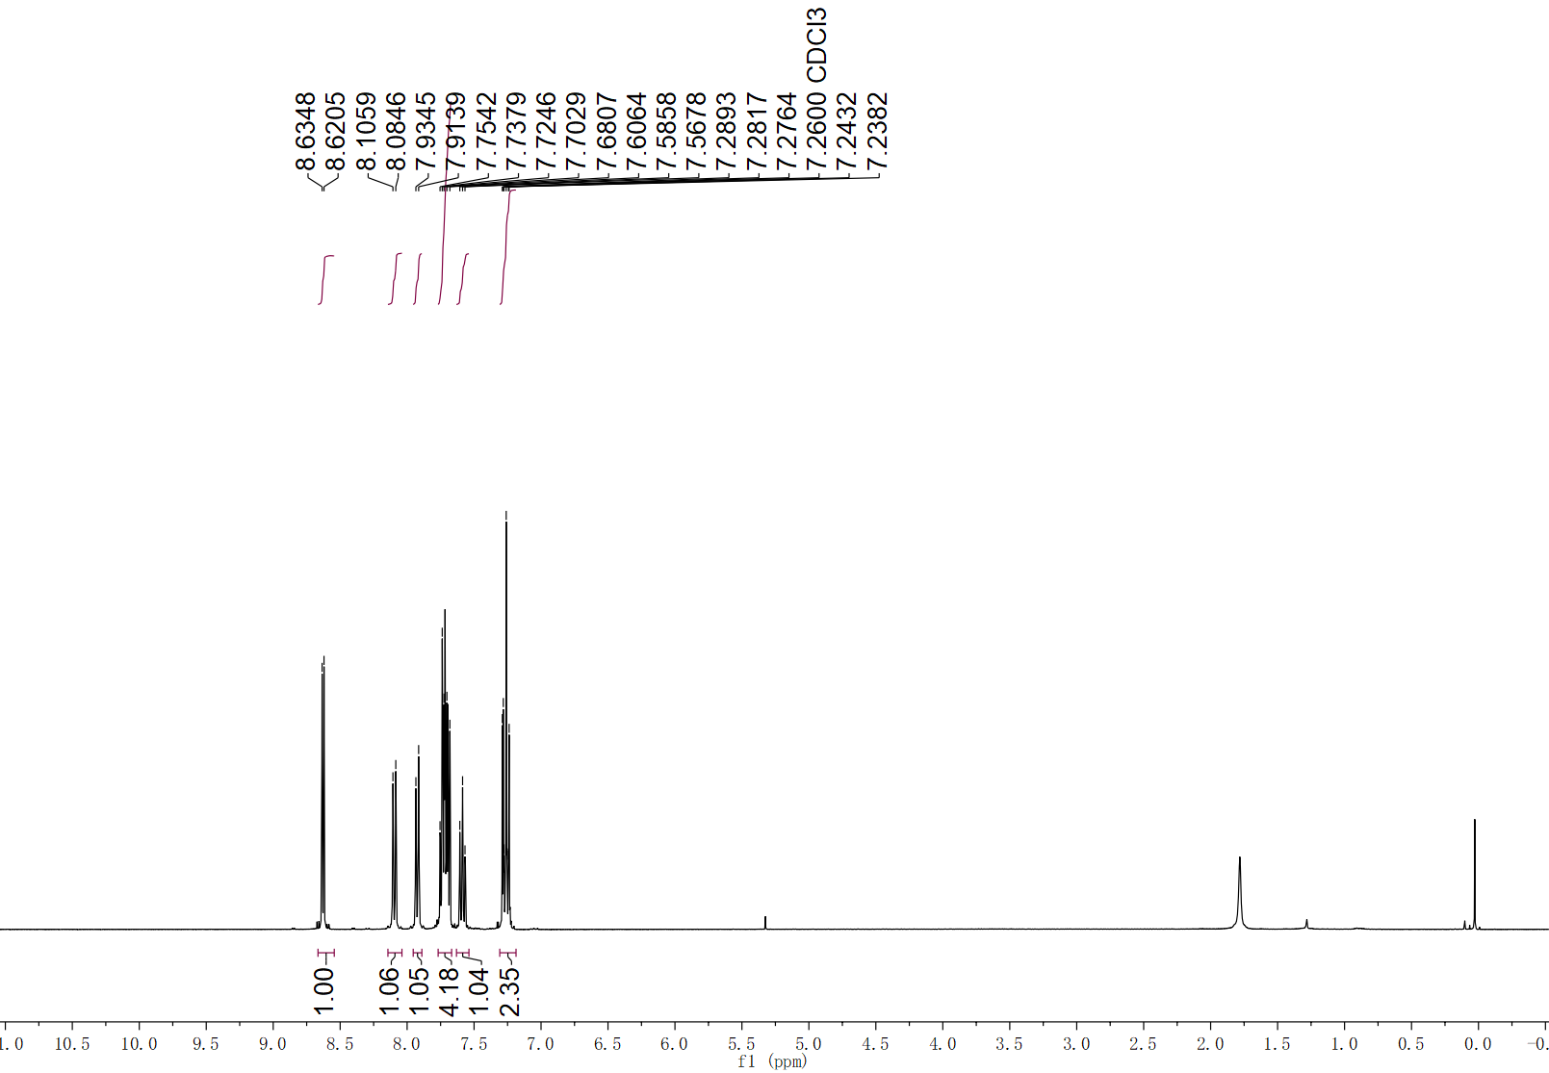
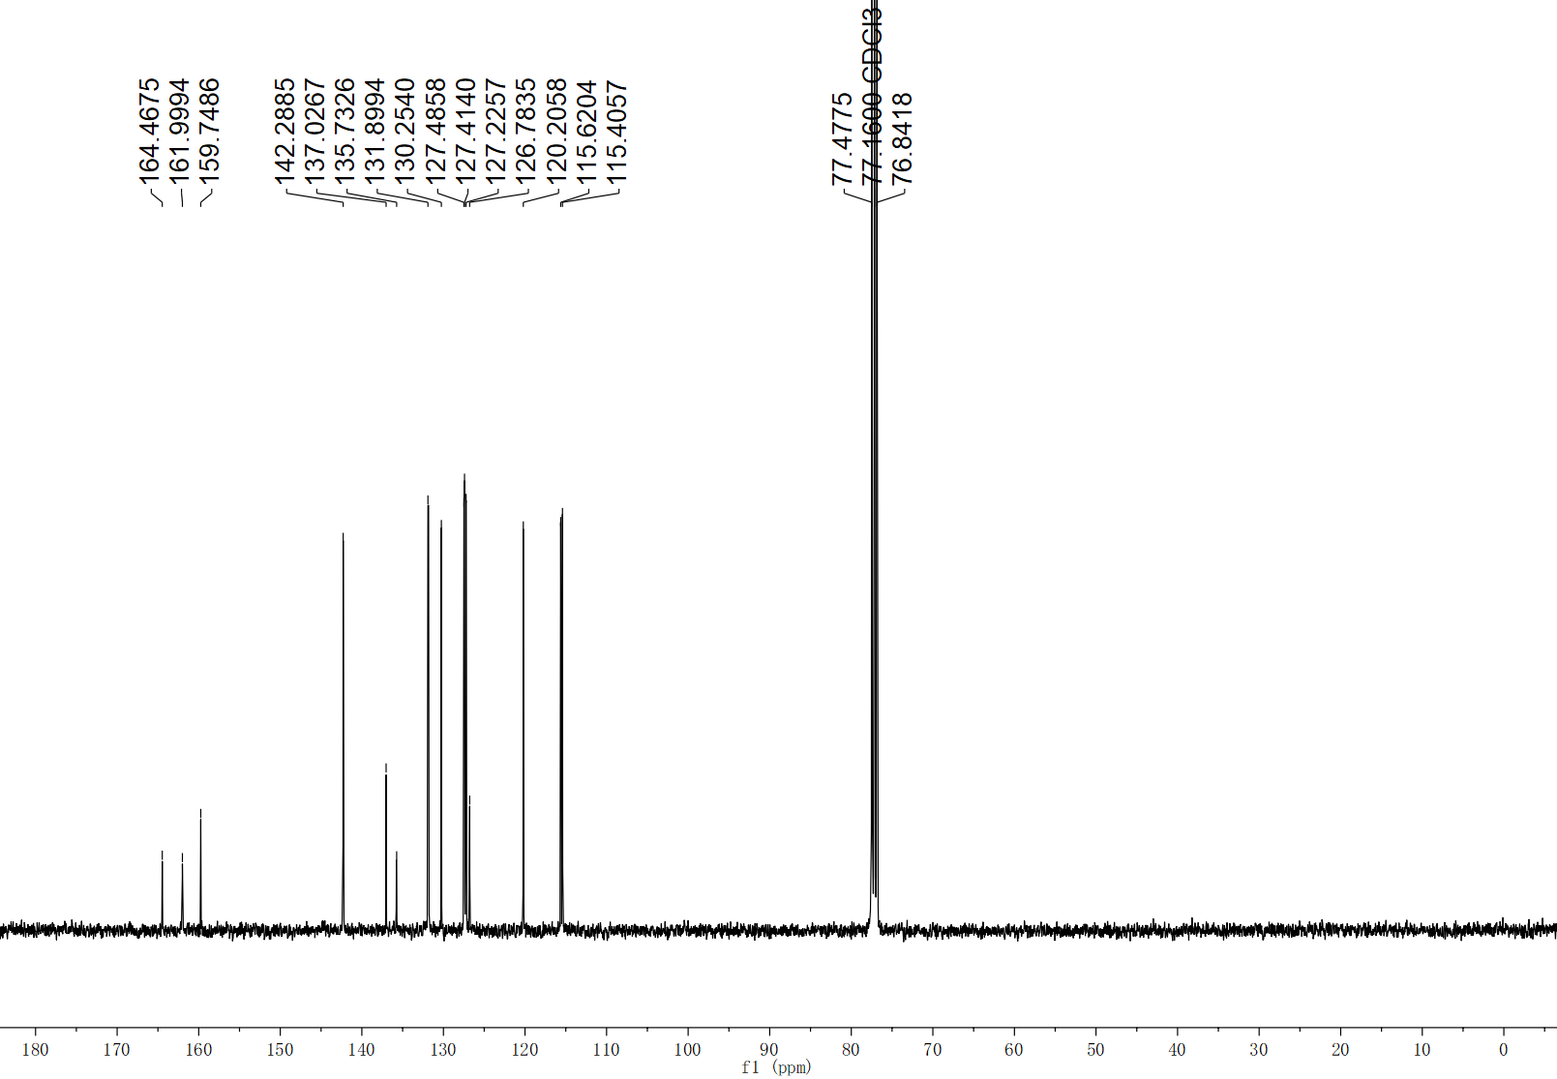
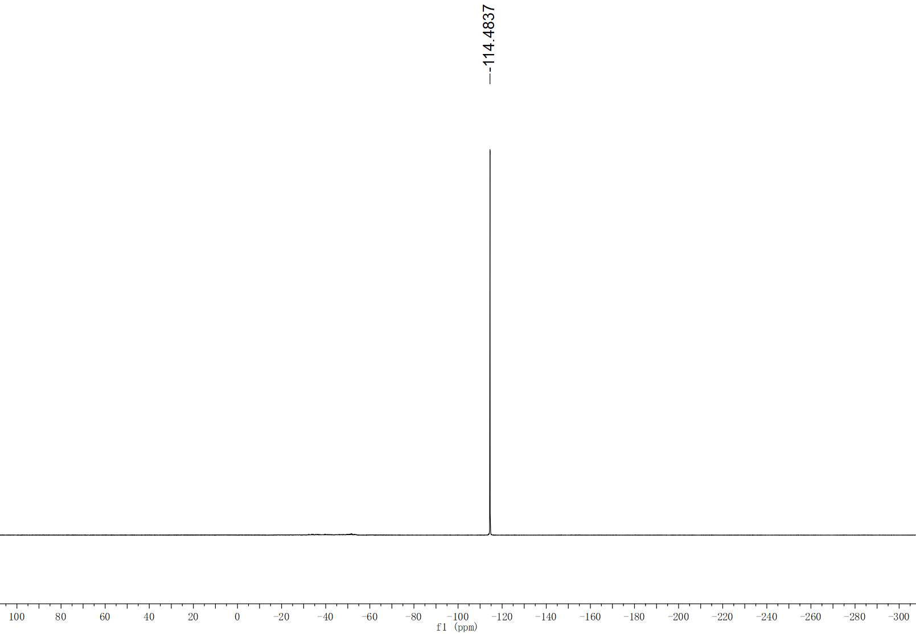
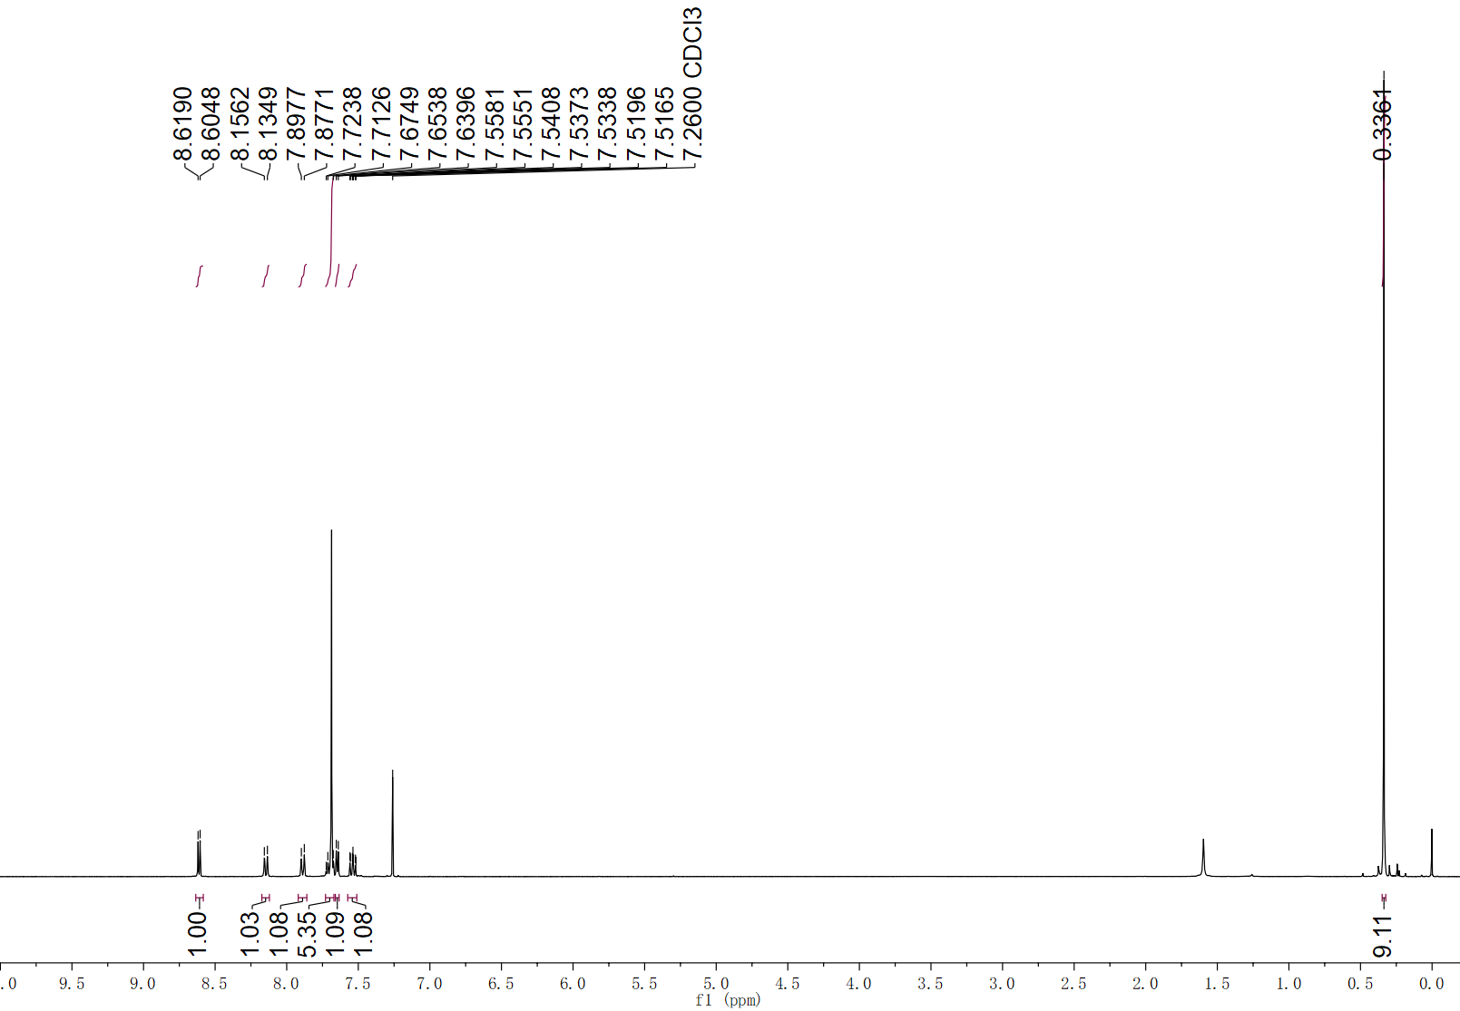
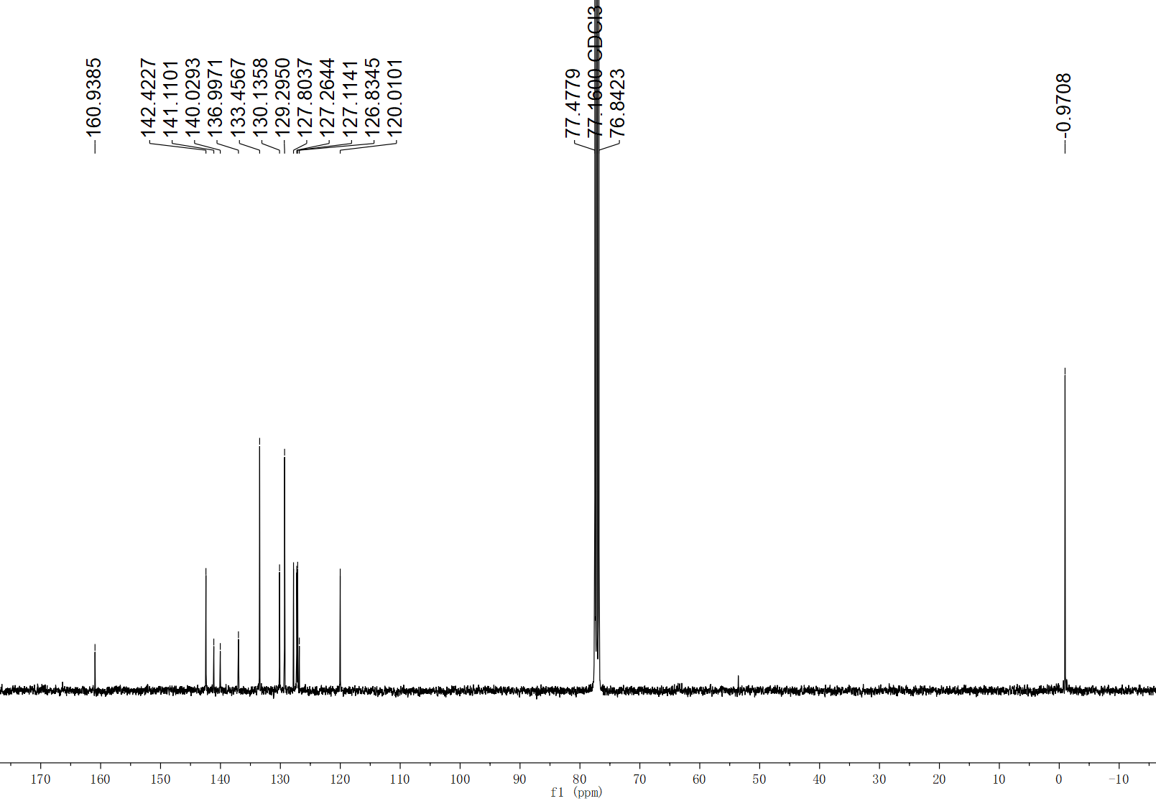

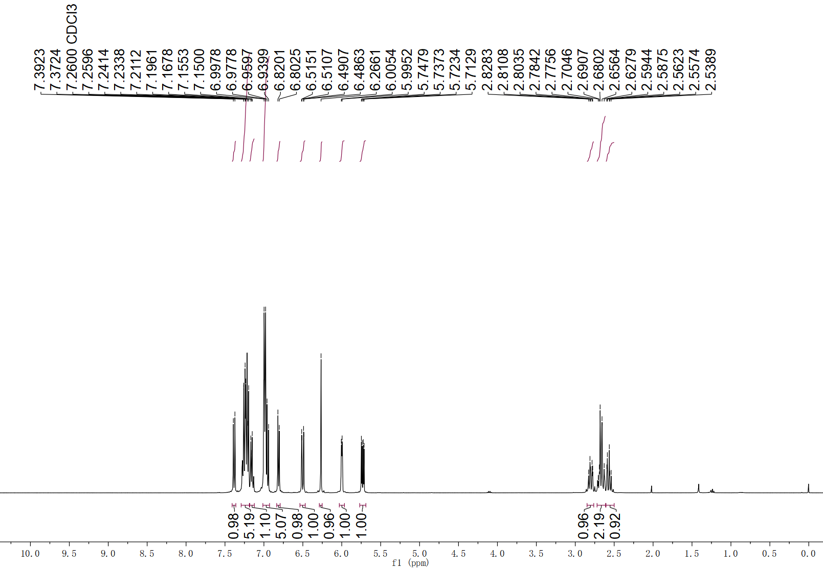
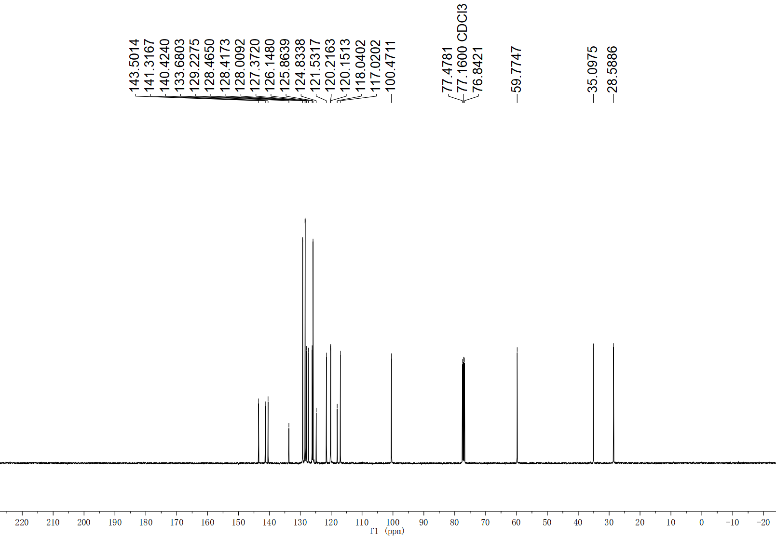

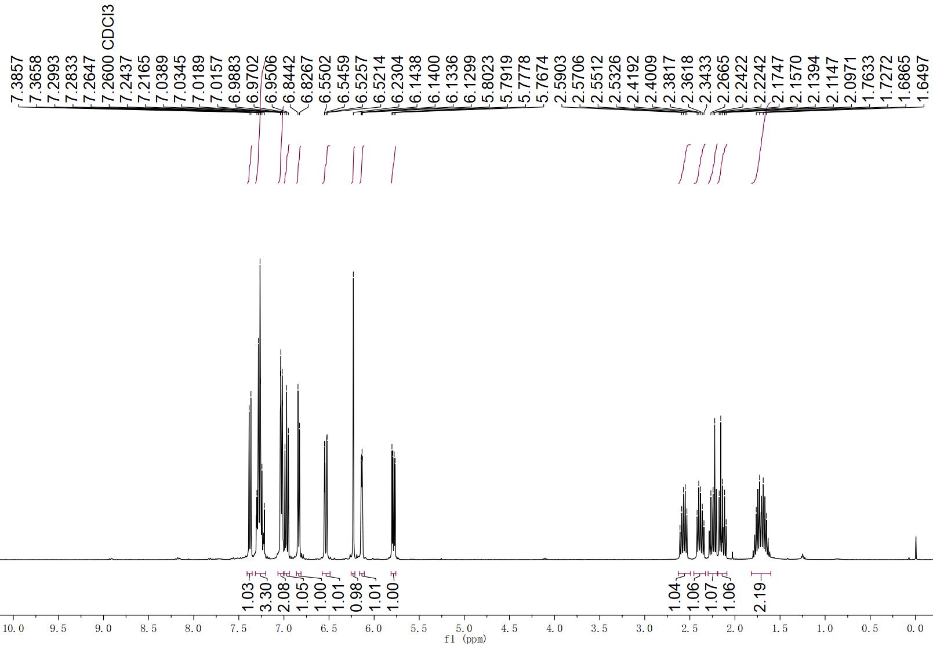
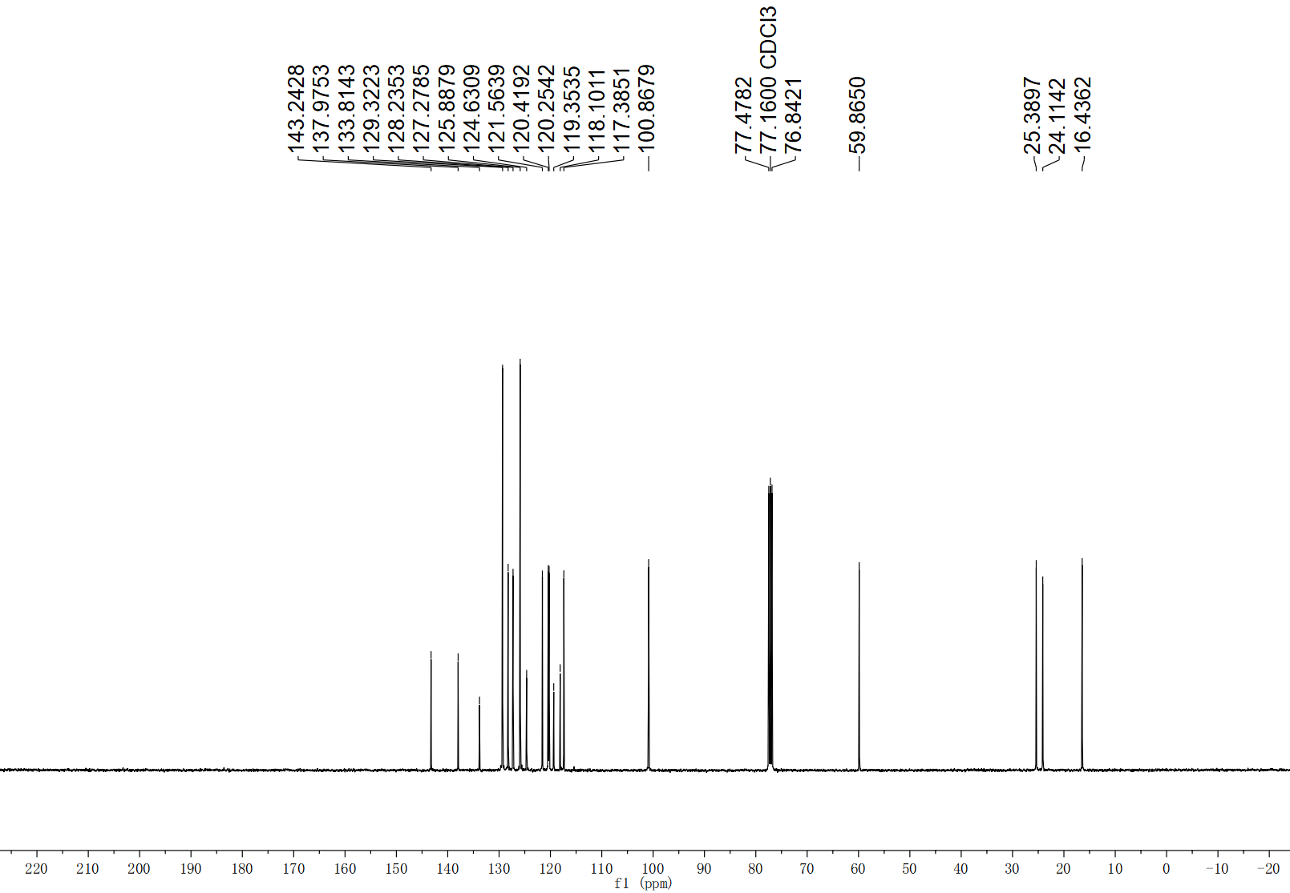
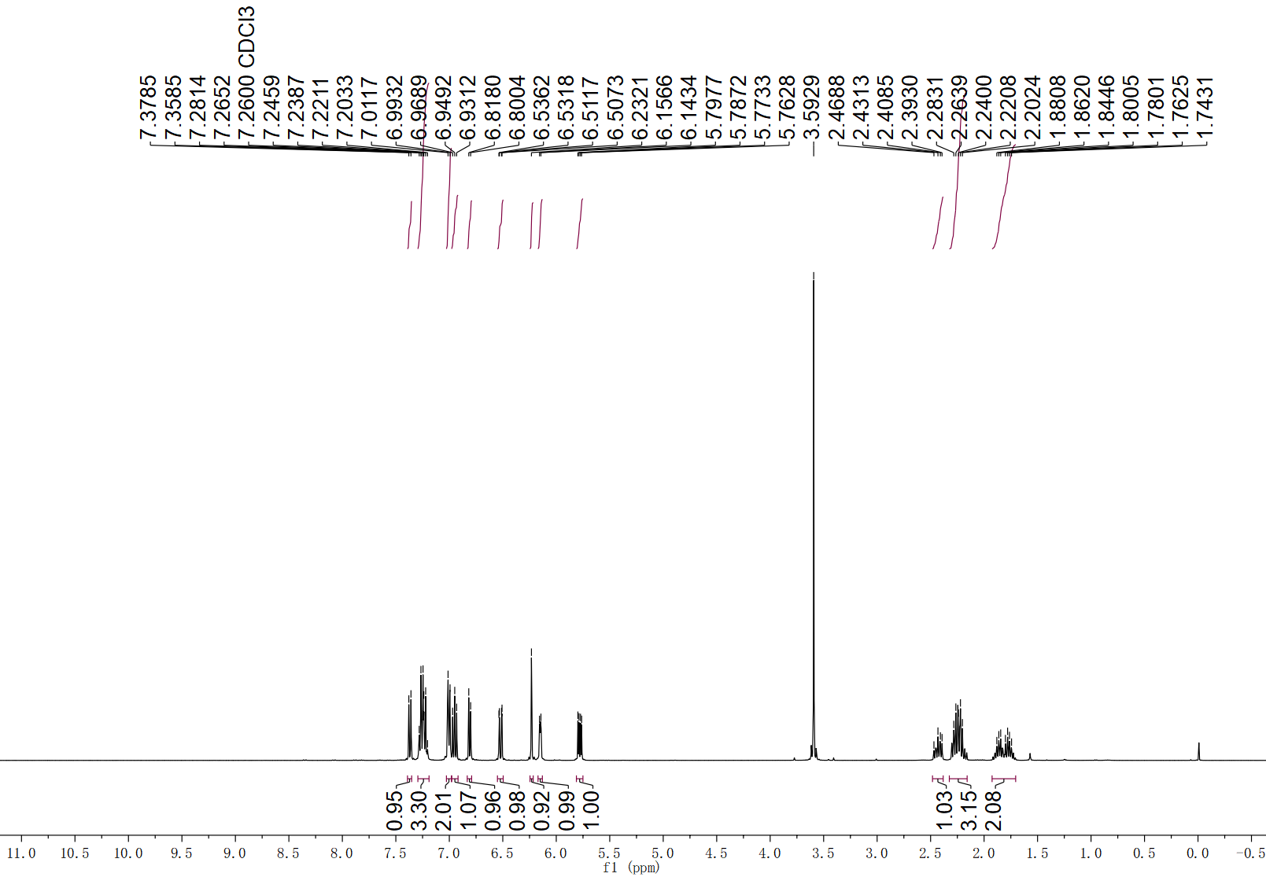
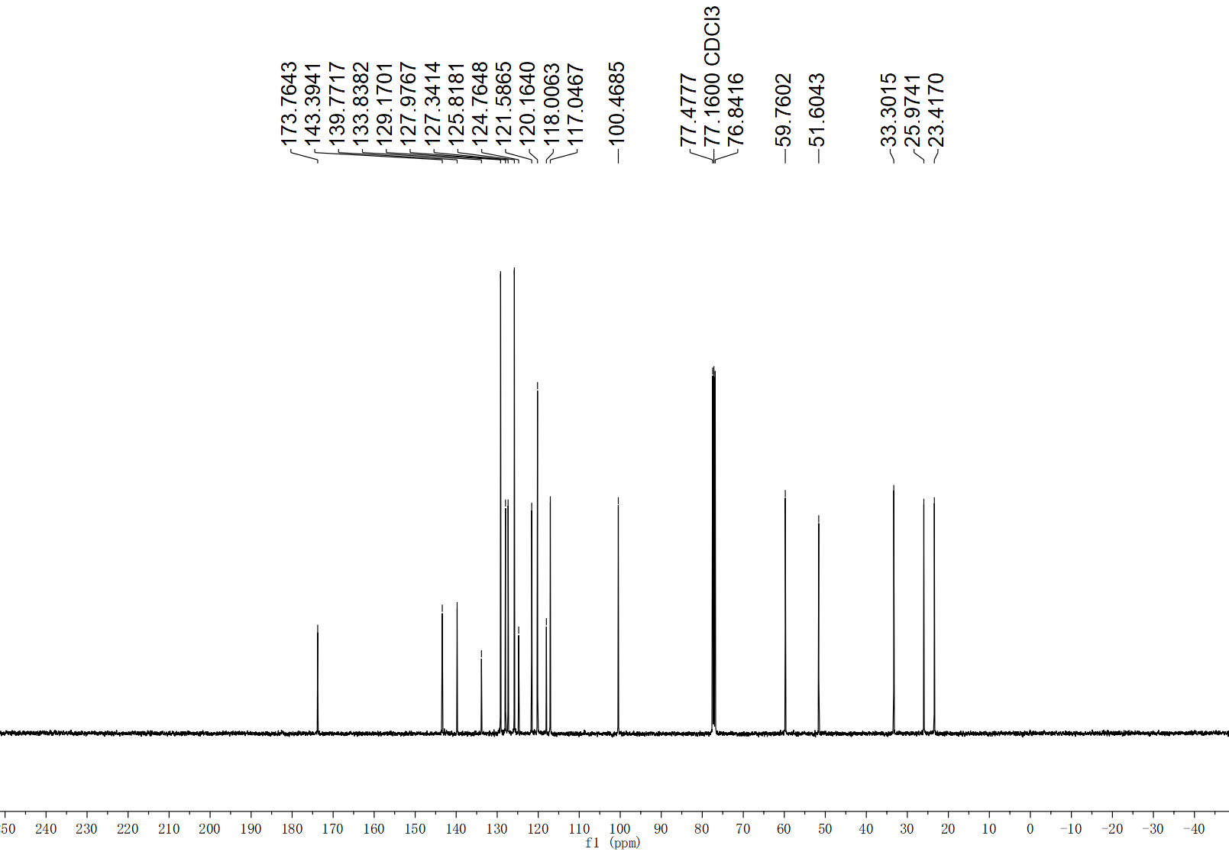
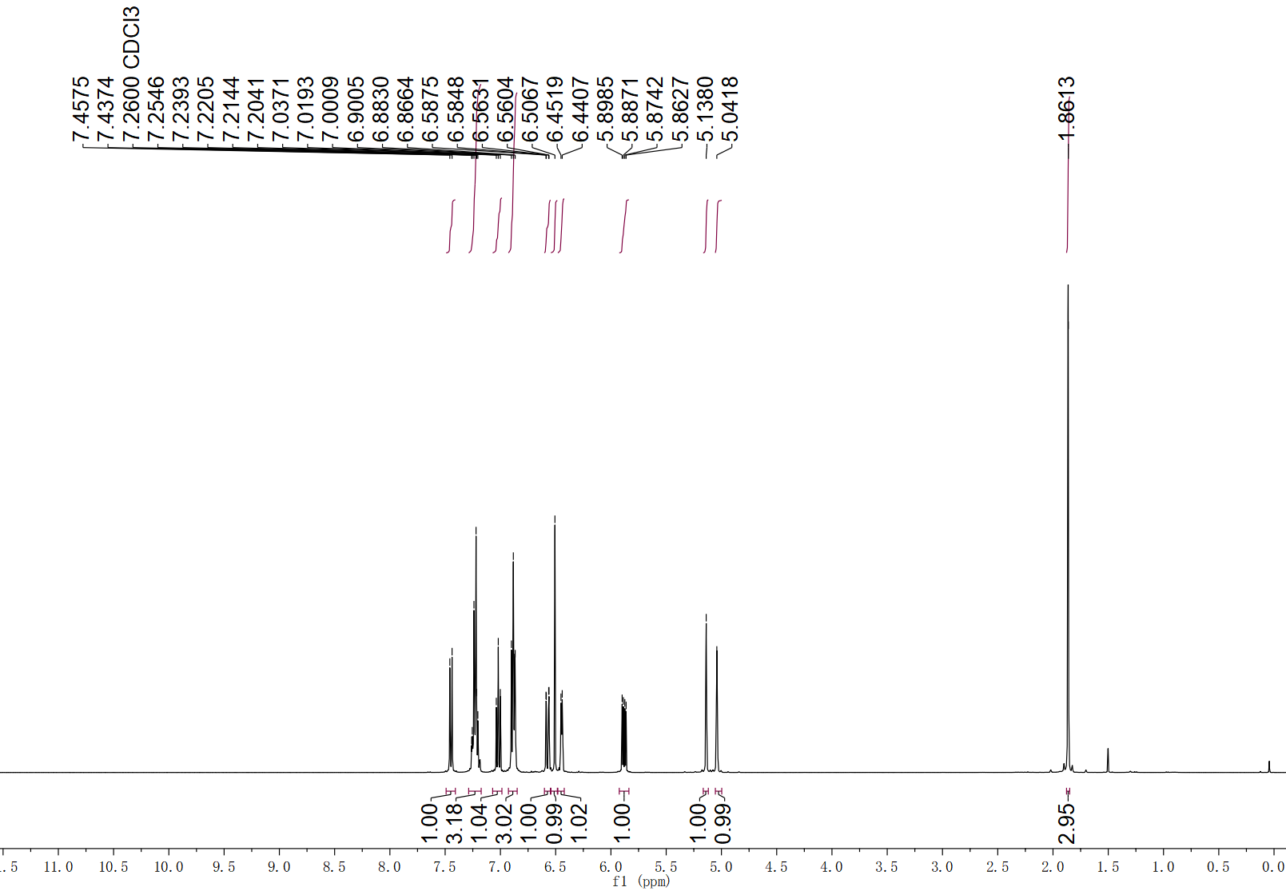
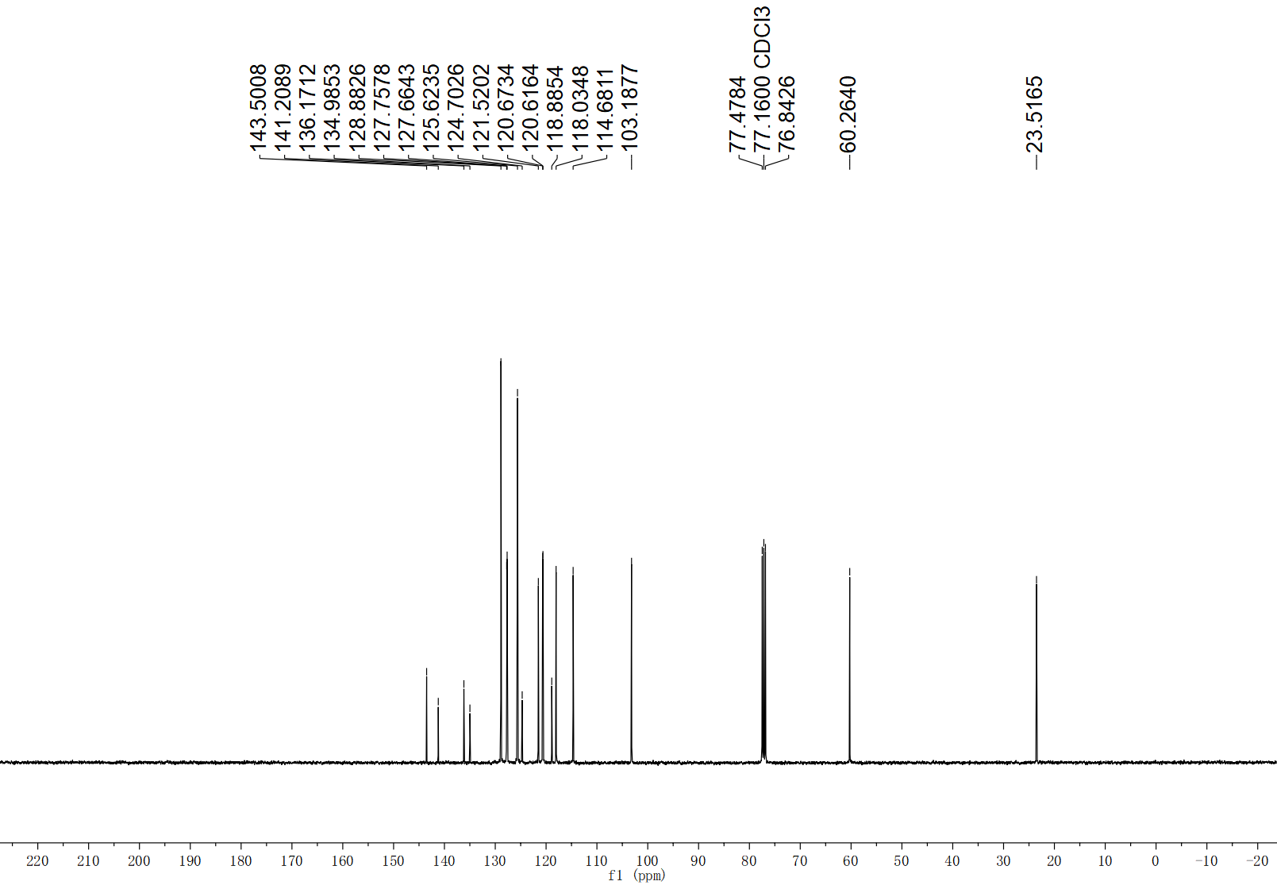
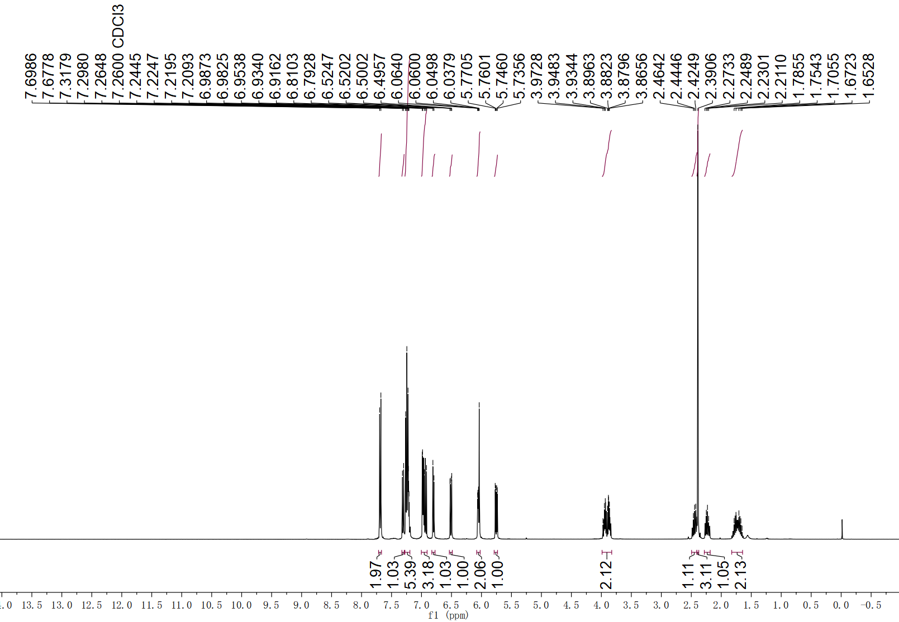
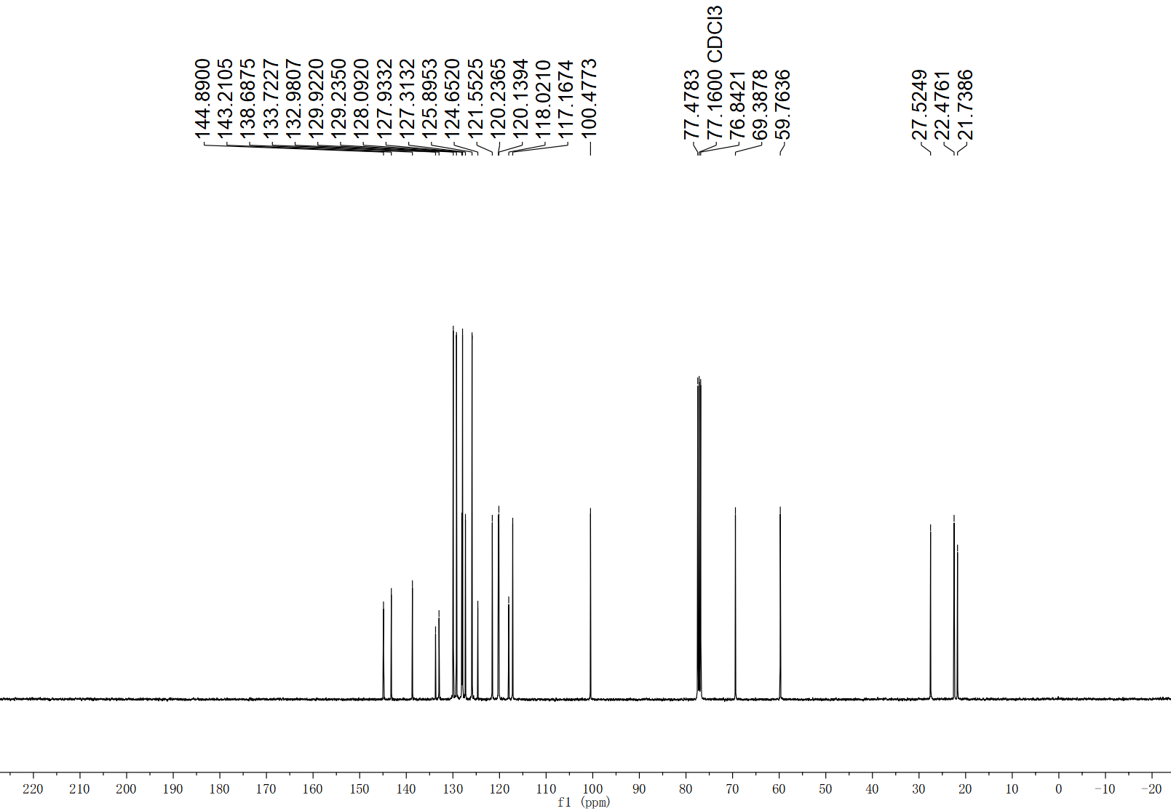
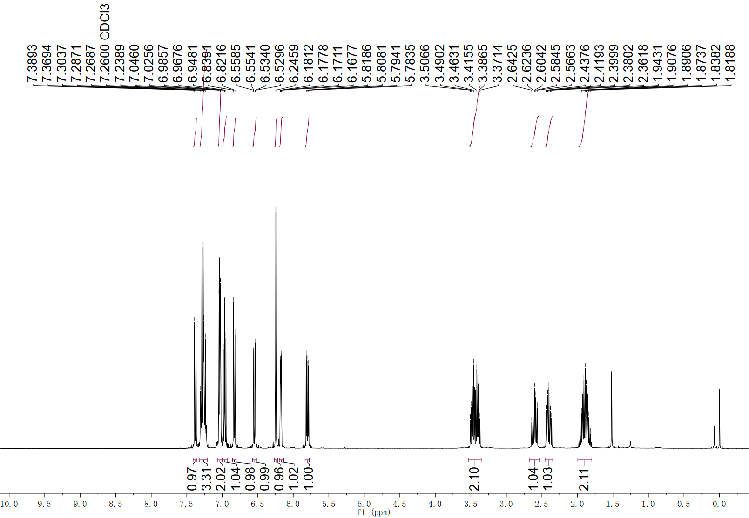
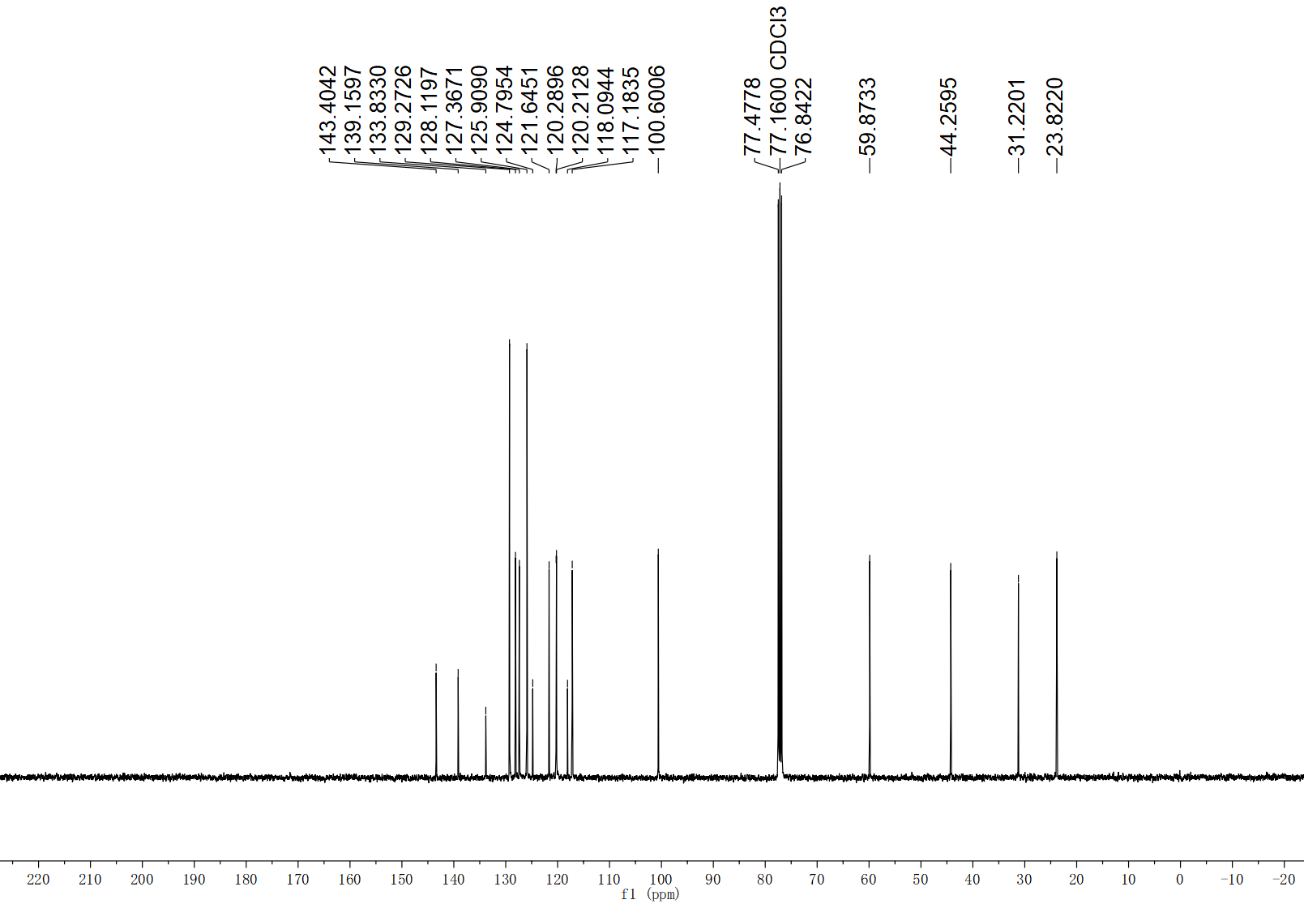
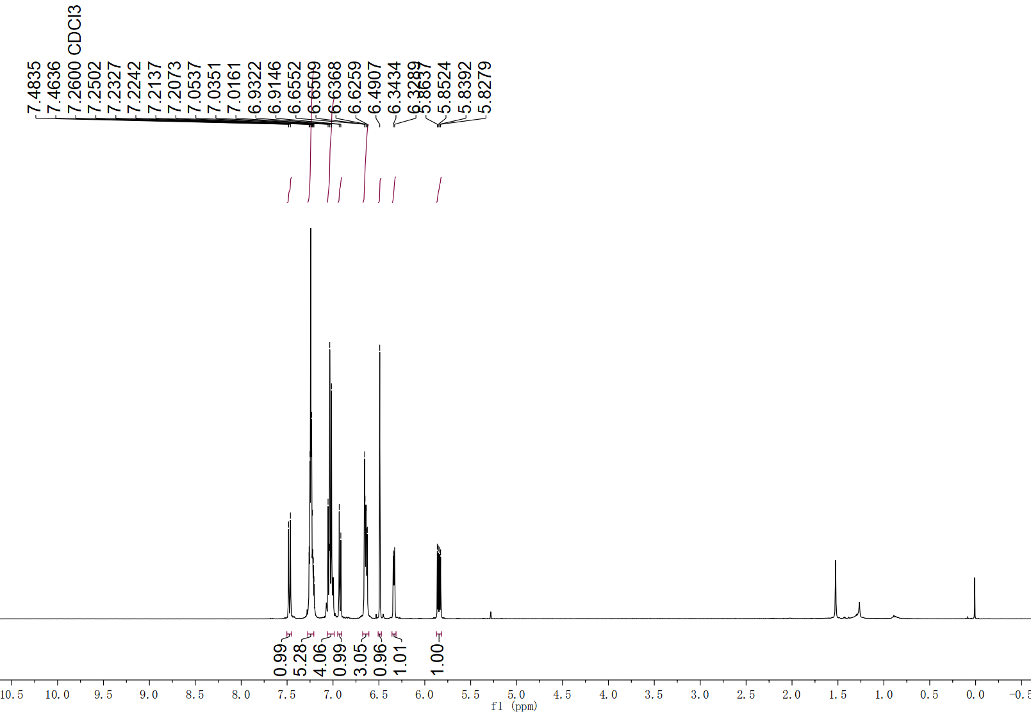
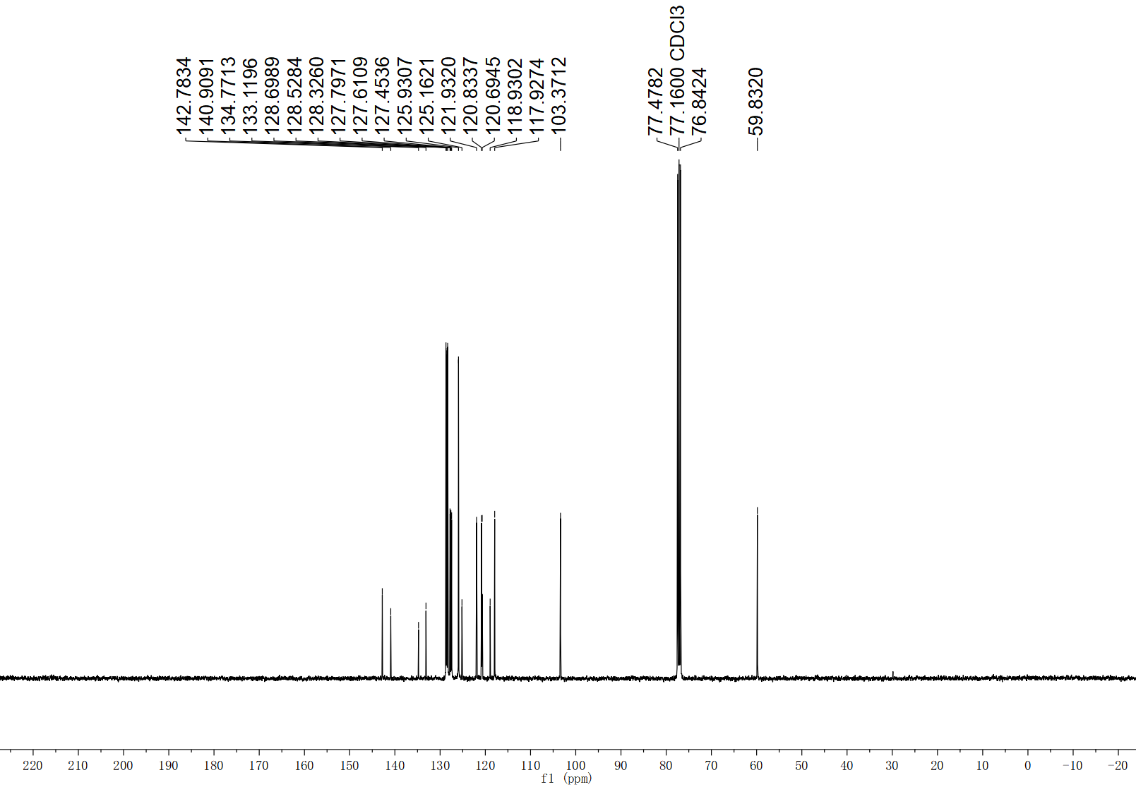
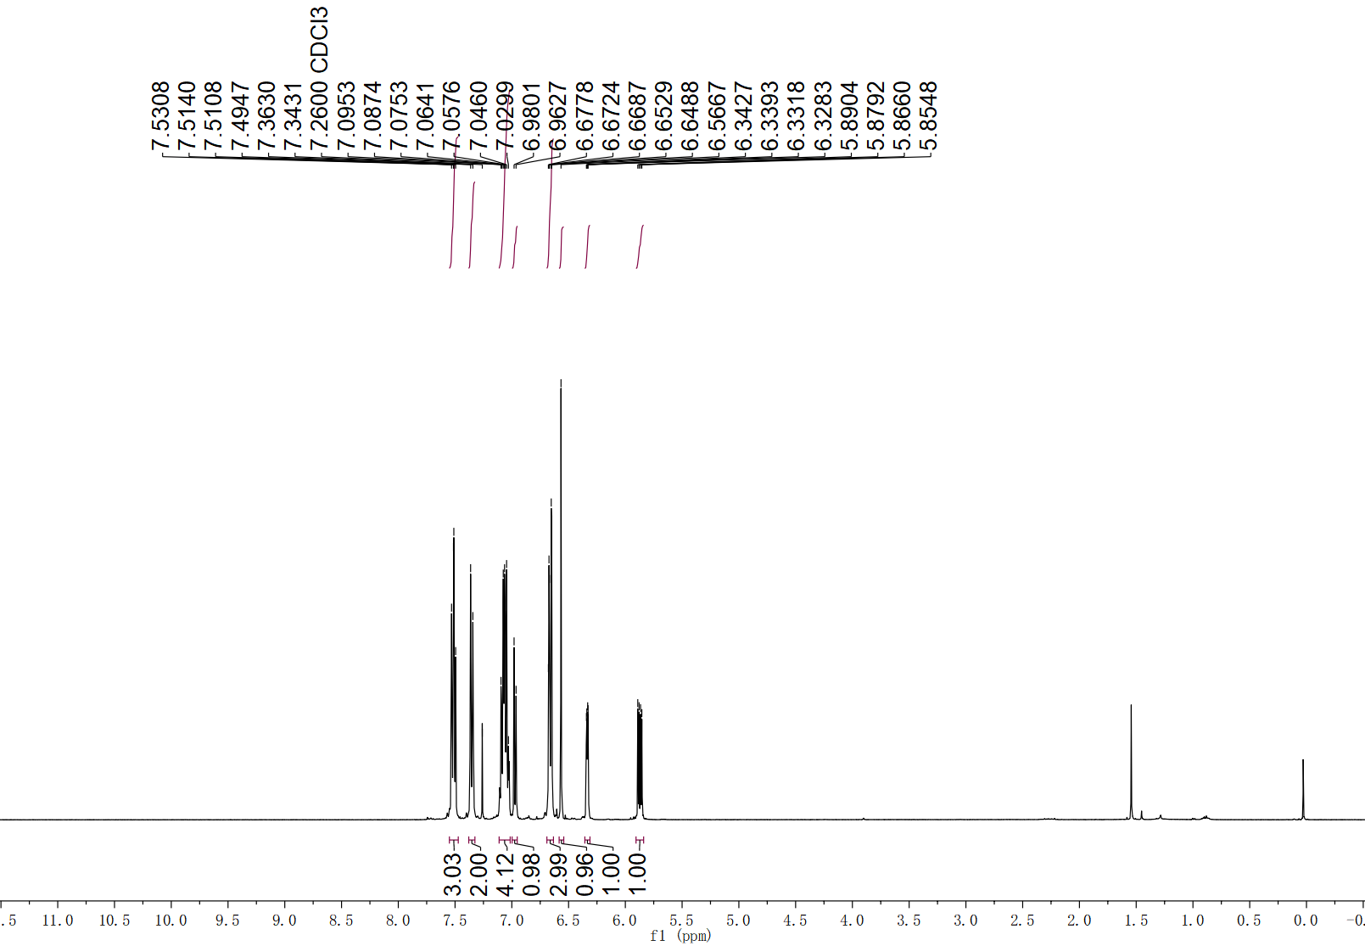
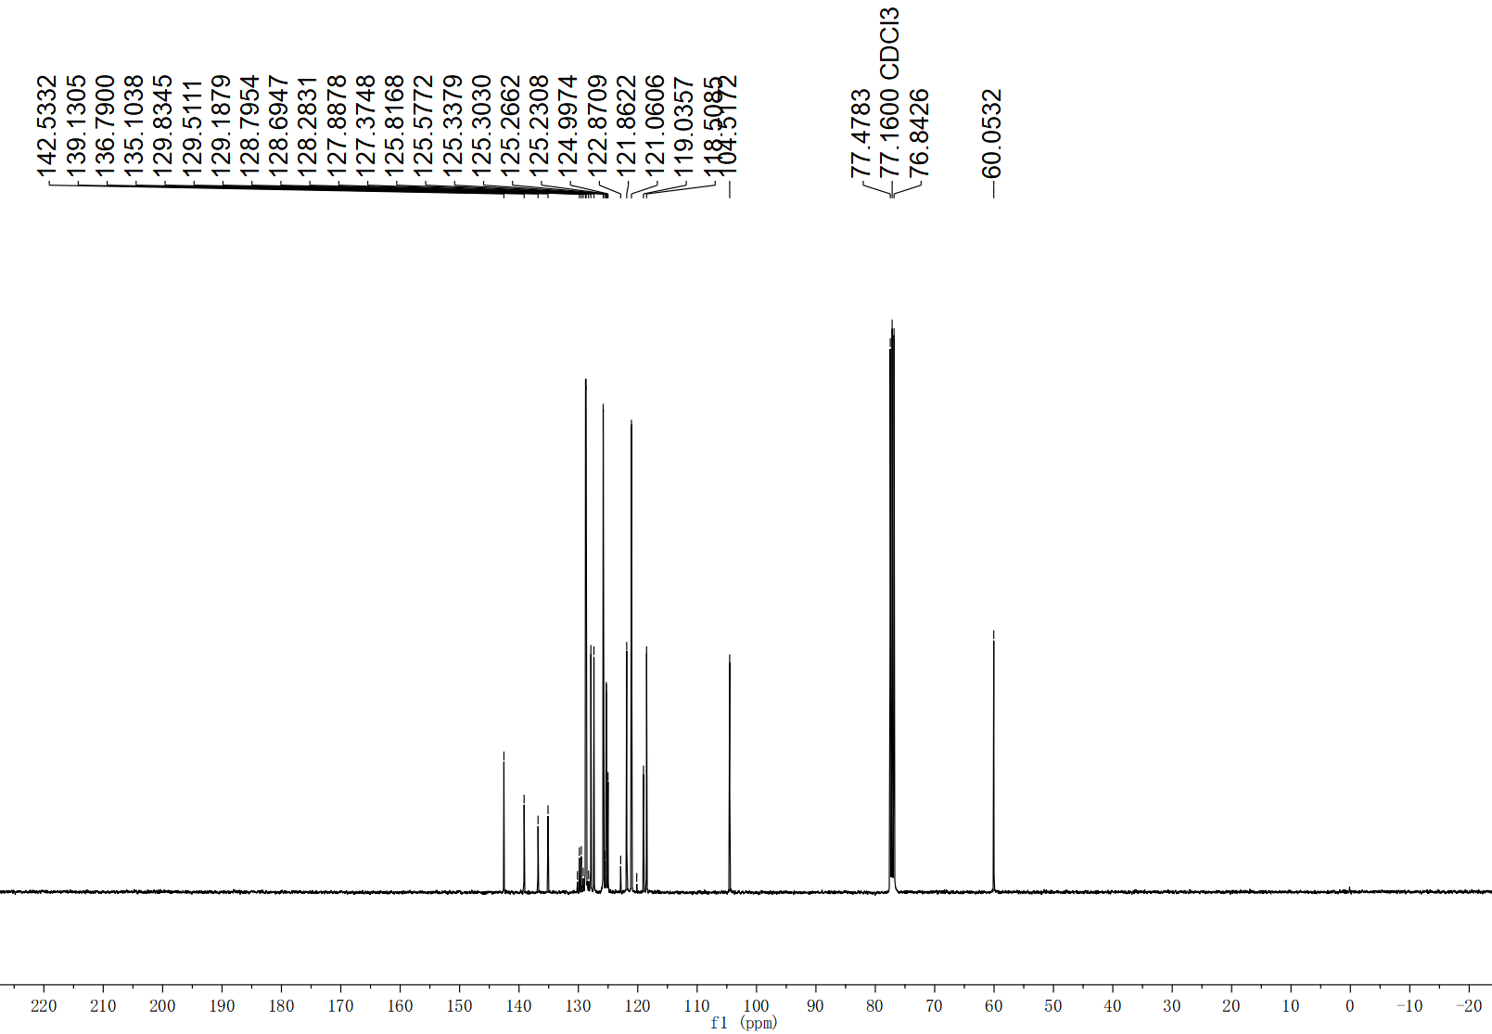
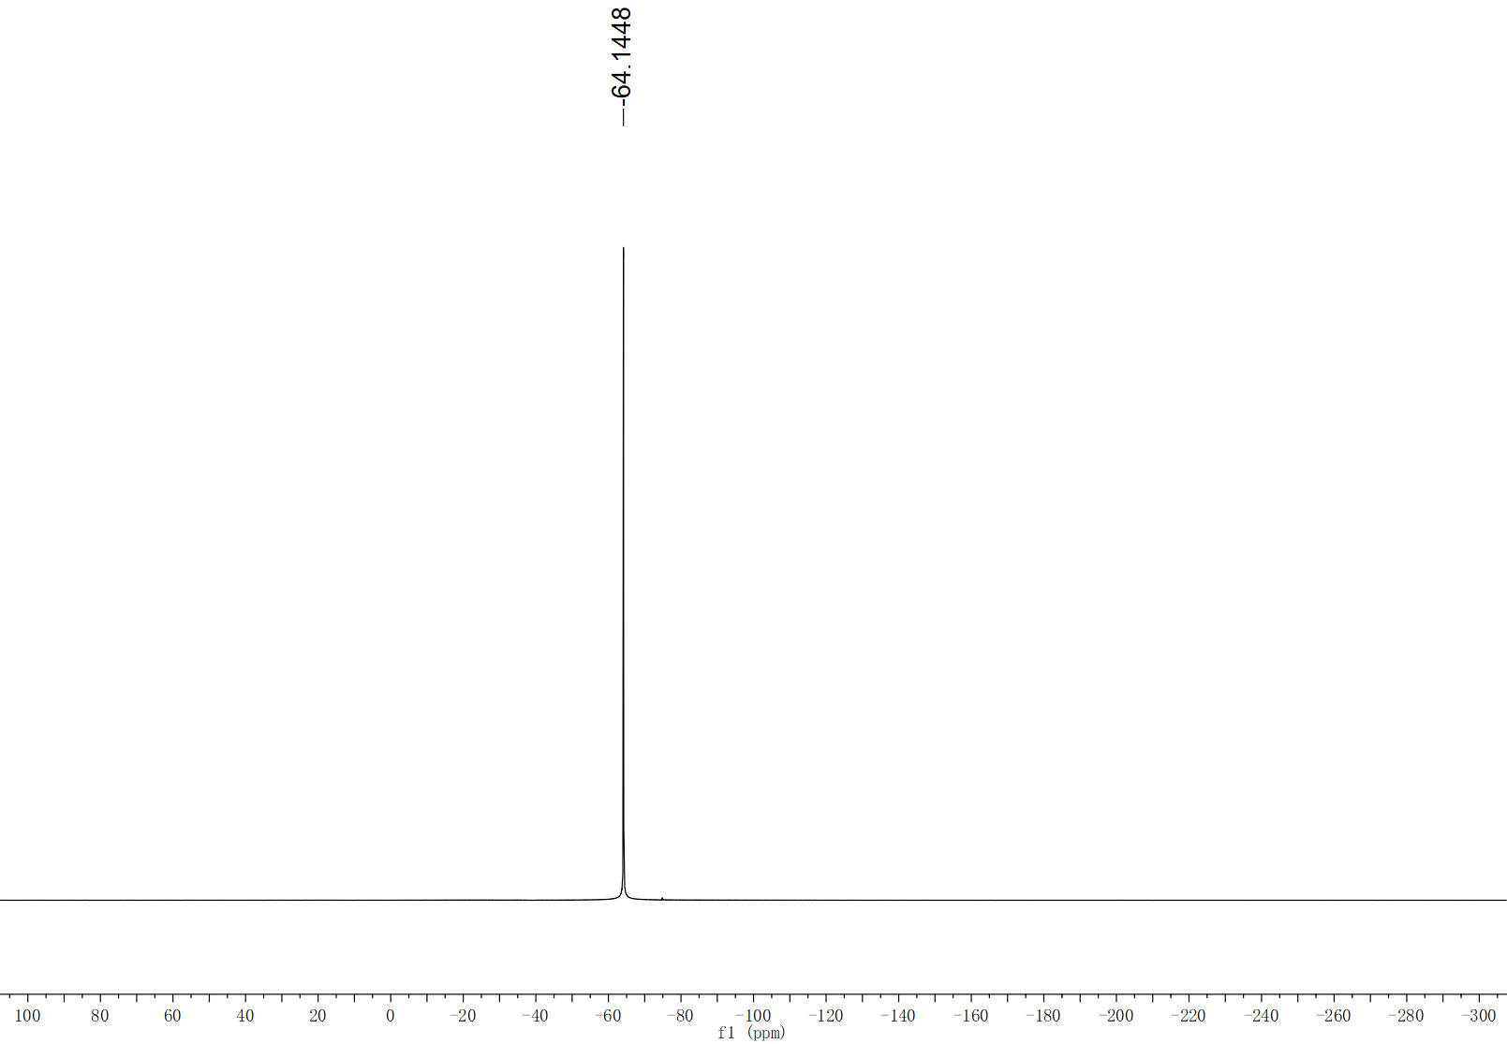
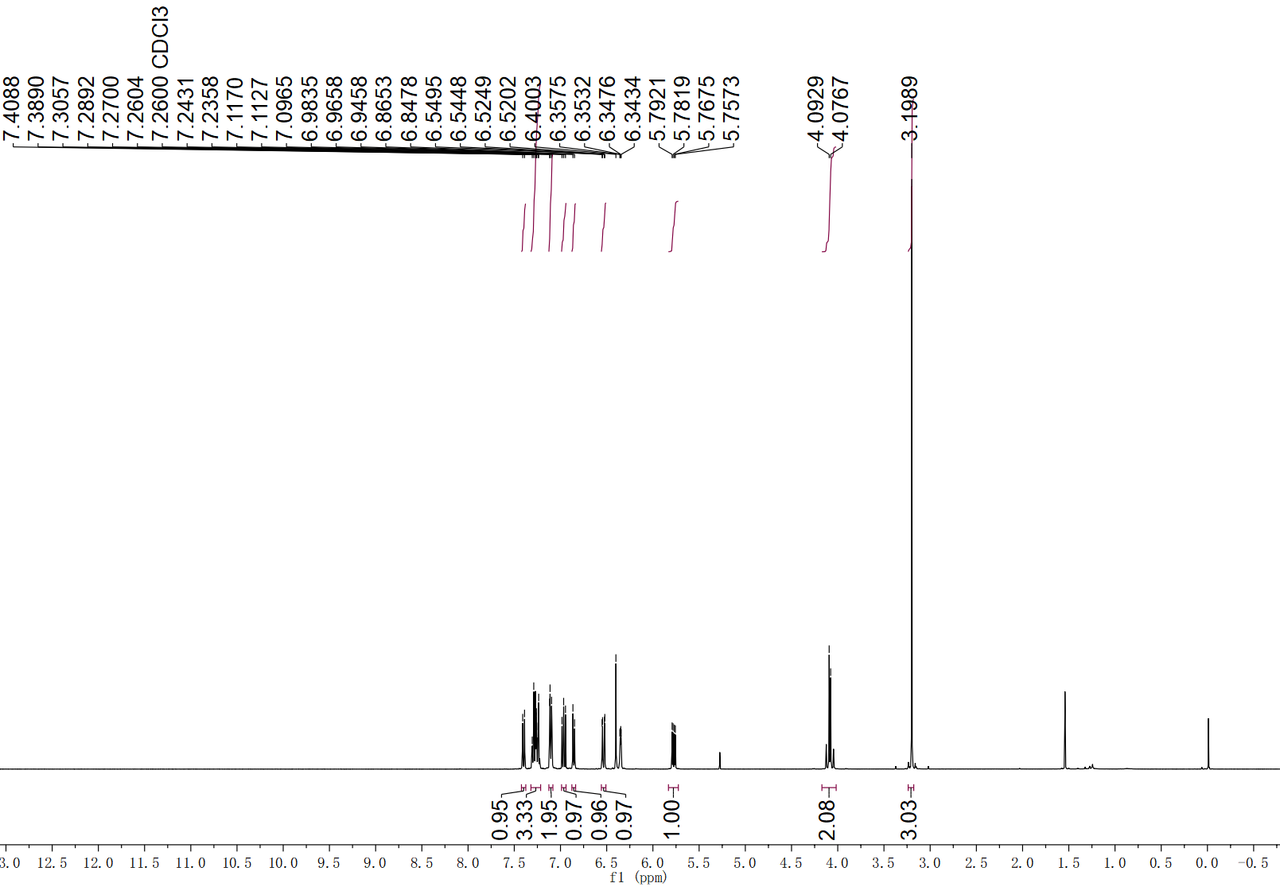
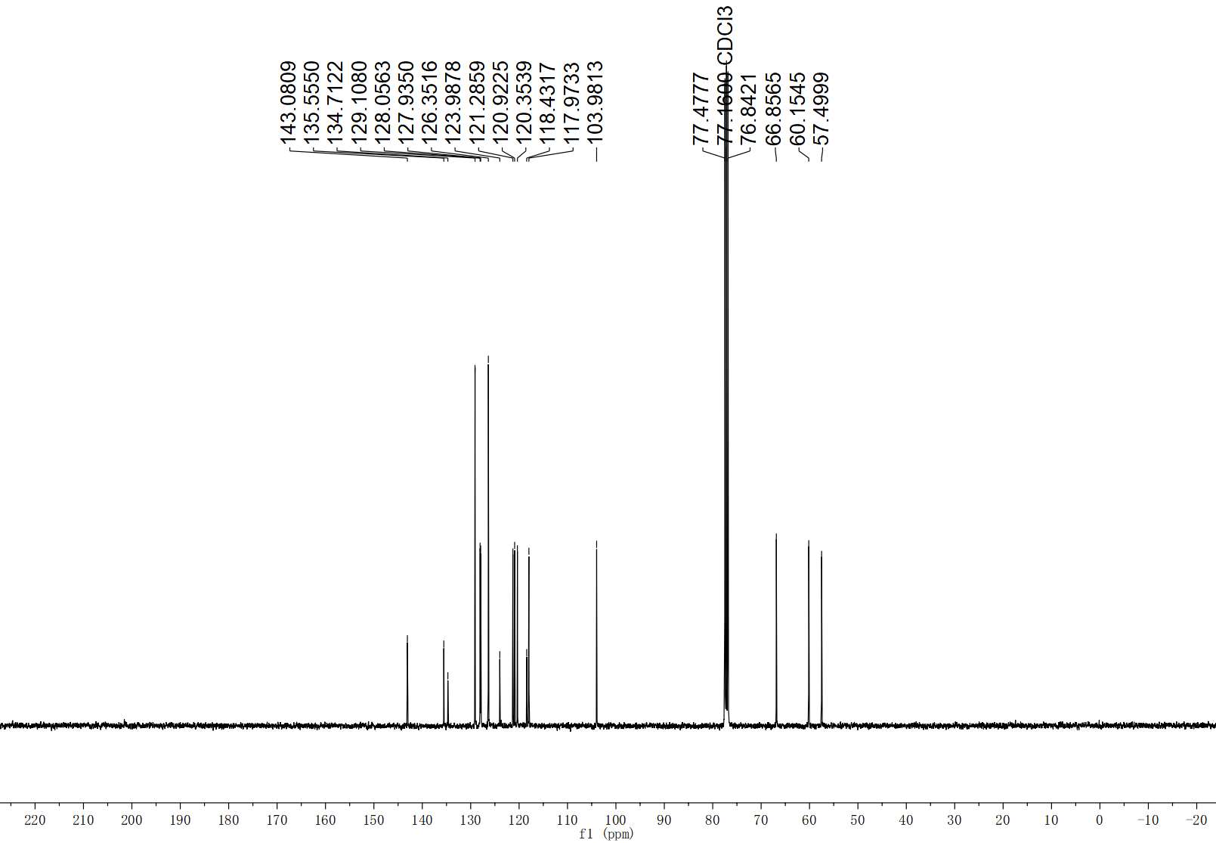
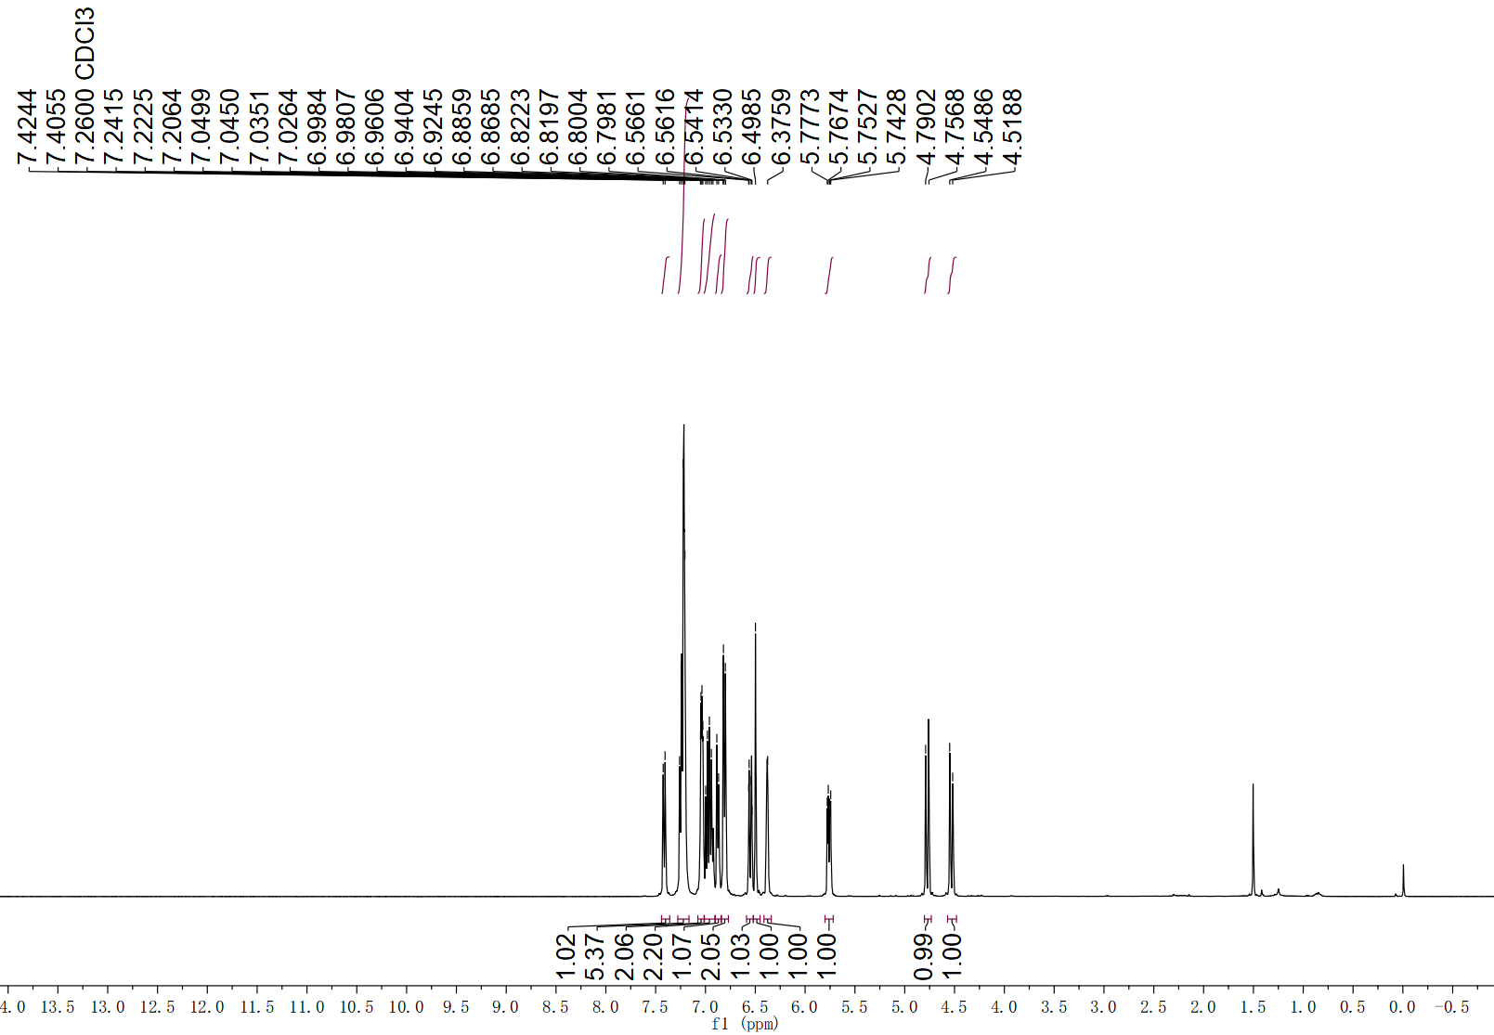
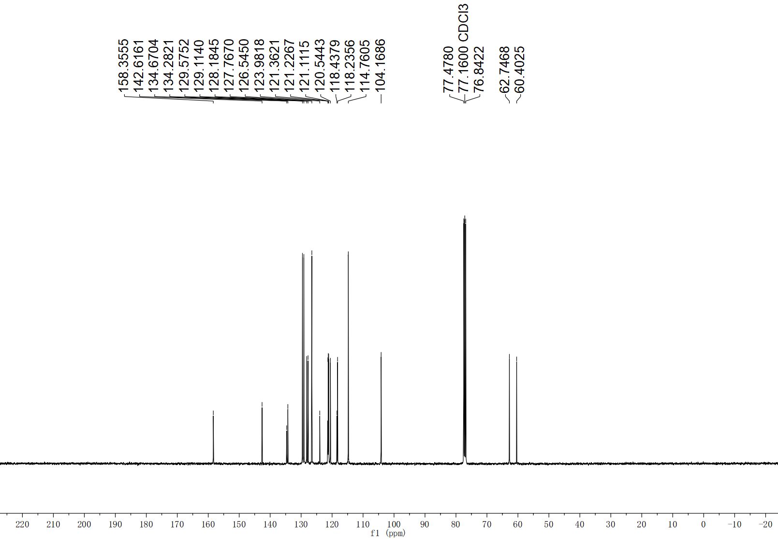
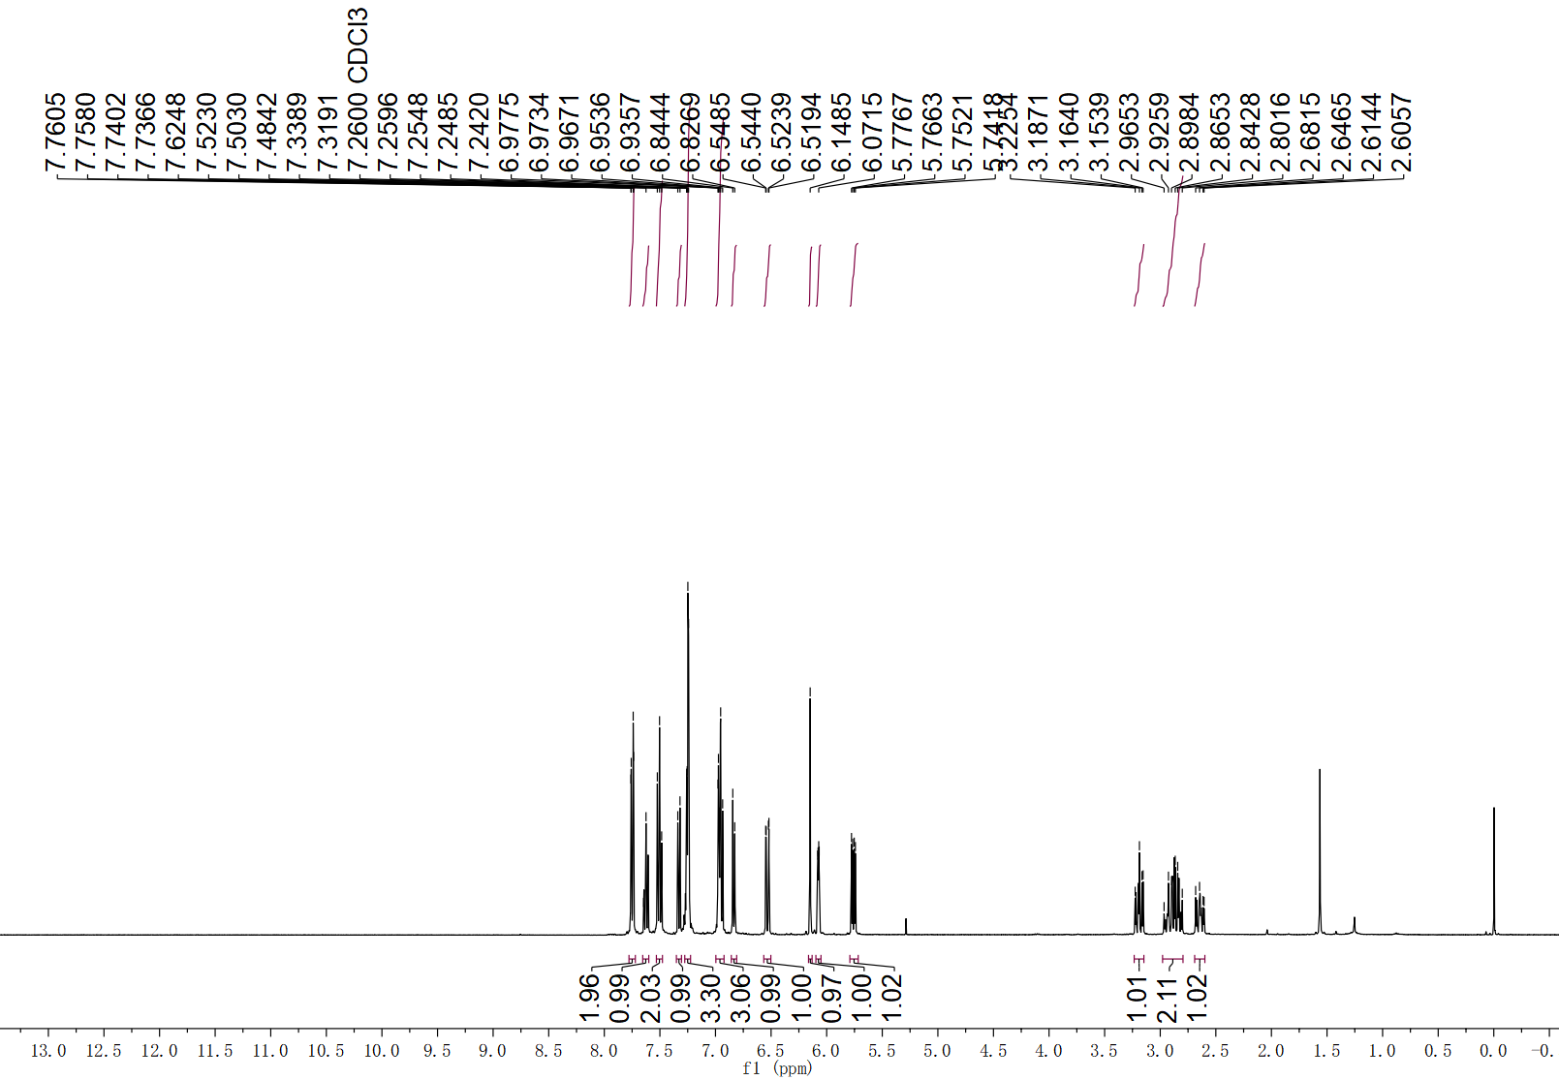
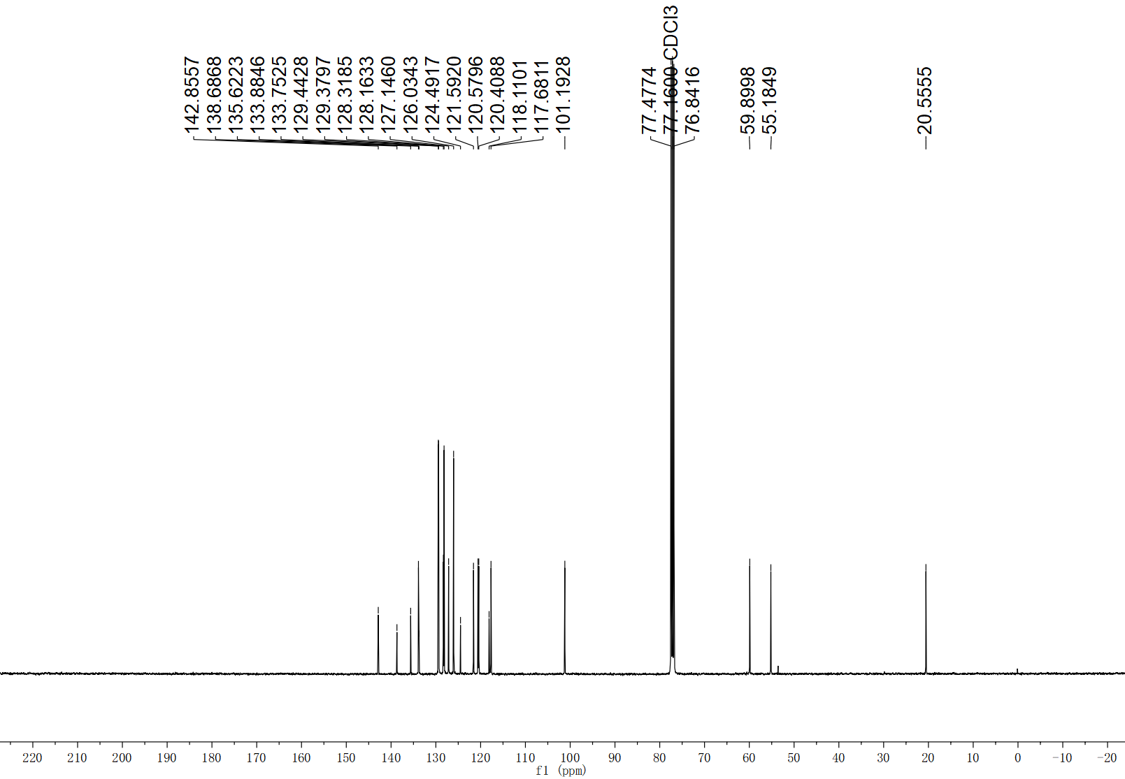
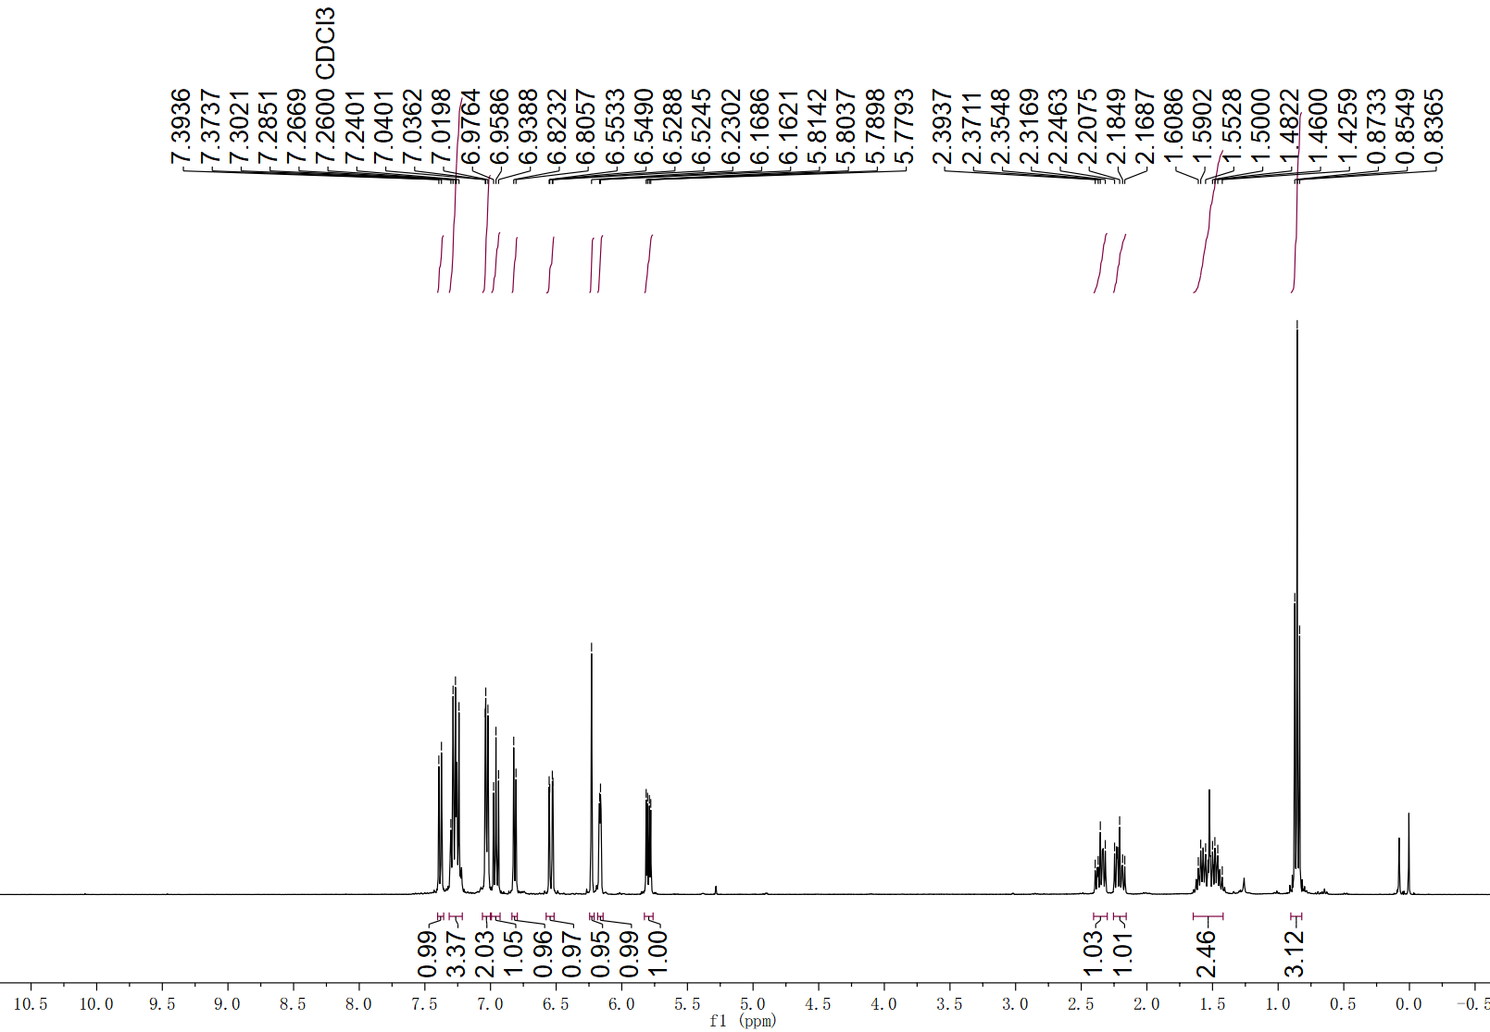
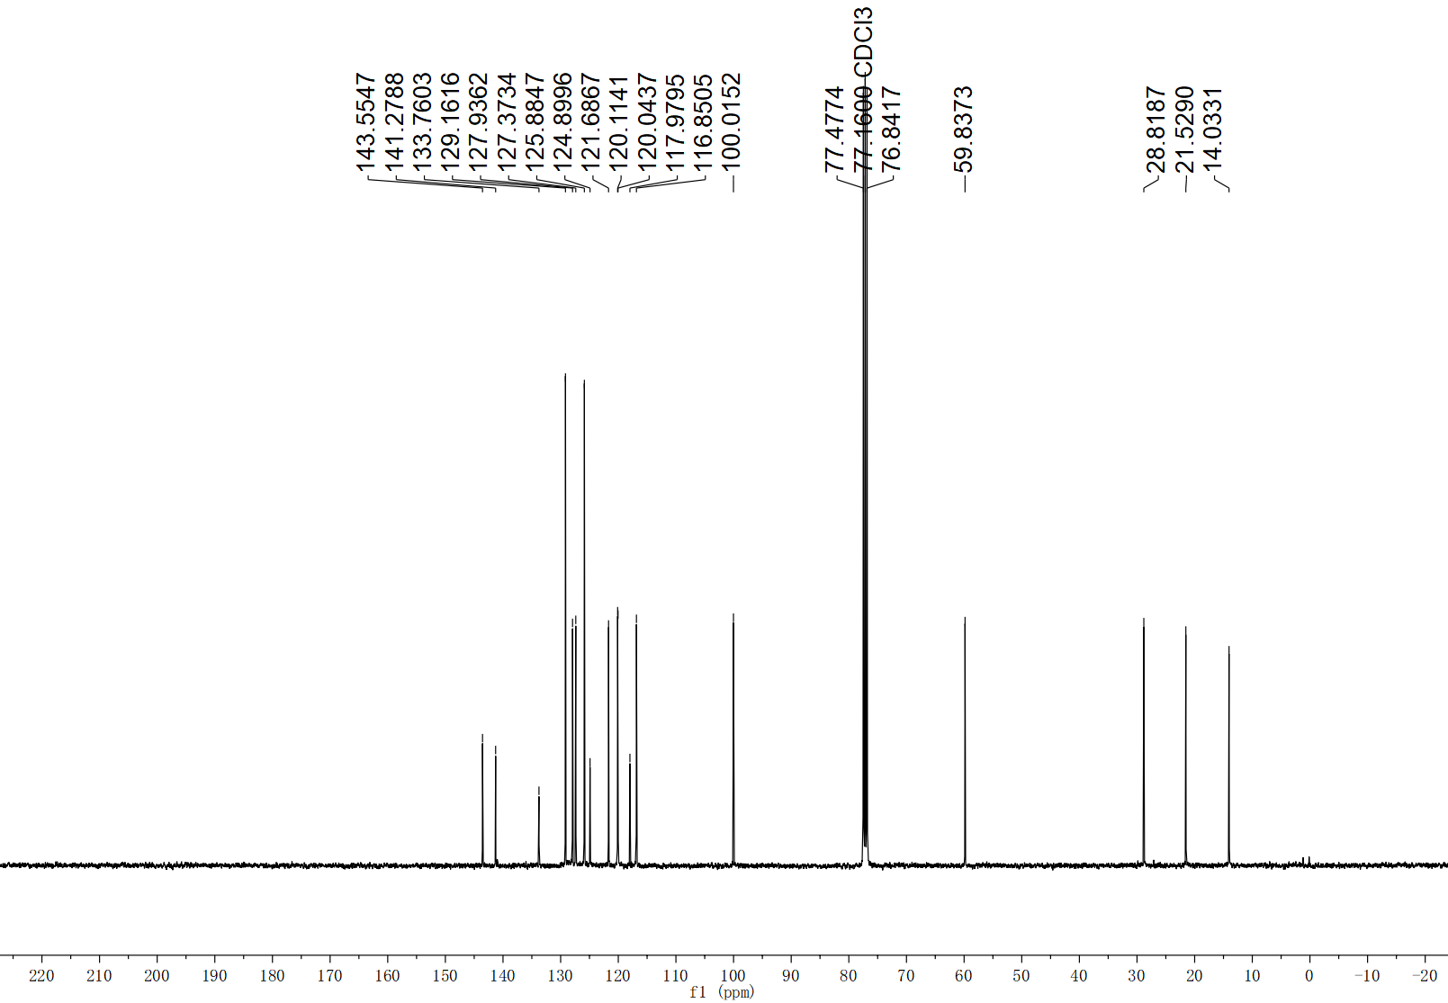
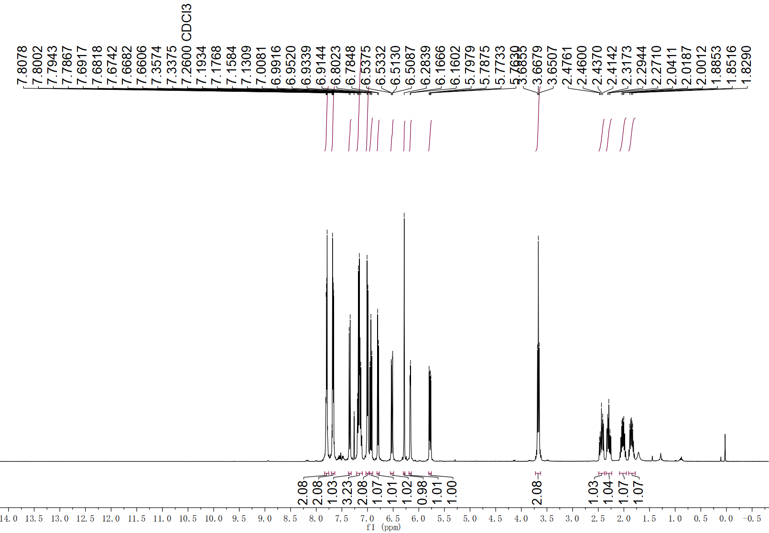
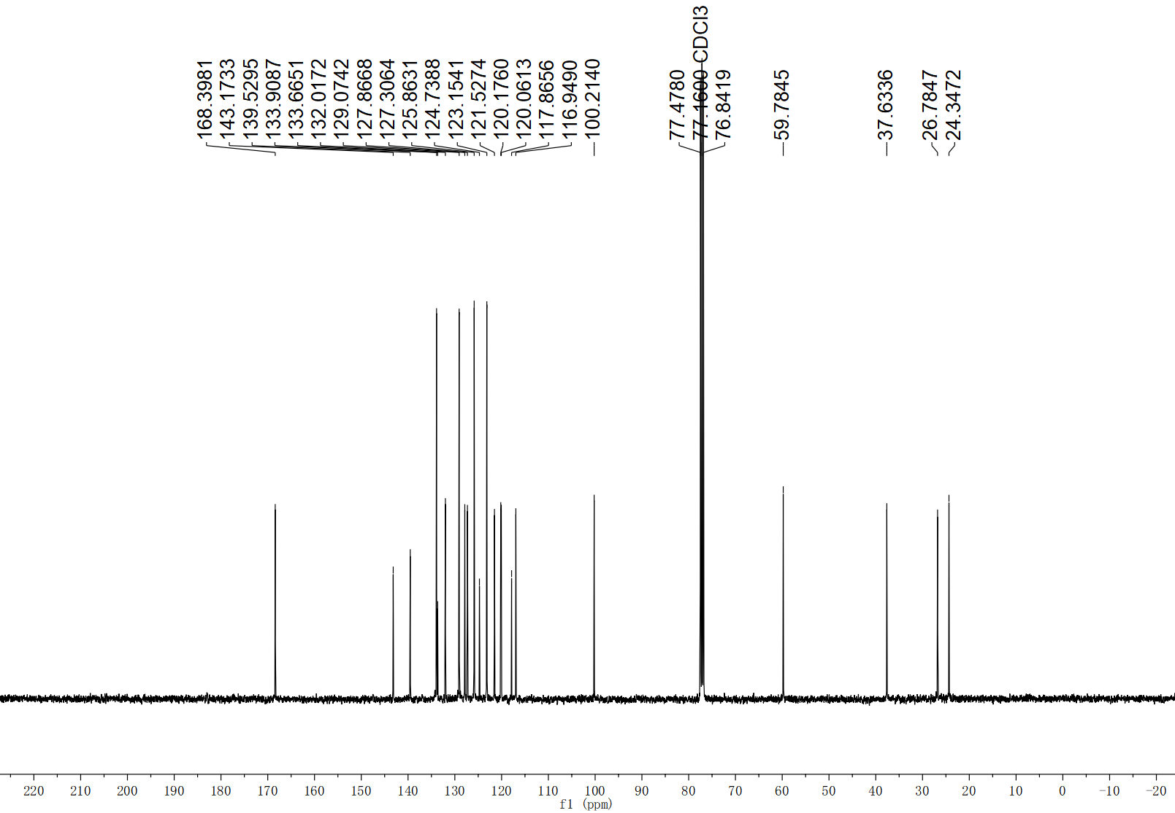
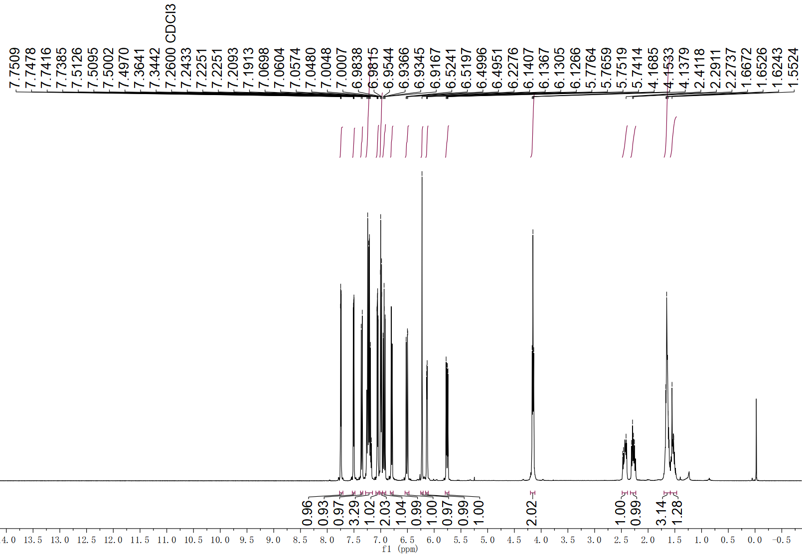
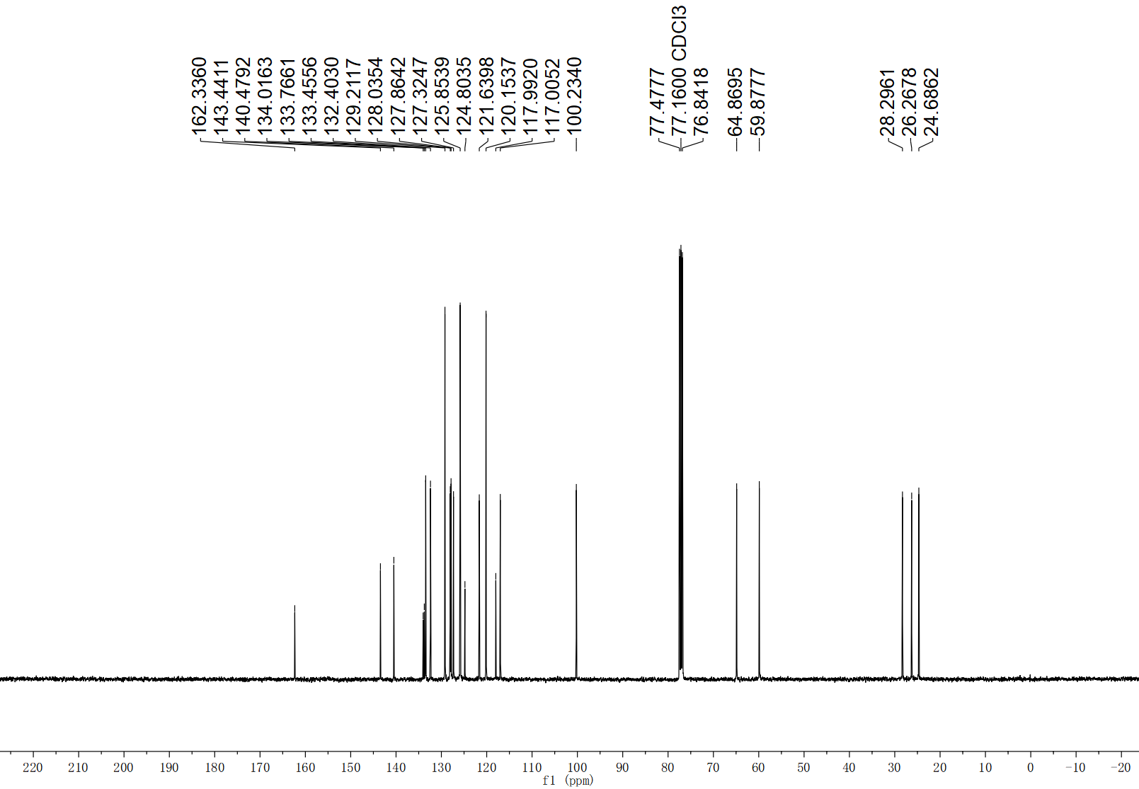
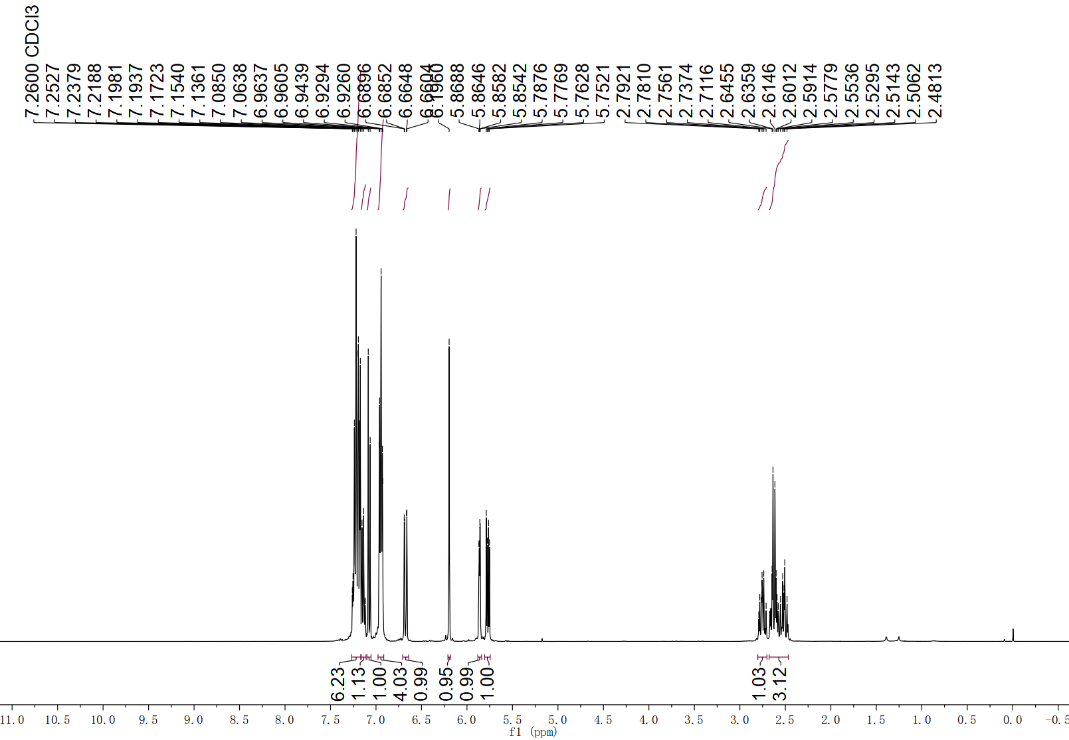
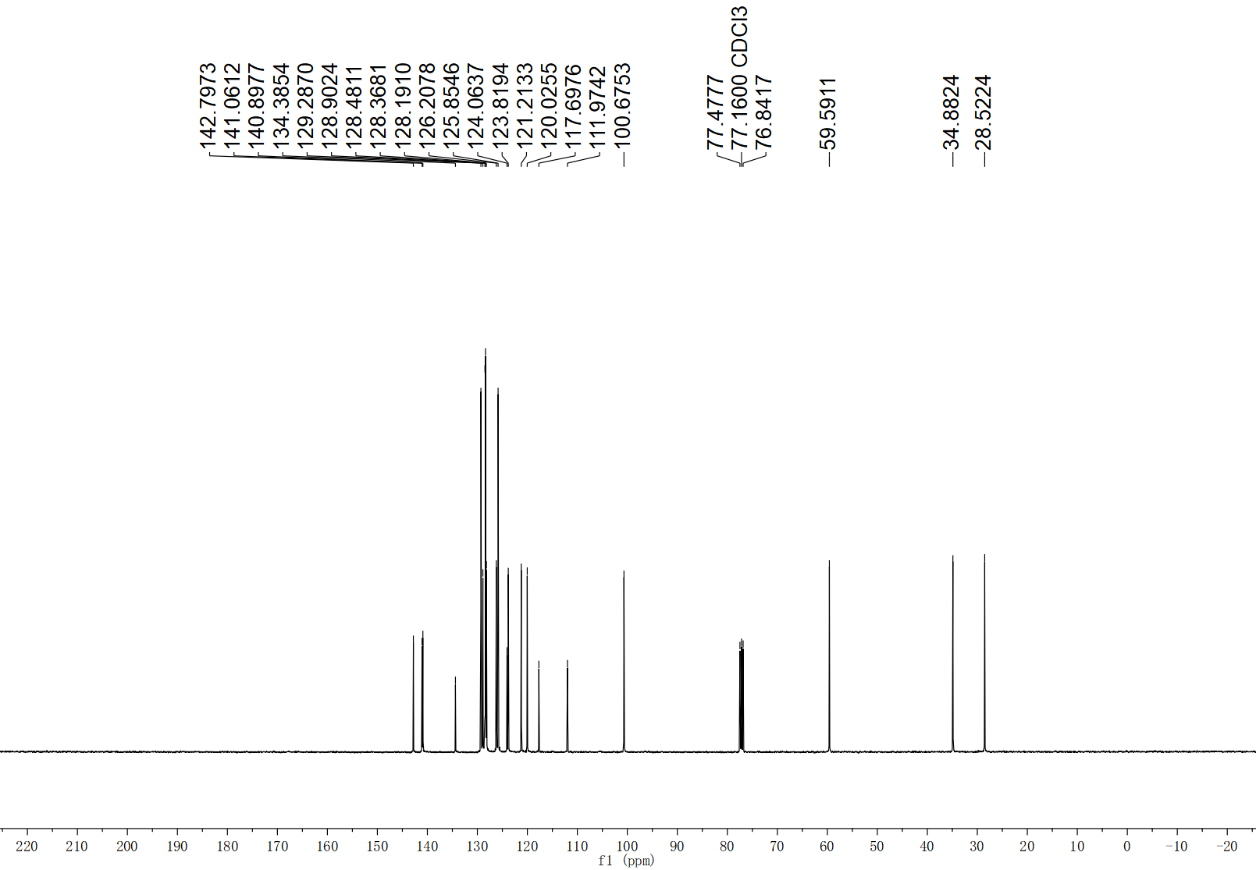
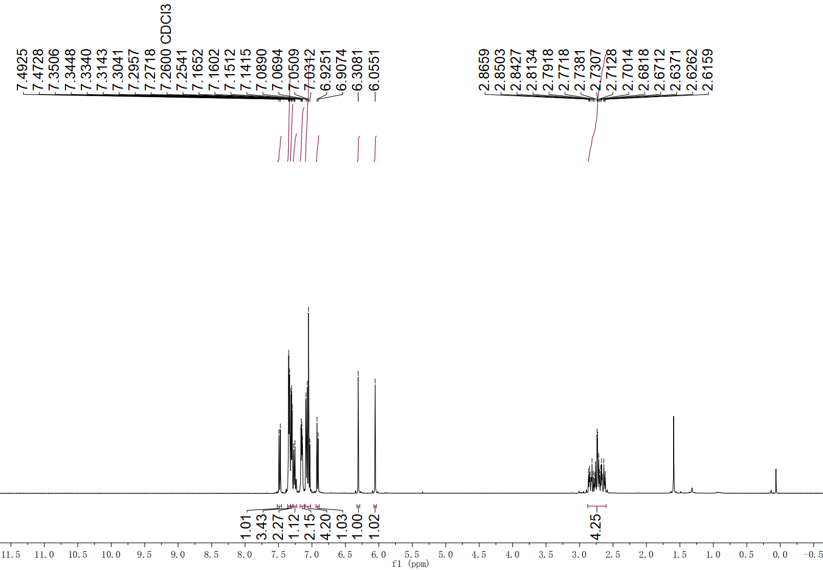
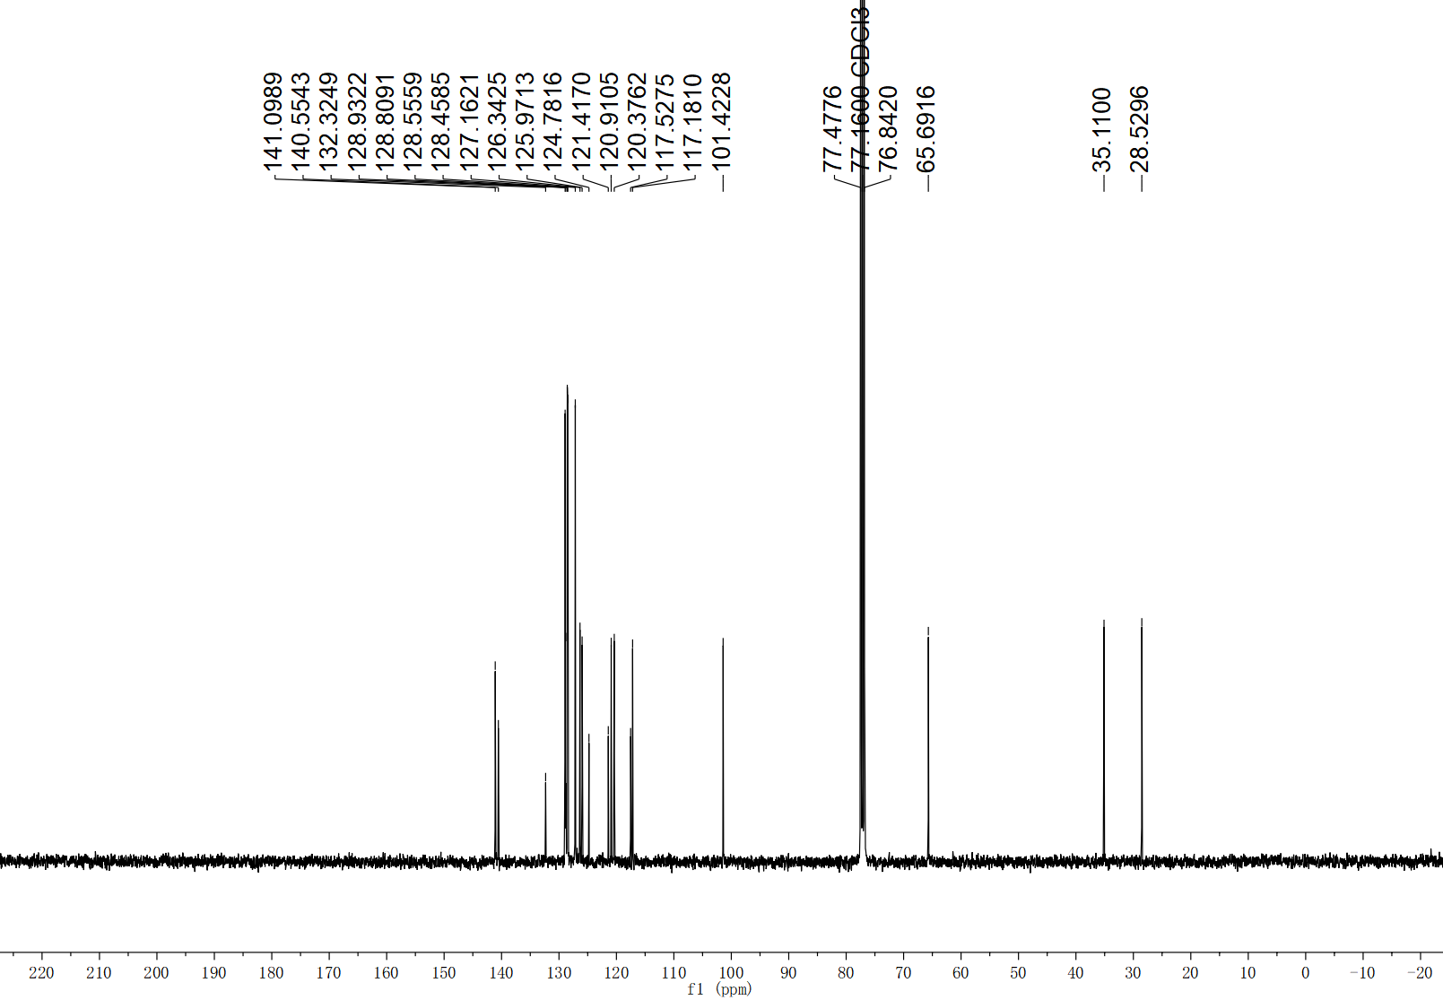
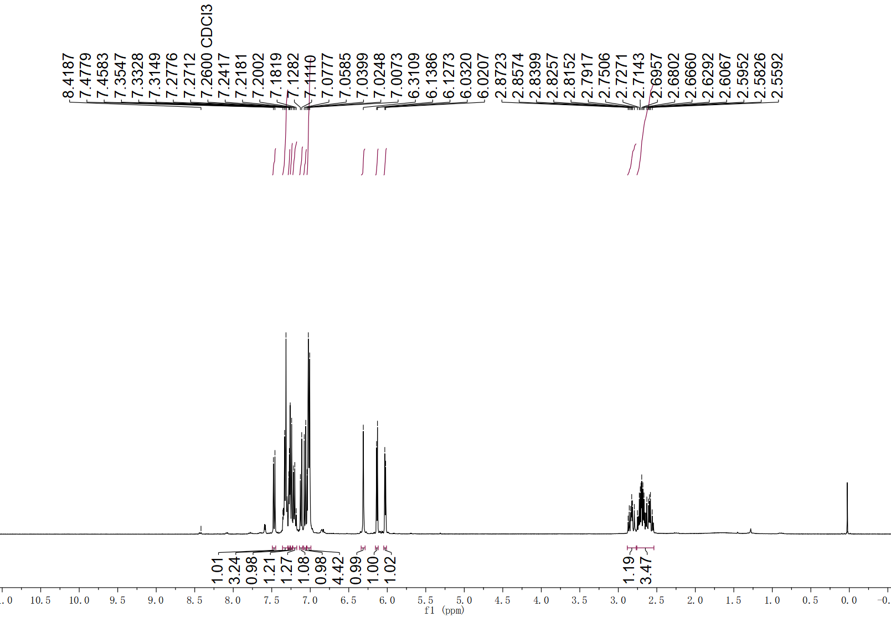
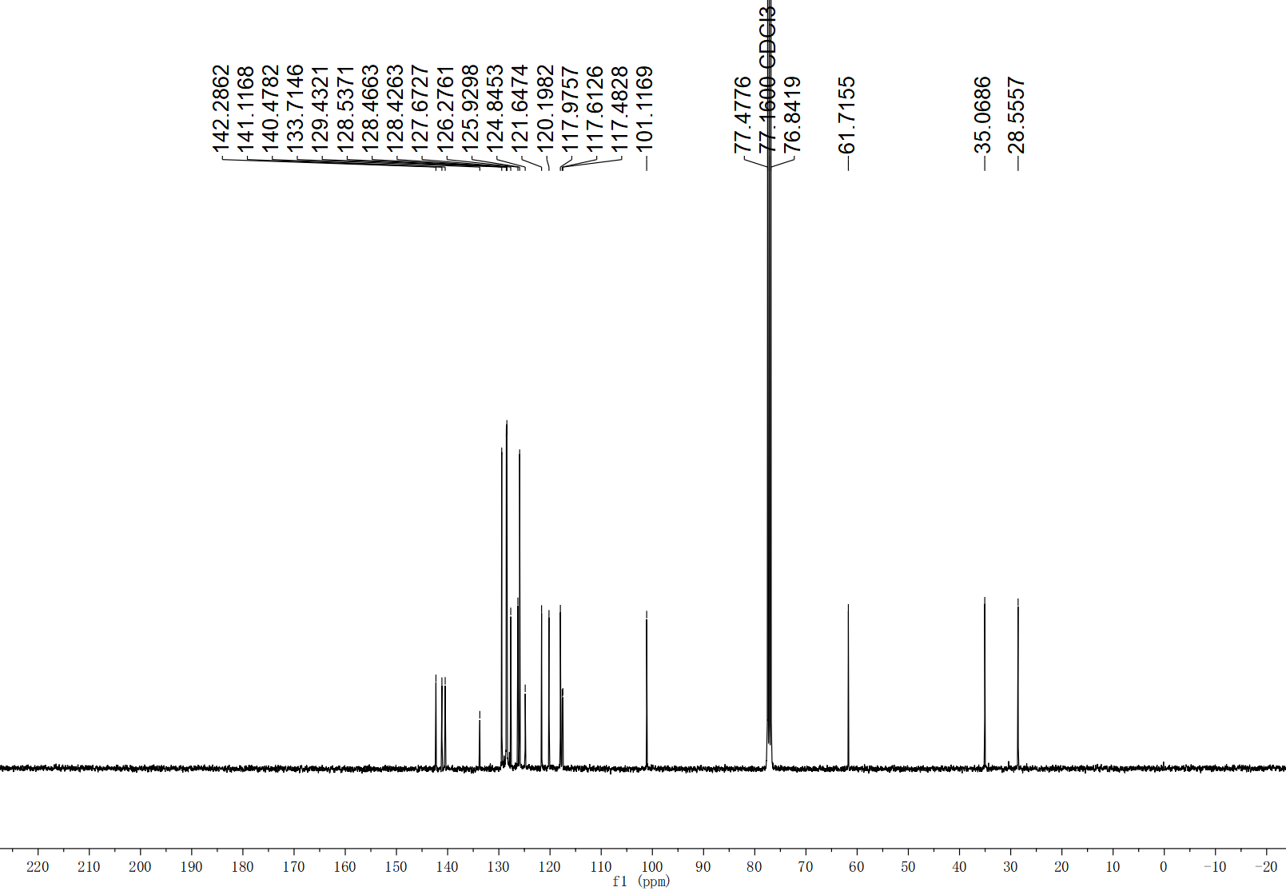
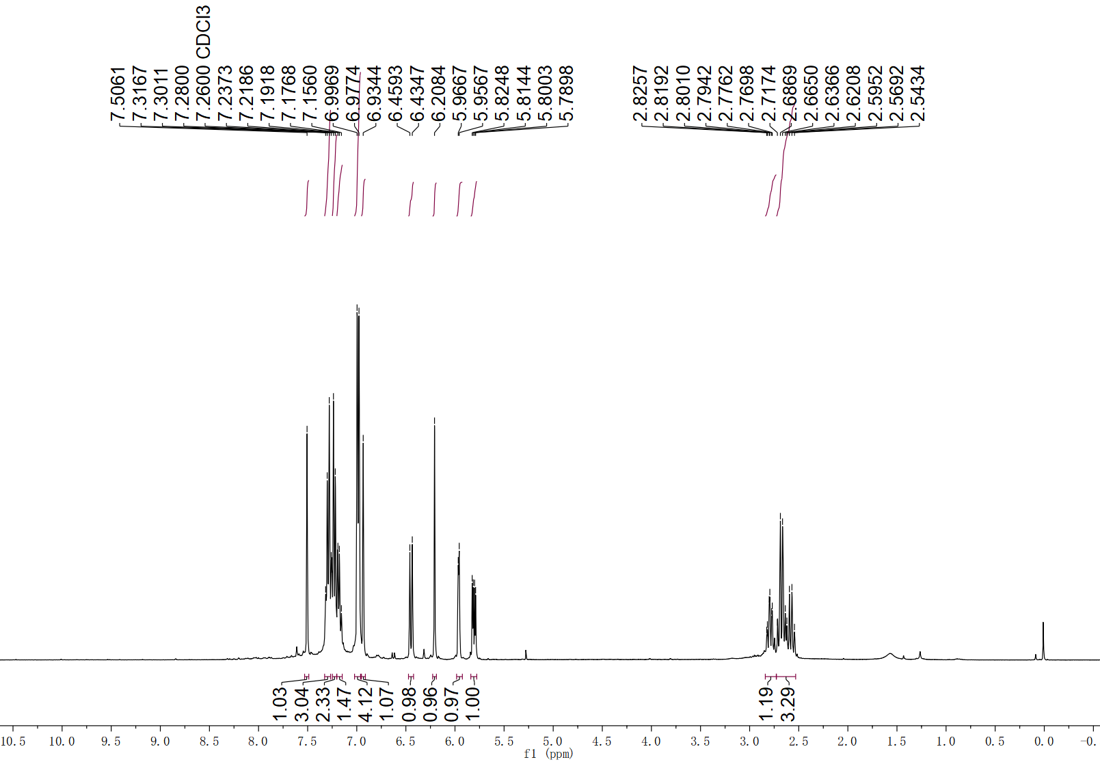
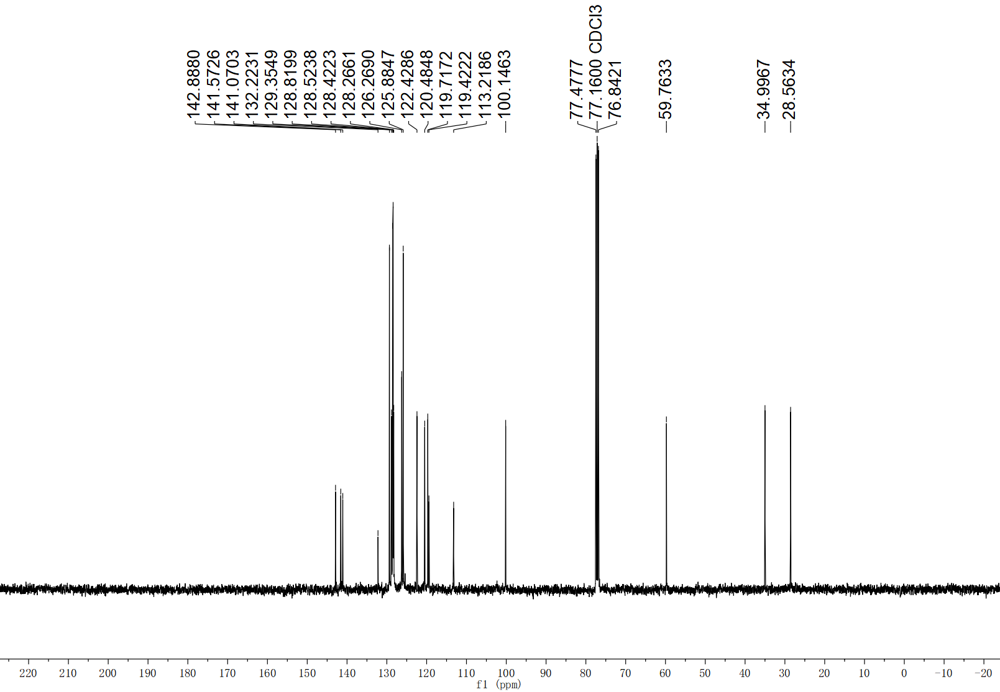
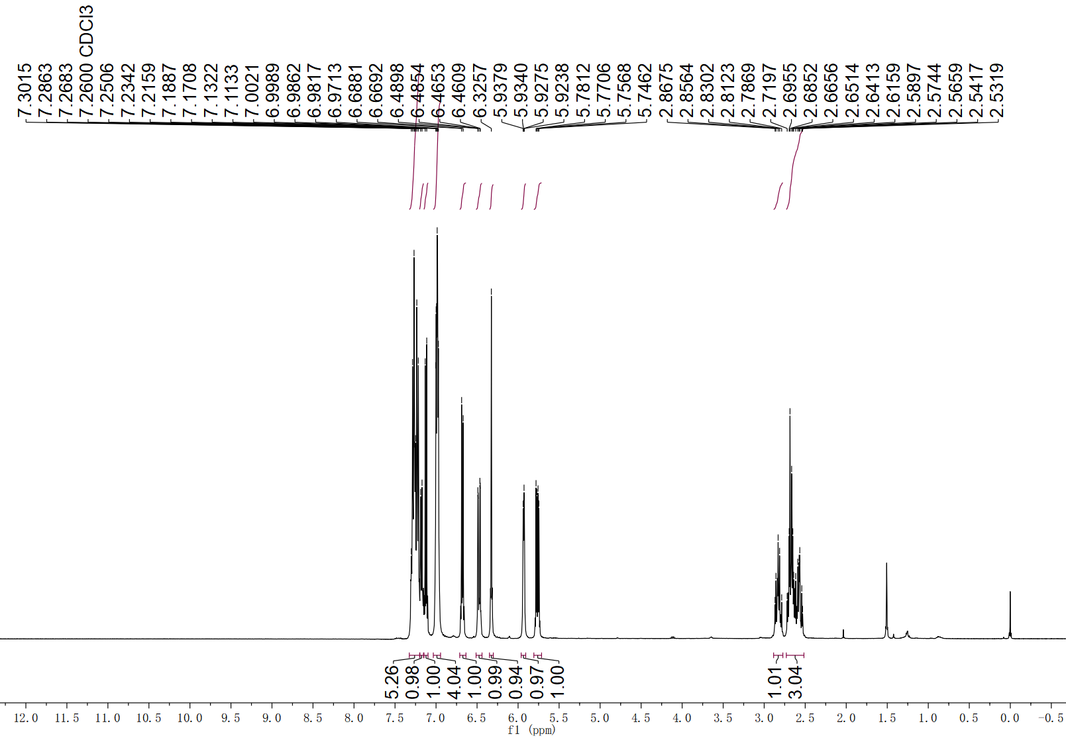
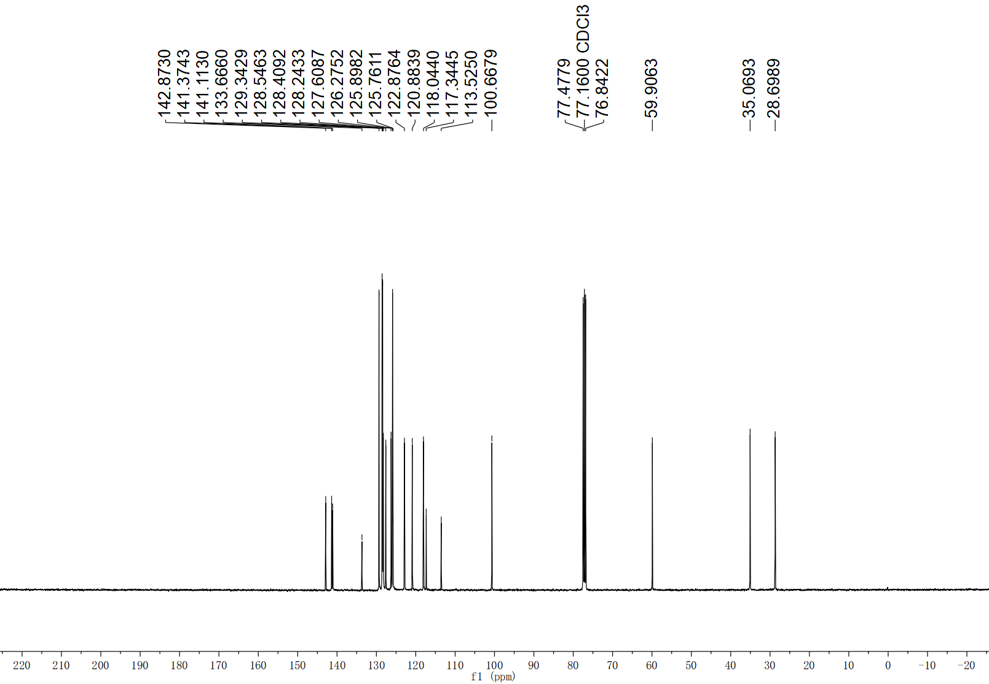
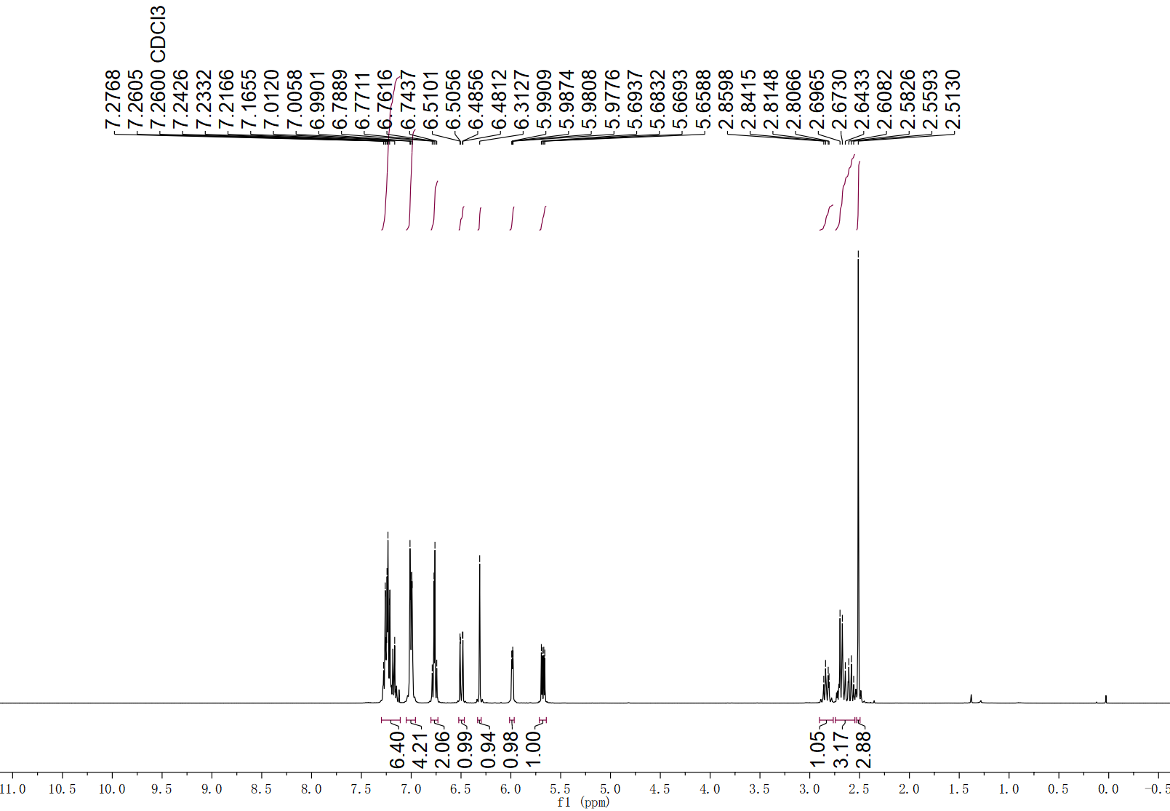
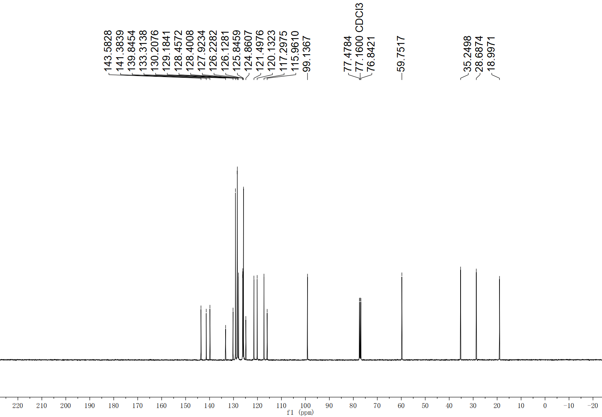
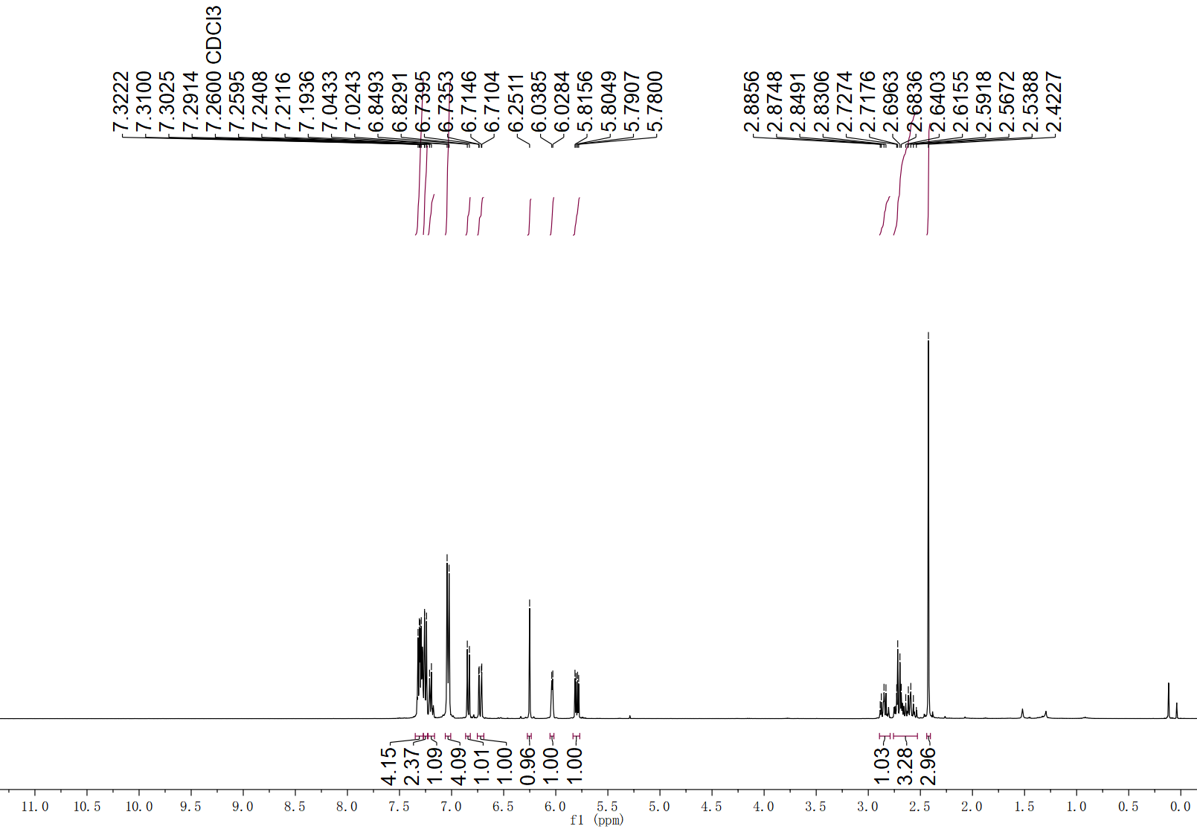
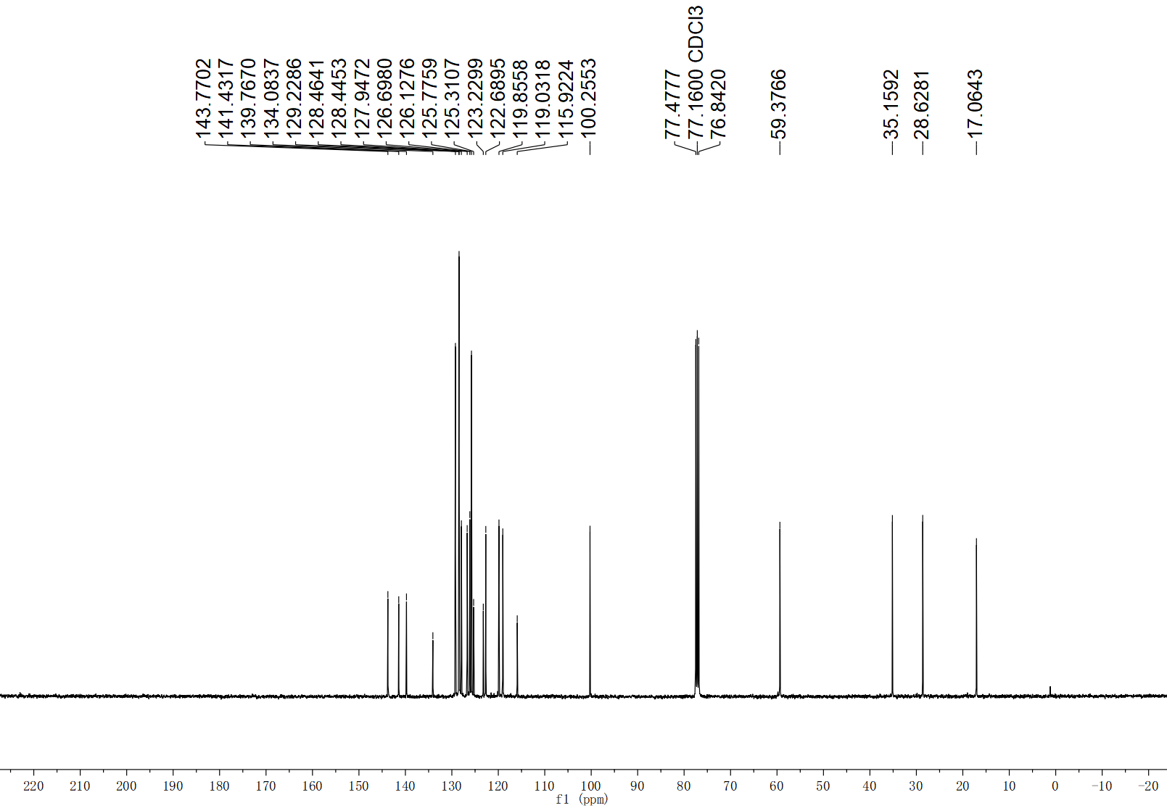
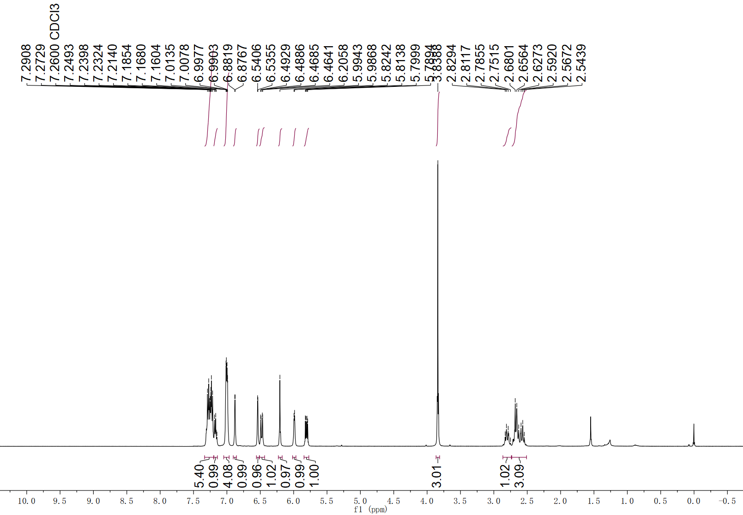
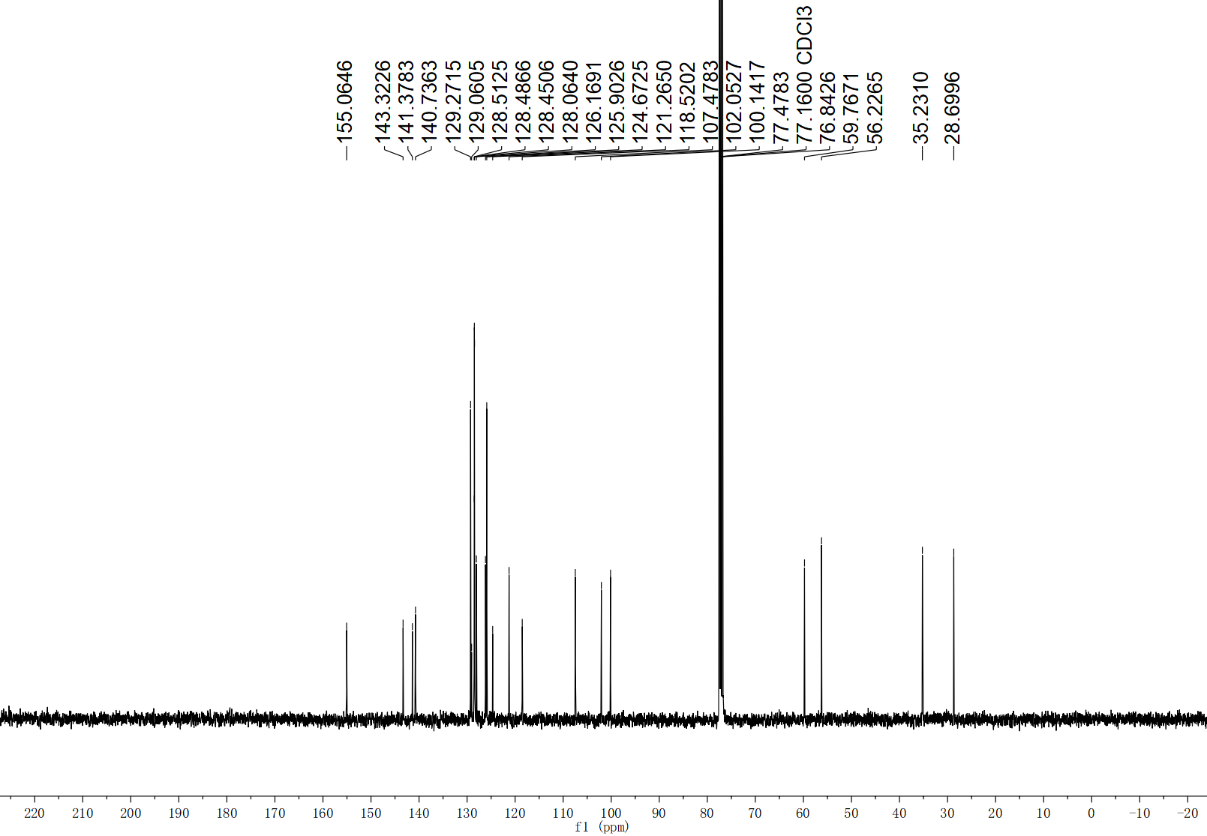
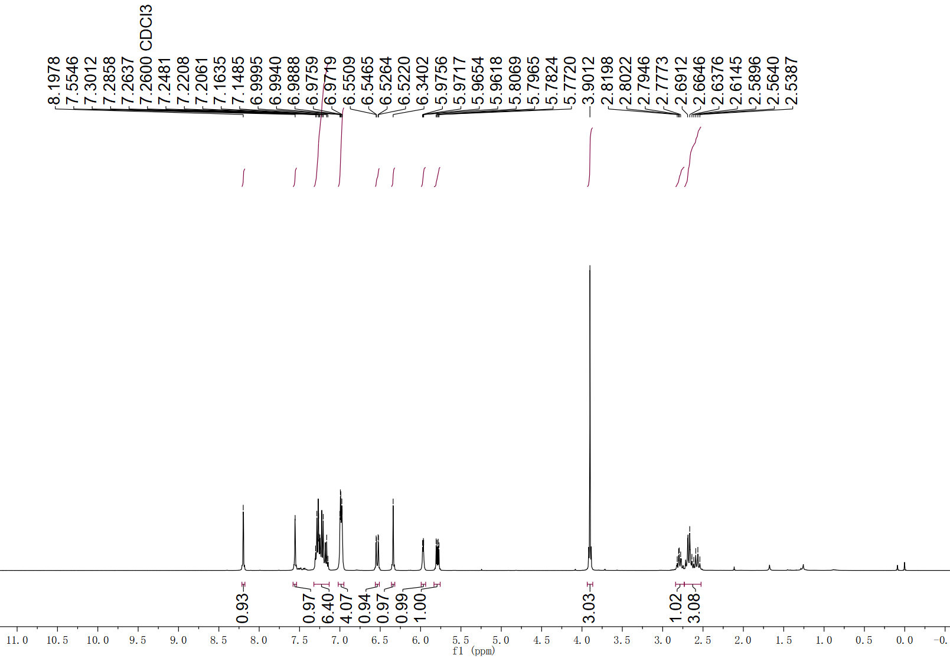
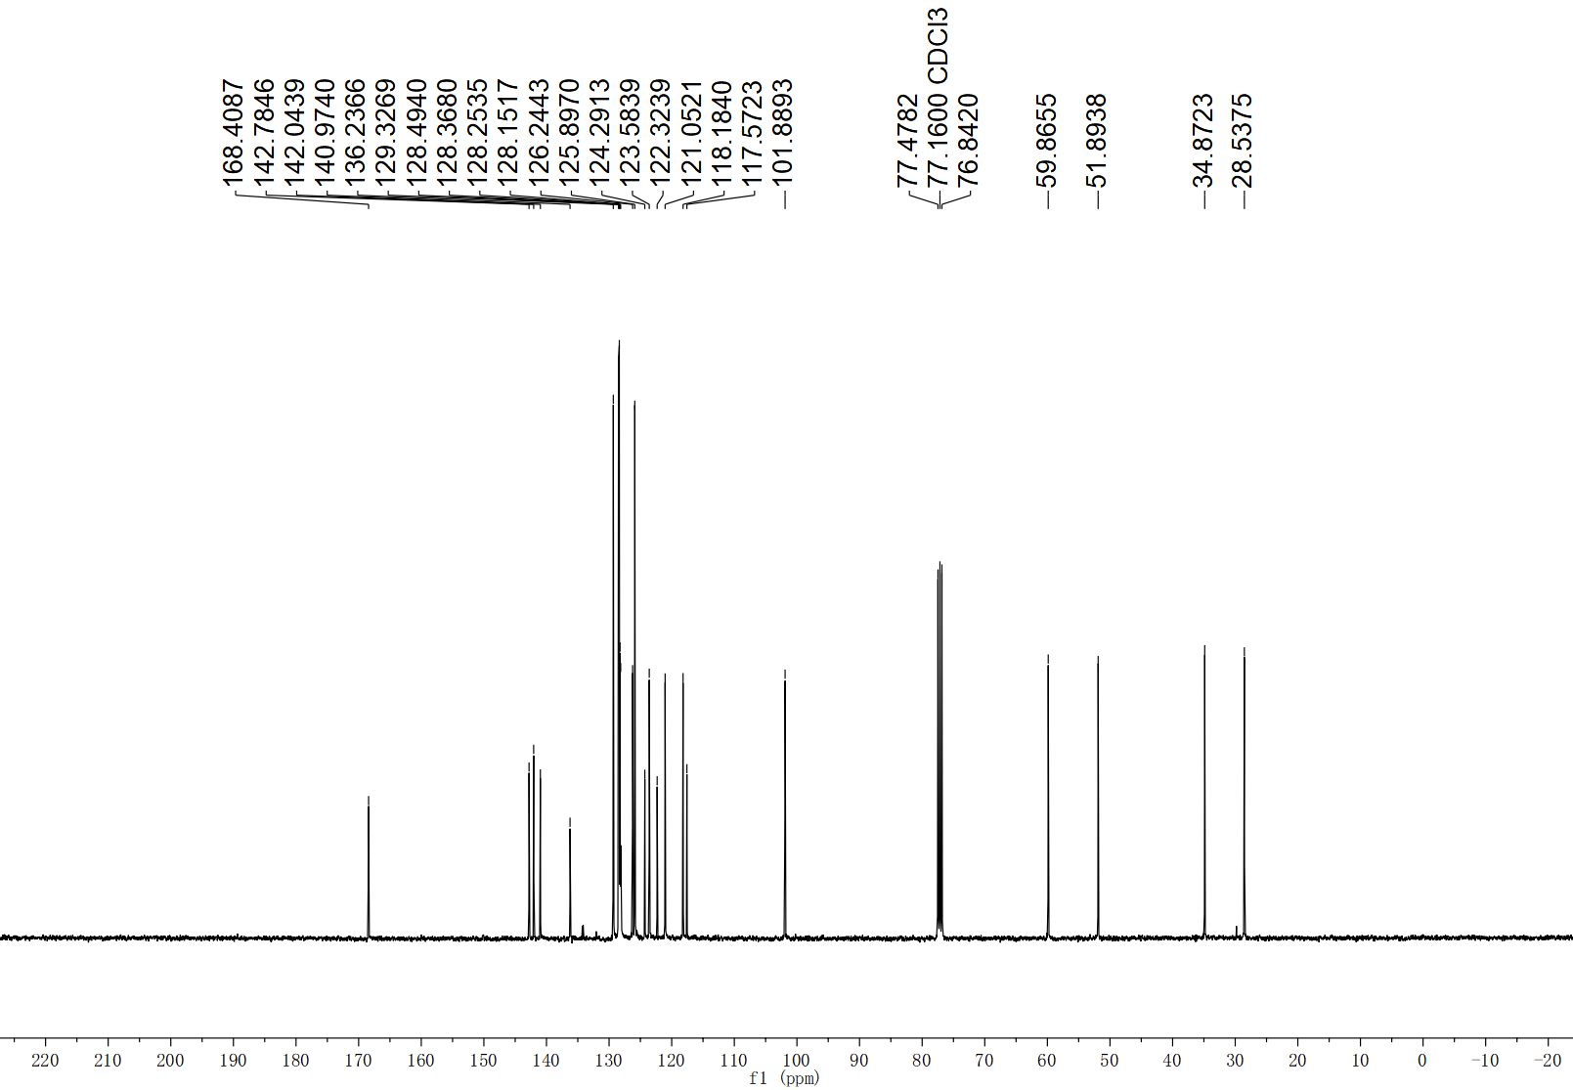
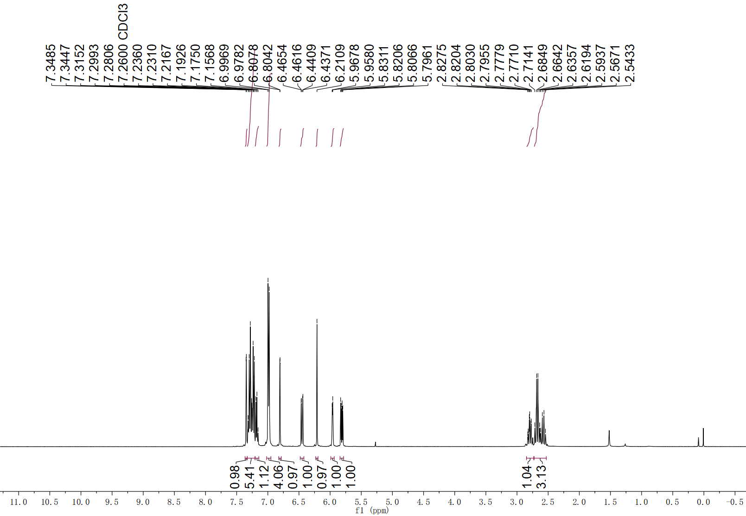
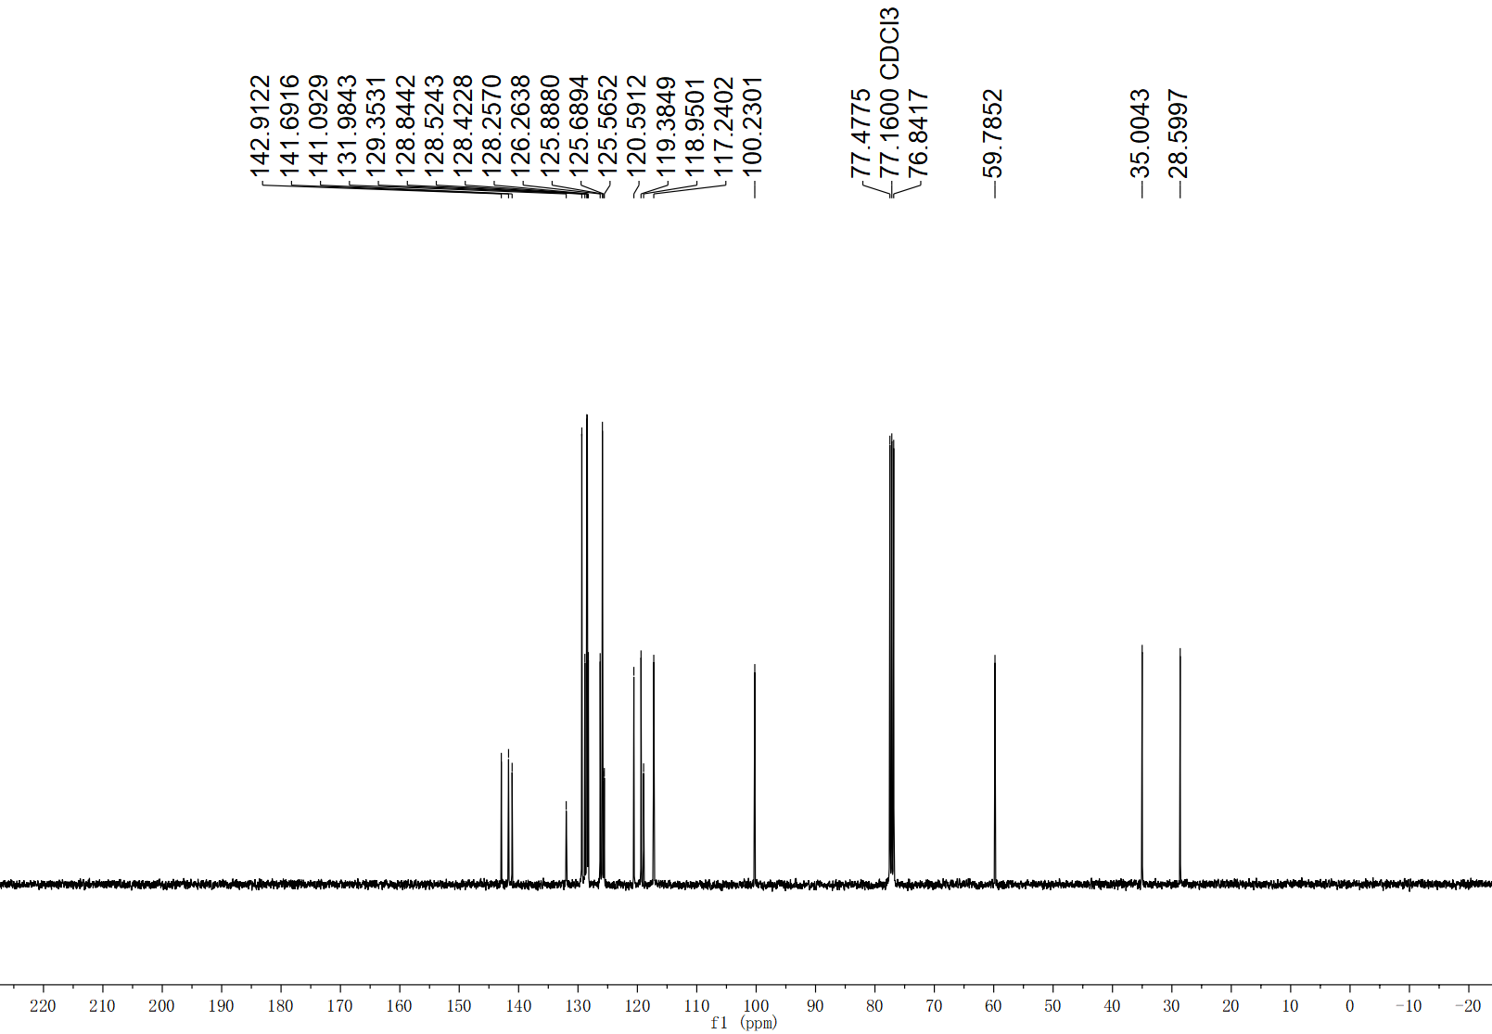
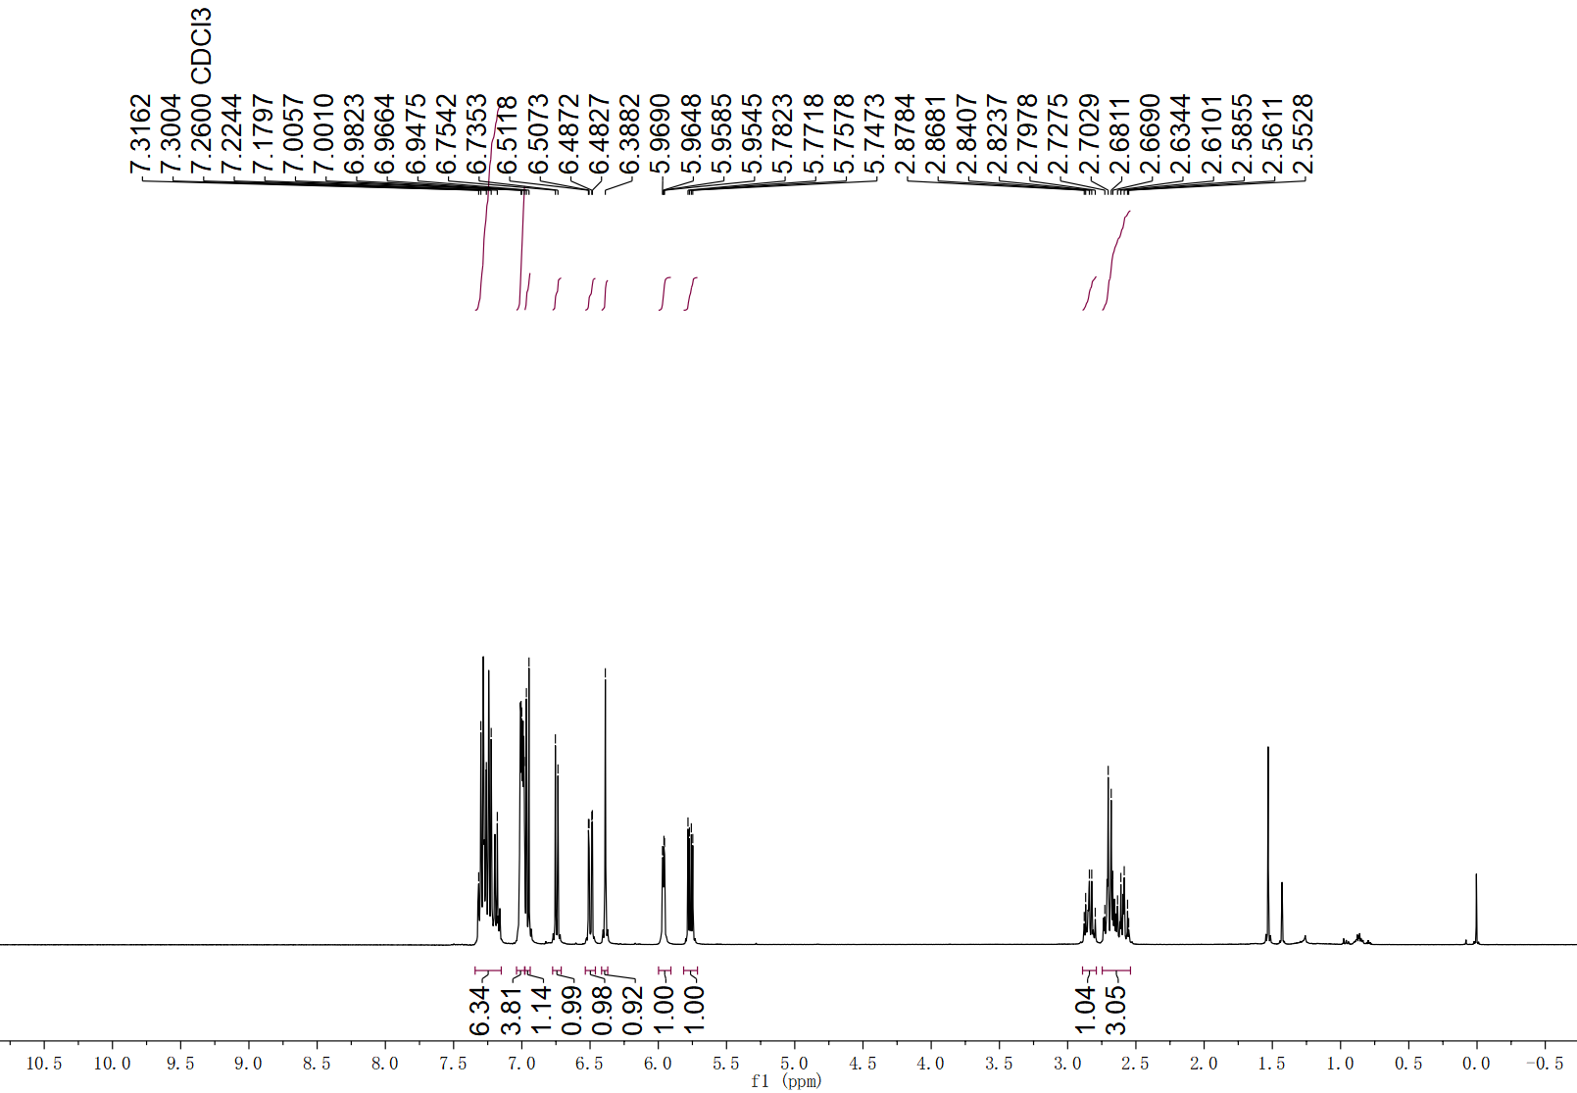
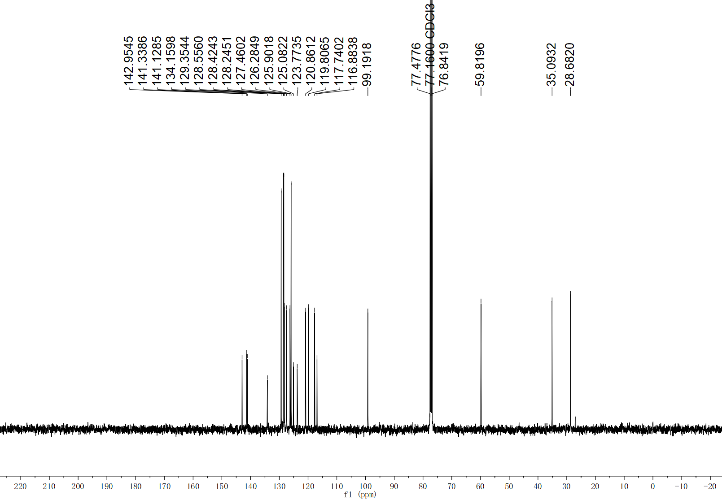
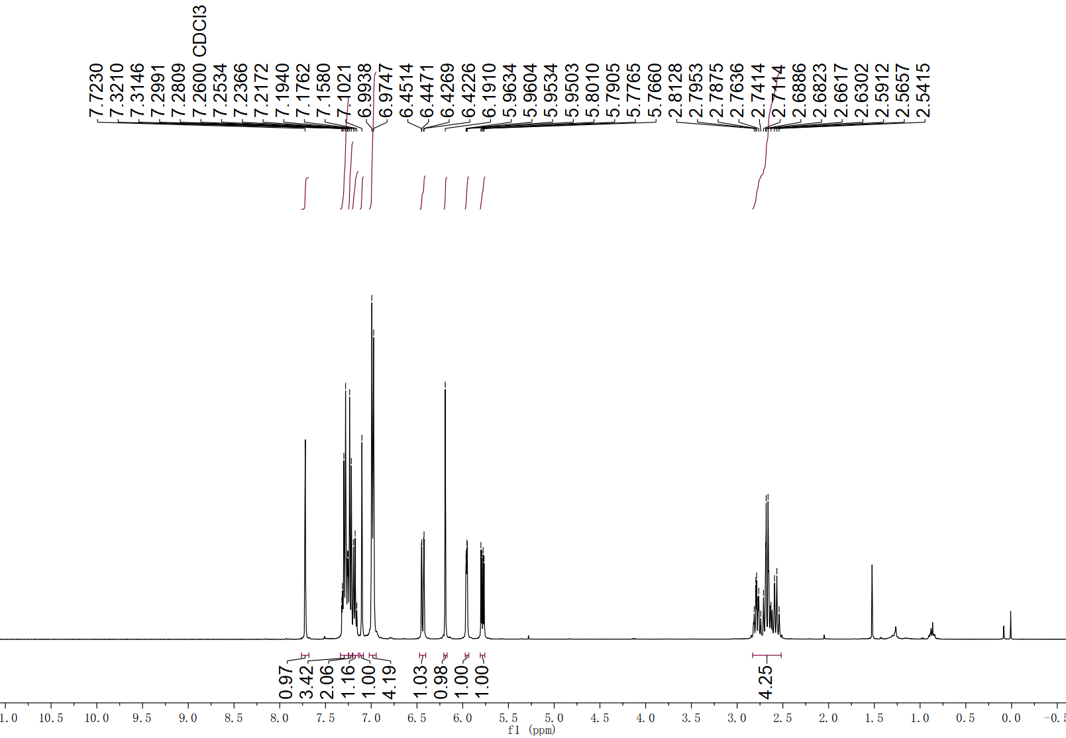
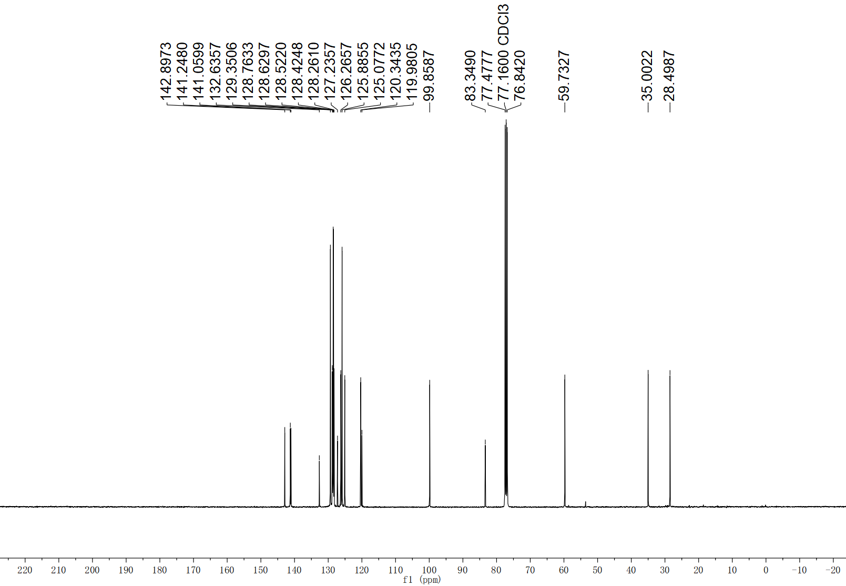
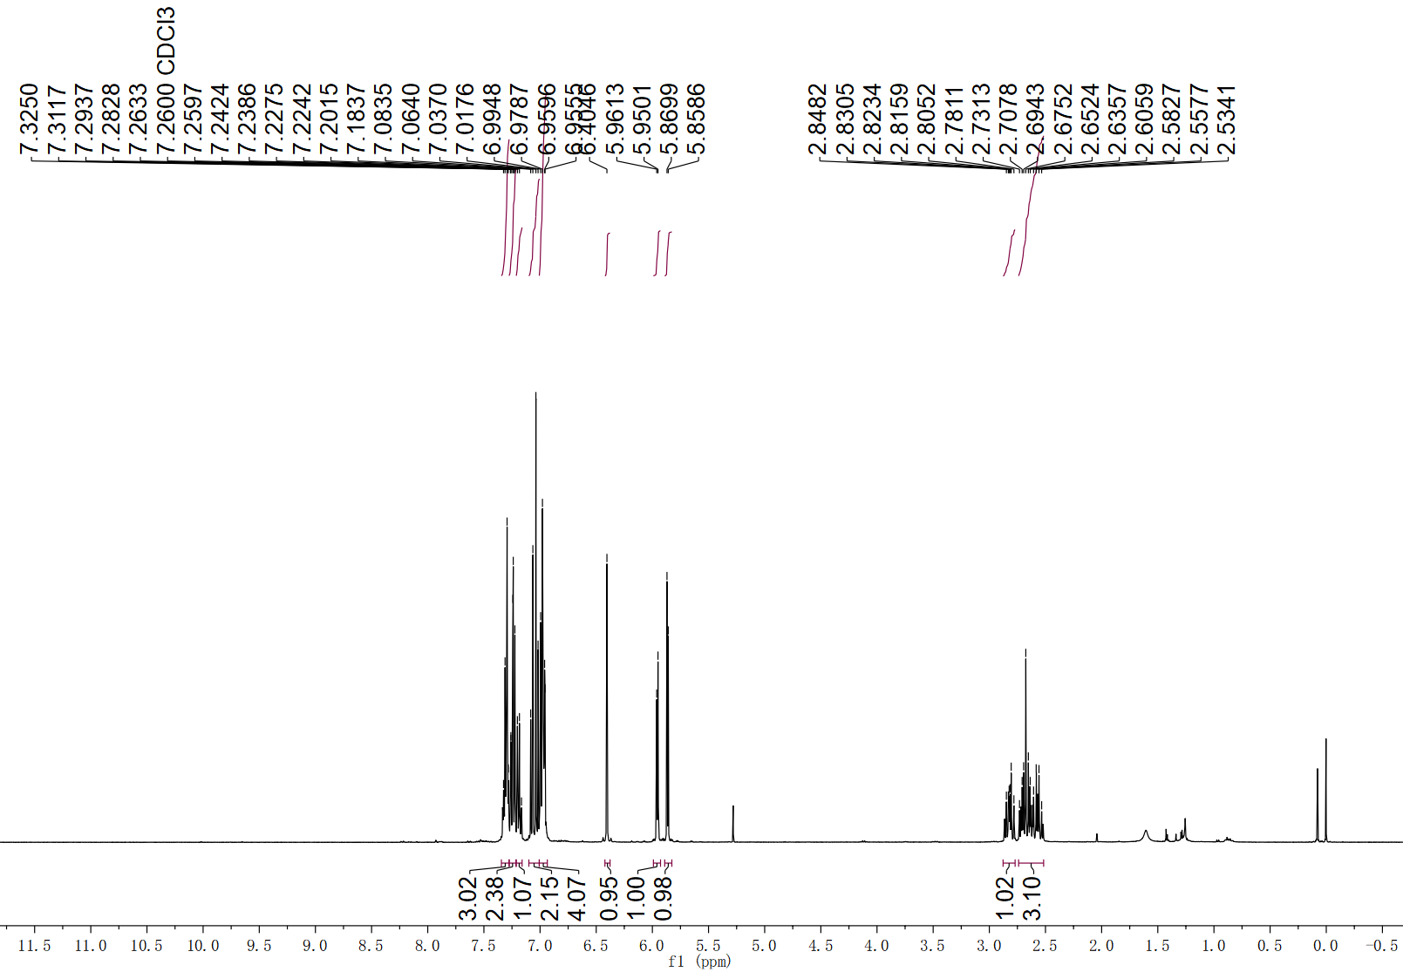
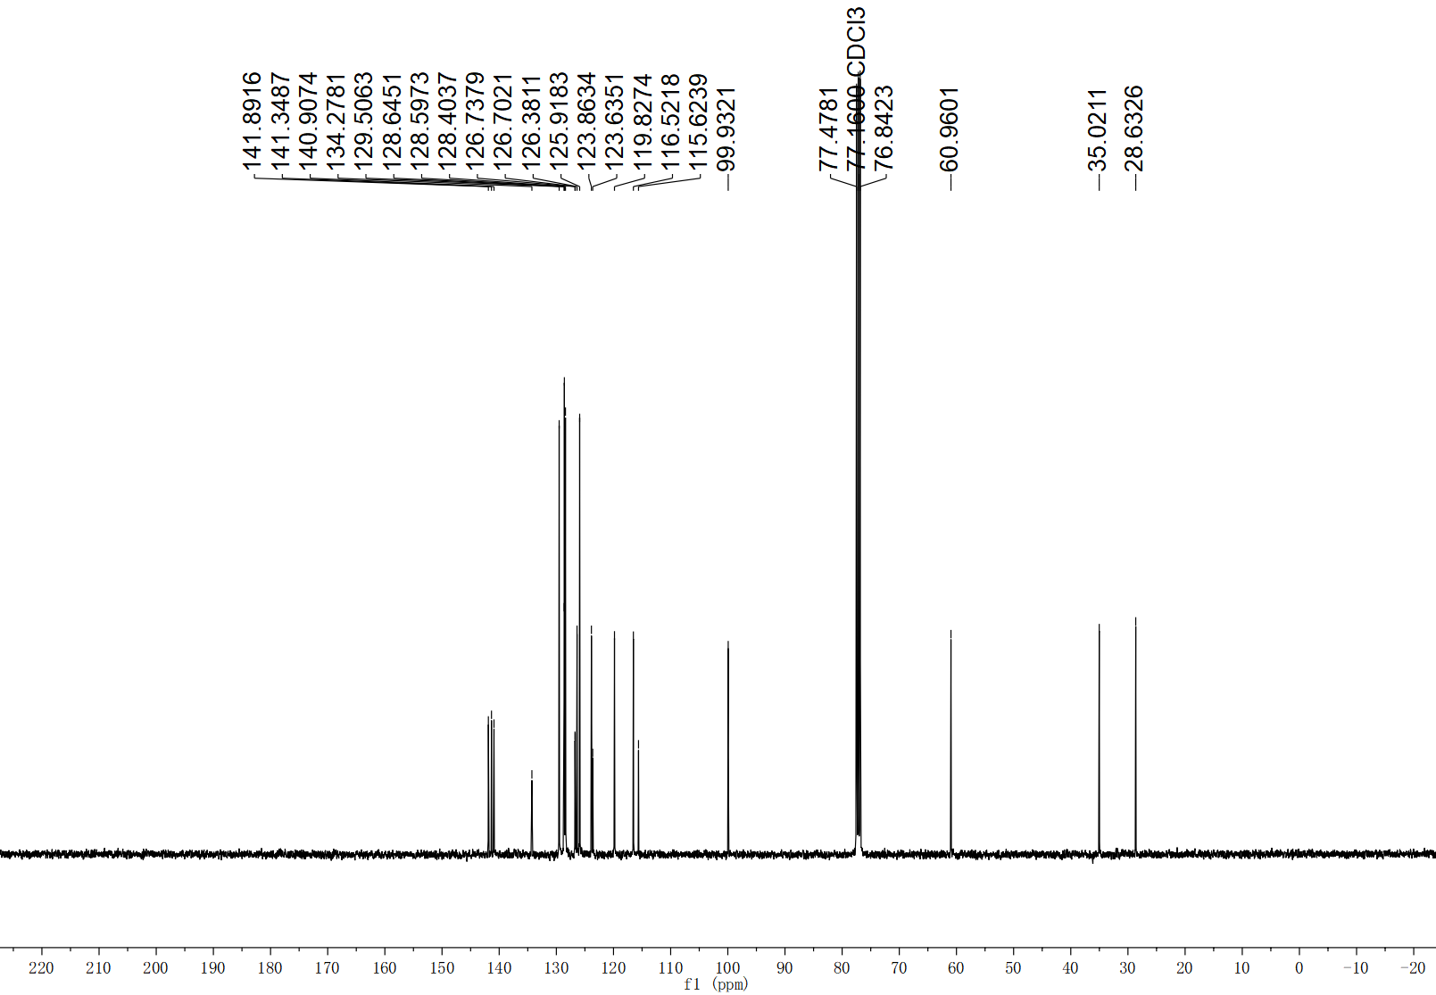
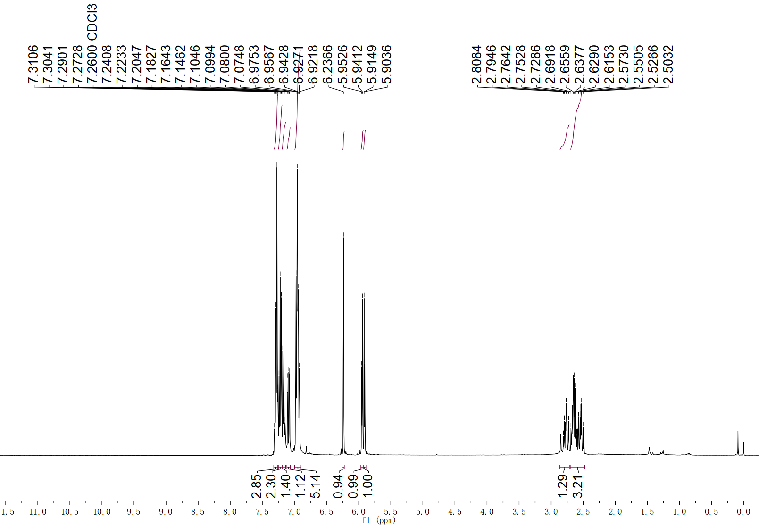
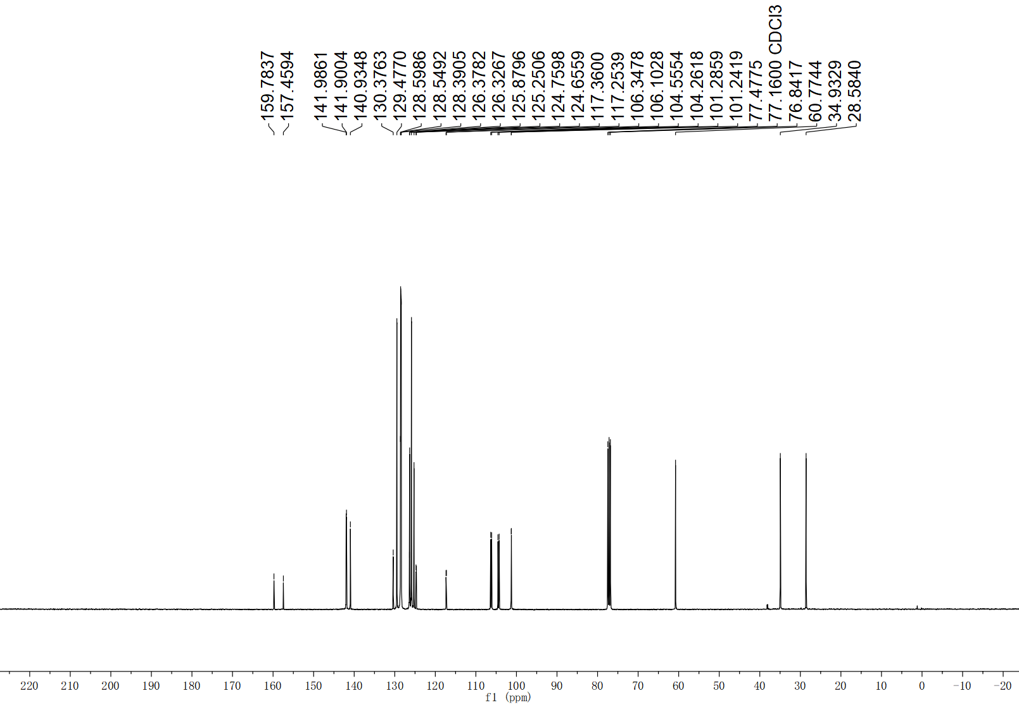
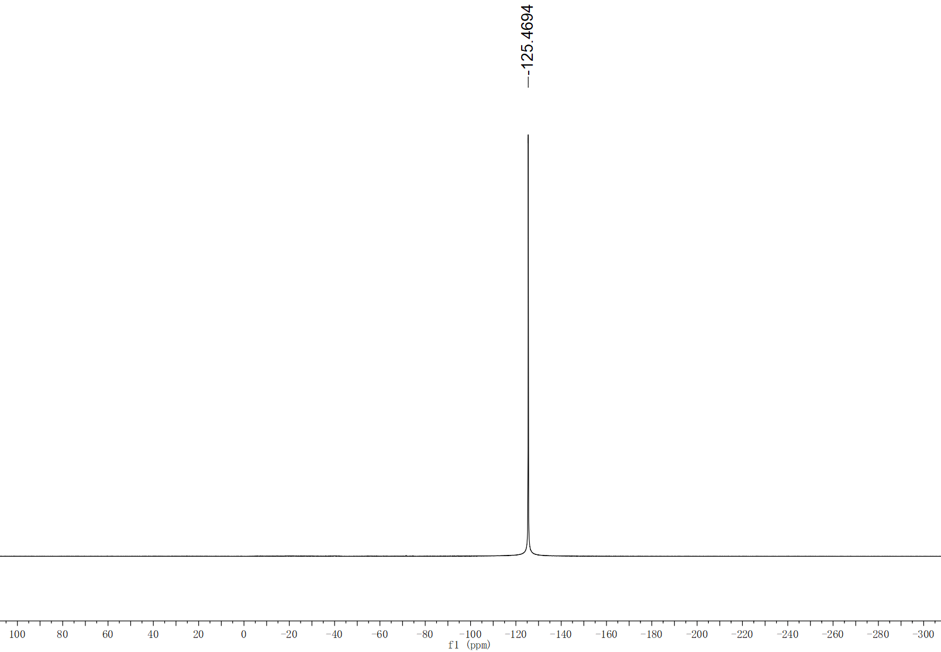
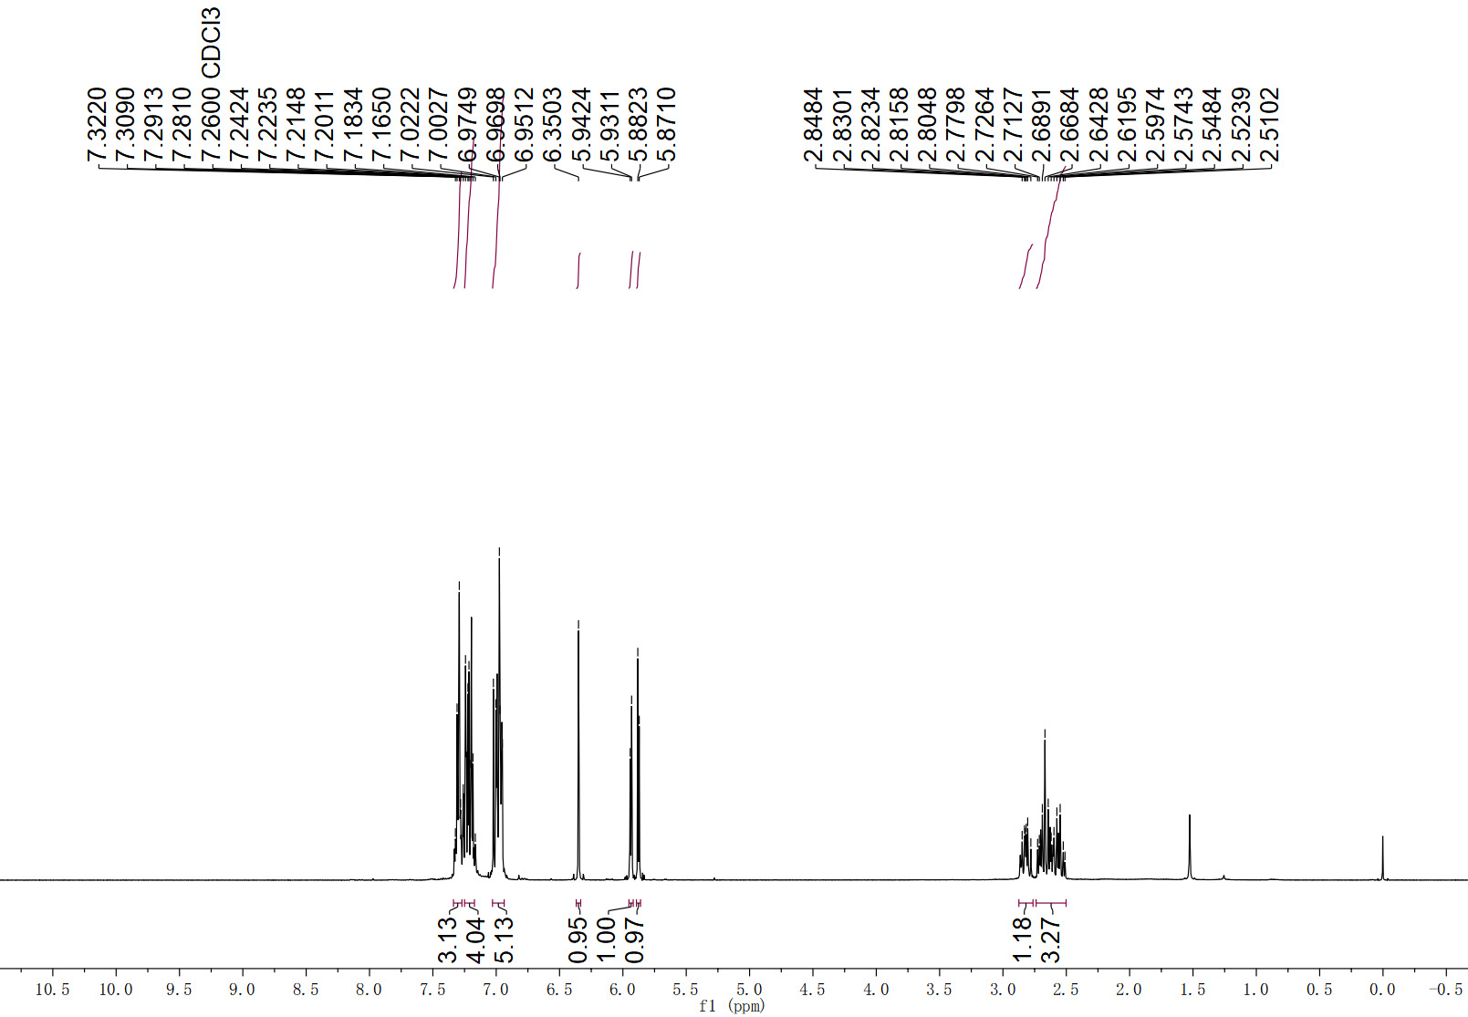
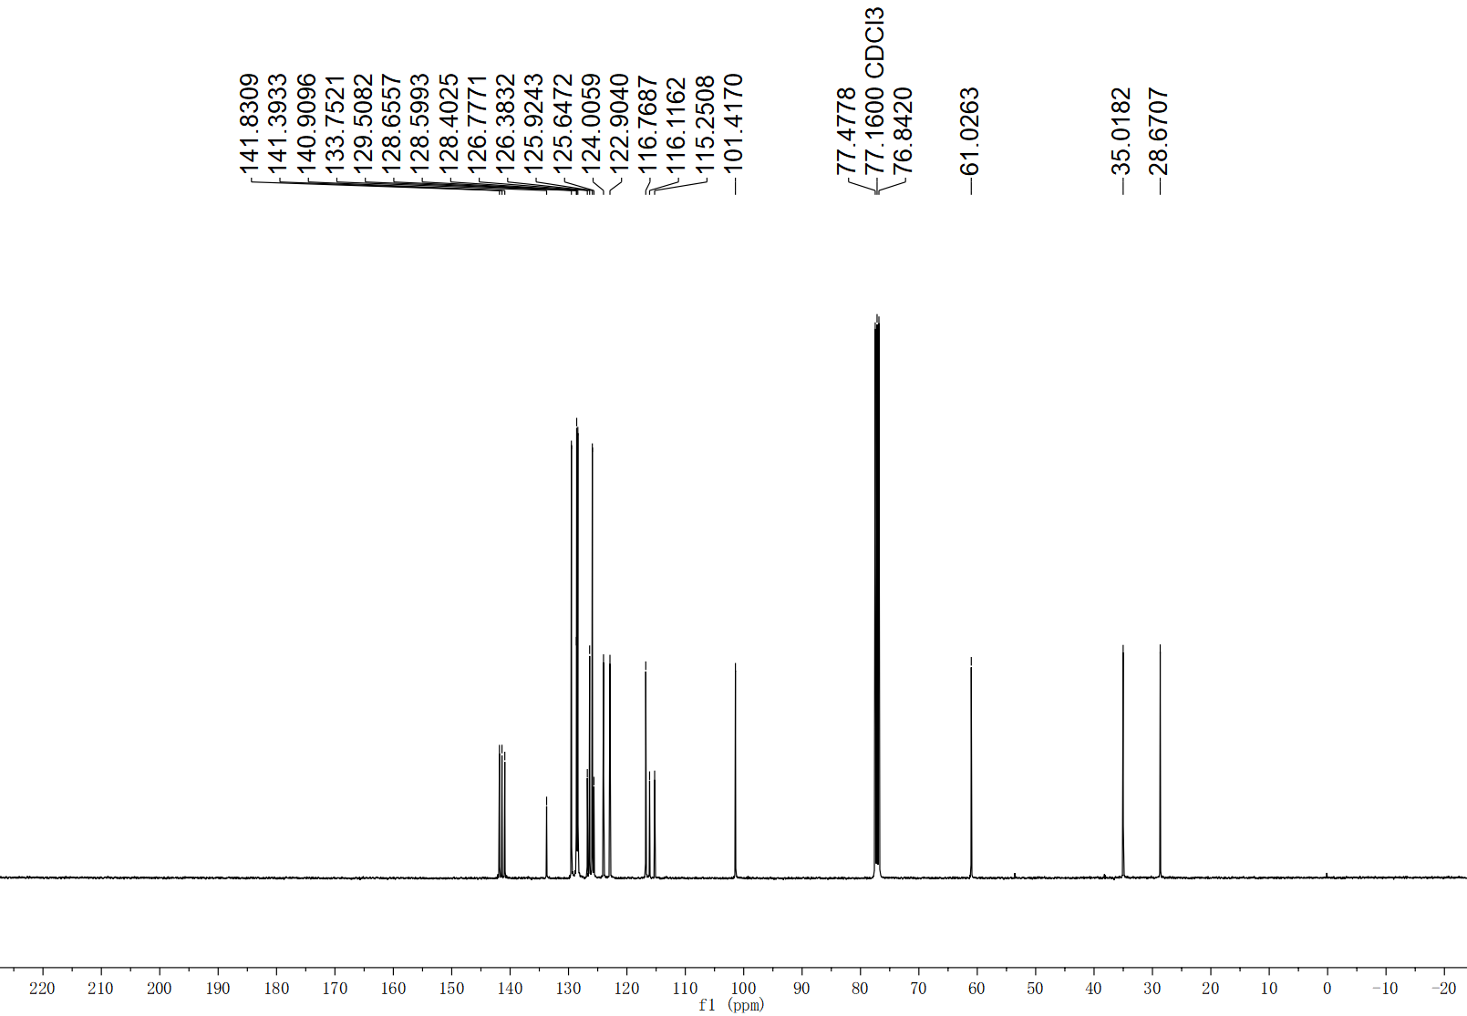
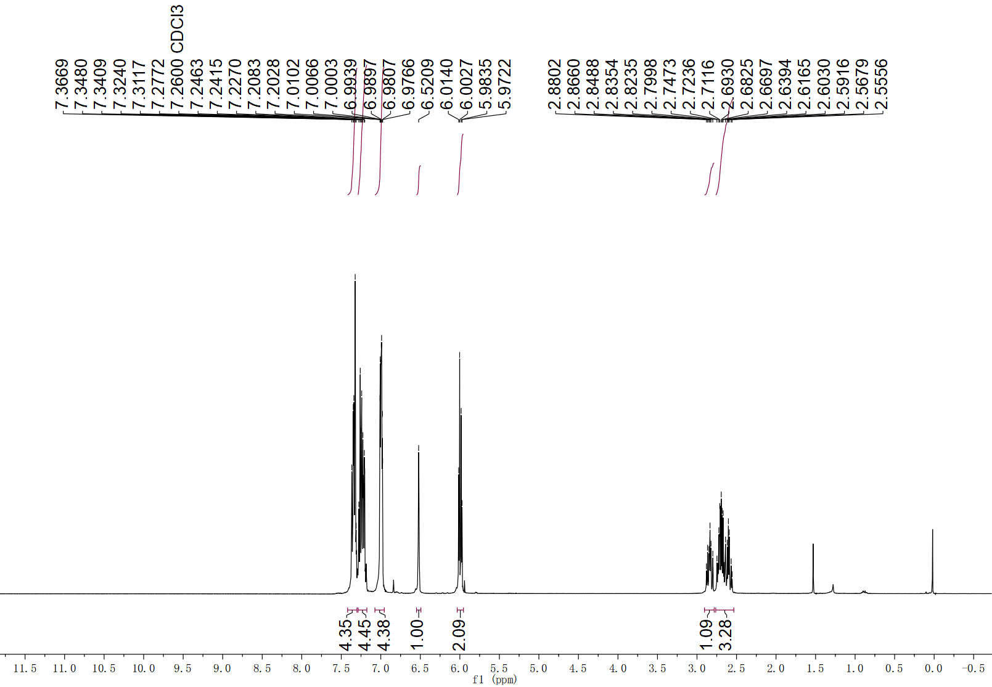
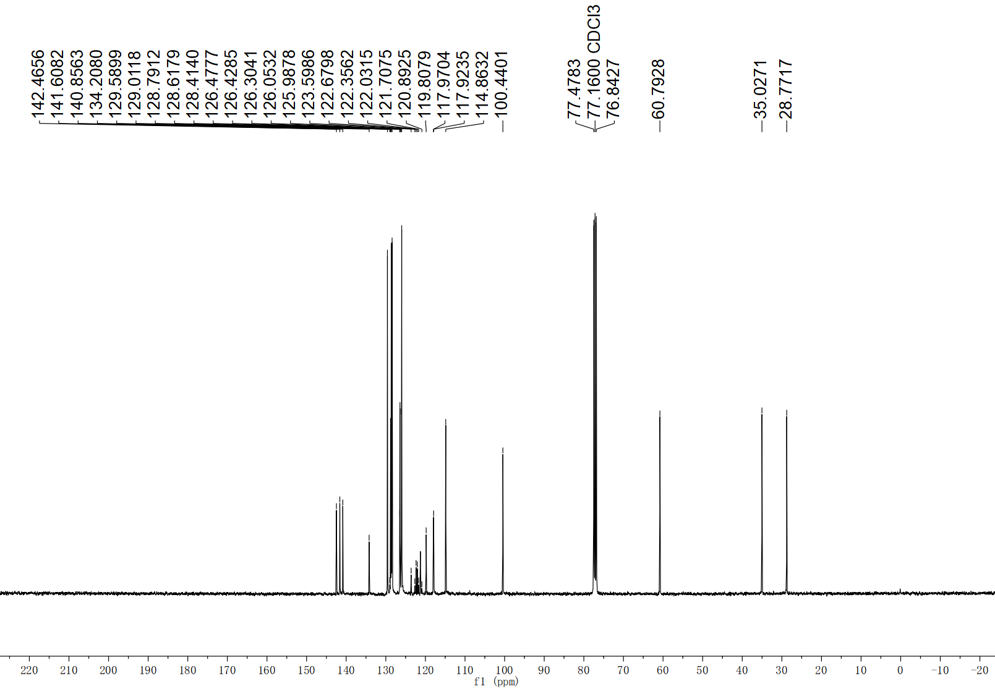
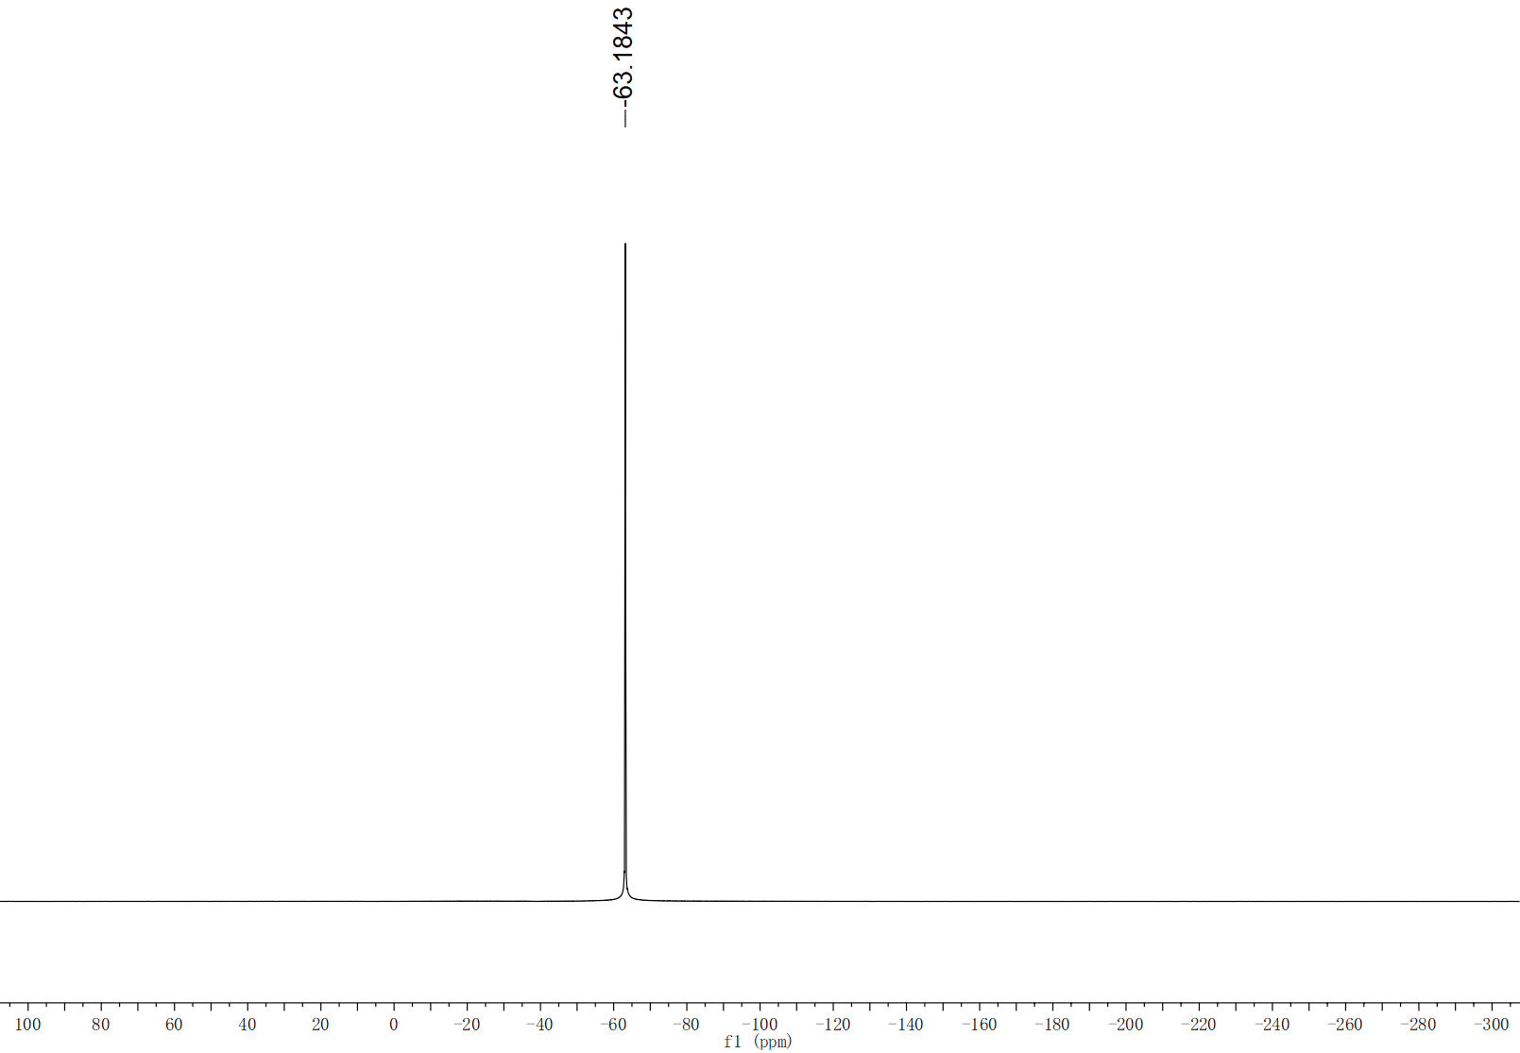
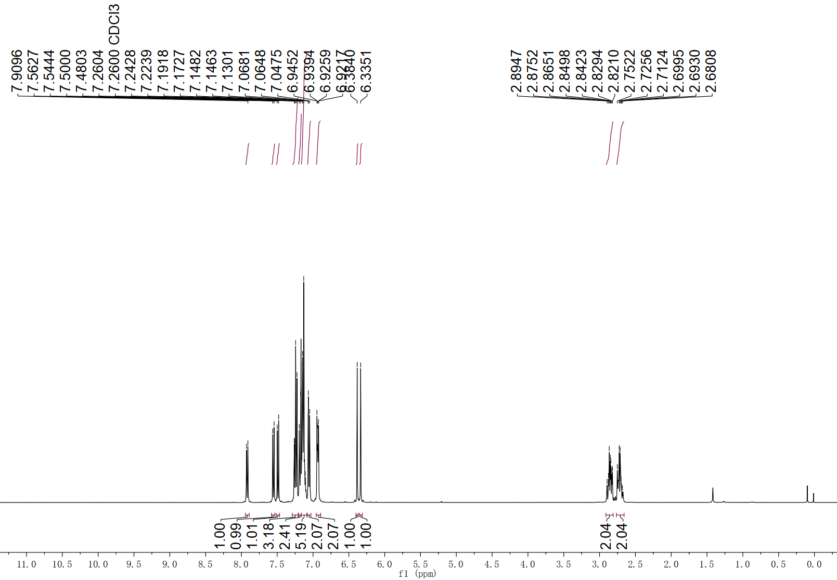
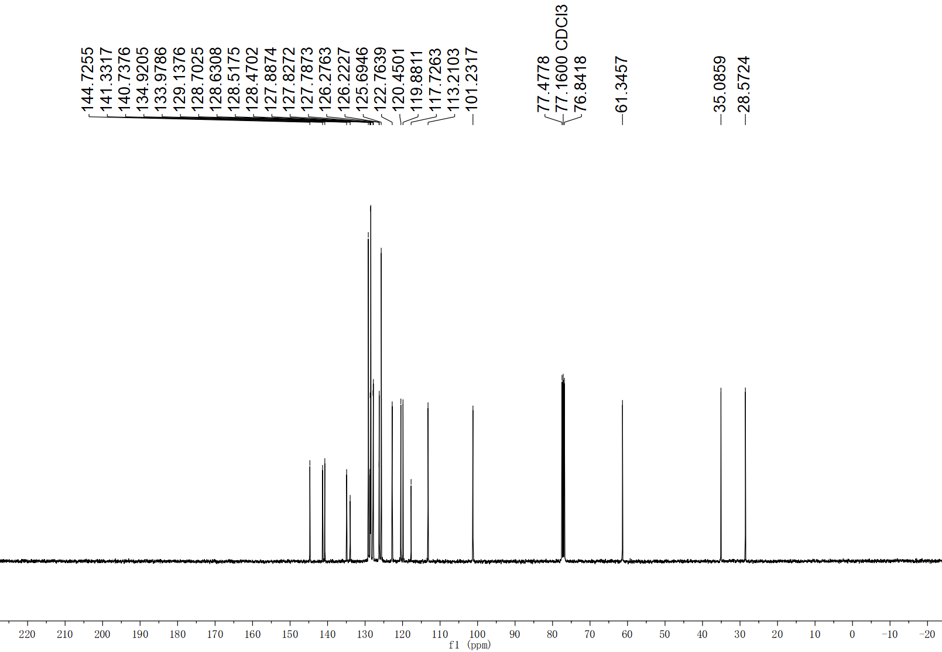
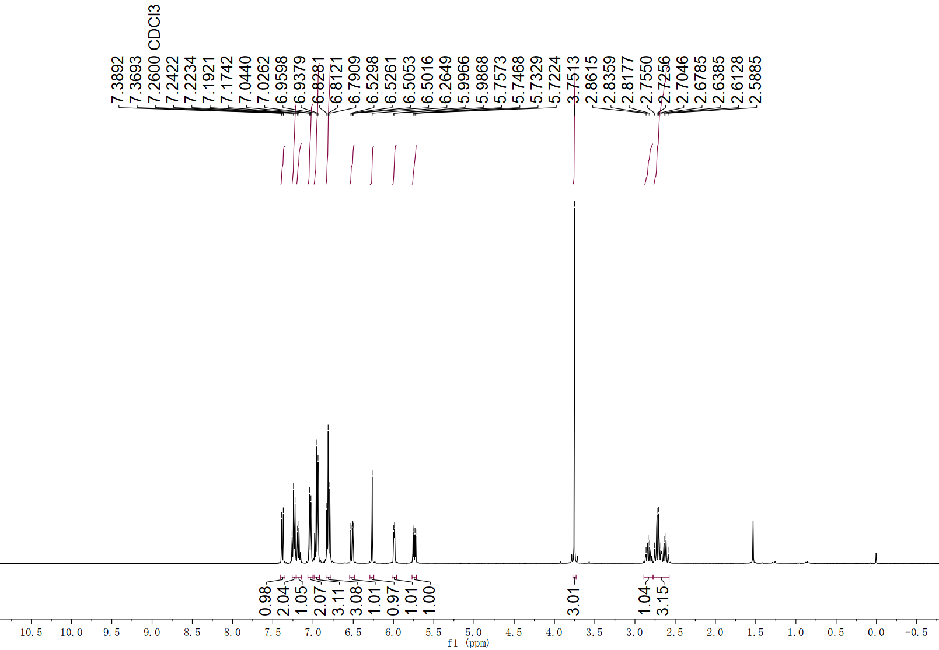

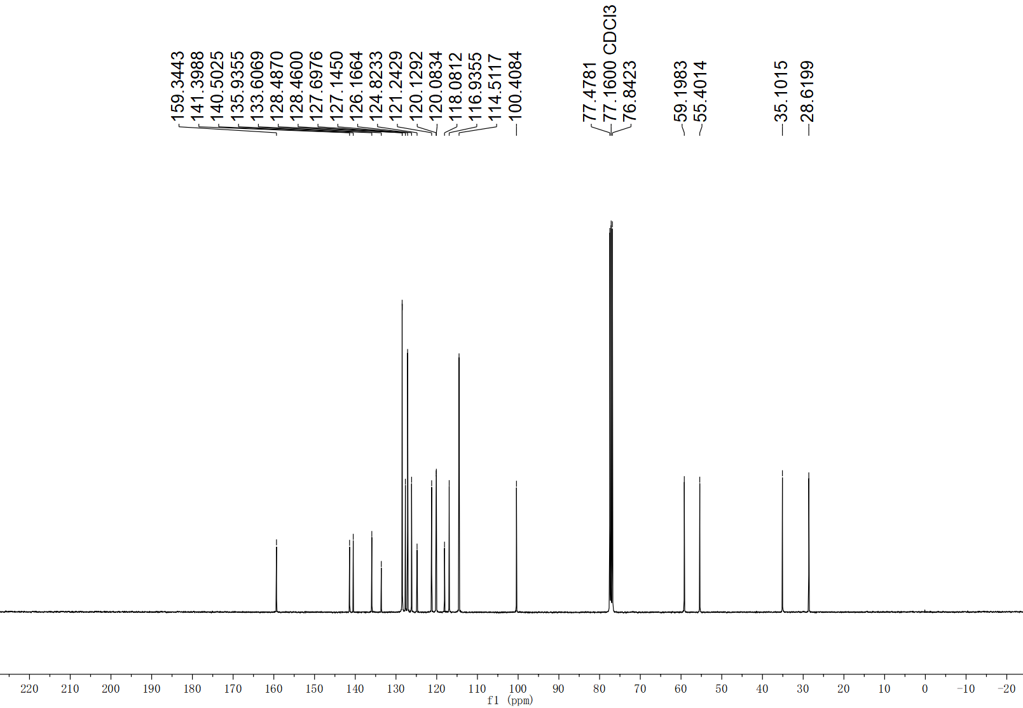
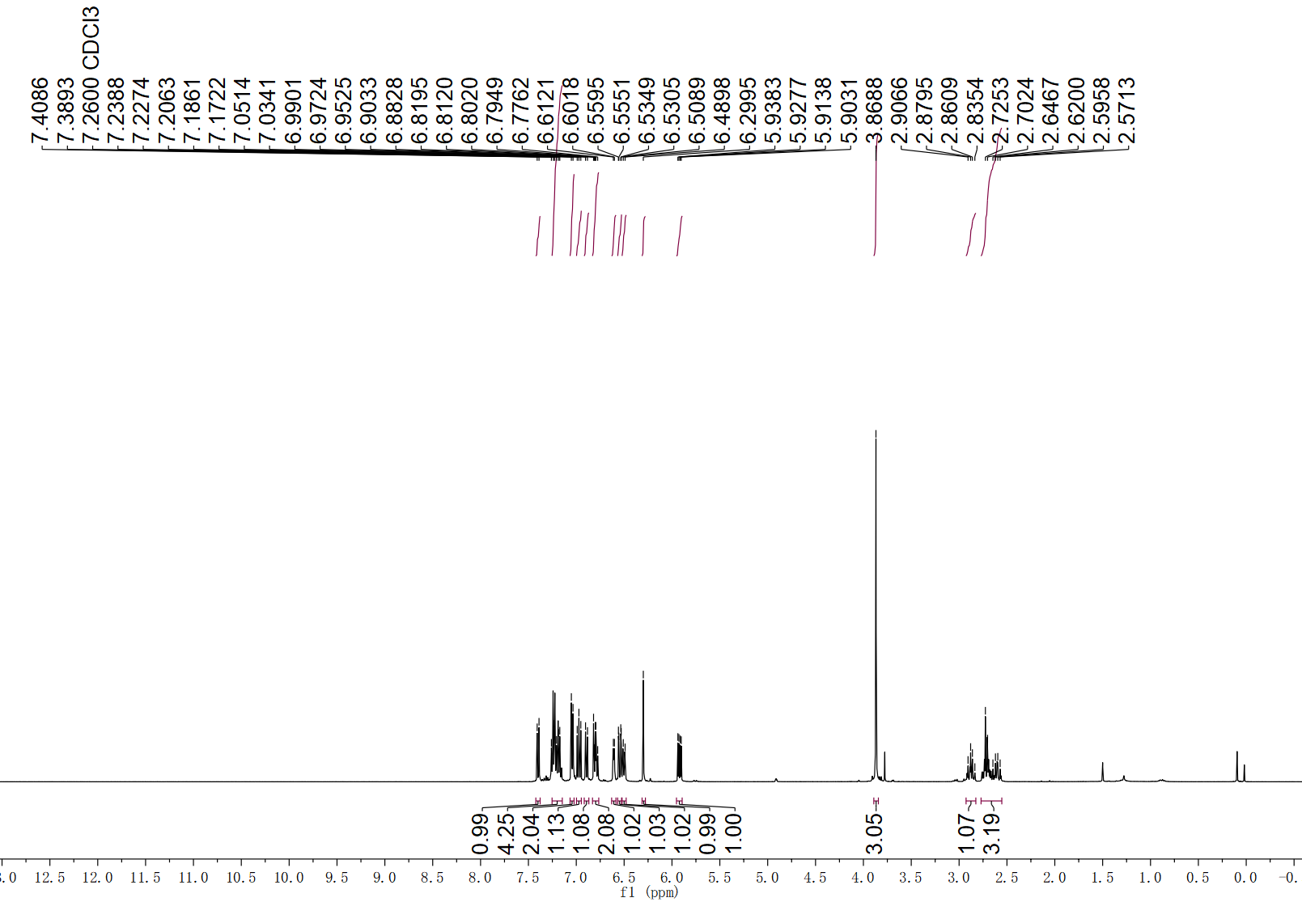
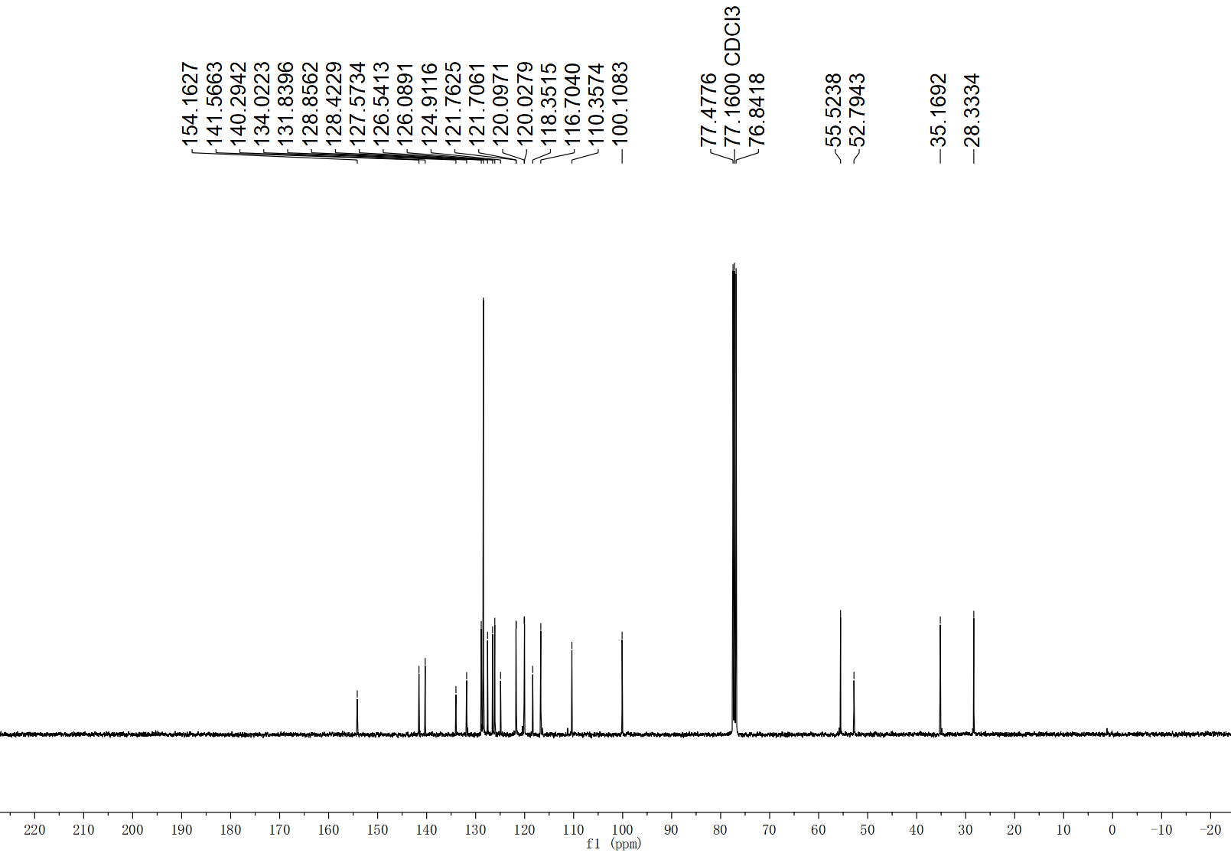
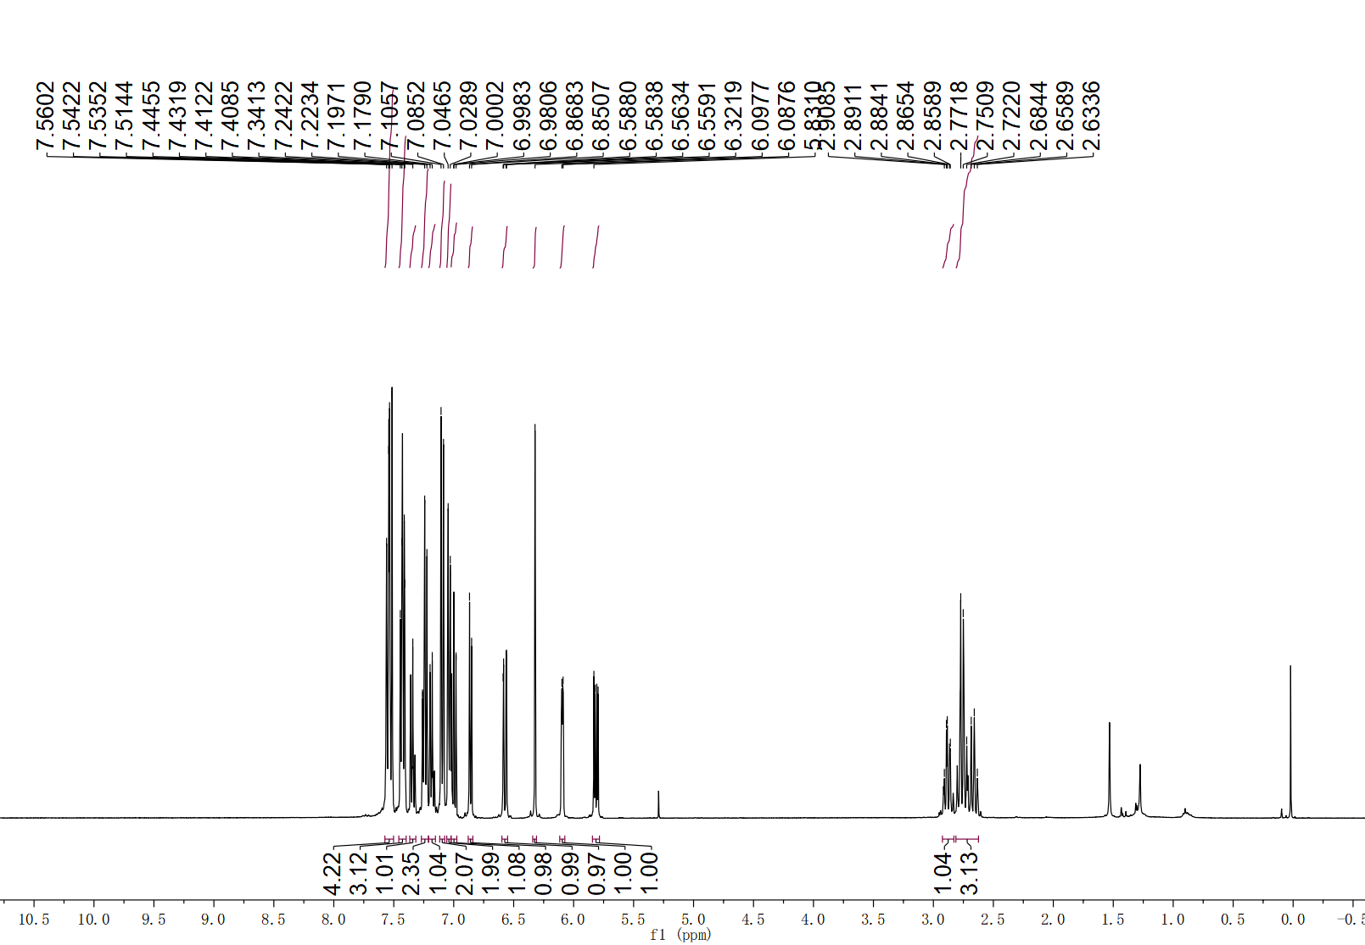
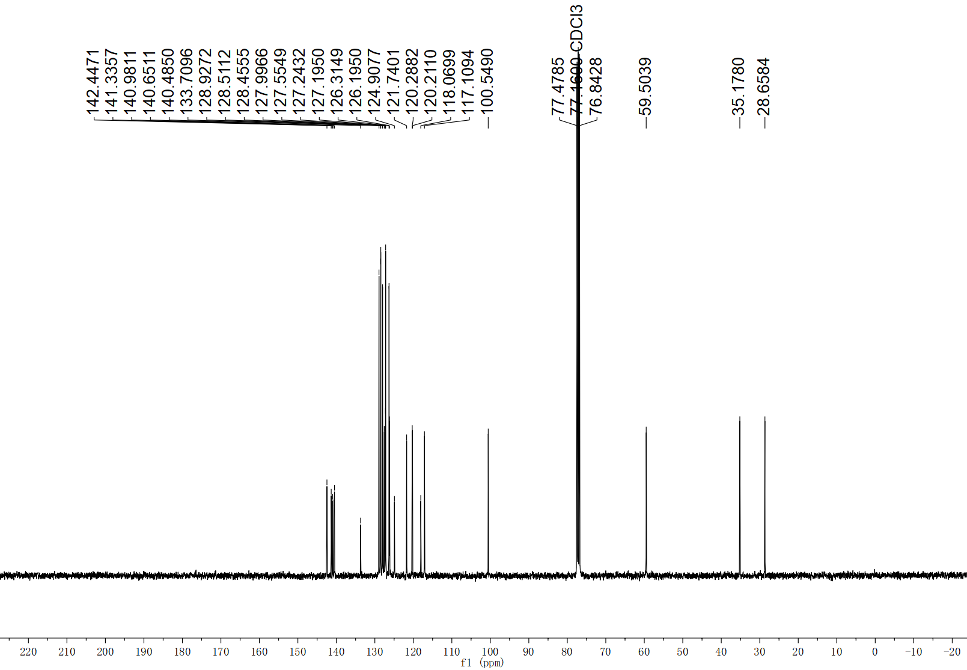
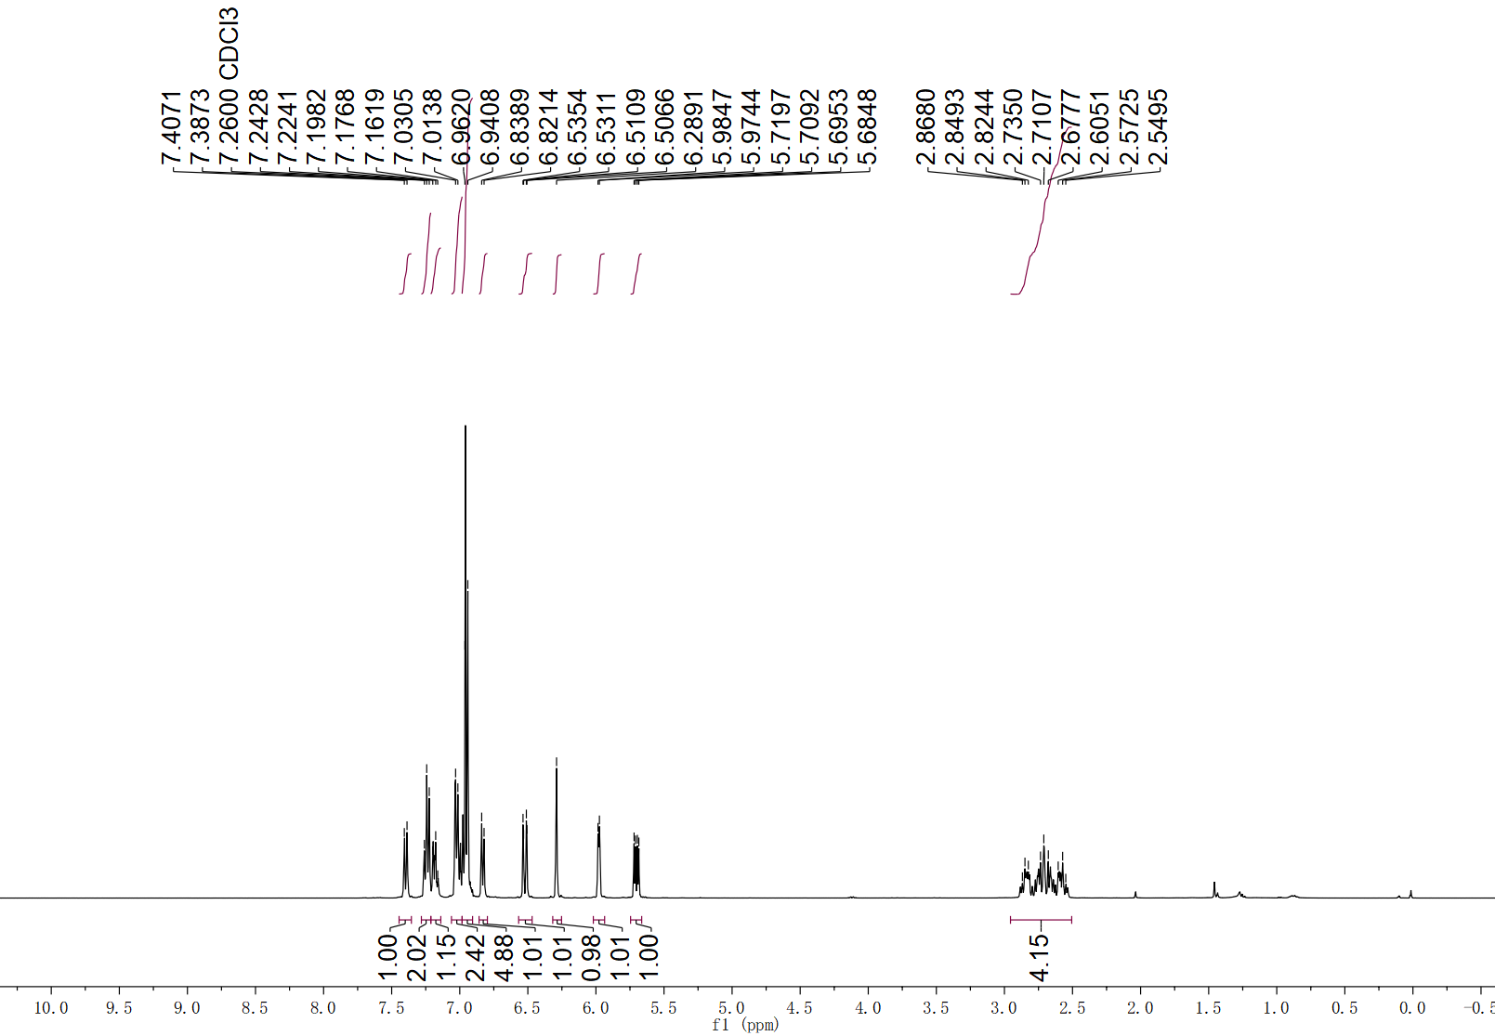
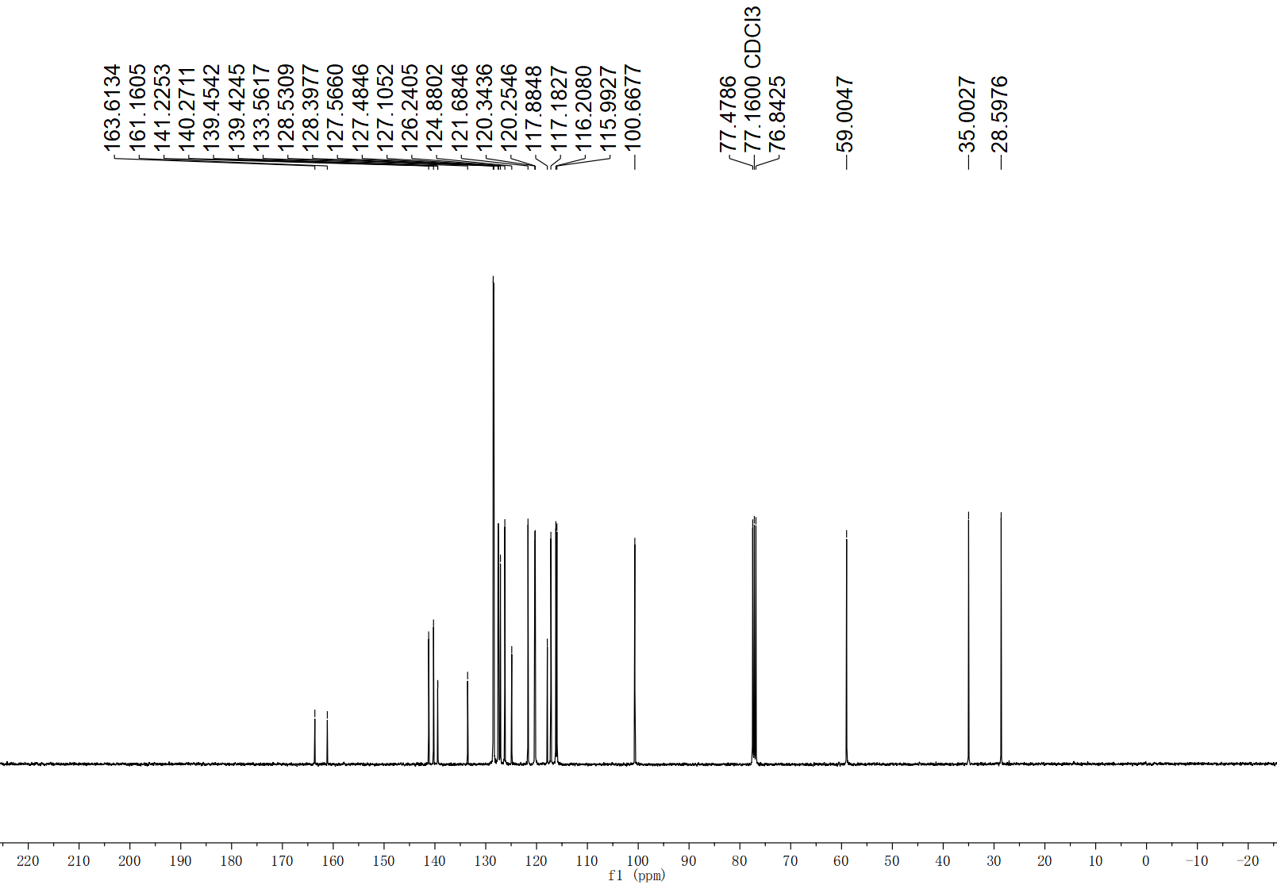
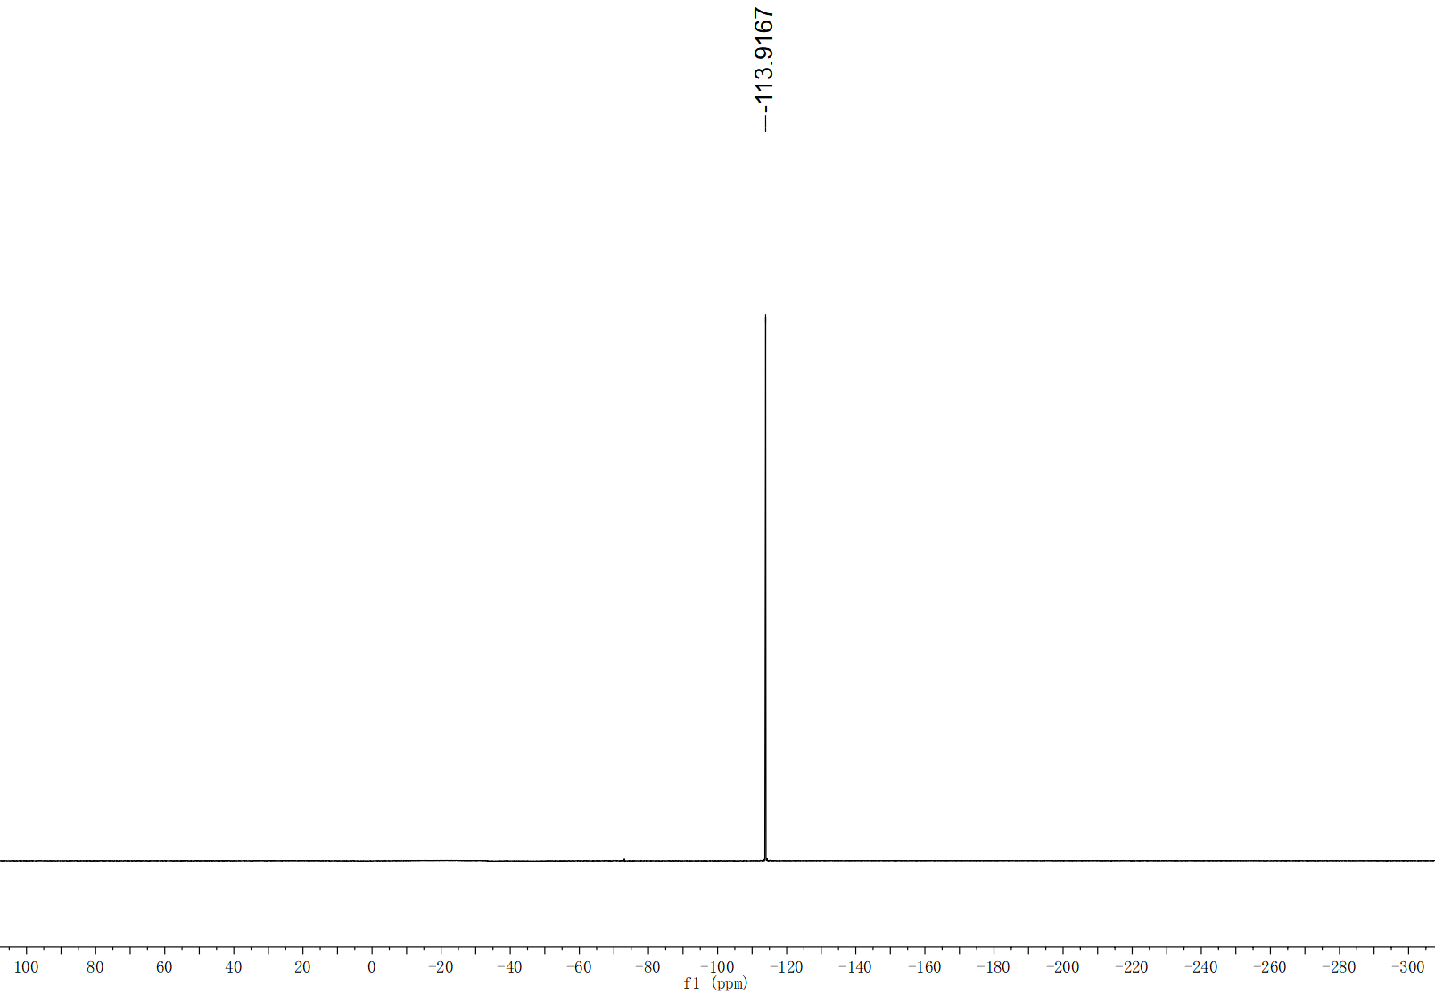
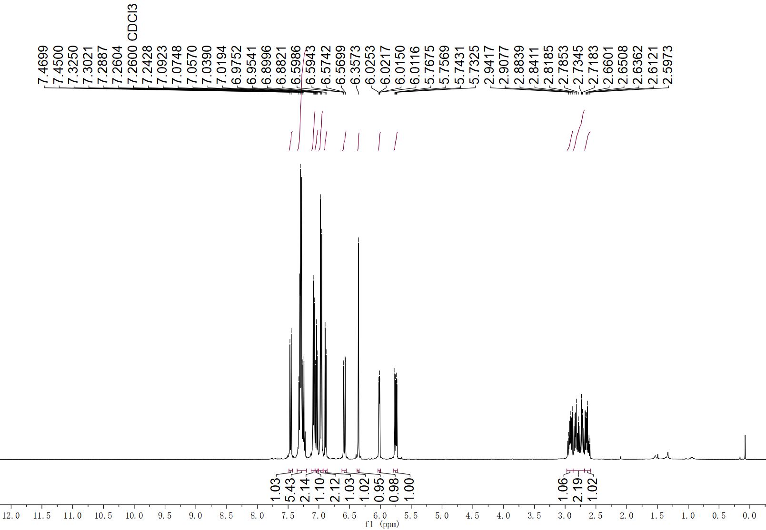
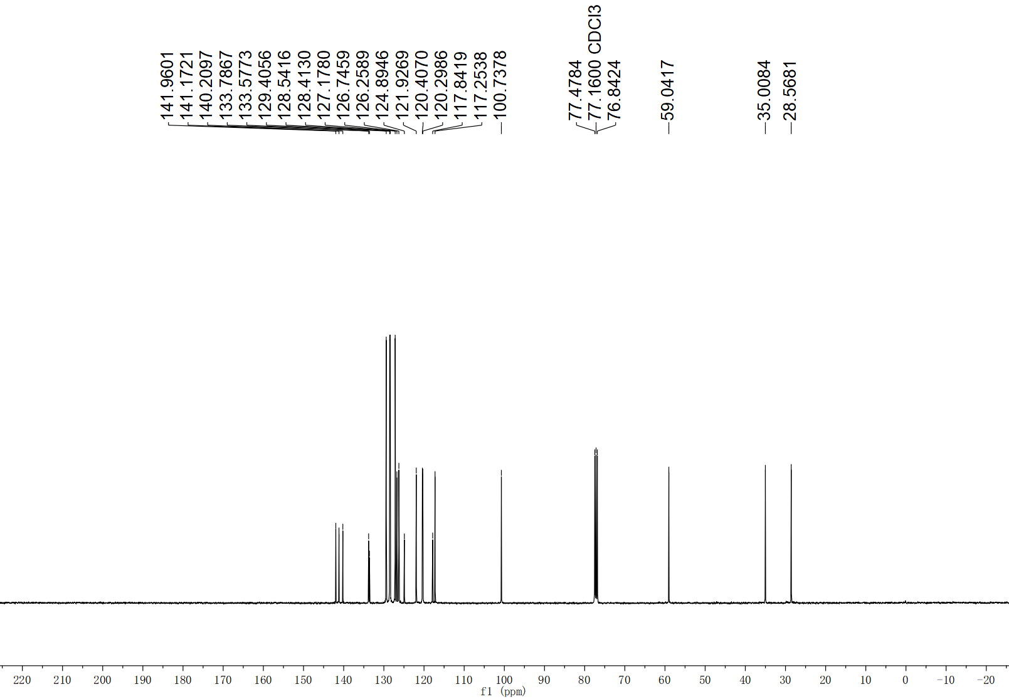

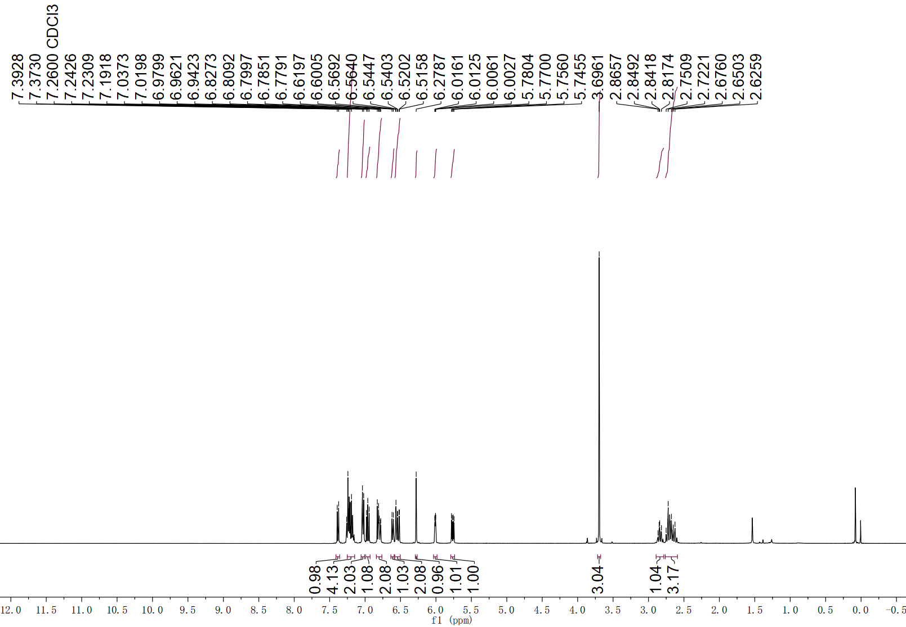
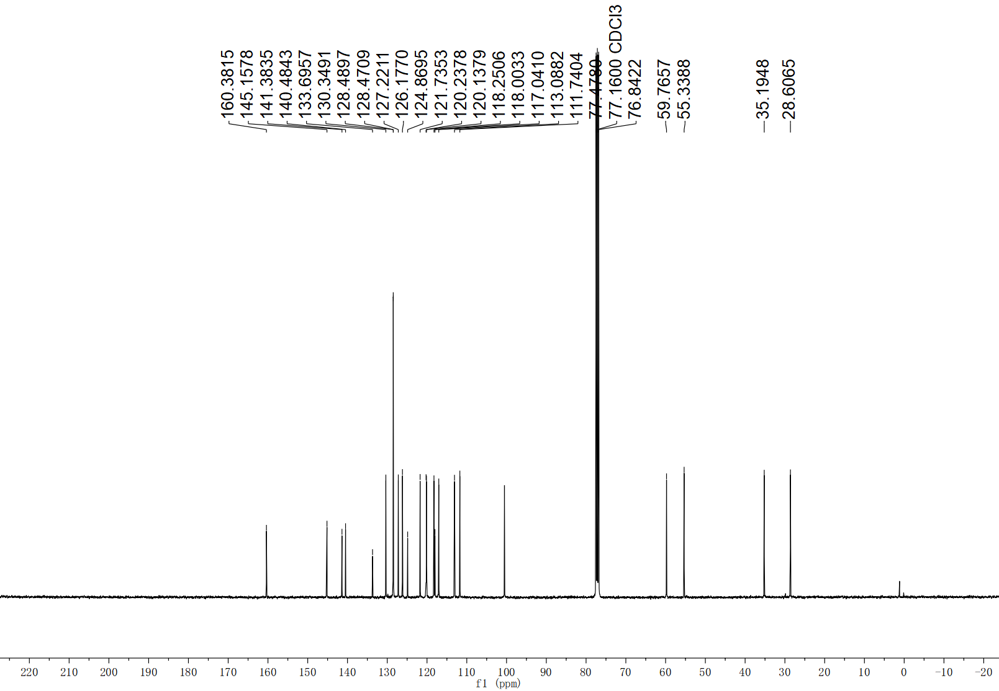

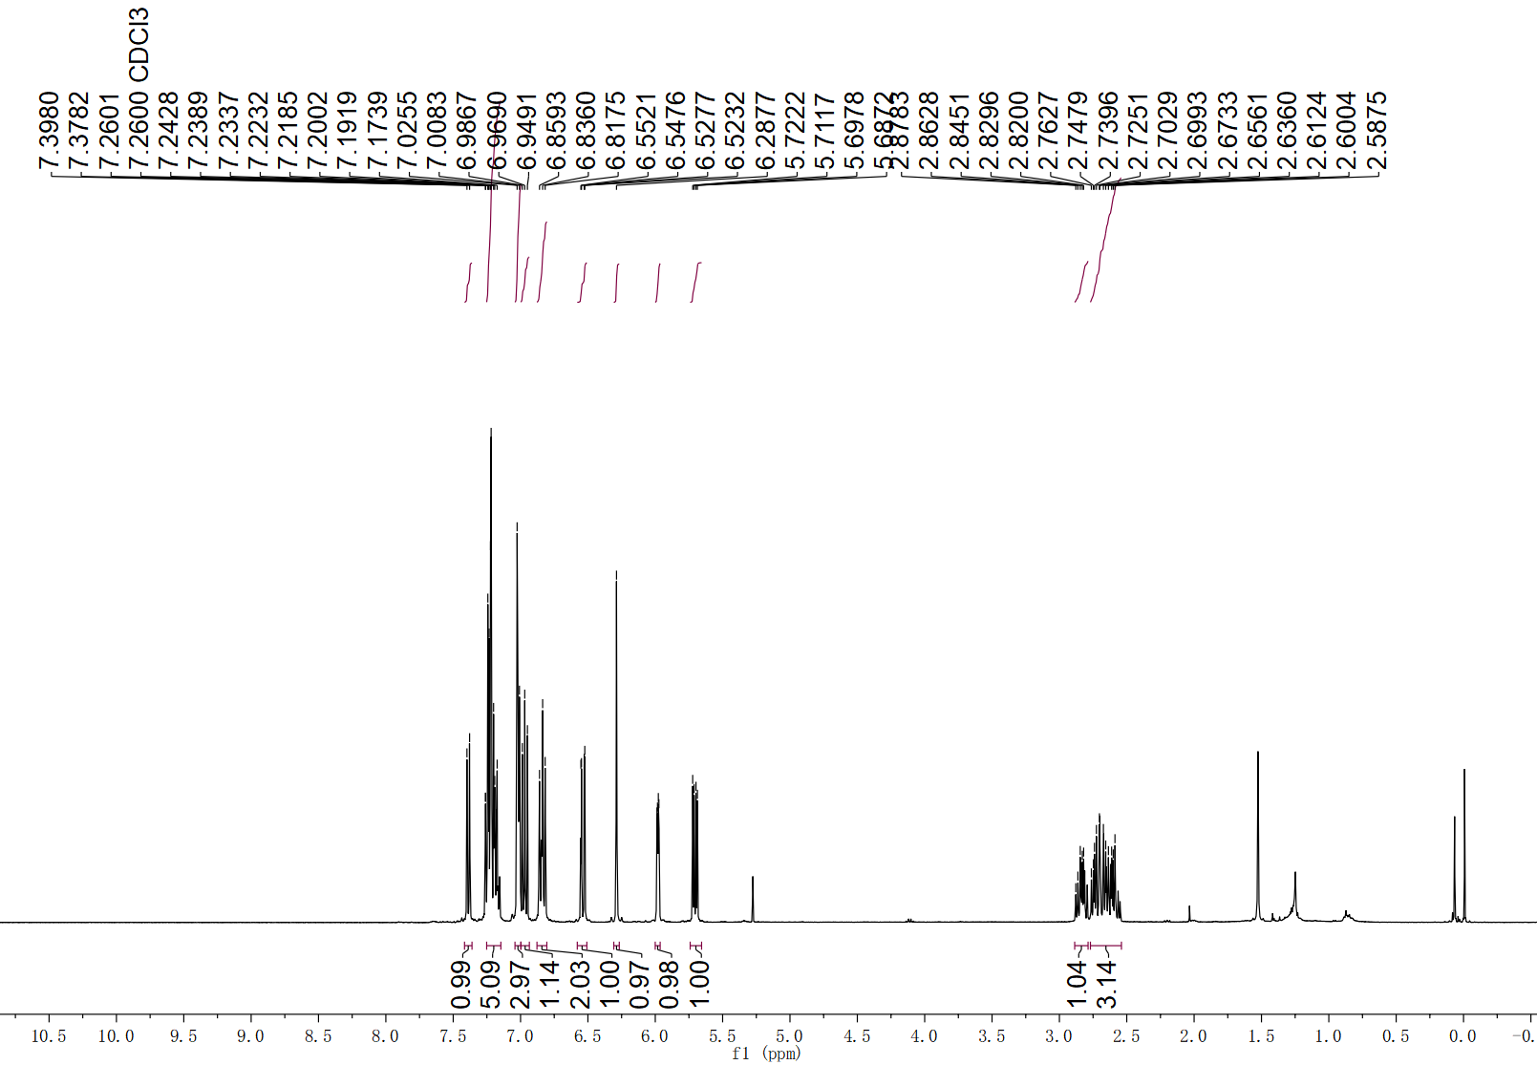
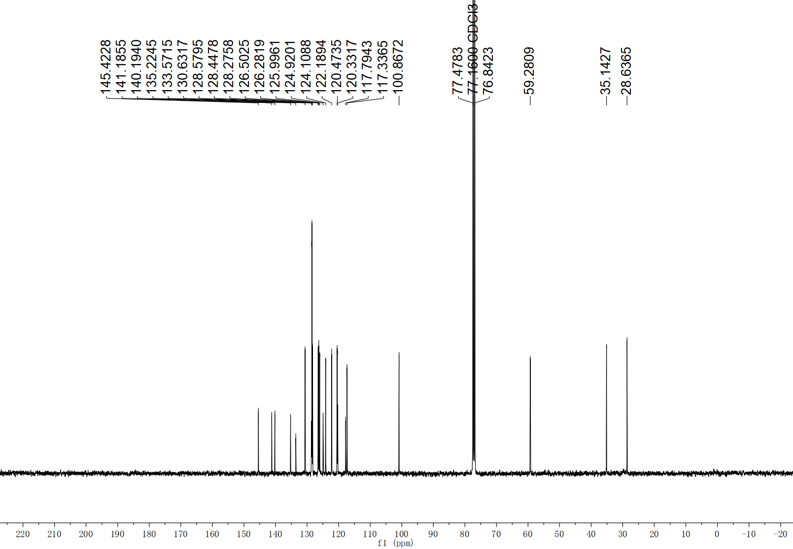
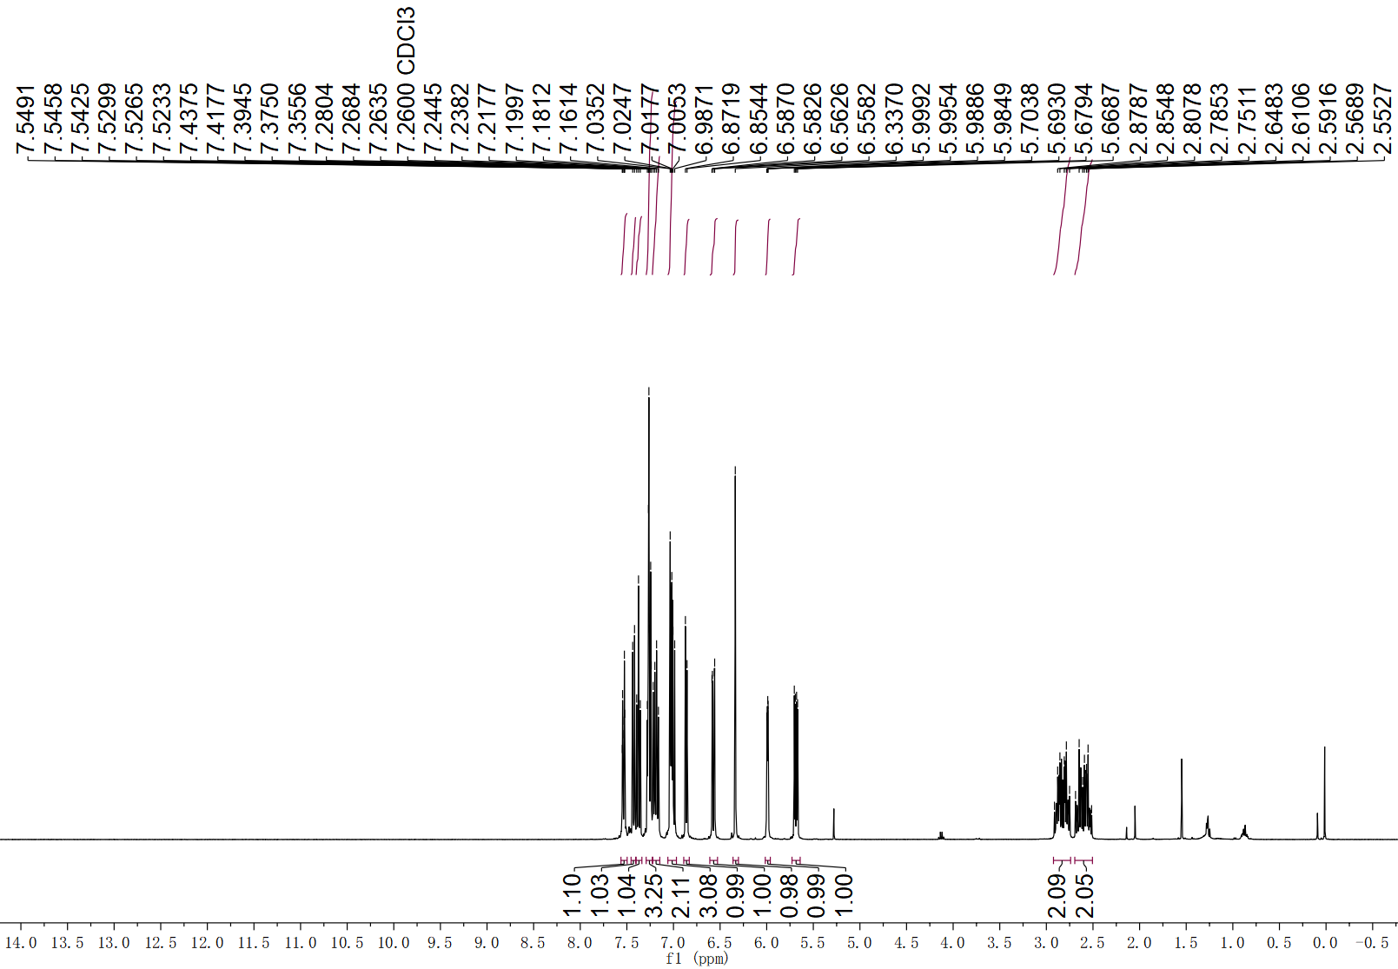
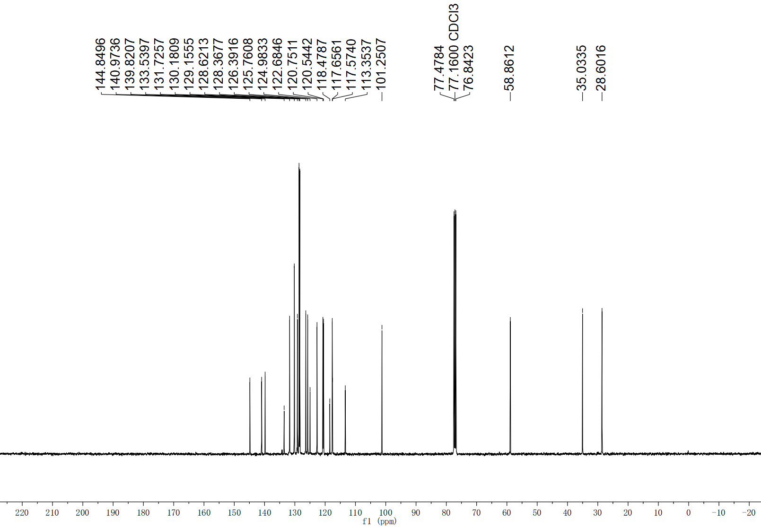
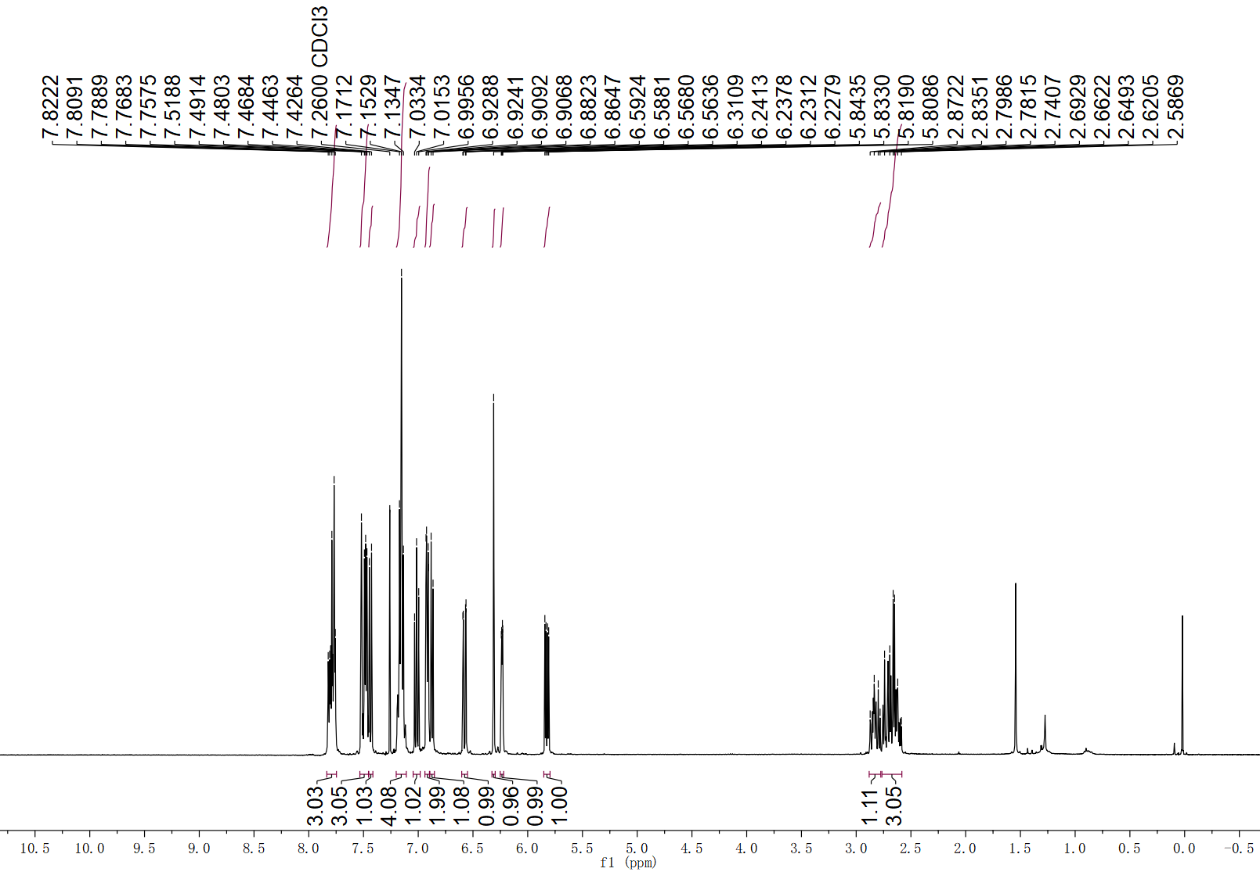
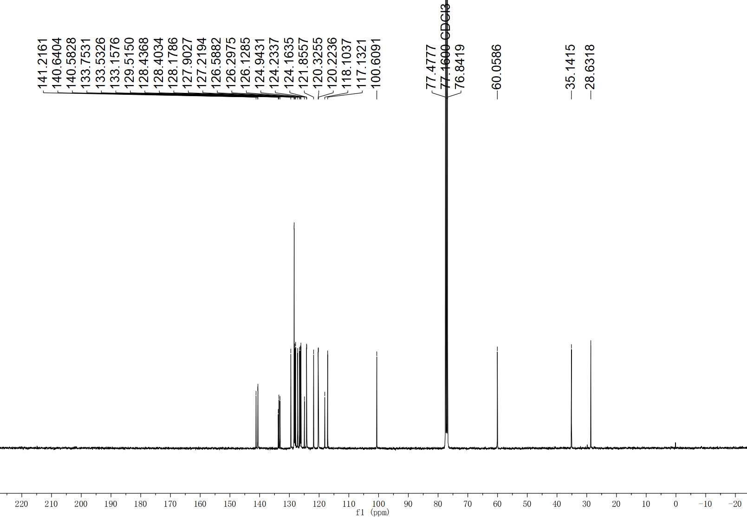
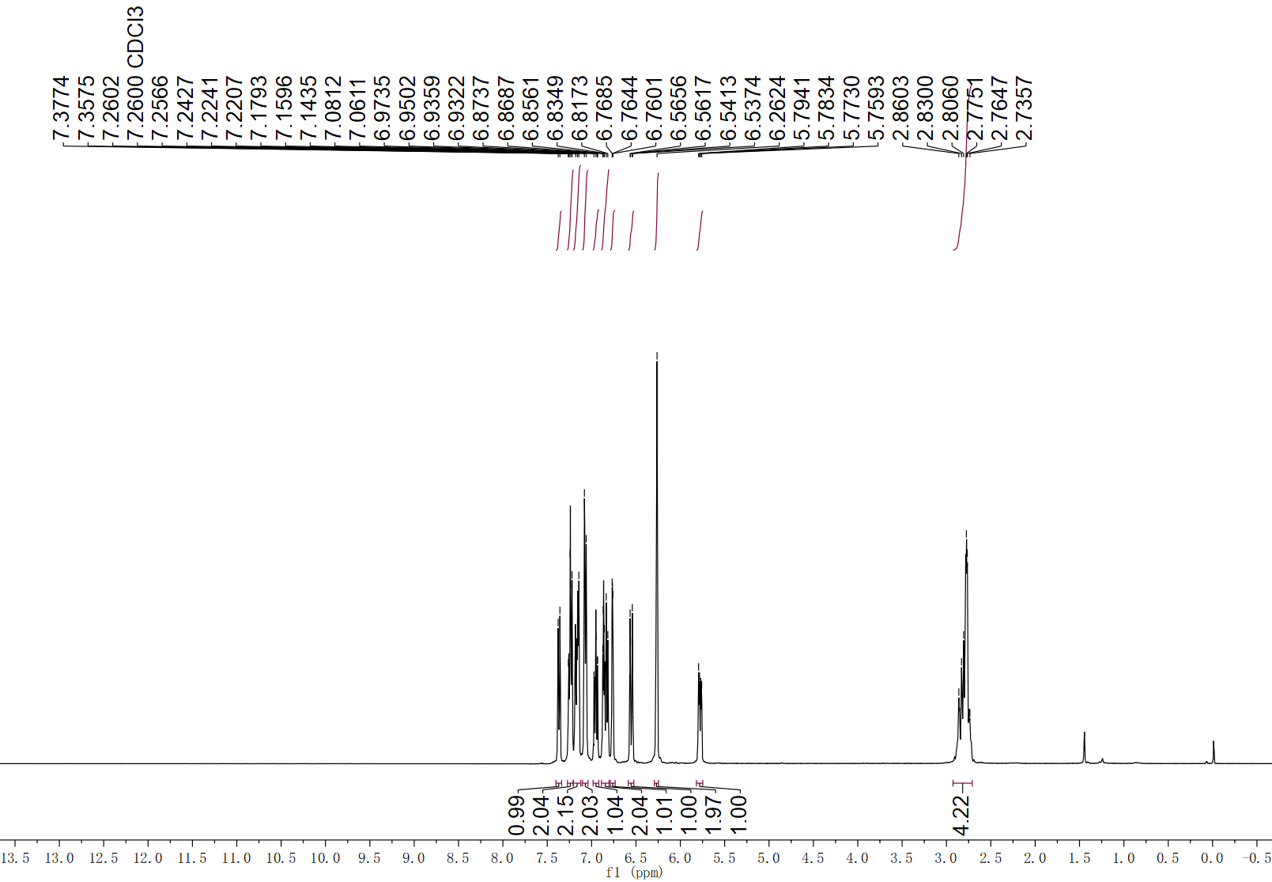
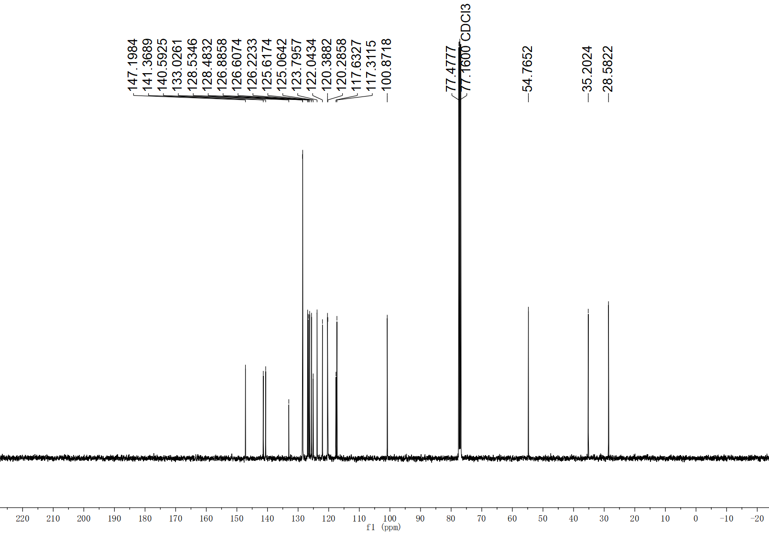
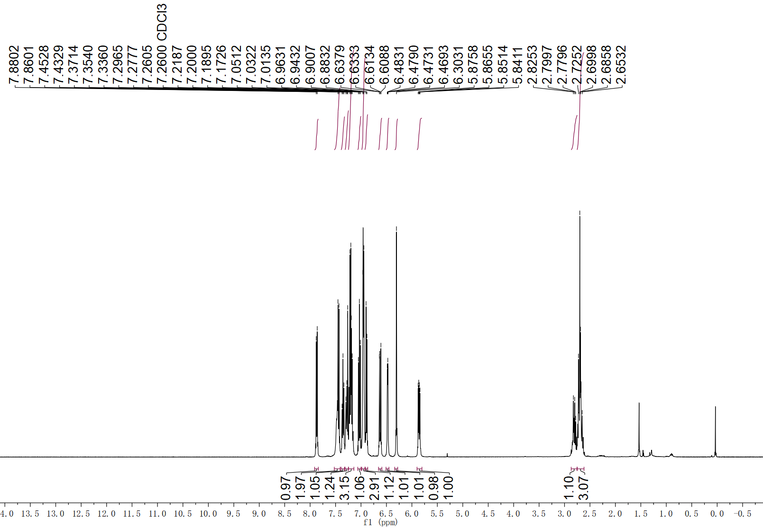
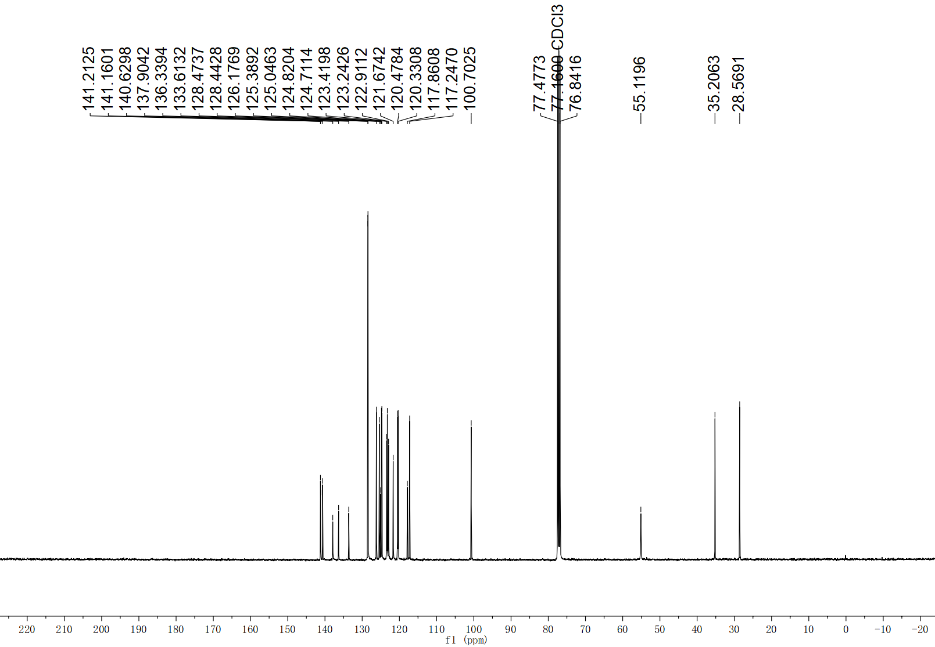

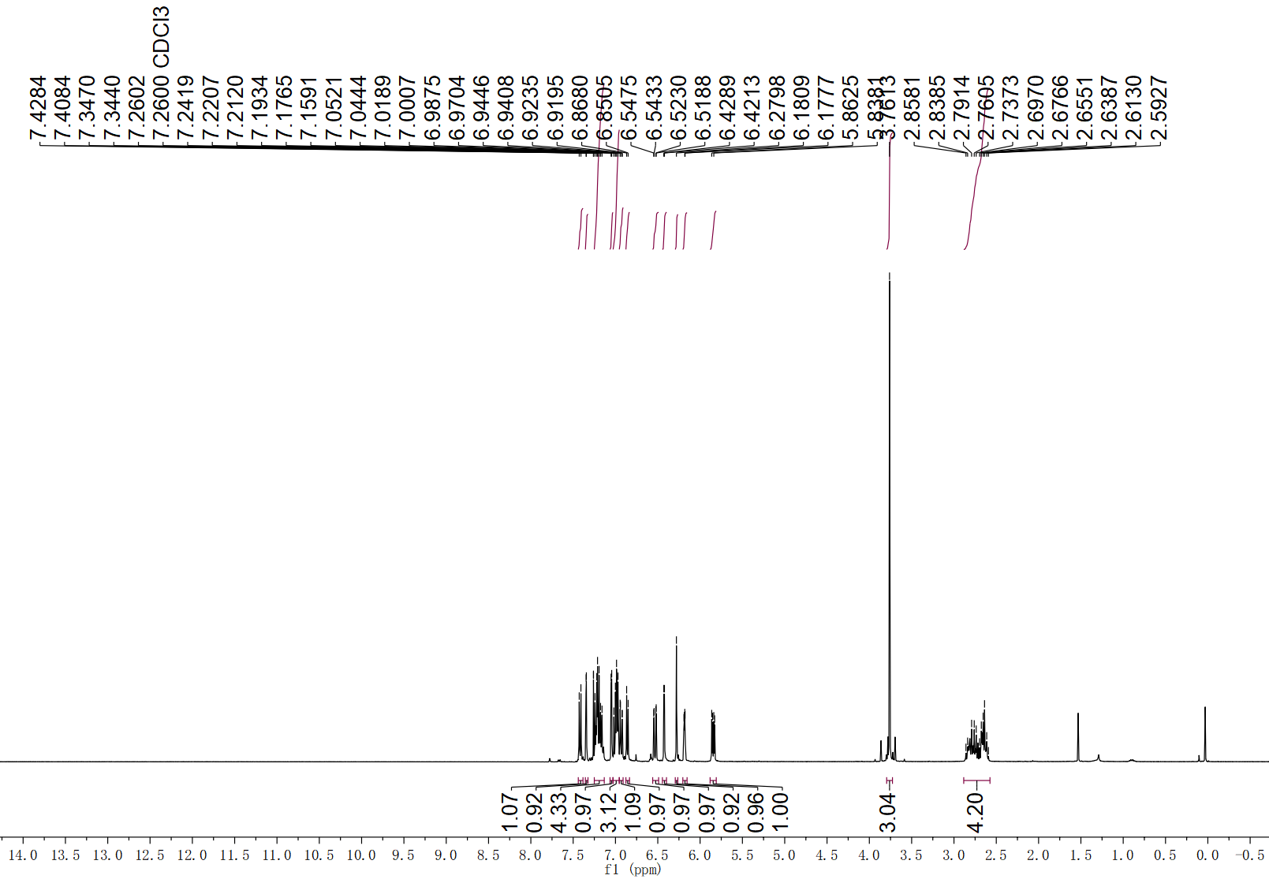
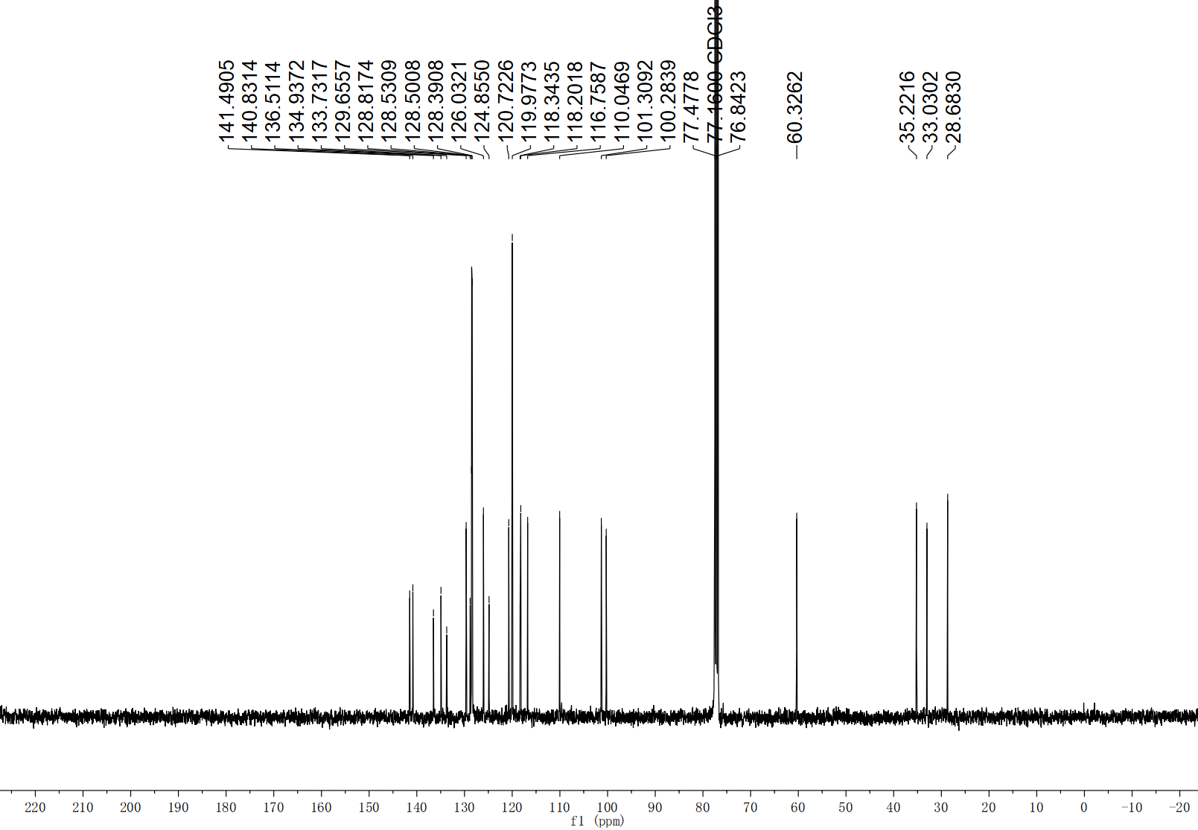
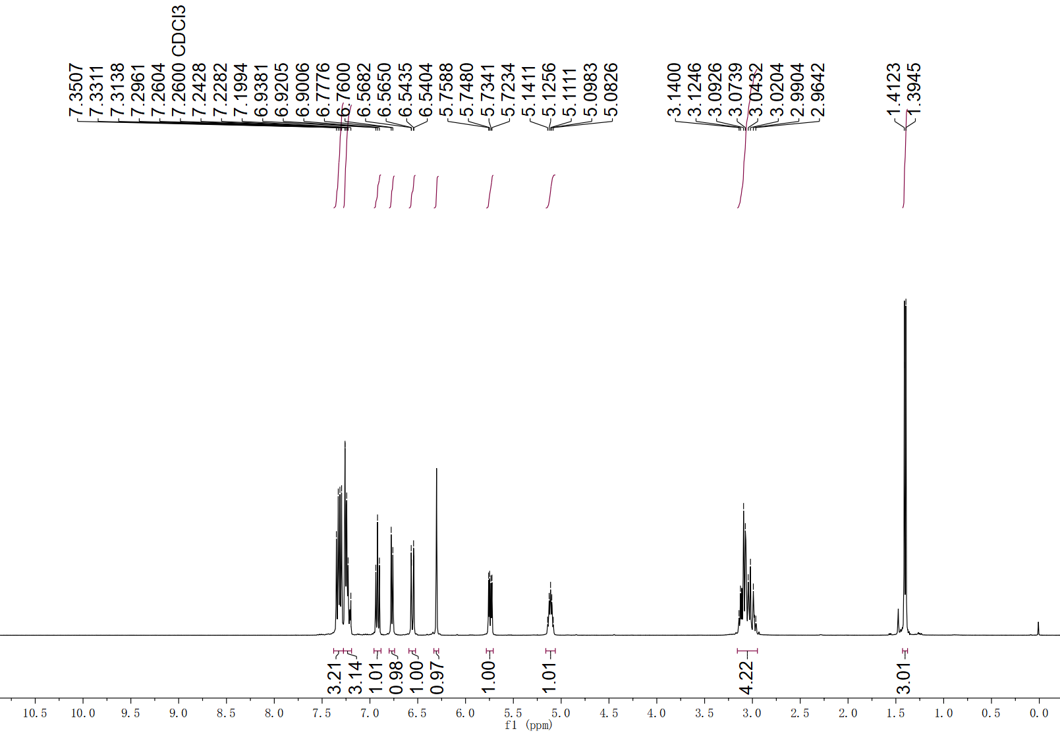
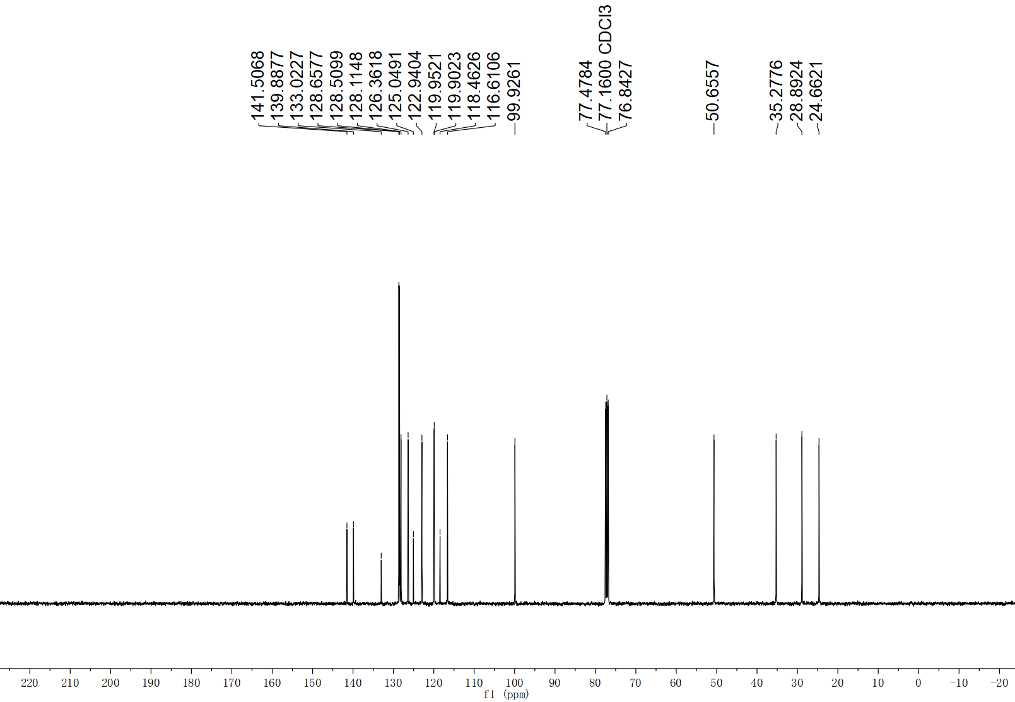
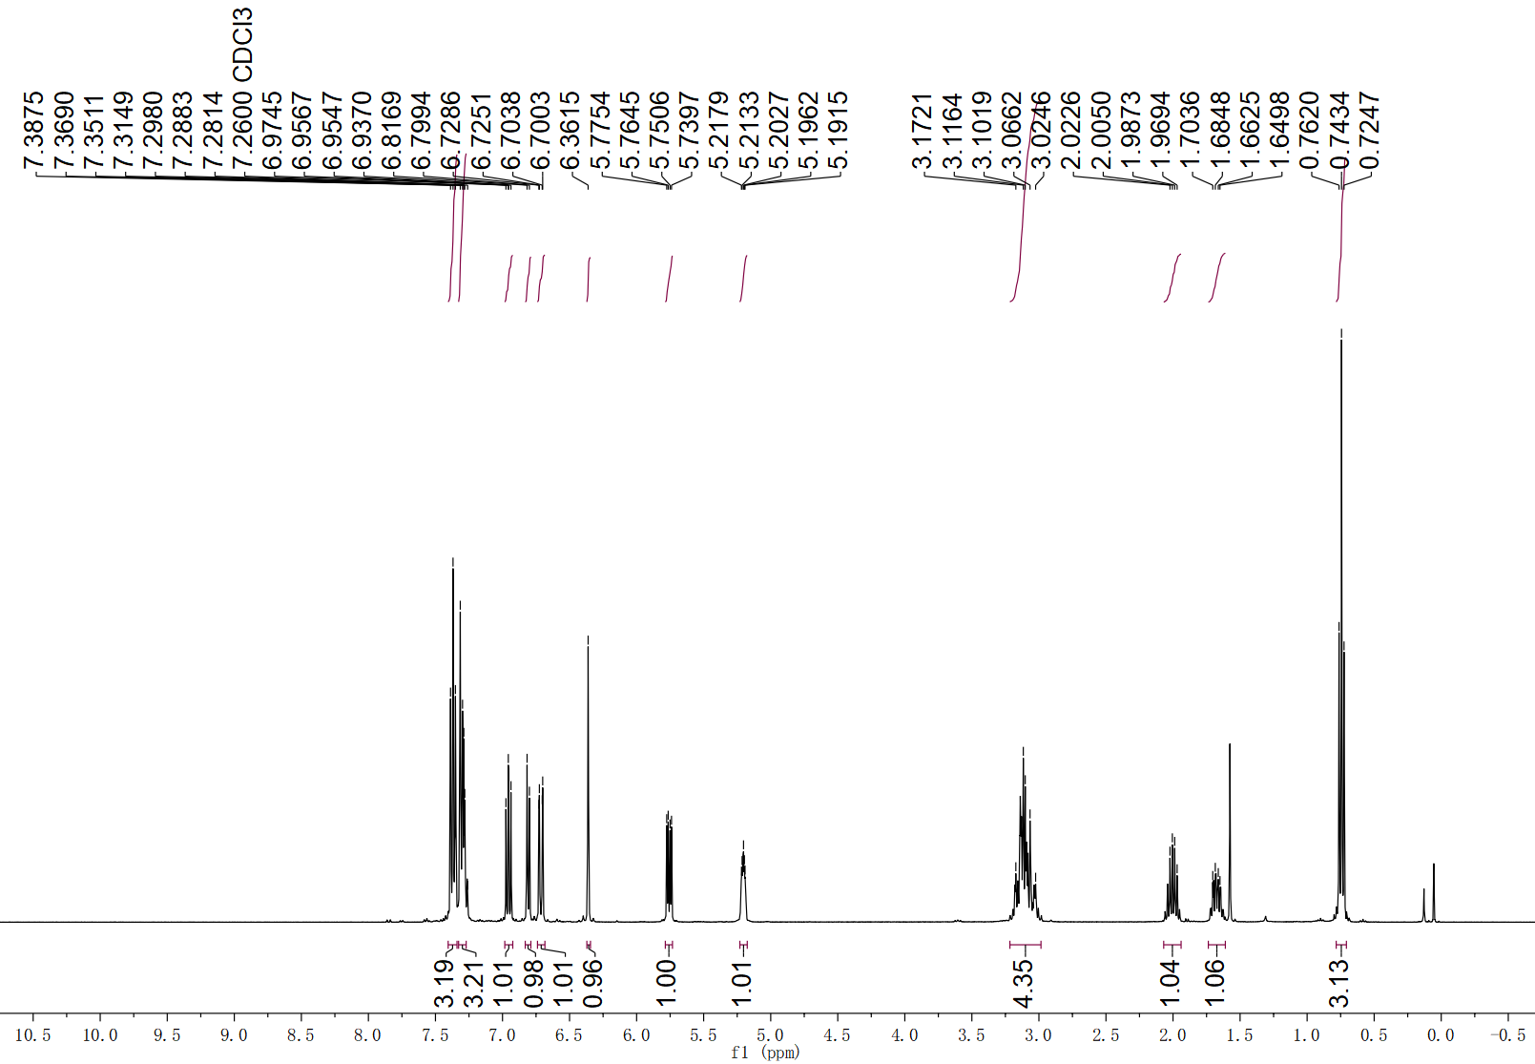
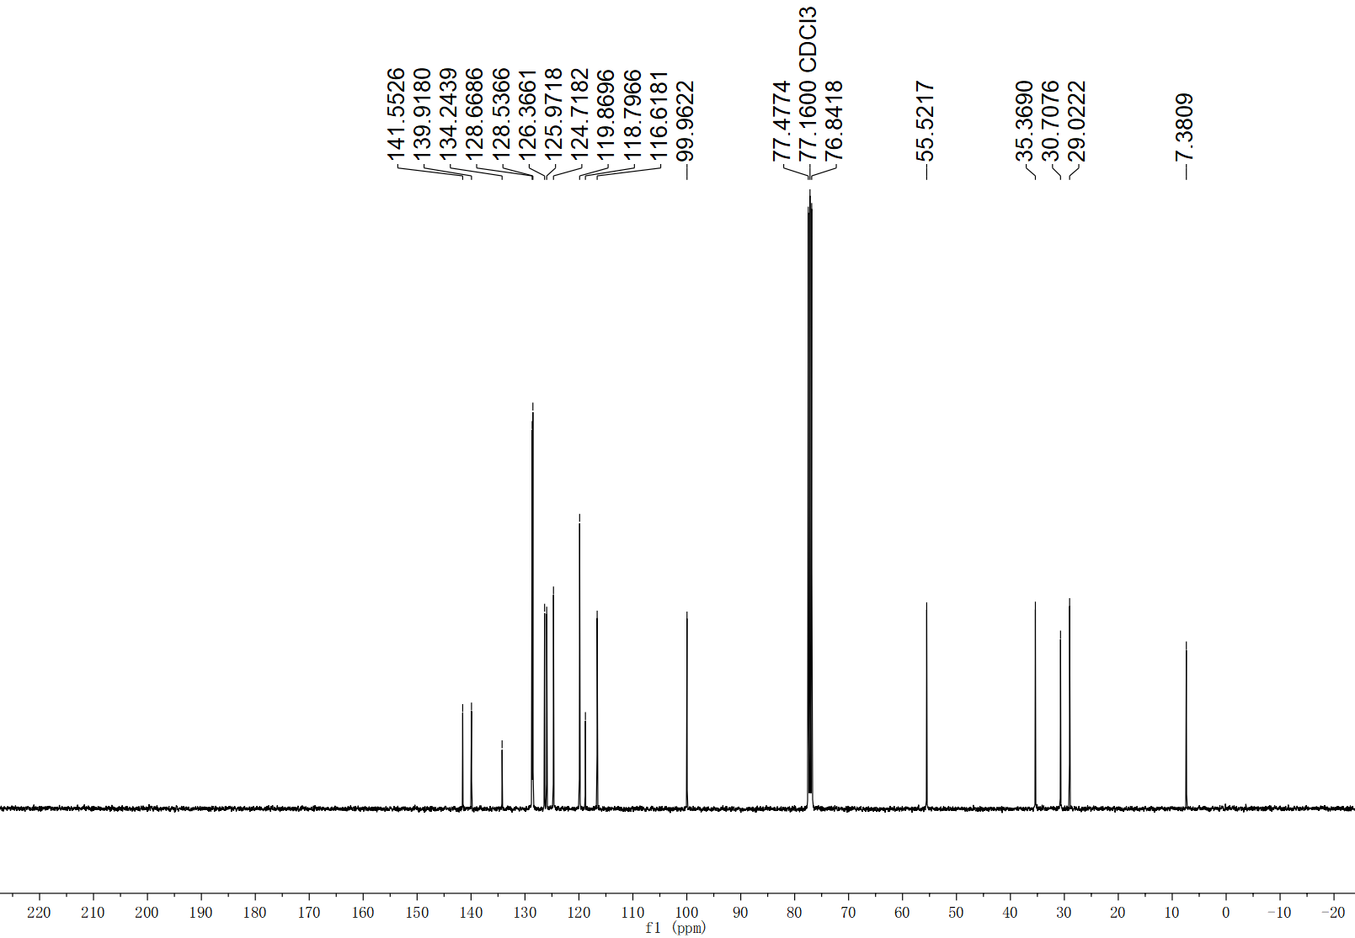
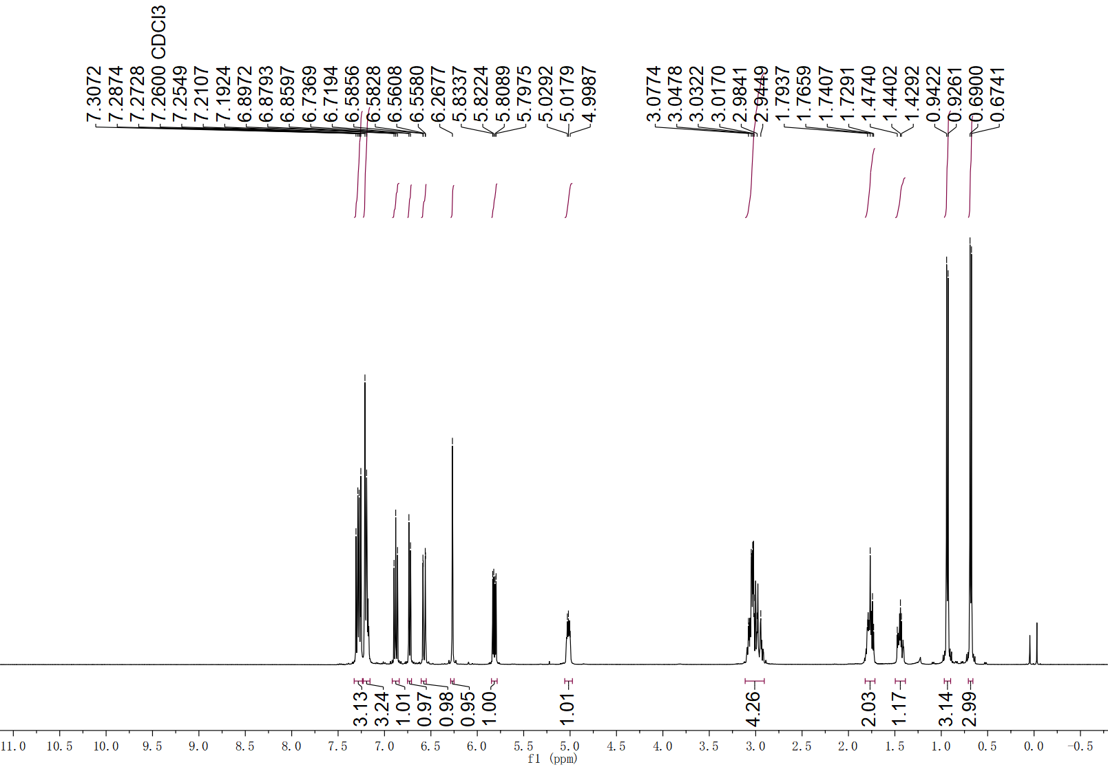
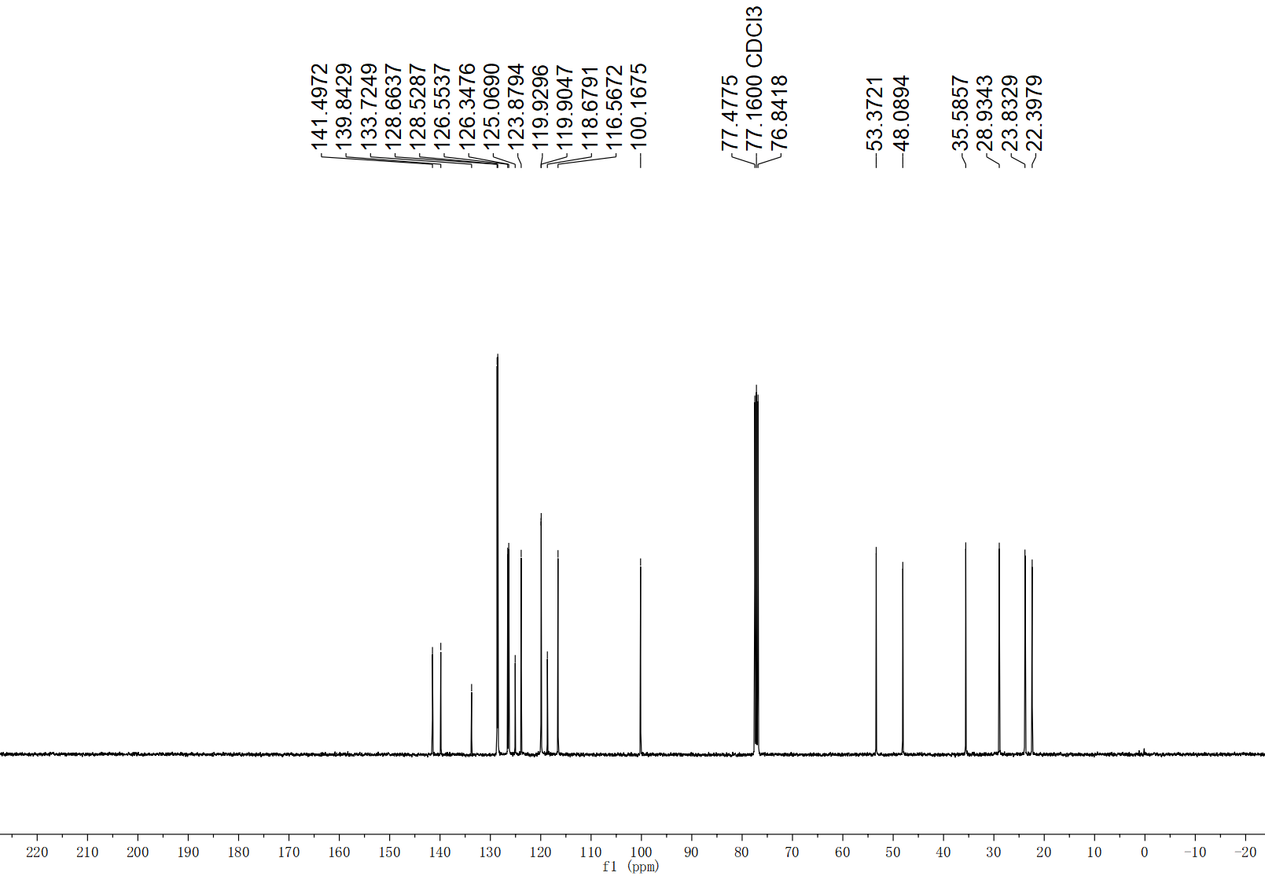
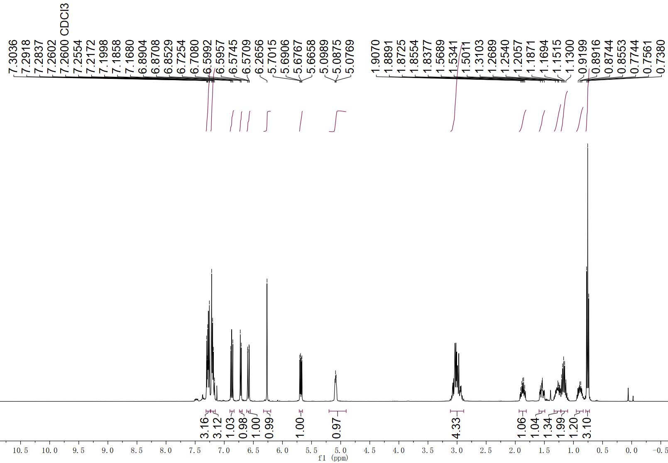
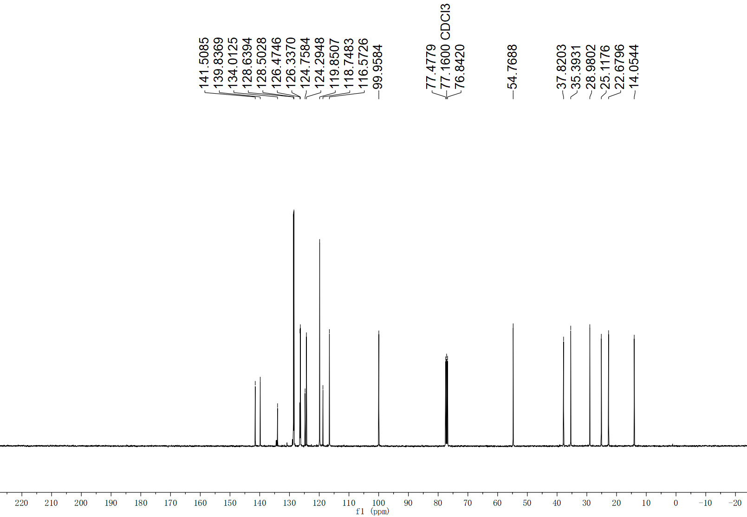
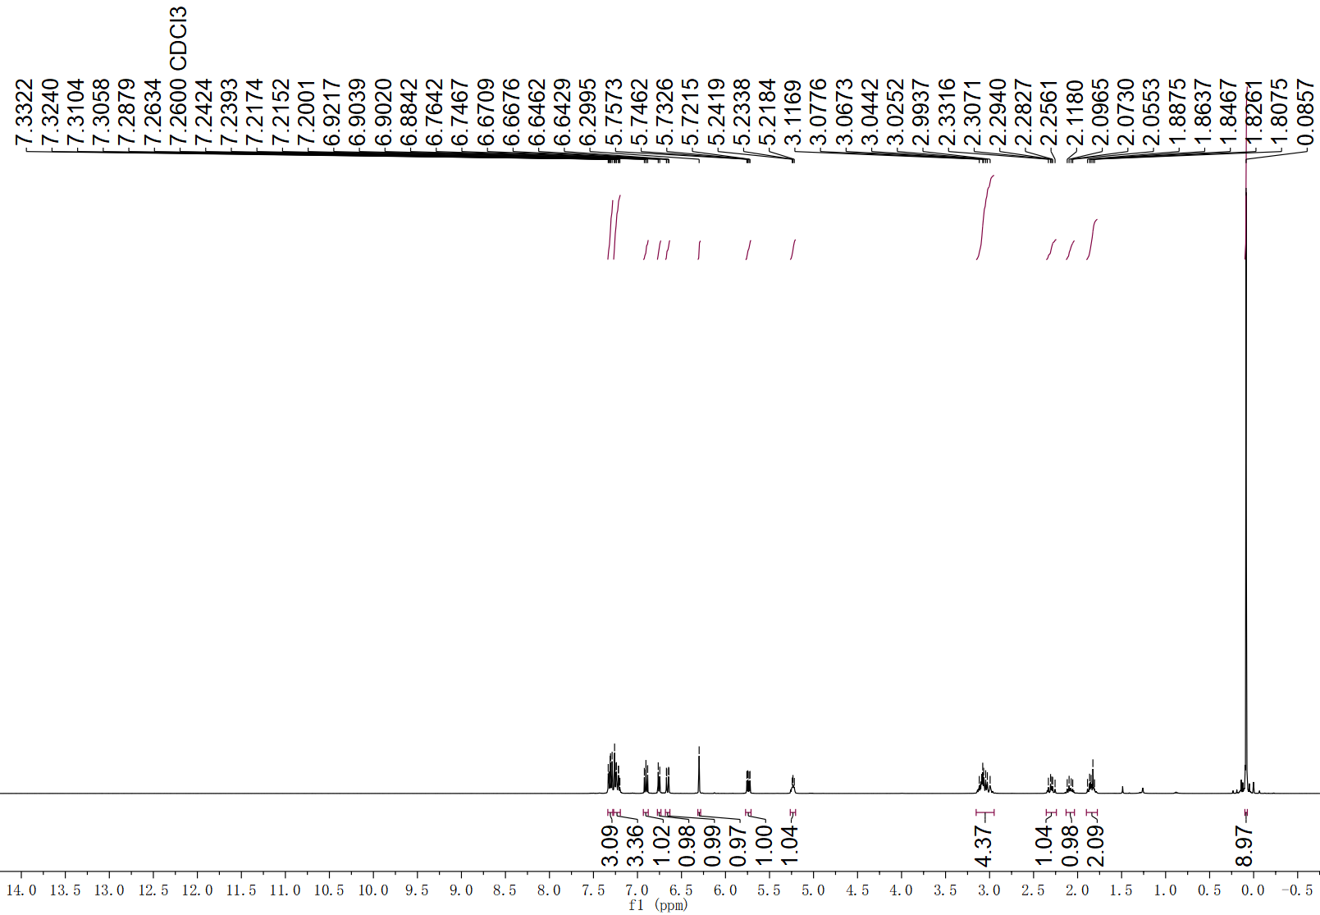
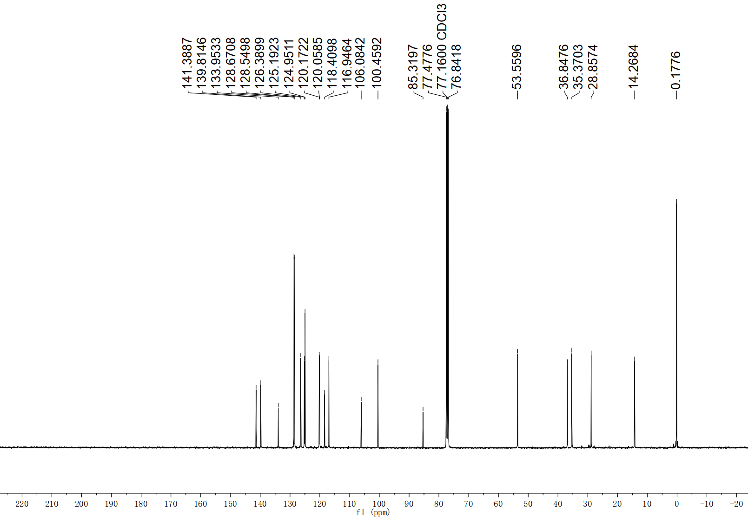

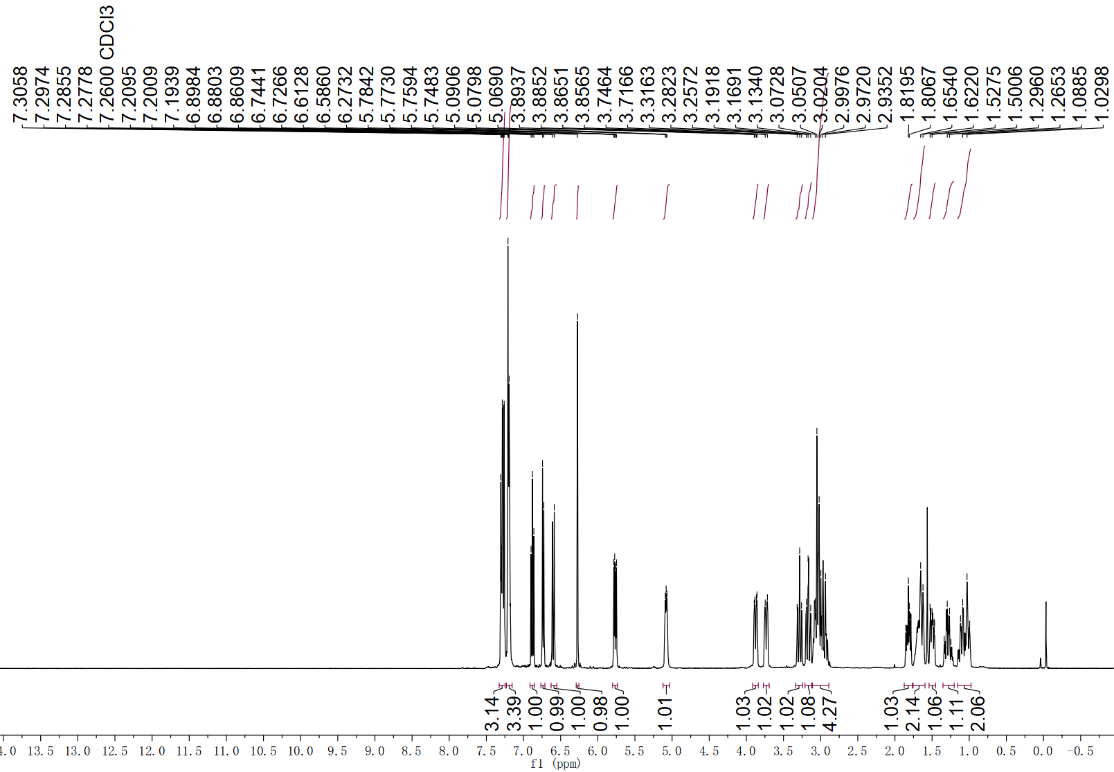
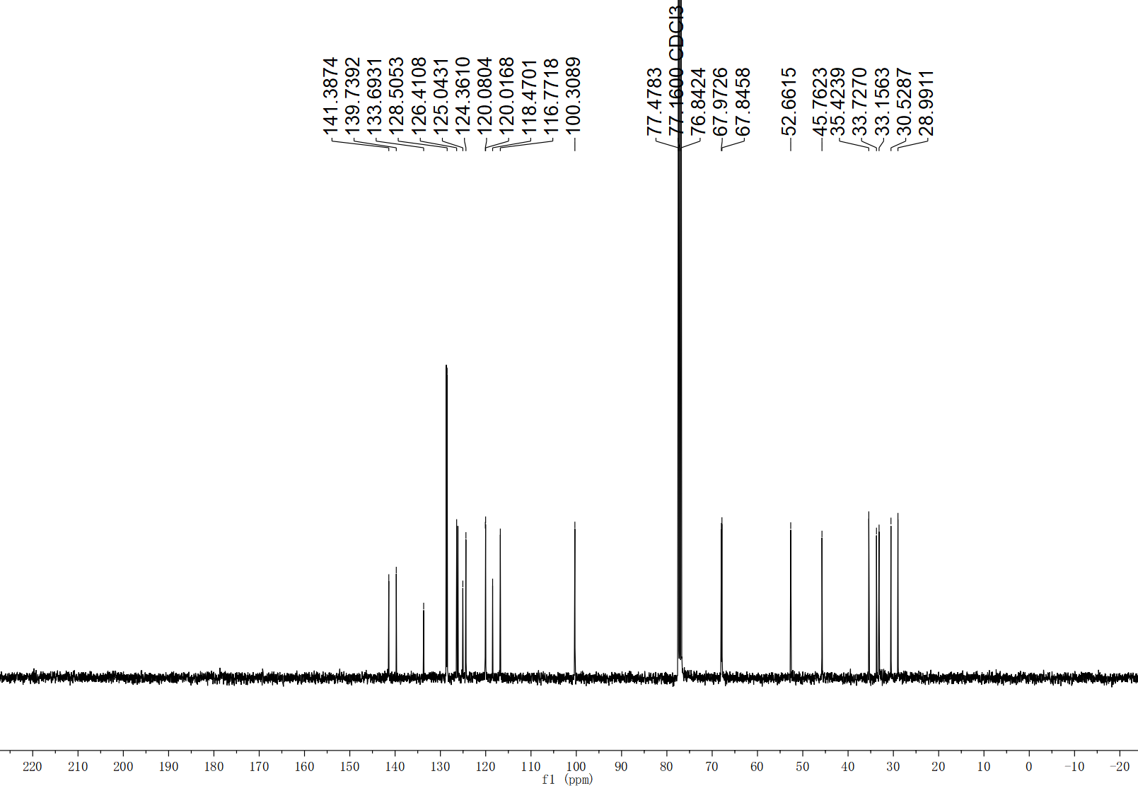
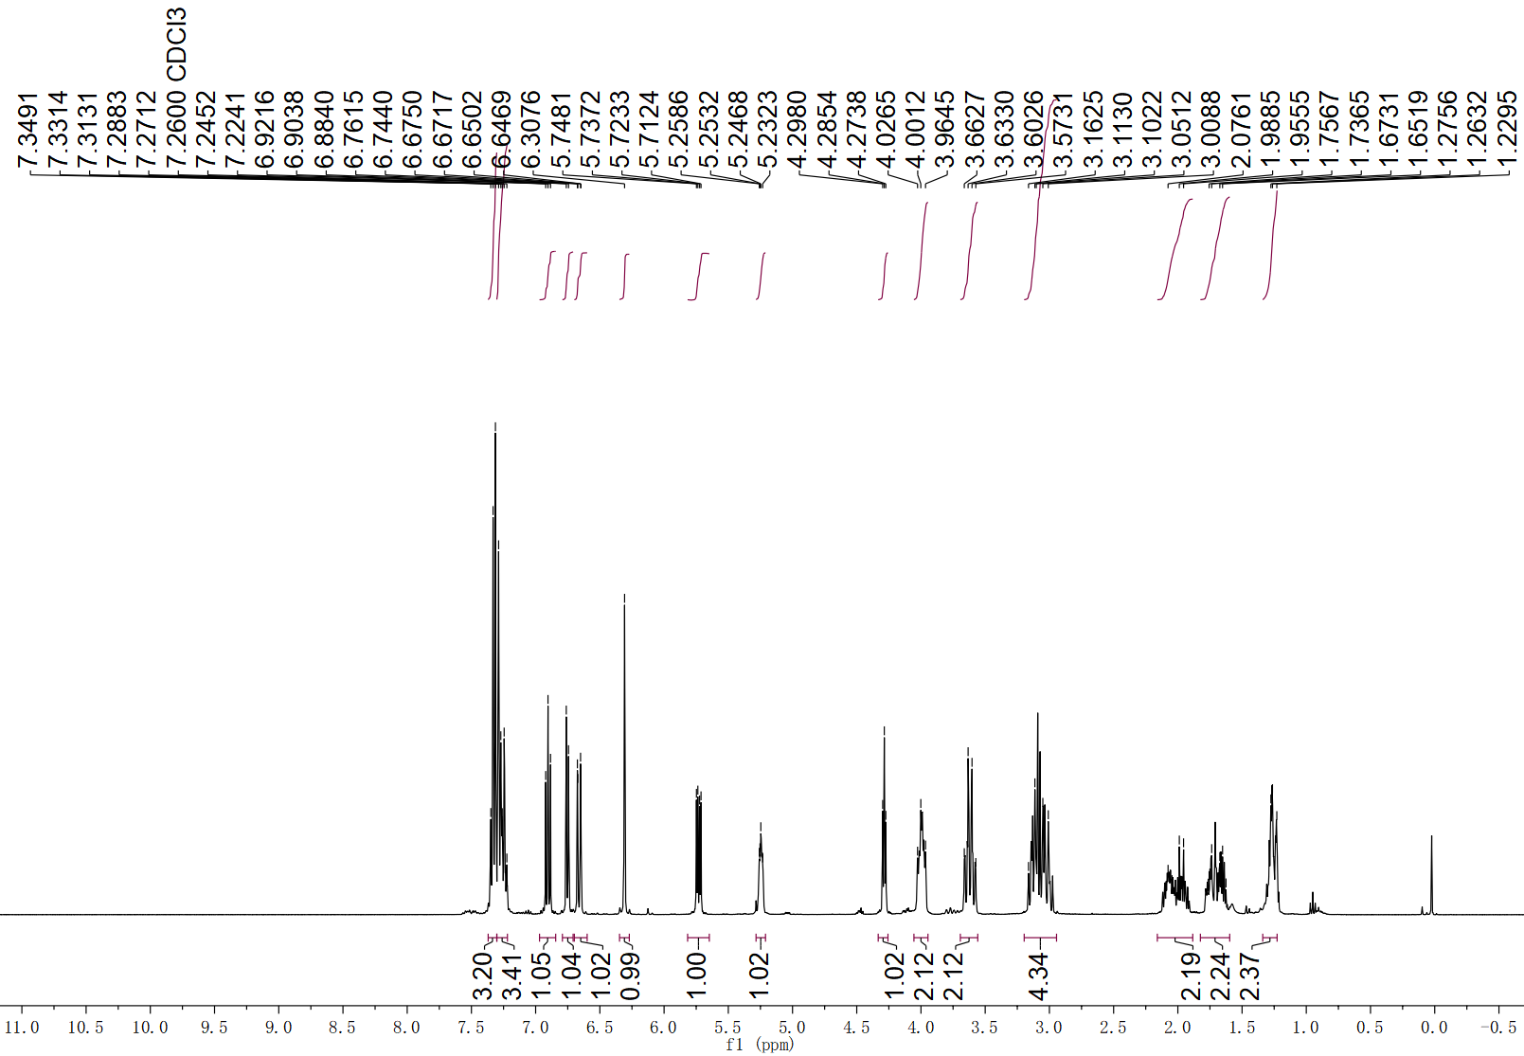
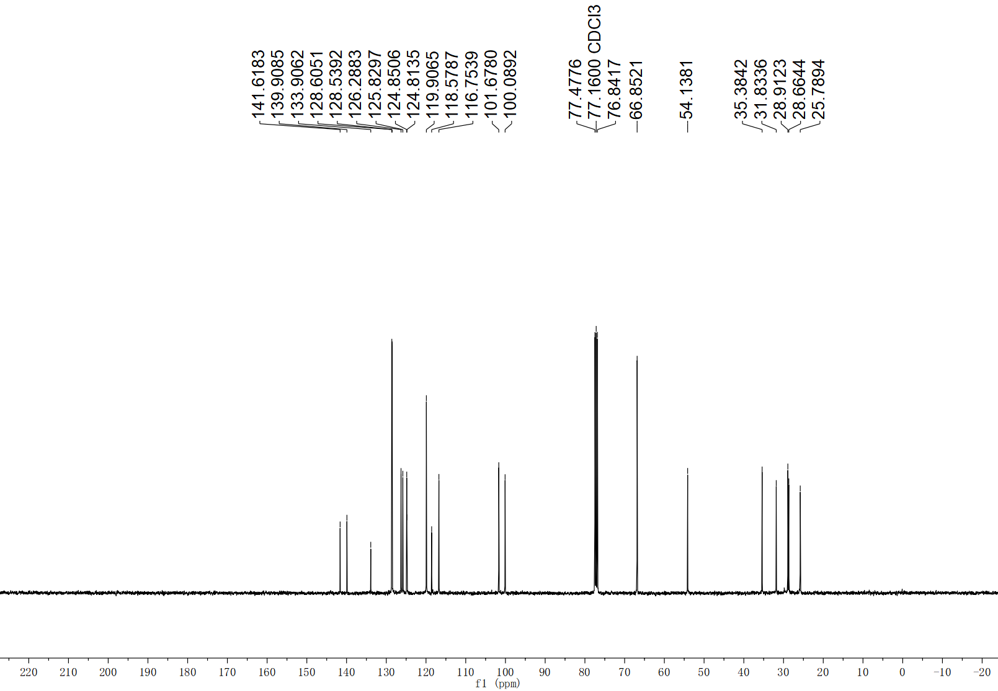
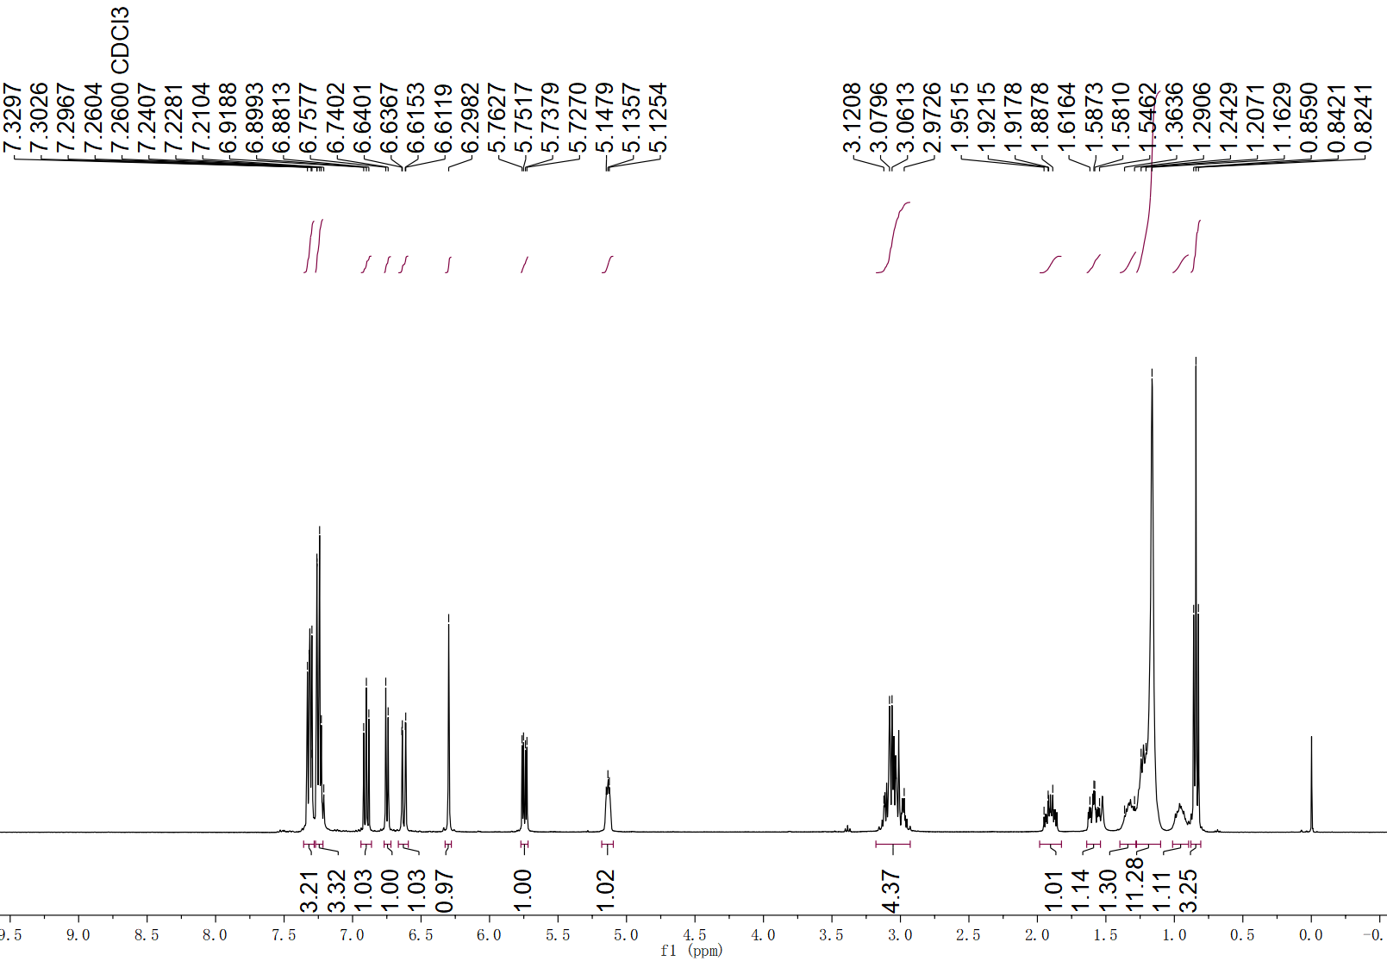
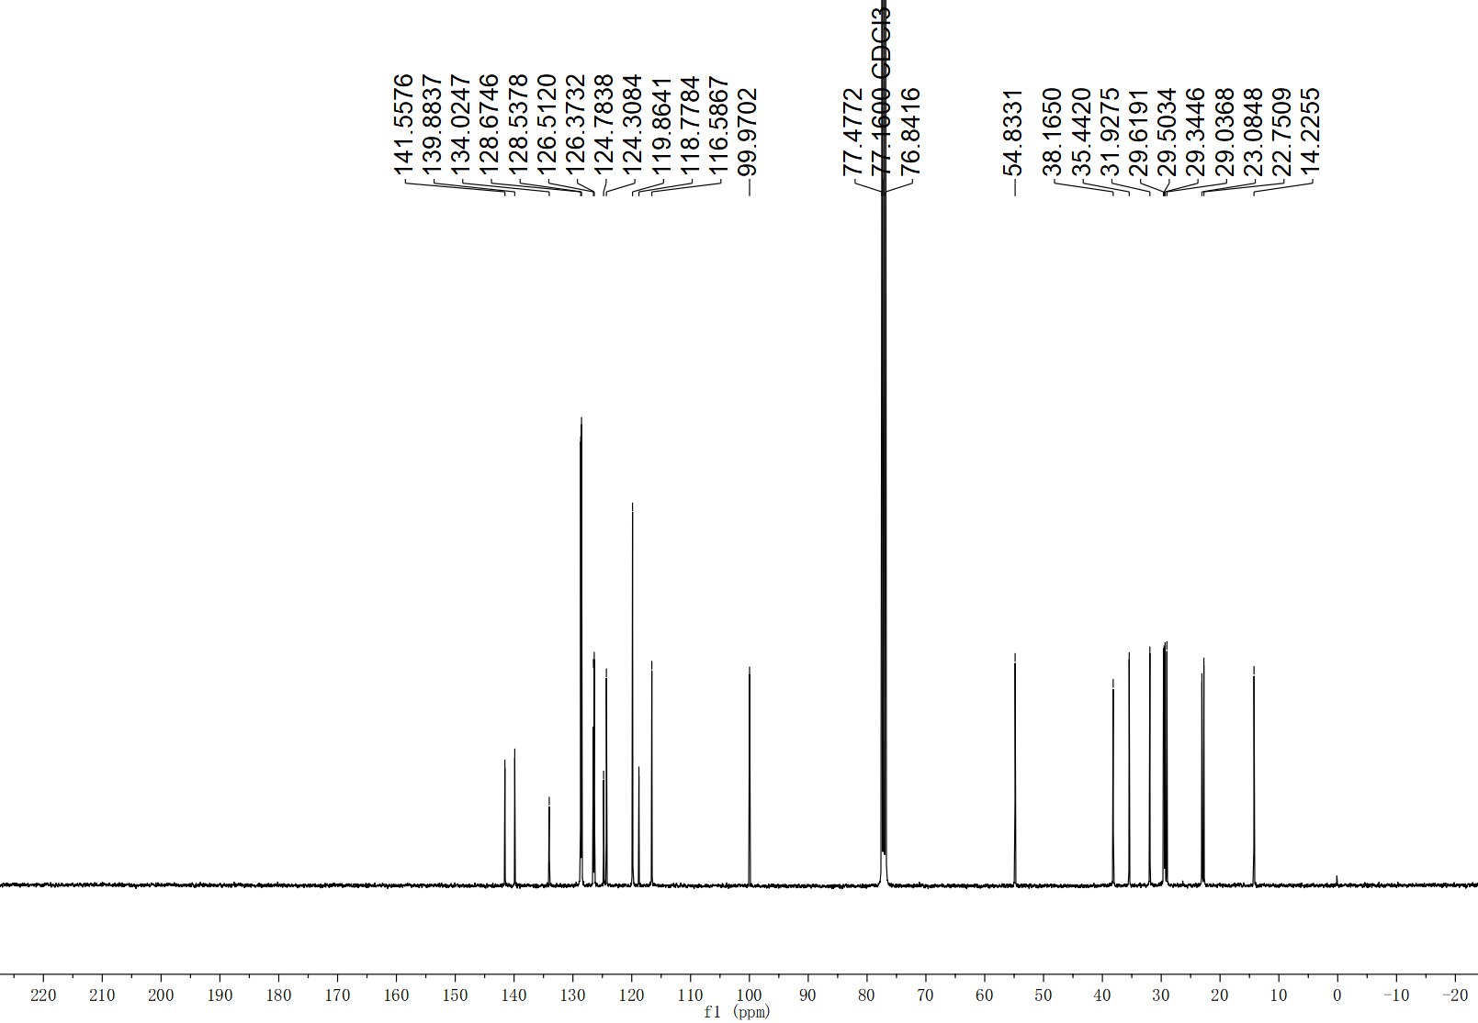
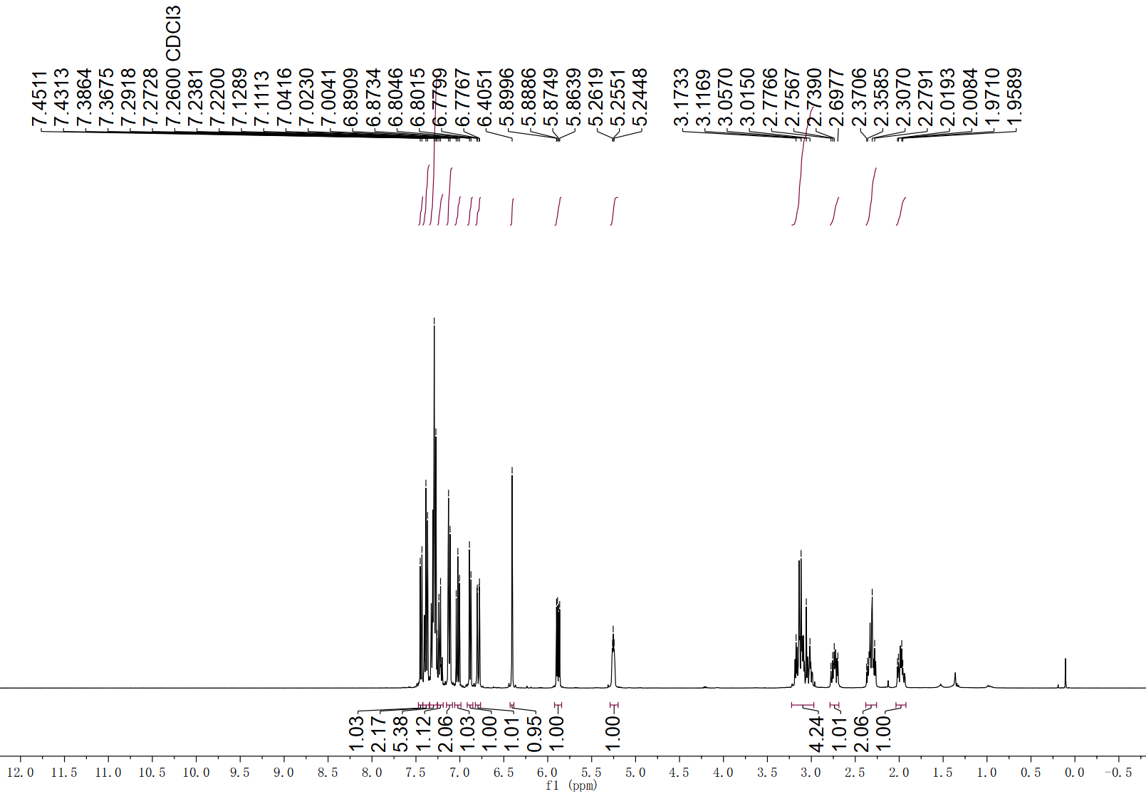
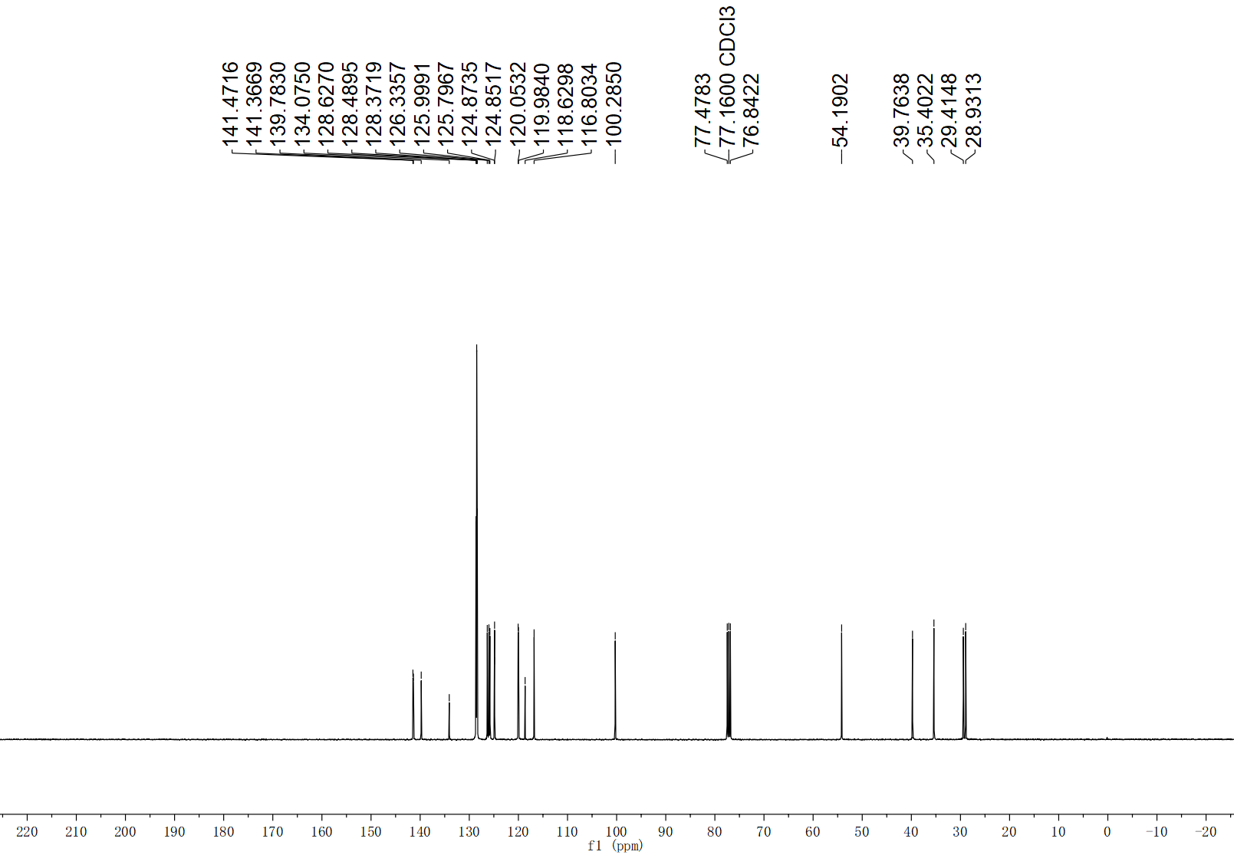
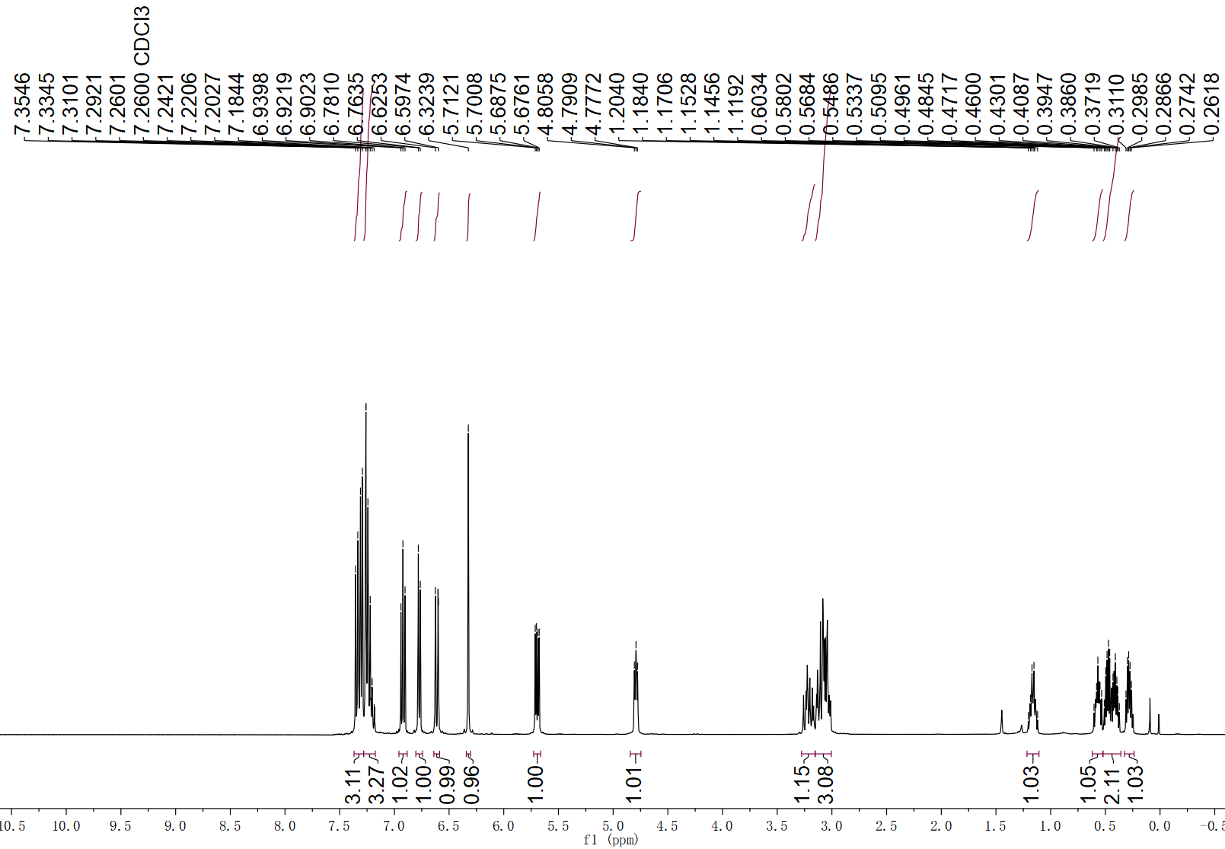
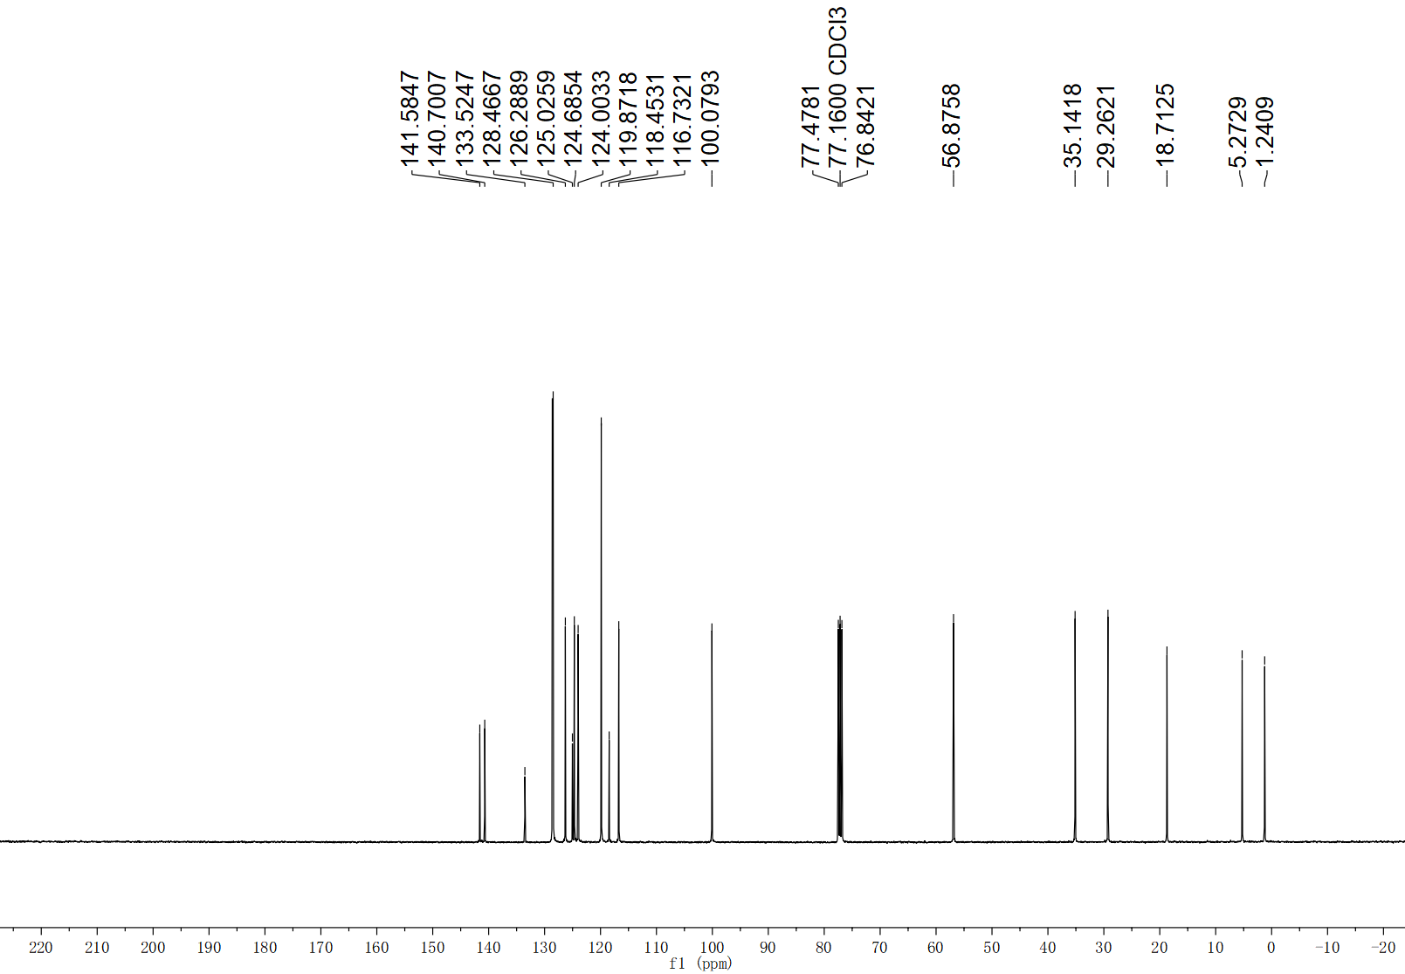
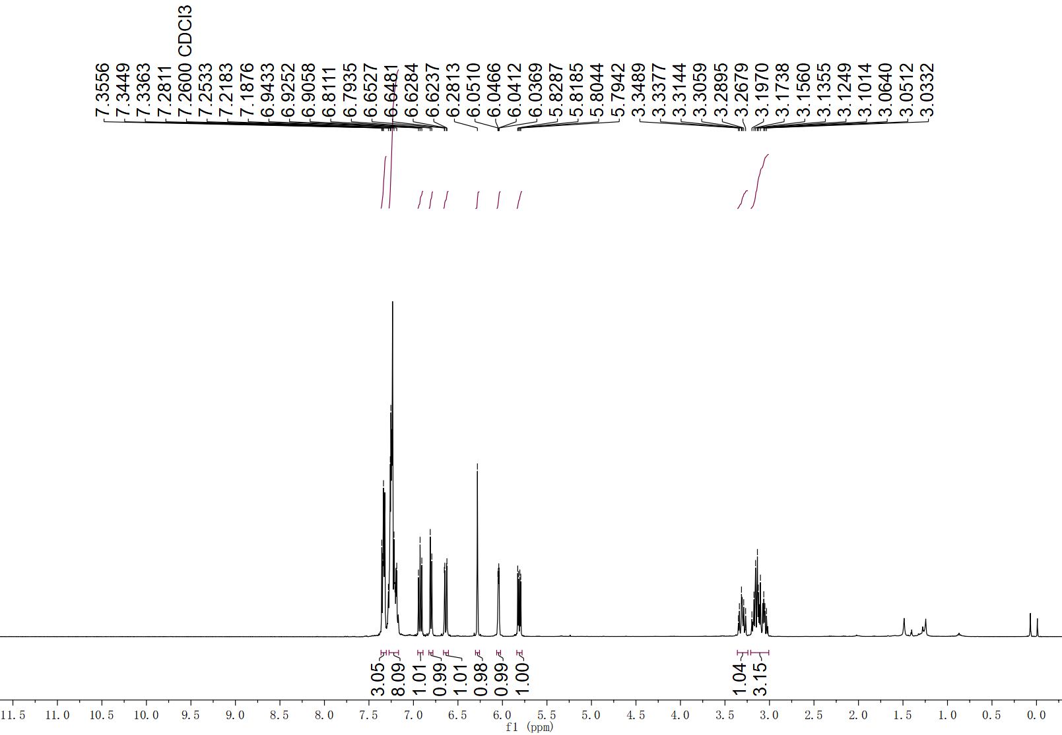
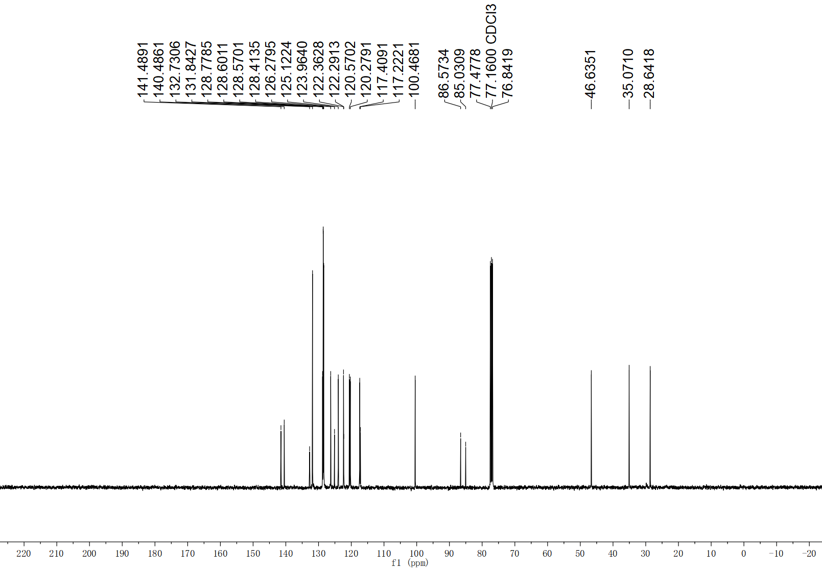
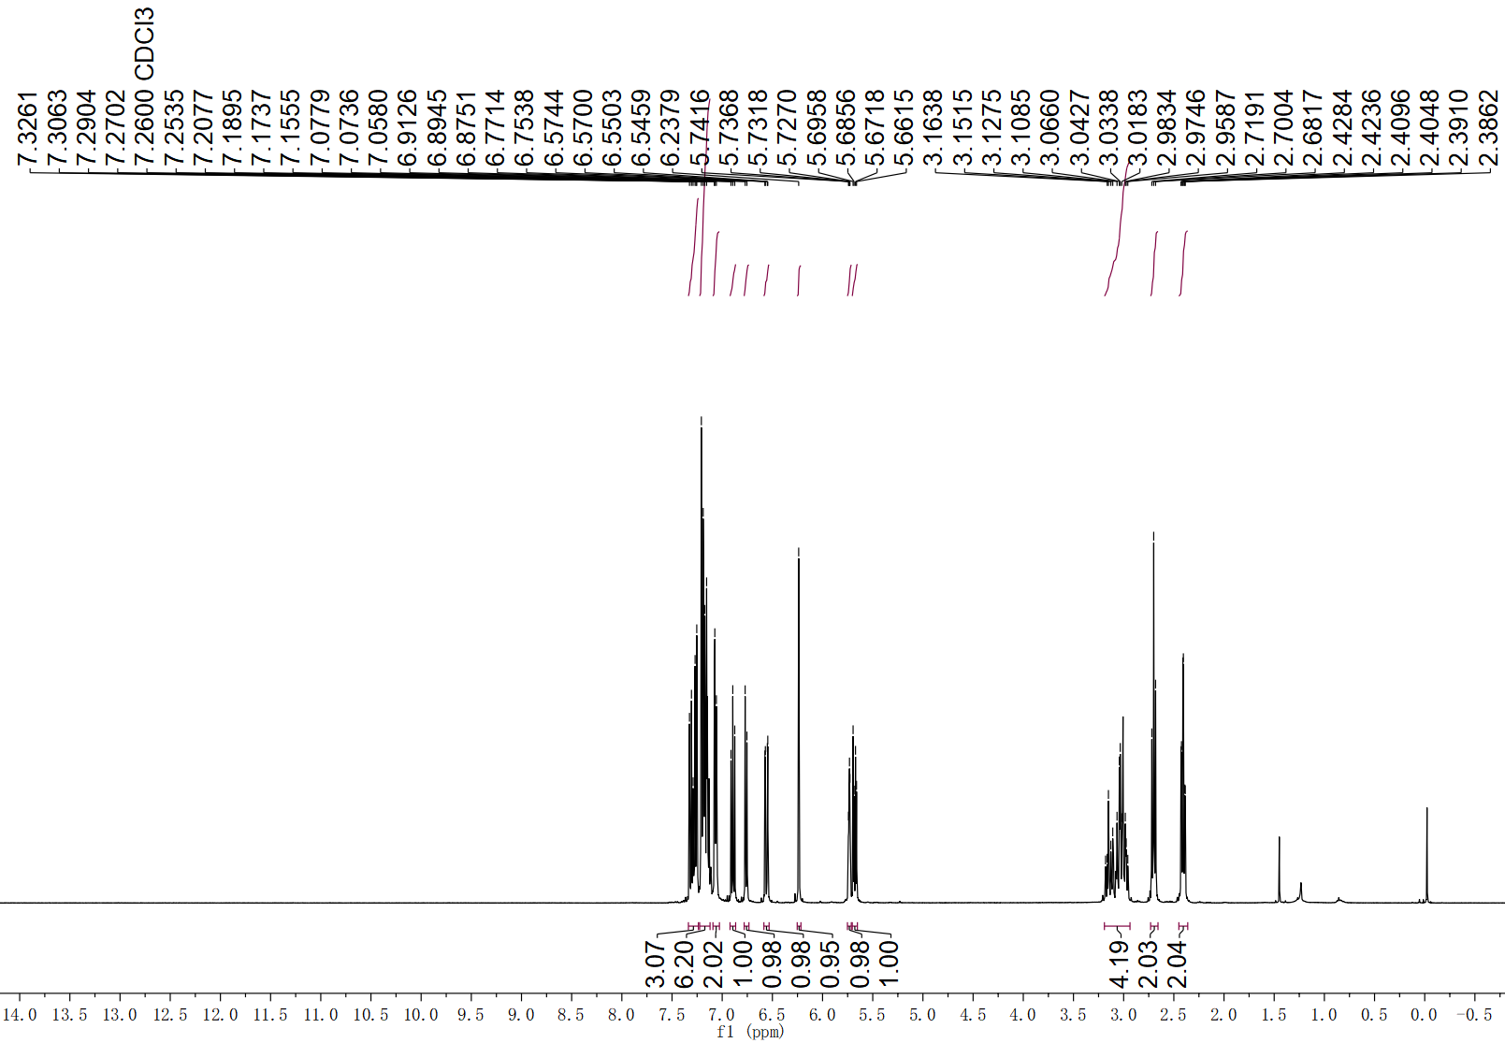
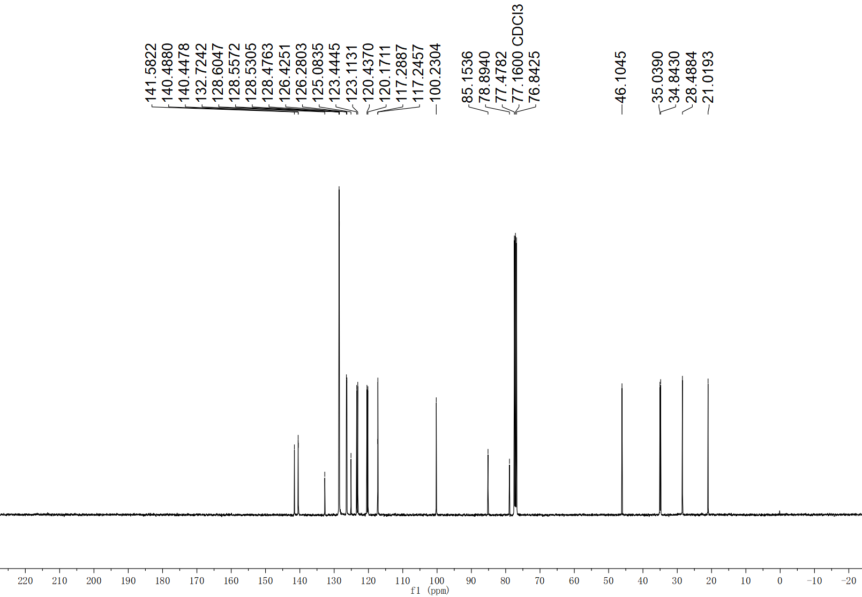
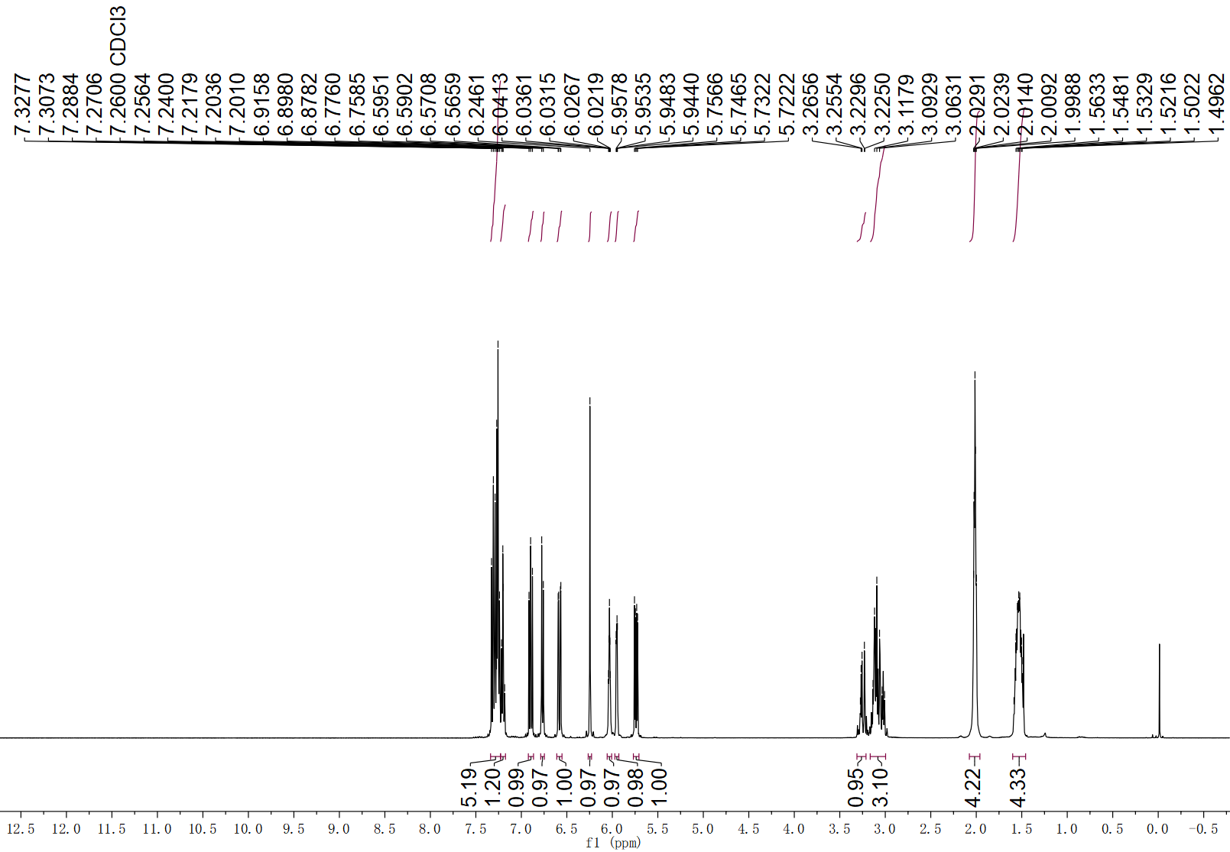
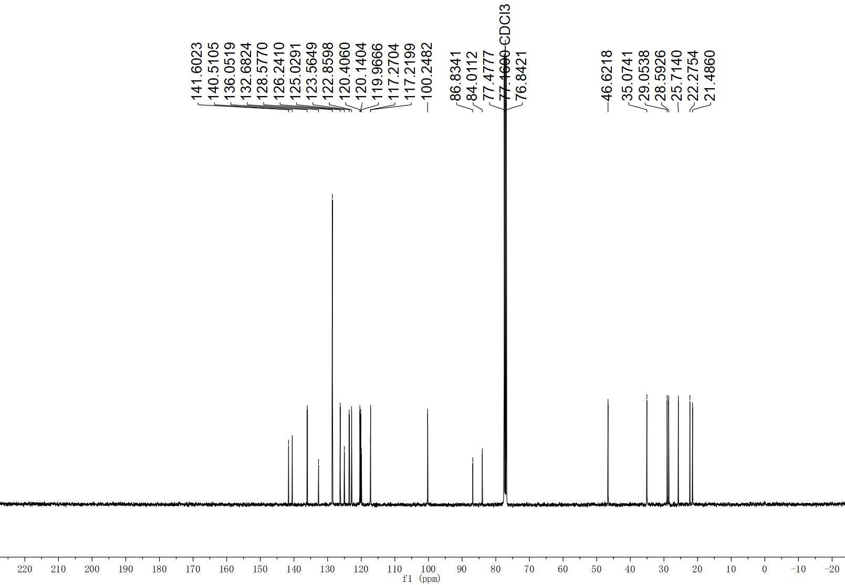
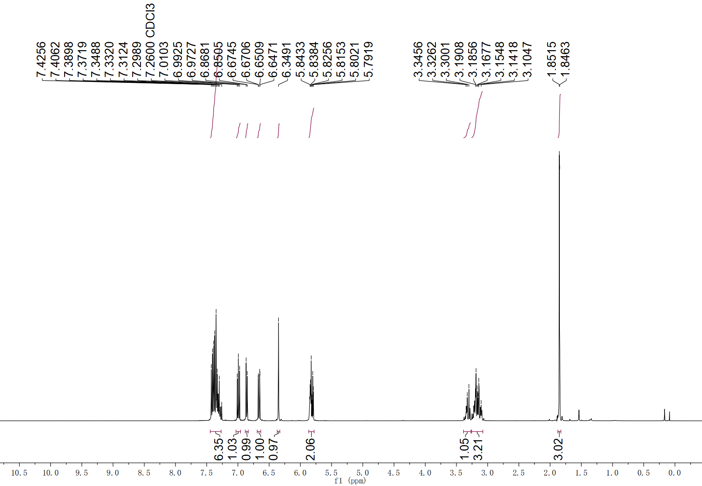
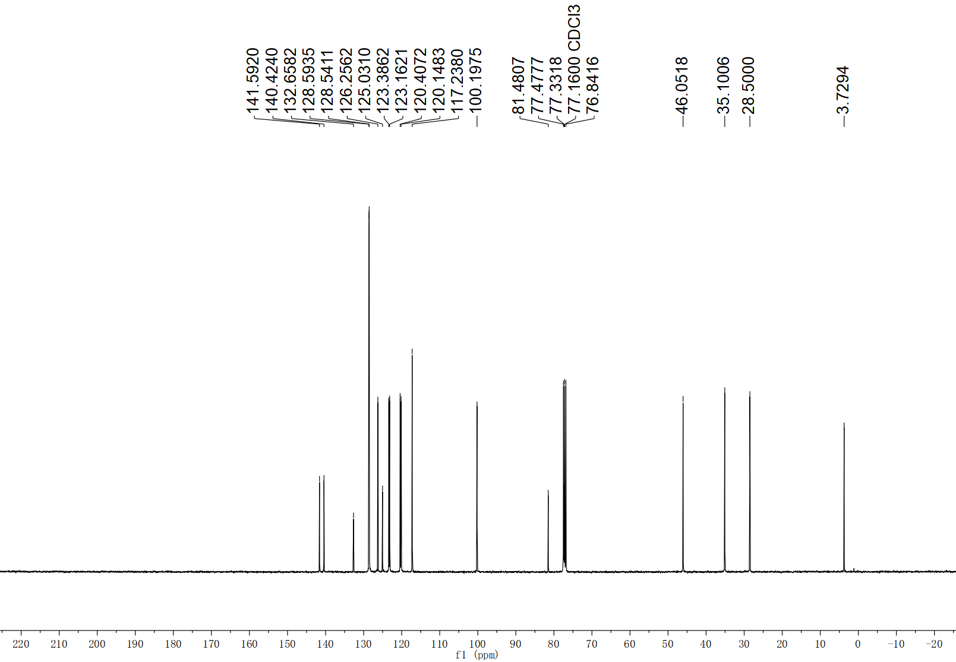
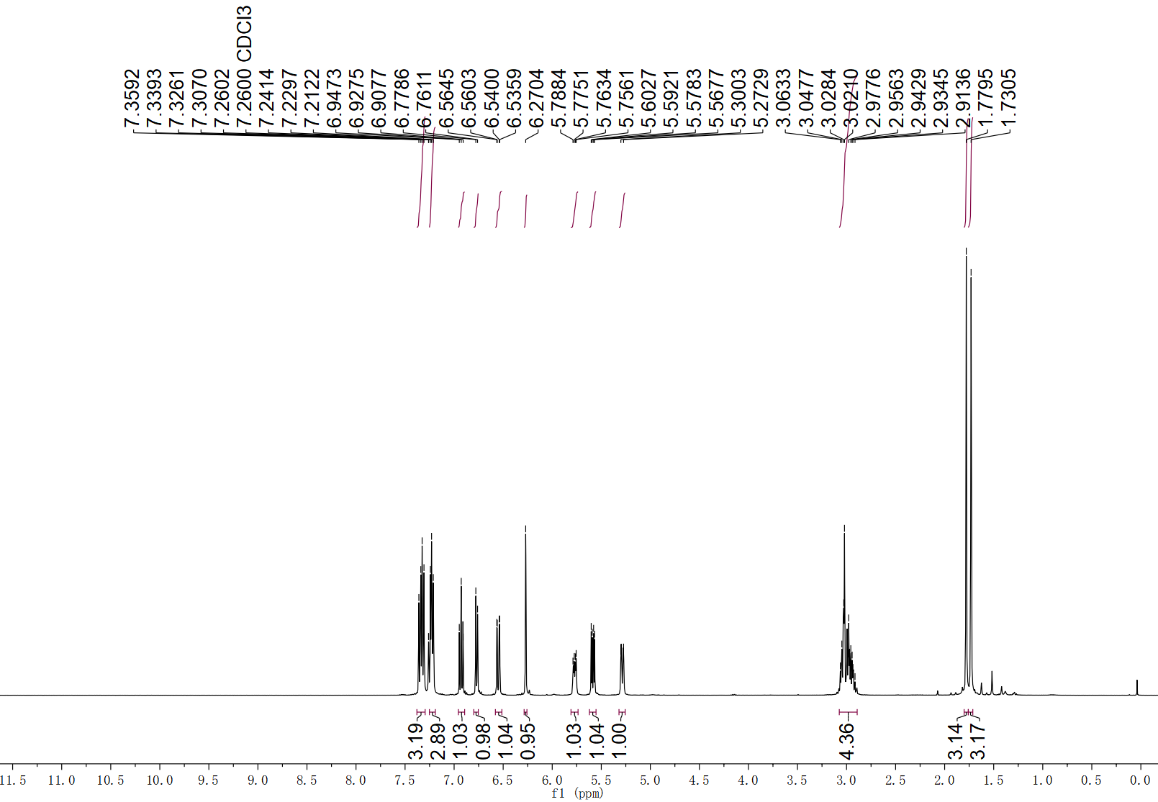
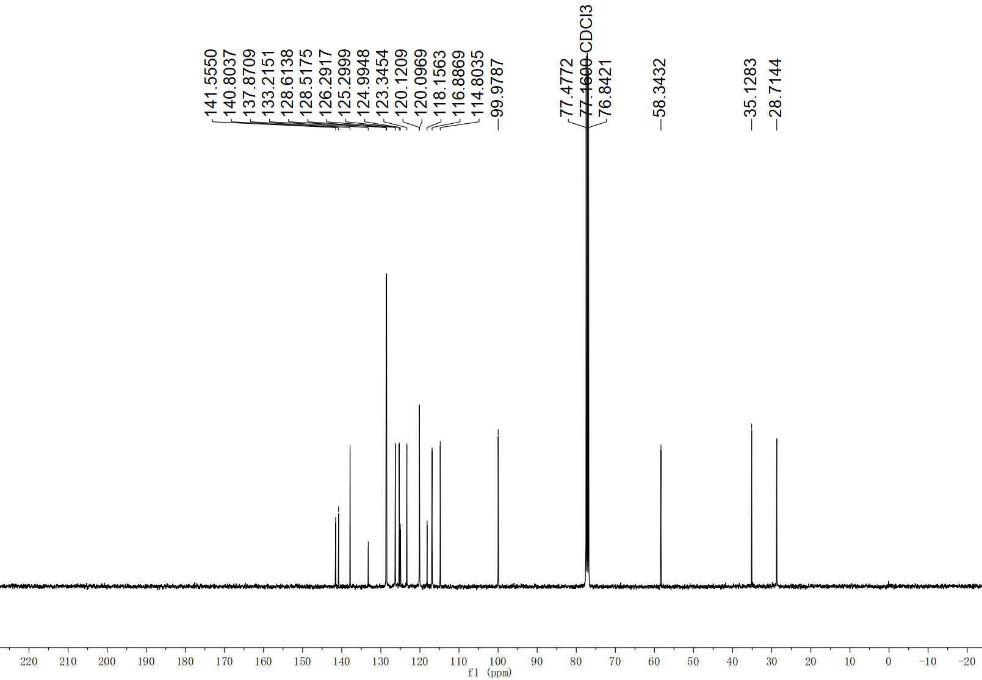

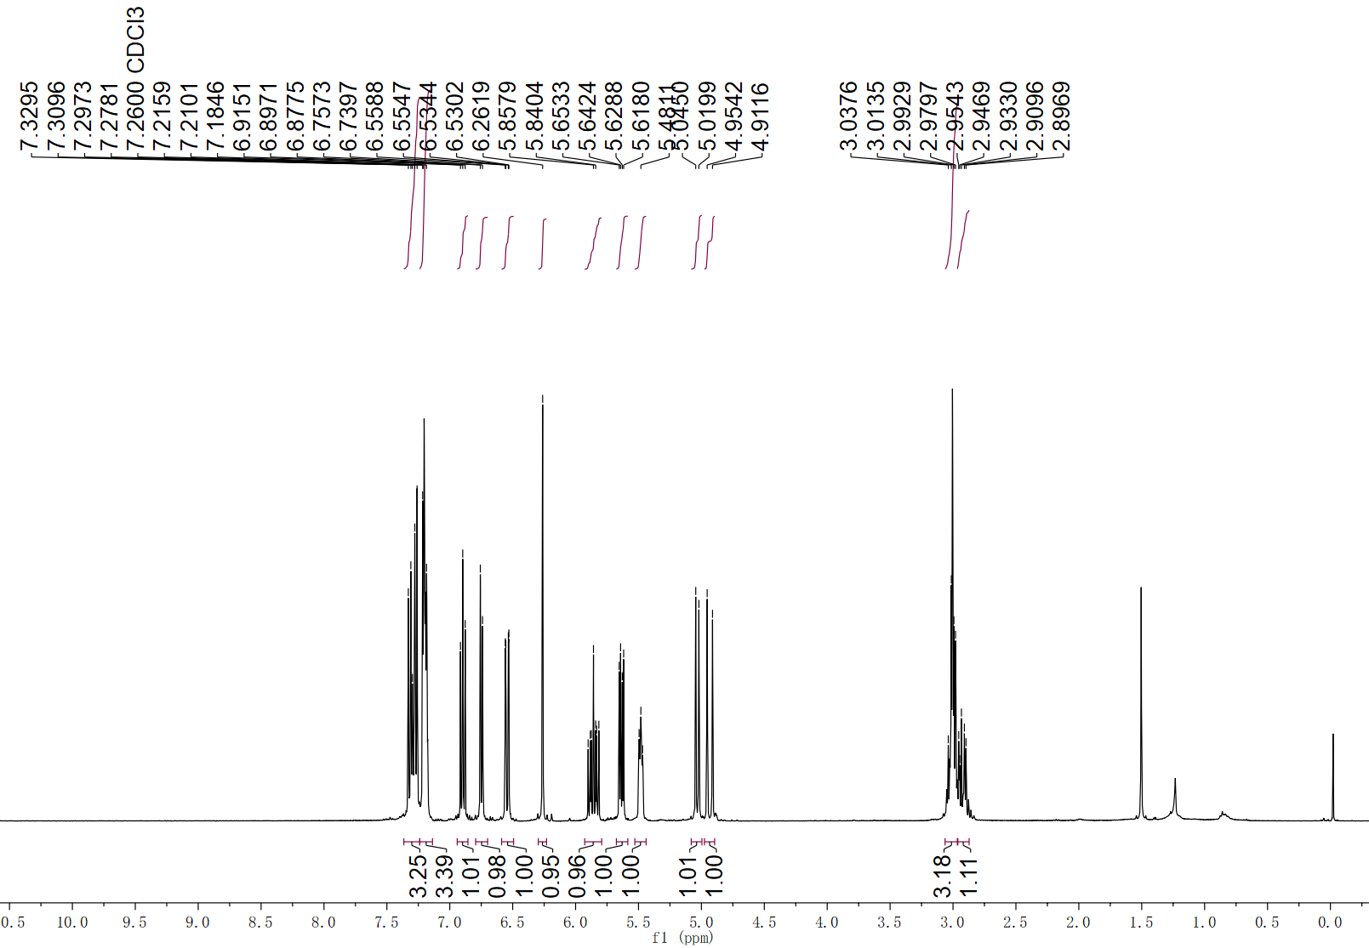
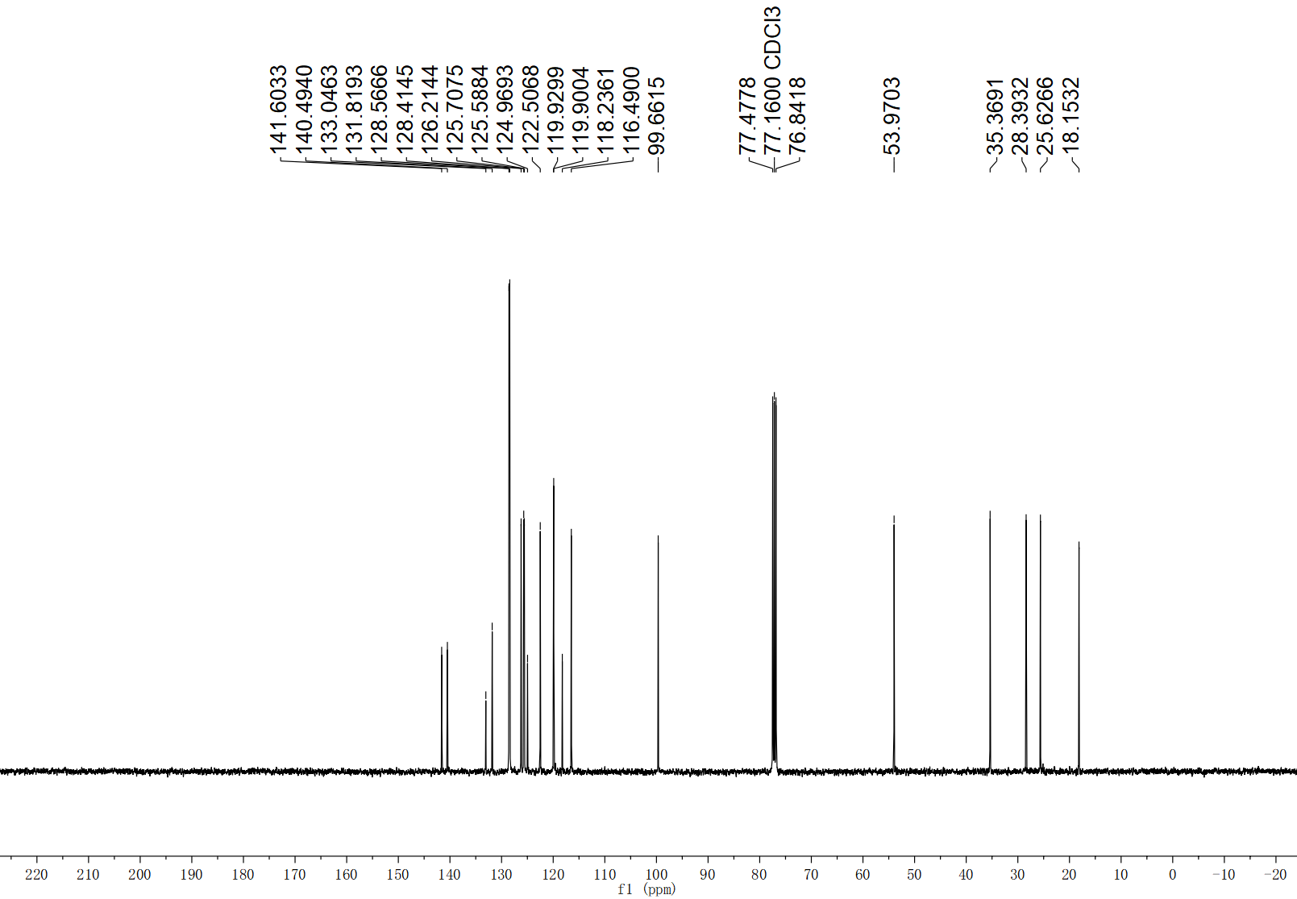
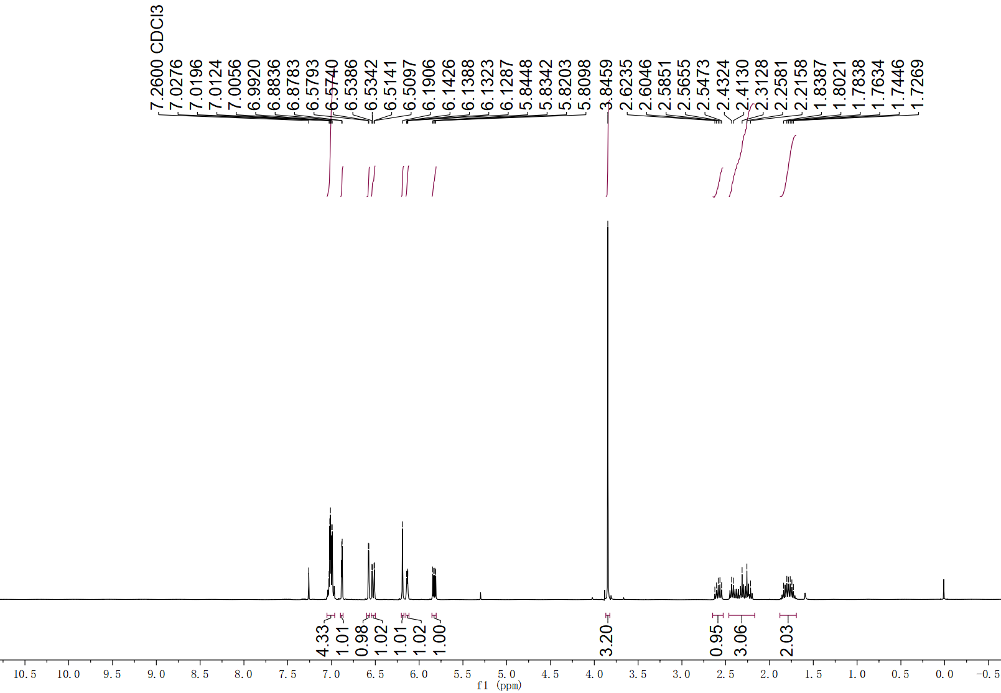
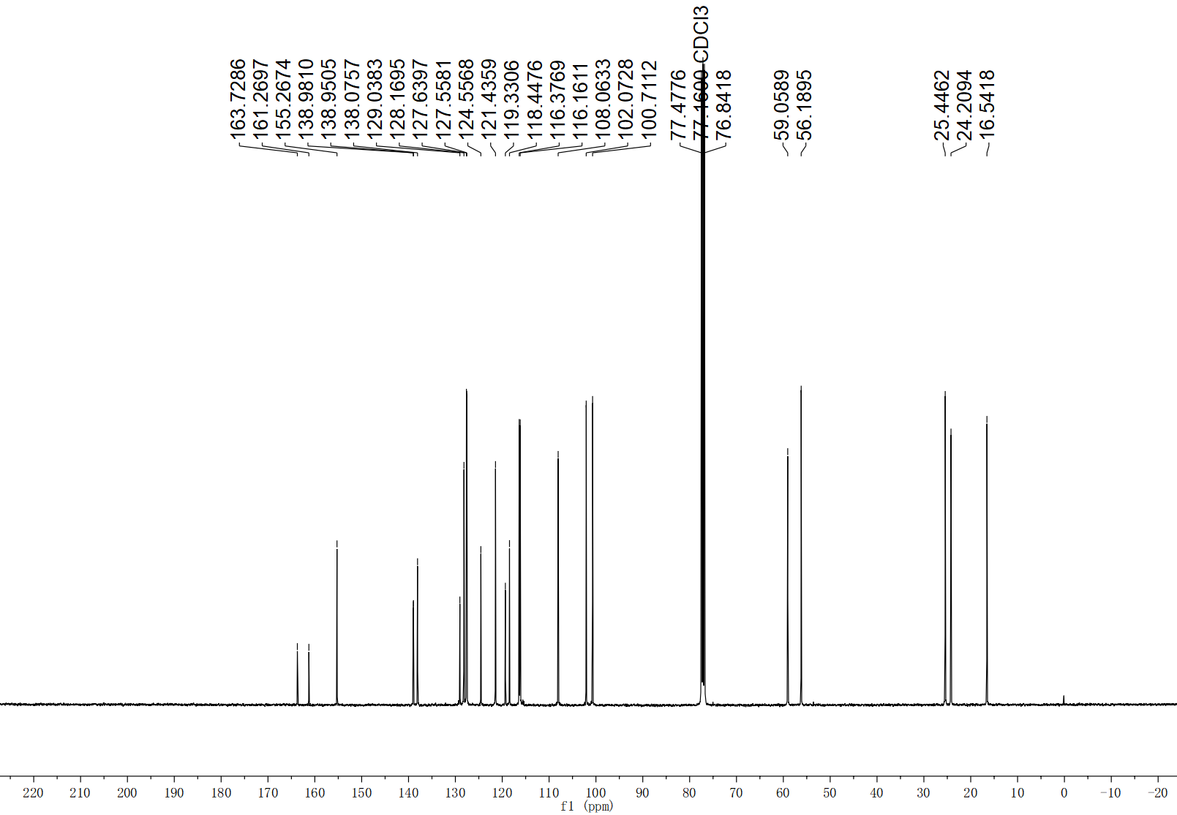
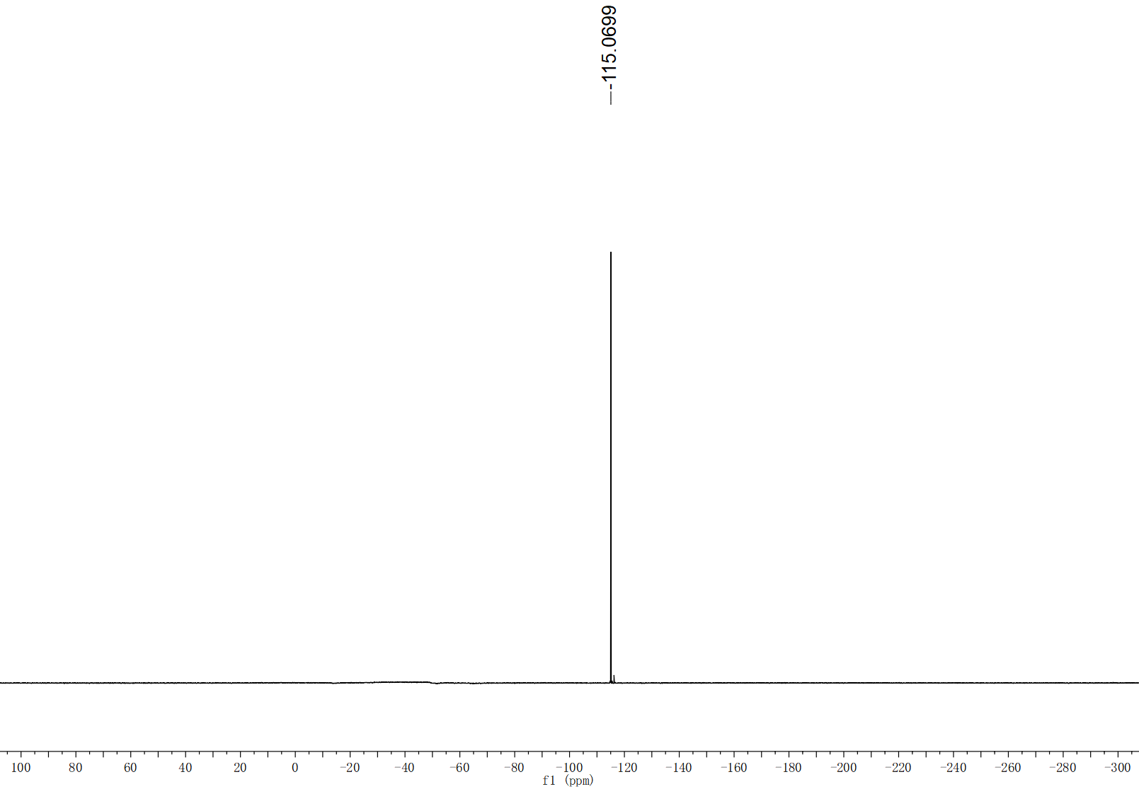
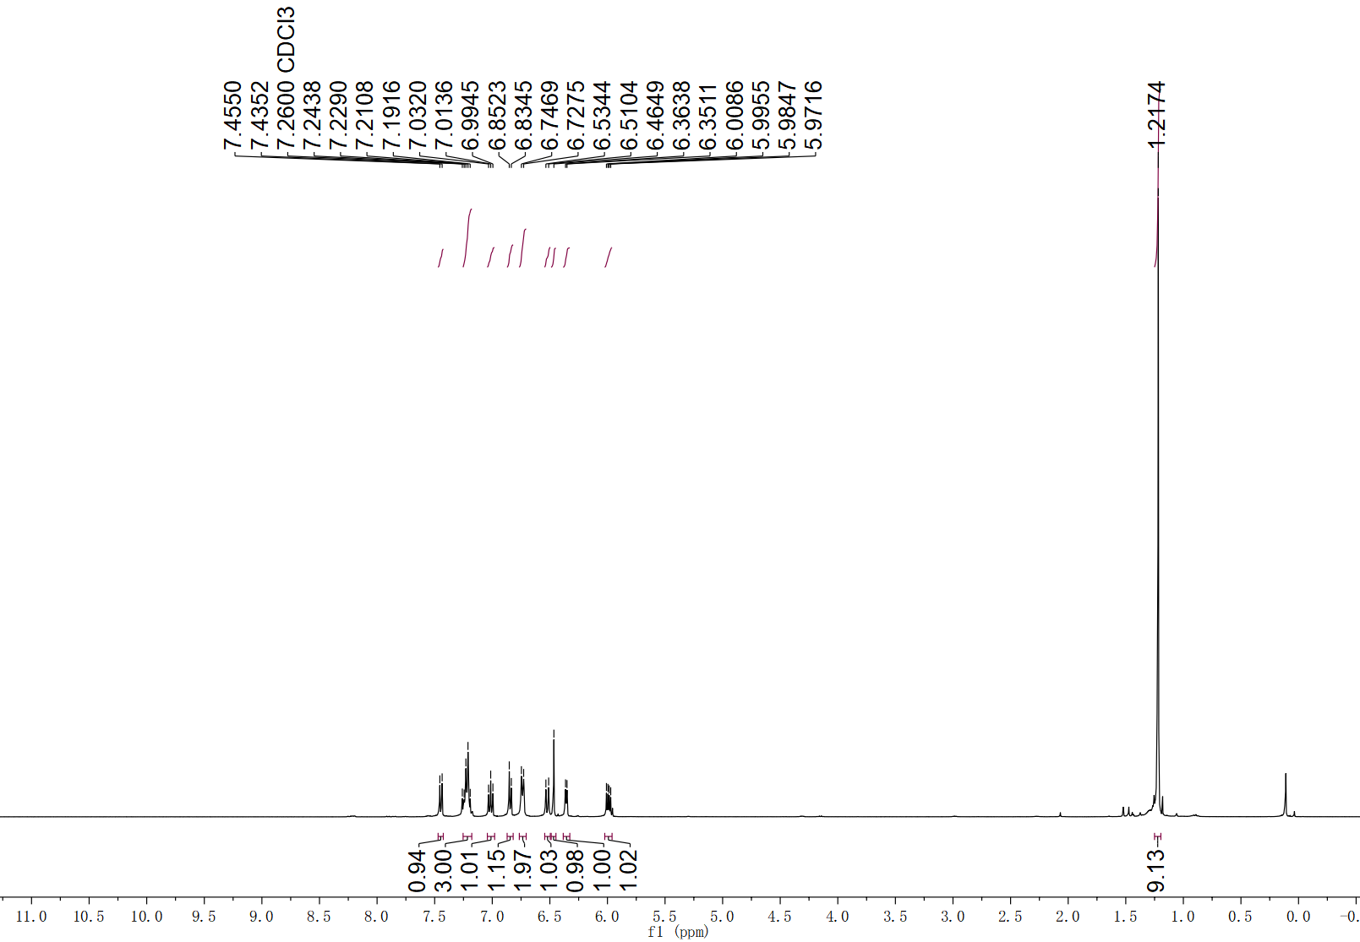
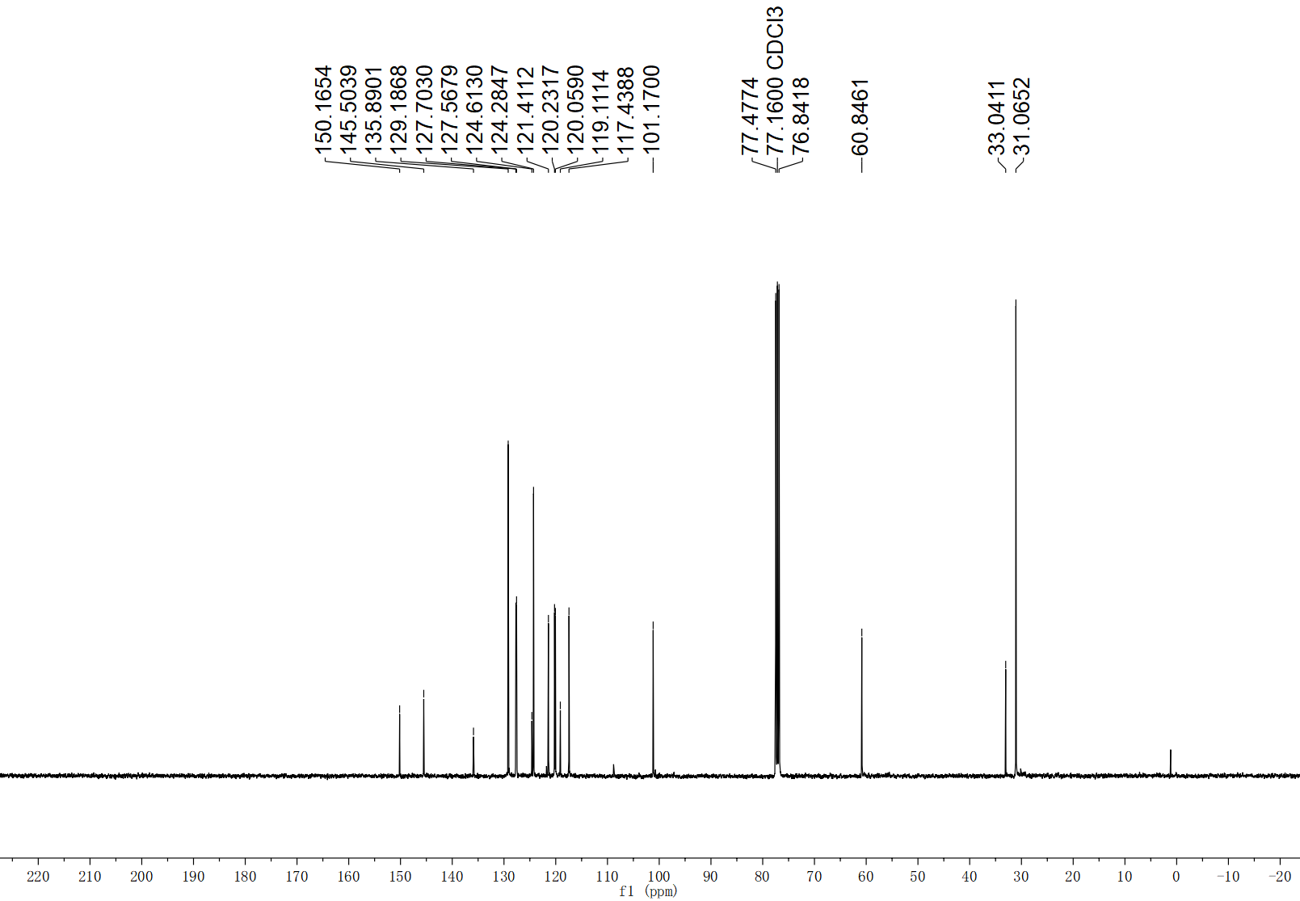
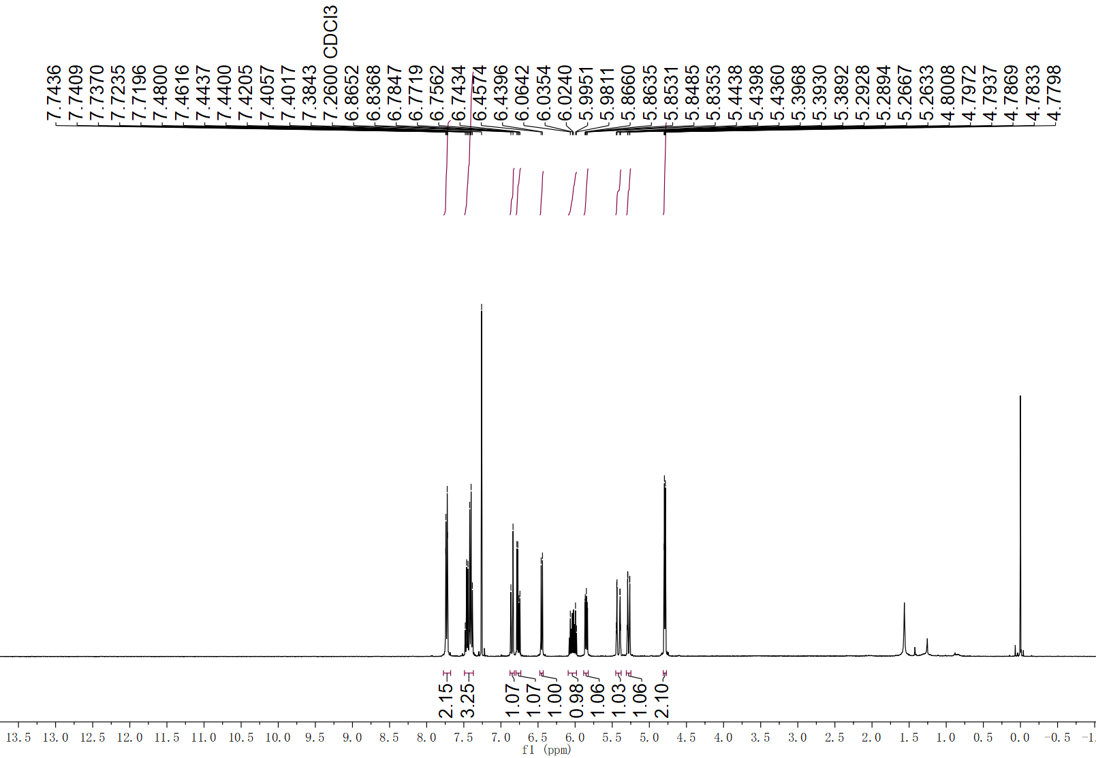
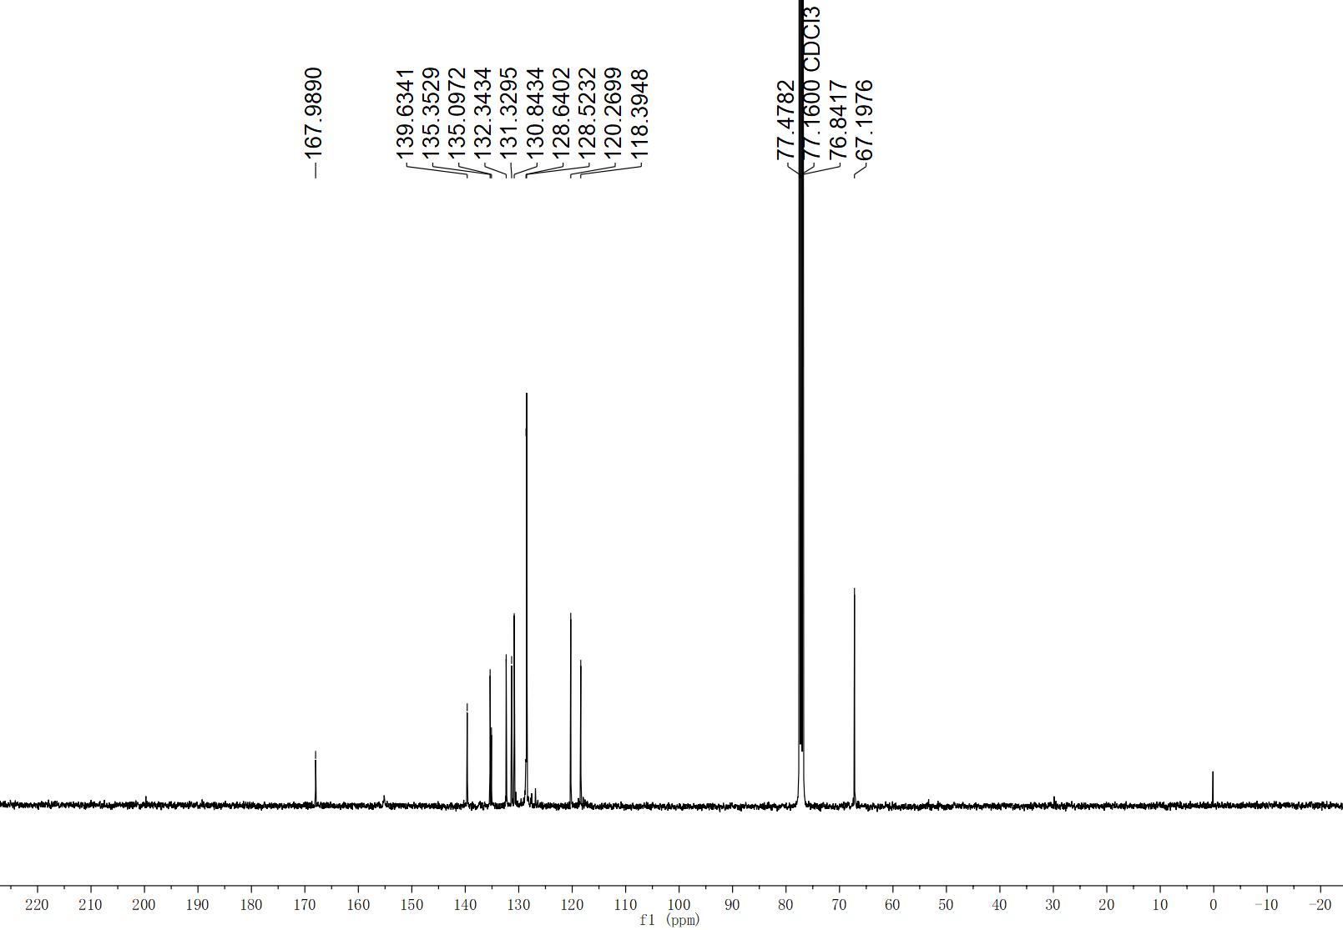
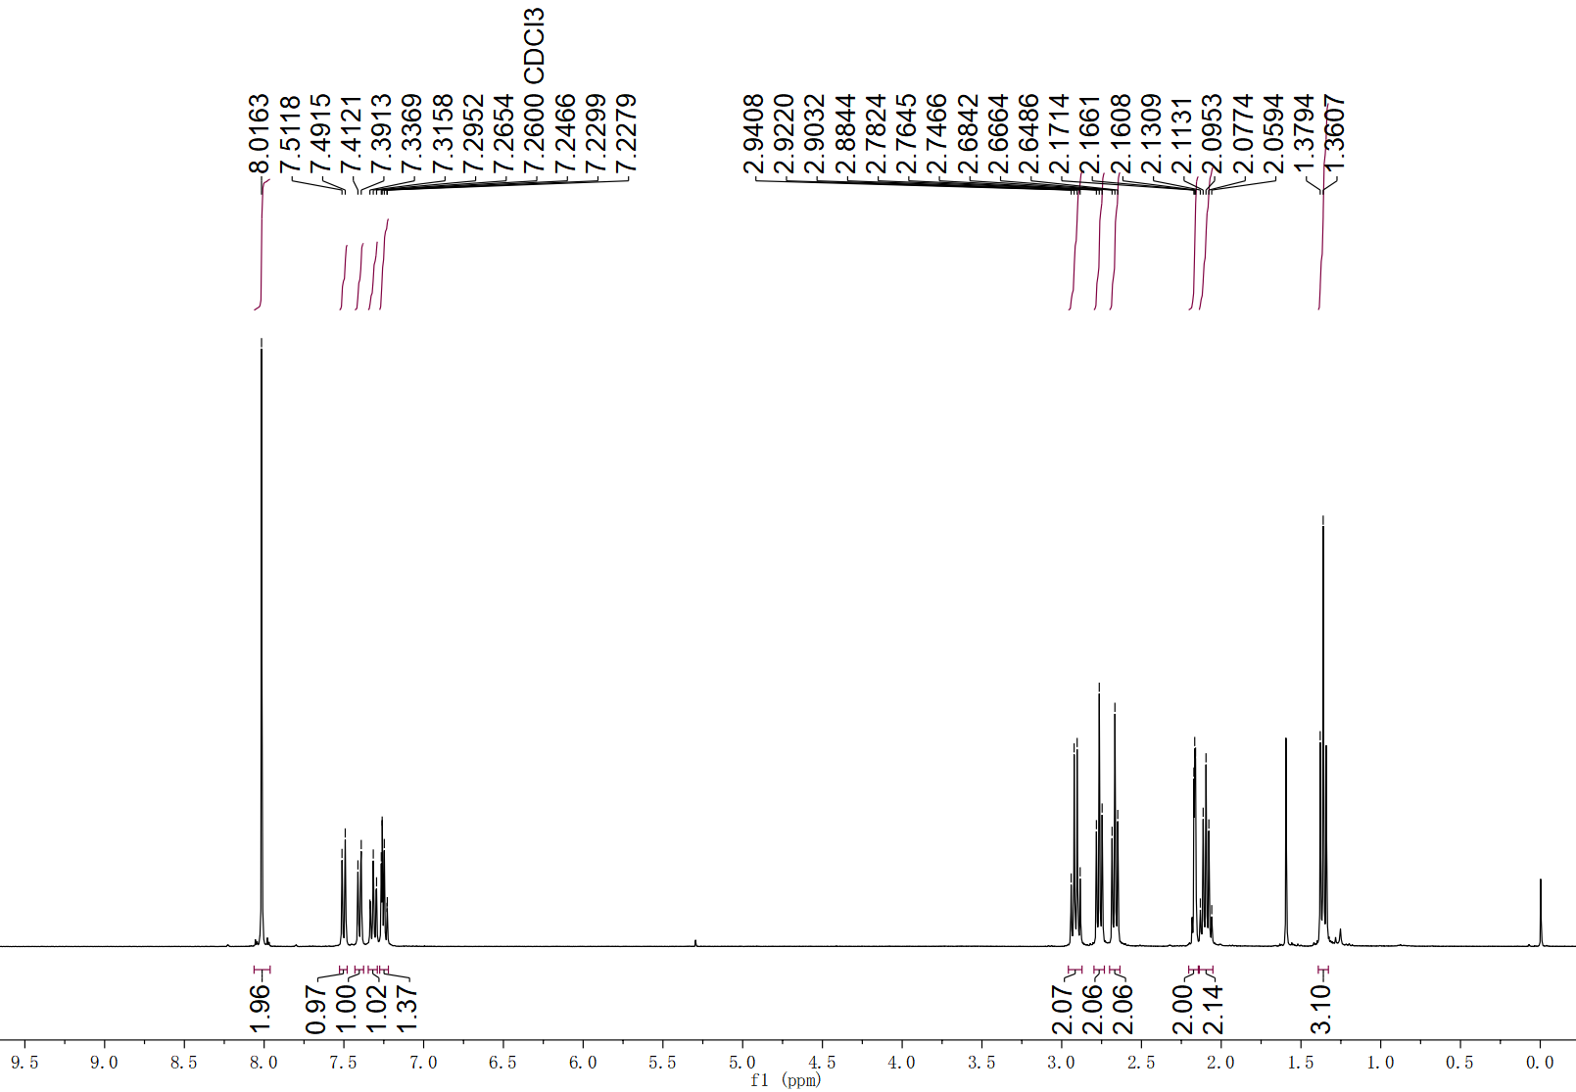
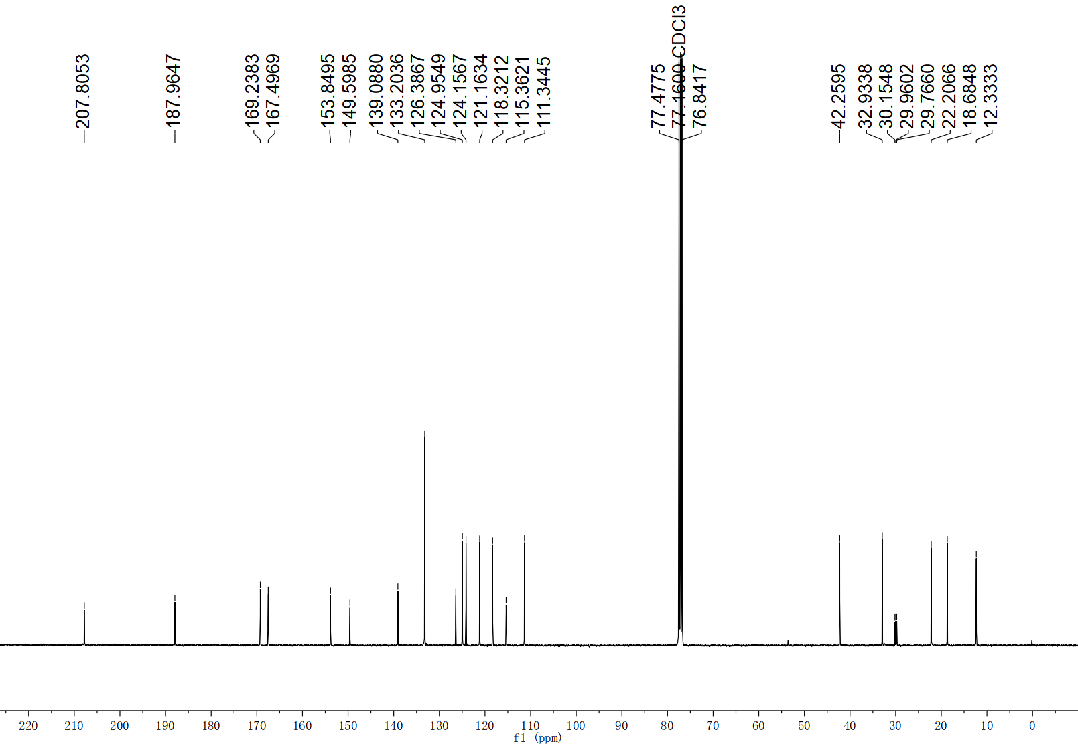
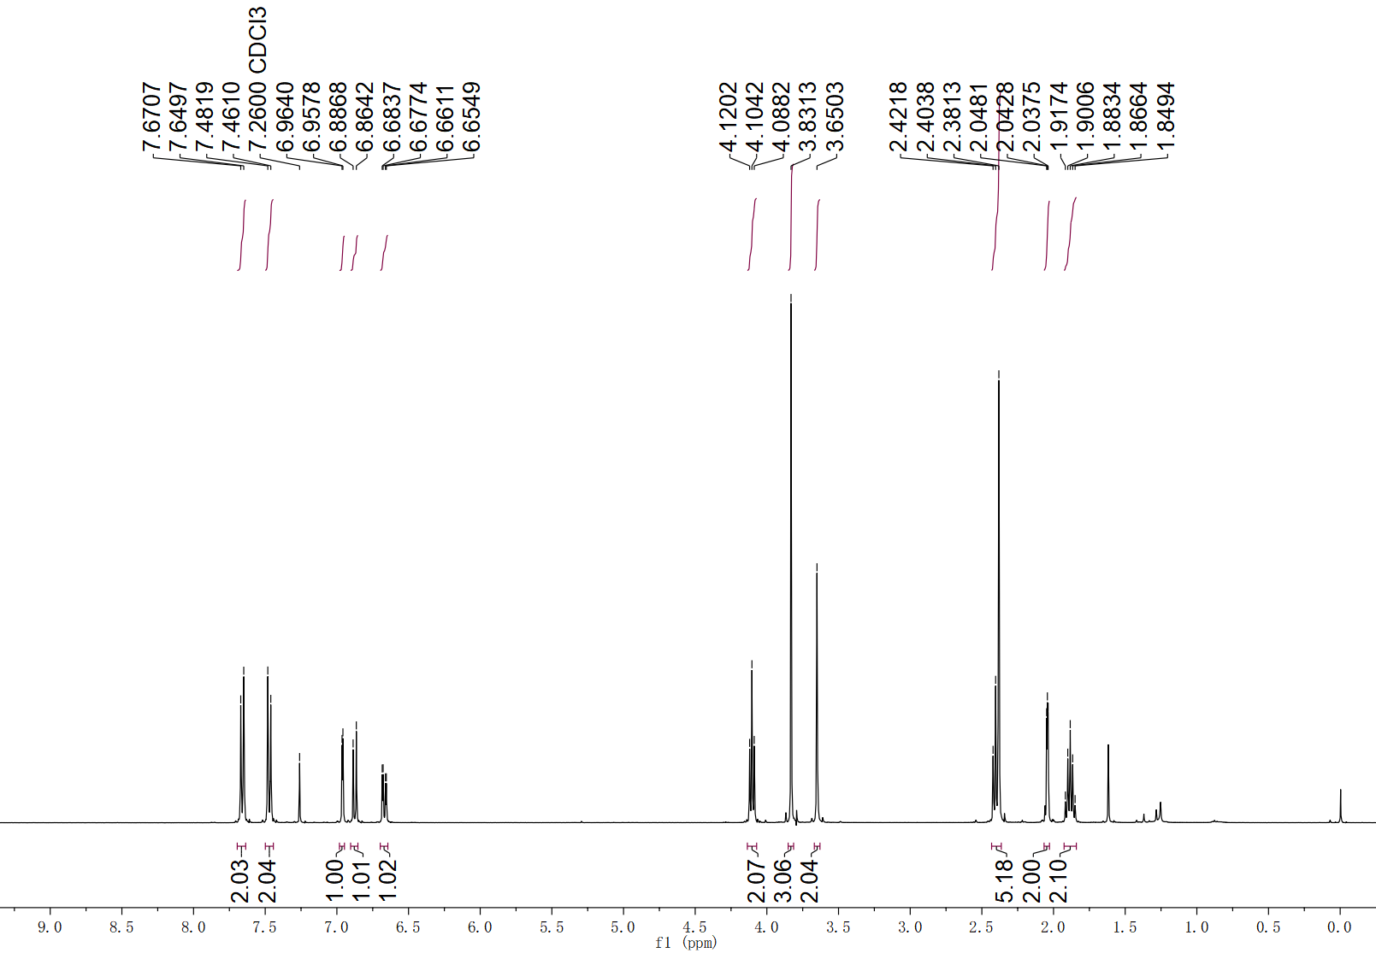
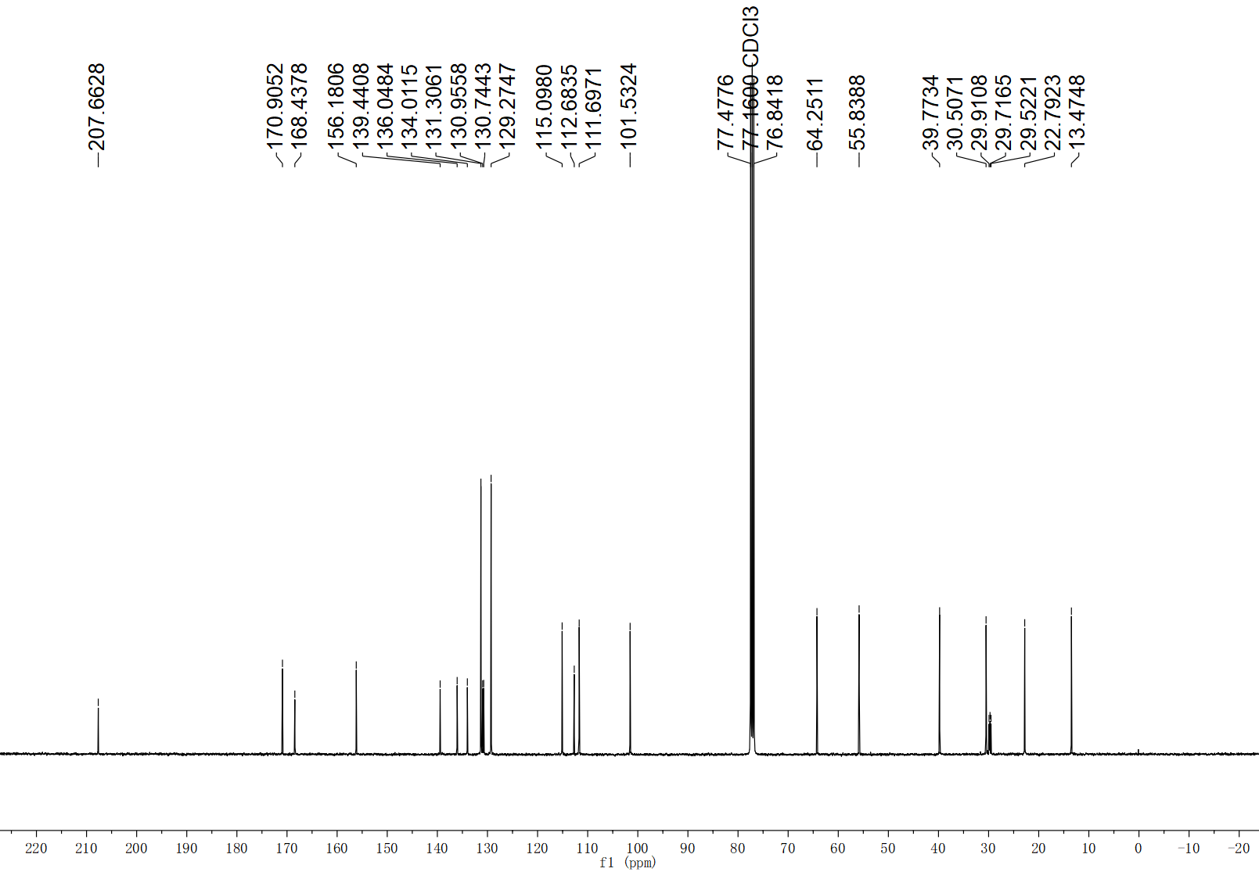
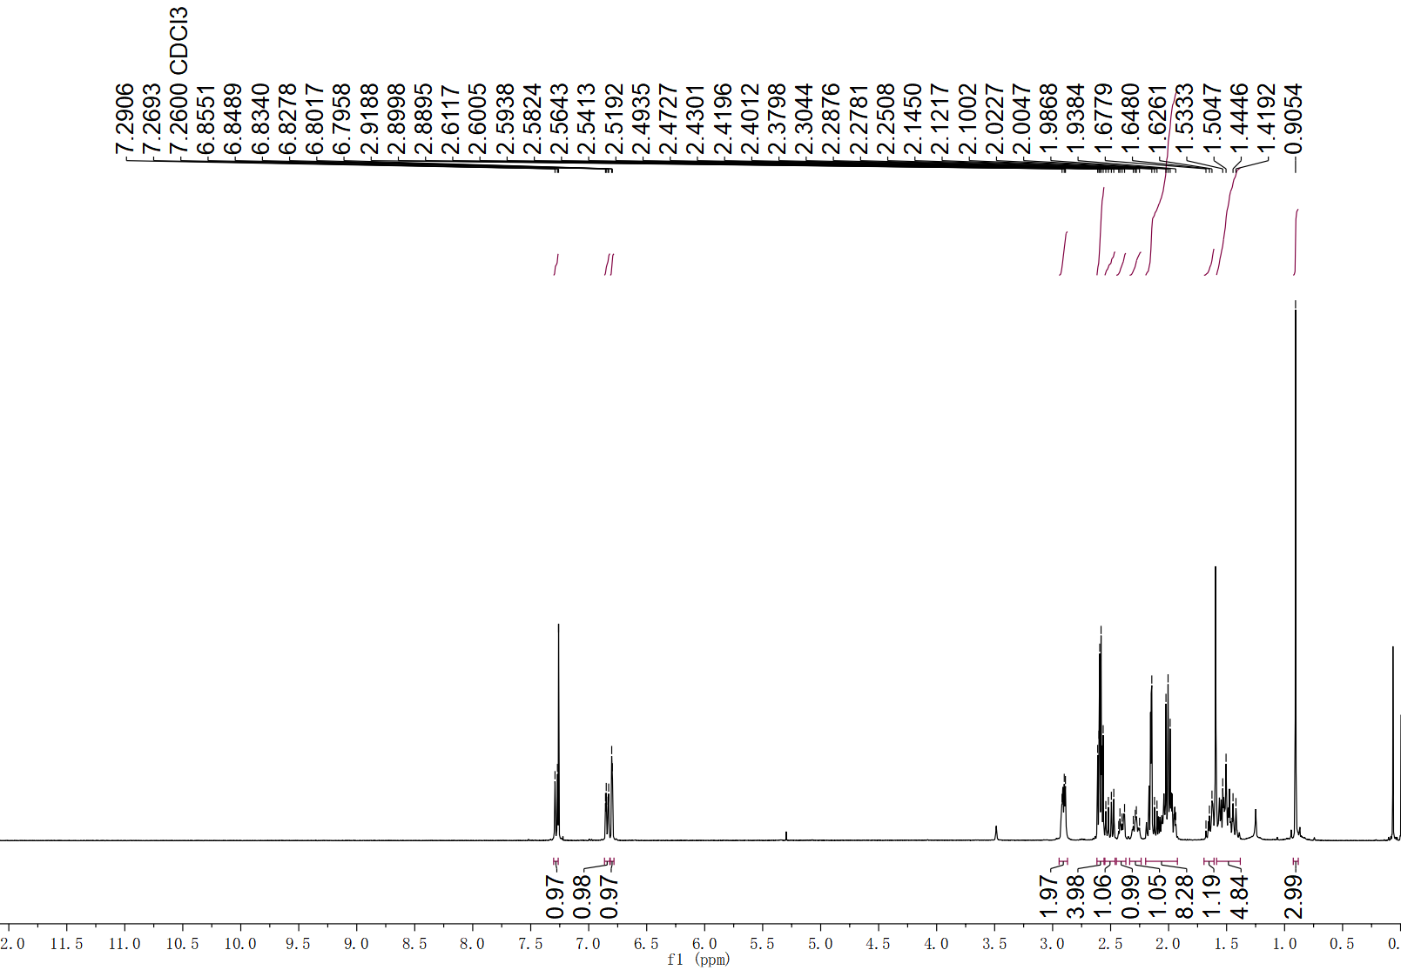
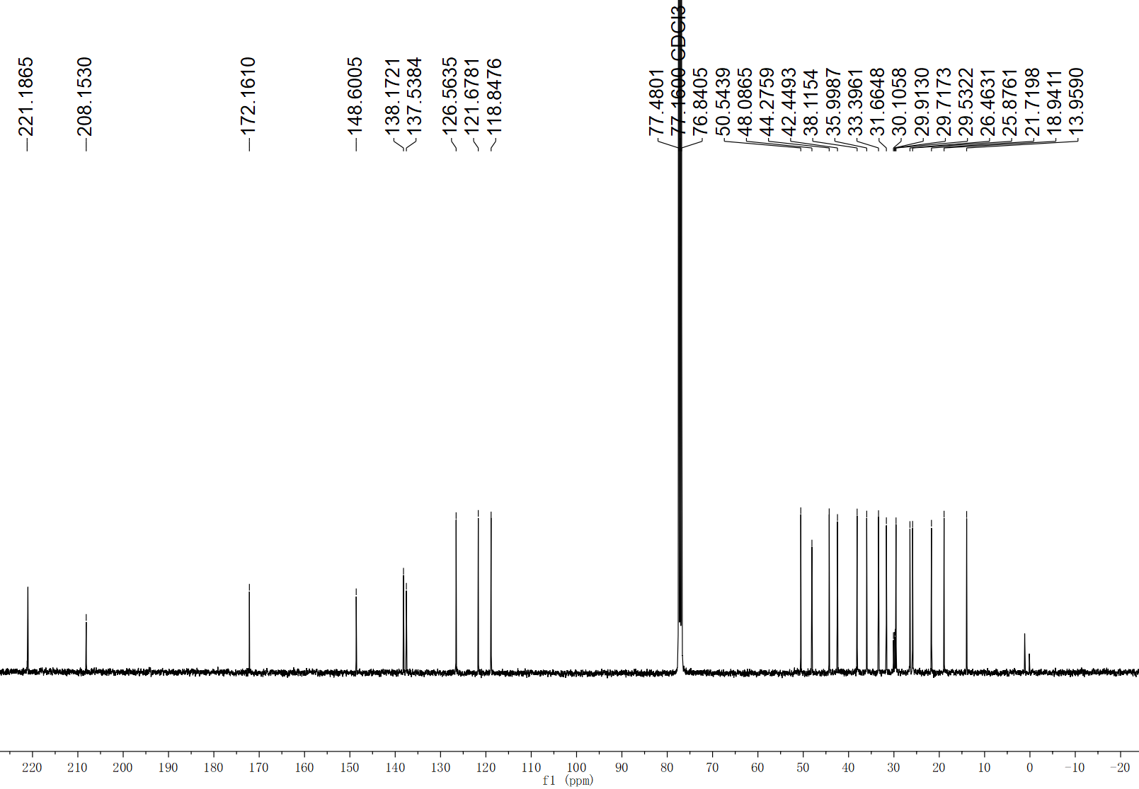
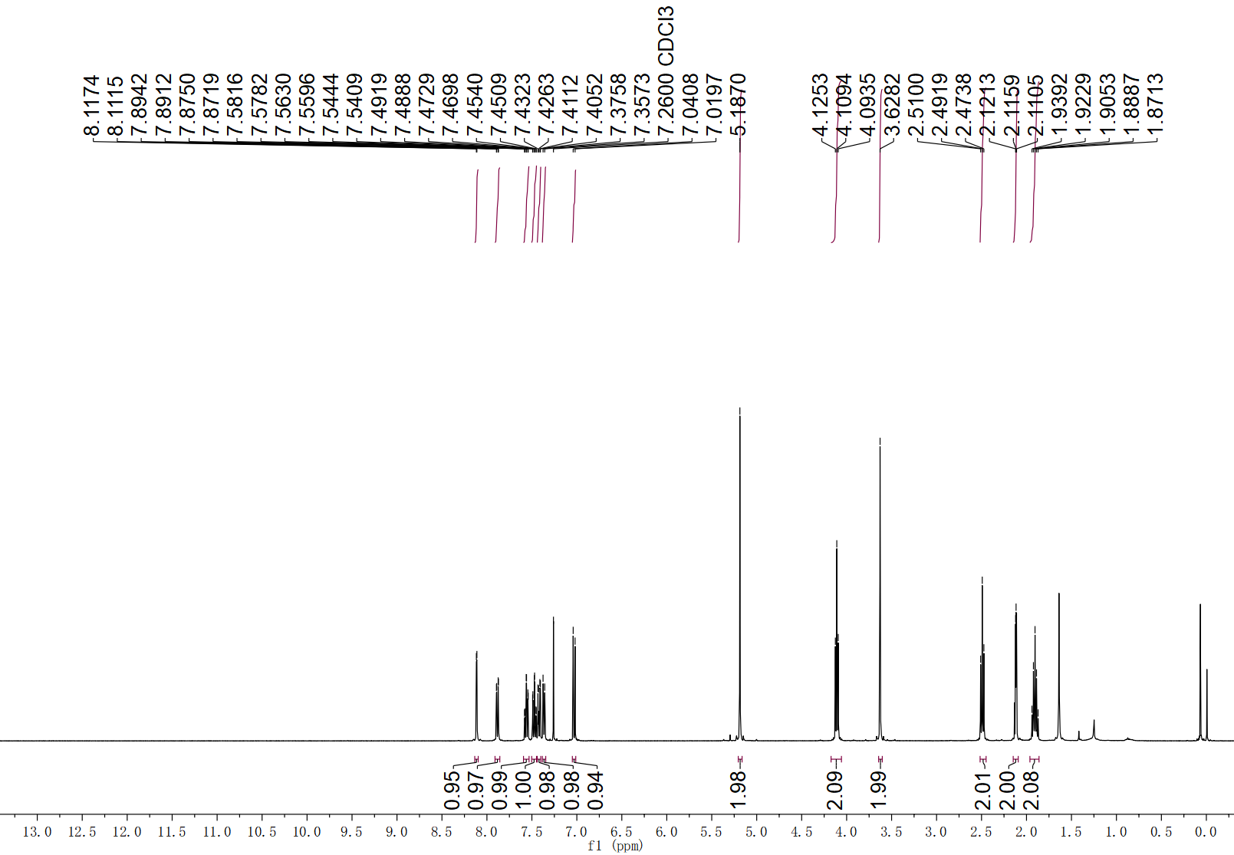
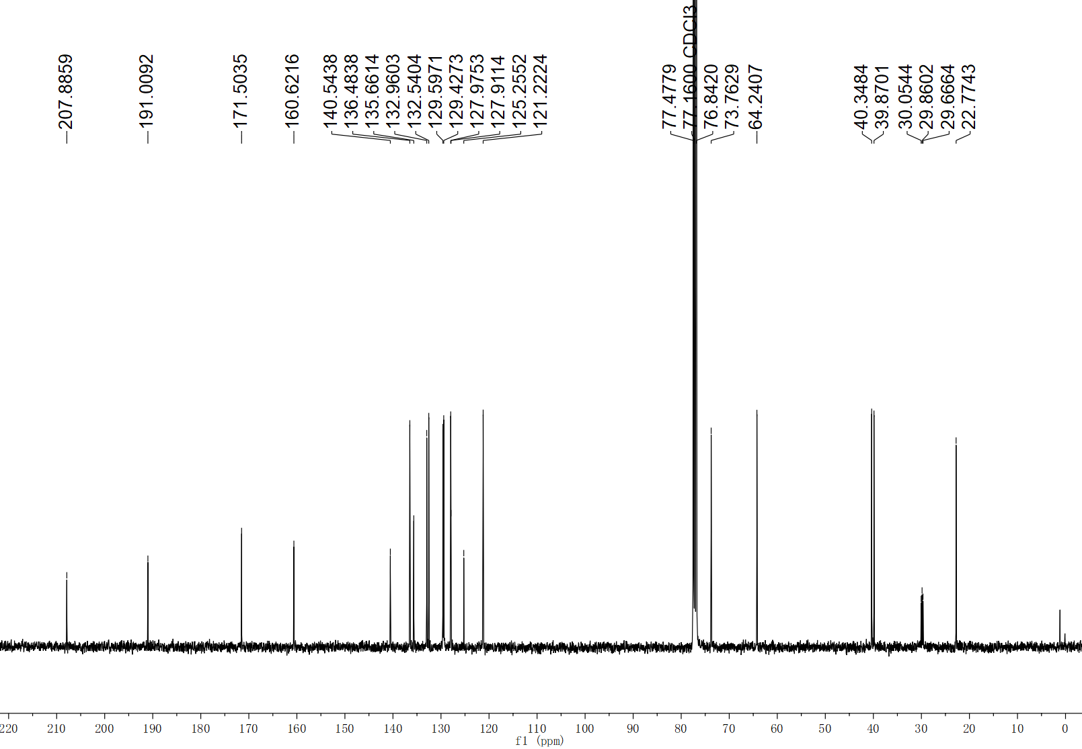
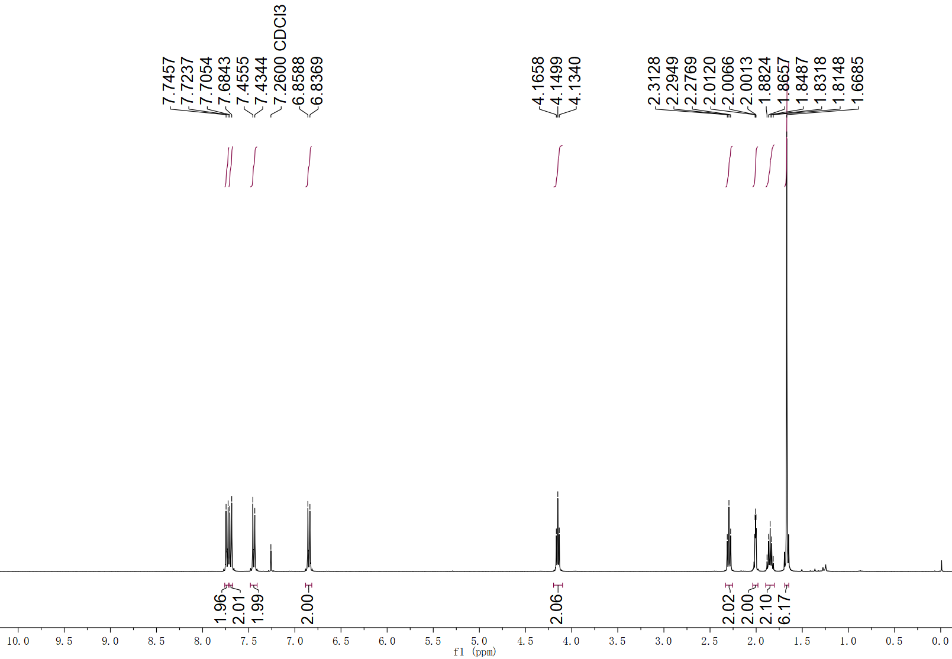
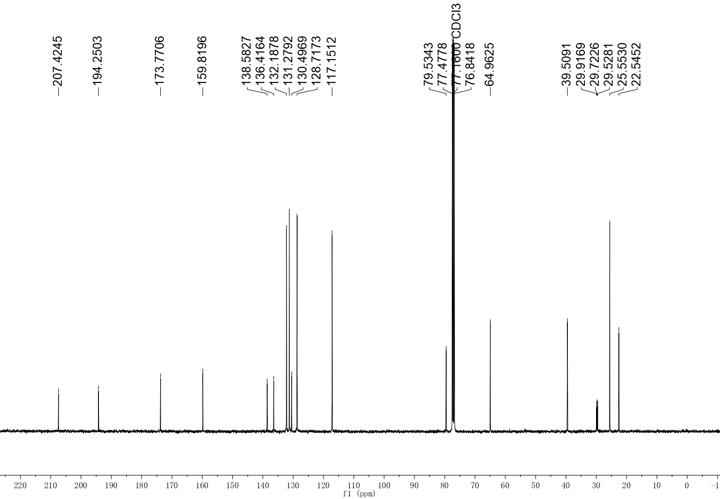
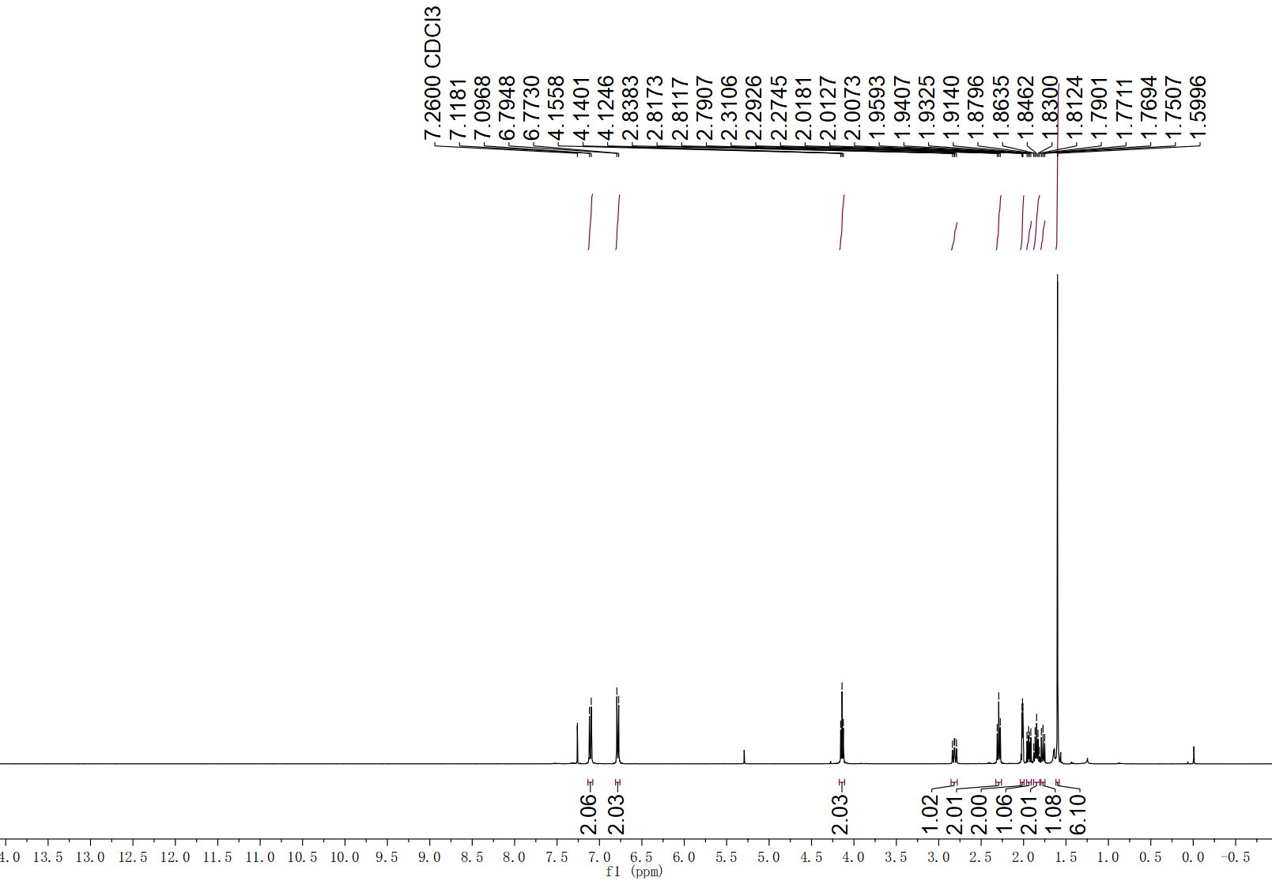
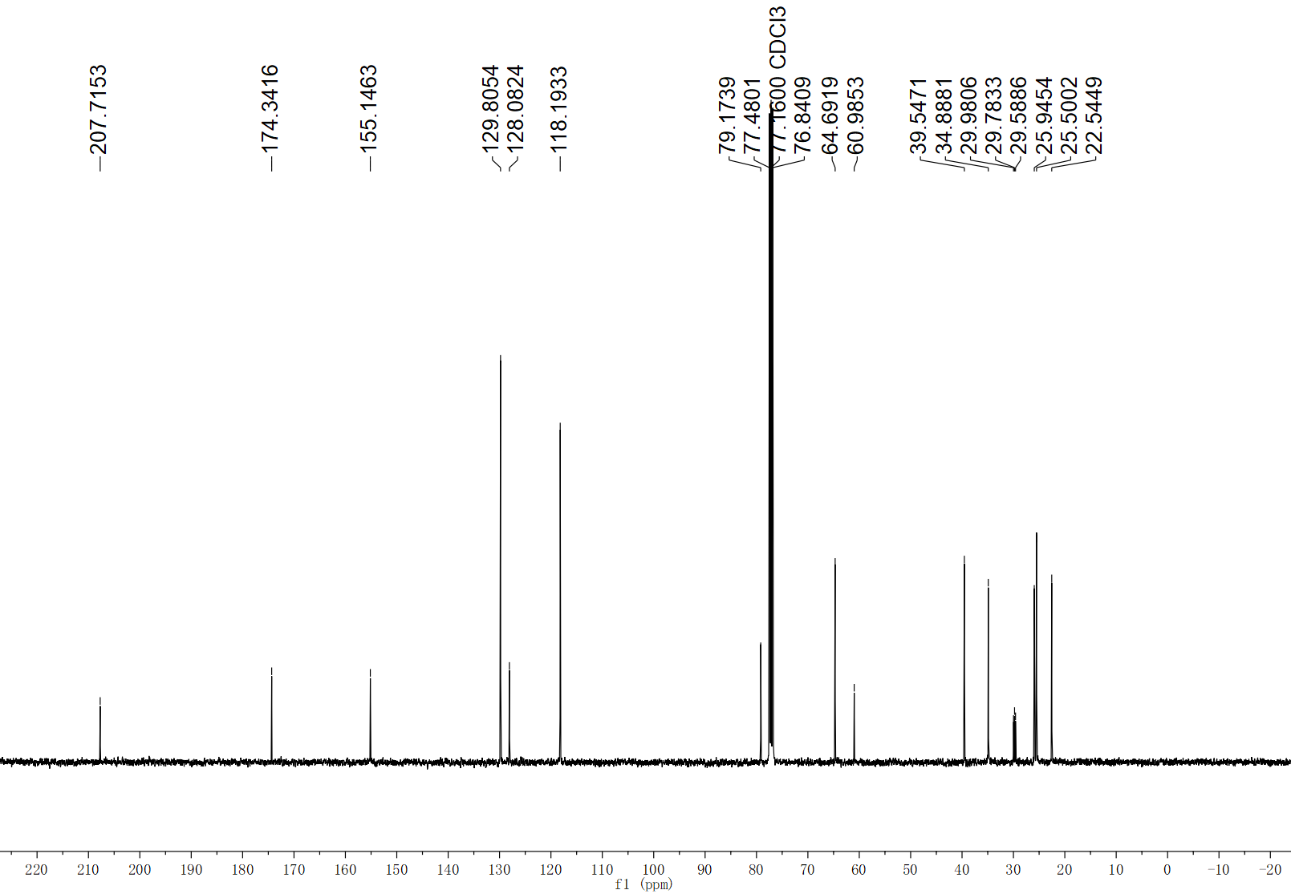
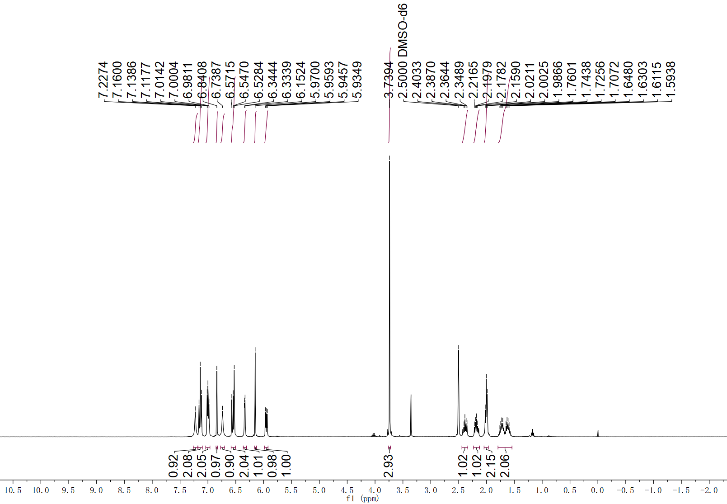
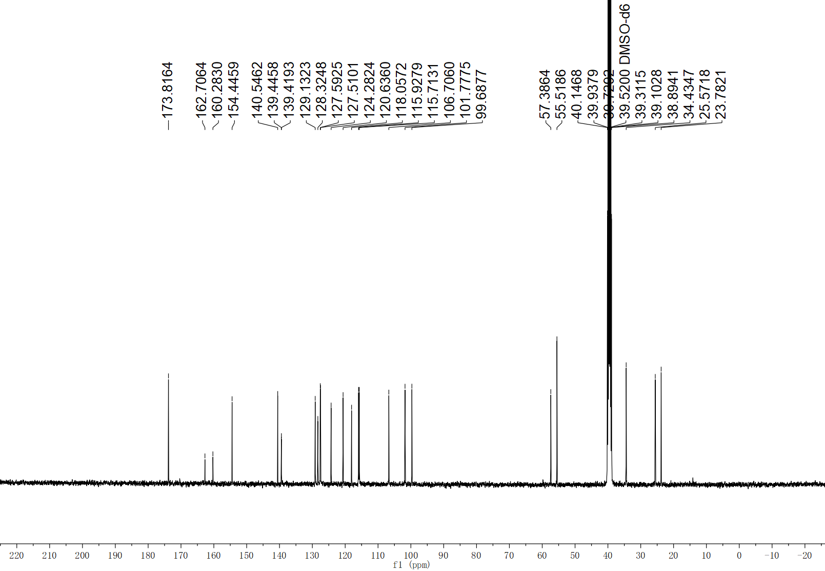
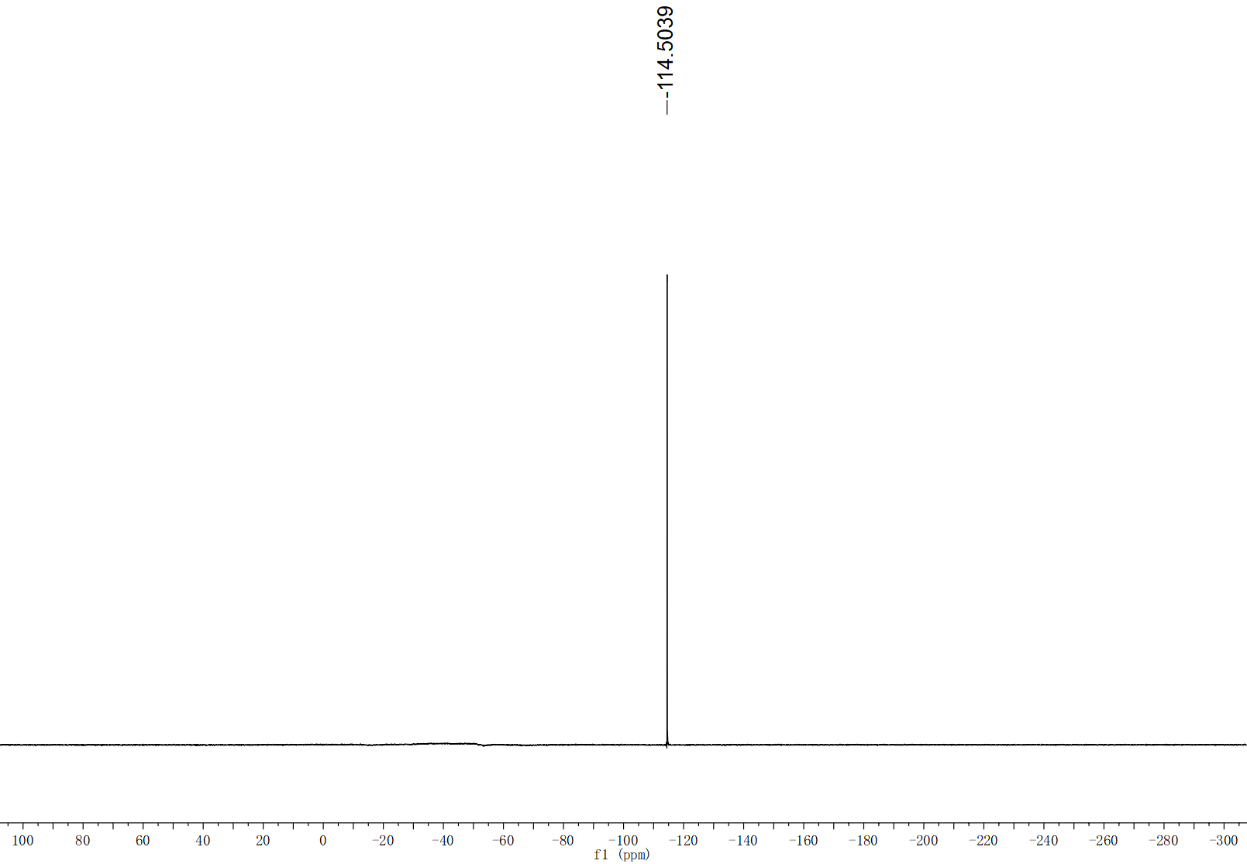
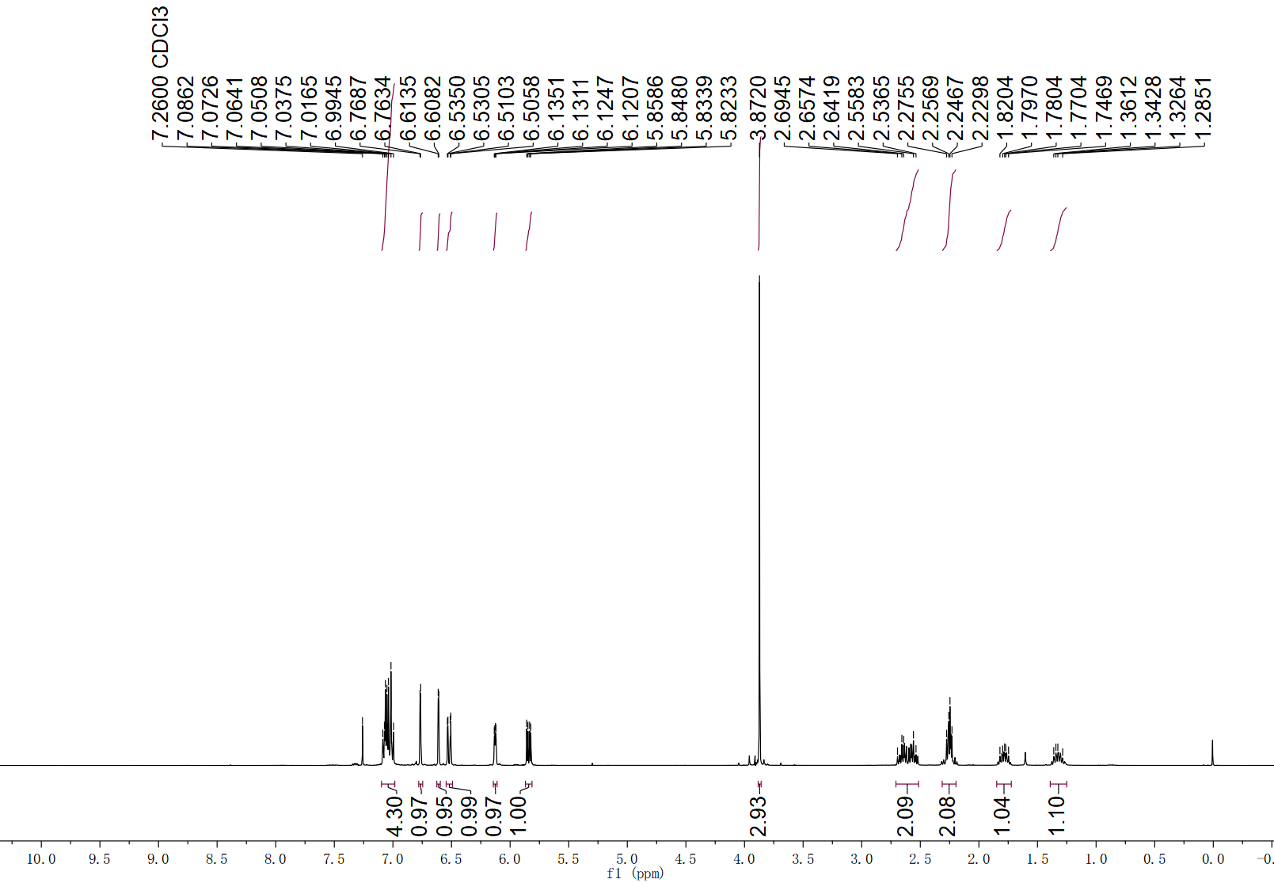
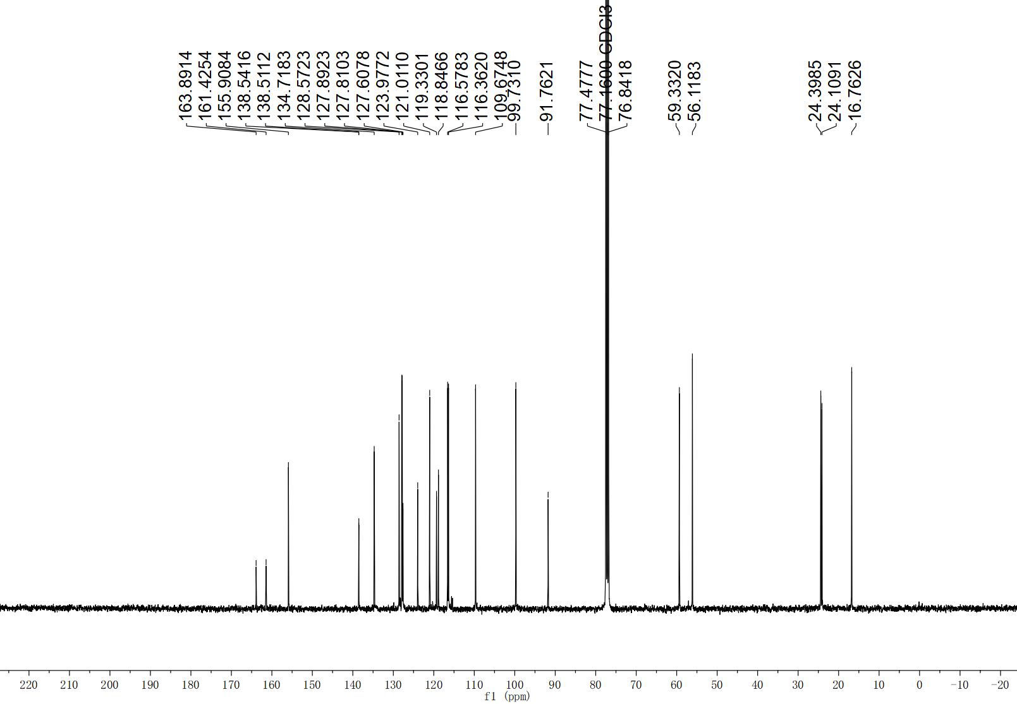
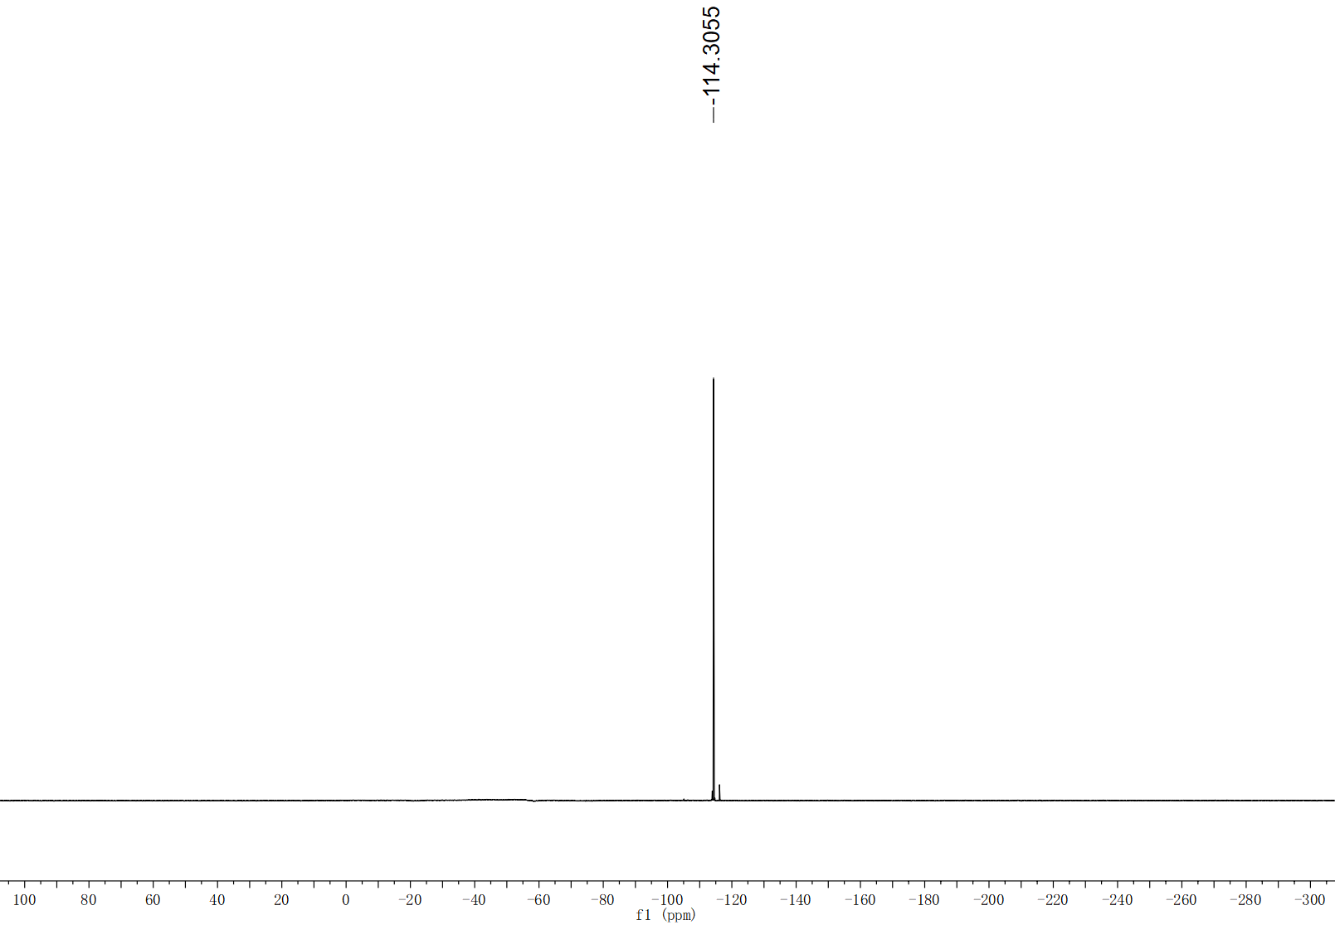
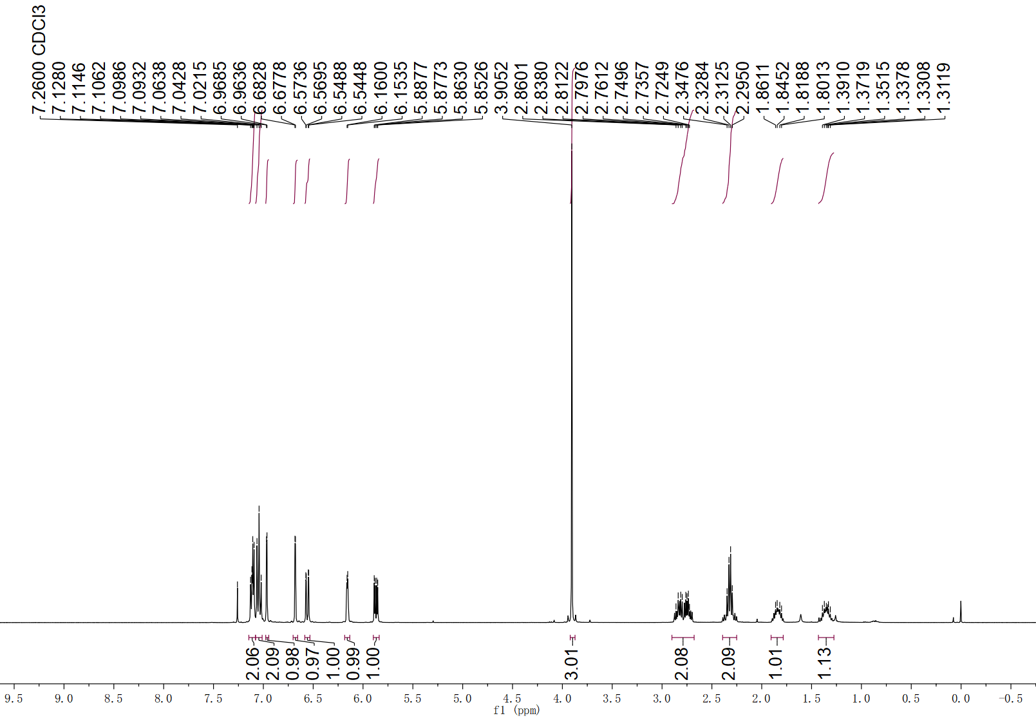
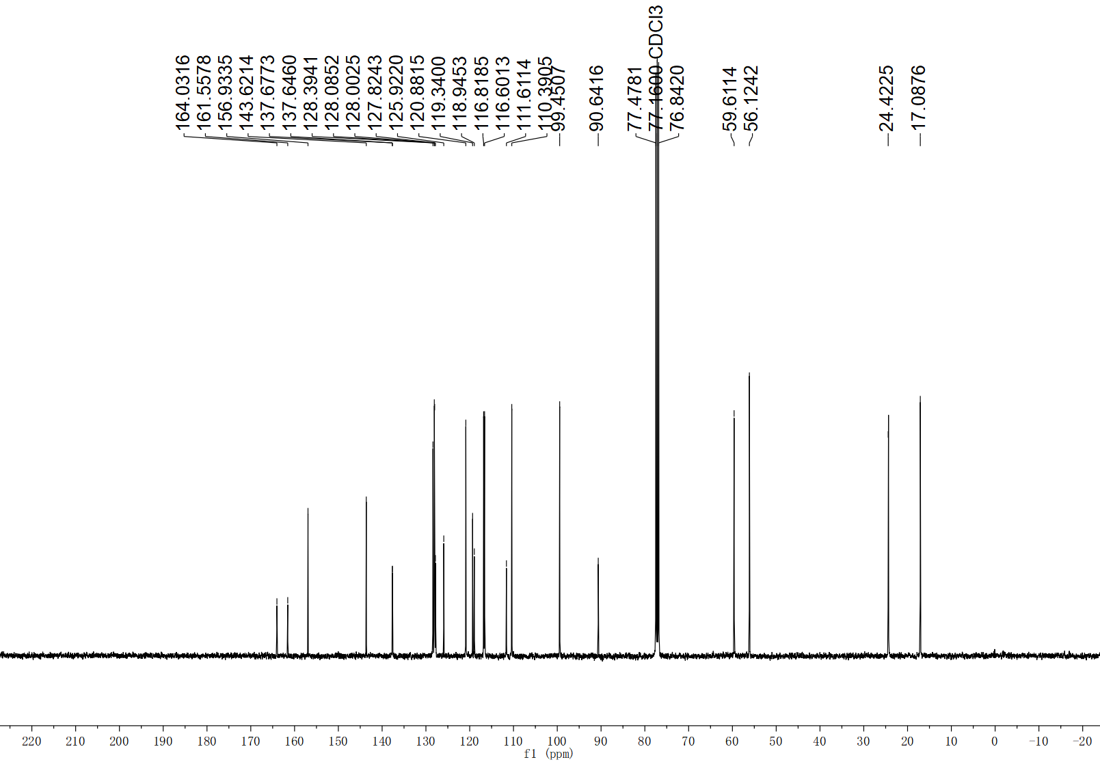
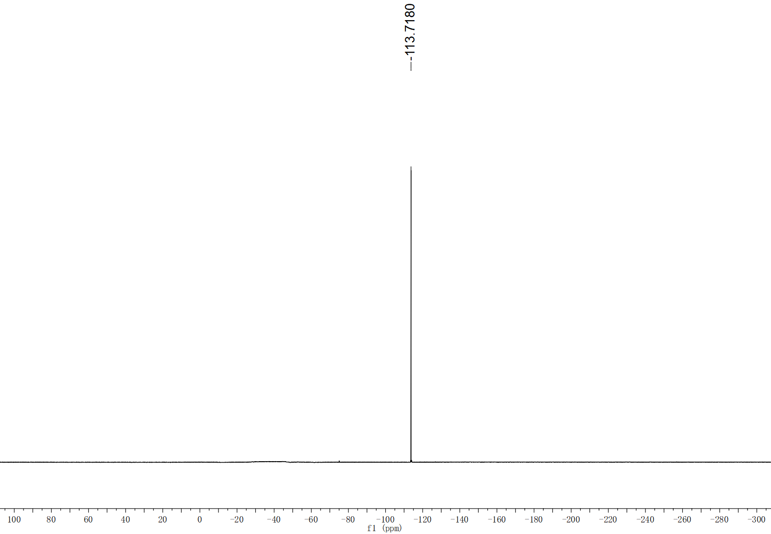
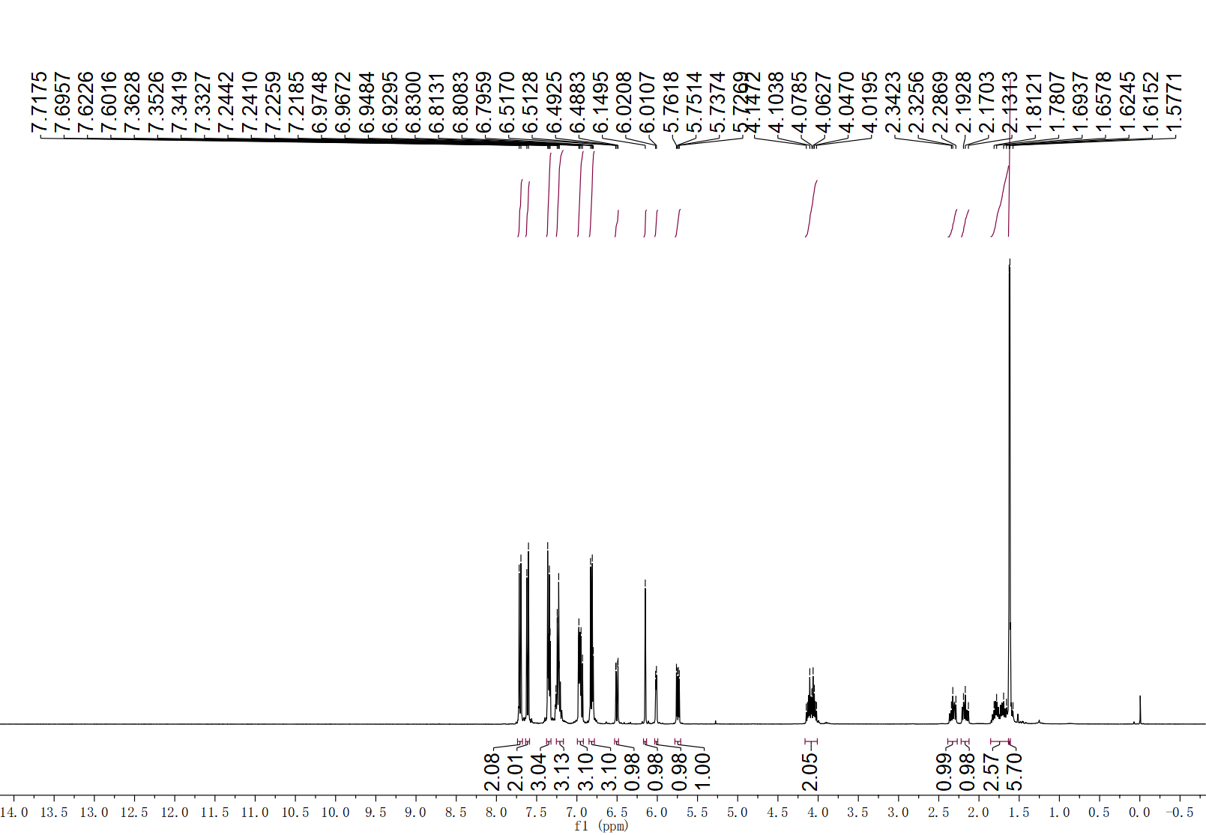
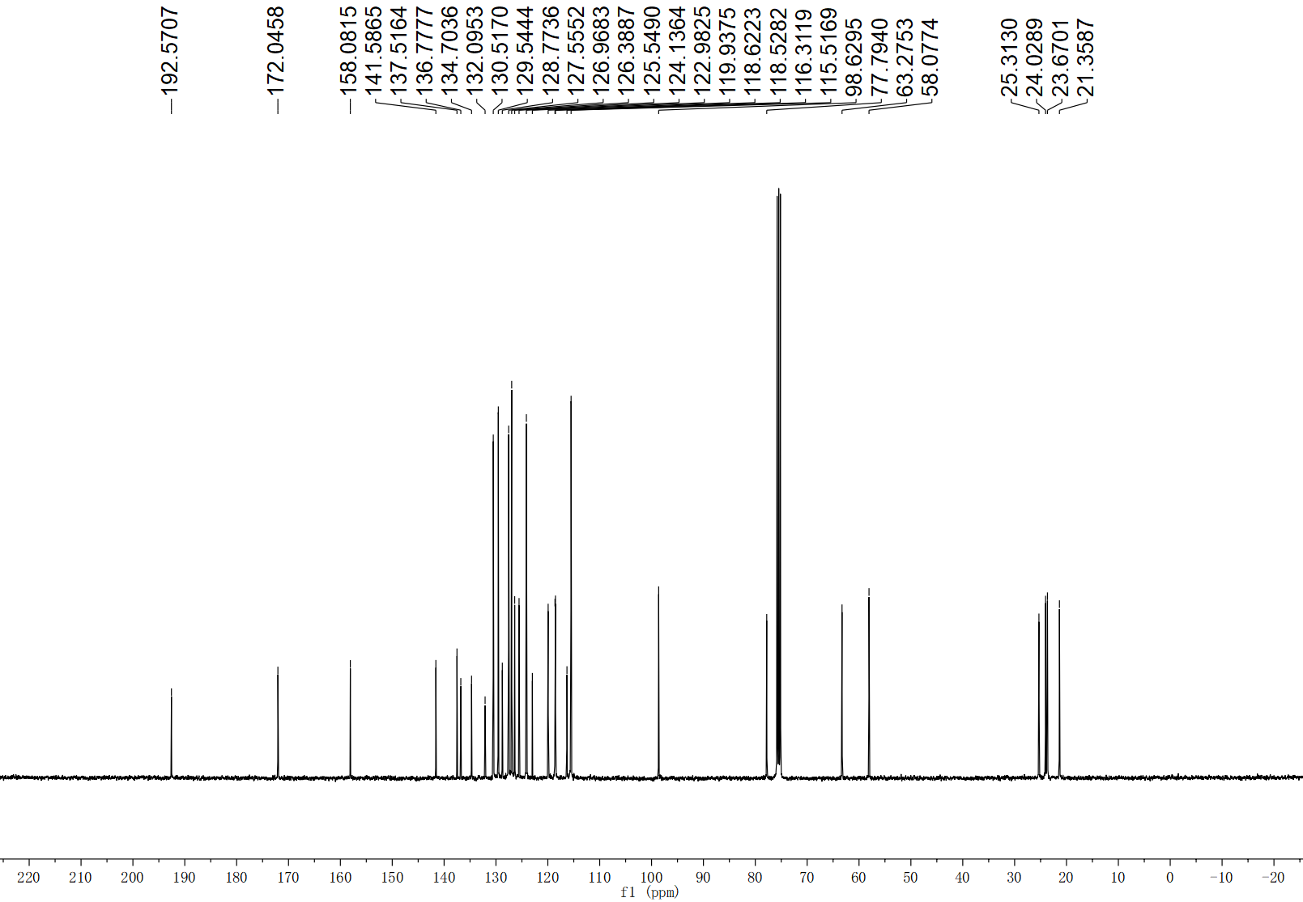
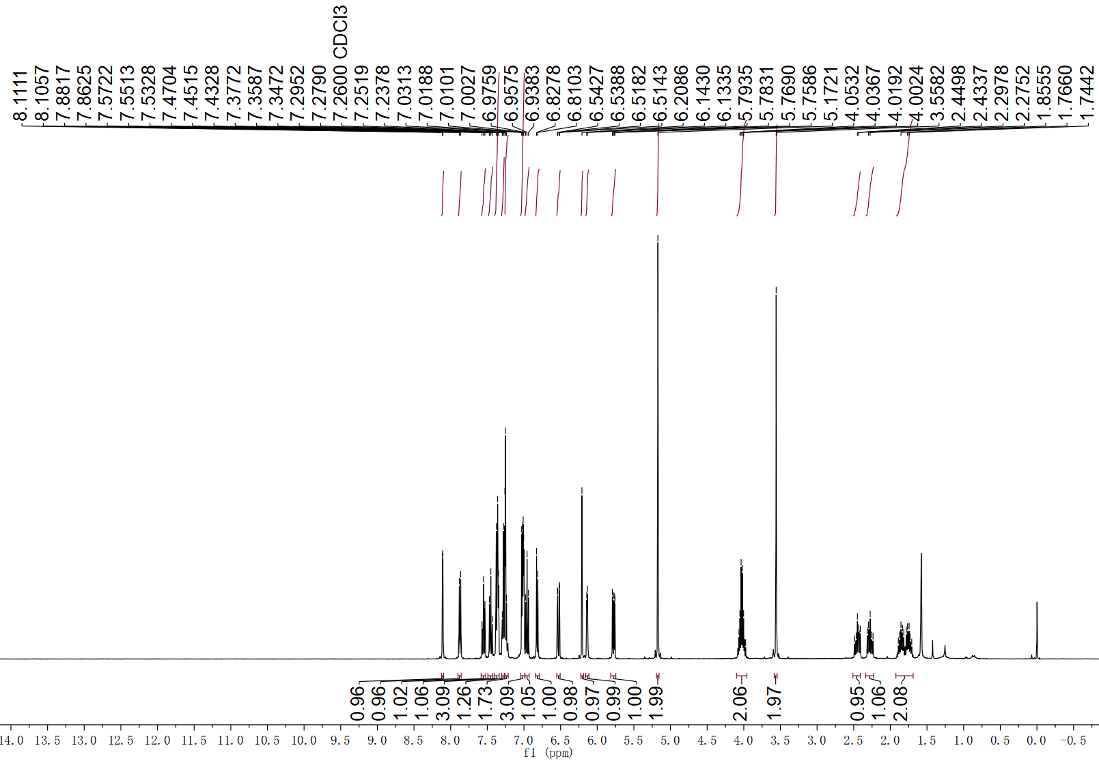
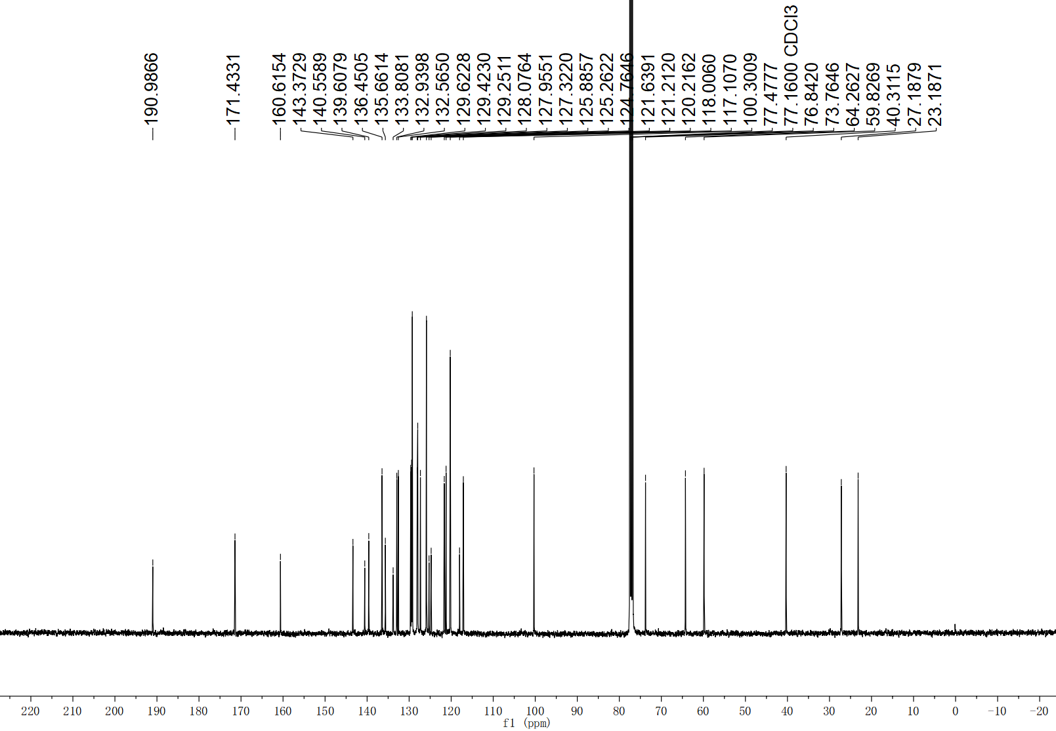
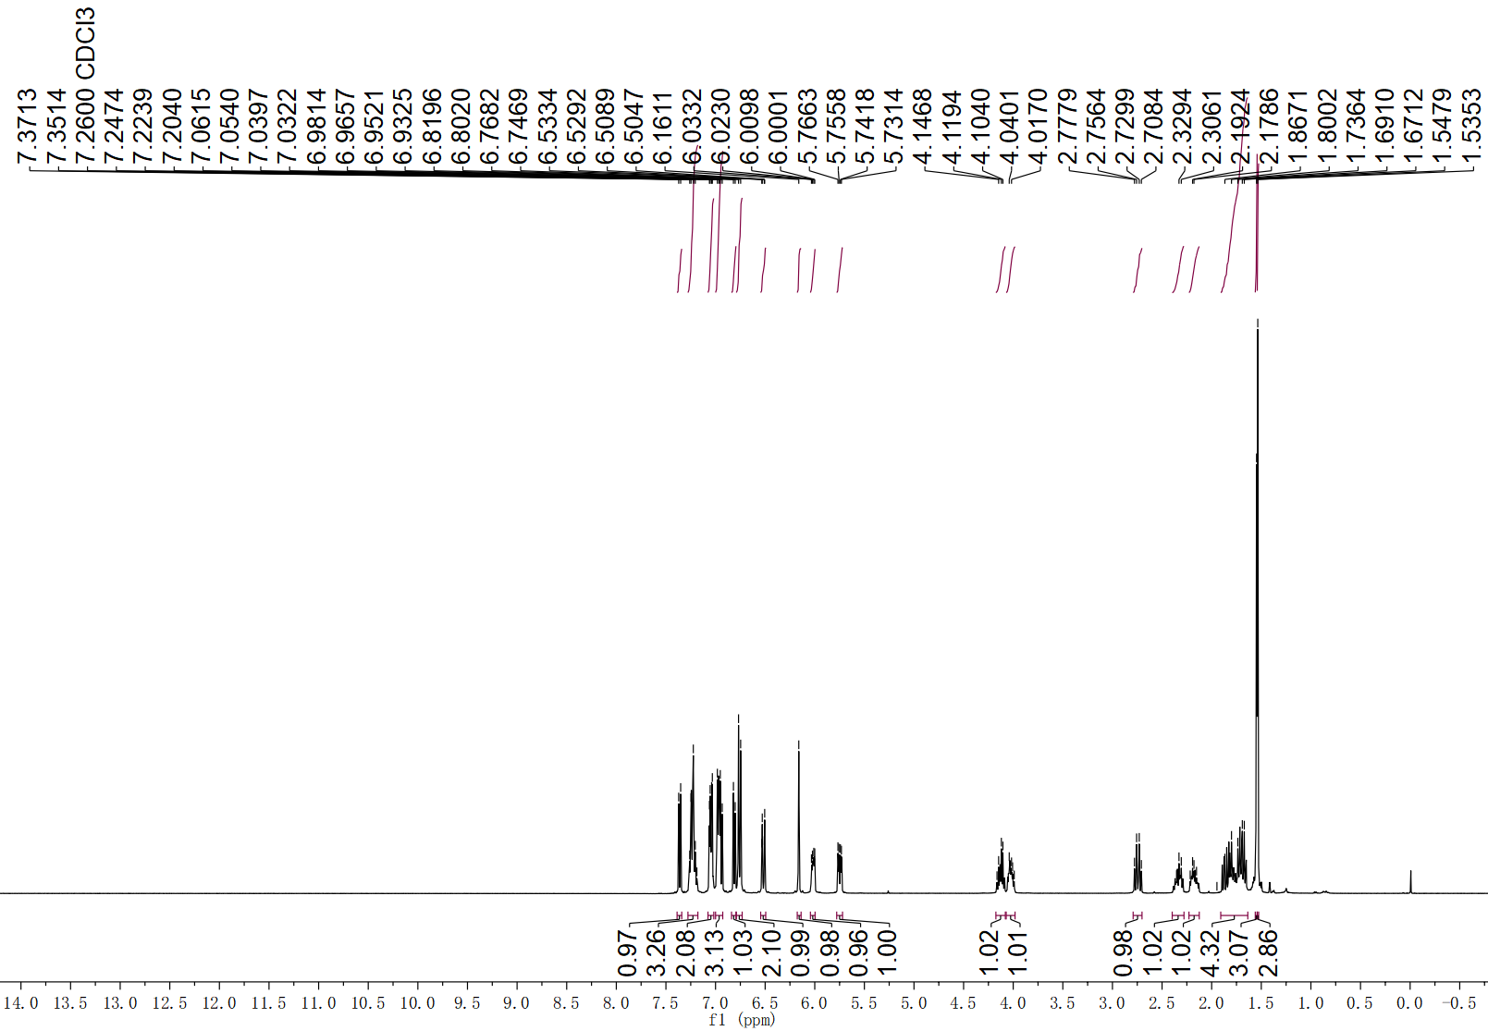
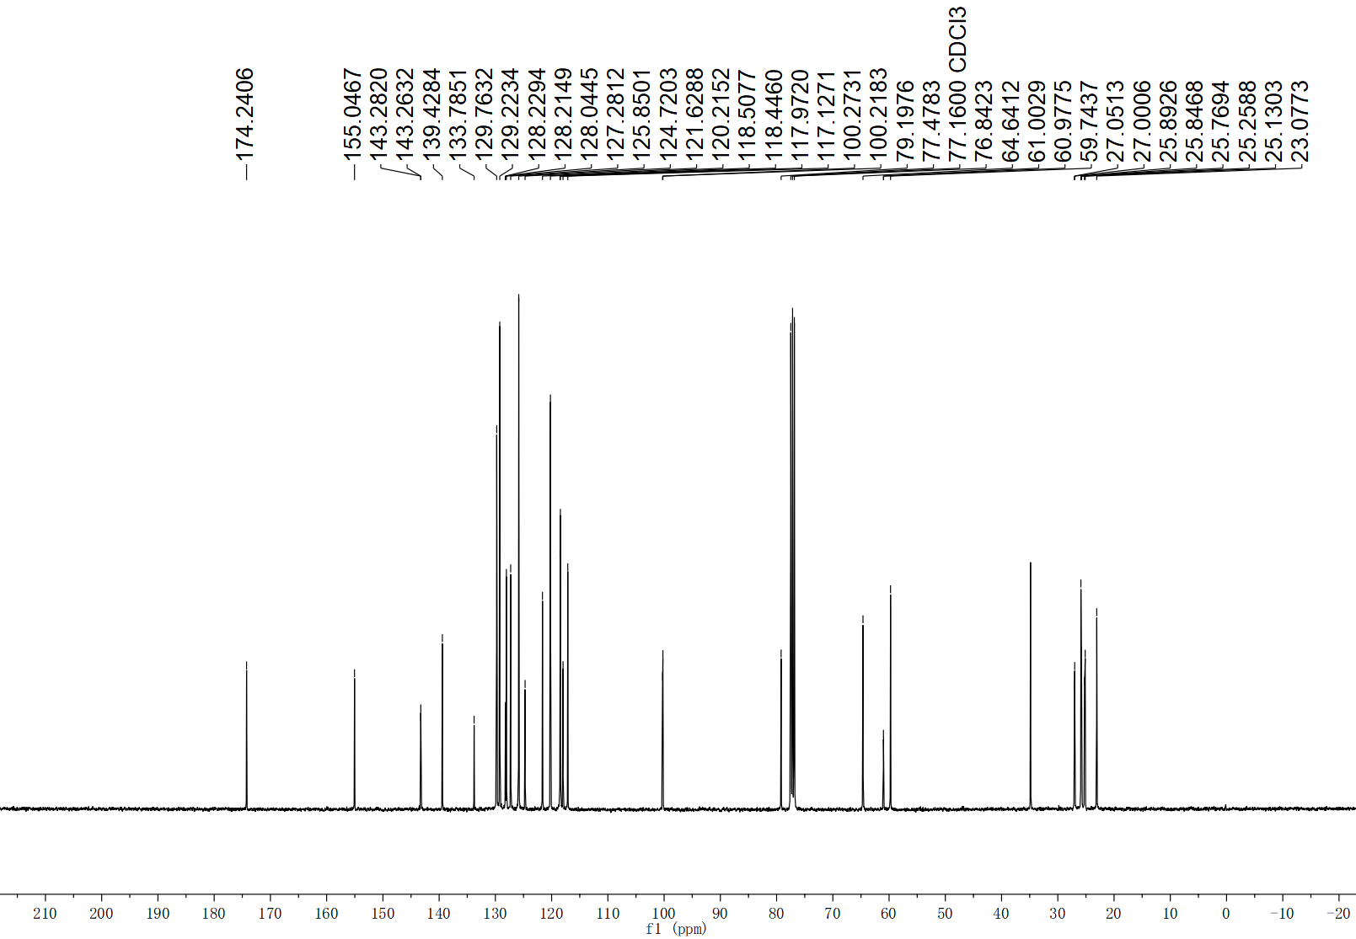
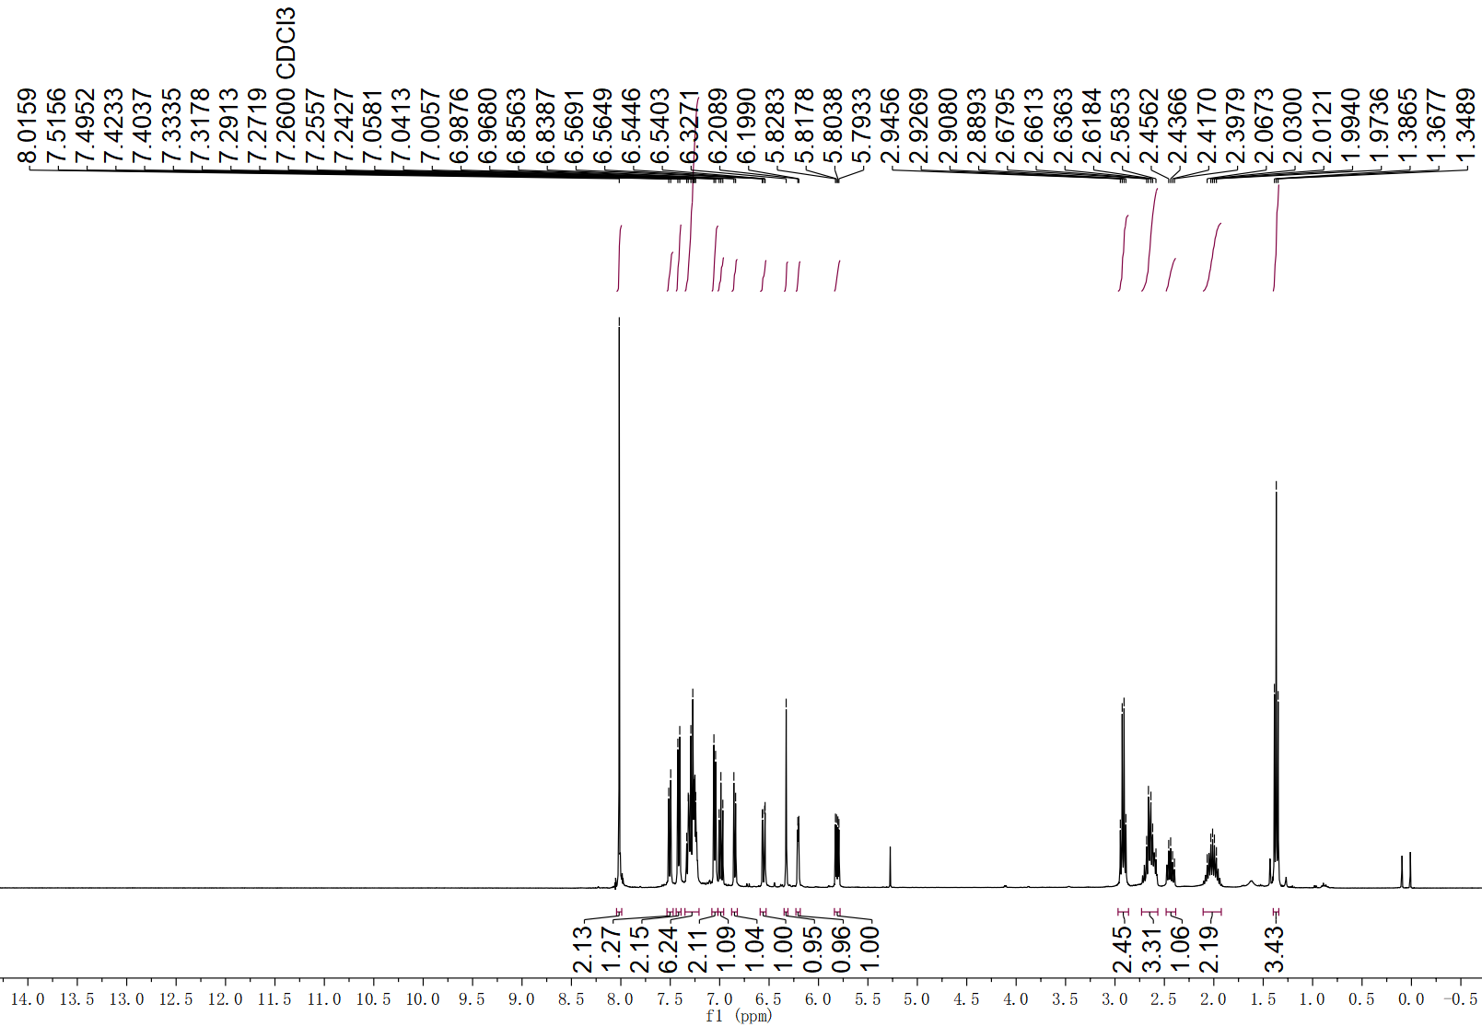
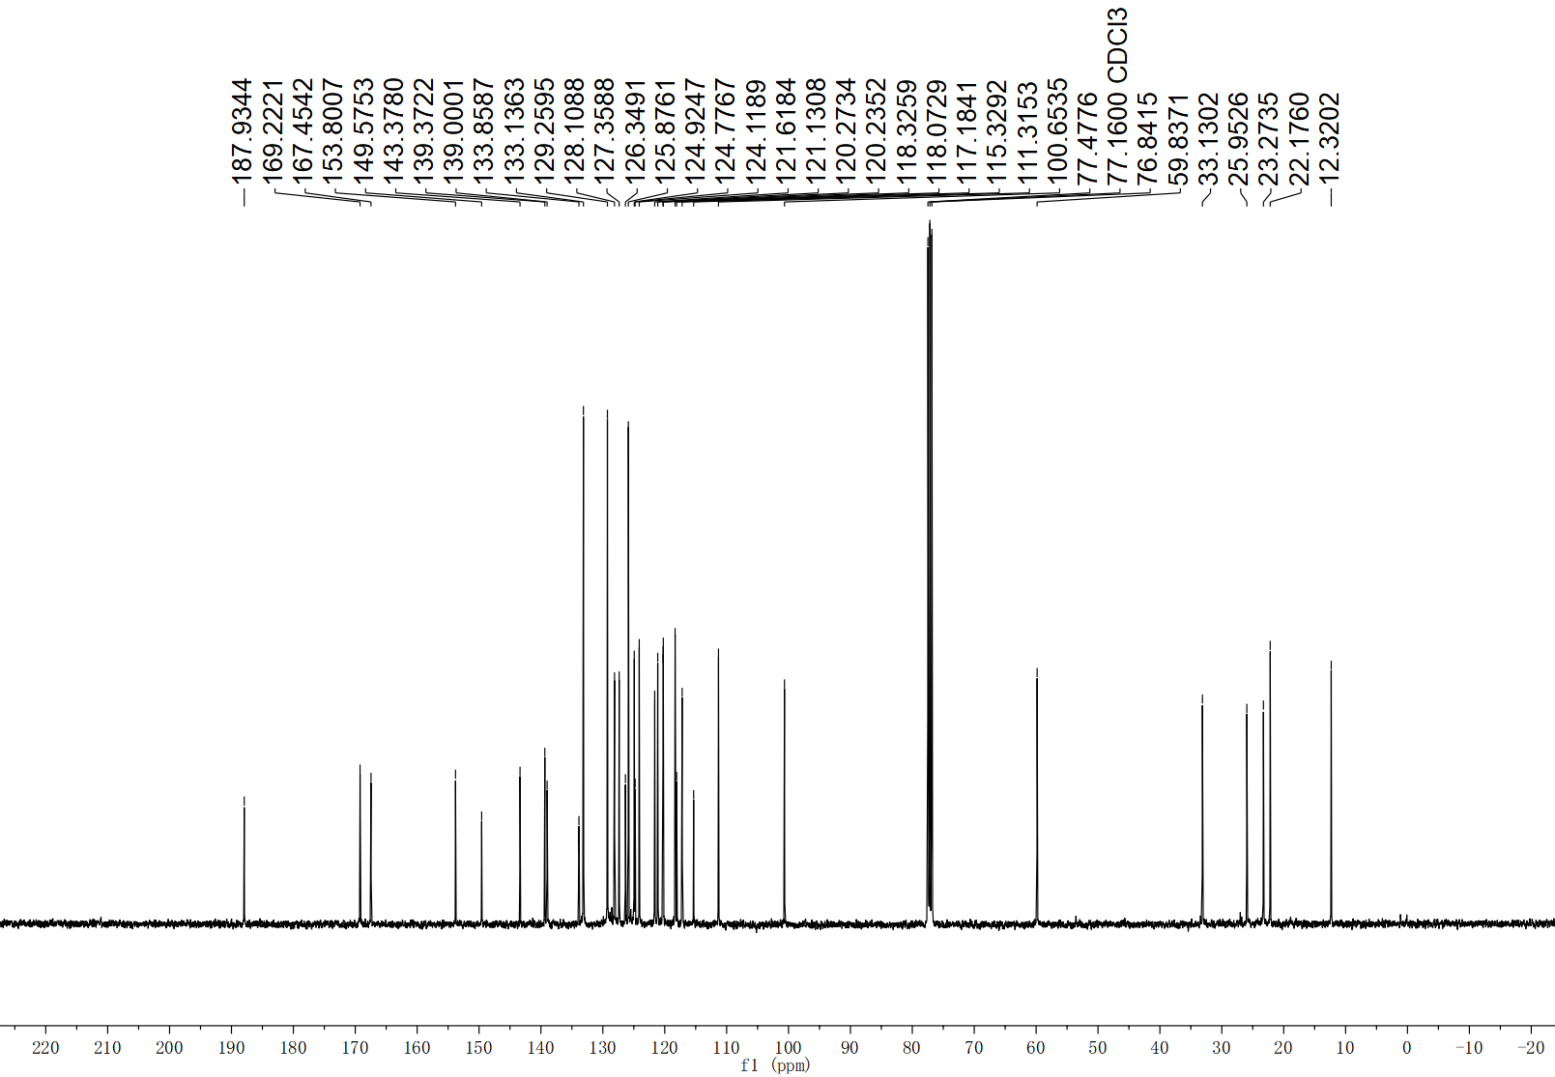
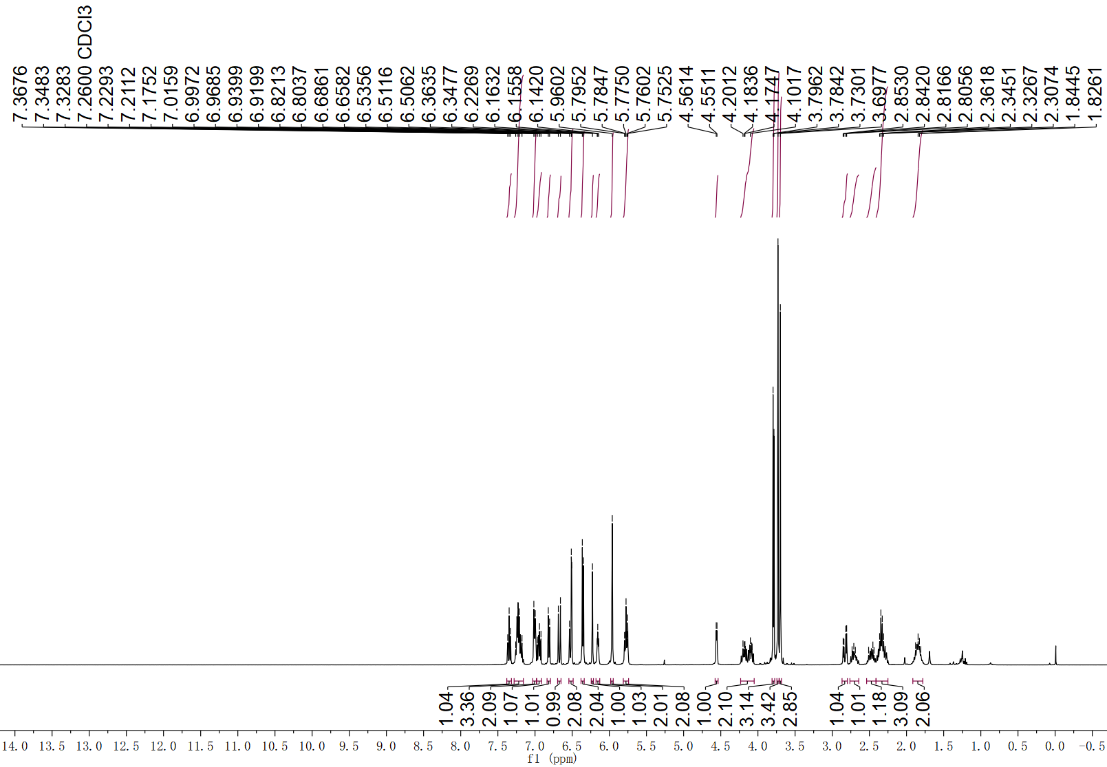
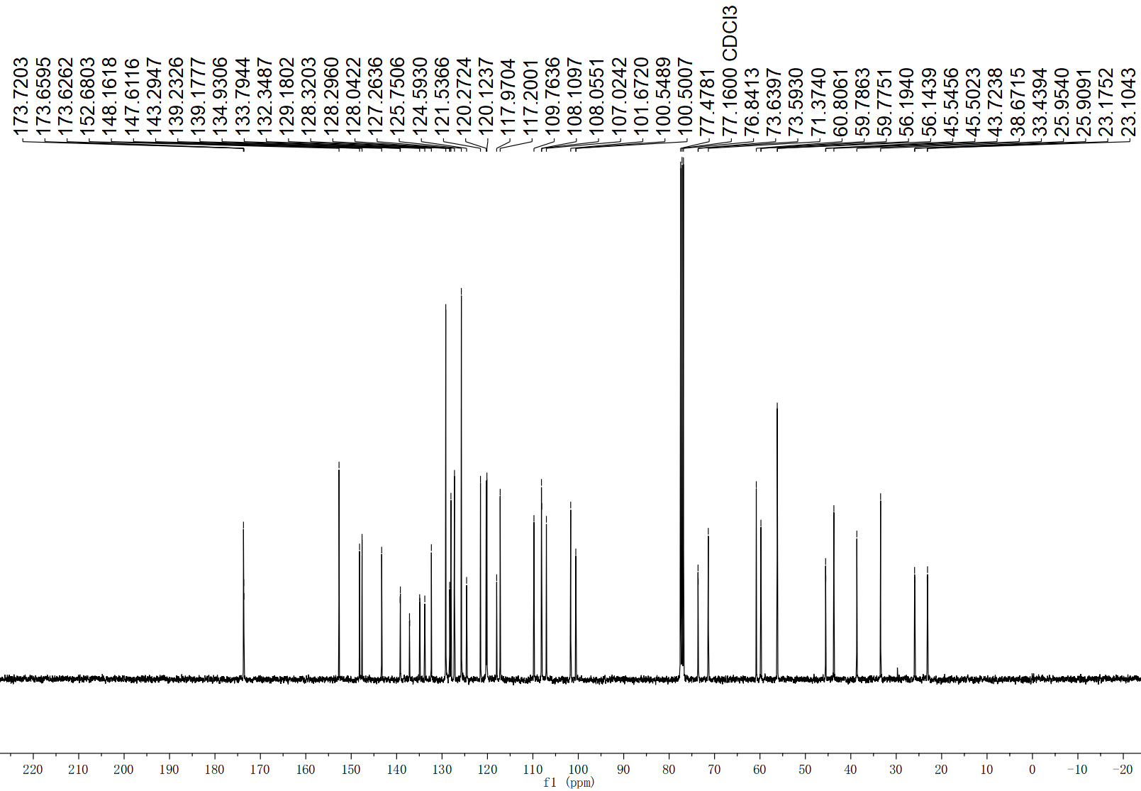
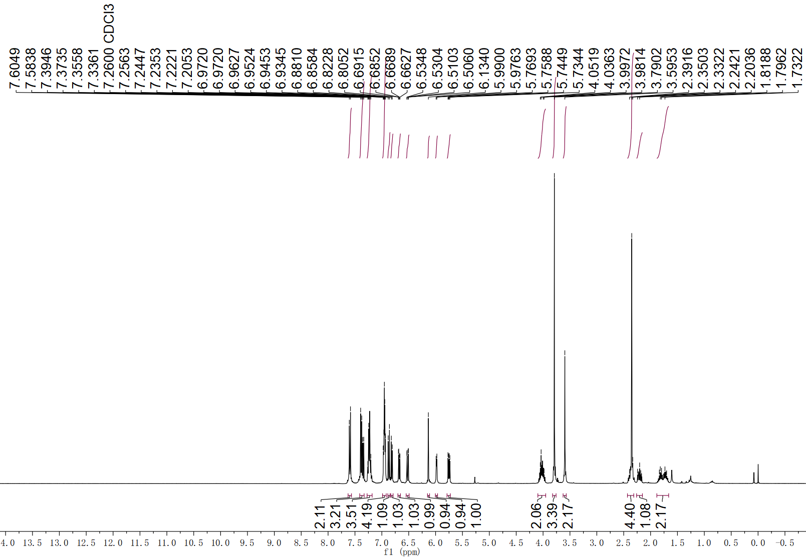
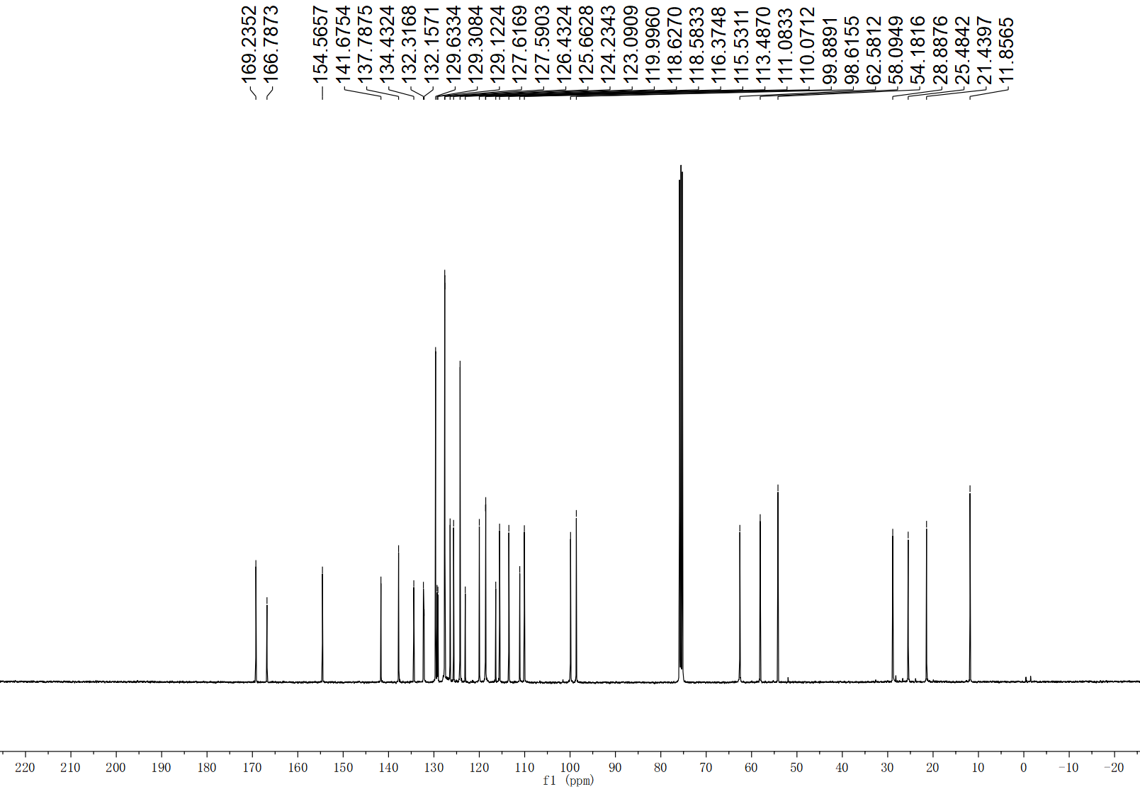
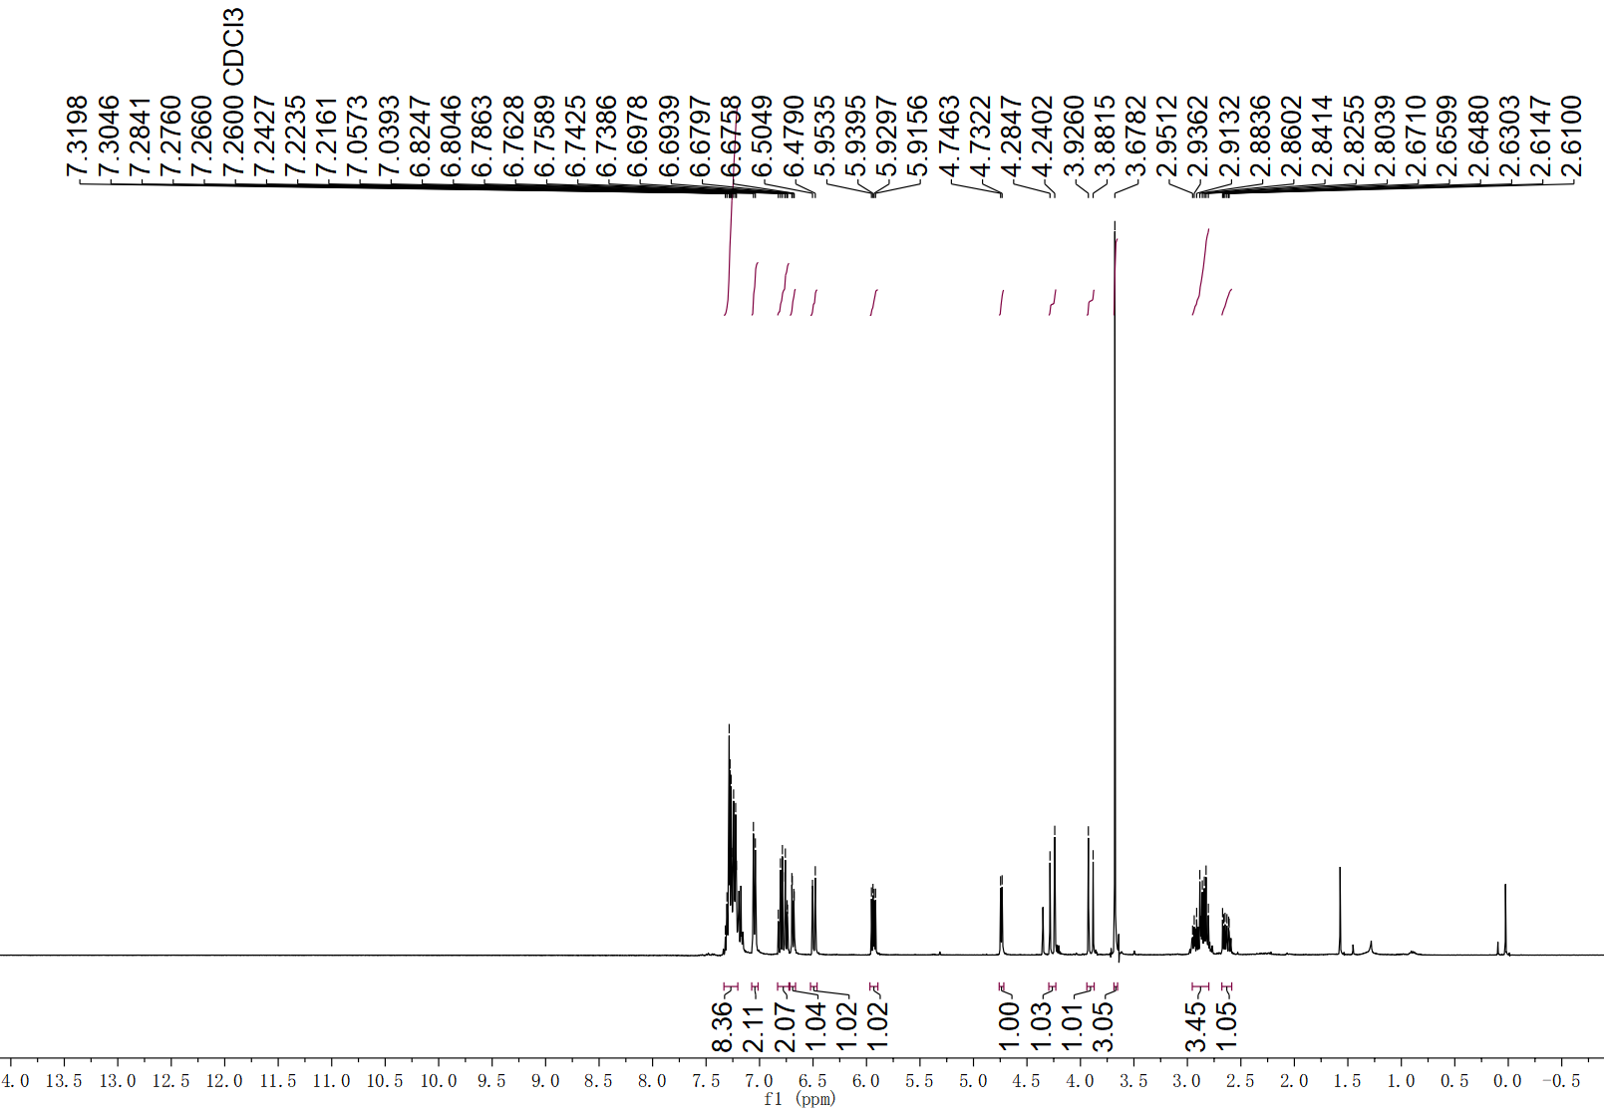
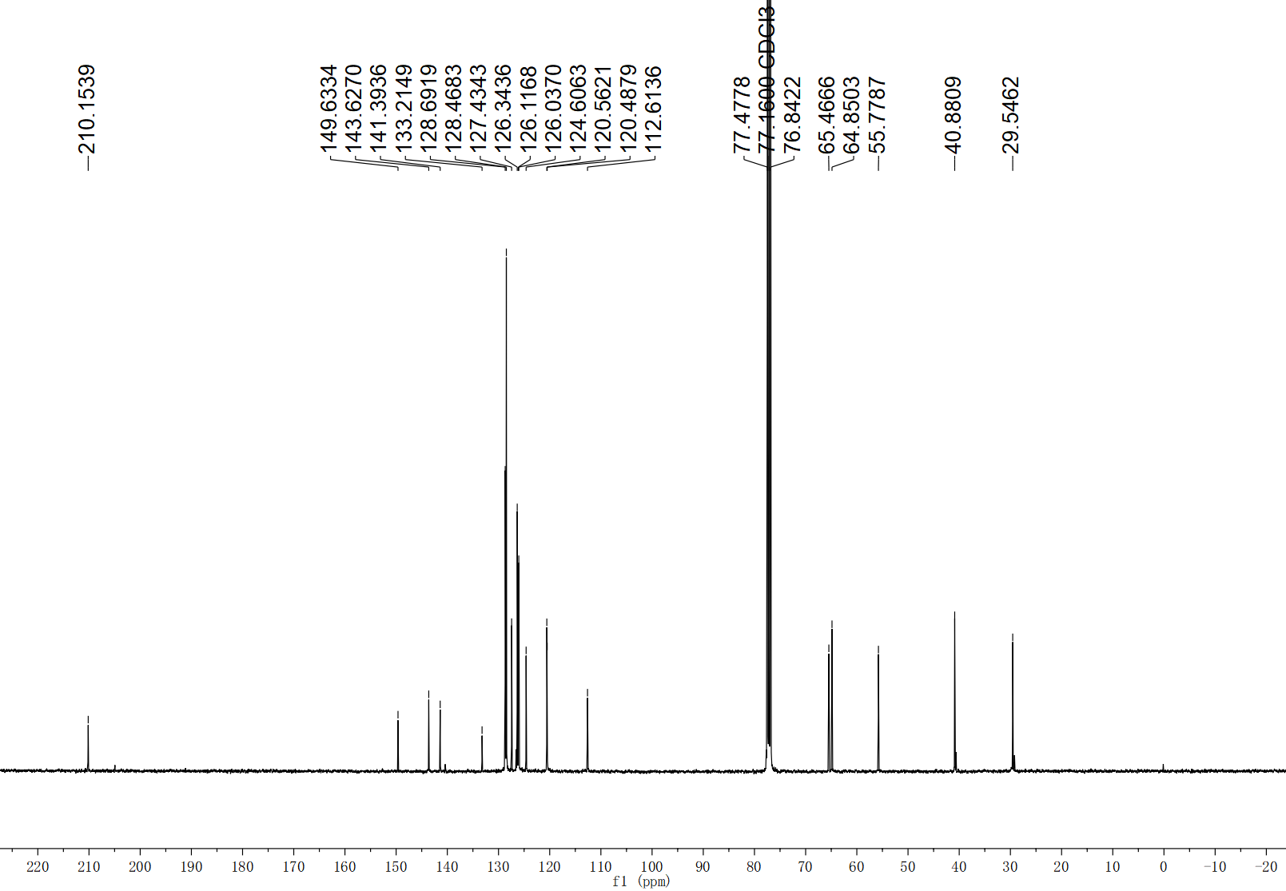
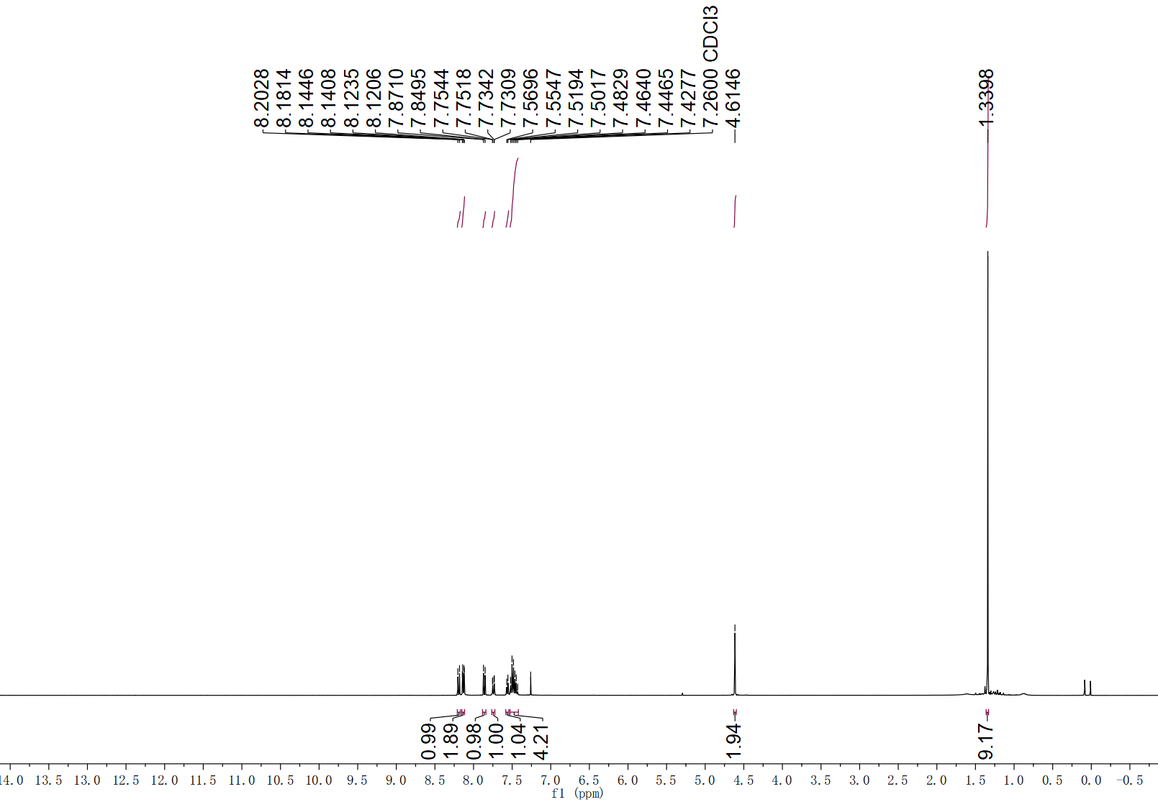
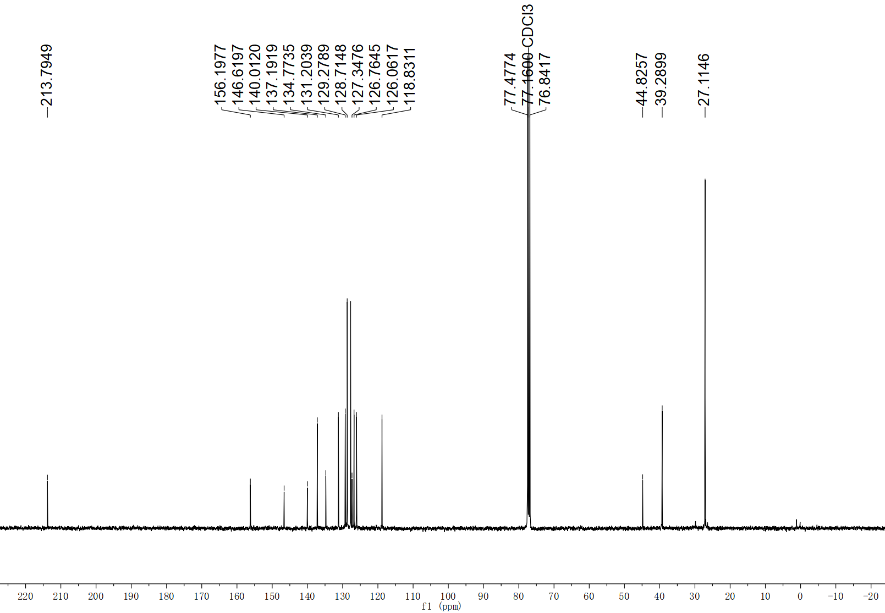

9. Single crystal X-ray diffraction
Single crystal of 5b for X-ray diffraction was grown by liquid-liquid diffusion in a n-hexane/DCM binary solvent system in a 10 mL screw cap vial at room temperature. The X-ray date of 5b is deposited in the Cambridge Crystallographic Data Centre with a number of CCDC 2391609.

(thermal ellipsoids are drawn at 50% probability)
Supplementary Figure 1. ORTEP representation of the X-ray structure of 5b
Supplementary Table 1. Crystal data and structure refinement for 5b

10. Reference
- Kanyiva, K. S., Nakao, Y. & Hiyama, T. Nickel-catalyzed addition of pyridine-N-oxides across alkynes. Angew. Chem. Int. Ed. 46, 8872–8874 (2007).
- Wang, Y. et al. Iron-catalyzed contrasteric functionalization of allenic C (sp2)–H bonds: synthesis of α-aminoalkyl 1,1-disubstituted allenes. J. Am. Chem. Soc. 143, 14998–15004 (2021).
- Gao, H. et al. Rapid heteroatom transfer to arylmetals utilizing multifunctional reagent scaffolds. Nat. Chem. 9, 681–688 (2017).
- Xu, Z., Chen, H., Wang, Z., Ying, A. & Zhang, L. One-pot synthesis of benzene-fused medium-ring ketones: gold catalysis-enabled enolate umpolung reactivity. J. Am. Chem. Soc. 138, 5515–5518 (2016).
- Boudry, E., Bourdreux, F., Marrot, J., Moreau, X. & Ghiazza, C. Dearomatization of pyridines: photochemical skeletal enlargement for the synthesis of 1,2-diazepines. J. Am. Chem. Soc. 146, 2845–2854 (2014).
- Zhao, B., Tan, H., Chen, C., Jiao, N. & Shi, Z. Photoinduced C–C Bond Cleavage and Oxidation of Cycloketoxime Esters. Chin. J. Chem. 36, 995–999 (2016).
- Heier, R. F. Synthesis and biological activities of (R)-5,6-dihydro-N,N-dimethyl-4H-imidazo [4,5,1-Ij] quinolin-5-amine and its metabolites. J. Med. Chem. 40, 639–646 (1997).
- Dey A. & Hajra, A. Potassium persulfate-mediated thiocyanation of 2H-indazole under iron-catalysis. Adv. Synth. Cat. 361, 842–849 (2019).
- Frisch, M. J. et al. Gaussian 09, revision A.1; Gaussian, Inc.: Wallingford, CT (2009).
- Zhao, Y. & Truhlar, D. G. Theor. Chem. Acc. 120, 215–241 (2008).
- Marenich, A. V., Cramer, C. J. & Truhlar, D. G. J. Phys. Chem. B. 113, 6378–6396 (2009).
- Legault, C. Y. CYL View 1.0b, Universite de Sherbrooke, Sherbrooke, Quebec, Canada (2009).

