Table 1 Percentage of environmental contribution of prebuilt models
Variable | Percent contribution | Permutation importance
alt | 71.1 | 69.5
bio_18 | 16.1 | 9
bio_1 | 3.5 | 2.8
slope | 2.7 | 1
aspect | 1.7 | 0.8
t_caco3 | 1.4 | 2.5
t_ph_h2o | 1 | 0.5
t_oc | 0.5 | 0.3
bio_4 | 0.3 | 6.8
bio_14 | 0.3 | 0
bio_5 | 0.2 | 0.1
t_esp | 0.2 | 0.3
t_silt | 0.2 | 0.4
bio_17 | 0.1 | 1.1
bio_2 | 0.1 | 0.5
bio_12 | 0.1 | 0.6
bio_11 | 0.1 | 0.3
bio_16 | 0.1 | 2.2
bio_19 | 0.1 | 0.1
t_usda_tex | 0.1 | 0.2
bio_3 | 0.1 | 0.2
t_gravel | 0.1 | 0.1
t_caso4 | 0 | 0
bio_15 | 0 | 0.3
t_sand | 0 | 0
t_clay | 0 | 0.1
bio_6 | 0 | 0
t_teb | 0 | 0.1
bio_8 | 0 | 0
t_bs | 0 | 0
bio_13 | 0 | 0
t_ece | 0 | 0
t_cec_soil | 0 | 0
bio_9 | 0 | 0
bio_10 | 0 | 0
t_ref_bulk | 0 | 0
bio_7 | 0 | 0
t_cec_clay | 0 | 0

Table 2 Correlation matrix of environmental factors of the Ophiocordyceps sinensis
 | t_usda_tex | alt | aspect | bio_1 | bio_2 | bio_3 | bio_4 | bio_5 | bio_11 | bio_12 | bio_14 | bio_16 | bio_17 | bio_18 | bio_19 | slope | t_caco3 | t_esp | t_gravel | t_oc | t_ph_h2o | t_silt
t_usda_tex | 1 | 0.299347 | -0.0205 | -0.36699 | 0.437771 | 0.12231 | 0.184894 | -0.22377 | -0.36709 | -0.45918 | -0.4388 | -0.43858 | -0.43919 | -0.41286 | -0.41742 | 0.017337 | -0.03403 | -0.08221 | 0.202797 | -0.1966 | 0.021979 | -0.30657
alt | 0.299347 | 1 | -0.01474 | -0.70044 | 0.413955 | 0.689078 | -0.37289 | -0.88939 | -0.38564 | -0.37603 | -0.3732 | -0.37309 | -0.36701 | -0.35828 | -0.31936 | 0.271861 | -0.20979 | -0.12292 | 0.303706 | 0.168455 | -0.2372 | 0.158572
aspect | -0.0205 | -0.01474 | 1 | -0.02307 | -0.01219 | -0.04431 | 0.048592 | 0.001794 | -0.03925 | 0.023251 | 0.033917 | 0.020609 | 0.034333 | 0.012093 | 0.04139 | 0.006078 | 0.004768 | -0.01687 | -0.02287 | 0.015896 | -0.01323 | 0.011403
bio_1 | -0.36699 | -0.70044 | -0.02307 | 1 | -0.60418 | -0.14399 | -0.31677 | 0.803155 | 0.913203 | 0.643653 | 0.623269 | 0.585736 | 0.621499 | 0.547505 | 0.589986 | -0.13755 | 0.180525 | 0.086593 | -0.031 | -0.13042 | 0.005615 | -0.22079
bio_2 | 0.437771 | 0.413955 | -0.01219 | -0.60418 | 1 | 0.282582 | 0.46703 | -0.23635 | -0.67385 | -0.84834 | -0.75819 | -0.80825 | -0.75117 | -0.78119 | -0.71048 | 0.025219 | 0.111843 | 0.139979 | -0.07918 | -0.07454 | 0.179103 | -0.09381
bio_3 | 0.12231 | 0.689078 | -0.04431 | -0.14399 | 0.282582 | 1 | -0.67508 | -0.50957 | 0.171317 | -0.04378 | -0.16998 | -0.02738 | -0.15793 | -0.00825 | -0.11204 | 0.224028 | -0.1462 | -0.08213 | 0.289534 | 0.104571 | -0.26867 | -0.00419
bio_4 | 0.184894 | -0.37289 | 0.048592 | -0.31677 | 0.46703 | -0.67508 | 1 | 0.292342 | -0.67492 | -0.55837 | -0.43606 | -0.51612 | -0.44033 | -0.49913 | -0.4506 | -0.20358 | 0.175133 | 0.164313 | -0.36063 | -0.13717 | 0.367256 | -0.05507
bio_5 | -0.22377 | -0.88939 | 0.001794 | 0.803155 | -0.23635 | -0.50957 | 0.292342 | 1 | 0.50008 | 0.235509 | 0.323214 | 0.189151 | 0.319629 | 0.154209 | 0.285937 | -0.24098 | 0.327765 | 0.213583 | -0.24115 | -0.23713 | 0.242699 | -0.28852
bio_11 | -0.36709 | -0.38564 | -0.03925 | 0.913203 | -0.67385 | 0.171317 | -0.67492 | 0.50008 | 1 | 0.740548 | 0.677525 | 0.675503 | 0.678055 | 0.637188 | 0.657612 | -0.02183 | 0.068119 | -0.00289 | 0.131432 | -0.04403 | -0.15142 | -0.14571
bio_12 | -0.45918 | -0.37603 | 0.023251 | 0.643653 | -0.84834 | -0.04378 | -0.55837 | 0.235509 | 0.740548 | 1 | 0.855706 | 0.973453 | 0.858633 | 0.938004 | 0.837503 | -0.08114 | -0.20088 | -0.1831 | 0.091724 | 0.113961 | -0.33132 | 0.024338
bio_14 | -0.4388 | -0.3732 | 0.033917 | 0.623269 | -0.75819 | -0.16998 | -0.43606 | 0.323214 | 0.677525 | 0.855706 | 1 | 0.747615 | 0.993552 | 0.659374 | 0.971822 | -0.08812 | -0.10883 | -0.11552 | 0.106176 | 0.069194 | -0.30028 | -0.01904
bio_16 | -0.43858 | -0.37309 | 0.020609 | 0.585736 | -0.80825 | -0.02738 | -0.51612 | 0.189151 | 0.675503 | 0.973453 | 0.747615 | 1 | 0.749622 | 0.983687 | 0.72791 | -0.10362 | -0.22194 | -0.19541 | 0.067512 | 0.121759 | -0.3063 | 0.049886
bio_17 | -0.43919 | -0.36701 | 0.034333 | 0.621499 | -0.75117 | -0.15793 | -0.44033 | 0.319629 | 0.678055 | 0.858633 | 0.993552 | 0.749622 | 1 | 0.658411 | 0.980256 | -0.08649 | -0.11224 | -0.11939 | 0.10424 | 0.073366 | -0.30529 | -0.02005
bio_18 | -0.41286 | -0.35828 | 0.012093 | 0.547505 | -0.78119 | -0.00825 | -0.49913 | 0.154209 | 0.637188 | 0.938004 | 0.659374 | 0.983687 | 0.658411 | 1 | 0.628016 | -0.10162 | -0.22642 | -0.19555 | 0.063052 | 0.124334 | -0.28158 | 0.066836
bio_19 | -0.41742 | -0.31936 | 0.04139 | 0.589986 | -0.71048 | -0.11204 | -0.4506 | 0.285937 | 0.657612 | 0.837503 | 0.971822 | 0.72791 | 0.980256 | 0.628016 | 1 | -0.07194 | -0.12087 | -0.1199 | 0.122853 | 0.076309 | -0.32292 | -0.02701
slope | 0.017337 | 0.271861 | 0.006078 | -0.13755 | 0.025219 | 0.224028 | -0.20358 | -0.24098 | -0.02183 | -0.08114 | -0.08812 | -0.10362 | -0.08649 | -0.10162 | -0.07194 | 1 | 0.074545 | -0.01912 | 0.092685 | 0.017305 | 0.031328 | 0.08703
t_caco3 | -0.03403 | -0.20979 | 0.004768 | 0.180525 | 0.111843 | -0.1462 | 0.175133 | 0.327765 | 0.068119 | -0.20088 | -0.10883 | -0.22194 | -0.11224 | -0.22642 | -0.12087 | 0.074545 | 1 | 0.35947 | -0.16054 | -0.18758 | 0.70246 | 0.264023
t_esp | -0.08221 | -0.12292 | -0.01687 | 0.086593 | 0.139979 | -0.08213 | 0.164313 | 0.213583 | -0.00289 | -0.1831 | -0.11552 | -0.19541 | -0.11939 | -0.19555 | -0.1199 | -0.01912 | 0.35947 | 1 | -0.10573 | -0.13038 | 0.343233 | 0.029816
t_gravel | 0.202797 | 0.303706 | -0.02287 | -0.031 | -0.07918 | 0.289534 | -0.36063 | -0.24115 | 0.131432 | 0.091724 | 0.106176 | 0.067512 | 0.10424 | 0.063052 | 0.122853 | 0.092685 | -0.16054 | -0.10573 | 1 | 0.127054 | -0.26537 | -0.08066
t_oc | -0.1966 | 0.168455 | 0.015896 | -0.13042 | -0.07454 | 0.104571 | -0.13717 | -0.23713 | -0.04403 | 0.113961 | 0.069194 | 0.121759 | 0.073366 | 0.124334 | 0.076309 | 0.017305 | -0.18758 | -0.13038 | 0.127054 | 1 | -0.20498 | 0.197804
t_ph_h2o | 0.021979 | -0.2372 | -0.01323 | 0.005615 | 0.179103 | -0.26867 | 0.367256 | 0.242699 | -0.15142 | -0.33132 | -0.30028 | -0.3063 | -0.30529 | -0.28158 | -0.32292 | 0.031328 | 0.70246 | 0.343233 | -0.26537 | -0.20498 | 1 | 0.264528
t_silt | -0.30657 | 0.158572 | 0.011403 | -0.22079 | -0.09381 | -0.00419 | -0.05507 | -0.28852 | -0.14571 | 0.024338 | -0.01904 | 0.049886 | -0.02005 | 0.066836 | -0.02701 | 0.08703 | 0.264023 | 0.029816 | -0.08066 | 0.197804 | 0.264528 | 1

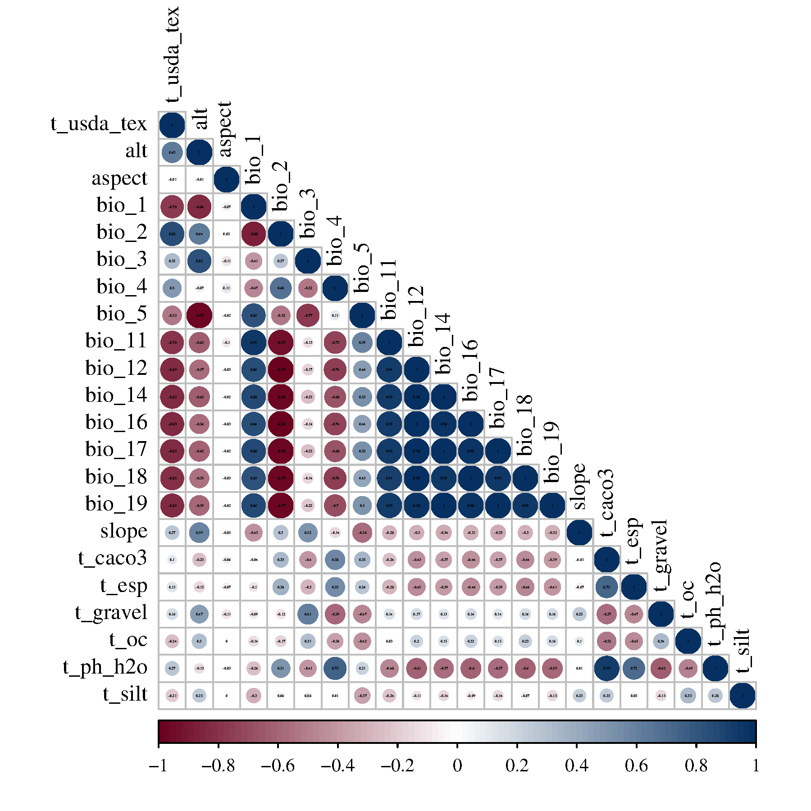
Figure S1 Spatial autocorrelation heat maps

