Title: Modelling enhanced phagocytosis of activated macrophage by outer membrane vesicles from Neisseria gonorrhoeae
Author: Jiaru Yang^{1,#}, Shilian Xu^{2,3,*,#}, Thomas Naderer^{1,*}
¹ Department of Biochemistry and Molecular Biology, Biomedicine Discovery Institute, Monash University, Clayton, VIC 3800, Australia
²The Taub Faculty of Computer Science, Technion—Israel Institute of Technology, Haifa 3200003, Israel
³Faculty of Biology, Technion—Israel Institute of Technology, Haifa 3200003, Israel

*Corresponding author: Thomas.Naderer@monash.edu, shlomo.bergger@gmail.com,
#Authors contributed equally to this work

This pdf file includes:
Supplementary text
Figures S1 to S7
Tables S1 to S14

Table of Contents
- Model Selection and Parameter Estimation
  - N. gonorrhoeae and E. coli Kinetics in Absence of Macrophages
  - Live Cell Imaging Data of Naive and NOMV-Activated Macrophages in Absence of Bacteria
  - Live Cell Imaging Data of NOMV-Activated Macrophages in Presence of E. coli
  - Live Cell Imaging Data of Naive Macrophages in Presence of E. coli
  - Live Cell Imaging Data of NOMV-Activated Macrophages in Presence of N. gonorrhoeae
  - Live Cell Imaging Data of Naive Macrophages in Presence of N. gonorrhoeae
- E. coli Kinetics in Presence of Macrophages Modelled by Semi-Saturated Systems (Systems 4 and 5)
- Activated and Naive Macrophage Kinetics Tested Against E. coli
- N. gonorrhoeae Kinetics in Presence of Naive/Activated Macrophages

- Model Selection and Parameter Estimation
In this section, we detail the process of selecting the most appropriate mathematical model and estimating parameters by delineating the live cell imaging (LCI) assay data. We specifically compare the performance of the saturated phagocytosis model (System 3, Methods, main text), the semi-saturated phagocytosis model with increasing bacterial concentration (System 4, Methods, main text), and the semi-saturated phagocytosis model with increasing macrophage concentration (System 5, Methods, main text).

  - N. gonorrhoeae and E. coli Kinetics in Absence of Macrophages
To characterize bacterial growth in isolation, we fitted the logistic growth model (System 1, Methods, main text) to previously published bacterial growth assay data.
For N. gonorrhoeae, data were obtained from Reference [1]. The estimated parameters for the logistic growth model were: per capita growth rate $r=0.2918(CFU/mL/hour)$, maximum carrying capacity $K=4.88×{10}^{10}(CFU/mL)$, and sum of squared error $SSE=0.0422$. The fitted growth curve for N. gonorrhoeae is presented in Figure S1A.
For E. coli, data were obtained from Reference [2]. The estimated parameters for the logistic growth model were: per capita growth rate $r=1.0665(CFU/mL/hour)$, maximum carrying capacity $K=5.6185×{10}^{9}(CFU/mL)$, sum of squared error (SSE) $SSE=0.5695$, and the fitted growth curve for E. coli is presented in Figure S1B.
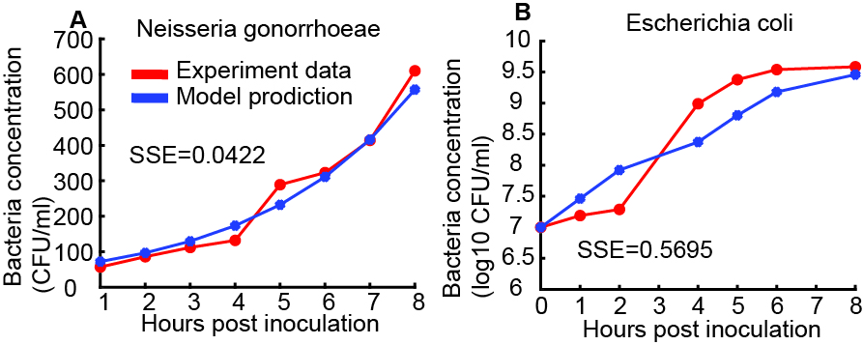
Figure S1: Fitted Logistic Growth Curves for Bacteria in the Absence of Macrophages. This figure displays the kinetics of bacterial growth without macrophage interaction, fitted to a logistic growth model (System 1). (A) N. gonorrhoeae Kinetics: Growth curve of N. gonorrhoeae. (B) E. coli Kinetics: Growth curve of E. coli.

  - Live Cell Imaging Data of Naive and NOMV-Activated Macrophages in Absence of Bacteria
To assess whether NOMV-induced activation impacts the natural death rate of macrophages, we fitted System 2 (Methods, main text) to live cell imaging data obtained from both naive macrophages and macrophages activated with N. gonorrhoeae Outer Membrane Vesicles (NOMVs), cultured in the absence of bacteria. The estimated natural death rates for naive and NOMV-activated macrophages are presented in Table S1 and Table S2, respectively.

Table S1: Natural Death Rate of Naive Macrophage
Biological  replicates | 1 | 2 | 3 | 4 | 5 | 6 | 7 | 8
Natural death rate | 0.0046 | 0.0031 | 0.0032 | 0.0016 | 0.0031 | 0.006 | 0.0043 | 0.0064
Biological  replicates | 9 | 10 | 11 | 12 | 13 | 14 | 15
Natural death rate | 0.004 | 0.0046 | 0.0018 | 0.0024 | 0.0051 | 0.0058 | 0.0056

Table S2: Natural Death Rate of Activated Macrophage by N. Gonorrhoeae OMV
Biological  replicates | 1 | 2 | 3 | 4 | 5 | 6 | 7 | 8
Natural death rate | 0.0038 | 0.0043 | 0.0026 | 0.0018 | 0.0024 | 0.0051 | 0.0058 | 0.0056

  - Live Cell Imaging Data of NOMV-Activated Macrophages in Presence of E. coli
To investigate the phagocytosis kinetics of macrophages activated by N. gonorrhoeae Outer Membrane Vesicles (NOMVs) against E. coli, we fitted three distinct models (System 3, System 4, and System 5; Methods, main text) to the corresponding live cell imaging (LCI) assay data. The fitted parameters, Sum of Squared Error (SSE), Akaike Information Criterion (AIC), and modified AIC for small sample sizes (AICc) for System 3, System 4, and System 5 are provided in Table S3, Table S4, and Table S5, respectively.

Table S3: Fitted Parameters and Model Selection Criteria for Saturated Phagocytosis Model (System 3) - NOMV-Activated Macrophages vs. E. coli
Biological replicates | 1 | 2 | 3 | 4
Phagocytosis rate, $κ$, (mL/cells/day) | 66.8634 | 78.7081 | 46.6332 | 46.7195
Saturation parameter in phagocytosis efficiency as bacteria cell concentration increases  η (mL/cells) | 4.6978 | 3.864 | 4.224 | 4.2595
Saturation parameter in phagocytosis efficiency as macrophage cell concentration increases  γ (mL/cells) | 14.3003 | 18.7187 | 1.2569 | 0.9496
Extra death rate due to phagocytosis, $λ$, (mL/cells/day) | 3.37E-05 | 2.06E-06 | 0.0092 | 0.0126
SSE | 0.0337 | 0.0171 | 0.0092 | 0.0103
AIC | -752.0089 | -845.6307 | -931.1735 | -915.5877
modified AIC | -751.3839 | -845.0057 | -930.5485 | -914.9627

Table S4: Fitted Parameters and Model Selection Criteria for Semi-Saturated Phagocytosis Model with Bacteria Concentration (System 4) - NOMV-Activated Macrophages vs. E. coli
Biological replicates | 1 | 2 | 3 | 4
Phagocytosis rate, $κ$, (mL/cells/day) | 68.8233 | 73.0971 | 56.0595 | 60.0507
Saturation parameter in phagocytosis efficiency as bacteria cell concentration increases  η (mL/cells) | 43.9864 | 25.7976 | 54.5774 | 57.2494
Extra death rate due to phagocytosis, $λ$, (mL/cells/day) | 2.40E-08 | 1.77E-07 | 0.0027 | 0.0084
SSE | 0.034 | 0.0171 | 0.003 | 0.0049
AIC | -752.8 | -847.6 | -1087.8 | -1020.1
modified AIC | -752.4 | -847.3 | -1087.4 | -1019.7

Table S5: Fitted Parameters and Model Selection Criteria for Semi-Saturated Phagocytosis Model with Macrophage Concentration (System 5) - NOMV-Activated Macrophages vs. E. coli
Biological replicates | 1 | 2 | 3 | 4
Phagocytosis rate, $κ$, (mL/cells/day) | 35.5867 | 56.0984 | 49.9454 | 50.0021
Saturation parameter in phagocytosis efficiency as macrophage cell concentration increases  γ (mL/cells) | 71.1729 | 63.2575 | 64.7963 | 63.8335
Extra death rate due to phagocytosis, $λ$, (mL/cells/day) | 2.95E-06 | 3.16E-05 | 0.1344 | 0.1884
SSE | 0.034 | 0.0171 | 0.0137 | 0.0104
AIC | -752.7858 | -847.6307 | -878.2230 | -916.2544
modified AIC | -752.4166 | -847.2615 | -877.8537 | -915.8851

  - Live Cell Imaging Data of Naive Macrophages in Presence of E. coli
To investigate the phagocytosis kinetics of naive macrophages against E. coli, we fitted three distinct models (System 3, System 4, and System 5; Methods, main text) to the corresponding live cell imaging (LCI) assay data. The fitted parameters, Sum of Squared Error (SSE), Akaike Information Criterion (AIC), and modified AIC for small sample sizes (AICc) for System 3, System 4, and System 5 are provided in Table S6, Table S7, and Table S8, respectively.

Table S6: Fitted Parameters and Model Selection Criteria for Saturated Phagocytosis Model (System 3) - Naive Macrophages vs. E. coli
Biological replicates | 1 | 2 | 3 | 4 | 5 | 6 | 7
Phagocytosis rate, $κ$, (mL/cells/day) | 50.4068 | 50.8152 | 56.6059 | 49.237 | 49.5568 | 49.2723 | 49.119
Saturation parameter in phagocytosis efficiency as bacteria cell concentration increases  η (mL/cells) | 67.6521 | 68.0495 | 59.8305 | 58.39 | 66.8251 | 71.4966 | 70.4025
Saturation parameter in phagocytosis efficiency as macrophage cell concentration increases  γ (mL/cells) | 0.0211 | 0.1268 | 54.5686 | 61.8907 | 0.0089 | 0.1669 | 0.122
Extra death rate due to phagocytosis, $λ$, (mL/cells/day) | 0.4457 | 0.3465 | 4.19E-05 | 2.73E-08 | 0.4685 | 0.3268 | 0.3745
SSE | 0.0166 | 0.0167 | 0.0175 | 0.0141 | 0.0801 | 0.0171 | 0.0248
AIC | -849.7260 | -848.8972 | -842.4399 | -872.2515 | -632.5315 | -845.6307 | -794.3272
modified AIC | -849.1010 | -848.2722 | -841.8149 | -871.6265 | -631.9065 | -845.0057 | -793.7022

Table S7: Fitted Parameters and Model Selection Criteria for Semi-Saturated Phagocytosis Model with Bacteria Concentration (System 4) - Naive Macrophages vs. E. coli
Biological replicates | 1 | 2 | 3 | 4 | 5 | 6 | 7
Phagocytosis rate, $κ$, (mL/cells/day) | 66.6254 | 61.0711 | 73.6504 | 72.1898 | 61.3574 | 60.0161 | 60.2089
Saturation parameter in phagocytosis efficiency as bacteria cell concentration increases  η (mL/cells) | 52.0481 | 55.4989 | 26.0224 | 26.5057 | 53.8954 | 54.4341 | 54.2794
Extra death rate due to phagocytosis, $λ$, (mL/cells/day) | 0.2887 | 0.0487 | 2.61E-06 | 4.57E-06 | 0.1107 | 0.0452 | 0.058
SSE | 0.1068 | 0.0061 | 0.0175 | 0.0141 | 0.0085 | 0.0081 | 0.0044
AIC | -594.8 | -989.9 | -844.4 | -874.3 | -944.1 | -950.7 | -1035.0
modified AIC | -594.5 | -989.5 | -844.1 | -873.9 | -943.7 | -950.4 | -1034.6

Table S8: Fitted Parameters and Model Selection Criteria for Semi-Saturated Phagocytosis Model with Macrophage Concentration (System 5) - Naive Macrophages vs. E. coli
Biological replicates | 1 | 2 | 3 | 4 | 5 | 6 | 7
Phagocytosis rate, $κ$, (mL/cells/day) | 50.0866 | 50.0416 | 64.6045 | 60.7073 | 50.012 | 49.9803 | 50.0093
Saturation parameter in phagocytosis efficiency as macrophage cell concentration increases  γ (mL/cells) | 57.818 | 60.7902 | 54.8838 | 58.5504 | 57.0684 | 61.7378 | 60.1092
Extra death rate due to phagocytosis, $λ$, (mL/cells/day) | 0.3809 | 0.3095 | 9.83E-07 | 4.01E-08 | 0.4001 | 0.2822 | 0.3198
SSE | 0.0166 | 0.0167 | 0.0175 | 0.0141 | 0.0801 | 0.0171 | 0.0248
AIC | -851.7260 | -850.8972 | -844.4399 | -874.2515 | -634.5315 | -847.6307 | -796.3272
modified AIC | -851.3568 | -850.5279 | -844.0706 | -873.8822 | -634.1623 | -847.2615 | -795.9579

  - Live Cell Imaging Data of NOMV-Activated Macrophages in Presence of N. gonorrhoeae
To investigate the phagocytosis kinetics of macrophages activated by N. gonorrhoeae Outer Membrane Vesicles (NOMVs) against N. gonorrhoeae, we fitted three distinct mathematical models (System 3, System 4, and System 5; described in Methods, main text) to the corresponding live cell imaging (LCI) assay data. The fitted parameters, Sum of Squared Error (SSE), Akaike Information Criterion (AIC), and modified AIC for small sample sizes (AICc) for each system are provided in Table S9, Table S10, and Table S11, respectively.

Table S9: Fitted Parameters and Model Selection Criteria for Saturated Phagocytosis Model (System 3) - NOMV-Activated Macrophages vs. N. gonorrhoeae
Biological replicates | 1 | 2 | 3 | 4 | 5
Phagocytosis rate, $κ$, (mL/cells/day) | 47.3779 | 45.6748 | 49.364 | 23.3262 | 27.6001
Saturation parameter in phagocytosis efficiency as bacteria cell concentration increases  η (mL/cells) | 74.8081 | 73.7972 | 64.4408 | 18.032 | 1.9544
Saturation parameter in phagocytosis efficiency as macrophage cell concentration increases  γ (mL/cells) | 0.1301 | 23.098 | 43.4671 | 77.5091 | 76.6851
Extra death rate due to phagocytosis, $λ$, (mL/cells/day) | 0.0953 | 5.93E-06 | 5.93E-06 | 3.18E-06 | 0.0196
SSE | 0.0266 | 0.005 | 0.0635 | 0.0634 | 0.0048
AIC | -784.7 | -1015.3 | -664.6 | -664.8 | -1021.0
modified AIC | -784.0 | -1014.7 | -664.0 | -664.2 | -1020.3

Table S10: Fitted Parameters and Model Selection Criteria for Semi-Saturated Phagocytosis Model with Bacteria Concentration (System 4) - NOMV-Activated Macrophages vs. N. gonorrhoeae
Biological replicates | 1 | 2 | 3 | 4 | 5
Phagocytosis rate, $κ$, (mL/cells/day) | 64.8426 | 73.285 | 46.8581 | 47.9293 | 19.5402
Saturation parameter in phagocytosis efficiency as bacteria cell concentration increases  η (mL/cells) | 5.2828 | 19.1051 | 67.9002 | 67.4882 | 72.4092
Extra death rate due to phagocytosis, $λ$, (mL/cells/day) | 0.3899 | 0.002 | 3.09E-08 | 4.97E-05 | 0.0138
SSE | 0.0082 | 0.005 | 0.0635 | 0.0634 | 0.0042
AIC | -949.1 | -1017.3 | -666.6 | -666.8 | -1041.4
modified AIC | -948.7 | -1017.0 | -666.2 | -666.4 | -1041.0

Table S11: Fitted Parameters and Model Selection Criteria for Semi-Saturated Phagocytosis Model with Macrophage Concentration (System 5) - NOMV-Activated Macrophages vs. N. gonorrhoeae
Biological replicates | 1 | 2 | 3 | 4 | 5
Phagocytosis rate, $κ$, (mL/cells/day) | 49.9984 | 68.0498 | 63.2437 | 74.1031 | 50.001
Saturation parameter in phagocytosis efficiency as macrophage cell concentration increases  γ (mL/cells) | 65.6108 | 46.4311 | 54.4128 | 44.4505 | 61.3906
Extra death rate due to phagocytosis, $λ$, (mL/cells/day) | 0.0836 | 1.51E-04 | 1.36E-05 | 8.97E-09 | 0.2903
SSE | 0.0266 | 0.005 | 0.0635 | 0.0634 | 0.0326
AIC | -786.7 | -1017.3 | -666.6 | -666.8 | -758.6
modified AIC | -786.3 | -1017.0 | -666.2 | -666.4 | -758.2

  - Live Cell Imaging Data of Naive Macrophages in Presence of N. gonorrhoeae
To investigate the phagocytosis kinetics of naive macrophages against N. gonorrhoeae, we fitted three distinct mathematical models (System 3, System 4, and System 5; described in Methods, main text) to the corresponding live cell imaging (LCI) assay data. The fitted parameters, Sum of Squared Error (SSE), Akaike Information Criterion (AIC), and modified AIC for small sample sizes (AICc) for each system are provided in Table S12, Table S13, and Table S14, respectively.

Table S12. Fitted Parameters and Model Selection Criteria for Saturated Phagocytosis Model (System 3) - Naive Macrophages vs. N. gonorrhoeae
Biological replicates | 1 | 2 | 3 | 4 | 5 | 6 | 7
Phagocytosis rate, $κ$, (mL/cells/day) | 47.6199 | 47.7335 | 0.0719 | 78.4991 | 38.5021 | 48.4022 | 16.3876
Saturation parameter in phagocytosis efficiency as bacteria cell concentration increases  η (mL/cells) | 73.8057 | 74.8552 | 0.2036 | 3.3577 | 43.4596 | 8.9934 | 1.0454
Saturation parameter in phagocytosis efficiency as macrophage cell concentration increases  γ (mL/cells) | 0.1358 | 0.1986 | 0.2319 | 4.4539 | 69.1047 | 73.2936 | 44.9156
Extra death rate due to phagocytosis, $λ$, (mL/cells/day) | 0.1961 | 0.1113 | 3.43E-05 | 0.2062 | 2.19E-08 | 0.0477 | 0.0182
SSE | 0.0235 | 0.0162 | 0.0129 | 0.0124 | 0.0223 | 0.006 | 0.0083
AIC | -801.7575 | -853.0920 | -884.5262 | -889.9815 | -808.9906 | -990.1608 | -945.3803
modified AIC | -801.1325 | -852.4670 | -883.9012 | -889.3565 | -808.3656 | -989.5358 | -944.7553

Table S13. Fitted Parameters and Model Selection Criteria for Semi-Saturated Phagocytosis Model with Bacteria Concentration (System 4) - Naive Macrophages vs. N. gonorrhoeae
Biological replicates | 1 | 2 | 3 | 4 | 5 | 6 | 7
Phagocytosis rate, $κ$, (mL/cells/day) | 50.6705 | 69.0394 | 67.5151 | 71.9034 | 69.6431 | 20.7509 | 19.823
Saturation parameter in phagocytosis efficiency as bacteria cell concentration increases  η (mL/cells) | 5.9423 | 6.6237 | 6.715 | 7.7576 | 42.9766 | 72.1989 | 72.8661
Extra death rate due to phagocytosis, $λ$, (mL/cells/day) | 0.4825 | 0.4158 | 0.1183 | 0.1992 | 1.88E-07 | 0.0208 | 0.0149
SSE | 0.0322 | 0.0096 | 0.0091 | 0.0124 | 0.0223 | 0.0063 | 0.0101
AIC | -760.2922 | -927.3003 | -934.6817 | -891.9815 | -810.9906 | -985.4277 | -920.2937
modified AIC | -759.9230 | -926.9310 | -934.3125 | -891.6122 | -810.6214 | -985.0585 | -919.9245

Table S14. Fitted Parameters and Model Selection Criteria for Semi-Saturated Phagocytosis Model with Macrophage Concentration (System 5) - Naive Macrophages vs. N. gonorrhoeae
Biological replicates | 1 | 2 | 3 | 4 | 5 | 6 | 7
Phagocytosis rate, $κ$, (mL/cells/day) | 49.9652 | 50.2589 | 49.904 | 49.9774 | 59.8801 | 49.995 | 50.2828
Saturation parameter in phagocytosis efficiency as macrophage cell concentration increases  γ (mL/cells) | 64.178 | 64.396 | 66.411 | 66.4987 | 60.0922 | 62.4944 | 61.2259
Extra death rate due to phagocytosis, $λ$, (mL/cells/day) | 0.1706 | 0.0958 | 0.011 | 0.0201 | 1.64E-05 | 0.2499 | 0.2875
SSE | 0.0235 | 0.0162 | 0.0129 | 0.0215 | 0.0223 | 0.009 | 0.0307
AIC | -803.7575 | -855.0920 | -886.5262 | -816.0323 | -810.9906 | -936.2066 | -766.8753
modified AIC | -803.3883 | -854.7228 | -886.1570 | -815.6630 | -810.6214 | -935.8374 | -766.5061

- E. coli Kinetics in Presence of Macrophages Modelled by Semi-Saturated Systems (Systems 4 and 5)
As discussed previously, the semi-saturated models (System 4 and System 5) generally provided a better fit to the live cell imaging data than the saturated model (System 3). However, when applied to E. coli kinetics in the presence of macrophages, both semi-saturated models yielded biologically unrealistic predictions regarding the macrophage concentration required for bacterial inhibition.
Specifically, System 5 predicted bacterial inhibition at an extremely low macrophage concentration, less than 1 cell/mL, which is not biologically plausible. Conversely, System 4 predicted that bacterial inhibition would only occur at a very high macrophage concentration (approximately 4.5 × 10⁹ cells/mL), which also falls outside typical physiological ranges.
For illustration:
- System 4: Incorporating the estimated parameters (second column in Table S14), the bifurcation diagram for System 4 is presented in Figure S2. This figure indicates that E. coli inhibition occurs at approximately 4.5 × 10⁹cells/mL, a macrophage concentration significantly higher than normally encountered.
- System 5: Utilizing the estimated parameters (second column in Table S15), the bifurcation diagram for System 5 is shown in Figure S3. This model predicts E. coli inhibition at macrophage concentrations less than 1 cell/mL, which is not biologically reasonable.
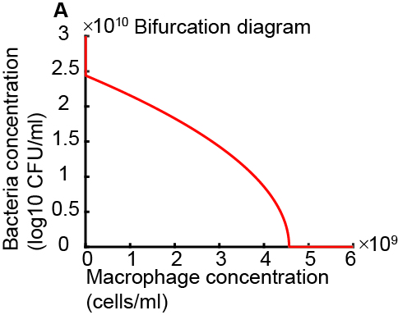
Figure. S2 Bifurcation Diagram for Semi-Saturated Phagocytosis Model with Bacteria Concentration (System 4). This figure presents the bifurcation diagram derived from System 4, illustrating the long-term E. coli kinetics as a function of macrophage concentration. The diagram indicates that bacterial inhibition occurs at approximately 4.5 × 10⁹ cells/mL, a macrophage concentration significantly higher than physiologically relevant levels.
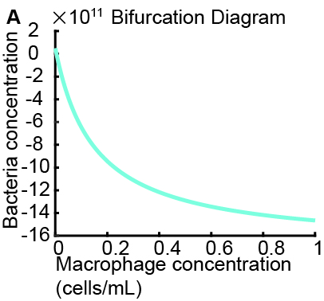
Figure. S3 Bifurcation Diagram for Semi-Saturated Phagocytosis Model with Macrophage Concentration (System 5). This figure presents the bifurcation diagram derived from System 5, illustrating the long-term E. coli kinetics as a function of macrophage concentration. The diagram indicates that bacterial inhibition occurs at macrophage concentrations less than 1 cell/mL, which is not biologically plausible.

- Activated and Naive Macrophage Kinetics Tested Against E. coli
The main text (Figures 4 and 5) details the kinetics of E. coli in the presence of both naive and activated macrophages. Complementing those findings, this section provides the corresponding macrophage kinetics: the activated macrophage kinetics are shown in Figure S4, and the naive macrophage kinetics are shown in Figure S5.
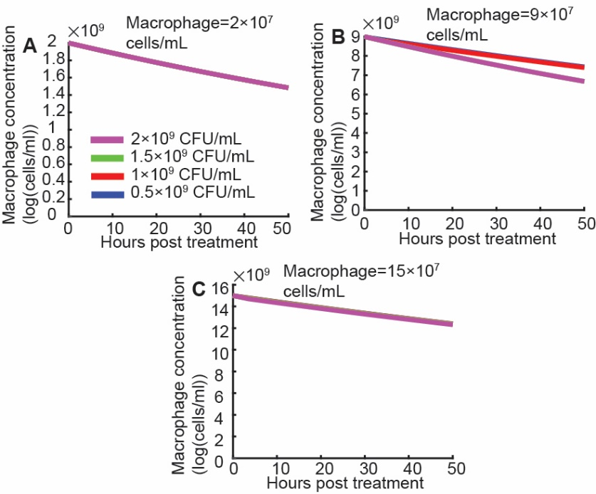
Figure. S4 Activated Macrophage Kinetics Across Varying Bacterial Inoculum Sizes. This figure illustrates the dynamic changes in activated macrophage concentration over time when co-cultured with E. coli at different initial bacterial inoculum sizes and macrophage concentrations. (A) Macrophage Concentration at 2 × 10⁷ cells/mL: Kinetics of activated macrophage concentration starting at 2 × 10⁷ cells/mL. (B) Macrophage Concentration at 9 × 10⁷ cells/mL: Kinetics of activated macrophage concentration starting at 9 × 10⁷ cells/mL. (C) Macrophage Concentration at 15 × 10⁷ cells/mL: Kinetics of activated macrophage concentration starting at 15 × 10⁷ cells/mL. In panels (A-C), the blue, red, green, and purple lines (and corresponding circles) represent macrophage kinetics when co-cultured with initial E. coli inoculum sizes of 0.5×10⁹ CFU/mL, 1×10⁹ CFU/mL, 1.5×10⁹ CFU/mL, and 2×10⁹ CFU/mL, respectively.

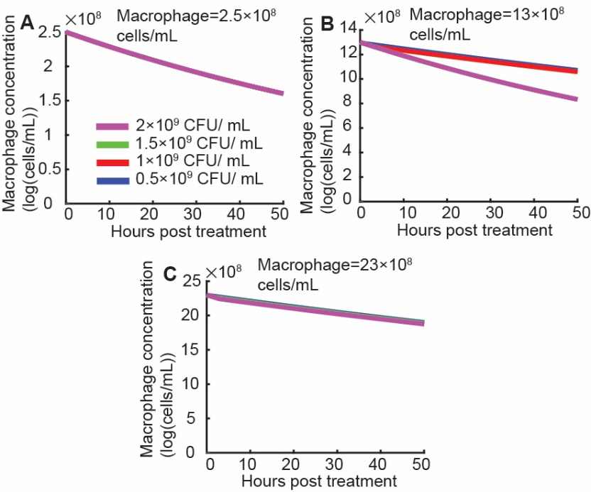
Figure. S5 Naive Macrophage Kinetics Across Varying Bacterial Inoculum Sizes. This figure illustrates the dynamic changes in naive macrophage concentration over time when co-cultured with E. coli at different initial bacterial inoculum sizes and macrophage concentrations. (A) Macrophage Concentration at 2 × 10⁷ cells/mL: Kinetics of naive macrophage concentration starting at 2 × 10⁷ cells/mL. (B) Macrophage Concentration at 9 × 10⁷ cells/mL: Kinetics of naive macrophage concentration starting at 9 × 10⁷ cells/mL. (C) Macrophage Concentration at 15 × 10⁷ cells/mL: Kinetics of naive macrophage concentration starting at 15 × 10⁷ cells/mL. In panels (A-C), the blue, red, green, and purple lines (and corresponding circles) represent macrophage kinetics when co-cultured with initial E. coli inoculum sizes of 0.5×10⁹ CFU/mL, 1×10⁹ CFU/mL, 1.5×10⁹ CFU/mL, and 2×10⁹ CFU/mL, respectively.

- N. gonorrhoeae Kinetics in Presence of Naive/Activated Macrophages
Building upon the E. coli kinetics presented in the main text (Figures 4 and 5), this section details the dynamics of N. gonorrhoeae when co-cultured with naive and activated macrophages. Our analysis demonstrates that bistable N. gonorrhoeae kinetics exist regardless of whether macrophages are activated or naive (Figures S6 and S7).
Similar to our observations with E. coli, distinct threshold values for macrophage concentration are associated with the inhibition of N. gonorrhoeae:
- For activated macrophages, the threshold macrophage concentration corresponding to inhibition of N. gonorrhoeae is approximately 4.9 × 10⁸ cells/mL (Figure S6D).
- For naive macrophages, this threshold value is considerably higher, approximately 5.6 × 10⁹ cells/mL (Figure S7D).

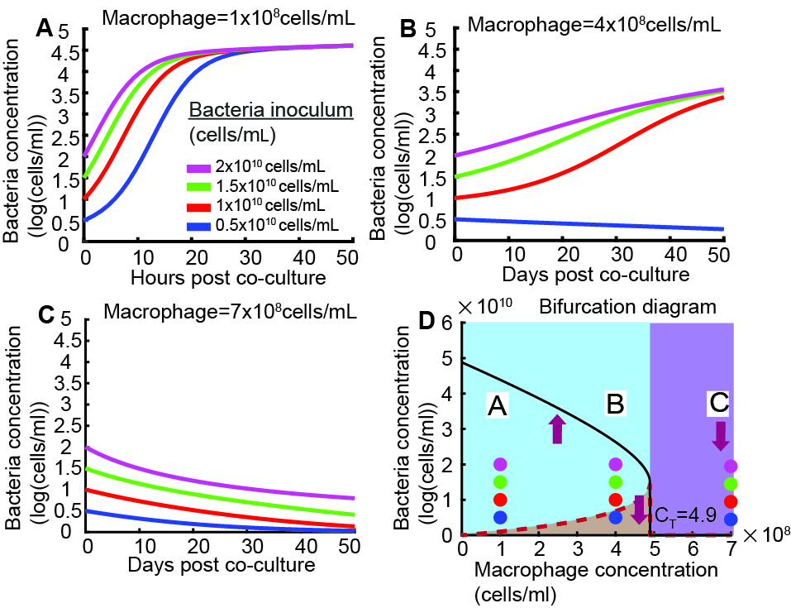
Figure S6: Simulated Kinetics of N. gonorrhoeae with Activated Macrophages. This figure displays the simulated kinetics of N. gonorrhoeae in co-culture with NOMV-activated macrophages, illustrating bistable behaviour influenced by initial bacterial inoculum size and macrophage concentration. The plots use estimated parameters relevant to this interaction. (A) and (B) Macrophage Concentration Below C_{T}: When the activated macrophage concentration is between 0 and a critical threshold (C_{T}), N. gonorrhoeae kinetics show bistability. Bacterial populations with an inoculum size above the dashed red curve persist (i.e., are not eradicated), while those with an inoculum size below the dashed red curve are suppressed. (C) Macrophage Concentration Above C_{T}: When the activated macrophage concentration is greater than C_{T} (approximately 4.9 × 10⁸ cells/mL), N. gonorrhoeae kinetics are inhibited regardless of the initial inoculum size. (D) Bifurcation Diagram of N. gonorrhoeae Concentration vs. Activated Macrophage Concentration: This diagram illustrates the long-term steady states of N. gonorrhoeae concentration as a function of activated macrophage concentration. The red dashed curve represents the unstable equilibrium (critical inoculum threshold), which increases with rising macrophage concentration, separating the basins of attraction for bacterial persistence and eradication. The black solid curve represents the stable equilibrium point, or the maximal carrying capacity of N. gonorrhoeae, which decreases as macrophage concentration increases. Purple arrows indicate the direction of the bacterial dynamics from various initial inoculum sizes. In panels (A-D), the blue, red, green, and purple lines (and corresponding circles) consistently represent N. gonorrhoeae kinetics originating from initial inoculum sizes of 0.5×10⁹ CFU/mL, 1×10⁹ CFU/mL, 1.5×10⁹ CFU/mL, and 2×10⁹ CFU/mL, respectively.

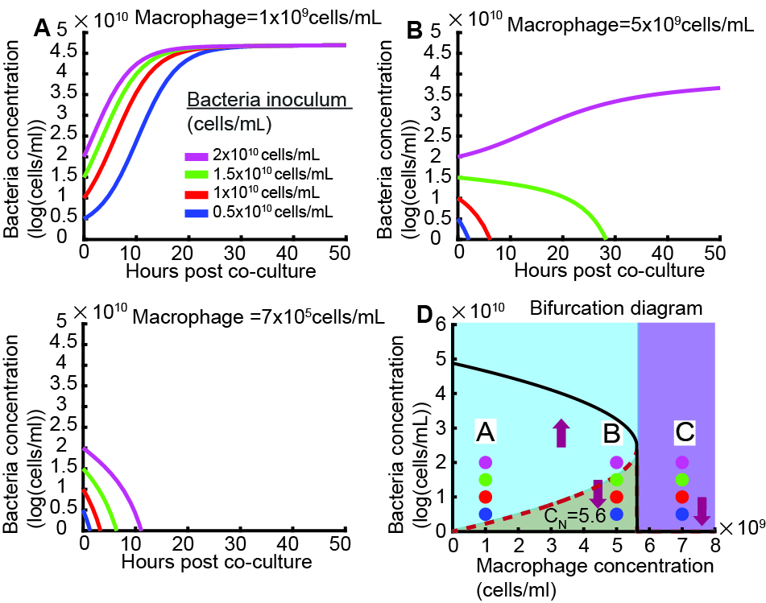
Figure S7: Simulated Kinetics of N. gonorrhoeae with Naive Macrophages. This figure displays the simulated kinetics of N. gonorrhoeae in co-culture with naive macrophages, illustrating bistable behaviour influenced by initial bacterial inoculum size and macrophage concentration. The plots use estimated parameters relevant to this interaction. (A) and (B) Macrophage Concentration Below C_{N}: When the naive macrophage concentration is between 0 and a critical threshold (C_{N}), N. gonorrhoeae kinetics show bistability. Bacterial populations with an inoculum size above the dashed red curve persist (i.e., are not eradicated), while those with an inoculum size below the dashed red curve are suppressed. (C) Macrophage Concentration Above C_{N}: When the naive macrophage concentration is greater than C_{N} (approximately 5.6 × 10⁹ cells/mL), N. gonorrhoeae kinetics are inhibited regardless of the initial inoculum size. (D) Bifurcation Diagram of N. gonorrhoeae Concentration vs. Naive Macrophage Concentration: This diagram illustrates the long-term steady states of N. gonorrhoeae concentration as a function of naive macrophage concentration. The red dashed curve represents the unstable equilibrium (critical inoculum threshold), which increases with rising macrophage concentration, separating the basins of attraction for bacterial persistence and eradication. The black solid curve represents the stable equilibrium point, or the maximal carrying capacity of N. gonorrhoeae, which decreases as macrophage concentration increases. Purple arrows indicate the direction of the bacterial dynamics from various initial inoculum sizes. In panels (A-D), the blue, red, green, and purple lines (and corresponding circles) consistently represent N. gonorrhoeae kinetics originating from initial inoculum sizes of 0.5×10⁹ CFU/mL, 1×10⁹ CFU/mL, 1.5×10⁹ CFU/mL, and 2×10⁹ CFU/mL, respectively.

Reference
1. Kandinov, I., et al., In vitro Susceptibility to β-Lactam Antibiotics and Viability of Neisseria gonorrhoeae Strains Producing Plasmid-Mediated Broad- and Extended-Spectrum β-Lactamases. Frontiers in Microbiology, 2022. 13.
2. McQuillan, J.S., et al., Silver nanoparticle enhanced silver ion stress response in Escherichia coli K12. Nanotoxicology, 2012. 6(8): p. 857-866.

