SUPPLEMENTAL DATA
Alpha diversity and pathway heatmap
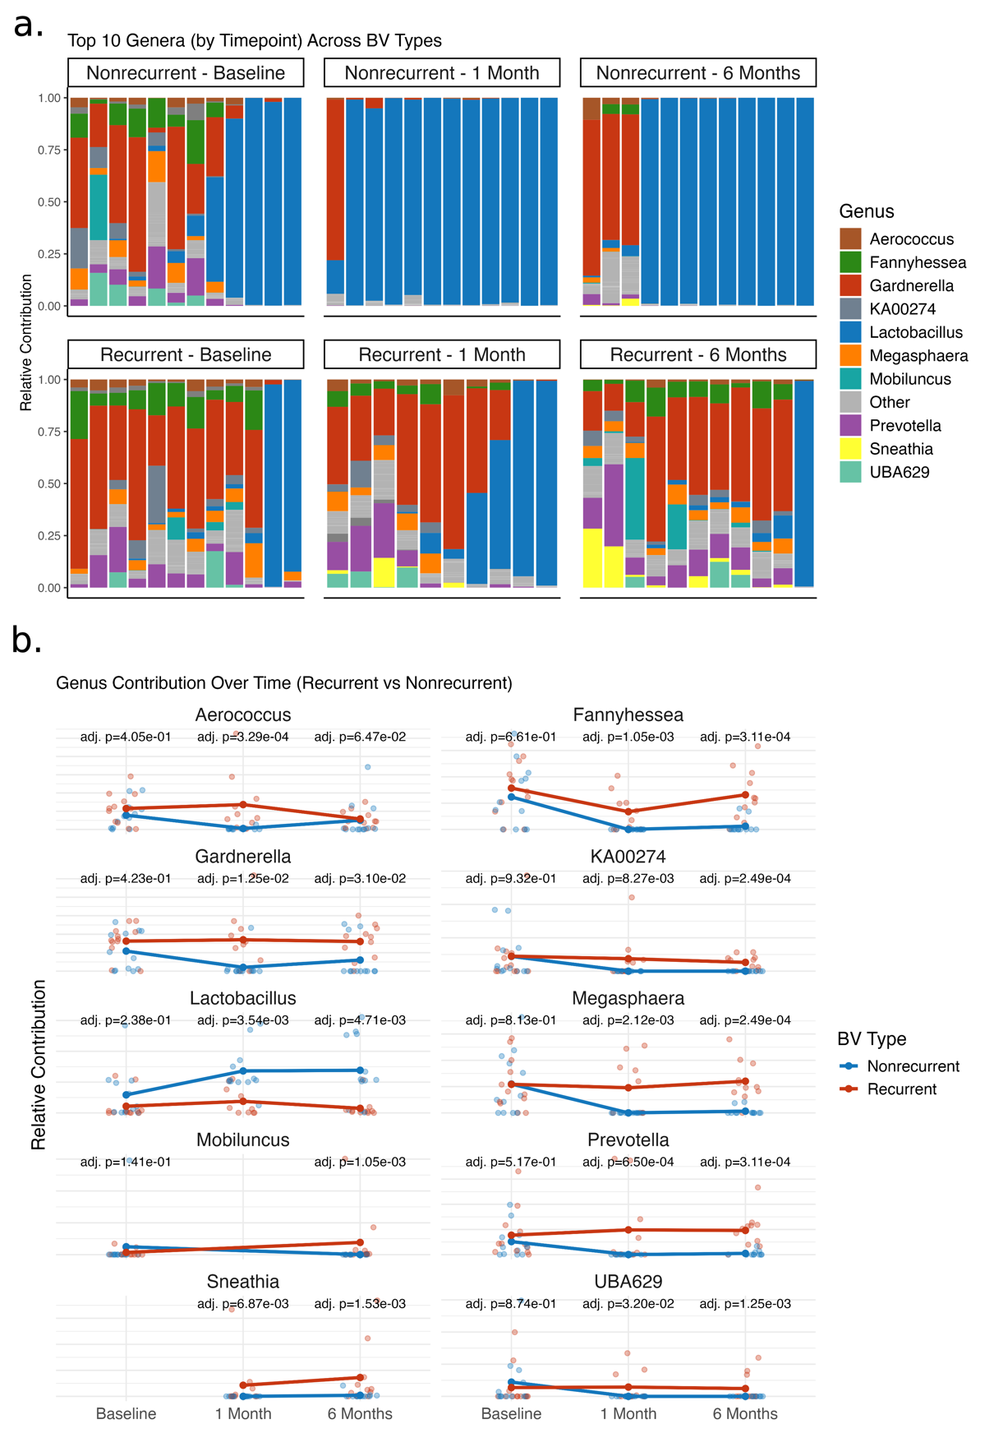
Supplementary Figure 1. Taxonomic composition and genus-level dynamics by BV recurrence status over time. (a) Stacked bar plots showing the relative contribution of the top 10 most abundant genera at baseline, 1 month, and 6 months, stratified by BV recurrence status (nonrecurrent: top row; recurrent: bottom row). Each bar represents an individual participant. (b) Line plots displaying mean relative contribution of each genus across timepoints, with individual-level data overlaid. Blue lines represent nonrecurrent participants, and red lines represent recurrent participants. Adjusted p-values (Benjamini-Hochberg correction) indicate significance of genus-level differences between recurrence groups at each timepoint.

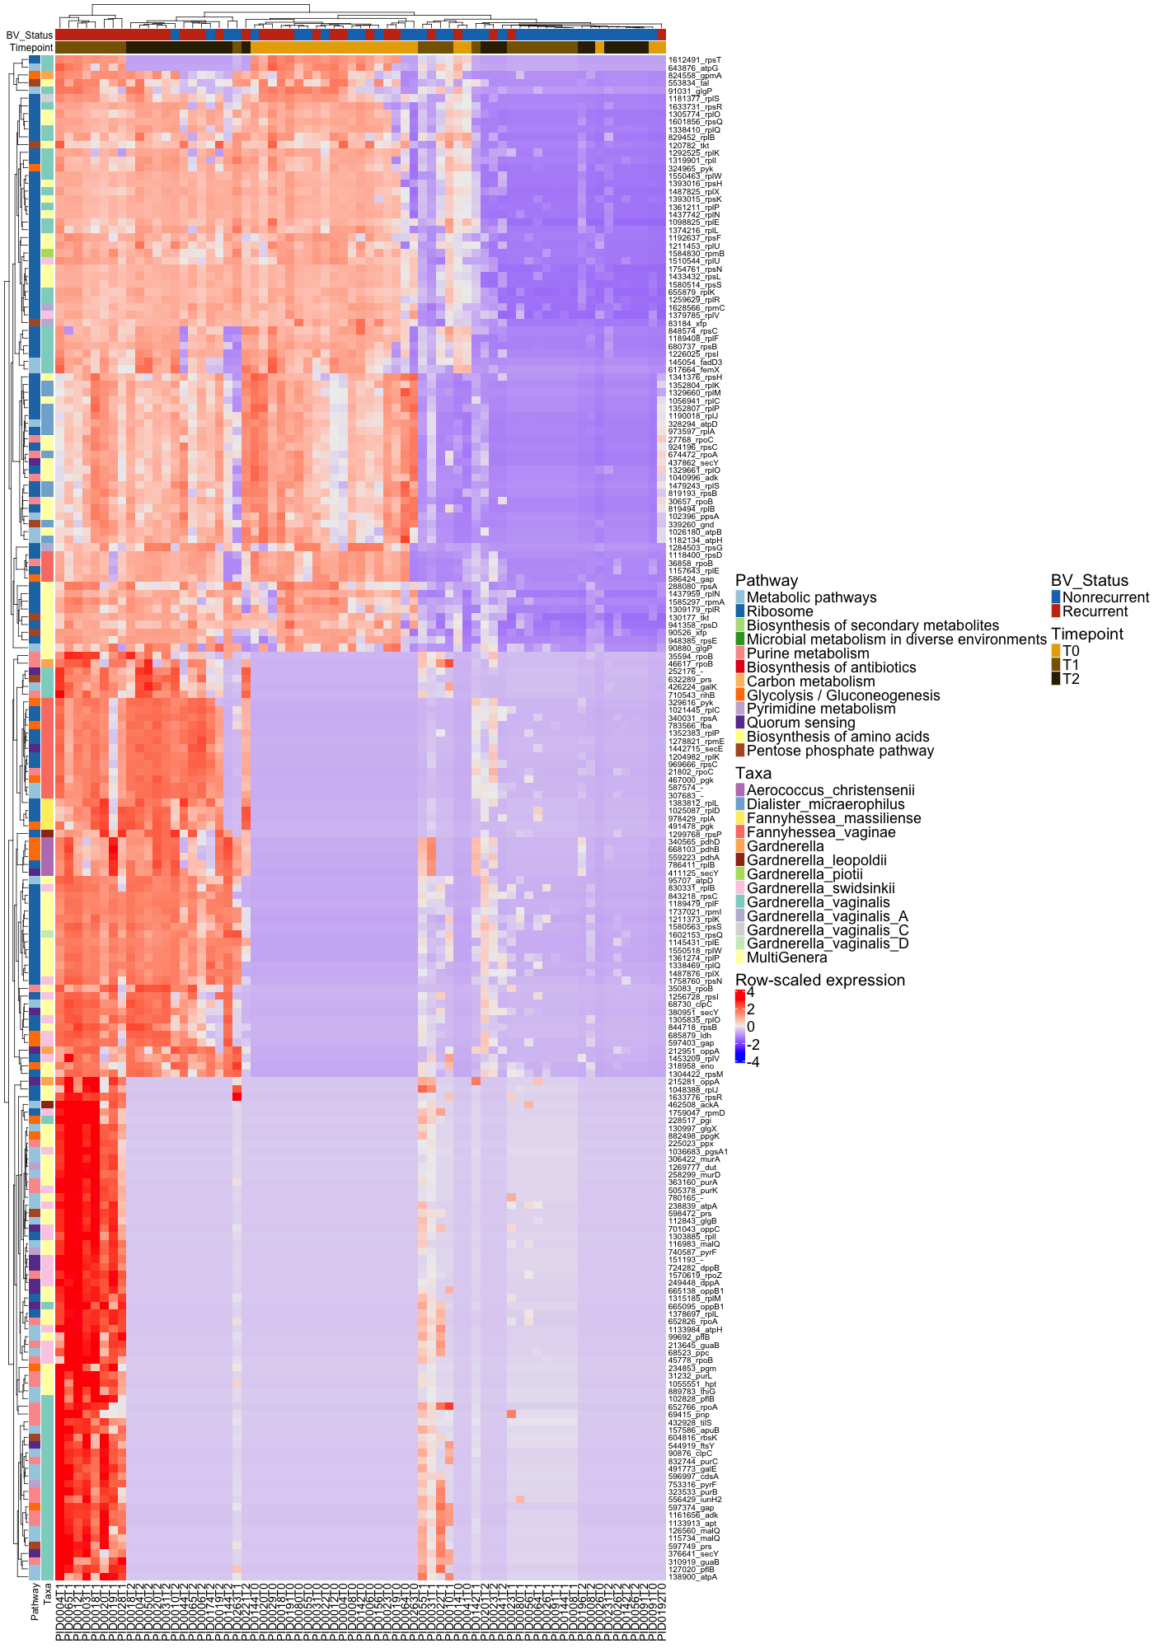Supplementary Figure 2. Functional gene expression heatmap of bacterial metatranscriptomes stratified by BV recurrence status and timepoint.
Heatmap displays row-scaled expression (Z-scores) of bacterial genes contributing to significantly enriched KEGG pathways across all samples and timepoints (T0 = baseline, T1 = 1 month, T2 = 6 months). Columns represent individual samples; rows represent bacterial genes grouped by pathway and colored by taxonomic origin.
Top annotations indicate participant recurrence status at 6 months (blue: nonrecurrent; red: recurrent) and timepoint of collection (light gray: T0; medium gray: T1; dark gray: T2). Genes are clustered by similarity in expression patterns, with strong separation observed between recurrence groups, particularly at T1. Pathways highlighted include metabolic and biosynthetic processes (e.g., ribosome, purine metabolism, carbon metabolism, quorum sensing). Taxonomic annotations highlight frequent contributions from Gardnerella, Fannyhessea, Dialister, and other cervicovaginal taxa.

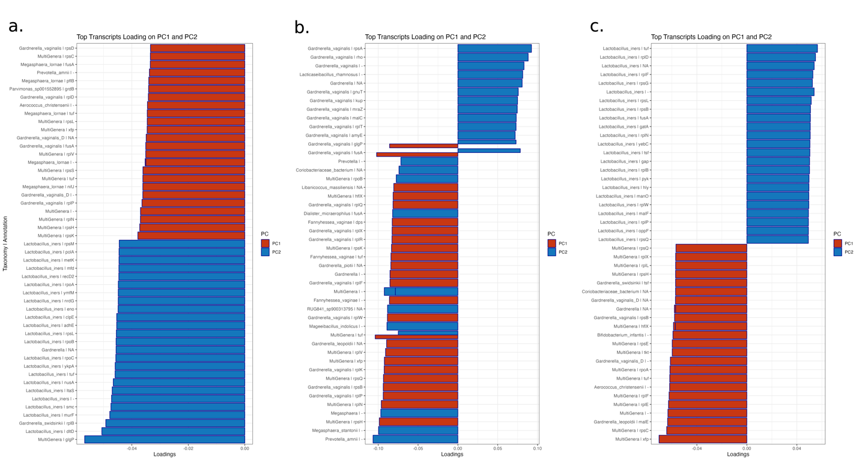
Supplementary Figure 3. Top bacterial transcript loadings for PC1 and PC2 at each study timepoint. Bar plots show the top 30 bacterial transcripts contributing most strongly (positive or negative) to PC1 (red) and PC2 (blue) axes in the PCA shown in Figure 2a–c. Genes are annotated by genus or species where identifiable; "MultiGenera" denotes transcripts indistinguishably mapped to multiple bacterial taxa. Loadings are directional and scaled for comparability within each plot. (a) Baseline loadings. (b) 1-month post-treatment loadings. (c) 6-month post-treatment loadings. Gardnerella and Lactobacillus iners transcripts dominate early and late timepoints respectively, with shifts in PC-defining transcripts over time reflecting temporal changes in functional bacterial activity between recurrence groups.

Trichomonas, virus, and phage expression through study period

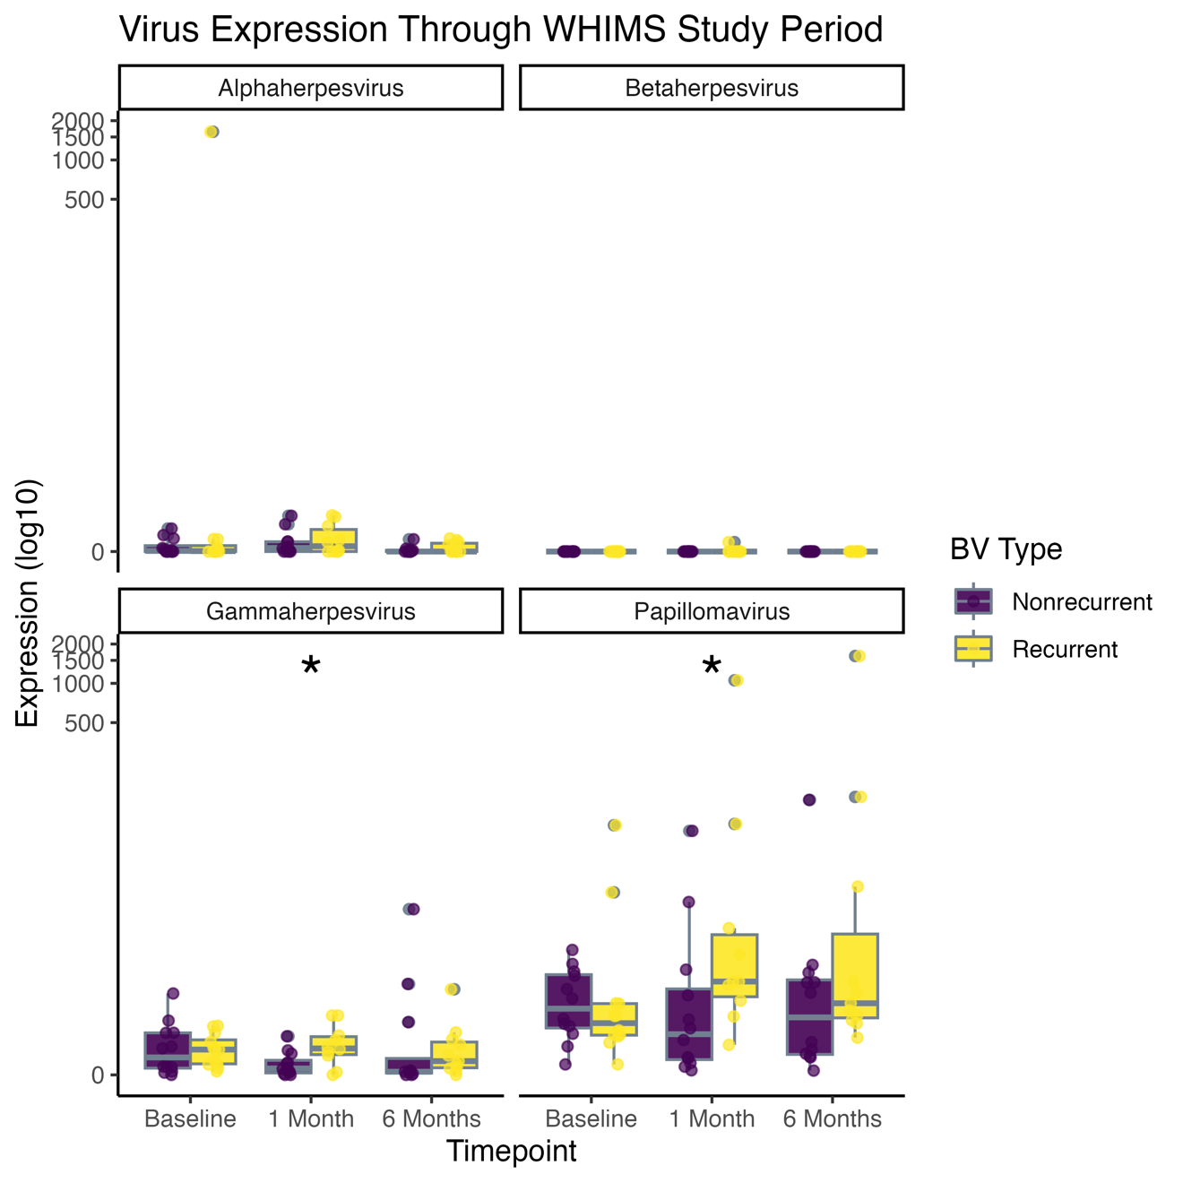
Supplementary Figure 4. Viral expression profiles over time by BV recurrence status. Boxplots show the log₁₀ expression values for four major viral families detected in cervical metatranscriptomes—Alphaherpesvirus, Betaherpesvirus, Gammaherpesvirus, and Papillomavirus—are plotted across baseline, 1 month, and 6 months, stratified by recurrence status (nonrecurrent: purple; recurrent: yellow).
Boxplots reflect individual participant data and group medians. Significant differences (*p < 0.05) were observed in Gammaherpesvirus and Papillomavirus expression, both elevated in the recurrent group at baseline and/or 1 month. These findings suggest possible viral-bacterial interactions that may predispose to BV recurrence.

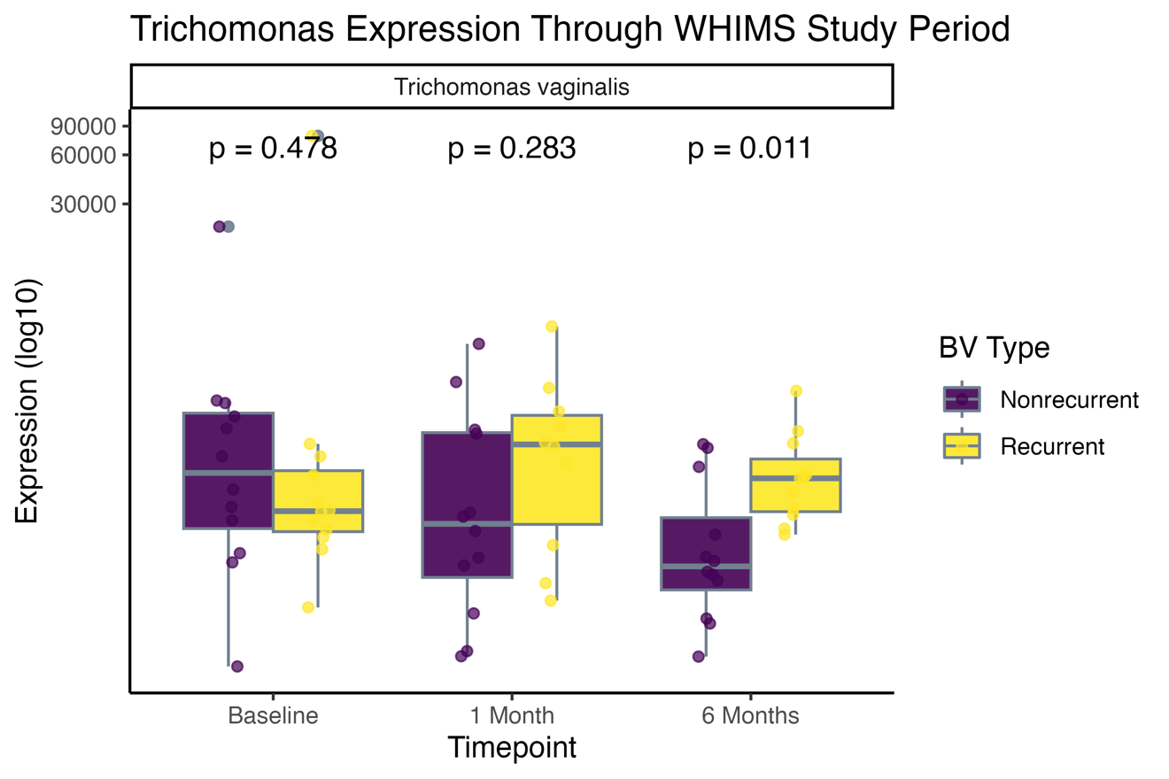
Supplementary Figure 5. Trichomonas vaginalis expression dynamics over time by BV recurrence status. Boxplots show the log₁₀-transformed expression of Trichomonas vaginalis transcripts at baseline (T0), 1 month (T1), and 6 months (T2), stratified by BV recurrence status (nonrecurrent: purple; recurrent: yellow). Each dot represents an individual participant; bars represent medians with interquartile ranges.
No significant differences were observed at baseline or 1 month, but T. vaginalis expression was significantly higher in the recurrent group at 6 months (p = 0.011), suggesting potential persistence or late expansion in a subset of individuals.
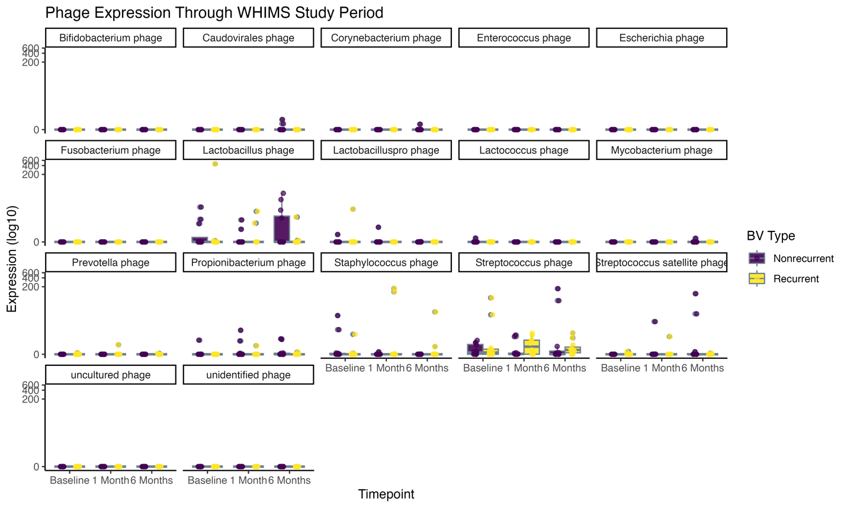
Supplementary Figure 6. Phage transcriptomic expression by host genus and BV recurrence status. Expression of bacteriophage transcripts targeting various bacterial genera is shown across baseline, 1 month, and 6 months, stratified by recurrence status (nonrecurrent: purple; recurrent: yellow). Each panel corresponds to a different phage taxon or group (e.g., Lactobacillus phage). Expression is plotted on a log₁₀ scale, with each point representing an individual sample.

Cytokine expression and correlations through study period
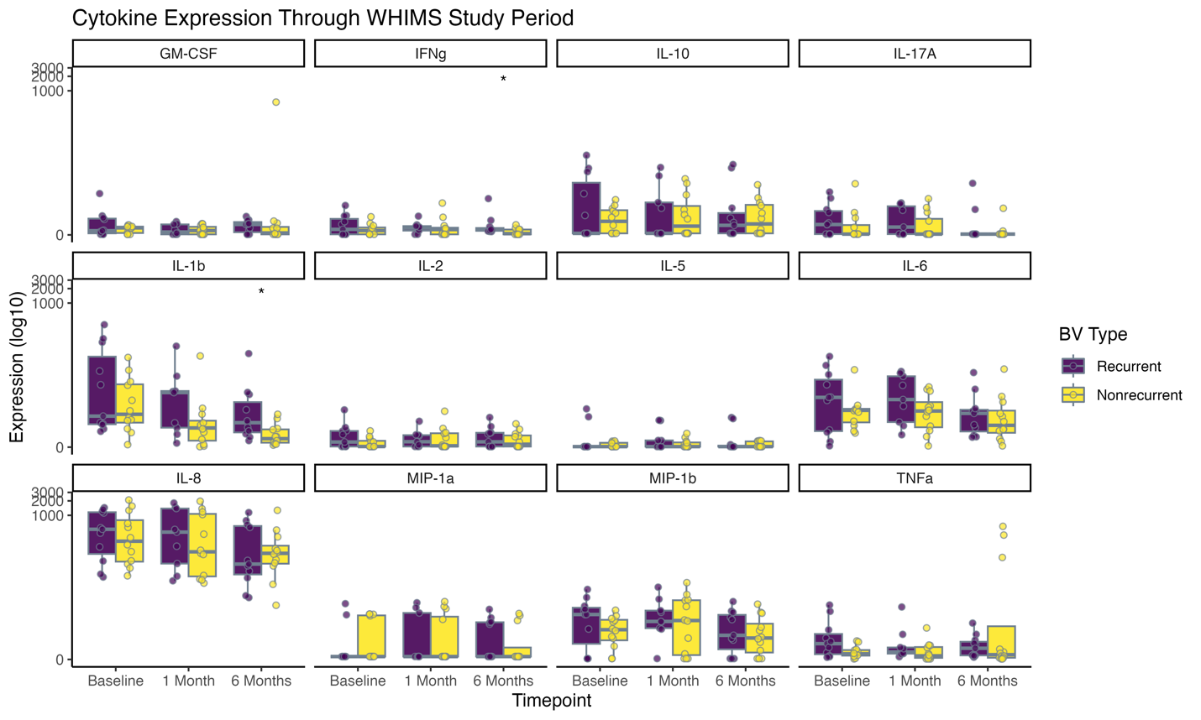
Supplementary Figure 7. Cervical cytokine protein expression over time by BV recurrence status. Boxplots show log₁₀-transformed concentrations (ng/µL) of 13 cytokines measured in cervical lavage fluid at baseline, 1 month, and 6 months post-treatment, stratified by BV recurrence status at 6 months (recurrent: purple; nonrecurrent: yellow). Cytokines include proinflammatory (e.g., IL-1β, IL-6, TNFα), regulatory (e.g., IL-10), chemotactic (e.g., IL-8, MIP-1α, MIP-1β), and Th1/Th17 markers (e.g., IFNγ, IL-17A). Individual participant data are overlaid as dots; boxplots show group medians and interquartile ranges. Asterisks (*) indicate nominally significant differences between recurrence groups at individual timepoints (unadjusted p < 0.05), including IFNγ at 1 month and IL-1β at baseline.
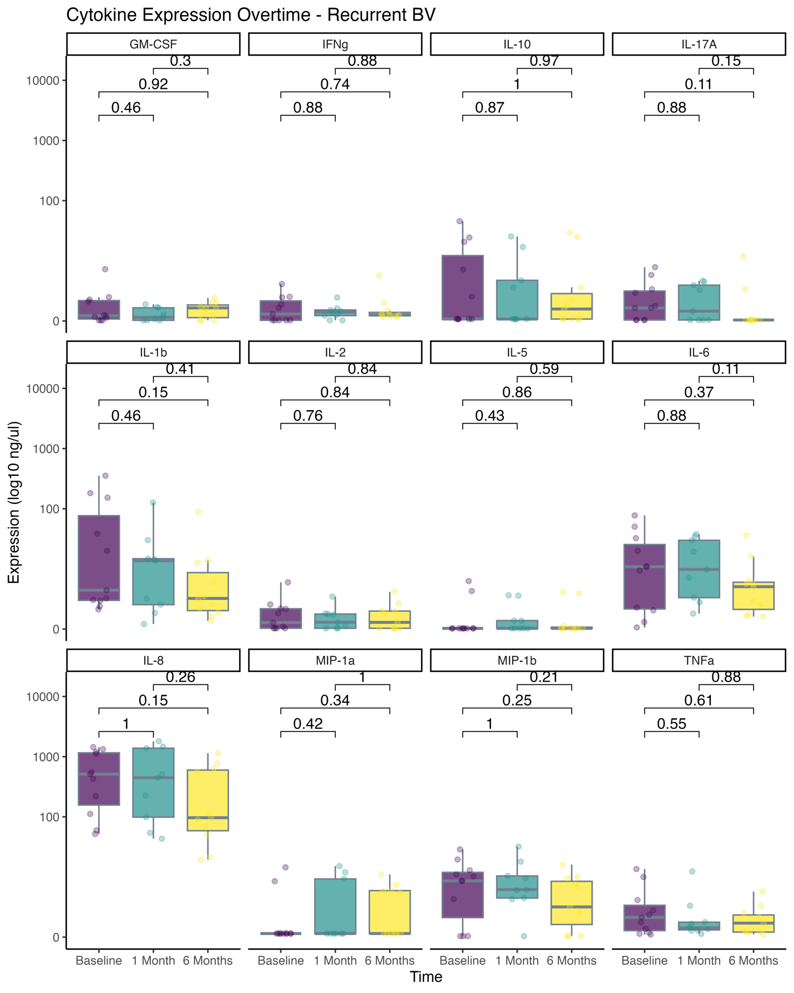
Supplementary Figure 8. Longitudinal cytokine protein expression in participants with recurrent BV. Boxplots show log₁₀-transformed concentrations (ng/µL) of 13 cervical cytokines measured at baseline, 1 month, and 6 months post-treatment in participants who experienced BV recurrence by month 6. Cytokines include GM-CSF, IFNγ, IL-10, IL-17A, IL-1β, IL-2, IL-5, IL-6, IL-8, MIP-1α, MIP-1β, and TNFα. Colored dots indicate individual participants; boxes represent median and interquartile range. Pairwise comparisons between timepoints are shown with raw p-values; no cytokine reached statistical significance after multiple testing correction. While variability was high, several cytokines (e.g., IL-1β, IL-6, IL-8, TNFα) trended downward over time, consistent with resolving inflammation despite later recurrence.

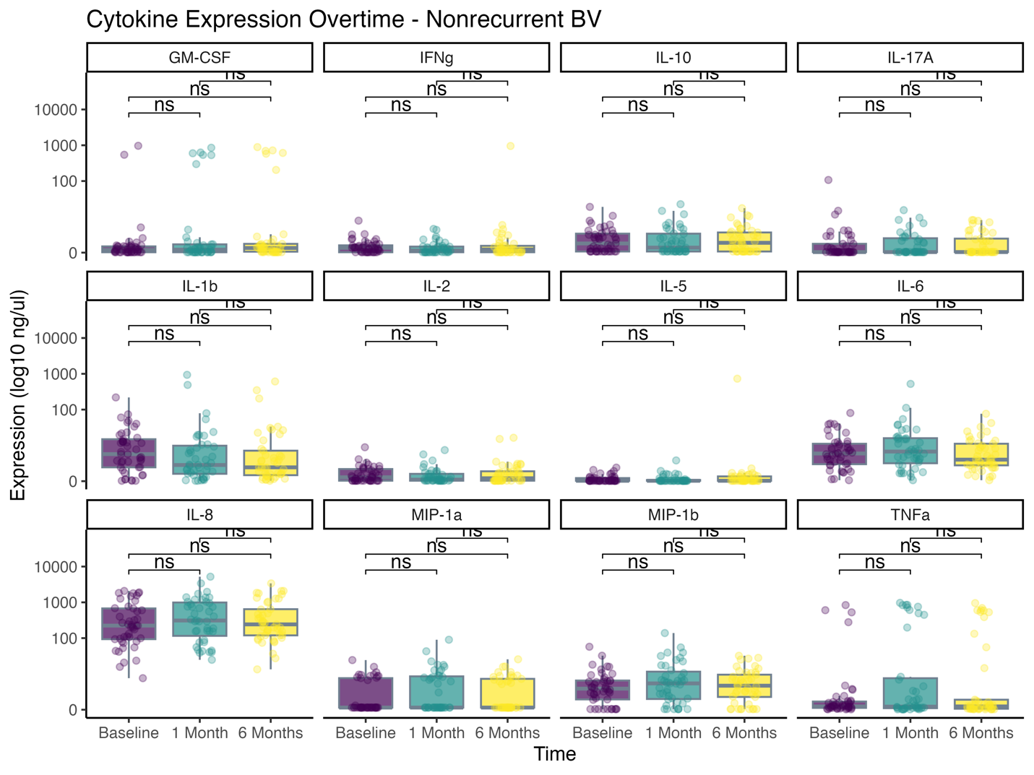
Supplementary Figure 9. Longitudinal cytokine protein expression in participants without BV recurrence. Boxplots display log₁₀-transformed concentrations (ng/µL) of 13 cytokines in cervical lavage fluid at baseline, 1 month, and 6 months post-treatment for participants who remained BV-negative throughout the study period. Cytokines include inflammatory (e.g., IL-1β, IL-6, TNFα), regulatory (IL-10), and chemotactic (IL-8, MIP-1α, MIP-1β) markers, as well as Th1/Th17 cytokines (e.g., IFNγ, IL-17A). Individual data points are overlaid; boxplots show medians and interquartile ranges. Statistical comparisons between timepoints were performed using pairwise tests; all results were non-significant (ns), indicating no detectable longitudinal changes in cytokine levels among nonrecurrent participants.

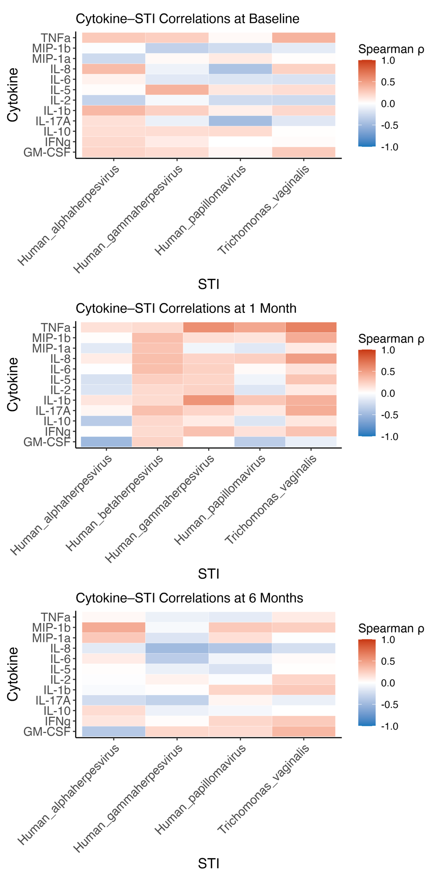
Supplementary Figure 10. Spearman correlations between cervical cytokine concentrations and STI transcript abundance over time. Heatmaps display Spearman ρ values between protein levels of 13 cervical cytokines (rows) and log₁₀-transformed expression levels of detected sexually transmitted infection (STI) transcripts (columns), including Trichomonas vaginalis, Human papillomavirus, Human herpesviruses (alpha, beta, gamma). Panels correspond to (top) baseline, (middle) 1 month post-treatment, and (bottom) 6 months post-treatment. Red indicates positive correlations; blue indicates negative correlations. Notable findings include dynamic shifts in cytokine–STI relationships over time, such as increasing positive associations between inflammatory cytokines (e.g., TNFα, MIP-1β) and Trichomonas vaginalis, and stronger IL-2 and IL-17A associations with herpesviruses at 1 month.

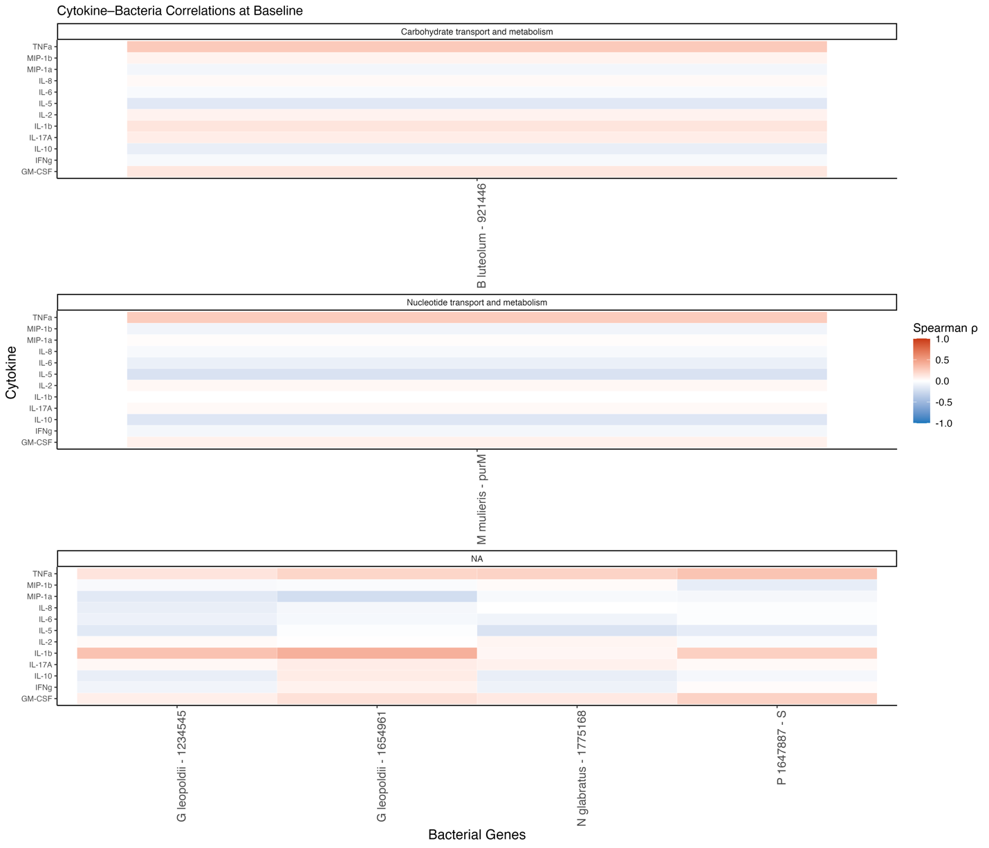
Supplementary Figure 11. Spearman correlations between cervical cytokine protein levels and bacterial gene expression at baseline. Heatmaps display Spearman correlation coefficients (ρ) between host cytokine concentrations (rows) and expression of selected bacterial genes (columns) at the baseline timepoint. Genes are grouped by predicted function or pathway, including carbohydrate metabolism, nucleotide metabolism, and unclassified functions. Color scale reflects correlation strength and direction (red: positive, blue: negative). Notable associations include consistent positive correlations between TNFα, IL-1β, IL-12, and several Gardnerella leopoldii genes.

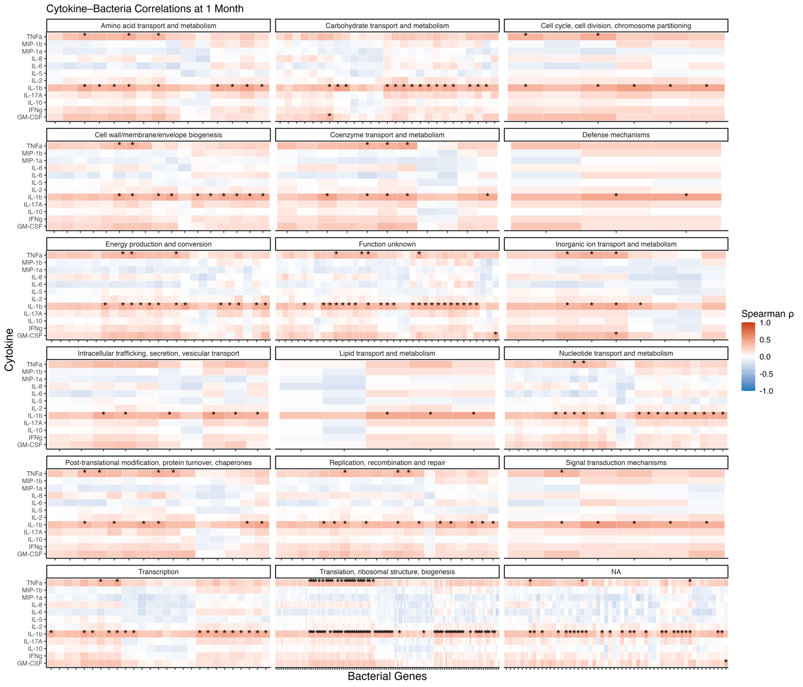
Supplementary Figure 12. Spearman correlations between cytokine protein levels and bacterial gene expression at 1 month post-treatment. Heatmaps show Spearman ρ correlations between host cytokine concentrations (rows) and expression of bacterial genes (columns), grouped by functional category (e.g., amino acid metabolism, translation, defense mechanisms). Genes were annotated using Clusters of Orthologous Groups (COG) categories where available. Color scale indicates direction and strength of correlation (red = positive; blue = negative). Asterisks denote statistically significant correlations (adjusted p < 0.05). Notable trends include consistent positive correlations between proinflammatory cytokines (e.g., IL-1β, IL-6, IL-17A) and genes involved in translation, transcription, energy production, and membrane biogenesis, particularly in recurrent participants. This legend applies to the summary heatmap shown here as well as each subsequent full-size panel labeled by functional category.
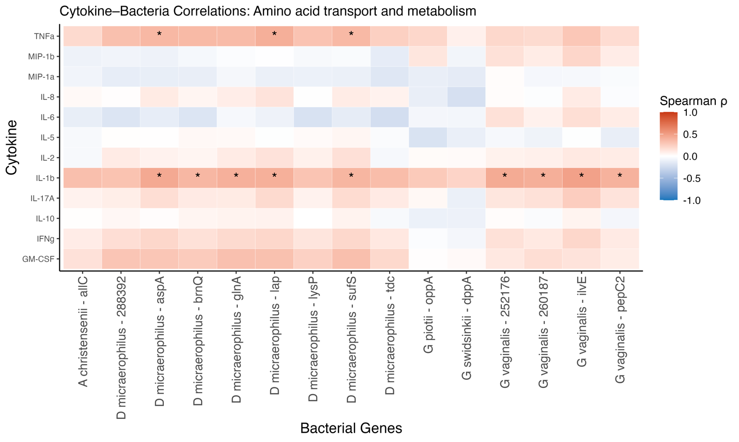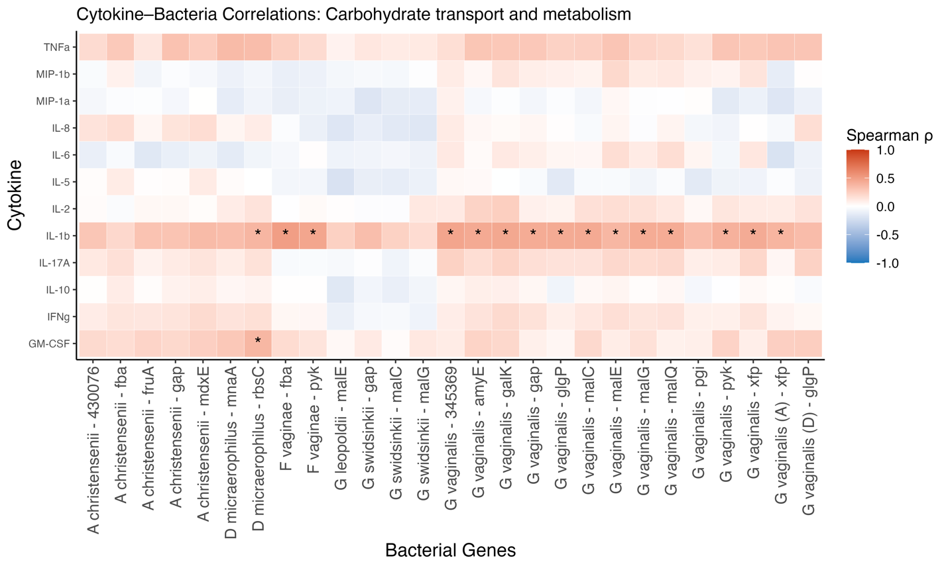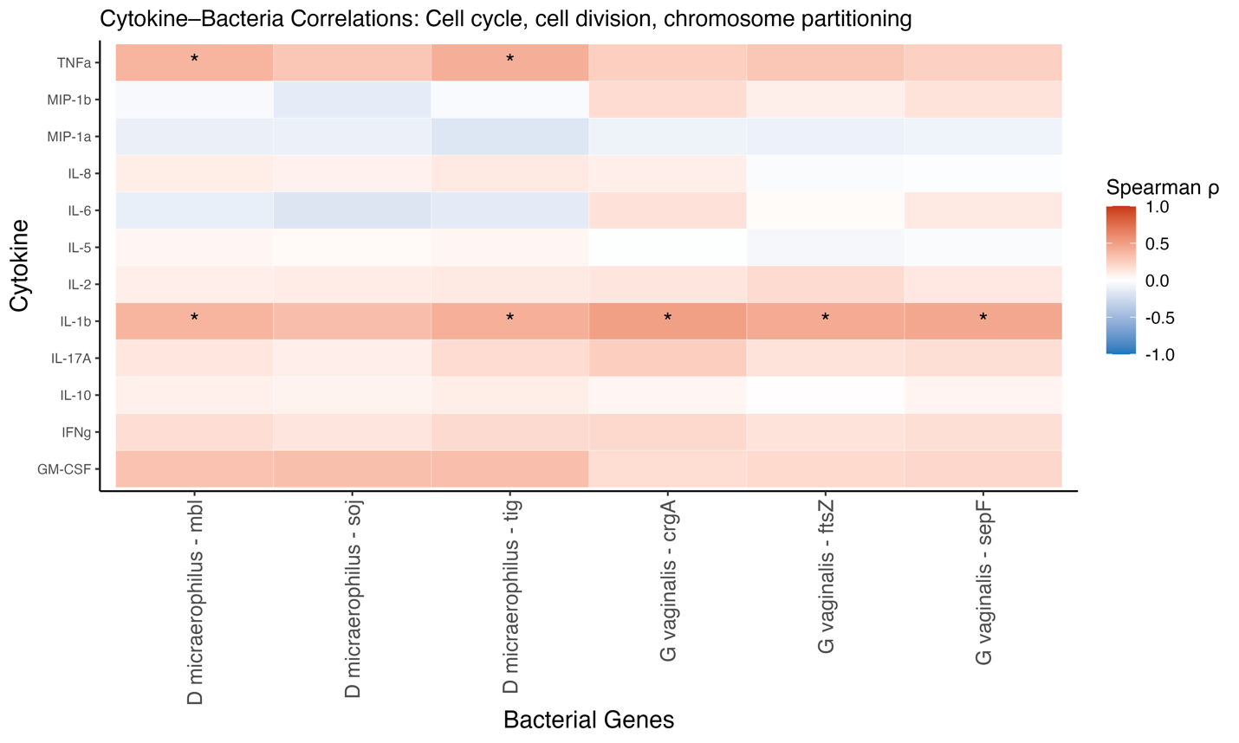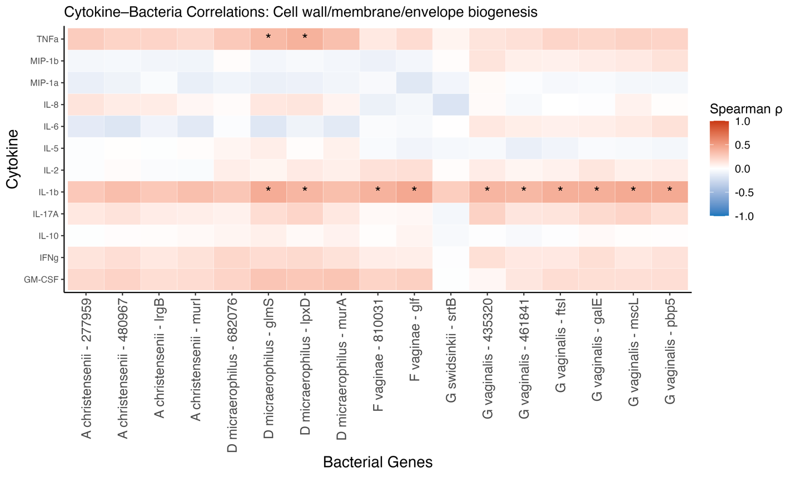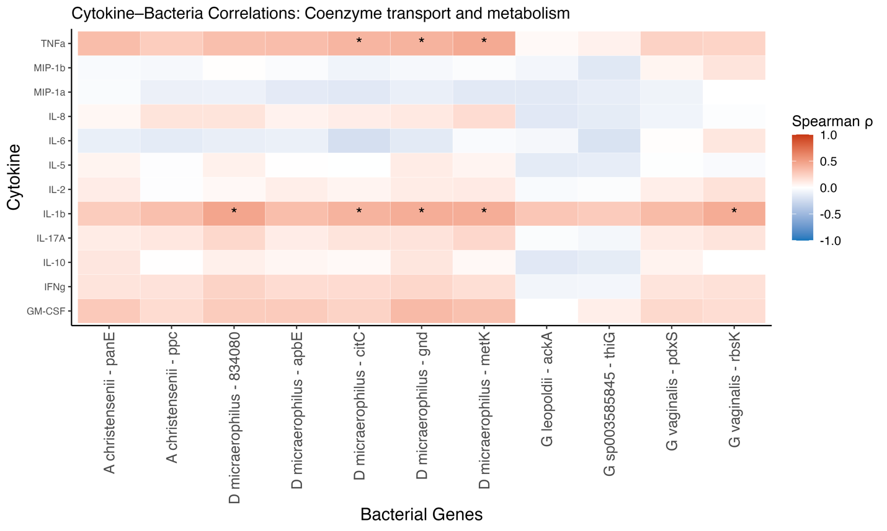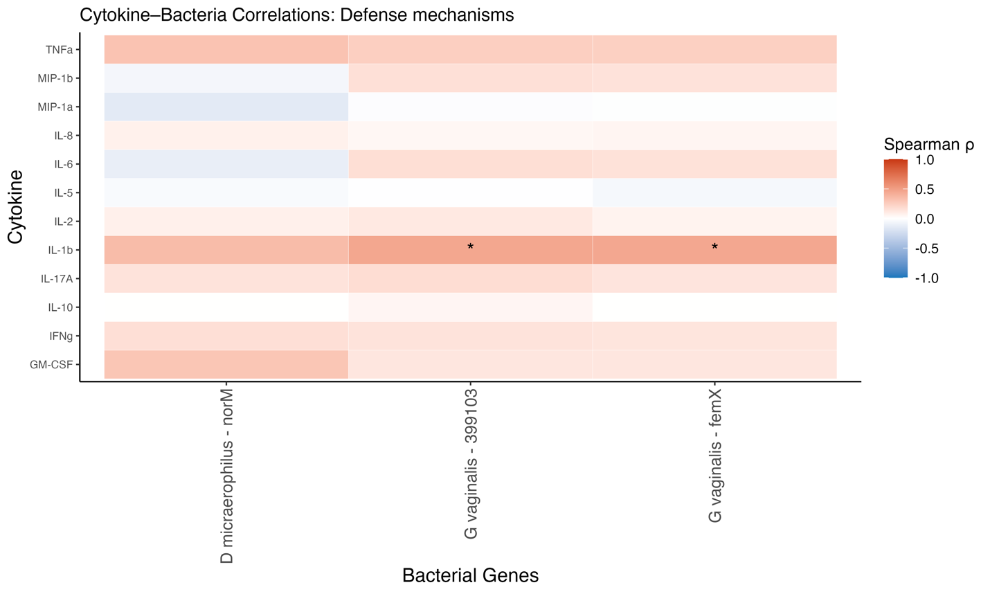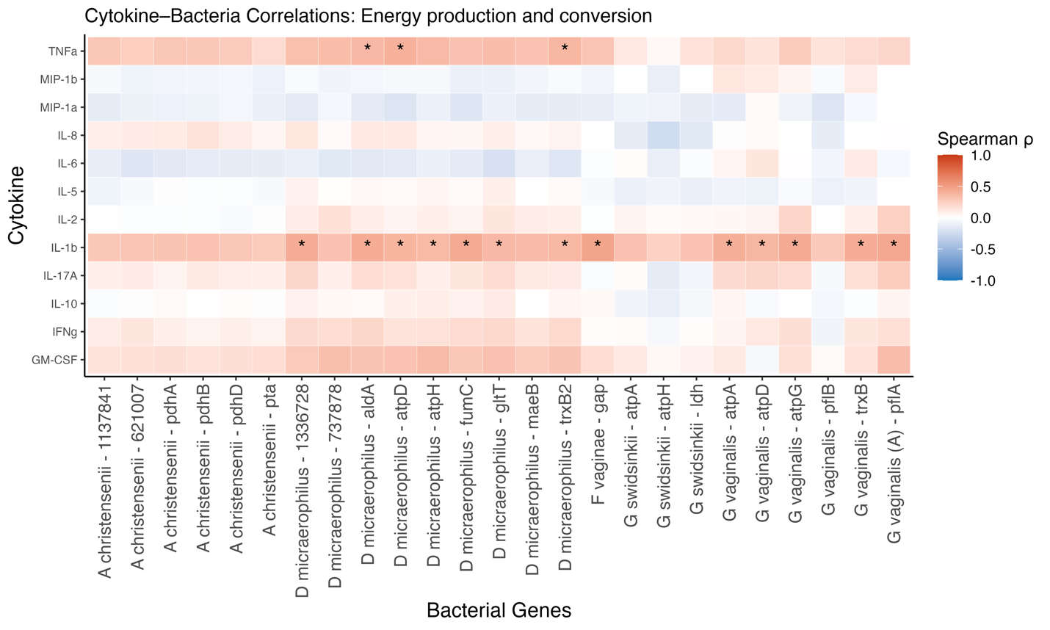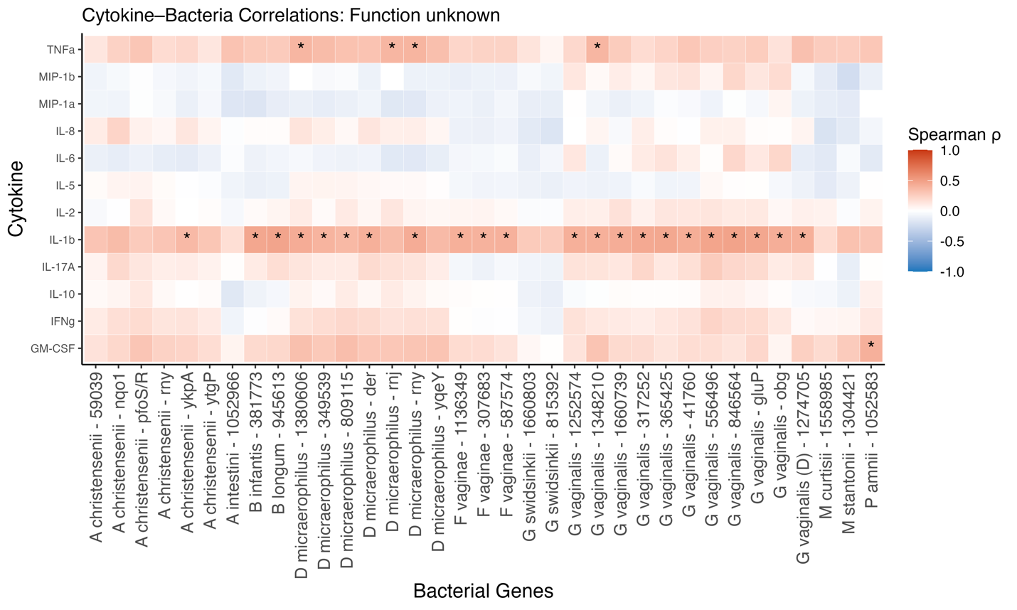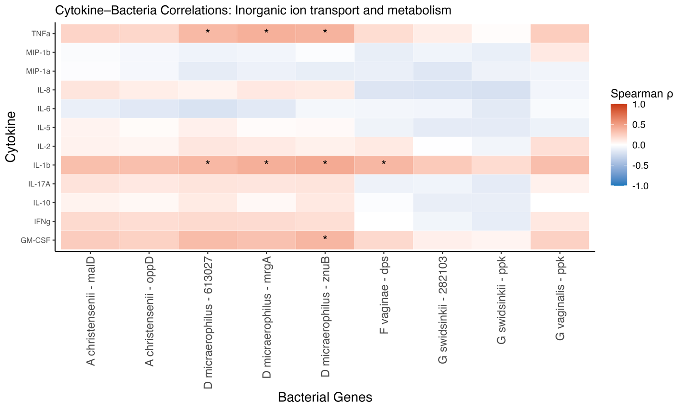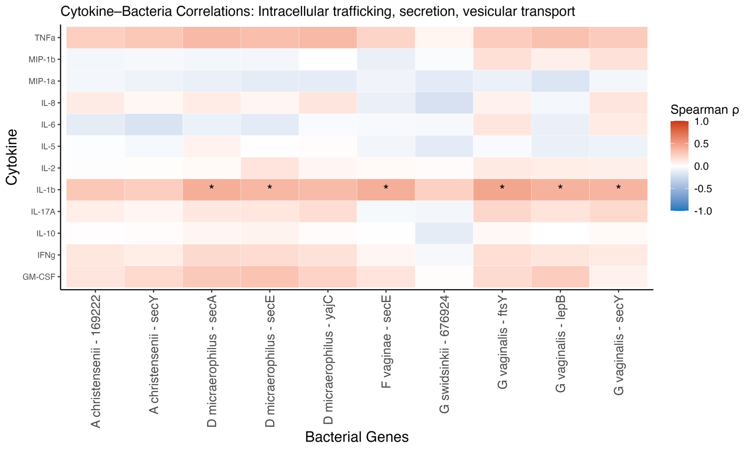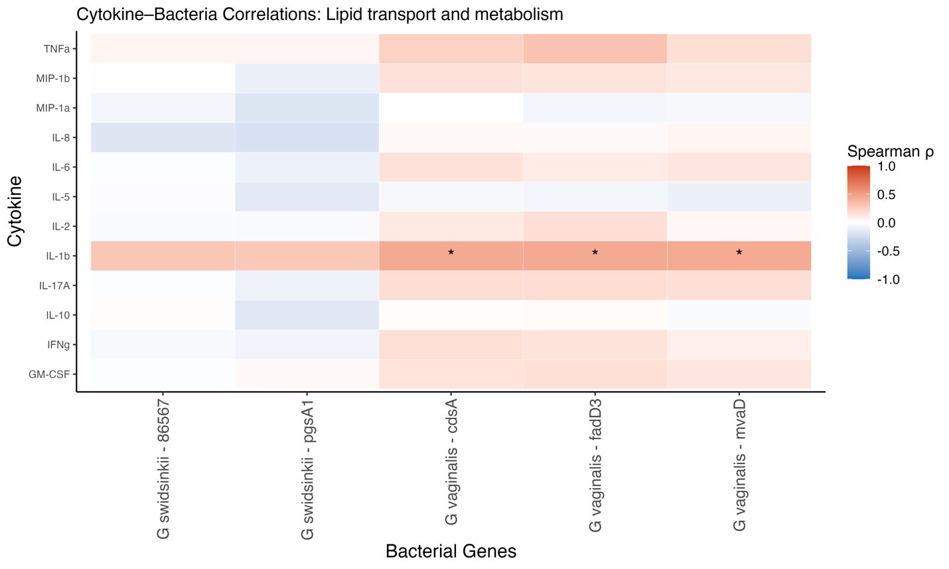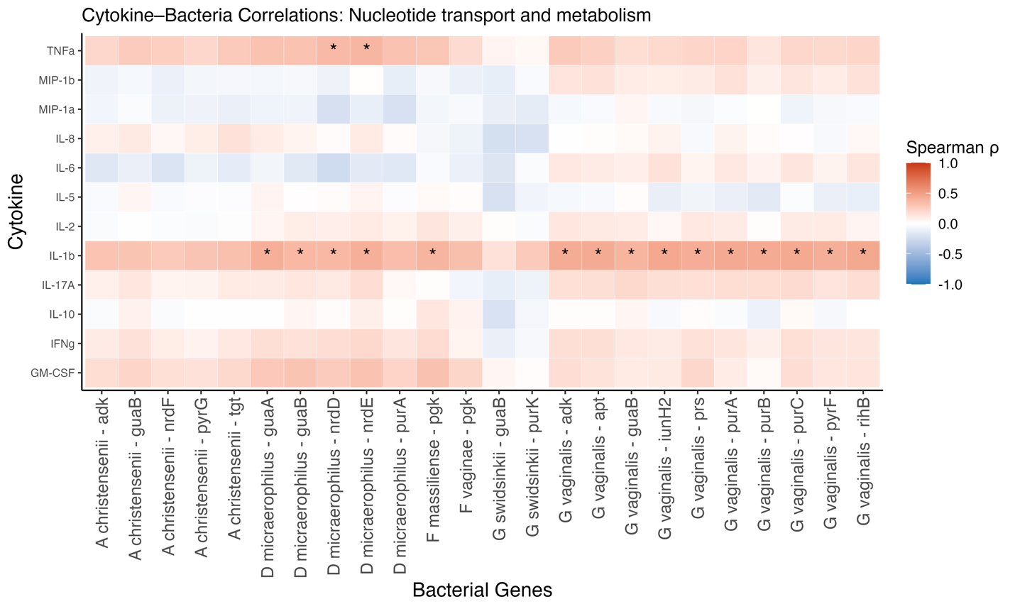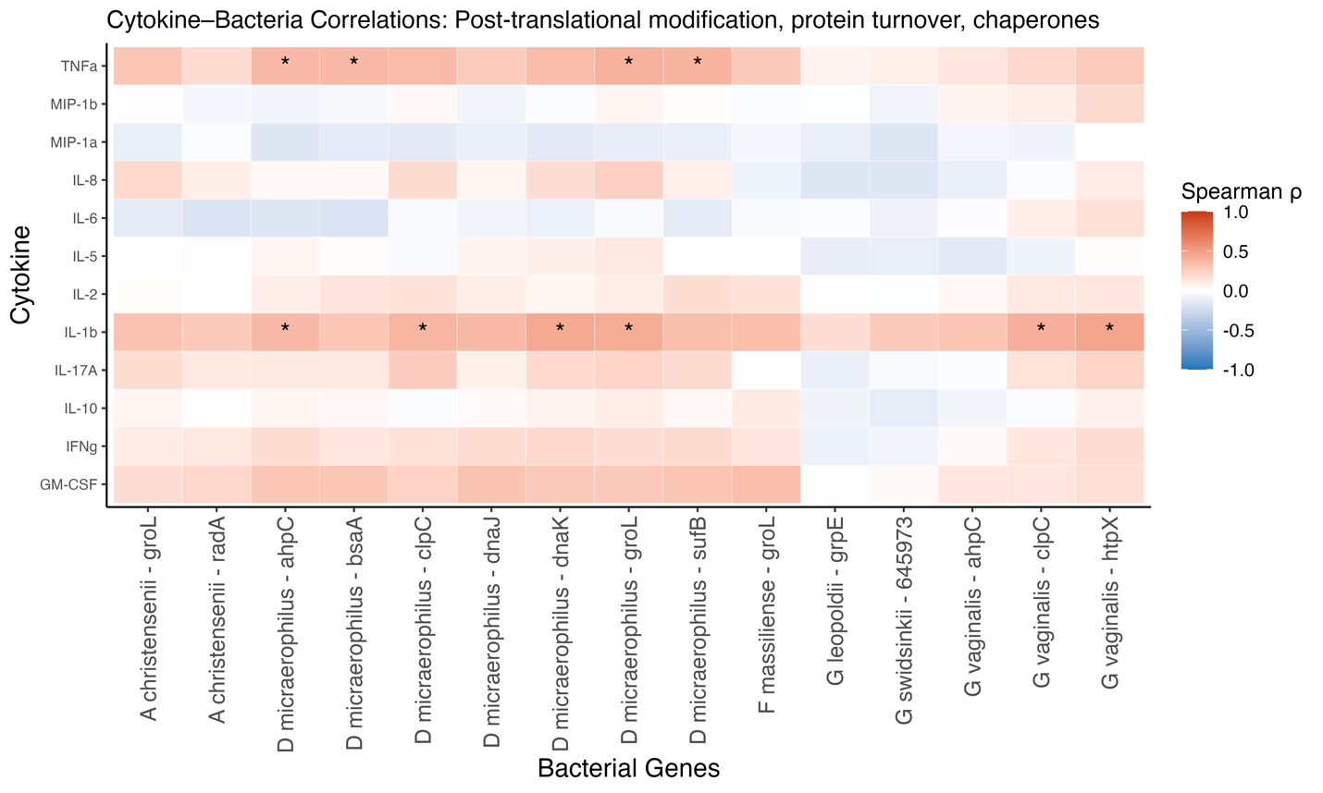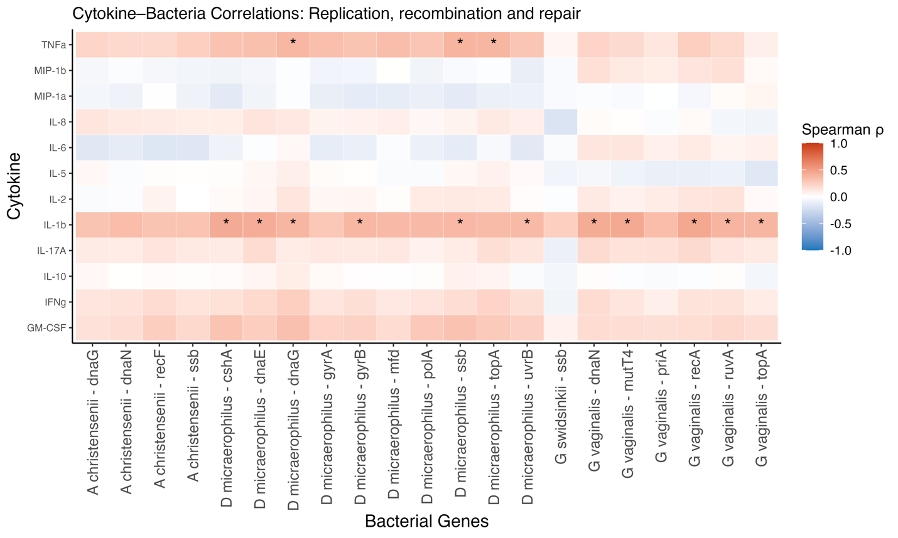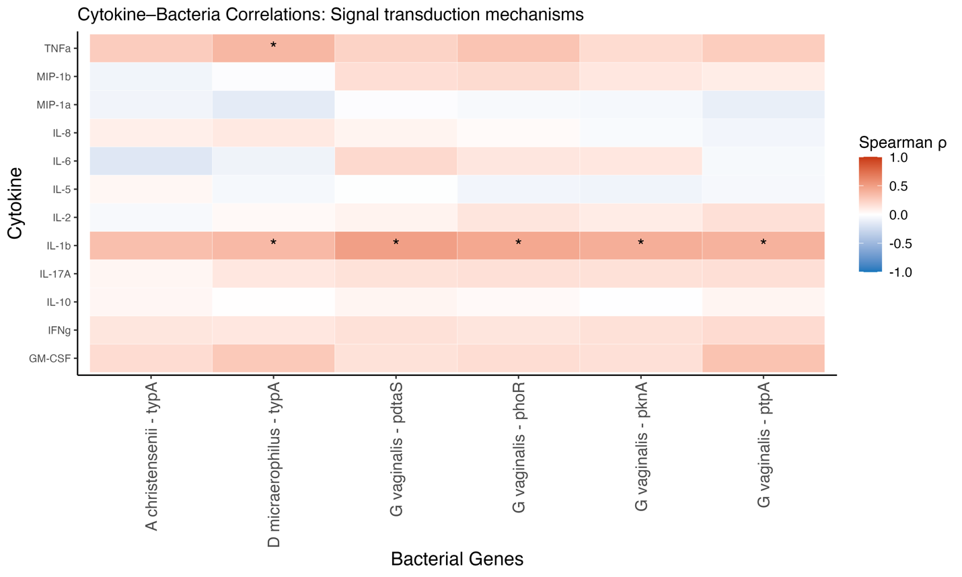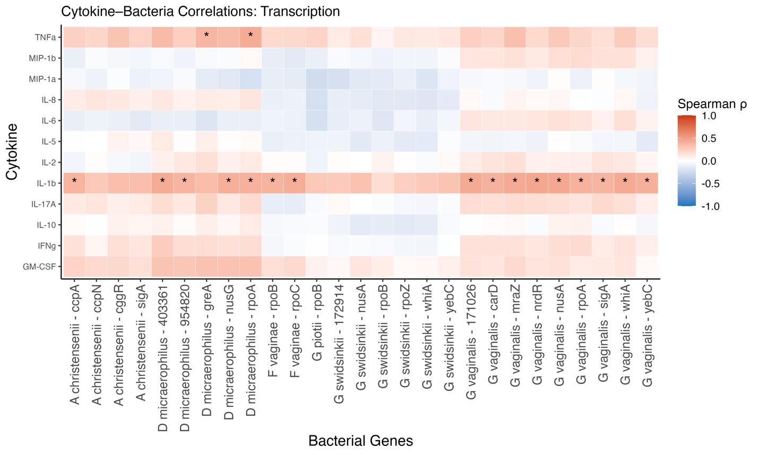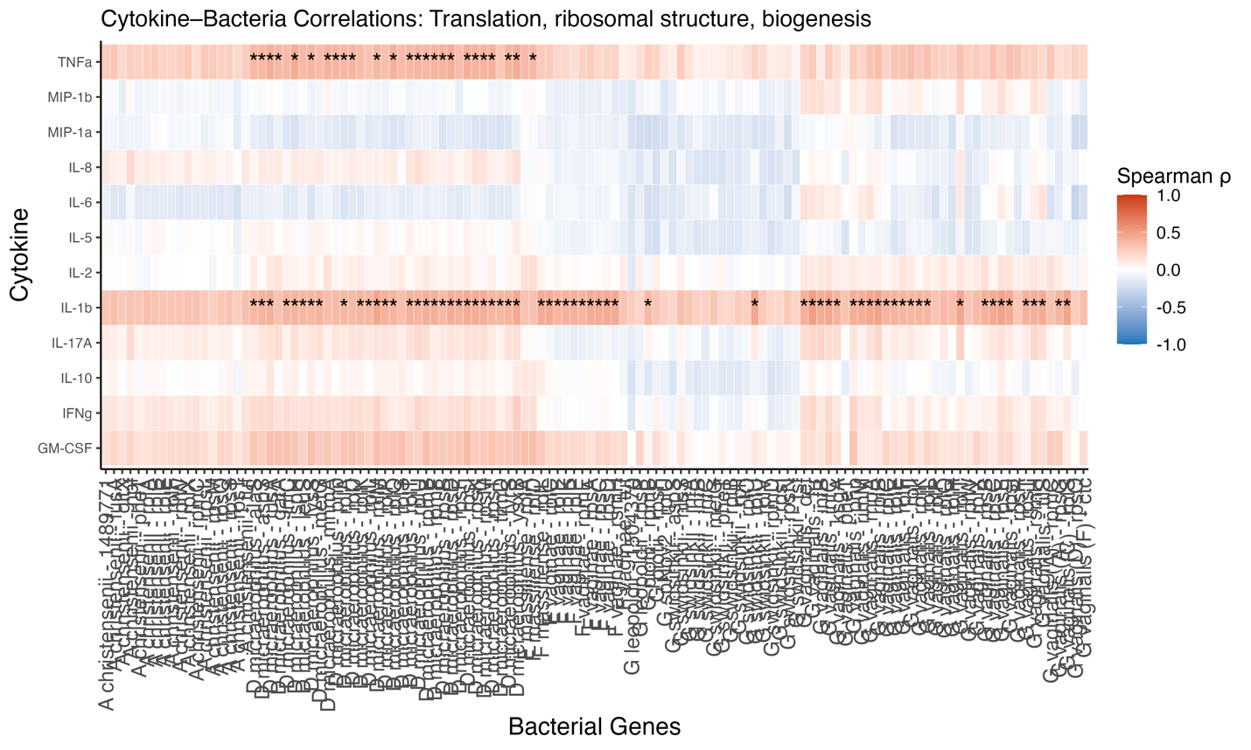
END OF FIGURE 12

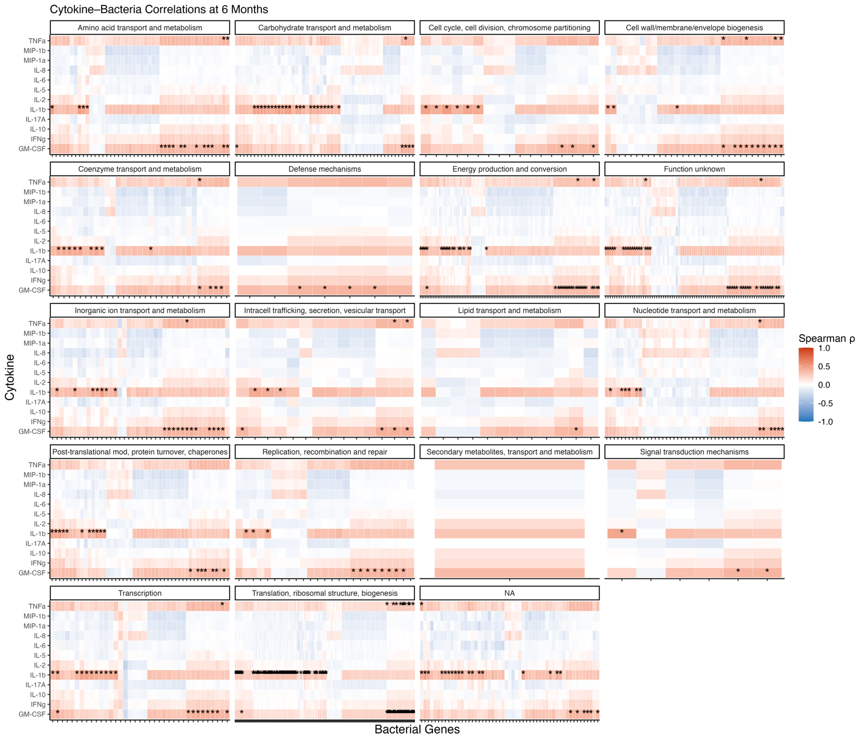
Supplementary Figure 13. Spearman correlations between cytokine protein levels and bacterial gene expression at 6 months post-treatment.
Heatmaps display Spearman ρ correlations between host cytokine concentrations (rows) and expression levels of bacterial genes (columns), grouped by predicted gene function using Clusters of Orthologous Groups (COG) categories. Color scale reflects correlation direction and strength (red = positive; blue = negative), and asterisks indicate significant correlations (adjusted p < 0.05). At 6 months, robust positive correlations persist between inflammatory cytokines (e.g., IL-6, IL-1β, GM-CSF) and genes involved in transcription, translation, and membrane-related processes, particularly in recurrent participants. This legend applies to the summary heatmap shown here as well as each subsequent full-size panel labeled by functional category.

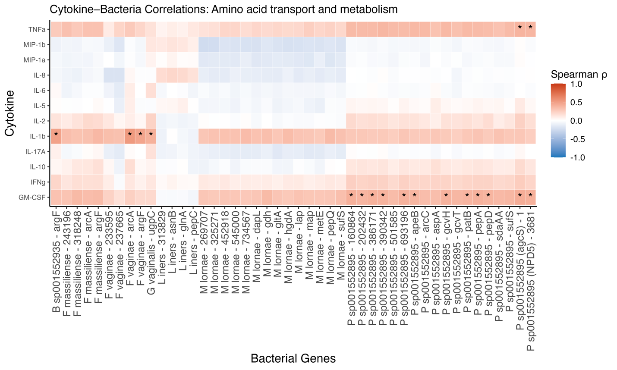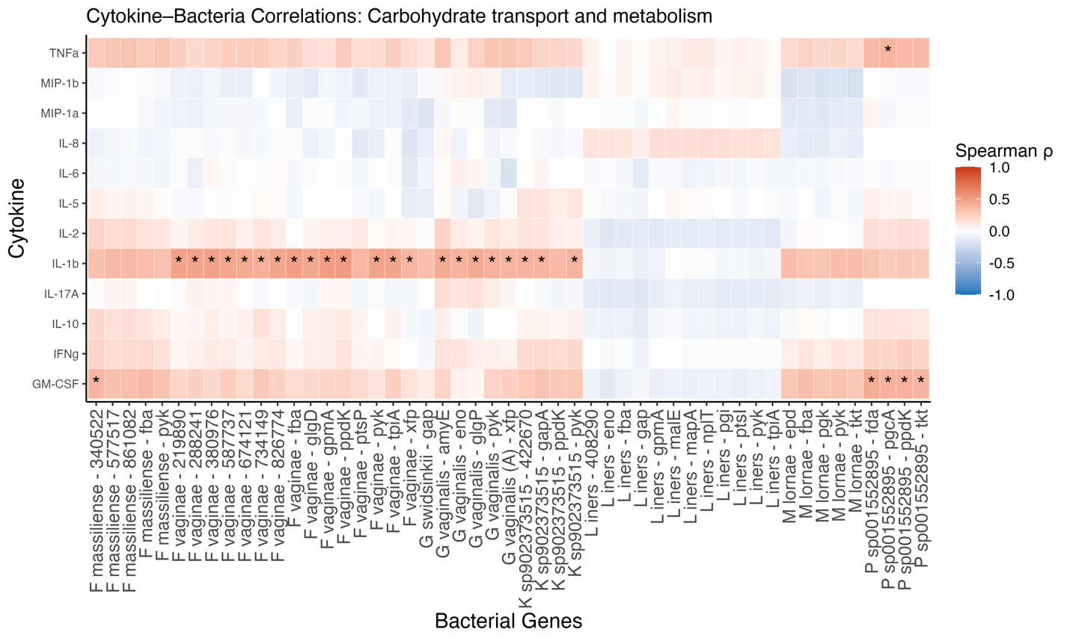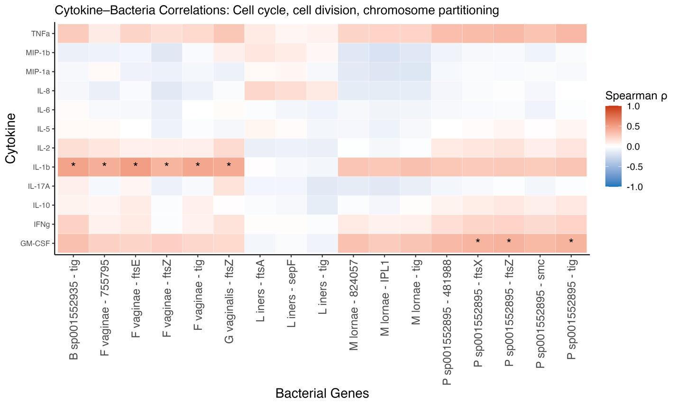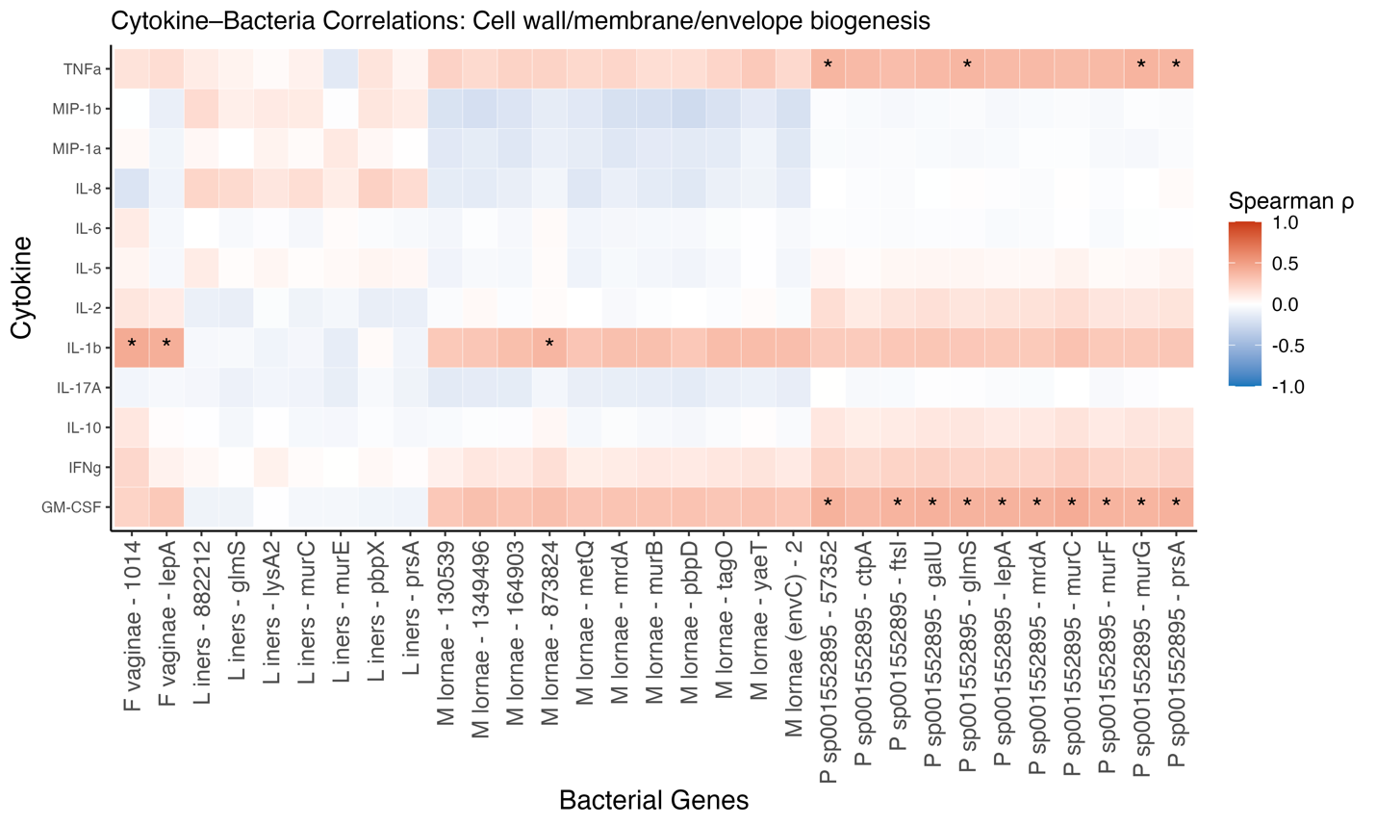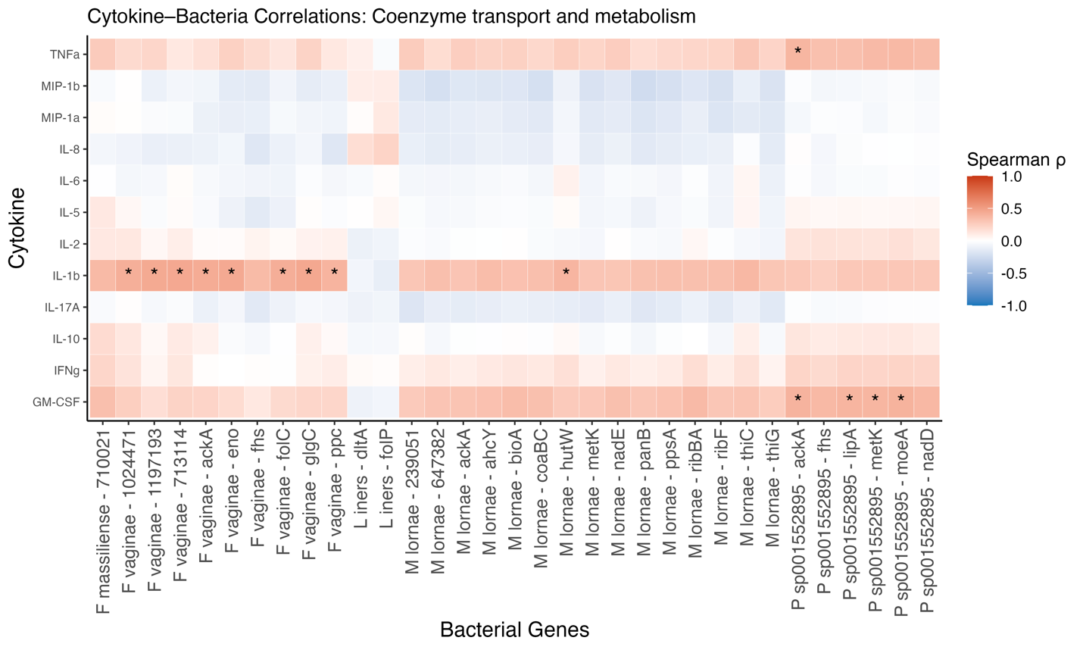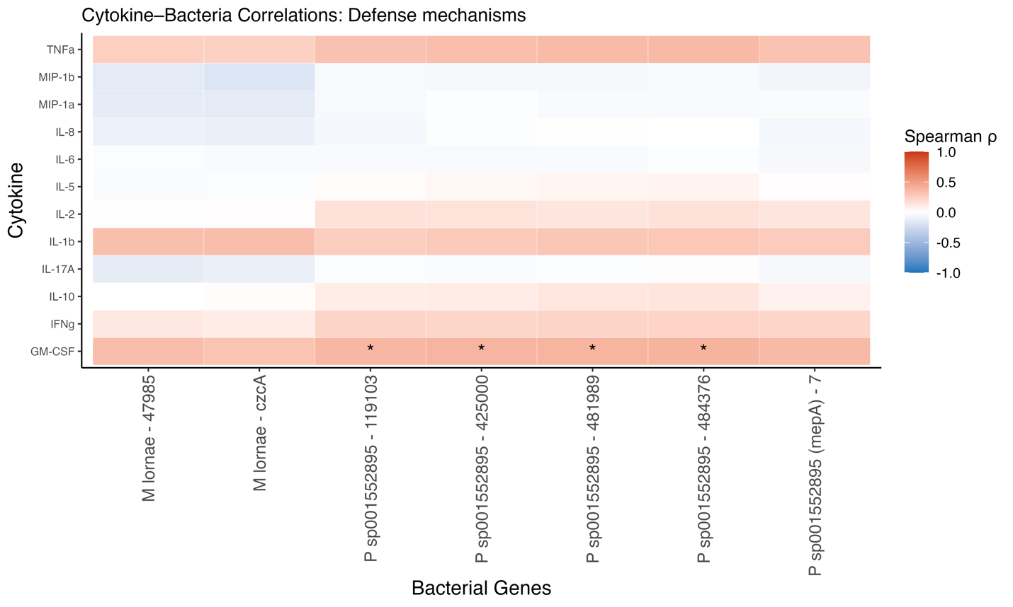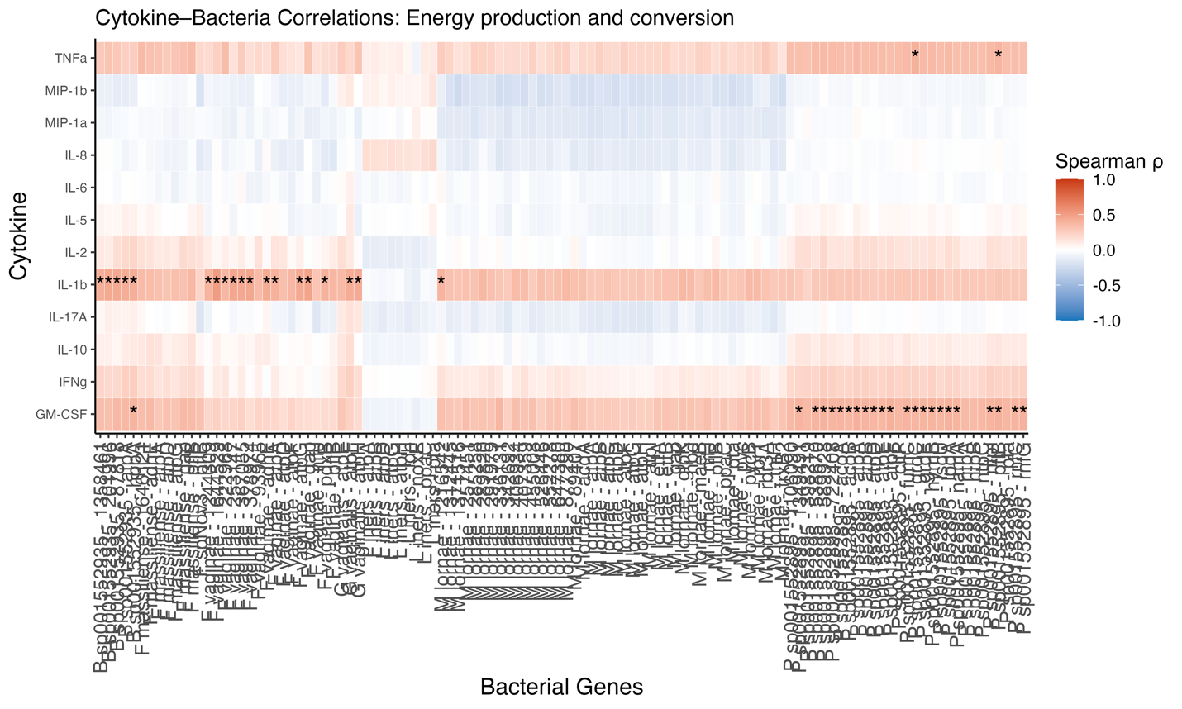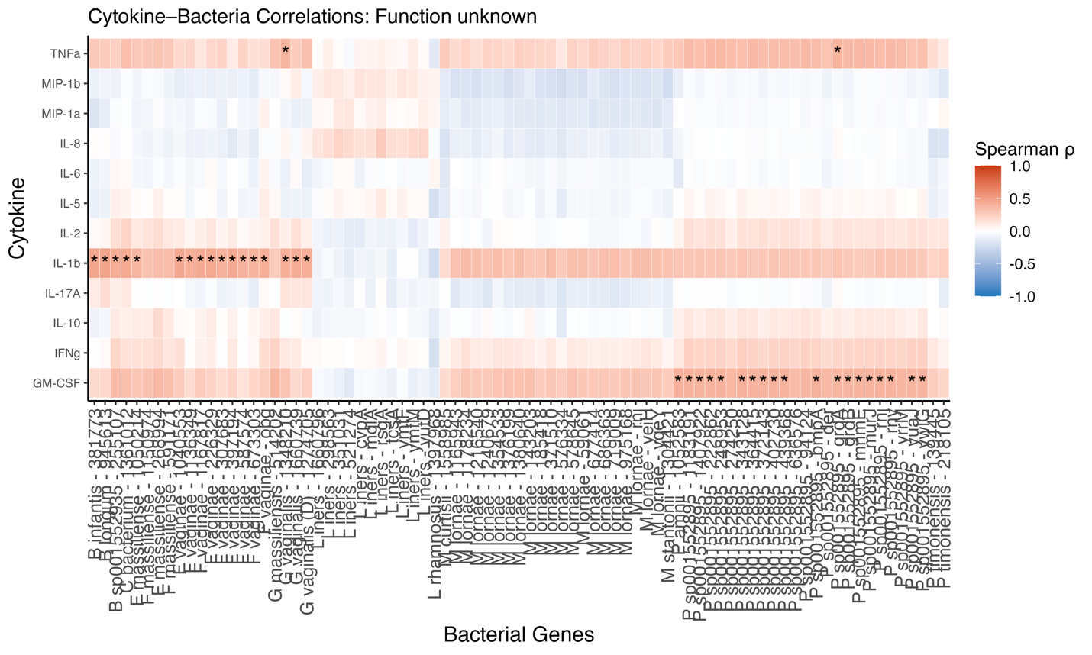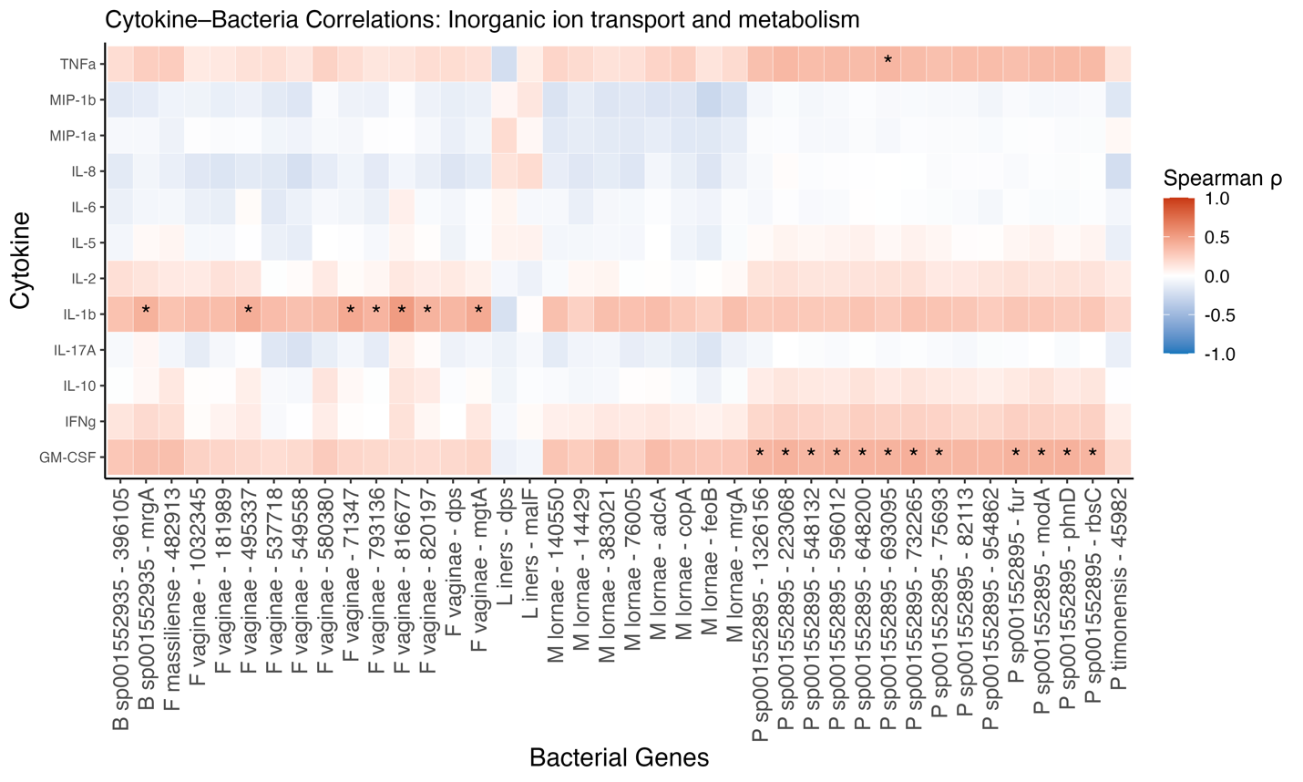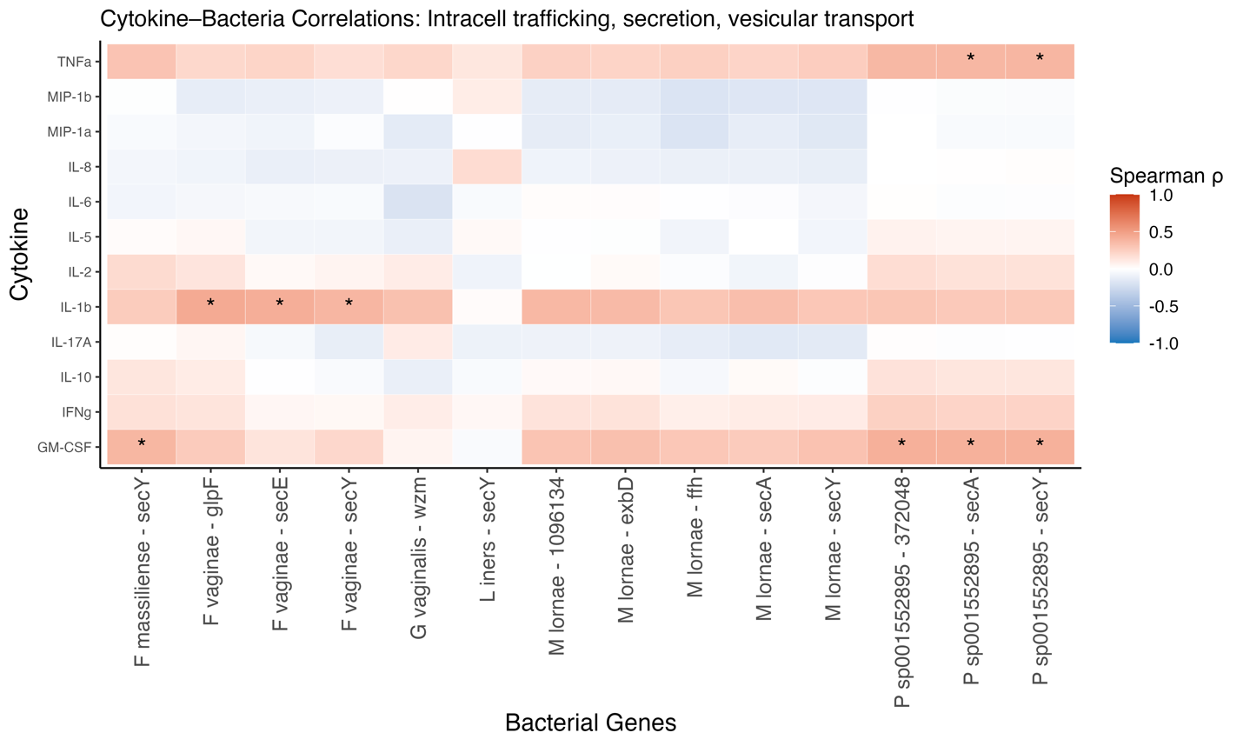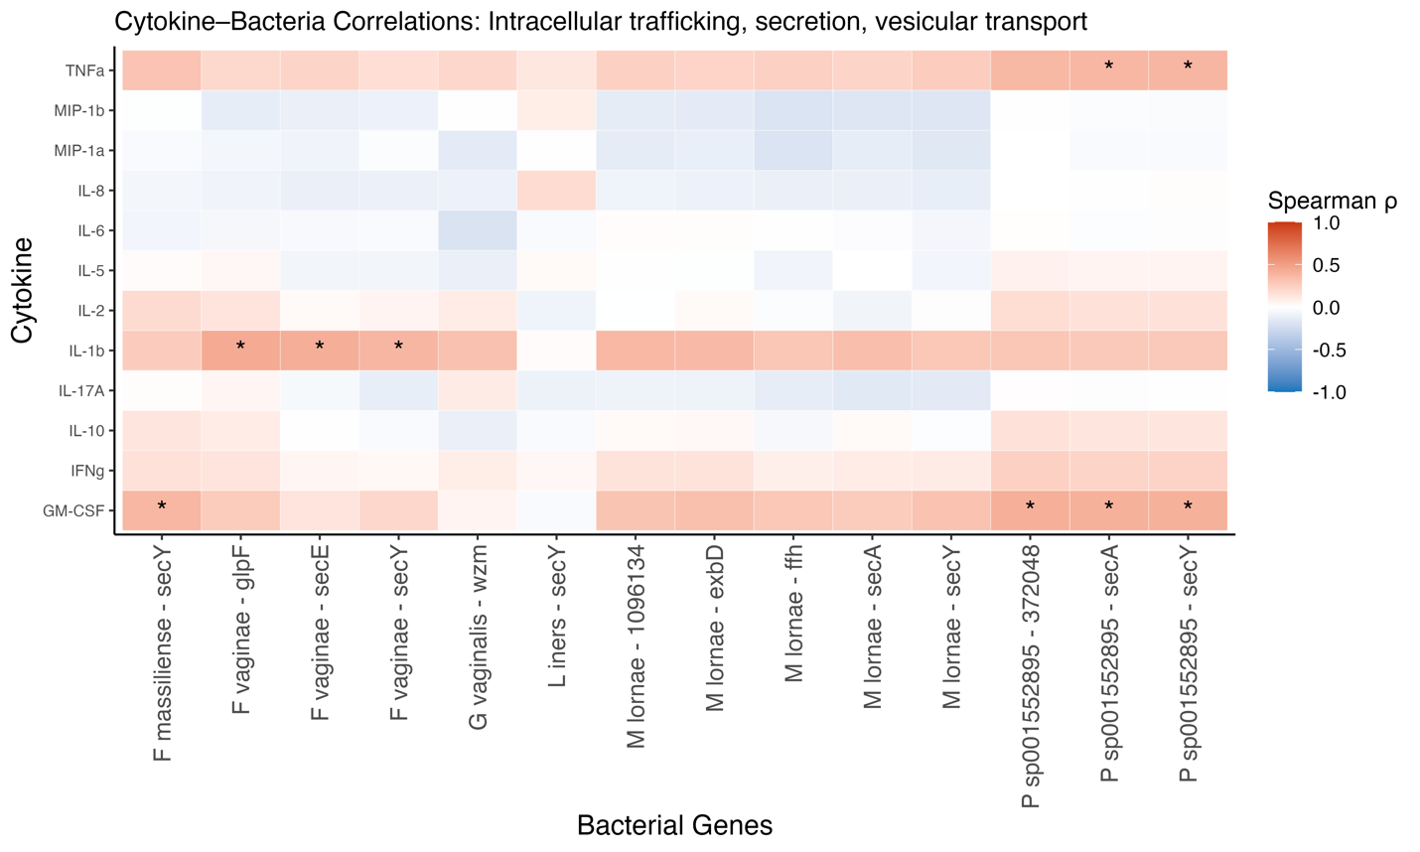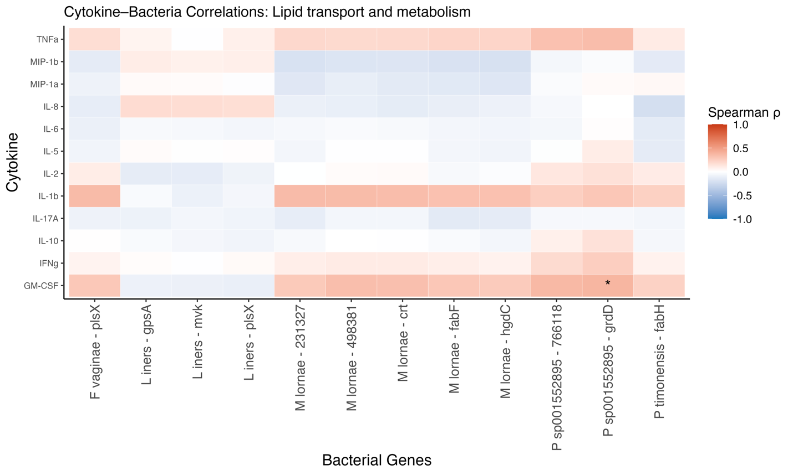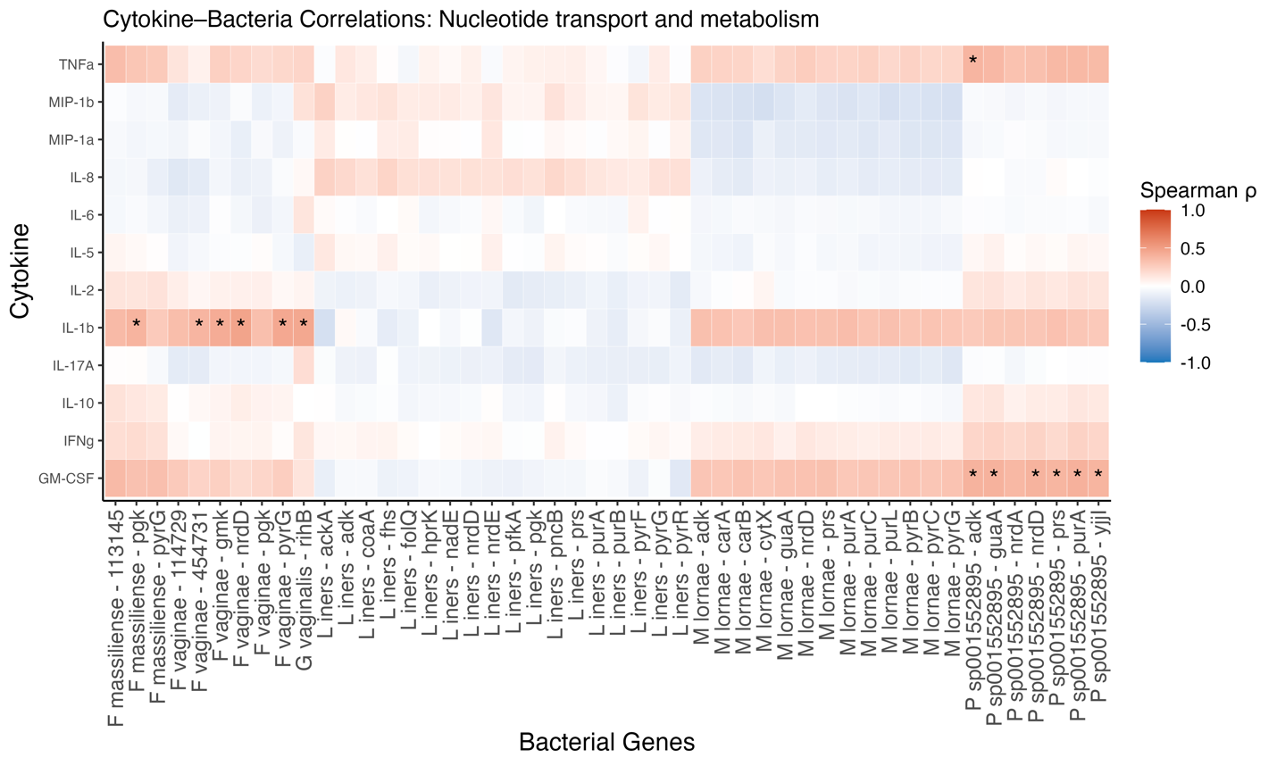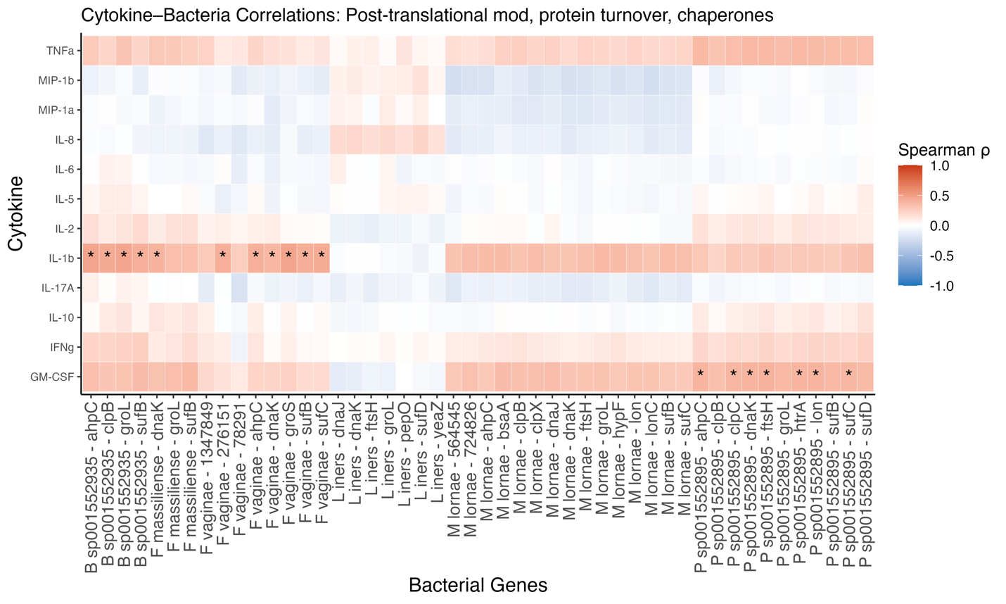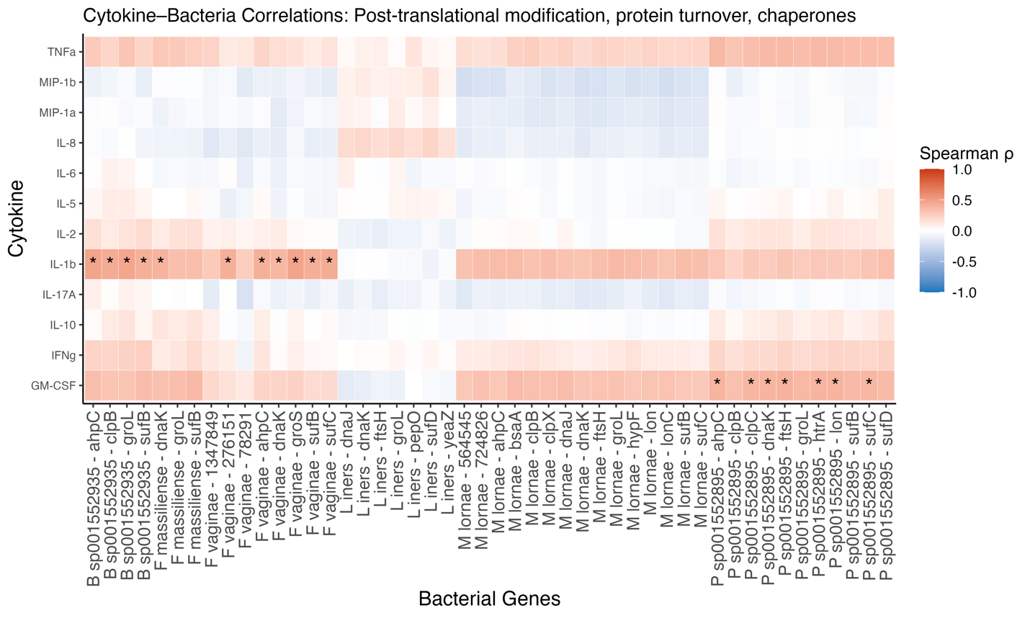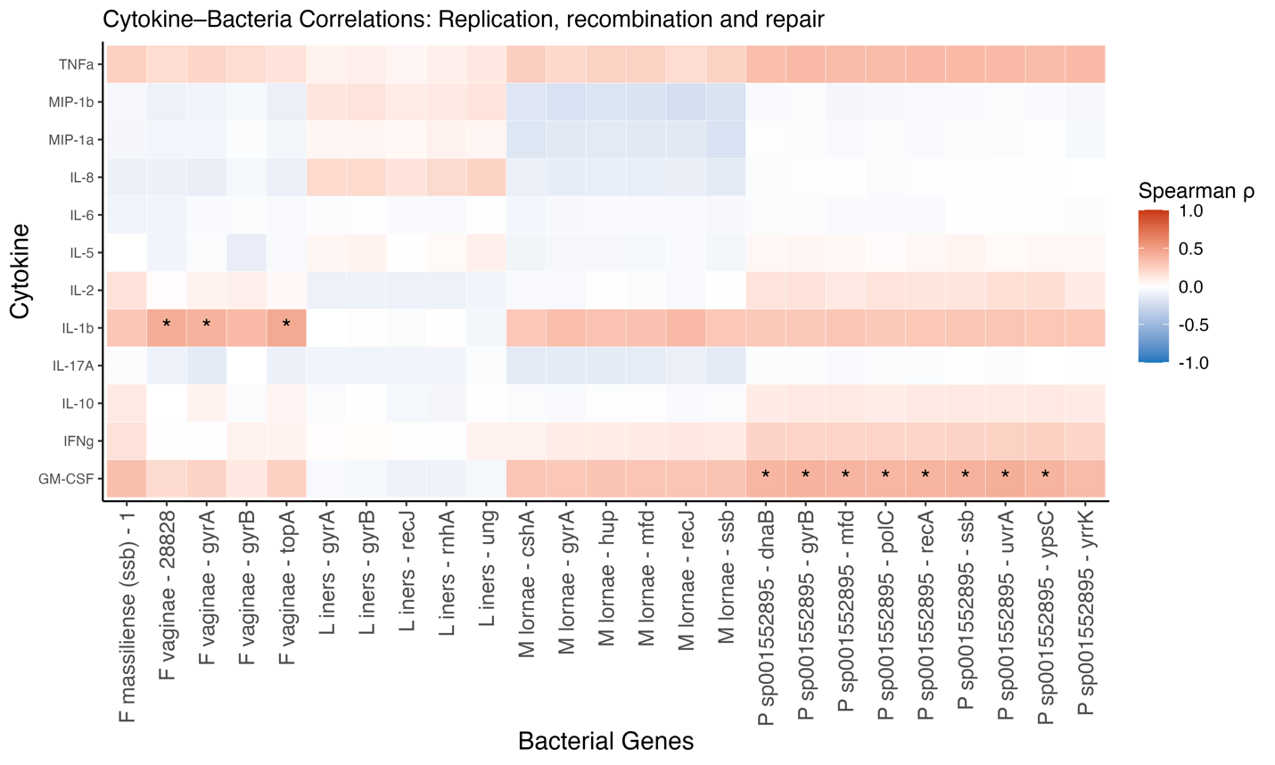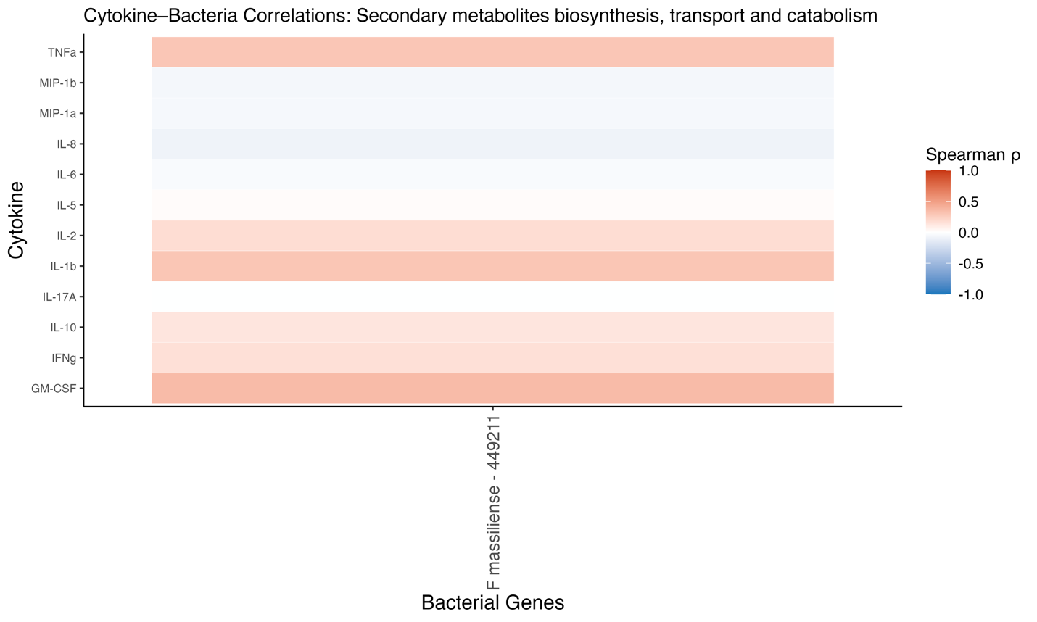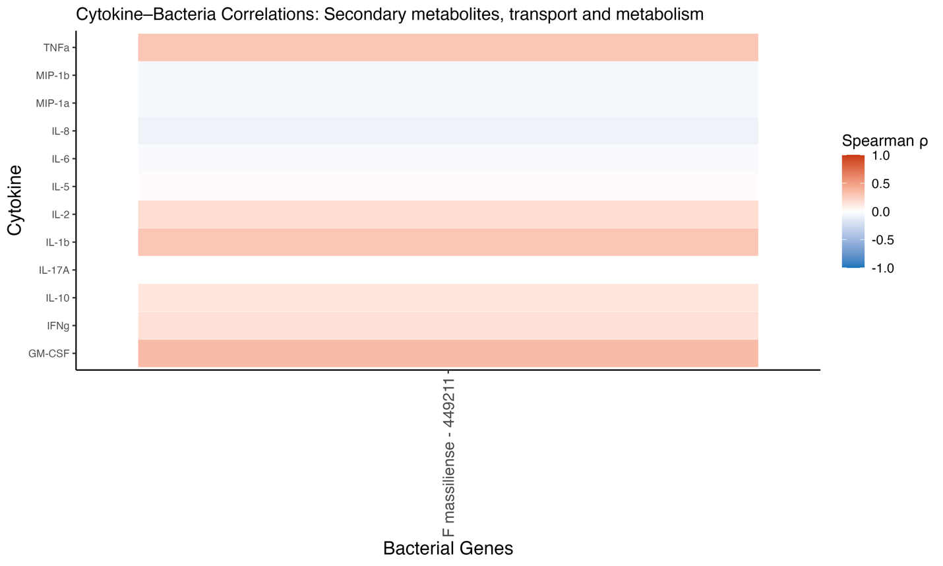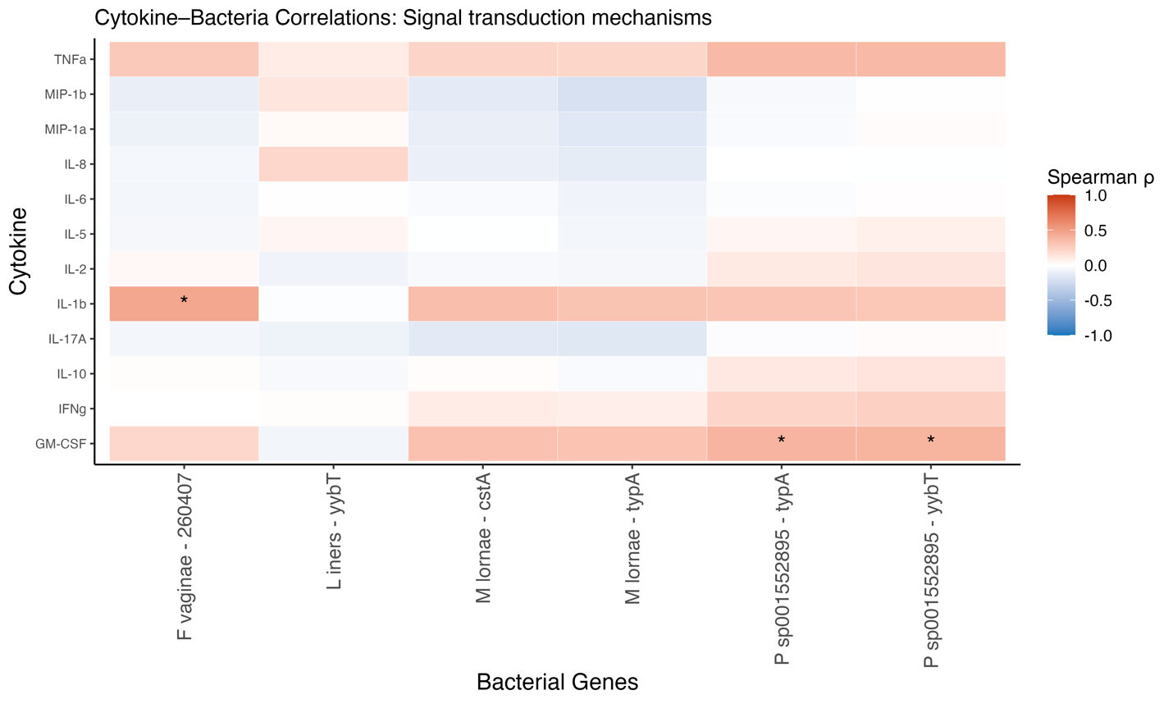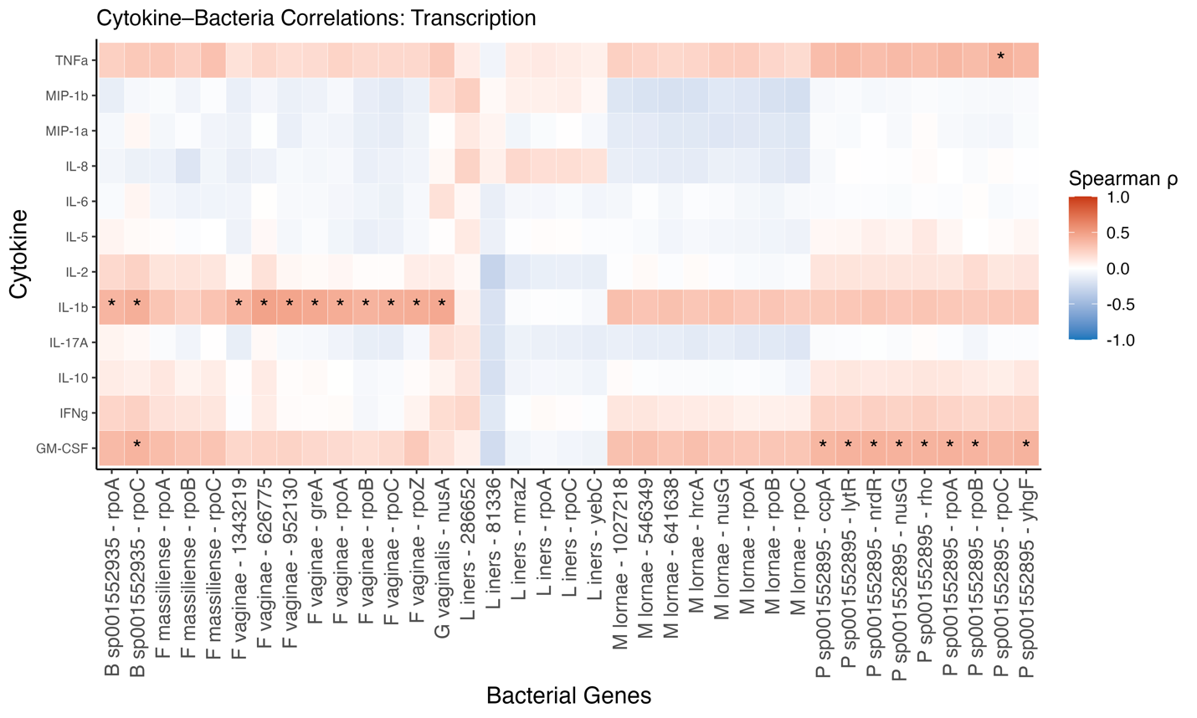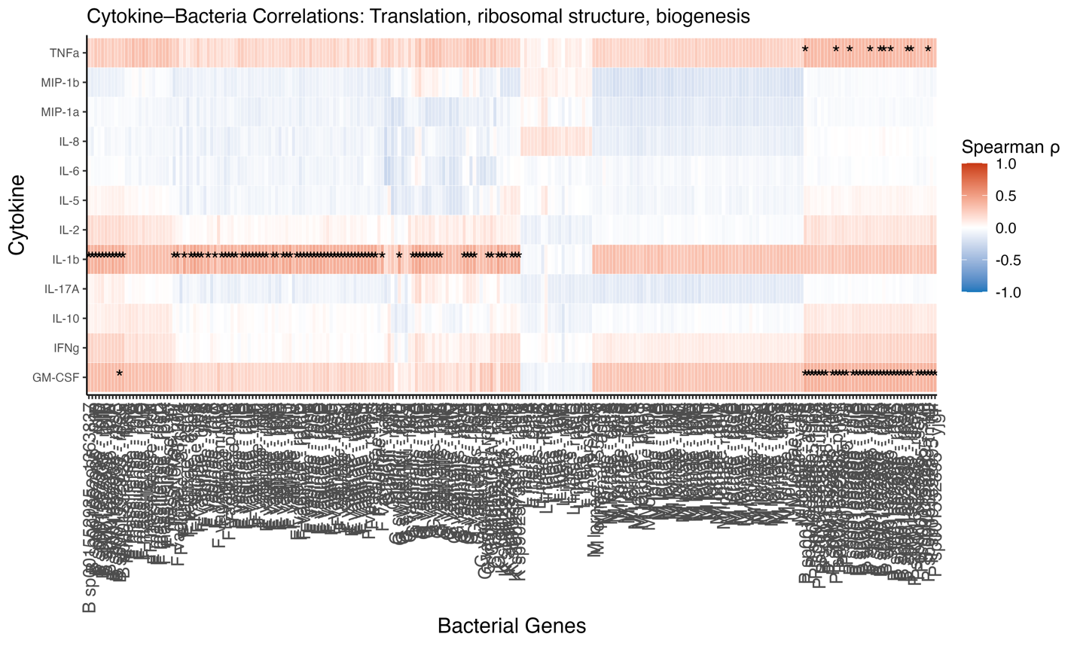
END OF FIGURE 13
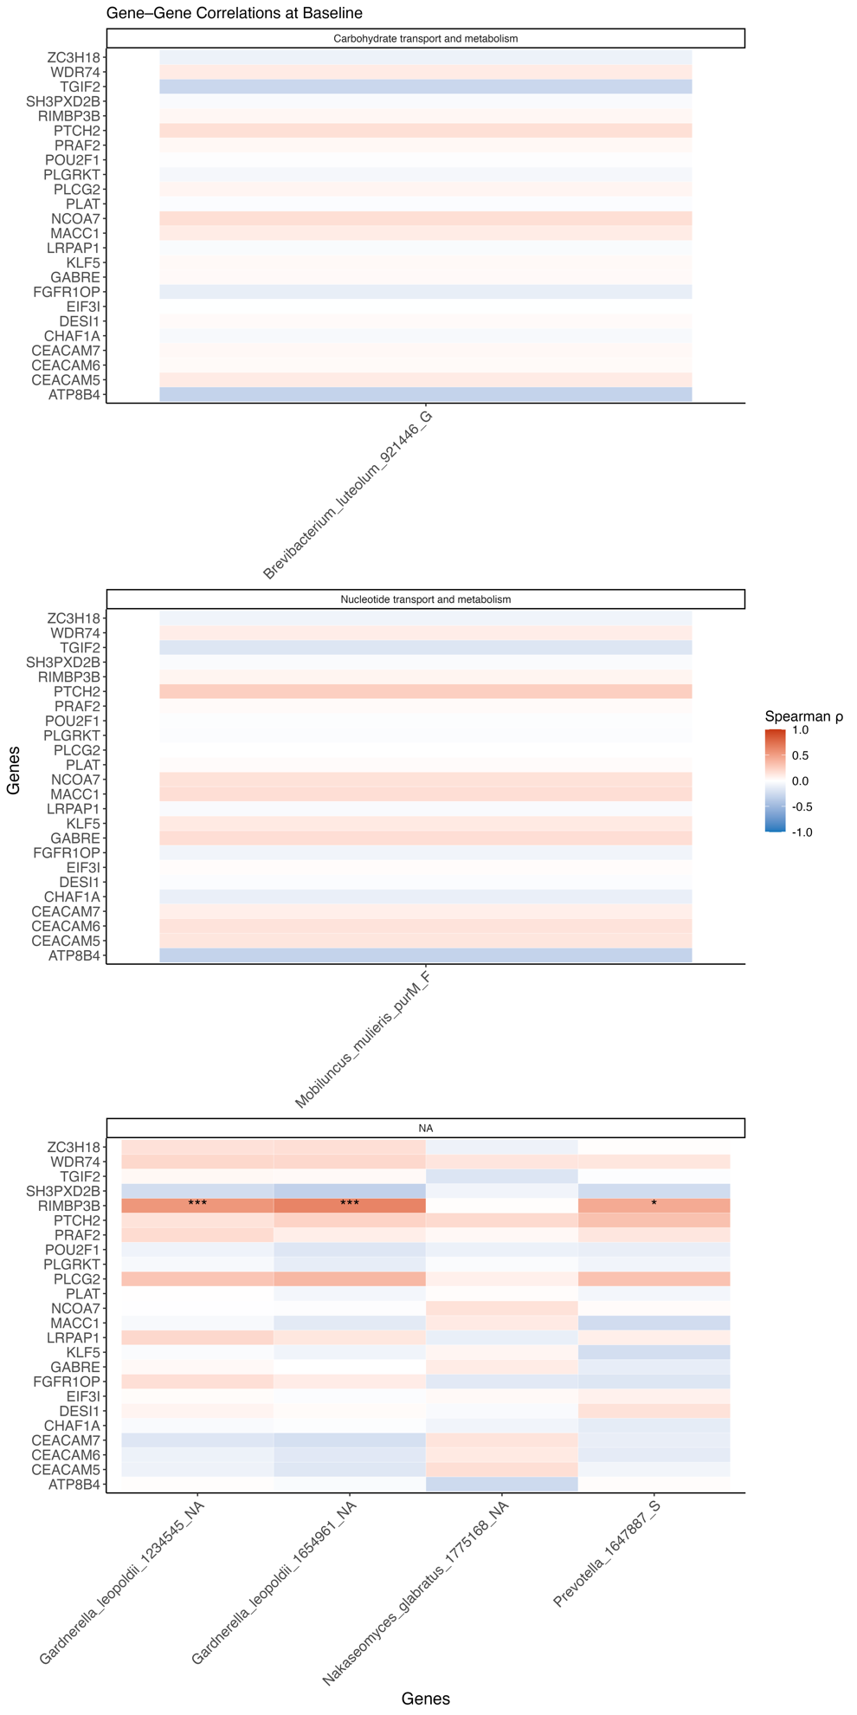
Supplementary Figure 14. Spearman correlations between host gene expression and microbial gene expression at baseline. Heatmaps show Spearman ρ correlations between selected host genes (rows) and bacterial or fungal genes (columns), grouped by microbial gene function where available (e.g., carbohydrate metabolism, nucleotide metabolism, unannotated). Color intensity indicates direction and strength of correlation (red = positive; blue = negative). Asterisks denote statistically significant correlations after multiple testing correction (*p < 0.05, ***p < 0.001). Notable associations include positive correlations between Mobiluncus mulieris and several immune-related or epithelial host genes (e.g., SH3PXD2B, RIMBP3B), as well as modest correlations between Gardnerella leopoldii and CEACAM family members.

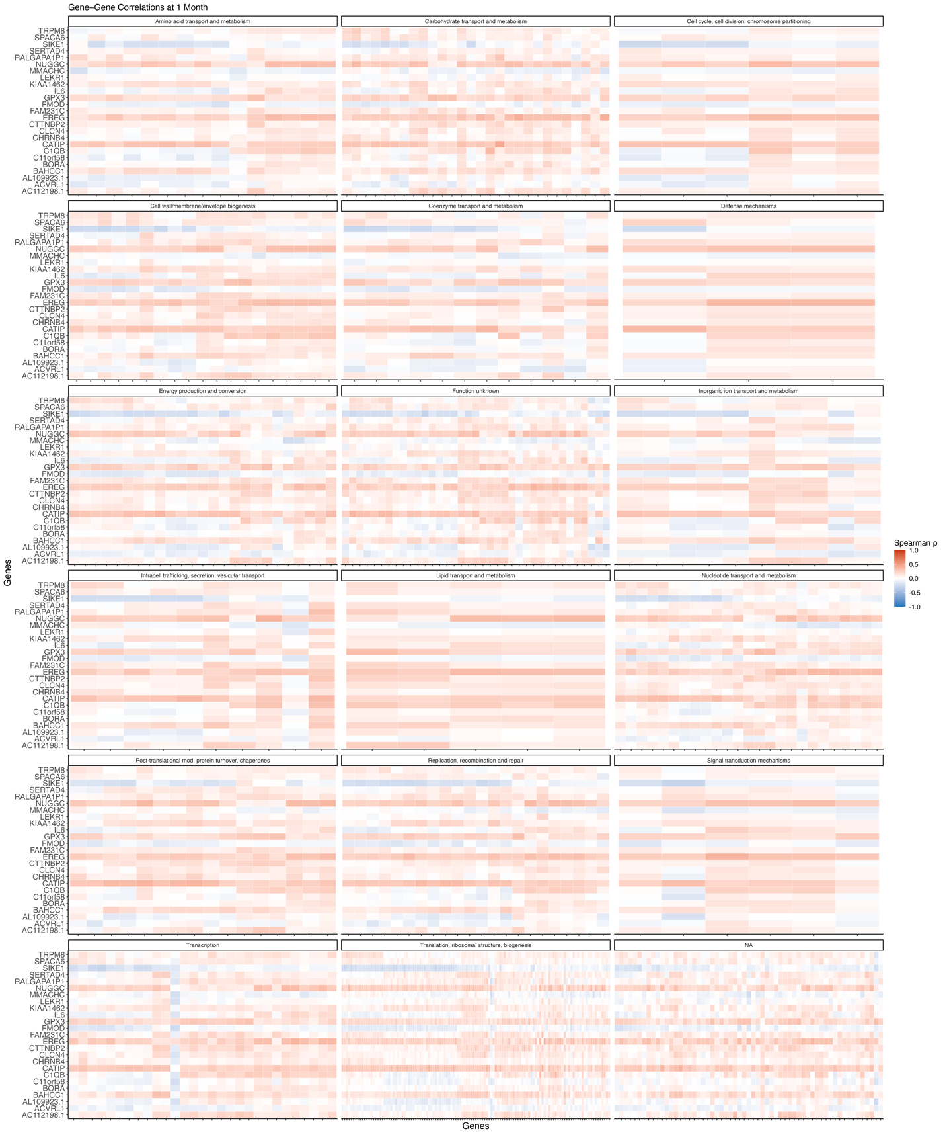
Supplementary Figure 15. Spearman correlations between host and microbial gene expression at 1-month post-treatment. Heatmaps show Spearman ρ correlations between selected human genes (rows) and bacterial gene expression (columns), grouped by microbial gene function using COG annotations. Each tile represents the correlation between a specific human-microbial gene pair. Color scale indicates correlation strength and direction (red = positive; blue = negative). While no formal significance annotations are shown here, patterns reveal broad clusters of moderate positive associations—particularly in genes related to microbial transcription, energy metabolism, and envelope biogenesis. This summary figure provides an overview across all microbial gene categories; subsequent panels display full-resolution individual heatmaps for each category.
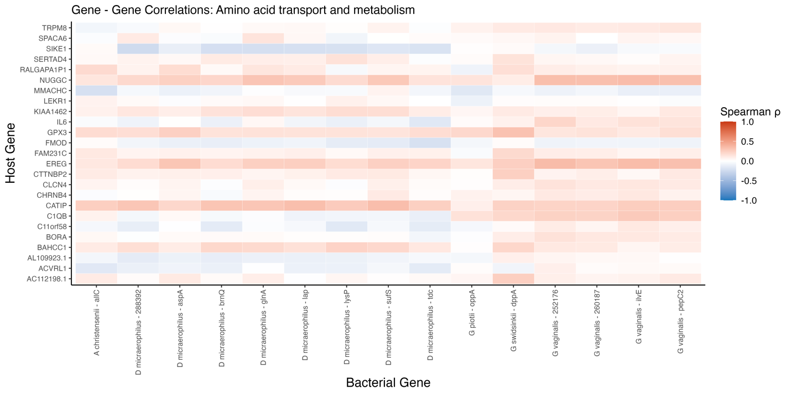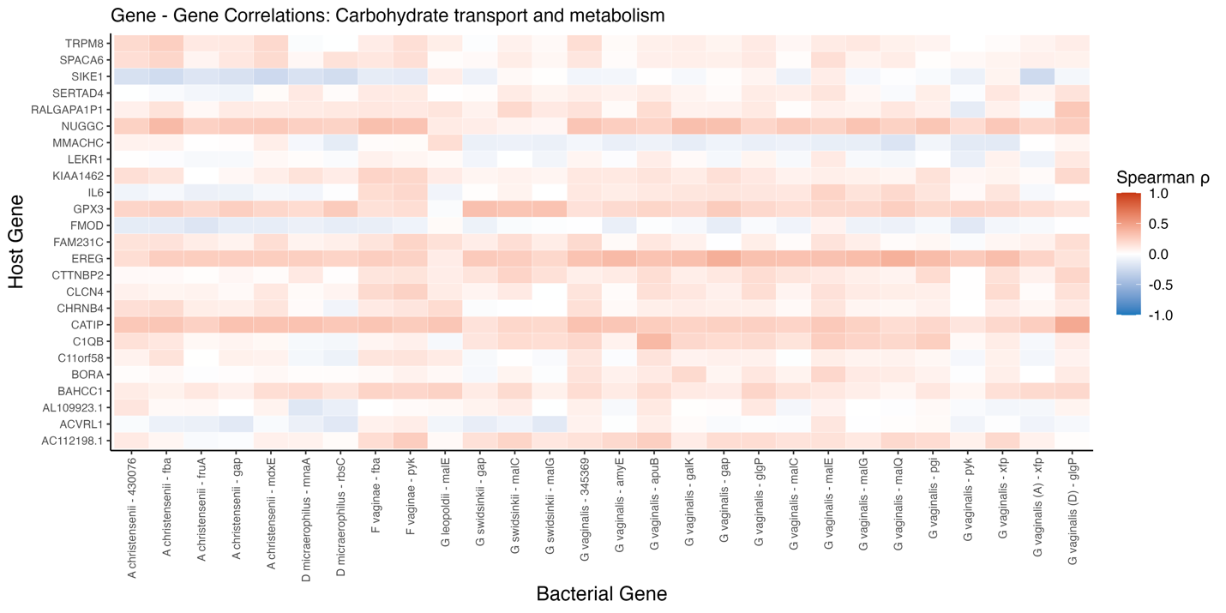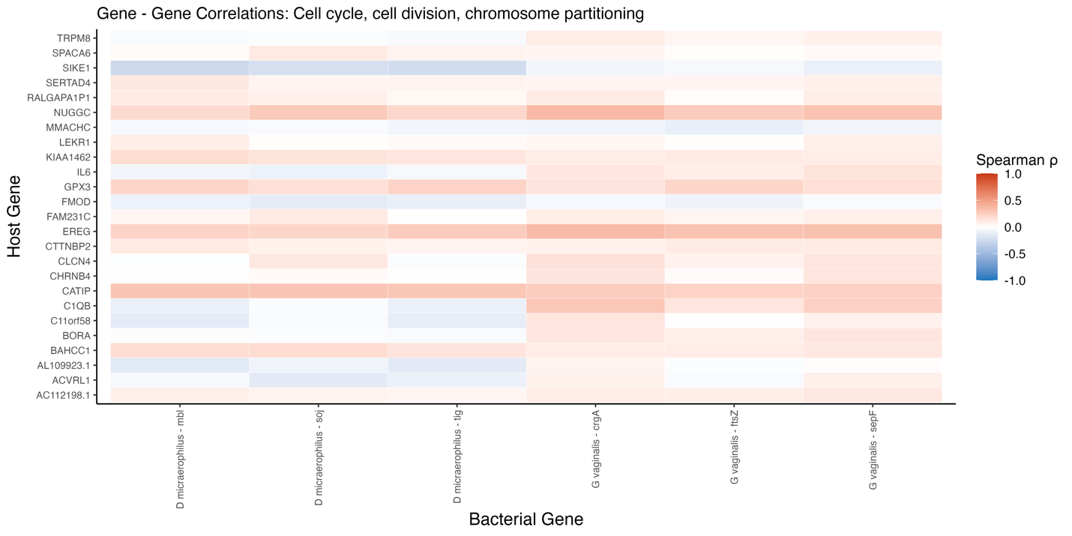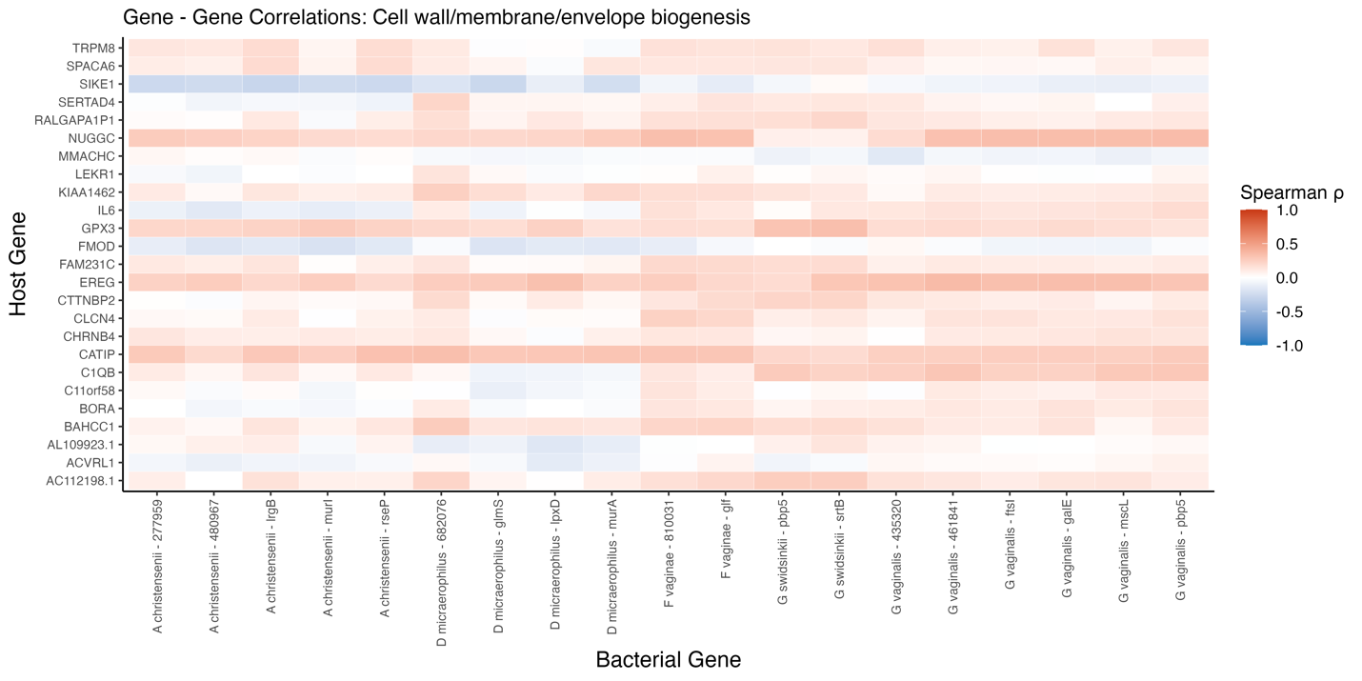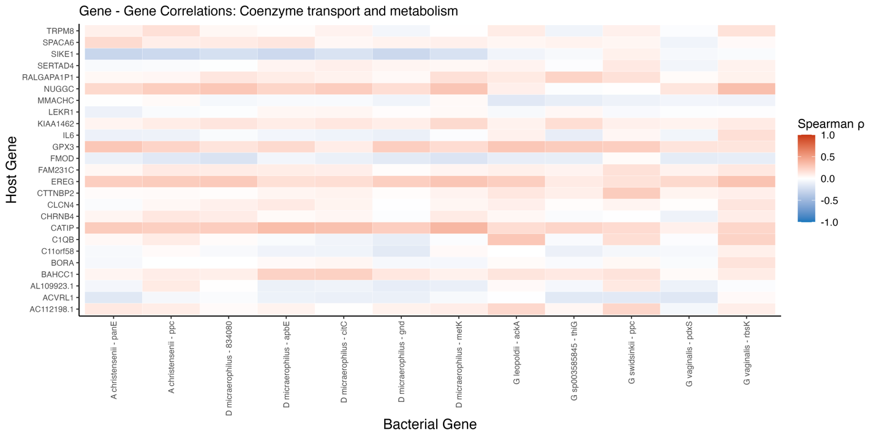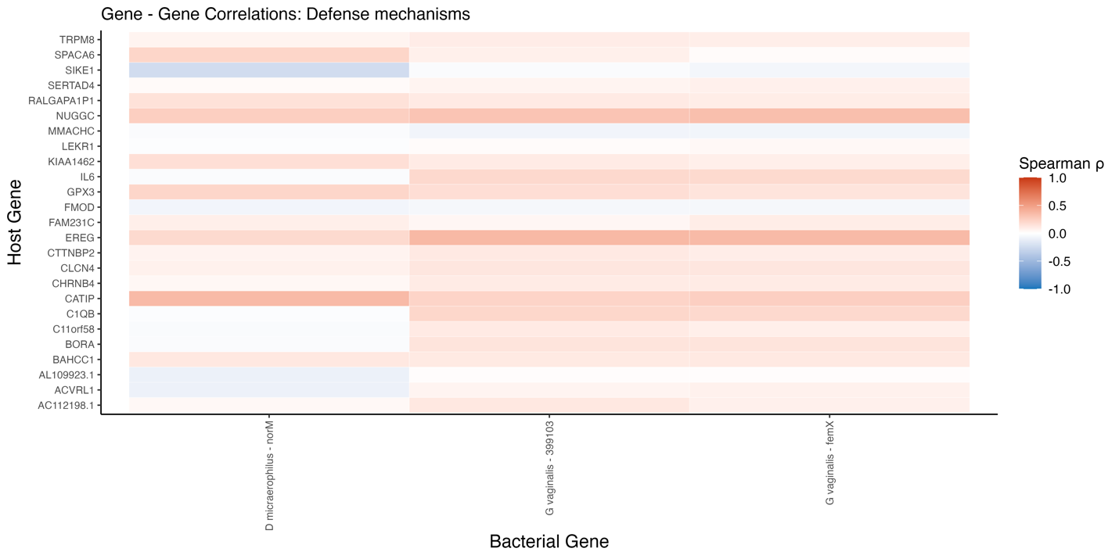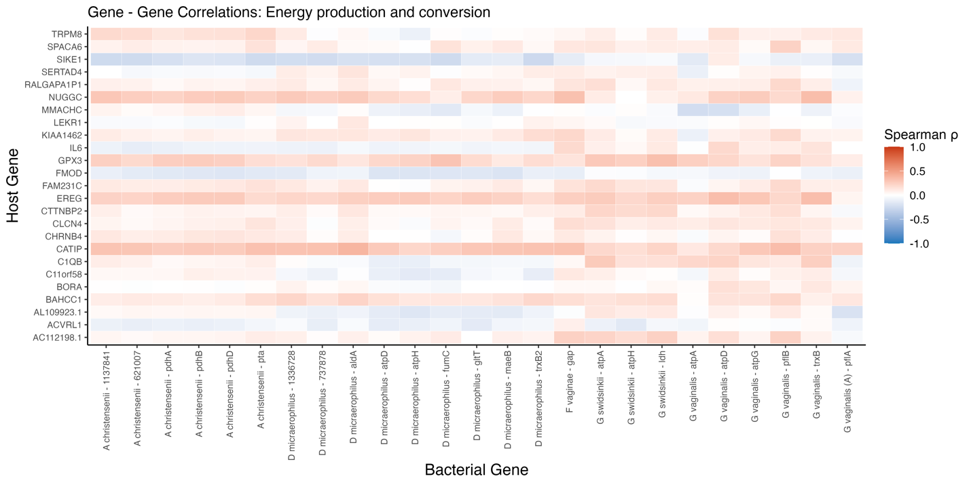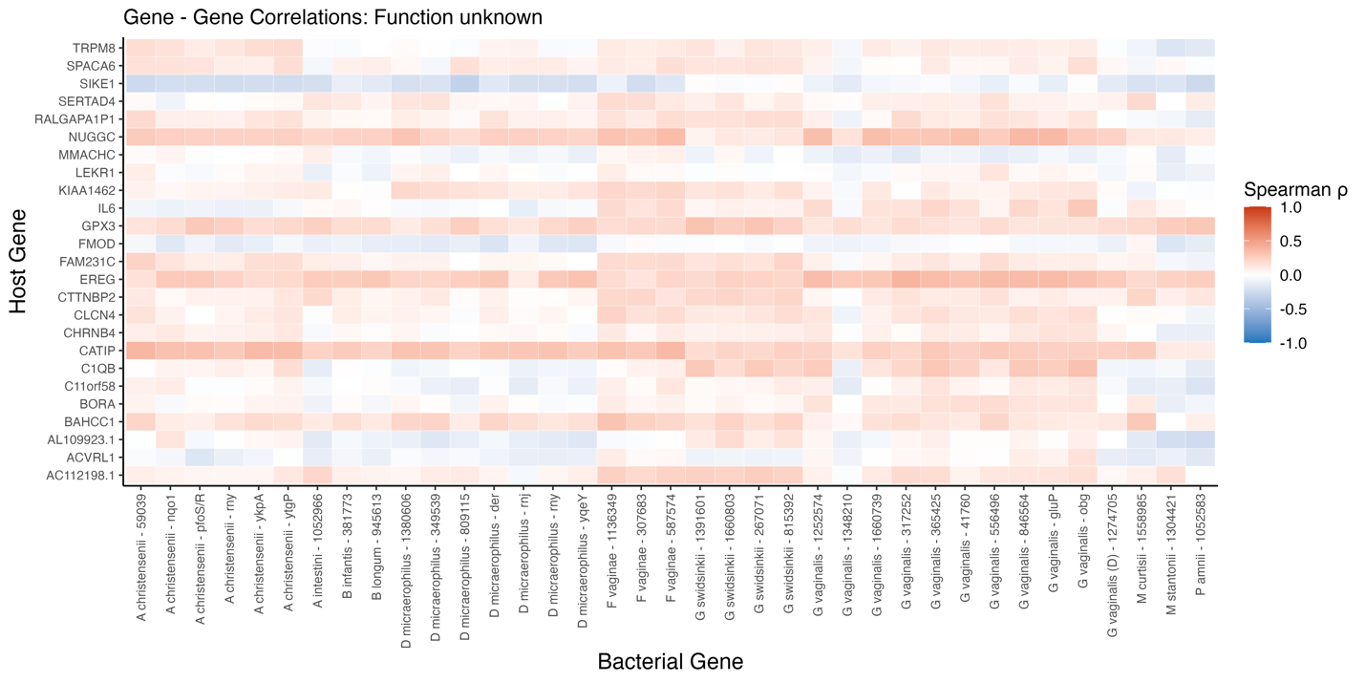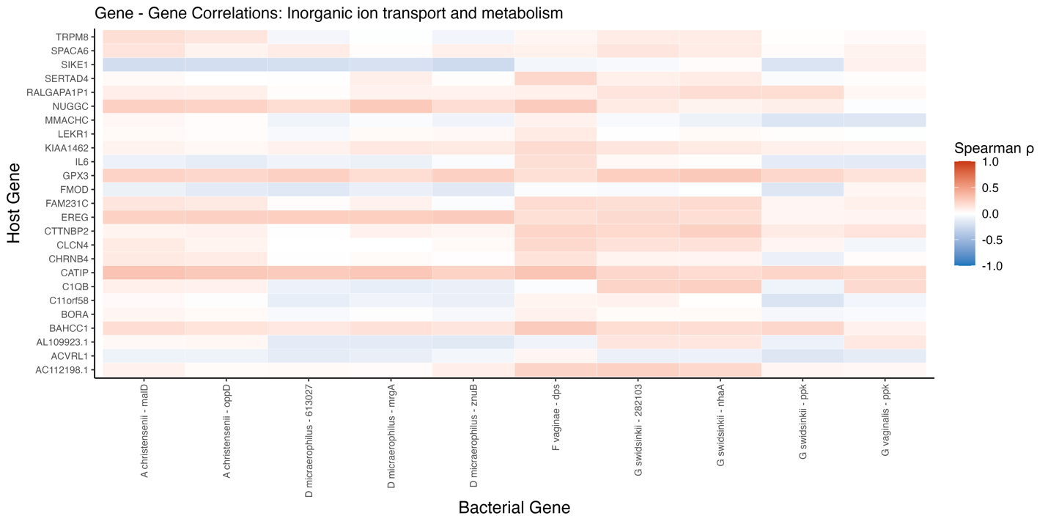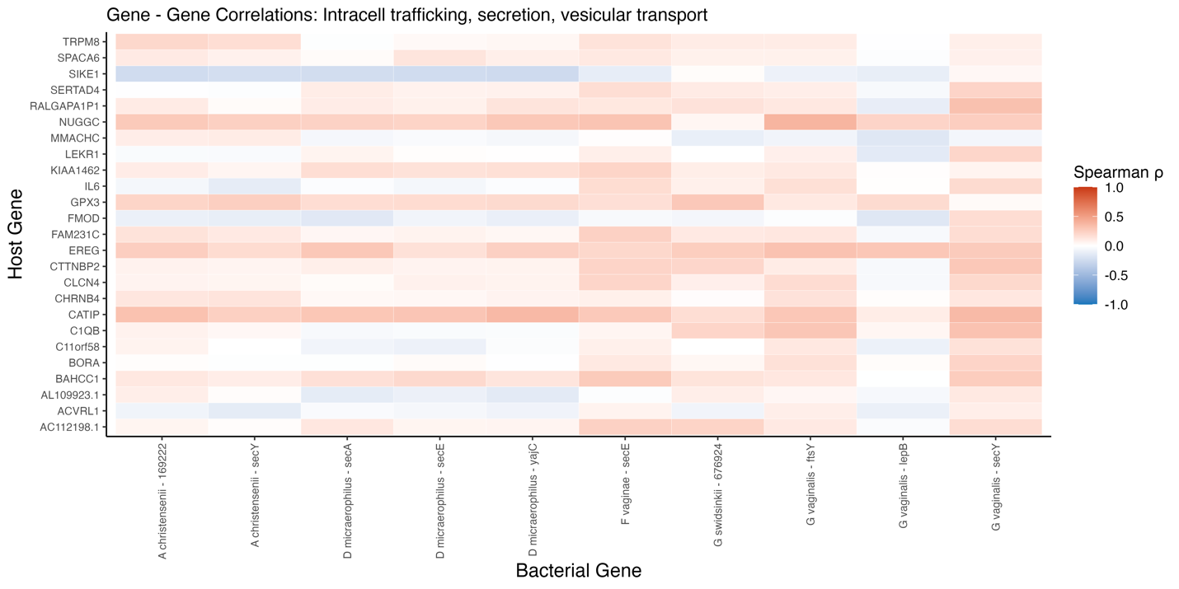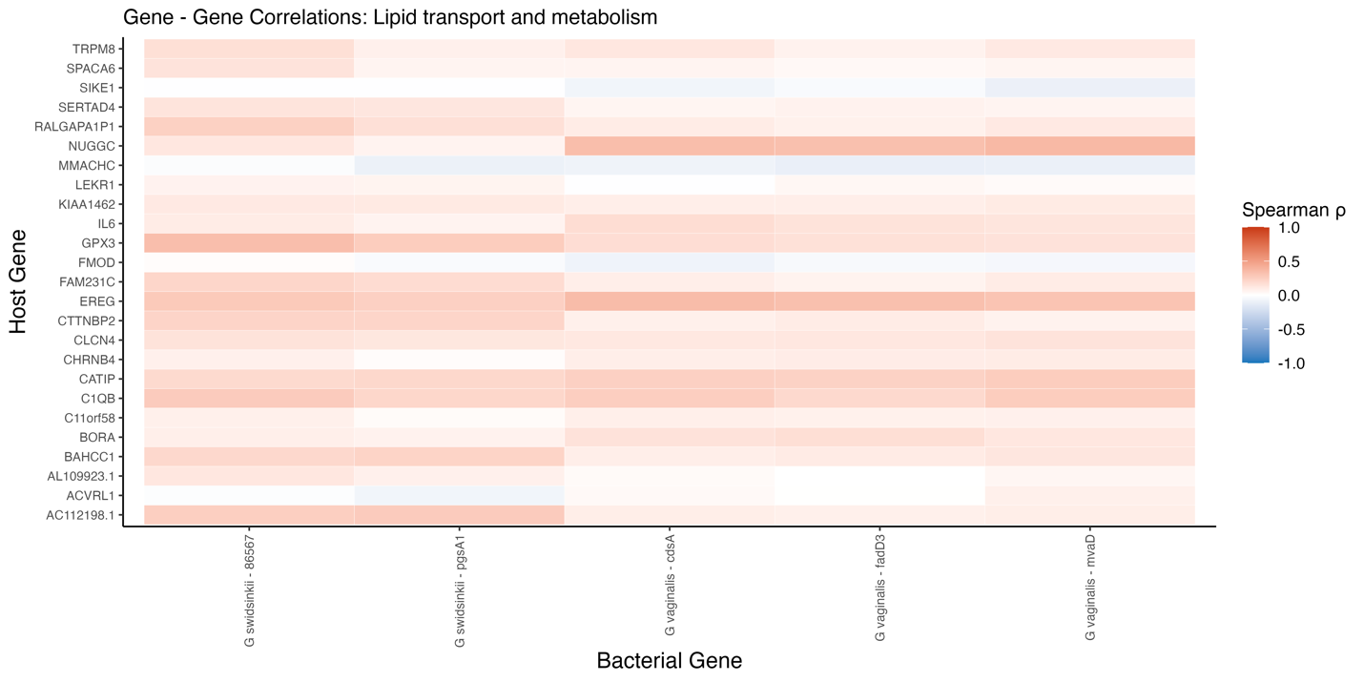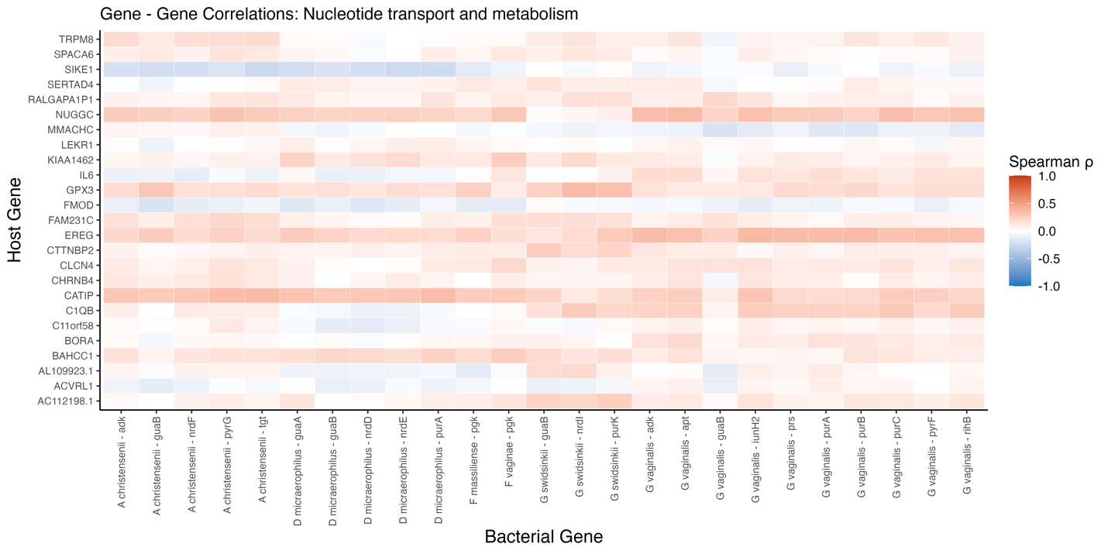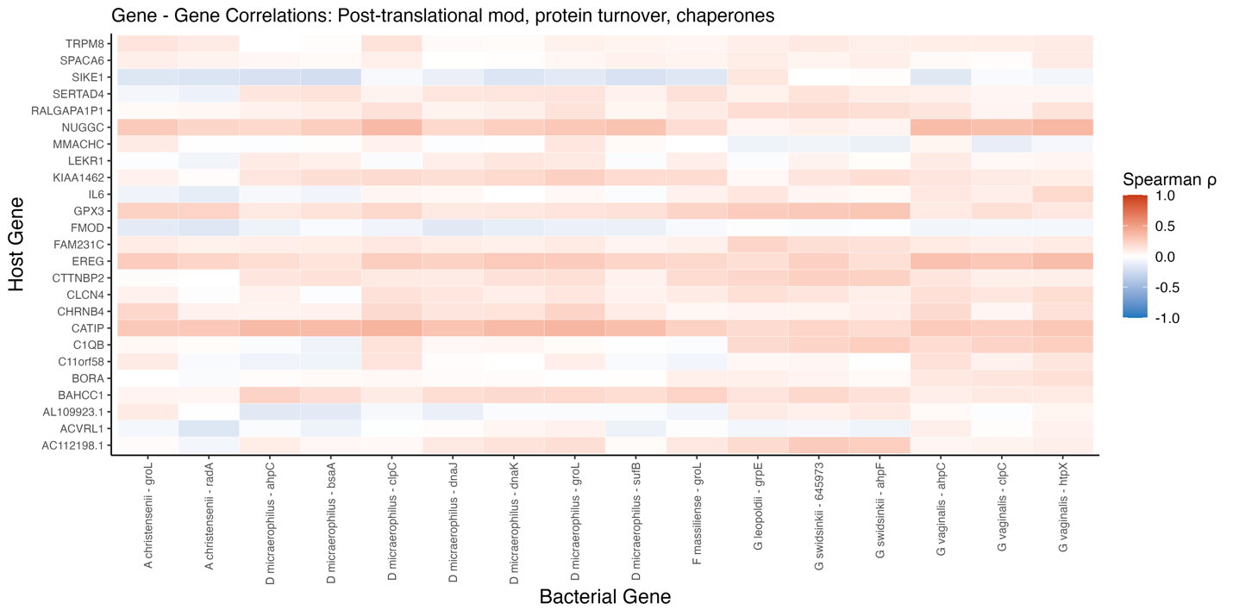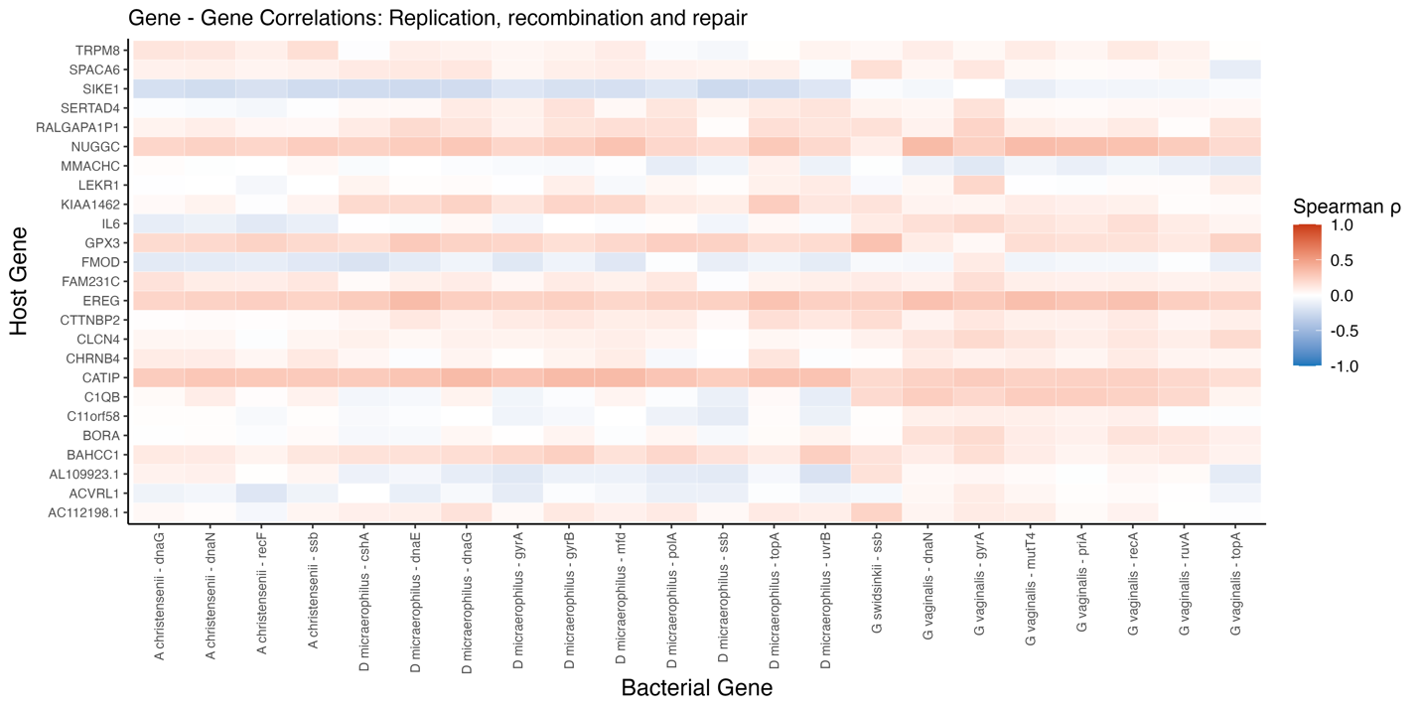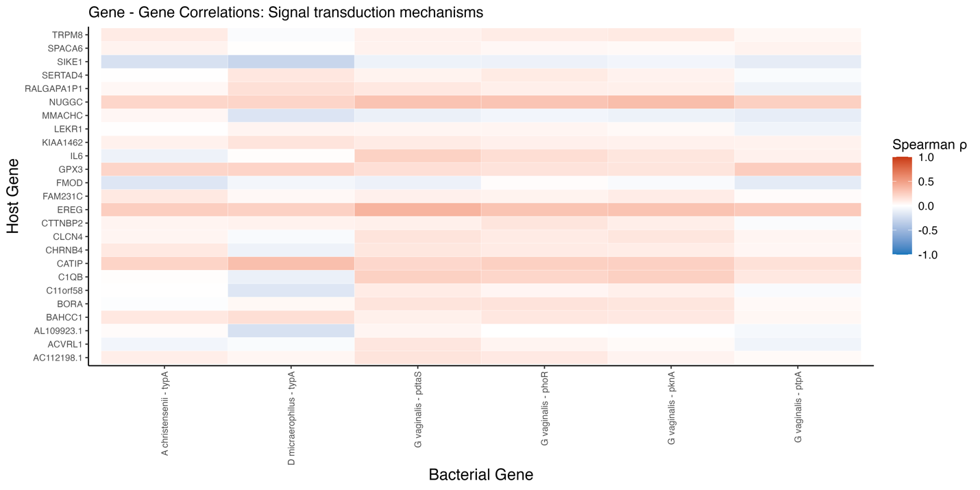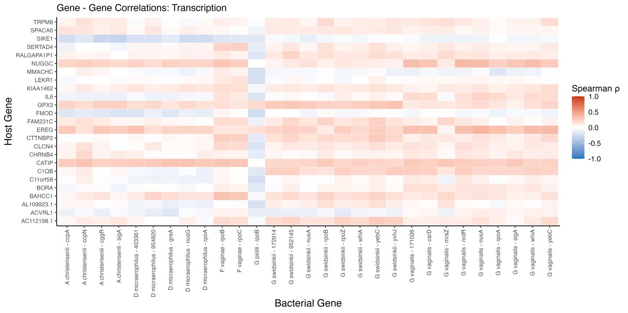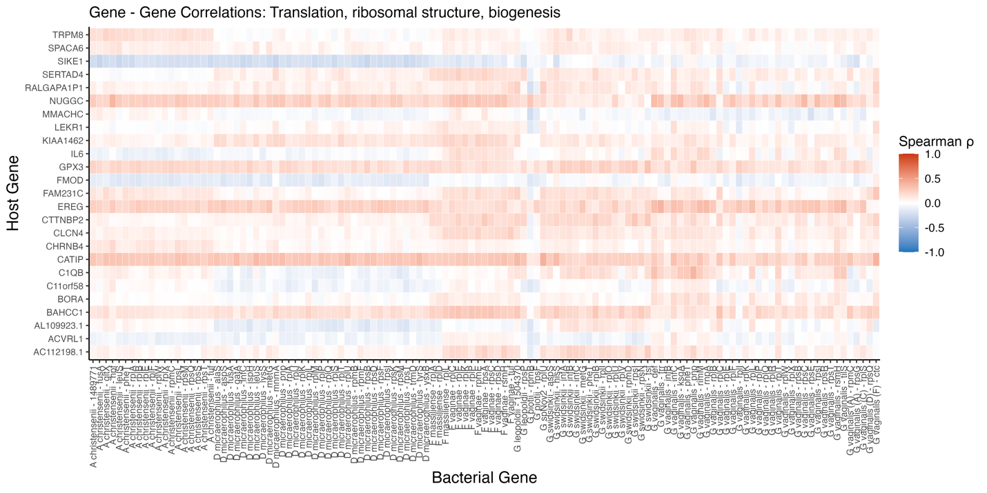

END OF FIGURE 15

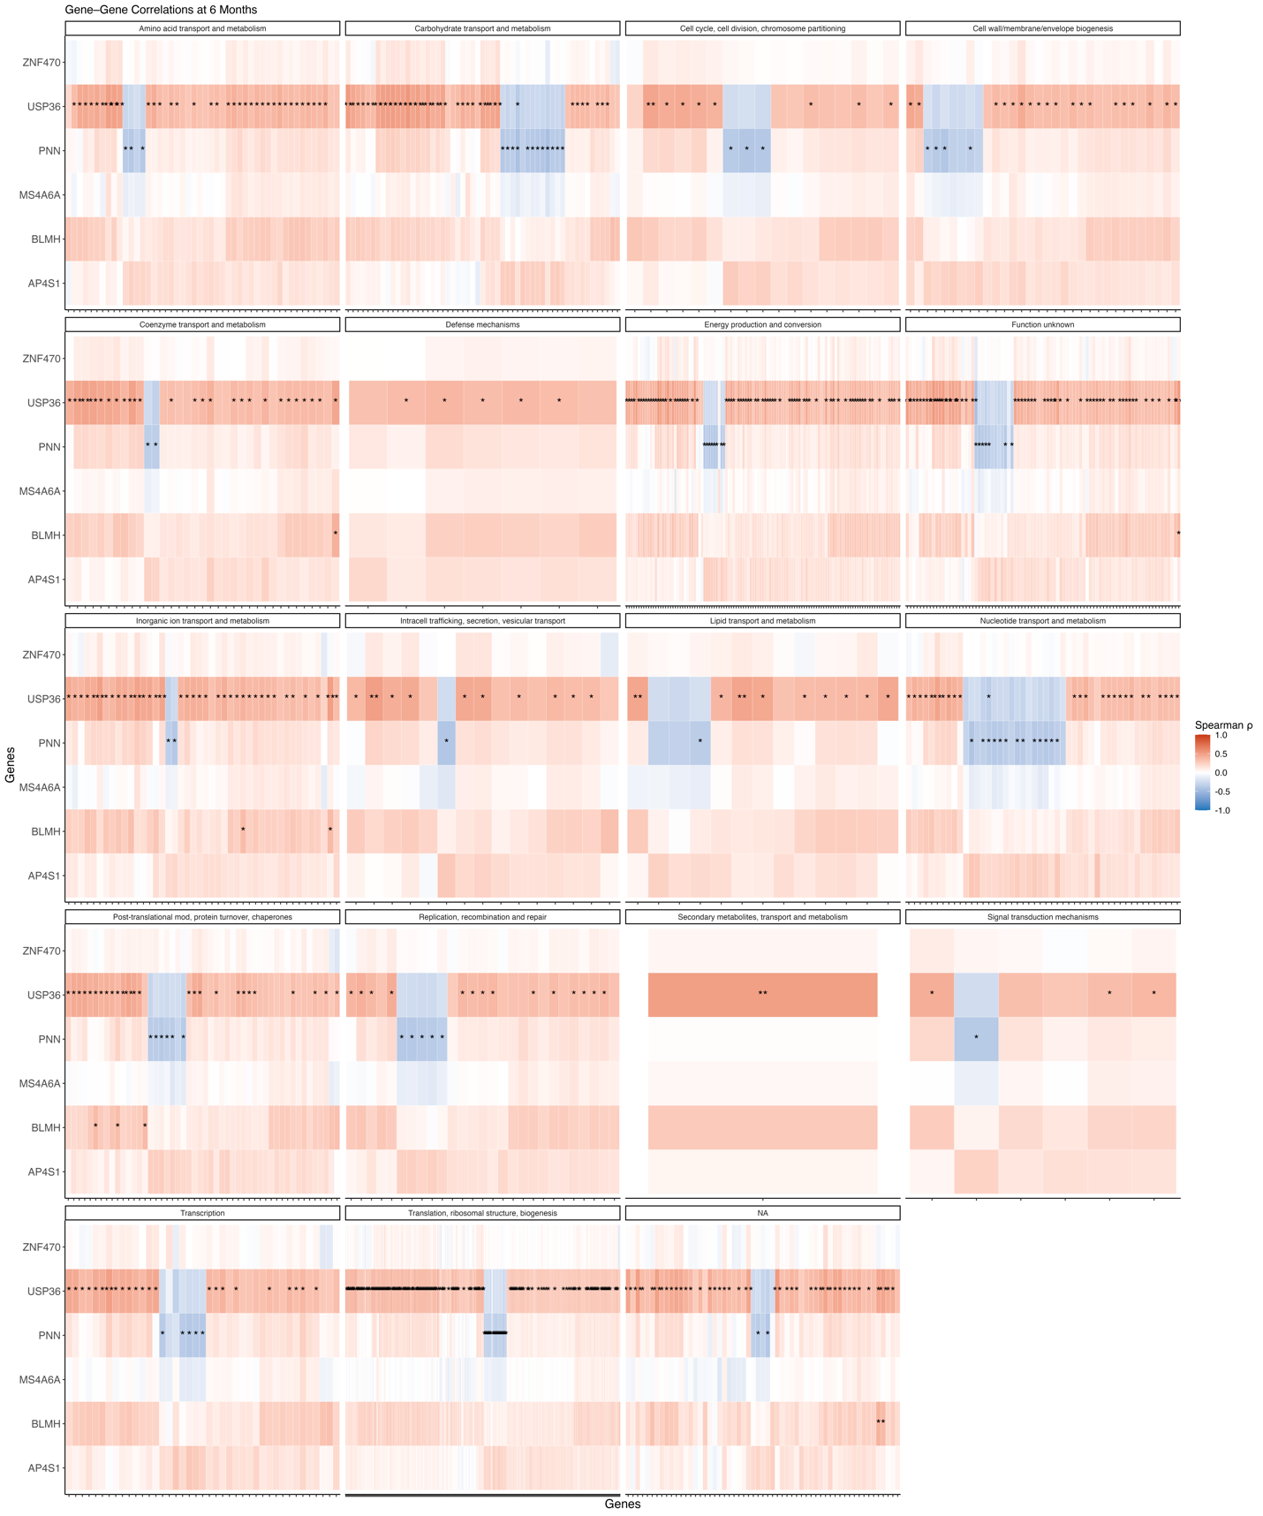
Supplementary Figure 16. Spearman correlations between host and microbial gene expression at 6 months post-treatment. Heatmaps display Spearman ρ correlations between selected host genes (rows) and microbial genes (columns), grouped by predicted microbial functional categories (e.g., carbohydrate metabolism, transcription, membrane biogenesis) using COG annotations. Color scale reflects the strength and direction of correlation (red = positive; blue = negative). Asterisks mark statistically significant correlations (adjusted p < 0.05). At this timepoint, strong and consistent correlations are observed across several gene pairs, particularly involving host genes USP36, PNN, and ZNF470. Microbial genes involved in translation, transport, and membrane-related processes were among the most associated categories.
This summary figure is accompanied by high-resolution facet-specific panels for each functional group.
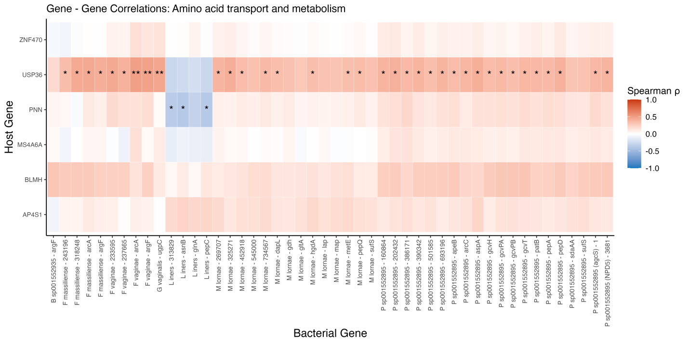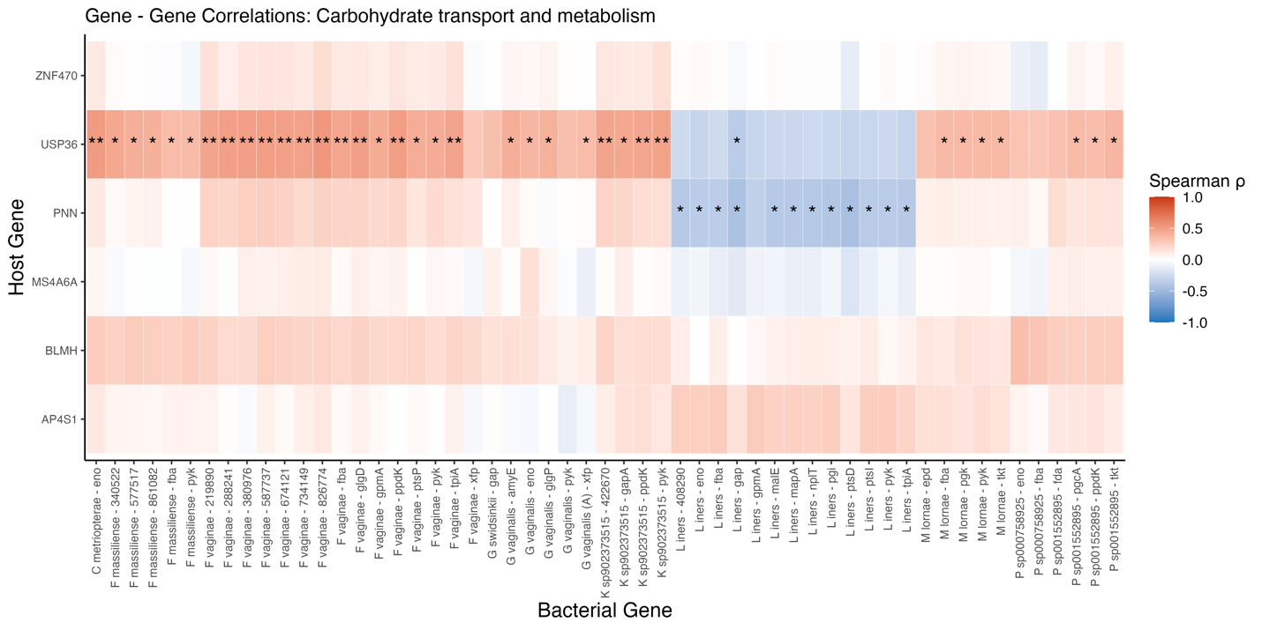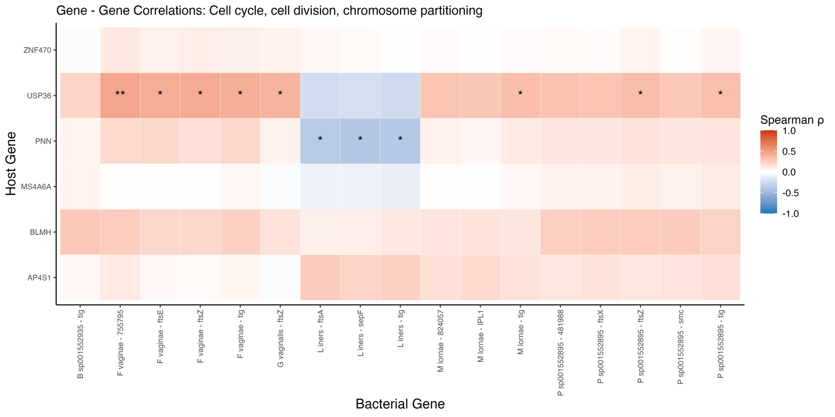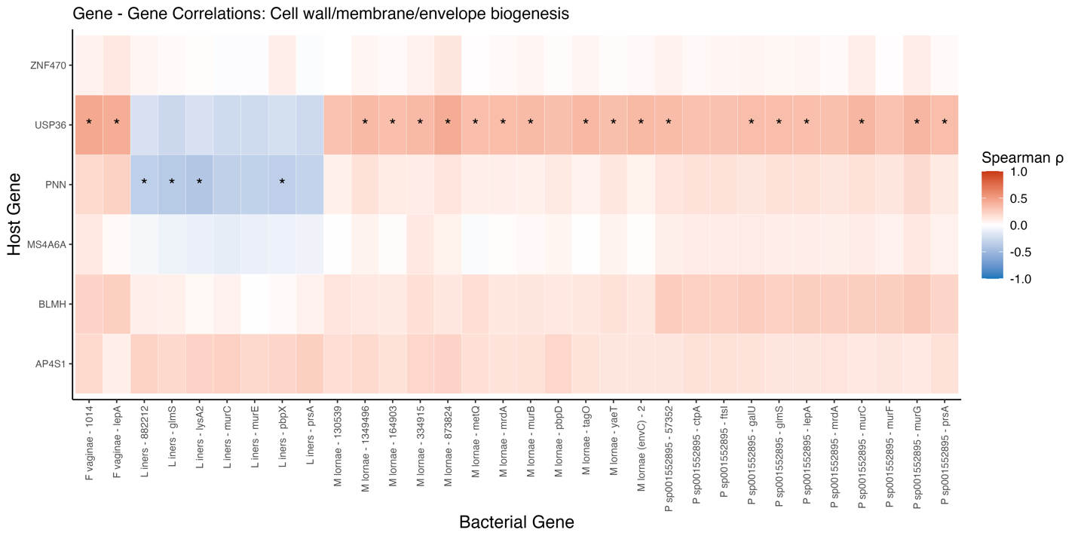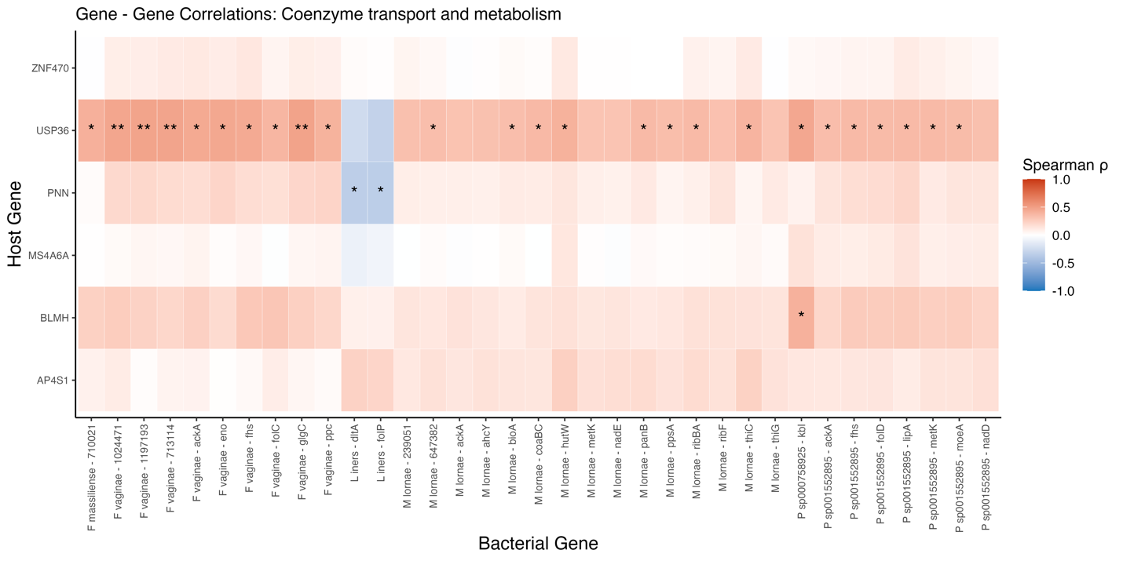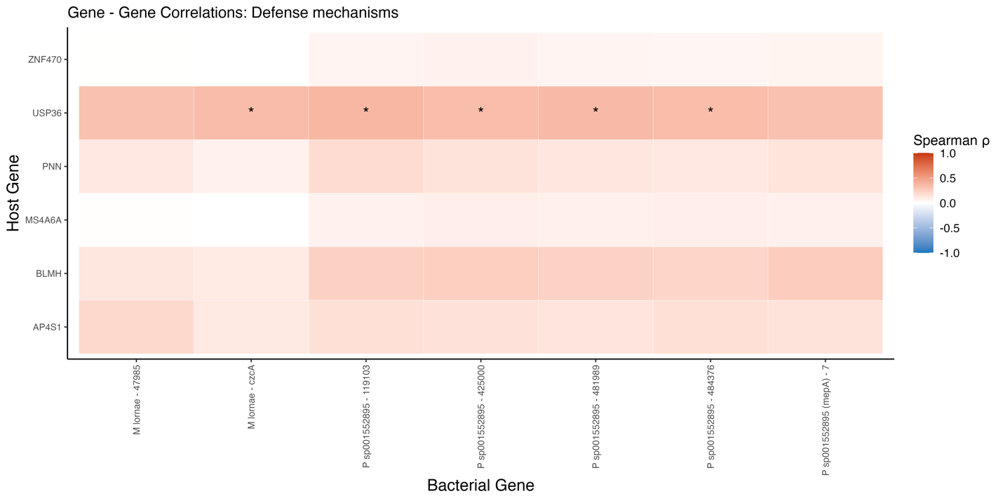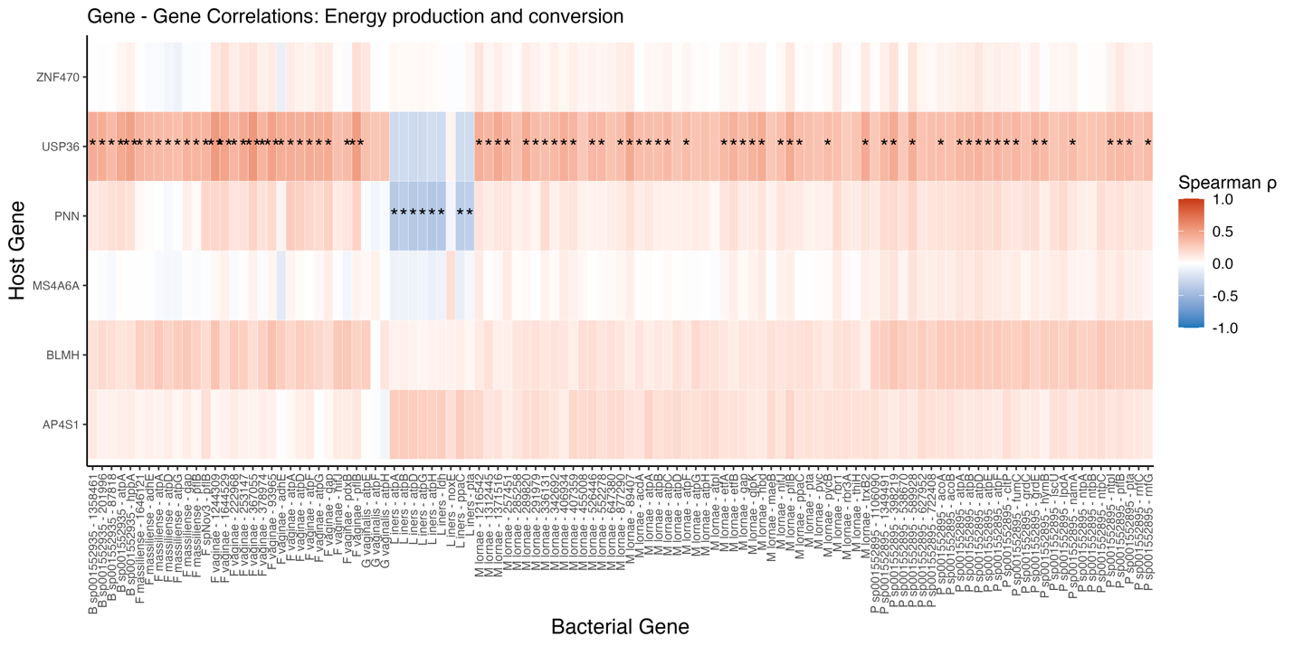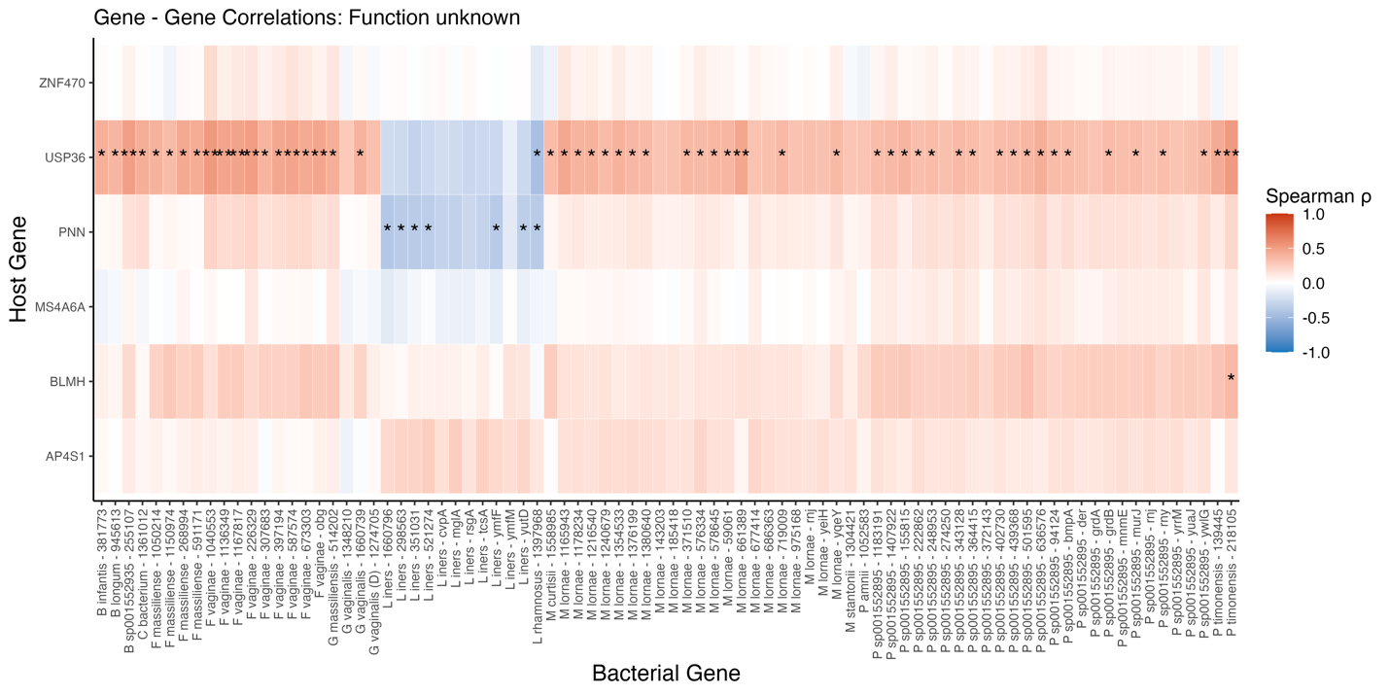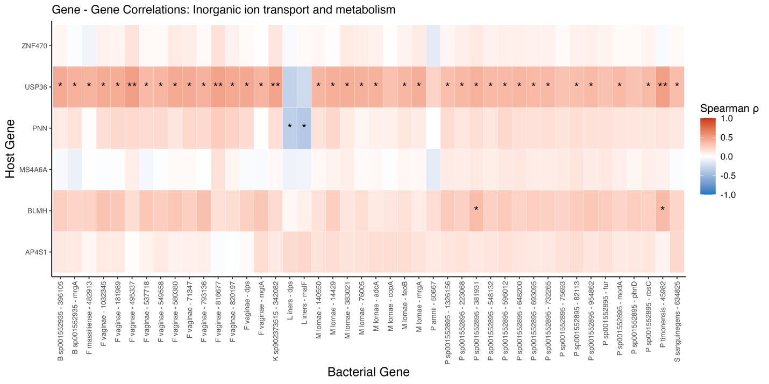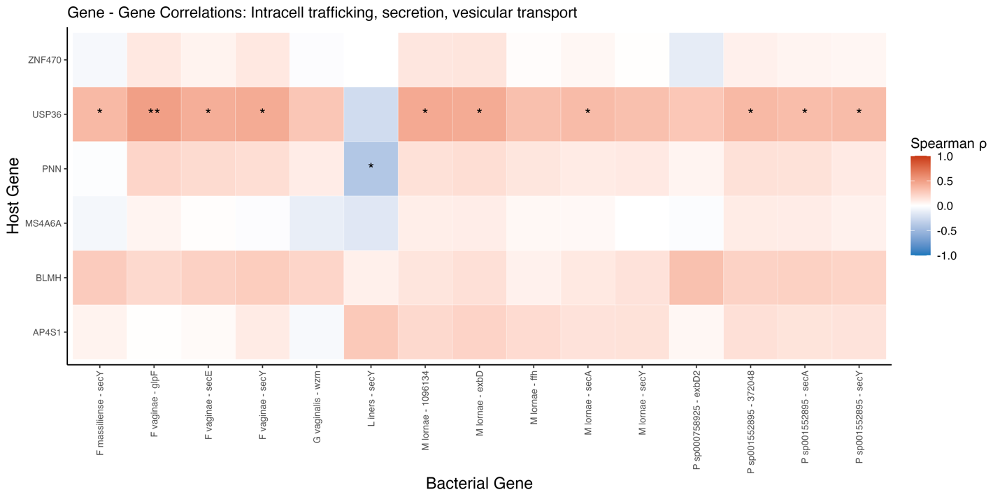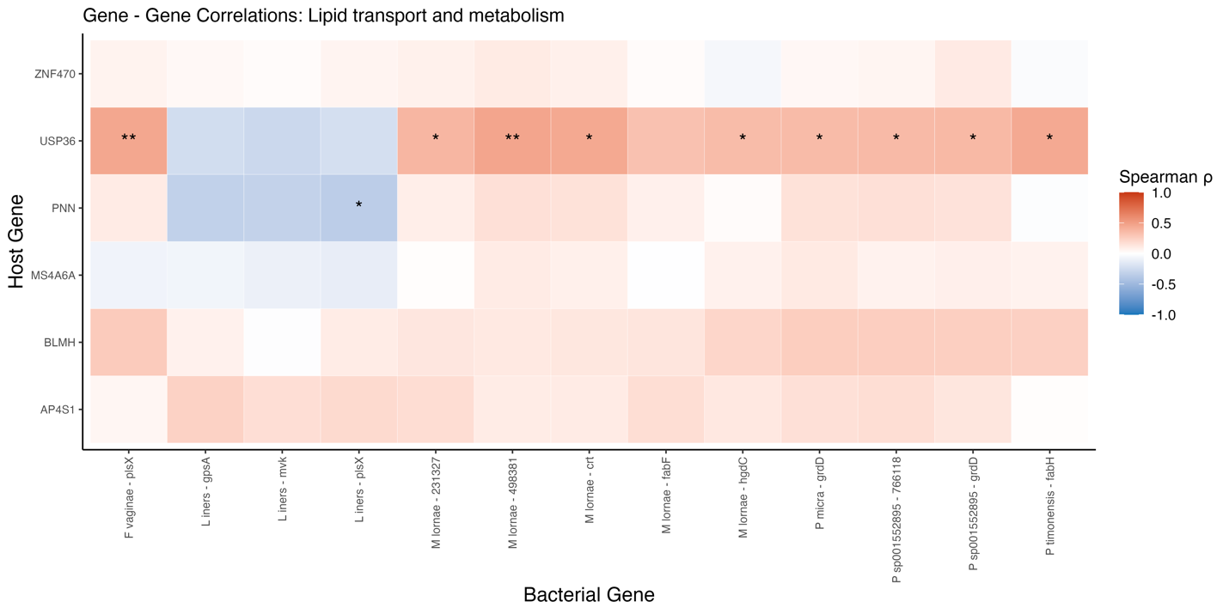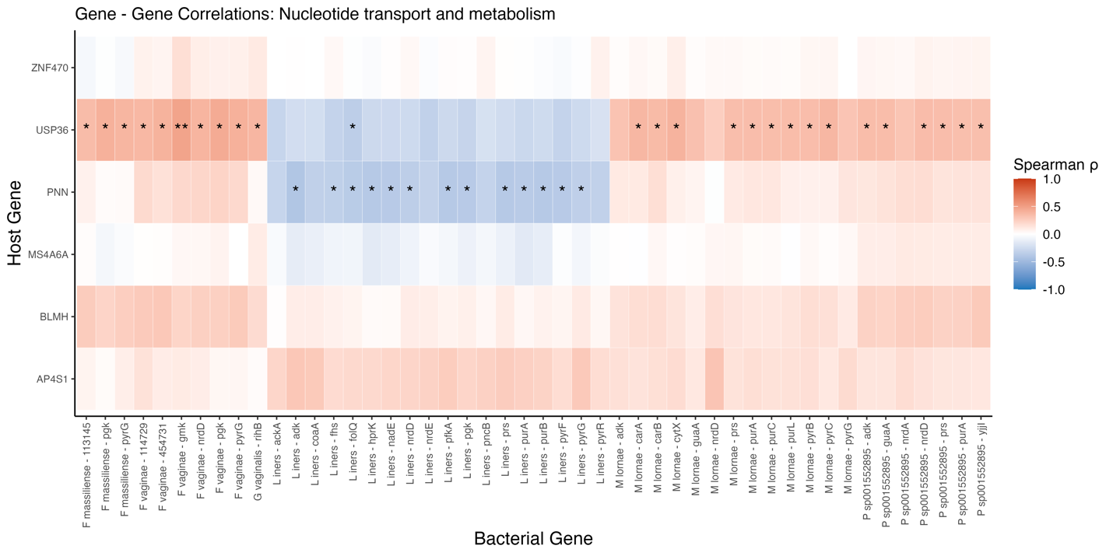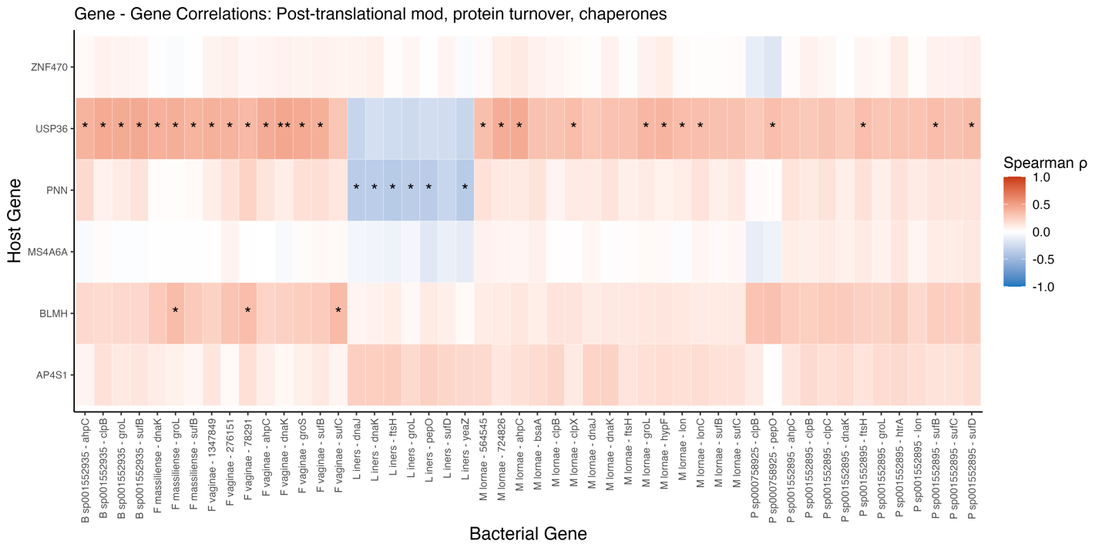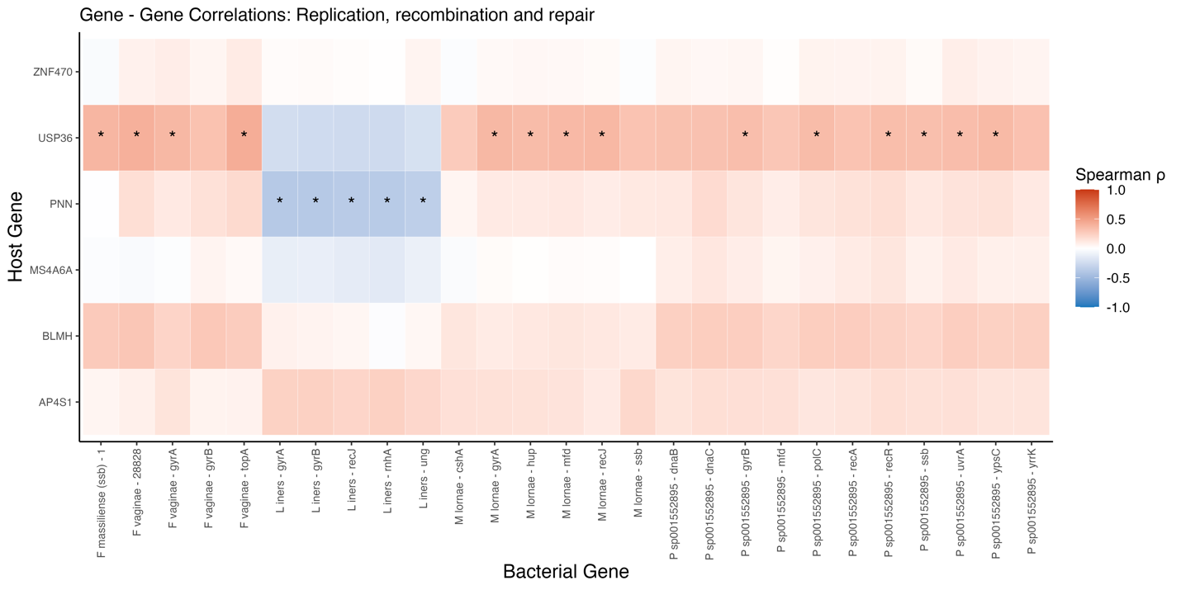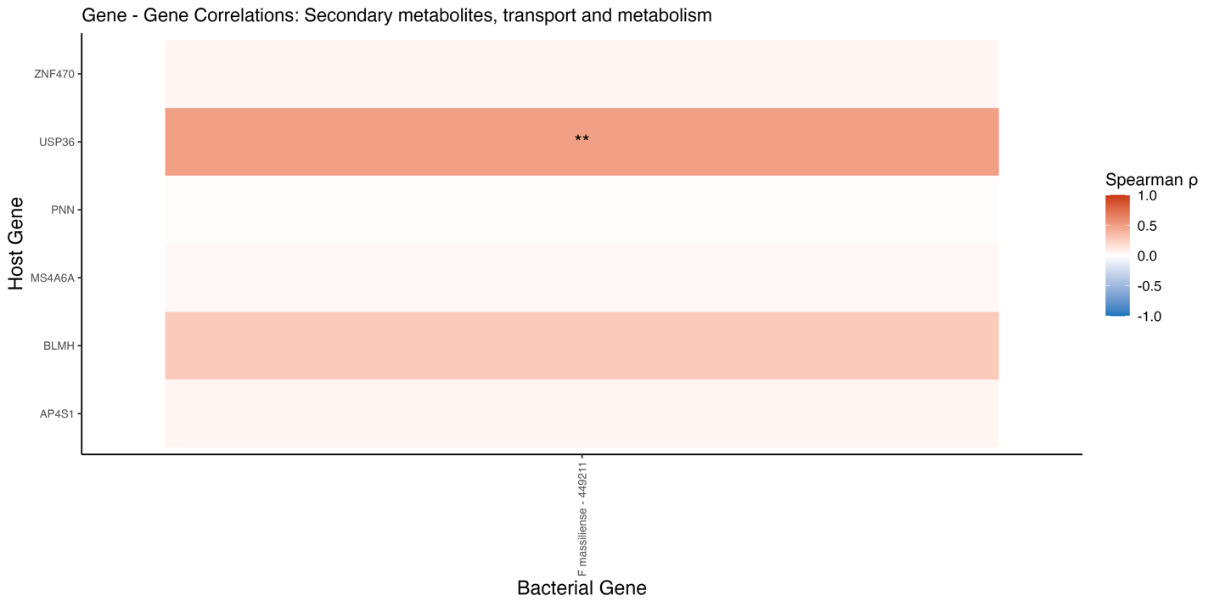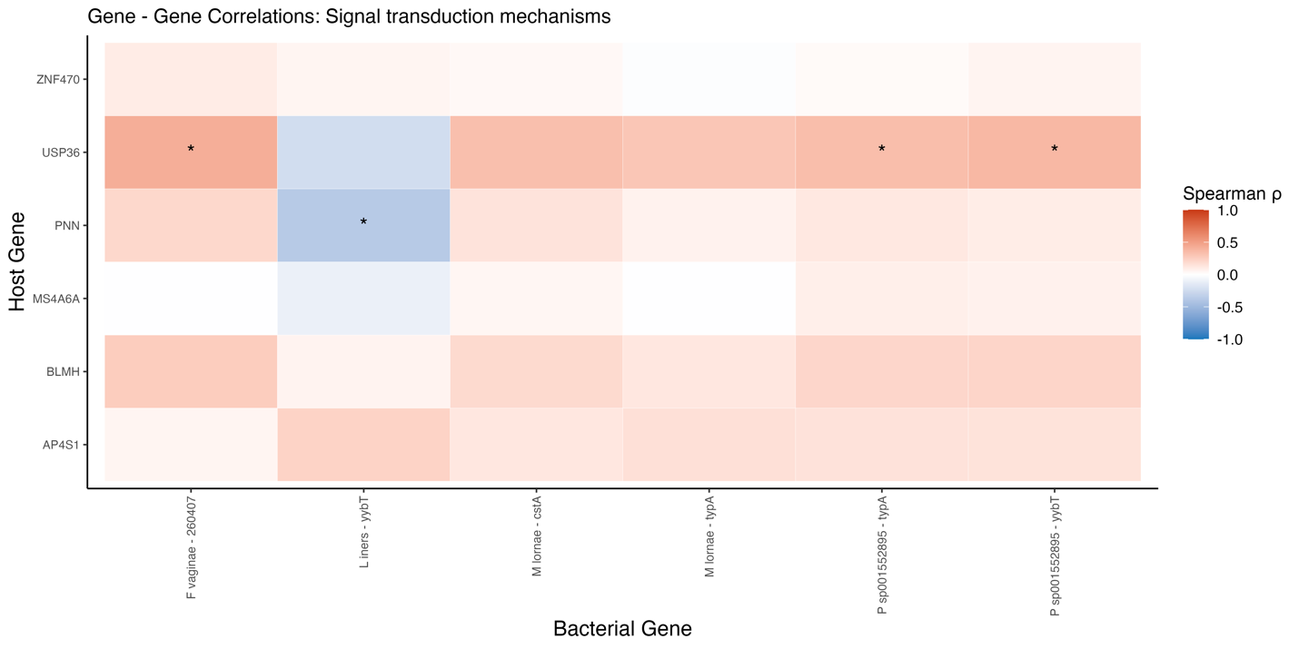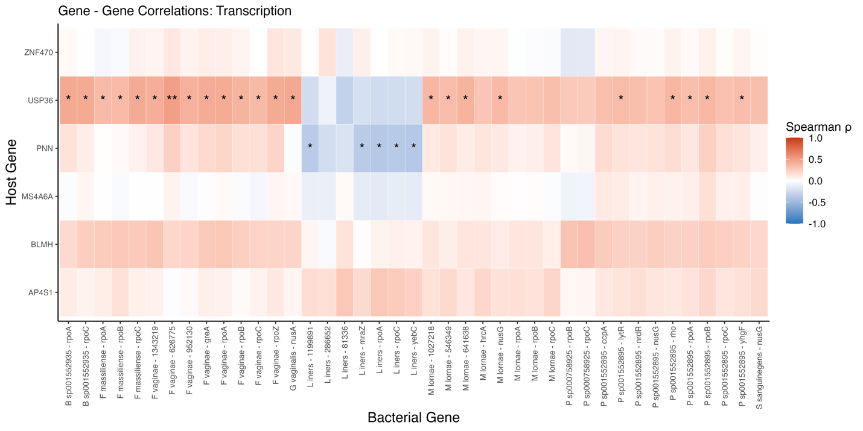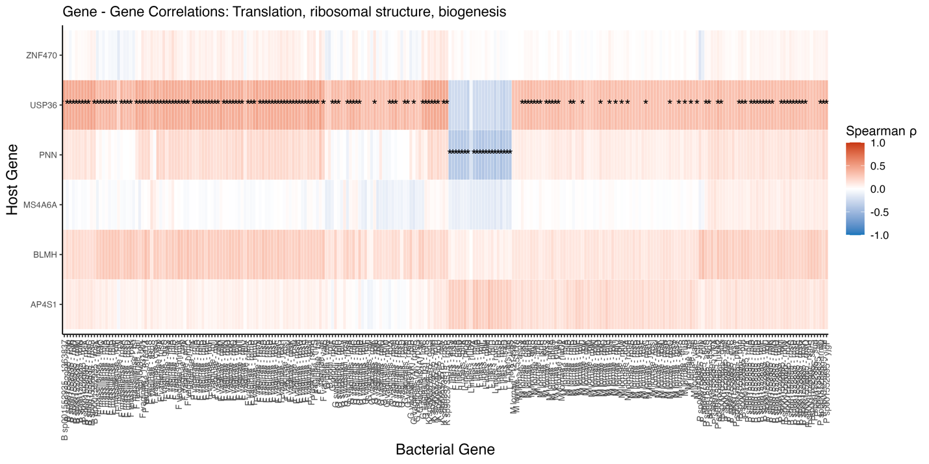
END OF FIGURE 16

Bayesian Mediation Modeling
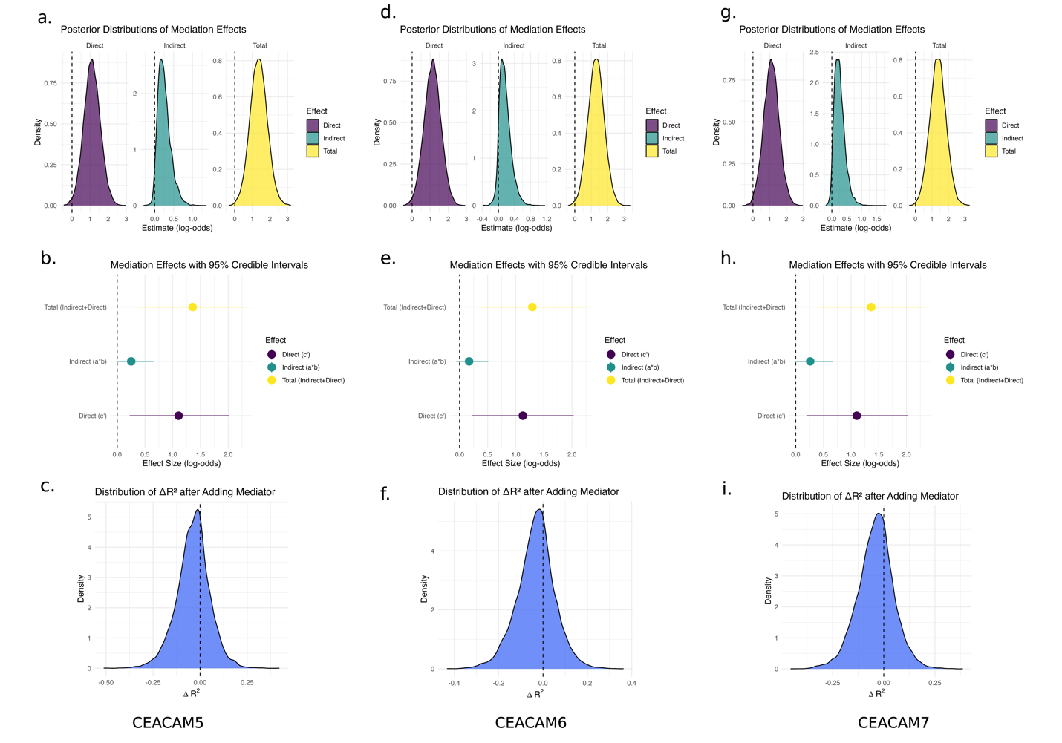
Figure 17. Bayesian mediation analysis of CEACAM5, CEACAM6, and CEACAM7 in the relationship between IL-6 and BV recurrence. Panels show mediation modeling results assessing whether CEACAM gene expression mediates the effect of IL-6 on BV recurrence at 6 months. Top row (a, d, g): Posterior distributions of the direct (c′), indirect (a*b), and total (c) effects for each CEACAM gene. Middle row (b, e, h): Dot plots summarizing posterior means and 95% credible intervals for the three effect types, showing that most of the association between IL-6 and recurrence is driven by the direct effect. Bottom row (c, f, i): Posterior distributions of the change in explained variance (ΔR²) when the CEACAM mediator is added to the model. All mediators show small or near-zero ΔR², consistent with weak indirect effects. These findings suggest that CEACAM5, CEACAM6, and CEACAM7 do not significantly mediate the effect of IL-6 on BV recurrence, despite their individual associations.

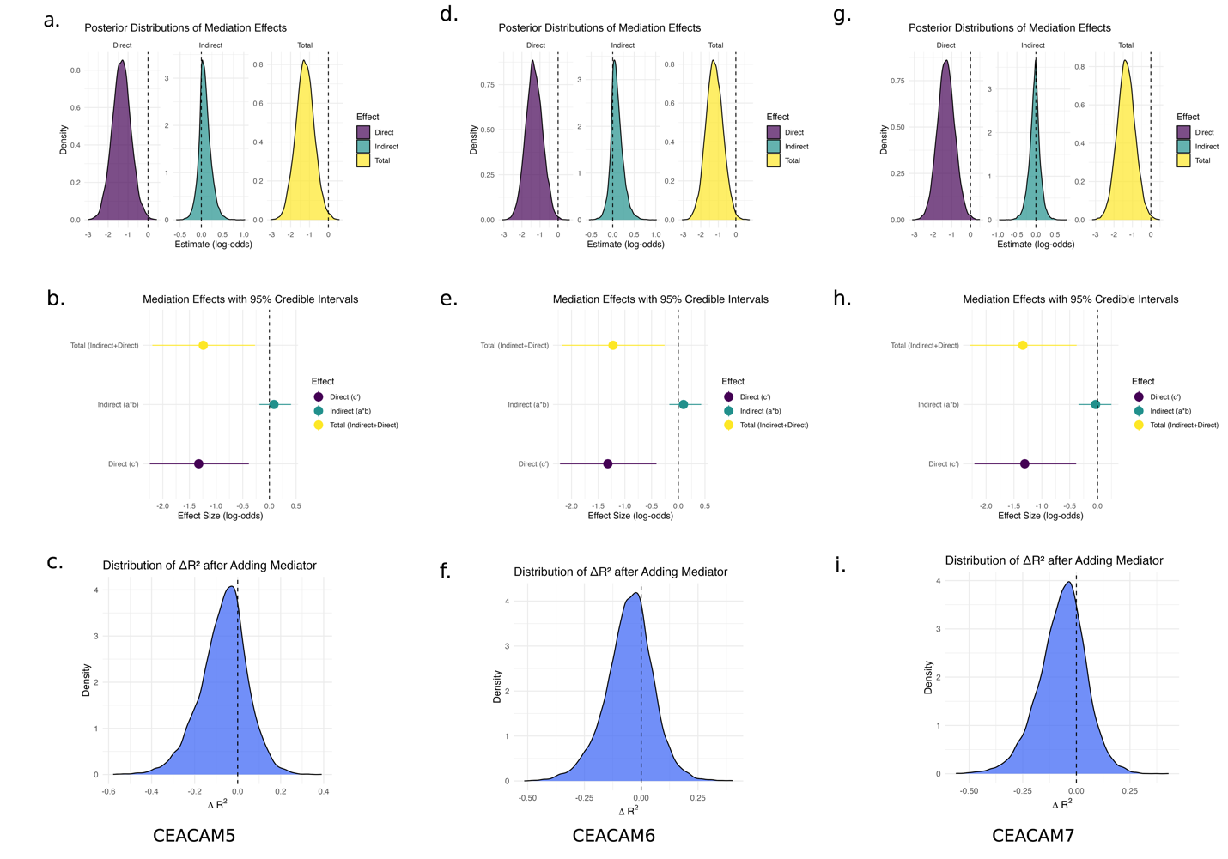
Figure 18. Bayesian mediation analysis of CEACAM5, CEACAM6, and CEACAM7 in the relationship between Lactobacillus abundance and BV recurrence. Panels assess whether CEACAM gene expression mediates the protective association between cervical Lactobacillus transcript abundance and BV recurrence risk.
Top row (a, d, g): Posterior distributions of direct (c′), indirect (a*b), and total (c) effects for each CEACAM gene mediator. Middle row (b, e, h): Dot plots showing posterior means and 95% credible intervals for each effect component. For all three CEACAMs, the indirect effects overlap zero, and the total effects are driven primarily by the direct effect of Lactobacillus. Bottom row (c, f, i): Posterior distributions of ΔR² for each model, reflecting the change in explained variance when CEACAM expression is added. Near-zero shifts suggest minimal mediation. These results indicate that CEACAM5, CEACAM6, and CEACAM7 do not substantially mediate the effect of Lactobacillus on recurrence, despite their independent associations.

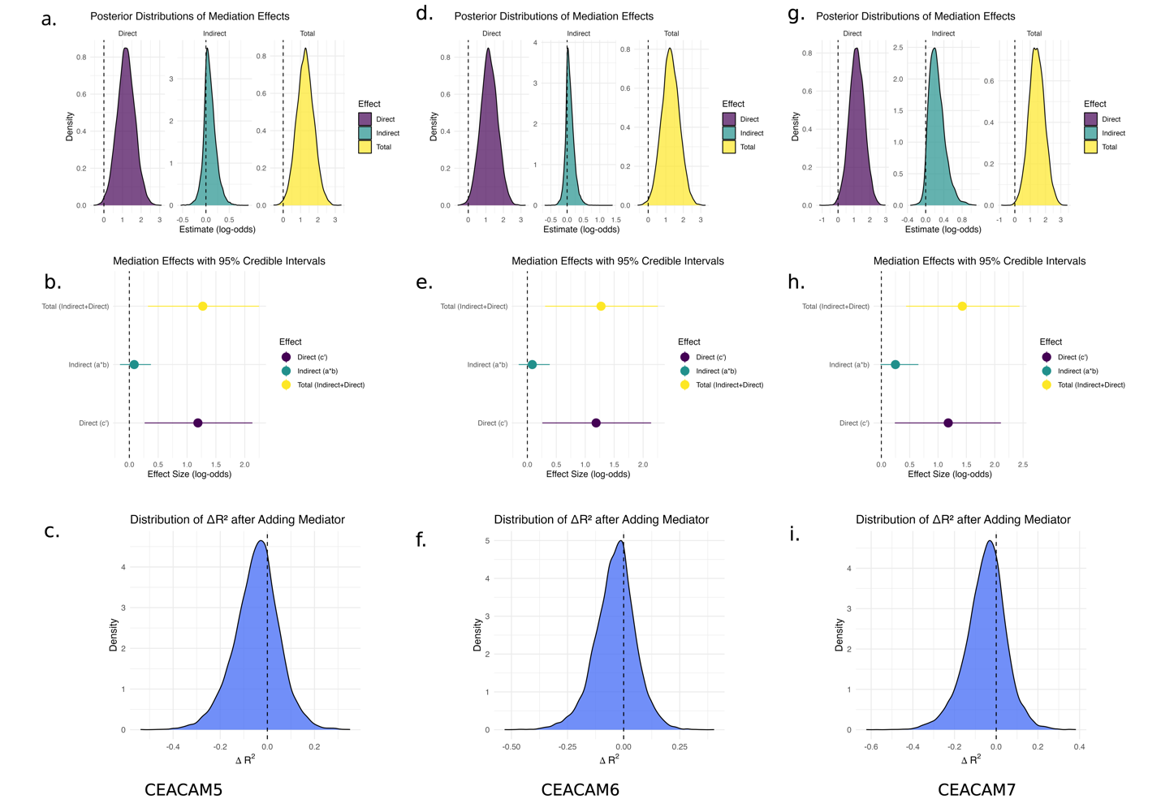
Figure 19. Bayesian mediation analysis of CEACAM5, CEACAM6, and CEACAM7 in the relationship between Dialister abundance and BV recurrence. Panels show mediation modeling results testing whether CEACAM gene expression mediates the effect of cervical Dialister transcript abundance on BV recurrence at 6 months. Top row (a, d, g): Posterior distributions of direct (c′), indirect (a*b), and total (c) effects for each CEACAM mediator. Middle row (b, e, h): Dot plots of posterior mean effect sizes with 95% credible intervals. All three CEACAM genes show a strong direct effect of Dialister on recurrence, and modest indirect effects via CEACAMs that contribute minimally to the total effect. Bottom row (c, f, i): Distributions of ΔR² for each model, indicating small or near-zero increases in explained variance after accounting for CEACAM expression. These results suggest that Dialister strongly influences recurrence risk independently of CEACAM modulation.

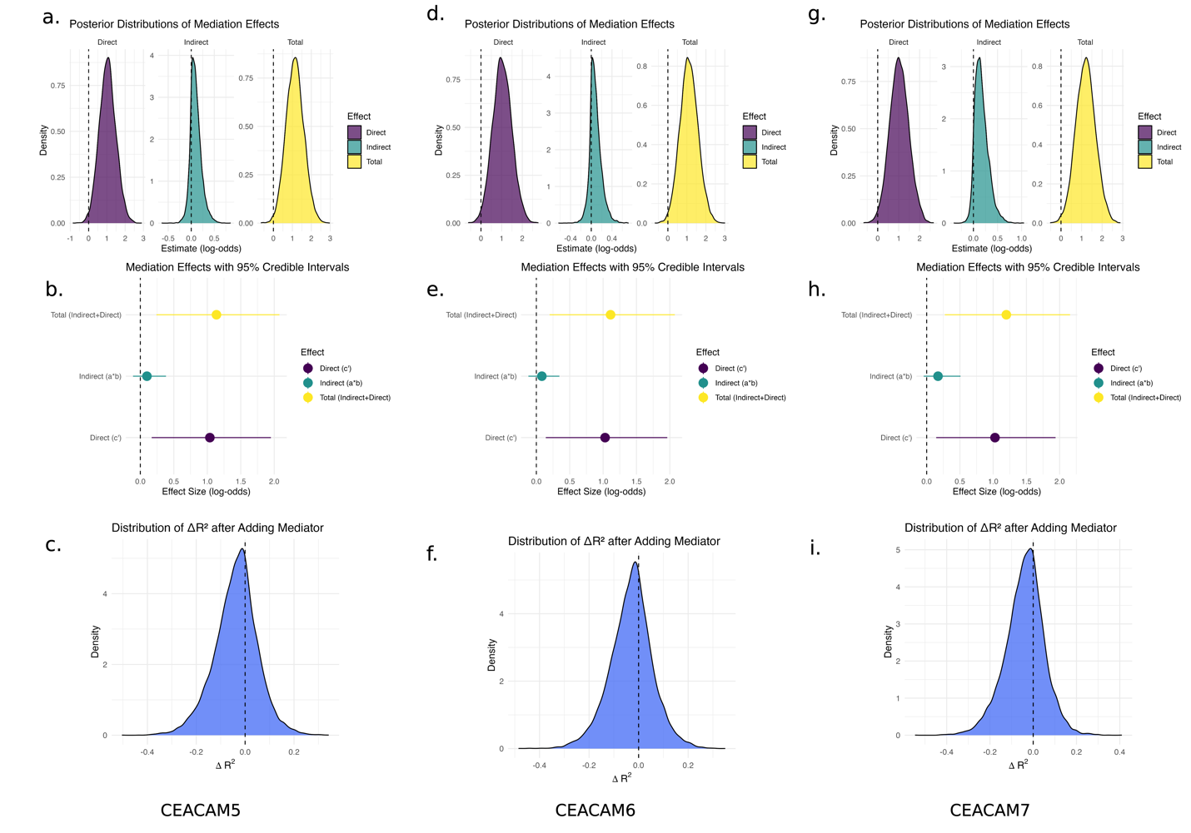
Figure 20. Bayesian mediation analysis of CEACAM5, CEACAM6, and CEACAM7 in the relationship between Fannyhessea abundance and BV recurrence. This figure examines whether CEACAM gene expression mediates the effect of cervical Fannyhessea transcript abundance on BV recurrence status at 6 months. Top row (a, d, g): Posterior distributions of direct (c′), indirect (a*b), and total (c) effects for each CEACAM mediator. Middle row (b, e, h): Dot plots summarizing the posterior means and 95% credible intervals. In all three models, strong total effects are observed, largely driven by the direct relationship between Fannyhessea and recurrence. Indirect effects through CEACAMs are present but modest. Bottom row (c, f, i): Posterior distributions of ΔR² (change in explained variance) upon adding each CEACAM mediator to the model. All ΔR² estimates center near zero, indicating limited mediation. These results suggest that while Fannyhessea is a strong predictor of recurrence, its effect is not substantially mediated by CEACAM5, CEACAM6, or CEACAM7 expression.

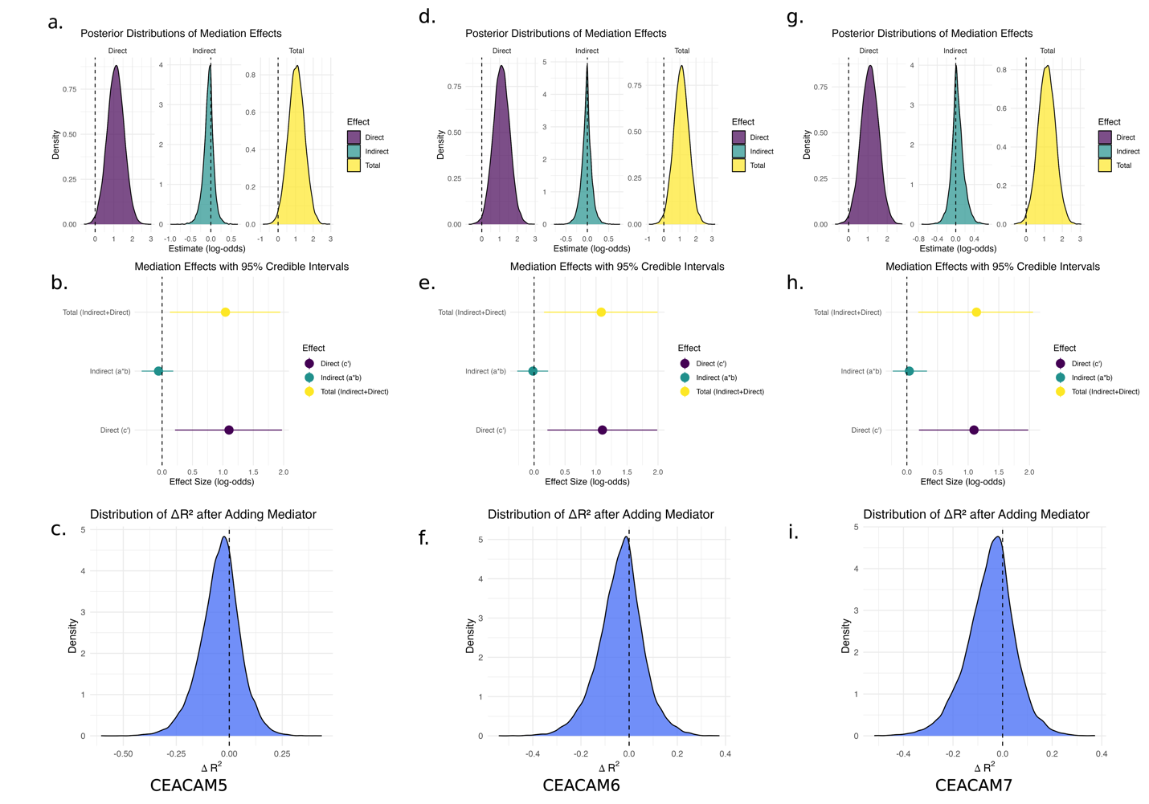
Figure 21. Bayesian mediation analysis of CEACAM5, CEACAM6, and CEACAM7 in the relationship between Gardnerella abundance and BV recurrence. This figure evaluates whether expression of CEACAM genes mediates the effect of cervical Gardnerella transcript abundance on BV recurrence at 6 months. Top row (a, d, g): Posterior distributions of direct (c′), indirect (a*b), and total (c) effects for each CEACAM mediator. Middle row (b, e, h): Effect size plots with 95% credible intervals show that Gardnerella has a strong total effect on recurrence, with a large portion explained by direct effects. Small but non-zero indirect effects via CEACAM5/6/7 are also observed. Bottom row (c, f, i): Posterior distributions of ΔR² show negligible shifts in explained variance after accounting for CEACAM expression, suggesting limited mediation. These results indicate that Gardnerella's impact on BV recurrence is primarily direct and not substantially mediated through CEACAM expression.

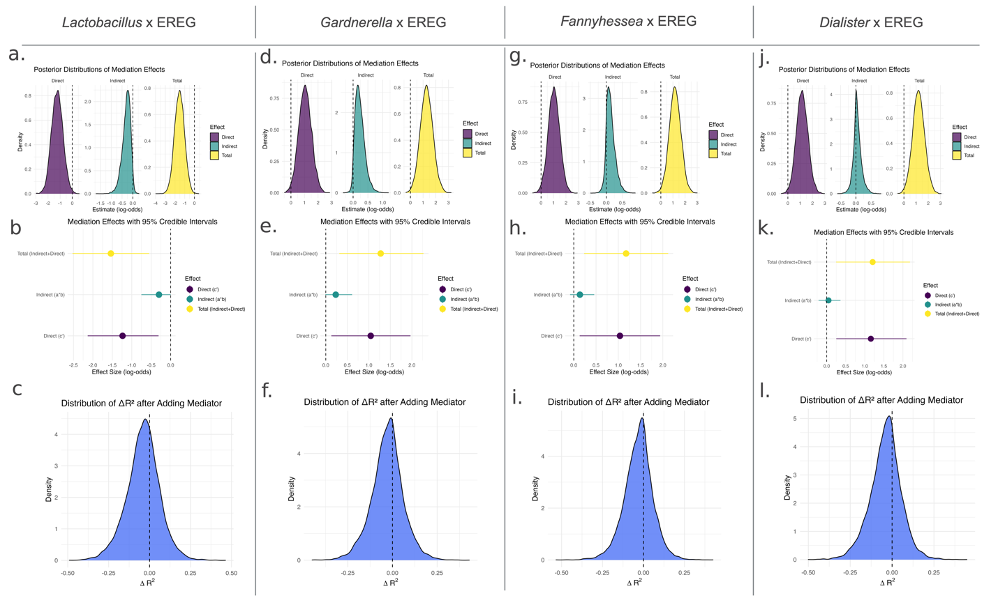
Figure 22. Bayesian mediation analysis of EREG in the relationship between cervical bacterial taxa and BV recurrence. This figure evaluates whether host EREG expression mediates the association between bacterial abundance (Lactobacillus, Gardnerella, Fannyhessea, Dialister) and BV recurrence at 6 months. Top row (a, d, g, j): Posterior distributions of direct (c′), indirect (a*b), and total (c) effects for each microbe–EREG mediation model. Middle row (b, e, h, k): Effect size plots with 95% credible intervals. In all four models, the effect of bacterial abundance on recurrence is primarily direct. Indirect effects via EREG are small and uncertain, with credible intervals overlapping zero. Bottom row (c, f, i, l): Distributions of ΔR² for each model, showing that adding EREG to the model provides minimal increase in variance explained (ΔR² ~ 0), further supporting limited mediation. These findings suggest that while bacterial taxa are associated with recurrence risk, EREG expression does not substantially mediate these effects.

