Electronic Supplementary Information

Nitrogen-Doped Carbon Dot-Based Dual-Emission Ratiometric Probe for Smartphone-Assisted Ultrasensitive Detection of Moxifloxacin

Sewara J. Mohammed ^{*a}, Azad H. Alshatteri ^{*b}, Sivan A. Abubakr ^{c}

- Department of Chemistry, College of Science, University of Sulaimani, 46001 Sulaymaniyah, Kurdistan Regional Government, Iraq.
- Department of Chemistry, College of Education, University of Garmian, 46021 Kalar, Sulaymaniyah, Kurdistan Regional Government, Iraq.
- Department of Chemistry, College of Science, Charmo University, 46023 Chamchamal, Sulaymaniyah, Kurdistan Regional Government, Iraq.

*Corresponding author. E-mail: Sewara.mohammed@univsul.edu.iq: azadalshatteri@garmian.edu.krd

- Fig. S1 FT-IR spectra of (a) 4AA, (b) CA, and (c) N-CDs.

- Fig. S2 ¹H-NMR spectra of (a) 4AA, and (b) N-CDs.

- Fig. S3 ¹³C-NMR spectra of (a) 4AA, and (b) N-CDs.

- Fig. S4 (a) Low-magnification and (b) higher-magnification TEM images of the synthesized N-CDs. The inset in (b) shows the particle size distribution histogram.

Fig. S1 FT-IR spectra of (a) 4AA, (b) CA, and (c) N-CDs

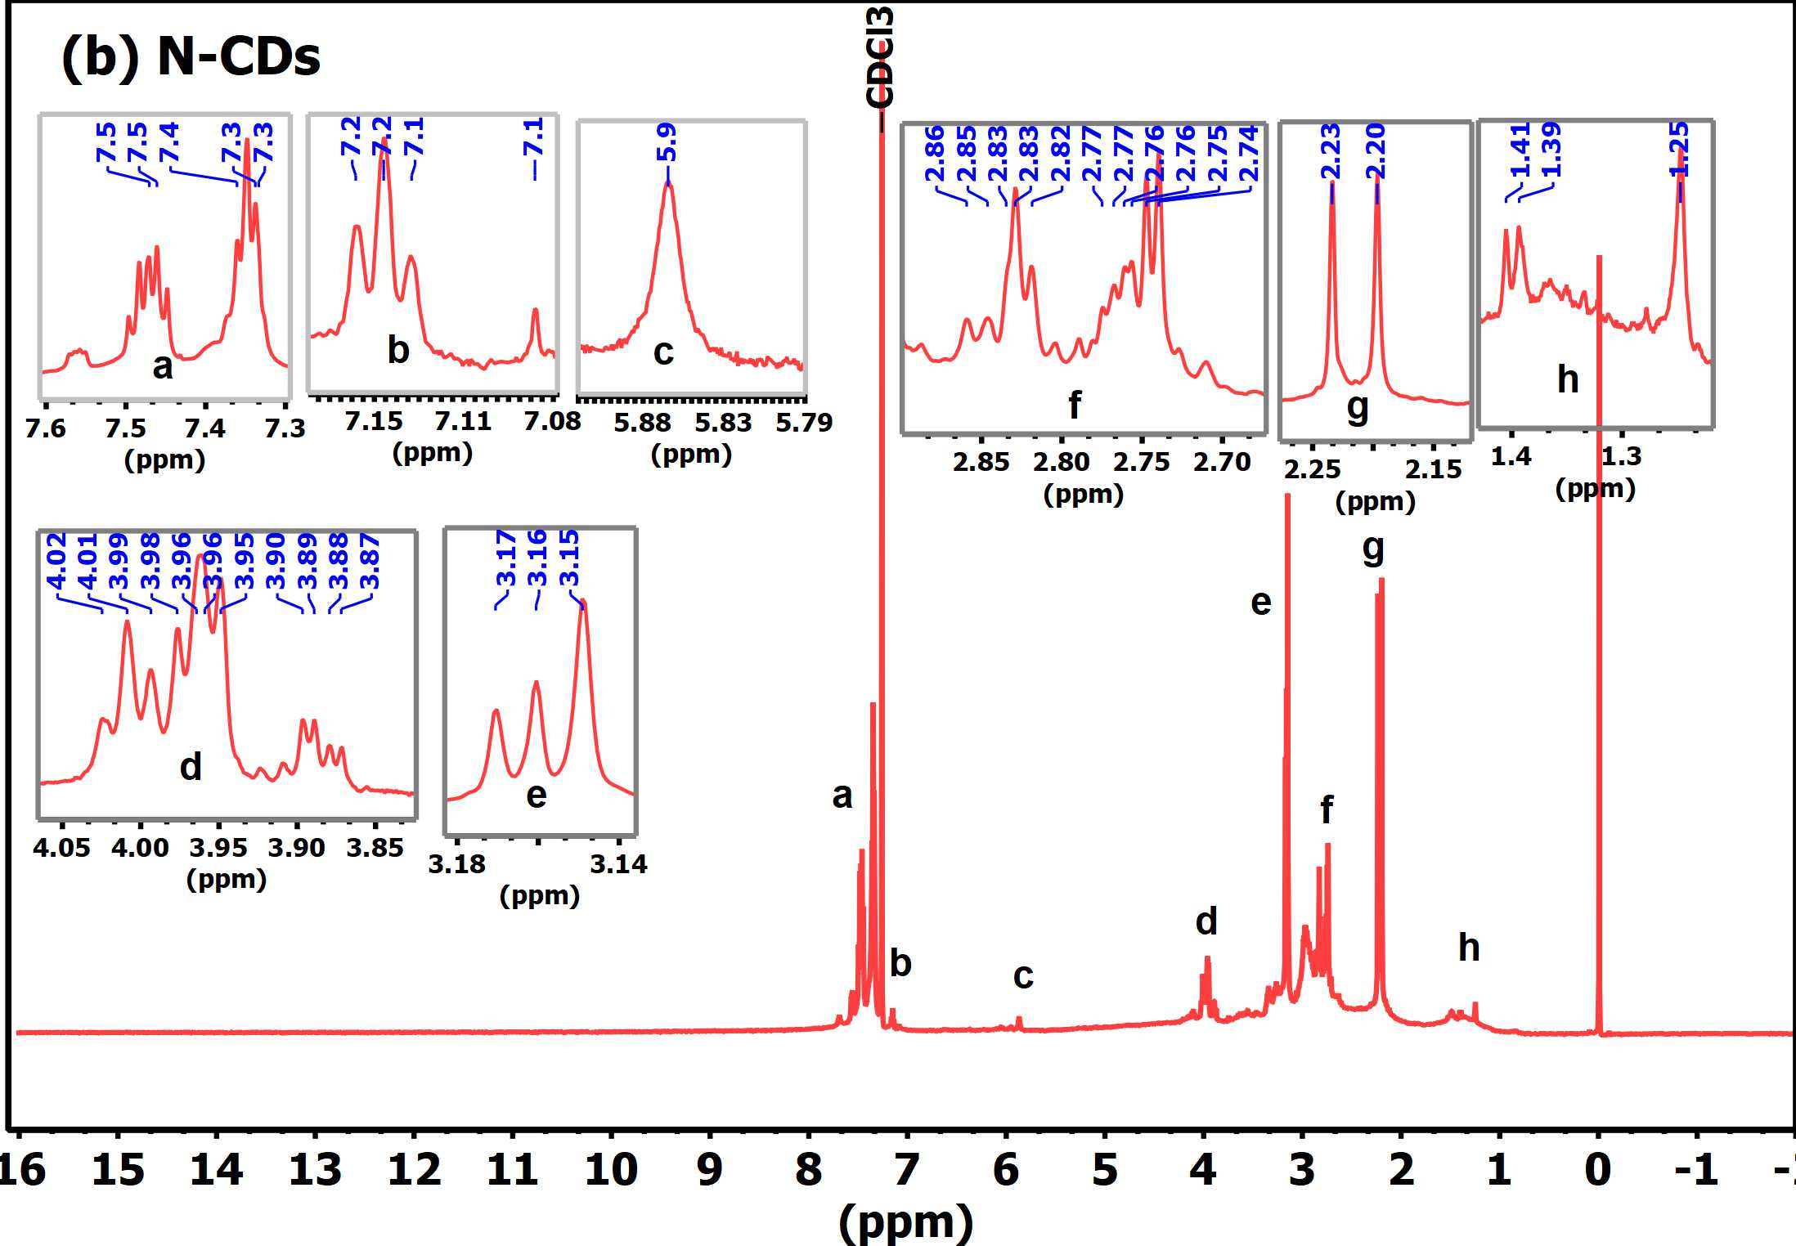

Fig. S2 ¹H-NMR spectra of (a) 4AA, and (b) N-CDs

Fig. S3 ¹³C-NMR spectra of (a) 4AA, and (b) N-CDs

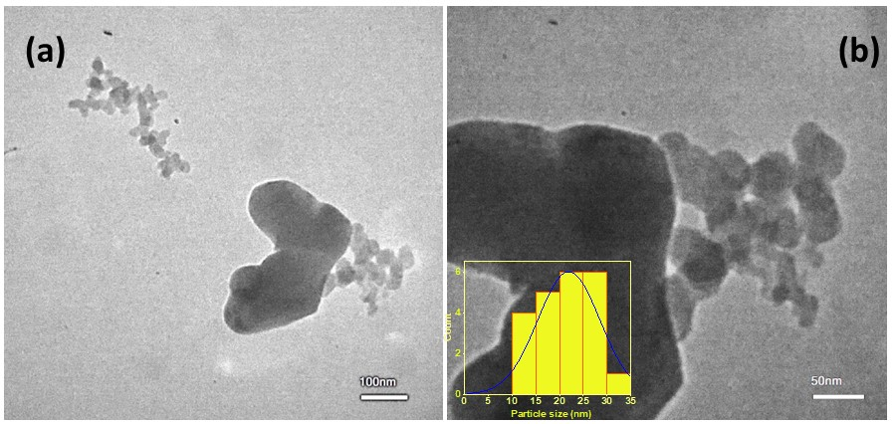

Fig. S4 (a) Low-magnification and (b) higher-magnification TEM images of the synthesized N-CDs. The inset in (b) shows the particle size distribution histogram.

