Appendix D Relationships of the mMMT with testing time
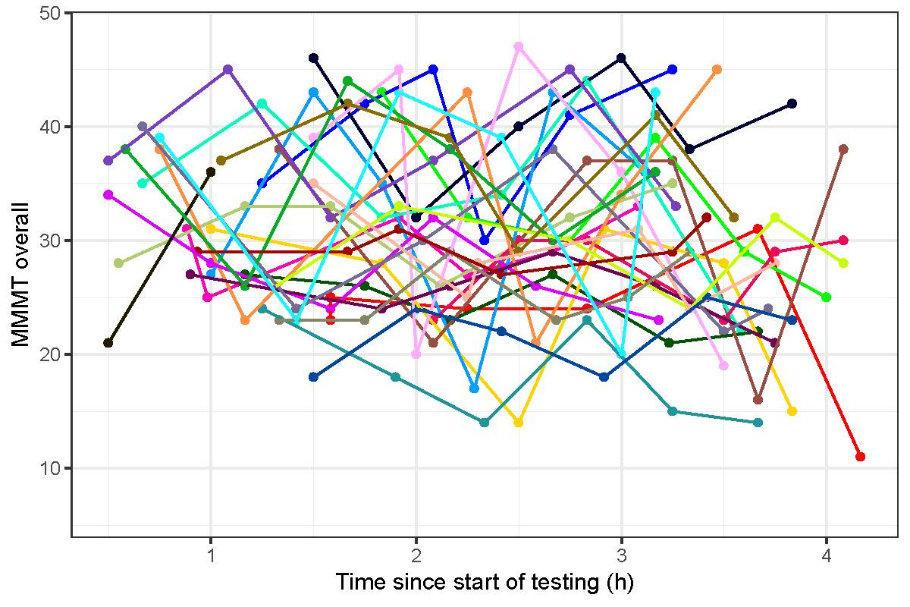
Fig. 1. Relationship between overall modified Manual Muscle Test (mMMT overall) score and testing time, i.e., time since start of testing (h). Each patient is represented by one line.

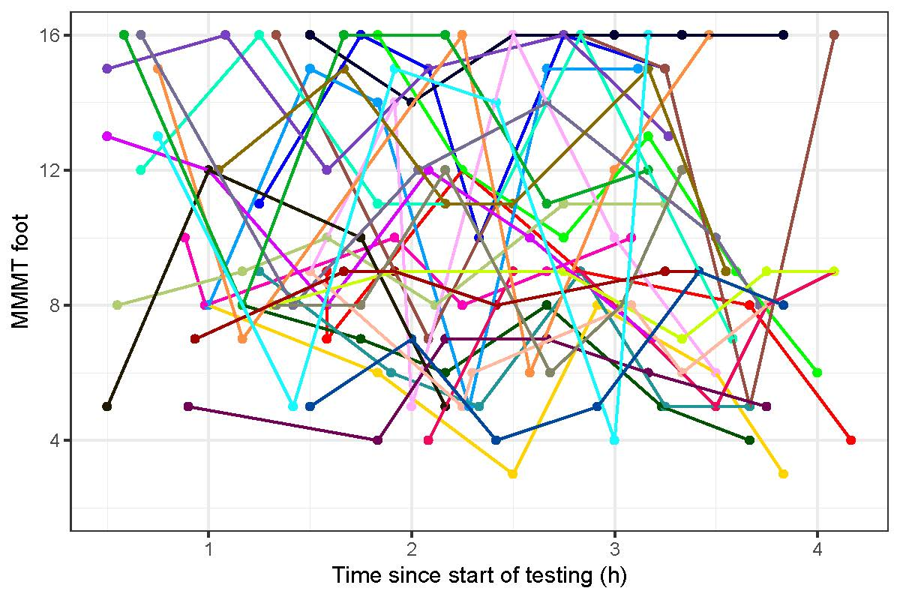
Fig. 2. Relationship between modified Manual Muscle Test (mMMT) foot score and testing time, i.e., time since start of testing (h). Each patient is represented by one line.
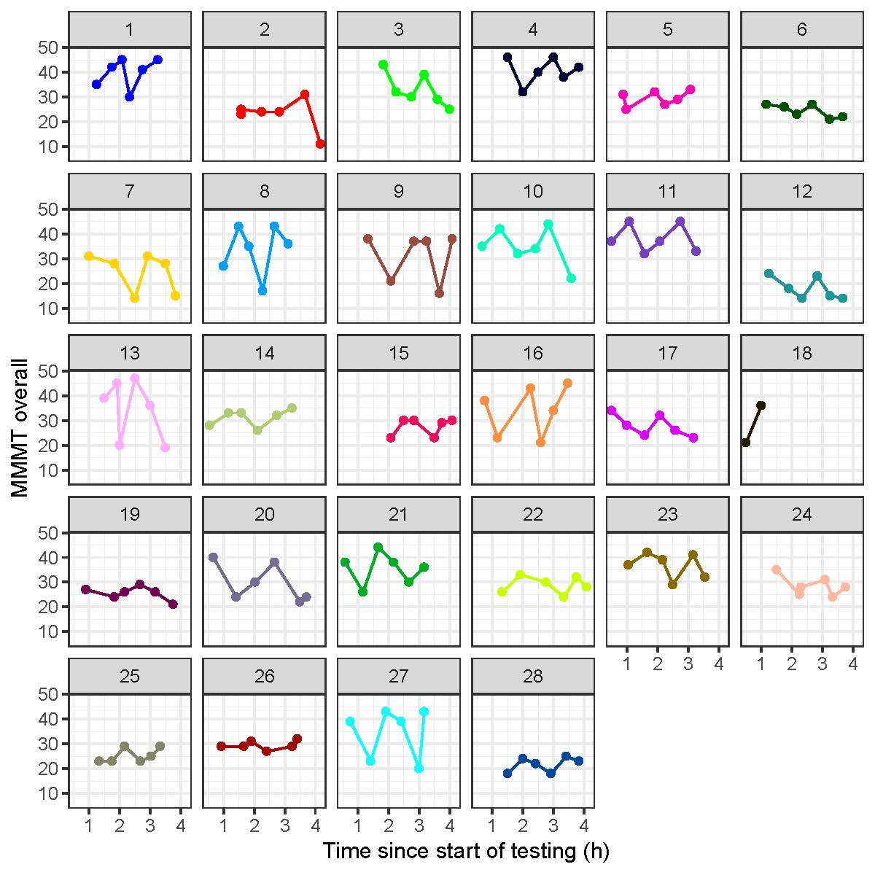
Fig. 3. Relationship between overall modified Manual Muscle Test (mMMT overall) score and testing time, i.e., time since start of testing (h). Each Plot represents one patient.

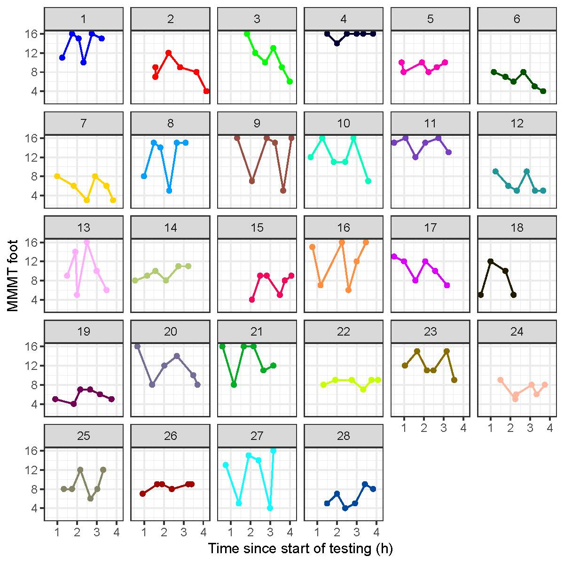
Fig. 4. Relationship between modified Manual Muscle Test (mMMT) foot score and testing time, i.e., time since start of testing (h). Each Plot represents one patient.

