Table 1:Derivatives of designed compound of Imidazole
Label | Structure | Chemical formulae | IUPAC Name
SA1 | 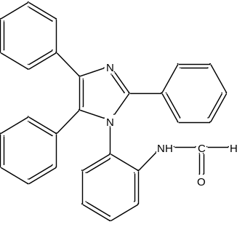 | C₂₈H₂₁N₃O | N-(2-(2,4,5-triphenyl-1H-imidazol-1-yl)phenyl)formamide
SA2 | 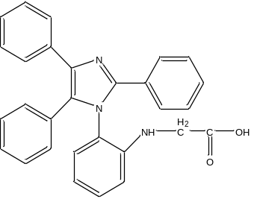 | C₂₉H₂₃N₃O₂ | (2-(2,4,5-triphenyl-1H-imidazol-1-yl)phenyl)glycine
SA3 | 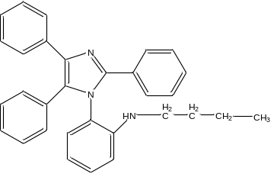 | C₃₁H₂₉N₃ | N-butyl-2-(2,4,5-triphenyl-1H-imidazol-1-yl)aniline
SA4 | 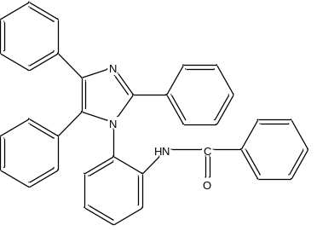 | C₃₄H₂₅N₃O | N-(2-(2,4,5-triphenyl-1H-imidazol-1-yl)phenyl)benzamide
SA5 | 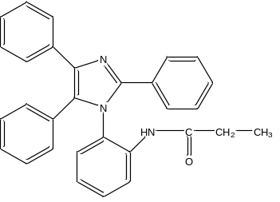 | C₃₀H₂₅N₃O | N-(2-(2,4,5-triphenyl-1H-imidazol-1-yl)phenyl)propionamide
SA6 | 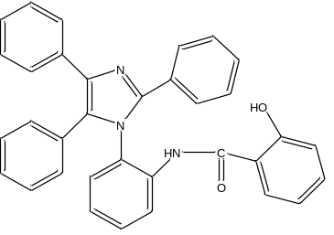 | C₃₄H₂₅N₃O₂ | 2-hydroxy-N-(2-(2,4,5-triphenyl-1H-imidazol-1-yl)phenyl)benzamide
SA7 | 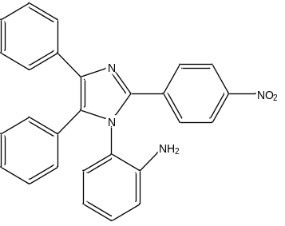 | C₂₇H₂₀N₄O₂ | 2-(2-(4-nitrophenyl)-4,5-diphenyl-1H-imidazol-1-yl)aniline
SA8 | 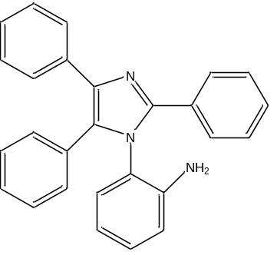 | C₂₇H₂₁N₃ | 2-(2,4,5-triphenyl-1H-imidazol-1-yl)aniline
SA9 | 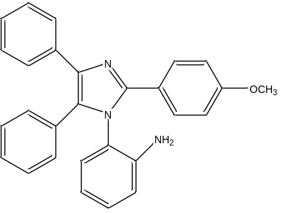 | C₂₈H₂₃N₃O | 2-(2-(4-methoxyphenyl)-4,5-diphenyl-1H-imidazol-1-yl)aniline
SA10 | 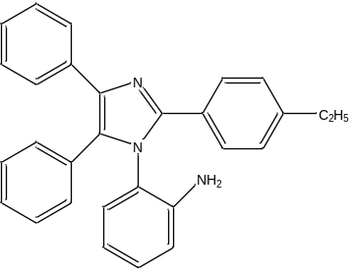 | C₂₉H₂₅N₃ | 2-(2-(4-ethylphenyl)-4,5-diphenyl-1H-imidazol-1-yl)aniline

Table 2: In silico ADMET (Absorption, Distribution, Metabolism, Excretion, and Toxicity) properties and Pharmacokinetics study ofImidazole Derivatives
Compound code | GI | BBB | P-gp | CYP1A2 | CYP2D6 | LogK_{p} (cm/s) | Bioavailability score
SA1 | High | No | Yes | No | Yes | -4.99 | 0.55
SA2 | High | No | Yes | No | Yes | -4.99 | 0.55
SA3 | High | No | Yes | Yes | Yes | -5.20 | 0.55
SA4 | Low | No | No | No | Yes | -5.76 | 0.55
SA5 | Low | No | No | No | Yes | -5.89 | 0.55
SA6 | Low | No | Yes | Yes | Yes | -6.70 | 0.55
SA7 | Low | No | No | No | No | -6.51 | 0.55
SA8 | High | No | Yes | Yes | Yes | -5.12 | 0.55
SA9 | Low | No | Yes | Yes | No | -4.87 | 0.55
SA10 | Low | No | No | No | No | -4.87 | 0.55
Ciprofloxacin | High | No | Yes | Yes | Yes | -4.96 | 0.55

Table 3: Ligand Energy (kcal/mol) and Binding Affinity ofofImidazole Derivatives
Ligand Energy (kcal/mol) | Binding Affinity | rmsd/lb | rmsd/ub
SA1
79.6002 kcal/mol | -7.4 | 0.000 | 0.000
79.6002 kcal/mol | -7.2 | 2.973 | 6.486
79.6002 kcal/mol | -7.0 | 3.659 | 7.869
79.6002 kcal/mol | -6.9 | 0.629 | 1.745
79.6002 kcal/mol | -6.9 | 2.799 | 5.175
79.6002 kcal/mol | -6.9 | 2.498 | 6.410
79.6002 kcal/mol | -6.8 | 2.481 | 6.289
79.6002 kcal/mol | -6.8 | 3.013 | 6.593
79.6002 kcal/mol | -6.8 | 2.223 | 3.004
SA2
79.0180 kcal/mol | -7.5 | 0.000 | 0.000
79.0180 kcal/mol | -7.3 | 2.007 | 6.471
79.0180 kcal/mol | -7.1 | 2.699 | 5.254
79.0180 kcal/mol | -7.1 | 2.875 | 7.907
79.0180 kcal/mol | -7.1 | 3.210 | 6.146
79.0180 kcal/mol | -7.0 | 2.771 | 5.051
79.0180 kcal/mol | -7.0 | 2.861 | 6.750
79.0180 kcal/mol | -7.0 | 0.974 | 6.344
79.0180 kcal/mol | -6.9 | 2.100 | 2.867
SA3
86.1905 kcal/mol | -8.4 | 0.000 | 0.000
86.1905 kcal/mol | -8.3 | 0.671 | 1.408
86.1905 kcal/mol | -8.2 | 2.555 | 4.919
86.1905 kcal/mol | -8.1 | 2.517 | 3.450
86.1905 kcal/mol | -7.7 | 2.635 | 3.912
86.1905 kcal/mol | -7.5 | 1.287 | 2.274
86.1905 kcal/mol | -7.4 | 2.562 | 4.001
86.1905 kcal/mol | -7.4 | 1.349 | 1.920
86.1905 kcal/mol | -7.2 | 3.574 | 6.860
SA4
80.9634 kcal/mol | -7.2 | 0.000 | 0.000
80.9634 kcal/mol | -7.1 | 2.242 | 6.788
80.9634 kcal/mol | -7.1 | 2.896 | 6.745
80.9634 kcal/mol | -6.8 | 2.329 | 3.159
80.9634 kcal/mol | -6.8 | 1.073 | 6.663
80.9634 kcal/mol | -6.7 | 1.126 | 6.767
80.9634 kcal/mol | -6.4 | 1.451 | 6.704
80.9634 kcal/mol | -6.3 | 1.669 | 6.904
80.9634 kcal/mol | -6.0 | 2.522 | 7.530
SA5
79.7544 kcal/mol | -7.2 | 0.000 | 0.000
79.7544 kcal/mol | -7.1 | 3.055 | 6.527
79.7544 kcal/mol | -6.8 | 2.133 | 2.836
79.7544 kcal/mol | -6.8 | 3.146 | 6.674
79.7544 kcal/mol | -6.7 | 2.582 | 6.360
79.7544 kcal/mol | -6.7 | 2.556 | 6.372
79.7544 kcal/mol | -6.5 | 2.736 | 5.022
79.7544 kcal/mol | -6.5 | 2.534 | 4.880
79.7544 kcal/mol | -6.4 | 2.780 | 6.489
SA6
79.4323 kcal/mol | -7.1 | 0.000 | 0.000
79.4323 kcal/mol | -6.9 | 2.541 | 8.110
79.4323 kcal/mol | -6.9 | 1.782 | 2.503
79.4323 kcal/mol | -6.3 | 3.100 | 8.516
79.4323 kcal/mol | -6.1 | 1.868 | 2.323
79.4323 kcal/mol | -5.8 | 3.143 | 8.849
79.4323 kcal/mol | -5.7 | 3.706 | 8.686
79.4323 kcal/mol | -5.7 | 1.862 | 2.850
79.4323 kcal/mol | -5.1 | 3.956 | 7.853
SA7
84.8958 kcal/mol | -8.0 | 0.000 | 0.000
84.8958 kcal/mol | -8.0 | 2.696 | 5.064
84.8958 kcal/mol | -7.9 | 2.001 | 5.236
84.8958 kcal/mol | -7.6 | 3.365 | 7.499
84.8958 kcal/mol | -7.5 | 3.399 | 7.489
84.8958 kcal/mol | -7.5 | 3.293 | 8.072
84.8958 kcal/mol | -7.4 | 3.236 | 6.525
84.8958 kcal/mol | -7.1 | 3.175 | 6.530
84.8958 kcal/mol | -7.0 | 2.386 | 5.178
SA8
79.1963 kcal/mol | -8.3 | 0.000 | 0.000
79.1963 kcal/mol | -8.0 | 0.923 | 6.080
79.1963 kcal/mol | -7.6 | 2.647 | 3.695
79.1963 kcal/mol | -7.5 | 2.447 | 5.320
79.1963 kcal/mol | -7.4 | 2.006 | 6.244
79.1963 kcal/mol | -7.4 | 2.024 | 6.258
79.1963 kcal/mol | -7.3 | 2.614 | 6.340
79.1963 kcal/mol | -7.3 | 3.433 | 6.944
79.1963 kcal/mol | -7.3 | 2.163 | 3.244
SA9
79.0698 kcal/mol | -7.4 | 0.000 | 0.000
79.0698 kcal/mol | -7.3 | 2.805 | 6.489
79.0698 kcal/mol | -7.1 | 2.383 | 6.263
79.0698 kcal/mol | -7.1 | 2.398 | 4.843
79.0698 kcal/mol | -7.1 | 2.312 | 3.393
79.0698 kcal/mol | -7.0 | 3.252 | 4.398
79.0698 kcal/mol | -7.0 | 3.219 | 6.719
79.0698 kcal/mol | -6.9 | 1.319 | 2.128
79.0698 kcal/mol | -6.9 | 2.896 | 5.295
SA10
79.7573 kcal/mol | -8.1 | 0.000 | 0.000
79.7573 kcal/mol | -8.0 | 2.710 | 5.008
79.7573 kcal/mol | -7.9 | 2.470 | 3.442
79.7573 kcal/mol | -7.3 | 0.820 | 1.978
79.7573 kcal/mol | -7.3 | 1.915 | 2.692
79.7573 kcal/mol | -7.3 | 2.429 | 4.577
79.7573 kcal/mol | -7.2 | 2.513 | 6.823
79.7573 kcal/mol | -7.2 | 1.652 | 6.696
79.7573 kcal/mol | -7.1 | 2.642 | 4.286

Table4: Active Amino Acid, Bond Length, Bond Category and Type of Bond interaction of Imidazole Derivatives
Active Amino Acid | Bond Length | Bond Category | Type of Bond
SA1
GLU488 | 2.73588 | Hydrogen Bond | Conventional Hydrogen Bond
CYS300 | 5.82372 | Other | Pi-Sulfur
UNL1 | 4.80153 | Hydrophobic | Pi-Pi T-shaped
LEU601 | 4.50494 | Hydrophobic | Pi-Alkyl
CYS300 | 4.15268 | Hydrophobic | Pi-Alkyl
SA2
CYS300 | 5.85238 | Other | Pi-Sulfur
CYS300 | 4.3523 | Other | Pi-Sulfur
UNL1 | 4.78067 | Hydrophobic | Pi-Pi T-shaped
LEU601 | 4.55841 | Hydrophobic | Pi-Alkyl
SA3
GLN348 | 2.28376 | Hydrogen Bond | Conventional Hydrogen Bondc
GLN348 | 2.38292 | Hydrogen Bond | Conventional Hydrogen Bond
SER349 | 2.21302 | Hydrogen Bond | Conventional Hydrogen Bond
SER349 | 1.86606 | Hydrogen Bond | Conventional Hydrogen Bond
CYS300 | 5.77058 | Other | Pi-Sulfur
CYS300 | 4.36096 | Other | Pi-Sulfur
LEU601 | 4.84497 | Hydrophobic | Pi-Alkyl
SA4
GLU488 | 2.40612 | Hydrogen Bond | Conventional Hydrogen Bond
CYS300 | 5.82512 | Other | Pi-Sulfur
UNL1 | 4.78835 | Hydrophobic | Pi-Pi T-shaped
LEU601 | 4.4484 | Hydrophobic | Pi-Alkyl
CYS300 | 4.51282 | Hydrophobic | Pi-Alkyl
SA5
GLU488 | 2.42401 | Hydrogen Bond | Conventional Hydrogen Bond
CYS300 | 5.83972 | Other | Pi-Sulfur
UNL1 | 4.78573 | Hydrophobic | Pi-Pi T-shaped
LEU601 | 4.38143 | Hydrophobic | Pi-Alkyl
CYS300 | 4.30423 | Hydrophobic | Pi-Alkyl
SA6
GLU488 | 3.93756 | Electrostatic | Pi-Anion
CYS300 | 4.36032 | Other | Pi-Sulfur
GLY301 | 4.2644 | Hydrophobic | Amide-Pi Stacked
VAL605 | 5.19789 | Hydrophobic | Pi-Alkyl
CYS300 | 4.54931 | Hydrophobic | Pi-Alkyl
VAL605 | 5.49904 | Hydrophobic | Pi-Alkyl
SA7
LYS603 | 2.26667 | Hydrogen Bond | Conventional Hydrogen Bond
SER303 | 3.24411 | Hydrogen Bond | Carbon Hydrogen Bond
THR302 | 2.67628 | Hydrogen Bond | Pi-Donor Hydrogen Bond
LEU484 | 3.50829 | Hydrophobic | Pi-Sigma
VAL605 | 3.54826 | Hydrophobic | Pi-Sigma
CYS300 | 5.37397 | Other | Pi-Sulfur
UNL1 | 4.8565 | Hydrophobic | Pi-Pi T-shaped
VAL605 | 4.92312 | Hydrophobic | Pi-Alkyl
LEU601 | 5.08256 | Hydrophobic | Pi-Alkyl
SA8
CYS300 | 2.74744 | Hydrogen Bond | Conventional Hydrogen Bond
UNL1 | 2.90559 | Hydrogen Bond | Pi-Donor Hydrogen Bond
VAL605 | 3.69308 | Hydrophobic | Pi-Sigma
LYS603, SER604 | 5.69749 | Hydrophobic | Amide-Pi Stacked
CYS300 | 4.51272 | Hydrophobic | Pi-Alkyl
VAL605 | 5.31142 | Hydrophobic | Pi-Alkyl
CYS300 | 4.28925 | Hydrophobic | Pi-Alkyl
SA9
SER349 | 2.63466 | Hydrogen Bond;Halogen | Conventional Hydrogen Bond;Halogen (Fluorine)
THR302 | 2.82232 | Hydrogen Bond | Conventional Hydrogen Bond
GLU488 | 2.42821 | Hydrogen Bond | Conventional Hydrogen Bond
CYS300 | 5.90774 | Other | Pi-Sulfur
CYS300 | 4.3927 | Other | Pi-Sulfur
LEU601 | 4.71499 | Hydrophobic | Pi-Alkyl
SA10
GLN348 | 2.42492 | Hydrogen Bond | Conventional Hydrogen Bond
SER349 | 2.8839 | Hydrogen Bond | Conventional Hydrogen Bond
SER349 | 2.05047 | Hydrogen Bond | Conventional Hydrogen Bond
GLU488 | 2.31351 | Hydrogen Bond | Conventional Hydrogen Bond
CYS300 | 5.71731 | Other | Pi-Sulfur
CYS300 | 4.4239 | Other | Pi-Sulfur
LEU601 | 4.43042 | Hydrophobic | Pi-Alkyl

