Genomic Surveillance for SARS-CoV-2 During the COVID-19 Pandemic: Collaborative Experience at Southeast Michigan
Rola Raychouni¹, Xiangmin Zhang¹, Samantha J. Bauer², Benjamin Wasinski³, Katherine Gurdziel^{4,5}, Nivisa Vakeesan¹, Paige Stanton^{1,6}, Anthony T. Lagina III³, Michael Mossing⁷, Geehan Suleyman⁸, Jagjeet Kaur^{8,} Maryssa Trupiano⁸, Phillip Levy³, Paul E. Kilgore^{9,10}, Marcus Zervos^{8,10}, Steven Korzeniewski², Wanqing Liu^{1,5*}
¹Department of Pharmaceutical Sciences, Eugene Applebaum College of Pharmacy and Health Sciences, Wayne State University, Detroit, MI 48201
²Department of Family Medicine and Public Health Sciences, Wayne State University, Detroit, MI 48201
³Department of Emergency Medicine, Wayne State University, Detroit, MI 48201
⁴Genome Sciences Core, Wayne State University, Detroit, MI 48202
⁵Department of Pharmacology, School of Medicine, Wayne State University, Detroit, MI 48201
⁶College of Health Sciences, Purdue University, West Lafayette, IN 47907
⁷Department of Biochemistry, Microbiology, and Immunology, Wayne State University, Detroit, MI 48201
⁸Department of Medicine, Division of Infectious Diseases, Henry Ford Health, Detroit, MI 48202
⁹Department of Pharmacy Practice, Eugene Applebaum College of Pharmacy and Health Sciences, Wayne State University, Detroit, MI 48201
¹⁰Department of Internal Medicine, Wayne State University 48201
*Corresponding author: Wanqing Liu, PhD. Department of Pharmaceutical Sciences, Eugene Applebaum College of Pharmacy and Health Sciences; Department of Pharmacology, School of Medicine, Wayne State University. Integrative Bioscience Center, 6135 Woodward Ave, Detroit, MI 48202.

SUPPLEMENTAL METHODS

Sample collection
Wayne State University (WSU) aimed for genome sampling reflective of the geographic area targeted and partnered with suppliers to maximize coverage. They drafted Material Transfer Agreements (MTAs) with Henry Ford Health, Detroit Health Department, and Ion Diagnostics Laboratories (IDL) which archived samples collected from the Wayne Health Mobile Clinic over the entire pandemic period. They established Institutional Review Board (IRB)-approved (IRB-20-04-2151) and Institutional Biosafety Committee (IBC) (IBC-20-04-2127) protocols and opened lines of communication necessary for handling, transporting, and storing samples. Based on these protocols, both retrospective and prospective SARS-CoV-2 samples were collected and transferred to the WSU Integrated Research Laboratories (WIRL) located at the Integrative Biological Sciences (IBio) Center. The system established enabled the pairing of genomic and epidemiologic data in compliance with HIPPA regulations through FORTE OnCore Clinical Trial Data Management System to ensure patient privacy. SARS-CoV-2 samples were received from the following clinics:
Henry Ford Health (HFH) samples: Nasal swab samples were collected as part of clinical work-up and tested for SARS-CoV-2 by real-time PCR (RT-PCR) in Microbiology/Serology lab, a division of Pathology and Laboratory Medicine (PALM) that provides various clinical and anatomical pathology lab services for Henry Ford Health. RT-PCR was performed using several SARS-CoV-2 RT-PCR kits on various platforms, including Xpert Xpress SARS-CoV-2 RT-PCR kit for positivity testing on the GeneXpert System. Positive SARS-CoV-2 samples were retrieved by the Infectious Disease Research lab for processing. When available, samples with cycle threshold (Ct) values <30 were selected and distributed to WSU.
Wayne Mobile Health Unit (WMHU) and Ion Diagnostic Laboratory (IDL) samples: In partnership with Wayne Health, WSU has established a fleet of eight fully upfitted mobile health units that operated 6-7 days a week, staffed by more than 60 full-time and part-time employees. WMHU serves as the medical service provider on the MHUs, offering health care screenings in the field and meeting the community where they are. These MHUs have been deployed to nursing homes, senior living facilities, churches, jails, homeless shelters, and other community-based organizations statewide, with more than 92,000 collective encounters to date. Services offered include, COVID-19 vaccine administration, diagnostic lab-based testing for SARS-CoV-2 by IDL, and other health conditions, point-of-care screenings, vital sign measurements, and linkage to follow-up care and community resources. The MHUs are equipped with medical grade refrigeration and are able handle sample processing and storage. Clinical procedures are performed by registered nurses and medical assistants, and each medical encounter is documented in the Wayne Health EMR, Athena clinicals®. Through this EMR, MHU staff can place lab orders and schedule follow-up appointments while in the field. Community Health Workers also are on on-site to link patients to social services. All results are communicated with the patients through the Wayne Health Athenahealth Patient Portal. Positive SARS-CoV-2 samples were collected by IDL for processing. Samples were assigned a unique sequence ID and placed in prelabeled tubes provided by IBio.
Detroit Health Department (DHD) samples: DHD testing operations focused on essential city workers (police, fire, city staff), outreach to vulnerable populations (skilled nursing centers, homeless shelters), community outbreaks (schools; behavioral health, retail and manufacturing facilities; great-lakes shipping vessels) and community walk-in testing. Samples were collected by nasal swab and processed on Abbott ID-NOW isothermal amplification devices in health department testing clinics. Eluants from positive samples were stored at -20°C, then thawed and heat inactivated for 20 minutes at 60°C before transport to WSU iBio for processing
Biobanking
The WSU Pathogen Bank, which is a component of the broader WSU Biobank, serves as a repository for specimens collected throughout the study collection basin. These specimens are meticulously categorized and stored. The Oncore Biospecimen Management (BSM) program, a comprehensive software for clinical trials data collection, is utilized for barcoding and categorizing the specimens. This program generates unique barcode labels and captures detailed information about each biospecimen, including its description, acquisition and preparation procedures, and storage location.
To ensure the integrity and security of the specimens, the biobank is housed in a state-of-the-art, temperature-controlled building with keycard-restricted access. The facility is equipped with backup systems to prevent sample loss in the event of a power failure, including emergency power and a backup generator. The ElPro temperature system is used to monitor the freezers, maintaining a consistent temperature of -80 degrees Celsius. This temperature is strictly monitored, logged, and tracked, with adherence to rigorous biosafety protocols to safeguard the samples and personnel. All samples including original swab and transport solution and nucleic acid isolations are stored at -80.
WSU expanded its storage capacity and secured dedicated personnel to coordinate the storage, maintenance, and distribution of the samples. All samples were bar-coded and stored, with the associated clinical, demographic, and diagnostic data archived into the existing OnCore system. This required establishing protocols, a data registry system, and monitored -80℃ refrigerators. WSU built up a Laboratory Information Management System (LIMS) based on SciNote, which allowed tracking, managing, and summarizing the entire lab test process.
Data capture and sample processing
Sample pre-processing: At each collaborative clinic, samples were de-identified and assigned a unique sequence ID provided by IBio on prelabeled tubes to maintain patient anonymity. At the IBio research lab, the tubes containing samples were incubated in water bath at 56°C for 30 min for heat inactivation, and 1ml of each sample was aliquoted into its respective prelabelled tube in the BSL-2 cabinet. Aliquoted samples were stored in sequential order in -80°C freezer until transfer to IBio for sequencing.
RNA extraction and PCR testing: To standardize the procedure, all samples received by the IBio Center were uniformly tested for SARS-CoV-2 positivity. RNA was extracted from samples using MagMAX Viral/Pathogen Nucleic Acid Isolation Kit (Applied Biosystems, Cat # A48310) using Thermo Scientific’s Kingfisher Apex platform (protocol “MagMax_MVP_Standard_v1”). Briefly, 200 µL of sample were mixed with proprietary DNA/RNA binding magnetic beads. Beads were then washed 1x with proprietary wash buffer, followed by 2x washes with 80% Ethanol (Sigma-Aldrich, Cat# E7023-1L) prepared with UltraPure Distilled Water (Invitrogen, Cat# 10977-015). Samples were then air-dried and eluted in 100 µL of proprietary elution solution. Samples were either briefly stored at 4°C for immediate downstream use (qPCR and/or sequencing) or stored at -80°C for long term storage. After extraction, qPCR was performed using TaqPath COVID-19 RNase P Combo Kit 2.0 (Applied Biosystems, Cat# A51333) on Thermo Fisher Scientific’s Quant Studio 7 Flex platform according to manufacturer’s protocol. Briefly, 14 µL of purified samples were mixed with 6 µL of reaction mix containing primer/probes that target ORF1a, ORF1b, N Gene regions of SARS-CoV-2 virus and human RNase P as a control. qPCR was performed using the Emergency Use Authorization protocol that can be found on Thermo Fisher’s website.
Sequencing and Variant Assignment: WSU worked to match the scalability of the project by improving its sequencing capacity by automation. Sequencing libraries and high-throughput sequencing were performed in the Genomic Sciences Core Lab at the IBio Center. SARS-CoV-2 variants were determined using whole genome sequencing with the QIAseq DIRECT Kit. In brief, 5 µL of RNA input was prepared following the “Below 32 Ct protocol” with QIAseq Enhancer and QIAseq Booster A add-ons. Each batch included a positive (AcroMetrix COVID-19 RNA Control (p/n: 954519)) and negative control (QIAGEN Nuclease-free water). Libraries were quantified using Agilent TapeStation 4200 before pooling and sequencing on a NovaSeq 6000 (150 bp x 2; 1% PhiX). After demultiplexing to individual samples, reads were trimmed before aligning to SARS-CoV-2 reference (NC045512) [1,2]. Variants and consensus sequences were determined following the SAMtools pipeline (3-5). Strains were called using Nextclade and Pangolin [6,7].
Turnaround times varied depending on accumulation of samples and delivery to WSU. Once received at WSU, samples required 1–2 days for preparation and transfer to the sequencing. 4 plates of 96 were sequenced Friday, and the sequencing was demultiplexed the following Monday. Processing the variant calls took an additional 3 days. Turnover times decreased as the process became more efficient, averaging 14 days between sample collection and sequencing results.
Data management, analysis and sharing
WSU established a high-performance computing grid for genomic data storage, sharing, and analysis. Bioinformatics analysis of sequencing results encompassed variant, clade, and lineage assignment as well as pathogen identification highlighting the genomic characteristics specific to Southeast Michigan. The genomic surveillance team also collaborated with a data analysis team (S.K) which conducted molecular epidemiological studies tracking the spread and evolution of the virus over time and geographic area. Sequencing, bioinformatics, and demographic data compiled by the data analysis team were analyzed and interpreted. They created the graphs presented in this descriptive paper illustrating the temporal and spatial distribution of viral evolution within the region.
Measures: The COVID-19 case prevalence rate was calculated from numerators of COVID-19 cases divided by denominators of US Census Bureau’s American Community Survey (ACS), 2015-2019. ACS population denominators were based on ZIP code tabulation area (ZCTA) specific estimates for ZIP codes observed in the sample. The mortality rate was calculated from numerators of COVID-19 deaths divided by ACS, 2015-2019, population denominators. The case fatality rate (CFR) was calculated from numerators of deaths divided by cases of COVID-19. Rates use ZCTA- and demographic- (e.g., age, biological sex) specific ACS estimates when possible. The Robert Graham Center’s ZIP code-level Social Deprivation Index (2019) was used as an area-level measure of social vulnerability. The Social Deprivation Index (SDI) is a composite measure based on percentages of poverty, less than 12 years education, single parent households, renting, overcrowding, households without a car, and unemployed adults over age 65 years. Given the distribution of the data, we created a composite measure of SDI tertiles and participant race to compare social vulnerability in terms of low/medium verse high SDI and Black verse non-Black individuals.
Statistical Analysis: Descriptive statistics, including counts and proportions, were used to estimate case and mortality rates. Statistical significance was evaluated by non-overlapping 95% confidence intervals (CI) calculated using the Altman [8] method [RStudio package ‘epiR’ version 2.0.36]. Loess locally weighted regression was utilized to visualize weekly time profiles. Logistic regression with a ZIP code random intercept was used to estimate odds ratios (OR) and 95% CIs between COVID-19 mortality and the composite measure of SDI and Black race. Analyses were conducted in R version 4.3.3 (Posit Software); maps were created using ArcGIS Pro 3.2.0 (Esri Inc.).
Data sharing: Conclusions pertinent to decision-makers are shared for public policies and interventions to be drafted. Each of the collaborative clinical partners (HFH, DHD, and Wayne Health-IDL) directly share the results with the government agencies. The data from master excel sheets used to communicate with WSU are matched with the end of the EPIC charts and the information is uploaded to the state of Michigan’s secure website. The program for this is run in SAS and the sequenced data is matched to the patient’s information and demographics. Their sequenced result is also matched to the SARS-CoV-2 test order in EPIC, and the information for the ordering physician is then extracted. The data is formatted to the specifications from the MDHHS into a .csv file, at which point an upload is attempted. The MDHHS website has encryption, and special access must be granted for the particular area where the data is uploaded. When the file is uploaded, it immediately checks for data quality. If there are any issues flagged, it is rejected and gives the error – one error at a time each upload attempt. They can vary from a null physician address to an illegal character – for example, no “/” characters are allowed in the street address. The personnel investigate the error and make the adjustments in SAS as needed until it passes the validation checker. Once it passes, submission is allowed.
REFERENCES
- Bolger AM, Lohse M, Usadel B. Trimmomatic: A flexible trimmer for Illumina sequence data. Bioinformatics. 2014;30(15):2114-2120. doi:10.1093/bioinformatics/btu170
- Li H, Durbin R. Fast and accurate short-read alignment with Burrows-Wheeler transform. Bioinformatics. 2009;25(14):1754-1760. doi:10.1093/bioinformatics/btp324
- Li H, Handsaker B, Wysoker A, et al. The Sequence Alignment/Map format and SAMtools. Bioinformatics. 2009;25(16):2078-2079. doi:10.1093/bioinformatics/btp352
- Li H. A statistical framework for SNP calling, mutation discovery, association mapping, and population genetic parameter estimation from sequencing data. Bioinformatics. 2011;27(21):2987-2993. doi:10.1093/bioinformatics/btr509
- Danecek P, Bonfield JK, Liddle J, et al. Twelve years of SAMtools and BCFtools. Gigascience. 2021;10(2):giab008. doi:10.1093/gigascience/giab008
- Aksamentov I, Roemer C, Hodcroft EB, Neher RA. Nextclade: Clade assignment, mutation calling, and quality control for viral genomes. J Open Source Softw. 2021;6(67):3773. doi:10.21105/joss.03773
- O'Toole A, Scher E, Underwood A, et al. Assignment of epidemiological lineages in an emerging pandemic using the pangolin tool. Virus Evol. 2021;7(2):veab064. doi:10.1093/ve/veab064
- Altman DG, Machin D, Bryant TN, Gardner MJ. Statistics with Confidence. 2nd ed. London: BMJ Books; 2000.

SUPPLEMENTAL TABLES
Table S1. Description of Sample Characteristics.
 |  |  |  | Cases (n) |  |  | Sample Proportions
Characteristics |  |  |  | N=4,583 |  |  | % |  |  |  | 95% CI
Age Group
<20 |  |  |  | 569 |  |  | 12.42 |  |  |  | (11.49, 13.40)
20-49 |  |  |  | 1,532 |  |  | 33.43 |  |  |  | (32.08, 34.81)
50-64 |  |  |  | 1,122 |  |  | 24.48 |  |  |  | (23.26, 25.75)
65-74 |  |  |  | 711 |  |  | 15.51 |  |  |  | (14.49, 16.59)
75+ |  |  |  | 649 |  |  | 14.16 |  |  |  | (13.18, 15.20)
Biological Sex
Female |  |  |  | 2,631 |  |  | 57.41 |  |  |  | (55.97, 58.83)
Male |  |  |  | 1,952 |  |  | 42.59 |  |  |  | (41.17, 44.03)
Race
White |  |  |  | 2,541 |  |  | 55.44 |  |  |  | (54.00, 56.88)
Black |  |  |  | 1,374 |  |  | 29.98 |  |  |  | (28.67, 31.32)
Other |  |  |  | 199 |  |  | 4.34 |  |  |  | (3.79, 4.97)
Unknown/Missing |  |  |  | 469 |  |  | 10.23 |  |  |  | (9.39, 11.14)
Hispanic Ethnicity |  |  |  | 189 |  |  | 4.12 |  |  |  | (3.59, 4.74)
N=4,583 COVID-19 cases
Sample proportion and 95% confidence intervals (CI) using Wilson Score method.
Table S2. Description of Sample Outcomes.
 |  |  |  |  |  | Cases (n) |  |  | Sample Proportions
Characteristics |  |  |  |  |  | N=4,583 |  |  | % |  |  |  | 95% CI
Vaccinated |  |  |  |  |  | 2935 |  |  | 63.28 |  |  |  | (61.88, 64.66)
Received Booster |  |  |  |  |  | 1,954 |  |  | 42.64 |  |  |  | (41.21, 44.07)
14-Day Post COVID Hospital Admission |  |  |  |  |  | 864 |  |  | 18.85 |  |  |  | (17.75, 20.01)
Intensive Care Unit (ICU) |  |  |  |  |  | 215 |  |  | 4.69 |  |  |  | (4.12, 5.34)
Deceased |  |  |  |  |  | 166 |  |  | 3.62 |  |  |  | (3.12, 4.20)
Discharge Status
Another Healthcare Facility* |  |  |  |  |  | 198 |  |  | 4.32 |  |  |  | (3.77, 4.95)
Court/Law Enforcement |  |  |  |  |  | 2 |  |  | 0.04 |  |  |  | (0.01, 0.16)
Died |  |  |  |  |  | 77 |  |  | 1.68 |  |  |  | (1.35, 2.09)
Home** |  |  |  |  |  | 549 |  |  | 11.98 |  |  |  | (11.07, 12.95)
Hospice |  |  |  |  |  | 24 |  |  | 0.52 |  |  |  | (0.35, 0.78)
Left Against Medical Advice |  |  |  |  |  | 12 |  |  | 0.26 |  |  |  | (0.15, 0.46)
Unknown/Missing |  |  |  |  |  | 3,721 |  |  | 81.19 |  |  |  | (80.03, 82.30)
N=4,583 COVID-19 cases
Sample proportion and 95% confidence intervals (CI) using Wilson Score method.
*Another healthcare facility includes short term hospitals, behavioral health, psychiatric hospitals, nursing homes, rehabilitation, and long-term care facilities.
**Home includes home healthcare.
Table S3. COVID-19 Case, Mortality, and Case Fatality Rates Overall and by Variant.
 | Cases |  |  |  | Mortality |  |  |  |  |  |  | Case Fatality
Variants | N=4,583 | Rate per 10K | 95% CI |  | n=166 |  |  | Rate per 10K |  | 95% CI |  | % |  | 95% CI
Overall* | 4,583 | 8.0 | (7.77, 8.24) |  | 166 |  |  | 0.29 |  | (0.25, 0.33) |  | 3.62 |  | (3.12, 4.20)
Variant
19 A+B | 260 | 0.45 | (0.40, 0.51) |  | 20 |  |  | 0.03 |  | (0.02, 0.05) |  | 7.69 |  | (5.03, 11.58)
20A | 736 | 1.28 | (1.19, 1.38) |  | 71 |  |  | 0.12 |  | (0.10, 0.15) |  | 9.65 |  | (7.72, 11.99)
Alpha | 29 | 0.05 | (0.03, 0.07) |  | 1 |  |  | 0.002 |  | (0, 0.01) |  | 3.45 |  | (0.61, 17.18)
Delta | 165 | 0.29 | (0.24, 0.33) |  | 1 |  |  | 0.002 |  | (0, 0.01) |  | 0.61 |  | (0.11, 3.35)
Omicron | 2,942 | 5.14 | (4.95, 5.32) |  | 57 |  |  | 0.10 |  | (0.07, 0.13) |  | 1.94 |  | (1.45, 2.50)
Unknown/Other | 451 | 0.79 | (0.71, 0.86) |  | 16 |  |  | 0.03 |  | (0.01, 0.04) |  | 3.55 |  | (2.20, 5.69)
Note: *Overall case and mortality rates are calculated using American Community Survey (2015-2019) population denominators for observed ZIP codes in the sample (N=5,728,013 individuals). Case fatality rates are calculated by dividing numerators of total deaths divided by denominators of total cases. 95% confidence intervals (CI) using Wilson Score method.

Table S4. Relationship Between COVID-19 Mortality and Social Deprivation Index with Black race among COVID-19 cases admitted to the hospital within 14 days of testing positive.
 |  | Model 1 |  | Model 2 |  | Model 3 |  | Model 4
Covariables |  | OR | 95% CI | OR | 95% CI | OR | 95% CI | OR | 95% CI
Exposure Status
High SDI | Black
- | - | Ref. | -- | Ref. | -- | Ref. | -- | Ref. | --
+ | - | 0.73 | (0.46, 1.16) | 0.74 | (0.46, 1.16) | 0.77 | (0.48, 1.22) | 0.80 | (0.49, 1.27)
- | + | *0.15 | (0.02, 0.49) | *0.15 | (0.02, 0.49) | *0.17 | (0.03, 0.59) | *0.14 | (0.02, 0.50)
+ | + | 0.66 | (0.43, 1.02) | 0.67 | (0.43, 1.02) | 0.71 | (0.46, 1.11) | 0.72 | (0.46, 1.13)
Biological Sex
Male |  |  |  | Ref. | -- | Ref. | -- | Ref. | --
Female |  |  |  | 0.89 | (0.62, 1.29) | 0.88 | (0.61, 1.27) | 0.9 | (0.62, 1.31)
Age
<65 years |  |  |  |  |  | Ref. | -- | Ref. | --
≥65 years |  |  |  |  |  | *3.28 | (2.17, 5.10) | *3.50 | (2.29, 5.49)
Variant
20A |  |  |  |  |  |  |  | Ref. | --
19 A+B |  |  |  |  |  |  |  | 0.86 | (0.44, 1.62)
Alpha |  |  |  |  |  |  |  | 1.61 | (0.06, 27.60)
Delta |  |  |  |  |  |  |  | 0.45 | (0.02, 2.54)
Omicron |  |  |  |  |  |  |  | *0.40 | (0.26, 0.61)
Unknown/Other |  |  |  |  |  |  |  | *0.51 | (0.25, 0.97)
Observations |  | 864 |  | 864 |  | 864 |  | 864
Log Likelihood |  | -379.54 |  | -379.35 |  | -362.23 |  | -352.2
Akaike Inf. Crit. |  | 767.07 |  | 768.71 |  | 736.46 |  | 726.41
Note: Subsample of COVID-19 cases admitted to hospital with 14 days of testing positive (n=864). Logistic regression model with ZIP code random intercept. Social Deprivation Index (Robert Graham Center, 2019) and COVID-19 mortality. *Statistically significant.

SUPPLEMENTAL FIGURES
Figure S1:

Figure S1: Distribution of Samples by Stage of Genomic Surveillance Pipeline per Source. Overview of sample count and distribution by stage of genomic surveillance pipeline. Samples were received from sources starting Dec 2022 through Mar 2024.

Figure S2:
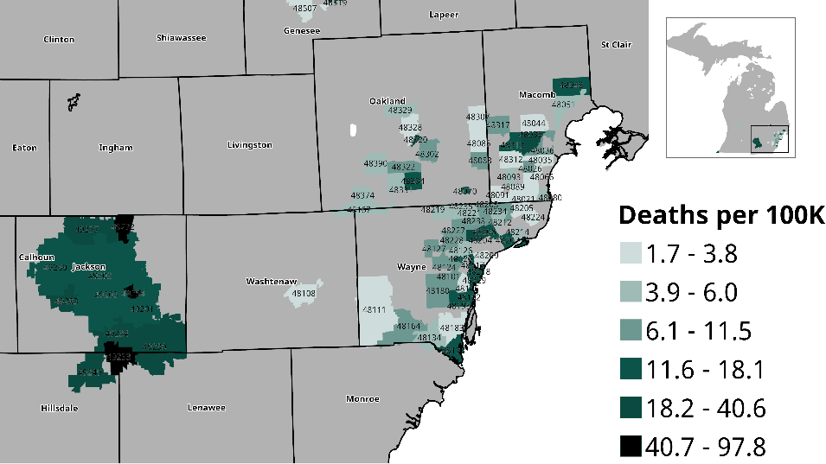
Figure S2. COVID-19 Mortality Rate by ZIP Code. Choropleth map of COVID-19 mortality rates (deaths per 100,000) by ZIP code. Mortality data include n=166 COVID-19-related deaths

Figure S3:
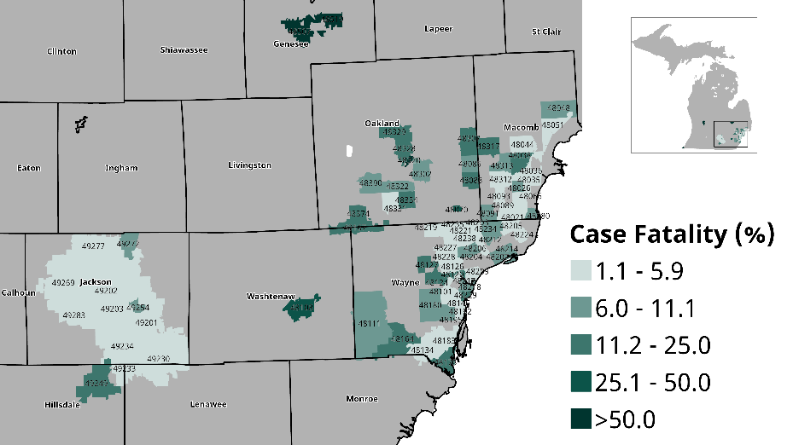
Figure S3. COVID-19 Case Fatality Rate by ZIP Code. Choropleth map presenting ZIP code-level case fatality rates, defined as the proportion of deaths among confirmed cases (n=166 deaths, 4,583 cases).

Figure S4:
COVID-19 Cases
N=4,637
Michigan Cases
n=4,583
Missing ZIP code n=12
Invalid/Non-MI ZIP n=42

Figure S4. Analytic Sample Consort Diagram. Flowchart detailing the selection criteria and derivation of the final analytic sample (n=4,583 COVID-19 cases) used in the SIPPHIRE study.

Figure S5:
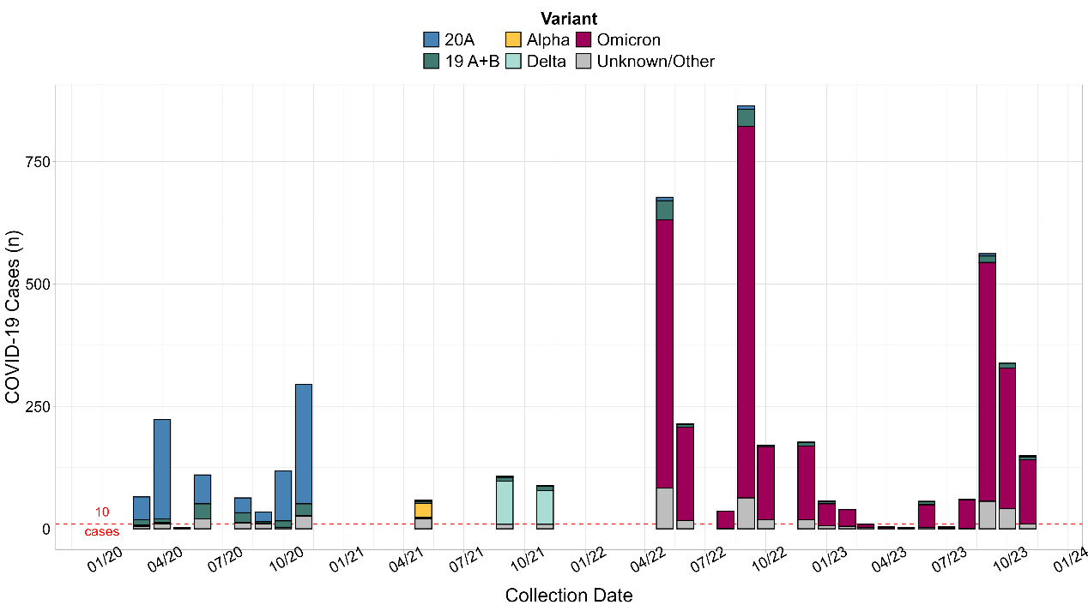
Figure S5. Monthly COVID-19 Cases by Variant. Stacked bar chart showing monthly COVID-19 cases (n=4,583), stratified by SARS-CoV-2 variant, among analytic sample (n=4,583 COVID-19 cases).

Figure S6:
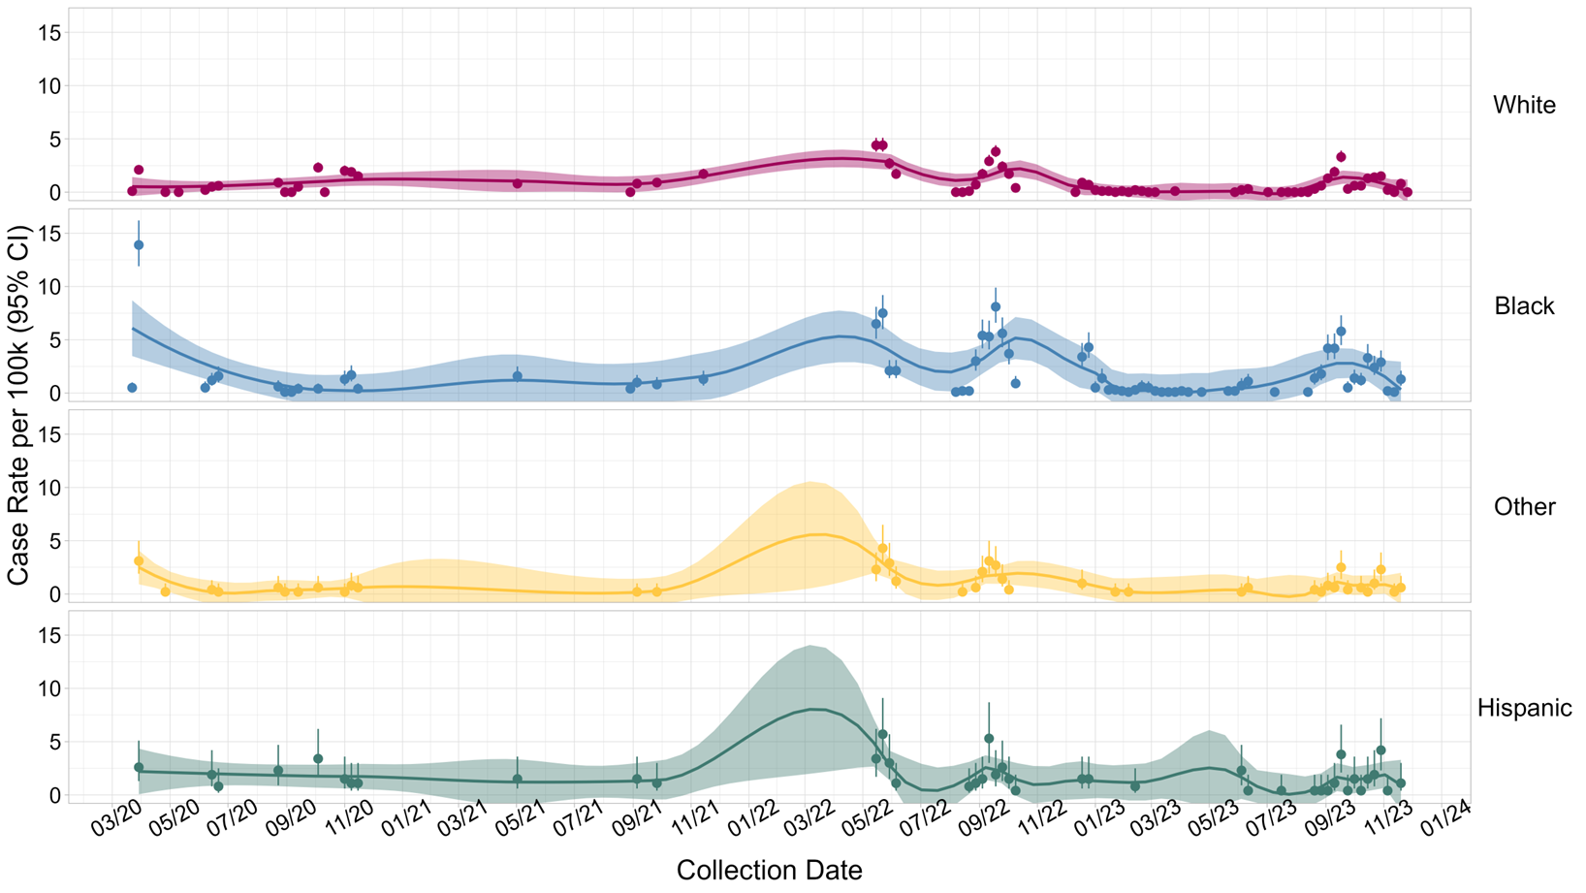

Figure S6. Weekly COVID-19 Incidence per 100,000 by Race and Ethnicity. Race/ethnicity-specific weekly COVID-19 incidence per 100,000 population. Race and Hispanic ethnicity are not mutually exclusive. Loess smoothing applied (span=0.25).

Figure S7:
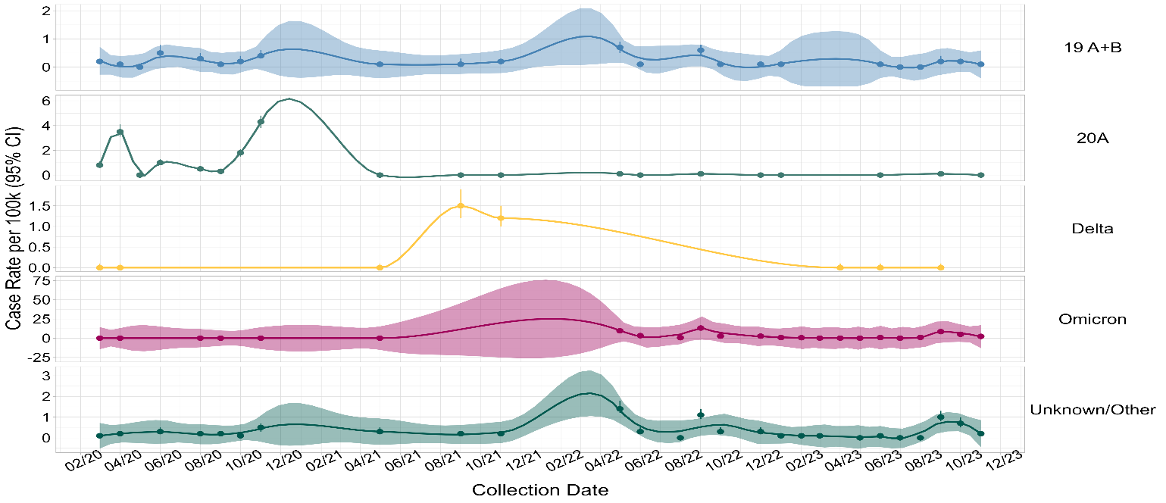
Figure S7. Variant-Specific Monthly Incidence with Varying Y-Axis. Varying y-axis dot plot showing monthly incidence by SARS-CoV-2 variant. Loess smoothing applied (span=0.25). Notes: Variant-Specific monthly COVID-19 cases per 100K population with loess smoothing’ with varying y-axes. COVID-19 cases n=4,583; denominator N=5,728,013. Population denominator from American Community Survey 2015-2019; ZCTA-specific totals of 295 Michigan ZIP codes. 95% Confidence interval (CI).

Figure S8:
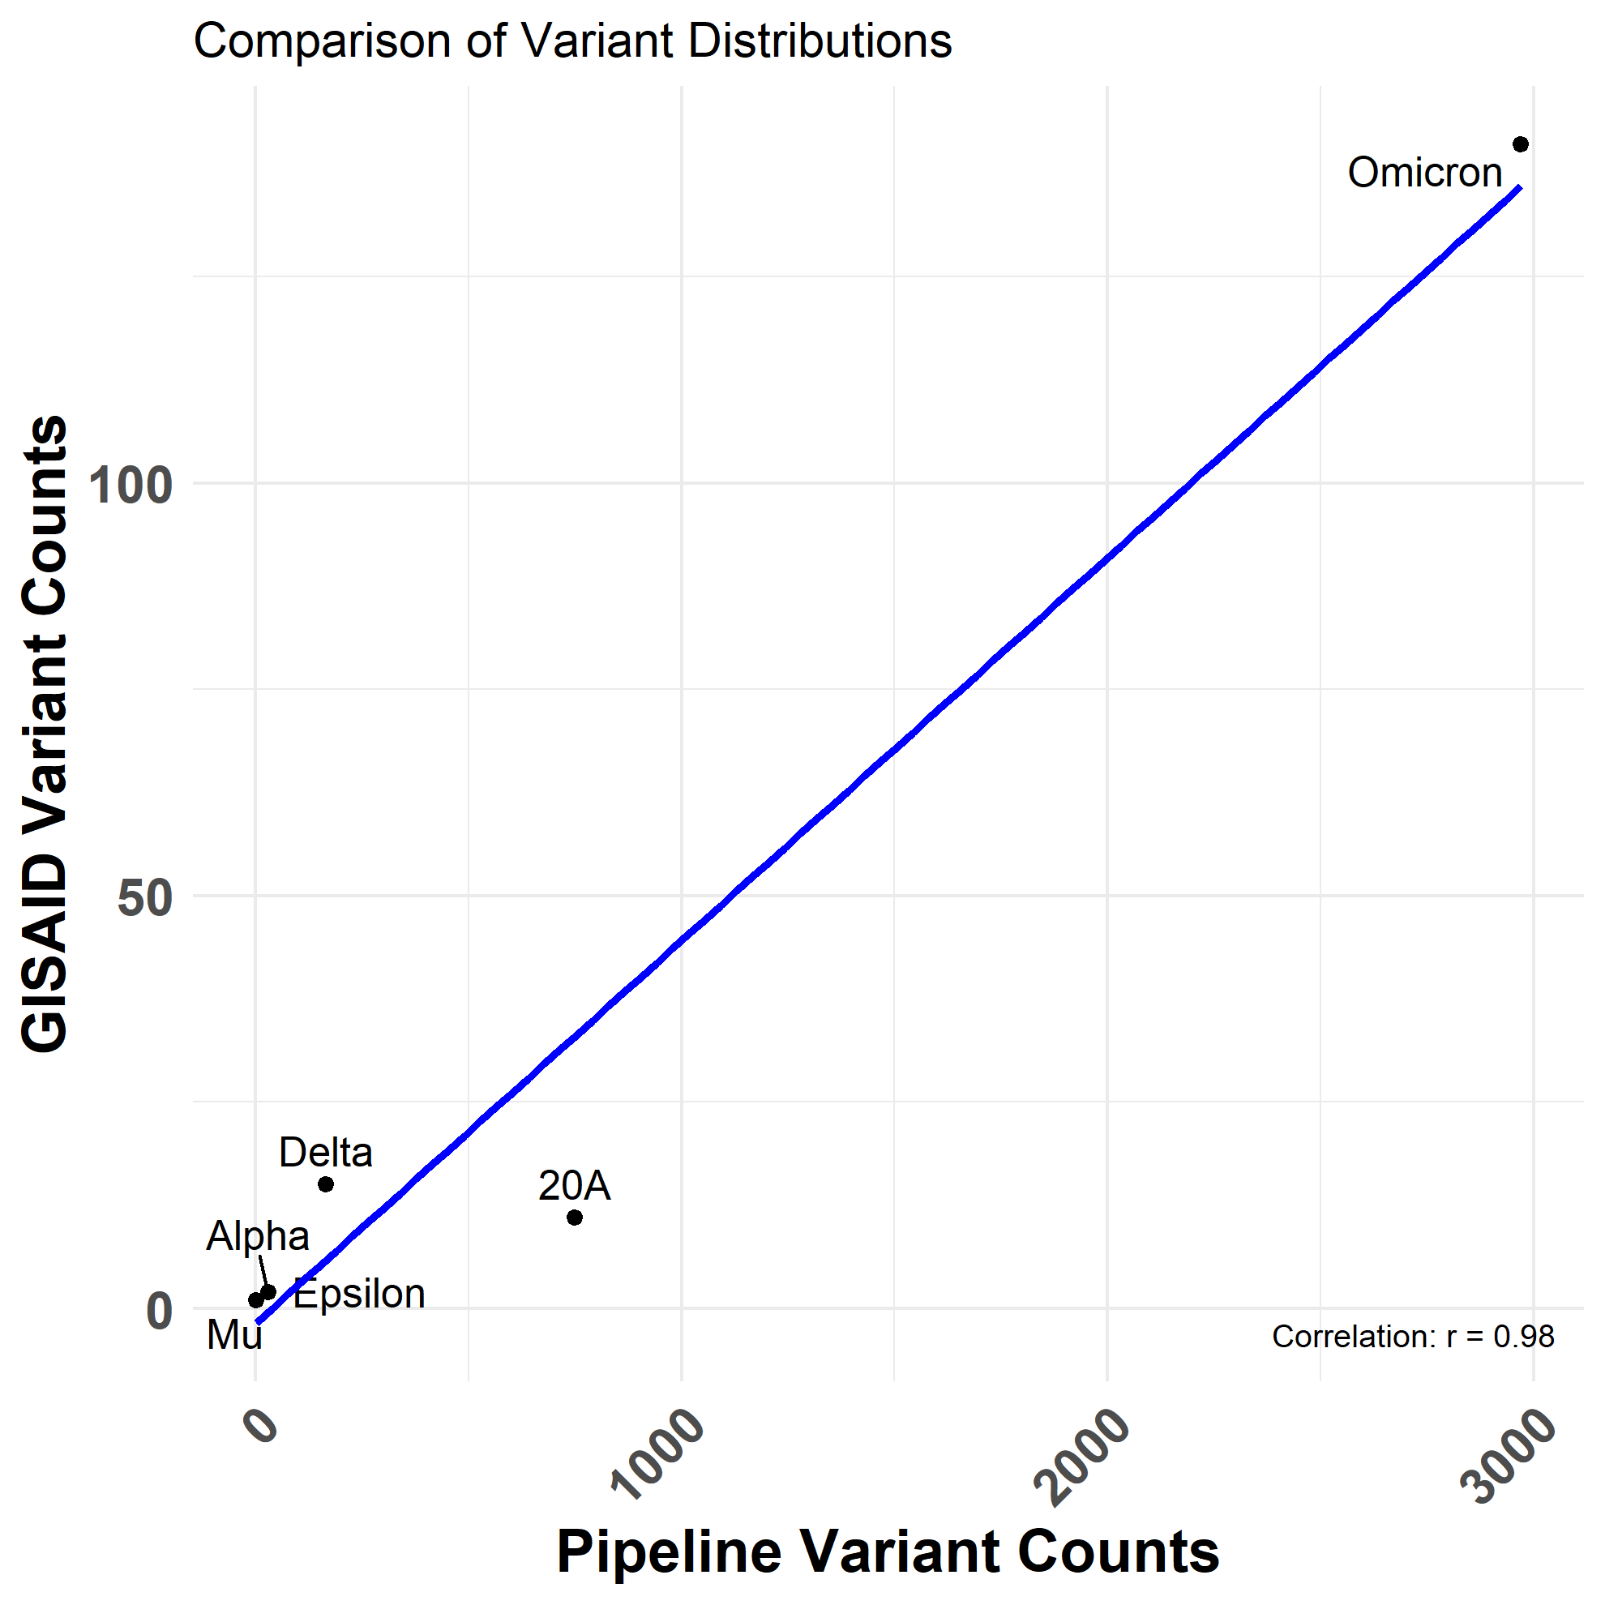
Figure S8: Correlation between GSAID of MI and Genomic Surveillance in Southeast MI. Correlation Between SARS-CoV-2 Variants Detected by GISAID and Pipeline Samples. The graph shows the correlation between the variants identified by GISAID, based on the number of sequenced cases, and 4583 samples collected from Henry Ford Hospital, r=0.98.

Figure S9: 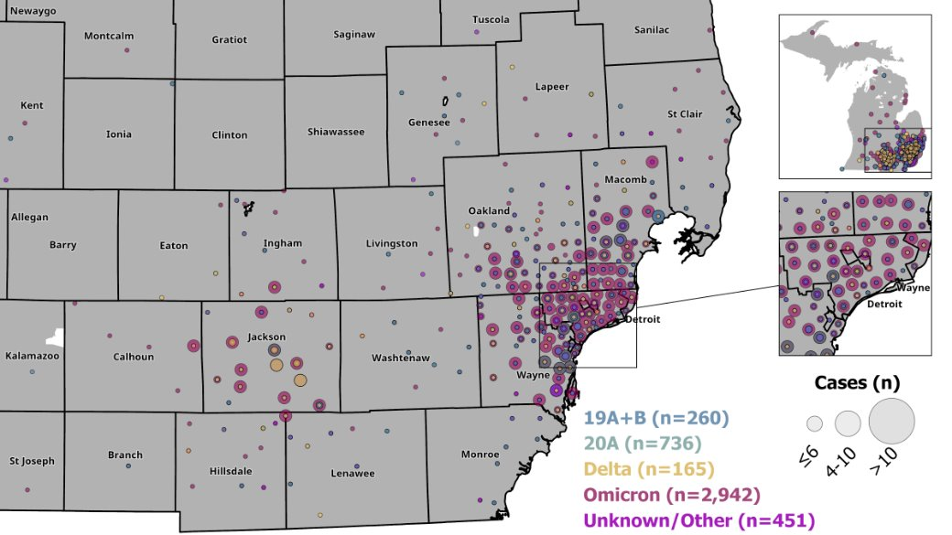
Figure S10: Variant Distribution Across Southeast MI. Choropleth map displaying the geographic variant distribution of the total number of COVID-19 cases sequenced in the SIPPHIRE study (n=4,583) by residential ZIP code in Michigan.

Figure S10:
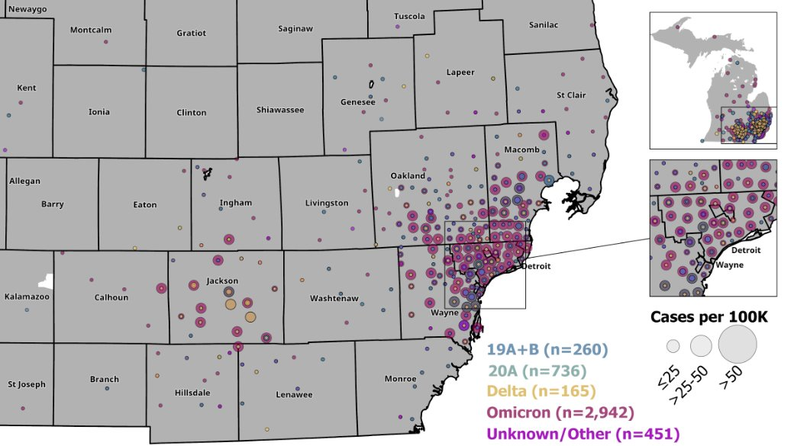
Figure S10: Variant Prevalence Across Southeast MI. Choropleth map showing variant prevalence of COVID-19 cases (n=4,583) by residential ZIP code.

Figure S11:
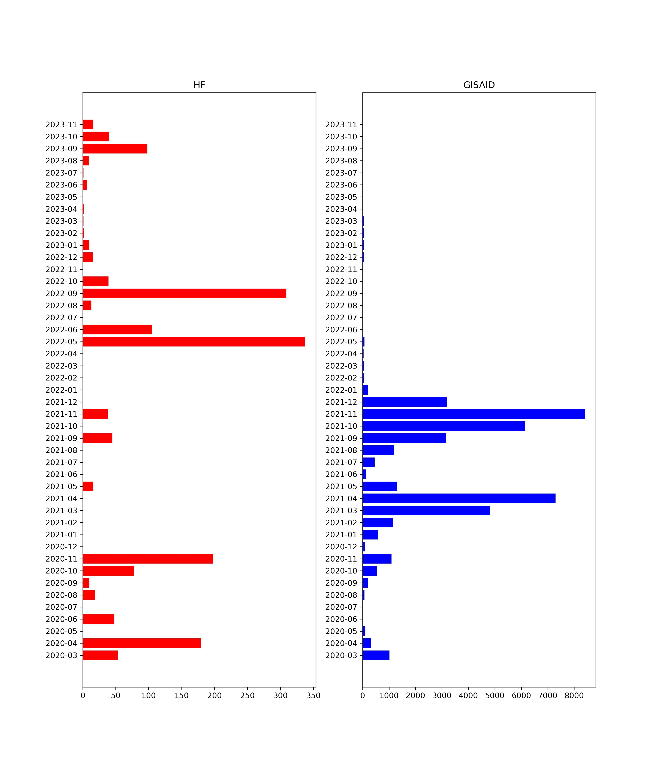
Figure S11: Comparison of sample distribution between HFH and GISAID. SARS-CoV-2 genomes submitted from Michigan between January 2020 and December 2021 were retrieved from GISAID for comparison with clinical samples collected from HFH during the same period. Only high-quality genomes, as determined by Nextclade analysis, were included. The monthly distribution of samples differed significantly between HFH and GISAID datasets (p < 0.01).
Figure S12:
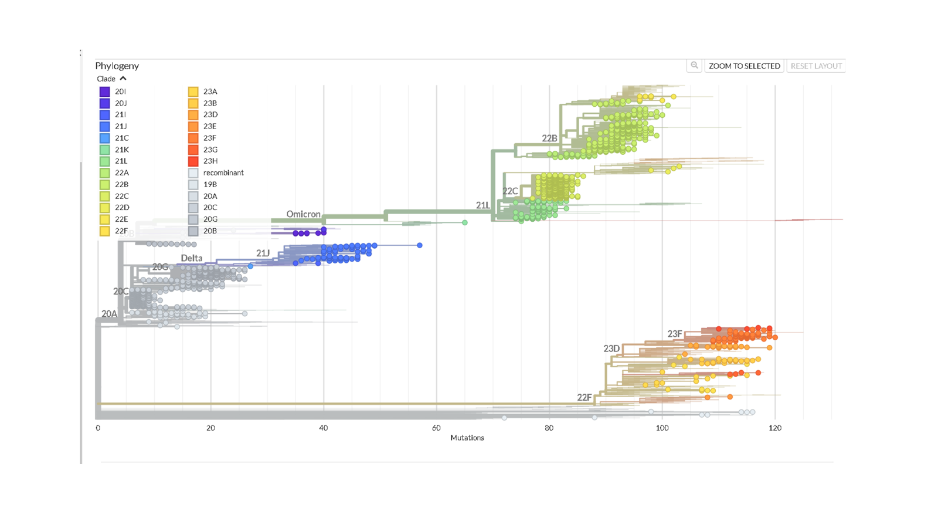Figure S12: Phylogenetic Tree for HFH Samples. Between January 2020 and December 2021, SARS-CoV-2 samples collected from HFH included 79 Delta variants, followed by 10 Alpha and 10 Omicron variants. Approximately 50% of the samples (349 in total) belonged to clade 20C. The other major clades identified were 20G and 21J, comprising 158 and 77 samples, respectively.

Figure S13:
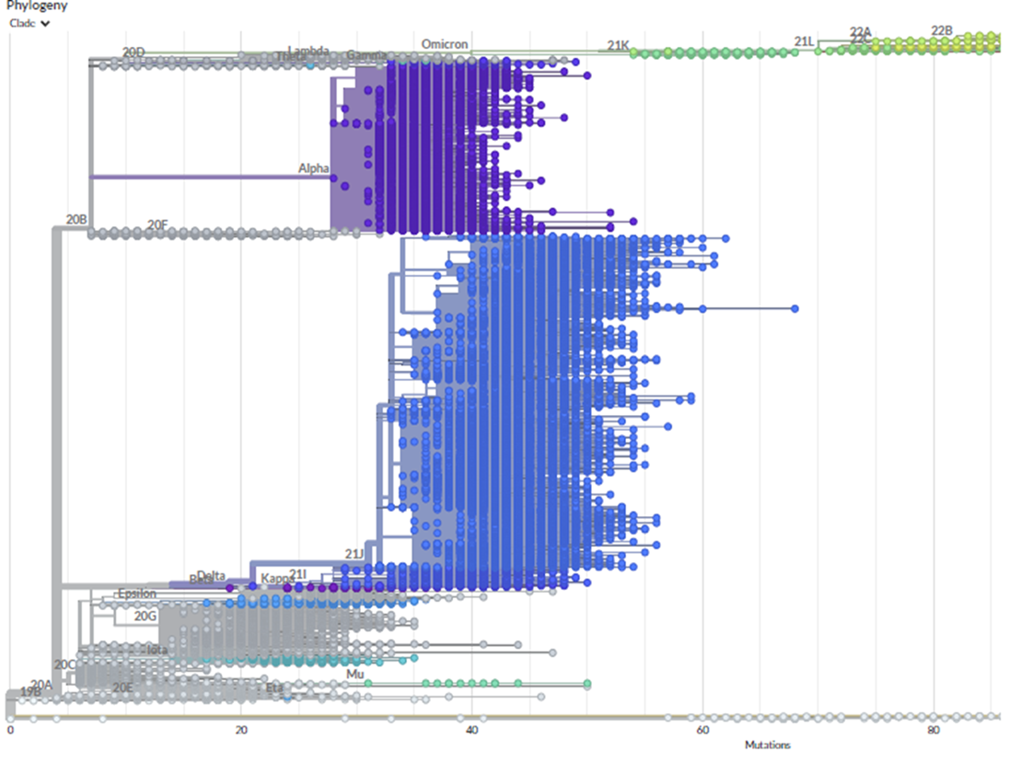
Figure S13: Phylogenetic Tree for GSAID Samples from MI. Between January 2020 and December 2021, SARS-CoV-2 samples collected from Michigan included 22,522 Delta variants, 10,704 Alpha variants, 461 Iota variants, and 413 Epsilon variants. The most prevalent clade was 21J, represented by 21,301 samples. Other major clades included 20I (10,704 samples), 20C (2,686 samples), and 20G (2,538 samples).

