Appendix A
The data comes from Field Polls 9605, 9606, and 9607.
The dependent variable measures whether a respondent can properly identify the consequences of passing Proposition 209. Some respondents were asked whether Proposition 209 would end affirmative action while others were asked if it would continue affirmative action. The questions are as followed: “Do you agree or disagree with the following statement: A ‘yes’ vote on Proposition 209 would be a vote to end race and gender-based affirmative action programs in in public employment, education, and contracting?”; “Do you agree or disagree with the following statement: A ‘no’ vote on Proposition 209 would be a vote to continue race and gender-based affirmative action programs in public employment, education and contracting?” Results show that awareness of Proposition 209 is substantively and statistically significant with accurately determining the measure’s consequences.
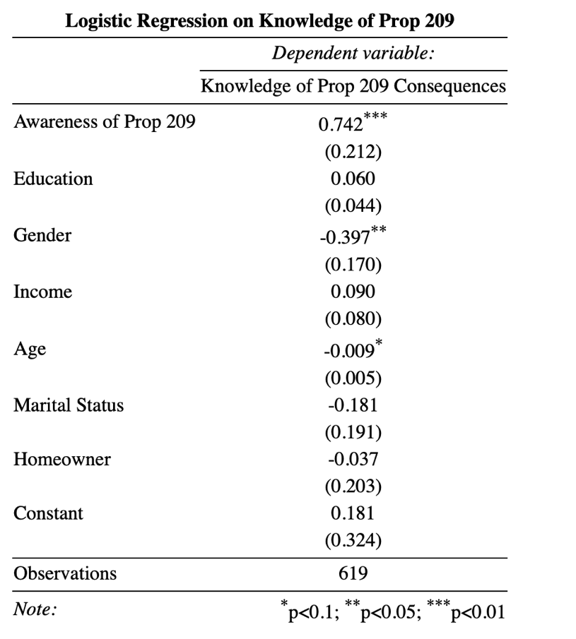
Appendix B
The following models present the full set of regressions from the main text.
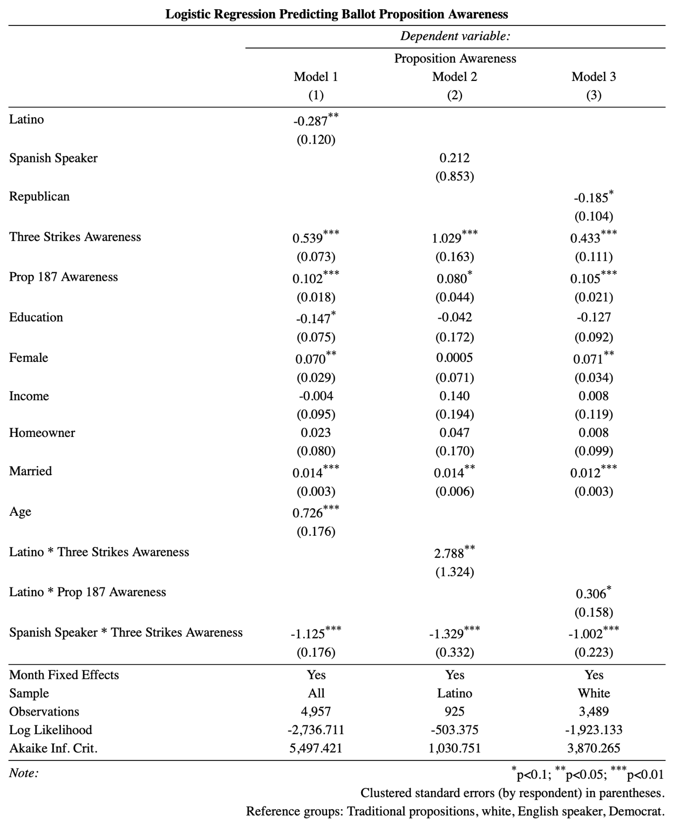

Several surveys in 1996 did not ask respondents about their marital status or homeownership. The main text pools the data without these controls. Attempting to run the models with these controls causes the months to drop out entirely. The first model below replicates the main text. The second model adds the controls.
