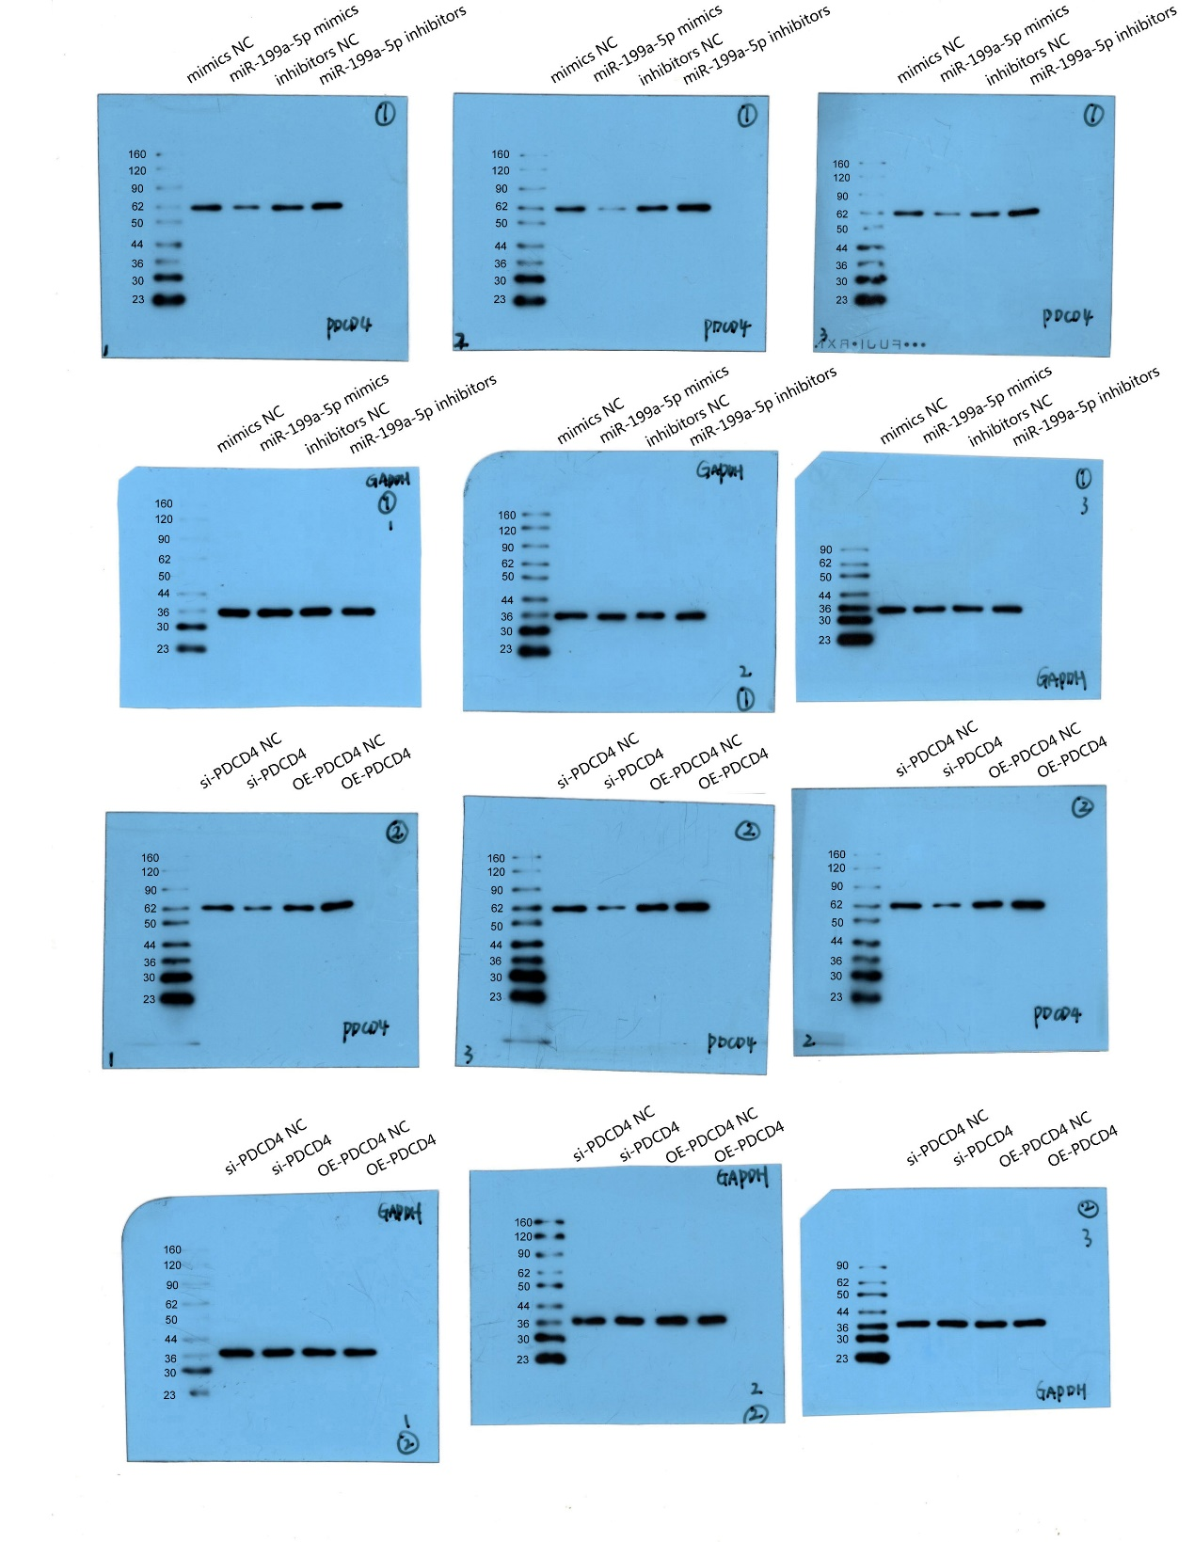
Original figures for Western blot of PDCD4.

