Supplementary Material
Table S1. Codebook description.

Topic | Definition | Inclusion criteria | Exclusion criteria | Example
Actors | Statements that focus on governments, organizations or individuals as contributors to climate change mitigation | Statements that mention the UN, national governments, private companies, civil society organizations or individual people | Statements that focus on the mitigation action rather than the actor | "Individuals with high socio-economic status contribute disproportionately to emissions and have the highest potential for emissions reductions, e.g., as citizens, investors, consumers, role models, and professionals"
Background information | Information about the past or definitions which sets the context for nearby statements | Statements about the past possibly including quantitative data | Statements about historic greenhouse gas emissions | "As of 2011, more than 52 % of the global population lives in urban areas."
Barriers to mitigation | Statements regarding the challenges which hinder climate change mitigation action | Statements about the risks associated with certain technologies and other barriers to mitigation | Statements about economic costs as barriers to mitigation. Statements about lock-in effects which hinder mitigation by driving emissions. | "Institutional, legal, financial and cultural barriers constrain low-carbon technology uptake and behavioural change."
Behavioural change strategies | Statements that outline approaches which lower the extent of human activity as a way of mitigation climate change | Statements that mention individual lifestyle choices change or organizational and policy change related to degrowth. Sentences that discuss the incentives for such behaviour change. | Statements about behaviour change which would not decrease human activity as a way of mitigating climate change | "Demand-side measures, such as changes in diet and reductions of losses in the food supply chain, have a significant, but uncertain, potential to reduce GHG emissions from food production"
Burden sharing | Statements that outline the distribution of mitigation efforts across regions because of the variance of regional mitigation costs or other drivers of mitigation potential | Statements about regional variance in mitigation costs and/or efforts and/or potential | Statements about the fairness of the distribution of mitigation efforts | "Countries’ past and future contributions to the accumulation of GHGs in the atmosphere are different, and countries also face varying challenges and circumstances, and have different capacities to address mitigation and adaptation."
Co-benefits | Statements on positive (un)intended consequences of climate change mitigation | Statements about the effects on air pollution, energy security or the sustainable development goals | Statements that focus on co-benefits but also mention side effects. | "Commercially available liquid and gaseous biofuels already provide co-benefits together with mitigation options that can be increased by technology advances"
Costs and cost-effectiveness | Statements about the costs and cost-effectiveness of climate change mitigation | Statements that outline what the expected mitigation costs are or what the most cost-effective mitigation option is | Statements that talk about costs or cost-effectiveness as barriers to mitigation | "Under the absence or limited availability of technologies, mitigation costs can increase substantially depending on the technology considered"
Emissions drivers | Statements about the factors driving greenhouse gas emissions | Include statements about gross domestic product growth, population growth, urbanization, infrastructure lock-in or other factors driving greenhouse gas emissions | Statements that discuss the distribution of emissions per sectors or technologies. | "Globally, economic and population growth continue to be the most important drivers of increases in CO2 emissions from fossil fuel combustion. "
Emissions projections | Statements that explain how greenhouse gases emissions are likely to develop in the future based on current measures | Sentences about baseline scenarios | Statements about mitigation scenarios (as opposed to business-as-usual scenarios) and sentences who emphasize a particular policy target | "Baseline scenarios (scenarios without explicit additional efforts to constrain emissions) exceed 450 parts per million (ppm) CO2eq by 2030 and reach CO2eq concentration levels between 750 and more than 1300 ppm CO2eq by 2100."
Equity | Statements about the fairness of climate change mitigation | Statements about what which groups of people stand to win or lose with mitigation and why that’s important | Statements which provide background context to an issue or mention something explicitly as a side effect of climate change mitigation. | "Consideration of climate justice can help to facilitate shifting development pathways towards sustainability, including through equitable sharing of benefits and burdens of mitigation, increasing resilience to the impacts of climate change, especially for vulnerable countries and communities, and equitably supporting those in need"
Historic emissions | Statements about past emissions as recorded in the greenhouse gases inventory | Statements with exact figures about greenhouse gases emitted or trends observed in the past | Statements about historic developments which do not mention emissions specifically | "Total anthropogenic GHG emissions were the highest in human history from 2000 to 2010 and reached 49 (±4.5) GtCO2eq/yr in 2010"
International policy | Statements about initiatives or policies that can be or have been implemented internationally | Statements about international policy initiatives or linkages of national policies | Statements that focus on actors like national governments or international organizations rather than policies. | "The Kyoto Protocol offers lessons towards achieving the ultimate objective of the UNFCCC, particularly with respect to participation, implementation, flexibility mechanisms, and environmental effectiveness"
Introductory information | General statements which introduce the concept of climate change mitigation and call for climate change motivation | Statements that define general concepts and motivational sentences for mitigation | Statements that describe how the assessment report is structured, the writing process or similar methodological considerations | "Effective mitigation will not be achieved if individual agents advance their own interests independently."
Methodological considerations | Statements which outline methodological considerations about the way the scientific evidence was created, assessed and its limitations | Statements about how the assessment report is structured, the assessment and writing process as well as nuances that relate to scientific findings | Statements that provide definitions of climate change, mitigation etc. | "Many areas of climate policy-making involve value judgements and ethical considerations."
Mitigation drivers | Statements about factors driving greenhouse gas emissions reduction | Statements about policy linkages, cooperation, financial investment or other factors clearly framed as drivers of mitigation | Statements about negative emissions, carbon tax or mitigation costs | "Many climate policies can be more effective if implemented across geographical regions."
Negative emissions strategies | Statements that outline approaches which increase greenhouse gases capture and storage as a way of mitigation climate change | Statements that mention CDR, CCS, BECCS, afforestation, reforestation or other negative emissions strategies | Statements that talk about bioenergy | "Depending on the level of the overshoot, overshoot scenarios typically rely on the availability and wide- spread deployment of BECCS and afforestation in the second half of the century."
Policy outcome | Statements that describe the outcome of implemented climate change mitigation measures | Statements about initiative and policies already implemented which have or are expected to contribute to climate change mitigation | Statements about specific policy measures for which it is not explicitly mentioned that they have been implemented. | "Methane-based fuels are already increasing their share for road vehicles  and waterborne craft. "
Public policy | Statements about policies that can be implemented on a national or local level | Statements about specific public policy measures | Statements which outline policy outcomes, e.g. lower fertilizer use, rather than measures. | "In principle, a cap-and-trade system can achieve mitigation in a cost-effective way; its implementation depends on national circumstances."
Side effects | Statements on negative (un)intended consequences of climate change mitigation | Statements about food affordability, biodiversity loss and other side effects | Statements that focus on side effects, but also mention co-benefits. | "Whether or not side-effects materialize, and to what extent side-effects materialize, will be case- and site-specific, as they will depend on local circumstances and the scale, scope, and pace of implementation. "
Targets | Statements which focus on feasible or necessary climate change mitigation policy targets | Statements about demand reduction, emission reduction, energy intensity reduction, temperature change and investment targets | Statements that focus on past targets or developments | "In scenarios reaching about 550 ppm CO2eq, emissions in 2050 are from 5 % above 2010 levels to 45 % below 2010 levels globally."
Technological change strategies | Statements that outline technological change approaches which decarbonize energy sources and carriers or increase the efficiency of human activity | Statements that talk about energy sources, carriers and their decarbonization or those that mention technology and standard improvements that lead to higher efficiency of economic activities | Statements about the barriers to decarbonizing certain energy sources and carriers. Statements which outline good practices or methodological considerations. Statements that mention changes which would increase efficiency but also require significant behavioural change, e.g. recycling. | "Hydrogen fuels from low-carbon sources constitute longer-term options"
Timeline | Statements about the timeline of climate change mitigation policy | Statements about early or delayed mitigation and the pace of mitigation | Statements that mention specific years as targets | "On the other hand, scenarios reaching lower concentrations require these changes on a faster timescale."
Undefined effects | Statements on both positive and negative (un)intended consequences of climate change mitigation | Statements which mention both co-benefits and side effects | Statements that outline the effects of baseline scenarios. | "There is a wide range of possible adverse side-effects as well as co-benefits and spillovers from climate policy that have not been well-quantified"
Undefined strategies | General statements about mitigation strategies | Statements that mention any combination of behavioural change, negative emissions or technological change mitigation strategies | Statements about behavioural change, negative emissions or technological change mitigation strategies specifically | "Scenarios associated with the limited number of published studies exploring this goal are characterized by (1) immediate mitigation action; (2) the rapid upscaling of the full portfolio of mitigation technologies; and (3) development along a low-energy demand trajectory"

Table S2. Frequency of topics omitted from analysis.

Topic | Assessment cycle | Number of SPM statements | Share of SPM
Introductory information | AR3 | 6 | 3%
Background information | AR3 | 2 | 1%
Methodological considerations | AR3 | 36 | 18%
Introductory information | AR4 | 5 | 2.09%
Background information | AR4 | 5 | 2.09%
Methodological considerations | AR4 | 32 | 13.39%
Introductory information | AR5 | 10 | 2.79%
Background information | AR5 | 12 | 3.35%
Methodological considerations | AR5 | 54 | 15.08%
Introductory information | AR6 | 2 | 0.35%
Background information | AR6 | 5 | 0.88%
Methodological considerations | AR6 | 38 | 6.73%

Table S3. Content distribution of the SPMs, averaged across all SPMs and rounded to two decimal points. The sum of distribution values for topics may not equal 100% because they are rounded to integer values and averaged across all SPMs.

Topic | Average coverage across SPMs
Actors | 6%
Argumentative knowledge | 36%
Barriers to mitigation | 7%
Behavioural change strategies | 3%
Burden sharing | 2%
Co-benefits | 8%
Costs and cost-effectiveness | 7%
Emissions drivers | 3%
Emissions projections | 5%
Equity | 3%
Historic emissions | 7%
International policy | 2%
Mitigation drivers | 7%
Negative emissions strategies | 4%
Policy outcome | 3%
Practical knowledge | 27%
Public policy | 10%
Side effects | 4%
Strategic knowledge | 38%
Targets | 4%
Technological change strategies | 6%
Timeline | 4%
Undefined effects | 4%
Undefined strategies | 5%

Table S4. Linear regression model details for all topics
Topic | Slope | R² | Change per SPM
Actors | -0.01069 | 0.411836 | -0.0107
Barriers to mitigation | 0.00476 | 0.324194 | 0.0048
Behavioural change strategies | -0.00751 | 0.660948 | -0.0075
Burden sharing | -0.00791 | 0.954306 | -0.0079
Co-benefits | -0.00781 | 0.318555 | -0.0078
Costs and cost-effectiveness | -0.02659 | 0.678173 | -0.0266
Emissions drivers | -0.00423 | 0.060264 | -0.0042
Emissions projections | 0.026742 | 0.923692 | 0.0267
Equity | 0.005496 | 0.159536 | 0.0055
Historic emissions | 0.01535 | 0.985009 | 0.0154
International policy | 0.005646 | 1 | 0.0056
Mitigation drivers | 0.004427 | 0.218113 | 0.0044
Negative emissions strategies | 0.004755 | 0.278128 | 0.0048
Policy outcome | 0.011894 | 0.711408 | 0.0119
Public policy | -0.00312 | 0.011752 | -0.0031
Side effects | -0.00507 | 0.079338 | -0.0051
Targets | 0.01264 | 0.298181 | 0.0126
Technological change strategies | -0.00555 | 0.1465 | -0.0055
Timeline | -0.00277 | 0.12234 | -0.0028
Undefined effects | -0.01127 | 0.490433 | -0.0113
Undefined strategies | -0.01622 | 0.493063 | -0.0162

Figure S1. Distribution of strategy and public policy topics in AR5 and AR6.
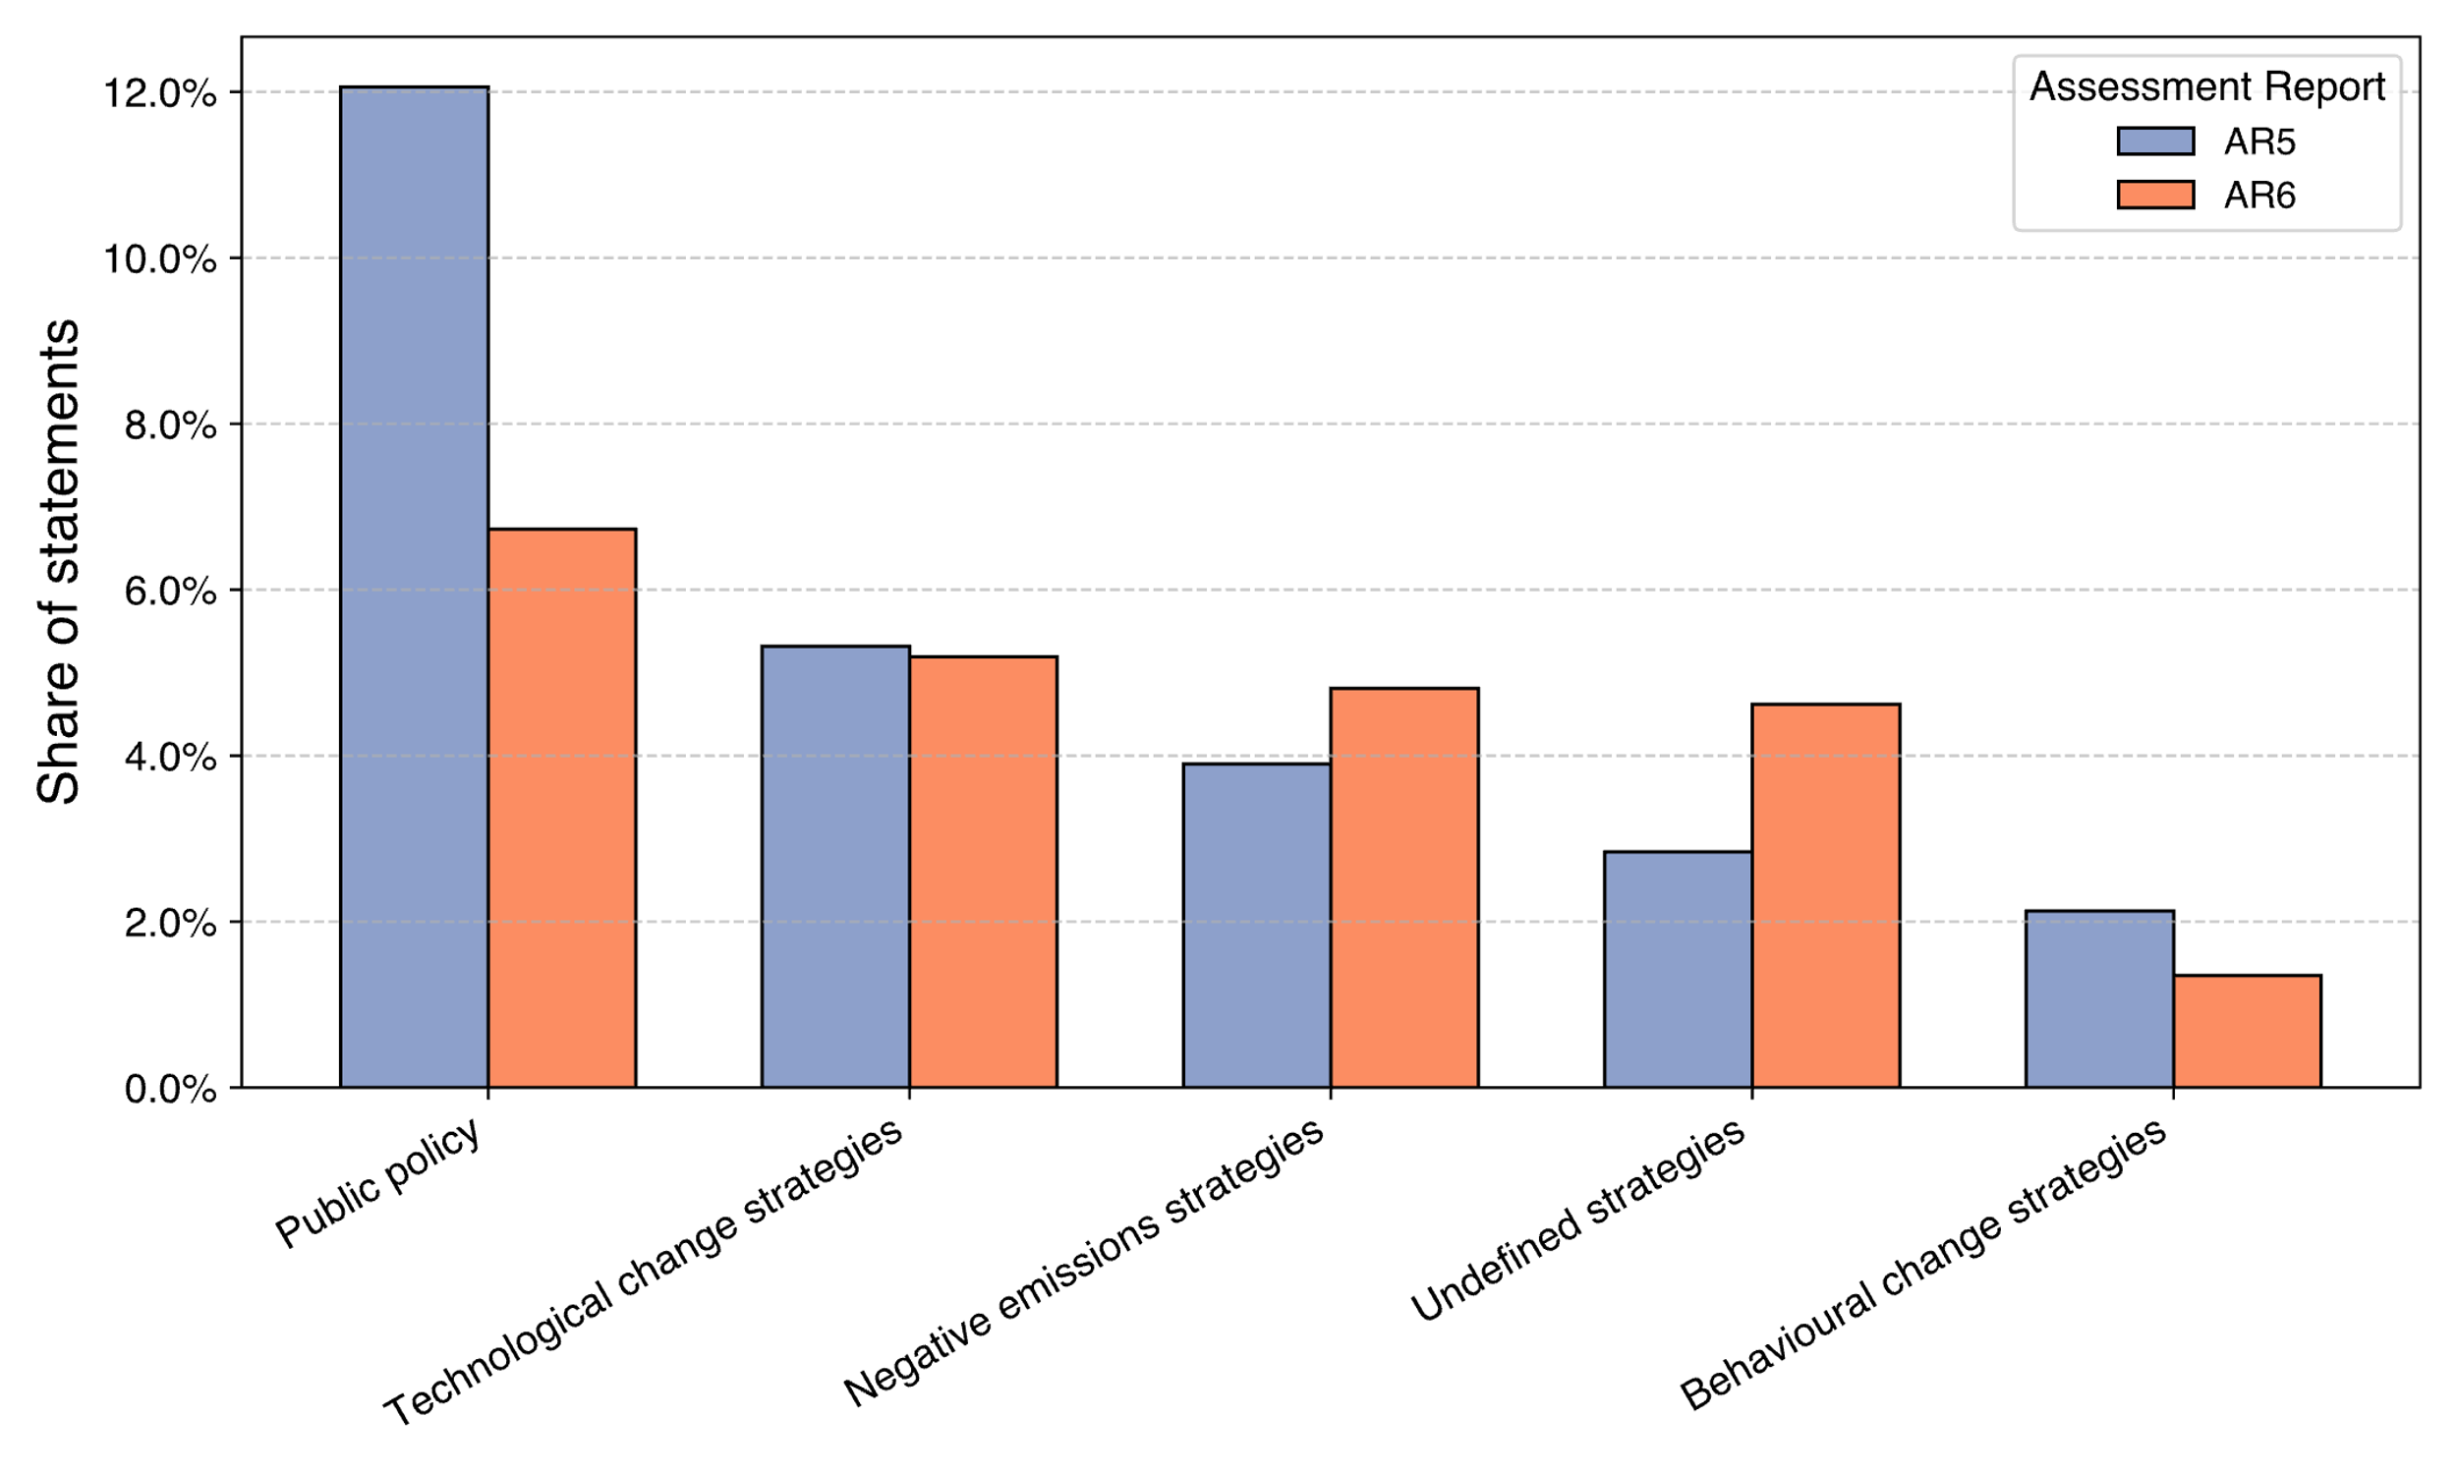
Note S1. Sensitivity analysis of topic classification into knowledge type themes

Our analysis reveals that theme distribution across assessment cycles is insensitive to how we classify topics. We alternated our original topic classification (see Figure 1) in four additional plausible ways (see Figures 2a-5a). But, the ranking of themes and consistency across assessment cycles remained the same (see Figures 2b-5b).
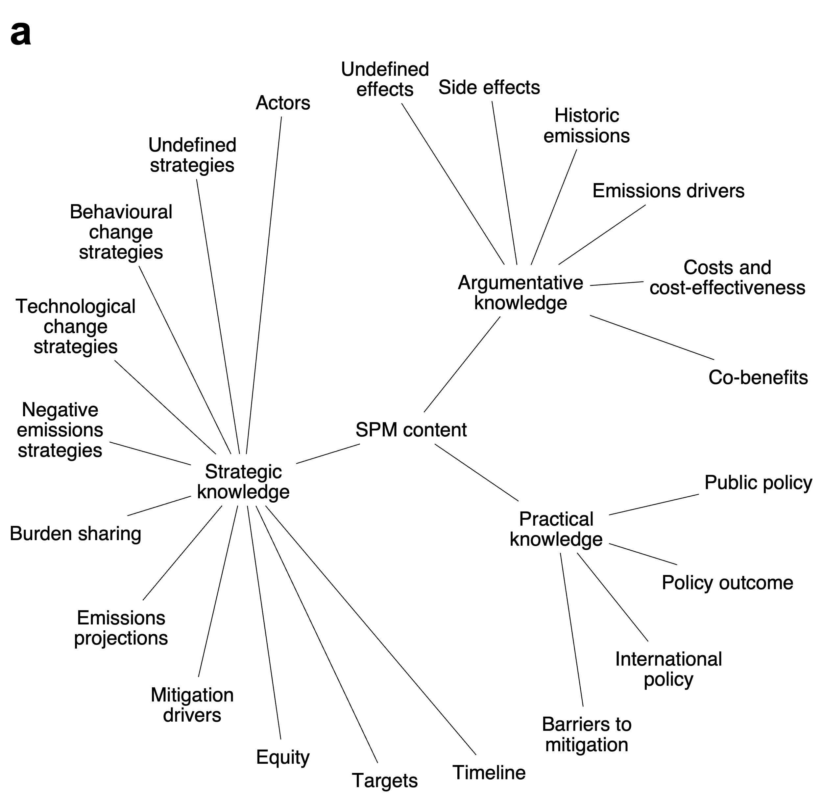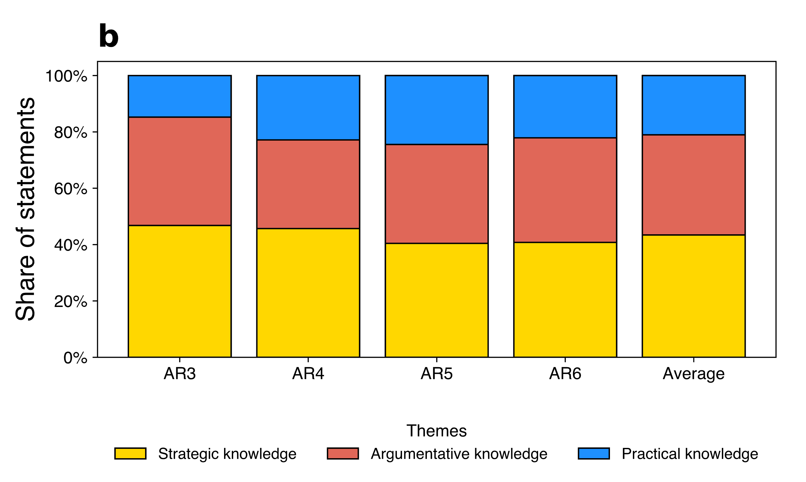
Figure 1. Original topic classification (a) and distribution of themes (b)
‘Timeline’ represents statements on when it is desirable to undertake mitigation, discussing the differences between early and delayed mitigation action. We consider this to be ‘Strategic knowledge’ because it informs policymakers on when mitigation policy is appropriate but lacks the specificity of actionable timing detail. If we re-classify ‘Timeline’ as ‘Practical knowledge’ (see Figure 2a), then the bottom-rank of ‘Practical knowledge’ remains (see Figure 2b).
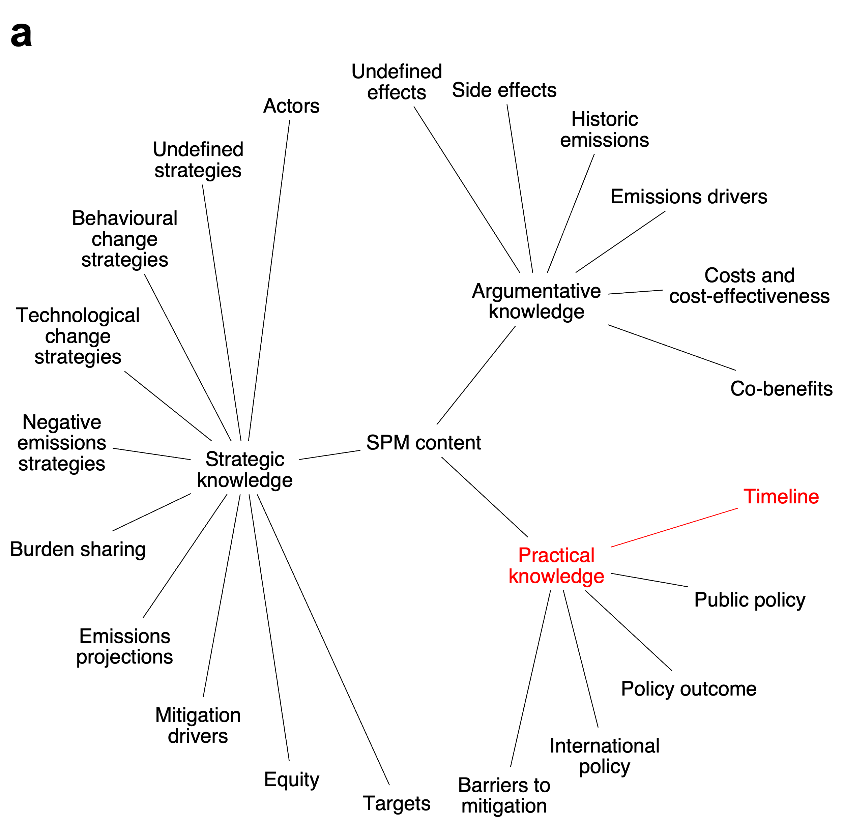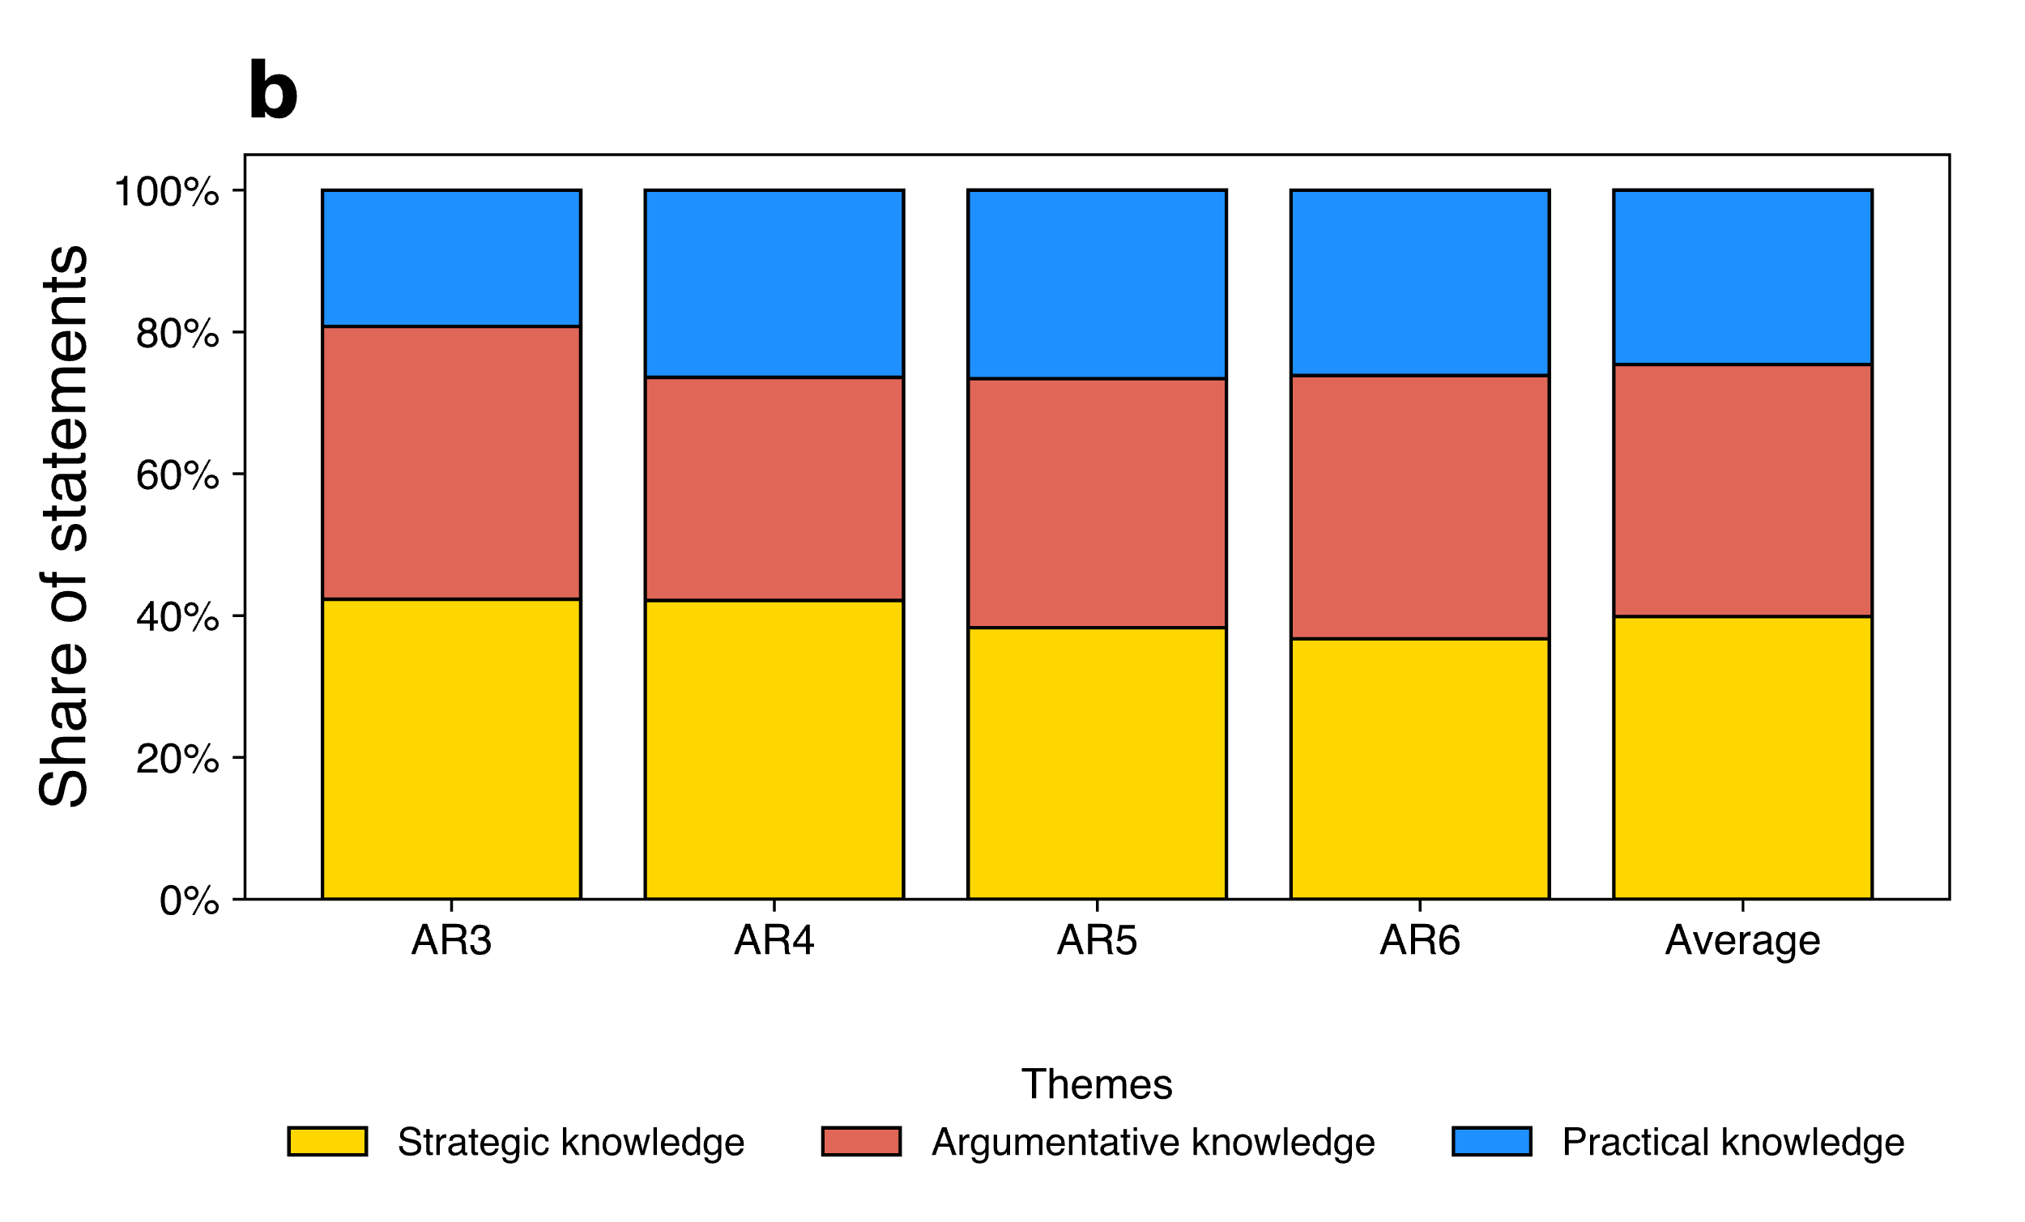
Figure 2. Altered topic classification (a) and distribution of themes (b)
‘Targets’ covers statements on expected emissions reductions in line with additional mitigation. Since these calculations are based on global scenarios, this information cannot directly inform the development of national or local policy. Hence we classify it as ‘Strategic knowledge’. However, it may inform the development of international policy in which case it can be considered as ‘Practical knowledge’. We test this re-classification (see Figure 3a) and see that it does not change the bottom ranking of ‘Practical knowledge’ (see Figure 3b).
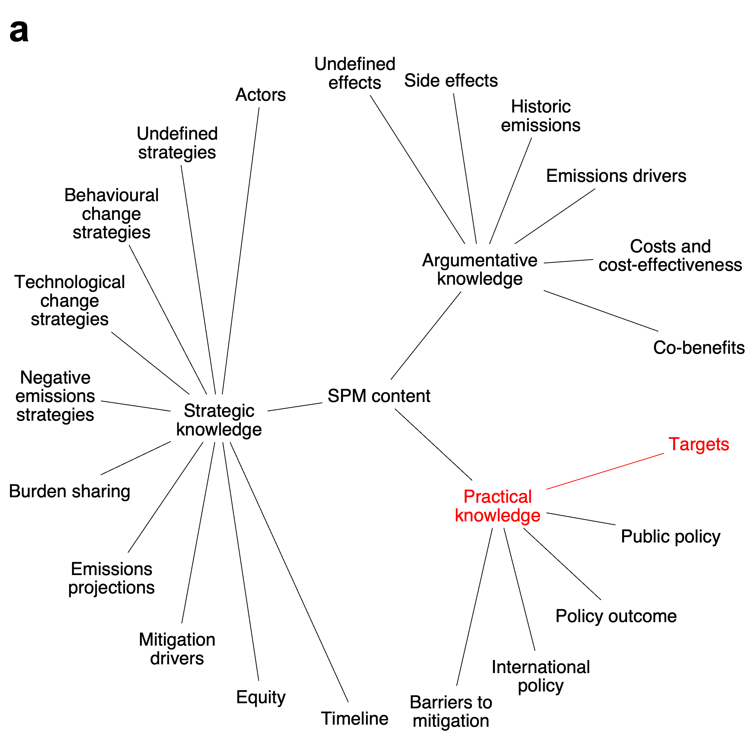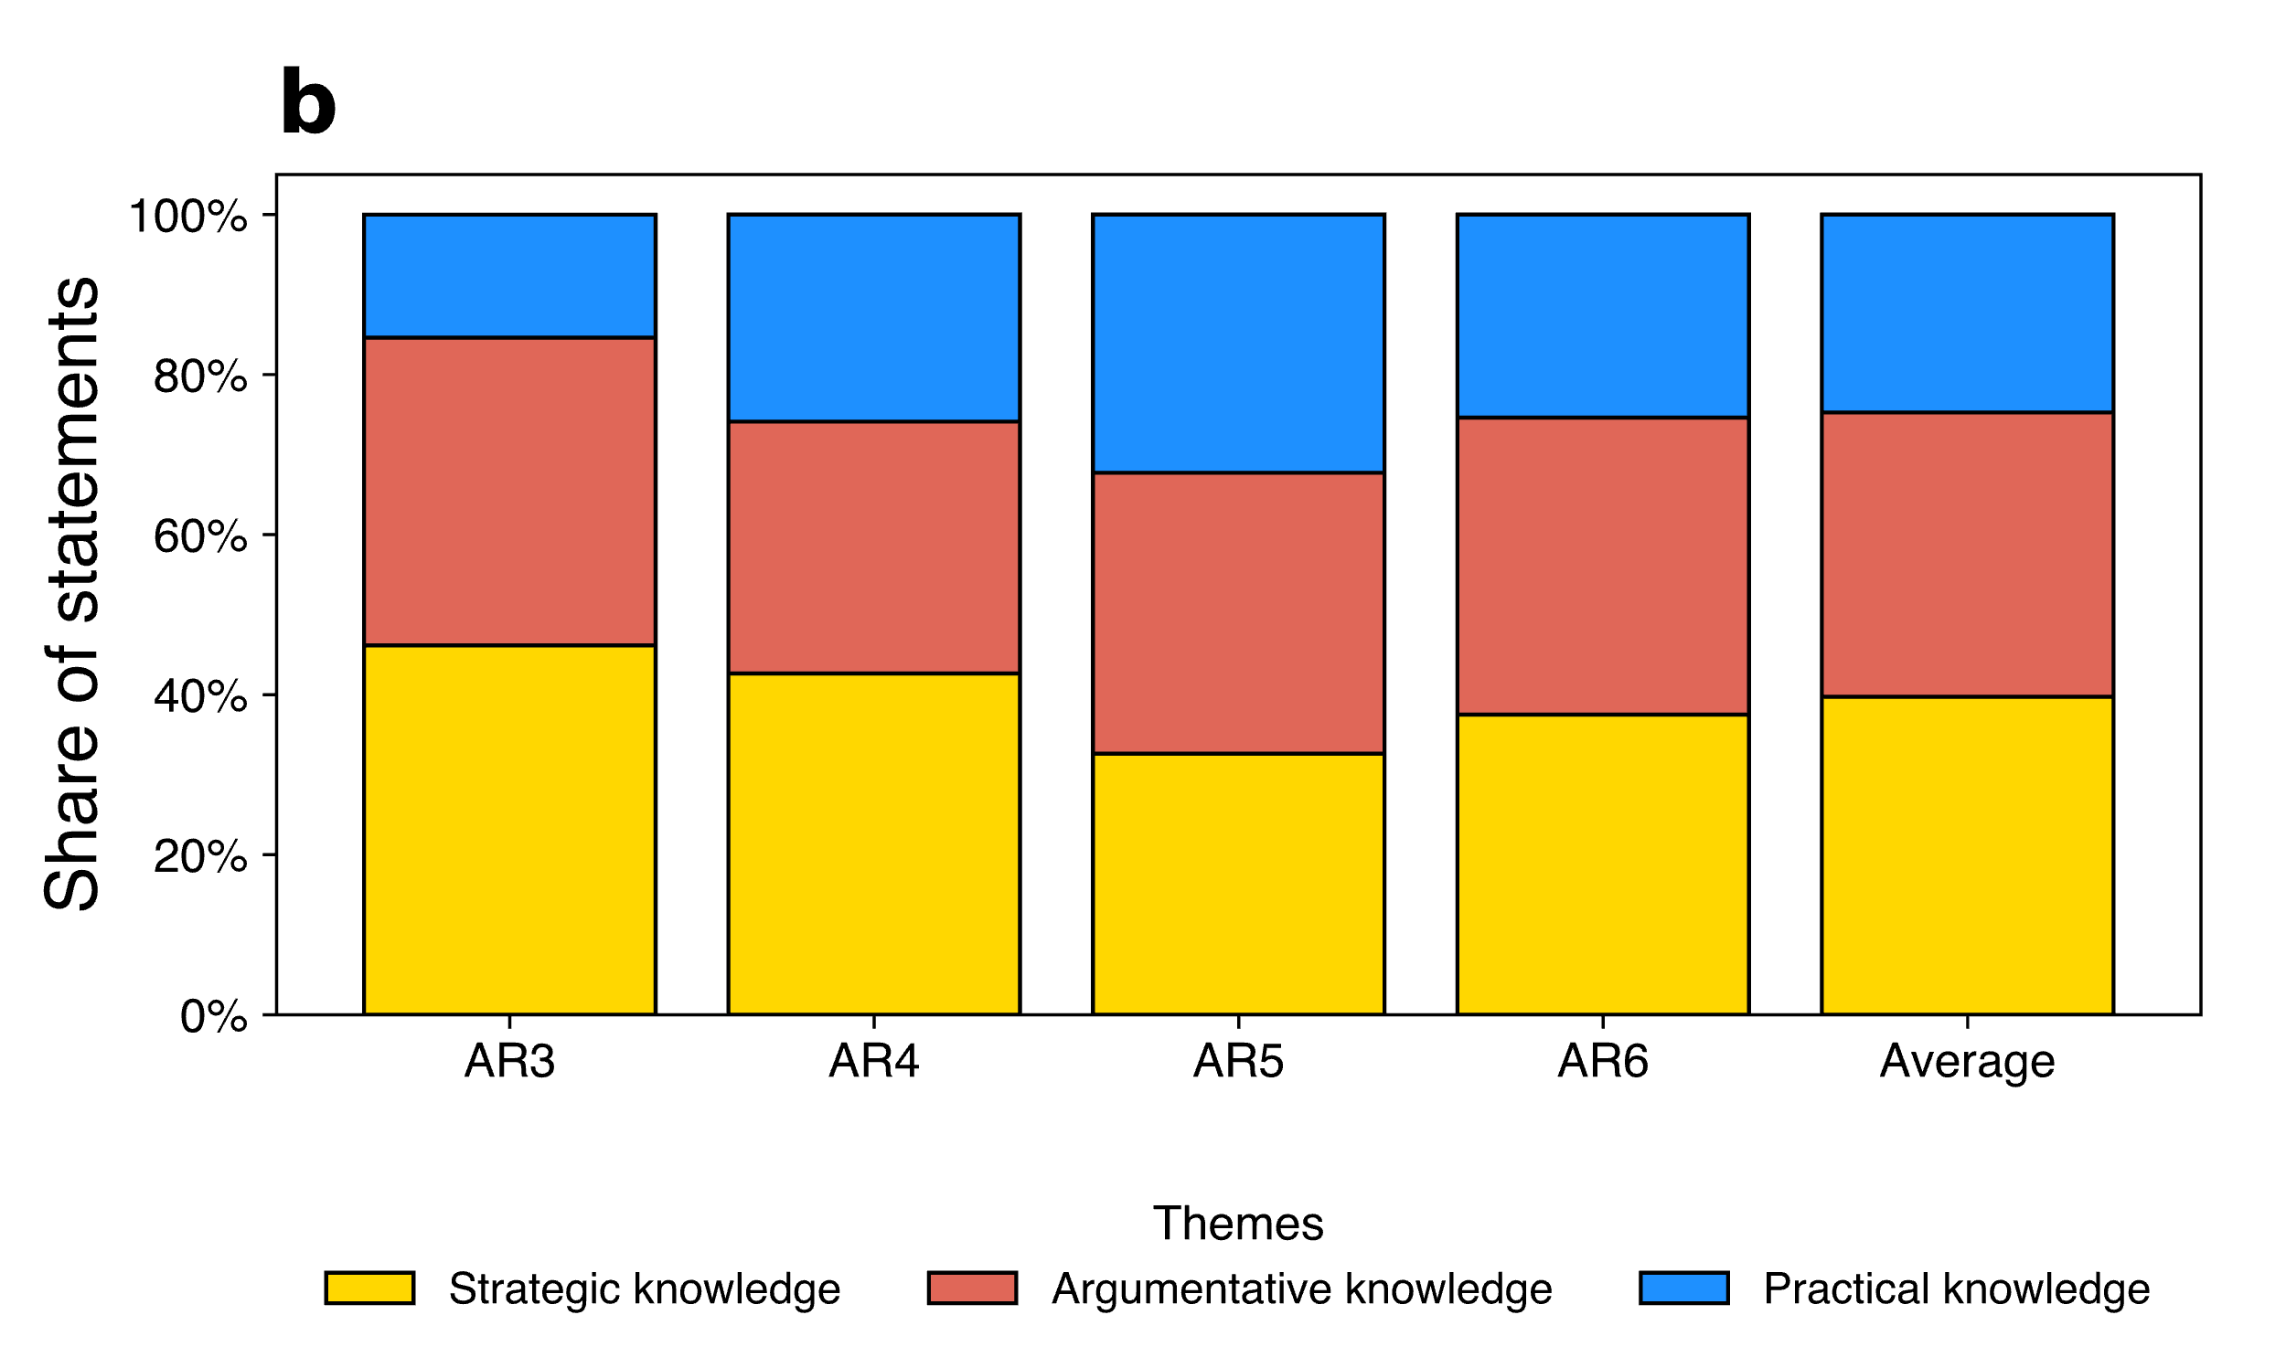
Figure 3. Altered topic classification (a) and distribution of themes (b)
‘Costs and cost-effectiveness’ refers to statements that outline the economic costs of mitigation in a high-level way. Thus, we categorize this as ‘Argumentative knowledge’ because it can justify the need for mitigation, but not directly inform the development of public policy because it lacks the specificity and context of real-world policy. However, some high-level insights on costs can inform policy development by screening out costly policy ideas. Given the re-classification of ‘Costs and cost-effectiveness’ to ‘Practical knowledge’ (see Figure 4a), we see no change in theme ranking (see Figure 4b).
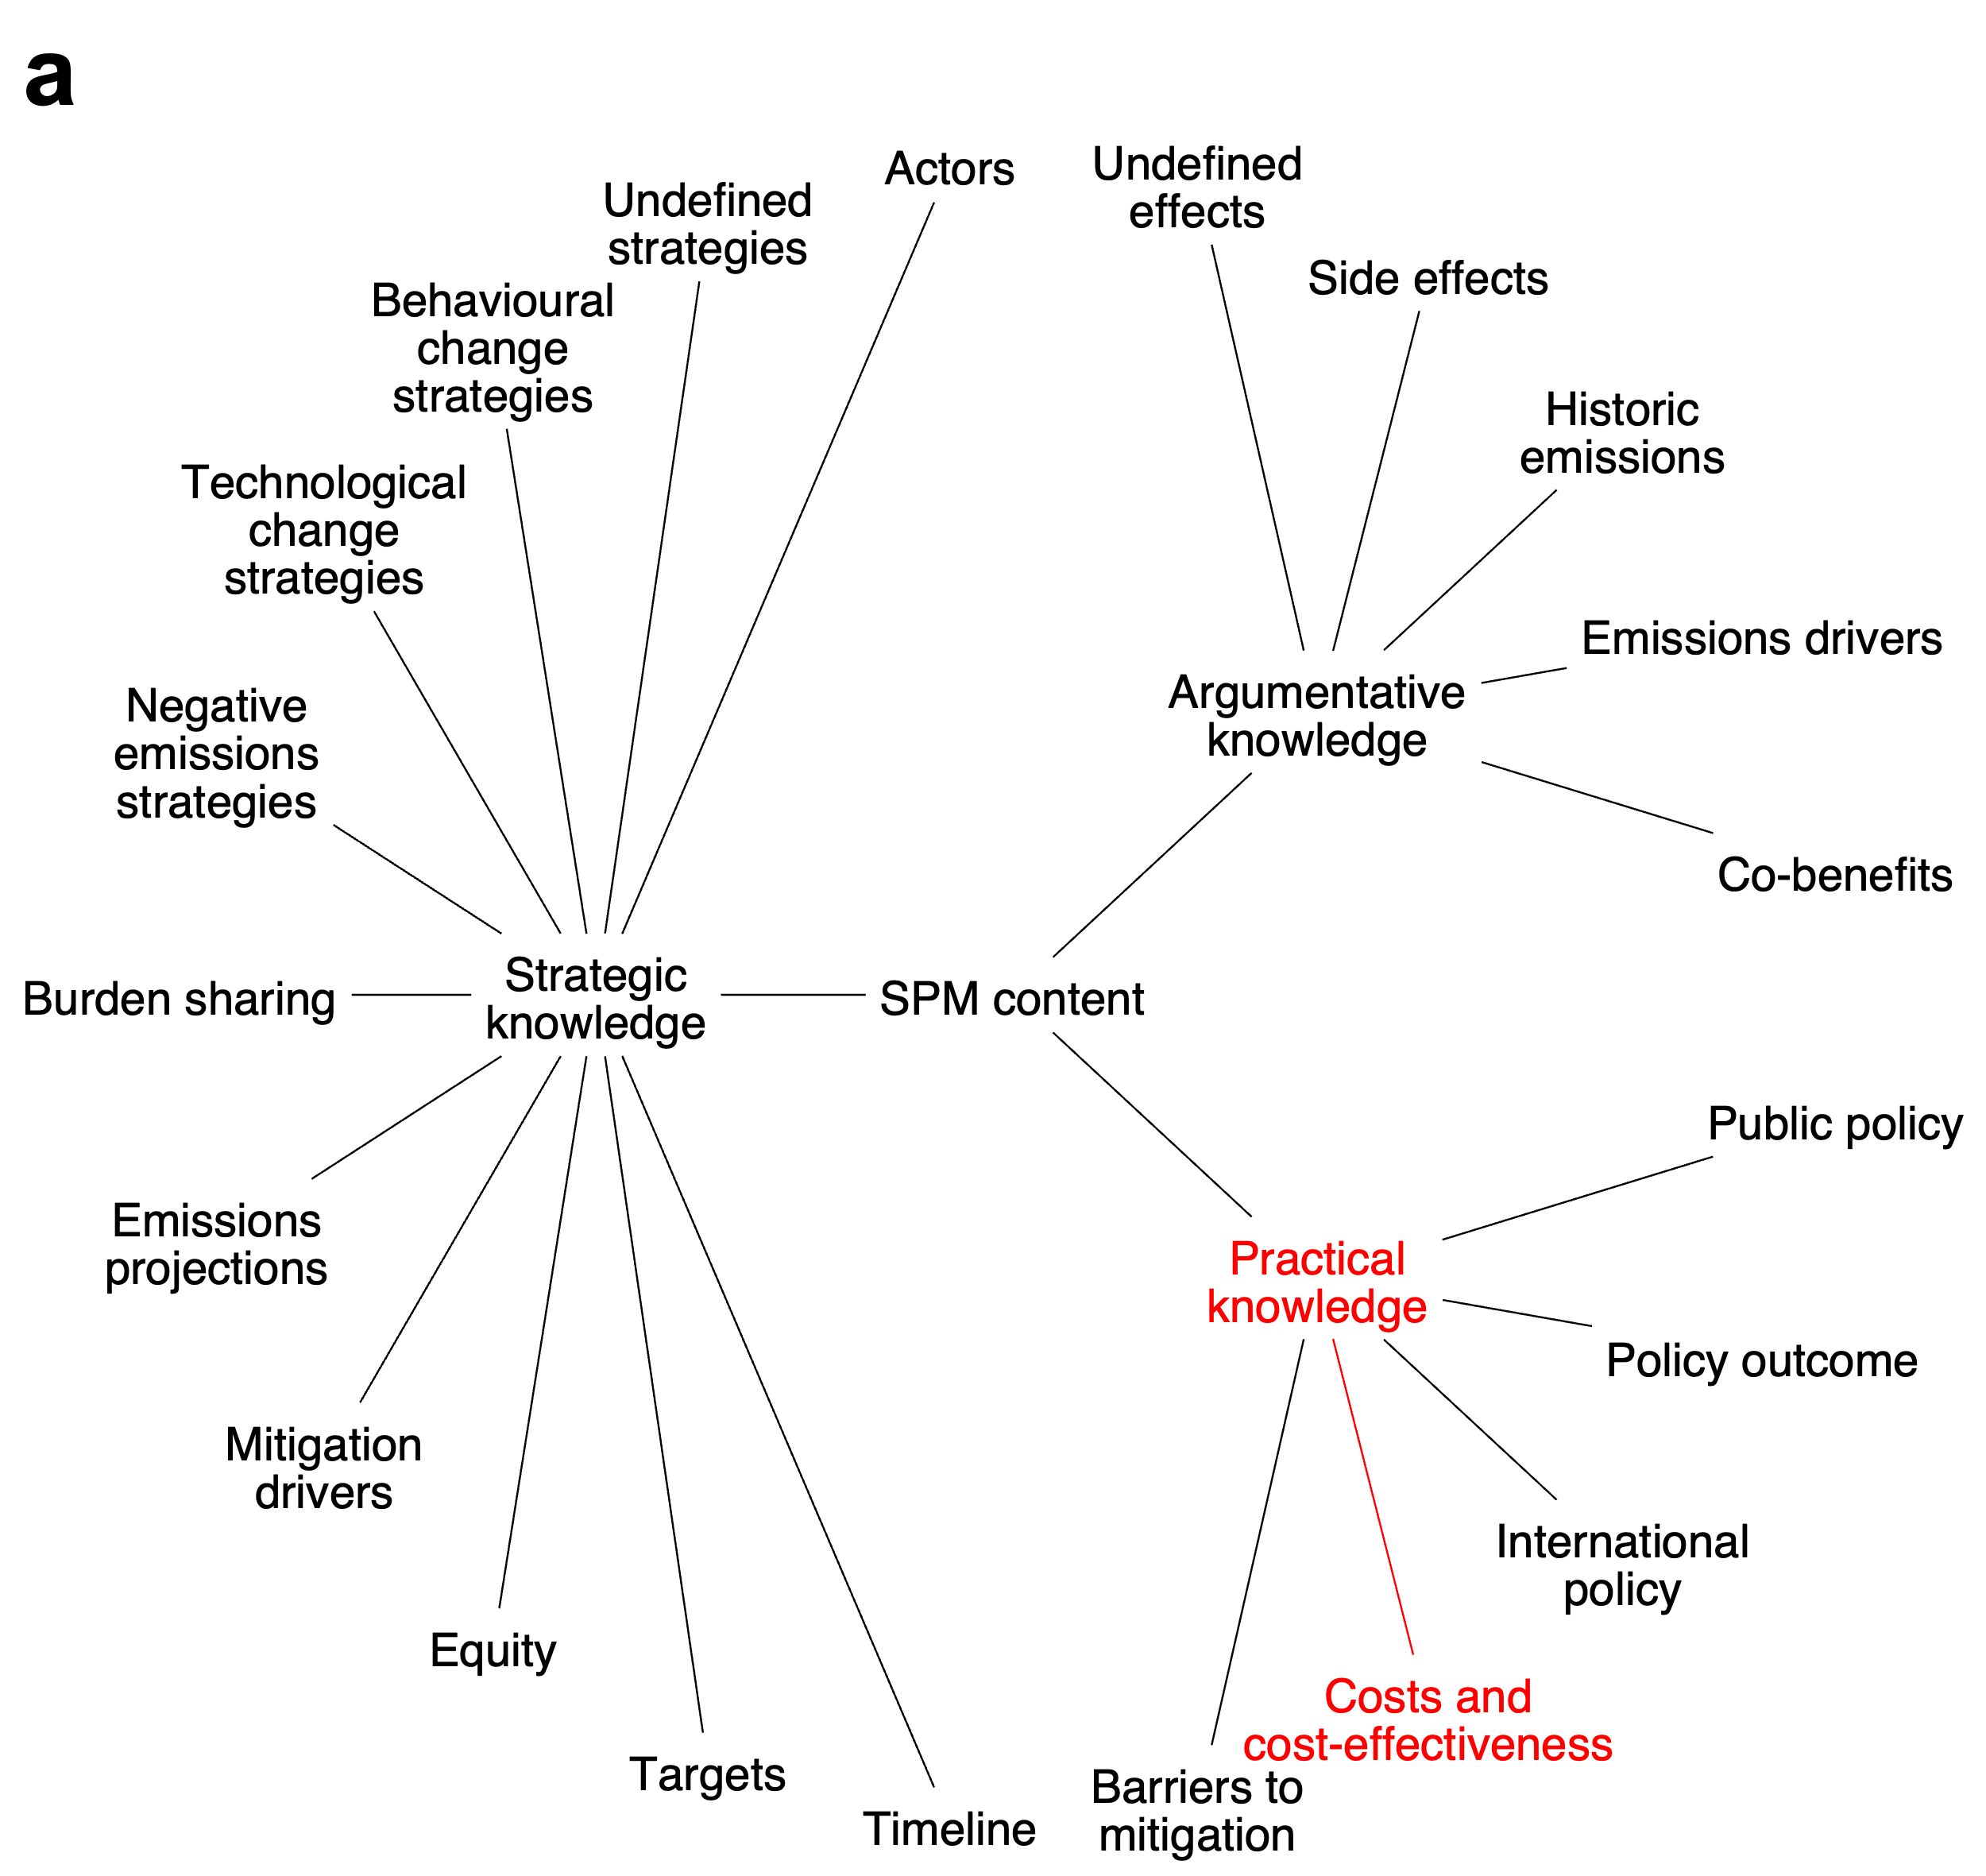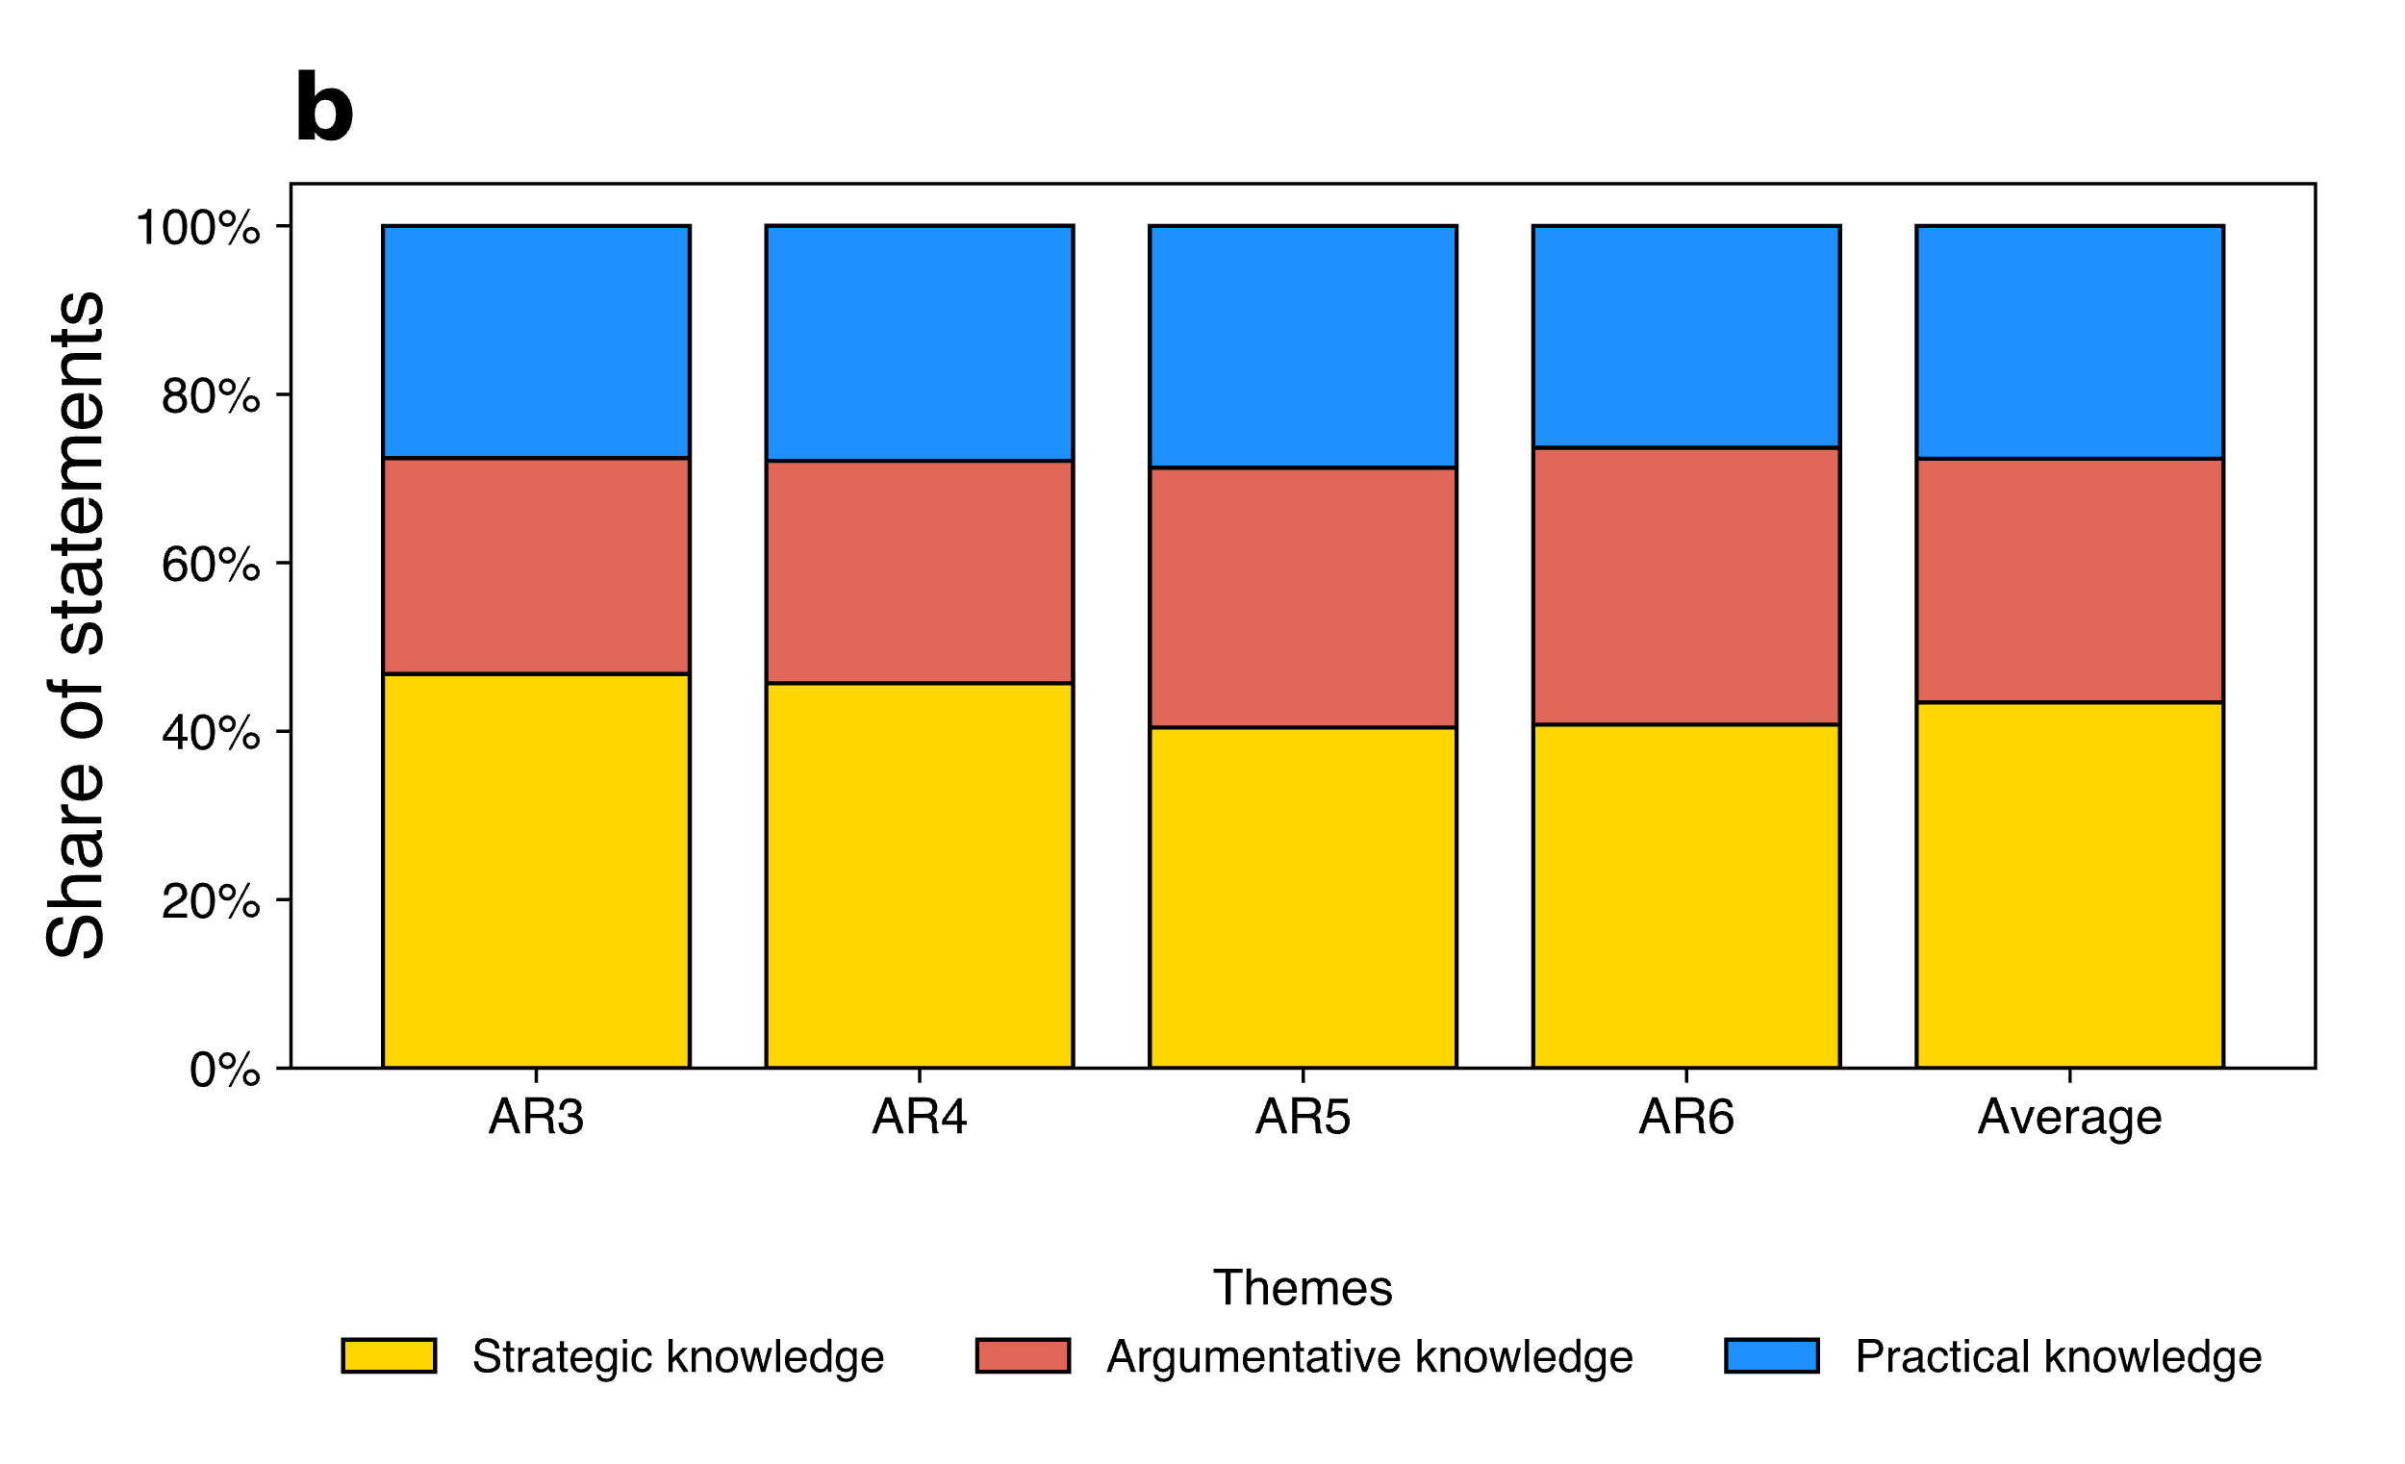
Figure 4. Altered topic classification (a) and distribution of themes (b)
‘Actors’ characterizes statements where international organizations, national governments, private organizations or individuals take center stage. We categorize these statements as ‘Strategic knowledge’ because shedding light on who is to undertake mitigation is strategic information that guides policy. However, it is also plausible that this is considered “Practical knowledge’ since it may help get the right actors on the table when developing policy. If we re-classify the topics in this way (see Figure 5a), then theme distribution and ranking remains the same (see Figure 5b).
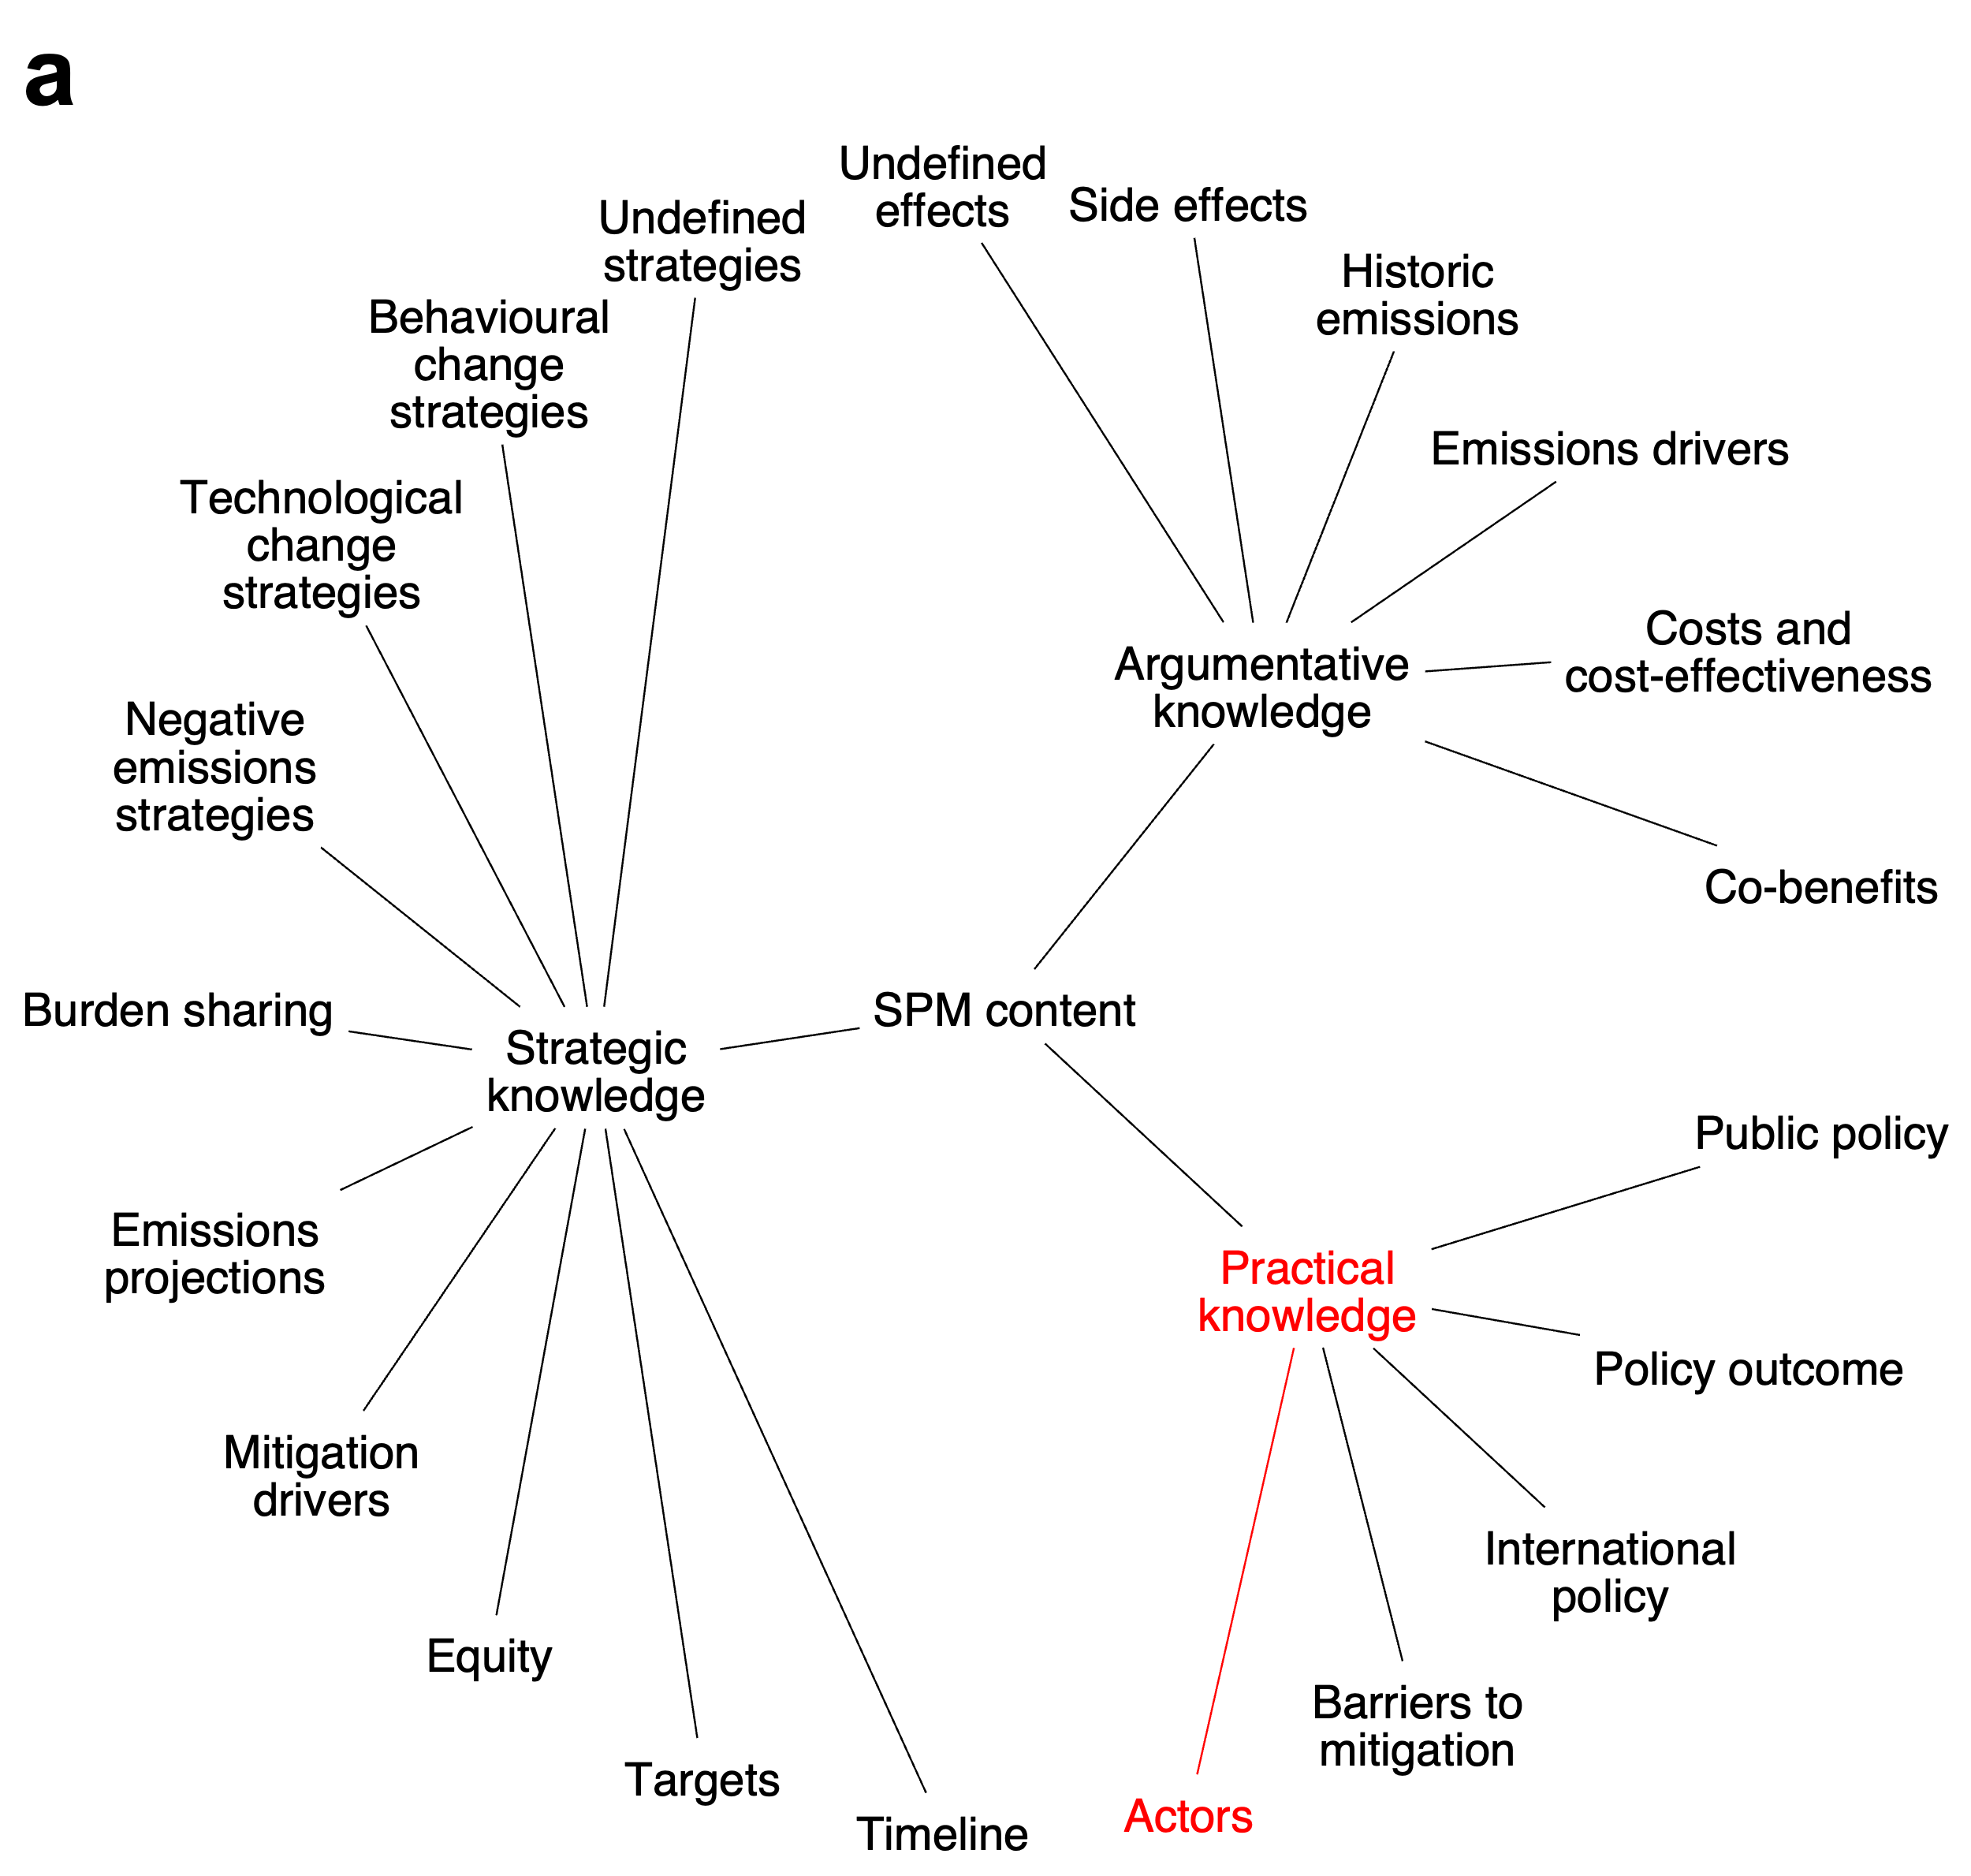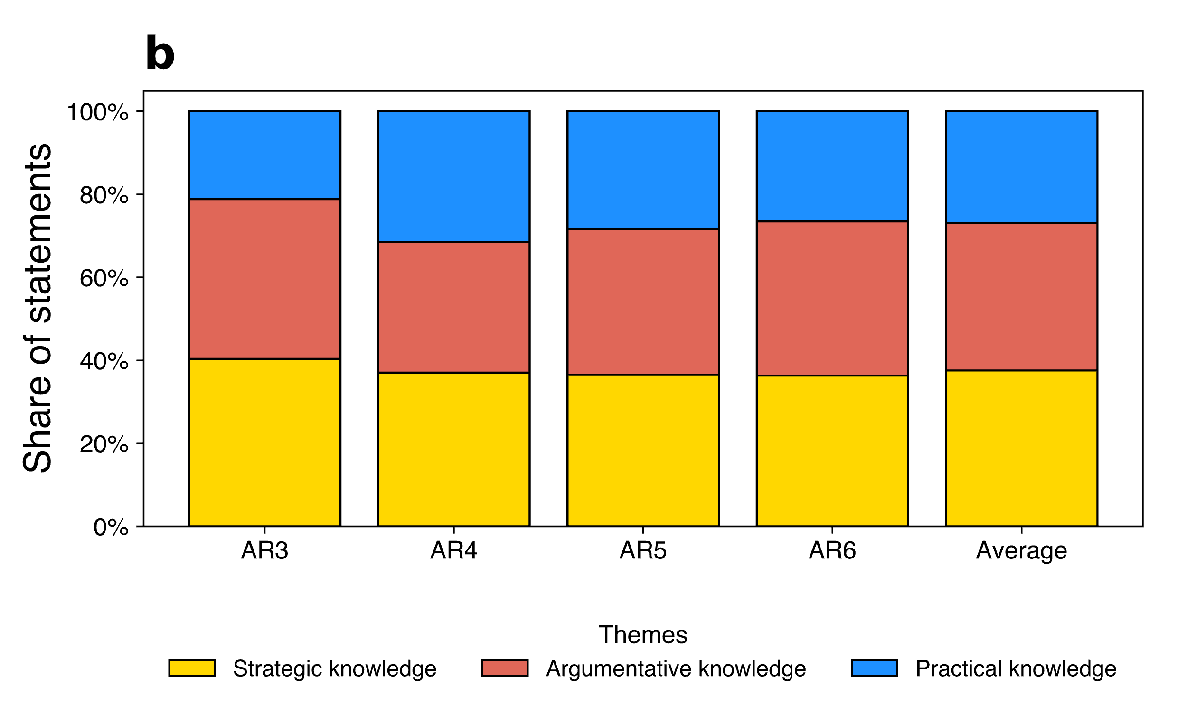
Figure 5. Altered topic classification (a) and distribution of themes (b)

