Supplementary Information

Ambiphilic Hydrogen in Tri-substituted Silanes: Substituent- Driven Polarity Flip Confirmed by NMR
P. Hobza et al.

Figure S1. The optimized geometries of silanes: a) SiH₄, b) F₃SiH, c) Cl₃SiH, d) Br₃SiH, e) (C₆F₅)₃Si-H, f) (CF₃)₃SiH, g) (CN)₃SiH, h) (NO₂)₃SiH, i) Ph₃SiH, j) (iPr)₃SiH, k) Me₃SiH, l) Et₃SiH, m) (Me₃Si)₃Si-H, n) (NH₂)₃SiH and o) (Me₂N)₃SiH. [C: grey, N: blue, H: white, Si: golden, O: red, F: cyan, Cl: green, Br: reddish-brown]
Table S1 The calculated Mulliken, Natural Bond Orbital, Hirshfeld, ADCH and CM5 charges (in e) on the H and C atoms of X₃C-H in various media at the PBE0-D3/def2-TZVPP level of theory. The extrema of the ESP on the molecular surface in the vicinity of H atom given in kcal/mol.
X₃C-H | Medium | Mulliken |  | NBO |  | Hirshfeld |  | ADCH |  | CM5 |  | ESP
X₃C-H | Medium | H | C | H | C | H | C | H | C | H | C | ESP
(CF₃)₃CH | Gas | 0.128 | -0.171 | 0.277 | -0.500 | 0.072 | -0.065 | 0.151 | -0.172 | 0.138 | -0.100 | 40.57
(CF₃)₃CH | BEN | 0.148 | -0.154 | 0.294 | -0.505 | 0.084 | -0.062 | 0.171 | -0.166 | 0.151 | -0.096 | 46.29
(CF₃)₃CH | o-DCB | 0.163 | -0.142 | 0.308 | -0.509 | 0.094 | -0.059 | 0.186 | -0.161 | 0.160 | -0.093 | 50.77
(CN)₃CH | Gas | 0.156 | 0.428 | 0.328 | -0.493 | 0.113 | 0.077 | 0.204 | 0.125 | 0.175 | 0.040 | 57.39
(CN)₃CH | BEN | 0.173 | 0.483 | 0.355 | -0.502 | 0.131 | 0.087 | 0.238 | 0.140 | 0.193 | 0.050 | 66.91
(CN)₃CH | o-DCB | 0.187 | 0.520 | 0.375 | -0.508 | 0.145 | 0.095 | 0.266 | 0.152 | 0.207 | 0.058 | 74.36
(NO₂)₃CH | Gas | 0.205 | -0.019 | 0.272 | 0.016 | 0.089 | 0.097 | 0.181 | -0.102 | 0.187 | 0.212 | 54.00
(NO₂)₃CH | BEN | 0.220 | 0.011 | 0.293 | 0.019 | 0.105 | 0.108 | 0.212 | -0.308 | 0.202 | 0.223 | 62.17
(NO₂)₃CH | o-DCB | 0.232 | 0.032 | 0.309 | 0.021 | 0.118 | 0.117 | 0.235 | -0.543 | 0.214 | 0.231 | 68.75
(NH₂)₃CH | Gas | 0.077 | 0.153 | 0.138 | 0.243 | 0.021 | 0.078 | 0.073 | 0.229 | 0.107 | 0.175 | 8.63
(NH₂)₃CH | BEN | 0.086 | 0.113 | 0.122 | 0.246 | 0.013 | 0.075 | 0.079 | 0.274 | 0.096 | 0.172 | 12.71
(NH₂)₃CH | o-DCB | 0.093 | 0.110 | 0.129 | 0.246 | 0.019 | 0.075 | 0.093 | 0.305 | 0.103 | 0.171 | 15.69
(Me₂N)₃CH | Gas | 0.055 | 0.097 | 0.155 | 0.282 | 0.021 | 0.091 | 0.060 | 0.156 | 0.114 | 0.204 | 8.79
(Me₂N)₃CH | BEN | 0.068 | 0.124 | 0.161 | 0.278 | 0.025 | 0.090 | 0.067 | 0.165 | 0.117 | 0.203 | 10.35
(Me₂N)₃CH | o-DCB | 0.076 | 0.099 | 0.163 | 0.280 | 0.026 | 0.090 | 0.070 | 0.179 | 0.119 | 0.202 | 11.30
(Me₃Si)₃CH | Gas | 0.078 | 0.010 | 0.284 | -1.663 | 0.040 | -0.270 | 0.129 | -0.346 | 0.112 | -0.216 | 13.34
(Me₃Si)₃CH | BEN | 0.083 | 0.005 | 0.288 | -1.664 | 0.043 | -0.269 | 0.133 | -0.347 | 0.115 | -0.216 | 14.93
(Me₃Si)₃CH | o-DCB | 0.087 | 0.004 | 0.291 | -1.666 | 0.045 | -0.269 | 0.137 | -0.347 | 0.117 | -0.216 | 16.25

Table S2 The calculated Mulliken, Natural Bond Orbital, Hirshfeld, ADCH and CM5 charges (in e) on the H and Al atoms of X₂Al-H at the PBE0-D3/def2-TZVPP level of theory. The extrema of the ESP on the molecular surface in the vicinity of H atom given in kcal/mol.
X₂Al-H | Medium | Mulliken |  | NBO |  | Hirshfeld |  | ADCH |  | CM5 |  | ESP
X₂Al-H | Medium | H | Al | H | Al | H | Al | H | Al | H | Al | ESP
(CF₃)₂AlH | Gas | -0.091 | 0.507 | -0.369 | 1.298 | -0.124 | 0.560 | -0.083 | 0.442 | -0.046 | 0.428 | 7.19
(CF₃)₂AlH | BEN
(CF₃)₂AlH | o-DCB
(CN)₂AlH | Gas | -0.093 | 0.695 | -0.336 | 1.449 | -0.116 | 0.645 | -0.082 | 0.504 | -0.036 | 0.504 | 12.26
(CN)₂AlH | BEN | -0.140 | 0.847 | -0.399 | 1.618 | -0.132 | 0.773 | -0.106 | 0.858 | -0.055 | 0.641 | 14.25
(CN)₂AlH | o-DCB | -0.182 | 1.004 | -0.460 | 1.799 | -0.148 | 0.917 |  |  | -0.075 | 0.796
(NO₂)₂AlH | Gas | -0.127 | 0.562 | -0.369 | 1.535 | -0.131 | 0.489 | -0.097 | 0.083 | -0.047 | 0.489 | 2.77
(NO₂)₂AlH | BEN | -0.131 | 0.842 | -0.448 | 1.946 | -0.133 | 0.771 | -0.097 | 0.716 | -0.055 | 0.726 | 9.92
(NO₂)₂AlH | o-DCB | -0.185 | 1.067 | -0.509 | 2.088 | -0.154 | 0.912 | -0.463 | 1.671 | -0.080 | 0.868 | 11.91
(NH₂)₂AlH | Gas | -0.148 | 0.513 | -0.405 | 1.665 | -0.155 | 0.461 | -0.139 | 0.380 | -0.077 | 0.463 | -14.17
(NH₂)₂AlH | BEN | -0.207 | 0.498 | -0.455 | 1.791 | -0.177 | 0.536 | -0.178 | 0.465 | -0.102 | 0.537 | -16.05
(NH₂)₂AlH | o-DCB | -0.281 | 0.663 | -0.508 | 1.913 | -0.201 | 0.622 | -0.214 | 0.584 | -0.131 | 0.623 | -18.38
(Me₂N)₂AlH | Gas | -0.141 | 0.338 | -0.399 | 1.660 | -0.152 | 0.450 | -0.144 | 0.359 | -0.074 | 0.451 | -13.34
(Me₂N)₂AlH | BEN | -0.207 | 0.498 | -0.455 | 1.791 | -0.177 | 0.536 | -0.178 | 0.465 | -0.102 | 0.537 | -16.05
(Me₂N)₂AlH | o-DCB | -0.281 | 0.663 | -0.508 | 1.913 | -0.201 | 0.622 | -0.214 | 0.585 | -0.131 | 0.623 | -18.3
(Me₃Si)₂AlH | Gas | -0.131 | 0.301 | -0.389 | 0.797 | -0.168 | 0.297 | -0.130 | 0.211 | -0.097 | 0.229 | -15.33
(Me₃Si)₂AlH | BEN
(Me₃Si)₂AlH | o-DCB

Table S3 The calculated Mulliken, Natural Bond Orbital, Hirshfeld, ADCH and CM5 charges (in e) on the H and P atoms of X₂P-H at the PBE0-D3/def2-TZVPP level of theory. The extrema of the ESP on the molecular surface in the vicinity of H atom given in kcal/mol.
X₂P-H | Medium | Mulliken |  | NBO |  | Hirshfeld |  | ADCH |  | CM5 |  | ESP
X₂P-H | Medium | H | P | H | P | H | P | H | P | H | P | ESP
(CF₃)₂PH | Gas | 0.056 | 0.049 | 0.009 | 0.373 | 0.015 | 0.106 | 0.095 | -0.023 | 0.101 | -0.035 | 25.59
(CF₃)₂PH | BEN | 0.070 | 0.060 | 0.025 | 0.380 | 0.026 | 0.117 | 0.118 | -0.015 | 0.113 | -0.025 | 30.02
(CF₃)₂PH | o-DCB | 0.081 | 0.068 | 0.03 | 0.386 | 0.035 | 0.126 | 0.137 | -0.008 | 0.122 | -0.016 | 33.69
(CN)₂PH | Gas | 0.080 | 0.248 | 0.042 | 0.571 | 0.038 | 0.259 | 0.110 | 0.209 | 0.123 | 0.111 | 35.67
(CN)₂PH | BEN | 0.096 | 0.284 | 0.062 | 0.586 | 0.053 | 0.286 | 0.135 | 0.254 | 0.139 | 0.139 | 42.73
(CN)₂PH | o-DCB | 0.109 | 0.315 | 0.079 | 0.600 | 0.066 | 0.309 | 0.156 | 0.289 | 0.151 | 0.162 | 48.68
(NO₂)₂PH | Gas | 0.114 | 0.229 | 0.009 | 0.668 | 0.028 | 0.252 | 0.095 | 0.151 | 0.129 | 0.229 | 34.01
(NO₂)₂PH | BEN | 0.130 | 0.263 | 0.024 | 0.700 | 0.041 | 0.285 | 0.113 | 0.191 | 0.142 | 0.261 | 39.87
(NO₂)₂PH | o-DCB | 0.142 | 0.291 | 0.037 | 0.726 | 0.052 | 0.311 | 0.128 | 0.225 | 0.153 | 0.288 | 44.78
(NH₂)₂PH | Gas | 0.004 | 0.170 | -0.086 | 0.882 | -0.025 | 0.096 | 0.080 | -0.083 | 0.070 | 0.065 | 1.63
(NH₂)₂PH | BEN | 0.003 | 0.145 | -0.089 | 0.861 | -0.029 | 0.075 | 0.092 | -0.126 | 0.065 | 0.045 | 2.95
(NH₂)₂PH | o-DCB | 0.009 | 0.130 | -0.085 | 0.843 | -0.027 | 0.061 | 0.105 | -0.163 | 0.066 | 0.030 | 3.45
(Me₂N)₂PH | Gas | -0.025 | 0.135 | -0.105 | 0.916 | -0.034 | 0.116 | 0.059 | -0.093 | 0.057 | 0.088 | 0.94
(Me₂N)₂PH | BEN | -0.017 | 0.113 | -0.098 | 0.900 | -0.031 | 0.101 | 0.074 | -0.134 | 0.061 | 0.073 | 1.57
(Me₂N)₂PH | o-DCB | -0.009 | 0.095 | -0.092 | 0.887 | -0.028 | 0.089 | 0.087 | -0.167 | 0.064 | 0.060 | 2.26
(Me₃Si)₂PH | Gas | 0.023 | -0.252 | 0.033 | -0.445 | -0.008 | -0.134 | 0.058 | -0.245 | 0.078 | -0.216 | 6.17
(Me₃Si)₂PH | BEN | 0.023 | -0.254 | 0.033 | -0.449 | -0.008 | -0.137 | 0.073 | -0.307 | 0.077 | -0.219 | 6.58
(Me₃Si)₂PH | o-DCB | 0.041 | -0.362 | 0.044 | -0.506 | -0.005 | -0.176 | 0.085 | -0.362 | 0.081 | -0.258 | 6.81

Table S4 The calculated Mulliken, Natural Bond Orbital, Hirshfeld, ADCH and CM5 charges (in e) on the H and Ge atoms of X₃Ge-H in the gas phase at the PBE0-D3/def2-TZVPP level of theory. The extrema of the ESP on the molecular surface in the vicinity of H atom given in kcal/mol.
X₃Ge-H | Mulliken |  | NBO |  |  | Hirshfeld |  | ADCH |  | CM5 |  |  | ESP
X₃Ge-H | H | Ge | H | Ge | H |  | Ge | H | Ge | H | Ge
GeH₄ | -0.018 | 0.071 | -0.113 | 0.452 | -0.063 |  | 0.251 | -0.029 | 0.115 | -0.004 | 0.014 | 2.07
F₃GeH | 0.006 | 1.003 | -0.214 | 2.174 | -0.002 |  | 0.691 | 0.040 | 0.667 | 0.062 | 0.656 | 28.33
Cl₃GeH | 0.040 | 0.739 | -0.131 | 1.221 | -0.021 |  | 0.430 | 0.042 | 0.286 | 0.042 | 0.329 | 20.50
Br₃GeH | 0.049 | 0.673 | -0.118 | 0.914 | -0.024 |  | 0.347 | 0.046 | 0.176 | 0.038 | 0.196 | 18.69
(C₆F₅)₃Ge-H | 0.056 | 0.405 | -0.096 | 1.279 | -0.045 |  | 0.355 | -0.013 | 0.460 | 0.021 | 0.257 | 10.72
(CF₃)₃GeH | 0.069 | 0.089 | -0.104 | 0.888 | -0.026 |  | 0.327 | 0.034 | 0.185 | 0.038 | 0.244 | 23.14
(CN)₃GeH | 0.102 | 0.350 | -0.058 | 1.128 | -0.002 |  | 0.523 | 0.055 | 0.348 | 0.062 | 0.433 | 36.19
(NO₂)₃GeH | 0.082 | 0.628 | -0.108 | 1.301 | 0.010 |  | 0.510 | 0.070 | 0.271 | 0.079 | 0.602 | 38.69
Ph₃GeH | -0.020 | 0.365 | -0.147 | 1.325 | -0.072 |  | 0.328 | -0.050 | 0.565 | -0.012 | 0.221 | -3.38ª/  -5.25
(iPr)₃GeH | -0.047 | 0.229 | -0.178 | 1.335 | -0.084 |  | 0.321 | -0.075 | 0.246 | -0.025 | 0.196 | -7.11ª/  -7.99
Me₃GeH | -0.053 | 0.329 | -0.178 | 1.327 | -0.087 |  | 0.344 | -0.076 | 0.280 | -0.028 | 0.211 | -6.60ª/  -7.20
Et₃GeH | -0.052 | 0.265 | -0.181 | 1.326 | -0.087 |  | 0.329 | -0.081 | 0.253 | -0.028 | 0.199 | -7.29ª/  -7.71
(Me₃Ge)₃GeH | -0.032 | -0.145 | -0.079 | -0.205 | -0.076 |  | 0.024 | -0.026 | -0.099 | -0.016 | -0.040 | -5.12ª/  -6.80
(NH₂)₃GeH | -0.057 | 0.529 | -0.217 | 1.758 | -0.077 |  | 0.423 | -0.056 | 0.502 | -0.012 | 0.513
(Me₂N)₃GeH | -0.038 | 0.330 | -0.206 | 1.828 | -0.070 |  | 0.432 | -0.050 | 0.427 | -0.004 | 0.536
ª The V_{s,min} of H atom on the extension of Ge-H.
Table S5 The calculated Mulliken, Natural Bond Orbital, Hirshfeld, ADCH and CM5 charges (in e) on the H and Sn atoms of X₃Sn-H in the gas phase at the PBE0-D3/def2-TZVPP level of theory. The extrema of the ESP on the molecular surface in the vicinity of H atom given in kcal/mol.
X₃Sn-H | Mulliken |  | NBO |  | Hirshfeld |  | ADCH |  |  | CM5 |  |  | ESP
X₃Sn-H | H | Sn | H | Sn | H | Sn | H | Sn | H |  | Sn
SnH₄ | -0.118 | 0.470 | -0.166 | 0.662 | -0.079 | 0.314 | -0.053 | 0.211 | -0.032 |  | 0.127 | -0.024ª/  -0.829
F₃SnH | -0.066 | 1.426 | -0.240 | 2.318 | -0.001 | 0.823 | 0.037 | 0.814 | 0.050 |  | 0.867 | 31.14
Cl₃SnH | -0.072 | 1.054 | -0.161 | 1.430 | -0.023 | 0.533 | 0.041 | 0.403 | 0.026 |  | 0.504 | 22.10
Br₃SnH | -0.069 | 0.938 | -0.148 | 1.149 | -0.029 | 0.436 | 0.045 | 0.275 | 0.019 |  | 0.356 | 19.28
(C₆F₅)₃SnH | -0.064 | 0.931 | -0.144 | 1.414 | -0.053 | 0.439 | -0.021 | 0.381 | -0.002 |  | 0.417 | 10.54
(CF₃)₃SnH | -0.066 | 0.421 | -0.157 | 0.985 | -0.041 | 0.412 | 0.012 | 0.277 | 0.008 |  | 0.398 | 19.69
(CN)₃SnH | -0.045 | 1.071 | -0.109 | 1.336 | -0.014 | 0.639 | 0.036 | 0.419 | 0.037 |  | 0.620 | 34.66
(NO₂)₃SnH | -0.031 | 0.921 | -0.165 | 1.391 | -0.006 | 0.600 | 0.044 | 0.507 | 0.045 |  | 0.754 | 34.29
Ph₃SnH | -0.132 | 0.973 | -0.197 | 1.427 | -0.086 | 0.395 | -0.069 | 0.579 | -0.039 |  | 0.361 | -4.71ª/  -5.51
(iPr)₃SnH | -0.146 | 0.698 | -0.224 | 1.361 | -0.102 | 0.376 | -0.105 | 0.307 | -0.056 |  | 0.324 | -9.24ª/  -9.54
Me₃SnH | -0.160 | 0.851 | -0.224 | 1.347 | -0.102 | 0.410 | -0.104 | 0.352 | -0.056 |  | 0.347 | -8.23ª/  -8.49
Et₃SnH | -0.160 | 0.786 | -0.229 | 1.338 | -0.104 | 0.389 | -0.112 | 0.320 | -0.058 |  | 0.331 | -9.37ª/  -9.54
(Me₃Sn)₃SnH | -0.118 | -0.149 | -0.120 | -0.179 | -0.090 | 0.038 | -0.041 | -0.096 | -0.044 |  | -0.009 | -6.64ª/  -7.57
(NH₂)₃SnH | -0.155 | 1.042 | -0.255 | 1.837 | -0.086 | 0.513 | -0.071 | 0.568 | -0.038 |  | 0.690 | 1.20ª/  1.11
(Me₂N)₃SnH | -0.125 | 0.995 | -0.236 | 1.920 | -0.073 | 0.521 | -0.051 | 0.519 | -0.023 |  | 0.718 | 0.05
ª The V_{s,min} of H atom on the extension of Sn-H.
Table S6 The calculated Mulliken, Natural Bond Orbital, Hirshfeld, ADCH and CM5 charges (in e) on the H and Pb atoms of X₃Pb-H in the gas phase at the PBE0-D3/def2-TZVPP level of theory. The extrema of the ESP on the molecular surface in the vicinity of H atom given in kcal/mol.
X₃Pb-H | Mulliken |  | NBO |  | Hirshfeld |  | ADCH |  |  | CM5 |  |  | ESP
X₃Pb-H | H | Pb | H | Pb | H | Pb |  | H | Pb |  | H | Pb
PbH₄ | -0.109 | 0.434 | -0.124 | 0.498 | -0.062 | 0.245 |  | -0.045 | 0.181 |  | -0.026 | 0.106 |  | 0.70ª/  -0.25
F₃PbH | -0.016 | 1.371 | -0.138 | 2.142 | 0.058 | 0.794 |  | 0.100 | 0.814 |  | 0.097 | 0.879 |  | 42.78
Cl₃PbH | -0.038 | 1.016 | -0.085 | 1.313 | 0.022 | 0.520 |  | 0.088 | 0.421 |  | 0.059 | 0.542 |  | 30.08
Br₃PbH | -0.044 | 0.914 | -0.083 | 1.052 | 0.010 | 0.424 |  | 0.086 | 0.287 |  | 0.045 | 0.401 |  | 25.71
(C₆F₅)₃PbH | -0.066 | 0.871 | -0.102 | 1.260 | -0.027 | 0.397 |  | -0.007 | 0.291 |  | 0.010 | 0.431 |  | 14.88
(CF₃)₃PbH | -0.062 | 0.298 | -0.119 | 0.813 | -0.023 | 0.351 |  | 0.021 | 0.246 |  | 0.013 | 0.383 |  | 19.13
(CN)₃PbH | -0.012 | 0.943 | -0.044 | 1.198 | 0.026 | 0.601 |  | 0.072 | 0.388 |  | 0.065 | 0.634 |  | 41.21
(NO₂)₃PbH | -0.050 | 0.840 | -0.151 | 1.128 | -0.005 | 0.519 |  | 0.035 | 0.452 |  | 0.030 | 0.673 |  | 27.94
Ph₃PbH | -0.123 | 0.821 | -0.159 | 1.248 | -0.067 | 0.339 |  | -0.061 | 0.560 |  | -0.032 | 0.359 |  | -3.51ª/  -4.36
(iPr)₃PbH | -0.155 | 0.611 | -0.203 | 1.153 | -0.095 | 0.313 |  | -0.115 | 0.292 |  | -0.062 | 0.315 |  | -10.91ª/  -11.11
Me₃PbH | -0.154 | 0.753 | -0.191 | 1.151 | -0.087 | 0.351 |  | -0.103 | 0.338 |  | -0.054 | 0.341 |  | -8.04ª/  -8.30
Et₃PbH | -0.164 | 0.695 | -0.204 | 1.135 | -0.094 | 0.328 |  | -0.120 | 0.310 |  | -0.061 | 0.324 |  | -10.46ª/  -10.58
(Me₃Pb)₃PbH
(NH₂)₃PbH | -0.130 | 0.930 | -0.197 | 1.611 | -0.054 | 0.465 |  | -0.047 | 0.543 |  | -0.018 | 0.667 |  | 6.24
(Me₂N)₃PbH | -0.109 | 0.892 | -0.185 | 1.698 | -0.045 | 0.472 |  | -0.034 | 0.534 |  | -0.008 | 0.693 |  | 3.49
ª The V_{s,min} of H atom on the extension of Pb-H.

Materials
Tris(pentafluorophenyl)silane (TPFPS), triphenylsilane (TPS, 97%), triethylsilane (TES, 99 %), tetramethylsilane (TMS, >99%), and benzene-D₆ (99.6 atom% D) were purchased from Sigma Aldrich (Merck). 1,1,1,3,3,3-Hexamethyl-2-(trimethylsilyl)trisilane (tris(trimethylsilyl)silane, TTMSS, 95% (stabilized with 0.05 % TBBPA)) was purchased from BLDpharm. 1,2-Dichlorobenzene-D₄ (o-DCB-D₄, 98 atom% D) was purchased from Fisher Scientific. All the materials were used directly without additional purification.
Sample preparation
With the exception of tris(pentafluorophenyl)silane, 50 µmol of the silane of interest was dissolved in 700 µL of deuterated solvent and placed into the 5mm NMR tube (Wilmad®, >400 MHz) and capped. Tris(pentafluorophenyl)silane, was poorly soluble in both tested media; therefore, the tests were conducted with 4 µmol (2 mg) of the compound, resulting in only partial dissolution in all of the tested solvents. To the prepared sample of triphenylsilane in benzene-D₆, a small amount of TMS was added for referencing.
NMR measurements and data processing
NMR measurements were performed using a JEOL spectrometer JNM-ECZ400R with a superconducting coil having a magnetic field of 9.4 T (working frequency: 399.8 MHz for ¹H) equipped with a 5 mm liquid probe. The samples, spinning at 15 Hz, were measured under ambient temperature (20 °C) using a simple single pulse job for proton NMR measurement at 45 ° pulse angle with a relaxation delay of 5 s. Magnetic shim coils were adjusted automatically or manually along the Z1, Z2, Z3, and Z4 axes. After the measurements, the acquired spectra were processed and visualized using MestReNova software. First, zero- and first-order phase corrections were applied to the acquired spectra, followed by referencing with respect to solvent reference shifts: benzene-D₅ proton signal in benzene-D₆ to 7.16 ppm, and H4 proton signal of o-DCB to 6.94 ppm. In the case of the triphenylsilane spectrum measured in benzene-D₆, the referencing was done with respect to tetramethylsilane (0 ppm) due to the overlap of the solvent reference signal with the signal from triphenylsilane. The Si-H proton signal was recognized according to the presence of a doublet signal caused by ¹J-coupling of ²⁹Si-¹H nuclei with ¹J_{Si-H} constant ranging from 150 to 260 Hz, appearing as intense sidebands along the main ²⁸Si-¹H signal (singlet or heptet depending on the presence of other interacting ¹H or ¹⁹F nuclei). The chemical shift positions and ¹J_{Si-H} constants for all the tested silanes in various solvents are summarized in Table S7.

Table S7 Chemical shifts and ¹J ²⁹Si-¹H coupling constants of the tested silanes in both tested solvents.
solvent | silane
solvent | TPFPS |  | TTMSS |  | TES |  | TPS
solvent | δ (ppm) | ¹J_{Si-H} (Hz) | δ (ppm) | ¹J_{Si-H} (Hz) | δ (ppm) | ¹J_{Si-H} (Hz) | δ (ppm) | ¹J_{Si-H} (Hz)
Benz.-D₆ | 5.81 | 252.0 | 2.54 | 153.9 | 3.90 | 177.5 | 5.71 | 197.9
oDCB-D₄ | 5.95 | 252.4 | 2.31 | 154.2 | 3.69 | 177.5 | 5.50 | 198.4

NMR data
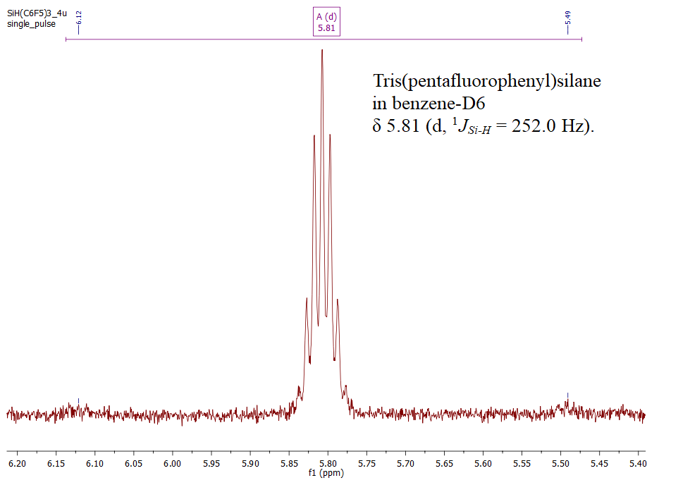
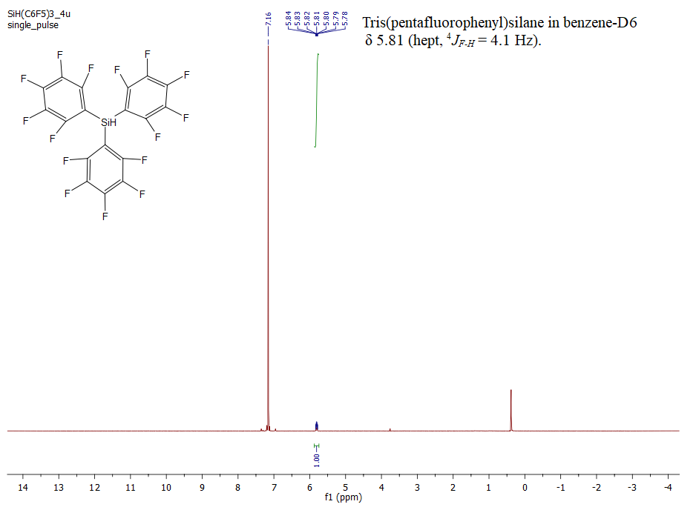
Figure S2 ¹H NMR spectrum of tris(pentafluorophenyl)silane in benzene-D₆ with the magnified region of the Si-H proton signal in the inset.

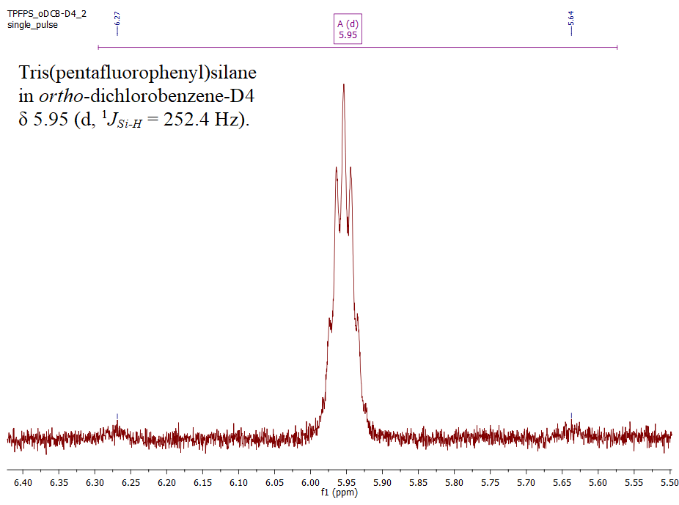
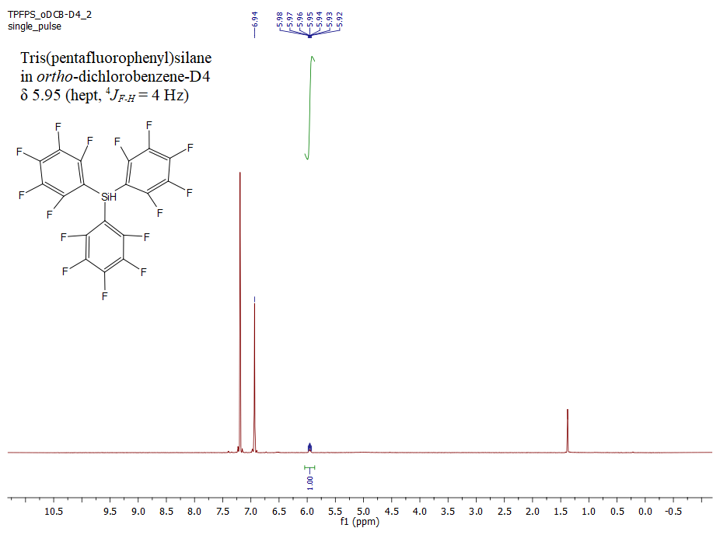
Figure S3 ¹H NMR spectrum of tris(pentafluorophenyl)silane in oDCB-D₄ with the magnified region of the Si-H proton signal in the inset.

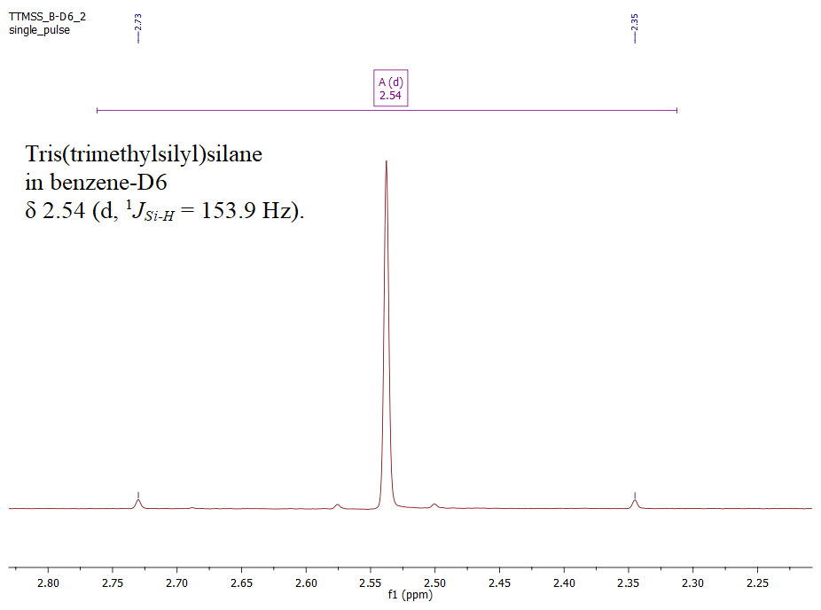
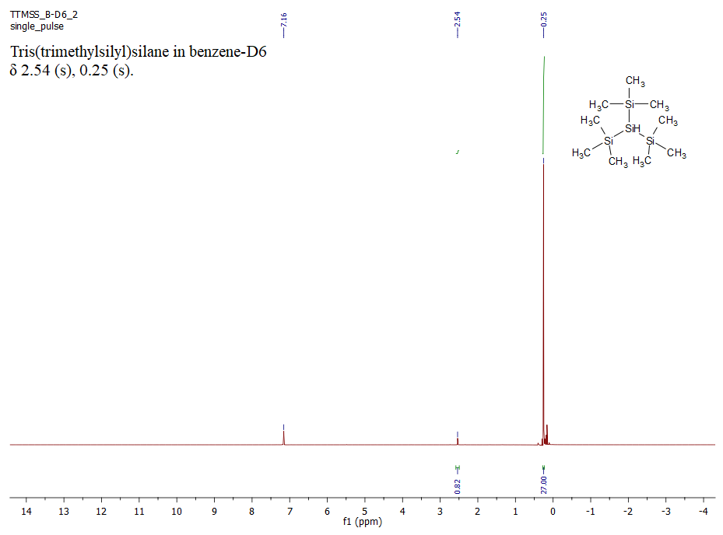
Figure S4 ¹H NMR spectrum of tris(trimethylsilyl)silane in benzene-D₆ with the magnified region of the Si-H proton signal in the inset.

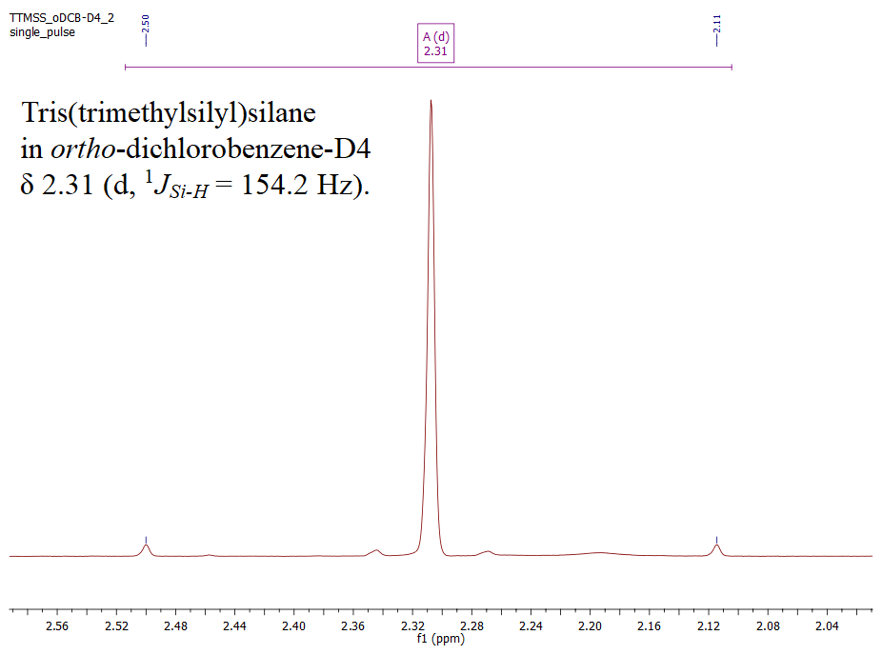
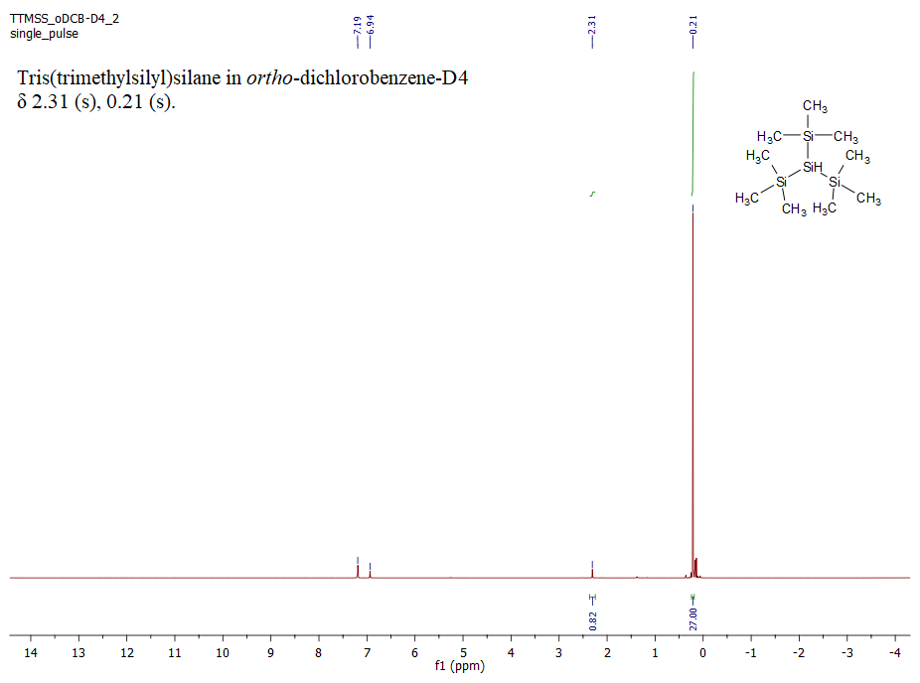
Figure S5 ¹H NMR spectrum of tris(trimethylsilyl)silane in oDCB-D₄ with the magnified region of the Si-H proton signal in the inset.

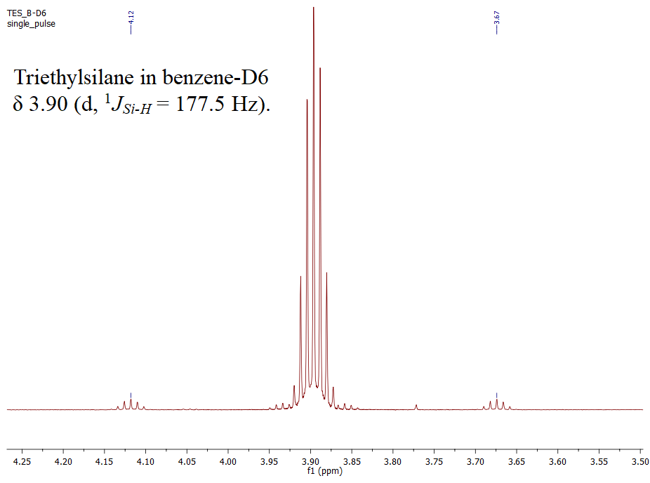
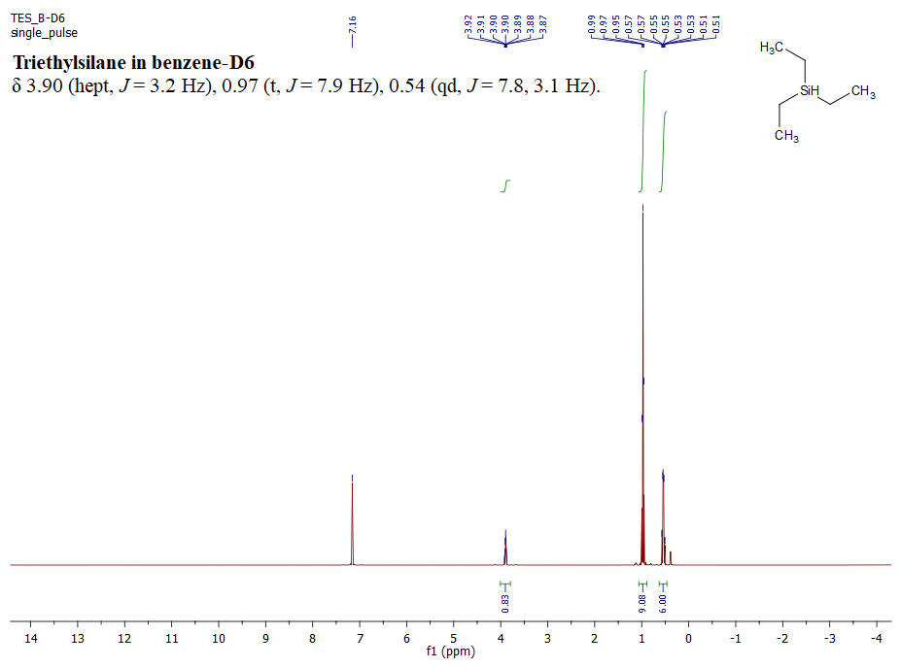
Figure S6 ¹H NMR spectrum of triethylsilane in benzene-D₆ with the magnified region of the Si-H proton signal in the inset.

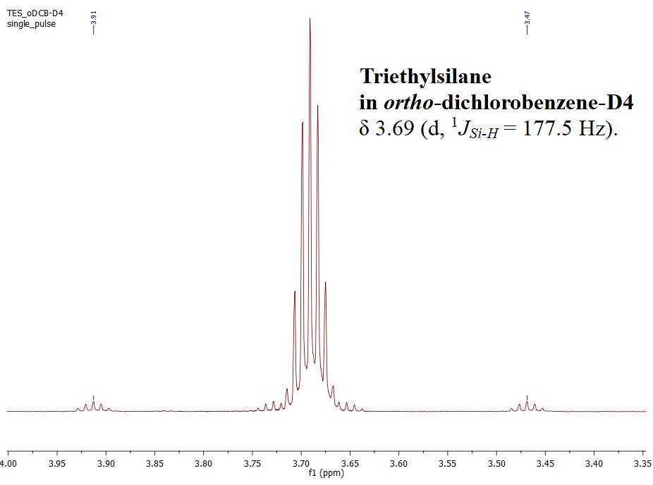
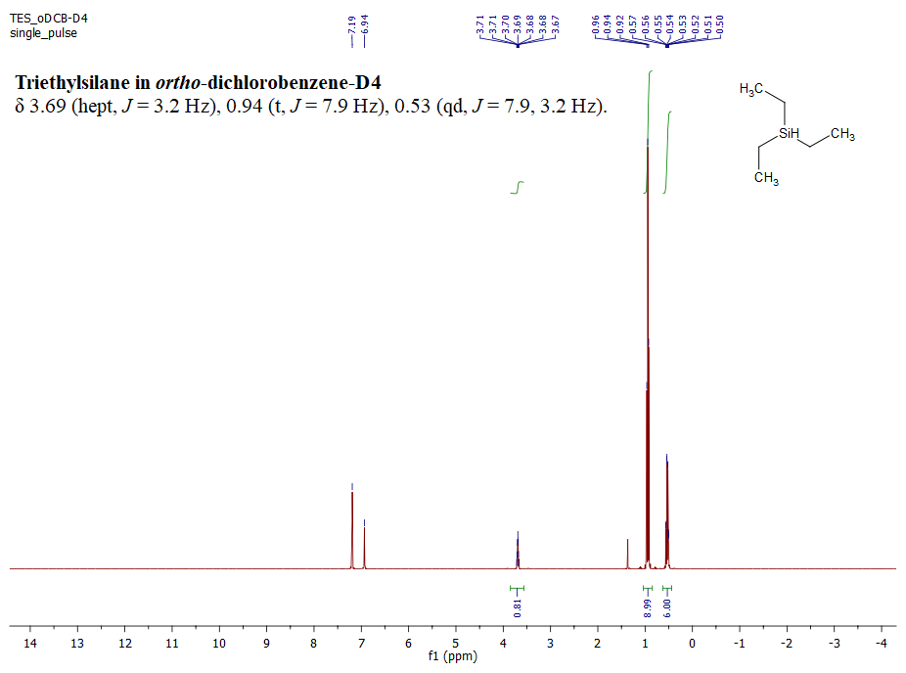
Figure S7 ¹H NMR spectrum of triethylsilane in oDCB-D₄ with the magnified region of the Si-H proton signal in the inset.

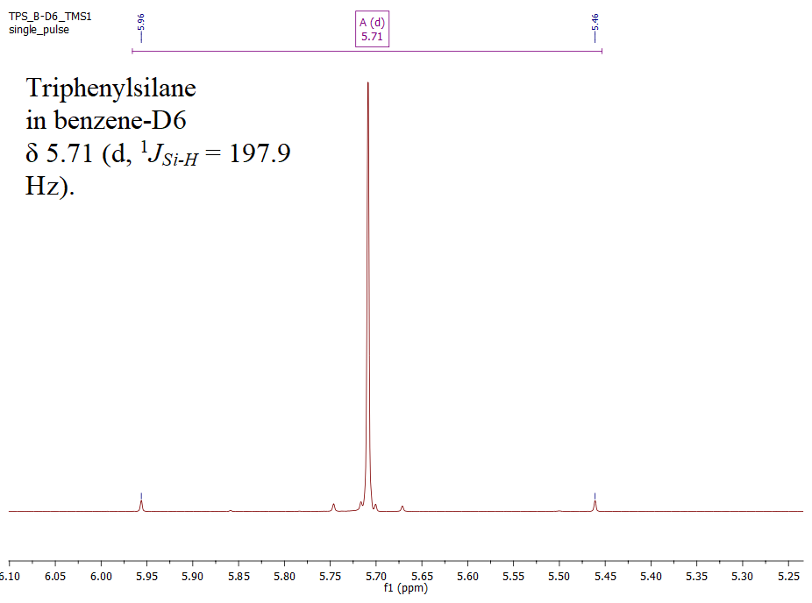
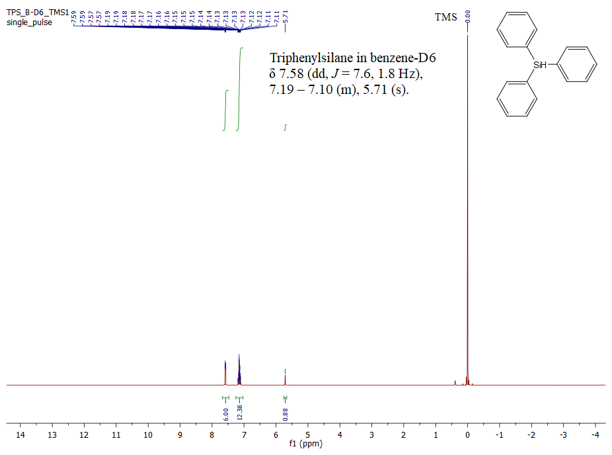
Figure S8 ¹H NMR spectrum of triphenylsilane in benzene-D₆ with the magnified region of the Si-H proton signal in the inset.
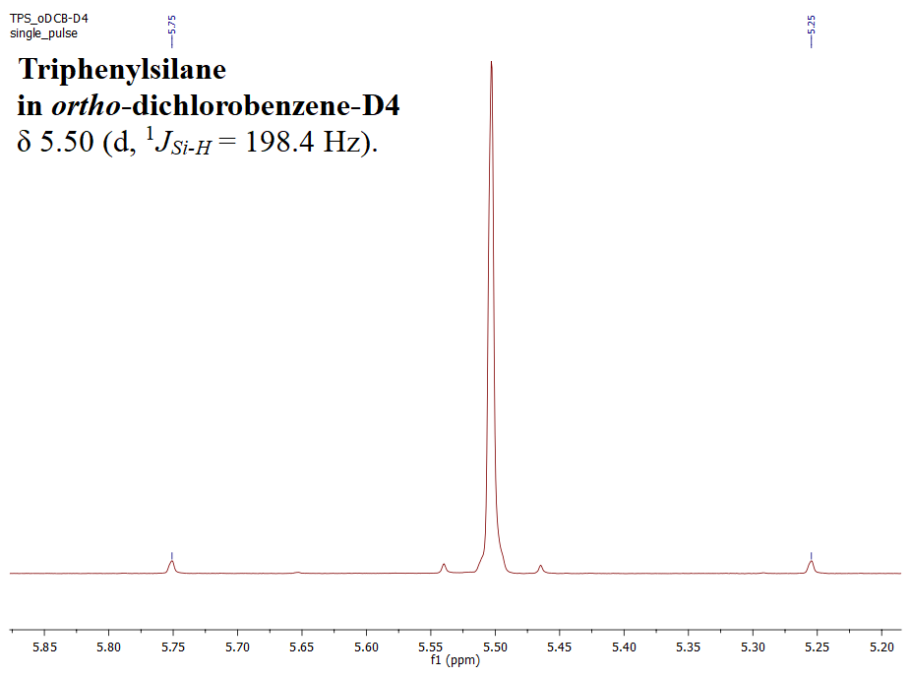
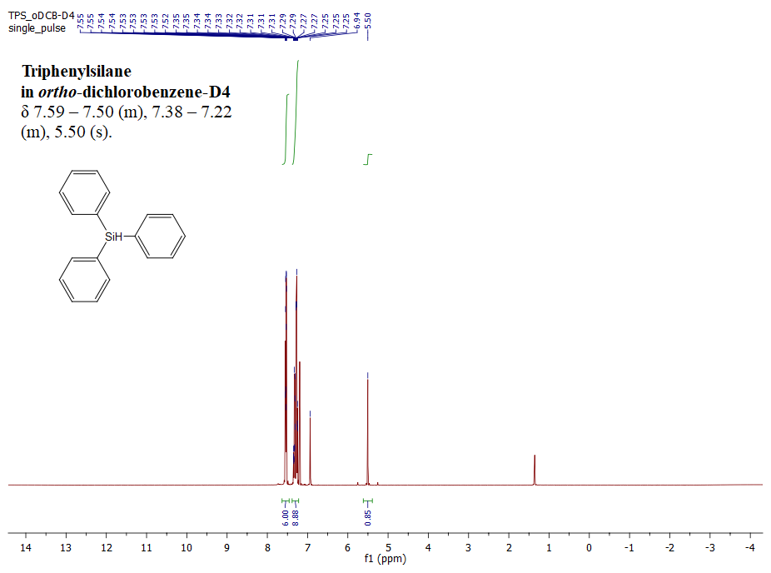
Figure S9 ¹H NMR spectrum of triphenylsilane in oDCB-D₄ with the magnified region of the Si-H proton signal in the inset.

