Supplementary table. 1 Primer sequences for Real-time PCR
Gene name | Sequence
GRIN3A | F-5'-CGGGACGCCCTCCTATTTG-3'
GRIN3A | R-5'-CCACGGTATGGCACACACT-3'
ENO2 | F: 5’-GAACTATCCTGTGGTCTCC-3’
ENO2 | R: 5’-CGACATTGGCTGTGAACTTG-3’
CHGA | F:5’-TGCCCAGAATGCACGCTAC-3’
CHGA | R: 5’-TTGGACCTTAGTGGAGTGGGA-3’
SYP | F: 5’-CCACCTCCTTCTCCAATCAGATG-3’
SYP | R: 5’-GGCAGGGCTCAGACAGATAAATA-3’
β-actin | F: 5’-CATGTACGTTGCTATCCAGGC-3’
β-actin | R: 5’-CTCCTTAATGTCACGCACGAT-3’

Supplementary Figure. 1
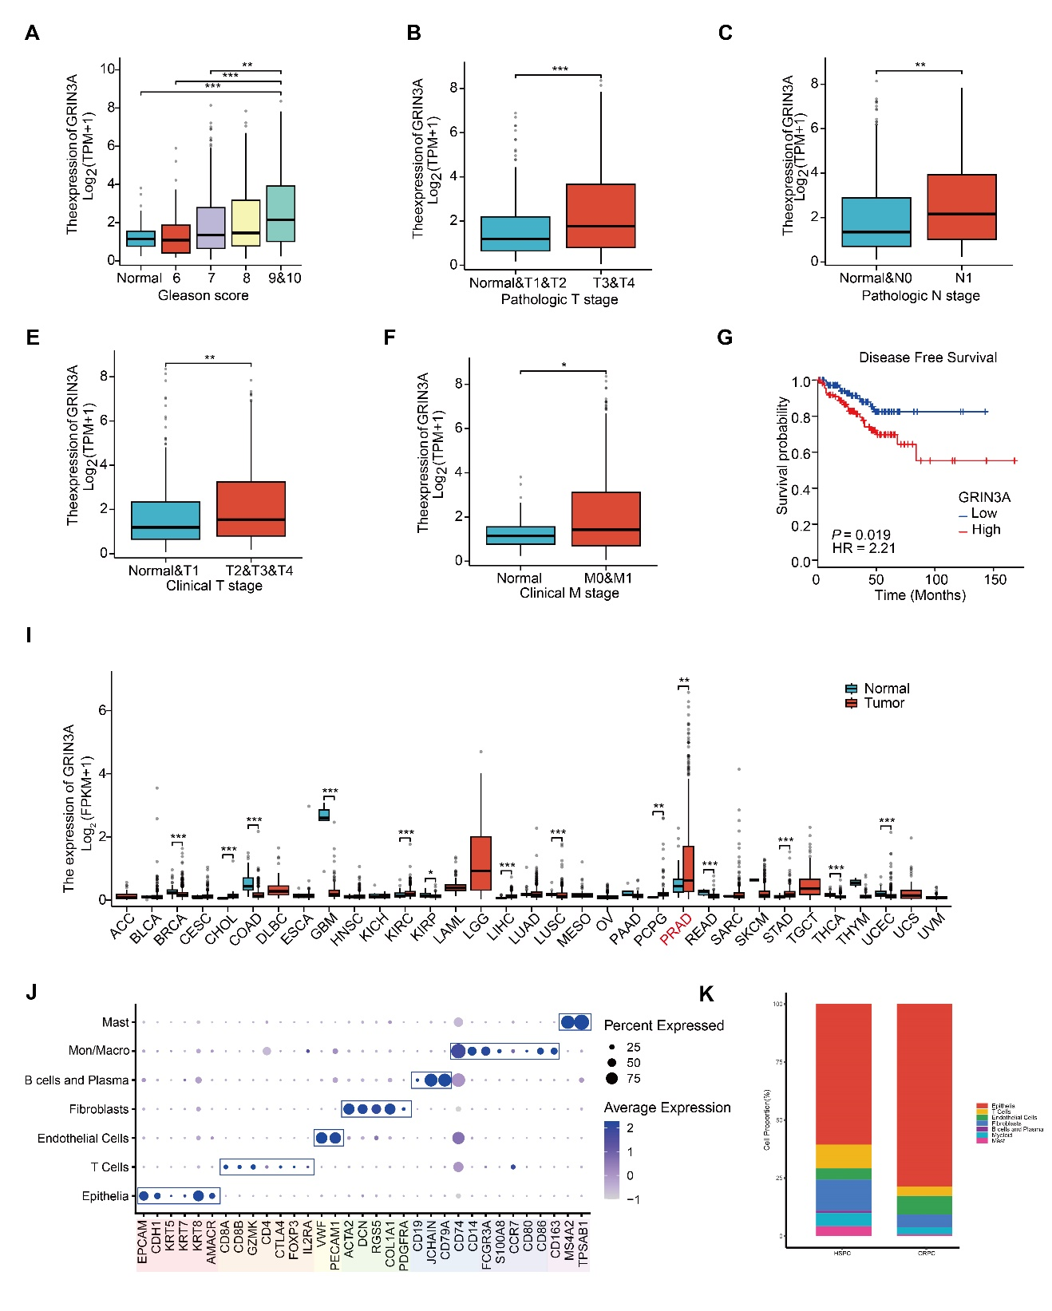
Supplementary Figure. 2

