SUPPLEMENTARY INFORMATION

Table S1 Determination of MIC
Times | MIC（μg/mL）
1 | 32
2 | 32
3 | 32
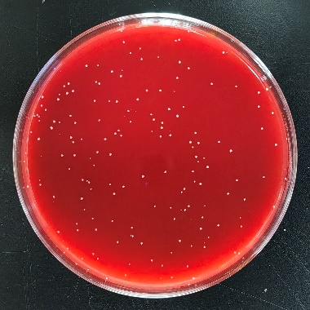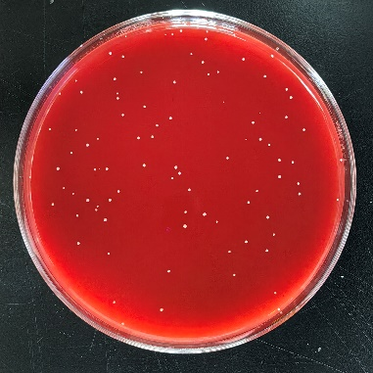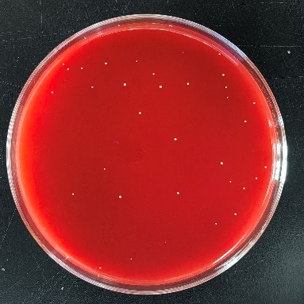
c
b
a
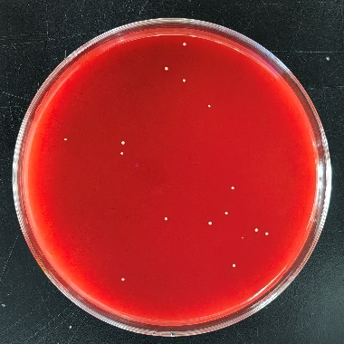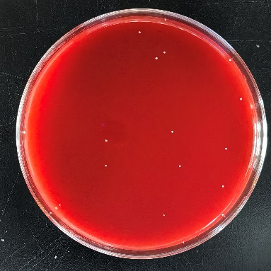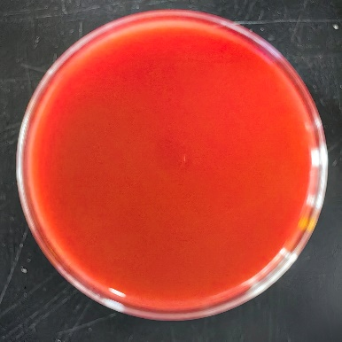
f
e
d
Fig. S1 Lysinibacillus sphaericus sp.1069 Minimum bactericidal concentration (a: 1.2MIC; b:1.4MIC; c: 1.6MIC; d: 1.8MIC; e: 2.0MIC; f: 2.2MIC)

