Appendix

Figure 7. The TFP growth in the Finnish ICT sector and the long-term trend. Source: Statistics Finland and own calculations
 | ICT | NIT | S
ICT-capital | 0.03 | 0.01 | 0.02
NIT-capital | 0.12 | 0.12 | 0.17
Service intermediate goods | 0.20 | 0.17 | 0.27
Labor | 0.18 | 0.24 | 0.39
ICT intermediate goods | 0.35 | 0.02 | 0.05
NIT intermediate goods | 0.12 | 0.44 | 0.10

Table 5. Factor shares in sectoral Cobb-Douglas production functions. ICT = ICT related manufacturing and services; traditional services = other private and public services; NIT = other industries, excluding primary production
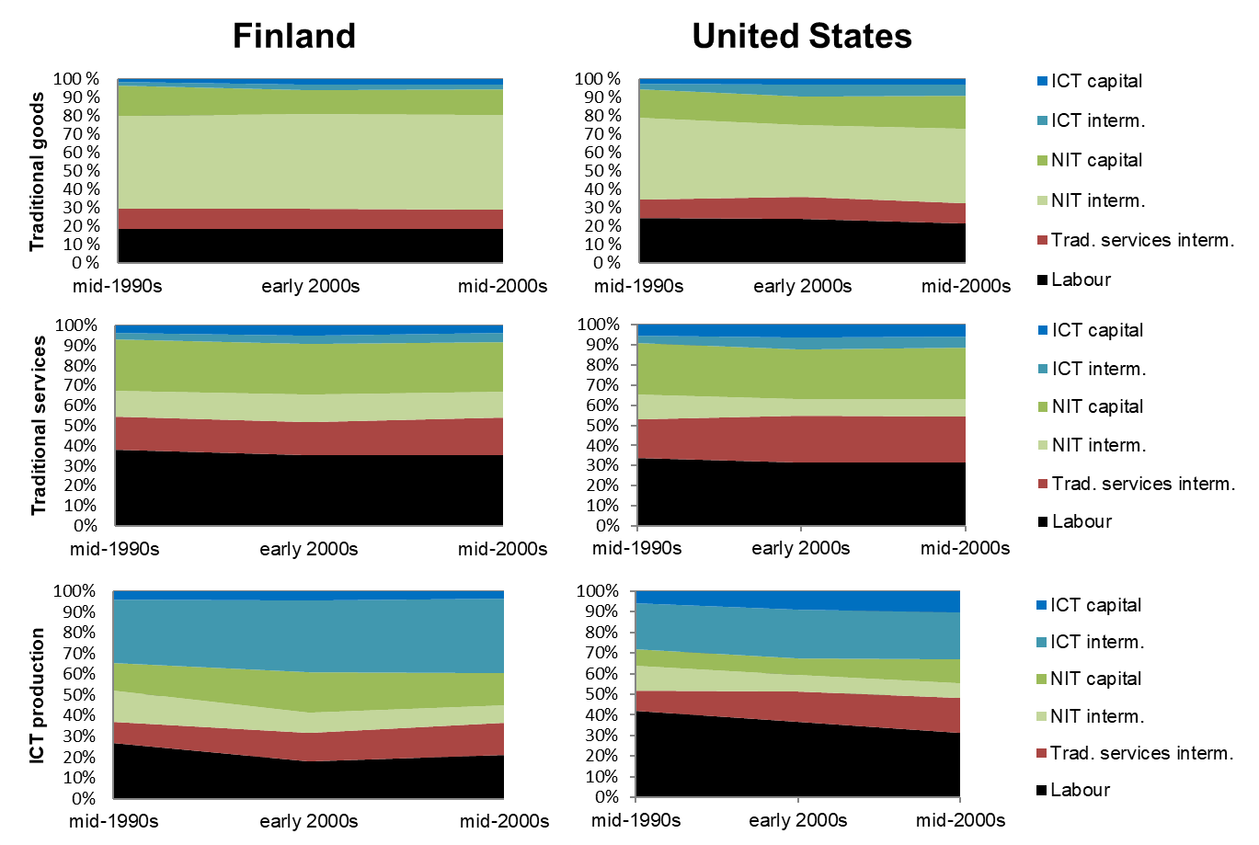
Figure 8. Nominal factor-share changes during the mid-1990s to mid-2000s period of the ICT revolution

Figure 9. A fitted line to the consumption data with the intratemporal elasticity of substitution receiving the value 0.5. Y-axis: the logratio of real consumption between traditional services and manufacturing. X-axis: the log-ratio of prices between traditional services and manufacturing. Source: Statistics Finland and own calculations

Figure 10. One-year real interest rate in different scenarios for different years. Period t marks the starting year of the GenAI shock (2023)

 | NIT sector investment per GDP, |  | Service sector investment per GDP |  | ICT sector investment per GDP |  | Aggregate investment per GDP
 | ICT | NIT | ICT | NIT | ICT | NIT | ICT capital | NIT capital | Total
Benchmark
 | 0.4 | 3.2 | 1.6 | 8.7 | 0.6 | 1.8 | 2.5 | 13.7 | 16.2
Baseline exposure, only labor
 | 0.4 | 3.2 | 1.6 | 8.6 | 0.6 | 1.8 | 2.5 | 13.6 | 16.1
Difference | 0.0 | 0.0 | 0.0 | -0.1 | 0.0 | 0.0 | -0.01 | -0.15 | -0.2
Baseline exposure, labor and capital
 | 0.4 | 3.2 | 1.6 | 8.5 | 0.6 | 1.8 | 2.5 | 13.5 | 16.0
Difference | 0.0 | 0.0 | 0.0 | -0.2 | 0.0 | 0.0 | -0.01 | -0.23 | -0.2
AI, extended capacities, only labor
 | 0.4 | 3.2 | 1.6 | 8.4 | 0.5 | 1.7 | 2.5 | 13.3 | 15.8
Difference | 0.0 | -0.1 | 0.0 | -0.3 | 0.0 | 0.0 | -0.03 | -0.44 | -0.5
Baseline exposure, only labor, 1pps increase in ICT factor share / decline in labor share
 | 0.3 | 3.0 | 1.6 | 7.7 | 0.6 | 1.9 | 2.5 | 12.6 | 15.2
Difference | 0.0 | -0.2 | 0.0 | -1.0 | 0.0 | 0.2 | 0.0 | -1.1 | -1.1

Table 6. investment rates in the scenarios. ICT = ICT related manufacturing and services; traditional services = other private and public services; NIT = other industries, excluding primary production

