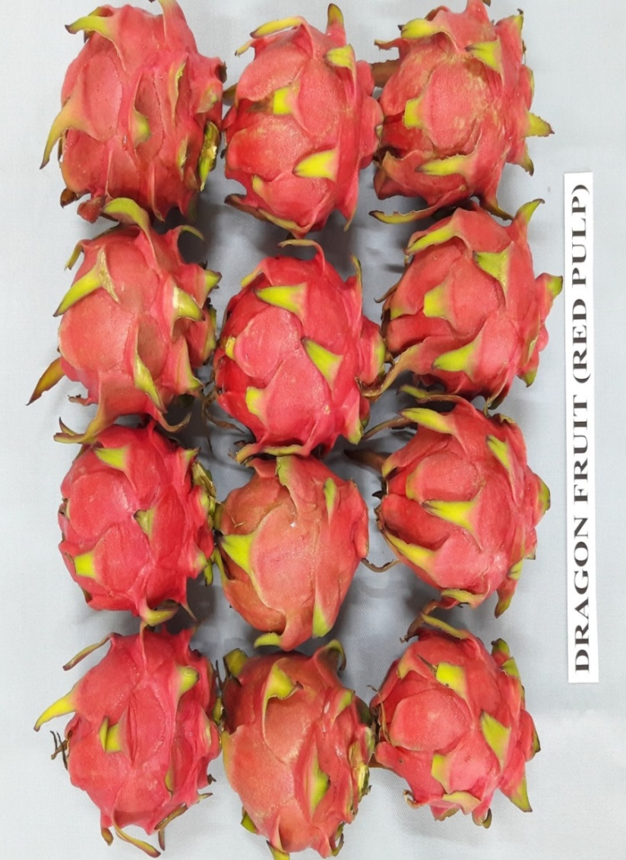

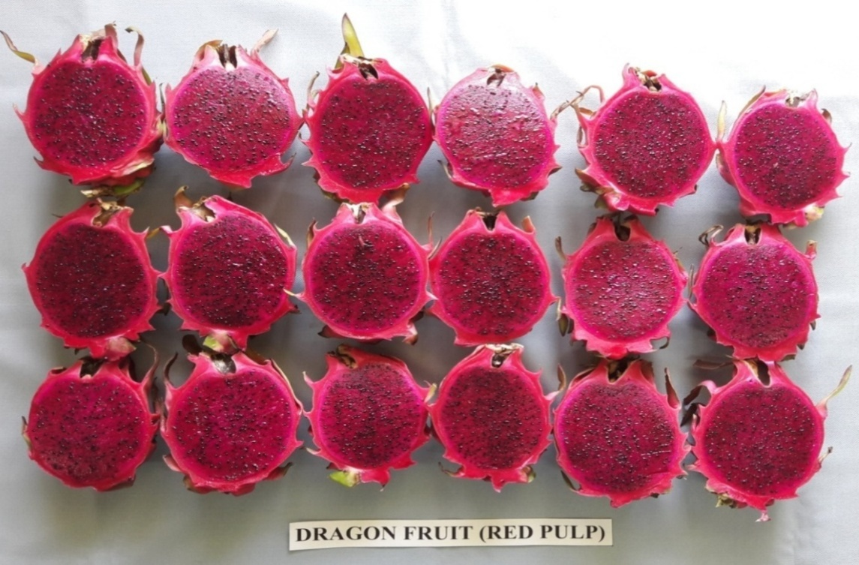

Plate 1: Uniform sized red pulp dragon fruits (Hylocereus polyrhizus) used in the experiment

