Supplementary Figure 1: Correlation matrix graph showing positive correlations between results from CIBERSORTx absolute score (ABS) and MCP-counter for all cell types evaluated. The circle size is inversely correlated with the magnitude of p-values.

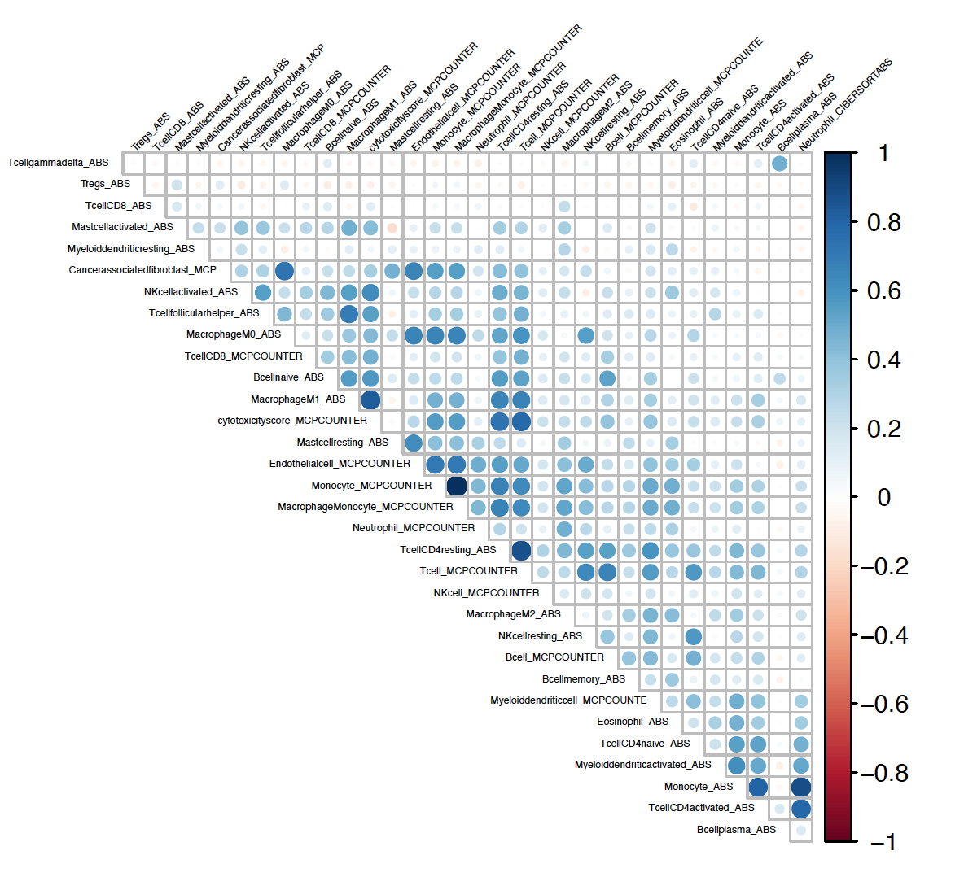

Supplementary Figure 2: Scatter plots showing the significant linear correlation between T cells abundance evaluated using IHC and (A) CIBERSORTx, and (B) MCP-counter.

Supplementary Figure 3: Relative fractions of infiltrating immune cells by CIBERSORTx in MBCs based on (A) TIDE responder status; (B) MBC cluster; (C) PV carrier status; (b) PAM50 molecular subtypes. *Significant differences.

Supplementary Figure 4: (A) Heatmap of the 2000 most variable transcripts among the whole series of MBC cases showing two clusters (Cluster 1 and Cluster 2). (B) Volcano Plot showing in red dots the 2338 differentially expressed genes between Cluster 1 and Cluster 2.

A
B

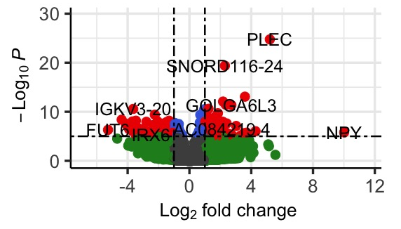
Supplementary Figure 5: Radar plot showing the absolute abundances of infiltrating immune cell types by CIBERSORTx based on MBC Cluster classification.

Supplementary Figure 6: Box plots showing differentially abundant infiltrating immune cell types and scores between MBCs based on clinical-pathologic features, including tumor grade, Ki67 expression, AR and HER2 status.

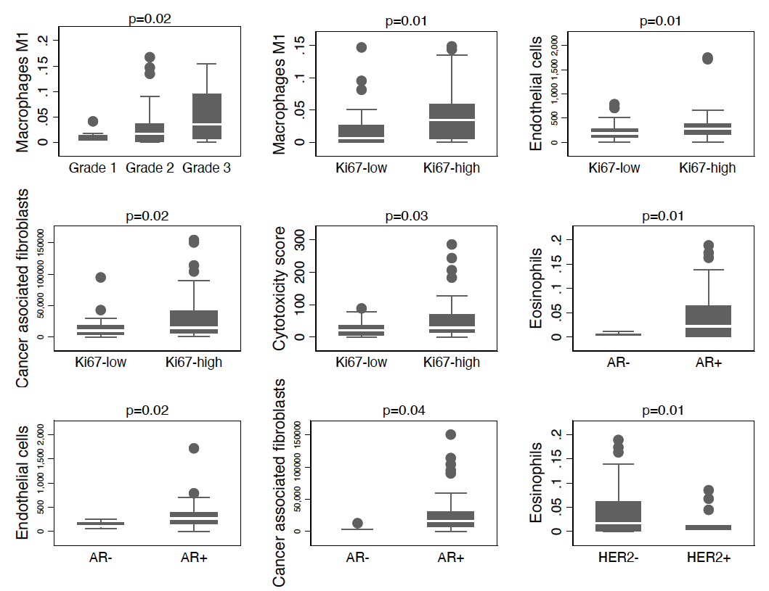

Supplementary Figure 7: Radar plot showing the absolute abundances of infiltrating immune cell types by CIBERSORTx based on PAM50 molecular subtypes.

