Supplementary material of “Natural images allow universal adversarial attacks on medical image classification using deep neural networks with transfer learning”

Akinori Minagi¹, Hokuto Hirano¹, Kazuhiro Takemoto^{1*}
1) Department of Bioscience and Bioinformatics, Kyushu Institute of Technology, Iizuka, Fukuoka 820-8502, Japan
*Corresponding author’s e-mail: takemoto@bio.kyutech.ac.jp

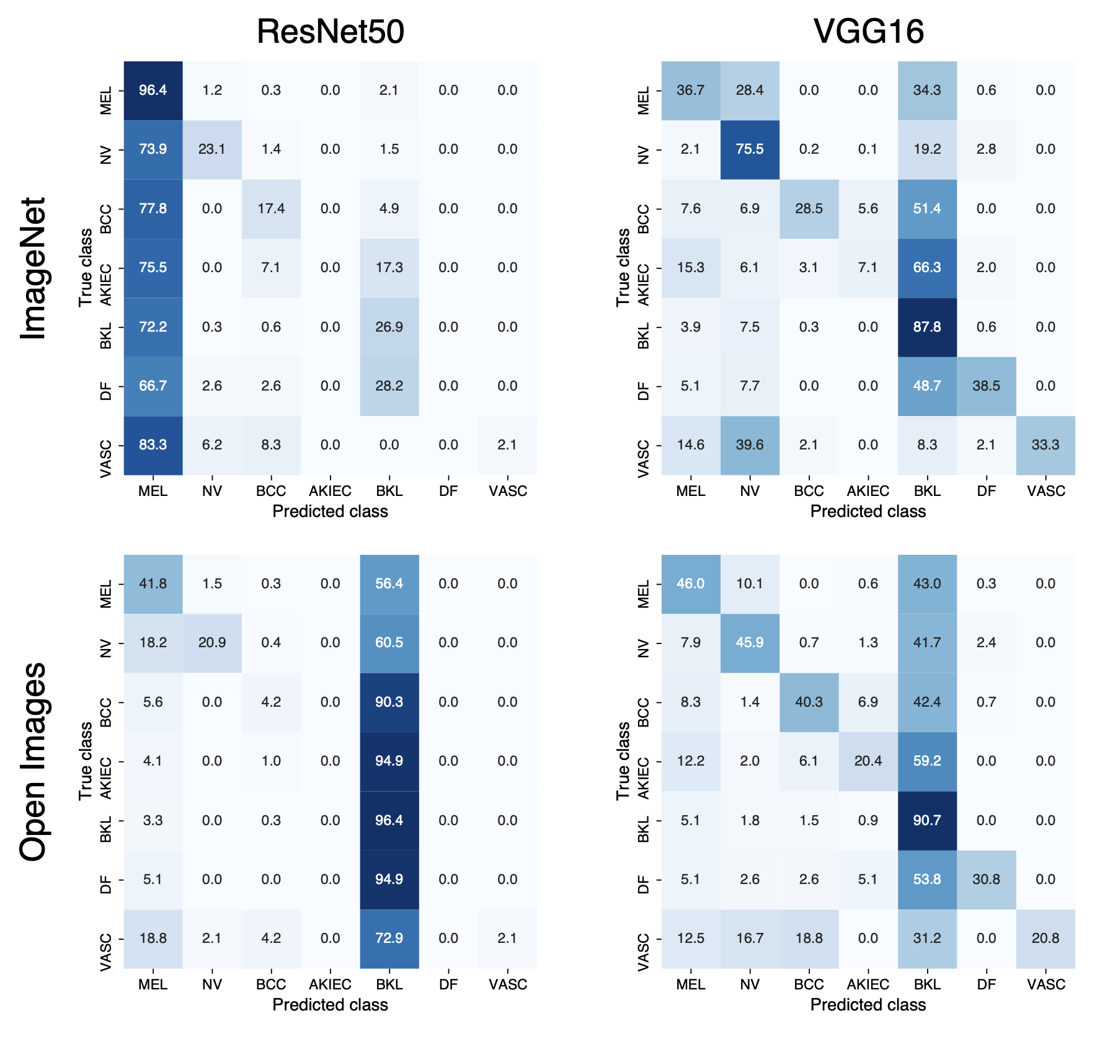
Supplementary Figure 1: Normalized confusion matrices for ResNet50 and VGG16 models attacked using nontargeted UAPs from ImageNet and Open Images datasets for skin lesions image classifications.

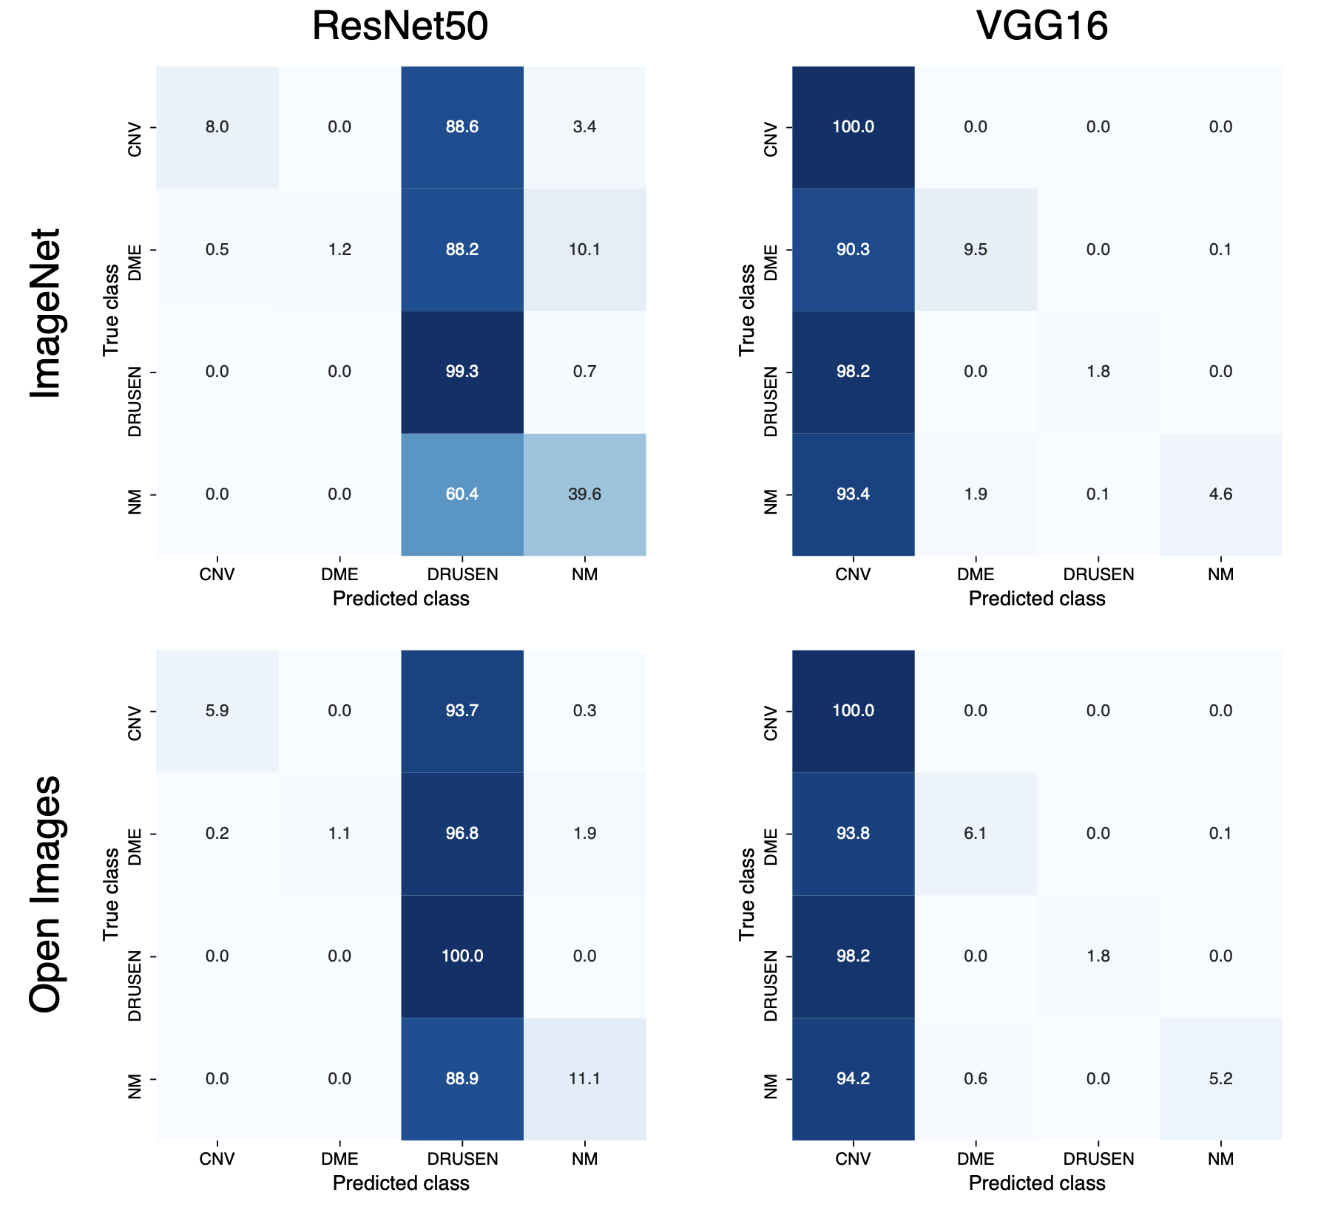
Supplementary Figure 2: Normalized confusion matrices for ResNet50 and VGG16 models attacked using nontargeted UAPs from ImageNet and Open Images datasets for OCT image classifications.

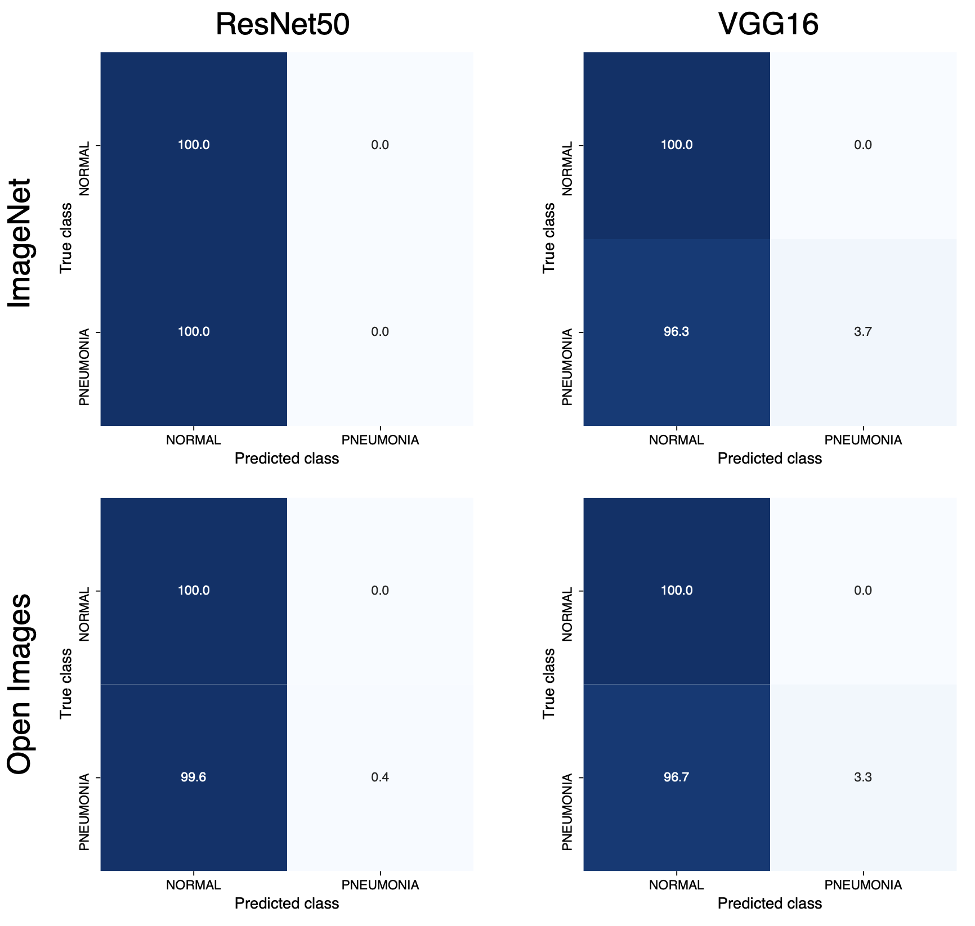
Supplementary Figure 3: Normalized confusion matrices for ResNet50 and VGG16 models attacked using nontargeted UAPs from ImageNet and Open Images datasets for chest X-ray image classifications.

Supplementary Table 1: Composition of the predicted labels of ImageNet and Open Images datasets from Inception V3, ResNet50, and VGG16 models for skin lesion image classification. Each dataset consists of randomly selected 100000 images.
Predicted labels | Inception V3 |  | ResNet50 |  | VGG16
Predicted labels | ImageNet | Open Images | ImageNet | Open Images | ImageNet | Open Images
MEL | 1722 | 803 | 14219 | 11776 | 5809 | 6768
NV | 43649 | 41742 | 56716 | 66536 | 78906 | 76445
BCC | 6556 | 7778 | 6471 | 4579 | 1844 | 2813
AKIEC | 478 | 775 | 363 | 371 | 26 | 42
BKL | 45563 | 46886 | 21709 | 15898 | 12730 | 12647
DF | 459 | 285 | 109 | 112 | 151 | 226
VASC | 1573 | 1731 | 413 | 728 | 534 | 1059

Supplementary Table 2: Composition of the predicted labels of ImageNet and Open Images datasets from Inception V3, ResNet50, and VGG16 models for OCT image classification. Each dataset consists of randomly selected 100000 images.
Predicted labels | Inception V3 |  | ResNet50 |  | VGG16
Predicted labels | ImageNet | Open Images | ImageNet | Open Images | ImageNet | Open Images
CNV | 33705 | 27581 | 92188 | 90611 | 62837 | 64580
DME | 53679 | 56899 | 1244 | 1267 | 34244 | 32294
DRUSEN | 7075 | 9337 | 5201 | 6836 | 1685 | 1739
NM | 5541 | 6183 | 1367 | 1286 | 1234 | 1387

Supplementary Table 3: Composition of the predicted labels of ImageNet and Open Images datasets from Inception V3, ResNet50, and VGG16 models for chest X-ray image classification. Each dataset consists of randomly selected 100000 images.
Predicted labels | Inception V3 |  | ResNet50 |  | VGG16
Predicted labels | ImageNet | Open Images | ImageNet | Open Images | ImageNet | Open Images
NORMAL | 18157 | 14100 | 19910 | 24069 | 17208 | 18625
PNEUMONIA | 81843 | 85900 | 80090 | 75931 | 82792 | 81375

