Supporting Information

Shielding surfaces from viruses and bacteria with a multifunctional coating
Deepu Ashok^{a,b}, Mahdiar Taheri^{c}, Daryl Webb^{d}, Pawan Parajuli^{e}, Puneet Garg^{a,b}, Yi Wangª, Bronte Funnellª, Bradley Taylorª, David C. Tscharke^{f}, Takuya Tsuzuki^{c}, Naresh K. Verma^{e}, Antonio Tricoli^{b,g}* & David R. Nisbetª*
ª Laboratory of Advanced Biomaterials, Research School of Chemistry and the John Curtin School of Medical Research, The Australian National University, Canberra, Australia, 2601
^{b} Nanotechnology Research Laboratory, Research School of Chemistry, The Australian National University, Canberra, Australia, 2601
^{c} Laboratory of Advanced Nanomaterials for Sustainability, Research School of Electrical, Energy and Materials Engineering, The Australian National University, Canberra, Australia, 2601
^{d} Centre for Advanced Microscopy, Australian National University, Canberra, Australia 2601
^{e} Division of Biomedical Science and Biochemistry, Research School of Biology, The Australian National University, Canberra, Australia, 2601
^{f} John Curtin School of Medical Research, Australian National University, 131 Garran Road, Acton, ACT, 2601, Australia
^{g} Nanotechnology Research Laboratory, Faculty of Engineering, The University of Sydney, Sydney, Australia, 2006

* Corresponding authors: david.nisbet@anu.edu.au, antonio.tricoli@sydney.edu.au

Table of Contents
Literature review 3
Materials and methods 6
Note 1: Morphology, chemistry and wettability of the coating 17
Note 2: Characterisation of the dual functional coating 19
Note 3: Robustness of the dual functional coatings for bacterial and virus shielding 23
Note 4: Shielding from virus uptake 25
Note 5: Failure kinetic of the water repellent shielding mechanism 27
References 31

This suplimentary file also includes:
- Figures S1 to S16
- Tables S1 to S3

Literature Review
Table S 1 Previous studies on evaluating bacterial adhesion on superhydrophobic water repellent coatings
Reference | Coating characteristics | Antibacterial  Protocol | Exposure time | % Reduction in adhesion |  | Inference
 |  |  |  | Gram  +ve | Gram  -ve | Inference
Hizal et al.(1) | Nanopillared Aluminium modified with Teflon | Parallel plate flow chamber.  - For the static assay: The substrates were held inside the chamber with the bacterial suspension.  -Dynamic assay: The bacterial suspension flown through the chamber at a certain rate | 1 h | 99.9 % for dynamic assay,  98 % for static assay | 99.4 % for dynamic assay,  99 % for static assay | The decrease in bacterial adhesion is attributed to the high roughness of the 3D pillars, that provided minimized contact area for bacteria
Crick et al.(2) | A highly rough thin film of Silicon elastomer | Immersion in the bacterial suspension | 1 h | 80% | 58% | The static assay was performed and the coated surface had a significant reduction in adhered bacteria
Privett et al.(3) | Xerogel coating of nanostructured fluorinated silica colloids, fluoroalkyl silane, silane backbone | A parallel plate flow cell  -Dynamic assay: The bacterial suspension flown through the chamber at a certain rate | 1.5 h | 99 % | 98.2% | The highly rough fluorinated surface provided reduced contact area for the bacteria
Bartlet et al.(4) | Titania nanotube arrays modified with (heptadecafluoro- 1,1,2,2- tetradecyl) trichlorosilane | Substrates in a well plate was treated with 1 mL of bacterial suspension | 6 h & 24 h |  |  | Reduced adhesion after 24 h and no biofilm formation observed
Fadeeva  et al.(5) | Nanorough titanium fabricated by femtosecond laser ablation | Incubation of the surface with a bacterial droplet on it | 18 h | - | - | Selective antifouling against a gram-negative strain

Materials and Methods

Synthesis of IPN
The polymeric suspension was prepared in a single-step one-pot synthesis approach as shown in (Fig S1). 100 mL each of acetone (Sigma-Aldrich, HPCL reagent 99.9%) and xylene (Univar, 99%) as the solvents were added to a 3- neck round bottom flask. 2.2 g of 1, 1, 1,- Tris(hydroxymethyl)-propane (Triol, Sigma-Aldrich, ≥ 98%) was added to the solvent mixture and stirred rapidly at 1000 rpm to disperse off the solids. After adding 10 mL of polytetramethylene ether glycol (Polyol, Sigma-Aldrich, M_{n} ~ 2000) and 3.57 mL of tolylene-2,4-diisocyanate (TDI, Sigma-Aldrich, 95%), the flask was closed using rubber stoppers and the mixture was left under stirring at 500 rpm for 30 minutes to initiate the polymerisation of PU. Following this, 10 mL of methyl methacrylate (MMA, Sigma-Aldrich, 99%), 0.472 mL of trimethylopropane trimethacrylate (TRIM, Sigma-Aldrich, technical grade) and 0.304 mL of 2,2’-azobis (2-methyl propionitrile) (AIBN, Sigma-Aldrich, 0.2 M in toluene) solutions were added to the flask. TDI and Polyol were melted at 50 ºC in a drying oven before adding to the flask. To catalyse the reaction, 50 µL of dibutyltin dilaurate (DD, Sigma-Aldrich, 95%) was then added and the flask was sealed and transferred to an oil bath under dark maintained at 60 ºC (PMMA polymerises by a free radical mechanism at this temperature) and stirred for 24 hours (h) at 500 rpm. Before initiating the reaction, a condenser was attached to one of the necks of the flask to prevent the evaporation of solvents. The suspension obtained post-reaction is called the sprayable PU-PMMA IPN. TDI: TRIOL molar ratio here 1.5 compared to our previous study where it was 2.41 and we have added no water to the IPN reaction. IPN has PU: PMMA ratio of 64.75:35.25 and it was storage stable at room temperature showing no inconsistency even after 10 months.

Fig S 1 Schematic showing the synthesis of IPN

Preparation of FS
The nanoparticles of FS were prepared by functionalising fumed silica with an organic fluorine-precursor as shown in (Fig S2). In a round bottom flask, 160 mL of anhydrous chloroform (Sigma-Aldrich, ≥ 99%), and 4 g of fumed silica powder (Sigma-Aldrich, 7 nm) was added and purged with dry nitrogen for 40 minutes under mild stirring. 0.95 mL of Trichloro(1H, 1H, 2H, 2H – perfluorooctyl)silane (Sigma-Aldrich, 97%) was added to the reaction mixture. The flask, necks of which sealed with rubber stoppers was left to progress for 48 h under 500 rpm stirring. After this, obtained FS was washed in 4 cycles of chloroform and then left to dry in a fume hood at room temperature for 48h. The FS particles formed were then suspended in analytical grade acetone at a concentration of 20 mg/mL and ultra-sonicated for 2 h to form a finely dispersed and sprayable solution.
Fig S 2 Schematic showing the preparation of FS

Spraying of PU-PMMA IPN & FS
Steel 316L substrates of 2×2 cm² were sprayed using artists acrylic spray guns of 0.3 mm in diameters as shown in (Fig S3). 5 mL of IPN was sprayed on each side of the substrate. The substrates were left for curing for 10 minutes and then sprayed with 5 mL of FS on each side of the substrates to achieve a water repellent coating. For bacterial adhesion assay, the substrates were spray-coated on their edges as well.

Fig S 3 Schematic of the fabrication of the coating

Physical and chemical characterisations of the coating
A field emission scanning electron microscope (FE-SEM, Zeiss Ultraplus) was used to analyse the surface morphology of the coating. Before the SEM analysis, the samples were sputter-coated with platinum at 20 mA for 1 minute. Chemistry of IPN and FS (polymerisation, functionalisation and cross-linking) was analysed using Fourier transform infrared – attenuated total reflectance (FTIR-ATR, Bruker-Alpha, U.S.A) on all as-synthesised samples and the pre-reaction constituents. Scans were performed from 400-4000 cm⁻¹. Static and dynamic water contact angles were measured using a contact angle analyser (Surface Electro-Optics, Phoenix – MT (M,A,T). A total of 9 samples were tested. Abrasion analysis of the coating was quantitatively assessed using a rotary platform abrasion tester with two CS-10 (Calibrase, U.S.A) abrasive wheels resurfaced with 150 grit discs). The discs were loaded 250 g and were rotated at 60 rpm. The method is a well-approved approach with parameters chosen based on ASTM D4060 Taber standard. The spray parameters mentioned before were optimised to get the best abrasion results. A total of 9 samples with 3 different regions on each sample were tested.

Preparation of ZIF-8 powders
ZIF-8 was synthesised via a mechanochemical route as reported elsewhere (6). The reagents Zinc acetate (Sigma-Aldrich) and 2-methylimidazole (HmIm, Sigma-Aldrich) with a metal-to-ligand ratio of 1:8 were placed in a ball milling chamber made of stainless steel, and containing stainless steel balls of 8 mm in diameter. Ball to powder mass ratio was 10:1. Net molar amounts of HmIm and metal acetate were optimised to be 16.64 mmol and 2.08 mmol, respectively. 2 h of milling in a Spex 8000 mixer/mill was performed to form a homogeneous paste. After this, 25 mL of deionised water (DI) water (18 mΩ) was added into the milling chamber and shaken for 15 minutes, converting the paste into a wet powder. Using filter papers of average pore size of 200 nm, the powder was vacuum filtered. Washing with DI water and then with ethanol removed the unreacted reactants, and then the powder was dried at 50 °C overnight in air.

Preparation of FS+ZIF-8 suspension
FS powders were suspended in acetone (analytical grade, Sigma-Aldrich) at a concentration of 20 mg/mL. In the next step, we added ZIF-8 powders to the solution to make its weight percent 5% (Z5), 10% (Z10), 15% (Z15) and 20% (Z20) against FS. These three samples were categorised as test specimens. The solutions were ultra-sonicated for 2 h to finely disperse the particles.

Fabrication of the dual functional coatings
The coatings IPN + (FS+ZIF-8) were fabricated the same as explained before in Fig S3.

Fibroblast cell culture and Anti-viral Experiments
Fibroblast cell line was thawed and cultured in 15 mL of full media including Dulbecco's Modified Eagle's Medium (DMEM), 10% Fetal bovine serum (FBS), 1X of antibiotic (penicillin, streptomycin and Neomycin), 1mM of Sodium pyruvate and supplemented with 2 mM of L-glutamine for 3 days in T75 culture flask. The cells were subculture at a 1:4 to 1:6 ratio into T75 culture flask. After trypsinisation, cells (8.75X 10³ cells/well) were loaded into 48 well plate with full media overnight, followed by loading virus.

Cell fixation and Immunohistochemical analysis
After removing the media, cells were washed with Phosphate buffered saline (PBS) for 10 minutes. 4% paraformaldehyde (PFA) was used for fixation for a total of 20 mins, following by 3 washes with PBS. GFP staining was carried out to enhance the signal from the viruses infected with the GFP-Lentivirus and to calculate the transfection efficiency. GFP primary antibody (1:20 000, donkey anti-rabbit GFP, Abcam) in PBS with 0.3% Tween-20 (PBST) and 5% donkey serum (DS) was added into the fixed cells. The solutions were left on the wells overnight at room temperature. The following day, cells were washed 3 times with PBS and blocked with 10% DS solution in PBST for 30 minutes. The secondary antibody (1:200, Donkey anti-rabbit Alexa Fluor 488, Abcam) was applied to cells for 2 h at room temperature. The cells were subsequently washed with PBS, followed by DAPI staining for 10 mins. Imaging was observed on fluorescent microscopy (Leica CTR6000) using LAS software to gather 3 randomly positioned images, and cell numbers were counted by Image J software.

Preparation of the bacterial cultures
The liquid cultures of Escherichia coli JM109 (Gram-negative) and Staphylococcus aureus (Gram-positive) were routinely grown in Luria–Bertani (LB) medium at 37 °C with shaking at 180 rpm. For fluorescent microscopy, Escherichia coli JM109 cells were transformed with plasmid pCR2.1 / T7-GFP (Addgene) by electroporation to express a green fluorescent protein (GFP) and were grown in media containing 100 μg/mL ampicillin to maintain the plasmid. The overnight cultures were diluted 1:100 in fresh LB to obtain a log-phage culture with optical density at 600 nm (OD₆₀₀) between 0.4 –0.6.

Confocal Microscopy Experiments
Specimens were imaged on a Zeiss Examiner Z.1 microscope fitted with an LSM 780 confocal using ZEN 2012 software (Carl Zeiss, Germany). All images were collected with a W-Plan-Apochrom/atic 20x 1.0 N.A water-dipping lens. Z series ranging from 70 -705 μm were all collected at 0.8 μm step intervals. Image format was varied between experiments with 1024x1024 (0.22-0.42 μm pixel size) used when the x-y resolution was deemed more important than speed and reduced to 512x512 pixels (0.69-1.19 μm pixel size) when the speed of acquisition was considered to be more important than resolution. Early studies used a water depth of approximately 15 mm, this was subsequently increased to approximately 32 mm. Time-course imaging was varied depending on the experiment and included every 30 minutes for 23 h, 20 minutes for 16 h and every six-minute for 15 h for rhodamine experiments through to six-minute intervals over 90 minutes and two minutes over 150 minutes for the eGFP E.coli. For rhodamine surface wetting studies, a two-track approach was utilised with surface details obtained in one track using the 561nm laser, an 80/20 main beam splitter and a detection window of 550-570 nm configured in reflection mode. Rhodamine Fluorescence was obtained in the second track using 561 nm excitation, a 458/561 nm main beam splitter and an emission window of 570-695 nm. For GFP tagged E. coli studies a two-channel approach was utilised, excitation was at 488 nm utilising an 80/20 beam splitter, 488 nm reflection was collected in channel 1 with a detection window of 485-495 nm and GFP fluorescence was collected in channel 2 using a 508-580 nm collection window. Post-processing, analysis, annotation and movie creation was performed using a combination of ZEN 2012 software and Fiji/ImageJ2 (Fig S4) (7, 8).
Fig S 4 Mechanistic studies using CLSM. (a) Anchoring a droplet of bacterial suspension on top of the substrate. (b) Long exposure studies by immersing a water repellent coating in a dye-coloured column of water and recording the event of plastron burst.

Antibiofouling and bactericidal evaluation of the coatings
Bacterial adhesion of the two strains of bacteria was assessed using a new method as described below. Bare steel and steel coated with only IPN were chosen as the controls. The experiment was performed in two ways – washed and unwashed adhesion analysis. For the un-washed assay, samples were dunked in a 2.5 cm high liquid column of bacteria suspension for 10 minutes, and then taken out and stamped on the agar plate. For the washed assay, samples were subjected to an additional step of gentle washing in PBS solution for 5 s prior to stamping. In each case, the samples were left on the agar plates for 5-10 s. The adhered bacteria on the samples were transferred to the agar plates and the plates were incubated at 37 °C. After 12-16 h of incubation, colonies formed on the agar plates were analysed to give a visual comparison of the bacterial adhesion on different samples. The residual PBS solution was used to wash the samples were plate-diluted and the number of colonies in it was enumerated according to the agar plate counting method. A schematic of the procedure is shown in (Fig S5). The experiment was repeated in triplicates. Axio observer inverted microscope (ApoTome.2, Carl Zeiss, Germany) under manual focus and with a 5x objective was used to obtain high-resolution fluorescent images of the substrate imprints on the agar plates. The images were processed using the Zen imaging software (Carl Zeiss, Germany). Since the imprints are quite large, the regions were automatically subdivided into small - square-shaped tiles using ZEN. The tiles were then combined via stitching to obtain the whole of the imprint. Photographs of the agar plates after the incubation is shown in Fig S6.
Fig S 5 Schematic representation of evaluating the quantitative and qualitative adhesion of bacteria

Long Exposure Experiments
Here, we try to challenge our coatings to a bacterial suspension and monitor the anti-biofouling effect with respect to time. The test and the control samples were exposed to a 2.5 cm column of bacterial suspension of E. coli for prolonged durations of time (10 mins <<). The procedure followed was similar to the ‘washed’ assay described in the previous section (Fig S5). The samples were dunked in the bacterial suspension and incubated at 37°C for designated periods of time. Time periods chosen were at an interval of an hour starting from 1 and going till 8. After the exposed duration of time, samples were transferred to the PBS solution and given a gentle wash for 5 s, followed by stamping onto the agar plate. The agar plates were incubated for 12-16 h and the PBS solution was plate diluted. To understand the mechanism of plastron collapse, we performed confocal microscopy experiments. For this, a water repellent coating was immersed in a 2.5 cm high column of rhodamine-B coloured milli-Q water (Fig S4(b)). The behaviour of plastron subjected to the liquid pressure over time was recorded. CLSM experiments are described in detail in the next section.

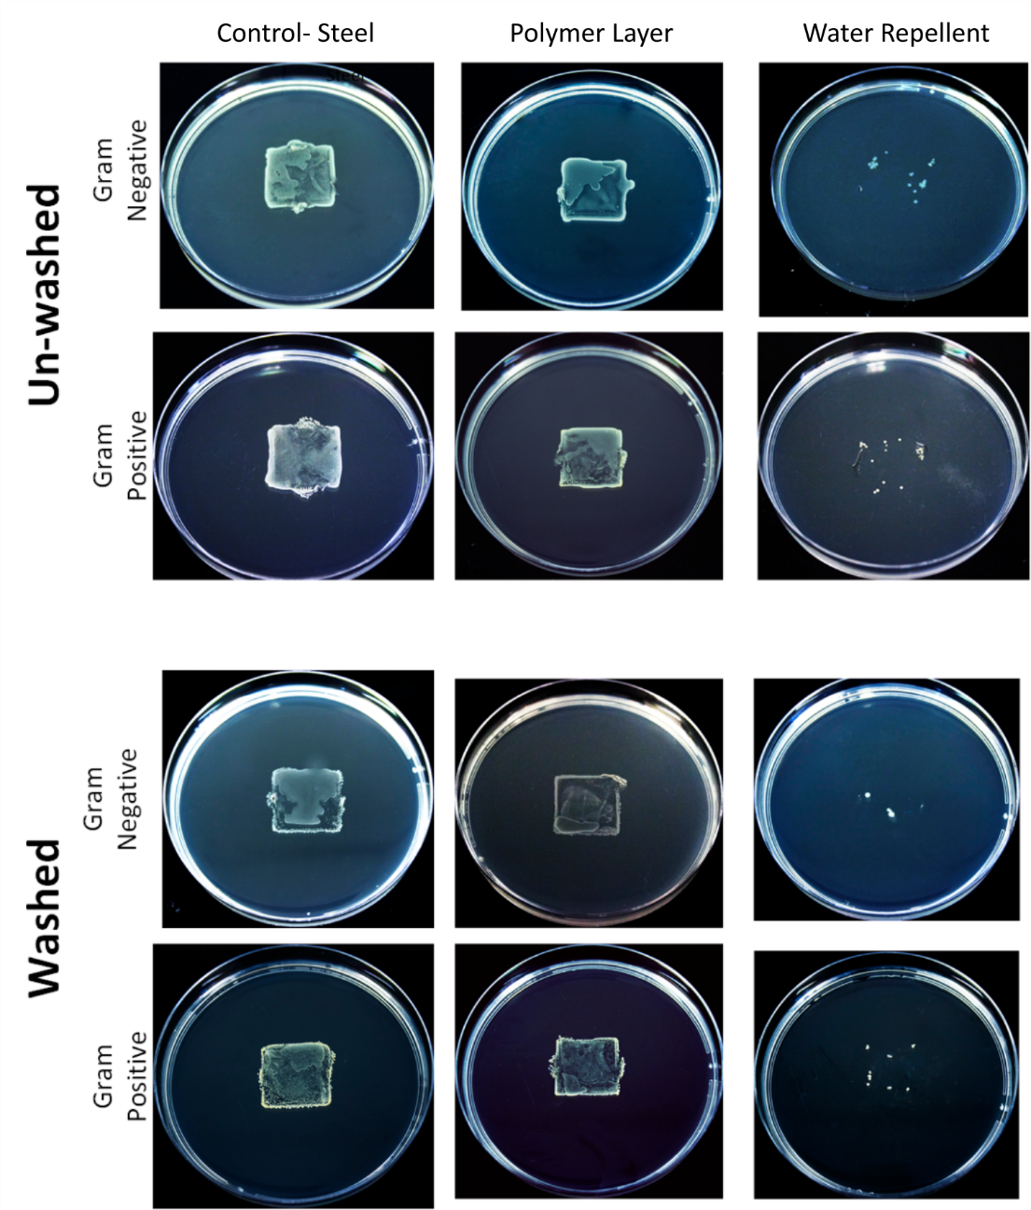
Fig S 6 Photographs of the agar plates stamped with specimens that were exposed to bacteria.

Antibacterial experiments on the dual-functional coating
The coatings Z5, Z10 and Z15 along with a bare steel as the control were incubated in a cell culture column of 5 cm height and containing 10⁴-10⁵ cells/mL. It was then transferred to an incubator at 37ºC. After 1 day, 5 days and 9 days, 1 mL of the culture was plate diluted to see the remaining number of colonies. The results of contact angle analysis and the aforementioned antibacterial analysis prompted us to eliminate all other dual functional coatings except the Z15.
In a different experiment also called scratch experiment, we intentionally created defects on the surfaces of water repellent coating and Z15. Same sized scratches were made on water repellent coating and Z15 coatings towards the centre of the sample (indicated with arrows). A pristine water repellent coating and bare steel were used as reference samples. A 20 μL droplet of bacterial culture in the log phase was anchored at the centre. In the case of the defective coatings, the droplet remained anchored on the surface (Fig S7 (b,c)). In the case of pristine water repellent coating, the droplet rolled away due to the small rolling angle. In the case of bare steel due to its hydrophilicity, the droplet spread on the surface (Fig S7 (a)). We left the droplet on the surface for 10 minutes and then washed the surface three times with PBS. Each cycle of washing had 1 mL of PBS pipetted onto the surface. The samples were then transferred to 6 well plates. To enable moisture for the bacteria on the surfaces to survive, we dropped droplets of PBS around the samples in the well. Also, we filled adjacent wells of the samples with PBS. After this, the well plates were transferred to an incubator at 37ºC. After 24 h of incubation, the samples were taken out and gently washed with PBS 3 times. Then, the samples were stamped on the agar plates. The agar plates were incubated overnight and then imaged under an Axio Observer microscope.
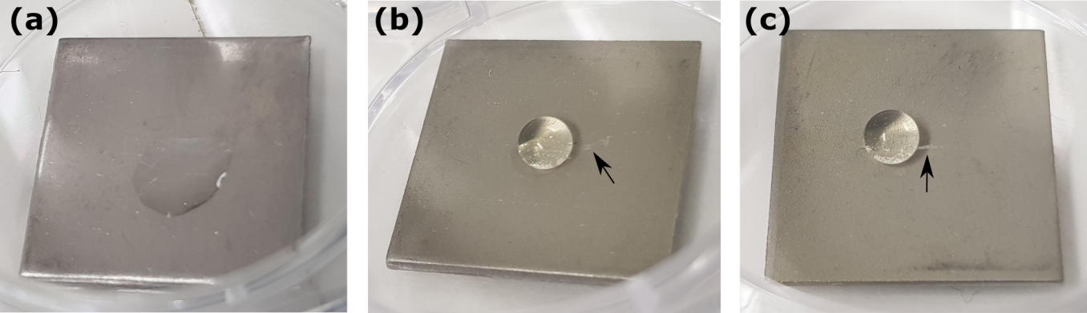
Fig S 7 Photographs of bacterial droplet behaviour on different samples; (a) bare stainless steel as the control, (b) scratched water repellent coatingcoating, and (c) scratched water repellent coating coating containing 15 wt% of ZIF-8

Note 1: Morphology, chemistry and wettability of the coating
Spectroscopic analysis of the suspension of IPN is shown in Fig S8(A). The loss of the 2235 cm⁻¹ N=C=O isocyanate stretch band, 3227 and 3492 cm⁻¹ –OH stretch bands belonging to PTHF and TRIOL, respectively and the formation of 3300 cm⁻¹ –NH stretch band confirms the completion of PU reaction (Fig S8(B)) (9). The loss of 1637 cm⁻¹ C=C stretch band confirms the completion of PMMA reaction (Fig S8(C)) (9). Spectroscopy analysis of fumed silica and FS are shown in Fig S9 showing the additional organic signatures in FS (9).
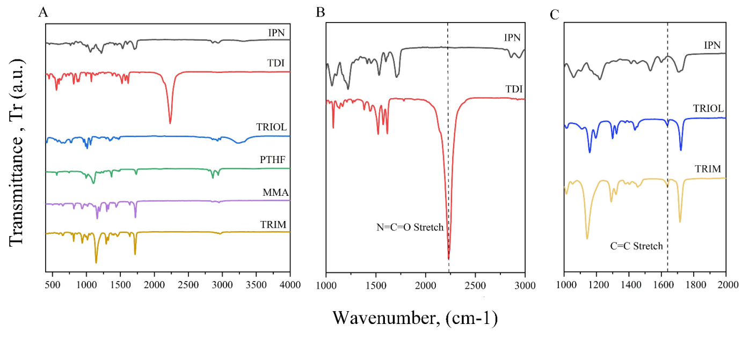
Fig S 8 FTIR spectroscopy of IPN. (A) Spectroscopy of IPN and its raw constituent chemicals. (B) Spectrum confirms the completion of PU reaction. (C) Spectrum confirms the completion of PMMA reaction.
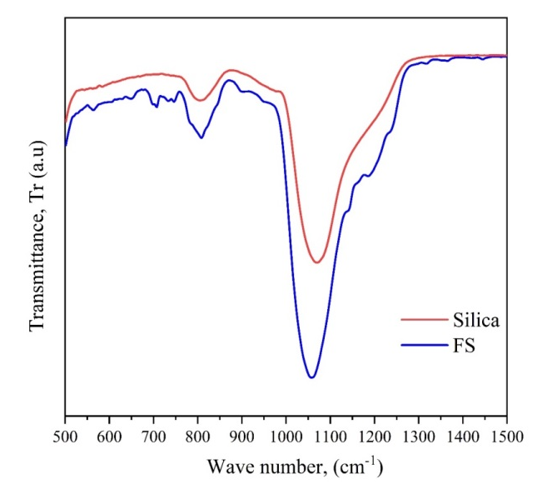
Fig S 9 FTIR spectra of fumed silica and FS. FS displays additional organic signatures, confirming the functionalisation of silica.

SEM images of IPN and IPN+FS is shown in Fig S10 (a,b). IPN provided micron-scale surface structure (Fig S10 (a)) to which FS particles are integrated (Fig S10(b)) resulting in a superhydrophobic water repellent coating of static contact angle 157 ± 0.47º and rolling angle of 0º. The spray deposition parameters including spraying distance, spraying angle and the IPN-curing time (time between spraying IPN and FS) were optimised to improve the integration and hence the abrasion resistance of the coating.
Fig S 10 Morphology of the coating. (a) SEM images of spray coated IPN showing the micro textured morphology. (b) SEM images of the IPN-FS spray coated coating shows the nano-rough morphology of the water repellent coating.

The use of an IPN film to mechanically stabilize the fluorinate silica particles has been demonstrated as an effective approach to achieve a durable water repellence (9). Our optimized coating structure (Table S2) provides sliding angles of ca 0°, static contact angles of 157 ± 0.47º, with details about the extended durability of the coatings reported in (Table S2, Fig S7-S8).

Table S 2 Contact angle and rolling angle values of the water repellent coating as a function the content of antimicrobial ZIF-8
ZIF-8 wt% | Contact angle (degrees) | Rolling angle (degrees)
0 | 157 ± 0.47 | 0
5 | 161 ± 4.67º | 0
10 | 158 ± 1.41º | 0
15 | 155 ± 0.66º | 0
20 | 149 ± 1.63º | 8 ± 1.72

Note 2: Characterisation of the dual functional coating
A field emission scanning electron microscope (FE-SEM, Zeiss Ultraplus) was used to analyse the ZIF-8 particles (Fig. S11(a)) as well as the surface morphology of the dual functional coating (Fig. S12(a-c)). Before the SEM analysis, the samples were sputter-coated with platinum at 20 mA for 1 minute.
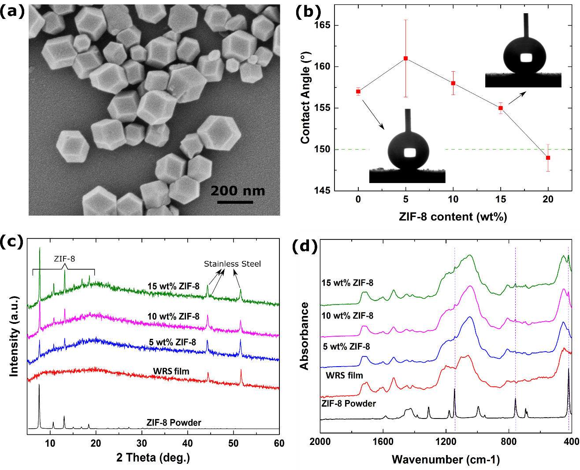
Fig S 11 (a) SEM image of the ZIF-8 powders, (b) contact angles of water repellent coating and the samples containing ZIF-8 powders (5-20 wt%), (c) XRD patterns, and (d) FTIR spectra of the coatings ( water repellent coating and the samples containing 5-15 wt% of ZIF-8 powders) on stainless steel in comparison with ZIF-8 powders

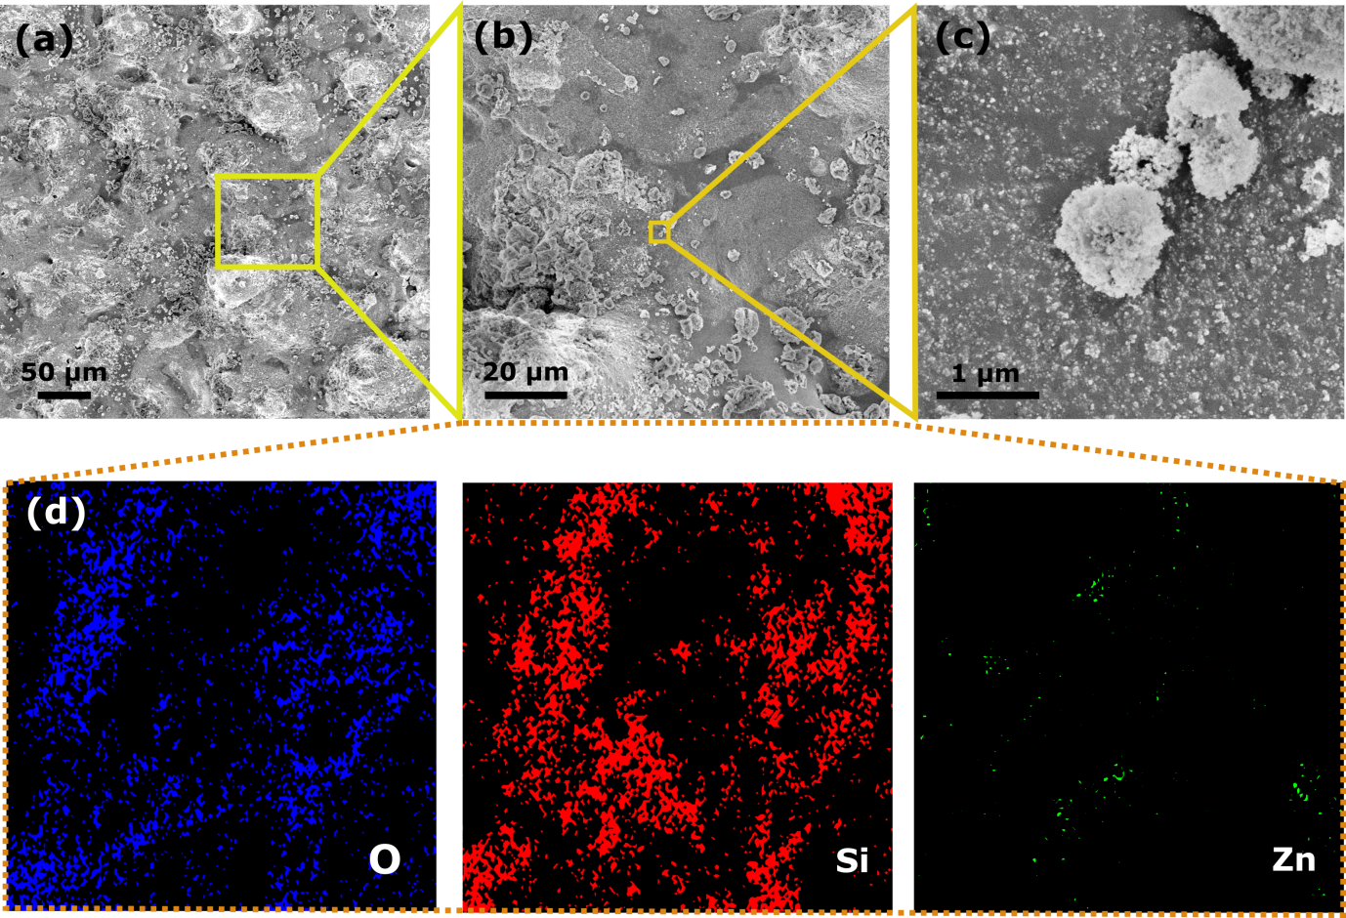
Fig S 12 (a-c) SEM images of the coating containing 15 wt% of ZIF-8 powders at different magnifications, (d) EDX elemental mapping of the coating showing the distribution of oxygen, silicon, and zinc elements

Static and rolling water contact angles were measured using a contact angle analyser (Surface Electro-Optics, Phoenix – MT (M, A, T). 9 samples were tested in each group as shown in Fig S11 (b) and Table S2. Z5 registered the highest contact angle value of 161º, Z10 with 158º, Z15 with 155º and Z20 with 149º. The rolling angles were 0 for all samples except Z20, where it went above 10º. Our hypothesis is that the presence of ZIF-8 in the coating until a certain amount creates an additional degree of roughness. However, once the limit is crossed, the hydrophobic ZIF-8 particles start being exposed on the surface, resulting in a reduction of the contact angle. For Z20, even though the angle was close to the characteristic superhydrophobic boundary, the increase in rolling angle was pinning the droplet on the surface. Hence, we decided to eliminate Z20 for the other characterisations.
The coating was characterised for the presence of ZIF-8 in it using a Bruker system (XRD, D2 Phaser, USA) equipped with copper Kα radiation with an average wavelength 1.54059 Å. ZIF-8 coatings record strong peaks at 2θ = 7.30, 10.35, 12.70, 14.80, 16.40 and 18.00º that indicates the presence of lattice planes (100), (200), (211), (310) and (222), respectively (Fig S11 (c)) (10).
Chemistry analysis of the coating to detect ZIF-8 was done using Fourier transform infrared – attenuated total reflectance (FTIR-ATR, Bruker-Alpha, U.S.A) on all as-synthesised samples. Scans were performed from 400-4000 cm⁻¹. The strong organic character at 421 cm-1 observed shows the presence of Zn-N stretching that occurs between zinc and nitrogen of the HmIm organic linker (Fig S11 (d)) (11).
Microstructural and elemental analysis of the coating containing 15 wt% of ZIF-8 powders are presented in Fig. S12. Considering the average particle size of the ZIF-8 powders (200-400 nm), it seems that the MOF particles are covered by FS as shown in Fig. S12(c). EDX elemental mapping of the coating (Fig. S12(d)) confirms the presence and dispersion of zinc element (from ZIF-8 structure) in this dual-functional water repellent coating.

Note 3: Robustness of water repellent coatings for bacterial and viral shielding
Results of abrasion analysis are shown in Fig S13. Table S2 shows the contact angle of the coating at 0 cycles, measured to be 157 (± 0.47º). Statistically, the water repellent coating was able to maintain super hydrophobic contact angles up to 100 cycles of rotary abrasion under a load of 250 g. After 100 cycles, there is a reduction in static contact angles. The high durability of the water repellent coating can be accounted for the presence of IPN that can act as a glue, holding the nanoparticles of FS. As the abrasion cycle increases, the FS nanostructures are slowly broken away and after a certain number of cycles (here 100), abrasion starts ripping away the embedded nanoparticles from the IPN surface, leaving a heterogeneous surface of IPN and FS. Some of the embedded FS stays until 200 cycles of abrasion, leading to the hydrophobic static contact angles shown in Fig S13. This robust water-repellency effectively prevents the interaction between pathogens present in liquids and the underlying coating surface by rolling off landing droplets or avoiding their adhesion and transfer from hydrated or humid host environments such as the human skin.
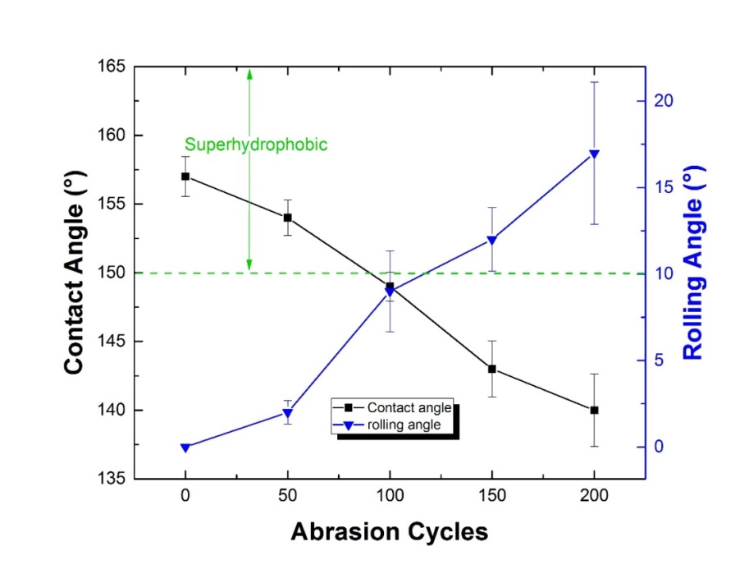
Fig S 13 Plot shows the abrasion resistance of the water repellent coating. water repellent coating statistically maintains superhydrophobic contact angles up to 100 cycles of rotary abrasion. Un-abraded water repellent coating registered static water contact angles of 157(± 0.47º).

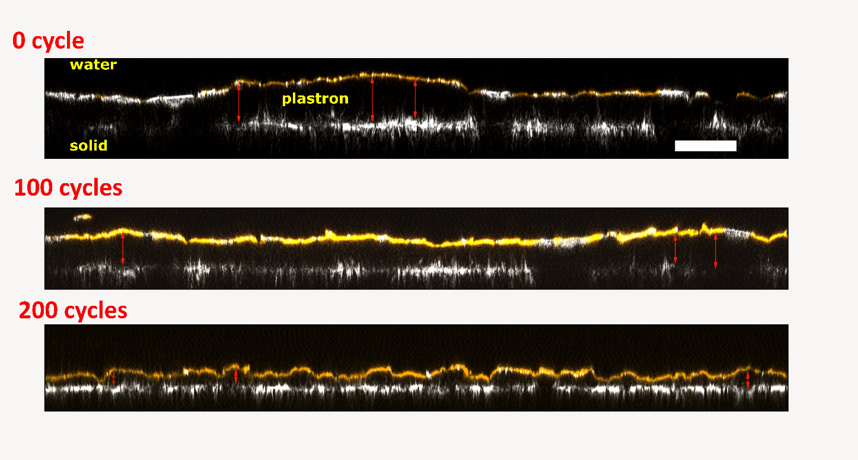
Fig S 14 CLSM orthogonal projections of un-abraded coating (0 cycles) versus the same coating abraded to 100 and 200 cycles. Scale bar is 50 μm. The plastron thicknesses were measured at the highest points, indicated by red arrows. For un-abraded sample, the thicknesses were 33, 33.3 and 38.4 μm. For 100 cycles, it is 27.8, 25.5 and 29.4 μm. For 200 cycles, the values are 13.5, 12.6, 24 μm. The samples at these cycles were chosen because of the significant decrease in plastron thickness that is apparent.

Note 4: Shielding from virus uptake
We performed anti-viral test on the coating of steel substrate to test whether samples can prevent virus transmission. We analysed the capability of steel (Fig S15(a-b)), superhydrophobic water repellent coatings (Fig S15(c-d)), or dual functional coatings to preventing adhesion of a Lentivirus.

In brief, the coated samples were dipped into the high titre of lentivirus virus (United Bioresearch, Monomeric eGFP (green fluorescent protein) lentiviral purified lentiviral particles, 10⁷ Tu/mL, 200 μL) for 10 seconds, then the samples (n=3) dipped into fresh media (named as contaminated surface) for 10 seconds and underwent cycles of washing (4 times: named as washed 1, washed 2, washed 3 and washed 4) in fresh media. The media from the contaminated surface and subsequent washes were then placed onto fibroblast cells and the transfection was examined. After 24 h, the media was replaced with fresh media to the wells, followed by incubation for another 72 h. The contaminated surface of steel showed cell transfection (Fig S15(e)) while water repellent coating only had a very small infection (0.3%) (Fig S15(f)).

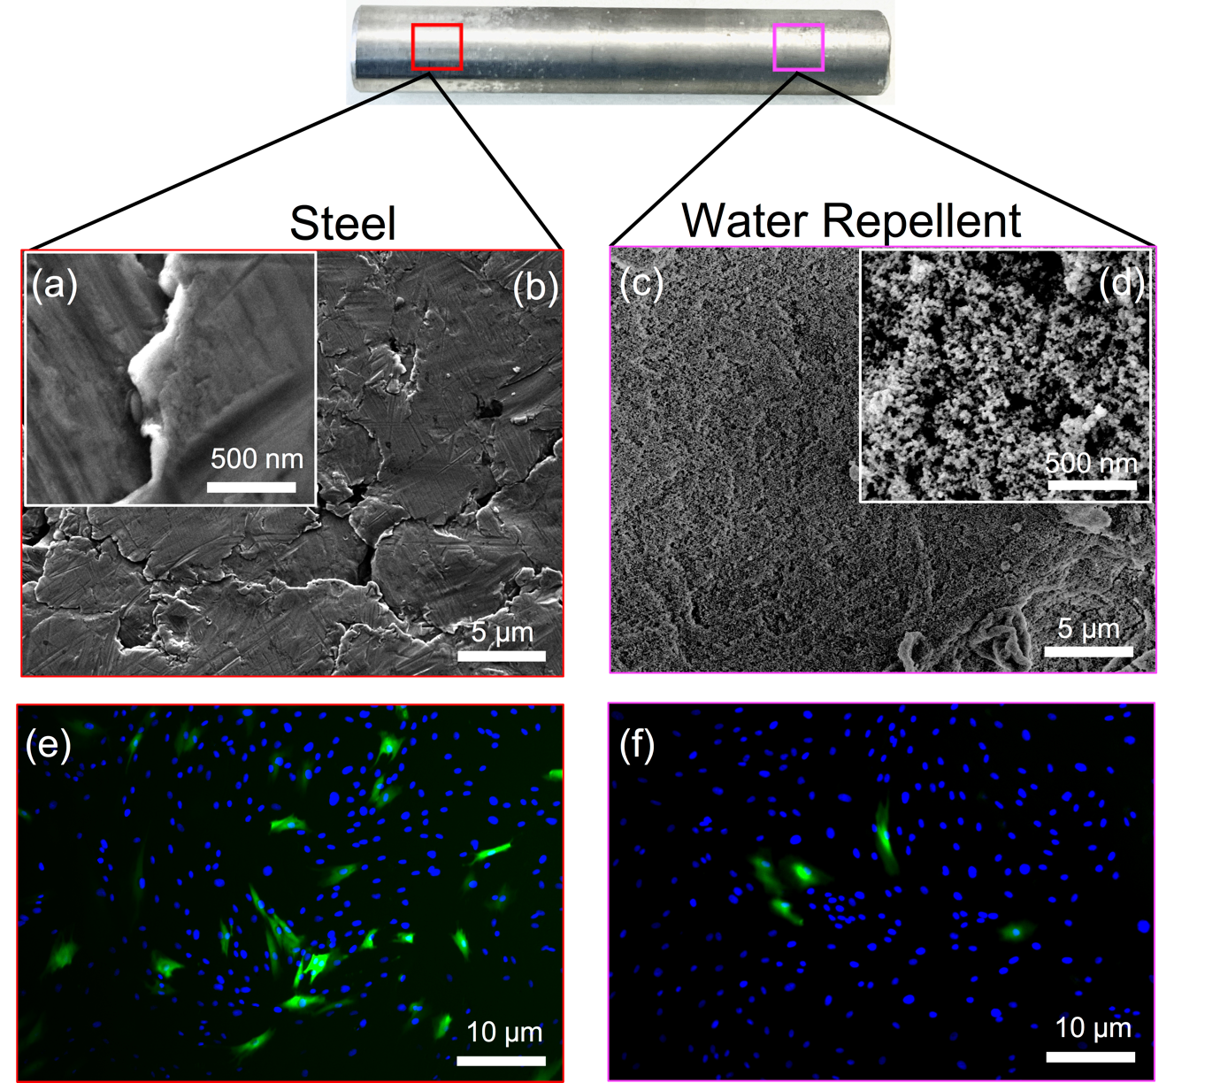
Fig S 15 SEM images of steel rods (uncoated steel (a, b) and coated surface (water repellent, c,d)) at different magnification and representative images of cell transfection for contaminated surface (e, f)

This shielding effect was slightly decreased by the addition of ZIF-8 in the dual functional coating. This may due to the formation of some sub-micro domains that are not superhydrophobic (12, 13). These domains may provide attachment points for some virions, but these few isolated and loosely adhered particles were easily removed upon a first gentle wash. Importantly, both coated surfaces performed exceptionally well compared with bare steel that was significantly more strongly contaminated and continued to shed infectivity through multiple washes.

Shielding from bacteria uptake
Swarming and biofilm formation are antagonist processes, with biofilms being sessile colonies, whereas swarming involving motion. Depending on the availability of nutrition and other factors, bacteria would choose to permanently adhere and form biofilms or keep swarming on the surface. Notably, the behaviour of the bacteria on the water repellent coatings was distinct from both swarming and biofilm formation (Movie 2). The bacteria kept swimming in a collective motion within the droplet suspension, confirming the lack of adhesion points to the water repellent coating.

Quantitative assessment of bacterial adhesion
Such loosely adhered bacteria may originate from micron-scale defects within the coating or to bacteria adhesion to dust and other contaminants particles that may have been floating over the plastron layer. While stamping, these particles are transferred to the agar plate along with their bacteria load resulting in the formation of few colonies.

Note 5: Failure kinetic of the water repellent shielding mechanism
We conducted an in-operando optical investigation of the surface protection mechanism of our water repellent coating structure, determining potential failure and bacterial adhesion mechanisms (Fig S16).
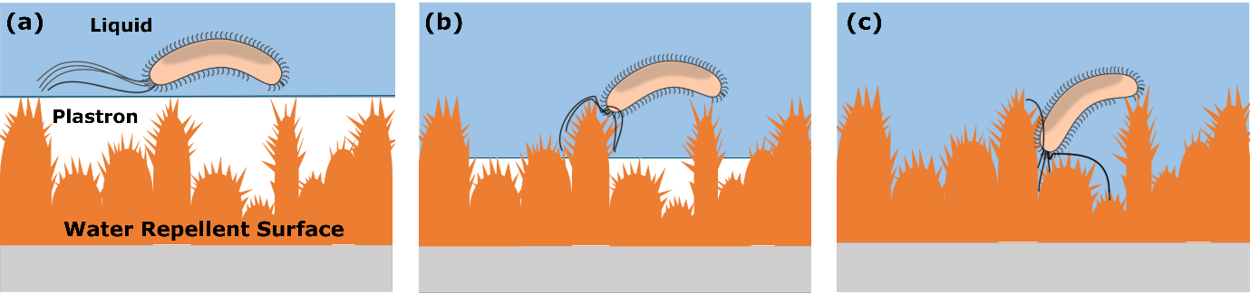
Fig S 16 Surface shielding mechanism. (a-c) Schematic representation of the surface shielding mechanism initially preventing the adhesion of bacteria to the coating.

The immersion depth is an important parameter often overlooked in plastron-stability studies (Table S1) (14). Following extended submersion of the coating, the liquid pressure on the plastron layer causes its gradual dissolution. As the plastron continues to degrade and thin, it exposes parts of the underlying coating surface to the bacteria allowing for their adhesion. We have observed that the multi-scale roughness of our coating structure increases the stability of the plastron layer up to 4 h. This is significantly longer than previous studies on water repellent coatings reporting plastron loss within 1 to 1.5 h (Table S1).
For exposures of 4 to 6 h, a rapidly increasing number of bacteria colonies is observed (Fig 6(c-e)). While longer time results in complete colonization of the bacteria-challenged area (Fig 6(f-h)). This trend was quantified by serial dilution data showing that up to 4 h a significant reduction of the number of bacteria colonies is observed with respect to the bare steel surface (Fig 6 (f-h), Table 3). Notably, the water repellent coatings were able to decrease the number of bacteria colonies by 99.8% for up to 4 h continuous immersion. This indicates a plastron layer stability in the range of 3-4 h.
Upon 5-6 h continuous immersion, the bare and coated steel samples resulted in similar bacteria colony densities (Table 3). Notably, for immersion times of 7 h and longer, the water repellent coatings displayed an increasingly larger number of bacteria colonies (Table 3). This is attributed to the micro and meso-scale roughness of the water repellent coatings that provide a larger area for bacteria adhesion upon dissolution of the plastron layer. Previous studies on the use of water repellent coatings to prevent bacteria adhesion have not been able to achieve comparable reductions in bacteria colonies for such an extended period of immersion time (Table S1). Significant reduction in bacteria colonies was reported only for significantly shorter immersion times of 1 h or less. One of the most recent studies that analysed the plastron collapse of water repellent coatings observed less than 90% reduction for 1 h (14).
Table S 3 Number of bacteria colonies after incubation with bacteria for 1hour to 8 hours
Incubation time  with bacteria (h) | Number of bacteria colonies  of Steel (CFUs/mL) | Number of bacteria colonies  of Water Repellent (CFUs/mL)
1 | 2.6×10⁵ ± 4.5×10⁴ | 144 ± 57
2 | 1.1×10⁶ ± 4.2×10⁵ | 13266 ± 2819
3 | 1.4×10⁷ ± 1.7×10⁶ | 20144 ± 2723
4 | 2.6×10⁷ ± 3.0×10⁶ | 8.4×10⁵ ± 2.4×10⁵
5 | 3.2×10⁷ ± 9.8×10⁶ | 1.7×10⁷ ± 1.6×10⁶
6 | 1.4±10⁸ ± 3.7×10⁷ | 1.0×10⁸ ± 4.5×10⁷
7 | 2.6×10⁸ ± 1.0×10⁸ | 8.1×10⁸ ± 3.4×10⁸
8 | 1.3×10⁹ ± 5.3×10⁹ | 1.6×10¹⁰± 4.3×10⁹

Stablility of the plastron layer and influence of multiscale roughness.
It has been reported that the disintegration time of the plastron layer depends from the immersion depth as an increase in the liquid pressure results in an exponential increase in the diffusion of air into the liquid (15). Similar correlations may be determined as a function of the temperature (16). Here, we have observed that the lifetime of the plastron layer is also a function of the surface roughness, and thus in the case of hierarchical surfaces with multi-scale roughness, the plastron layer lifetime depends on the local topography of the coating. For this reason, the transition from non-wetting to wetting regimes does not occur abruptly and at the same time for the entire area of the coating.

References
1. F. Hizal et al., Nanoengineered Superhydrophobic Surfaces of Aluminum with Extremely Low Bacterial Adhesivity. ACS Applied Materials & Interfaces 9, 12118-12129 (2017).
2. C. R. Crick, S. Ismail, J. Pratten, I. P. Parkin, An investigation into bacterial attachment to an elastomeric superhydrophobic surface prepared via aerosol assisted deposition. Thin Solid Films 519, 3722-3727 (2011).
3. B. J. Privett et al., Antibacterial Fluorinated Silica Colloid Superhydrophobic Surfaces. Langmuir 27, 9597-9601 (2011).
4. K. Bartlet, S. Movafaghi, L. P. Dasi, A. K. Kota, K. C. Popat, Antibacterial activity on superhydrophobic titania nanotube arrays. Colloids and Surfaces B: Biointerfaces 166, 179-186 (2018).
5. E. Fadeeva et al., Bacterial Retention on Superhydrophobic Titanium Surfaces Fabricated by Femtosecond Laser Ablation. Langmuir 27, 3012-3019 (2011).
6. M. Taheri, T. G. Enge, T. Tsuzuki, Water stability of cobalt doped ZIF-8: a quantitative study using optical analyses. Materials Today Chemistry 16, 100231 (2020).
7. J. Schindelin et al., Fiji: an open-source platform for biological-image analysis. Nature Methods 9, 676-682 (2012).
8. C. T. Rueden et al., ImageJ2: ImageJ for the next generation of scientific image data. BMC Bioinformatics 18, 529 (2017).
9. W. S. Y. Wong, Z. H. Stachurski, D. R. Nisbet, A. Tricoli, Ultra-Durable and Transparent Self-Cleaning Surfaces by Large-Scale Self-Assembly of Hierarchical Interpenetrated Polymer Networks. ACS Applied Materials & Interfaces 8, 13615-13623 (2016).
10. K. S. Park et al., Exceptional chemical and thermal stability of zeolitic imidazolate frameworks. Proceedings of the National Academy of Sciences 103, 10186 (2006).
11. H. Kaur, G. C. Mohanta, V. Gupta, D. Kukkar, S. Tyagi, Synthesis and characterization of ZIF-8 nanoparticles for controlled release of 6-mercaptopurine drug. Journal of Drug Delivery Science and Technology 41, 106-112 (2017).
12. K. Zhang et al., Exploring the Framework Hydrophobicity and Flexibility of ZIF-8: From Biofuel Recovery to Hydrocarbon Separations. The Journal of Physical Chemistry Letters 4, 3618-3622 (2013).
13. W. Miao, J. Wang, J. Liu, Y. Zhang, Self-Cleaning and Antibacterial Zeolitic Imidazolate Framework Coatings. Advanced Materials Interfaces 5, 1800167 (2018).
14. G. B. Hwang et al., The Anti-Biofouling Properties of Superhydrophobic Surfaces are Short-Lived. ACS Nano 12, 6050-6058 (2018).
15. R. Poetes, K. Holtzmann, K. Franze, U. Steiner, Metastable Underwater Superhydrophobicity. Physical Review Letters 105, 166104 (2010).
16. A. Martínez-Gómez et al., Long-Term Underwater Hydrophobicity: Exploring Topographic and Chemical Requirements. ACS Omega 2, 8928-8939 (2017).

