Figure S1: Overarching framework of the screen data collection workflow.

a. 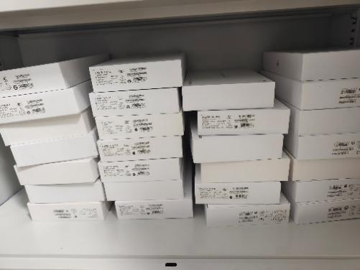
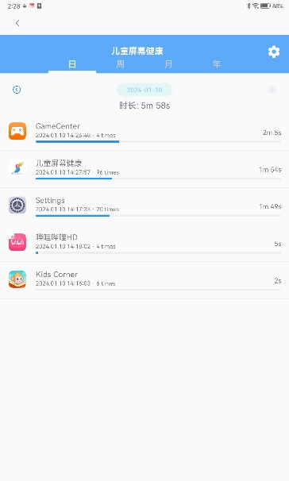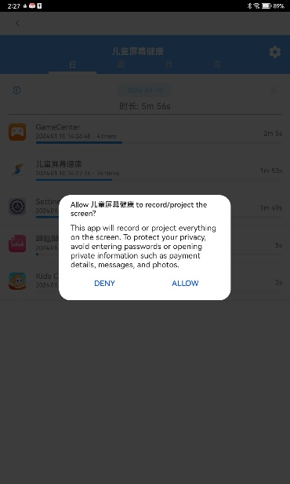
b (1). b (2).

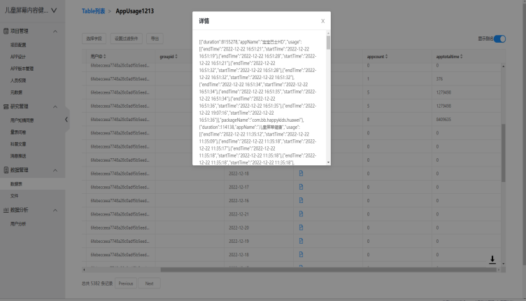.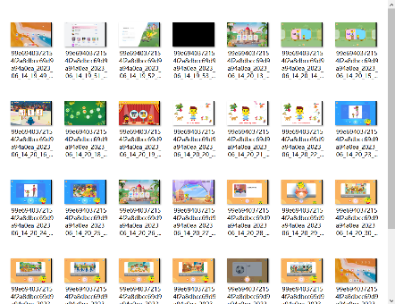
c (1) c (2)

Note:
- Tablets of the same model (Huawei MatePad 10.4) are used as the equipment for data acquisition.
b (1). The front-end HSVC app, displaying the usage duration of various applications.
b (2). The screenshot capture feature of the HSVC app requires parental authorization to be enabled.
c (1). The screen usage data is stored on the Huawei Cloud server.
c (2). Researchers download the screenshots through the Huawei Research Platform.
Table S1: Descriptive characteristics of sample included in the analysis and sample with complete data.
Characteristics | Complete data |  | Included in Analysis |  |  | P-Value
Characteristics | N | n(%) | N |  | n(%)
Sex | 541 |  | 355
Male |  | 303(56.0) |  |  | 204(57.5) | .67
Female |  | 238(44.0) |  |  | 151(42.5) | .67
Age | 556
4 |  | 215(38.7) | 355 |  | 70(19.7) | <.001
5 |  | 183(32.9) |  |  | 137(38.6) | <.001
6 |  | 158(28.4) |  |  | 148(41.7) | <.001
Mother's education | 547 |  |  | 355
≤High school |  | 250(45.7) |  |  | 164(46.2) | .96
College or bachelor |  | 243(44.4) |  |  | 158(44.5) | .96
≥Master |  | 54(9.87) |  |  | 33 (9.30) | .96
Annual family income | 547 |  | 355
≤79，000 RMB |  | 59(10.8) |  |  | 42(11.8) | .76
80，000-199，000RMB |  | 173(31.6) |  |  | 117(33.0) | .76
≥200，000RMB |  | 315(57.6) |  |  | 196(55.2) | .76
Family structure | 547 |  | 355
Singleton |  | 282(51.6) |  |  | 179(50.4) | .74
More than one child |  | 265(48.4) |  |  | 176(49.6) | .74
Main caregiver | 547 |  | 355
Parents |  | 338(61.8) |  |  | 219(61.7) | .98
Grandparents or others |  | 209(38.2) |  |  | 136(38.3) | .98

Figure S2: The elbow method of the K-means cluster analysis
