Supplementary Materials

Supplementary Table 1. Feature variable selection for logistic regression in the internal derivation cohort
Variables | OR | 95% CI | P-value
α | 1.15 | 1.12-1.19 | < 0.001
L₂ | 1.04 | 1.03 – 1.08 | < 0.001
Traction length of machine disconnection | 1.03 | 1.01 – 1.16 | < 0.001
Palatopharyngeal flow velocity | 0.26 | 0.11 – 0.55 | < 0.001
Mouth opening | 0.84 | 0.71 – 0.98 | 0.031

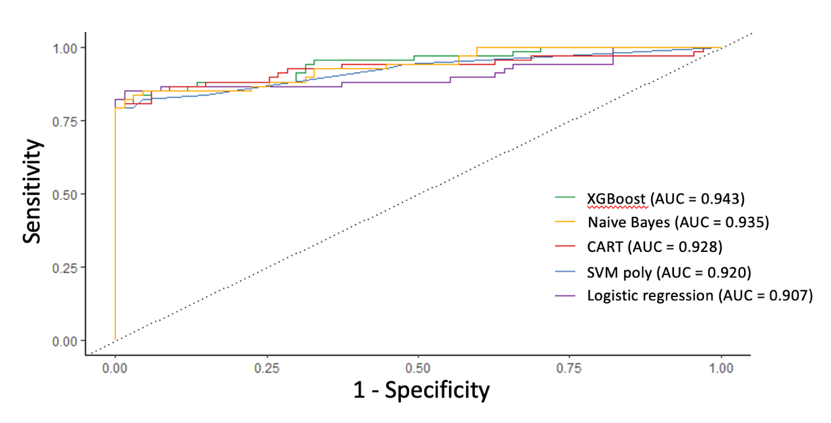
Supplementary Figure 1. Model performance evaluation in the external validation cohort. The model performance was evaluated using XGBoost, Naive Bayes, CART, SVM with a polynomial kernel function, and logistic regression classifiers, respectively. XGBoost, extreme gradient boosting; CART, classification and regression tree; SVM, support vector machine.

