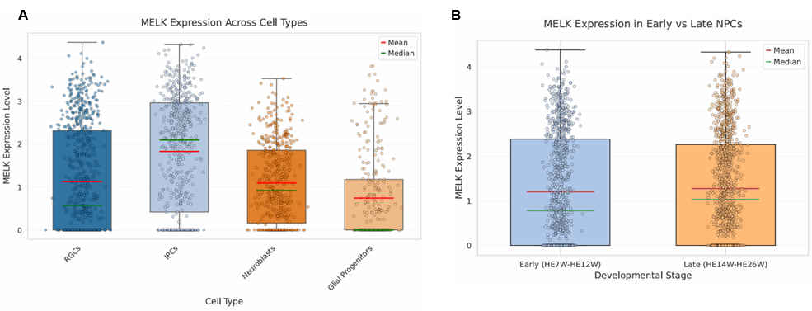
Figure S1. Cell - Type and Stage - Specific MELK Expression Profiles. (A) Distribution of MELK expression across different cell types (Radial Glial Cells, RGCs; Intermediate Progenitor Cells, IPCs; Neuroblasts; Glial Progenitors). The boxplots show the mean (red line), median (green line), and dispersion of MELK expression levels within each cell type. (B) MELK expression in neural progenitor cells (NPCs) of humans at early gestation (HE7W - HE12W) and late gestation (HE14W - HE26W). The boxplots show the distribution of the mean (red line) and median (green line) of the expression levels in the two stages.
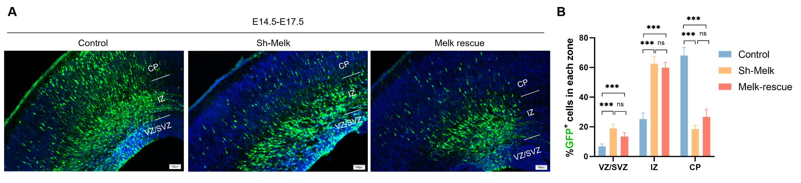
Figure S2. Insignificant Rescue Effect of Melk Overexpression after Melk Knockdown. (A) From E14.5 to E17.5, GFP staining shows the distribution of cells in different regions (VZ/SVZ, IZ, CP) of mouse brain tissues in the control group, Melk knockdown group (Sh - Melk), and Melk rescue group. (B) Statistics of the proportion of GFP⁺ cells in the VZ/SVZ, IZ, and CP regions among different treatment groups. n=3 Control, n=3 Sh-Melk，n=3 Melk rescue. Mean±SEM, unpaired t-test (***p<0.005, ns p>0.05); n= the number of independent mouse experiments,3 sections/mouse, scale bar=100 μm.
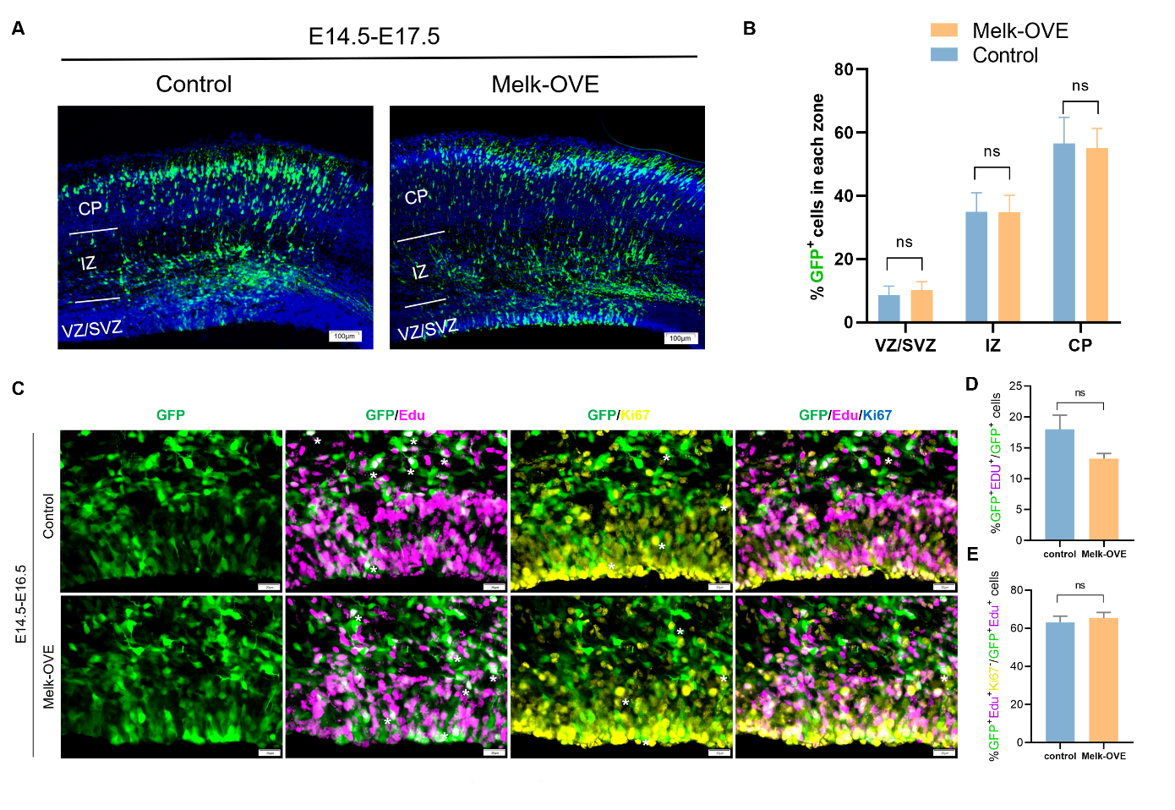
Figure S3. Effects of Melk Overexpression on Cell Distribution and Proliferation in the Mouse Embryonic Cortex. (A) From E14.5 to E17.5, fluorescence staining shows the distribution of GFP⁺ cells in different regions (VZ/SVZ, IZ, CP) of mouse brain tissues in the control group and the Melk - overexpression group (Melk - OVE).(B) Statistics of the proportion of GFP⁺ cells in the VZ/SVZ, IZ, and CP regions in the control group and the Melk - overexpression group (n = 3).(C - E) At the stage from E14.5 to E16.5, through GFP/EdU/Ki67 multiplex staining (C, white asterisks mark positive cells), the proportion of GFP⁺EdU⁺ cells (D) and the proportion of GFP⁺EdU⁺Ki67⁺ cells (E). Mean±SEM, unpaired t-test (ns p>0.05); n= the number of independent mouse experiments,3 sections/mouse, scale bar=100 μm.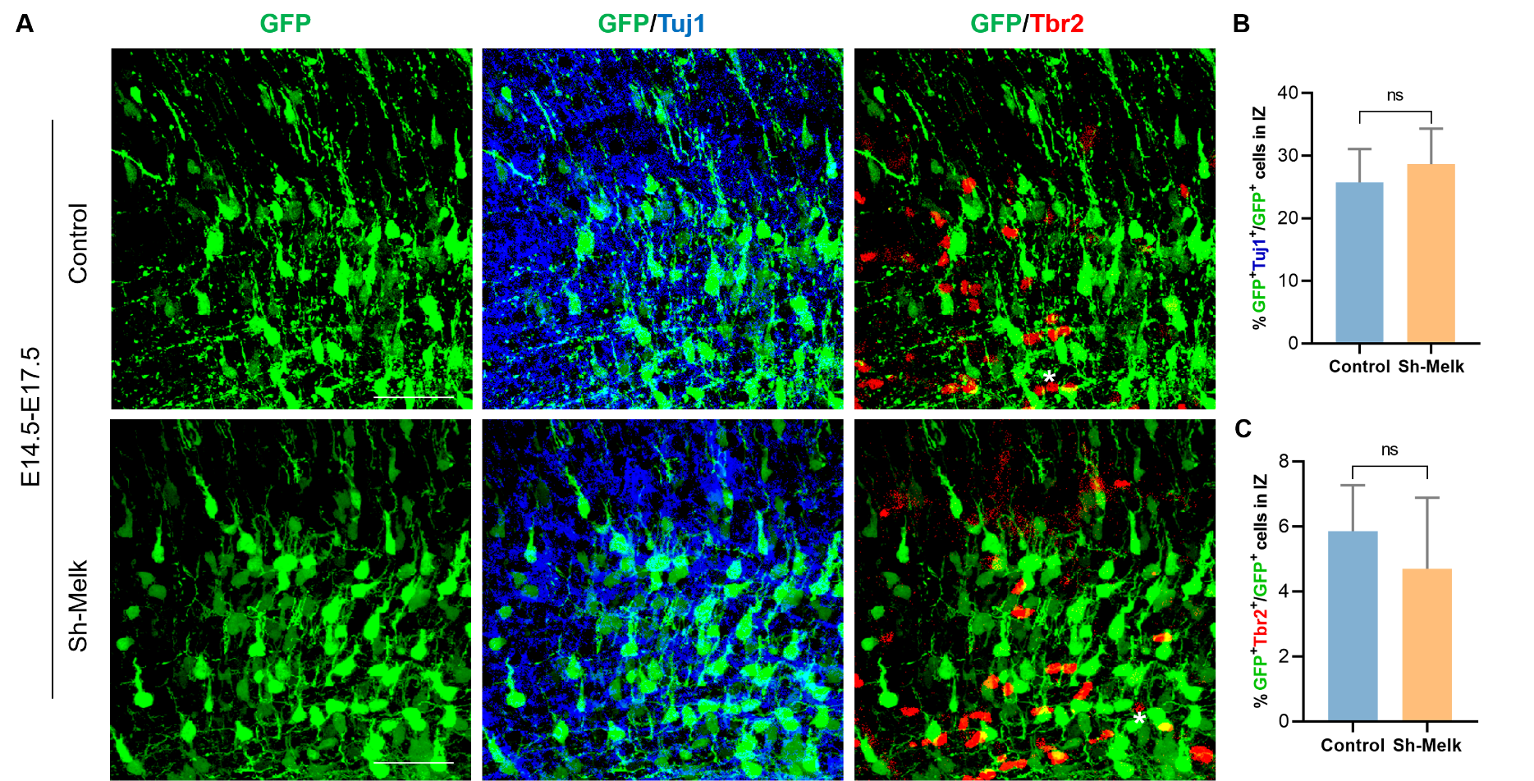
Figure S4. Effects of Melk Knockdown on the Expression of Differentiation Markers Tbr2 and Tuj1 in the IZ. (A) From E14.5 to E17.5, fluorescence staining shows the results of GFP single - staining, GFP/Tuj1 double - staining, and GFP/Tbr2 double - staining in cells of IZ of mouse brain tissues in the control group (Control) and the Melk knockdown group (Sh - Melk). Green fluorescence labels GFP⁺ cells, blue labels Tuj1⁺ cells, red labels Tbr2⁺ cells, and white asterisks mark double - positive cells. (B) Statistics of the proportions of GFP⁺Tuj1⁺ cells and GFP⁺Tbr2⁺ cells in the IZ region. Mean±SEM, unpaired t-test (ns p>0.05); n= the number of independent mouse experiments,3 sections/mouse, scale bar=100 μm.

